A study of atmospheric CO₂ transfer within surface fjord water in southern Hood Canal.

Xiaodi Yin
University of Washington, Seattle, WA
School of Oceanography, Box 357940
Email: xiaody2@uw.edu
05/27/2018

Acknowledgments

I would like to thank professor Julian Sachs for mentoring and providing guidance in carrying out this study. I would also like to thank Arthur Nowell for his feedback and encouragement throughout this study. I also want to thank our TA Susanna Michael for her constant guidance. I also respect and thank all cruise members on R/V Welander for their assistance and hard work. I would like to acknowledge professor Alex Gagnon and Kathy Newell and their graduate students Isaiah W. Bolden and Marta Wolfshorndl for providing assistance and support for this study. Finally, I want to thank all my oceanography peers for their encouragement and support.

Abstract

Atmospheric CO₂ is expected to continually increase and raise the global temperature by ~2 degree C by 2100. The global ocean consumes 30-40% of all CO₂ emitted into the atmosphere every year which limits more dramatic temperature change in the atmosphere. As one of the carbon reservoirs, fjord water has the largest carbon burial rate. It’s been long discussed whether fjord system is a source or a sink for atmospheric CO₂. This study examined the air-sea flux of CO₂ along southern Hood Canal in Washington State, USA. The partial pressure of CO₂ (pCO₂) in the surface of Hood Canal exceeded that in the atmosphere by an average of 332.9 μatm resulting in outgassing of CO₂ at all 10 stations, and implying that Hood Canal was a source for atmospheric CO₂ during January 2018.

Introduction

Continental margins such as coastal and estuary environments play an essential role in the global organic carbon cycle and carbon sequestration through the biological pump (Muller-Karger et al., 2005). Margins have both high production and high organic carbon deposition characteristics. With a global organic carbon burial rate of 0.15 Pg C, it has been suggested that 0.06 Pg C y⁻¹ are buried in margin sediments (>50m) and 0.09 Pg C y⁻¹ are buried in deep sea (4000m). Thus, carbon flux along the margins contribute about 40% to the oceanic biological pump, serving as the main export of organic carbon to the deep ocean. Fjords, as long and narrow inlet connected to the sea, have been shown to have burial rates of organic carbon in the fjord are about 100 times greater than that in the open ocean (Smith, et al., 2015). Smith, et al., (2015) determined that about 18 million tons of organic carbon are buried in fjord environments every year, equivalent to 11% of global oceanic carbon burial in the sediments.
The carbon uptake rate in the fjord system can be controlled by the air-fjord carbon dioxide fluxes at the surface. However, due to the high spatial heterogeneity, the air-fjord fluxes often vary between different estuary systems. A study in Patagonian fjords and Chilean offshore waters found that the fjords were sinks for carbon dioxide in the summer, but in the winter, fjords had a total efflux of atmospheric CO₂ with supersaturated CO₂ waters (Torres et al. 2011).
Natural perturbations such as river inputs of terrestrial organic matter and nutrients, photosynthesis and surface oxygen saturation are major factors controlling the surface fluxes of CO₂ gas in the fjord systems. Also, being smaller by volume, fjords are less resilient to pH change comparing to ocean water, which can increase the duration and occurrence rate of acidification of fjords and ultimately act on the open ocean. The factors contributing to the CO₂ flux in fjords can play an important role in the global carbon cycle.
Several studies of air-fjord CO₂ gas transfer were conducted in Nootka Sound fjords on the northwest coast of Vancouver Island, British Columbia during winter by students from the University of Washington. Knox (2015) concluded that both Muchalat and Tahsis Inlets in Nootka Sound were sinks for CO₂ gas, and the fluxes were -4.7 mmol C m⁻² d⁻¹ and -1.7 mmol C m⁻² d⁻¹ respectively. Her study also indicated that higher wind speeds in Muchalat Inlet enhanced gas transfer between the surface water and overlying air, resulting in a larger influx of CO₂. Miller (2015) focused mainly on alkalinity analysis in Nootka Sound. She found the relationship between alkalinity and salinity was stronger in Muchalat Inlet where no mixing or biological activity took place.
Hood Canal is a fjord within the Puget Sound estuary system, Washington (Fig. 1a). The fjord has an L shape and stretches 109 kilometers, sitting between Olympic and Kitsap peninsulas (Fig. 1b). This study focuses on the southern portion of Hood Canal, which is the most landward and narrowest region of the entire fjord (Fig. 1c). The primary objective was to determine whether Hood Canal has an influx or an efflux for atmospheric carbon, and what the mechanisms controlling the air-fjord fluxes were.
Comparing to other fjords in Puget Sound such as Admiralty Inlet and Main Basin, Hood Canal is characterized as restricted mixing and poorly circulating, especially in the southern portion. A previous study in Puget Sound analyzed the relationship between ocean acidification and formation of the local low pH waters and found ocean acidification can account for 24%-49% of the pH decrease in Hood Canal (Feely R.A., 2010). Overtime, the influence of ocean acidification is thought to have an even greater impact on the pH decrease of the subsurface waters. Combining new carbonate system measurements from Hood Canal in Winter 2018 with these and other previous studies, it may be possible to improve our understanding of long-term map of carbon cycle changes and mechanisms in fjord system due to anthropogenic impacts.

Method
Sampling locations
Surface sampling was undertaken in the southern Hood Canal, Washington on R/V Welander, 20-21 January 2018 (Fig. 1c). Water samples were collected at 15 surface stations in the top 10 centimeters of the water column (Table 1). For each station, three types of surface samples were collected: one for DIC and Alkalinity analysis, one for dissolved oxygen, and one for nutrients. DIC and Alkalinity were collected by a handheld Niskin bottle placed horizontally just below the water surface. Water samples for DIC and Alkalinity were then transferred into 300ml borosilicate glass BOD bottles with stoppers while making sure no air bubbles are observed. After poisoning all bottles with mercuric chloride to prevent any biological activity, they were sealed with greasy stoppers and saved for post-cruise analysis. Nutrient and oxygen were collected in the same way using handheld Niskin bottle, and oxygen samples were transferred into calibrated oxygen bottles and capped for post-cruise analysis. For nutrient samples, all samples were filtered with syringes and Nalgene filters to plastic bottles onboard, and post-cruise analysis was done by Kathy Krogslund in UW’s Marine Chemistry lab. At each station, temperature and salinity were measured by a handheld CTD, YSI Data Sonde 2030. Wind speed data were recorded while collecting water samples using a handheld anemometer. In addition, pCO_{2(atmosphere)} data was obtained from a buoy at Twanoh (47.37°N, 123.01°W) from NANOOS ORCA (Oceanic Remote Chemical Analyzer) program (https://pmel.noaa.gov/co2/story/Twanoh).

Post-cruise analysis
Winkler titration was performed in Kathy Newell’s lab by using a Dosimat 665 to apply on all calibrated oxygen bottles (Carpenter, 1965). Alkalinity titrations were performed with Metrohm AG 876 Dosimat automated open cell titrator (Dickson, 2003). DIC measurements were prepared by a cell filled with cathode and anode solution and analyzed by Marianda VINDTA 3D with UIC coulometer. From one 300ml bottle, we got two replicate DIC measurements and one Alkalinity measurement, and both procedures used Certified Reference Material (CRM) 162 set by Andrew Metrohm from Scripps as referenced dissolved CO₂ concentration with fixed salinity and constant temperature. Both ALK and DIC measurements were performed in Alex Gagnon’s lab.
Calculations
In order to determine whether Hood Canal is a sink or a source for atmospheric CO₂, CO₂ flux, alkalinity and DIC are three major components to analyze at the surface water.
DIC and Alkalinity equations are defined as:

DIC = [CO₂] + [HCO₃ ⁻] +[CO₃ ²⁻] (1)

[HCO₃-] + 2[CO₃ ²⁻] + [B(OH)₄ ⁻] = Alkalinity
= [Na⁺] + 2[Mg²⁺] + 2[Ca²⁺] + [K⁺]- [Cl⁻] - 2[SO₄ ²⁻] - [NO₃ ⁻] (2)

Also, alkalinity can be estimated closely as carbonate alkalinity, which is defined as:

A_{C} = [HCO₃ ⁻] + 2[CO₃ ²⁻] (3)

Two equations to calculate the CO₂ flux are defined as:
F = k * S * ΔpCO₂ (4)

k = (0.222*U² + 0.333*U)(Sc/600)^{-0.5} (5)
ΔpCO₂ = pCO_{2 (seawater)} – pCO_{2 (atmosphere)} (6)
F is the air-water CO₂ flux (Eq. 4), and k is CO₂ gas transfer velocity that depends on in-situ wind speed measurements (U) and the Schmidt number (Sc) (Eq. 5). S is the solubility of CO₂ gas in the water and is dependent on temperature and salinity. CO₂ is more soluble in cold and fresh water (Takahashi et al. 2009; Torres et al. 2011). Using the measured pCO_{2(atmosphere)} from Twanoh buoy and calculated pCO_{2(seawater)} from CO2SYS (Robbins et al. 2010), we can compute ΔpCO₂ (Eq. 6).

Results

Surface salinity and temperature
The surface water salinity at southern Hood Canal ranged from 11.8 to 24.5 with an average of 20.2 (Fig. 2). Surface water was fresher landward with a minimum salinity of 11.8. Larger variation was observed at the corner of the fjord. The average surface temperature was 7.5°C with a maximum of 8.8°C at both landward and northward sampling locations. Minimum temperature of 6.6°C was observed with low salinity surface water. The water was ~1.5°C warmer at northward stations.

Dissolved oxygen (DO)
The surface dissolved oxygen concentration ranged from 7.6 mg L⁻¹ to 9.9 mg L⁻¹ (Fig. 3), and the average DO% is ~72%. Lowest DO% occurred at Station 7 with a highest salinity recorded of 24.5 and the highest DO% occurs at Station 4 with a lowest salinity of 11.8.

Nutrients (NO₃⁻, SiO₂, NO₂⁻, NH₄⁺, PO₃⁴⁻)

Nitrate concentrations ranged from 13.1 μM to 21.2 μM. The lowest concentration was observed with the lowest salinity, and the highest concentration occurred with highest salinity of 24.5 (Fig. 4).
Silica levels were much higher and the distribution was much different from other nutrients along the southern fjord with an average of 89.4 μM. Maximum silica level of 112.7 μM occurred with the lowest salinity and minimum of 73.54 μM occurred at the highest salinity.
Nitrite and ammonia concentrations were near 0 μM along the southern Hood Canal and were slightly higher at landward locations.
Phosphate showed a similar distribution to nitrite and ammonia but with a higher average of 1.76 μM.

DIC and Alkalinity

DIC ranged from 1.10 to 1.75 mmol L⁻¹ with an average of 1.54 mmol L⁻¹ (Fig. 5). The maximum DIC was 1.12 mmol L⁻¹ corresponding to the lowest salinity and the minimum DIC was observed at the station with the highest salinity.
Alkalinity ranged from 1.10 to 1.76 mmol L⁻¹ with an average of 1.53 mmol L⁻¹, and it reached maximum and minimum value at the same stations as DIC (Fig. 6).
In Figure 7, DIC is plotted against Alkalinity and the ratio at the surface was about 1:1. And both measurements increase with salinity, which matched the 1:1 relationship between DIC and Alkalinity.

ΔpCO₂ and CO₂ flux

The pCO₂ of seawater overall exceeded pCO₂ in the atmosphere at the surface with a mean ΔpCO₂ of 332 μatm. This resulted in a positive water-to-air CO₂ flux between 0.1 to 15.32 mmol m⁻² d⁻¹.

Discussion

Southern Hood Canal exhibited CO₂ outgassing to the atmosphere at all stations in January 2018 which made it a source for atmospheric CO₂. Air-sea CO₂ gas exchange mostly depends on pCO₂ in the seawater, and a larger seawater pCO₂ values lead to an efflux of CO₂ gas along the fjord. An average of 416.8 μtam pCO₂ in the atmosphere was recorded from the Twanoh buoy during our field sampling dates, and the pCO₂ of the seawater calculated from our measured DIC, ALK, temperature, salinity, and atmospheric pressure was between 450 and 900 μatm. In winter, the Hood Canal water column is extremely stratified due to largest amount of freshwater flows out of rivers, making the surface water very buoyant. Skokomish River, a major river at the southern end of Hood Canal, has been observed maximum discharge in the winter with an average of 45.87 m³ s⁻¹ while minimum discharge of 15.57 m³ s⁻¹ during the summer every year (Water-Year Summary for Site USGS 12059500) (Fig. 8). However, a large gradient of salinity along the fjord is observed, we must consider both biological and mixing processes that lead to the variations of seawater pCO₂.
Alkalinity of the global surface ocean with a salinity of 35 ranges between 2.15 and 2.35 mmol kg⁻¹ (Takahashi T, et al., 2014), and is higher than the values in southern Hood Canal that averaged 1.53 mmol kg⁻¹ and were associated with a much lower salinity. It is likely that freshwater runoff from rivers lowers the alkalinity of Hood Canal surface waters. A ratio of 1:1 is found between Alkalinity and DIC (Fig. 7), and when salinity equals 0, DIC and Alkalinity are both 0.5 mmol kg⁻¹, which suggests that the processes dominating Alkalinity are equally affecting DIC, and the strong correlation between alkalinity and salinity further indicates freshwater input from Skokomish River is significantly affecting mixing between surface layer and driving surface alkalinity in winter Hood Canal.
Even though concentrations of dissolved oxygen vary from year to year, deep waters of Hood Canal is generally undersaturated with respect to dissolved oxygen (DO) and has lead to extensive fish kills (Fagergren, et al 2004). Surface oxygen concentration can be affected by natural perturbations such as climate and river input, as well as land input of nutrients and carbon that changes the surface photosynthesis and production rate. In winter, due to low solar radiation and high freshwater input, surface water is considered to have higher concentration of dissolved oxygen than that of summer. Slightly higher dissolved oxygen concentration is seen at stations 1-4 within the Great Bend. It is suggested that nutrient-rich water sourced from anthropogenic inputs increase surface photosynthesis production rate and resulted in higher surface dissolved oxygen.
Rivers are the largest source of silica and account for ~80% silica concentration that enters open ocean (Treguer et al. 1995). High silicate concentration is often sourced from anthropogenic activities including developed land use and deforestation. At stations close to Skokomish River in the Great Bend, surface water samples are silicate-rich. Maximum silicate concentration of 112.7 μM is observed at Station 4 that is next to the river mouth.
Unlike silica distribution, nitrate and phosphate both decreases with surface salinity, and the ratio of N:P is 15.2 which is within the range of Redfield ratio (16:1) (Fig. 9), no limitation of phosphate or nitrate is observed at the surface during winter Hood Canal.
The CO₂ flux at station 6-10 is 10 times larger than those at the end of Hood Canal (Fig. 10). It is believed that stronger wind (Fig. 11) during sampling at station 6-10 increased the rate of CO₂ gas exchange (Wanninkhof and McGillis, 1999). Aside from atmospheric data, a chemical sensor mounted on Twanoh buoy also provides real-time data for seawater pCO₂ (Fig. 12). The mean value of pCO₂ of seawater in January is 810.0 μatm which is greater than our calculated pCO₂. Although the value given by the buoy is a bit off from our measurements, it still shows pCO₂ of seawater reaches maximum in the winter and thus surface outgassing of CO₂ in Hood Canal.
Timothy Tang analyzes the upper region of Hood Canal and also finds an overall outgassing of CO₂ into the atmosphere during the winter. With a higher mean salinity of 25.7 and a lower DO saturation of 67.8%, upper region of Hood Canal exhibits a higher CO₂ fluxes than those in the southern Hood Canal and range from 10 to 45 mmol m⁻² d⁻¹ due to high wind.

Conclusion
Surface water in Hood Canal exhibits an overall outgassing of CO₂ gas into the atmosphere which indicates Hood Canal is a source for atmospheric CO₂. Due to surface salinity distributions, a horizontal stratification along southern Hood Canal is observed. Also, large freshwater runoff during January 2018 strongly influences mixing between surface layer and deeper water, resulting in variations of Alkalinity and DIC. In order to understand the carbon cycle and anthropogenic impacts within Hood Canal during the winter, a profile of long-term CO₂ uptake of surface water is recommended for future studies.

References

Carpenter, J. H. The Chesapeake Bay Institute technique for the Winkler dissolved oxygen method. 1965. Limnol. Oceanogr. 10: 141–143.

Dickson, A. G., Afghan, J. D. & Anderson, G. C., Reference materials for oceanic CO2 analysis: A method for the certification of total alkalinity. 2003. Marine Chemistry 80, 185–197

Feely, R.A., et al., The combined effects of ocean acidification, mixing, and respiration on pH and carbonate saturation in an urbanized estuary. 2010. Estuarine, Coastal and Shelf Science 4-88, 442-449. https://doi.org/10.1016/j.ecss.2010.05.004

Fagergren, D., Criss, A. and Christensen, D., Hood Canal low dissolved oxygen: Preliminary assessment and corrective action plan: Olympia, WA, Puget Sound Action Team. 2004. Publication #PSAT04-06, 43 p.
Knox, C. (unpublished-2015). Are fjords sources or sinks of CO2? A study of air-sea CO2 fluxes in Nootka Sound, B.C. https://digital.lib.washington.edu/researchworks/handle/1773/33389
Miller, U. (unpublished-2015). Characterizing the controls on surface alkalinity in Nootka Sound, British Columbia. http://hdl.handle.net/1773/33400
Muller-Karger, F. E., R. Varela, R. Thunell, R. Luerssen, C. Hu, and J. J. Walsh. The importance of continental margins in the global carbon cycle. 2005. Geophys. Res. Lett., 32, L01602, 10.1029/2004GL021346.

Robbins, L.L., et al., CO2calc: A User-Friendly Seawater Carbon Calculator for Windows, Mac OS X, and iOS (iPhone). 2010. Open-File Report 2010-1280.
R. Torres, P. Ampuero. Strong CO2 outgassing from high nutrient low chlorophyll coastal waters off central Chile (30°S): The role of dissolved iron. 2009. Estuarine Coastal Shelf Sci., 83-2, pp. 126-132

R. Wanninkhof, W.R. McGillis. A cubic relationship between air–sea CO2 exchange and wind speed. 1999. Geophysical Research Letters, 26, pp. 1889-1892

Smith, R.W., et al., High Rates of Organic Carbon Burial in Fjord Sediments Globally. 2015. Nature Geoscience 8, 450-453. 10.1038/ngeo2421

Treguer P, Nelson DM, van Bennekom AJ, DeMaster DJ, Leynaert A, Queguiner B 1995. The Silica balance in the world ocean: a reestimate. Science 268:375–379

Torres, R., et al., Air-sea CO₂ fluxes along the coast of Chile: From CO₂ outgassing in central northern upwelling waters to CO₂ uptake in southern Patagonian fjords. 2011. Journal of Geophysical Research, vol. 116. 10.1029/2010JC006344

Takahashi, T., et al.. Climatological distributions of pH, pCO2, total CO2, alkalinity, and CaCO3 saturation in the global surface ocean, and temporal changes at selected locations. 2014. Marine Chemistry. 164:95-125
Takahashi, T., et al., Climatological mean and decadal change in surface ocean pCO2, and net sea–air CO2 flux over the global oceans. 2009. Deep Sea Research Part II: Topical Studies in Oceanography. 56, 8–10, 554-577. https://doi.org/10.1016/j.dsr2.2008.12.009
Water- Year Summary for Site USGS 12059500, https://waterdata.usgs.gov/nwis/wys_rpt?dv_ts_ids=148589&wys_water_yr=2017&site_no=12059500&agency_cd=USGS&adr_water_years=2006%2C2007%2C2008%2C2009%2C2010%2C2011%2C2012%2C2013%2C2014%2C2015%2C2016%2C2017&referred_module

Figure Captions

Fig. 1. Sampling stations along southern Hood Canal in Puget Sound, Washington
Fig. 2. Surface salinity along southern Hood Canal
Fig. 3. Surface dissolved oxygen saturation along southern Hood Canal. An average of 72% is observed.
Fig. 4. Surface nutrient distributions along southern Hood Canal
Fig. 5. Surface DIC along southern Hood Canal
Fig. 6. Surface Alkalinity along southern Hood Canal
Fig. 7. Alkalinity vs DIC at the surface
Fig. 8. Skokomish River discharge over a year record
Fig. 9. Nitrate and phosphate ratio (N:P)
Fig. 10. Surface CO₂ flux along southern Hood Canal
Fig. 11. Wind speed along southern Hood Canal
Fig. 12. Seawater pCO₂ obtained from Twanoh buoy
Table 1. 15 Surface stations
Table 2. Results of data collecting and lab measurements

Figures and Tables

Fig. 1
a. b.
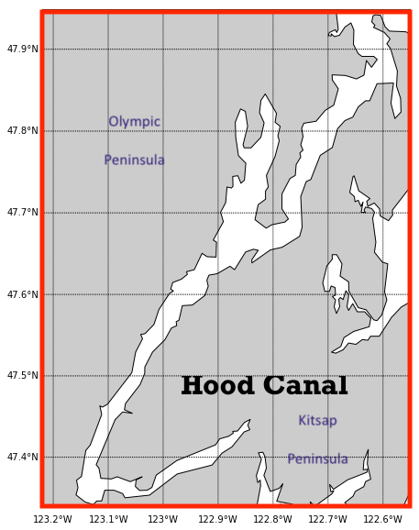
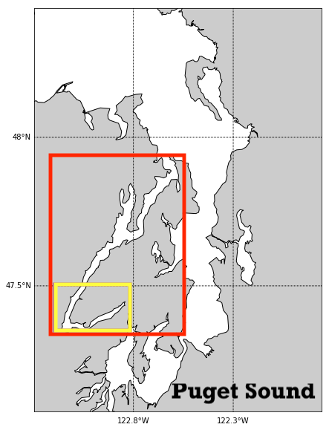

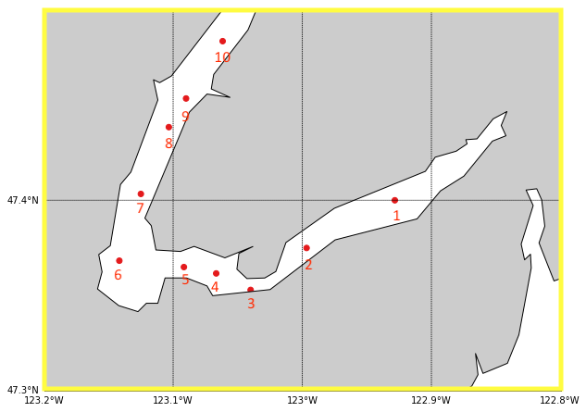
c.

Fig. 2

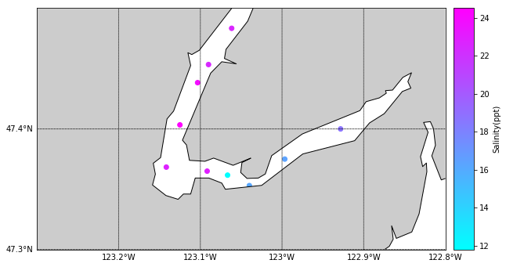

Fig. 3
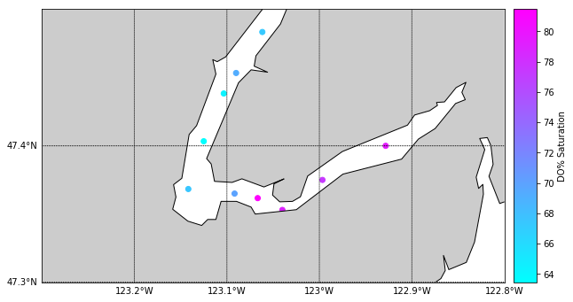
Fig. 4
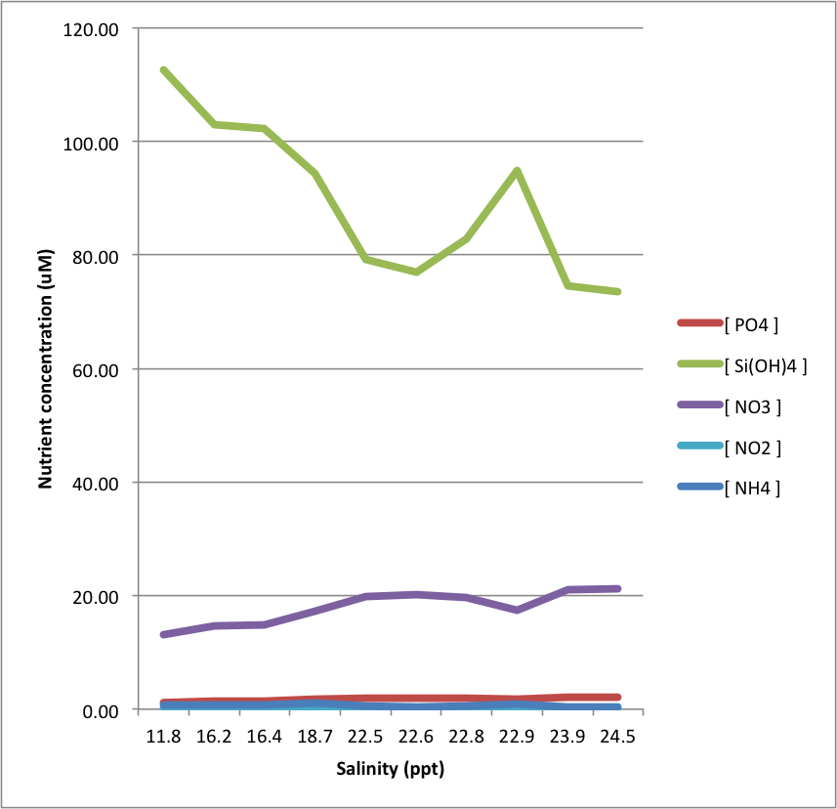

Fig. 5
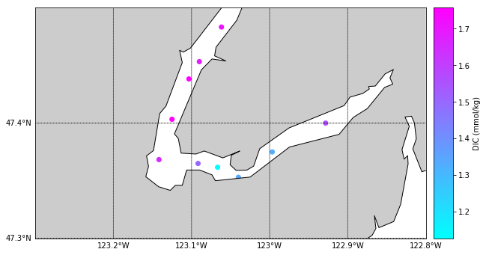
Fig. 6
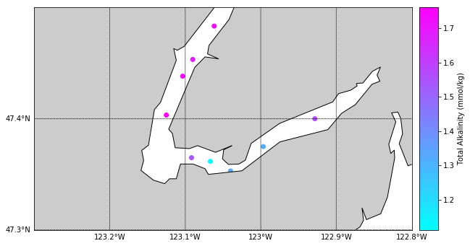

Fig. 7
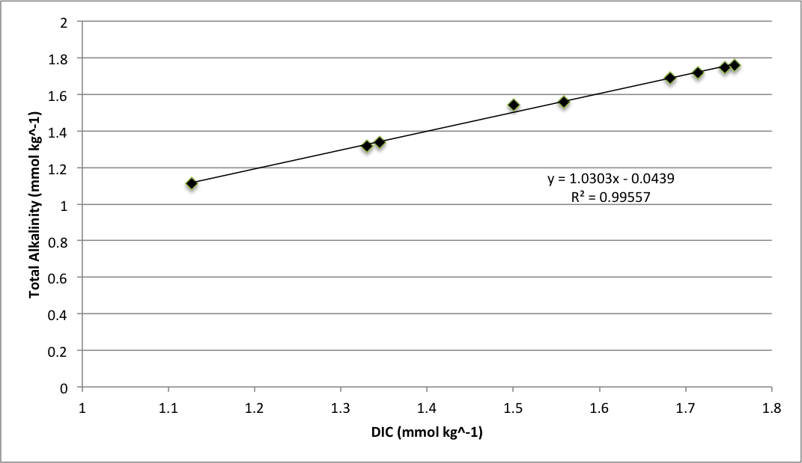
Fig. 8
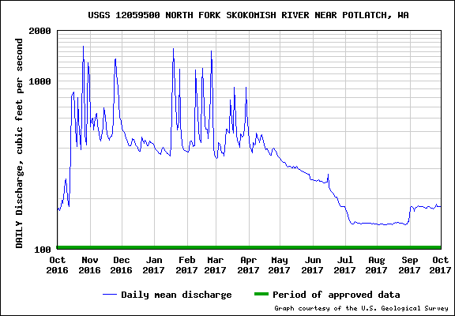

Fig. 9
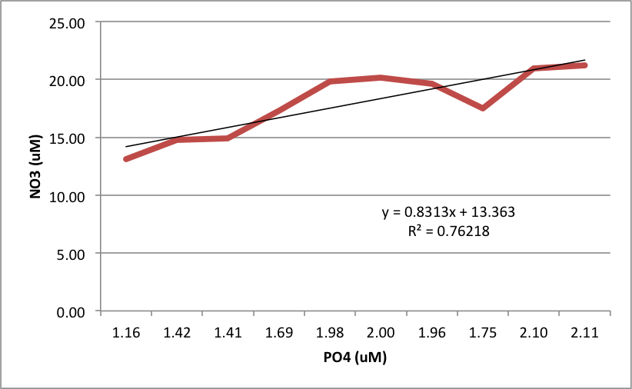

Fig. 10
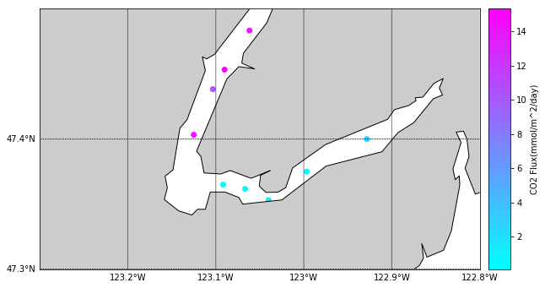

Fig. 11
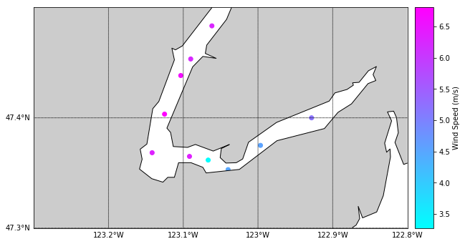
Fig. 12
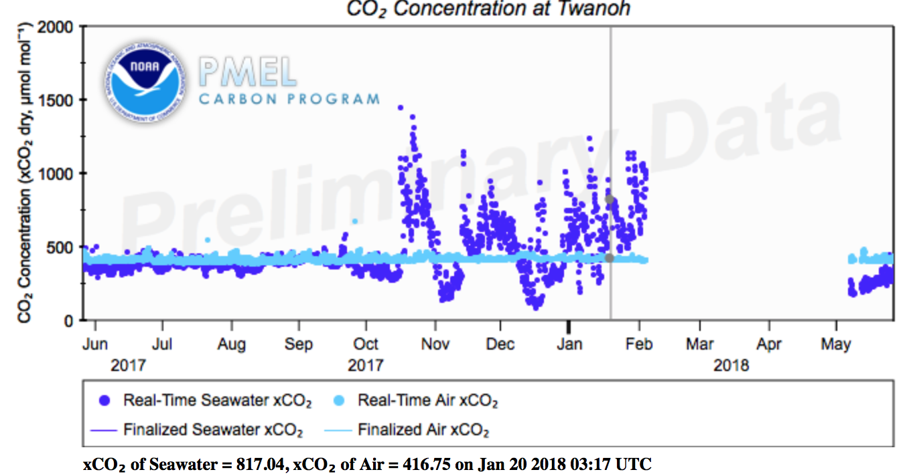

Table. 1

Table. 2

