Appendix

Table 4: Interview Themes and Supporting Quotes

Interview Theme | Supporting Quotes
- The structure of the medical care system creates a sense of scarcity, which generates high emotions as people compete for attention, supplies, —which are often difficult to afford or find—and rooms. | - “For example, we could tell a patient to go do a lab and the family cannot pay for it, they will fight with us and say, ‘just do the surgery, we don’t want to do that lab, it is too expensive.” --Interview 9  - “It is not fair. They think the doctor controls everything: the laws, the medicines, the symptoms the patient is feeling. We can only diagnose and treat them. If the pharmacy does not carry the medicine, it is not our doing. But they come back to the ward and blame us.” --Interview 2  - “One time I was treating a patient. Her mother was in the internal medicine unit. [The daughter] hit me because I told her that she has to go find someone to donate blood to her mother. She saw that we had given a patient some blood in another room, and she started shouting at us. She asked why we gave the woman in the other room, but not to her mother? We told her that we don’t have any blood of the same blood type, so we need to get someone to donate some. She called corrupt and said we only save the blood for when our families come to get treated. She was calling us thieves for stealing the country’s money. This was in fact, far from the truth. We told her to go find someone to donate or if she had a match then she could. She kept shouting and when I told her to calm down, she punched my shoulder.” –Interview 18  - “There is overcrowding also, there are not enough doctors working and we get many, many patients. This hospital gets more patients than the other ones.” –Interview 2
- The public doesn’t understand the concept of triage well, explaining anger at delays in receiving health care services. | - “Here, the patients mostly are coming from small areas, they are not very educated, they don’t know a lot about health [care] systems.” –Interview 2  - “The patient or the relatives see us as working to serve them especially if this is a government hospital and they become very aggressive. In the government hospitals, the patients feel very entitled when they come in. They think because this is a government hospital, you have to do everything they say and when they demand things because they think that we don’t have knowledge or experience.” –Interview 6  - “I think many things can cause the violence. One example is the whole structure of the hospital. We need more hospital rooms, more doctors. One doctor cannot be responsible for the whole floor, because we might make mistakes if there is too much work for us.” –Interview 15
- The structure of the medical education pipeline generates doctors who are quite young, who might not be fully prepared for these challenging roles and lack skills and authority to respond in the moment to family attacks. | - “The first time I experienced physical violence, it was partly my mistake. The nurse gave me the wrong file for the patient, and I thought I was seeing a 12-year-old boy who was in the other room, it was actually a 7-year-old boy. I took the file, read it, and went into the room of the 7-year-old boy with his father. I was in a rush and did not check the name of the patient to make sure it was the right file. I began explaining the diagnosis to the father, and he was denying it. I said, look it says it in the file here…The father was getting angry at me and was shouting. Then I read the name out loud, and he said that it’s not his son. He grabbed my collar, his knuckles were on my neck, and he was shaking me aggressively. He told me I was going to kill his son because of the mistake. I sympathize with him completely, but I was also scared.” --Interview 15  - “Most people come in with emergency cases that aren’t actual emergencies, and those people are the most violent. When we tell them that this patient is not in an emergency, they think we are insulting them, and they don’t want to listen to us.” --Interview 2  - “Families are very protective of their patients and that protectiveness can sometimes turn into fear and anxiety. Without health literacy, nothing you say to these patients will calm them down or de-escalate the tension that they are already feeling. Even if you explain to patients a diagnosis, or a treatment they need, they will always insist they know better.” --Interview 1
- Patient families perform violent or hostile acts towards physicians who may not meet their expectations to exercise instinctive protection or devotion to the patient. | - “It was a small boy [being treated] and the boy died. My cousin was the doctor. The father held a gun to my cousin’s head and he said, ‘if you don’t bring my son back, I will kill you.’ You know when someone dies, we say “Allah Yerhamah” [May Allah have mercy on his soul], well the patients take out their guns and they say ‘Allah yerhamak inteh’ [May Allah have mercy on your soul].” –Interview 2  - “When I was in emergency room rotation, the doctors were all being cursed at including me, the [patient relatives] were saying these doctors are new and they don’t know anything and saying bad words at us. The reason? The patient came with his brother, and his situation was not life and death. It was a simpler case, so most of us went to treat another case that was more urgent.” --Interview 7  - “Two days ago, I was actually in the ER, in here [Al-Yarmouk Hospital] and we had a patient that was here due to psychological distress and her mother was angry about it. She was not convinced of the lack of gravity in her daughter’s condition and she was shouting and calling doctors names and I was on the receiving end of her insults.” --Interview 1
- Doctors reported they believed family attacks persist because patient families are not facing legal consequences. | - “The system is welcoming this behavior. If the law was stricter, then the patients would not dare to hit any doctor. The doctors are not always the victims because sometimes they do make mistakes, but it should not be resolved by hitting. There should be a strong law and a strong court to deal with it.” --Interview 13  - “There are laws, and we can complain and [the perpetrators] can be charged a fee or put in jail but people need to be reminded of the law. They need to see the law enforced and be afraid to be violent.” --Interview 2  - “The problem is that the hospital never tells the patients the consequences of their violence until the violence happens and the [perpetrators] start to beg us to not complain to police or the FPS. The FPS can also put the [perpetrators] in jail.” --Interview 12
- Doctors who are the targets of verbal and physical violence experience mental health problems, including depression and loss of self-esteem, and contemplate leaving their positions. | - “When I saw the bruises, I was pitying myself a lot and I told my parents, they told me they would support me if I reported him [the perpetrator]. But when I filed the complaint and they charged him, he started coming to the hospital to verbally abuse me again. I was so afraid he would hit me again. He told me what I did was wrong, and I had to have my cousin drive me home every day for like two weeks. I told the guy I will call the police and has stalking me. He stopped on his own but it was really scary.” --Interview 10  - “My mental health was not very good. It’s better now because nothing surprises me anymore in terms of violence from the patients. But when I first started being a doctor, it was hard. I was frustrated, I was angry, I was scared. Sometimes, I called in sick to not come because I would wake up feeling very miserable because I didn’t want to go back to the hospital some days.” --Interview 8  - “I tried many times, believe me. It’s difficult to leave the country. I wish I could. I applied, I paid [bribes] to get my paperwork to progress. It keeps getting rejected.” –Interview 19  - “I researched it because I really wanted to leave. But the longer I stay here, the more I feel it is difficult to start again in another country.” --Interview 17  - “Being a doctor? Sometimes I regret it. We study for five years, more if we specialize, and it’s very difficult. The content is difficult, and we learn it, and we practice it, and we have people who try to kill us, or hit us, and they insult us daily.” --Interview 5  - “I regret being a doctor. Maybe I would have been a pharmacist or computer engineer. It’s better.” --Interview 7  - “It makes me very scared. I really don’t like dealing with relatives. I love my job as a doctor in the delivery room. My favorite thing is seeing a newborn come into the world, I check if the baby is breathing. But once I have to answer to the family, I get really scared. Especially because I get [flashbacks] from when I was choked.” --Interview 22

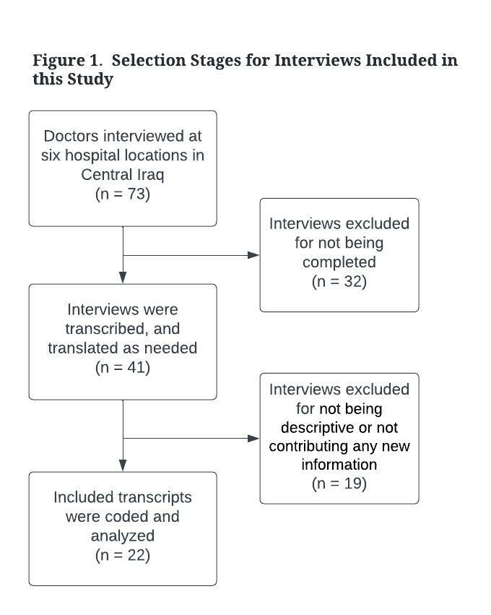

Workplace Violence Against Junior Doctors in Central Iraq Hospitals
Semi-Structured Interview Guide

(Introduce yourself, ask for consent to conduct the interview)

Demographics: Age Gender
- Describe your current job:
- Tell me about your decision to become a doctor, what motivated you to join this profession?
- How long have you been a doctor?
- Have you worked at other health care facilities?
D What are the department/unit you are currently working in?

Workplace violence between patients and providers:
- Can you describe a time where either you were the victim of workplace violence, or you witnessed someone else become a victim of workplace violence?
- Physical:
- Verbal:
- Threatening:
- Others:
- Can you describe, from the beginning, how the situation escalated to violence?
  - Who were the perpetrator(s)?
B What factors can you think of that contribute to patient violence? (Prompts could include time pressures or patient volumes, lack of supplies, chaos and noise, health literacy, training on communication etc.).
C What seems to work to calm patients down after the situation escalates to violence?

Reporting and Doctor Support:
- Have you ever reported this violence to anyone (i.e., security, police, hospital director, etc.)?
A If you haven’t, why?
B How did the administration respond?
    - What was your response?
    - Do you talk to other doctors about the violence? Have doctors ever talked to you about this?
    - What policies and processes are in place or are being considered to manage this problem?

Consequences of Workplace Violence:
- How has this violence affected your mental health (i.e., depression, anxiety, fear, etc.)?
- How has this violence influenced your satisfaction with your current job?
  - How has the violence influenced your decision to continue to practice in the country? (i.e., Have you ever thought about leaving the country as a result of this violence?)
  - Could you tell me how long you have been feeling this way?
  - Do you think this kind of violence occurs in other facilities/ countries in this same way?
  - What is your expectation about the future of this phenomenon in Iraq?

العنف في مكان العمل ضد الأطباء المبتدئين في مستشفيات وسط العراق
اسئلة المقابلة (Modern Standard Arabic)

(عرّف عن نفسك ، واطلب الموافقة على إجراء المقابلة)
الأسئلة الأساسية
- صِف وظيفتك الحالية
- حدثني عن قرارك بأن تصبح طبيبة ، ما الذي دفعك للانضمام إلى هذه المهنة؟
- منذ متى وانت كنت طبيبا؟
- هل عملت في مستشفيات أخرى؟

العنف في مكان العمل بين المرضى والأطباء:
- هل يمكنك وصف الوقت الذي كنت فيه إما ضحية للعنف في مكان العمل ، أو شاهدت شخصًا آخر يقع ضحية للعنف في مكان العمل على يد مريض أو أفراد أسرة مريض؟ تذكر أن العنف لا يقتصر على العنف الجسدي فحسب ، بل يشمل أيضًا الإساءة اللفظية والتهديدات
- هل يمكنك أن تصف ، منذ البداية ، كيف تصاعد الوضع إلى عنف؟
- ما هي العوامل التي تعتقد أنها تساهم في عنف المريض؟ يمكن أن تشمل الموجهات ضغوط الوقت أو أعداد المرضى ونقص الإمدادات
- ما الذي يبدو أنه يعمل على تهدئة المرضى بعد تصعيد الوضع إلى العنف؟

عن الأطباء الذين يبلغون عن العنف ويتلقون الدعم:
- هل سبق لك أن أبلغت أي شخص عن هذا العنف (أي ، الأمن ، الشرطة ، مدير المستشفى)؟
كيف استجابت الادارة لشكواك؟
- أين تذهب للحصول على الدعم عندما يحدث العنف؟
- هل تتحدث مع أطباء آخرين عن العنف؟ هل تحدث لك الأطباء عن هذا من قبل؟
- ما هي السياسات والعمليات المعمول بها أو التي يتم النظر فيها لإدارة هذه المشكلة؟

نتائج العنف في مكان العمل:
- كيف أثر هذا العنف على وضعك الصحي النفسي؟
- كيف أثر هذا العنف على رضاك ​​عن وظيفتك الحالية؟
- كيف أثر العنف على قرارك بالاستمرار في الممارسة في العراق؟ هل فكرت يومًا في مغادرة العراق نتيجة لهذا العنف؟
- هل يمكن أن تخبرني منذ متى وأنت تشعر بهذه الطريقة؟
- هل تعتقد أن هذا النوع من العنف يحدث في دول أخرى بنفس الطريقة؟
- ما هي توقعاتك لمستقبل هذه الظاهرة في العراق؟

