SENIOR CAPSTONE PROJECT

FORCING OF GULF STREAM POSITION AND STRENGTH BY WIND AND OCEAN CIRCULATION

Michaela Maier
mm4n13@uw.edu
University of Washington, Seattle
Department of Oceanography

May 29th, 2017

Abstract

The Gulf Stream (GS) is the western boundary current of the North Atlantic Subtropical Gyre, which in turn is part of the Atlantic Meridional Overturning Circulation (AMOC). As a wind driven gyre, the Gulf Stream is sensitive to changes in the dominant wind patterns represented by the North Atlantic Oscillation (NAO). Under the current global climate changes, the NAO and AMOC could experience changes, which would then force the Gulf Stream to change, either by strengthening (weakening) or shifting its position to the north (south). In this paper, we analyse observational data for the NAO index and the AMOC (provided by the RAPID array and statistical reconstruction) and correlate them to the observed changes in the Gulf Stream over the past 23 years, obtained from satellite altimetry. The Gulf Stream has been divided into three sections to account for any permanent fixtures affecting its downstream behaviour. We have found that there are strong correlations between the NAO/ AMOC and the position of the Gulf Stream, but not many correlations that significantly explain the weakening of the Gulf Stream. The eastern part of the Gulf Stream has been identified as a possible indicator for the overall Gulf Stream behaviour, as it shows the same trends as the GS over the past 23 years, as well as robust correlations to NAO and AMOC.

Introduction

The Gulf Stream (GS), as the western boundary current of the North Atlantic Subtropical Gyre, is one of the most important currents in the North Atlantic, bringing heat and nutrients polewards. Gyres are wind driven circulation cells, and as such are subject to seasonal and longer scale changes in atmospheric variability, which changes the surface winds. This particular gyre is the part of the Atlantic Meridional Overturning Circulation (AMOC), where the warm, salty and nutrient rich water is being brought north to then cool down in the polar region, sinks as it becomes denser and return south at depth.
The starting point of the Gulf Stream is widely considered to be where it is fed by the Florida Current (FC). The FC is a strongly contained current formed in the Gulf of Mexico (from the North Equatorial and Canary Currents) which curls around Florida and passes between the coast and the Bahamas, flowing northwards along the East coast of the United States (Srokosz et al., 2012). It is the main source of water for the GS.
For this paper and due to the limited spatial range of data available, the Gulf Stream is defined as the current that leaves the US coast at Cape Hatteras (around 35°N, 78°W) and flows to about 38°N 44°W, where bathymetry causes it to split into the North Atlantic Drift (which is the part that continues northwards along the continental slope and brings warm water polewards past northern Europe) and the Azores Current, which flows south towards the Mid-Atlantic Ridge (Gangopadhyay et al., 2016).
The GS experiences an increase in downstream transport (see Fig. 1; reddish colours represent stronger currents), mainly thought to be due to the velocity changes in the deep (through recirculation cells), bringing the transport from 30 Sv at Cape Hatteras to its maximum of 150 Sv at around 55°W (Gangopadhyay et al., 2016).
Because the entire gyre is wind driven, the Gulf Stream experiences significant seasonal variation in transport, with a maximum in autumn and minimum in spring – concurrent with a northwards shift of the GS in autumn, and a southwards shift in the early winter and spring (Frankignoul et al., 2001).
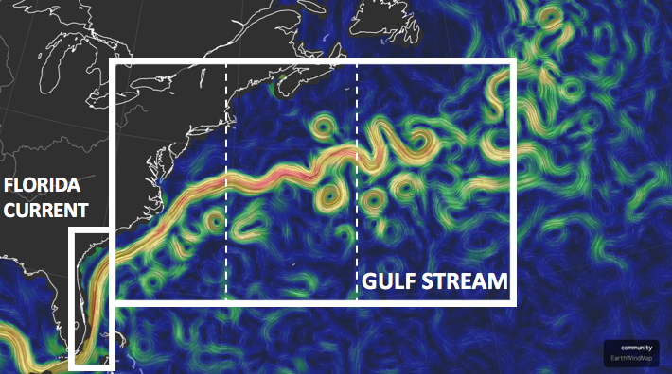
Fig. 1 - Florida Current and Gulf Stream, later splitting into the North Atlantic Drift/ various south-eastward flowing currents (Beccario, 2016). The box labelled ‘Gulf Stream’ also shows the spatial range of the observational data used in this paper; the dashed line the subsections (see 2.1/ 2.2).

The North Atlantic Oscillation (NAO) represents the dominant wind pattern over the North Atlantic. In its positive phase, it leads to increased westerly winds, which create wind stress curl around 30°N that causes a convergence (Westerlies/ Trades) of Ekman transport. This triggers a westwards moving depression of the thermocline (Rossby waves, caused by planetary vorticity and of order ${10}^{3}$ bigger than the associated sea level rise at the surface), bringing energy to the western side of the basin. Changes in the prevailing wind patterns should therefore affect the behaviour of the GS.

The AMOC balances the overall meridional flow of water. Since the installation of the RAPID array at 26.5°N (see Fig.2), reliable data for the AMOC transport has become available. From that, Smeed et al. (2013) have seen a noticeable decrease in the AMOC, which should also affect the Gulf Stream. Others have stated that there was no overall change, only a different distribution of flows (McCarthy et al., 2012), while others claimed the Gulf Stream has weakened by 15-20% (Rahmstorf et al., 2015).

Both the NAO and AMOC are very likely subject to the changing conditions under a global climate change (see e.g. Cunningham et al., 2007; Cheng et al., 2016). It is therefore important to have them and their effects on the Gulf Stream accurately represented in climate models.

In this paper, we analyse observational data from the NAO and AMOC, representing wind and ocean circulation, and satellite altimetry data of the Gulf Stream, to determine if and to what extend NAO and/ or AMOC changes affect the Gulf Stream; either through a strengthening (weakening) effect or by shifting its mean position to the north (south).
The Gulf Stream experiences some constraints due to its underlying bathymetry. This creates a stable, seasonally independent pattern (see Fig. 4). In order to account for this already fixed downstream pattern and avoid any conflicts between it and the changes we are looking for, the Gulf Stream will be divided into three sections, which will then be analysed separately and in relation to each other.

Data and Methods

Data Requirements

For this observational analysis of the possibly controlling effects of NAO and AMOC on the GS, the following parameters have been used:
- A longitude/latitude grid of dynamic height profiles (GS_dh) and the corresponding position (GS_lat) for the Gulf Stream strength and position
- AMOC transport, which consists of the Florida Current (FC), Ekman and Upper Midocean transport (UMO), as seen in Fig. 2 below,
- North Atlantic Oscillation Index (NAO).
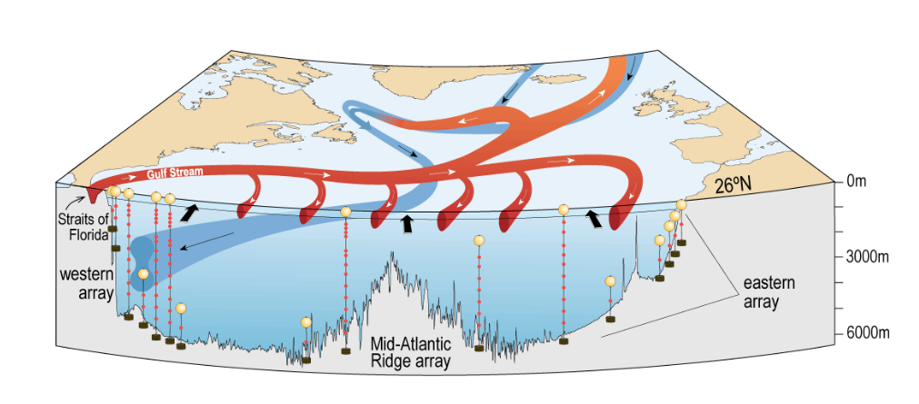
Fig. 2 - Schematic diagram of the AMOC with Ekman transport (black arrows, predominantly northward), Straits of Florida, where the FC (northwards) feeds the Gulf Stream and UMO (southward) The measuring arrays west/ east and around the ridge show the RAPID array (McCarthy et al., 2014) which measures the UMO (Figure from Smeed et al., 2016).

The topography of the North Atlantic Basin is important in this paper as it shows the need to divide the Gulf Stream into the three subsections (see 2.2). It might also constitute a possible reason for the obtained results; especially the large range of depths on its western edge and turbulence caused by the New England Seamount Chain (Fig. 3 d), at ~35°N/65°W) could obscure the correlations. However, no quantitative bathymetry data was used as this would have exceeded the extend of this analysis.

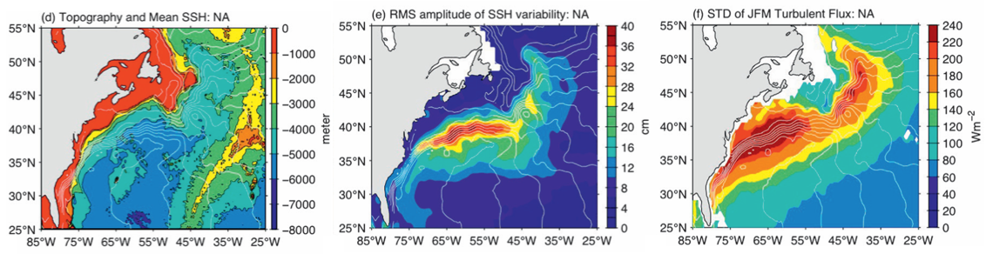
Fig. 3 - North Atlantic bottom topography (d), standard deviation of weekly sea surface height (e), and standard deviation of daily wintertime (January–March) turbulent heat flux (f), from Kelly at al. (2010).

Gulf Stream Position and Strength

The changes in the Gulf Stream can be separated into changes of strength and position where it enters the North Atlantic Basin. Kelly and Gille (1990) showed that through careful calculations, empirical estimates and statistical analysis, the SSH obtained from cross track satellite altimetry can be used to create a Gaussian-shaped velocity profile and dynamic height profile, which allowed them to obtain values for the maximum velocity of the GS ($a_{1})$, the position of the GS centre ($a_{2}$, usually where $a_{1}$ is) and its width ($a_{3}$, the standard deviation of the Gaussian shape). This gives the positon of the GS, as well as the strength (surface transport), which is proportional to the height difference across the stream, through $U= \sqrt{2π} a_{1}a_{3}$. Since they are proportional and the main focus here is on the relative changes, we use the the dynamic height (here referred to as SSH) directly to represent the transport strength of the GS.

The data is collected from the Aviso altimetry satellite, processed according to Morrow and Le Traon (2012), and provided as monthly averages from January 1993 to December 2015. The satellite grid covers the basin from 78.5°W to 45.5°W and 28°N to 45°N; (see Fig. 1) and is provided in a quarter degree grid resolution.

Atlantic Meridional Overturning Circulation

The AMOC shows the volume transport in the North Atlantic related to the subtropical gyre. While the GS strength and position are analysed through the SSH-data (see above), the AMOC is a combination of the flow through the Straits of Florida (Florida Current), the flow caused directly by wind/ sea interactions (Ekman) and the transport due to density gradients (UMO). FC and Ekman both have northwards flow while the UMO flows southwards. Smaller currents or corrections have been included in the UMO.

Florida Current Transport

The transport volume of the FC can be measured very precisely through the cable observatory in the spatially contained (roughly 80 km wide and 800 m deep) Straits of Florida (see Fig. 3d). The subsea telephone lines placed here experience voltages through the electrical field generated by the movement of charged water particles through Earth’s magnetic field; a stronger flow increases these voltages. The corresponding transport volumes have been recorded since 1982 (NOAA, 2017). The data is available on the NOAA website from April 1982 to the current date (here taken until December 2016). Gaps in the records due to interruptions of the cable or else have been filled in using SSH anomalies as proxy (Gibbins, 2016).

Ekman Transport, Upper Midocean Transport

Wind stress from the NASA’s Quick Scatterometer is used to calculate the Ekman transport $M_{E}= \frac{\overset{⃑}{τ} × \hat{z}}{f}$ in the surface layer; while the RAPID array provides pressure, salinity, and temperature measurements in order to calculate the geostrophic transport between the density gradients in the interior (UMO), as well as direct current speed for smaller currents like the Antilles current.

These data sets are available from 2004. Missing monthly averages and a past time series have been reconstructed from January 1993 – December 2014 using SSH and cable transport (Frajka-Williams, 2015). This dataset is available as 1.5 year Tukey smoothed and has been supplemented with data for 2015, obtained from the RAPID website and also Tukey-smoothed.

North Atlantic Oscillation Index

The NAO as an index gives the difference in sea level pressure between Iceland and the Azores. Iceland has a permanent low pressure system, the Azores a High. If the difference in pressure between them is high, the NAO is positive, the Westerlies are strong and there is enhanced negative (clockwise) wind stress curl. A comparatively small difference on the other hand gives a negative NAO, and supressed Westerlies (DiNezio et al., 2009). The NAO index is therefore used to represent the dominant wind pattern over the North Atlantic. The monthly NAO averages from January 1950 – December 2016 have been obtained from the NAO website (NAO, 2017).

Data Processing

The Gulf Stream data has been recalculated from a ¼° into a 1° grid. All dataset then had a climatology (average yearly profile) created and removed to obtain the anomalies, which have been smoothed with a 1.5 year Tukey filter, empirically chosen because it provided the best results for the correlations and ensured that the pre-processed data and raw data were filtered with the same window.

The GS strength shows a specific, stable pattern which is independent of the seasonal changes (Fig. 4). In order to better understand the behaviour of the GS without being restricted or contested by this fixed pattern, the anomalies have been divided into three sub-sections, East, Mid and West. GS_West (GSW) has been set from 78.5°W to 68.5°W, GS_Mid (GSM) captures the maximum strength patterns between 68.5°W and 57.5°W, GS_East (GSE) is defined from 75.5°W to a 45.5°W.
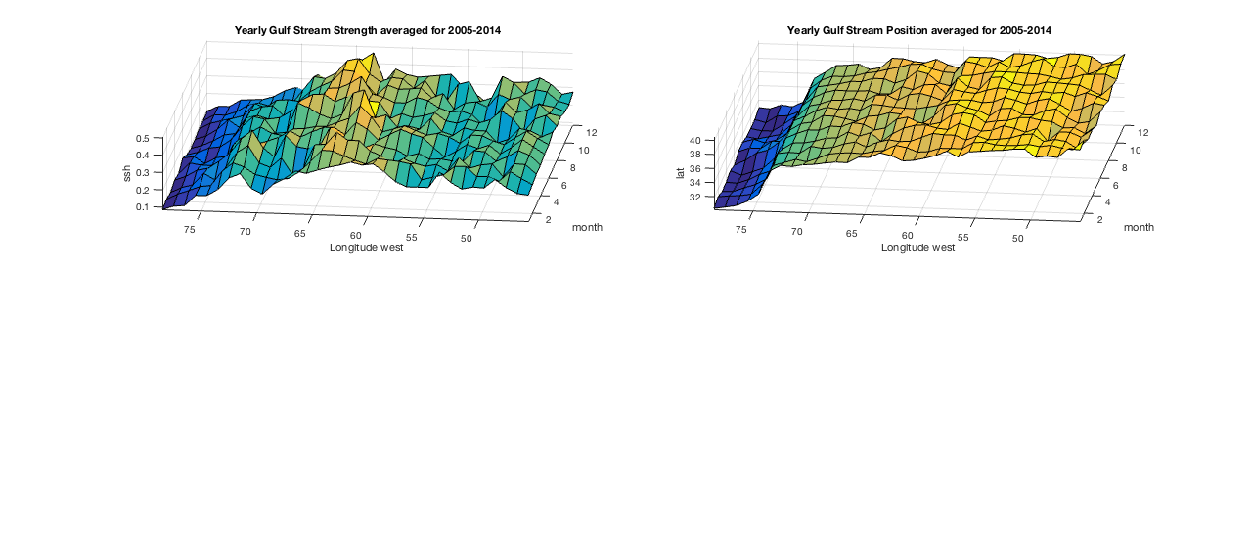
Fig. 4 - Gulf Stream strength and position climatologies. The GS shows a clear pattern in its strength over the year, with its maximum transport occurring late in the year and always occurring between 68.5°W and 57.5°W. Its position does not vary much over the year; the GS path consistently moves further north as it crosses into the Atlantic. The black dashed lines show where the sections have been cut into West/ Mid/ East.

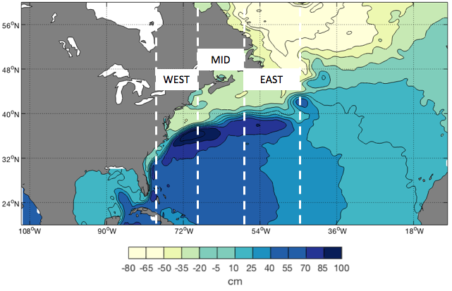
Fig. 5 - Mean sea level height and deviations in the North Atlantic. The Gulf Stream can be seen by the path of increased SSH gradients, which show a maximum over the New England Seamount chain (see Fig. 3). The dashed lines show the boundaries at 78.5°W and 45.5°W, and the divisions at 68.5°W (West/Mid) and 57.5°W (Mid/ East).

Methods for Analysis

In order to compare long term trends with interannual variability, time series with trends have been created for the period of 1993 – 2015, when most datasets had data available. These can then be compared to the lagged correlations, which have been calculated between the different data sets, with a window of 3 years (18 months either side) to show the shorter time scales. This lagged correlation moves the time series against each other until a relevant correlation can be found. The threshold for relevance was set at a 95% significance of a maximum correlation with the dominant lead or lag. Correlations are calculated between the NAO/ AMOC (and the individual components) and the GS position and strength, as well as the subsections of the GS.

Concerns with processing and analysis of data

While the methods used to fill in gaps in the data were determined to be the most accurate available, the use of reconstructed data bares some inconsistency, as it was not the same methods for all data sets (see Gibbs, 2016, Frajka-Williams, 2015, DiNezio et al., 2009). The time series themselves and correlations chosen here might also contribute to any differences, since the time series have been chosen as the longest possible record, and not focused on one specific time period.

For this analysis, only observational (either direct or reconstructed from other observations) data for the NAO, AMOC and GS strength and position have been considered. Since the subtropical gyre system is very complex, selecting only these few and ignoring other data sets, for example the buoyancy forcing from the Labrador Sea, which has been shown to affect the Gulf Stream behaviour (Gangopadhyay et al., 2016), or more detailed atmospheric forcing does not allow for an accurate representation of the system. These data sets however are difficult to obtain and usually not yet available for long enough time periods to be considered significant. Although this paper does not consider all nuances of the system, the overall picture and correlations should still be valid.

Results

Trends
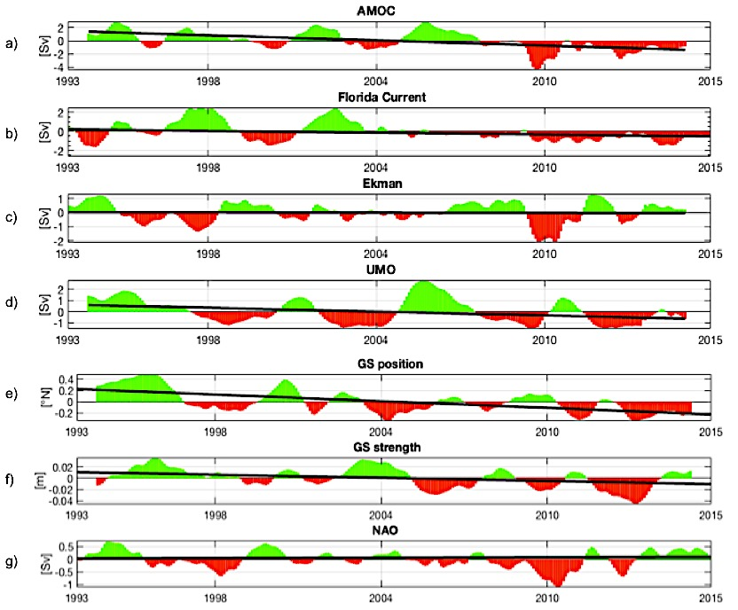
Fig. 6 - Time series from 01/ 1993 to 12/ 2014. Green (red) bars show positive (negative) deviations from the climatology; the black line shows the overall trend. The trends for Ekman and NAO are insignificant (P-values of 0.76 and 0.11)

Fig. 6 shows the smoothed values and trends in all the data sets. The obvious decline in the AMOC (a) appears mainly due to the negative anomalies in the past 6 years. The Ekman transport (c) volume is balanced between positive and negative anomalies, and has no significant trend or contribution to the AMOC. The UMO (d) and, to a slightly lesser degree, the FC (b) show marked decreases in transport volume as well, suggesting the UMO as driver of AMOC changes. The correlations (see 3.1.2) between AMOC and UMO confirm a 67% agreement, 55% for FC (Appendix; 8.59, 8.60). The NAO (g) does not show a significant trend.
The GS strength and position especially show a strong decline (f and e). For the GS position, this decline means a lower latitude value, which equals a shift to the south; while an increase means it shifts northwards. For the strength, a decline means the GS is weaker, while and increase means it is stronger than its mean.

The obtained trends for the position and strength of the GS and its subsections reveal a strong variability: The GS experiences a southward shift of about 0.44° lat (7.a), and a decline in strength proportional to a decrease in the dynamic height profile of about 2.6 cm (e); the western part (b) shows insignificant change in position and a slight incline in strength (f); the mid part sees a significant southward shift in position (c), but no significant change in strength (g) and the eastern part (d and h) shows very strong declines for both strength and position.

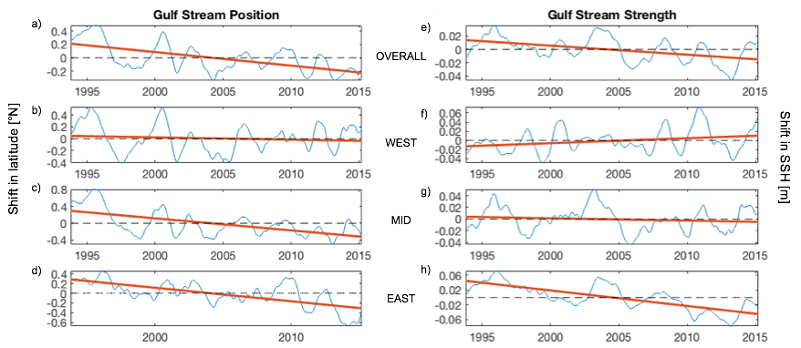
Fig. 7 - Trends of deviations in GS strength and position Overall/ West/ Mid/ East. Blue shows the interannual variability; the red line shows the overall trend in the data over the past 23 years. The P-values suggest that b) and g) are not truly significant (0.98, 0.49).

Lagged Correlations

The following correlations have been calculated from the anomalies and found to be significant (>95%). A leading correlation means data 1 is the driving force in the relationship and determines the behaviour of the signal of data 2, either strengthening or weakening it. A lagging relationship means the reverse, so data 2 is dominant and determines the behaviour of data 1. The strength of the correlation shows how well the patterns agree, with + 1 (- 1) indicating a 100% positive (negative) correlation. Only correlations stronger than 0.4 and with a lead or lag of less than 18 months (the limit of the window) have been considered. Here, only the important correlations are listed; all correlations are listed in the Appendix (8).

# | DATA 1 | DATA 2 | Strength of correlation  (+) strength., (-) weak. | Lead (-) / Lag (+) [months]
1 | NAO | GS pos. | + 0.5206 | - 9
2 | NAO | GSW pos. | + 0.4658 | - 7
3 | NAO | GSM pos. | + 0.5477 | - 8
4 | NAO | GSE pos. | - 0.4020 | + 7
5 | AMOC | GS pos. | + 0.5076 | - 13
6 | AMOC | GSM pos. | + 0.4373 | - 9
7 | AMOC | GSE pos. | + 0.5414 | - 15
8 | GS pos. | GSW pos. | + 0.7473 | Direct (+1)
9 | GS pos. | GSM pos. | + 0.928 | Direct (+1)
10 | GS pos. | GSE pos. | + 0.7866 | - 3
11 | GS str. | GSM str. | + 0.7612 | Direct (+1)
12 | GS str. | GSE str. | + 0.8116 | - 2
13 | GSW pos. | GSM pos. | + 0.6942 | Direct (0)
14 | GSM pos. | GSE pos. | + 0.6544 | - 6
15 | GSM str. | GSE str. | + 0.5046 | - 5
16 | GSE pos. | GSE str. | + 0.5878 | + 15
Table 1 - Calculated and significant lagged correlations (pos. refers to the change in latitude (position) of the Gulf Stream, str. to the change in ssh (strength)).
NAO and AMOC

The correlations between the NAO and AMOC components (Appendix 8.1 - 4) show that the NAO and Ekman are directly related (68% agreement), but that no significant correlation can be found between the NAO and the UMO or FC. There is also no significant correlation between the NAO and the overall AMOC.

NAO and Gulf Stream

The NAO does not show a significant correlation with the GS strength (3.1.2.1 – 4). There are however strong correlations between the NAO and all GS positions. The overall position and GSW and GSM positions are positively affected by the NAO, with a lag of around 7 - 9 months. The eastern part (GSE) on the other hand appears to lead the NAO (and weaken it), which would suggest a northwards shift of the GS between 57.5°W and 45.5°W causes a decline in the NAO around 7 months later.

AMOC and Gulf Stream

Like the NAO, the AMOC affects the position of the GS, but not the strength
(3.1.2.5 – 7). There is no correlation between the AMOC and the position of the western part, only the overall, mid and eastern parts. Unlike the NAO, which has a lag in relation to the eastern part; the AMOC leads all the correlations, meaning a strong AMOC leads to a northward shift in most parts of the GS after around 9 (GSM) to 15 (GSE) months. Curiously, a stable correlation has been found between the FC and the GSE, with a delayed reaction (13 months, see 8.52). However, these correlations between the AMOC components (Appendix 8.29-8-52) and the GS and its subsections suggest a more complex pattern with different weakening and strengthening relationships that will not be further examined at this point.

Gulf Stream and Gulf Stream subsections

The correlations among the GS subsections (3.1.2.8 – 12) show a large variability (see also 3.1.1 and Fig. 7). Significant trends can be seen in the mid and east positions and east strength. The correlations between the GS and its subsections show no or unreliable lags for the west and mid strength and mid position (see Fig. 7 b, f, g).
Among the significant correlations are the position of mid (GSM) and east (GSE), and the strength of the eastern part (see Fig. 7 c, d, h). The GSM position has a direct correlation to, and therefore moves with the overall GS position shift. The GSE position on the other hand lags behind the GS by 3 months, suggesting that the shift happens as a delayed reaction. The GSE strength is the only part that is significantly correlated to the overall GS, and lags behind by 2 months. These results suggest that for both position and strength, changes in the Gulf Stream only affect the eastern part.

To further analyse this behaviour, correlations have been run between the different subsections as well (3.1.2.13 – 15). They show a direct correlation between the GSW and GSM positions, suggesting immediate feedback. Further downstream, the correlations between GSM and GSE suggest a delayed reaction of 6 months where the eastern part catches up to the shift. Increases in strength in GSM lead to a delayed (5 months) increase in strength in GSE as well.

Correlations have also been run to determine to what extend a change in position affects the strength of the GS and the subsections (3.1.2.16). Only GSE showed a significant correlation; suggesting that it experiences an increase of strength first and shows a corresponding northwards shift after 15 months.

Discussion and Conclusion

The correlations found in the analysis of the observational data available can been used to confirm some acknowledged facts from literature. The AMOC has been found to largely depend on UMO and FC fluctuations, not Ekman, which agrees with Srokosz et al., (2012).
The NAO and Ekman have been found to be correlated, which agrees with logic (Ekman is wind driven, NAO represents the dominant wind pattern); as well as, among others, Marshall et al (2001), Peng et al. (2006).
Bryden et al. (2014) found that the UMO temperatures affect the NAO; however, SSTs are not considered in this paper, so no correlation could be found.
Literature suggests that there should (DiNezio et al., 2009) or should not (Meinen et al., 2010; Park and Sweet, 2015) be a correlation between the NAO and FC. In this paper, no correlation was found. Because the aforementioned papers analysed different time series or more detailed connections (e.g. wind stress curl), differences might be expected.

No correlation has therefore been found between NAO and the overall AMOC, which could be explained by the fact that, within the given observations, the NAO only affects Ekman, which is the least significant part of the AMOC.

In order to answer the question as to whether or not, and to what extent the changes in the wind and ocean circulation have affected the Gulf Stream, we will first focus on the changes in the position.

The data clearly shows an overall trend in the Gulf Stream that signifies a shift towards the south (~0.44° over the past 23 years). This trend can be seen in the overall GS, as well as the mid (immediately) and western parts (after 3 months). Correlating these shift with the NAO showed that the GS and each subsection on its own have a strong connection to the NAO, be it lagging (GS, GSW, GSM) or leading (GSE). According to Frankignoul et al. (2001), a higher NAO index usually finds the Gulf Stream further north around 2-3 years later. This is a longer time than the 7-9 months we have found here.

The AMOC does not display the same strong, consequent connection with all subsections, but instead has been shown to lead the GS, GSM and GSE position. There is no doubt that changes in either the NAO or AMOC affect the Gulf Stream position, and have quite possibly already done so in the past. Longer time series are needed to confirm this.

For the Gulf Stream strength, the correlations are less clear: the GSE part is the only one where a northward shift was significantly correlated to an increase in strength. The correlation of the GS path to its strength was strong, but with a lead of 18 months could not be considered reliable and was therefore discarded. A different window for the correlation might have revealed this pattern better. In the seasonal pattern, a northward shift always comes with increased strength (Frankignoul et al., 2001). Here, only the deviations from those seasonal patterns are analysed, which might explain the lack of a significant correlation. Analysing the (sub)sections showed that an overall increase in GS strength is immediately observable in the GSM section, and 2 months later progresses to the eastern part.

Neither the NAO nor the AMOC show a significant correlation to the changes in strength that the GS experiences, suggesting that the connection here is more subtle than can be explained and reproduced through the available data.

Overall, there is enough observational evidence to show that the wind and ocean circulation definitely force changes in the Gulf Stream behaviour. More data and a more detailed analysis will be needed to reveal some of the finer patterns and connections. As predicted in 2.4, using only the NAO for any atmospheric forcing obscured some of the otherwise expected connections (e.g. between the NAO and FC). Especially the teleconnections and more subtle interactions in the North Atlantic were lost.

However, through the less detailed patterns, an interesting connection was discovered: the eastern part of the Gulf Stream, between 57.5°W and 45.5°W shows all changes that the Gulf Stream as a whole experience. This connection should be explored further: The GSE shows significant correlations to both wind (NAO) and ocean circulation (AMOC), which affect the entire Gulf Stream strength and position. This direct correlation between the NAO/ AMOC and GSE would allow us to use the GSE as an indicator for changes of the entire Gulf Stream.

While this paper shows the behaviour and changes in the observational data and can so be used to examine if current climate models show the same trends; the connection between the GS and the GSE part might be used as an easier way to validate future climate models: Instead of having to track the entire Gulf Stream or AMOC, it is enough to monitor a cross-track altimetry path of the Gulf Stream in the eastern section. A time series created here will provide information about the changes in strength and position that the Gulf Stream experienced 2-3 months earlier.

Glossary

AMOC | Atlantic Meridional Overturning Circulation
EK | Ekman Transport
FC | Florida Current Transport
GS | Gulf Stream
GSE | Gulf Stream eastern part
GSM | Gulf Stream middle part
GSW | Gulf Stream western part
NAO | North Atlantic Oscillation Index
pos. | Position, refers to the latitude value
str. | Strength, refers to the ssh (dynamic height profile) that represents the proportional GS velocity profile
Sv | Sverdrup, unit of transport; ${10}^{6} \frac{m^{3}}{s}$
UMO | Upper Midocean Transport
WBC | Western Boundary Current

Figures

Fig. 1 - Florida Current and Gulf Stream 4
Fig. 2 - Schematic diagram of the AMOC with Ekman transport. 6
Fig. 3 - North Atlantic bottom topography, SSH and turbulence. 7
Fig. 4 - Gulf Stream strength and position climatologies.. 10
Fig. 5 - Mean sea level height and deviations in the North Atlantic. 10
Fig. 6 - Time series from 01/ 1993 to 12/ 2014. 12
Fig. 7 - Trends of deviations in GS strength and position overall/ West/ Mid/ East. 13

References

Amante, C. and B.W. Eakins, 2009. ETOPO1 1 Arc-Minute Global Relief Model: Procedures, Data Sources and Analysis. NOAA Technical Memorandum NESDIS NGDC-24. National Geophysical Data Center, NOAA. doi:10.7289/V5C8276M [05/08/2017].
Beccario, C. (2016). earth :: a global map of wind, weather, and ocean conditions. [online] Earth.nullschool.net. Available at: https://earth.nullschool.net/ [Accessed 19 Nov. 2016].
Bryden, H., King, B., McCarthy, G. and McDonagh, E. (2014). Impact of a 30% reduction in Atlantic meridional overturning during 2009&ndash;2010. Ocean Science, 10(4), pp.683-691.
Cheng, J., Liu, Z., Zhang, S., Liu, W., Dong, L., Liu, P. and Li, H. (2016). Reduced interdecadal variability of Atlantic Meridional Overturning Circulation under global warming. Proceedings of the National Academy of Sciences, 113(12), pp.3175-3178.
Cunningham, S., Kanzow, T., Rayner, D., Baringer, M., Johns, W., Marotzke, J., Longworth, H., Grant, E., Hirschi, J., Beal, L., Meinen, C. and Bryden, H. (2007). Temporal Variability of the Atlantic Meridional Overturning Circulation at 26.5 N. Science, 317(5840), pp.935-938.
DiNezio, P., Gramer, L., Johns, W., Meinen, C. and Baringer, M. (2009). Observed Interannual Variability of the Florida Current: Wind Forcing and the North Atlantic Oscillation. Journal of Physical Oceanography, 39(3), pp.721-736.
Frajka-Williams, E. (2015). Estimating the Atlantic overturning at 26°N using satellite altimetry and cable measurements. Geophysical Research Letters, 42(9), pp.3458-3464.
Frankignoul, C., de Coëtlogon, G., Joyce, T. and Dong, S. (2001). Gulf Stream Variability and Ocean–Atmosphere Interactions*. Journal of Physical Oceanography, 31(12), pp.3516-3529.
Gangopadhyay, A., Chaudhuri, A. and Taylor, A. (2016). On the Nature of Temporal Variability of the Gulf Stream Path from 75° to 55°W. Earth Interactions, 20(9), pp.1-17.
Gibbins, M. (2016). Using sea surface height anomaly as a proxy for Florida Current transport. Seattle: University of Washington.
Kelly, K. and Gille, S. (1990). Gulf Stream surface transport and statistics at 69°W from the Geosat altimeter. Journal of Geophysical Research, 95(C3), p.3149.
Kelly, K., Small, R., Samelson, R., Qiu, B., Joyce, T., Kwon, Y. and Cronin, M. (2010). Western Boundary Currents and Frontal Air–Sea Interaction: Gulf Stream and Kuroshio Extension. Journal of Climate, 23(21), pp.5644-5667.
Marshall, J., Johnson, H. and Goodman, J. (2001). A Study of the Interaction of the North Atlantic Oscillation with Ocean Circulation. Journal of Climate, 14(7), pp.1399-1421.
McCarthy, G., Frajka-Williams, E., Johns, W., Baringer, M., Meinen, C., Bryden, H., Rayner, D., Duchez, A., Roberts, C. and Cunningham, S. (2012). Observed interannual variability of the Atlantic meridional overturning circulation at 26.5°N. Geophysical Research Letters, 39(19),
McCarthy, G., Smeed, D., Frajika-Williams, E., Moat, B., Rayner, D., Baringer, M., Meinen, C., Collins, J. and Bryden, H. (2014). Measuring the Atlantic Meridional Overturning Circulation at 26°N. Progress in Oceanography, 130(January 2015), pp.91-111.
Meinen, C., Baringer, M. and Garcia, R. (2010). Florida Current transport variability: An analysis of annual and longer-period signals. Deep Sea Research Part I: Oceanographic Research Papers, 57(7), pp.835-846.
Morrow, R. and Le Traon, P. (2012). Recent advances in observing mesoscale ocean dynamics with satellite altimetry. Advances in Space Research, 50(8), pp.1062-1076.
NAO. (2017). Climate Prediction Center - Teleconnections: North Atlantic Oscillation. [online] Available at: http://www.cpc.ncep.noaa.gov/products/precip/CWlink/pna/nao.shtml [Accessed 29 Jan. 2017].
NOAA. (2017). Physical Oceanography Division - Western Boundary Time Series - Florida Current Transport Time Series and Cruises - Data Access. [online] Available at: http://www.aoml.noaa.gov/phod/floridacurrent/data_access.php [Accessed 3 Feb. 2017].
Park, J. and Sweet, W. (2015). Accelerated sea level rise and Florida Current transport. Ocean Science, 11(4), pp.607-615.
Peña-Molino, B. and Joyce, T. (2008). Variability in the Slope Water and its relation to the Gulf Stream path. Geophysical Research Letters, 35(3).
Peng, S., Robinson, W., Li, S. and Alexander, M. (2006). Effects of Ekman Transport on the NAO Response to a Tropical Atlantic SST Anomaly. Journal of Climate, 19(19), pp.4803-4818.
Rahmstorf, S., Box, J., Feulner, G., Mann, M., Robinson, A., Rutherford, S. and Schaffernicht, E. (2015). Exceptional twentieth-century slowdown in Atlantic Ocean overturning circulation. Nature Climate Change, 5(5), pp.475-480.
RAPID. (2017). RAPID data download. [online] Available at: http://www.rapid.ac.uk/rapidmoc/rapid_data/datadl.php [Accessed 9 Mar. 2017].
Roden, G. (2013). Effect of Seamounts and Seamount Chains on Ocean Circulation and Thermohaline Structure. Seamounts, Islands, and Atolls, pp.335-354.
Rossby, T., Flagg, C., Donohue, K., Sanchez-Franks, A. and Lillibridge, J. (2014). On the long-term stability of Gulf Stream transport based on 20 years of direct measurements. Geophysical Research Letters, 41(1), pp.114-120.
Schmittner, A., Chiang, J. and Hemming, S. (2007). Introduction: The Ocean’s Meridional Overturning Circulation. [online] Available at: http://people.oregonstate.edu/~schmita2/ pdf/S/schmittner07agu_intro.pdf [Accessed 8 Apr. 2017].
Smeed, D., McCarthy, G., Cunningham, S., Frajka-Williams, E., Rayner, D., Johns, W., Meinen, C., Baringer, M., Moat, B., Duchez, A. and Bryden, H. (2016). Observed decline of the Atlantic Meridional Overturning Circulation 2004 to 2015. British Oceanographic Data Centre - Natural Environment Research Council, UK.
Srokosz, M., Baringer, M., Bryden, H., Cunningham, S., Delworth, T., Lozier, S., Marotzke, J. and Sutton, R. (2012). Past, Present, and Future Changes in the Atlantic Meridional Overturning Circulation. Bulletin of the American Meteorological Society, 93(11), pp.1663-1676.

Appendix

All correlations
# | Data 1 | Data 2 | >95%  Yes/ No | Correlation,  (+) strong., (-) weak. | Lead (-) or Lag(+)
1 | NAO | FC | N | -0.2127 | 5
2 | NAO | EK | Y | 0.6847 | Direct (+1)
3 | NAO | UMO | Y | 0.427 | -18
4 | NAO | AMOC | N | 0.309 | -18
5 | NAO | GS pos. | Y | 0.5206 | -9
6 | NAO | GS str. | N | 0.2933 | -10
7 | NAO | GSW pos. | Y | 0.4658 | -7
8 | NAO | GSW str. | N | -0.278 | Direct (+1)
9 | NAO | GSM pos. | Y | 0.5477 | -8
10 | NAO | GSM str. | N | 0.2575 | 1
11 | NAO | GSE pos. | Y | -0.402 | 7
12 | NAO | GSE str. | N | 0.3372 | -18
13 | AMOC | GS pos. | Y | 0.5076 | -13
14 | AMOC | GS str. | N | 0.3597 | -18
15 | AMOC | GSW pos. | N | 0.2167 | -11
16 | AMOC | GSW str. | N | -0.2908 | -12
17 | AMOC | GSM pos. | Y | 0.4373 | -9
18 | AMOC | GSM str. | N | 0.1713 | 18
19 | AMOC | GSE pos. | Y | 0.5414 | -15
20 | AMOC | GSE str. | Y | 0.6093 | -18
21 | GSW pos. | GSM pos. | Y | 0.6942 | Direct (0)
22 | GSW str. | GSM str. | N | -0.2757 | -18
23 | GSM pos. | GSE pos. | Y | 0.6544 | -6
24 | GSM str. | GSE str. | Y | 0.5046 | -5
25 | GS pos. | GS str. | Y | 0.4539 | -18
26 | GSW pos. | GSW str. | N | -0.1608 | 13
27 | GSM pos. | GSM str. | N | 0.2928 | -12
28 | GSE pos. | GSE str. | Y | 0.5878 | 15
29 | UMO | GS pos. | Y | 0.437 | -14
30 | UMO | GS str. | N | 0.1588 | 18
31 | UMO | GSW pos. | N | 0.2327 | -11
32 | UMO | GSW str. | N | -0.2889 | 18
33 | UMO | GSM pos. | Y | 0.4633 | Direct (0)
34 | UMO | GSM str. | N | -0.2523 | 7
35 | UMO | GSE pos. | Y | 0.4656 | -18
36 | UMO | GSE str. | N | 0.3561 | 18
37 | EK | GS pos. | Y | -0.4345 | 10
38 | EK | GS str. | Y | -0.3906 | 18
39 | EK | GSW pos. | Y | 0.377 | -8
40 | EK | GSW str. | N | -0.2948 | -5
41 | EK | GSM pos. | Y | -0.3698 | 11
42 | EK | GSM str. | Y | -0.4135 | 18
43 | EK | GSE pos. | Y | -0.5037 | 8
44 | EK | GSE str. | N | -0.3701 | 18
45 | FC | GS pos. | Y | 0.4927 | 18
46 | FC | GS str. | Y | 0.4764 | 18
47 | FC | GSW pos. | Y | -0.4025 | 2
48 | FC | GSW str. | N | -0.2125 | -11
49 | FC | GSM pos. | Y | 0.534 | 18
50 | FC | GSM str. | Y | 0.4903 | 18
51 | FC | GSE pos. | Y | 0.446 | 13
52 | FC | GSE str. | Y | 0.4851 | -13
53 | GS pos. | GSW pos. | Y | 0.7473 | Direct (+1)
54 | GS pos. | GSM pos. | Y | 0.928 | Direct (+1)
55 | GS pos. | GSE pos. | Y | 0.7866 | -3
56 | GS str. | GSW str. | Y | -0.5168 | 18
57 | GS str. | GSM str. | Y | 0.7612 | Direct (+1)
58 | GS str. | GSE str. | Y | 0.8116 | -2
59 | AMOC | FC | Y | 0.5331 | -9
60 | AMOC | UMO | Y | 0.6712 | 4
61 | AMOC | EK | N | 0.3018 | -1

