Interpreting Submarine Structures for Glacial Retreat Periodicity within Muchalat Inlet in Nootka Sound
John Deeter
Advisor: Miles Logsdon
University of Washington
School of Oceanography
1501 NE Boat St. Seattle, WA 98195
5/31/15

Acknowledgements:
Dr. Miles Logsdon
Charles Garcia

Abstract:
At the end of the last glacial maximum a tidewater glacier, as part of the larger Cordilleran Ice Sheet, filled what is now Muchalat Inlet within Nootka Sound on Vancouver Island. As the glacier retreated it left distinct marks and features on the seafloor giving evidence as to what type, and how fast this retreat was. In this study we examined data collected with a Knudsen Chirp Echo Sounder 3260 dual channel sub-bottom profiler operating at 3.5 kHz to look at the seafloor structures present within the inlet. This data gave a centerline profile of the inlet, extending some depth below the surface of the seafloor, and allowed us to visualize the seafloor itself, as well as any overlying sediments. The data also allowed us to distinguish between bedrock and sediments. By analyzing the average slope of the seafloor, as well as the structures present, we are able to classify specific structures as sills. These sills represent periods when glacial retreat was paused for some length of time, and a terminal moraine was able to form. The overall pattern of structures such as sills along the comparably flatter seabed represents a distinct type of glacial retreat. Using the shape and size of the sills, their intermittent spacing within the inlet, and the location and extent of laminated sediments we can conclude, as shown by previous studies, that this glacier underwent episodic retreat.

Introduction:
As a glacier erodes the bedrock within its valley, it deposits rock debris at the terminal end in a mound-like structure called a moraine. The location of this terminal moraine marks the extent of the furthest advance of the glacier during a particular glacial season or cycle, where the end of the glacier stood still for some time. When a glacier retreats up its valley it creates a sequence of these terminal moraines as it pauses chronicling the cycle of retreat of the glacier. The type of glacier that once occupied Nootka Sound and Muchalat Inlet is called a tidewater glacier, meaning that the glacier’s terminus reached the ocean. During the last glacial maximum when this glacier was at its maximum extent, this tidewater glacier was connected to the larger Cordilleran Ice Sheet that covered much of North America (Hidy et al. 2013). The terminal moraine of a tidewater glacier is called a shoal, and their formation is influenced by many factors. If the glacier retreats far enough up the valley the ocean can begin to fill it. When this occurs oceanographers refer to the moraines or shoals as sills (Syvitski et al. 1995).
When tidewater glaciers retreat, they form specific types of structures depending on the type and the speed of glacier shrinkage. The shape and distribution of these structures is directly related to the rate of glacial retreat. There are three major categories of retreat rates: rapid, episodic, and slow. Rapid retreat is characterized by extremely large-scale lineations (grooves) in the bedrock parallel to the glacial valley. In this scenario, the basin is largely void of features, except the lineations, indicating that the glacier did not have sufficient time to pause and deposit significant amounts of material. Episodic retreat is characterized by a smooth basin with lineations, with a few depositional features, like sills interspersed and superimposed in the seafloor. The last type, slow, is characterized by many retreat moraines superimposed on the bottom of the valley. These retreat moraines are between one and two orders of magnitude smaller than sills, and are usually found in assemblages that contain tens to hundreds of ridge structures (Dowdeswell et al. 2008).
Vancouver Island is comprised of an amalgamation of various terrains, which are, from west to east, Crescent Terrain, Pacific Rim Terrain, and the Insular Terrain. These terrains range in age from the Cenozoic to the Mesozoic. The glacier that occupied Nootka Sound was located in the Crescent and Pacific Rim Terrains. The Crescent Terrain is made up of basaltic ocean crust, erupted during the Eocene. The Pacific Rim Terrain is composed of volcanic rock erupted from island chains, muddy sandstones, chert, and some basalt lava flows (Alt et al. 1995).
The goal of this study is to look at these submarine moraine structures, or sills, and try to determine the pattern of glacial retreat in Muchalat Inlet at the end of the last glacial maximum. Examining the overall shape of the sills and the spatial distribution of structures on the seafloor will hopefully shed some light on the relative pattern of glacial retreat. In this study we look at the overall slope of the sills themselves, as well as the rest of the seafloor in an effort to determine if the rate of retreat at the end of the last glacial maximum was uniform along the length of the inlet. Once completed, this analysis will allow us to classify the glacial retreat that occurred within Muchalat Inlet at the end of the last glacial maximum as rapid, episodic, or slow.
Methods:
The data for this study were collected aboard the R/V Thomas G. Thompson from the 13th to the 20th of December 2014. With a ship speed of five knots or less, the hull mounted Knudsen Chirp Echo Sounder 3260 dual channel sub-bottom profiler was used to create a centerline profile of the entire length of Muchalat Inlet within Nootka Sound. The echo sounder was operating continuously at 3.5kHz and was supervised during transmission and gain to ensure quality of the data over varying terrain. The sub-bottom profiler was used exclusively to gather data for this project because the goal of the study is to use the sill formations in the bedrock of the bottom of the inlet to infer patterns of glacial retreat. Therefore, it was necessary to use a data collection method that would allow one to “see through” the sediment and mud that has built up on the seafloor since the last glacial maximum. The sub-bottom profiler provides a perfect compromise to this problem. Using the data it provides, we can see the surface of the seafloor, as well as hard returns representing solid rock. Parallel layers, usually extending a few tens of meters below the surface of the seafloor, represent sediments. Bedrock is shown by a single distinct line, called a hard return, with no additional lines beneath it (Howe et al. 2003). In this way, we can disregard the effect of sediments and muds on the slope of the seafloor and on the sills themselves, allowing for a higher degree of accuracy when calculating the slopes that will be used for analysis.
Once on shore, the program PostSurvey by Knudsen, was used to process the sub-bottom profile data from SEG-Y format to a visual representation. Analysis started with the earliest data record collected in Muchalat Inlet because we wanted to capture as much of the rhythm of ups and downs of the seafloor as possible. Using this program, the average slope of the seafloor was calculated by splitting the entire profile into 140m sections and calculating the slope over each section of seafloor. Although the 140m length is arbitrary, the focus was to ensure the detection of the sills, which are the geomorphic feature most closely associated with glacial retreat. Using sections of 140m allowed the larger sills to be captured as a single entity, while at the same time allowing the overall pattern of the rest of the seafloor to be identified and visualized accurately.
The slope of each section was calculated using simple rise over run calculations, and is represented as percent grade in Table 1. The negative signs simply denote direction of the seafloor, and are ignored when calculating the mean and standard deviation. Positive slope is defined as the height of the seafloor increasing with distance in the positive x direction, and negative slope is a decrease in the height of the seafloor with increasing distance in the positive x direction. The slope of each section of seafloor was compared to the average slope and the standard deviation. Using this information, a sill was then defined as a section or consecutive sections of seafloor where the average slope was higher that one standard deviation above the average slope. Once specific sections were classified as sills, the spatial lag, or distance along the trackline between them, was calculated.
Table 2 is a comparison of the frontslope and backslope of each feature classified as a sill. Frontslope is defined as the side of the sill feature facing the mouth of the inlet, and backslope is defined as the side facing the head. The values given for slope in this table are all given as an absolute value in order to highlight the differences in magnitude of frontslope and backslope at each sill.

Results:
A profile of the Chirp Echo Sounder 3260 data can be seen in Figure 1. Overall, the slope of the seafloor is variable along the length of the profile. There are two sills within Muchalat Inlet itself, in addition to the main Nootka Sill at the mouth of Nootka Sound. Table 1 shows the slope of each section of the seafloor, represented as percent grade, and the sills are shown in red. There are three sections (indicated by question marks) where a slope could not be calculated because of the quality of the data. The average slope of the entire length of the profile was 17.7%, with a standard deviation of 21.4, as shown in Table 3. The profile can be broken into five distinct regions, including each of the sills, each having their own unique characteristics. The colors in Figure 1 (purple, red, yellow, green, and blue) represent each of these distinct regions:
The purple region is the start of the survey, and is characterized by predominantly downward facing (negative) slopes. There is a large consecutive portion at the start of this section with only negative slopes (140m – 1120m). This area forms a large depression, as after this region the slopes begin to rise in the positive direction again. In the sections after the large depression, the slope varies from positive to negative, with a slight bias toward positive slopes. The slopes in this area have slightly larger values than in the area of depression.
The red section of the profile is the first sill after the main sill at the mouth of the Sound. This sill is labeled Sill #1 in Figure 2. The sides of this sill rise sharply, in stark contrast to the rest of the seafloor preceding it. Sill #1 has a frontslope of 85.7%, and a backslope of 71.4%, as shown in Table 2. The front and back sides of this sill are very symmetrical, with the backslope being only 14.3% shallower than the front. The top of this sill is somewhat rounded and the seafloor on either side is at approximately the same depth.
The yellow section of the profile is the area behind the first sill and before the second one. This area is characterized by a mix of positive and negative slopes with slightly more in the positive direction. This slight inclination toward positive slopes gives this region an overall slight trend of positive slope. The distance of this region between the two sills is 3.91km.
The green region is the second sill, labeled Sill #2 in Figure 2. The slopes of this sill rise sharply up from the seafloor, but both the front and back slopes of this sill are not as steep as Sill #1. This sill has a front slope of 53.6%, and a backslope of 64.3%, as shown in Table 2. Overall, this sill has relatively smooth sides with a much sharper peak than Sill #1. The backslope of this sill is steeper than the frontslope, and as a result of this, the seabed on the backside of the sill is at a significantly deeper depth than on the front side. Additionally, there is a bulge like feature on the backslope of this sill. It is not large enough to influence the slope of this region of seafloor, but it should be noted as a significant feature.
The last section is the blue region in Figure 1. This section is the end of the profile, stretching from Sill #2 to the head of Muchalat Inlet. This region is characterized by relatively equal portions of positive and negative slopes. The slopes in this area are much more gradual then those of the sills. The most significant feature in this region is a depression, similar to that of the purple region, in the middle of the section. The slopes in this depression are slightly higher than those in the rest of this section, with the steepest being 28.6% in the negative direction.
Discussion:
Based on the results of this study, there are two different conclusions that can be drawn regarding the composition and formation of the sills themselves. The first is that the sills are composed of rock debris from glacial erosion. In this situation, the shape of the sill would be created by different processes on each side of the sill. On the side that contacted the ice, the shape of the sill is created by the pushing action of the face of the glacier, as well as upward flowing sediment caused by hydrostatic pressure. On the side opposite the face of the glacier, material cascades down the slope of the sill. In this way, material is moved over the sill, from the bottom the side contacting the ice to the bottom of the opposite side (Nick et al. 2007). This allows the sill to gradually move forward as long as the glacier remains advancing, or at least stationary. In this scenario, the angle of the sill should be no greater than the angle of repose. Evidence for this condition would be laminated sediments on the sills themselves, as well as extending outward on both sides. While distinct layering is visible in many areas of the profile shown in Figure 1, there are no visible layers on either of the sills themselves (red and green sections). The single hard return in the sub-bottom profile data at each sill suggests a lack of layering of on the actual sills, implying that the sills are not composed, at least entirely, of rock debris and sediments.
The second possibility is that the sills themselves are largely composed of bedrock, with only a very small amount of debris. In this condition, the sills represent resistant rock that largely survived glacial erosion, and the angle of their sides could potentially be greater than the angle of repose Their shape would be entirely due to erosional processes when ice was present. The two main processes would be abrasion and plucking. Abrasion is the result of rock stuck in the ice rubbing against the bedrock and eroding it. Plucking happens when ice removes large pieces of rock, and results in asymmetrical landforms (Clarke 1987). Evidence for this condition would be the absence of sediments on the sills themselves, which we can clearly see in the red and green portions of Figure 1. There is further evidence for this condition behind Sill #1 where there are several sediment layers that are truncated instead of connecting to the sill. This is likely due to erosion by water currents, and suggests that the sill is composed of a more resistant material than the sediment layers. In other areas, laminated sediment layers are visible right up to the bottom edge of the sill (Ottensen et al. 2006). However, there is not enough evidence to support either scenario definitively, and further research using better sub-bottom imaging and sampling at the sills needs to be done to accurately determine the composition of the sills.
Additionally, we can conclude that this glacier underwent episodic retreat, (Dowdeswell et al. 2008). The profile in Figure 1 clearly shows only two sills along the entire length of the profile. The rest of the seafloor is very smooth in comparison with the sills themselves, providing clear evidence for a fast retreat rate in these areas. While we cannot see the lineations in the seafloor using a sub-bottom profile, the long distances between the sills are a clear indication of episodic retreat. The distance between Sill #1 and Sill #2 shows that in this area the glacier retreated 3.91 kilometers before pausing again. Based on the size of the sills themselves, these intervals where the glacier paused likely lasted hundreds of years.
Further evidence for episodic retreat comes from the continuous laminated sediments between the two sills in the yellow section of Figure 1. The depth of the sediment layering in this area is not seen in either the purple or blue sections. These sediments were likely deposited by glacial fluvial outwash, when the terminus of the glacier was paused at Sill #2. The horizontal nature of these sediments, as well as the fact that they are continuous throughout the entire length between Sill #1 and Sill #2 suggests that the glacier was paused at Sill #2 for an extended period of time (Boldt et al. 2012).
Conclusion:
While we can conclude from this study that the retreat of the glacier that once occupied Muchalat Inlet can be classified as episodic, we were unable to calculate a numerical value for the rate of retreat. Further research should be done to date sediments from various areas along the trackline in an effort to find the rate of retreat for this glacier. Additionally, sediment core samples taken at the sills themselves would provide more evidence for the actual composition of the sills. It should also be noted that studies of this type have mainly been focused in areas like Scandinavia and the Newfoundland area of Canada. The west coast of North America remains largely unstudied in this topic, and as such, this fjord could be unusual. This type of research is extremely important in order to better understand the significant impacts that rising atmospheric carbon dioxide levels and atmospheric temperatures can have on the world’s glaciers. The last glacial maximum was a time of significant changes in temperature and global sea level, a situation that we are rapidly approaching currently. If we can better understand how glaciers retreated in the past, it will help give more insight into the possible effects that today’s anthropogenic conditions might have on modern glaciers. This will allow us to better prepare for the global environmental changes we will be presented with in the near future.

Tables and Figures:

Distance (meters) | Average Slope (%)
0-140 | 3.5
140-280 | -3.5
280-420 | -7.1
420-560 | -7.1
560-700 | -7.1
700-840 | -17.9
840-980 | -7.1
980-1120 | -5.7
1120-1260 | 3.5
1260-1400 | 0
1400-1540 | -7.1
1540-1680 | 25
1680-1820 | 21.4
1820-1960 | ?
1960-2100 | ?
2100-2240 | 21.4
2240-2380 | -10.7
2380-2520 | 85.7
2520-2660 | -71.4
2660-2800 | 17.9
2800-2940 | -3.5
2940-3080 | 7.1
3080-3220 | 53.6
3220-3360 | -64.3
3360-3500 | 37.5
3500-3640 | ?
3640-3780 | -7.1
3780-3920 | -7.1
3920-4060 | 2.1
4060-4200 | 9.3
4200-4340 | -21.4
4340-4480 | -28.6
4480-4620 | -7.1
4620-4760 | 7.1
4760-4900 | -1.4
4900-5040 | 21.4
Table 1 shows the calculated average slope of each section of the profile, reported in percent grade. The colors (purple, red, yellow, green, blue) correspond to the sections of the same color in Figure 1.

 | Front Slope (%) | Back Slope (|%|)
Sill #1 | 85.7 | 71.4
Sill #2 | 53.6 | 64.3
Table 2 compares the front slope and backslope (reported in percent grade) of each sill. The colors (red and green) correspond the sections of the same color in Table 1 and Figure 1.

Mean Slope (|%|) | Standard Deviation
17.7 | 21.4
Table 3 shows, on the left, the mean slope of the entire profile, shown as the absolute value of the slopes in percent grade. On the right is the standard deviation of this range of slope values, calculated using the absolute value of the slopes. Notice that the sills (red and green sections in Tables 1&2) vary significantly from the average, and their slopes are outside of the standard deviation.

Figure 1 shows a profile of the entire length of the trackline survey. It has been split into two sections in order to preserve detail. The colors on top of each section (purple, red, yellow, green, blue) correspond to the sections of the same color in Tables 1 & 2.

Sill #1 Sill #2
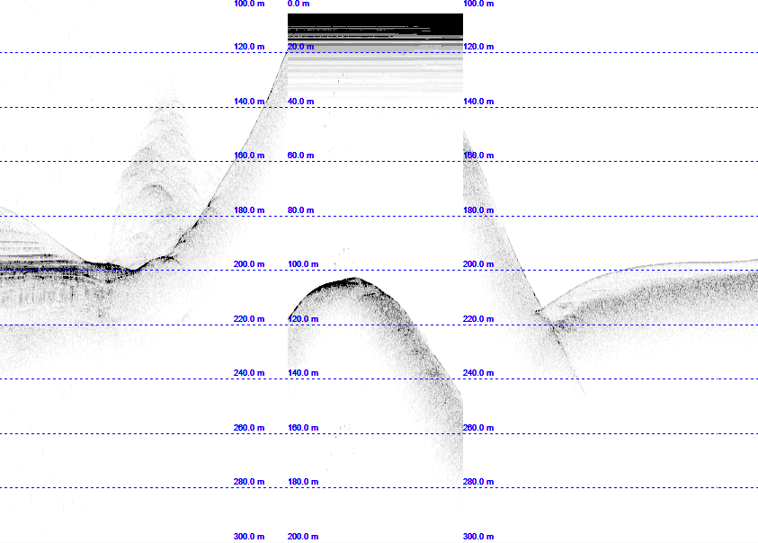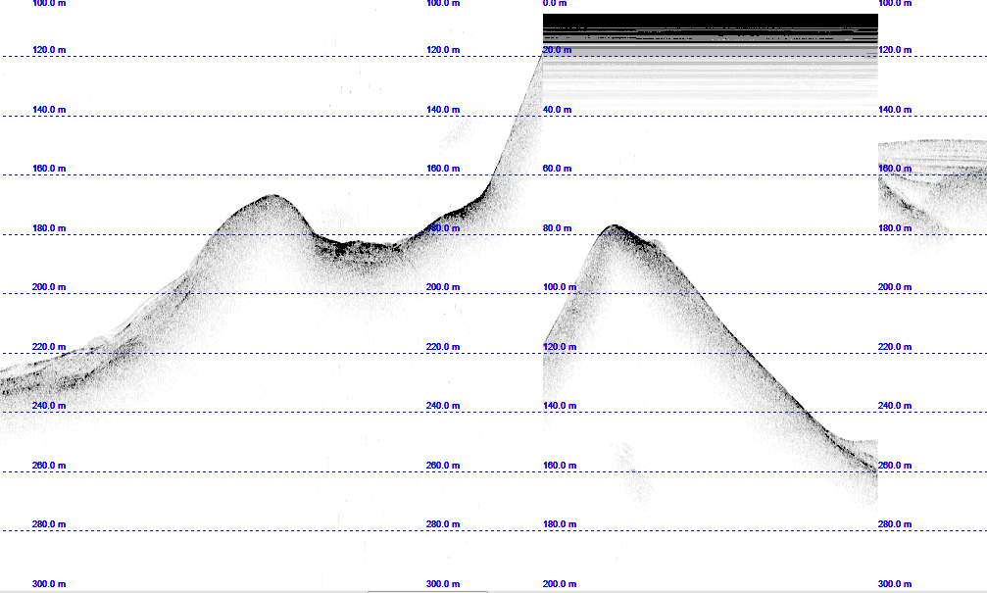
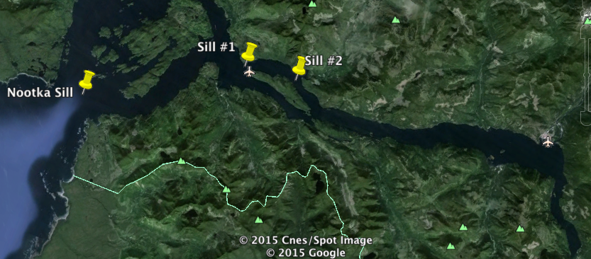

Figure 2 shows a detailed image of Sill #1 and Sill #2 in the upper half of the figure. The bottom half of the figure is a satellite image from Google Earth, showing the locations of Sill #1 and Sill #2 within Muchalat Inlet. Also shown is the main Nootka Sill at the mouth of Nootka Sound, but it should be noted that this sill couldn’t be seen clearly on the trackline shown in Figure 1.

References:

Alt, D., Hyndman, D.W., 1995. Northwest Exposures: A Geologic Story of the Northwest. Mountain Press.

Boldt, K.V., Hallet, B., Nittrouer, C. A., Barker, A. D., 2012. Rapid glacial marine sedimentation and effects on glacier melting and fjord hydrography; Columbia Glacier fjord, AK. Ocean Sciences Meeting. 2012: 41

Clarke G., 1987. Fast Glacier Flow: Ice Streams, Surging, and Tidewater Glaciers. Journal of Geophysical Research. 92: 8835-8841

Dowdeswell, J. A., Ottensen, D., Evans, J., Cofaigh, C. O., Anderson, J. B., 2008. Submarine glacial landforms and rates of ice stream collapse. Geology. 36: 819-822

Hidy, A. J., Gosse, J. C., Froese, D. G., Bond, J. D., Rood, D. H., 2013. A latest Pliocene age for the earliest and most extensive Cordilleran Ice Sheet in northwestern Canada. Quaternary Science Reviews. 61: 77-84

Howe, J. A., Moreton, S. G., Morri, C., Morris, P., 2003. Multibeam bathymetry and the depositional environments of Kongsfjorden and Krossfjorden, western Spitsbergen, Svalbard. Polar Research. 22(2): 301-316

Nick, F. M., van der Veen, C. J., Oelermans, J., 2007. Controls on advance of tidewater glaciers: Results from numerical modeling applied to Columbia Glacier. Journal of Geophysical Research. 112

Ottensen, D., Dowdeswell, J. A., 2006. Assemblages of submarine landforms produced by tidewater glaciers in Svalbard. Journal of Geophysical Research. 111

Syvitski, J., Shaw, J., 1995. Sedimentology and Geomorphology of Fjords. Developments in Sedimentology. 53: 113-178

