TABLES

Table 1. Demographic and initial clinical/ molecular characteristics of the patients by geographic location.
AdV, adenovirus; *among the patients who were PCR positive for adenovirus.

Location | US | India | Sri Lanka | Brazil
n | 113 | 200 | 84 | 103
Men (%) | 47 (42) | 134 (67) | 55 (65) | 54 (52)
Mean age (range) | 37.4 (1-90) | 34.2 (18-64) | 38.4 (17-74) | 31.2 (18-72)
VA at presentation, ETDRS (SD)  Snellen | 90.8 (9.8)  20/30 | 92.4 (7.6)  20/29 | 90.3 (8.9)  20/30 | 93.7 (7.9)  20/26
PCR + for Adenovirus(%) | 63 (56) | 168 (84) | 82 (98) | 77 (75)
Mean number of AdV/swab* (log₁₀) | 7.8 | 8.7 | 8.6 | 8.4

Table 2. Demographic characteristics of the patients and initial viral load by adenoviral species.

Species | AdV-B (n=34) | AdV-C (n=4) | AdV-D (n=316) | AdV-E (n=36) | AdV-neg  (n=110) | p-value
Age (Mean, SD) | 39.0 (13.5) | 36.0 (8.8) | 34.4 (12.5) | 33.7 (16.9) | 36.0 (16.8) | 0.37
Men (n, %) | 25 (73.5) | 3 (75.0) | 191 (60.4) | 15 (41.7) | 56 (51.0) | 0.04
Mean Viral Load (log₁₀) | 8.00 | 6.22 | 8.60 | 7.99 | - | 0.05
AdV, adenovirus; SD, standard deviation

 | AdV-B  (n=34) | AdV-C  (n=4) | AdV-D  (n=316) | AdV-E  (n=36) | AdV-neg  (n=110) | p-value
Clinical Signs
Day 1 (SD) | 5.6 (4.6) | 6.8 (4.8) | 5.5 (4.1) | 7.0 (3.9) | 4.8 (4.0) | 0.09
Day 3 | 4.6 (4.5) | 4.0 (3.3) | 5.6 (3.8) | 5.9 (3.7) | 3.7 (3.4) | 0.0002
Day 6 | 2.5 (3.5) | 0.3 (0.5) | 4.4 (3.8) | 3.6 (3.0) | 1.7 (2.6) | <0.0001
Day 11 | 0.5 (1.1) | 0 | 2.0 (2.6) | 0.7 (1.3) | 0.8 (1.6) | <0.0001
Day 18 | 0.6 (2.0) | 0 | 1.8 (3.3) | 0.5 (1.2) | 0.5 (1.2) | 0.0003
Clinical Symptoms
Day 1 (SD) | 4.9 (4.3) | 6.8 (5.4) | 5.0 (4.4) | 6.9 (4.3) | 5.6 (4.8) | 0.15
Day 3 | 3.7 (4.0) | 4.3 (3.5) | 4.6 (4.1) | 4.7 (3.6) | 4.3 (4.2) | 0.80
Day 6 | 2.8 (3.5) | 0 | 4.0 (4.2) | 3.7 (3.2) | 2.7 (3.5) | 0.02
Day 11 | 0.2 (0.7) | 0.3 (0.5) | 2.5 (3.1) | 1.4 (2.1) | 1.1 (2.3) | <0.0001
Day 18 | 1.1 (2.5) | 0.3 (0.5) | 2.1 (3.3) | 0.9 (2.0) | 1.3 (3.1) | 0.03
Table 3. Average composite sign scores on day 1 -18 by adenoviral species (Analysis of Variance).
AdV, adenovirus; SD, standard deviation

Table 4. Mean difference in composite scores by adenoviral species (defined as the difference in the score between day 18 and day 1, Analysis of Variance).
AdV, adenovirus; CI, confidence interval.

 | AdV-B | AdV-C | AdV-D | AdV-E | AdV-neg | p-value
Clinical signs  (95% CI) | -5.2  (-7.1, -3.3) | -6.8 (-14.4, 0.9) | -3.7 (-4.3, -3.2) | -6.5 (-7.9, -5.2) | -4.6 (-5.5, -3.8) | 0.003
Symptoms | -3.5 (-5.4, -1.6) | -6.5 (-15.7, 2.7) | -2.7 (-3.3, -2.1) | -6.1 (-7.6, -4.7) | -4.0  (-5.0, -3.0) | 0.0009

Table 5. Univariate linear regression analyses of visual acuity change on day 18.

 | Beta (95% CI) | p-value | Mean VA change*
Initial visual acuity | -0.4 (-0.5 to -0.3) | <0.001 | 1.8
Age | -0.1 (-0.1 to 0.04) | 0.69 | 1.3
Women | Reference group |  | 2.2
Men | -0.5 (-2.1 to 1.01) | 0.50 | 1.7
Country
United States | Reference group |  | 3.6
India | -1.9 (-3.8 to 0.1) | 0.06 | 1.8
Brazil | -2.9 (-5.3 to -0.6) | 0.01 | 0.7
Sri Lanka | -2.7 (-5.0 to -0.4) | 0.02 | 0.9
AdV species
AdV-non D (B,C,E) | Reference group |  | 2.7
AdV-D | -1.3 (-3.5 to 0.9) | 0.24 | 1.4
AdV negative | -0.1 (-2.7 to 2.4) | 0.91 | 2.6
Initial viral load (log₁₀) | -0.2 (-0.4 to 0.1) | 0.14
SEI negative | Reference group |  | 2.6
SEI positive | -1.4 (-2.9 to 0.1) | 0.07 | 1.2
AdV, adenovirus; VA, visual acuity; *Mean VA change (VA day18 – VA day1) is given within categories for categoricals given or at the average value of the predictor for continuous variables.

Table 6. Univariate logistic regression analyses of subepithelial infiltrate (SEI) development.

 | Odds Ratio (95%CI) | p-value
Age | 1.0 (1.0-1.01) | 0.36
Men | 1.1 (0.7-1.5) | 0.81
AdV positivity | 3.3 (2.2-5.2) | <0.001
AdV species
AdV-non D (B,C,E) | Reference group
AdV-D | 3.7 (2.2-6.2) | <0.001
AdV negative | 0.8 (0.5-1.5) | 0.57
Initial viral load (log₁₀) | 0.1 (0.04-0.1) | 0.001

AdV, adenovirus

FIGURES

Figure 1. Geographic distribution of adenoviral species in keratoconjunctivitis. X-axis, country of origin; y-axis, the percentage of total distribution; AdV, adenovirus.

Figure 2. Geographic distribution of molecular diagnoses in keratoconjunctivitis. X-axis country of origin; y-axis, the total number of cases. AdV, adenovirus.

Figure 3. A, Mean composite scores of signs in adenoviral keratoconjunctivitis on day 1, 3, 6, 11, 18. B, Mean composite scores of symptoms on day 1, 3, 6, 11, 18. Colors represent different adenoviral species and adenoviral negative group. Bars represent 95% confidence intervals. AdV, adenovirus.

Figure 4. Histogram of patients with signs or symptoms present on day 1. AdV, adenovirus.

Figure 5. Hazard ratios of resolution of signs and symptoms in patients infected with AdV-D compared to other species. ||, confidence interval extends beyond 3. AdV, adenovirus.

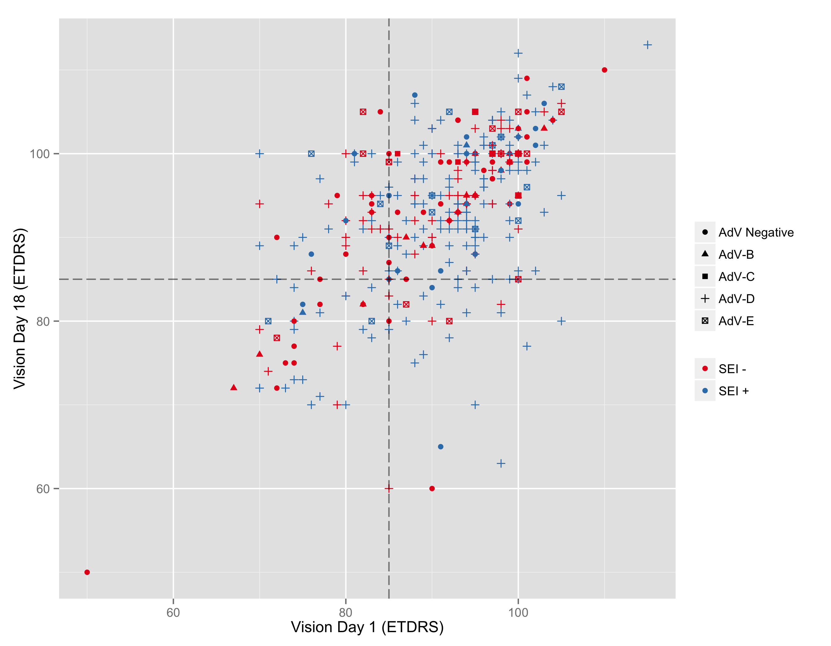Figure 6. Scatter plot of visual acuity on day 1 versus day 18 stratified by adenoviral species and adenovirus-negative keratoconjunctivitis. Blue dots represent those who developed subepithelial infiltrates, and red dots represent those who did not. The dotted lines represent 85 ETDRS letters, equivalent of 20/40 Snellen visual acuity. AdV, adenovirus.

