²¹⁰Pb Accumulation Rates in Andvord Bay, Western Antarctic Peninsula

Khadijah Karrington Homolka

University of Washington
School of Oceanography, Box 355351
Seattle WA 98195-5351
khomolka@uw.edu

Abstract

With the rate of temperature rise on the Western Antarctic Peninsula (WAP) being six times higher than the global average, the effects of modern climate change on glacier dynamics and meltwater production hold particular significance for sediment accumulation rates. Few data exist for examining the subbasin variability of sediment accumulation in an individual fjord, where only 1-2 cores per fjord are available. In Andvord Bay, Antarctica, modern sediment accumulation rates were determined from 9 kasten cores collected throughout the fjord aboard the R/V Nathaniel B. Palmer. A relatively low circulation velocity, and numerous deep basins throughout the fjord created ideal conditions for sediment to accumulate, and to be easily cored. Sediment accumulation rates were determined using ²¹⁰Pb geochronology, where excess ²¹⁰Pb activity profiles reveal spatially variable steady-state sediment accumulation rates throughout the fjord that are on the order of millimeters of accumulation per year. These modern accumulation rates agree with previously determined accumulation rates in polar and subpolar fjords, and are significantly slower than those of temperate tidewater glaciers, further indicating that the subpolar fjords of the WAP have been accumulating sediment at a steady-state for the past century. These excess ²¹⁰Pb activity profiles provide further insight into the small-scale spatial variability of sediment transport and accumulation in individual fjords, and contribute to the subpolar-polar sediment accumulation dataset that is imperative for understanding the effects of modern climate change on the dynamics of glaciers at high latitudes.

Keywords: ²¹⁰Pb geochronology, climate change, Antarctica, sediment accumulation rate

Introduction

The Western Antarctic Peninsula (WAP) extends northward from the Antarctic continent, and experiences strong climatic gradients ranging from polar to subpolar with decreasing latitude along the peninsula (Fig. 1; Harden et al., 1992). Previous studies along the WAP indicate that the tidewater glaciers in this region produce little sediment as a result of restricted meltwater production from the polar climate (Harris et al., 2015). Temperature measurements from the Faraday Station report that over the last fifty years, the approximate warming rate on the WAP was 5.7± 2.0˚C per century (Vaughan et al., 2003). With the rate of temperature rise on the WAP six times higher than the global average, the effects of modern climate change on glacier dynamics, and meltwater production hold particular significance for sediment accumulation rates in polar and subpolar fjords (Boldt et al., 2013).
Modern sediment accumulation over decadal-to-century time scales can be determined by ²¹⁰Pb geochronology. Radiogenic ²¹⁰Pb naturally occurs in seawater, and is primarily constrained by scavenging onto biogenic, and lithogenic particles because of its particle-reactivity (Marsa and Church, 2014). ²¹⁰Pb is delivered to marine environments by precipitation, runoff, and the decay of ²²⁶Ra (Bruland, 1974). Seasonal changes in temperature, salinity, freshwater flow from tidewater glaciers, and the concentration of suspended particles in the water column, can influence the ²¹⁰Pb activity within the sediment by the altering accumulation of sediment, particle mixing, and radioactive decay (Marsa and Church, 2014; Harden et al., 1992).
In a sediment core, there are three distinct regions of activity that are commonly observed: a surface layer homogenized by bioturbation, a zone of logarithmic decay, and a region of supported activity (Nittrouer et al., 1979). ²¹⁰Pb geochronology is not only important in determining sediment accumulation rates, but it can also provide insight into the mechanisms that affect the accumulation of sediment (Nittrouer et al., 1979). In a previous study, Boldt et al., 2013 determined that sediment accumulation rates for fjords in the temperate Patagonian ice field, where accumulation rates are much faster, reached a maximum of 23.6 mm yr⁻¹ in Marinelli Fjord (54.390°S, 69.591°W). In the same study, it was reported that despite the rapid warming in Antarctica, the sediment accumulation rates have been steady over the past century, accumulating sediment at a rate of 1-7 mm yr⁻¹ (Boldt et al., 2013). In light of this study however, little previous research has investigated the spatial variability of accumulation rates in fjords on the WAP, where only 1-2 cores have been collected per fjord (Boldt et al., 2013), and few data exist for examining the subbasin variability of sediment accumulation in an individual fjord.
In this study we present the sediment accumulation rates for 9 sediment cores from Andvord Bay, Antarctica. The objectives of this study are to 1) determine the temporal and spatial variability of sediment accumulation in each basin of the fjord, and 2) investigate transport mechanisms that could account for subbasin variability of sediment accumulation.

Materials and Methods
Field Methods
Kasten and box cores were retrieved from Andvord Bay, Antarctica from April-June, 2016 aboard the 308-foot R/V Nathaniel B. Palmer. The coring devices were deployed off the starboard side of the R/V Palmer using the shipboard forward main crane. Following core recovery, a 6 inch polyvinyl chloride (PVC) barrel was inserted into the core to portion out, and remove two centimeter depth increments from kasten cores, and centimeter depth increments for box cores starting at the uppermost layers for each. After sediment cores were incrementally portioned, the sediment was removed with a spatula and transferred to a sample bag. A total of 33 sediment cores were collected and stored in a cold room aboard the R/V Nathaniel B. Palmer until they were transported and stored at room temperature in the Sediment Dynamics Laboratory at the University of Washington.

Laboratory Methods
In the laboratory, approximately 20 g of sediment from each sample bag was weighed out into an aluminum pan, and were dried for 6 days in a 60˚C oven. After complete dryness had been achieved, the samples were weighed, and the wet and dry weights of each sample were used to determine the porosity of each layer of the core.
Using a balance, approximately 5g of crushed sediment was weighed into individual HNO₃ washed 150 mL beakers. Subsequently, each beaker was spiked with 1 mL of synthetic ²⁰⁹Po as a yield determinant, and 10 mL of 15.8 N HNO₃ was added to the sample to leach ²¹⁰Po from the sediment particles (Nittrouer et al. 1984, ²¹⁰Pb Analysis Instructions). ²¹⁰Po is a granddaughter isotope to ²¹⁰Pb, and can be used to obtain ²¹⁰Pb activities because the two isotopes are in secular equilibrium within the sediment (Nittrouer et al. 1984). All beakers were placed on a hot plate and continuously stirred until near-dryness has been achieved, taking precautions to avoid splattering the sediment mixture (²¹⁰Pb Analysis Instructions). At near-dryness, the beakers were removed from the hot plate and 10 mL of 6N HCl was added, using 0.3N HCl to rinse down the sides, and the mixtures were brought to near dryness (²¹⁰Pb Analysis Instructions).
Approximately 5 mL of 6N HCl was added, using 0.3N HCl to rinse the contents of the beaker into a labeled centrifuge tube. ²⁰⁹Po and ²¹⁰Po were separated from the sediment particles by centrifugation, repeating the process two more times using 0.3N HCl instead of 6N HCl to soak the beakers while the samples are in the centrifuge (Nittrouer et al., 1984, ²¹⁰Pb Analysis Instructions). After the samples have been centrifuged three times, magnetic stir bars were added to each plating jar and placed on a magnetic stir plate. L-ascorbic acid was added to each plating jar to reduce the oxidized iron in the supernatant, continuing to add L-ascorbic acid until the supernatant turns clear, or white and foggy depending on the amount of organic pigments present (²¹⁰Pb Analysis Instructions). Spontaneous electrodeposition plated ²¹⁰Po onto silver planchets that were hung in each plating jar for no more than 24 hours (Nittrouer et al., 1984, ²¹⁰Pb Analysis Instructions). ²¹⁰Pb activity for each depth increment was determined by alpha-particle spectroscopy in the Sediment Dynamics Laboratory.

Post-Processing Methods
Exported alpha-particle spectroscopy data is cleaned, and managed in MATLAB to generate total and excess ²¹⁰Pb activity profiles. Supported ²¹⁰Pb activities are determined from the total ²¹⁰Pb activity profiles, making sure to consistently choose the lowest background activity as the supported value for that core. The excess plot is generated from subtracting the supported value from the activities in the total ²¹⁰Pb activity profile (IAEA TECDOC-1360, 2003). A linear regression is fit to the identified zone of logarithmic decay to determine the accumulation rate. The sediment accumulation rate equation is derived from the radioactive decay equation, and is as follows:
$S=-\text{λ}∙m=$𝜆$\frac{(z_{0}-z)}{ln⁡\left(\frac{A_{0}}{A_{z}}\right)}$

Results

Grain Size Results
Grain size profiles provided a quantitative record of grain classifications based on their settling velocities, as determined by sedigraph analysis, and a pass through a 63 μm sieve to remove the sand fraction. The profile for CRS 1771 indicates that the top 4 cm of the core is 60% sand, and then transitions to being silt, and clay dominated. The sand fraction increases to 50% from 20-40 cm, however transitions again to being equally dominated by silt and clay.

X-radiograph Results
Cores CRS 1814, CRS 1829, CRS 1836, and CRS 1780 all have a homogenous fine-grained matrix that have randomly distributed angular ice-rafted debris, and show no evidence of layering. CRS 1791 also has a homogeneous fine-grained matrix, but has large angular dropstones, and a thin layer of gravel at 22 cm depth (Fig. 4). Evidence of gravity flows are restricted to IB-B where CRS 1771 has an increase in the number of dropstones, and sandy layers at 25, and 155 cm depth. The sandy layers in CRS 1772 occur at 50, and 135 cm depth, and are well-sorted, laminated, and coarse-grained.

²¹⁰Pb Results

The accumulation rates, and accompanying information for the 9 cores analyzed in this study are compiled in Table 1. In Inner Basin A (IB-A), kasten core CRS 1824 was collected in the deepest part of the basin, however coring was difficult due to very stiff mud, and a rocky layer that prevented coring past 36 cm. A sediment accumulation rate of 0.7 mm yr⁻¹, and a steady-state accumulation style were determined for CRS 1824, however results from this core are most likely inaccurate. Cores CRS 1771, and CRS 1772 from Inner Basin B (IB-B) were easier to core, and yielded accumulation rates of 2.5, and 1.1 mm yr⁻¹. Main Basin A (MB-A) is located at a convergence point of discharge from the tidewater glaciers of IB-A and IB-B. CRS 1791 from MB-A records the fastest accumulation for Andvord Bay, with a steady-state accumulation of 6.1 mm yr⁻¹, and a pulse of material that occurred 32.2 years ago that disrupts the steady-state accumulation (Fig. 4). Main Basin B (MB-B) is located farther down fjord, and is separated from MB-A by a shallow sill that has a steady-state accumulation rate of 3.0 mm yr⁻¹ from CRS 1840. CRS 1829, and CRS 1814 from MB-B have steady-state accumulation rates of 2.2 and 3.8 mm yr⁻¹. From the outermost basins, CRS 1780 from Outer Basin A (OB-A) provided a steady-state accumulation rate of 2.4 mm yr⁻¹ (Fig. 2), and CRS 1836 from Outer Basin B (OB-B) showed a change in accumulation at 17 cm core depth (Fig. 3). The accumulation rate from 0-17cm is 5.0 mm yr⁻¹, and then slows to a rate of 2.8 mm yr⁻¹.

Discussion

Seven of the cores analyzed in this study, all of which are from different basins, indicate from their excess ²¹⁰Pb profiles that the sediments have been accumulating uninterrupted for the last century. This steady-state style of accumulation suggests that the delivery of sediment has not experienced considerable change in frequency, size or source during the formation of this 100-year sediment record (Boldt et al., 2013). The X-radiographs of these cores all show a fine-grained matrix of mud and silt, with randomly distributed dropstones, which is consistent with the behavior of steady-state accumulation (Boldt et al., 2013). The two cores from IB-B also have a steady-state accumulation behavior, but x-radiographs show coarse-grained sandy beds in each. These sandy beds are potential indicators of gravity flows generated from coarse-grained material abruptly released from the tidewater glacier of IB-B.
In all of the cores analyzed there is an absence of a bioturbated layer (seen in Fig. 2). The total and excess ²¹⁰Pb profiles show that the area of logarithmic decay starts at the top of the cores, and on average spans 52 cm in the core. The lack of a bioturbated layer can confidently be attributed to a lack of burrowing benthos in the fjord, as there are no burrow holes visible in any x-radiograph. CRS 1772, and CRS 1824 do appear to have a homogenized surface layer, however in conjunction with the lack of bioturbation evident in other cores, the mixed layers seen in these cores are most likely a result of being close to the ice fronts, and rapid episodic input from the glacier terminus (Harden et al., 1992). The accumulation rates of the inner basins however, are some of the slowest in the fjord. Freshwater surface plumes from glacial meltwater could be carrying evacuated sediment out of the inner basins in the stratified freshwater surface layer apart of estuarine circulation (Vaughn et al., 2013). This process could also account for the increase in accumulation rate seen in OB-B, however it is more likely that the accumulation rate was influenced by the sediment transport processes in Gerlache Strait as opposed to the tidewater glaciers of the inner basins.
CRS 1814 sits behind the shallow sill that separates MB-A from MB-B, and has a higher accumulation rate than its neighboring sites. This higher rate could be the result of sediment slumping off the sill into MB-B. Bathymetry shows that the basin walls have a steep gradient, which could also contribute to the slumping of sediment off the basin walls (Fig. 5). The highest accumulation rate in the fjord is CRS 1791, which lies in the convergence zone of sediment plumes from the glaciers, and accounts for the isolated increase in accumulation rate. Boldt et al., 2013 reported a steady-state accumulation rate of 5.6 mm yr⁻¹ with an event layer from IB-B that is the same order of magnitude as our determined rate of 2.5 mm yr⁻¹ for IB-B, and further reinforces the observation that there has not been a significant increase in sediment supply from global warming in the immediate past.

Conclusions

In sum, this dataset confidently shows that rates of sediment accumulation vary basin to basin, and that grain size throughout the fjord is dominated by silt, and clay with randomly distributed ice-rafted debris. The steady-state ²¹⁰Pb profiles that have been found to best characterize Andvord Bay indicate that there has been consistent sediment release from the glaciers during the past century. It is likely that increased sediment input attributed to global warming could be too recent to show up in ²¹⁰Pb profiles, and future studies of this scope would be necessary to investigate glacial response to global warming, and compare to previous data to isolate a definitive transition in the sediment record from a subpolar to temperate climate (Boldt et al., 2013). With the addition of more spatially representative data, a more accurate reconstruction of a sediment budget, and erosion rates can be calculated in the future, and provide more accurate insight into the glacier's’ response to recent warming.

Acknowledgments
I am immensely grateful to Dr. Charles Nittrouer, and Emily Eidam for the opportunity to use this incredible dataset, and for the mentorship that you have both shown me. Your faith in me has given me the confidence to pursue the goals that others had deemed unattainable. I would also like to show gratitude to the members of the Sediment Dynamics Laboratory that have taught me everything that I know about marine geochemistry, and who have been incredible colleagues, and mentors. I would also like to thank Dr. Arthur Nowell for his patience, guidance, and kind words that kept my sanity intact throughout this thesis process. Finally, I would like to dedicate this manuscript to my mother, and grandmother, who raised me to never give up in the face of adversity, and whose sacrifices are why I am fortunate enough to be pursuing oceanography. Chokma’shki.

References
Boldt, K. V., C.A. Nittrouer, B. Hallet, M.N. Koppes, B.K. Forrest, J.S. Wellner, and J.B. Anderson. 2013. Modern Rates of Glacial Sediment Accumulation along a 15 S-N Transect in Fjords from the Antarctic Peninsula to Southern Chile. J. Geophys. Res.: Earth Surf. 118, 2072-2088.

Bruland. K.W., 1974. Geochronology in the coastal marine environment. Dissert., Univ. California, San Diego, Calif., 106 pp.

Harden, S.L., DeMaster, D.J. and Nittrouer, C.A., 1992. Developing sediment geochronologies for high-latitude continental shelf deposits: a radiochemical approach. Mar. Geol., 103: 69-97.

Harris, P.T., E. Domack, P.L. Manly, R. Gilbert, and A. Leventer. 1999. Andvord drift: A new type of inner shelf, glacial marine deposystem from the Antarctic Peninsula. Geology. 27, 683-686.

IAEA TECDOC-1360 (2003) Collection and preparation of bottom sediment samples for analysis of radionuclides and trace elements. International Atomic Energy Agency, Vienna, pp: 63-82.

Marsan, D., S. Rigaud, and T. Church. 2014. Natural Radionuclides ²¹⁰Po and ²¹⁰Pb in the Delaware and Chesapeake Estuaries: Modeling Scavenging Rates and Residence times. J. Environ. Radioact. 138, 447-55.

Nittrouer, C., R. Sternberg, R. Carpenter, and J. Bennett. 1979. The use of Pb-210 geochronology as a sedimentological tool: Application to the Washington continental shelf. Mar. Geol., 31, 297–316

Nittrouer, C., D. Demaster, B. Mckee, N. Cutshall, and I. Larsen. 1984. The effect of sediment mixing on Pb-210 accumulation rates for the Washington continental shelf. Mar Geol., 54, 201–221.

Nittrouer, C. 2007. ²¹⁰Pb analysis instructions.

Vaughan, D. G., G. J. Marshall, C. Connolley, and others. 2013. Recent rapid regional climate warming on the Antarctic Peninsula. Climate Change 60: 243–273.

Tables and Figures
Core | Basin | Depth at Core Site** | Core length (cm) | Latitude (˚S) | Longitude (˚W) | Accumulation Rate (mm yr⁻¹) | Accumulation Style | Visible Layering
CRS 1824 | IB-A | 544 | 36 | 64.900 | 62.569 | *0.7 | SS | No
CRS 1771 | IB-B | 525 | 184 | 64.870 | 62.422 | 5.3 | SS | Yes
CRS 1772 | IB-B | 548 | 140 | 64.875 | 62.425 | 1.1 | SS | Yes
CRS 1791 | MB-A | 514 | 226 | 64.858 | 62.567 | 4.4 | SS w/ pulse | No
CRS 1829 | MB-B | 443 | 252 | 64.820 | 62.653 | 2.2 | SS | No
CRS 1814 | MB-B | 432 | 220 | 64.783 | 62.725 | 3.8 | SS | No
CRS 1840 | Sill 3 | 397 | 218 | 64.836 | 62.640 | 3.0 | SS | No
CRS 1780 | OB-A | 518 | 220 | 64.772 | 62.848 | 2.4 | SS | No
CRS 1836 | OB-B | 555 | 296 | 64.900 | 62.569 | 2.1 | SS change | No
Table 1. Accumulation style described as steady-state (SS), a change in steady-state (SS change), or a steady-state accumulation with a pulse (SS w/ pulse). Water depths will be added after they have been processed through GIS.
*CRS 1824 was difficult to core due to stiff mud, and rocky material. The sediment accumulation rate is likely not accurate.
**Multibeam depths are about 3% shallow that indicated by the Knudsen, which was not corrected with a sound velocity profile.

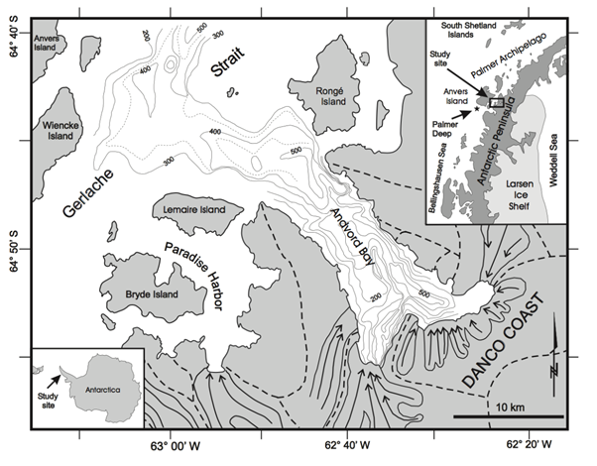
Fig. 1. A map from Harris et al., 1999 showing the location of Andvord Bay on the Western Antarctic Peninsula, the bathymetric contours of the bay, and the local directions of ice movement of the two tidewater glaciers.

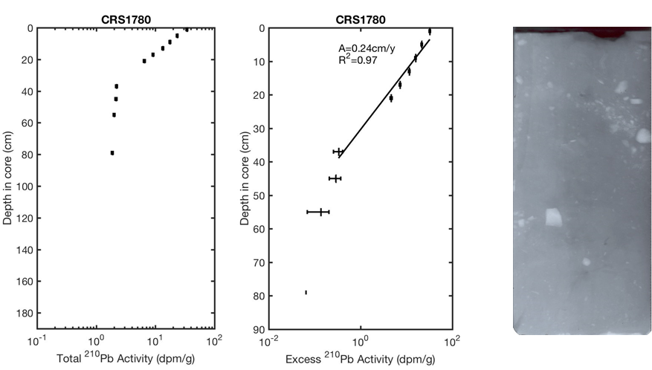
0-30 cm
Fig. 2. Total and excess ²¹⁰Pb profiles for CRS 1780 from OB-A, and accompanying x-radiograph showing a homogenous matrix with random dropstones.
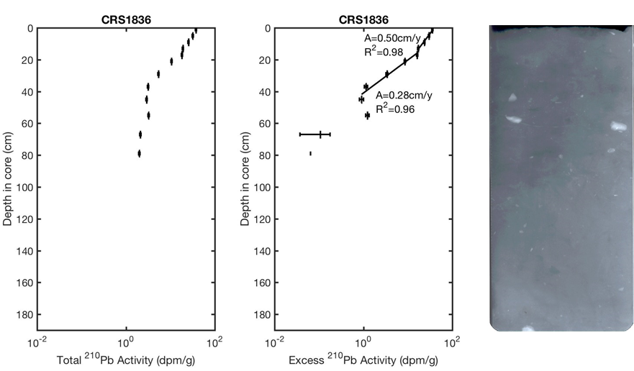
60-90 cm
Fig. 3. Total and excess ²¹⁰Pb profiles for CRS 1836 from OB-B, and accompanying x-radiograph showing a homogenous matrix with a few dropstones.
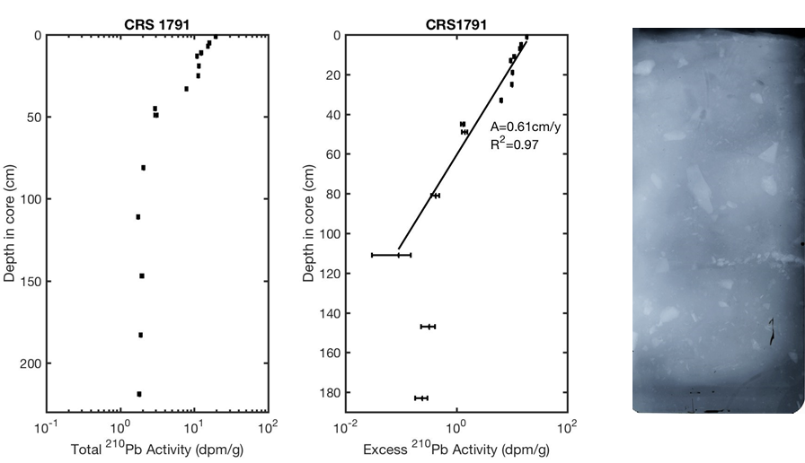
0-30 cm
Fig. 4. Total and excess ²¹⁰Pb profiles for CRS 1791 from MB-A, and accompanying x-radiograph showing a homogenous matrix with random dropstones, and a small gravel layer at 22 cm.

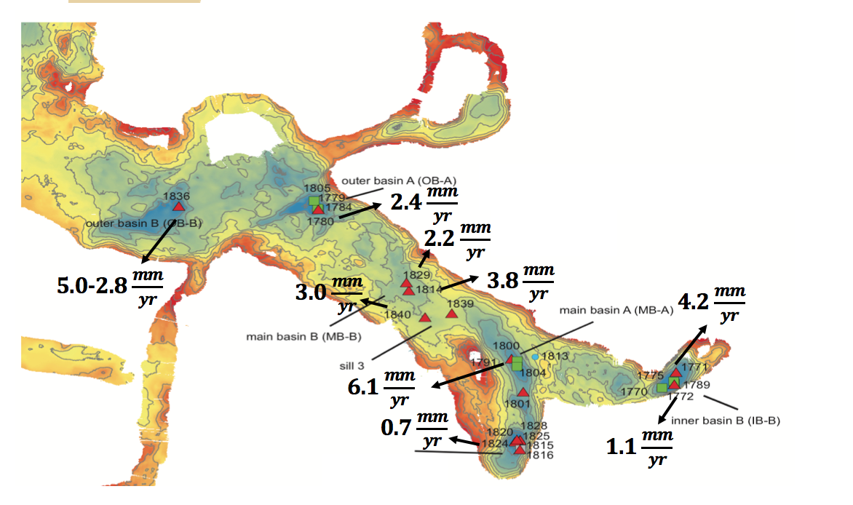
Fig. 5. A bathymetric map of Andvord Bay depicting the accumulation rates for each subbasin.

Data Appendix

Total and Excess ²¹⁰Pb Profiles

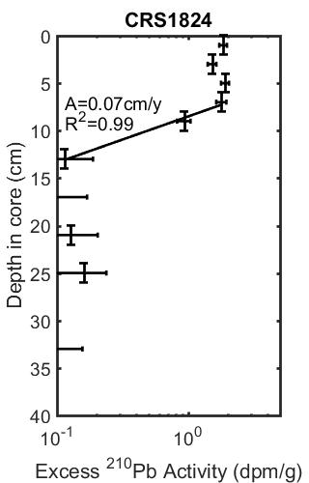
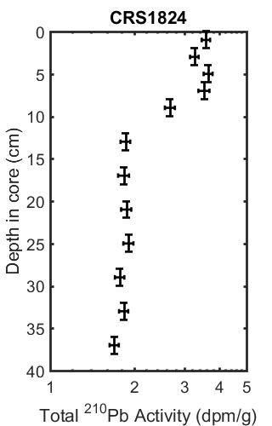

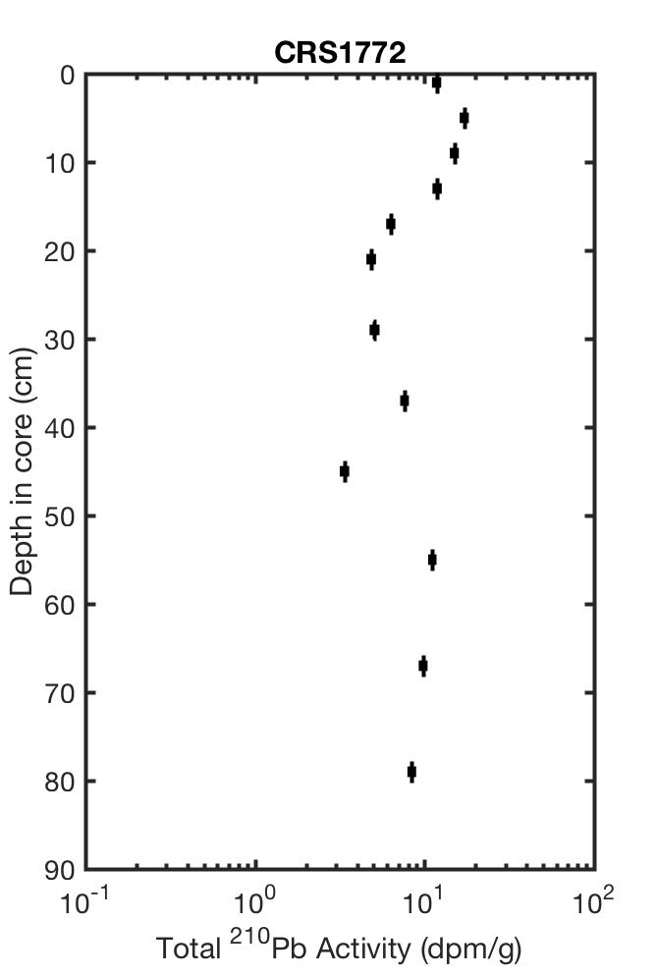
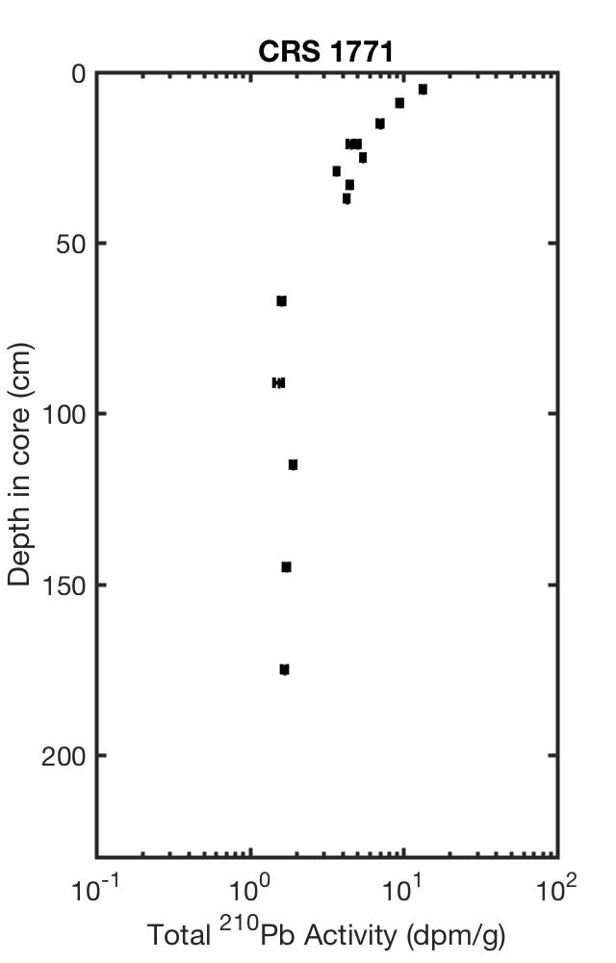
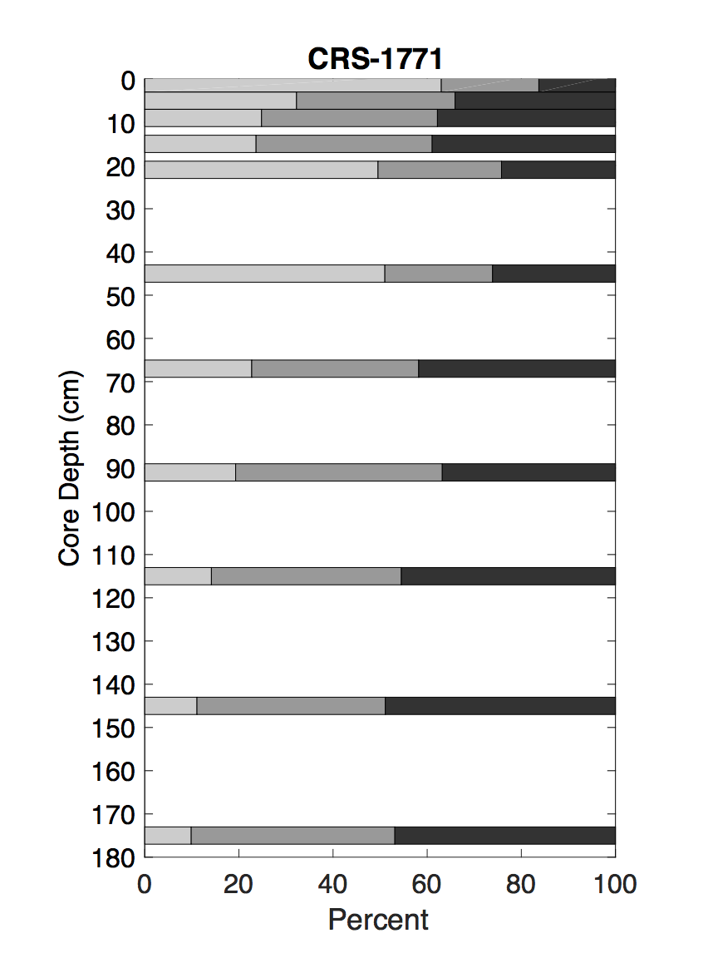
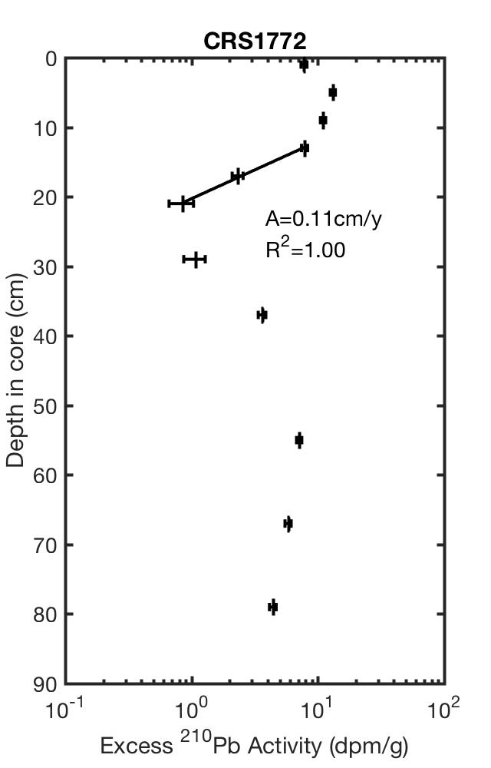
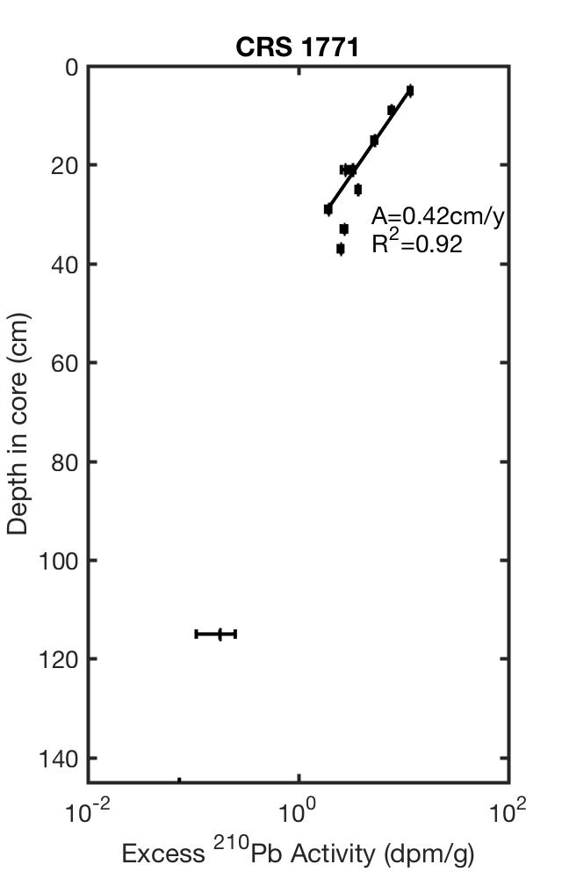

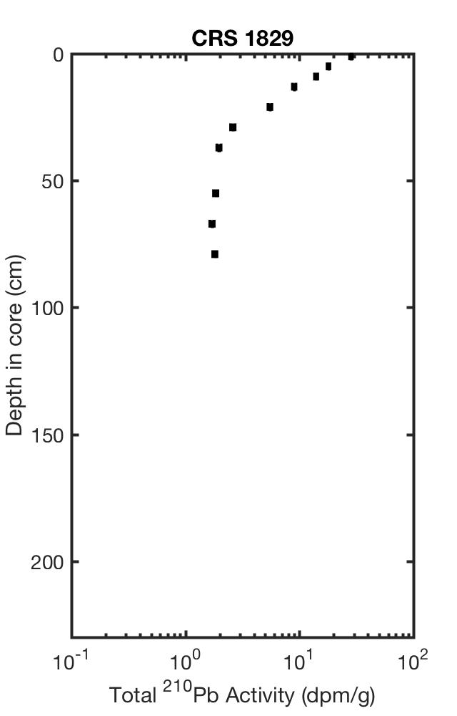
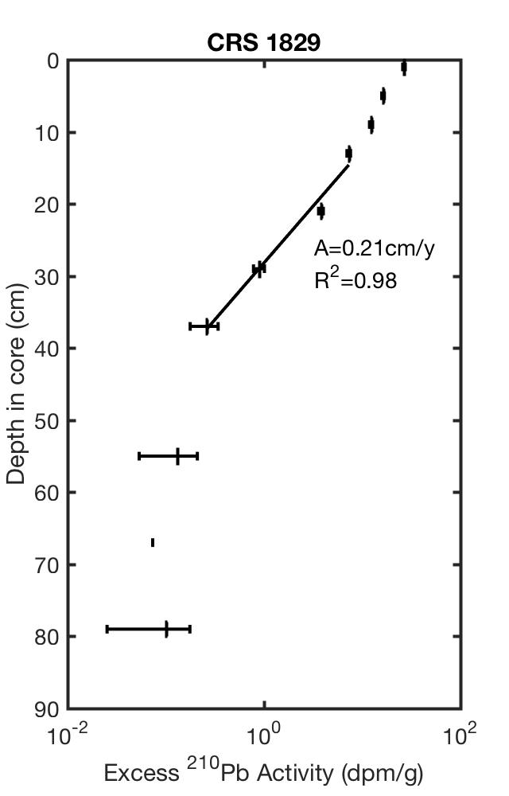

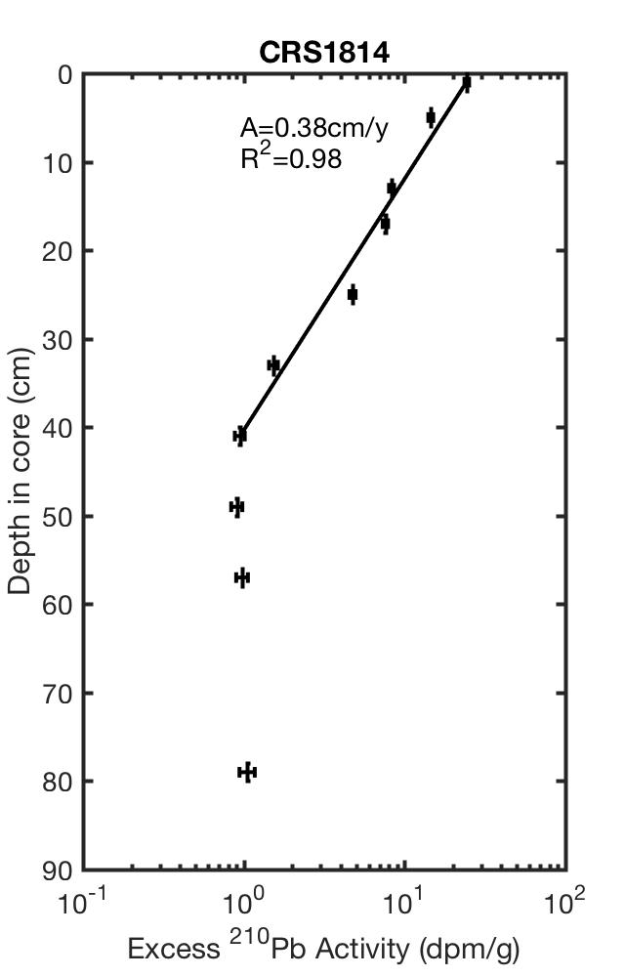
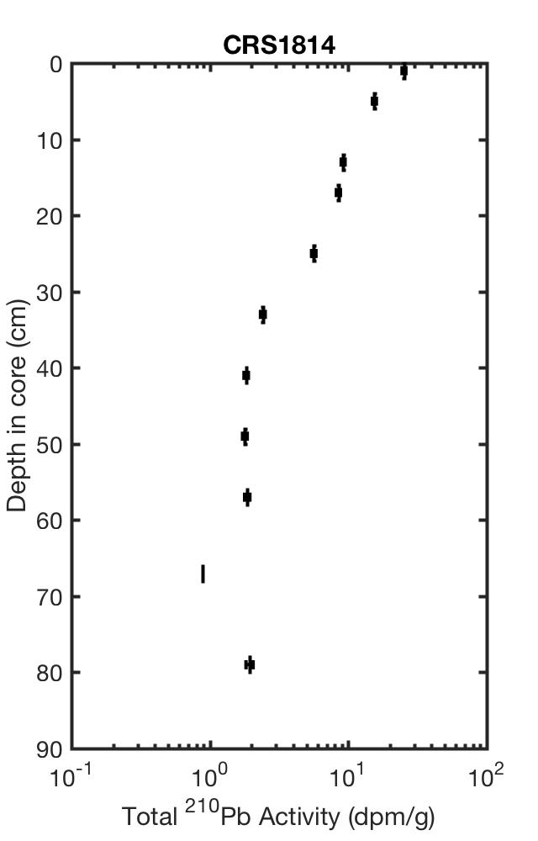

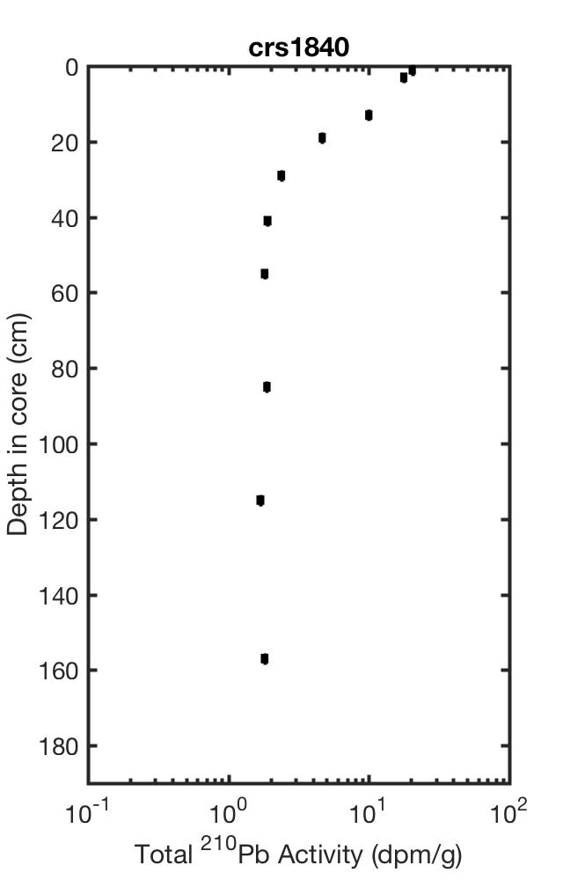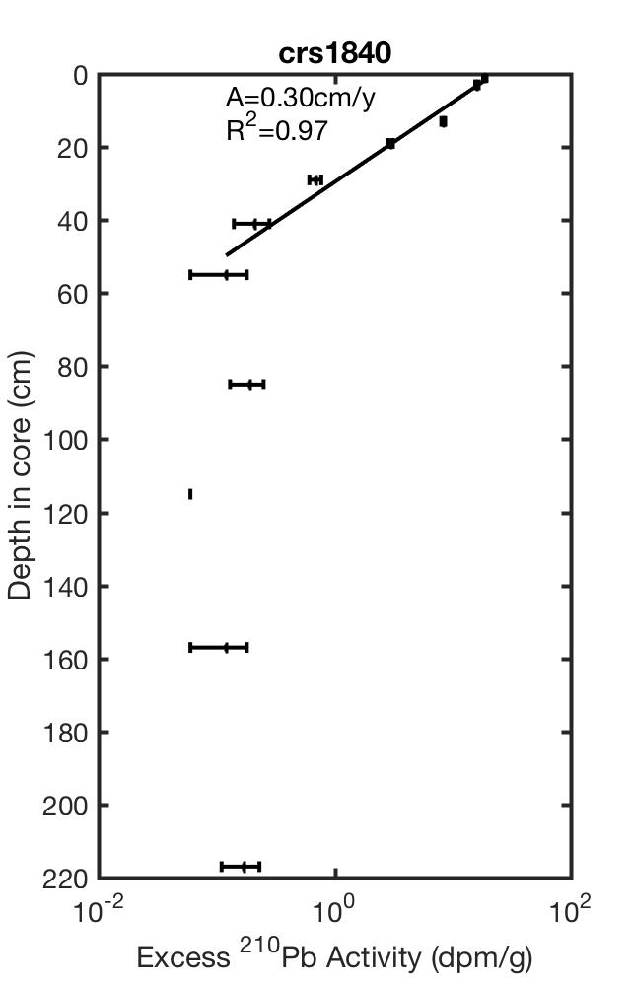

X-radiographs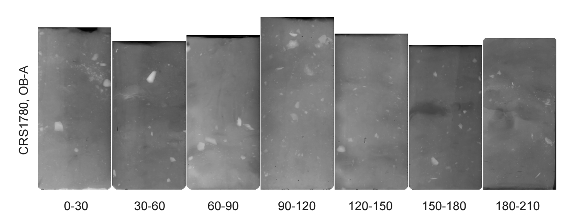

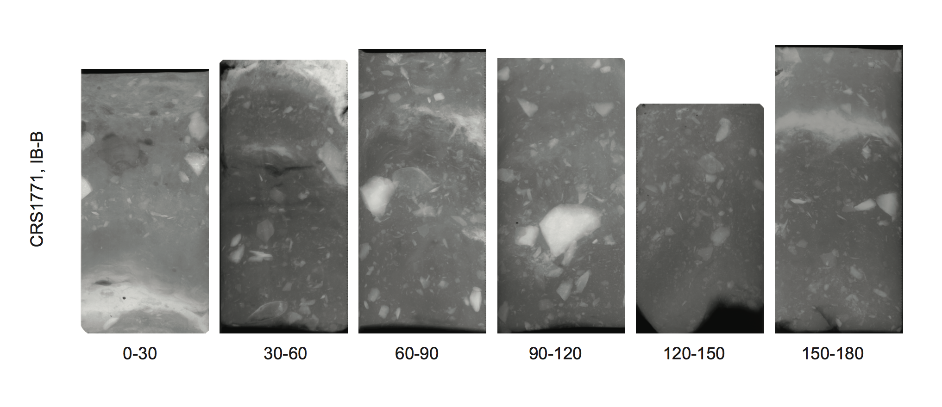

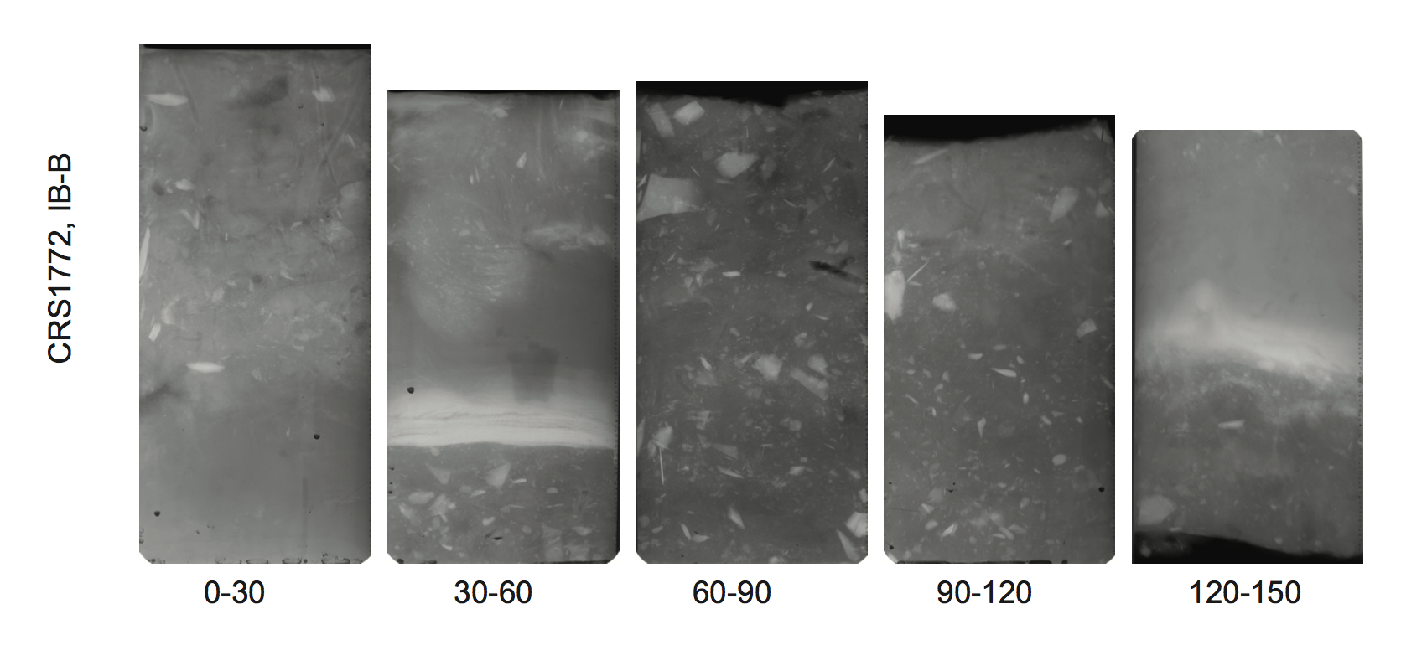
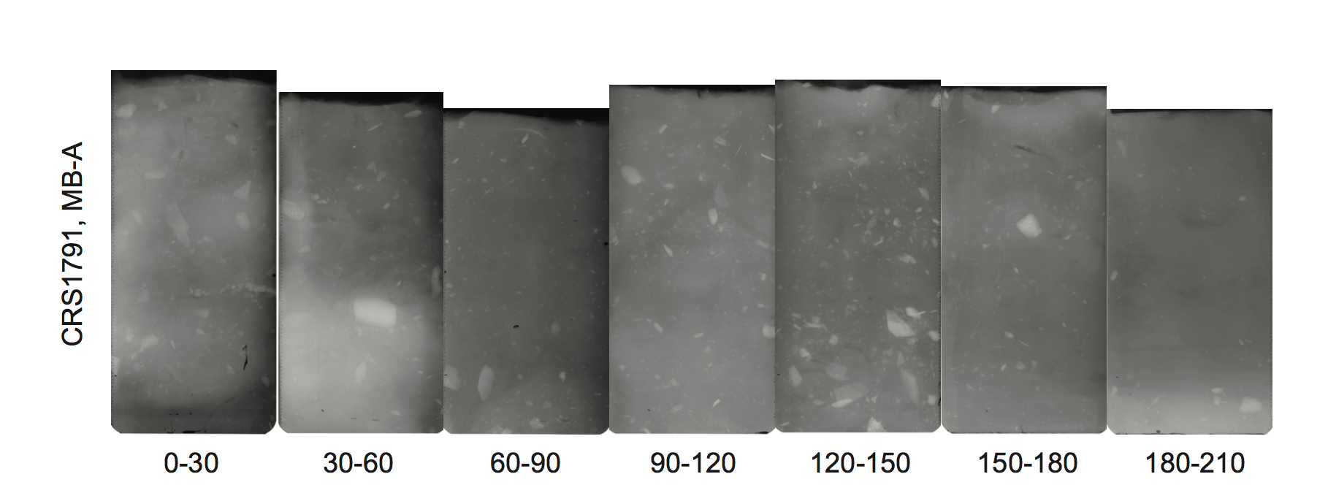

CRS1814, MB-B
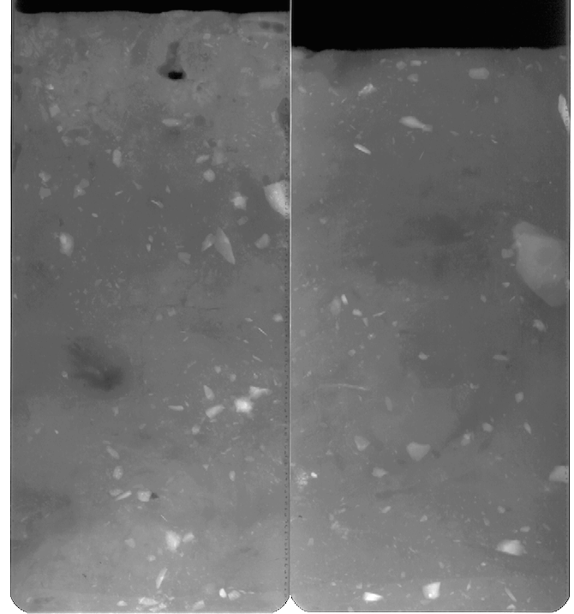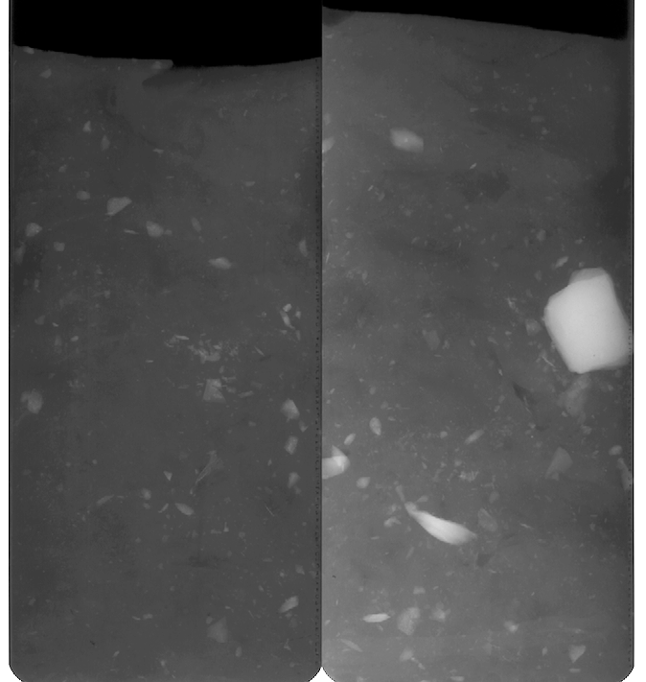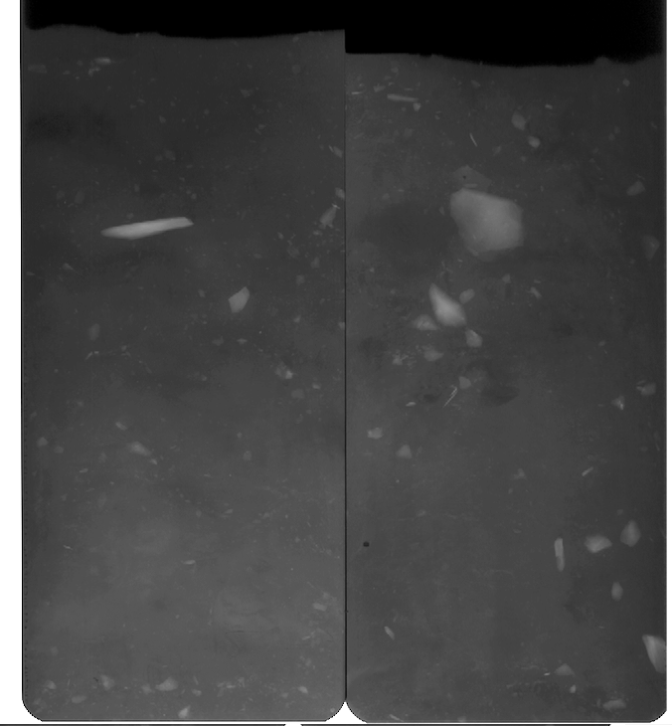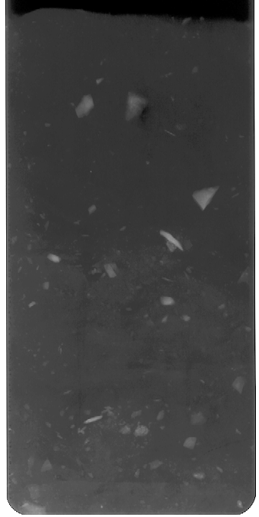
0-30 60-90 120-150 150-180

CRS1829, MB-B
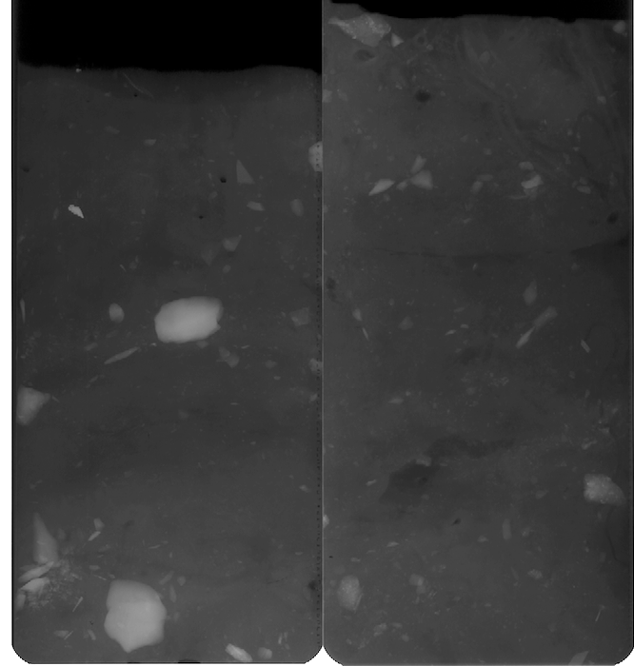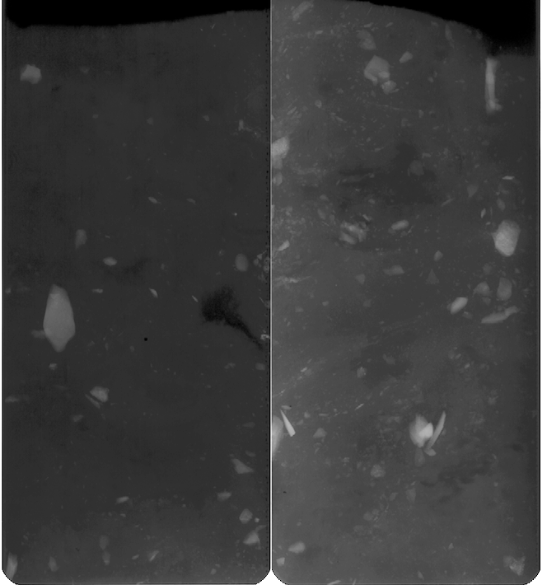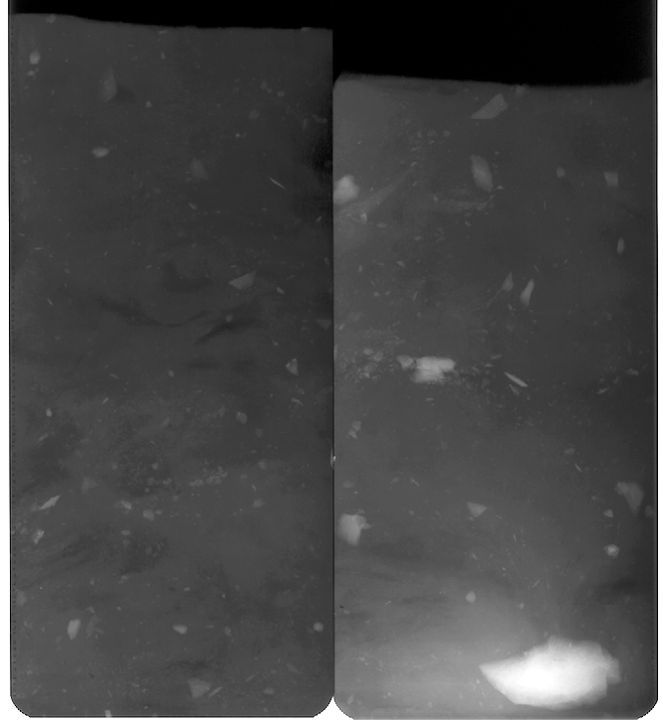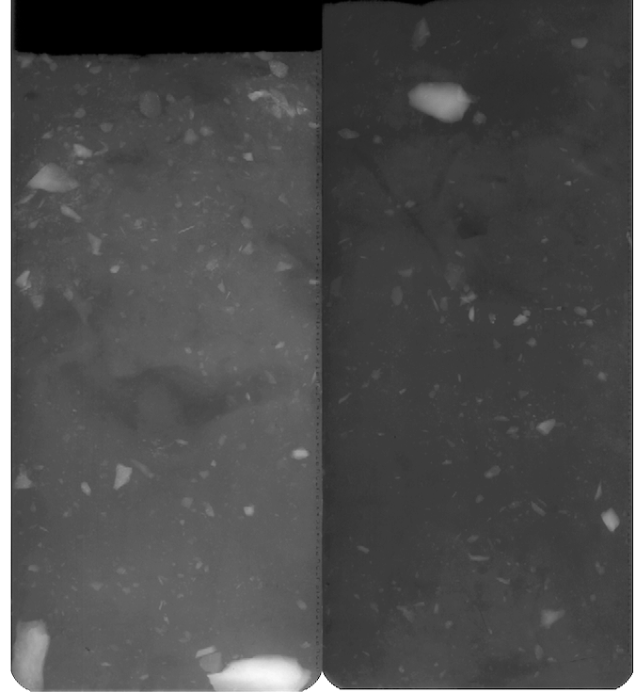
0-30 60-90 120-180 150-210

CRS1836, OB-B
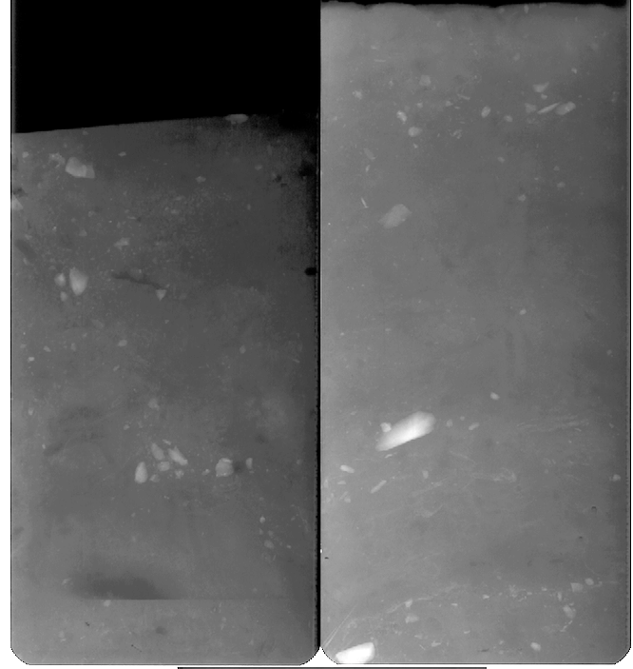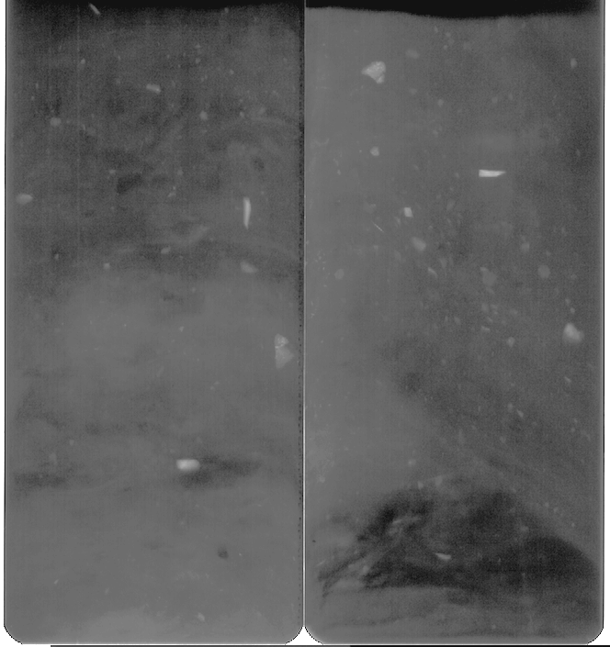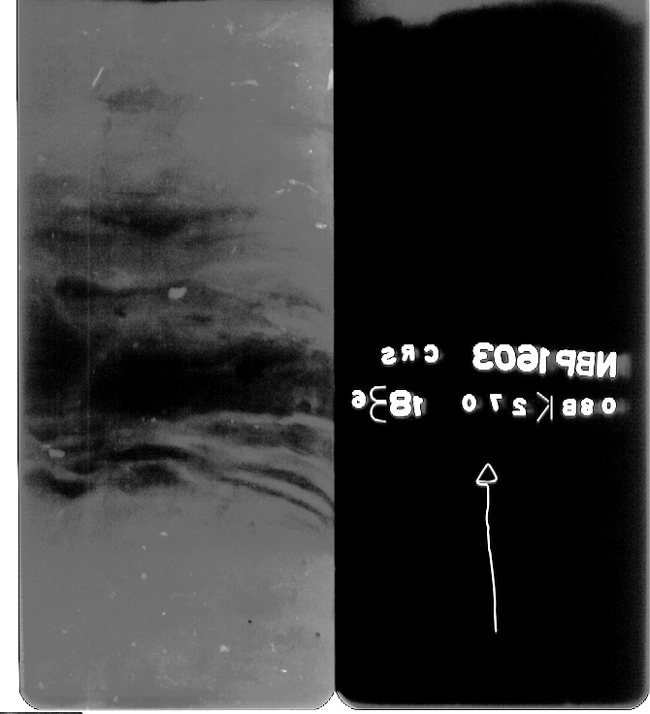
0-150 180-210 240-270

