Lowe et al. – American Journal of Botany XXXX – Appendix S4
Appendix S4: Special cases in the protocol for measuring petiole width.
Royer et al. (2007) detail how petiole width measurements are made in their modern calibration dataset as follows:
“We measured petiole width (PW) perpendicular to the midvein in the plane of the leaf blade, at the basal-most insertion of the lamina into the petiole. If the position of this measurement corresponded to a locally thickened or winged region of the petiole, PW was measured just basal to the feature.”
Here we highlight some special cases that added some difficulty to measuring petiole width following the protocol above and provide explanation for how they were handled in this study.
There are cases where petiole width at the point of insertion as explained above is not reflective of the width of the petiole across its entire length, such as when petioles taper (Fig. S4.1) or flare (Fig. S4.2) towards the lamina. One hypothesis is that petiole width measurements better reflect the load-bearing potential of a petiole when integrated across the entire length of the petiole (perhaps most easily assessed by purposefully measuring petiole width at a location most reflective of the entire petiole), or when measuring the structurally weakest part of the petiole (assessed by measuring the thinnest width of the petiole along its length). However, until further evidence is presented, we advocate against either of those approaches because, as mentioned in Royer et al. (2007), the entire length of the petiole is often not preserved in fossils, and thus judgments of the ‘width most reflective of the entire petiole along its length’, or the thinnest width of the petiole, are difficult to make and introduce subjectivity that decrease reproducibility of measurements. In addition, Royer et al. (2007) found that measurements made at the thinnest width of the petiole, and at the midpoint of the petiole, did not improve correlations in a subset of their data.
As mentioned in Royer et al. (2007), the width of the petiole at its insertion is sometimes made anomalous by features such as local thickenings (Fig. S4.3) or ‘wings’ (Fig. S4.4) of lamina. We found it difficult to make an objective decision for the presence of local thickenings, which may overlap in morphology with flaring petioles (e.g., Fig. S4.2). Thus, to reduce subjectivity, we measure petiole width across a thickened feature if it is a feature of the petiole itself (Figs. S4.3A, S4.3B), but not when thickenings were (or suspected to be) the result of debris (Fig. S4.3C). Local thickenings in this case do not include features like glands, nectaries, thorns, and trichomes, which were avoided when measuring. Thick coverings of trichomes on petioles is fairly common, and special care was taken to either determine the correct petiole margins, sometimes resulting in the petiole width being measured below the point of insertion (Fig. S4.5A), or to recognize that trichomes sometimes prevent reliable petiole width measurements (Fig. S4.5B).
Another set of special cases involving palmately veined leaves was addressed in Butrim et al. (2022). These cases occur when primary veins converge into a single petiolar strand beneath the point where the leaf margin intersects the outermost primary vein. If petiole width were measured at the point of leaf margin intersection, the drawn line would cross leaf veins and intervening photosynthetic laminar tissue (Fig. S4.6A). To decrease subjectivity and increase reproducibility, we follow Butrim et al. (2022) and instead measure the petiole width at the point just below where the primary veins converge (Figs. S4.6A and S4.6C), even in those cases where the petiole width at that location is much wider than along the rest of its length (Fig. S4.6B).
We also considered the case of the pulvinus, which inflates petiole width when it occurs at the location of petiole insertion. This has potential to introduce noise into analyses because pulvini function to influence growth-independent movement, in addition as functioning to support the load-bearing leaf. Royer et al. (2007) found that the scaling relationship between petiole metric and leaf mass per area was the same between simple leaves and leaflets, and because pulvini more commonly occur on leaflets than on leaves, it may provide evidence for minimal bias introduced from measuring across pulvini, though further tests are required for a reliable interpretation. Measurements across pulvini were included in this study, though future work may consider making measurements both across the pulvini and just below them when possible (Fig. S4.7), to determine the extent that measured pulvini may skew results.
For leaves that have narrowly decurrent bases, it may be difficult to pinpoint where the point of insertion occurs (Fig. S4.8). In this case, special care needs to be taken to determine where photosynthetic laminar tissue surrounding the petiolar strand stops, so petiole width can be measured there (Fig S4.8).
Lastly, we took care to recognize damaged sections of the petiole, such that if damage at the petiole insertion occurs, the measurement should be made immediately below that damage.

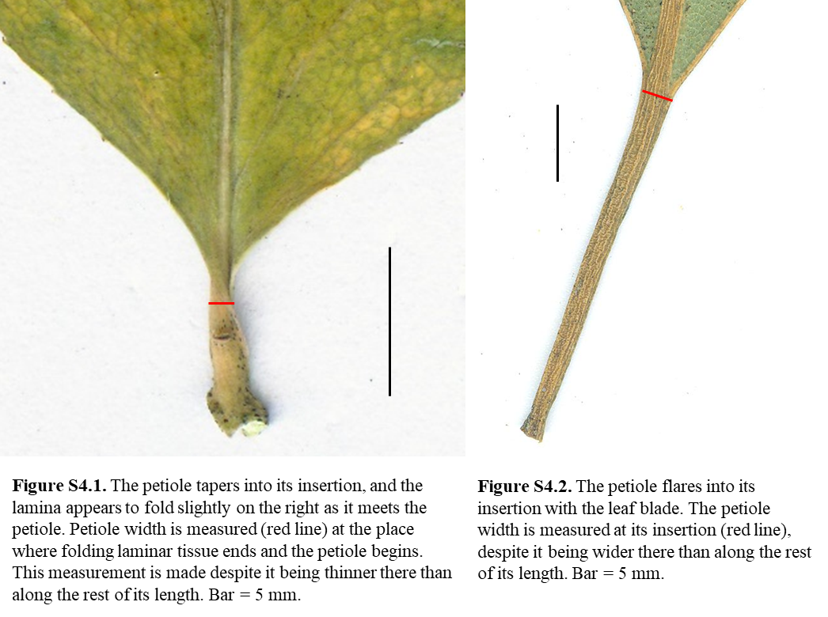
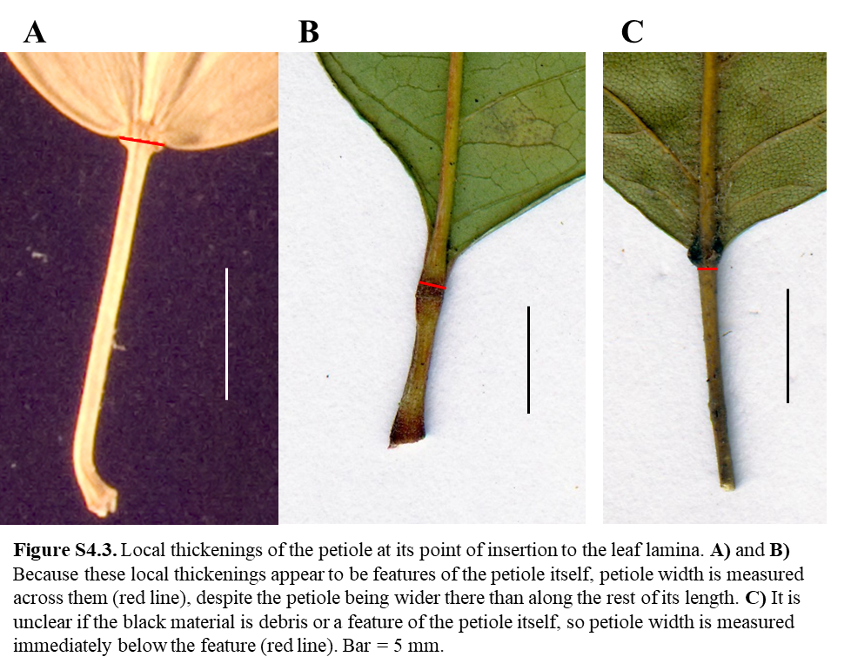
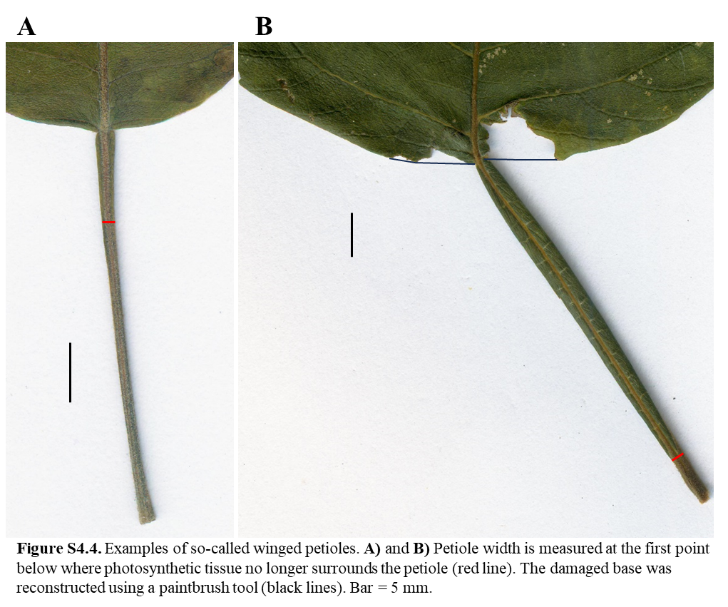
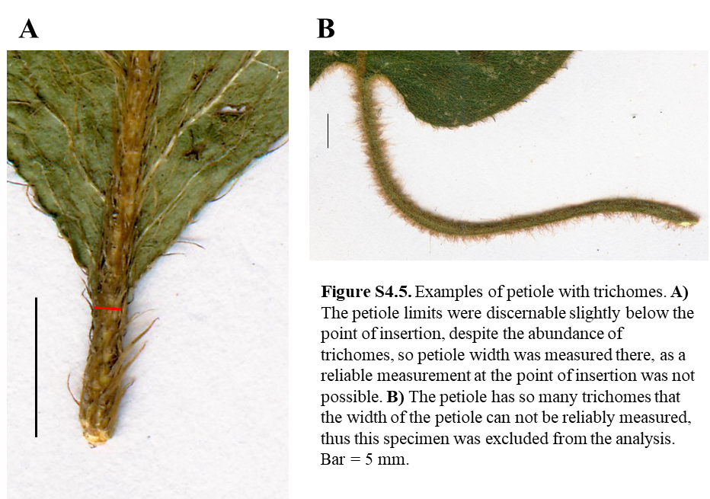
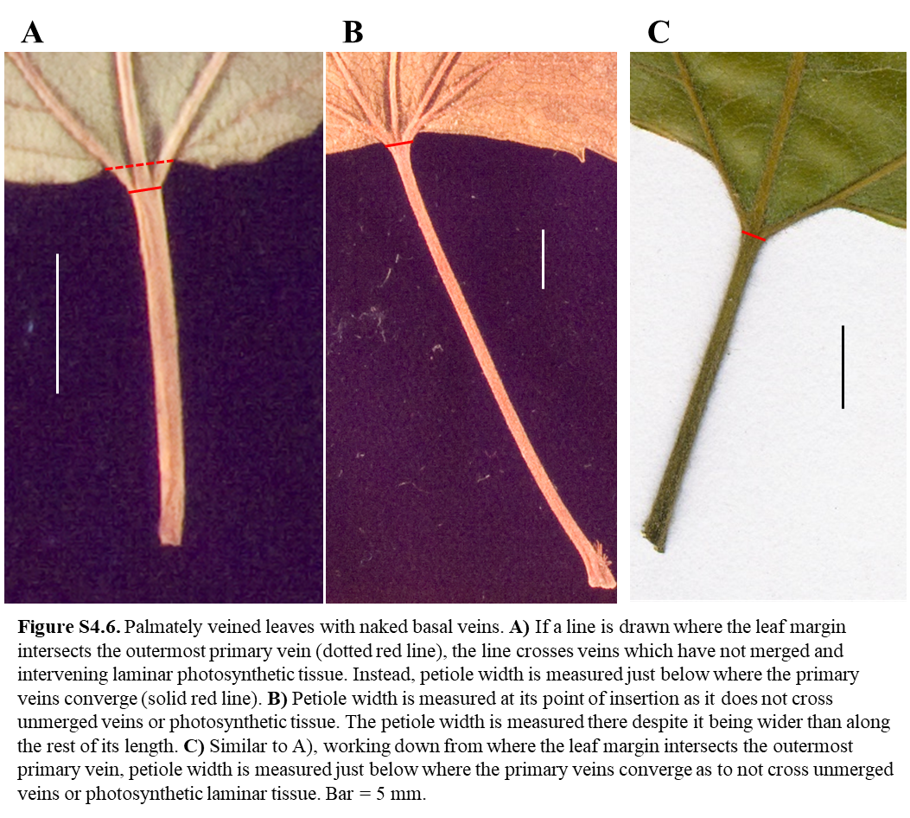
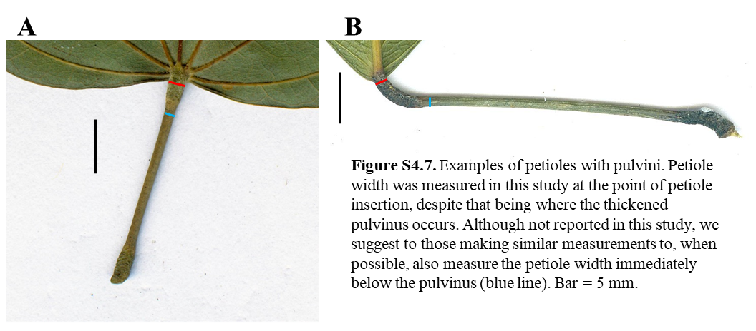
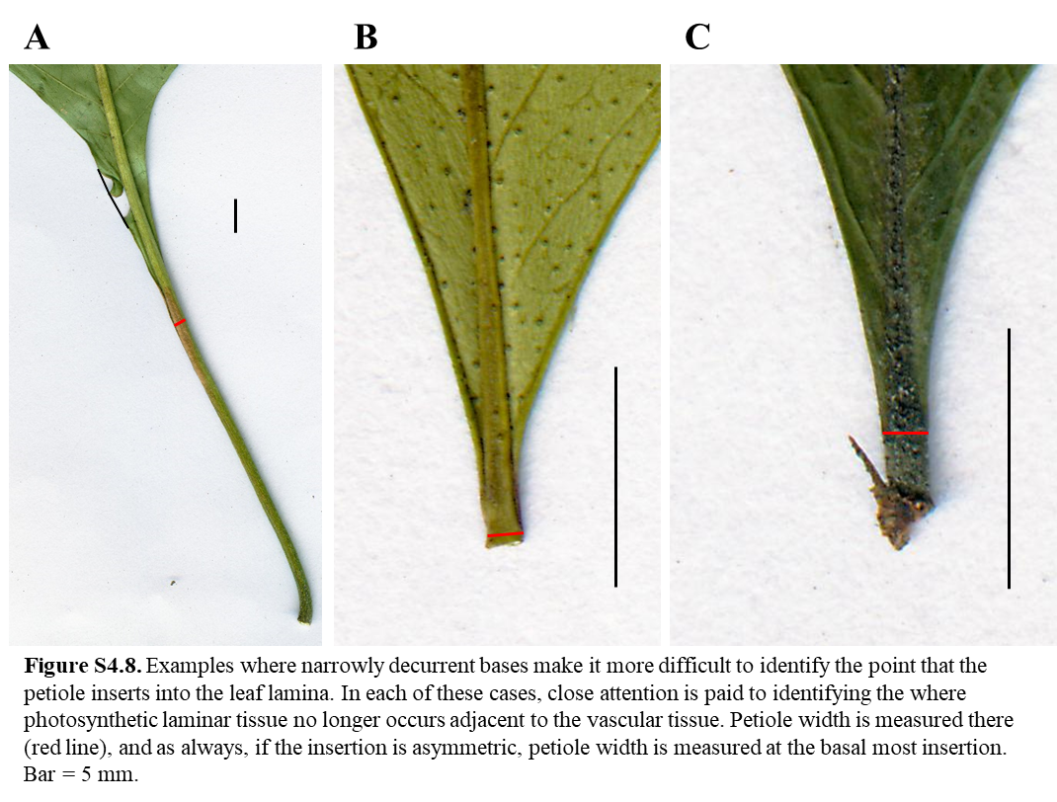
LITERATURE CITED
Butrim, M.J., Royer, D.L., Miller, I.M., Dechesne, M., Neu-Yagle, N., Lyson, T.R., Johnson, K.R. and Barclay, R.S., 2022. No Consistent Shift in Leaf Dry Mass per Area Across the Cretaceous—Paleogene Boundary. Frontiers in Plant Science, 13, p.894690.
Royer, D. L., L. Sack, P. Wilf, C. H. Lusk, G. J. Jordan, Ülo Niinemets, I. J. Wright, et al. 2007. Fossil Leaf Economics Quantified: Calibration, Eocene Case Study, and Implications. Paleobiology 33: 574–589.

Lowe et al. – American Journal of Botany XXXX – Appendix S5
Appendix S5: LMA measurements when leaf area is measured from fresh vs dried leaves.
Blonder et al. (2012) found that leaf area on average shrinks 22% during the process of leaf drying. Because leaf mass per area (LMA) is meant to measure leaf area available for light capture, it is typically advised that it be measured on fresh leaves before drying for subsequent mass measurements. Most of the sites incorporated from the Digital Leaf Physiognomy dataset have leaf area measured on dried leaves because that work took advantage of previous leaf collections housed in herbaria and lab collections. Leaf size shrinkage would result in higher LMA values by reducing leaf area but keeping dry mass constant. The same might be true for resulting petiole metric (PM) measurements. We tested this potential bias by seeing if LMA and PM were significantly higher within climate types for sites with dry area measured compared to sites where fresh area was measured, for climate types represented by ≥2 sites in each category. For LMA, Table S5.1 shows seven climate types with no significant difference. Of those climate types that did have significant differences, in arid climates, sites with dry area measured had lower LMA, counter to what was predicted (Figure S5.1A); tropical seasonally very dry sites were the only climate type where LMA was higher in dry leaves (Figure S5.1B). For PM, the only significant difference observed was in warm temperate dry winter sites (Table S5.1) where PM was lower for sites with dry area measurements, also counter to what was predicted (Figure S5.1C).

Table S5.1. T-test results of LMA and PM values where leaf area and petiole width were measured on dried vs. fresh leaves.
 | p-value
Climate type | LMA | PM
Arid | 0.003 | -
Cool temperate dry winter | - | 0.060
Cool temperate everwet | 0.450 | -
Tropical everwet | 0.404 | 0.391
Tropical seasonally dry | 0.835 | -
Tropical seasonally very dry | 0.018 | -
Warm temperate dry summer | 0.106 | -
Warm temperate dry winter | - | 0.015
Warm temperate everwet | 0.481 | 0.709

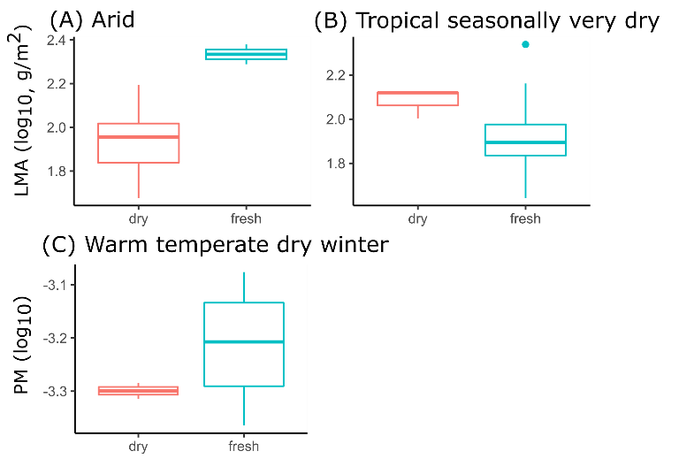
Figure S5.1. LMA and PM values where leaf area and petiole width were measured on fresh or dried leaves.
LITERATURE CITED
Blonder, B., V. Buzzard, I. Simova, L. Sloat, B. Boyle, R. Lipson, B. Aguilar-Beaucage, et al. 2012. The leaf-area shrinkage effect can bias paleoclimate and ecology research. American Journal of Botany 99: 1756–1763.

Lowe et al. – American Journal of Botany XXXX – Appendix S6
Appendix S6: Differing Log₁₀-transformation approaches.
Log₁₀-transformations were made to force the distribution of leaf mass per area (LMA) central moments across sites to normality, permitting reliable parametric statistics. There is the option to transform data at the leaf, species average, or site-central moment level. As several sites included from the TRY dataset only reported species averages, we considered the effect of log₁₀-transforming before and after the calculation of site central moments. Calculated community mean of LMA and petiole metric (PM) differed very little between the two transformation methods (Fig. S6.1A and Fig. S6.1B), though variance differed strongly (Fig. S6.1C vs. Fig. S6.1D). Log₁₀-transforming values after the calculation of site variance resulted in distributions across sites that were less right-skewed, compared to log₁₀-transforming species averages, and then calculating site variance (Fig. S6.1D). In addition, log₁₀-transforming species averages resulted in much less predictive power for LMA variance (Table S6.1). Thus, in this study, log₁₀-transformations were applied at the level of community LMA central moments (“transform after”).

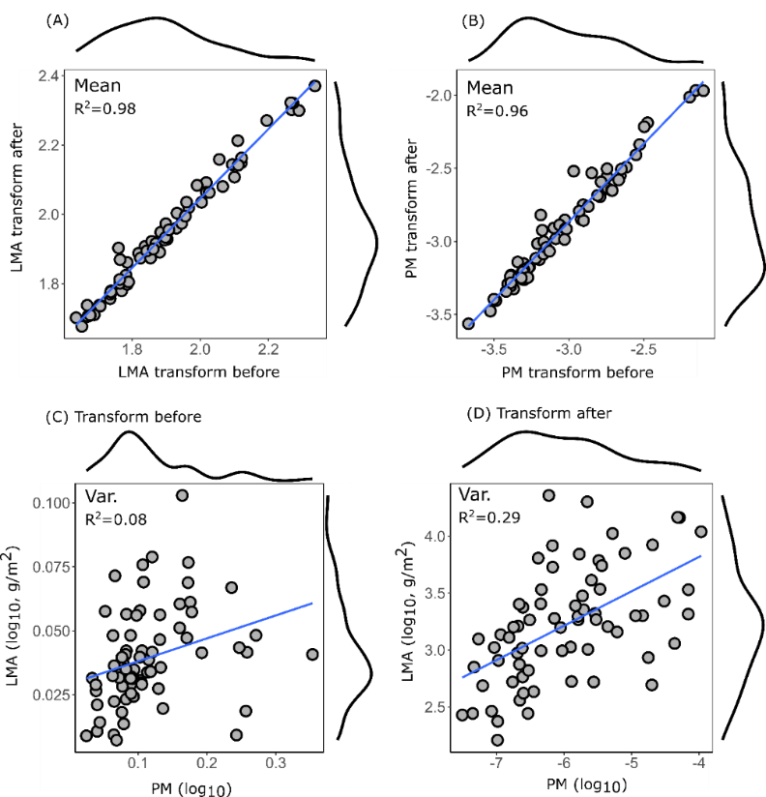
Figure S6.1. Comparison of LMA and PM when log-transformation were done before or after the calculation of site central moments.

Table S6.1. Strength of correlation between PM-LMA using different data transformation approaches.
Method | Central moment | PM-LMA Adj-R²
Transform after | Mean | 0.55
Transform after | Variance | 0.26
Transform before | Mean | 0.61
Transform before | Variance | 0.04

LITERATURE CITED
Brett, M. T. 2004. When is a correlation between non-independent variables “spurious”? Oikos 105: 647–656.
Jackson, D. A., and K. M. Somers. 1991. The spectre of ’spurious’ correlations. Oecologia 86: 147–151.
Niklas, K. J. 1994. Plant Allometry: The Scaling of Form and Process. University of Chicago, Chicago.
Royer, D. L., D. J. Peppe, E. A. Wheeler, and Ülo Niinemets. 2012. Roles of climate and functional traits in controlling toothed vs. untoothed leaf margins. American Journal of Botany 99: 915–922.
Royer, D. L., L. Sack, P. Wilf, C. H. Lusk, G. J. Jordan, Ülo Niinemets, I. J. Wright, et al. 2007. Fossil Leaf Economics Quantified: Calibration, Eocene Case Study, and Implications. Paleobiology 33: 574–589.

Lowe et al. – American Journal of Botany XXXX – Appendix S7
Appendix S7: Species-scale relationship between LMA and PM.
Species averages were compiled from those reported in Royer et al (2007) (blue; Fig. S7.1) and those measured more recently (red; Fig. S7.1), which includes measurements published in Royer et al. (2012) and those novel to this study (see Appendix S1). This resulted in 2,078 species-site pairs, compared to 667 species-site pairs presented in Royer et al. (2007). Petiole metric was remeasured for 65 species from 7 sites originally included in Royer et al. (2007) (green; Fig. S7.1). The gold lines mark the linear model (solid line; Fig. S7.1) and associated 95% prediction intervals (PI; dashed lines; Fig. S7.1) for this compilation, and is compared to the linear model presented in Royer et al. (2007) (blue line; Fig. S7.1). Both linear models are very similar, but there is larger scatter in the compilation herein (R²=0.37) compared to that presented in Royer et al. 2007 (R²=0.55). The linear regression is $\log_{10}\left(LMA\right)=2.918 +0.330 × \log_{10}(PM)$.
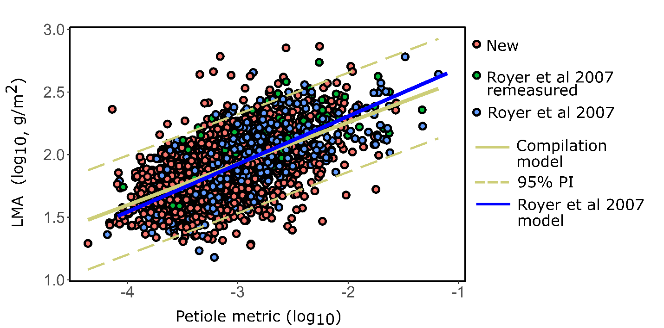
Figure S7.1. Species-level relationship between LMA and PM using the expanded dataset of this study. The linear model of Royer et al. (2007) is included for comparison.
LITERATURE CITED
Royer, D. L., D. J. Peppe, E. A. Wheeler, and Ülo Niinemets. 2012. Roles of climate and functional traits in controlling toothed vs. untoothed leaf margins. American Journal of Botany 99: 915–922.
Royer, D. L., L. Sack, P. Wilf, C. H. Lusk, G. J. Jordan, Ülo Niinemets, I. J. Wright, et al. 2007. Fossil Leaf Economics Quantified: Calibration, Eocene Case Study, and Implications. Paleobiology 33: 574–589.
Lowe et al. – American Journal of Botany XXXX – Appendix S8
Appendix S8: Probability density function within and between climate types.
Probability density functions (kernel density, Gaussian) of species-averaged measured leaf mass per area (LMA) for sites in different climate types (blue-green lines; Fig. S8.1) and the distribution when all of the sites within a climate type are combined into a single probability distribution function as a single representation for the entire climate type (black line; ‘climate type distributions’ used in the main text; Fig. S8.1).
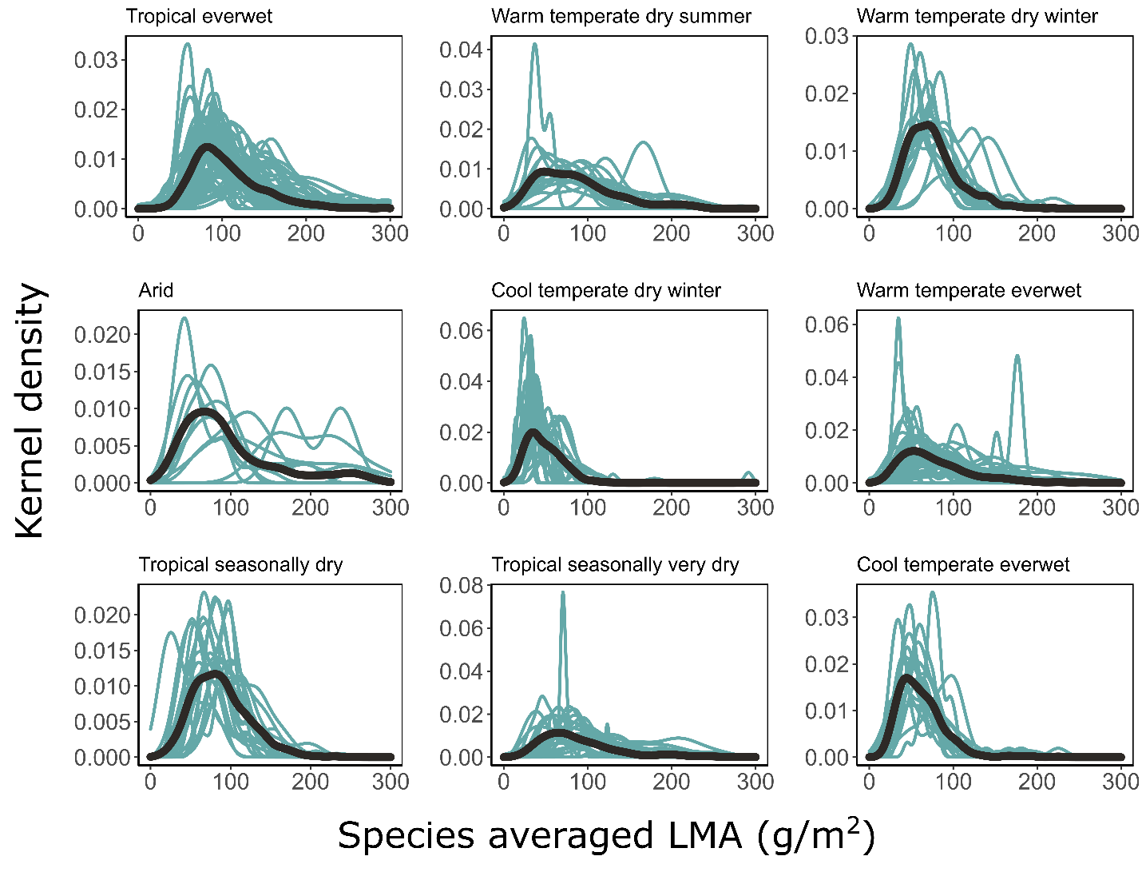
Figure S8.1. LMA distributions in different climate types.

Lowe et al. – American Journal of Botany XXXX – Appendix S9
Appendix S9: The relationship between % evergreen and continuous climatic variables.
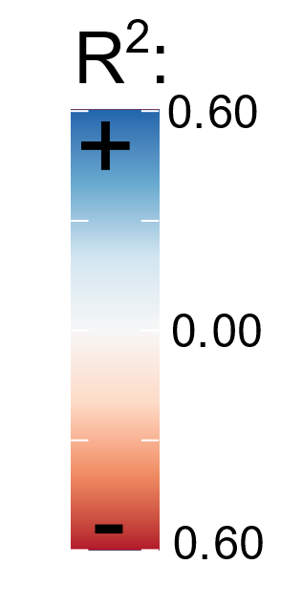
Figure S9.1 reports Adj-R² values calculated between the percentage of evergreen species in a community and several climatic variables (acronyms reported in Table 1 of main text). Values reported as negative and with warm colors represent negative relationships, cool colors represent positive relationships, and “X” represents non-significant relationships. The strongest relationship shows that as temperature seasonality (TS) increases and winters become colder (T cold Q), the percentage of evergreen species decreases. This trend was much stronger in temperate latitudes than tropical, where measures of temperature seasonality vary much less.
 | % Evergreen
Climate | All | Temp. | Tropics
TS | -0.55 | -0.45 | -0.19
MART | -0.52 | -0.50 | -0.05
T cold Q | 0.50 | 0.41 | 0.07
T warm Q | 0.12 | X | X
MAT | 0.39 | 0.25 | X
MAP | 0.24 | 0.07 | 0.07
P wet Q | 0.19 | 0.05 | 0.03
P wet M | 0.20 | 0.05 | X
P dry Q | 0.10 | X | 0.09
P dry M | 0.09 | X | 0.09
PS | X | X | -0.07
PET | 0.09 | 0.07 | -0.12
AI | 0.11 | X | 0.13
Figure S9.1. Correlation between % evergreen and climatic variables.

Lowe et al. – American Journal of Botany XXXX – Appendix S10
Appendix S10: Spurious correlations in LMA and PM relationships.
We recognize that in LMA-PM community-scale regressions of this study, and in the one first presented by Royer et al. (2007) at the species scale, leaf area occurs as the denominator in both PM and LMA, allowing potential for spurious correlation (Jackson and Somers, 1991; Brett, 2004). The extent of spurious correlation (X/Z vs. Y/Z type; Brett, 2004) was determined by creating a null model to use in testing for significant correlations between LMA and PM. This was done using the bootstrapping technique of Brett (2004), whereby random values of leaf mass, leaf area, and petiole width² were sampled from the pool of values within the dataset, with replacement. These random values were then used to calculate LMA and PM, matching the sample size of the observed dataset, and subsequently used to calculate correlation coefficients, slopes, and y-intercepts of LMA-PM relationships. This was repeated 1,000 times and the resulting distributions of correlation coefficients, slopes, and y-intercepts were compared to that in the observed dataset. For the new PM data presented in this study, measurements at several sites were done in units of pixels rather than metric units; both the observed and randomized data omitted these sites, only including sites measured with metric units.
We find that the PM and LMA relationship was significant, i.e., that the observed correlation coefficient was higher than those produced in the randomized data, for the Royer et al. (2007) species-scale data, but not for the species- or site-level relationships of this study (Fig. S10.1). Although the species-scale data of this study is a supplement to that in Royer et al. (2007), the inclusion of more species resulted in larger variation in leaf mass and petiole width² values (coefficients of variation of 131 vs. 148, and 102 vs. 133, respectively), which is known to increase the strength of spurious correlations (Brett, 2004). However, the slopes and intercepts of the spurious correlations differ from those of the observed dataset (Fig. S10.1).
Spurious correlations are less problematic when used as a means of prediction (i.e., predicting LMA from PM), rather than to infer mechanistic and biological meaning between the association (i.e., PM drives mechanistic variation in LMA; Brett, 2004). Thus, the relationships presented in this study offer a means of prediction but do not provide evidence that there is a biomechanical significance in the association of LMA and PM—an important assumption when predictions are extrapolated to the geologic past. There are three points of evidence from prior work which do provide support to this assumption.
First, the correlation aligns with biomechanical and developmental principles. Leaf biomechanics complies well with basic engineering principles applied to cantilevered beams, where a greater cross-sectional area of that beam can support a greater mass (Niklas, 1994). Second, the relationship of species-averaged LMA and PM presented in Royer et al. (2007) does not suffer from spurious correlation, i.e., the correlation coefficient is higher than that produced by randomized data, meaning that study does provide evidence that PM potentially drives mechanistic variation in LMA. The species-averaged compilation of this study, which is a supplement to that presented in Royer et al. 2007, includes 312% the number of species, resulting in greater variation of both LMA and PM values, and an overall weaker relationship. The greater noise introduced in this larger data set weakens the correlation coefficient, overlapping with what is expected from the spurious nature of the correlation alone. Thus, the overlap of the observed and spurious correlation coefficients here may then result from a lower signal-to-noise ratio in this expanded and more scattered dataset, but further investigations into the biological source of this “noise” are required. Lastly, for both species-averaged data presented in Royer et al. (2007), and the supplement presented here, petiole width² correlates strongly with both leaf area and leaf mass, but more strongly with leaf mass, as would be expected from a biomechanical perspective, rather than simply a size-scaling relationship (Fig. S10.2). A potential future alternative to reconstructing LMA for fossil leaves while avoiding any potential for spurious correlation is to predict leaf mass from petiole width² (Fig. S10.2), and then divide reconstructed leaf mass by the measured leaf area, although we prefer to utilize the approach used by previous work in this study, to make our finding more compatible with interpretations of those studies.
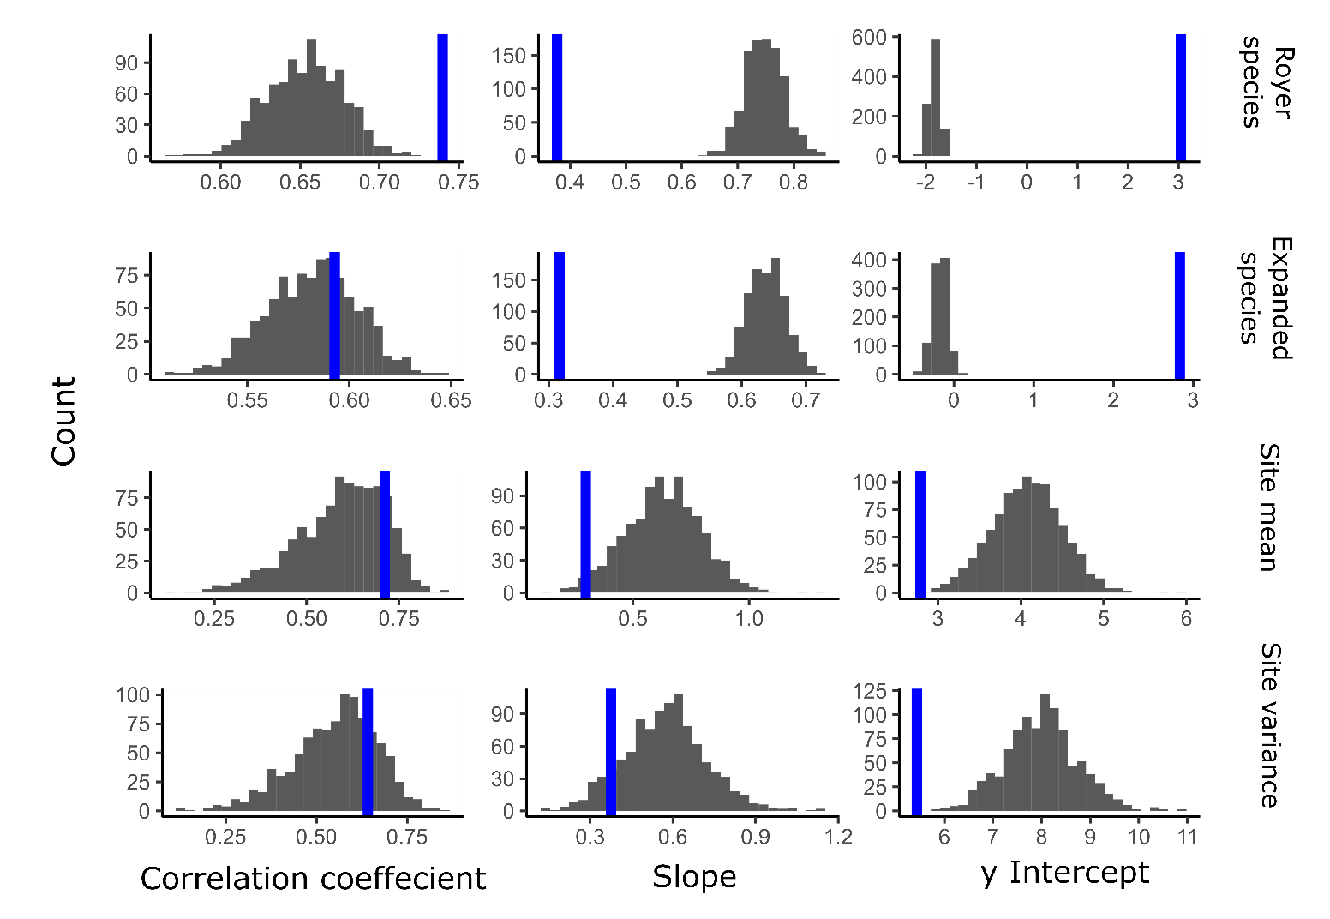
Figure S10.1. Comparisons of the observed coeffecients of the petiole metric (PM) vs. leaf mass per area (LMA) relationship for different datasets (blue lines) compared to a null model (grey bars, n = 1000). The null model describes the strength and nature of the relationship based solely on the spurious effect of leaf area being shared in the denominators of PM and LMA.
Royer species = the data of Royer et al. (2007); Expanded species = the data of Royer et al. (2007) supplemented with measurements from Royer et al. (2012) and new measurements made in this study (see Appendix S1); Site mean and Site variance = the community-scale distributions presented in this study, though representing a subset of sites whose traits were measured in metric units rather than pixels.

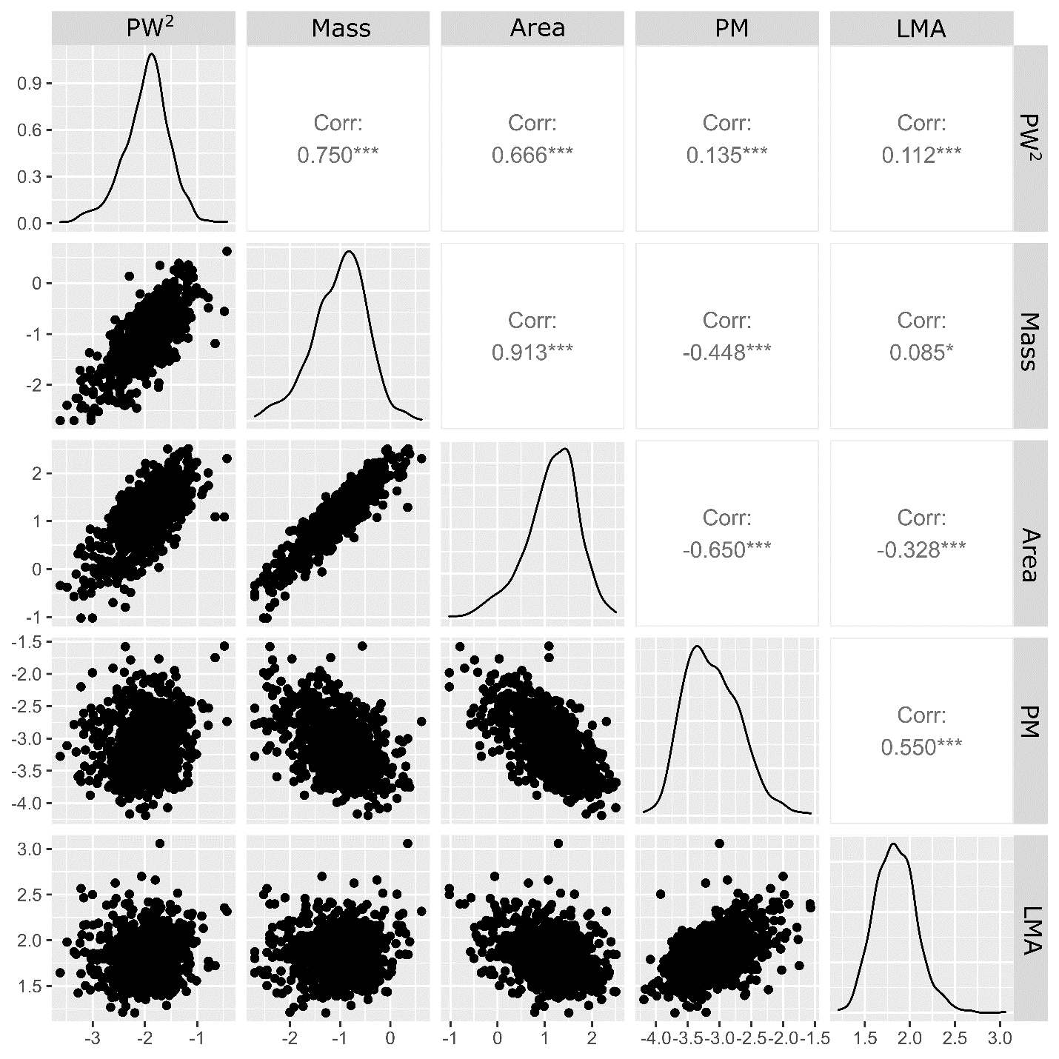
Figure S10.2. Relationships of the various components of leaf mass per area (LMA) and petiole metric (PM), including petiole width² (PW²), leaf mass, and leaf area. Pearson correlation coeffecients are plotted diagnol to each plot. Asterices represent levels of statistical signficance. All values are log₁₀-transformed.

Lowe et al. – American Journal of Botany XXXX – Appendix S11
Appendix S11: Offset between measured and reconstructed LMA.
To simulate a fossil leaf assemblage, community mean and variance of leaf mass per area (LMA) was “reconstructed” at sites where petiole metric (PM) was measured using the established relationships between log₁₀(LMA) and log₁₀(PM) presented in the main text. To avoid circularity, a jackknife method was employed so that each site was excluded from the generation of the regression equation used to reconstruct its LMA. Reconstructed log₁₀(LMA) was then back-transformed by applying it as an exponent raised to the power of 10. The LMA offset was calculated for each of these sites as the difference between reconstructed LMA and measured LMA, such that negative values represent an underestimation and positive values an overestimation. As a whole, reconstructed LMA mean did not consistently over- or underestimate measured LMA mean (Fig. S11.1A), with a median offset of 0.22 g/m² (interquartile range [IQR] = 28.0), though sites in tropical everwet and tropical seasonally very dry were all underestimated, and cool temperate everwet sites were consistently overestimated, but not by much (ranging -6.1 to 31.2 g/m²). There was also not a consistent over- or underestimation of variance as a whole, with a median offset of 23.1 (IQR = 2006.4), and there was no strong pattern of offset in different climate types (Fig. S11.1B).
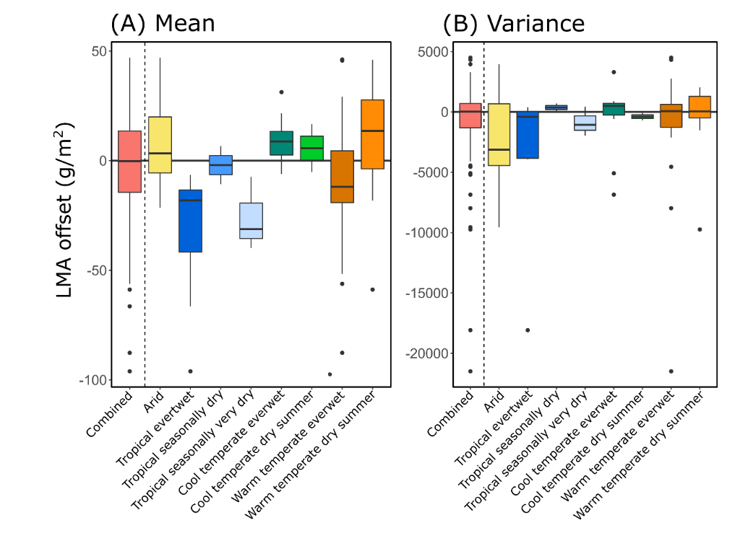
Figure S11.1. The offset between measured and reconstructed LMA for all sites and seperated by their climate type.
Lowe et al. – American Journal of Botany XXXX – Appendix S12

Appendix S12: Abundance- vs. species-weighted measured of LMA mean and variance.
Community leaf mass per area (LMA) mean was compared when calculated with species weighted evenly (species-weighted mean) and when species were weighted by their total stem basal area within the sampled 0.1 ha plot (abundance-weighted mean). This was done for the subset of sites incorporated from Wieczynski et al. (2019), which were the only where accompanying stem basal area data were available. There was high correspondence between abundance-weighted and species-weighted values for mean (Adj-R² = 0.85; Fig. S12.1A), though no significant relationship for variance (Fig. S12.1B).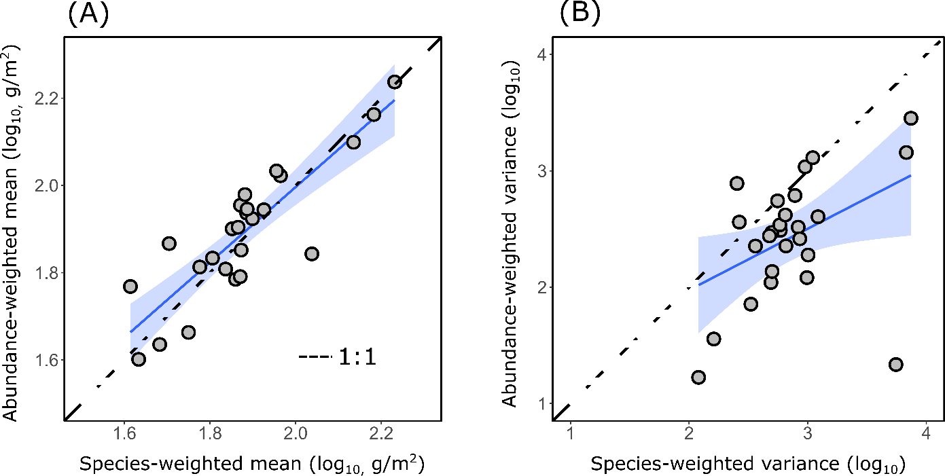
Figure S12.1. LMA mean and variance calculated using weighted and unweighted approaches.
LITERATURE CITED
Wieczynski, D. J., B. Boyle, V. Buzzard, S. M. Duran, A. N. Henderson, C. M. Hulshof, A. J. Kerkhoff, et al. 2019. Climate shapes and shifts functional biodiversity in forests worldwide. Proceedings of the National Academy of Sciences 116: 587–592.
Lowe et al. – American Journal of Botany XXXX – Appendix S13
Appendix S13: Potential cutoffs to distinguish evergreen- from deciduous-dominated communities.
Leaf mass per area (LMA) mean was reconstructed at sites where petiole metric data was measured to assess the potential that LMA cut-off values could signify a high probability of a community being either deciduous- or evergreen-dominated (i.e., >50% of species in the community deciduous or evergreen). Figure S13.1 plots the reconstructed LMA mean of sites in ascending order. The graph indicates that 75% of sites with a mean LMA of 80 g/m² and below (dotted line) were deciduous-dominated while 80% of sites with a mean LMA of 140 g/m² or greater (dotted line) were evergreen-dominated. Therefore, fossil plant sites with reconstructed LMA means of <80 g/m² have a high probability of being deciduous-dominated, while those with LMA means of >140 g/m² have a high probability of being evergreen-dominated. Absolute values between these cutoffs do not offer a means to reliably predict dominance class.
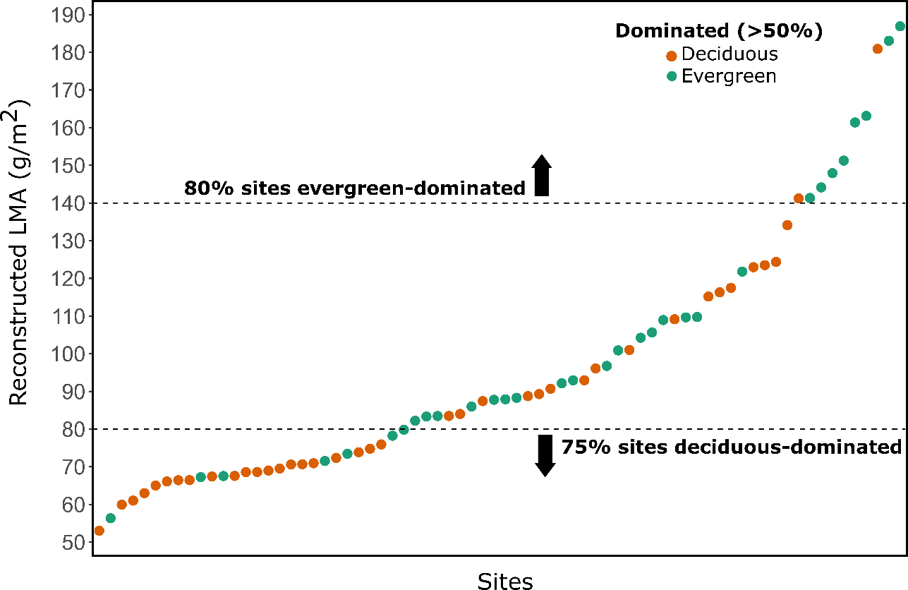
Fig. S13.1. Site reconstructed LMA with cutoffs defined for deciduous-dominated and evergreeen-dominated communities.

