Hemigrapsus nudus Feeding on Ulva lactuca When Exposed to High Salinity and High Temperature

Ariyanna Pyles

May 27th, 2022

FHL 470: Research in Marine Biology

Abstract
Hemigrapsus nudus is a species of crab that dominates the intertidal of the Pacific Coast in North America, making them valuable to the intertidal ecosystem through their large contribution to the food web. H. nudus is exposed to a wide range of salinities and temperatures within the intertidal. To determine if elevated salinities and temperatures affect H. nudus I conducted a study to monitor the crabs feeding on Ulva lactuca when exposed to different conditions: high salinity, high temperature, and ambient control. I hypothesized that high salinity and high temperature will have an impact on H. nudus feeding. The crabs exposed to high salinity showed the greatest variance in consumption rate. However, an R generated ANOVA showed no difference in the feeding rate of H. nudus when exposed to the different treatments. Overall, H. nudus showed no detectable response to slight elevations in temperature and salinity.

Introduction
Physical conditions vary greatly across intertidal environments (Wan, 1991). These conditions include wide variation in temperature and salinity that many organisms within the intertidal must tolerate (Todd & Dehnel, 1960). Such organisms include Hemigrapsus nudus, also known as the purple shore crab. This crab inhabits the middle to low intertidal rocky shore where it feeds mostly on green algae including Ulva lactuca (Oliver & Schmelter, 1998; Birch, 1979). H. nudus dominates the intertidal areas along the Pacific Coast within North America (Low, 1970) and is an integral part of the intertidal food webs.
With such expansion along the Pacific, H. nudus is a vital part to the intertidal ecosystem and understanding how they handle intertidal conditions such as high temperature and salinity is important. It has been found that when H. nudus is exposed to high salinity and high temperature, its oxygen consumption increases because it is a hyperosmoregulator (Hulbert et al., 1976; Corroto & Holliday, 1996). While the responses of H. nudus’s increased oxygen consumption to high salinity and temperature have been tested, the impacts to their feeding rate on U. lactuca have yet to be individually tested (Hulbert et al., 1976; Corroto & Holliday, 1996).
The purpose of this paper is to further understand the feeding rates of H. nudus when exposed to high salinity and high temperature. To do so, I analyzed the feeding rate of H. nudus local to Friday Harbor Labs under flow tank conditions of high temperature, high salinity, and ambient control over the course of four days. I hypothesize that high salinity and high temperature would have an impact on H. nudus feeding.

Methods
I collected 15 crabs from the shores of Friday Harbor Labs (FHL), and equally divided them into three flow tank conditions: high salinity, high temperature, and ambient control. After one day of acclimation in the control tank, one group of crabs was put in the high salinity treatment and the other in the high temperature treatment.
Every night at 7pm I weighed out 3g of U. lactuca for each treatment of crabs and adjusted the salinity and temperature of the treatment tanks to their corresponding conditions. I made sure that the high temperature tank was at 18℃ by adjusting the tank heaters and that the high salinity tank was around 35ppt by using a refractometer and adding salt pellets to the water. Every morning at 9am I removed the U. lactuca from each tank, weighed and recorded how much each group had consumed. Then I altered the tanks to their corresponding conditions again when it was needed. I repeated this process over the course of four days.
After all data was collected the crabs were released back to the shores of FHL and data analysis in R was conducted. A box and whiskers plot was created from the data and an ANOVA test was run to determine the significance.
Results
The H. nudus exposed to high salinity had the greatest weight and widest variance of U. lactuca consumed (Figure 1). The ambient control treatment had the lowest variance of consumption, and the high temperature treatment was in between in its variance (Figure 1).
The ANOVA in Table 1 shows that there is no significant difference in variance between the crabs' feeding rates when exposed to diverse tank conditions (p > 0.05 and F = 0.08).
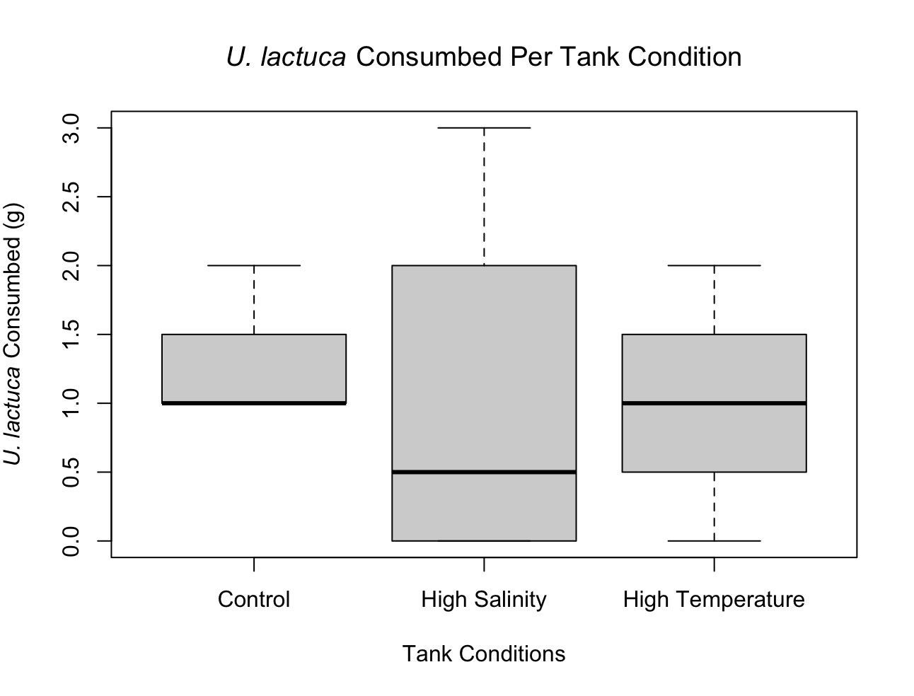
Figure 1 - A box and whiskers plot comparing the weight of U. lactuca consumed by H. nudus in their respective treatment conditions (Control, High Salinity, and High Temperature) over the course of four days.
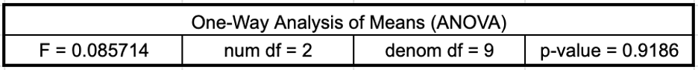
Table 1 - A One-way ANOVA table generated by R, showing the significance of the data collected when comparing the weight of U. lactuca consumed between each tank condition.

Discussion
I found no significant difference in feeding rate of H. nudus when exposed to high salinity and high temperature. While Figure 1 did show some differences in U. lactuca consumption, the ANOVA from Table 1 provides statistical support that there is no variance in H. nudus feeding (p > 0.05 and F = 0.08). Therefore, I cannot reject the null hypothesis that high salinity and high temperature does not have an impact on feeding in H. nudus.
When comparing this study to others, some factors were found that helped interpret the results. Reasons why a higher temperature might have not caused a change in feeding is because H. nudus, when acclimated to 10℃, have a greater thermal tolerance to high temperatures (McGaw, 2003). As for salinity, when H. nudus is exposed to higher salinities, they generally become more aversive (Frank & Meyer, 1972). However, salinity does not alter the crab’s behavior much if they are provided with sufficient shelter (McGaw, 2001). Since the ambient temperature of water at FHL is 10℃ and the crabs were given sufficient cover, it could have influenced the results of no detectable feeding behaviors under diverse tank conditions.
If I were to repeat this experiment, I would adjust some of the treatment conditions to produce stronger feeding responses from the crabs. I would increase the high temperature to be in the 20℃ range and provide a more reliable method to maintain a high salinity in a flow tank as it varied throughout the experiment. Even though the crabs exposed to the high salinity had the most diverse U. lactuca consumption of the other groups, there was no significant data gathered from the experiment.

References
Birch, D. W. (1979). Food preferences of Hemigrapsus nudus (Dana, 1851)(Decapoda, Grapsidae) on San Juan Island, Washington, USA. Crustaceana, 36(2), 186-188.

Corotto, F. S., & Holliday, C. W. (1996). Branchial Na, K-ATPase and osmoregulation in the purple shore crab, Hemigrapsus nudus (Dana). Comparative Biochemistry and Physiology Part A: Physiology, 113(4), 361-368.

Frank, L. H., & Meyer, M. E. (1972). Activity as a function of salinity in two species of intertidal crab, Hemigrapsus oregonensis and Hemigrapsus nudus. Psychonomic Science, 27(3), 169-170.

Hulbert, W. C., Schneider, D. E., & Moon, T. W. (1976). Temperature and salinity adaptation in the purple shore crab Hemigrapsus nudus: an in vitro physiological study with excised gills. Marine Biology, 36(3), 217-222.

Low, C. J. (1970). Factors affecting the distribution and abundance of two species of beach crab: Hemigrapsus oregonensis and Hemigrapsus nudus (Doctoral dissertation, University of British Columbia).

McGaw, I. J. (2001). Impacts of habitat complexity on physiology: purple shore crabs tolerate osmotic stress for shelter. Estuarine, Coastal and Shelf Science, 53(6), 865-876.

McGaw, I. J. (2003). Behavioral thermoregulation in Hemigrapsus nudus, the amphibious purple shore crab. The Biological Bulletin, 204(1), 38-49.

Oliver, J., & Schmelter, A. (1998). Life History of the native shore crabs Hemigrapsus oregonensis and Hemigrapsus nudus and their distribution, relative abundance, and size frequency distribution at four sites in Yaquina Bay, Oregon.[Online] Oregon State University.

Todd, M. E., & Dehnel, P. A. (1960). Effect of temperature and salinity on heat tolerance in two grapsoid crabs, Hemigrapsus nudus and Hemigrapsus oregonensis. The Biological Bulletin, 118(1), 150-172.

Wan, H. (1990). Population distribution and some aspects of the reproductive biology of two species of shore crab Hemigrapsus nudus and Hemigrapsus oregonensis at Bamfield, Vancouver Island, British Columbia, Canada.

