Dietary preferences of the green sea urchin, Strongylocentrotus droebachiensis, for dried macroalgae

Allison Nichols
Friday Harbor Laboratories, University of Washington
FHL 470: Research in Marine Biology
Dr. Terrie Klinger
May 24, 2022

Abstract
The harvesting of sea urchins for gonad production has taken place worldwide and is increasing in demand. However, formula feed can be costly and difficult to obtain. Here we investigate the dietary preferences of green urchins, Strongylocentrotus droebachiensis, with dried macroalgae as an alternate food source in sea urchin aquaculture, for it may be more sustainable and cost-effective. Saccharina latissima was consumed more compared to the other dried macroalgae, Mazzaella splendens, and Costaria costata. Harvesting and supplementing feed with dried Saccharina latissima may serve as a new avenue for sea urchin aquaculture.
Introduction
Sea Star wasting disease (SSW) has resulted in mass mortality of asteroids ranging from the Alaskan Aleutian Islands to Baja California (Harvell et al., 2019). The sunflower sea star, Pycnopodia helianthoides (Brandt 1835), was one of the species most severely impacted by SSW (Hodin et al., 2021). Sunflower stars help to maintain population control of green and purple urchins through predation. However, with the decline of sunflower stars, the urchin population increased drastically and was left unchecked. Urchins, specifically the genus Strongylocentrotus, are dominant grazers of kelp beds, which are ecologically important sources of primary productivity, providing habitat and food (Dexter et al., 2014).
As macroalgae abundance and food availability decrease, sea urchin feeding behavior switches from passive to active foraging. Active grazing of kelp forests by urchins transformed forest reefs into sea urchin barrens that are devoid of macroalgae (Smith et al., 2020). Gonad production declines with active grazing in order to conserve energy. The term “zombie urchins” was coined to describe sea urchins with decreased gonads resulting from lost food supply. They do not always die but enter an almost dormant state (Handel 2022).
Sea urchins have been harvested for their gonads worldwide and there is an increasing interest in sea urchin aquaculture. A potential tool for reverting sea urchin barrens into vegetated habitats is the harvesting of sea urchins (Piazzi et al., 2019). However, the harvesting of wild sea urchins may not be economically viable due to poor gonad quality. It is possible that these wild-caught urchins may be useful for aquaculture if their gonads can be enhanced through formula feed (Carrier et al., 2017).
This study aims to evaluate the feeding preferences of green urchins, Strongylocentrotus droebachiensis (O.F. Müller 1776), with dried macroalgae. I introduced three different types of dried macroalgae, Saccharina latissima, Costaria costata, and Mazzaella splendens. Developing feed that is cost-effective and produces high gonad yields will help to make sea urchin aquaculture an economically viable endeavor (Carrier et al., 2017). From an aquaculture perspective, it will be advantageous to understand the feeding preferences of green sea urchins among three species of dried macroalgae.
Material and methods
S. droebachiensis were collected from sea tables at Friday Harbor Laboratory, San Juan Island Washington. Prior to the experiment, the green urchins (n =10) were kept in a tank with other marine invertebrates at ambient temperature and flow. The green urchins were placed in two 56-gallon outdoor tanks at ambient temperature and flow. In each tank, five urchins were separated into individual containers with mesh lids and holes allowing flow.
Algae preparation began with the collection of multiple blades of Saccharina latissima, Costaria costata, and Mazzaella splendens from Friday Harbor Laboratory docks in the San Juan Islands. The macroalgae were hung and airdried for twenty-four hours. Each species was then cut and divided into samples for feeding. The dehydrated seaweed was weighed before being fed to the green urchins. The seaweed was rehydrated once placed in each container and was left for twenty-four hours for consumption.
After collecting the consumed rehydrated seaweed, it was placed on a tray to redry before weighing again. After five days of sampling, I calculated the amount of seaweed consumed from initial to final weight.
Statistical analysis of the data was performed with ANOVA with a Kruskal Wallis test and Turkey HSD with R studio. For all tests, P < 0.05 was considered significant.
Results
Data from the trials are shown in Figure 1. There was a significant difference in the dietary preference of sea urchins among the three species of dried macroalgae. Saccharina latissima was consumed more compared to the other species, Costaria costata, and Mazzaella splendens (P < 0.5). However, there were no significant differences between preferences between species Costaria costata, and Mazzaella splendens (P > 0.5).
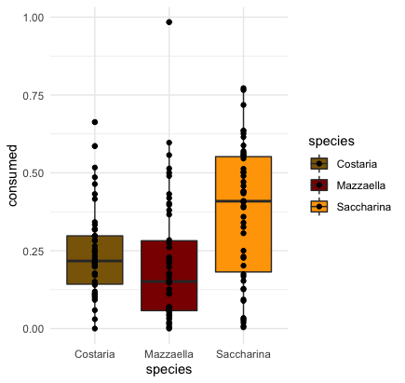
Fig. 1. Consumption of dried macroalgae (grams). Points represent the individual measure of daily consumption from the sea urchin. Means with bars are shown. (ANOVA: Kruskal-Wallis’s test, P = 8.811 x 10⁻⁵)
(Species to species p-value: Mazzaella – Costaria P = 0.667 : Saccharina– Costaria P = 0.0015 : Saccharina – Mazzaella P = 0.0000612)

Table 1. Distribution of consumed dried macroalgae. Saccharina was preferred over Mazzaella and Costaria.

Species | Min. (g) | 1st Qu. (g) | Median (g) | Mean (g) | 3rd Qu. (g) | Max. (g)
Costaria | 0 | 0.1425 | 0.217 | 0.2407 | 0.2978 | 0.663
Mazzaella | 0 | 0.0575 | 0.151 | 0.2084 | 0.282 | 0.984
Saccharina | 0.004 | 0.1817 | 0.409 | 0.374 | 0.552 | 0.772

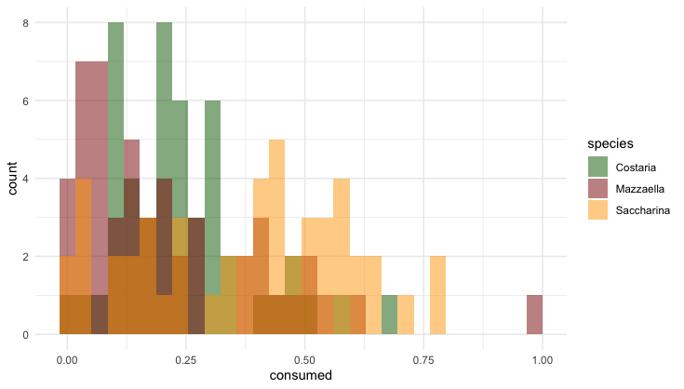
Fig. 2. Histogram distribution of macroalgae consumed by species.

Discussion
My results demonstrate that Saccharina latissima is preferred over the other two species of macroalgae. When using dried macroalgae for aquaculture, Saccharina latissima could be advantageous for alternate feeding methods. From an aquaculture perspective, finding dietary supplies that are environmentally sustainable and cost-effective is key in advancing the industry. The nutritional and dietary preferences of sea urchins are a crucial factor in the success of sea urchin aquaculture (Kennedy et al., 2007).
It is noted that I was unable to investigate the relationship between dried seaweed diets and gonad quality. Further research into the effects of diet on gonad quality and the utility of dried S. latissima will be required to optimize and advance sea urchin aquaculture. One of the main growth requirements in echinoids is dietary protein (Kennedy et al., 2007). It would be advantageous to investigate the dietary preferences of sea urchins in relation to protein concentrations in dried macroalgae.
Harvesting from sea urchin barrens coupled with the use of dried S. latissima as feed supplement has the potential to serve as a new avenue for mitigating the decline of macroalgal forests. As destructive urchin foraging continues to decimate kelp forests, it is important to look for alternate solutions. The use of dried S. latissima may be a crucial step in developing a more sustainable and cost-effective solution in sea urchin aquaculture.

References

Carrier, T.J., Eddy, S.D. & Redmond, S. (2017) Solar-dried kelp as potential feed in sea urchin aquaculture. Aquaculture Int 25, 355–366
Dexter, K., & Scheibling, R. E. (2014). Sea urchin barrens as alternative stable states of collapsed kelp ecosystems. Marine Ecology Progress Series, 495, 1–25.

Handel, Steven. (2022) Zombie Urchins, Sea Otters, and the Hidden Reach of Restoration. Ecological Restoration, Vol 40, Issue 1, 1-2
Harvell, C. D., D. Montecino-Latorre, J. M. Caldwell, J. M. Burt, K. Bosley, A. Keller, S. F. Heron, A. K. Salomon, L. Lee, O. Pontier, et al. 2019. Disease epidemic and a marine heatwave are associated with the continental-scale collapse of a pivotal predator (Pycnopodia helianthoides). Sci. Adv. 5

J. Hodin, A. Pearson-Lund, F. P. Anteau, P. Kitaeff, and S. Cefalu. (2021). Progress Toward Complete Life-Cycle Culturing of the Endangered Sunflower Star, Pycnopodia helianthoides. The Biological Bulletin

Kennedy, Edward. Robinson, Shawn. Parson, Jay. Castell, John. (2007). Effect of Protein Source and Concentration on Somatic Growth of Juvenile Green Sea Urchins Strongylocentrotus droebachiensis. Journal of the World Aquaculture Society. Vol 36, 3/ 320-336.

McBride, Susan. (2005) Sea urchin aquaculture. American Fisheries Society. University of California, California, USA.
Pearce, C. M., Daggett, T. L., & Robinson, S. M. C. (2004). Effect of urchin size and diet on gonad yield and quality in the green sea urchin (Strongylocentrotus droebachiensis). Aquaculture, 233(1-4), 337–367.

Piazzi, L., Ceccherelli, G. (2019) Effect of sea urchin human harvest in promoting canopy-forming algae restoration. Estuarine, Coastal and Shelf Science. Vol 219, 5/ 273-277

S.M. Robinson. (2003) The evolving role of aquaculture in the global production of sea urchin
J.D. Lawrence (Ed.), Sea Urchins-Fisheries and Ecology: Proceedings of the International Conferences on Sea Urchin Fisheries and Aquaculture Chile March 25–27, DEStech Publications Inc./Lancaster, PA, USA
Smith, J. G., Tomoleoni, J., Staedler, M., Lyon, S., Fujii, J., & Tinker, M. T. (2021). Behavioral responses across a mosaic of ecosystem states restructure a sea otter–urchin trophic cascade. Proceedings of the National Academy of Sciences, 118(11).

