DBT Skills Training as a Treatment Strategy for Female Survivors of Human Trafficking
Jessica J. Gayle
University of Washington

Abstract

This paper will include suggestions for the first six group sessions using Dialectical Behavior Therapy for adults who were victims of sex trafficking in their youth. Group therapy involving DBT primarily focuses on skills training in the areas of distress tolerance, mindfulness, interpersonal skills and emotional regulation. DBT stresses the didactic of acceptance and change, purporting that for change to be lasting and meaning one must first accept things as they are without judgment and without making attempts to avoid pain or discomfort. By helping adults understand the ways in which they are in control of their emotional and intellectual functioning, and to which degree they give up control when trying to avoid pain, the hope is to build upon the strengths that they already have, enable them to tolerate the realities of their experiences and to assist them in creating new and healthier thoughts, emotions and behaviors that will bring about new understandings of past events and for events that they will struggle with in the future.

Format
The Journal of Specialists in Group Work contains a model for working with groups and for choosing activities appropriate to the different group stages. DBT skills training has a built -in mechanism for achieving the same results as it is specifically designed to be a careful and conscientious mode of therapy that was originally designed to meet the needs of populations of clients who experienced elevated levels of self-injury, suicide attempts and who present with the highest ratio of successfully completed suicides. There is no room for error in the primary phases of therapy and the design of DBT hopes to ensure that there won’t be.
This group will meet 2 times a week as is customary for DBT skills training, for 1.5 hours per session, and to last for two 16 week cycles, which has been shown to be of the most effective duration for creating lasting and meaningful change (Linehan, 2015). The role of a DBT skills trainer is to not only teach clients how to master skills that foster positive change but to always validate the emotional states, and behaviors of their clients. Even about self-injurious behavior, a DBT therapist conveys an understanding of why the cutting of one’s self made a certain type of sense given the world their client was experiencing. This doesn’t however hinder a therapist from suggesting diverse ways to either tolerate or feel pain. A common sentiment for those individuals that have been sexually exploited is that they are damaged goods. Although a therapist knows this to not be true, they still also know how powerful a message is carried by the act of sexual exploitation and how coupled with society’s ideas surrounding sexual acts outside of love or legacy (whether for a fee, free, forced or given away), an individual ultimately comes to internalize certain messages about themselves. For this individual, this is as good as true and providing a space where the dichotomous nature of their belief can be respectfully and delicately challenged in a way that leads to the client themselves debunking their own myth is exactly the kind of work that generates meaningful and lasting change. Endlessly trying to convince a person who has been sexually exploited that this sentiment simply isn’t true is not likely to go very far in being therapeutic. There is nothing in the statement that explains “why” she isn’t broken, nor does it introduce any new understandings. It is said that the only way to truly break a cycle of PTSD, is through the introduction of new and novel information becoming paired with the memory of an event. The helpful discovery of this new and novel information is at the heart of a DBT therapist’s responsibility to their clients.
Per Linehan, it is the co-leader of a skills group whose role is more diverse as well as more involved. “she mediates tensions that arise between members and the primary leader, providing a balance from which a synthesis can be created. Second, while the primary group leader is looking at the group the co- leader keeps a focus on each individual member, noting any need for individual attention and either addressing that need directly during group sessions or consulting with the primary leader during breaks. Third, the co- leader serves as a co- teacher and tutor, offering alternative explanations, examples, and so on. The co- leader may move his or her seating around the group as needed to assist participants in finding the right handouts or worksheets or to provide needed support. The co- leader is often the person who keeps track of the homework assignments. This is especially important when special individual assignments are given to one or more participants in the group. In these cases, it is also the co- leader who is charged with remembering the various assignments. There is a third dimension to leadership in the application of DBT that isn’t present in any other modality of therapy. This entity is known as the DBT Consultation team. Again, in Linehan’s words,” The DBT consultation team serves as the third point providing the dialectical balance between the two co- leaders, much as the co- leader does between the primary leader and a group member in a group session. Thus, the function of the DBT consultation team is to highlight the truth in each side of an expressed tension, fostering reconciliation and synthesis (Linehan, 2015).

Referral to Group
Members of this group were referred to it from their individual therapist’s once the therapist ascertained that enough progress had been made to accept the requirements inherent in DBT therapy. Most individuals are in one on one therapy for at least a year before DBT therapy is recommended. All individuals were trafficked before the age of 16 years old and for a minimum of 2 years.
Best Practices
In the 2012 Report published by the Department of Justice for the State of California, many recommendations are made for best practices. Of those that specifically apply to mental health and therapy, a victim-centered approach is suggested that includes training police officers and first responders on how to spot and respond to human trafficking. Assurance that victims are made aware of and have access to critical services to meet their immediate safety, health and housing needs is also a necessity. Thirdly, the internet, social media, and mobile devices should also provide new avenues for outreach to victims of human trafficking. Human trafficking victims should be permitted to expunge records of a conviction that resulted from forced labor or services, and caseworkers should be offered confidentiality privilege training. It is also suggested that reporting of human trafficking become a mandatory reportable event for medical professionals as this is not currently the case. Increasing access to long term care centers and legal services and the assurance that eligibility for CalVCP benefits are specific enough to meet victim’s needs are also recommended.
While the victimization experienced in their youth by way of sexual exploitation will be very much at the center of the work we do, this group will concentrate more on the secondary effects of human trafficking. For example, it is common knowledge among those who study the phenomenon of sexual exploitation that having been a victim of such abuse in youth puts a person in a likely position of experiencing multiple revictimizations over the course of their life. This also causes disrupted development and disrupted transitions as the transition to adulthood is precocious or worded differently, altogether too swift. “It has even been demonstrated that there are links between precocious transitions, such as early sexual activity, teenage pregnancy, early cohabitation, and early marriage, and negative long-term emotional, behavioral, and physical health outcomes” (Wickrama and Baltimore, 2010). Group therapy will concentrate on some of the more consequence heavy behavioral and emotional manifestations experienced by this group of individuals. The first few sessions however will start with skills training to allow group members to become comfortable enough with one another to eventually disclose their more painful and subjective experiences with the direct events associated with the trafficking in later sessions.
The reason DBT is considered such a viable option for this population has much to do with the overlap of symptoms and etiology with those who have borderline personality disorder, the population that DBT was originally designed to address. Not surprisingly, many of these adults will also meet the diagnostic criteria for borderline personality disorder, either in addition to or because of exploitation. “Extreme experiences of victimization are also associated with symptoms of a personality disorder known as Borderline Personality Disorder. As defined by APA (1994), personality disorders are characterized by symptoms associated with maladaptive and inflexible personality traits. Borderline Personality Disorder is characterized by enduring patterns of instability in relationships, goals, values, and mood, nonfatal suicidal behavior and suicidal threats (i.e., parasuicidal behaviors), and other impulsive behaviors that may be harmful (e.g., substance abuse, unsafe sex). Research has shown that among the most severely impacted survivors of childhood sexual trauma, such as women in high security psychiatric hospitals, Borderline Personality Disorder is a common diagnosis (Warner & Wilkins, 2004). “In a recent study, women with a history of childhood sexual trauma met the diagnostic criteria for both Borderline Personality Disorder and Complex PTSD (McLean & Gallop, 2003). Thus, the researchers suggested that survivors might be better understood by a single diagnosis of Complex PTSD. In an additional study, it was found that the percentage of human trafficking victims that also met the diagnostic criteria for BPD was 13.2%. 41.5% of those interviewed in this study had attempted suicide, at least once and as many as nine times (Lederer and Wetzel, 2014).
For those who do not meet criteria for a diagnosis of BPD, the dialectical framework is no less powerful due to the overlap of emotional, behavioral and intellectual states experienced by both groups.

Shared Struggles
Additional long term outcomes for the exploited include depression, eating disorders, sexual dysfunction, alcohol and illicit drug use, non-fatal suicidal behavior and suicidal threats. Other common symptoms include somatization/psychosomatic symptoms, feeling permanently damaged, incongruent affect, numbness, guilt, shame, self-blame, isolating behavior, Stockholm syndrome, recurrent and intrusive memories of abuse, fear of strangers and of being alone, fear of abandonment and dissociation and memory loss are also common (Williamson, 2009).
The six sessions I will describe and outline in this paper will aim at treating a common set of struggles that are often faced by victims of childhood sex trafficking and BPD and treatable through a dialectical group model, to include the teaching of skills in the areas of mindfulness, emotional regulation, distress tolerance, interpersonal effectiveness skills, and skills that helps members become aware of their own personal systems of meaning and where they may be holding them back or even worse, placing them at risk for revictimization. Additional goals for this group include members establishing a hopeful and trusting relationship with one another and the facilitator. Another important part of the group’s function will be to put members in contact with additionally needed services and advocating for group members as needed as well as helping them develop their own self-advocacy skills.

Session I – Intro, Ground Rules & Psychoeducation on PTSD
The first group session will involve discussions about confidentiality and informed consent, letting members know that as part of group therapy, absolute confidentiality cannot be guaranteed. The basic premise and purpose of the group as well as an outline of the session’s major goals will also be discussed. Ground rules will be put in place jointly between facilitators and group members to clearly define rules about the communication of what transpires in the group is permitted outside of the group, if any at all (which isn’t likely) and with whom.

Worksheet 1:
(The Group Guidelines Worksheet from Linehan’s DBT Skills Workbook)
1. Keep information that comes up in group private to the
group.
2. If you are going to be late or miss group, please let a group
leader know ahead of time.
3. Limit napping to times outside of group. Maintain
responsibility for keeping yourself awake during group.
4. If you ask a peer to help with skills coaching, be open to them
ideas.
5. If a peer needs more help than you can offer, encourage them
to talk to a staff member.
6. Treat other group members with the same courtesy that you
would like to receive.
7. Keep trauma-related information and self-harm experience to
yourself and do not share this with other patients either in
group or outside of group.
8. Strive to be non-judgmental about what other group members
say. Find something that you agree with in what they say,
even if there’s part of it that you disagree with.

Members will be given an opportunity to introduce themselves to one another and briefly state how old they were when they were trafficked, how long it occurred for, and what they are hoping to get out of group therapy. After the introductions, which could be a bit unnerving for some, a mindfulness activity will follow on paced breathing. As so much of the long-term consequences of being a victim of trafficking involve symptoms of complex PTSD, a group would be dedicated to psychoeducation on the topic of PTSD itself. The group will discuss the concept of pain avoidance as an actual factor in causing additional suffering and the facilitator will ask members if anyone wants to try sitting with a painful event and attempting to do nothing more than observe and describe what the feeling is like, how it impacts the body and how it inevitably loses its power, as no singular emotion can be sustained without end. The first group meeting is also an appropriate time to have members complete the TSC-40, which is a 40 item self-report measure of symptomatic distress in adults arising from childhood or adult traumatic experiences. They will answer questions that ask how often they have experienced each symptom in the last two months using a 4-point frequency rating scale ranging for 0 (“never”) to 3 (“often”). In addition to yielding a total score of 120 points, the TSC-40 features six subscales: anxiety, depression, dissociation, sexual abuse trauma index, sexual problems and sleep disturbances. This will illustrate to all members of the group that while they may have felt alone or alienated up to this point, that this first group session marks a point where that is no longer a reality and hopefully increases feelings of relatability and cohesion between members.

Session 2 – Core Mindfulness Skills/Observing & Describing Thoughts
The second session will bring with it the introduction of the core mindfulness skills as well as discussion, reflection and practice with them. The observe skill will be explained and the group will practice adopting a curious and open minded stance about the state of their emotions as opposed to lending any judgment to them. Like we practiced the first week, members will observe what they feel, how long it lasts and whether it changes. The facilitator will ask members to notice how feelings ebb and flow much like waves do, to the forefront and then to the back of our consciousness.
The “Describe” skill will follow where member practice using words in a more factual manner, as in “just a thought” or “just a feeling”. Group members will practice using words that everyone would agree with. The challenge for many will be to try to keep words pure and unassuming. Colorfully painted words can magnify a situation and the use of emotional words can make many situations additionally unpleasant. Helping members develop a type of respect for the power and seriousness of words, and reflecting upon how they can create, or at least convince an individual that a reality exists that in fact does not sets the stage for logic to be the primary basis for self -assessment. Teaching this population that it is ok to take a break from the emotion as they carry a heavy load is a sentiment that may be expressed many times before becoming second nature, as the nature of their experiences is “trauma”, but it’s important to remind members to be gentle with themselves and to pick their battles with emotional liability on the basis of necessity to ensure healthier and more acceptable outcomes are attained .The group will also practice letting go of constructs such as “right” and “wrong” because as DBT points out, two things that seem to be in opposition, can both be true. Both individuals in a debate can be “right” for example. Homework will be given to notice “either-or” statements made by themselves or others and practice changing these statements to “BOTH-AND” statements over the time that they are away from group. Other skills such as learning to take a non-judgmental stance and to unglue opinions from facts, as well as how to attend to only one thing at a time and remain mindful in the present moment, when mastered, will help members go about situations in a way that meets larger goals and helps them let go of emotions that are useless, such as anger and righteousness. Beneficial to clients are situations that lend to learning what emotion is hiding under these more easily identified emotions, because it is often those emotions and the messages they carry that matter more and are of more value in the quest for understanding, actualization and mastery. For example, anger is often used to avoid feelings of shame. The shame however is what keeps a person stuck and the avoidance of feeling it, has the potential for causing even more shame, anger and pain. In the Linehan workbook, this is called “playing by the rules” in that a person is focused to act as skillfully as they can, meeting the needs of the situation they are in, not the situation they wish they were in (Linehan, 2015). I also like how this also implicitly cautions against manipulating situations to meet personal needs and instead concentrates on the acceptance of what is a present reality.

Session 3 – Interpersonal Effectiveness – General Introduction to Goals
The third session of this group will introduce concepts that form the basis for all the interpersonal skills that will be learned over the following 32 weeks. This area of skills training is crucial for those who have been victimized as it forms the basis for a newly found sense of agency that hopefully propels them to forge new, healthier and more meaningful relationships. This is also the area where group members will understandably feel the most vulnerable and have some of their more intense struggles against returning to old behaviors. For those who have been exploited, skills that involve saying “no”, denying a request made by another in the face of pressure, and being mindful of whether relationships are respectful of their personal values and boundaries might be particularly novel ideas. Understanding that one can deny another person something that they want yet to remain likeable is another idea that might come as a surprise and take some getting used to before they can say “no” without fearing abandonment or ridicule. Discussing with members those things that they consider their legitimate rights in, and as they pertain to their personal relationships assists both the therapist and client in helping optimize those relationships that make one feel capable, effective and respected. On the other hand, it also brings to light ways in which an individual may contribute to their own persisting objectification, and highlight the need for more core esteem building skills to be established before interpersonal issues can be navigated with the strength and self-respect they will require fostering healthy interactions. One way to help individuals express and attain those things they want out of their relationships is through use of the acronym “DEARMAN”.

Worksheet 2:
Guidelines for Objectives Effectiveness: Getting What You Want (From Linehan’s DBT Skills Workbook)
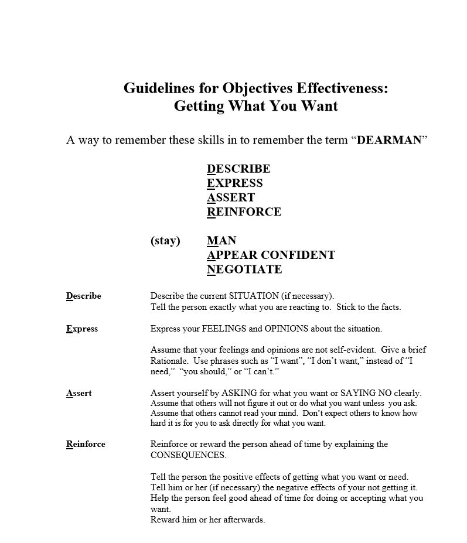

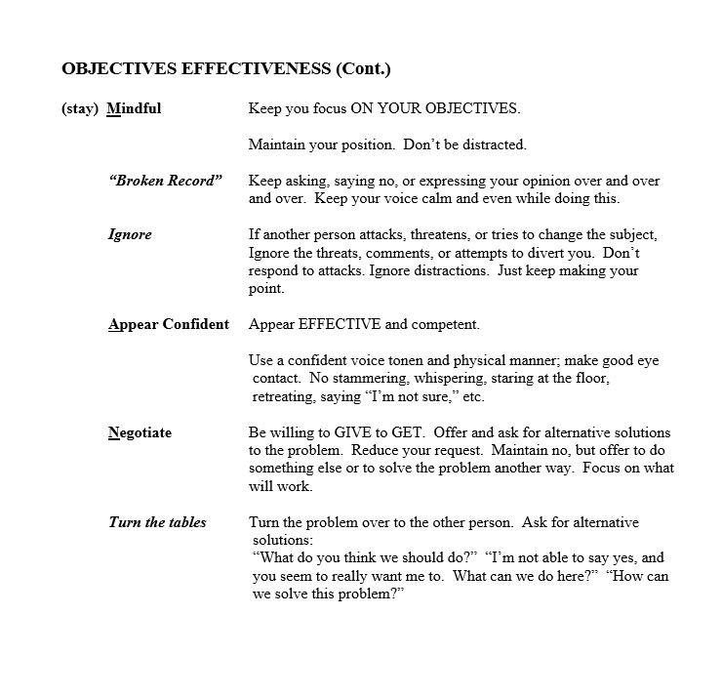

Session 4 – Personal Goals for Interpersonal Effectiveness/Factors That Hinder & Myths
Session 4 will allow members time to flesh out exactly what their goals and priorities are in any situation that creates problems for them such as in those relationships where they feel their rights or wishes aren’t being respected, when they want someone to do or change something, when they want their point of view to be taken more seriously, when they need to say no to something or resist pressure to do something and when there is general conflict with another individual. Exercises that can help members set goals and priorities include having them write down the promoting event for their problem and include who did what to who, what led to what and what about the situation is specifically problematic. Then members write down their wishes and desires in the situation as well as specific results that they want to occur or what changes they want another person to make. Another piece of information to include is how they want the individual to feel about them after the interaction takes place as well as how they want to feel about themselves after the interaction takes place. After this information is noted and members have listed their priorities from most to least important, members are asked to look for any conflicts in their priorities that may make it hard to be effective. Refining the situation to a point where little conflict is present and therefore likely to have a more positive outcome teaches members how to modify the ways in which they approach different scenarios to achieve their end goals. Discussing those things that can reduce interpersonal effectiveness is also included in this session. Highlighting the fact that sometimes it is as simple as a person not knowing what to say or how to act that causes a breakdown in efficacy. Normalizing things like simply “not knowing” can be incredibly effective in helping break down dichotomous belief systems and black and white thinking. Everyone despite whatever brilliance they have, also has a degree of “not knowing”. Members start to see where they have only considered the most extreme polarities of a situation, and how it has closed them off from understandings that can normalize many of their own presumed faults and by way of discovering the fault, are instead enriched by the experience of having a fault and the act of radically accepting that fault’s existence without catastrophizing it. Myths such as “Everyone must like me”, “I am not a good enough person to deserve good things” and “I have to do everything right or I’m stupid” are also habits of thought that are hard to break and will sometimes even when a certain sense of mastery is achieved, make a person ineffective in their communications. Knowing that this too happens to everyone at times to some degree, acknowledging it, refraining from judging it and refusing to be discouraged make each subsequent experience more likely to be effective, and those that aren’t, are taken with greater ease as people learn that when someone doesn’t like them it isn’t the end of the world. Sometimes those choices people make that cause them to lose fans can be the choices that forge a deeper and more authentic sense of self and self-respect. Group members will learn skills and helpful tips for expressing emotions in a more effective manner that involve concentrating on describing subjective experiences as opposed to what another person is bringing to a situation to makes it unpleasant or ineffective. It also avoids putting another person on the defensive and shutting down a conversation that has the potential to, if navigated skillfully, enrich the relationship altogether.

Session 5 – Emotion Regulation Skills
DBT purports that there are only 8 primary emotions, surprise, anger, shame, interest, fear, disgust, sorrow and joy. Emotions serve three main functions. These are communication, motivation and validation. Our faces convey emotion more rapidly than any other part of the body and more rapidly than spoken words can. They can tell us to act now or to stay focused. They can signal us and alarm us. In the fifth group session, members will be asked to slow down their emotional reactions and act more like detectives to learn what the body feels as they attend to different emotions. Group members will be asked to share some of the common beliefs or myths they hold about certain emotions. They will also be asked if there are emotions that they find especially hard to tolerate. The group will also be asked to think about the secondary emotions and action urges that tend to go with each emotion. For example, for some people, the feeling of shame evokes an anger response and for others, the experiencing of anger causes a person to feel shame. The action urge that accompanies an anger response might be to punch a wall. The point is to slow the bodies emotional reaction down and simply experience it for what it is. People within this population can also often have a tough time discerning between a thought, emotion, event or behavior. Practicing with members using text examples can help them begin to understand the difference between thoughts and feelings and how transient feelings often are. This way the pitfalls of adopting a thought that tends to be more lasting and concrete based on transient emotions can begin to be avoided or carefully considered in a space not governed by an individual’s emotional world, for the facts are, that world will change and then it will change again.
Changing Emotions by Acting Opposite to the Current Emotion
FEAR
• Do what you are afraid of doing…OVER and OVER and OVER.
• APPROACH events, places, tasks, activities, people you are afraid of.
• Do things to give yourself a sense of control and MASTERY.
• When overwhelmed, make a list of small steps or tasks you can do.

Worksheet 3: Letting Go of Emotional Suffering: Mindfulness of Your Current Emotion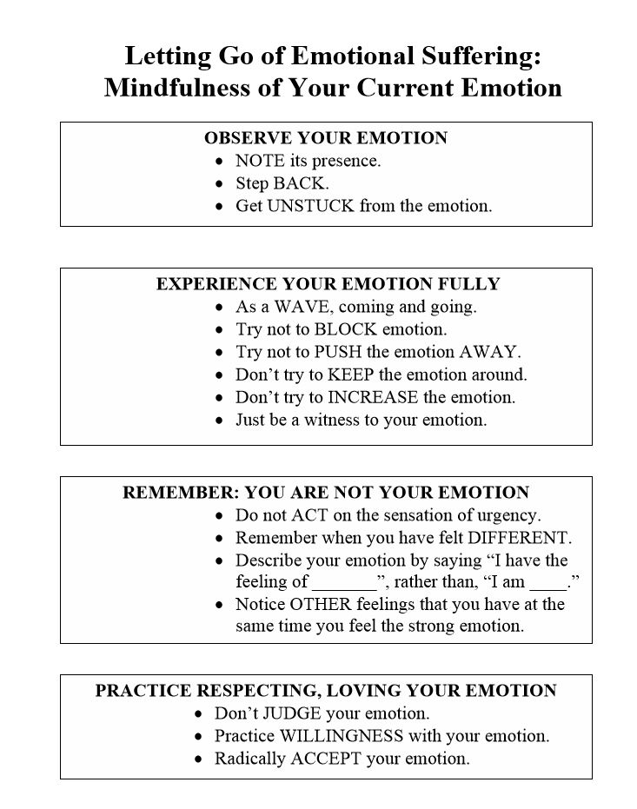

Session 6 – Common Factors
Table 1: Psychological Disorders Victims of Sex Trafficking May Face
1. Anxiety and Stress Disorder | 11. Anxiety Disorders  - Panic Attacks  - Agoraphobia  - Social Phobia
2. Attachment Disorder | 12. Dissociative Disorders
3. Attention Deficit/Hyperactivity Disorder (ADHD) | 13. Eating Disorders  - Anorexia Nervosa  - Bulimia Nervosa
4. Conduct Disorder | 14. Impulse Control Disorders
5. Depression; major, (Dysthymia) | 15. Mood Disorders  - Major Depression  - Dysthymia  - Bipolar  - Hyperthymia
6. Developmental Disorders | 16. Personality Disorders  - Borderline P.D.  - Histrionic P.D.  - Narcissistic P.D.  - Paranoid P.D.  - Anti-Social P.D.  - Avoidant P.D.  - Dependent P.D.  - Obsessive Compulsive P.D.
7. Eating Disorders | 17. Self-Harming Disorders  - Self-mutilation
8. Learning Disorders | 18. Sleep Disorders  - Insomnia  - Hypersomnia
9. Acute Stress Disorder | 19. Somatic Disorders
10. Post -Traumatic Stress Disorder (PTSD) | 20. Substance Abuse Disorders (Often DTMs use substances to cope)

The sixth session shows people amid the working phase of group. This session is the first one that will utilize time to discuss some of the more painful, abstract and severe consequences of having experienced sexual exploitation in childhood. Reexperiencing, avoidance, numbing, dissociation and hyperarousal are likely to be some of the concepts that members bring to topic. Members will also have varying degrees of experience with many of the mental health issues illustrated in Figure 1 above. Because this will be the first time the group broaches these more sensitive topics and since it may also be some individuals first experience with speaking publicly about their experiences, this session will be primarily guided by what people choose to share as opposed to having an agenda. Subsequent sessions will feature more structured work being done with the more severe symptoms of complex trauma as well as working on skills in an order that builds upon a previously learned skill set.

References
Nicole P. Yuan, M. P. (2006). The Psychological Consequences of Sexual Trauma.
Warner, S. & Wilkins, T. Journal of Contemporary Psychotherapy (2004) 34: 265. doi:10.1023/B: JOCP.0000036634.36358.0e

Lederer, L. J. & Wetzel, C. (Winter 2014). The Health Consequences of Sex Trafficking and Their Implications for Identifying Victims in Healthcare Facilities. Annals of Health Law, 23(1), 61-91.

AP Association - American Psychiatric Association, Washington, DC, 1994

United Nations Office on Drugs and Crime, United Nations Global Initiative to Fight Human Trafficking, An Introduction to Human Trafficking: Vulnerability, Impact and Action 84 (2008) available at http://www.umodc.org/documents/human-trafficking/An_introduction_to_human_trafficking_

“Human Trafficking Fact Sheet,” U.S. Department of Health & Human Services, accessed December 5, 2016, http://acf.hhs.gov/programs/orr/resource/fact-sheet-human-trafficking

Steven C. Hayes, Victoria M. Follette and Marsha M. Linehan (2004). Mindfulness and acceptance: Expanding the Cognitive-Behavioral Tradition, The Guilford Press: New York, pp. 319, ISBN 0-59385-066-2

Karyn Dayle Jones & E. H. Mike Robinson III (2000) Psychoeducational groups: A model for choosing topics and exercises appropriate to group stage, The Journal for Specialists in Group Work, 25:4, 356-365, DOI: 10.1080/01933920008411679

