Collecting Sinking Particles using a PIT Trap to Visualize and Measure the Vertical Flux of Particles
Low Cost Sediment Trap Sampler

Marlena Wied
Miles Logsdon, Science Advisor
Ocean Technology Center, University of Washington
mwied@uw.edu

Abstract
Fjords account for 11 percent of the total marine carbon burial in sediments globally, however there is currently no agreement on how their geological characteristics impact the global cycle. In order to understand the carbon cycling in fjords, an affordable and lightweight particle inceptor trap (PIT) was developed to characterize and measure the mass of sinking particles. Sampling stations were located in Puget Sound, which is an estuary system located in Washington State, that has a large sequestration impact by the Snohomish River. By comparing the sinking particles near and further away from the Snohomish River mouth, the filtered mass of sinking particles furthest from the Snohomish River is 0.678 g and 0.57 g while the filtered masses closest to the river almost tripled in mass with recorded values of 1.637 g and 1.908 g. More particles were observed further away from the river consisting of silts and clays, as well as phytoplankton and small zooplankton due to slower particle sinking velocities, bottom current resuspension and smaller river influence. Closer to the Snohomish River, larger particles such as sands and terrestrial material such as wood were observed. This data signifies that this prototype sinking particle sampler was effective and met expectations by being able to obtain microscopic imagery and sinking particle masses to better understand carbon cycling in a fjord system.

Introduction
Organic carbon sequestration in marine sediments has significantly impacted the global atmospheric conditions by controlling the amount of oxygen and carbon dioxide in the atmosphere (Berner 1982). In places of sequestration, organic carbon is buried for long periods of time where it is not used or mixed throughout the oceans, reducing the amount of available carbon for other processes. Sequestration reduces the amount of carbon in the oceans because there is less available carbon dioxide (CO₂) that can be converted into oxygen through photosynthesis and respired back into CO₂ by organisms.
Continental margins are the largest sequestration sites of organic matter in the oceans but cover only 15% of the ocean area. These margins account for almost 90 percent of the total burial (Cui et. al 2016; Berner 1982; Hedges and Keil 1995). While this is a large burial percentage, there also have been studies conducted by Gilbert et al (2002) and Walinsky et al (2009) who found that fjords are becoming recognized as significant burial locations for organic matter. Fjords can be large burial sites because they are glacially-carved estuaries located in higher latitudes with high sedimentation rates and the particles from these watersheds have relatively short residence times both in terrestrial and marine environments (Howe et al., 2010; Syvitski et al., 1987). Fjords account for 11 percent of the total marine carbon burial in sediments globally which is approximately 17-20 x 10¹² gCyr⁻¹ (Smith et al., 2015).
Even though fjords and continental shelves play a large role in carbon cycling, there is currently no agreement on how their geological characteristics impact the global cycle. There is uncertainty in the estimates of carbon flux because there is variability in primary production, sedimentation and early diagenetic regimes (Sauer et al., 2016). Therefore, variability creates complications on the quantitative measures of sinks and sources and further complicates how to integrate fjords and shelves in global carbon cycle models (Smith et al., 2015).
Carbon sequestration can be investigated using sediments traps deployed in the water column. The scope of this project is to better understand sequestration and vertical flux by developing a particle interceptor trap (PIT) that contains a gel in order to characterize sinking particles as well as filter and measure flux. It is important to characterize sinking particles because it provides evidence of what material is contributing to the flux and their general proportion. The design goals for this prototype sampling device were to be inexpensive, light-weight and easy-to-use.
Since carbon burial controls the amount of carbon dioxide available in the oceans and atmosphere, understanding fjords that contribute a significant percentage to carbon burial is important, thus having a prototype that can analyze and measure flux is crucial for understanding climate change.
Background:
Fjords are highly influenced by terrestrial sediments and marine organic matter. Since fjords are glacial-carved systems, these areas produce a large amount of carbon where much of the carbon comes from terrestrial sources such as continental erosion and rivers (Wiedmann et al. 2016, Cathalot et al. 2013). This runoff comes from the glaciers that entrain lithogenic material that are scavenged by sinking particles which enhance vertical flux. Particle aggregation leads to greater vertical flux because particle sinking velocity increases (Passow and De la Rocha, 2006). Materials deposited into fjords are dependent on geological and climate factors such as vegetation, rainfall, and weathering rates (Goni et al. 2006). Furthermore, dispersal forces such as tides and currents influence where carbon burial will occur due to the movement of particles, however these forces are poorly understood in relation to sequestration and burial rates since they vary around the world (Goni et al., 2006)
Large blooms of phytoplankton and zooplankton occur in fjords because nutrients are supplied from river deposits which fuel the food web, therefore enhancing vertical flux (Wiedmann et al., 2014). Vertical flux can be impacted by phytoplankton because these organisms can either sink or aggregate together increasing the amount of vertical flux due to increasing density (Alldredge et al., 2001). Hamm et al. 2001 proposed that vertical flux can be greater when zooplankton such as copepods and krill feed on small organic particles and excrete large fecal pellets that have a fast sinking rate due to density. The vertical flux can also be altered by small primary producers and microzooplankton (<10 µm) in high-latitude regions, instead of the particulate organic carbon (POC) being exported to depths where it is recycled back into the food web in the pelagic ocean environment (Wiedmann et al., 2014).
Sediment traps are an efficient way of collecting particles in the water column. Larger sediment traps that usually consist of large funnels are generally deployed in deeper parts of the ocean and for longer periods of time. Furthermore, if additional equipment is attached such as pH probes or pressure gauges, this equipment must be pressure proof. However, with the addition of equipment these larger traps become bulky, heavy and require multiple personnel for deployment. Smaller traps are useful for the upper ocean; they are easier to work with since they are lighter and can obtain more data since multiple traps can be deployed at once. One limitation is that these traps can be deployed only for a few days at a time because of the high abundance of particles present in the upper ocean. Particle inceptor traps (PIT) are considered to be small traps and are useful for researching particle settling in the upper ocean. Additionally, these traps contain a gel which allows for microscopic analysis of the particles. These traps are useful in comparing diurnal and nocturnal flux, biogeochemical flux, as well as seasonal flux. A study that has used the specific PIT trap was conducted by Wiedmann et al. 2015 who studied the Arctic Ocean and focused on how sinking particle characteristics, such as size and distribution frequency, changed with seasons. In the gels, sedimentation of fresh biomass was dominant for spring and winter months, with large detrital sinking particles that were resuspended from the seafloor dominated in abundance in the gels. In Autumn, this season had the largest POC flux because of glacial runoff and high pteropod abundances (Wiedmann et al., 2015). Our study was based on Wiedmann et al. 2015 in terms of using gels that retain sinking particle for analysis. However, this study uses the gels and takes a step further by dissolving and filtering the particles onto a filter in order to obtain a mass for sinking particles collected by the gels.
Methods
Design Process
PIT traps are cylindrical in shape and are composed of polyacrylic tubing that contain an attachment system of a jar at the bottom of the tube which collect the sinking particles onto a petri dish containing the gel. Design, prototyping and assembly took place in the Ocean Technology Center at the University of Washington during fall quarter of 2017. Design considerations included an efficient and leak proof manner of attaching jars filled with gel to polyacrylic tubing, an efficient way of mounting polyacrylic tubing to a platform rack that could remain vertical within the water column, a way of attaching the vertical platform rack to poly-dac line in order to deploy off the bow of the boat. To account for any sampling bias, duplicates were considered.
In order to reduce as much hydrodynamic bias as possible, evaluating alternatives in design of the PIT trap is necessary. The traps should be vertical within the water column and must have a certain aspect ratio. According to Busseler et al. 2007, in terms of cylindrical traps, the aspect ratio of height (cm) to diameter (cm) must be preferably over 5 in order to avoid perturbations of horizontal flow from ocean currents that could easily over or under estimate the net downward flux. Therefore, we propose an aspect ratio of 12 to 1 in order to overcome most ocean current velocities as well as to obtain efficient collection of particles. Specifically, we suggest a PIT trap with a height of 77.72 cm with a diameter of 6.48 cm. The gel within the jars should also contain no baffles or poison in the gel.
The first prototype design attempted to use a 3-D printing threaded attachment adapter of the 8 oz jar to be secured to the polyacrylic tubing. However, early testing confirmed that the limitations of this method were the difficulties to achieve correct thread spacing. The second design settled on using electrical tape to connect the jar to the polyacrylic tubing and a clamping system consisting of half-sliced PVC tubing to latch over the polyacrylic tubing. In addition to the electrical tape, the jar was secured to the polyacrylic tubing using hose clamps to compress and tighten the jar to the tubing. Another project challenge was keeping the polyacrylic tubing vertical and leveled. This called for the development of horizontal plastic frames at the top and bottom of the polyacrylic tubing using U-bolts to keep the tubing vertical within the column. Additional vertical wooden frames were implemented to keep the plastic frames leveled, further securing the tubing to remain in place (Fig. 1).
Trap Design Testing
Through the establishment of the trap, testing was first conducted in a laboratory setting. This test was to observe if the traps were able to remain secure to the deployment line, if the tubes U-bolt assembly effectively secured the tubes and how well the gel would collect particles. Results of these design test showed that the trap was successful at remaining on the line and the gel was able to effectively collect particles. One limitation was that the tubing was prone to slide out of the U-bolts, thus rubber backing had to be placed between the U-bolts and tubing to stabilize the tubes.
A final performance test was also conducted on the R/V Thompson on the 13th and 14th of January of 2018 to analyze how the traps performed in an open water system. This test was successful and the instrument performed to design. The next steps were to analyze the samples underneath a dissecting scope. The challenge was that it was difficult to analyze the gel under the microscope due to the jar’s height, therefore this lead to the inclusion of petri dishes into the protocol. Petri dishes were taped to the bottom of the 8 oz jars to efficiently remove and analyze the particles underneath the dissecting microscope.
Field Work
This project investigates vertical flux of the Snohomish River in the Everett area of Puget Sound and compares how flux changes as a function of distance from the river mouth. Two sampling stations were used to make this comparison: Station PS03 was closest to the Snohomish River mouth while Station PS01 was further from the mouth (Fig. 2). Station PS03 had a depth of 130 m and Station PS01 had a depth of 41 m. A trap was deployed at each sampling station with a single duplicate at depths: 2 m (PS03) and 10 m (PS01); and was anchored to remain stationary (Fig. 3). Furthermore, the poly-dac line, which the traps were mounted to, was attached to a single large ball float to provide buoyancy for the traps. A mast was also included to assist in recovery and provide aid for navigation for all vessel traffic. These traps were deployed for approximately 24 hours to collect settling particles by accounting for tides and biochemical processes on January 27th and 28th of 2018 off the R/V Clifford A. Barnes. Eight-ounce (8 oz) jars were prepared with petri dishes filled with Tissue Tec gel which were later attached to the traps based on methods from previous research conducted by Wiedmann et al. 2015. These traps were mounted onto frames which attach to poly-dac line and were deployed off the R/V Barnes in the top 10 m of the ocean surface. Each trap was filled with 3 liters (L) of ocean water collected from a conductivity, temperature and depth probe (Sea-bird SBE911plus) at the same depths that the traps were deployed. After deployment, the water in the traps was vacuumed out using a hand-pump system and the samples were stored in a -80 ◦C freezer. Additional water column data from on-board sensors that were collected include salinity (from Sea-Bird SBE911plus) which was used to identify river influence. Beam transmittance data was acquired from a transmissometer (WET Labs C-Star) which provides an estimate on the number of particles present. And fluorescence, collected from a fluorometer (WET Labs ECO-AFL/FL) which was a proximation for chlorophyll a.
Lab Analysis
Samples were analyzed under a dissecting scope to identify and measure the particles present. Gels were dissolved with deionized water and were filtered by a hand-pump system on combusted GF-75 0.3-micron filters and placed in petri dishes. Samples were then combusted at 60 ◦C for 24 hours, desiccated for more than 12 hours and then weighed on a scale to find the total mass. Weights of the petri dishes and combusted GF-75 filters were recorded to subtract the final weight from the initial weight to find solely the mass of particles present.

Results
Salinity
Salinity near the river mouth is lower when it is near the surface and increases with depth (Fig. 4). At PS03, the salinity is about 20 PSU at the surface until 10 m, the halocline occurs and then the salinity increases to 29 PSU at 31 m. At PS01, salinity at surface depths is higher than at PS03 at 26 PSU but still has some stratification suggesting it is slightly affected by the river. At 15 m, the halocline occurs, and then matches the salinity of PS03 at 29 PSU at deeper depths. The range of salinity is larger at PS03 than at PS01.
Particle Analysis
PS01 had finer particles such as silts and clays because there was less surface area covered in the gels (Fig. 5A). There were also smaller organisms observed such as crab zoea larvae and copepods (Table 1). PS03 contained larger sediments such as sand compared to PS01 because the sediment covered the entire surface area of the gel for the same deployment time (Fig. 5B). PS03 had more seaweed and larger organisms such as marine worms based off of observational counts (Table 1). PS01 had a lower beam transmittance percentage between 40-80% versus 80-100% at PS03 (Fig. 6A). Furthermore, PS01 had a higher fluorescence with a decreasing range of 1 mg/m³ to 0.4 mg/m³ with depth in comparison to PS03 with a range of 1 mg/m³ to 0.2 mg/m³ (Fig. 6B).
Trap Analysis
At PS01, the masses of the filtered samples for the duplicated samples are 0.678 g and 0.57 g (Fig. 7) with a mass difference of 0.108 g. At PS03, the samples almost doubled in mass in comparison to PS01 with recorded masses of 1.637 g and 1.908 g for the duplicate samples with a difference of 0.271 g (Fig. 7).
Findings
Freshwater Influence by the Snohomish River
The salinity profiles for each station confirm that PS03 is more river dominated than PS01 because of the freshwater layer observed at the surface (Fig. 4). Samples collected at PS03 had a large amount of sand deposit collected in the gels due to entrainment of lithogenic material from the Snohomish River in comparison to PS01 (Wiedmann et al., 2014). Since the traps were deployed at shallower depths (at 10 m), this allows for the majority of particles to be collected by the traps without having much settling and aggregation occurring especially being closer to the Snohomish River. Also at PS03, vegetation and small pieces of wood were observed in the gels (Table 1) consistent with the Snohomish River deposits being terrestrial material. Consequently, terrestrial and marine material are sequestered in this area. The study conducted by Wiedmann et al. 2015 in the Arctic Ocean which compared seasonal particle characteristics and their composition using carbon to nitrogen (C/N) ratios with respect to the Redfield Ratio. This study found that during the winter, detritus was the largest contributor to overall composition rather than lithogenic material from runoff because the C/N ratio was higher with respect to the Redfield ratio which signifies its degraded marine and terrestrial material. To fully compare these studies, a C/N ratio should be conducted on the samples that were collected in this study.
Particle Abundance
At PS01, there was a lower beam transmittance (Fig. 6A). Since the transmissometer uses a beam of light to penetrate into the water column, if there are more particles present and if these particles have a larger surface area, more light will be reflected off the particles back to the transmissometer resulting in a lower transmittance percentage. At PS01, this suggests that there are more particles present in the water column even though the gel appears translucent in comparison to the gel collected at PS03 (Fig. 5A & B). Even though it is assumed that the site near the river should have more particles present due to river deposits, especially since filters at PS03 weighed about three times as much as the filters at PS01 (Fig. 7), since PS01 is shallow, this leaves the possibility of having more disturbed sediment due to deep water currents. Having sediments disturbed would cause more mixing and overall, a resuspension of particles causing there to be more particles within the water column. Also, since this station is further away from the Snohomish River, this signifies that sinking and aggregation most likely occurred, leaving only the lighter and smaller particles that have slower sinking rates to remain within the water column such as silts and clays (Passow and De la Rocha, 2006).
Another possibility as to why PS01 has more finer particles present could be accounted for in the fluorescence data. Since fluorescence is a proxy for chlorophyll a, chlorophyll is made from marine organisms such as phytoplankton but does not account for terrestrial detritus and debris as they do not produce chlorophyll a because they are nonliving. Only at PS01, microorganisms such as phytoplankton were observed which supports the fluorometer data that chlorophyll a is being produced by photosynthesis since fluorescence was higher overall with depth (Fig. 6B). Having more phytoplankton present could also decrease beam transmission percentage because light is absorbed by these microorganisms.
PS01 contained phytoplankton and zooplankton while at PS03, no phytoplankton or zooplankton were observed, however there were two marine worms observed (Table 1). This is possibly due to the freshwater current coming from the river being too large for phytoplankton and zooplankton, pushing them further out into the Sound. Also, since there was a large deposit of sediment into the gels, this could have caused the phytoplankton or zooplankton to be buried within the gel by the sediment. Therefore, the largest contributor to carbon sequestration during this season appears to be the Snohomish River. Some possible errors to be accounted for that could have influenced the data are hydrodynamic bias, whether the tubing was precisely vertical which could have increased or decreased mass.
Conclusion
The scope of this project was to design a low cost and effective way of identifying and measuring sinking particles. Through conducting multiple tests, a prototype was constructed and can be used from small or large boats as the prototype is lightweight and not bulky. Even though materials were limited due to a budget, this prototype was still efficient and met its expectations. In order to strengthen the understanding of carbon sequestration in fjords, identification of where particles have originated from, whether terrestrial or marine, should be considered using the Redfield Ratio as similar studies have done (Wiedmann et al., 2015). Further testing on the errors and improvements on the materials used in this project will increase the efficiency of these PIT traps and provide a better concept of carbon sequestration not only in fjord environments, but they can be applied to different marine environments to track organic carbon flux.

References:
Alldredge, A. (2001), Particle aggregation dynamics, in Encyclopedia of Ocean Sciences, edited by J. H. Steele, S. A. Thorpe, and K. K. Turekian. 2090–2097, Academic, San Diego, Calif., doi:10.1006/rwos.2001.0468.

Berner, R.A., 1982. Burial of organic carbon and pyrite sulfur in the modern ocean: its geochemical and environmental significance. Am. J. Sci.282, 451–473.

Buesseler, K. O., Antia, A. N., Chen, M., Fowler, S. W., Gardner, W. D., Gustafsson, O., Harada, K., Michaels, A. F., Rutgers van der Loeff, M., Manmohan, S., Steinberg, D., and Thomas Trull. 2007. An assessment of the use of sediment traps for estimating upper ocean particle fluxes. J. Mar. Res. 65, 345-416.

Cathalot, C., Rabouille, C., Tisnerat-Laborde, N., Toussaint, F., Kerherve, P., Buscail, R., Loftis, K., Sun, M.-Y., Tronczynski, J., Azoury, S., Lanzard, B., Treignier, C., Pastor, L., and T. Tesi. 2013. The fate of river organic carbon in coastal areas: A study in the Rhone River delta using multiple isotopic and organic tracers. Geochim. Cosmochim. Acta. 118, 33-35. Doi: 10.1016/j.gca.2013.05.001

Cui, X., Bianchi, T.S., Savage, C. and Richard W. Smith. 2016. Organic carbon burial in fjords: Terrestrial versus marine inputs. Earth Planet Sci. Lett. 451., 41-50. doi:10.1016/j.epsl.2016.07.003

Gilbert, R., Nielsen, N., Moller, H., Desloges, J., and Morten Rasch. 2002. Glacimarine sedimentation in Kangerdluk (Disko Fjord), West Greenland, in response to a surging glacier. Mar. Geo. 191., 1-18.
Goni, M. A., Monacci, N., Gisewhite, R., Ogston, A., Crockett, J., and Charles Nittrouer. 2006. Distribution and sources of particulate organic matter in the water column and sediments of the Fly River Delta, Gulf of Papua (Papa New Guinea). Estuar. Coast. Mar. Sci. 69, 225-245. Doi: 10.1016/j.ecss.2006.04.012

Hamm, C., M. Reigstad, C. W. Riser, A. M€uhlebach, and P. Wassmann (2001), On the trophic fate of Phaeocystis pouchetii. VII. Sterols and fatty acids reveal sedimentation of P. pouchetii-derived organic matter via krill fecal strings, Mar. Ecol. Prog. Ser., 209, 55–69, doi:10.3354/
meps209055.
Hedges, J.I., Keil, R.G., 1995. Sedimentary organic matter preservation: an assessment and speculative synthesis. Mar. Chem.49., 81–115.

Howe, J.A., Austin, W.E., Forwick, M., Paetzel, M., Harland, R., Cage, A.G., 2010. Fjord systems and archives: a review. Geol. Soc. (Lond.) Spec. Publ.344, 5–15.
Passow, U., De La Rocha, C.L., 2006. Accumulation ofmineral ballast on organic aggregates. Global Biogeochem. Cycles 20. doi:10.1029/2005GB002579 (GB1013).

Smith, R.W., Bianchi, T.S., Allison, M., Savage, C., Galy, V., 2015. High rates of organic carbon burial in fjord sediments globally. Nat. Geosci., 450–453.
Syvitski, J., Burrell, D., Skei, J., 1987. Fjords: Processes and Products. Springer-Verlag, New York.
Waite, A. M., Gustafsson, O., Lindalh, O., and Peter Tiselius. 2005. Linking ecosystem dynamics and biogeochemistry: Sinking fractionation of organic carbon in a Swedish fjord. Limnol. Oceangr. 502(2), 658-671.
Walinsky, S., Prahl, E., Mix, A., Finney, B., Jaeger, J., and G. Rosen. 2009. Distribution and composition of organic matter in surface sediments of coastal Southeast Alaska. Cont. Shelf Res.29., 1565–1579.
Wiedmann, I., M. Reigstad, A. Sundfjord, and S. Basedow (2014). Potential drivers of sinking particle’s size spectra and vertical flux of particulate organic carbon (POC): Turbulence, phytoplankton, and zooplankton, J. Geophys. Res. Oceans, 119, 6900–6917, doi:10.1002/2013JC009754.

Wiedmann, I., Reigstad, M., Marquardt, M., Vader, A., and Tove M. Gabrielsen. 2016. Seasonality of vertical flux and sinking particle characteristics in an ice-free high arctic fjord—Different from subarctic fjords? J. Mar. Sci., 154. 192-205. doi:10.1016/j.jmarsys.2015.10.003.

Table 1. The particles identified at each station along with their abundance and size (a range is indicted by a dash if there are more than one size).
Particles Identified | Quantity |  | Size (µm)
 | PS01 | PS03
Amphapod | 1 | 0 | 4.5
Seaweed | 2 | 19 | 0.8-11
Crab Zoea Larvae | 4 | 0 | 1
Juvenile Copepod | 1 | 0 | 0.9
Worms | 0 | 2 | 7, 11
Wood Pieces | 0 | 10 | 0.8

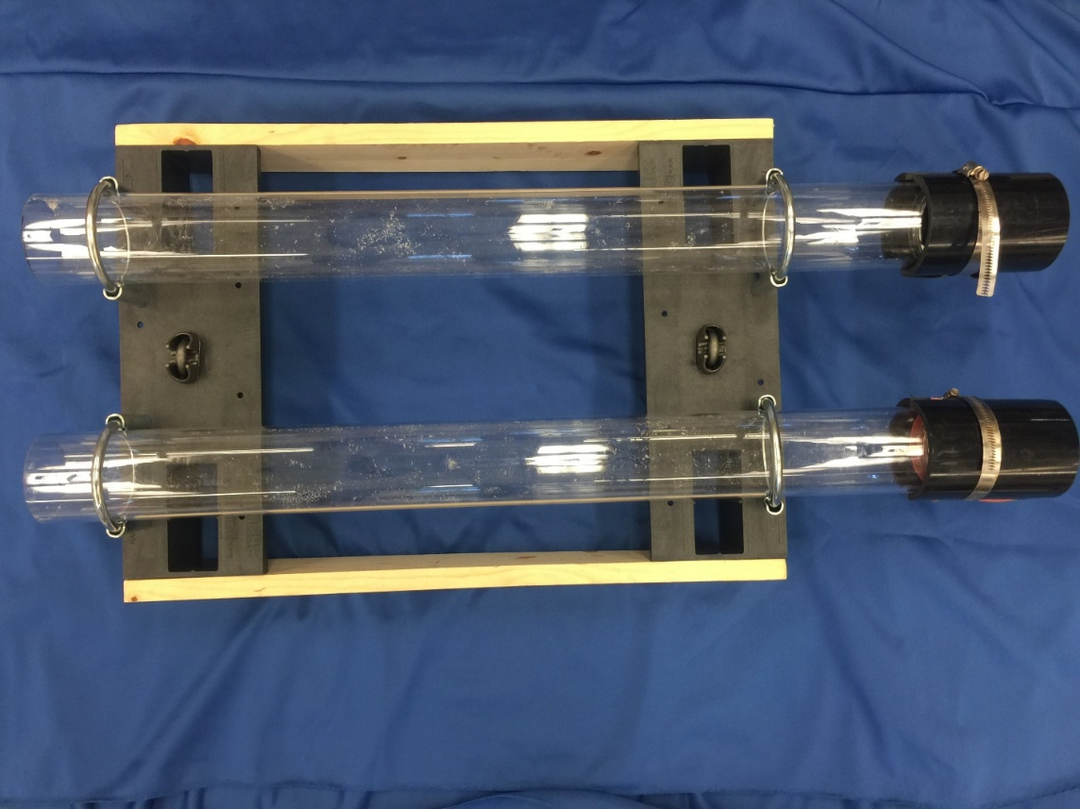
Fig. 1 Image of PIT trap fully assembled.

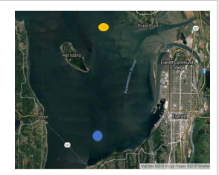
Fig. 2 PS01, the station furthest from the Snohomish River is represented by the blue dot. PS03, the station closest to the Snohomish River is represented by the orange dot.

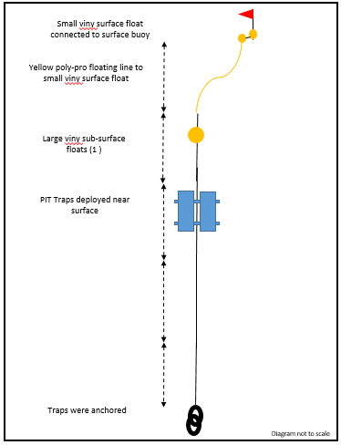
Fig. 3 Overview of PIT trap deployment.

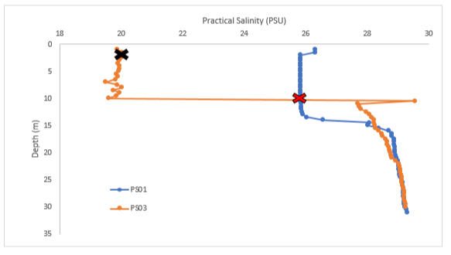
Fig. 4 Practical salinity plotted for each station with depth. PS03 is observed to be impacted by the Snohomish River due to the freshwater influence observed in the first 10 m while PS03 has a slight indication of freshwater influence for the top 15 m. The trap deployment depth at PS01 is signified by a red “X” with black outlining and the trap at PS03 is signified by a solid black “X”.

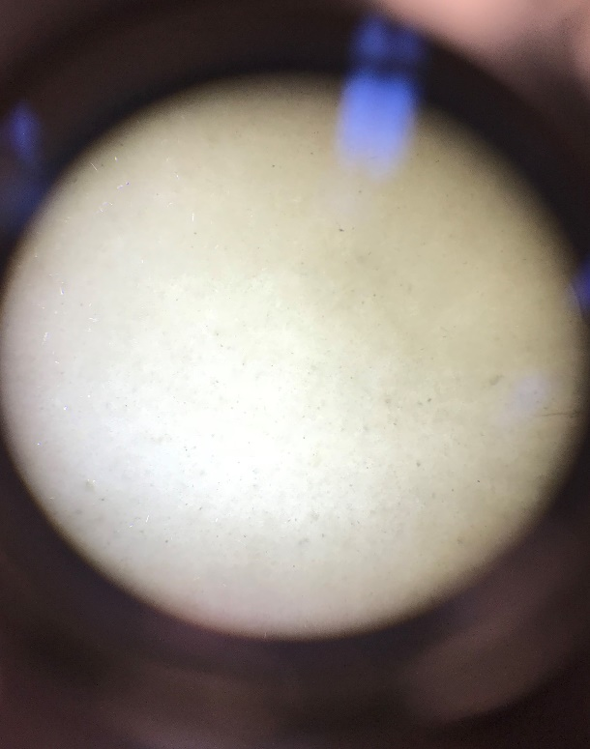  A | 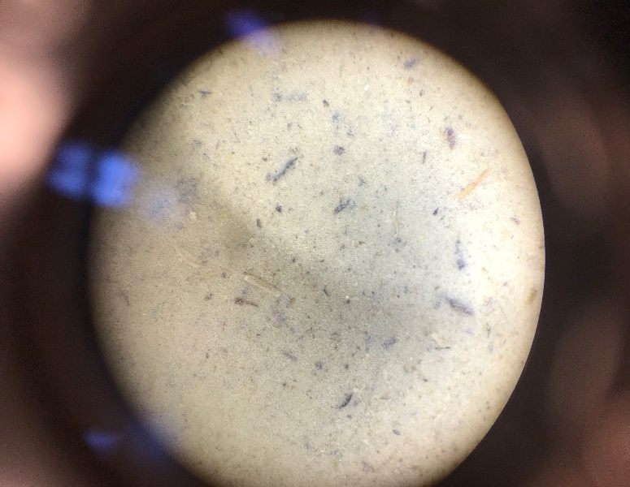  B

Fig. 5 Comparison of how the gels differed at each station PS01 (A) and PS03 (B) visually in terms of particle abundance and types of particles identified with PS03 having more vegetation observed.

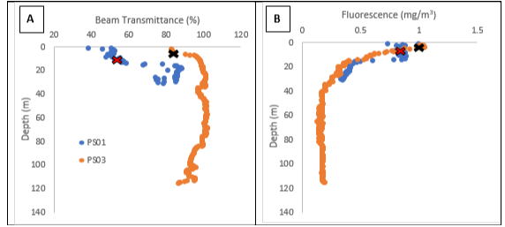
Fig. 6 Beam transmittance plotted against depth for both stations (A) and fluorescence at each station plotted with depth (B). PS01 is represented in the color blue and PS03 is plotted in orange. The trap at PS01 is signified by a red “X” with black outlining and the trap at PS03 is signified by a solid black “X”.

Fig. 7 Masses of each filter containing the particles at each station. Duplicates were considered in order to see if there was any bias in the sample.

