Investigation of the Relationship Between Tidal Height and Body Volume of Abarenicola pacifica in False Bay, Washington

Riley Messinger
Friday Harbor Labs, University of Washington
FHL 470: Research in Marine Biology
Dr. Terrie Klinger
May 23, 2022

Abstract
This study aimed to determine whether nourishment of Abarenicola pacifica varied at different tidal heights in False Bay, Washington. We hypothesized that the higher concentration of sediment organic matter at the head of the bay would lead to a negative correlation between body volume and distance from shore, as well as a relationship between fecal to body volume ratio and distance from shore. We tested this by measuring the volume of the fecal castings and the body of 120 individuals of A. pacifica on two 100-meter transects placed on the north and south sides of False Bay. Our linear regression showed a positive correlation between body volume and distance from shore. This correlation was weak but significant on the northern transect, but was not significant on the southern transect. When the data from both transects were combined, the correlation was signfiicant. This disparity was likely due to the amount of variability within the data, resulting in low R-squared values on both transects. There was no evidence of a significant relationship between fecal volume to body volume ratio and tidal height, likely because fecal volume is not a good indicator of body size. This indicates that although sediment organic concentration may be higher at the head of the bay, multiple factors influence growth of A. pacifica, some of which include selective feeding behavior, temperature, salinity, and exposure to pollutants.

Introduction
Abarenicola pacifica is one of two species of lugworm found in False Bay, Washington. They are burrowing deposit feeders that can be identified from aboveground by their fecal castings that form a distinctive spiral. They affect their ecosystem by causing biogenic disturbance in the sediment through their burrows and fecal castings, which decreases recruitment and increases emigration of benthic organisms in the surrounding area (Kruger & Woodin, 1993). They inhabit the head of False Bay, where there is finer, less penetrable, and more heterogeneous sediment composition, as compared to the other species present, A. claparedi, which is more prevalent toward the mouth and is adapted to burrowing in softer sediment (Crane & Merz, 2017).
Though previously thought to be non-selective feeders, A. pacifica were shown to select for food such as nematodes, diatoms, motile flagellates, and bacteria that pass through an 80 µm sieve (Hylleberg, 1975). In False Bay, the area inhabited by A. pacifica has a sediment organic concentration of 0.5-1.2% (Hobson, 1967). In a few studies, A. pacifica had a higher feeding rate when sediment organic concentration and sediment protein concentration were higher, up to a certain point where satiation occurred, after which feeding rate plateaued (Taghon & Greene, 1990; Hymel & Plante, 2000). However, a study occurring around the same time as Hymel & Plante had differing results, in which smaller, juvenile A. pacifica showed higher feeding and growth rates in higher quality sediment, but larger adults in high quality sediment showed lower feeding rates than their similarly-sized counterparts (Linton & Taghon, 2000). Their growth rate and reproduction (measured by number of eggs) were also positively affected by higher sediment organic concentration (Linton & Taghon, 2000). A. pacifica were also shown to respond to temperature, with individuals at higher temperatures feeding at higher rates (Hymel & Plante, 2000). A. pacifica were not shown to be affected by oxygen stress in False Bay, as a study assessed oxygen concentrations of A. pacifica burrows and determined them to not be anoxic at any point during the tidal cycle; moreover, A. pacifica were able to survive in anoxic conditions for three days, likely due to anaerobic respiration (May 1972). A. pacifica are also known to be affected by low-salinity environments as they are poor osmoregulators. They were shown to have poor tolerance to salinities below 50% of the seawater concentration, with little control over their volume and coelomic fluid, which could make them vulnerable to freshwater runoff (Oglesby, 1973). In addition, A. pacifica absorbs and accumulates necessary trace metals, such as cadmium, from the surrounding sediments, instead of from seawater, therefore the bioavailability of these trace metals in the sediment may affect their growth and fitness (Oakley et al., 1983).
This study aimed to determine what tidal height was most conducive to Abarenicola pacifica growth in False Bay. Properties such as sediment size, and organic matter concentration vary between the mouth and the head of the bay, which could influence the growth and body size of A. pacifica. To determine the effect of tidal height,, we assessed the size of the body and the volume of the fecal castings left aboveground. We hypothesized that the higher concentration of organic material at the head of the bay would be more conducive to growth and therefore, the body volume of A. pacifica would increase with tidal height.

Methods
Two locations at False Bay, WA were selected for sampling, one at the north side of the bay, and one at the south. On the first day of sampling each location, a 100-meter transect was laid starting at the first indication of A. pacifica fecal deposits near the head of the bay, outward toward the mouth. The transect was divided into four sections of 25 meters each. We walked along the transect, selecting ten lugworm fecal deposits per section to sample nearest the transect, and recorded the distance measurement along the transect. On the second day of sampling for each location, we laid the 100-meter transect where it had been set previously, and then used the endpoint of the transect as the starting point of sampling for that day. We repeated the sampling procedure until no more A. pacifica deposits were found.

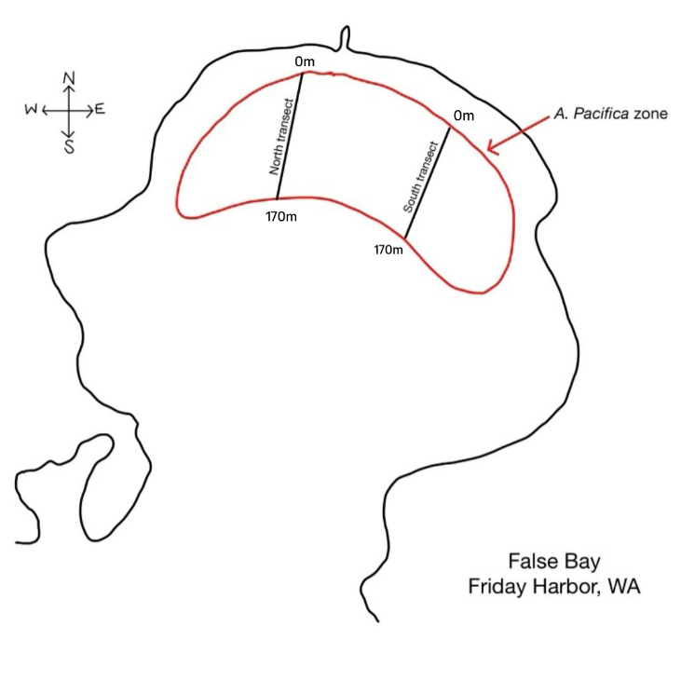
Figure 1. Diagram showing False Bay, WA, the range of Abarenicola pacifica within the bay, and the locations where the two transects were laid (modified from Crane & Merz, 2017).

To acquire our data, we scraped the fecal deposit with a knife and measured the volume via displacement using a 20-mL graduated cylinder, emptying and rinsing it out after use. After the fecal volume measurement was recorded, we dug around the location of the fecal deposit using a shovel until A. pacifica was found. If no A. pacifica was found, we selected another deposit with a similar distance along the transect to sample. If multiple A. pacifica were found, we measured the first individual we encountered to avoid sampling bias. We then rinsed off the A. pacifica and measured the volume via displacement with the same graduated cylinder. Afterwards, the worm was returned to its burrow and the hole was filled with sand.
The data were then entered into a spreadsheet with columns for transect value, fecal volume, worm volume, and fecal to worm volume ratio, and location, with the northern transect location labeled as “0” and the southern transect location labeled as “1”. These were then plotted as scatterplots in R with a linear regression analysis, from which R-squared and P-values were calculated. Analyses were run combining data from both locations, as well as comparing both locations to one another.

Results
- 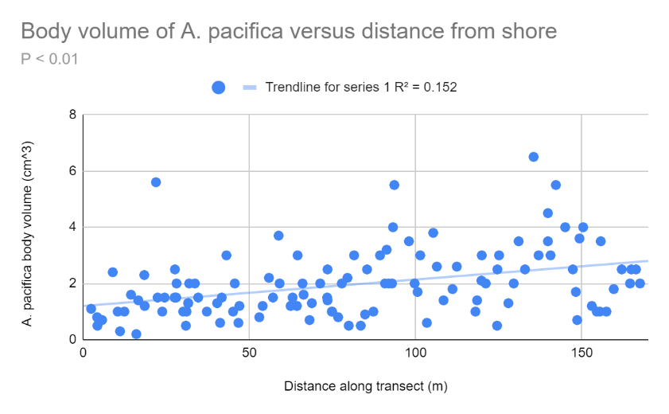
- 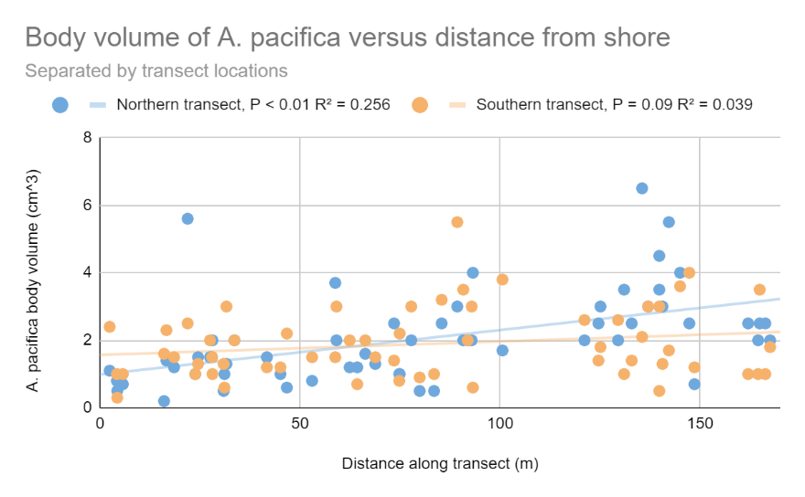
Figure 2. Scatterplot of body volume of A. pacifica along the two transects. a) shows the linear regression combining data from both transects, and b) shows the linear regressions of each separate transect.

As depicted in Figure 2, our data showed a weak but significant (P < 0.01) positive correlation between A. pacifica body volume and distance along the transect. When separated by transect location, the data shows differing results between the two locations. Transect 1 (north) shows a significant (P < 0.01) positive correlation, whereas Transect 2 (south) does not show a significant correlation (P = 0.09). The difference between these two correlations was shown to be significant (P < 0.01), revealing that the distribution of lugworm volume at varying tidal height is different on the northern and southern parts of False Bay. The low R-squared values for both correlations indicate that there are likely several other factors that affect lugworm volume, which may have caused the difference in volume distribution between the two transects.

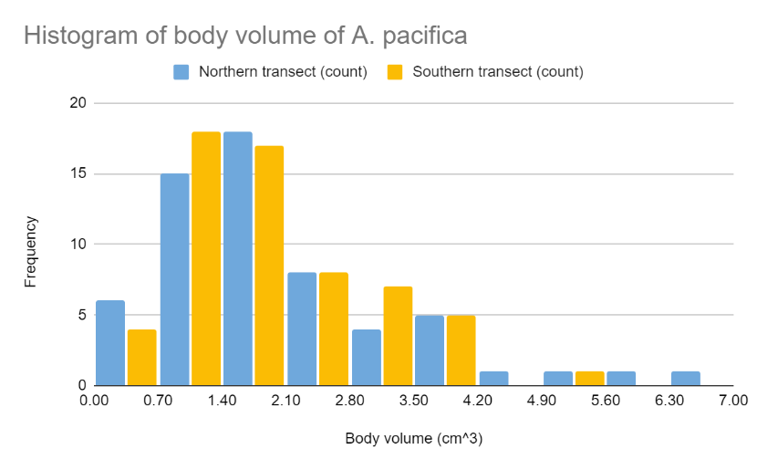
Figure 3. Distribution of body volume separated by transect location
As shown in Figure 3, the distributions of body volume of A. pacifica, regardless of distance along the transect, was similar across the two transects. A two-sample t-test showed that there was no statistically significant difference between the two distributions (P = 0.38), despite the difference between the correlations.
- 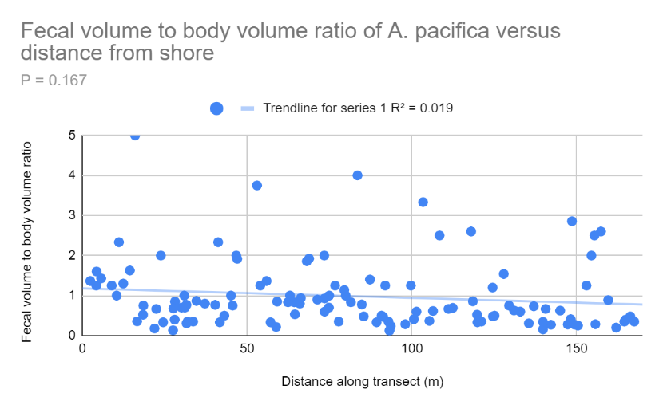
- 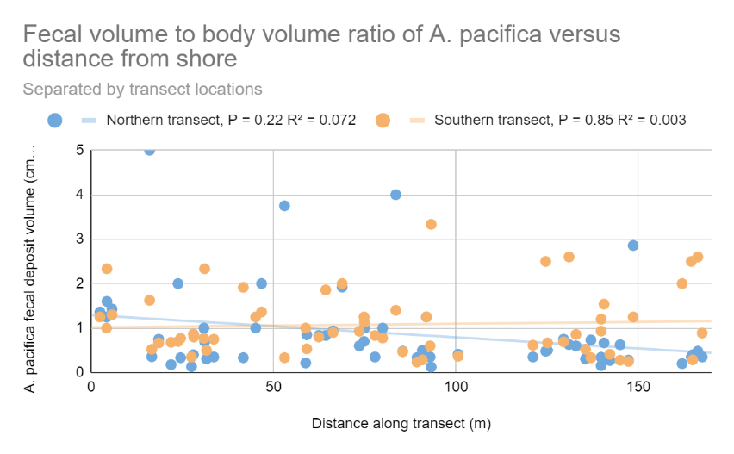
Figure 4. Scatterplots of A. pacifica fecal volume to body volume ratio along the two transects. a) shows the linear regression combining data from both transects, and b) shows the linear regressions of each separate transect.
As depicted in Figure 4, our data shows no evidence of a correlation between fecal to body volume ratio and tidal height. This held true both when the data from the two transects were combined (P = 0.167, R² = 0.019), and when they were separated (P = 0.22, R² = 0.072 for the northern sampling location, and P = 0.85, R² = 0.003 for the southern sampling location). There was not a statistically significant difference between the correlations for the two transect values. The absence of a relationship between fecal volume and body volume could support the absence of a correlation between fecal to body volume ratio and tidal height.

Discussion
In this study, we found a weak positive correlation between distance from shore and body volume. This varied in significance between the two transect locations, with the northern transect yielding a significant correlation, and the southern transect yielding no significant correlation. This difference may be attributed to the low R-squared value for both, as both transects had a large amount of variation. This directly contradicts our hypothesis, which was that the higher organic matter availability at the head of the bay would be more conducive to growth. The weakness of the correlation indicates that there are likely more factors at play than simply organic matter composition. For example, since A. pacifica are selective feeders, their food may not be distributed in the same manner (Hylleberg, 1975). In addition, feeding and growth rate could follow the pattern described by Linton and Taghon, in which adults over a certain size had a lower feeding and growth rate when in higher quality sediment (Linton & Taghon, 2000).
Factors other than food availability could have an effect on the body volume. These factors include temperature, salinity, and availability of trace metals. Temperature is known to affect feeding rate, with higher temperatures being conducive to higher feeding rates (Hymel & Plante, 2000). Exposure to seawater and absorption of light at different tidal heights could affect the temperature of the sediment, which may have caused variations in feeding rates. Additionally, salinity could affect the volume of the worm due to changes in water content and coelomic fluid (Oglesby, 1973). Since the head of the bay could have higher exposure to freshwater runoff, it is possible that salinity stress could affect the volume of A. pacifica in that area. Bioavailable trace metals in the sediment could also be found at different concentrations throughout the bay, which could affect lugworm nutrition. Additionally, a factor we had not previously considered was the potential for pollution at the head of the bay due to its proximity to a road. A. pacifica feeding rates were shown to decline when sediment was exposed to crude oil (Augenfield, 1980). Another possible factor could be longer feeding times further offshore. Because A. pacifica requires water to irrigate their burrow and feed, individuals at higher tidal heights may not have the same opportunities to feed. One or a combination of these enumerated factors may have contributed to the weakness of the correlation between lugworm body volume and tidal height.
In previous studies, A. pacifica fecal castings were used as a predictor for the size of the individuals. The study showed that the volume of the fecal casting was poorly correlated with the volume of the worm; however, the body volume was significantly correlated with the cube of the diameter of the coil (Kruger & Woodin, 1993). The volume of the fecal coil may be a better indicator of ejestion rate than the size of the individual. This may explain why we did not find a significant relationship between coil volume and body volume, and thus no relationship between fecal to body volume ratio and tidal height.
This study could be improved by increasing randomness of sampling, as visual selection of fecal castings could lead to a bias toward larger castings. In addition, it is possible that we did not dig deep enough to locate some of the worms, as A. pacifica can be found up two two feet deep. It was also difficult to determine whether the worm we measured was the worm that produced the fecal coil that we measured, especially in dense areas where multiple individuals were found in a sampling location. We could have also improved the study by measuring the diameter of the fecal coils in addition to or instead of the volume, as that appears to be a better indicator of body volume (Kruger & Woodin, 1993). Feces volume could also be affected by varying weather conditions throughout the sampling period, with rain causing partial or full disintegration of the fecal castings.
The results of this study contradicted our hypothesis, with a positive correlation between distance from shore and body volume. While one of the transects produced a significant result, there was high variation along the transect as well as between transects. This indicates that there are likely a combination of other factors that contribute to growth of A. pacifica outside of sediment organic concentration, which is the basis upon which we formed our hypothesis.

Riley, this is an excellent first draft. Your writing is organized, clear, and concise, and your use of the literature is very good. I’ve noted only a few things that could be improved—please address these. Good job!
Works Cited
Augenfeld, J.M. “Effects of Prudhoe Bay Crude Oil Contamination on Sediment Working Rates of Abarenicola Pacifica.” Marine Environmental Research, vol. 3, no. 4, Sept. 1980, pp. 307–313., https://doi.org/10.1016/0141-1136(80)90043-4.
Crane, R. L., and R. A. Merz. “Mechanical Properties of Sediment Determine Burrowing Success and Influence Distribution of Two Lugworm Species.” Journal of Experimental Biology, vol. 220, no. 18, 15 Sept. 2017, pp. 3248–3259., https://doi.org/10.1242/jeb.156760.
HOBSON, KATHARINE D. “The Feeding and Ecology of Two North Pacific ABARENICOLA Species (Arenicolidae, Polychaeta) .” The Biological Bulletin, vol. 133, no. 2, Oct. 1967, pp. 343–354., https://doi.org/10.2307/1539830.
Hylleberg, Jørgen. “Selective Feeding byAbarenicola Pacificawith Notes onAbarenicola Vagabundaand a Concept of Gardening in Lugworms.” Ophelia, vol. 14, no. 1-2, 1975, pp. 113–137., https://doi.org/10.1080/00785236.1975.10421972.
Hymel, S. N., and C. J. Plante. “Feeding and Bacteriolytic Responses of the Deposit-Feeder Abarenicola Pacifica (Polychaeta: Arenicolidae) to Changes in Temperature and Sediment Food Concentration.” Marine Biology, vol. 136, no. 6, 17 July 2000, pp. 1019–1027., https://doi.org/10.1007/s002270000301.
Kruger, Clinton D., and Sarah Ann Woodin. “Spatial Persistence and Sediment Disturbance of an Arenicolid Polychaete.” Limnology and Oceanography, vol. 38, no. 3, May 1993, pp. 509–520., https://doi.org/10.4319/lo.1993.38.3.0509.
Linton, Debra L, and Gary L Taghon. “Feeding, Growth, and Fecundity of Abarenicola Pacifica in Relation to Sediment Organic Concentration.” Journal of Experimental Marine Biology and Ecology, vol. 254, no. 1, 1 Nov. 2000, pp. 85–107., https://doi.org/10.1016/s0022-0981(00)00266-5.
May, Dora Radcliffe. “The Effects of Oxygen Concentration and Anoxia on Respiration of Abarenicola Pacifica and Lumbrineris Zonata (Polychaeta).” The Biological Bulletin, vol. 142, no. 1, Feb. 1972, pp. 71–83., https://doi.org/10.2307/1540247.
Oakley, Stewart M., et al. “Accumulation of Cadmium by Abarenicola Pacifica.” Science of The Total Environment, vol. 28, no. 1-3, 1983, pp. 105–118., https://doi.org/10.1016/s0048-9697(83)80011-4.
OGLESBY, LARRY C. “Salt and Water Balance in Lugworms (Polychaeta:Arenicolidae), with Particular Reference toABARENICOLA Pacificain Coos Bay, Oregon.” The Biological Bulletin, vol. 145, no. 1, Aug. 1973, pp. 180–199., https://doi.org/10.2307/1540358.
Taghon, Gary L., and Ron R. Greene. “Effects of Sediment-Protein Concentration on Feeding and Growth Rates of Abarenicola Pacifica Healy Et Wells (Polychaeta: Arenicolidae).” Journal of Experimental Marine Biology and Ecology, vol. 136, no. 3, 1990, pp. 197–216., https://doi.org/10.1016/0022-0981(90)90161-5.

