Using Quality Improvement Tools to Redefine a Clinical Librarianship Program: a Case Study
Frances Chu
Andrea L. Ball

Frances Chu is Clinical Liaison & Content Librarian, (E-mail: chuf@uw.edu); Andrea L. Ball (E-mail: aball1017@gmial.com) is Care Management & Population Health Librarian, at University of Washington Health Sciences Library, Seattle, WA.

Abstract
University of Washington (UW) Medicine is a large hospital system in Seattle, WA. Historically, the UW Health Sciences Library (HSL) has had one clinical librarian to support the organization. However, after the clinical librarian retired in 2015, 1.5 FTE clinical librarians were hired to support UW Medicine. This paper details process improvement strategies being implemented at UWHSL to align and modernize the library’s clinical librarianship program given the significant changes occurring in healthcare. This case study will examine the use of qualitative research techniques for gathering information and the use of Value Engineering tools to analyze results.
Keywords:
Clinical librarianship, qualitative research, hospitals, medical libraries
Background
University of Washington (UW) Medicine is a large hospital system associated with a large university in the state of Washington with a Level 1 Trauma Center in one hospital, a 6-time accredited Magnet hospital and two community hospitals in addition to several community and outpatient clinics in the greater Seattle area. UW Medicine not only cares for the population of the state of Washington and the Pacific Northwest, but also encompasses innovative basic and clinical research, and education of health professionals.

The UW Health Sciences Library (HSL) has a mission of supporting and advancing scholarship, research, education and health care by anticipating information needs, providing essential resources, and facilitating learning for the greater health sciences community. (1) Given this mission, UW HSL supports six health sciences schools: dentistry, medicine, nursing, pharmacy, public health and social work in addition to the UW Medicine’s clinical and research areas. Historically, the UW HSL had one librarian supporting UW Medicine, but, after the clinical librarian retired in 2015, 1.5 FTE librarians were hired to support UW Medicine and the clinical arena.

The librarians hired were both new to the Library and to UW Medicine. It was determined that the first step towards bringing them up to speed was to assess the current library support environment at UW Medicine with the aim of identifying new services/programs to provide the clinical professionals beyond what has been provided in the past. The overarching question the librarians wanted to find answers for was “How can we, librarians, support UW Medicine to reach the goals of patient satisfaction, quality and safety, physician and employee satisfaction and fiscal responsibility”? The goal was to examine the utility and level of integration of the clinical library program in support of healthcare reform.

There have been a few articles in the medical library literature where librarians have used Quality Improvement techniques to evaluate and enhance their services. For example, Esparza (2) reviewed Six Sigma tools and used these tools to engage stakeholders to create a shared vision, shape a vision, mobilize commitment, make change lists and monitor progress. Hug (3), on the other hand, used the Deming Plan-Do-Check-Act (PDCA) cycle to implement a productivity standard for literature searching in the library. Lastly, Thomas (4) used Value Stream Mapping (part of the Lean methodology) to look at an entire process from start to finish to review workflow. Because of the library’s implementation and use of Quality Improvement techniques, Thomas (4) notes that the library has now become part of the medical center executive team and has impact on patient care.

Study Purpose
Healthcare has been undergoing significant changes is the past few years, such as the move towards achieving the Triple Aim of affordable care, improved patient satisfaction and improved population health. UW Medicine has been an active participant in this transformation. In response to these efforts, this paper will detail process improvement strategies being implemented at the University of Washington’s Health Sciences Library to align and modernize the library’s clinical librarianship program.

This case study will examine the use of qualitative research techniques for gathering information and the use of Value Engineering tools to analyze the qualitative evidence.

Case Presentation
When the two new clinical librarians of UW HSL came together to discuss ways of assessing the clinical arena, the decision was made to use qualitative research techniques to gain insight into the clinicians’ view of the clinical librarian support for UW Medicine. After reviewing different techniques for qualitative assessment, such as appreciative inquiry, the decision was to conduct a needs assessment where the librarians would use interviews and focus groups asking these basic questions:
- Tell us about a time when you had assistance from the library staff. What was the situation?
- If you had three wishes tied to your experience with the library services that would make them exceptional, what would they be?
- What is the most significant change you have experienced because of using the library? Why was it significant and will it make a difference in the future? OR How can the library change to continue to have a significant impact on you?

The librarians decided to not record the sessions and just capture what was said with one person taking notes while the other person asked questions. They used purposive sampling with identified users of the library such as people they have helped in the past with teaching, clinical support or research support. They also asked library users to advertise to colleagues for the open sessions that were made available at the two main hospitals of UW Medicine.

During the months of January and February 2016, Institutional Review Board (IRB) approval was obtained for exempt status. In the month of March 2016, the librarians were able to conduct five focus group sessions that ranged from one to five interviewees, with a total of 16 total participants. These clinicians ranged from residents to attending physicians to nurses to clinicians working in the quality improvement arena. One library science-trained information specialist supporting a clinical research team attended one session. Interviewees’ length of employment with UW ranged from less than one year for several decades. With these participants, saturation was rapidly reached with no new information gained when interviewing the last of the five groups. The decision was made to stop gathering information March 30, 2016.

After gathering and transcribing the written notes into Microsoft Word™, both librarians did content analysis of the notes. One librarian used traditional content analysis looking for themes while the other librarian used Value Engineering techniques in order to identify thematic functions.

Results
The top three themes gleaned from the conversations and the notes where:

Lack of awareness of clinical library services
Comments heard included a clinical nurse educator saying “Nobody knows you actually exist” while a nurse researcher kept reiterating “[I] don’t know what [I] don’t know” to the interviewers. All the participants suggested various ways to raise the awareness of the clinical library services such as:
- Provide examples of situations where the library can be of assistance
- Link to library resources via the Intranet link
- Advertise library services via Library newsletter/posts
- Participate in face-to-face outreach events such as orientations
- Attend and participate in committees and big initiatives of UW Medicine

Librarians as teachers in the clinical arena
Within this theme, because librarians have been seen as experts in finding and managing information, it was suggested that imparting their knowledge and skills would help clinicians find and manage their own information in a more efficient manner. One participant noted that with the explosion of information, clinicians sometimes “lack the ability to judge good and not so good information.” A physician liked having the librarian in rounding. He noted that “although it (librarian rounding) did not change patient care, it helped medical education and the librarian was a teaching asset.” As with the previous theme, all the participants suggested ways librarians can help educate clinicians such as:
- Provide face-to-face education events with topics on copyright, information literacy, Evidence-Based Practice, research skills, information management, keeping up with the information, and others.
- Create tutorials that clinicians can refer to after the face-to-face teaching sessions have been completed
- Rounding with the care team with the physician providing specific suggestions on when librarians could attend

Librarians as Expert Consultants
Lastly, many participants noted that librarians, because of their expertise, can be consultants that clinicians can connect with regarding their information needs. As librarians teach more often and awareness of the clinical library services increases, many clinicians would be utilizing librarians’ expertise more often to help them with information management within the arenas of patient care, research and their own teaching. The participants had the following suggestions:
- Searching the literature services to locate the BEST evidence (not just all evidence)
- Teaching information management services
- Keeping up with the information services targeted at specific audiences
- Using forms to request services and track request usage/quality of service

In general, there were no truly innovative ideas about what services the librarians can provide to the clinical arena. Indeed, many were simply unaware of what the library and the librarians can do to help solve problems and manage information they may have in clinical care, research and teaching.

As an additional step in the analysis of the content, one librarian with Quality Improvement experience applied Value Engineering techniques to the interviews/focus groups. Value Engineering is a technique much like Lean or Six Sigma in that it is a structured methodology used to understand problems, identify solutions and build consensus. Using Value Engineering’s Function Analysis System Technique (FAST), several functions were identified that illustrated the clinical librarian service.

During the FAST model development, the content from the focus groups was broken down into functions. These functions consisted of an actionable verb and a measurable noun which describe what that element much do. The various functions were then ordered in such a way that one can see the connection between one function and another. The FAST model can be read from left to right (the How pathway) or vice versa (the Why pathway), and makes sense in either direction.
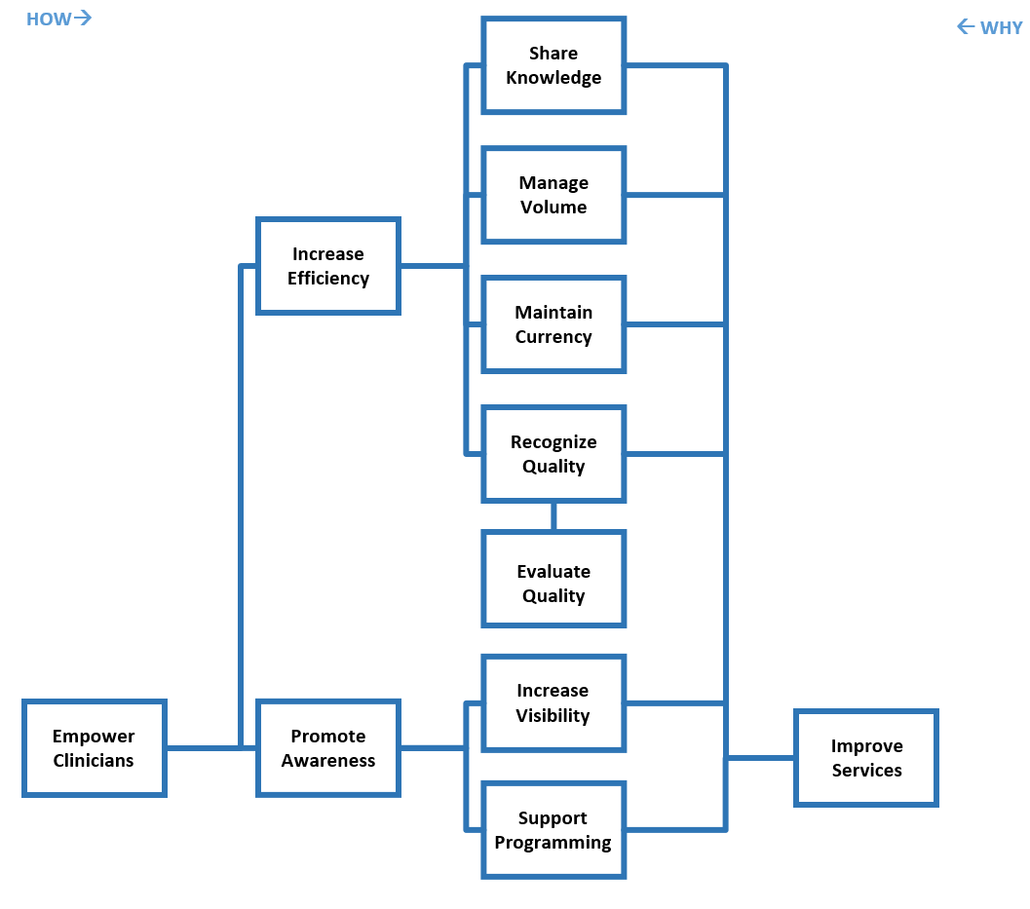
Figure 1: Function Analysis System Technique model showing organization of functions in support of Empower Clinicians.

For example, you would read the lower portion of the FAST model as such: Why do we Improve Services? So we can Increase Visibility and Support Programming. The other direction would read: How do we Increase Visibility and Support Programming? We Improve Services.

The function to the far left of the model is considered the Basic Function. It is this function that is the ultimate goal of the process - if this goal is not met, then the process has failed. In this case, we determined that the one thing this project must do was to Empower Clinicians.

Certain functions were selected for further development. Ideas were brainstormed on how these functions could be met by the clinical librarianship program. The ideas identified ranged from things we were currently doing (develop and teach courses), to some ideas that were a bit far-fetched (take a library ‘coffee cart’ to the floors). But at this point in the process, all ideas were captured and evaluated.

Using this approach, the clinical librarians reviewed the sub-functions of Increase Efficiency and focused on the function Share Knowledge. A logic model (another quality improvement tool) was used to evaluate the education programs for the clinicians. The Resources, Activities, Outputs, Outcomes and Goals were defined and analyzed.

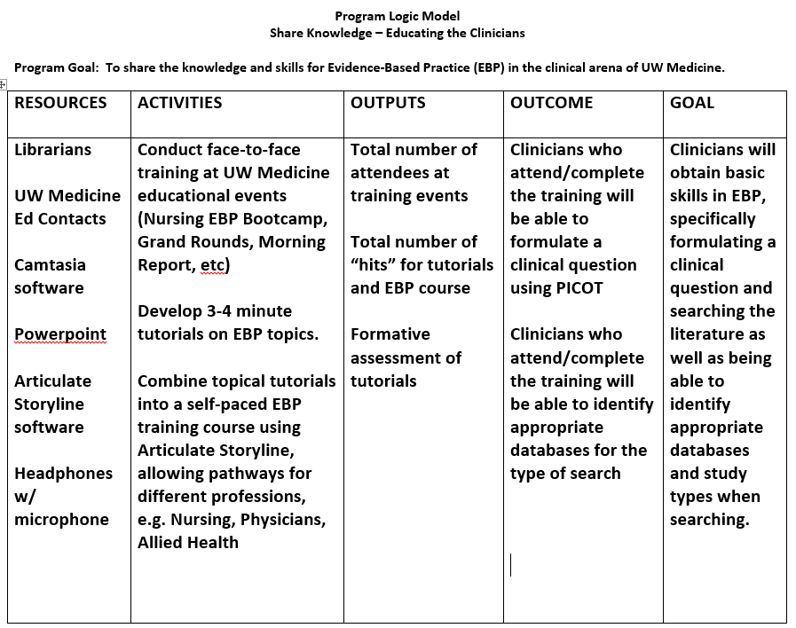
Table 1: Example of Logic Model for one Program

Since the librarians had already developed several training sessions for the various health care provider groups at UW, they believed these could be a good starting point to implement possible content, especially on the topic of Evidence-based practice (EBP). The content for a Best Practices for Searching course, a part of existing EBP training, could be used for a variety of audiences and formats. A Video Tutorial Team was established with several library staff to look at content that could be converted into a short video tutorial format. Many content areas are now under consideration or development for tutorial creation using such tools as TechSmith’s Camtasia™ and Articulate Storyline™.

Discussion
UW Medicine has been an active participant in process and quality improvement initiatives, sometimes in conjunction with the Health Sciences Library. Through the learning and application of quality improvement techniques such as Logic Models and FAST models by the clinical librarians, the Library is aligning itself with the larger organization. The Health Sciences Library’s clinical librarians believe that with this assessment, any investment in collaboration by the libraries and its parent organization will be a worthwhile endeavor. Using qualitative assessment and the Value Engineering quality improvement technique, the clinical librarians will continue to identify opportunities to teach, support research and promote the clinical services of the organization.

References

1. About the Health Sciences Library 2017 [Available from: http://hsl.uw.edu/topics/about-the-health-sciences-library/.
2. Esparza JM. A librarian's experience with six sigma(R) tools. J Hosp Librariansh. 2008;8(3):332-43.
3. Hug GP. Literature search improvement project. Med Ref Serv Q. 2002;20(4):39-46.
4. Thomas DA. The Lean Librarian. J Hosp Librariansh. 2015;15(1):23-30.

