Spectral Variations in Airborne Observations of Marine Primary Productivity

Submitted by:
Ryan McMullin
University of Washington School of Oceanography
Ocean Teaching Building Room 105
ryanmc95@uw.edu

Submitted to:
Dr. Miles Logsdon
University of Washington School of Oceanography
Ocean Science Building Room 505
mlog@uw.edu

Executive Summary
Multispectral differentiation and quantification of terrestrial and marine phenomena have become effective and popular methods of scientific observation. Measuring Normalized Difference Color Index (NDVI) to observe vegetation health and finding patters in ocean color using the Moderate Resolution Imaging Spectroradiometer (MODIS) satellite are only the tip of the iceberg in what can be accomplished using multispectral analysis. However, the gap in current analysis capabilities lies in data resolution in observation of marine phenomena. Currently, data products can report resolutions as fine as 1km, though this is still too course to observe phenomena such as primary productivity in estuarine or fjord environments.
The instrument detailed in the following design and built experiment seeks to increase the resolution of current multispectral analysis capabilities for applications in observing primary productivity in estuarine environments. This study focused on algae blooms in the Puget Sound fjord-like estuary in the Pacific Northwest United States, and data from in-situ sampling of 3 different aerial transect sites suggests that differentiation of primary producers and blooms is possible using this instrument in the future, given ample resources and time for sampling.
I. Introduction
The Puget Sound has long been a valuable resource culturally and economically not only to Washington State, but to the nation, particularly regarding its shellfish industry. Shellfish fisheries in the Puget Sound amount to 18% of national shellfish production (Pacific Shellfish Institute). These Northwest fisheries are threatened more than ever by increasing levels of toxins such as domoic acid, saxitoxin, strains of dinophysis toxins, and okadaic acid in the Puget Sound. These toxins are responsible for domoic acid poisoning (DSP), Paralytic Shellfish Poisoning (PSP), and diarrheic shellfish poisoning when ingested by humans. The presence of these toxins in Puget Sound, produced by species such as Alexandrium catenella and Pseudo-nitzschia has resulted in thousands of pounds of shellfish recall in recent years and led to several events of suspended shellfish collection in certain areas of Puget Sound (Pacific Shellfish Institute, 2017).
In-situ shipboard sampling is impractical for any sizeable region, so on a global scale zooplankton and algae monitoring is often done using aerial or satellite images (Eyes Over Washington, 2017). Satellite analysis using the Ocean Color 4 (OC4) algorithm is useful for large scales for the spatial and temporal pattern of ocean primary productivity, but the basis for that algorithm makes little sense for applications in the nearshore and in estuaries. The Moderate Resolution Imaging Spectroradiometer (MODIS) satellite can achieve 500m resolution for remotely sensing water leaving radiance of the wavelengths needed for estimation of primary productivity, but the data products produced are a 1-kilometer data resolution at best. This data resolution is too coarse for studying phytoplankton abundance and distribution in the narrow, constricted fjords of Puget Sound or other estuaries. Other satellites that have a finer data resolution and could be used for these purposes must achieve an increase in spatial coverage by decreasing the repeat interval of observations. MODIS, for all it's capabilities, has a 1 to 2 day cycle between passes; a frequency unacceptable for studying algae blooms which can appear, change shape or distribution, and disappear again in a matter of days or even hours. For studying algae blooms and changes in primary productivity, multiple passes within a period of several hours is ideal.
Recently, hyperspectral analysis and red, green, blue (RGB) wavelength detection was used to great effect in underwater identification of several coral species and sediments and in identification of algae species (Chennu et. al. 2017). This design alternative utilizes multispectral analysis coupled with an RGB wavelength sensor detecting upwelling radiation to identify Alexandrium catenella and to characterize marine primary production in an estuarine environment. This design alternative provides the benefits of satellite analysis on an estuarine spatial scale, utilizing a normalized difference color index and RGB analysis of upwelling radiation (that which is unused by marine organisms) to identify Harmful Algae Blooms (HABs) at low cost and deployable from any general aviation aircraft.
II. Methods
This design of an airborne instrument to characterize the spatial, spectral, and temporal patterns of light absorption leading to primary productivity and concentration of toxic species involved the design and build of a prototype airborne sensor and a field experiment with in situ water sampling with aircraft overflight. The instrument design is characterized by a 425 nanometer and 555 nanometer band pass filter in front of two separate photoresistors combined with a red, green, and blue (RGB) wavelength light sensor for multispectral analysis of observations of hydrographic phenomena.
After construction, the instrument was calibrated using blue and red color reference plates. Field of view calculations were done by starting the red band pass filter/photoresistor combination on a red plate and raising the sensor higher above the plate until the readings changed from pure red, indicating that the sensor was detecting a wider swath of color than just the monochromatic reference plate directly below it. Additional calibrations for blue and red color were done in the saltwater test tank of the UW Ocean Science Building. Testing involved photoresistor samples with both band pass filters looking at red and blue plates on dry land, at the water's surface, at 1 cm depth, and at 10 cm depth in the tank.
In situ sampling occurred over two days, 14APR2018 and 15APR2018 with 3 locations selected both for specific algae growth potential based on past and recent reports, and for general testing of the instrument on its first deployment. Possession Sound was selected as a calibration overflight as the R/V Carson was available at that location as a ship of opportunity. Quartermaster Harbor was used because the SoundToxins Weekly Report stated that Alexandium catenella was found in Quartermaster Harbor that week (personal correspondence with Dr. Kathy Newell, further report information in appendix 3). One transect was taken of a sea to land transition and another was taken over a small, grass field airport. These locations were chosen simply to diversify the data and test the limits of the instrument. Transects taking aerial measurements of upwelling radiation on 14APR2018 were flown in a Cessna 172 GA aircraft at 600 ft over the R/V Rachel Carson just off Naval Station Everett, at 600 ft passing from sea to land north of Lynwood, WA, at 550 ft over Quartermaster Harbor, and during a go-around at 1S2 airfield on Vashon Island. On 15APR2018, weather constraints and aircraft availability limited collection to only 2 aerial measurements, one at 500 ft over the R/V Carson in Possession Sound, and one at 500 ft over Quartermaster Harbor, though these samples went much smoother and provided more reliable data than the measurements on 14APR2018. Shipboard in situ measurements aboard the R/V Carson included surface zooplankton identification, CTD data, and upwelling and downwelling light over the side of the ship.
III. Deliverables
Section A: Design and Build
Detecting and quantifying estuarine phenomena via aerial analysis can be difficult because of the altitude required for acceptable data product resolution, adequate downwelling light resulting in undetectable differences in upwelling light, and cost. Therefore, design parameters included multispectral analysis with a spatial resolution finer than 3280 ft (1000m to be competitive with satellite imagery), a budget of less than $200, aircraft independence (non-affixed to the aircraft body for frame), ability to be deployed from a Cessna 172 general aviation aircraft, and compliance with FAA regulations (Earth Observatory, Measuring Vegetation, 2017). Multispectral analysis revolved around two photoresistors with 425nm and 555nm (blue and green) band pass filters over them. Each photoresistor provides analog input to an Arduino microcontroller with GPS shield while the Arduino simultaneously receives digital lux data from the ISL29125 breakout board which detects RGB (red, green, and blue) radiation. This provides the instrument with location and course data for each photoresistor and RGB sensor sample which are taken concurrently. Analysis from the photoresistors is done using what I refer to as the Normalized Difference Color Index (NDCI). This is similar to the Normalized Difference Vegetation Index (NDVI) used to quantify plant health from satellite imagery (Earth Observatory, Measuring Vegetation, 2017). The equation used in this design and build project is NDCI = $\left|λ_{G}-λ_{B}\right|/(λ_{G}+λ_{B}$) which normalizes the difference between the intensity of upwelling green and blue wavelengths to provide the most accurate description of the difference between the two, regardless of downwelling light intensity in those wavelengths.
The housing for my instrument is a 2-segment PVC construct consisting of a 3" L-shaped arm connected to a semicircular 3" tube with downward facing acrylic lenses. Behind each these lenses are precision cut foam pads holding one of the band pass filters with a photoresistor fixed behind it. Power and data wires travel up each PVC tube from the photoresistors and connect to the GPS shield on the Arduino board. During deployment, a USB cord is run up through the L-shaped segment of the case, connecting to a computer inside the aircraft to provided power and receive data. The L-shaped section is used as a sort of handle during deployment, with the foot of the L secured inside the aircraft and the longer section of the L hanging vertically out the window to keep the instrument's sensors out of the shadow of the aircraft fuselage (photographs in appendix 4). Total design and build costs were under $150.
Section B: Calibration
Calibration was done using blue and red color reference plates in a dry setting, at the water's surface in the test tank, just under the surface, and at 10 m depth. Testing demonstrated a 98 degree field of view and proof of concept, but also yielded insight into the accuracy of blue and red NDCI measurements with depth. Field of view was calculated using trigonometry given the photoresistor's height above the color reference plate where the sensor was still only detecting the plate's color, not the white floor around it (0.48m), and the width of the reference plate (1.09m). Therefore, the field of view could be determined by dividing 0.545m by 0.48m, calculating the inverse tangent of the result, and multiplying the angle result by 2.
Section C: Application
In-situ application of the instrument was done on 14APR2018 and 15APR2018 because those dates allowed for an overflight transect over the R/V Carson, a sea to land transect, a transect over Quartermaster Harbor, and a transect over a grass airfield (transects available on aviation charts in appendix 2).

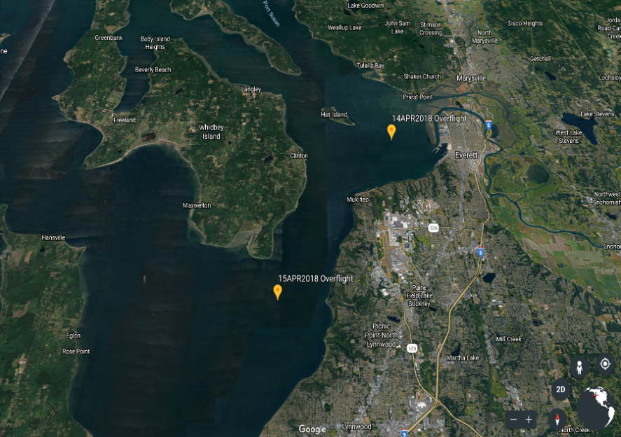
Figure 2. R/V Rachel Carson Locations during the flyovers on 14APR2018 and 15APR2018.
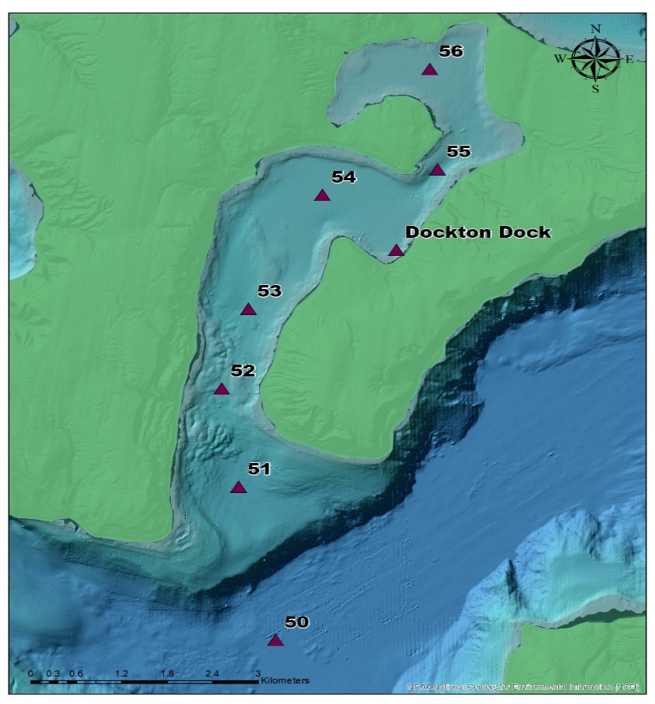
Figure 3. Sampling stations from Julie Masura's Cruise on 13APR2018. The Quartermaster Harbor transect described in this paper surveyed waters over stations 54, 55, and 56 two days after Masura took her samples
A transect over the R/V Carson was vital to collect data on in-situ biologics and sediments during an overflight transect. This allowed calibration for my instrument to identify those biologics or sediments in future flights. Unfortunately, phytoplankton identification from the R/V Carson samples (stations 8 and 9) were not possible because the samples were contaminated onboard. Shipboard data from station 18 was partially usable and the total concentration of chlorophyll in the water was 1.713 ug/L while the phaeopigment concentration was 0.525 ug/L. The ratio of chlorophyll to phaeopigment was 1.85, indicating that the chlorophyll was from living cells. The second transect occurred just southeast of the ship transect and sampled from open water to land to observe the transition and any noticeable change in NDCI between the two. The third transect was an overflight of Quartermaster Harbor. Another UW research vessel took phytoplankton samples here at stations 54, 55, and 56, two days before the overflights. These samples, taken by Julie E. Masura, found a variety of phytoplankton present with both Pseudo-nitzschia pungens and Actinoptychus senarius classified as "abundant" (report in appendix 3). NDCI and RGB transect data from the instrument was dramatically different for Quartermaster Harbor than any of the other water sampled during flights.
The last transect was taken over grass airfield 2S1 on Vashon Island. The purpose of this sample was to identify what samples of trees and grass look like from the instrument, and to determine how these compare to the sea to land transect and to the Quartermaster harbor transect where water was noticeably more blue than it was in the R/V Carson sample according to readings from the RGB sensor.
IV. Discussion
Saltwater Tank Calibration Data
Data collected during calibrations was consistent with what one would expect from light penetration underwater. Comparing the NDCI for the red and blue reference plates during testing, it becomes clear that the instrument is capable of differentiating the two plates at all depths tested. Although only 6 data points are shown in Figure 4, this powerful graphic demonstrates that the instrument performs as designed and is in agreement with the physics of underwater light attenuation for red and blue wavelengths. Light detected from the red plate diminishes dramatically with depth, far more than the blue object. This aligns with what one would expect from the attenuation of upwelling light from red and blue objects with depth and proves that the instrument works as designed.

Figure 4. Blue and red NDCI for blue and red color reference plates. NDCI for the blue reference plate is referred to as "Blue NDCI" and NDCI for the red reference plate is referred to as "Red NDCI."
In-Situ Application Data
Although only two days of in-situ operations were possible due to budget constraints, the 4 regions sampled provided excellent insight into the instrument's basic discrimination capabilities. Using the instrument, one can clearly distinguish a difference between water and land using average NDCI when comparing any of the transects. A statistical average was used to quantify each transect because there are relatively few outliers in the samples for each transect and most samples fall close to the statistical average for their transect. Both transects containing only water provide NDCI values between 0.035 and 0.040, whereas transects containing land samples exhibit NDCI values between 0.025 and 0.030 (Figure 4). By virtue of the NDCI formula used, a larger value indicates a greater difference between the two wavelengths as more reflection of 555nm (green) wavelength and absorption of 425nm (blue) wavelength. A lower number indicates more 425nm wavelength reflectance relative to 555nm reflectance. The Possession Sound transect over the R/V Carson exhibited the highest NDCI value of 0.039242, closely followed by the transect over Quartermaster Harbor which had an NDCI value of 0.037878. This difference in coloration was likely caused by the greater number of phytoplankton in the surface waters of Possession Sound in comparison to Quartermaster Harbor. Hardly any plankton were found in the Quartermaster harbor at the stations sampled, but the Possession Sound station provided a total chlorophyll concentration of 1.713 ug/L and a phaeopigment concentration of 0.525ug/L. This puts the ratio of chlorophyll to chlorophyll to phaeopigment at 1.85, indicating an abundance of living cells, not merely dead cells from a previous bloom (personal correspondence with Dr. Kathy Newell, 01MAY2018).

Figure 5. Average NDCI by transect. The "Sea to Land" transect is split in two for easier visualization of the differences perceived by the instrument from the sea and land segments of the transect.

Figure 6. The flight path over the sea to land transect was 2nm long (4000 yards) long. Here, the NDCI along the flight path is shown with a trendline overlaid to highlight the much lower NDCI value that samples containing mostly land will yield in comparison to samples containing mostly water.
The transect from Possession Sound to a partially developed shoreline, labelled "Sea to Land" on Figure 6 exhibited a lower NDCI throughout, the segment over water still exhibited a higher NDCI value than the segment over land with a difference between the two segments of 0.0026. It is likely that the overall low NDCI value of this transect in comparison to the others was caused by man-made structures caught in the instrument's field of view during sampling. Structures caught in the field of view during this transect included roads and a long dock near the shoreline which may have been observed in both the sea and land samples, reducing overall NDCI due to the low green and blue wavelength reflectance of concrete and wood.
The transect over trees and grass was taken over airfield 1S2 on Vashon Island, a small grass strip airfield which is seldom used in the winter and early spring, meaning that vegetation on the strip was still green and in good health at the time of sampling. As one would expect, average NDCI for healthy vegetation falls between that of open water which is highly reflective for 555nm light and water/land with roads which, taken as a whole transect, reflects relatively high 555nm and low 425nm. NDCI for the trees and grass transect is in the middle with a value of 0.025264, indicating healthy reflectance of the 425nm wavelength with some 555, allowing one to differentiate healthy vegetation from open water and partially developed land (as seen in the sea to land transect).
V. Conclusion and Recommendations
Accurate multispectral quantification of marine and even terrestrial phenomena is possible using the instrument detailed in this report; it operates as designed. However, it is important to note that numerical quantification of phenomena using this sensor is not intuitive relative to how humans would see the phenomena being observed. Additionally, actual identification or quantification of phenomena requires far more samples and transects than were discussed here in order to determine statistical significance of the data and how it pertains to the specific species of phytoplankton collected at sample sites during overflights. As is, there are simply too many variables to isolate any species or to claim that any species can be identified using the instrument I have designed and built. The data I have, however, proves that differentiation between water, vegetation, and partially developed land is possible using this instrument. Additional in-situ data is all that is needed to perform more accurate quantification of phytoplankton and algae in Puget Sound.

References
Institute, Pacific Shellfish. The Pacific Shellfish Institute | Washington, www.pacshell.org/washington.asp.
“Linking to Redirect to Eyes Over Puget Sound.” Redirect to Eyes Over Puget Sound, www.ecy.wa.gov/programs/eap/mar_wat/eops/.
“Measuring Vegetation (NDVI & EVI) : Feature Articles.” NASA, NASA, earthobservatory.nasa.gov/Features/MeasuringVegetation/measuring_vegetation_2.php.
Morel, Anclré, and Louis Prieur. “Analysis of variations in ocean color.” Limnology and Oceanography, 22 Dec. 2003, onlinelibrary.wiley.com/doi/10.4319/lo.1977.22.4.0709/abstract.
Prepared for WDFW by TCW Economics With Technical Assistance from The Research Group. “Economic Analysis of the Non-Treaty Commercial and Recreational Fisheries in Washington State.” Washington Department of Fish & Wildlife, wdfw.wa.gov/publications/00464/.
ISL29125 RGB Light Sensor Hookup Guide, learn.sparkfun.com/tutorials/isl29125-rgb-light-sensor-h Digital Red, Green and Blue Color Light Sensor with IR ... 24 Jan. 2014, www.bing.com/cr?IG=F1C6F4207B7B4E909B61F2F5814E5F0A&CID=2A46E078855E649B0BB7EB4784586595&rd=1&h=HyWGW0nNXPzCBUpFgO8yFV4FkSdEXm4PD8kBRrpWOwU&v=1&r=https%3a%2f%2fcdn.sparkfun.com%2fdatasheets%2fSensors%2fLightImaging%2fisl29125.pdf&p=DevEx,5067.1.ookup-guide#hardware-overview.
“3. Tidal Wetlands.” Encyclopedia of Puget Sound, Puget Sound Insitute, www.eopugetsound.org/science-review/3-tidal-wetlands.
“Harmful Algal Bloom Monitoring Data for Puget Sound - SoundToxins: Partnership for Enhanced Monitoring and Emergency Response to Harmful Algal Blooms in Puget Sound.” Harmful Algal Bloom Monitoring Data for Puget Sound - SoundToxins: Partnership for Enhanced Monitoring and Emergency Response to Harmful Algal Blooms in Puget Sound - Data.Gov, Responsible Party Northwest Fisheries Science Center (Point of Contact), 5 Feb. 2017, catalog.data.gov/dataset/harmful-algal-bloom-monitoring-data-for-puget-sound-soundtoxins-partnership-for-enhanced-monito.
Chennu, Arjun, et al. “A Diver-Operated Hyperspectral Imaging and Topographic Surveying System for Automated Mapping of Benthic Habitats.” Nature News, Nature Publishing Group, 2 Aug. 2017, www.nature.com/articles/s41598-017-07337-y#Fig5.

Appendix 1. Arduino Code

/******************************************************************************
TinyGPSPlus_GPS_Shield.ino
TinyGPS++ Library Example for the SparkFun GPS Logger Shield
By Jim Lindblom @ SparkFun Electronics
February 9, 2016
https://github.com/sparkfun/GPS_Shield

This example uses SoftwareSerial to communicate with the GPS module on
pins 8 and 9. It uses the TinyGPS++ library to parse the NMEA strings sent
by the GPS module, and prints interesting GPS information to the serial
monitor.

After uploading the code, open your serial monitor, set it to 9600 baud, and
watch for latitude, longitude, altitude, course, speed, date, time, and the
number of visible satellites.

Resources:
TinyGPS++ Library - https://github.com/mikalhart/TinyGPSPlus/releases
SoftwareSerial Library

Development/hardware environment specifics:
Arduino IDE 1.6.7
GPS Logger Shield v2.0 - Make sure the UART switch is set to SW-UART
Arduino Uno, RedBoard, Pro, Mega, etc.
******************************************************************************/

#include <TinyGPS++.h> // Include the TinyGPS++ library
TinyGPSPlus tinyGPS; // Create a TinyGPSPlus object

#define GPS_BAUD 9600 // GPS module baud rate. GP3906 defaults to 9600.

// If you're using an Arduino Uno, Mega, RedBoard, or any board that uses the
// 0/1 UART for programming/Serial monitor-ing, use SoftwareSerial:
#include <SoftwareSerial.h>
#define ARDUINO_GPS_RX 9 // GPS TX, Arduino RX pin
#define ARDUINO_GPS_TX 8 // GPS RX, Arduino TX pin
SoftwareSerial ssGPS(ARDUINO_GPS_TX, ARDUINO_GPS_RX); // Create a SoftwareSerial

//include RGB library
#include <SFE_ISL29125.h>
SFE_ISL29125 RGB_sensor;

// Set gpsPort to either ssGPS if using SoftwareSerial or Serial1 if using an
// Arduino with a dedicated hardware serial port
#define gpsPort ssGPS // Alternatively, use Serial1 on the Leonardo

// Define the serial monitor port. On the Uno, Mega, and Leonardo this is 'Serial'
// on other boards this may be 'SerialUSB'
#define SerialMonitor Serial
int GphotocellReading;
int BphotocellReading;
int Gbrightness;
int Bbrightness;

void setup()
{
SerialMonitor.begin(9600);
gpsPort.begin(GPS_BAUD);
// Initialize the ISL29125 with simple configuration so it starts sampling
if (RGB_sensor.init())
{
//Serial.println("RGB Initialization Successful\n\r");
}
}

void loop()
{
// read the input on analog pin 0 and 3:
int GsensorValue = analogRead(A0);
int BsensorValue = analogRead(A3);
// print out the value you read:
//Serial.print("Analog light reading");
//Serial.println(sensorValue);
GphotocellReading = 1023 - GsensorValue;
BphotocellReading = 1023 - BsensorValue;
Gbrightness = map(GphotocellReading, 0, 1023, 0, 255);
Bbrightness = map(BphotocellReading, 0, 1023, 0, 255);

// Read sensor values (16 bit integers)
unsigned int red = RGB_sensor.readRed();
unsigned int green = RGB_sensor.readGreen();
unsigned int blue = RGB_sensor.readBlue();
// Print out readings, change HEX to DEC if you prefer decimal output
//Serial.print("Red: "); Serial.println(red,DEC);
//Serial.print("Green: "); Serial.println(green,DEC);
//Serial.print("Blue: "); Serial.println(blue,DEC);
//Serial.println();
//Serial.print("Analog Green light reading");
//Serial.print(",");
//Serial.print("scaled value of Green photo sensor");
//Serial.print(",");
//Serial.print("Analog Blue light reading");
//Serial.print(",");
//Serial.print("scaled value of Blue photo sensor");
//Serial.print(",");
//Serial.print(sensorValue);
//Serial.print(",");
//Serial.print(brightness);
//Serial.println();
//Serial.print(",");
//Serial.print("Red");
//Serial.print(",");
//Serial.print("Green");
//Serial.print(",");
//Serial.println("Blue");
//Serial.println(",");
Serial.print(GsensorValue);
Serial.print(",");
Serial.print(Gbrightness);
Serial.print(",");
Serial.print(BsensorValue);
Serial.print(",");
Serial.print(Bbrightness);
Serial.print(",");
Serial.print(red,DEC);
Serial.print(",");
Serial.print(green,DEC);
Serial.print(",");
Serial.print(blue,DEC);
Serial.println();

// print position, altitude, speed, time/date, and satellites:
printGPSInfo();

// "Smart delay" looks for GPS data while the Arduino's not doing anything else
smartDelay(1000);
}

void printGPSInfo()
{
// Print latitude, longitude, altitude in feet, course, speed, date, time,
// and the number of visible satellites.
//SerialMonitor.print("Lat: ");
SerialMonitor.print(tinyGPS.location.lat(), 6);
SerialMonitor.print(",");
//SerialMonitor.print("Long: ");
SerialMonitor.print(tinyGPS.location.lng(), 6);
SerialMonitor.print(",");
//SerialMonitor.print("Alt: ");
SerialMonitor.print(tinyGPS.altitude.feet());
SerialMonitor.print(",");
//SerialMonitor.print("Course: ");
SerialMonitor.print(tinyGPS.course.deg());
SerialMonitor.print(",");
//SerialMonitor.print("Speed: ");
SerialMonitor.print(tinyGPS.speed.mph());
SerialMonitor.print(",");
//SerialMonitor.print("Date: ");
printDate();
SerialMonitor.print(",");
//SerialMonitor.print("Time: ");
printTime();
SerialMonitor.print(",");
//SerialMonitor.print("Sats: ");
SerialMonitor.print(tinyGPS.satellites.value());
SerialMonitor.print(",");
}

// This custom version of delay() ensures that the tinyGPS object
// is being "fed". From the TinyGPS++ examples.
static void smartDelay(unsigned long ms)
{
unsigned long start = millis();
do
{
// If data has come in from the GPS module
while (gpsPort.available())
tinyGPS.encode(gpsPort.read()); // Send it to the encode function
// tinyGPS.encode(char) continues to "load" the tinGPS object with new
// data coming in from the GPS module. As full NMEA strings begin to come in
// the tinyGPS library will be able to start parsing them for pertinent info
} while (millis() - start < ms);
}

//printDate() formats the date into dd/mm/yy.
void printDate()
{
SerialMonitor.print(tinyGPS.date.day());
SerialMonitor.print("/");
SerialMonitor.print(tinyGPS.date.month());
SerialMonitor.print("/");
SerialMonitor.print(tinyGPS.date.year());
}

// printTime() formats the time into "hh:mm:ss", and prints leading 0's
// where they're called for.
void printTime()
{
SerialMonitor.print(tinyGPS.time.hour());
SerialMonitor.print(":");
if (tinyGPS.time.minute() < 10) SerialMonitor.print('0');
SerialMonitor.print(tinyGPS.time.minute());
SerialMonitor.print(":");
if (tinyGPS.time.second() < 10) SerialMonitor.print('0');
SerialMonitor.print(tinyGPS.time.second());
}

Appendix 2. Transect Locations and Distances

Possession Sound transect. 2.1 NM.
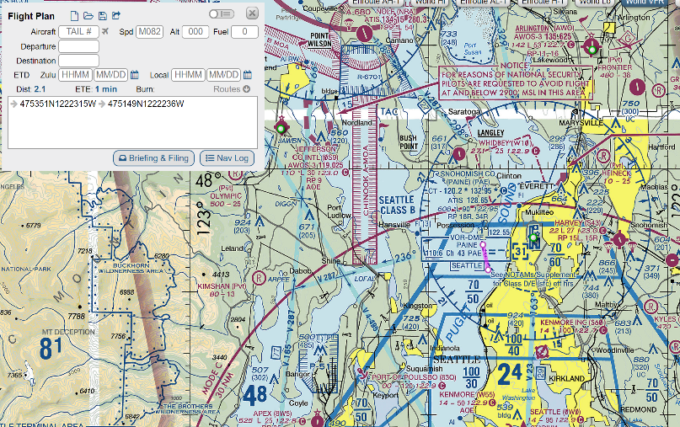
Sea to Land transect. 2.1 NM.
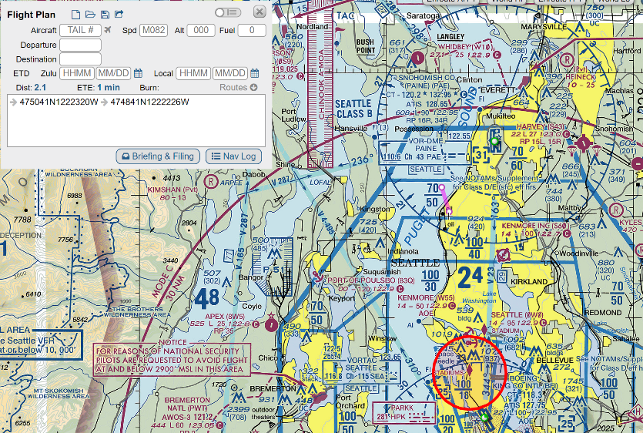
Quartermaster Harbor transect. 2.0 NM.
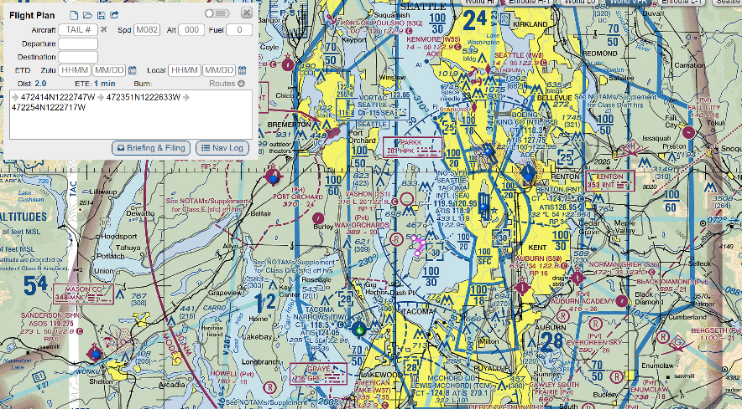
Trees and Grass transect over 1S2 on Vashon. 1.7 NM.
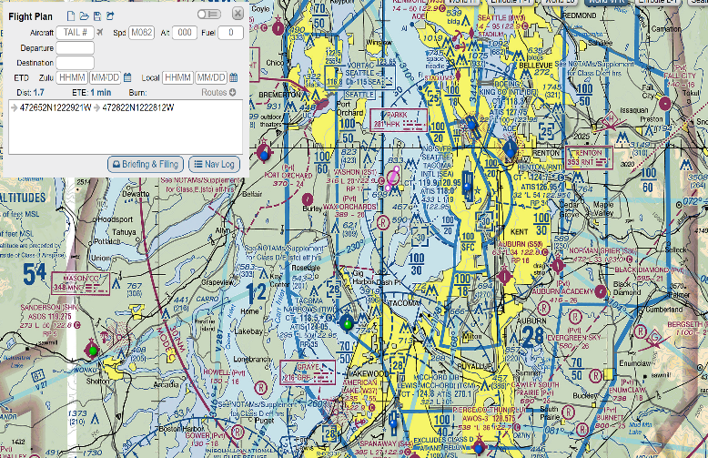

Appendix 3. SoundToxin Reports
All SoundToxin reports can be found at soundtoxins.org

Appendix 4. Photographic Documentation of the Instrument
