
Tsunami wave propagation throughout the puget sound
By Ari Pape-Uphoff

June 2, 2019

Abstract
Tsunamis are commonly caused by submarine earthquakes. An earthquake along the Cascadia Subduction Zone has the potential to create a tsunami that could enter the Straits of Juan de Fuca and propagate throughout the Puget Sound causing damage in its wake. The Puget Sound model is an option to predict the propagation of a tsunami wave throughout the Puget Sound. The Puget Sound model predicts wave heights of 11 meters, 8 meters, 5 meters, and 6 meters at Port Townsend, Seattle, Hood Canal, and Tacoma respectively. Once scaled down, so that the initial wave at Port Townsend is 2 meters tall, the Puget Sound model predicts a similar wave height in Seattle and Tacoma to other mathematical models. There should be time for communities in the Puget Sound to evacuate if a tsunami were to occur. The Puget Sound model predicts that a tsunami would reach Seattle a half hour after it passes Port Townsend. It would take even longer, more than one hour, for the tsunami to reach The Great Bend in the Hood Canal and Tacoma. The Puget Sound model provides a basic understanding for tsunami propagation throughout the Puget Sound.

Introduction
A tsunami is a series of waves caused by large vertical displacements of water. This vertical displacement is usually generated from seafloor deformation during underwater earthquakes (Figure 1). In fact, about 75% of tsunamis recorded are generated by this process (Arcas and Segur, 2012). The submarine earthquake usually has a magnitude of 6.5 or higher on the Richter scale to cause a tsunami wave. Tsunamis can also be caused by underwater or coastal landslides, volcanic eruptions, or impacting meteorites (Single).
Tsunamis are considered shallow water waves. A shallow water wave is when the wavelength of the wave is much less than two times the depth of water that wave is moving in. The equation for a shallow water wave is:
$$ν=√gd$$
Were $ν$ is the velocity of the wave, g is the gravitational constant (9.8 m/s²), and d is the depth of the water column. Essentially the speed of a shallow water wave is determined by the depth of the water column (Single).
As a tsunami approaches the shore, the front of the wave slows down as the water column shallows. The back of the wave’s speed has not slowed since it is still far offshore. This causes the long tsunami wave to compress horizontally. Because water is nearly incompressible the tsunami’s height increases while its width compresses due to equilibrium (Arcas and Segur, 2012).
Tsunamis can be generated without warning from earthquakes or submarine landslides. Because tsunamis can generate suddenly from earthquakes and landslides, scientists have focused on detections of tsunamis to give coastal communities a chance to escape the initial impact. A chance that many coastal communities lack. In the 1990’s, there were fourteen tsunami events that impacted coastlines around the world. Even though other natural disasters caused greater death counts and industrial destruction, tsunamis capture the attention of many scientists (Bryant, 2008).
The Puget Sound has been affected by earthquakes and tsunamis. A recent earthquake in 2001 had a magnitude of 6.8. This earthquake and did not cause structural damage, however, it left psychological marks on many people and introduced the Puget Sound’s seismic vulnerability (New York Times, 2001). Models suggest a 14% chance of a magnitude 9 earthquake occurring on the Cascadia subduction zone in the next 50 years (Frankel, 2018). While this will have a large impact on the infrastructure at large urban hubs such as Seattle and Tacoma, a tsunami following that earthquake would be devastating. A magnitude 9 earthquake will potentially have a 20-meter-high tsunami accompanying it (Mörner, 2017).
Tsunamis in Washington State can be sourced within the Puget Sound due to earthquakes at the Seattle, Tacoma, and South Whidbey Island faults. They also occur due to landslides from earthquakes set off by the Juan de Fuca plate subducting underneath the North American plate. However, tsunamis propagating from large subduction zones off the coast of Washington are unlikely to impact the Puget Sound due to the angle of the Straits of Juan de Fuca in relationship to the coastline and the geological complexity of the Puget Sound, mainly the refracting of the wave south towards Seattle/Tacoma area. Though, there is no great concern for incoming substantially-sized waves arriving from the Pacific Ocean, tsunami can still form from smaller faults within the Puget Sound (Gonzalez et al., 2003).
The Seattle fault has set off an earthquake with magnitude greater than 7. This occurred sometime in the 1100s and sediment deposits in the area led scientists to believe that this earthquake created a tsunami. Models have been created to predict and map the tsunami hazards for large urban communities along coastlines within the Puget Sound, such as Seattle and Tacoma. The model simulation uses a mean tide in calculating the sea level height during the tsunami (Koshimura and Mofjeld, 2005). A mean tide is the computed average between the mean high tide and the mean low tide of an area (Tidal, 2018). At high tide, tsunamis have a greater impact on coastal communities because the water level is higher. Results from this model show that a tsunami would strike Elliot Bay with a height of 3 meters or greater at Northshore and 1.5 meters at the head of the bay. Because this model focuses on an earthquake from the Seattle fault there would be no time to move out of the tsunami hazard. However, in Tacoma the harbors and ports would be struck with a wave less than one meter 20 minutes after the earthquake (Koshimura and Mofjeld, 2005).
However, despite it being unlikely that a tsunami from a Cascadia Subduction Zone earthquake to propagate throughout the Puget Sound, it can still happen. There is evidence of a potential Cascadia subduction thrust earthquake (CSTE) caused a tsunami to propagate throughout the Puget Sound. One evidence comes from tidal marsh deposits at Lynch Cove, located at the head of the Hood Canal. A tsunami from a CSTE better explains the sediment layer than storms, river floods, or geologic processes. Mathematical simulations suggest that a tsunami from the Seattle fault had no effect on Lynch Cove and that it is more likely that the tsunami came from a CSTE. Simulations from a CSTE would explain the silt layer deposited at Lynch Cove and Discovery Bay. These simulations show a wave of about 2-4 meters in height reached Lynch Cove roughly 3 hours after the earthquake and a wave of about 3-6 meters reached Discovery Bay about 2 hours after the earthquake. These simulations were running for an CSTE with a magnitude of about 9 (Garrison, 2017)
There are other mathematical simulations for a tsunami from the Cascadia subduction zone. One model, for an earthquake with the magnitude of 8.2, predicts that a wave of about 2 meters will form at the mouth of the Straits of Juan de Fuca. The wave height will be constant until after it passes Victoria, B.C. The wave then loses a lot of energy moving through the narrow passages of the Puget Sound. The predicted wave height for the tsunami once it reaches Seattle and Tacoma are reduced 1-meter or less (Ng, 1990).
There is uncertainty about how a tsunami from a Cascadia Subduction Zone earthquake would impact coastal communities throughout the Puget Sound. The Puget Sound model offers another way to predict tsunami propagation throughout the Puget Sound. The Puget Sound model was not designed to look at tsunami waves. It was initially created to look at tide circulation. However, tsunamis and tides are both shallow water waves so it is possible that the Puget Sound model could predict how a tsunami would propagate throughout the Puget Sound.

Methods
The Puget Sound model was used to look at how tsunamis propagate throughout the Puget Sound.
A model of the Puget Sound was created in the 1950s at the University of Washington to look at and understand circulation patterns in the Puget Sound. Its fundamental purpose is to look at tides and water circulation over basin sills. Before the construction of the model, an in-depth theoretical study was done to determine the scale sizes. The Puget Sound model needed to be scales so that flow in the model must be turbulent for an appropriate representation. There are known limitations to the model. Mainly, that there is no control for wind, and surface tension cannot be eliminated (Lincoln, 1979).
This causes certain mixing to be unreliable and water movement near the shoreline and in shallow areas to be skewed. This physical model consists of the entire Puget Sound. It does not include the Canadian side of the of the Straits of Juan de Fuca or the San Juan islands. It does include up slightly past Deception pass. The model has a vertical scale ratio of 1:1,152, a horizontal scale ratio of 1: 40,000, and a time scale of 1:1178.5 (Lincoln, 1979).
Sensors were constructed to measure the waves height in the Puget Sound model. The circuit includes four Ultrasonic Distance Sensors (HC-SR04), and Arduino board, and a battery bridge (Figure 2, 3). HC-SR04 sensors were soldered and wired to the Arduino and exposed wires were wrapped in electrical tape to protect them from water damage. The code used for running the sensors and collecting data is located in the Appendix.
The HC-SR04 sensors were placed into 3-D printed holders that were attached to small wooden planks. This apparatus was then placed above the water and each side of the plank was duck taped to the Puget Sound model for stabilization. Unfortunately, the way that the sensors were rigged caused them to not all have the same height above the water. The Port Townsend sensor was measured at 39 millimeters above the water, the Seattle sensor 48 millimeters above the water, and the Hood Canal and Tacoma sensors each 37 millimeters above the water. The sensor recording the initial height of the tsunami wave was stationed between Port Townsend and Fort Casey. The other sensors were placed at various locations in the Puget Sound model. One was placed at the entrance to Elliot Bay, another at the Great Bend in the Hood Canal, and the last one was placed outside of Commencement Bay. Each of these sensors recorded the height of the propagation wave as it moved throughout the model (Figure 4)
Waves were created using a plastic bucket in the physical Puget Sound Model. The wave was formed by the vertical displacement cause by the bottom of the bucket pressed down into the water in the model. This process is located behind the block that creates the tides in the model (Figure 5). Thirty trials were taken in this way and the amplitude for each wave was recorded, using the HC-SR04 sensors, and the time recorded using a stop watch.
A lot of scaling needed to be done for the Puget Sound model. The vertical depth of the model is scaled so that 0.878 millimeters in the model is one meter in the actual Puget Sound. All sea level height values collected by the sensors were scaled within that relationship. These scaling values can be found online or in the Puget Sound model manual. The initial values were recorded onto a computer using Coolterm, then copied to a text file, and imported and comma delimited to a Microsoft Excel worksheet.
In Microsoft Excel the data is converted from the recorded values to actual world values. The equation used to convert the height was:
$$h_{f}=\left(\frac{h_{r}}{0.878}\right)-(\frac{h_{m}}{0.878})$$
Where h_{f} is the final height, h_{r} is the height recorded by the sensors, and h_{m} is the measured height that the sensor was above the water.
The time for each trial was recorded by a stopwatch. This time was then divided by the number of measurements taken. This averages the time between each measurement. The Puget Sound model has a time scale of 3.055 seconds to one hour. Therefore the times recorded were converted to hours by dividing them by 3.055.
Scatter plots with lines were then created with the x-axis as time and the y-axis as wave height. All max heights and the times they occurred at each location were averaged and plotted in both a bar graph and scatter plot with lines.
The peak heights of the good graphs (Figure 6), good graphs are considered to be where the wave height decreases with distance from Port Townsend to Seattle to Tacoma, are then averaged for each location. These averaged heights at each location were plotted on a bar graph. The times that the peak wave height passed the Seattle, Hood Canal, and Tacoma sensors were subtracted by the time that the peak wave passed under the Port Townsend sensor. This was done to determine how long it took the peak of the wave to reach the Seattle, Hood Canal, and Tacoma sensors. This was plotted on a lined scatter plot.
Another bar graph was created to compare the diffusion and dispersion of the tsunami between the Puget Sound model and numerical models. This bar graph is scaled down so that the wave passing Port Townsend is 2 meters tall, the predicted height of a tsunami at Victoria, B.C. from the mathematical model.

Results
The height of the tsunami wave decreases as it propagates throughout the Puget Sound. The average height of a wave decreases from about 11.5 meters to about 8 meters from Port Townsend to Seattle and from about 8 meters to 6 meters from Seattle to Tacoma. The maximum average wave height decreased from 11.5 meters from Port Townsend to about 5 meters at the Great Bend in the Hood Canal. The highest standard deviation was at the Port Townsend sensor of 1.29 meters. The second highest standard deviation was at Hood Canal with 0.85 meters (Fig. 7).
After calculations, the peak of the wave takes about 0.66 hours to go from the initial sensor at Port Townsend to Seattle. It takes another 0.49 hours for the peak of the wave to reach Tacoma. The wave takes about 1.34 hours to propagate from Port Townsend to the Great Bend in the Hood Canal. The wave height seems to decrease linearly with time. With every hour, the wave height decreases by 4.74 meters (Fig. 8).
After measuring the distance from Port Townsend to the other sites, Seattle, Hood Canal, and Tacoma, one can determine the speed of the wave. The distance from Port Townsend to Seattle is about 64 kilometers. This makes it so the average speed of the wave from Port Townsend to Seattle is roughly 26.8 meters per second. The distance from Port Townsend to the Great Bend is roughly 107 kilometers and Port Townsend to Tacoma is roughly 104 kilometers. The average speed respectively is then about 22 meters per second and about 25 meters per second. Using the shallow water wave equation, the speed of the wave at Port Townsend is roughly 19 meters per second. The simulated wave is predicting a wave 8 meters per second faster than the shallow water waves equation.

Discussion
The time it takes for the peak of a tsunami wave to disperse from Port Townsend to Seattle, The Great Bend in the Hood Canal, and Tacoma is extremely important. It allows us to know how much time cities of Seattle and Tacoma, the two largest hubs in the Puget Sound, have for evacuation. It is also important to know how much time people in the Hood Canal have for evacuation even though the population density is smaller.
Luckily, it looks like Seattle has just over half an hour to evacuate until a wave passes Port Townsend. However, this does not agree with another mathematical model which suggest that the time between the peak of the tsunami wave from Victoria to Seattle is about 2 hours (Ng, 1990). This is much slower than the Puget Sound model suggests.
According to the Puget Sound model, Tacoma and the Great Bend in the Hood Canal each have over an hour to evacuate after the tsunami wave reaches Port Townsend. However, another mathematical model suggest that the peak of the wave would arrive at Discovery Bay, about 2 hours after the earthquake and the peak of the wave would arrive to Lynch Cove about 3-4 hours after the earthquake (Garrison, 2017). Discovery Bay is about 27 kilometers from Port Townsend via water and Lynch Cove is about 24 kilometers from the Great Bend in the Hood Canal. The wave in the Puget Sound model took about 1.3 hours from Port Townsend to the Great Bend in the Hood Canal (Figure 8). This is fairly similar to the difference between the time the peak wave propagates from Discovery Bay to Lynch Cove, which was about 1 hour. However, the distance is about 42 kilometers more from Discovery Bay to Lynch Cove than Port Townsend to the Great Bend. This means that a mathematical model again suggests a slower moving wave than the Puget Sound model.
The maximum height of the tsunami wave is also very important. Waves with large amplitudes can cause devastating destruction to the coastal communities in the Puget Sound. There is a lot of infrastructure along the coastline in Seattle and Tacoma. If the wave is tall enough and has enough force, a lot of this infrastructure could be destroyed and it would likely take some time to rebuild. Important infrastructures along these coastlines are the ferry system, tourist attractions such as the Ferris wheel, and business located on the piers would all be flooded.
There is a mathematical model for a tsunami coming down the mouth of the Puget Sound. That model suggests a wave of 2 meters at the mouth of the Straits of Juan de Fuca without much loss to Victoria. The amplitude of the tsunami wave then becomes less than 1 meter in height at Seattle and Tacoma (Ng, 1990). The Puget Sound model predicts an average wave height of 11.5 meters in Port Townsend. The wave will decrease to 8.26 meters in Seattle and decrease to 6.42 meters in Tacoma. These waves are massive considering the wave travelled 64 kilometers from Port Townsend to Seattle and another 40 kilometers to Tacoma. When these wave heights are scaled down so that the wave height is 2 meters at Port Townsend the data correlates well with the mathematical model. The wave height in Seattle and Tacoma are now roughly 1.5 meters and 1 meter respectively. This is still larger than the mathematical model’s predictions, however, the rates of diffusion for a tsunami wave throughout the Puget Sound are similar in both models (Figure 9).
The average peak wave height is about 4.95 meters in the Hood Canal according to the Puget Sound model. A mathematical model suggests that the peak wave height in Lynch Cove will be 3-4 meters (Garrison, 2017). This is 1-2 meters less than the Puget Sound model predicted.
The agreement and disagreement between the mathematical models and the Puget Sound model shows that more research needs to be done on tsunami wave propagation within the Puget Sound.
One interesting thing was that the Puget Sound model data showed a lot of double waves. It seems possible that the block, responsible for creating and controlling the tides in the Puget Sound model, unintentionally created a second, unnatural wave in the model. Most tsunami waves do have multiple waves, but these waves were so close together that it could have come from the tsunami wave interacting with the block.
All of the waves were created when the block was set for high tide. This could have amplified the results. That could be there reason why the height the Puget Sound model recorded for the Hood Canal was about 1-2 meters greater than the mathematical model. It could also be the reason why even though the rate of diffusion for one mathematical model and the Puget Sound model was similar the Puget Sound predicted greater wave heights than the mathematical model. Having the model adjusted to high tide shows the worst-case scenario seems to be the best way to predict a tsunami waves impact in the Puget Sound. This way communities and people can be prepared for the absolute worst case rather than being caught by surprise.
Another limitation that could have led to conflicting data was the quality of the sensors. The HC-SR04 has a potential error of 3 millimeters which correlates to an error of about 3.4 meters in the real world.

Conclusion
Summarize and then put your editorial opinions in a second paragraph.
The Puget Sound model offers a basic simulation for tsunami wave propagation throughout the Puget Sound. The Puget Sound model shows a potential propagation of a tsunami throughout the Puget Sound and its implications for structures along the shore in the Puget Sound. The Puget Sound model predicts greater wave heights and faster wave speeds than other mathematical models suggest. The mathematical models can take the limitations of the HC-SR04 sensor and the Puget Sound models into account for a more accurate description of the propagation of a tsunami in the Puget Sound.
More research needs to be done on tsunami wave propagation throughout the Puget Sound. Also, it seems that looking at different angles at the mouth of the Straits of Juan de Fuca would provide critical information.

Reference:

Arcas, D., & Segur, H. (2012). Seismically generated tsunamis. Philosophical Transactions of the Royal Society A, 370(1964), 1505-1542.

Bryant, E. (2008). Tsunami : The underrated hazard (2nd ed., Springer-Praxis books in geophysical sciences). Berlin ; New York : Chichester, UK: Springer ; Published in association with Praxis.

Frankel, A., Wirth, E., Marafi, N., Vidale, J., & Stephenson, W. (2018). Broadband Synthetic Seismograms for Magnitude 9 Earthquakes on the Cascadia Megathrust Based on 3D Simulations and Stochastic Synthetics, Part 1: Methodology and Overall Results. Bulletin of the Seismological Society of America, 108(5A), 2347-2369

Garrison-Laney, C., Atwater, Brian F., Crider, Juliet, Nesbitt, Elizabeth, Schmidt, David, & Sherrod, Brian. (2017). Tsunamis and Sea Levels of the Past Millennium in Puget Sound, Washington, ProQuest Dissertations and Theses.

González, F., Sherrod, Brian Louis, & Pacific Marine Environmental Laboratory , issuing body. (2003). Puget Sound tsunami sources--2002 workshop report : A contribution to the inundation mapping project of the U.S. National Tsunami Hazard Mitigation Program (NOAA OAR special report). Seattle, WA: U.S. Department of Commerce, National Oceanic and Atmospheric Administration, Pacific Marine Environmental Laboratory.

Koshimura, S., & Mofjeld, H. (2005, July 15). Puget Sound Tsunami Inundation Modeling Preliminary Report: Phase 2. Retrieved May 19, 2019, from https://nctr.pmel.noaa.gov/pugetsound/pre2/

Lincoln, J. H. (1979, May 01). The Puget Sound Model Summary. Retrieved May 19, 2019, from https://www.eopugetsound.org/articles/puget-sound-model-summary

Mörner, N. (2017). Converting Tsunami Wave Heights to Earthquake Magnitudes. Open Journal of Earthquake Research, 06(02), 89-97.

Ng, M., Leblond, P., & Murty, T. (1990). Simulation of tsunamis from great earthquakes on the Cascadia subduction. Science,250(4985), 1248-1251.

The Puget Sound Earthquake: Editorial]. (2001, Mar 02). New York Times Retrieved from https://search.proquest.com/docview/431714350?accountid=14784

“Tidal Datums.” NOAA Tides & Currents, Center for Operational Oceanographic Products and Services, 8 Aug. 2018, tidesandcurrents.noaa.gov/datum_options.html.

Single Slit Diffraction, labman.phys.utk.edu/phys221core/modules/m12/Water_waves.html.

Figure Captions:

Figure 1. Demonstrates the displacement of water that can occur when an earthquake happens causing a tsunami wave.

“Tsunami or the Seismic Sea Wave.” A Learning Family, 27 Aug. 2015, www.alearningfamily.com/main/tsunami-seismic-sea-wave/.

Figure 2. Wiring diagram for sensor build.

Figure 3. Photo of wiring of Arduino board and battery bridge.

Figure 4. Photo of where the sensors were deployed on the Puget Sound Model. The sensors are deployed at Port Townsend, Seattle, Hood Canal, Tacoma. Red stars mark where sensors are located in the model.

Figure 5. Where the plastic bucket was placed in the physical model.

Figure 6. An example of the data graphed, and the data points collected (red triangles) that were used to find the mean maximum wave height at Port Townsend, Seattle, Hood Canal, and Tacoma as well as the time between the initial wave from Port Townsend to Seattle, Hood Canal, and Tacoma.

Figure 7. A bar graph showing the mean maximum height of a tsunami wave at Port Townsend, Seattle, the Great Bend in the Hood Canal, and Tacoma. The vertical lines show the standard deviation.

Figure 8. A scatter plot with lines comparing the mean maximum height of a tsunami wave and the time it takes for the wave to move to the three other locations in the Puget Sound. The dotted trend line shows a negative slope.

Figure 9. A bar graph showing the tsunami wave height at Port Townsend, Seattle, Hood Canal, and Tacoma after scaling the wave height down to match other mathematical models predictions.

Figures:

Figure 1. Demonstrates the displacement of water that can occur when an earthquake happens causing a tsunami wave.

“Tsunami or the Seismic Sea Wave.” A Learning Family, 27 Aug. 2015, www.alearningfamily.com/main/tsunami-seismic-sea-wave/.

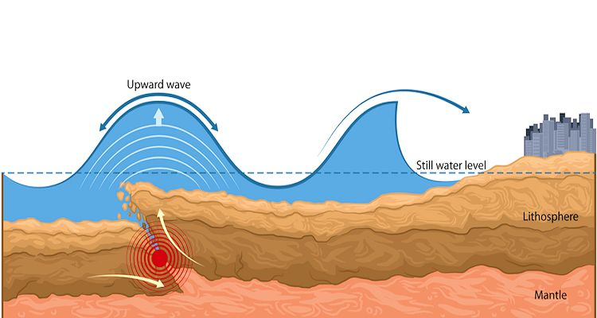

Figure 2. Wiring diagram for sensor build.
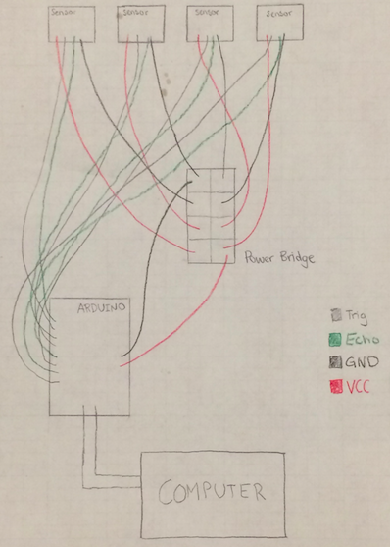

Figure 3. Photo of wiring of Arduino board and battery bridge.
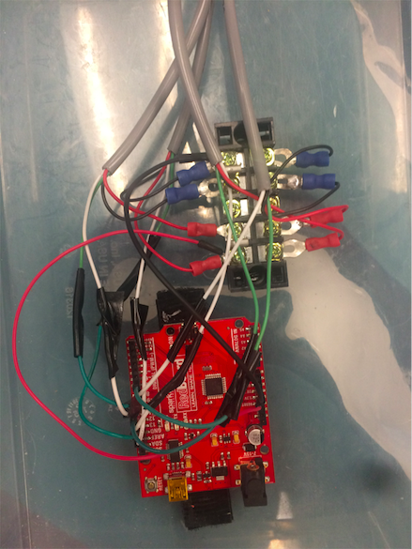

Figure 4. Photo of where the sensors were deployed on the Puget Sound Model. The sensors are deployed at Port Townsend, Seattle, Hood Canal, Tacoma. Red stars mark where sensors are located in the model.
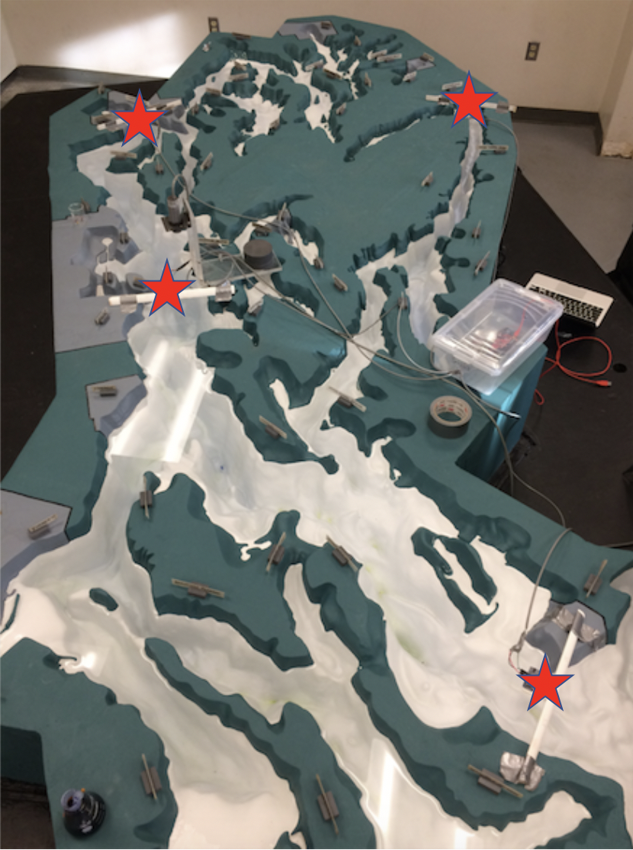

Figure 5. Where the plastic bucket was placed in the physical model.

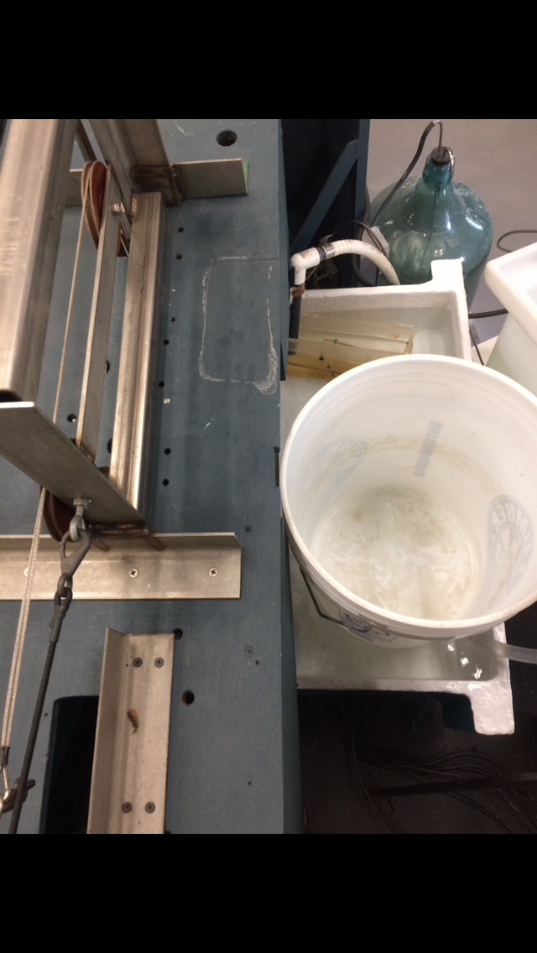

Figure 6. An example of the data graphed, and the data points collected (red triangles) that were used to find the mean maximum wave height at Port Townsend, Seattle, Hood Canal, and Tacoma as well as the time between the initial wave from Port Townsend to Seattle, Hood Canal, and Tacoma.
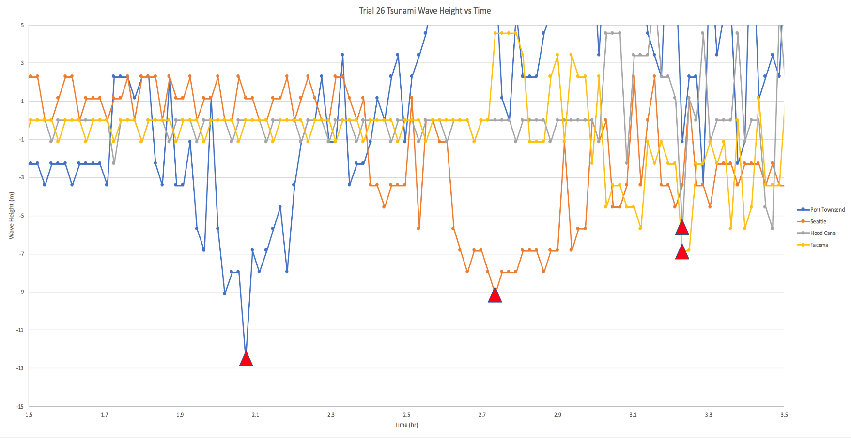
Figure 7. A bar graph showing the mean maximum height of a tsunami wave at Port Townsend, Seattle, the Great Bend in the Hood Canal, and Tacoma. The vertical lines show the standard deviation.

Figure 8. A scatter plot with lines comparing the mean maximum height of a tsunami wave and the time it takes for the wave to move to the three other locations in the Puget Sound. The dotted trend line shows a negative slope.

Figure 9. A bar graph showing the tsunami wave height at Port Townsend, Seattle, Hood Canal, and Tacoma after scaling the wave height down to match other mathematical 1models’ predictions.

Appendix:

#define trig4Pin 7
#define echo4Pin 6
#define trig3Pin 9
#define echo3Pin 8
#define trig2Pin 11
#define echo2Pin 10
#define trigPin 13
#define echoPin 12

void setup() {
Serial.begin (9600);
pinMode(trigPin, OUTPUT);
pinMode(echoPin, INPUT);
pinMode(trig2Pin, OUTPUT);
pinMode(echo2Pin, INPUT);
pinMode(trig3Pin, OUTPUT);
pinMode(echo3Pin, INPUT);
pinMode(trig4Pin, OUTPUT);
pinMode(echo4Pin, INPUT);
}

void loop() {
long duration, distance;
digitalWrite(trigPin, LOW); // Added this line
delayMicroseconds(2); // Added this line
digitalWrite(trigPin, HIGH);
// delayMicroseconds(1000); - Removed this line
delayMicroseconds(10); // Added this line
digitalWrite(trigPin, LOW);
duration = pulseIn(echoPin, HIGH);
distance = (((float) duration/58.0) * 10.0);
if (distance >= 200 || distance <= 0){
Serial.println("Out of range");
}
else {
Serial.print(distance);
Serial.print(",");
// Serial.println("Port Townsend cm");
}
long duration2, distance2;
digitalWrite(trig2Pin, LOW); // Added this line
delayMicroseconds(2); // Added this line
digitalWrite(trig2Pin, HIGH);
// delayMicroseconds(1000); - Removed this line
delayMicroseconds(10); // Added this line
digitalWrite(trig2Pin, LOW);
duration2 = pulseIn(echo2Pin, HIGH);
distance2 = (((float) duration2/58.0) * 10.0);
if (distance2 >= 200 || distance2 <= 0){
Serial.println("Out of range");
}
else {
Serial.print(distance2);
Serial.print(",");
// Serial.println("Elliot Bay cm");
}
long duration3, distance3;
digitalWrite(trig3Pin, LOW); // Added this line
delayMicroseconds(2); // Added this line
digitalWrite(trig3Pin, HIGH);
// delayMicroseconds(1000); - Removed this line
delayMicroseconds(10); // Added this line
digitalWrite(trig3Pin, LOW);
duration3 = pulseIn(echo3Pin, HIGH);
distance3 = (((float) duration3/58.0) * 10.0) ;
if (distance3 >= 200 || distance3 <= 0){
Serial.println("Out of range");
}
else {
Serial.print(distance3);
Serial.print(",");
// Serial.println("Hood Canal cm");
}
long duration4, distance4;
digitalWrite(trig4Pin, LOW); // Added this line
delayMicroseconds(2); // Added this line
digitalWrite(trig4Pin, HIGH);
// delayMicroseconds(1000); - Removed this line
delayMicroseconds(10); // Added this line
digitalWrite(trig4Pin, LOW);
duration4 = pulseIn(echo4Pin, HIGH);
distance4 = (((float) duration4/58.0) * 10.0);
if (distance4 >= 200 || distance4 <= 0){
Serial.println("Out of range");
}
else {
Serial.println(distance4);
// Serial.println("Tacoma cm");
}
delay(50);
}

