Table S1: Provided as separate file. Sample data for all 170 diaspores used in this study. Internal specimen numbers and Burke Museum collection numbers and localities are provided for each. Information about the preserved specimens from which diaspores were originally collected is provided as Index Herbariorum codes and specimen numbers. Dispersal data is provided as median, minimum, maximum and standard deviation of the ten falling velocity trials conducted for each diaspore, as well as the Potential Wind Dispersal Range (PWDR) calculated using median falling velocity and species’ maximum culm height. Recorded diaspore mass (average of three trials plus standard error) are also presented. Mean annual (MAP) and warm quarter (WQP) precipitation (in millimeters), as well as the proportion of occurrences at burned sites, and proportion of occurrences in each of six land cover classes are also given for each species.

Figure S1: Dimensions of the chamber and camera setup used in measuring diaspore falling velocity. Falling velocity was measured from high speed video (959.04 frames/second) of diaspores descending through an enclosed, plexiglass chamber, and calculated from the number of frames elapsed before diaspores travelled the vertical distance of the frame. Diaspores were placed in a repurposed camera shutter and dropped into the chamber using a manual shutter release to ensure controlled release. The chamber ensured air currents in the surrounding room did not disrupt the trajectory of the falling diaspore.
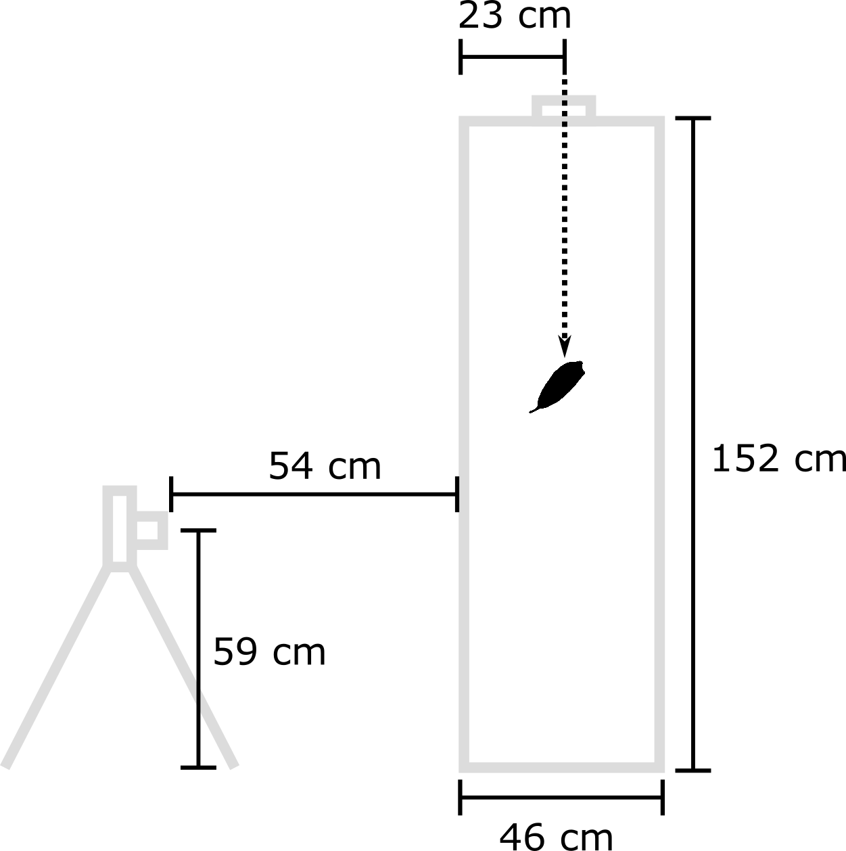
Methods S1: Ecological data for the project were obtained using a Geographic Information System (GIS) approach. Georeferenced occurrence records were downloaded from the Global Biodiversity Information Facility (GBIF) individually for each taxon. A separate Digital Object Identifier (doi) for each download is given below. Once obtained, occurrence records were “cleaned” using GBIF’s internal quality tags, limiting records to just those associated with preserved specimens collected after 1949, and excluding all those which were flagged with any of the following notifications.

CONTINENT_INVALID
PRESUMED_NEGATED_LONGITUDE
TAXON_MATCH_FUZZY
COORDINATE_ROUNDED
COUNTRY_INVALID
GEODETIC_DATUM_INVALID
PRESUMED_NEGATED_LATITUDE
PRESUMED_SWAPPED_COORDINATE
COUNTRY_MISMATCH
TAXON_MATCH_HIGHERRANK

The remaining records were subjected to further checks using the CoordinateCleaner package (v 2.0-11; Zizka et al., 2019) in the R software environment (v. 4.0.5; R Core Team, 2021). This excluded all records that were assigned the coordinates of the capital or centroid of the country in which they were found (within 1km) or those assigned the coordinates of known institutions housing preserved specimens (e.g., botanical gardens, herbaria). Records with the same latitude and longitude or zero values were also excluded. Finally, the dataset was limited to unique records (i.e., limit of one record per locality). GIS data were supplemented by a literature survey of standard handbooks, descriptions on preserved specimens, and other published sources. Excerpts from these sources are compiled below for each included taxon.

BRYLKINIA - “One species, Japan, China. Pooideae, Poodea, Meliceae, or Brylkinieae, perennial, herbaceous, slender, rhizomatous...shade, woodland…” - (Quattrochi, 2006)
Brylkinia caudata
“Asia.” - (Quattrochi, 2006)
“Forest glades; below 3000 m. Jilin (Changbai Shan), Sichuan [Japan, Russia (Far East)].” -(Flora of China vol. 22)
“Mountain woods; Hokkaido, Honshu, Shikoku, Kyushu; rather common. -Sakhalin, s. Kuriles, and Manchuria.” -(Ohwi, 1965)
“Coniferous forests. -Far East: Sakh. (West. coast, Vladimirovka). Gen. Distr.: Jap. -Chin. Described from Sakhalin. Type in Leningrad.” -(Flora of the U.S.S.R.)
GBIF.org (21 January 2021) GBIF Occurrence Download https://doi.org/10.15468/dl.pk554n

GLYCERIA – “...16-40 species, northern hemisphere...temperate regions...perennial, tall...usually aquatic or marsh grasses, strongly rhizomatous with creeping rhizomes or stoloniferous...aquatic weeds, in some of the species the leaves may float on the water surface, spread vigorously in water, useful in controlling erosion of riverbanks, species very palatable, the seeds are eaten by waterfowl, some species may cause cyanogenic poisoning in livestock, found in marshes, moist woodlands, wet and swampy places, sides of lakes and ponds, bog gardens, native pasture grasses, pampas, grasslands...” – (Quattrochi, 2006)
Glyceria borealis
“North America, US, California, Mexico. Perennial...endangered...grains worth gathering for food, occurs in wetlands and in meadow habitats, in shallow water or mud of streams, around margins, shallow water of lakes and streams, fens, ditches, ponds and marshes, swamps, along lakeshores...” – (Quattrochi, 2006)
“...margins of freshwater streams, lakes, and ponds...” – (Hitchcock and Cronquist, 2018)
“Rhizomatous perennials...grows in fine-textured soils in wet meadows and along the edges and on the muddy shores of streams, lakes, and ponds. It commonly grows in standing, shallow water. It is palatable to livestock and wildlife but is usually not grazed because of its habitat.” – (Stubbendieck et al., 2017)
“...grows along the edges and muddy shores of freshwater streams, lakes, and ponds. In the southern portion of its range, it is restricted to subalpine and alpine areas.” – (Barkworth et al., 2007)
“…sun; wet; shallow water, streams, ponds, lakeshores, wet ditches…common in shallow water bodies and shorelines throughout Minnesota's east central deciduous and northeastern coniferous forest regions.” – (Minnesota Wildflowers)
GBIF.org (21 January 2021) GBIF Occurrence Download https://doi.org/10.15468/dl.nm5p46
Glyceria grandis
“...North America, US, California, Canada. Perennial...rare to extremely rare species, native pasture grass, grows in swampy places, in wet areas along lakeshores, shallow water, ditches, lake-margins, freshwater wetlands, shores, bogs and fens, stream bank, brook sides, meadows and wet meadows, edge habitats, mud of marshes, ponds, lakes, cyanogenic potential...” – (Quattrochi, 2006)
“...banks and streams, ditches, ponds, and wet meadows...” – (Hitchcock and Cronquist, 2018)
“...grows on banks and in shallow water of ponds, streams, ditches, and wet meadows. It is palatable to livestock but not an important forage species. It can be important for deer. It is found in the northern and western Great Plains and in northern and western North America. It grows also from Alaska to Newfoundland.” – (Stubbendieck et al., 2017)
“...on banks and in the water of streams, ditches, ponds, and wet meadows.” – (Barkworth et al., 2007)
“sun; wet; shallow water, swamps, marshes, streams, ponds, lakeshores, wet ditches…common to open shallow waters or mud throughout Minnesota.” – (Minnesota Wildflowers)
GBIF.org (21 January 2021) GBIF Occurrence Download https://doi.org/10.15468/dl.vvx3n2
Glyceria maxima
“Temperate Eurasia, Europe. Perennial, aquatic of semi-aquatic, tall...native pasture grass, used as a forage crop, palatable, a nutritious wetland fodder for cattle, ornamental grass naturalized elsewhere in temperate regions, vigorous growth, extensive root system, potential seed contaminant, reproduces vegetatively, troublesome aquatic weed and aggressive species, has the potential to be a serious invader of wetlands, sometimes forms vast floating mats, forms dense monoculture in fertile sites, forms dense settlements in the most frequently flooded areas, poisonous due to the presence of smut only in fresh foliage, in Australia and New Zealand cattle poisoning due to cyanide production in the young shoots, a poor food-plant and nesting substrate for wetland wildlife, provide shelter for water birds and other aquatic organisms, tolerate strongly acid soils, useful for erosion control, suitable for reducing erosion of riverbanks, grows in slow moving streams, edges of slow flowing streams, lowland swamps, drains, creeks, dams, open habitats, swampy places, pools, waterholes, wet areas, very wet or boggy soils, on alluvial or peat soils, irrigation and drainage channels, ditches, on riversides and waterways...” – (Quattrochi, 2006)
“...disturbed wetlands; Eurasian intro, noxious...” – (Hitchcock and Cronquist, 2018)
“...native to Eurasia. It grows in wet areas, including shallow water, at scattered locations in the Manual region. It is an excellent fodder grass, and may have been planted deliberately at one time. At some sites, the species appears to be spreading, largely vegetatively.” – (Barkworth et al., 2007)
“...confined to the margins of freshwater bodies such as ponds, rivers, ditches, lakes and canals and to wet marshy areas, such as water-meadows, which are flooded in winter. It is most commonly found on waterlogged alluvial soils of high fertility and pH (6.0-8.0) close to still or slow flowing water where it often grows in tall dense luxuriant stands, and may form thick floating peaty mats across the water’s surface. In these situations it excludes most other species, forming a distinct zone in the riparian community...populations of G. maxima are morphologically very similar and most population are maintained, and established vegetatively. Detached pieces of rhizome may be dispersed by water to found new populations, the grass spreading by this means along canals, rivers and interconnecting water bodies...Newly established plants take 2-5 years to flower and despite the large panicles, seed set appears to be generally poor (between 3 and 18%) and establishment from seed may be a rare event....long history of cultivation of this species as a fodder plant and to prevent bank erosion. It is eagerly grazed by cattle and is tolerant of fairly frequent mowing...water fowl may occasionally disperse the seed. (Biol. Flora: Lamber, 1947; CPE: 338).” – (Cope and Gray, 2009)
“Marshy floodlands, stream and lake banks. Xinjiang [Kazakhstan, Russia (W Siberia westward); Europe; introduced in North America and Australia].” -(Flora of China vol. 22)
GBIF.org (21 January 2021) GBIF Occurrence Download https://doi.org/10.15468/dl.89zhh6
Glyceria septentrionalis
“...native and restricted to eastern North America. It grows in shallow water or very wet soils. It resembles G. notate in its rather short, truncate to rounded lemmas, but tends to have fewer spikelets on its branches.” – (Barkworth et al., 2007)
“…preference is full or partial sun, wet conditions, and soil containing loam, clay, or sand with organic material…Habitats include floodplain forest, swamps, marshes, margins of ponds and lakes, sloughs, and sink holes. These habitats consist of both sandy and non-sandy wetlands.” – (Illinois Wildflowers)
GBIF.org (04 February 2021) GBIF Occurrence Download https://doi.org/10.15468/dl.ry32b4
Glyceria striata
“Northern America, US, California, Canada, Mexico, Guatemala. Perennial...shortly rhizomatous, stoloniferous...grains large and worth gathering for food, naturalized elsewhere, occurs in wetlands and in meadow habitats, moist meadows, light woodland, shady places, sandy soil, open areas, sandy floodplain, low woods, bogs, saturated soil, sand bars, lakeshores, roadside ditches, fresh wet meadows, wet grounds, ponds, wet woods, wet places, low wet grounds, swamps, springs and stream margins...” – (Quattrochi, 2006)
“...bogs, along lakes and streams, other wet places...” – (Hitchcock and Cronquist, 2018)
“Caespitose or rhizomatous perennials...grows on the edges of marshes, swamps, bogs, lakes, streams, and other wet places. It provides good forage for cattle and horses. Palatability is good to very good for cattle and fair to good for sheep and wildlife. It is a common component of hay cut from subirrigated and wet meadows. Hay quality is good if harvested before plants reach maturity. It grows in the northern three-fourths of the Great Plains and throughout most of North America.” – (Stubbendieck et al., 2017)
“...grows in bogs, along lakes and streams, and in other wet places. Its range extends from Alaska to Newfoundland and south into Mexico.” – (Barkworth et al., 2007)
“Native.” – (Flora of Missouri)
“….part shade, sun; wet; shallow water, swamps, marshes, streams, ponds, lakeshores, wet ditches, open woods…favors a wide range of wet habitats from open marshes, wetlands and lakeshores to semi-shaded woodland ponds.” – (Minnesota Wildflowers)
GBIF.org (04 February 2021) GBIF Occurrence Download https://doi.org/10.15468/dl.y2cr9n

MELICA – “About 70-80 species, temperate regions...cleistogamous or chasmogamous...ornamental and very variable, toxic for cattle and horses when grazed in large amounts, shade species, dry stony slopes, species of open habitats...” – (Quattrochi, 2006)
“About 30 species, in temperate regions of the N. Hemisphere.” -(Ohwi, 1965)
Melica altissima
“Central and eastern Europe. Perennial...occurs on slope near woods, in brush thicket...” – (Quattrochi, 2006)
“...native to Eurasia. It is grown as an ornamental in North America and is reported to have escaped and become established in Oklahoma and Ontario. In its native region, it grows in the moist soils of shrubby thickets and forest edges, and on rocky slopes.” – (Barkworth et al., 2007)
“Woodland fringes, among shrubs; 800 – 1400 m. Xinjiang [Khazakhstan, Kyrgyzstan, Russia, Tajikistan, Uzbekistan; SW Asia (Caucasus, N Iran), C and E Europe].” – (Flora of China vol. 22)
“Shrubby thickets and borders of forests. -European part: Upp. Volg. (along Oka River), Volg. -Kam., Mid. Dnep., Volg.-Don., Zavolzh., Prichern., Low. Don., Low. Volg. (along Volga River); Caucasus: Cis-cauc., Dag., East. and South. Transcauc.; West. Siberia: Upp. Tob., Irt., Alt.; East Siberia: Ang. -Sayan (Kamenka on Ensei); Centr. Asia: Aral.-Casp. Dzung. -Tarb., Pam. -Al., Tyan’-Shan. Gen. Distr.: Centr. Eur. southeast. part), Balk. -As. Min. (north. part), Dzung. -Kashg. Described from Siberia. Type in London.” – (Flora of the USSR)
GBIF.org (04 February 2021) GBIF Occurrence Download https://doi.org/10.15468/dl.5hbj6v
Melica bulbosa
“Northern Ameica, Canada, US Perennial, forage, open areas, rocky slopes, rocky ravines...” – (Quattrochi, 2006)
“...grassl, sagebr, open for, rocky slopes, talus...” – (Hitchcock and Cronquist, 2018)
“...is most abundant in deep, well-drained, rich sandy loams or clay loams in meadows, alluvial fans, open woods, and along streams on east and north exposures. It provides excellent forage for cattle, sheep, horses, elk, bighorn sheep, and deer. Generally, it does not produce high quantities of forage. It is found in northwestern Great Plains, as well as in the western and northwestern United States and adjacent Canada.” – (Stubbendieck et al., 2017)
“...mostly in open woods on dry, well-drained slopes and along streams.” – (Barkworth et al., 2007)
GBIF.org (04 February 2021) GBIF Occurrence Download https://doi.org/10.15468/dl.e56d62
Melica californica
“Northern America, US Perennial, clump forming, found in open areas, rocky slopes, rocky ravines, dry bare soil, dry red rocky soil, along roadsides...” – (Quattrochi, 2006)
“...grows from sea level to 2100 m, in a wide range of habitats, from dry, rocky, exposed hillsides to moist woods.” – (Barkworth et al., 2007)
“Open or rocky hillsides, oak woodland, conifer forest; Elevation: < 2200 m.” – (Jepson eFlora)
GBIF.org (04 February 2021) GBIF Occurrence Download https://doi.org/10.15468/dl.vfsve4
Melica ciliata
“Armenia, Iran, Turkey, Europe...useful for erosion control, common in meadows, stony areas, dry to very dry steep rocky sites...” – (Quattrochi, 2006)
“...grown as an ornamental in North America and is not known to have escaped. It is native to Europe, northern Africa, and southwestern Asia, where it grows on damp to somewhat dry soils.” – (Barkworth et al., 2007)
“Grassy places in rock gullies; ca. 1500m. Xinjiang [Kazakhstan, Russia, Turkmenistan; SW Asia (Caucasus, N Iran), Europe].” – (Flora of China vol. 22)
“Perennial...Rocky and stony places...” – (from Melica taurica C. Koch. in the Flora of the USSR)
“Dry and arid places, in almost all of France and Corsica.” – (Tela Botanica)
“It is the characteristic species of the rupicolous calcareous grasslands of the Festucion pallentis allicance, and also occurring in pioneer rupicolous grasslands of the Alysso-Sedion alliance. Competitive weakness and transformations of the species’ habitat – xerothermic communities from the Festuco-Brmetea class – are the main factors causing disappearing of this plant (Kwiatkowski 1997; Szczesniak 2001a, 2001b).” – (Szczepaniak and Cieslak, 2006)
GBIF.org (04 February 2021) GBIF Occurrence Download https://doi.org/10.15468/dl.w7bkpj
Melica mutica
“Northern America, US Shortly rhizomatous...grows in moist or dry areas in open woods and thickets, in sandy swamps, woods...” – (Quattrochi, 2006)
“...grows in moist or dry areas in open woods and thickets, from Iowa and Texas east to Maryland and Florida.” – (Barkworth et al., 2007)
“Dry to mesic forests and woodlands, including coastal fringe and maritime forests.” – (Weakley, 2020)
GBIF.org (04 February 2021) GBIF Occurrence Download https://doi.org/10.15468/dl.7xnnxu
Melica nutans
“North and southwest Asia, Europe. Clumped or solitary, stems slender, loose and nodding panicles...” – (Quattrochi, 2006)
“Type locality: Europe. Distribution: Kashmir; Europe and Northern Asia.” -(Cope, 1982)
“Hill slopes, shady places; 1500–2300 m. Heilongjiang, Xinjiang [Japan, Kashmir, Kazakhstan, Korea, Kyrgyzstan, Russia, Tajikistan, Uzbekistan; SW Asia (Caucasus), Europe].” -(Flora of China vol. 22)
“Grassy slopes of hills and mountains; Hokkaido, Honshu, Shikoku, Kyushu; rather common. -Kuriles, Sakhalin, Kora, China to Sibera, and Europe.” - (Ohwi, 1965)
“Shady forests, less often dense scrubs. -European part: Kar. -Lap., Dv. -Pech., Lad. -Il’m., Upp. Volg. Volg. -Kam., Upp. Dnep., Volg.- Don, Zavolzh., Prichern. (northern part), Crimea (mountainous, rarely), Low. -Don (northern part); Caucasus: Ciscauc., Dag., West. and East. Transcauc. (west. part); West. Siberia: Ob., Upp. Tob., Irt., Alt.; East. Siberia: Yenis. (south. part), Ang. -Sayan, Daur.; Far East: Ze. -Bur., Ud., Ussr., Sakh.; Centr. Asia: Dzung. -Tarb. (Kul’dzha), Tyan’-Shan (along the river Issyk). Gen. Distr.: Scand., Centr. and Atl. Eur., West. Medit. (north. part), Balk- As. Min. (west. part), Jap. -Chin. Described from Europe. Type in London.” -(Flora of the U.S.S.R.)
“A generally uncommon grass, it can be locally frequent in and around deciduous woods, in shady scrub (typically of birch, alder or hazel) and in the grikes of limestone pavement. It is confined to basic infertile soils over limestone and other base-rich rocks and to shady habitats as much on the borders of woodland as in the woods themselves. It occurs with a range of woodland associates and is found from a few lowland sites to 820m in Glen Isla (Angus).” – (Cope and Gray, 2009)
GBIF.org (05 February 2021) GBIF Occurrence Download https://doi.org/10.15468/dl.t5p77k

Melica onoei
“Distributed in Japan, Korea, and Northern China.” -(Gramineae in Flora of Taiwan)
“Type: Japan, Ono.. Distribution: Pakistan (N.W.F.P & Kashmir); China and Japan.” -(Cope, 1982)
“This species is mainly distributed from Japan to Yunnan, but a few gatherings are known from the W Himalayas...Woodlands, damp shady places on hillsides, gullies, roadsides; 400–2500 m. Anhui, Gansu, Guizhou, Hebei, Henan, Hubei, Hunan, Jiangsu, Jiangxi, Ningxia, Shaanxi, Shandong, Shanxi, Sichuan, Taiwan, Xizang, Yunnan, Zhejiang [Japan, Kashmir, Korea, N Pakistan].” – (Chinese Plant Names)
“Woodlands, damp shady places on hillsides, gullies, roadsides; 400–2500 m. Anhui, Gansu, Guizhou, Hebei, Henan, Hubei, Hunan, Jiangsu, Jiangxi, Ningxia, Shaanxi, Shandong, Shanxi, Sichuan, Taiwan, Xizang, Yunnan, Zhejiang [Japan, Kashmir, Korea, N Pakistan]. This species is mainly distributed from Japan to Yunnan, but a few gatherings are known from the W Himalayas.” – (Flora of China vol. 22)
“Thin woods; Honshu (Kanto Distr. and westw.), Shikoku, Kyushu; rather rare. - Korea and China.” – (Ohwi, 1965)

GBIF.org (05 February 2021) GBIF Occurrence Download https://doi.org/10.15468/dl.nyg6zj

Melica racemosa
“South Africa. Perennial...rhizomatous...found in rocky sites, dune forests, on slopes, mountain slopes, steep hills, along roadsides, densely wooded areas, light shade, grassland...” – (Quattrochi, 2006)
“...occurs from the south-western Cape to Natal, Lesotho and the southern and eastern Orange Free State, and is rare in the eastern Transvaal...often grows among rocks on steep hill and mountain slopes and also in savanna and fynbos, at the edges of bushclumps and in grassland, and rarely between seaside dunes and in forest clearings.” – (Russell and Ellis, 1982)
“On steep hills and mountain slopes among rocks and also in lightly shaded places at edges of bushclumps and dune forest. Infrequent. Biome: Fynbos, Grassland, and Nama-Karoo. Endemic.” -(Russell et al., 1990)
GBIF.org (05 February 2021) GBIF Occurrence Download https://doi.org/10.15468/dl.2z4nk5
Melica scabrosa
“China.” – (Quattrochi, 2006)
“Rocky slopes, river gravel banks; 200–3300 m. Anhui, Hebei, Heilongjiang, Henan, Hubei, Jiangsu, Nei Mongol, Ningxia, Qinghai, Shaanxi, Shanxi, Shandong, Sichuan, Xizang [Korea, Mongolia].” -(Flora of China vol. 22)
Herbarium Descriptions:
“Exposed rocky cliff” – (US 1936446)
“Hillside. Herbs” – (PE 20064-073)
“in forests on slope” – (PE 1504051)
“wasted place” – (US 1938820)
“by roadside. Herb.” – (US 1938537)
“shady rocky slope” – (US 03988098)
“in forests. Herbs.” – (PE 1501059)
“Open ravine on Eagle Rock” – (US 1061304)
GBIF.org (05 February 2021) GBIF Occurrence Download https://doi.org/10.15468/dl.v2p549
Melica stricta
“Northern America, US. Found in dry ground, under trees...” – (Quattrochi, 2006)
“...grows from 1200-3350 m on rocky, often dry slopes, sometimes in alpine habitats.” – (Barkworth et al., 2007)
“Southern Oregon to southern California eastward to Utah; rocky slopes or open woods; extends to alpine areas.” – (Boyle, 1945)
GBIF.org (05 February 2021) GBIF Occurrence Download https://doi.org/10.15468/dl.t69b7y
Melica subulata
“Northern America, US. Perennial...” – (Quattrochi, 2006)
“...dry to moist meadows for, rocky slopes...” – (Hitchcock and Cronquist, 2018)
“...is found in a wide range of soil textures, but it is most abundant in fine textured soils. It grows in mesic woods and meadows and is tolerant of shade. It is palatable to all classes of livestock and wildlife, but low levels of leaf production reduce its potential as an important forage species. It occurs in the northwestern Great Plains, northwestern North America, and the Rocky Mountain region.” – (Stubbendieck et al., 2017)
“...grows from sea level to 2300 m in mesic, shady woods. Its range extends from the Aleutian Islands of Alaska through British Columbia to California, east to South Dakota and Colorado.” – (Barkworth et al., 2007)
“Central California northward to Alaska, southeastward in the Rocky Mountains to Sheridan County, Wyoming; also recorded from Chile; distributed chiefly in moist woods, on banks, and on shady slopes.” – (Boyle, 1945)
GBIF.org (05 February 2021) GBIF Occurrence Download https://doi.org/10.15468/dl.8pqg8p
Melica transsilvanica
“Europe, Russia, Turkey. Perennial, rhizomatous, poisonous grass, occurs on high steppe grassland, open meadow area, clearings and around edges of the woods, shallow rocky soil, calcareous soil...” – (Quattrochi, 2006)
“Deciduous broad-leaved forests, hills in steppe, dry places; 800–2000 m. Xinjiang [Kazakhstan, Kyrgyzstan, Russia, Tajikistan, Turkmenistan, Uzbekistan; SW Asia (N Iran), Europe].” -(Flora of China vol. 22)
“Shrubby thickets, forest borders, steppes, rocky places. -European part: Volg. -Kam (southern part), Mid. Dnep., Volg. -Don., Zavolzh., Prichern., Crimea, Low. Don,Low. Volg.; Caucasus: Ciscauc., Dag., West., East., and South. Transcauc.; West. Siberia: Upp. Tob., Irt.; Alt.; East. Siberia: Ang. -Sayan. (Kavakzskoe, near Minusinsk); Centr. Asia: Pribalkh., Dzung.- Tarb., Tyan’-Shan. Gen. Distr.: Centr. and Atl. Eur. (east part), Balk.- As. Min. (Bulgaria). Described from Transilvania.” -(Flora of the U.S.S.R.)
“…displays wider ecological tolerance than M. ciliata; it grows in pioneer rupicolous grasslands of Seslerio-Festucion duriusculae alliance, and also in xerothermic grasslands of Cirsio-Brachypodiuon pinnate alliance of the Festuco-Brometea class, as well as in the thermophilous thickets from Berberidion alliance.” – (Szczepaniak and Cieslak, 2006)
GBIF.org (09 February 2021) GBIF Occurrence Download https://doi.org/10.15468/dl.2d986h

Melica turczaninowiana

“China, Mongolia. Perennial, on shallow soil, meadows, dark brown soil...” – (Quattrochi, 2006)
“Fringes of conifer and Betula japonica forests in mountainous regions, meadows on N slopes; 700–2200 m. Hebei, Heilongjiang, Henan, Nei Mongol, Shanxi [N Korea, Mongolia, Russia (Far East, E Siberia)].” -(Flora of China vol. 22)
“Rocks, grass-covered mountain slopes. -East. Siberia: Ang. -Sayan. (southeast. part), Daur.; Far East: Ze. -Bur., Ussur. Gen Distr.: Mong. (north). Described from Zabikal’e. Type in Leningrad.” -(Flora of the U.S.S.R.)
GBIF.org (09 February 2021) GBIF Occurrence Download https://doi.org/10.15468/dl.xzxzkh
Melica virgata
“Asia, Mongolia. On mountain steppe, rocky slopes, rocky soil, sandy soils, sandy and gravelly soil, meadow along a stream...” – (Quattrochi, 2006)
“Stony and grassy mountain slopes, rocky gullies; 1000–3900 m. Gansu, Hebei, Nei Mongol, Ningxia, Qinghai, Sichuan, Xizang [Mongolia, Russia (SE Siberia)].” -(Flora of China vol. 22)
“Rocks. -East. Siberia:Ang. -Sayan. (Bobroiskii Chian), Daur. Gen. Distr.: Mong. (north.) Described from Zabaikal’e. Type in Leningrad.” -(Flora of the U.S.S.R.)
GBIF.org (09 February 2021) GBIF Occurrence Download https://doi.org/10.15468/dl.fq3h6a

PLEUROPOGON – “About 5-6 species, Canada, Arctic and Subarctic, Northern America, US, Greenland...annual or perennial, herbaceous, aquatic or nonaquatic, emergent and submerged, sometimes floating, rhizomatous, stoloniferous...dry sandy places, shallow waters, wet meadows, marshes, low-lying areas, poorly drained soils, along streams...” – (Quattrochi, 2006)
Pleuropogon californicus
“North America, US Short-lived perennial...” – (Quattrochi, 2006)
“...grows in vernal pools, marshy grasslands, orchards, and roadside ditches...” – (Barkworth et al., 2007)
GBIF.org (09 February 2021) GBIF Occurrence Download https://doi.org/10.15468/dl.bsdhy2
Pleuropogon refractus
“West Coast of North America, US Perennial...in seasonally wet places, lakeshores, along creeks, rivers, in alluvial forests...” – (Quattrochi, 2006)
“...wet places, such as bogs, stream banks, swampy meadows, and shaded woodl, from near sea level to subalp...” – (Hitchcock and Cronquist, 2018)
“...grows in wet meadows, riverbanks, and shady places, from sea level to about 1000 m.” – (Barkworth et al., 2007)
GBIF.org (09 February 2021) GBIF Occurrence Download https://doi.org/10.15468/dl.wpxpbg
Pleuropogon sabinei
“North America, US, Canada...leaves submerged and emergent...stream borders, damp ground, wet meadows, ponds, shallow waters...” – (Quattrochi, 2006)
“...grows in open, wet places, frequently partially submerged, around lakes, ponds, marshy areas, and riverbanks.” – (Barkworth et al., 2007)
“Wet tundra, along borders of streams. -Arctic: Nov. Zem., Arct. Sib.; West. Siberia: Alt. Gen. Distr.: Arct. Amer. and California. Described from N. Am., from Melville Island. Type in London, cotype in Leningrad.” -(Flora of the U.S.S.R.)
GBIF.org (09 February 2021) GBIF Occurrence Download https://doi.org/10.15468/dl.5x48cq

SCHIZACHNE – "One to 2 species, Asia, Eurasia, North America...growing in moist areas, woodlands, open habitats...” – (Quattrochi, 2006)
Schizachne purpurascens
“Northern America.” – (Quattrochi, 2006)
“...open grassy or wooded, moist to dry, and rocky areas...” – (Hitchcock and Cronquist, 2018)
“...grows in moist but well-drained, sandy or rocky soils of woodlands, meadows, and open slopes. It is seldom abundant enough to be significant forage. In places where it is seeded and managed, it can provide fair to good forage for grazing or haying. It has a circumboreal distribution and is found in the northern and western Great Plains, throughout Canada, and in the northeastern United States, Rocky Mountains, and Great Lakes states.” – (Stubbendieck et al., 2017)
“...grows in moist to mesic woods, from south of the tree line in Alaska and northern Canada through the Rocky Mountains to New Mexico in the west, and to Kentucky and Maryland in the east.” – (Barkworth et al., 2007)
GBIF.org (09 February 2021) GBIF Occurrence Download https://doi.org/10.15468/dl.wbekbh

Table S2: Next page. Abbreviations for UN Land Cover Classification System (UN LCCS) categories used in European Space Agency Climate Change Initiative Land Cover maps, with groupings for generalized categories used in this study.

Brightly et al. groups | UN LCCS classifiers
anthropogenic | crop  crop_flooded  crop_herb  crop_woody  mosaic_crop.natural  mosaic_natural.crop  urban
forest/woodland | tree_broadlv_decid  tree_broadlv_decid_closed  tree_broadlv_decid_open  tree_broadlv_evrgr  tree_mixed  tree_needle_decid  tree_needle_evrgr  tree_needle_evrgr_closed
hydric | flood_herb  flood_tree_fresh  water
grassland/mosaic | grassland  mosaic_herb.woody  mosaic_woody.herb
shrubland | shrub  shrub_decid  shrub_evrgr
sparse/bare | bare  bare_cons  ice  moss  sparse  sparse_herb  sparse_shrub

Figure S2: Next page. Habitat data used in primary comparative analyses for all 24 sampled species. Panel a) shows proportion of occurrences found in each of the six general land cover categories used in this study (top) and proportion of occurrences at sites with at least one recorded burn over the years 2000 – 2012 (bottom). Panel b) shows the balance tree used in computing summed log ratio (SLR) transformations of proportion data. Five new SLR transformed variables based upon the six land cover classes are shown at the nodes of the tree, with those used in primary comparative analyses highlighted in yellow. Anth.X represents the proportion of sites classified as anthropogenic relative to all other sites, and forest.open represents the proportion of natural, terre firme sites classified as occurring in forested as opposed to open habitats.
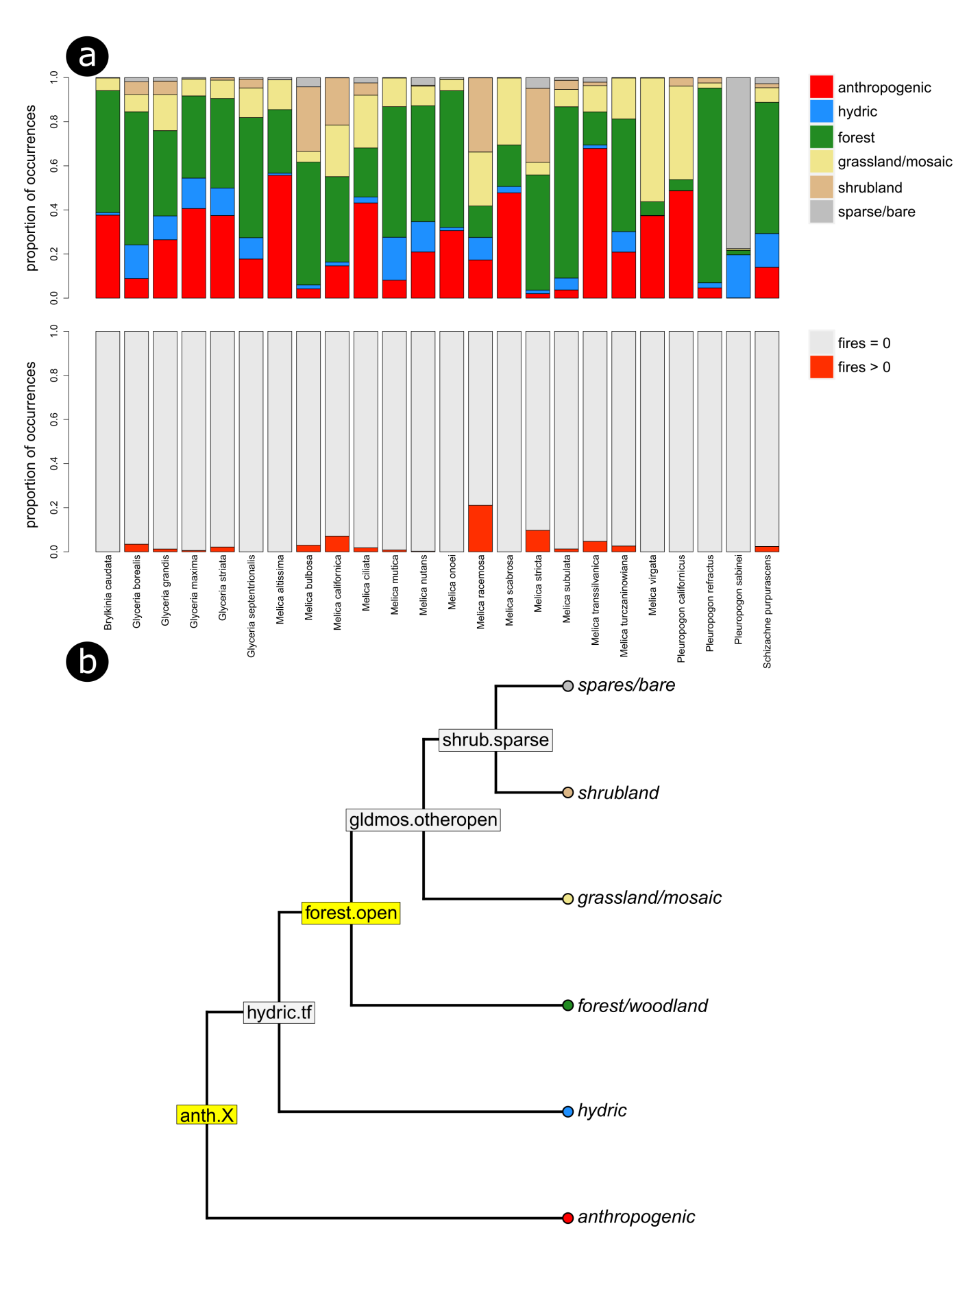
Table S3: Provided as separate file. Raw geospatial data with extracted landcover and climate data provided for all 8,428 occurrence records which met our sampling criteria (Methods S1). Includes longitude (x), latitude (y), species, collection year of the georeferenced specimen, alpha-2 country codes, full UN LCCS class labels, landcover classes used in this study (Table S2) and mean annual and warm quarter precipitation in millimeters.

Table S4: Next page. Accession numbers for sequence data downloaded from gen bank for each marker used in phylogenetic analyses.
Species | ITS | matK | ndhF | psbA-trnH | rbcL | trnC-ycf6 | trnK-rps16 | trnL
Glyceria borealis01 | KJ912925 | - | KJ913064 | DQ665463 | MG226985 | DQ665372 | DQ665553 | -
Glyceria borealis02 | EU594625 | - | - | DQ665466 | MF596813 | DQ665374 | DQ665555 | -
Glyceria borealis03 | EU594626 | - | - | DQ665469 | MG226963 | DQ665376 | DQ665557 | -
Glyceria grandis01 | JN832695 | MG217110 | AY622314 | HQ596720 | AY632364 | DQ665416 | DQ665633 | -
Glyceria grandis02 | EU594638 | MF597404 | - | DQ665509 | HQ590123 | DQ665417 | DQ665634 | -
Glyceria grandis03 | EU594639 | MF597405 | - | DQ665508 | MF596819 | DQ665418 | DQ665635 | -
Glyceria maxima01 | KU883454 | KU883530 | KJ912961 | DQ665516 | MF596822 | DQ665424 | DQ665636 | EF137603
Glyceria maxima02 | FJ013226 | JN894363 | - | DQ665515 | MG227179 | DQ665425 | DQ665637 | KX668027
Glyceria maxima03 | JN832699 | JN895612 | - | - | JN891214 | - | KJ912993 | -
Glyceria striata | JN832694 | - | - | HQ596721 | - | - | DQ665620 | -
Melicaaltissima | JN832686 | KX601228 | AF251452 | - | KC123375 | - | - | -
Melica bulbosa | KJ496334 | - | KJ913020 | DQ665547 | MG227679 | DQ665457 | DQ665641 | -
Melica californica | L36518 | KX601230 | KJ913021 | - | - | - | - | -
Melicaciliata | KJ598968 | KX601229 | KX601249 | - | KJ599189 | - | - | JN187650
Melica mutica01 | - | KM974742 | KM974742 | KM974742 | KM974742 | KM974742 | KM974742 | KM974742
Melica mutica02 | - | NC_027477 | NC_027477 | NC_027477 | NC_027477 | NC_027477 | NC_027477 | NC_027477
Melica nutans | HQ600516 | MH888104 | KJ913026 | HQ600137 | HQ600444 | KJ912951 | KJ913001 | KX372446
Melicaonoei | MH808848 | - | - | HQ600149 | HQ600456 | - | - | -
Melicaracemosa | KJ496331 | KP860332 | KJ913031 | - | - | - | - | -
Melicascabrosa | MH808852 | NC_050212 | NC_050212 | NC_050212 | NC_050212 | NC_050212 | NC_050212 | NC_050212
Melica stricta | KJ912901 | - | KJ913019 | - | - | - | - | -
Melica subulata01 | KJ496337 | NC_027478 | NC_027478 | NC_027478 | NC_027478 | NC_027478 | NC_027478 | NC_027478
Melica subulata02 | MG215819 | - | KJ913017 | - | MF596878 | KJ912949 | KJ912998 | -
Melicatranssilvanica | JN172096 | - | KJ913036 | - | - | KJ912950 | KJ912999 | -
Melicaturczaninowiana | KJ489384 | - | KJ913027 | - | - | KJ912953 | KJ913002 | -
Melica virgata | KJ912906 | - | KJ913023 | - | - | - | - | -
Pleuropogoncalifornicus | KM077284 | - | KJ913011 | - | - | - | KJ912983 | -
Pleuropognohooverianus | KJ912911 | - | - | - | MF963220 | - | KJ912948 | -
Pleuropogonrefractus | MG216349 | - | GU222749 | - | MG227465 | KJ912941 | - | -
Pleuropogon sabinei01 | JN832700 | KC475304 | KJ913012 | - | KC483464 | KJ912940 | KJ912982 | GQ245266
Pleuropogon sabinei02 | MG216741 | KC475302 | - | - | KC483465 | - | - | GQ245267
Schizachne purpurascens01 | KF977434 | LN554451 | GU222748 | HQ596837 | HQ590262 | KJ912954 | KJ913003 | HE993617
Schizachne purpurascens02 | KJ477052 | FM253126 | KJ913037 |  | KF977469 | - | - | HE993618
Brylkiniacaudata | KJ477051 | FM253121 | GU222750 | - | - | KJ912955 | KJ913005 | GU254957
Festuca rubra | AF303422 | MN309825 | MN309825 | MN309825 | MN309825 | - | MN309825 | MN309825
Poa palustris | MK804431 | KM974749 | KM974749 | KM974749 | KM974749 | - | KM974749 | KM974749

Table S5: Output from brms model showing priors used in analyses. Showing the prior (using brms syntax), the parameter class, the coefficient and response which it corresponded to and the source of each.
prior | class | coef | group | resp | source
normal(0, 0.75) | b |  |  | long | user
normal(0, 0.75) | b | anth.X |  | long | (vectorized)
normal(0, 0.75) | b | burn.slr |  | long | (vectorized)
normal(0, 0.75) | b | forest.open |  | long | (vectorized)
normal(0, 0.75) | b | log10avg.mass |  | long | (vectorized)
normal(0, 0.75) | b |  |  | velocitymd | user
normal(0, 0.75) | b | anth.X |  | velocitymd | (vectorized)
normal(0, 0.75) | b | burn.slr |  | velocitymd | (vectorized)
normal(0, 0.75) | b | forest.open |  | velocitymd | (vectorized)
normal(0, 0.75) | b | log10avg.mass |  | velocitymd | (vectorized)
student_t(3, 2.8, 1) | Intercept |  |  | long | user
student_t(3, 5, 2) | Intercept |  |  | velocitymd | user
lkj_corr_cholesky(0.5) | L |  |  |  | user
lkj_corr_cholesky(0.5) | L |  | tip |  | (vectorized)
student_t(3, 0, 2.5) | sd |  |  | long | user
student_t(3, 0, 2.5) | sd |  |  | velocitymd | user
student_t(3, 0, 2.5) | sd |  | tip | long | (vectorized)
student_t(3, 0, 2.5) | sd | Intercept | tip | long | (vectorized)
student_t(3, 0, 2.5) | sd |  | tip | velocitymd | (vectorized)
student_t(3, 0, 2.5) | sd | Intercept | tip | velocitymd | (vectorized)
normal(0, 1) | sigma |  |  | long | user
normal(0, 1) | sigma |  |  | velocitymd | user

Figure S3: Next page. Maximum likelihood tree inferred using the 36 concatenated sequences produced for this study. Bootstrap support values for branches are also shown.
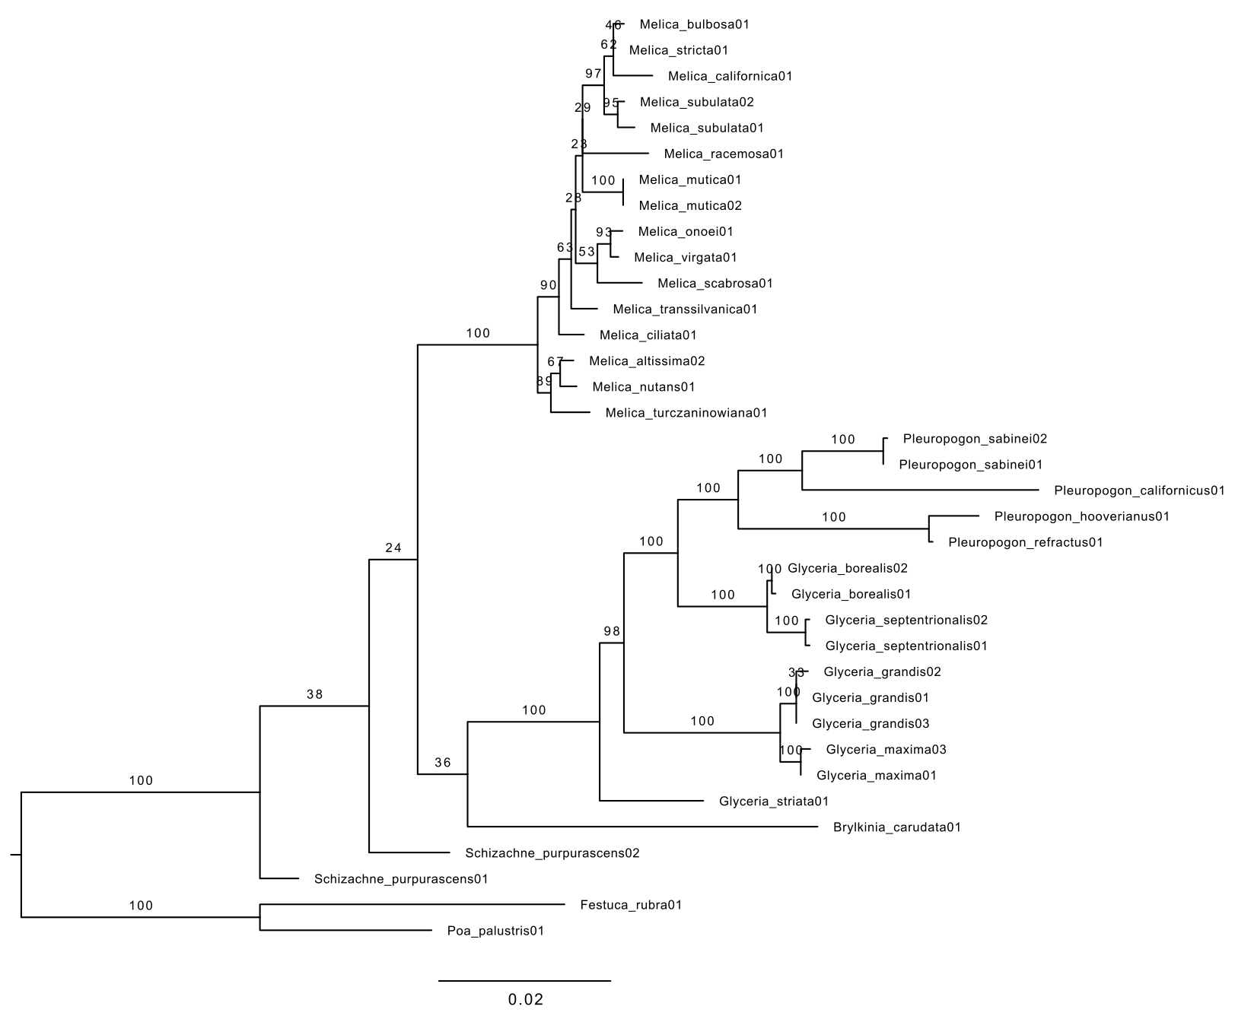
Results S1:
GIS habitat data were compared against descriptions used in standard handbooks, other published sources, and descriptions pulled directly from herbarium specimens (Supplementary Data Methods S1). Relevant sections from these sources are compiled below for each species. To test whether GIS based predictors were consistent with published habitat descriptions, we first extracted a list of habitat keywords for each taxon using the descriptions compiled below (Supplementary Data Table S6). Several were synonymized in an effort to unify terminology across sources and minimize the number of keywords representing a single taxon. A full list of keywords (with synonyms in parentheses) is provided below. For each keyword, we obtained a list of all species whose habitat it was used to describe, and then calculated these species’ average GIS predictor values for forest and anthropogenic site affinity.

UNIQUE KEYWORDS:
conifer
deciduous
disturbed (wasted place)
ditch
dune
forest
forest edge (woodland fringe, borders of forest)
glade (forest clearing)
grassland (savanna, steppe)
grassy
lake (pond)
meadow
mountain (alpine, subalpine)
open (exposed)
open woods (light wood, semi-shaded woodland, open forest, thin woods, orchard)
ornamental
partial shade
pioneer
roadside (edge habitat)
rocks (rocky slopes, rocky ravines, talus, stony areas)
shade
shrub (sagebrush, fynbos, bushclumps)
stream (river)
sun
thicket (scrub)
tundra
wet
wetland (marsh, swamp, bog, fen, slough)
woods

We observed that keywords suggesting more forested or closed habitats (e.g., “shade”, “forest”, “conifer”) were disproportionately used to describe taxa with GIS predictor scores suggesting affinity for forest sites. The opposite was also true, with keywords describing open sites (e.g., “grassland”, “shrub”) found predominantly in taxa with low forest affinity scores on our GIS predictors (Fig. S4). Surprisingly, the keywords “grassy” and “sun” showed higher association than expected with our GIS forest predictor. To better understand this result, we looked at the taxa associated with these keywords in more detail. Three taxa were described as occupying "grassy" habitats. Of these, two also had descriptions consistent with more closed habitats (e.g., “shade”, “forest”, “woods”), suggesting the taxa in question are found in a range of habitats. The last of the three taxa (M. ciliata) did not have any descriptions suggesting a wooded habitat, however it also possessed a markedly lower forest affinity values than either of the other two taxa (-0.36, 1.41, 1.67). Thus, it appears the association between our forest affinity predictor and the keyword "grassy" is driven by the two taxa which occupy both forested and "grassy" areas. The keyword “sun” was curiously only associated with descriptions for species of the genus Glyceria, and these originating from two sources (Minnesota Wildflowers; Illinois Wildflowers). Of the four taxa associated with this keyword, three also had descriptions suggesting a wooded environment, and the one that didn't (G. grandis) again had a markedly lower forest affinity value than the other taxa (0.48, 1.10, 1.36, 1.46).
Similar results were seen for our anthropogenic site predictor, which showed strongest correlation with keywords suggestive of an early successional habitat (e.g., “pioneer”, “disturbed”) (Fig. S4). We also noted that the keyword ornamental was associated with high occurrence in anthropogenic sites (Fig. S4). This is unsurprising since grasses planted ornamentally by definition occur in an anthropogenic environment. However, it is potentially problematic if these taxa are not disturbance adapted, since we argue in the main text that this variable can be interpreted as a proxy for disturbance adaptation. Fortunately, traits that make plants desirable ornamentals are often those associated with a ruderal lifestyle (e.g., quick germination), and disturbance is known to facilitate ornamentals escaping cultivation (Haeuser et al., 2017). Furthermore, two of the three taxa listed as ornamentals were also associated with descriptions more traditionally suggestive of disturbance adaptation (i.e., “disturbed”, “pioneer”).
Overall, our comparisons between published descriptions and our habitat predictors revealed only minor inconsistencies. These were readily explained, and ultimately boil down to the fact that taxa are found in a range of habitats. Many taxa had descriptions suggesting a wide range of occasionally very different habitats (e.g., Glyceria striata’s keywords included “shade”, “partial shade”, and “sun”). Indeed, our comparisons highlight one of the major difficulties inherent to using flora descriptions to define habitat preferences, that being the absence of an easy way to quantify the relative frequency with which taxa occupy different habitats. The difference between true generalists and taxa which only infrequently occur outside of their preferred habitat is thus obscured.
Due to the relatively small number of usable occurrence records, we conducted a closer comparison for Melica virgata, which was the taxon with the least available data. We found that GIS data and published records were largely congruent. Although we were able to find relatively few published descriptions of the habitat for this taxon, those we were able to find suggested it was largely found in high elevation steppe and rocky areas (Methods S1), which matches occurrence records, the preponderance of which occur in grasslands (Fig. S2; Table S3).
A substantial proportion of our occurrence records were associated with specimens collected prior to the range covered by our geospatial climate and habitat data. Unfortunately, when the sample is limited to records falling within the collection range of our habitat data, sample sizes become prohibitively small for several taxa. We therefore sought to evaluate whether land cover data from 1992 to 2015 accurately reflect the local conditions prior to this period. Preliminary observations revealed that land cover class at each site was remarkably consistent across the 24 year range covered by the CCI-LC maps, with only 7% of records showing any change in class over the entire span. Of those only ten showed more than one change, and none showed more than two. Note also that this reflects differences among the original 37 UN LCCS classifiers, which were subsequently combined into more general categories. At least during this period then it appears that changes in land cover class are the exception.
To further investigate possible biases we took a random sample of 100 records from our dataset which were associated with plants collected prior to 1992 (i.e., predating ESA CCI-LC data ranges), and checked digitized records for each of these specimens for an original description of the collection location. Of these records, only 30 were associated with comprehensible descriptions. Unfortunately, many of these descriptions did not provide sufficient information for evaluation. Of those with sufficient description, approximately two thirds appeared to match the assigned landcover class. Notably there did not seem to be any pattern whereby the oldest records were less likely to be consistent with CCI-LC data. Many were difficult to evaluate because the two records reflected different spatial scales (see Discussion in main text). Of those herbarium sheets which include information about the community from which the specimen was collected, relatively few describe it on a scale comparable to the 300 x 300 meter areas on which the CCI-LC maps are resolved. Overall, our comparisons suggested that data drawn from CCI-LC maps reflect local vegetation structure for occurrences predating the period over which they were collected with reasonable accuracy. This combined with results described above we believe support our assertion that our habitat predictors reflect meaningful ecological attributes of the sampled taxa.
Finally, the issue of timing is potentially problematic if one worries that current habitats in which taxa occur do not reflect those in which dispersal traits originally evolved. This is unfortunately a very difficult factor to control, and GIS based data in particular may give some readers pause. Nevertheless, we do not believe it fares any worse than other approaches. Although land cover assignments are based only upon data dating back several decades, published sources do not sample much farther back. This is especially true when one considers the age of the lineages in question. The Meliceae originated tens of millions of years ago (Gallaher et al., 2019). Furthermore, many of the species in the Meliceae were not described until the late 19th century (e.g., Glyceria borealis - 1900; Melica transsilvanica - 1866; Melica onoei - 1875; and these excluding combinations based upon earlier basionyms). As such, even the oldest scientific records are unlikely to reflect a substantially better view of unmolested habitat preferences than the data used herein. Significant human modification to the regions and habitats in which these (and nearly all) taxa occur substantially predates any scientific interest in them. All told, we must operate under the assumption that current species ranges at least partially reflect their "true" habitat preferences as they existed when dispersal relevant traits evolved. Unfortunately, no practical alternative exists.

Table S6: Next page. Synonymized keywords (see above) extracted from habitat descriptions for each sampled species.

Species | Keywords
Brylkinia caudata | forest, glade, woods, mountain, conifer
Glyceria borealis | wet, wetland, meadow, lake, stream, ditch, mountain, sun, conifer, deciduous, forest
Glyceria grandis | wetland, wet, lake, wetland, stream, ditch, meadow, sun, open
Glyceria maxima | wet, wetland, stream, lake, open, ditch, disturbed, ornamental
Glyceria septentrionalis | sun, partial shade, wet, forest, wetland, lake
Glyceria striata | wetland, meadow, shade, open woods, open, lake, stream, partial shade, sun, ditch
Melica altissima | woods, thicket, forest edge, shrub, rocks, ornamental
Melica bulbosa | open, rocks, grassland, open woods, shrub, meadow
Melica californica | open, rocks, roadside, woods, conifer
Melica ciliata | meadow, rocks, ornamental, grassy, pioneer, grassland
Melica mutica | open woods, thicket, wetland, woods, forest
Melica nutans | shade, grassy, mountain, forest, thicket, deciduous, woods, forest edge
Melica onoei | woods, shade, roadside, open woods
Melica racemosa | rocks, dune, forest, mountain, roadside, woods, partial shade, grassland, shrub, glade
Melica scabrosa | rocks, open, forest, disturbed, roadside, shade
Melica stricta | rocks, mountain, open woods
Melica subulata | meadow, forest, rocks, woods, shade
Melica transsilvanica | grassland, meadow, open, forest edge, deciduous, thicket, rocks, pioneer
Melica turczaninowiana | meadow, conifer, forest edge, mountain, rocks
Melica virgata | grassland, rocks, meadow, mountain
Pleuropogon californicus | lake, wetland, grassland, open woods, ditch, roadside
Pleuropogon refractus | lake, stream, forest, wetland, wet, meadow, shade, woods, mountain
Pleuropogon sabinei | stream, wet, meadow, lake, open, wetland, tundra,
Schizachne purpurascens | open, grassy, woods, rocks, meadow

Figure S4: Next page. Average GIS habitat predictor values of species described with each of the unique keywords extracted from habitat descriptions obtained during our literature survey. Error bars represent standard error. Forest affinity and anthropogenic affinity are respectively the SLR transformed proportion of occurrences found in forest sites relative to open habitats (shrubland, grassland, bare ground) and the SLR transformed proportion of occurrences in anthropogenically modified sites relative to all other habitat types (Fig. S2b). Larger values on each axis represent greater relative affinity for forested or anthropogenic sites.

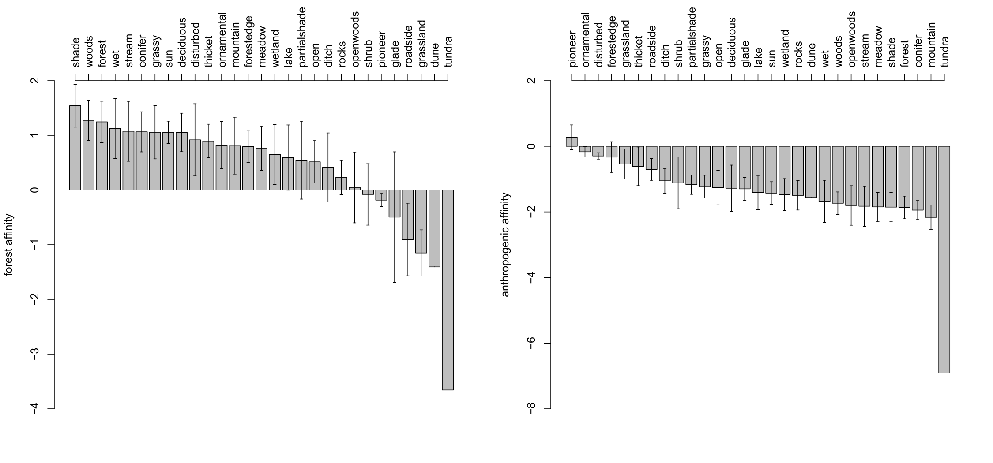
Table S7: Next page. Summaries of the posterior distribution of model parameters for analyses run with mass included as a predictor. Parameters are separated into group-level, population-level, and family specific parameters. Original internal variable names are used throughout. Respectively these refer to PWDR – potential wind dispersal range, velocity.md – median diaspore falling velocity from ten conducted trials, anth.X – anthropogenic disturbance variable, forest.open – habitat openness variable, burn.slr – fire frequency variable (see main text Methods).
Parameter | Estimate | Est.Error | l-95% CI | u-95% CI | Rhat | Bulk_ESS | Tail_ESS
GROUP-LEVEL EFFECTS
sd(PWDR_Intercept) | 5.28 | 0.89 | 3.81 | 7.31 | 1 | 5842 | 8868
sd(velocitymd_Intercept) | 3.39 | 0.61 | 2.39 | 4.78 | 1 | 6223 | 8765
cor(PWDR_Intercept,velocitymd_Intercept) | -0.93 | 0.05 | -0.99 | -0.81 | 1 | 7121 | 10140
POPULATION-LEVEL EFFECTS
PWDR_Intercept | 3.07 | 0.61 | 1.87 | 4.28 | 1 | 5743 | 8252
velocitymd_Intercept | 4.63 | 0.4 | 3.83 | 5.44 | 1 | 6062 | 8203
PWDR_forest.open | -0.1 | 0.06 | -0.23 | 0.02 | 1 | 7523 | 9598
PWDR_anth.X | 0.14 | 0.09 | -0.04 | 0.31 | 1 | 6383 | 9073
PWDR_burn.slr | 0.04 | 0.06 | -0.08 | 0.17 | 1 | 5922 | 8044
PWDR_log10avg.mass | -0.99 | 0.12 | -1.23 | -0.76 | 1 | 11044 | 10762
velocitymd_forest.open | 0.14 | 0.04 | 0.06 | 0.22 | 1 | 8035 | 9955
velocitymd_anth.X | -0.04 | 0.06 | -0.15 | 0.07 | 1 | 6623 | 8961
velocitymd_burn.slr | -0.05 | 0.04 | -0.13 | 0.03 | 1 | 6306 | 8941
velocitymd_log10avg.mass | 0.67 | 0.09 | 0.49 | 0.85 | 1 | 10375 | 10610
FAMILY SPECIFIC PARAMETERS
sigma_PWDR | 0.29 | 0.02 | 0.26 | 0.32 | 1 | 9979 | 9199
sigma_velocitymd | 0.23 | 0.01 | 0.2 | 0.25 | 1 | 10185 | 9966

Table S8: Next page. Summaries of the posterior distribution of model parameters for analyses run with mass excluded as a predictor. Parameters are separated into group-level, population-level, and family specific parameters. Original internal variable names are used throughout. Respectively these refer to PWDR – potential wind dispersal range, velocity.md – median diaspore falling velocity from ten conducted trials, anth.X – anthropogenic disturbance variable, forest.open – habitat openness variable, burn.slr – fire frequency variable (see main text Methods).
Parameter | Estimate | Est.Error | l-95% CI | u-95% CI | Rhat | Bulk_ESS | Tail_ESS
GROUP-LEVEL EFFECTS
sd(long_Intercept) | 5.33 | 0.89 | 3.88 | 7.35 | 1 | 6548 | 9229
sd(velocitymd_Intercept) | 3.20 | 0.57 | 2.25 | 4.51 | 1 | 7139 | 9521
cor(long_Intercept,velocitymd_Intercept) | -0.95 | 0.04 | -0.99 | -0.83 | 1 | 8215 | 9334
POPULATION-LEVEL EFFECTS
long_Intercept | 3.24 | 0.62 | 2.03 | 4.46 | 1 | 6379 | 8500
velocitymd_Intercept | 4.52 | 0.38 | 3.76 | 5.28 | 1 | 6752 | 8952
long_forest.open | -0.09 | 0.07 | -0.23 | 0.04 | 1 | 9306 | 10490
long_anth.X | 0.26 | 0.09 | 0.09 | 0.44 | 1 | 7122 | 9095
long_burn.slr | 0.08 | 0.06 | -0.05 | 0.20 | 1 | 6225 | 8406
velocitymd_forest.open | 0.12 | 0.04 | 0.04 | 0.21 | 1 | 9582 | 10453
velocitymd_anth.X | -0.13 | 0.06 | -0.24 | -0.02 | 1 | 7343 | 9130
velocitymd_burn.slr | -0.07 | 0.04 | -0.15 | 0.01 | 1 | 6387 | 9310
FAMILY SPECIFIC PARAMETERS
sigma_long | 0.33 | 0.02 | 0.3 | 0.37 | 1 | 8595 | 9182
sigma_velocitymd | 0.26 | 0.02 | 0.23 | 0.29 | 1 | 9353 | 10078

Figure S5: Density plots of posterior samples of slope parameters for models including (solid) and excluding (dashed) mass as a predictor for both model responses (PWDR, and diaspore falling velocity). Environmental predictors are indicated by color (blue – anthropogenic, red – fire, green – habitat openness). Those parameters where the 95% credibility interval did not overlap with zero are marked by an asterisk.
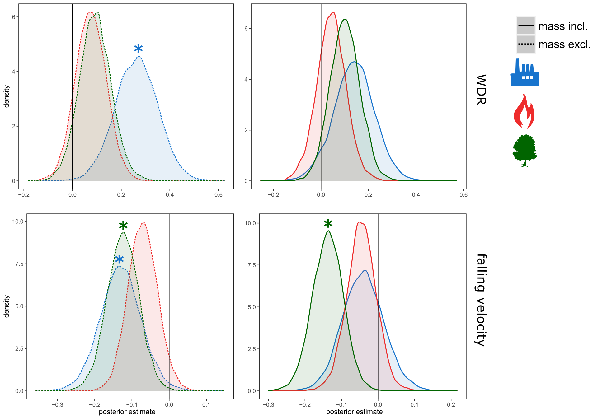

Figure S6: Density plots of Bayesian R² value estimates for models including (blue) and excluding (red) mass as a predictor. Plots are further divided to show R² estimates of full (darker shading) and marginal (i.e., excluding group effects; lighter shading) model effects. Results are shown for PWDR (top two panels) and diaspore falling velocity (bottom two panels).
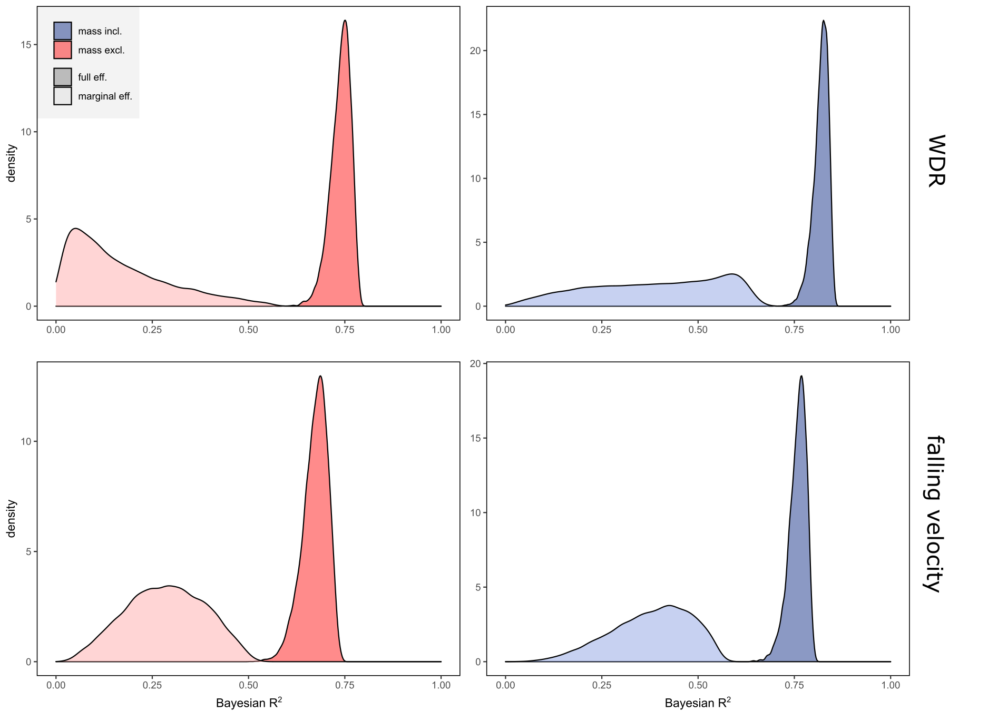

Figure S7: Next page. Conditional effects of models predicting potential wind dispersal range (PWDR) and diaspore falling velocity using the full dataset, including the outlier Pleuropogon sabinei (yellow points). Results are shown for models including (red) and excluding (blue) diaspore mass as a predictor. Dashed lines represent effects where posterior credibility intervals (CI) for the slope overlap with zero (i.e., no effect), while solid lines indicate the opposite. Results are shown for the effects of a, d) anthropogenic habit occupation, b,e) burn frequency, and c,f) open habitat occupation. Note that the direction of the horizontal axes in sections c and f are reversed so the direction of effects is the same for each habitat predictor. Results are largely the same as those presented in the main text. While there is still a reduced impact of anthropogenic disturbance on PWDR when mass is included, this effect is less pronounced. This is due to the extremely short stature, and thus low PWDR of P. sabinei. The other primary difference is a weaker impact of anthropogenic disturbance on velocity, although the credibility interval of this effect when including P. sabinei only just overlaps with zero (-0.08 +/- 0.09), and the strength of the relationship is still substantially weakened when mass is included. Note that differences manifest only when considering the ecological axis along which P. sabinei is the greatest outlier (i.e., anthropogenic site occupation).
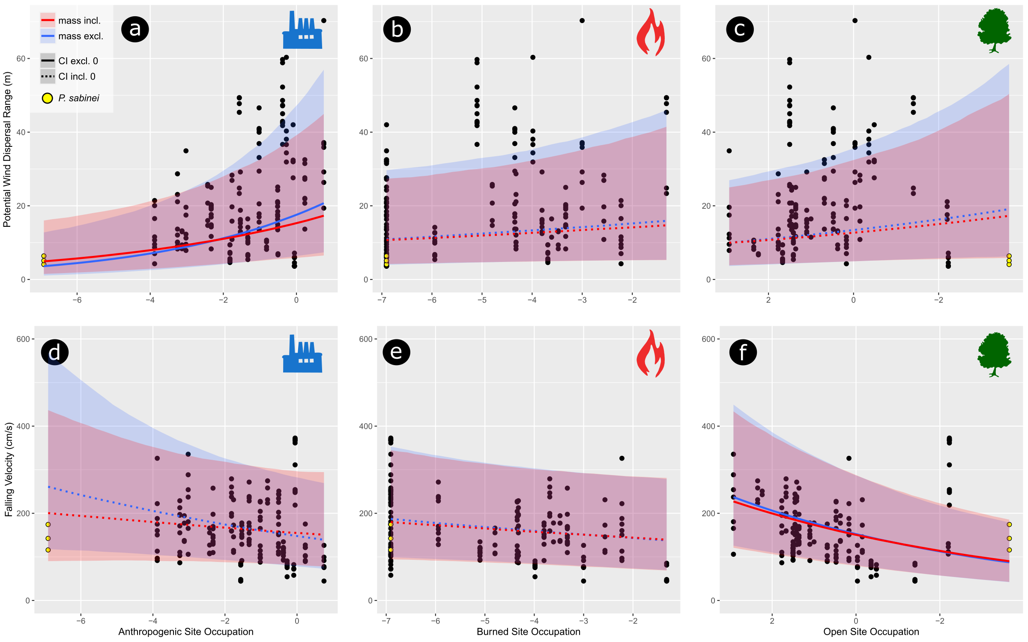
Figure S8: Next page. Conditional effects of models predicting wind dispersal range (WDR) with WDR parameterized under two separate sets of environmental conditions. Upper panels (a-c) are the same results presented in the main text (Fig. 4), where dispersal distances are calculated under the assumption of circulation conditions approximating an open grassland. Lower panels (d-f) show results where WDR is parameterized under circulation conditions more closely approximating a forest understory (see Methods in main text). Results are shown for models including (red) and excluding (blue) diaspore mass as a predictor. Dashed lines represent effects where posterior credibility intervals (CI) for the slope overlap with zero (i.e., no effect), while solid lines indicate the opposite. Results are shown for the effects of a, d) anthropogenic habit occupation, b,e) burn frequency, and c,f) open habitat occupation. Note that the direction of the horizontal axes in sections c and f are reversed so the direction of effects is the same for each habitat predictor. Results are largely the same as those presented in the main text (i.e., panels a-c), the only notable difference is a stronger effect of anthropogenic habitat on WDR under forest conditions when mass is included (see panel d). While the inclusion of mass still reduces the impact of anthropogenic disturbance, this effect is less pronounced (see panel d). This is likely due to the more minor role that falling velocity has on the predicted dispersal distance under these less amenable circulation conditions (particularly weaker vertical mixing; Tackenberg et al., 2003). Plant height, which tends to be larger in those taxa more frequently found in anthropogenically modified sites, thus plays a more important role in determining dispersal distances.
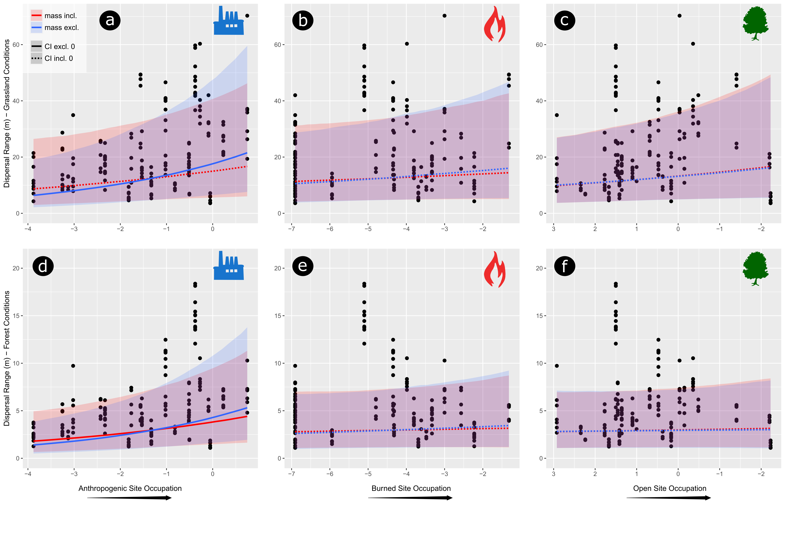
Results S2: Several different patterns of autorotation were observed in the sampled taxa. These are described below. Note that all taxa showing any repeated and predictable movement during descent were classified as autorotating, regardless of whether diaspores produced appreciable lift or fell at a slow pace. In this respect many of the taxa described below may resemble the maple samaras with excised wings described by Varshney et al. (2012).

Type I – Diaspore makes full rotation, with either dorsal or lateral side facing downward. Axis of rotation either through body of diaspore (Type I), or outside it so that diaspore moves in wider circles (Type Ia). Speed of rotation varies.

Type II – Diaspore does not make full rotation, reversing direction before ~90 of rotation. May only rotate around axis passing through body of diaspore (Type II), or may move laterally during descent (Type IIa). Speed varies substantially.

Autorotating taxa:

Glyceria borealis – displays both Type I and Type II autorotation. One of either type was observed in all measured samples

Glyceria grandis – displays both Type I and Type II, although the latter is more common. One of either type was observed in all measured samples

Glyceria maxima – displays both Type I and Type II, although the latter is more common, autorotation often slow, occ inconspicuous. One of either type was observed in all or almost all measured samples.

Glyceria septentionalis – displays Type I and rarely Type II autorotation, to irregular tumbling of diaspore. One of either type was observed in all or almost all measured samples.

Glyceria striata – primarily displays Type II autorotation, usually slow, occ inconspicuous. Type I rare. One of either type was observed in all or almost all measured samples.

Melica altissima – displays Type I or Type Ia autorotation, rotation speed varies. Observed in all measured samples.

Melica californica – displays Type I or Type IIa autorotation. Latter is slow verging on inconspicuous. One of either type was observed in all or almost all measured samples.

Melica mutica – displays Type I autorotation. Speed of rotation varies considerably, occ inconspicuous. Observed in all or almost all measured samples.

Melica nutans – displays Type I autorotation (rarely Type Ia). Speed varies, occ slow to inconspicuous. Observed in all or almost all measured samples.

Melica onoei – displays Type I or Type II autorotation which grades to irregular tumbling of diaspore. One of either type observed in most, but not all samples.

Melica scabrosa – displays Type Ia autorotation in some specimens, rotation slow and inconsistently observed. Most specimens do not show any autorotation.

Melica stricta – displays Type I autorotation, but inconsistently observed in some specimens. Observed in all or almost all measured samples.

Melica subulata – displays both Type I and Type II autorotation, although latter is uncommon. Observed in all or almost all measured samples.

Melica turczaninowiana – displays Type I autorotation, occ grading toward Type Ia. Observed in all measured samples.

Melica virgata – displays occ Type I autorotation grading to irregular tumbling. Observed in half of measured samples.

Pleuropogon californicus – displays Type I autorotation. Observed in all measured samples.

Pleuropogon refractus – displays both Type I and Type II. Latter is uncommon and occ inconspicuous. Orientation of diaspore from vertical varies. One of either type was observed in all measured samples.

Pleuropogon sabinei – displays Type I autorotation. Observed in all measured samples.

Most non-plumose taxa show autorotation to some degree. However, the nature of autorotation (i.e., speed, diaspore orientation), consistency with which it occurs, and apparent impact on falling velocity varied considerably between taxa. Many of those diaspores showing autorotation do not achieve low falling velocities (e.g., Pleuropogon californicus). Autorotation may also be ancestral to the Meliceae (Fig. S?), although low falling velocities are clearly not (Fig. 3a). This suggests that autorotation may have originally arisen as a side effect of other morphological changes, and served as a preadaptation favoring the glume and/or lemma expansion which was derived in some Melica lineages (e.g., Melica altissima, Melica stricta, Fig 1; Fig 3a), since these taxa show both autorotation and achieve low falling velocities. Nevertheless, it remains to be tested how effective autorotation in these taxa is compared to the better studied arborescent anemochores possessing autorotating diaspores. Substantial differences in absolute and relative wing size may account for the inconsistency with which many of the taxa studied here showed autorotation.

Video S1: Provided as separate file. High speed video of specimen MO-013(b), showing Type I autorotation in Melica altissima.

Video S2: Provided as separate file. High speed video of specimen WTU-191(b), showing Type II autorotation in Melica californica.

Figure S9: Next page. Generalized comparison of falling velocity over time in autorotating and plumose taxa showing comparison of mean, maximum, and equilibrium (“terminal”) falling velocities.
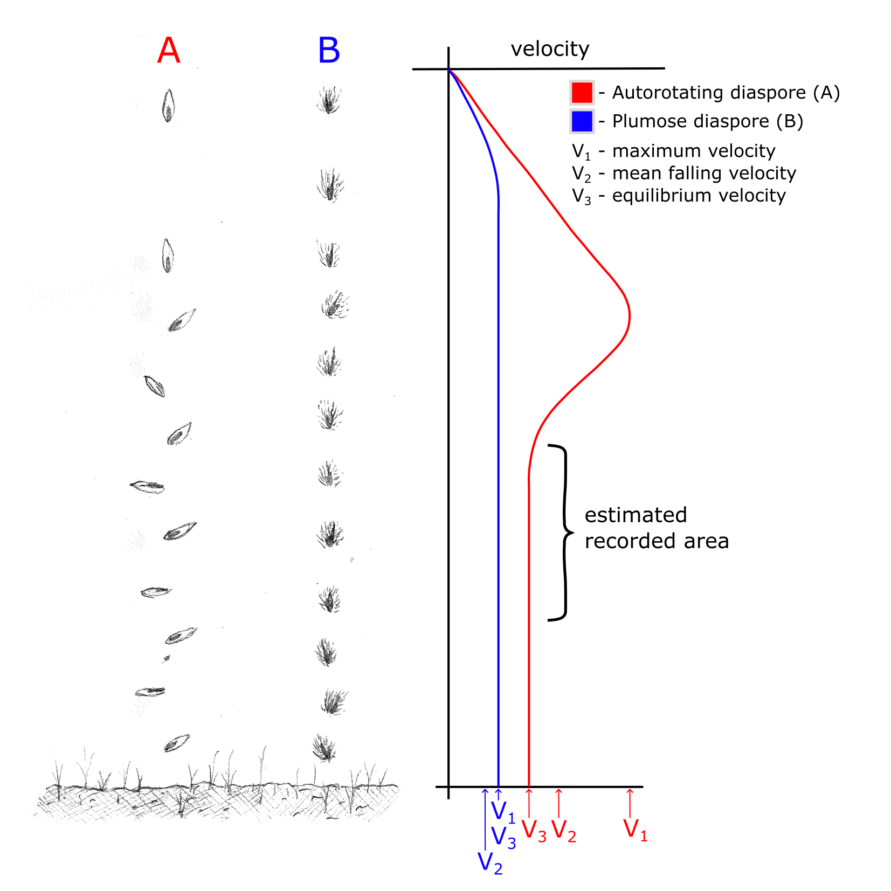

Figure S10: Ancestral state reconstruction showing diaspore falling velocity along branches, and reconstructed autorotation state (dark – present, light – absent) at interior nodes. Results for diaspore falling velocity are replicated from Fig. 3a in the main text. Autorotation reconstruction is result of 250 generations of stochastic mapping under an equal rates model of character evolution, implemented using the make.simmap function in phytools (Revell, 2012).

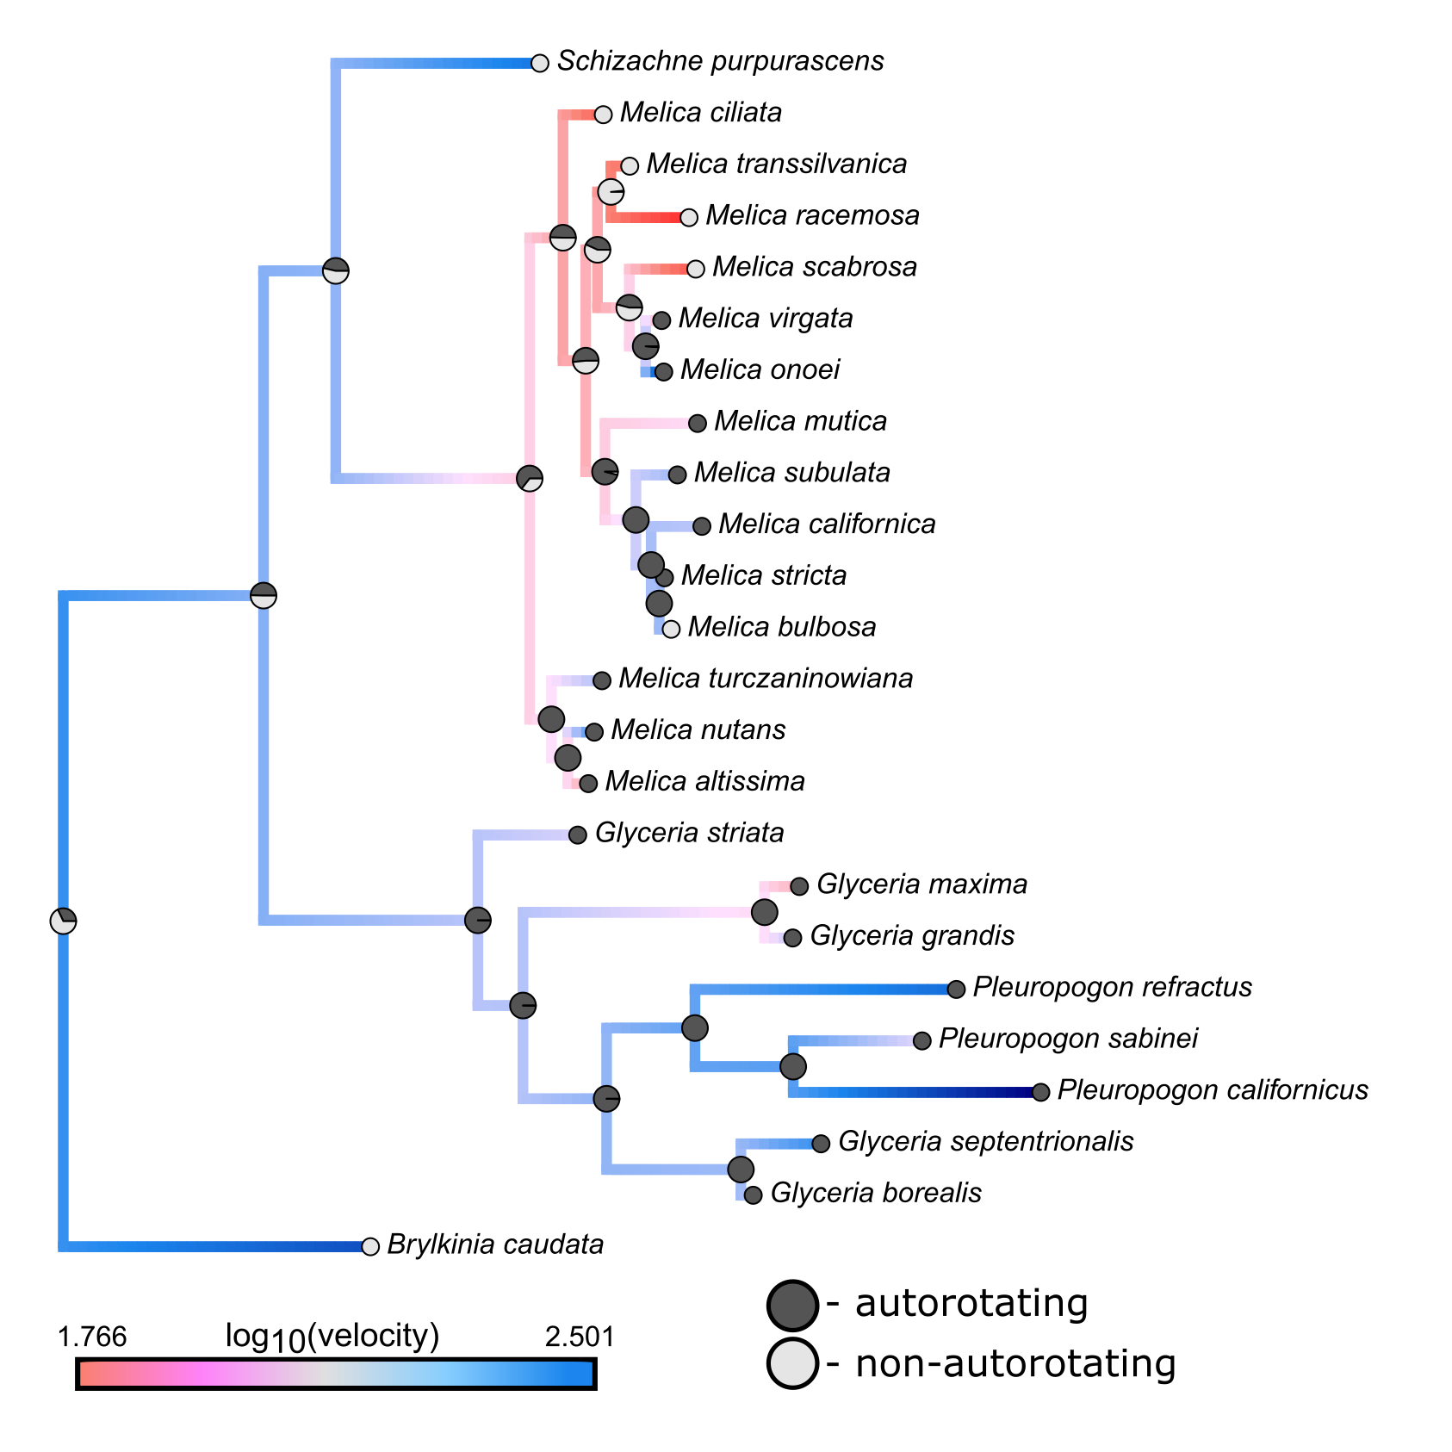

Figure S11: Next page. Conditional effects of models predicting wind dispersal range (WDR) and diaspore falling velocity using alternate values for autorotating specimens. Panel a) shows results if autorotating diaspores are all assumed to fall at the minimum observed velocity, while panel b) shows results if autorotating diaspores are all assumed to fall their maximum observed velocity. Results presented in the main text use median values of ten trials. See Table S1 for comparison between these values. Results are shown for models including (red) and excluding (blue) diaspore mass as a predictor. Dashed lines represent effects where posterior credibility intervals (CI) for the slope overlap with zero (i.e., no effect), while solid lines indicate the opposite. Autorotating specimens are indicated by red rather than black points (Table S1). Results are largely the same as those presented in the main text. Differences primarily arise in the strength of the effect of anthropogenic habitat occupation, with minimum velocity models showing slightly weaker and maximum velocity models showing slightly stronger correlations compared to those presented in the main text. We also note that the effect of fire occurrence on falling velocity (particularly in maximum velocity models) has 95% CI only just overlapping with zero (i.e., no effect) when mass is not included as a predictor.
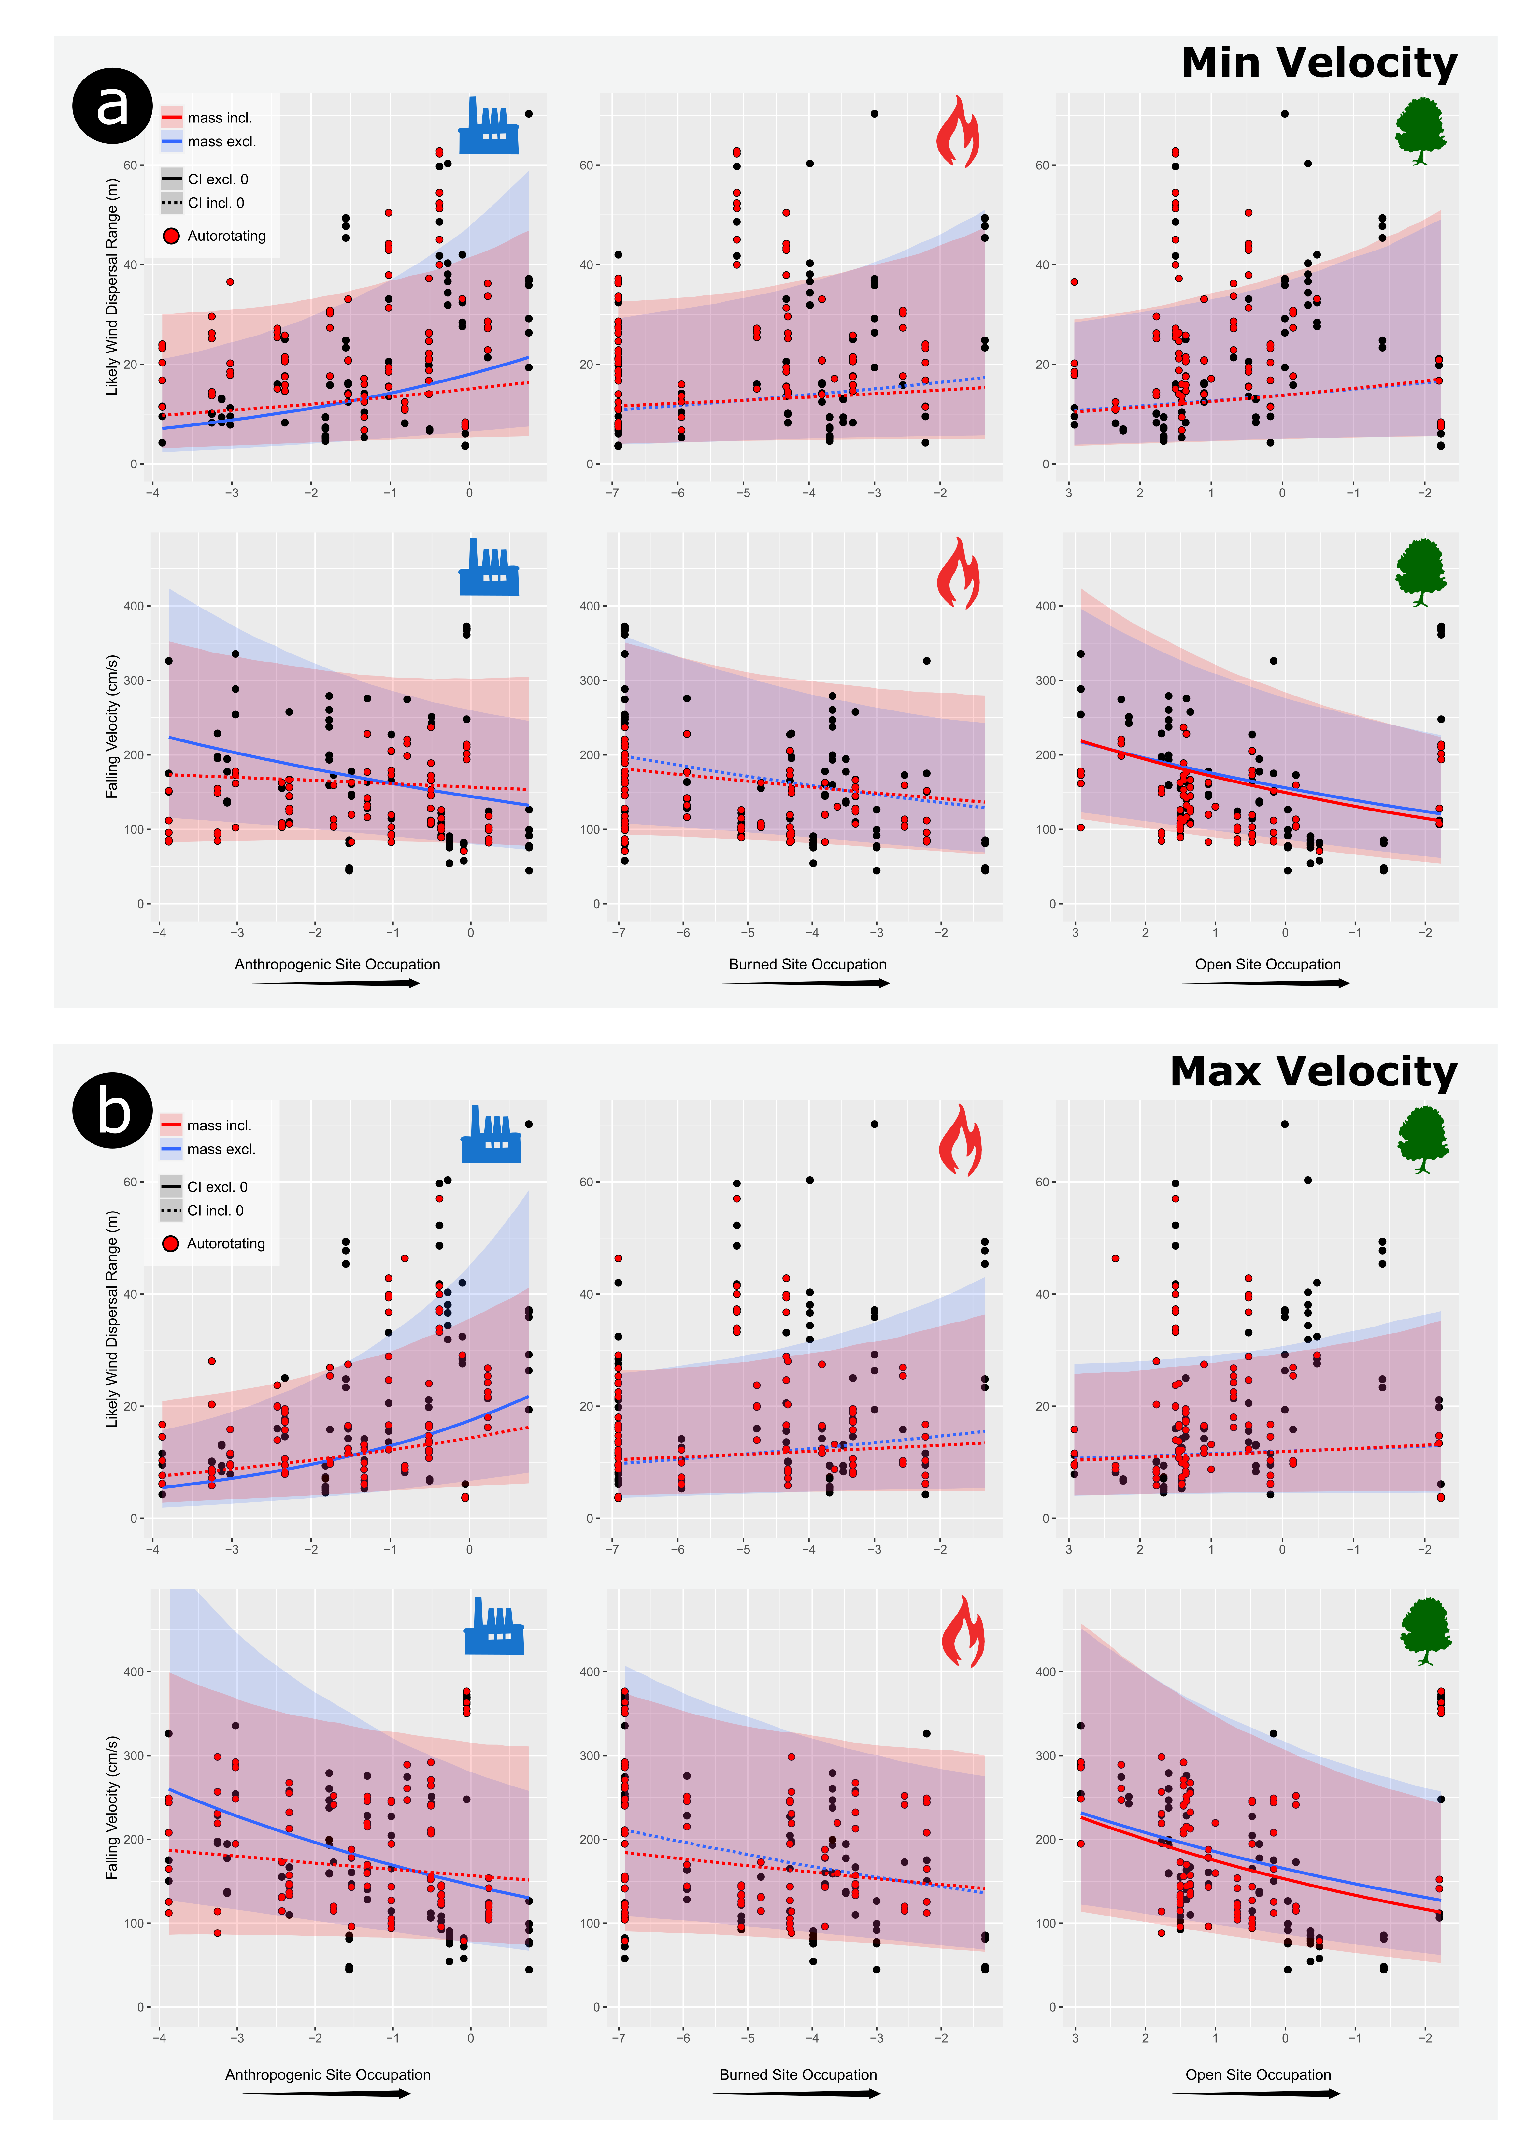
Figure S12: Next page. Conditional effects of phylogenetically informed mixed effects models predicting maximum average culm height of species. Results are shown for models including (blue) and excluding (red) Pleuropogon sabinei. Dashed lines represent effects where posterior credibility intervals (CI) for the slope overlap with zero (i.e., no effect), while solid lines indicate the opposite. Results are shown for the effects of a) anthropogenic habit occupation, b) burn frequency, and c) open habitat occupation.
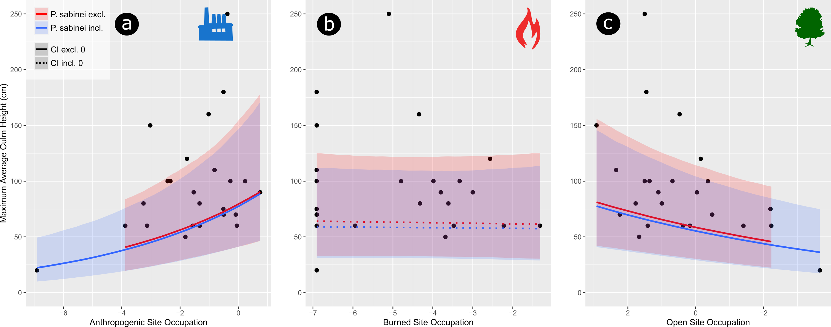

Figure S13: Next page. Conditional effects of phylogenetically informed mixed effects model predicting diaspore mass. Results are shown for models including (blue) and excluding (red) Pleuropogon sabinei. Dashed lines represent effects where posterior credibility intervals (CI) for the slope overlap with zero (i.e., no effect), while solid lines indicate the opposite. Results are shown for the effects of a) anthropogenic habit occupation, b) burn frequency, and c) open habitat occupation.
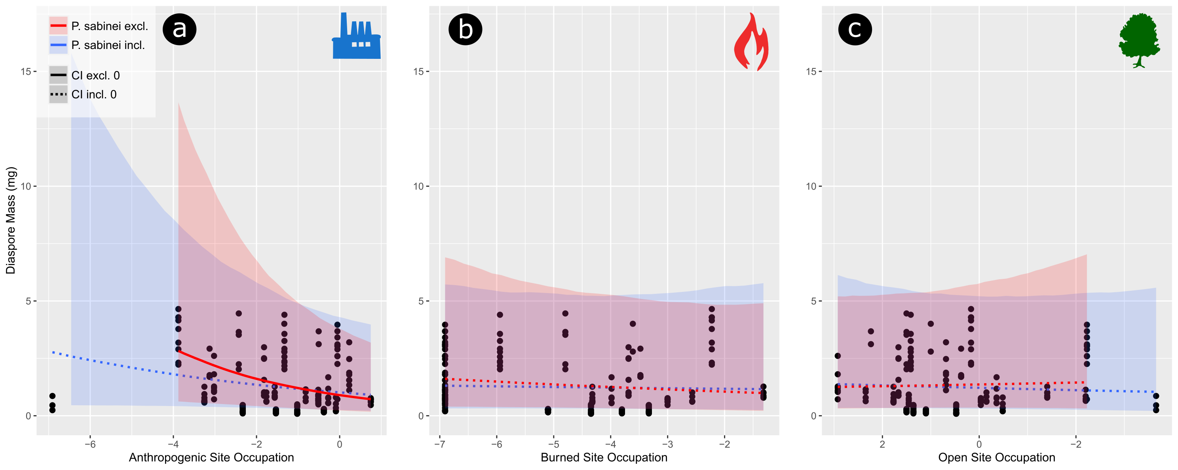
Results S3: An important, but unknown factor is at what spatial scale(s) habitat structure most influences dispersal outcomes and ultimately fitness. The spatial resolution of our habitat data is relatively coarse (300 m), which occasionally results in counterintuitive impressions of species’ habitats. For example, both Glyceria and Pleuropogon are typically considered wetland adapted, but neither genus had a preponderance of occurrences within sites classified as “hydric” (Supplementary Data Methods S1; Fig. S2). This is likely because these habitats are not always spatially extensive enough to be recognized by landcover maps as distinct from the broader habitat in which they occur. While a literature based approach is better equipped to capture these local conditions, it is unclear whether the coarse scale of GIS data is actually drawback, especially if the alternative results in preference defined at a variety of spatial scales.
To explore the implications of the spatial scale of our habitat variables, we obtained an estimate of the number of generations it was likely to take for a single lineage (starting with one selfing plant) to reach an adjacent patch if initially placed at the center of a 300 m x 300 m patch. We assumed each plant produced 50 surviving offspring, which dispersed away from the parent along a random angle (0° – 359°) and a random dispersal distance (between 0 and 500 m) with probability defined by a dispersal kernel parameterized with the median height and falling velocity of species in our data set. The most distant of these simulated offspring was then taken as the starting location of a new generation. The process was then repeated until a diaspore left the bounds of the starting patch. This process was repeated 1000 times, and the first generation where a diaspore entered an adjacent patch was recorded for each. The average number of generations was 10.7 (sd = 1.9). R code for running simulations is included with the rest of the code for this project.
These results suggest that parents are unlikely to disperse seeds into adjacent patches, but offspring are likely to reach one after only a small number of generations. This balance seems reasonable with patches not so small that many seeds are dispersed outside of them each generation, but not so large that lineages are unlikely to ever exceed their bounds. Nevertheless, at what spatial scale(s) habitat has its strongest influence on the evolution of dispersal strategy, and whether this varies between dispersal modes, habitats, and plant lineages remains unanswered.

LITERATURE CITED:
Barkworth ME, Anderton LK, Capels KM, Long S, Piep MB. 2007. Manual of Grasses for North America, Intermountain Herbarium and Utah State University Press.
Boyle WS. 1945. A cyto-taxonomic study of the North American species of Melica. California Botanical Society 8(1): 1-26.
Chinese Plant Names. http://www.efloras.org/flora_page.aspx?flora_id=3. 6 Jan. 2022.
Cope TA. 1982. Flora of Pakistan No. 143 Poaceae. University of Karachi.
Cope TA, Gray A. 2009. Grasses of the British Isles. BSBI.
Flora of China vol. 22. http://www.efloras.org/volume_page.aspx?volume_id=2022&flora_id=2. 6 Jan. 2022.
Flora of Missouri vol. 1. http://www.efloras.org/flora_page.aspx?flora_id=11. 6 Jan. 2022.
Flora of the U.S.S.R. vol. II. 1963. In V. L. Komarov, R. Y. Rozhevits, & B. K. Shishkin eds. Vol. II. Israel Program for Scientific Translations.
Gallaher TJ, Adams DC, Attigala L et al. 2019. Leaf shape and size track habitat transitions across forest–grassland boundaries in the grass family (Poaceae). Evolution 73(5): 927-946.
Gramineae in Flora of Taiwan. http://www.efloras.org/flora_page.aspx?flora_id=1050. 6 Jan. 2022.
Haeuser E, Dawson W, van Kleunen M. 2017. The effects of climate warming and disturbance on the colonization potential of ornamental alien plant species. Journal of Ecology 105: 1698-1708.
Hitchcock CL, Cronquist A. 2018. Flora of the Pacific Northwest, 2nd edn. Seattle: University of Washington Press.
Illinois Wildflowers. https://www.illinoiswildflowers.info. 6 Dec. 2022.
Jepson eFlora. 2019. University of California, Berkeley Jepson Herbarium. https://ucjeps.berkeley.edu/eflora. 6 Jan. 2022.
Minnesota Wildflowers. https://www.minnesotawildflowers.info. 6 Dec. 2022.
Ohwi J. 1965. Flora of Japan (in English). Washington: Smithsonian Institution.
Quattrocchi U. 2006. CRC World Dictionary of Grasses. Boca Raton: CRC Press.
R Core Team. 2021. R: A language and environment for statistical computing. R Foundation for Statistical Computing.
Russell GG, Ellis RP. 1982. The genus Melica L.(Poaceae) in southern Africa. Bothalia 14(1): 37-44.
Russell GG, Watson L, Koekemoer M et al. 1990. Grasses of southern Africa. Pretoria: National Botanic Gardens.
Szczepaniak M, Cieslak E. 2006. Genetic variation and structure in natural populations of Melica ciliata and M. transsilvanica (Poaceae) as indicated by AFLP markers. Biodiversity Research and Conservation 3-4: 235-239.
Stubbendieck J, Hatch SL, Dunn CD. 2017. Grasses of the Great Plains. College Station: Texas A&M University Press.
Tackenberg O, Poschlod P, Bonn S. 2003. Assessment of wind dispersal potential in plant species. Ecological Monographs 73(2): 191-205.
Tela Botanica. https://www.tela-botanica.org/flore. 6 Jan. 2022.
Varshney K, Chang S, Wang ZJ. The kinematics of falling maple seeds and the initial transitions to a helical motion. Nonlinearity 25: C1-C8. doi:10.1088/0951-7715/25/1/C1
Weakley AS. 2020. Flora of the Southeastern United States. Chapel Hill: University of North Carolina at Chapel Hill Herbarium.
Zizka A, Silvestro D, Andermann T et al. 2019. CoordinateCleaner: Standardized cleaning of occurrence records from biological collection databases. Methods in Ecology and Evolution 10(5): 744-751.

