The relationship of tropical Pacific sea surface temperature and sea level to tropical cyclones on varying time scales
Marisa Borreggine
University of Washington School of Oceanography
Seattle, WA, 98195-5351
Marisab6@uw.edu | 909-367-6519

Abstract
This study examined the relationship between sea surface height (SSH), sea surface temperature (SST), El Niño Southern Oscillation (ENSO), and tropical cyclones (TC) on high-frequency (monthly to yearly) and low-frequency (decadal to multidecadal) timescales in the Western Tropical Pacific. We verified the relationship between SST and TCs on short timescales, found a minimum SSH for anomalously intense tropical cyclones (SSH_{m}), and discovered a long-term relationship between SSH and TC counts. Our research produced a SSH_{m} of 70 cm, an anomaly indicative of the minimum upper ocean heat content with the potential intensity for an anomalous TC. We analyzed the size of areas of the sea surface that had SST or SSH greater than or equal to the lower limit for anomalously intense tropical cyclones. On yearly to decadal timescales, SSH and TC counts show an interesting likeness, where TC count fluctuations are mirrored in SSH patterns. We focused on the heat content of the upper ocean as an important driver of TC intensity, and as the factor that unites SST, SSH, and TC count. SST is directly indicative of surface heat content, SSH represents the integrated upper ocean heat content, and TC formation is driven by heat. We conclude that the multidecadal and high-frequency variability patterns of SST are more closely tied to the activity of tropical cyclones than those of SSH. The relationship between SSH and tropical cyclone counts on low-frequency timescales merits further investigation to establish a new understanding of shifts in TC count and extended occurrence patterns.

1 Introduction
1.1 Global significance
Tropical cyclones constitute a major threat not only to local economies and infrastructure, but to the people in their paths. Tropical cyclones are a type of tropical storm—classified by wind intensity and their location in the Subtropical Pacific—labelled cyclones once the winds reach 74 mph, according to the Saffir-Simpson scale (National Hurricane Center). Collins et al. (2016) outlines the main factors that influence cyclone intensity and formation: high SST, high relative humidity, high low level vorticity, and low vertical wind shear all lead to more intense cyclones. The fundamental principle of cyclone formation lies in that they are fueled by the release of heat. Greenhouse gas addition to the atmosphere has created a warming trend in the ocean, especially in the sea surface, establishing a growing source of energy for cyclones (Rhein et al., 2013). As these greenhouse gasses are continuously added into the atmosphere, more heat is trapped on earth and taken up by the ocean. The heat content of the upper ocean is expected to increase in the years to come, even in the International Panel on Climate Change’s (IPCC) best-case emissions scenario (Sobel et al., 2016). The increased heat content could result in TC intensification and occurrence, as well as increase in SSH and SST preceding the storm (Lin et al., 2012).

We can also begin to better understand the difficult nature of predicting these storms by evaluating their long-term variability in comparison with the trends of factors that contribute to TC formation. Constraining the relationships between cyclones and the elements that form them is fundamental in protecting at-risk communities. When all contributing factors are favorable for cyclone formation, as they were in the active season of 2015 in the Pacific, the results can be devastating. While track errors in predicting cyclones have significantly decreased in recent years, forecasting cyclone intensity has proved to be a tougher task due to the intricacies of the factors contributing to intensity (Lin et al., 2012). Intensity forecast errors have improved about 8 knots over the past two and a half decades (National Hurricane Center 2017). Though incremental, these improvements occur as more factors are integrated into numerical track and intensity prediction models, and new approaches to understanding cyclone patterns are considered. One such example is the recent addition of tropical cyclone heat potential (TCHP) to intensity models, a component of storm formation which is detectable in SSH (Lin et al., 2012).

1.2 SST, SSH, and cyclone formation
SST is used as a proxy for heat stored in the upper ocean, which in turn can fuel cyclones. The minimum temperature necessary to form a cyclone is 26°C, and the heat content above this isotherm is defined as tropical cyclone heat potential (TCHP) (Lin et al., 2012). High SST causes moist air near the sea surface to rise and form clouds, creating an area of low pressure, where more air moves in, becomes moist, and rises. High humidity, low vertical wind shear, and high low-level vorticity are also necessary for heat and moisture to be efficiently added into the forming system. Low vertical wind shear concentrates the heat over a contained area, while high vorticity imparts spin upon the system and creates a low-pressure eye of the storm (National Weather Service). A tropical cyclone has the potential to become anomalously intense when the SST exceeds the 28.5°C isotherm (Collins et al., 2016). Under these conditions, SSH also acts as an integrated measure of surface heat content and SSH anomalies (SSHA) indicate the depth of this heat (Goni et al., 2007). SST is often the only driver of TC modeling, yet it can fail to represent the entire heat content available to drive storm intensity (Ali et al., 2007). The relationship of SST to TC formation on immediate timescales is well documented, but the long-term patterns of cyclonic activity compared to SSH perturbations can reveal a new dynamic understanding of TC systems.

1.3 Research goals
This research aims to examine the monthly to multidecadal relationship of cyclone counts to SSH and SST, and to determine the degree to which SSH can help predict shifts in tropical cyclone counts in the presence of the changing global climate. Here, we examine how SSH, which indicates the amount of heat that can fuel tropical cyclones, is characterized and compare it to monthly and yearly cyclone counts. This SSH analysis is compared with one using SST anomalies. Although this type of SSH investigation has been undertaken in the Indian Ocean (Ali et al., 1998), it has yet to be incorporated into large-scale cyclone models in the Pacific Ocean basin. Studies in the north Indian Ocean have shown a strong relationship between SSH anomaly (SSHA) and tropical cyclone intensity (Ali et al., 2007), and addition of SSHA in tropical cyclone (TC) tracking models reduced errors in cyclone forecasting (Lin et al., 2012). Taking note from said studies, a thorough investigation of SSH and its relationship to TC counts on different timescales in the Pacific Ocean basin should provide insight into TC patterns and drivers, and consequently reduce risk for many communities.

2 Data & Methods
2.1 Data utilized
References and details for the data used can be found in Table 1. This research makes use of satellite SSH data (AVISO), SST data (OAFlux), as well as the Western Pacific Hurricane Tracking dataset (Unisys) through the University of Washington library and data network. The JISAO ENSO 4 SST anomaly index was also employed for comparison to the SSH and SST time series produced. The Niño 4 index is a time series of SST anomalies and was chosen from three different indices for its basis in the equatorial Pacific, where this research is focused. To frame the focus of our investigation, the SST analysis was longitudinally restricted from 120°W to 110°E to encapsulate the Pacific Ocean. The principal area of interest for SSH perturbations is the Western Tropical Pacific, so SSH analysis was constrained to the same longitudinal area as SST, and restricted from 10°S to 10°N. Cyclones do not form within 5 degrees of the equator, but the heat content examined in the area patches surrounding the equator contributes to local humidity and the intensity of cyclones outside of this area. The varying Mean Dynamic Topography (MDT) was added to SSHA data to create an accurate picture of total SSH behavior.

2.2 Area analysis time series
We investigated the relationships between cyclones, SST, and SSH on multiple time scales. We created time series that capture these monthly, yearly, and decadal changes by calculating the areas of high SST and SSH content (Fig 1). The SST time series is calculated as the combined area of patches of sea surface where the temperature is greater than or above 28.5°C, on a monthly timescale. This temperature represents of the minimum amount of surface heat necessary to create an anomalously intense cyclone (Lin et al., 2012), and therefore creates an informative metric to examine the relationship of SST to cyclone counts. SSH is a proxy for upper ocean heat content and indicative of tropical cyclone potential intensity. Total SSH was examined to determine a numerical SSH value as an analog to 28.5°C, which we call SSH_{m} for minimum SSH. The area of the Pacific Ocean with patches of SST greater than or equal to 28.5°C was compared to total SSH to determine the lower limit of SSH for anomalously intense cyclones (SSH_{m}). This limit was used to construct a time series for SSH, using the combined area of patches of sea surface with SSH greater than or equal to 70cm, also on a monthly timescale. Once SSH_{m} was determined and the SSH time series constructed, we compared SSH with cyclone counts to examine the relationship between tropical storm counts and SSH. A time series was also created for yearly cyclone counts for comparison to yearly average SST and SSH time series.

2.3 Time series correlations
Time series were compared to identify trends and verify correlations (Fig 2B, 5B). The ENSO 4 index was superimposed on the SST time series to check its credibility, since both time series measure temperature anomalies. To quantify the relationships between the variables, correlations were performed using a Pearson correlation coefficient and p-value to determine the statistical significance. Time series comparisons with a p-value greater than 0.05 are considered statistically insignificant. This was done for both monthly and annual SST and SSH measurements and TC count. After determining that SST is more closely correlated to cyclone counts than SSH, the yearly averages of SST and SSH were compared to yearly totals of TC counts to investigate low-frequency temporal patterns. In this yearly lens, the time series comparisons reveal the longer-term relationships between SSH, SST, and TC count.

3 Results
3.1 SST, El Niño time series, and cyclone count
The SST area time series (Fig 2) shows both a long-term increase and significant year to year variability. The ENSO 4 index is significantly correlated to the SST area time series with a Pearson correlation coefficient of 0.51 and p-value of 7.368x10⁻²⁰ (Fig 2A; Table 2). From the SST time series, September of 2014 was the month with the maximum sea surface area with SST within our threshold (Fig 3). The large section of the sea surface with anomalous temperature, the extraordinarily active cyclone season in the Pacific, and the strong 2014 El Niño all confirm the relationship between SST, ENSO, and cyclone formation. The SST and TC count time series comparison has a Pearson correlation coefficient of 0.43 and a p-value of 9.54x10⁻¹², confirming the operating assumption that SST is an accurate indicator of cyclone characteristics (Fig 2B; Table 2).

3.2 SSH time series and cyclone count
The SSH time series was constructed in the same fashion as the SST series and demonstrates the independent nature of SSH variance. On average, 70 centimeters SSH above mean sea level corresponds to 28.5°C SST, and is thus considered the lower limit of SSH for an anomalously intense cyclone (SSH_{m}) (Fig 4). The maximum point on this time series (Fig 5A), June 1997, had the greatest sea surface area with SSH within our threshold, and four tropical storms that originate in SSH_{m} contour (Fig 6). On a monthly timescale, SSH and tropical cyclone counts have a Pearson correlation coefficient of 0.11 and a p-value of 0.08, less than that of SST and the tropical cyclone time series (Fig 5B; Table 2). The lack of a significant relationship between SSH and TC data shows that SST is a more accurate predictor of TC characteristics on a monthly timescale.

3.3 SST, SSH, and tropical cyclone count comparison
We observed high correlations for SST, SSH, and TC count on a monthly scale, and lower correlations on a yearly scale (Table 2). The yearly averages of SST and SSH remove the noise from seasonal cycles and reveal low-frequency changes for SSH and TC counts. On a yearly timescale, the SST and TC count time series have a Pearson correlation coefficient of -0.396 and a p-value of 0.09, while SSH still shows a smaller correlation and significance with a Pearson value of -0.110 and a 0.65 p-value (Fig 7A; Fig 7B; Table 2). There is a distinct step trend apparent in the low-frequency SSH and TC count comparison around 1998, just after a large El Niño, which suggests a longer-term connection between SSH and TC count (Fig 7B). The shift in SSH shows a temporal lag after the shift in TC count on both monthly and yearly scales (Fig 5B; Fig 7B).

4 Discussion & Conclusions
4.1 SST and tropical cyclones
This investigation revealed that SST is closely tied to the monthly-scale variations in tropical cyclone counts. Comparing SST, SSH, and TC counts on monthly, yearly, and multidecadal timescales show that SST signals are stronger than SSH signals in TC count prediction. Previous work has shown a strong correlation between SST preceding tropical cyclones and the subsequent cyclone frequency on seasonal timescales, supporting our findings here (Nicholls, 1984). Higher SST is indicative of higher sea surface heat, resulting in warmer air that can hold more moisture. Increased SST and moisture conditions are highly conducive to anomalously intense cyclone formation, since heat and moisture are the fuel for storm formation and the driving force of potential cyclone intensity (Vecchi and Soden, 2007). SST is directly dependent upon surface heat content, while SSH is indicative of the integrated heat content of the upper ocean, as well as gravity, tides, and currents (NASA Science Beta). On monthly to daily timescales, SST and tropical cyclones are both products of surface heat content and moisture, causing SST and TC counts to be closely correlated.

4.2 SSH and tropical cyclone patterns
Our finding of a SSH threshold for anomalously intense tropical cyclones (SSH_{m}) is a significant contribution to cyclone detection on a multidecadal scale. On yearly to decadal timescales, SSH can be useful to identify long-term shifts in TC counts. Increased sea surface area where SSH is within our threshold, SSH_{m}, appears to be linked to increased tropical cyclone counts (Fig 7B). Tropical cyclone formation and subsequent movement (i.e., storm track) may also be tied to the SSH of the region where the tropical storm forms. The origin for a number of storms is located in areas with SSH greater than or equal to SSH_{m} (Fig 6). The significant finding here is the hint of a relationship between SSH and TC count on a multidecadal scale.

The relationship of tropical cyclones to SSH is evident in longer timescales, given that long-term SSH and cyclone patterns both vary with seasonal cycles and ocean circulation, processes that take place on monthly to decadal timescales (Mei et al., 2013; Fig 7B). Low-frequency temporal analysis of tropical cyclone counts removes the noise of seasonal cycles and regional climate perturbations, allowing us to see the overarching trend in the time series. Though SSH and TC count lack a statistically significant correlation on the timescales explored here (Table 2), the distinct step pattern in the low-frequency comparison suggests the need for further investigation. This pattern, demonstrated in both variables, confirms the necessity of analyzing the yearly and decadal relationship of SSH and tropical cyclones to understand how they are linked.

4.3 The future of tropical cyclones
Incorporation of our SSH_{m} for anomalously intense cyclones can improve warnings for oncoming tropical storms. In a time where extreme weather events may be occurring more frequently and modern infrastructure is unprepared to endure these disturbances, considerable warning time for affected communities is essential. The results of this research reveal the low-frequency temporal relationship of SSH and tropical cyclone counts, and further research into this relationship could be essential to preparing affected communities. The close relationships between El Niño and SST as well as SST and TC count presented here are increasingly relevant as rising sea surface heat content causes extreme El Niño events to become more frequent (Cai et al., 2014), and consequently increase TC count (Zhao et al., 2010). Diverse methods of understanding tropical storm frequency on various timescales will hone the accuracy of our models, which will be invaluable as the heat content of the upper ocean and sea level rise, leading to increased cyclone frequency (Emanuel, 2008).

Directed macroscopic-scale analysis of SSH, SST, and tropical cyclone counts can reveal an underlying trend that can help us predict further tropical cyclone patterns over monthly, yearly, and decadal timescales. We suggest evaluating climate models and existing multidecadal-scale SSH and TC count data for this relationship. The yearly to multidecadal relationship of TC count and other TC formation factors, such as low-level vorticity, humidity, and low vertical wind shear, merits investigation and comparison to our findings here. Moving forward, understanding the long-term consequences of the relationships between these variables can provide insight into the complex interconnected system of the ocean, the atmosphere, and human activities.

Data | Variable | Units | Sampling Resolution | Time Frame | Source Reference
OAFlux | SST | °C | Monthly, by 1° | 1958-Present | Woods Hole Oceanographic Institution, and NOAA Climate Observations and Monitoring  Program. 2013. OAFlux Monthly Sea Surface Temperature.
Aviso | SSH | m | Monthly, by 0.25° | 1993-Present | Centre national d'études spatiales, Center for Topographic studies of the Ocean and  Hydrosphere, Observatoire Midi-Pyrénées, Copernicus Marine and Environment Monitoring Service, and Aviso. Aviso Daily SSH.
Unisys | Cyclone count | N/A | Monthly | 1945-2011 | Unisys Weather, National Weather Service. 2017. Western Pacific Hurricane Tracking Data by Year. Retrieved from: http://weather.unisys.com/hurricane/w_pacific/.
JISAO | Niño 4 Index | °C | Monthly | 1982-Present | University of Washington College of the Environment, Joint Institute for the Study of the Atmosphere and Ocean. 2017. Nino 4 Sea Surface Temperature (SST) anomaly indices. Retrieved from http://jisao.washington.edu/data-realtime_climate_data.
Table 1. Data Summary

Table 2. Summary of SST, SSH, ENSO, and tropical cyclone count relationships.
Relationship | Timescale | Pearson correlation coefficient | p-value
SST & Niño 4 | Monthly Count | 0.513 | 7.369x10⁻²⁰
SST & TC count | Monthly Count | 0.433 | 9.536x10⁻¹²
SSH & TC count | Monthly Count | 0.116 | 0.082
SST & TC count | Yearly Average | -0.396 | 0.093
SSH & TC count | Yearly Average | -0.110 | 0.653

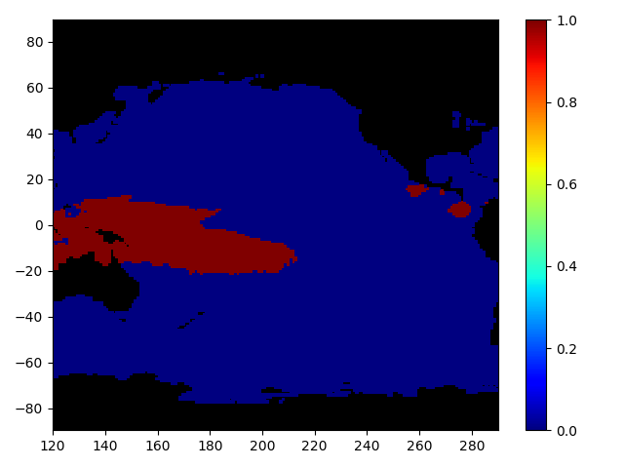
Figure 1. January 2014 SST area patch map. SST greater than or equal to 28.5°C is set to 1, and SST less than 28.5°C is set to 0. The area of the red patch is used to create the SST time series. The same technique is used for the SSH time series.

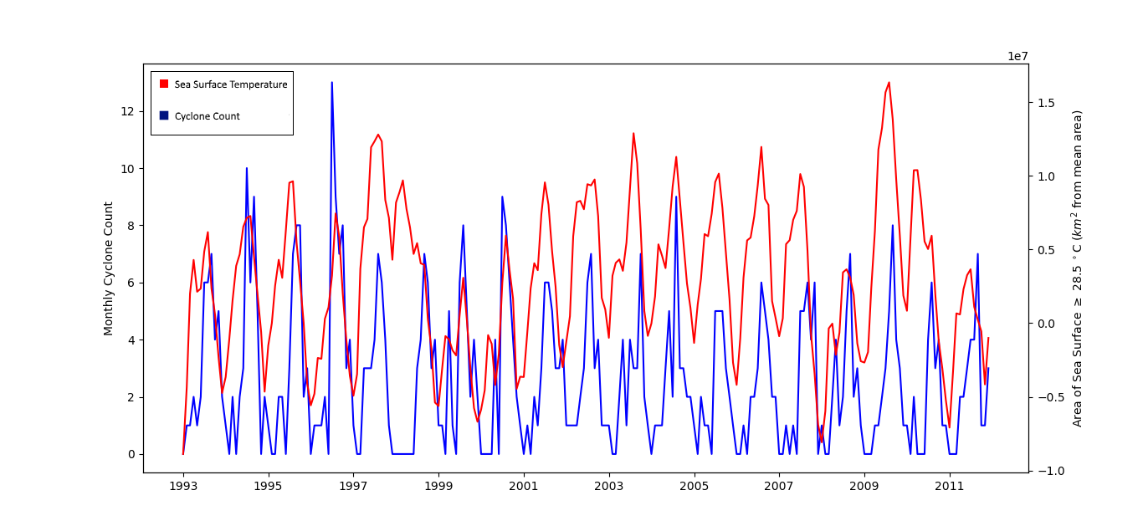
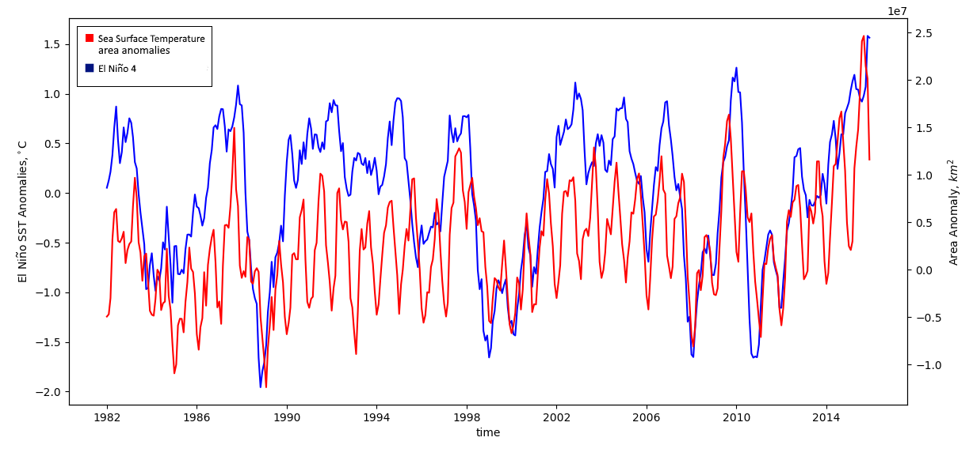
Figure 2. SST time series. A. Correlation of the SST area analysis time series and ENSO 4 from 1982-2016. The SST analysis is of total area of the sea surface greater than or equal to 28.5°C. B. SST time series and tropical storm count from 1993-2011.
B.
A.
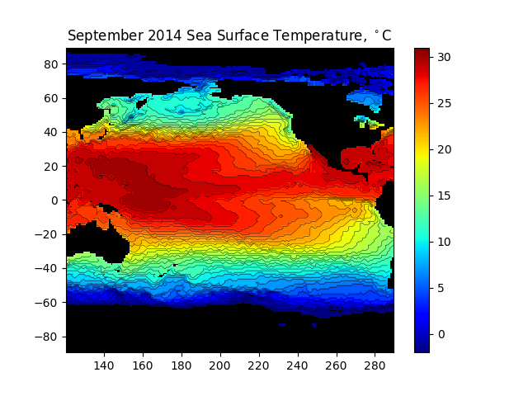
Figure 3. Contour plot of SST in the Pacific Ocean for September 2014, the month with maximum area of SST greater than or equal to 28.5°C from 1958-2016.

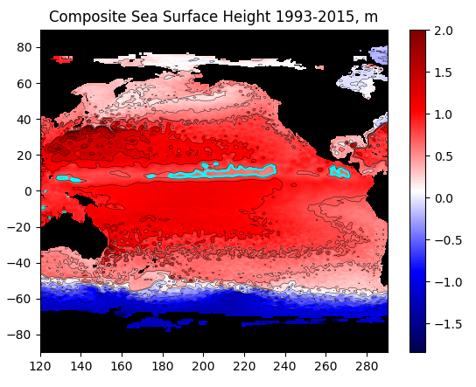
Figure 4. Composite SSH (m) for the Pacific Ocean basin. SSH is from SSHAs added to MDT (mean dynamic topography). The 70cm SSH contour is highlighted in blue only in the area where SSH analysis was performed.

A. 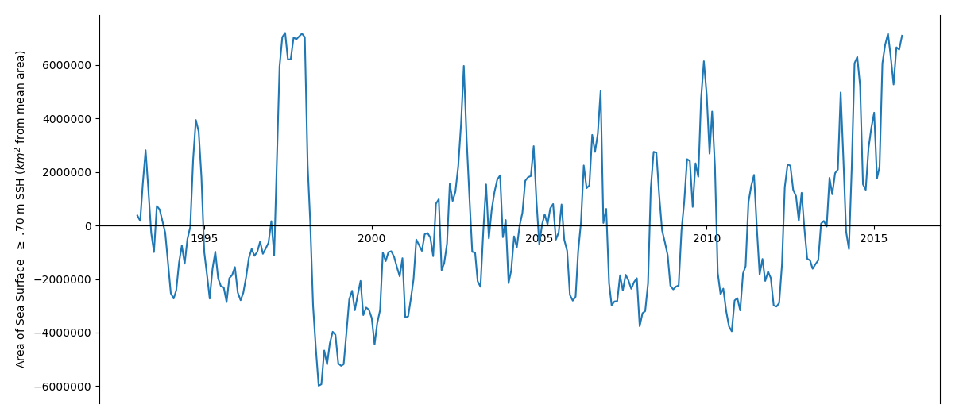
B. 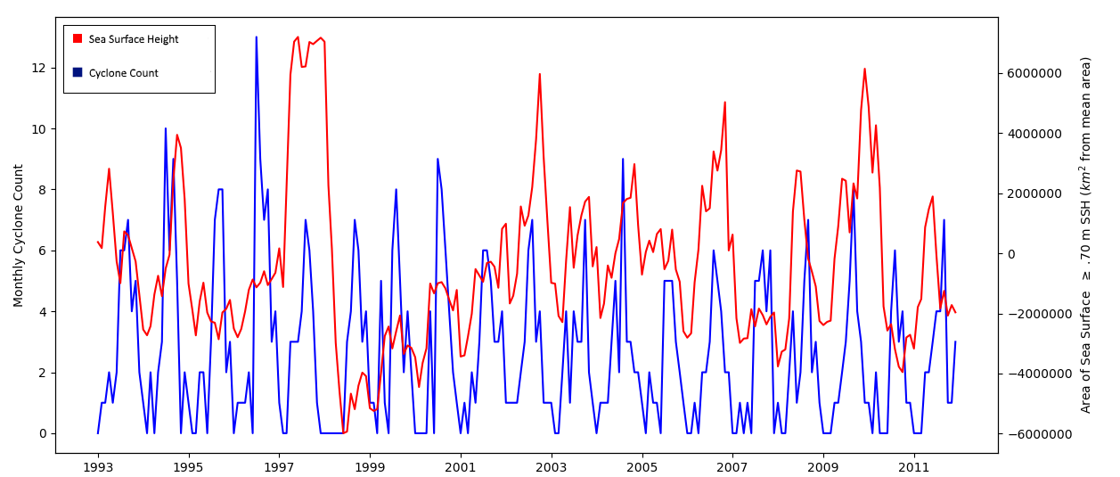
Figure 5. SSH time series. A. Area analysis time series for SSH. Area of sea surface with SSH greater than or equal to 70 centimeters. B. SSH time series with tropical cyclone counts from 1993-2011.

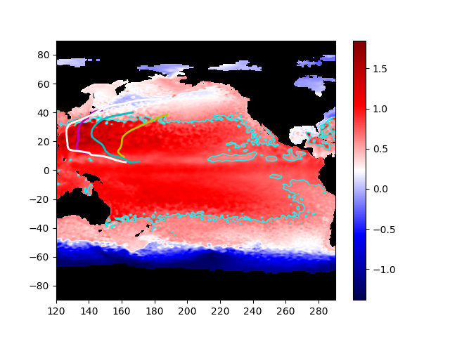
Figure 6. SSH (m) and tropical storm tracks for June 1997, the maximum point on the SSH time series. 70cm SSH contour outlined in light blue.

A. 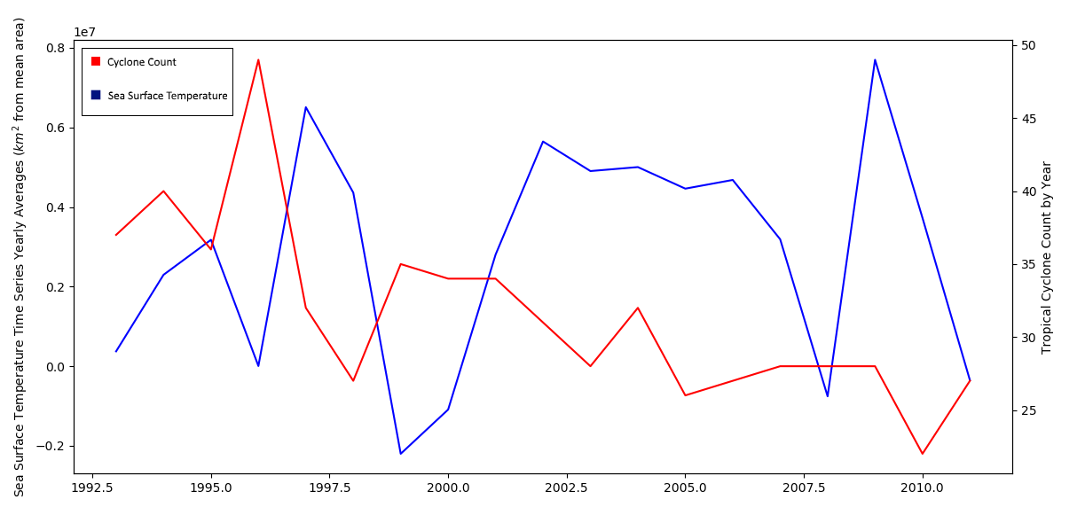
B. 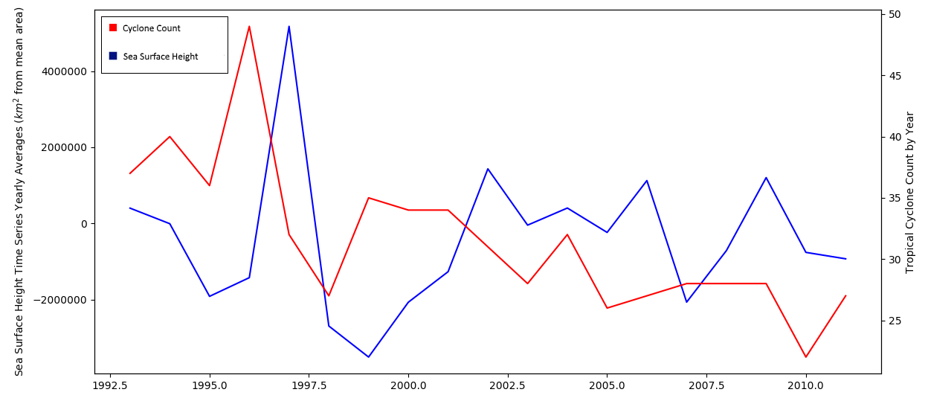
Figure 7. Yearly averages and totals time series from 1993-2011. A. SST and tropical cyclone count. B. SSH and tropical cyclone count.

Acknowledgements
I wish to thank LuAnne Thompson for her continued support and guidance in this strenuous, yet rewarding, project. I would also like to recognize Marie Salmi for her patience, flexibility, and outstanding ability to teach students how to think like a computer scientist. Jamee Adams and Anna Bakker were, are, and always will be my inspiration. Arthur Nowell also deserves acknowledgement for his constant enthusiasm and guidance. Thank you to the UW School of Oceanography faculty and staff for raising up a new generation of inquisitive and passionate scientists.

References

Ali, M.M. and Sharma, R. 1998. Studying Indian ocean typical dynamical phenomena using
TOPEX observations. Marine Geodesy, 21: 193-201. doi: 10.1080/01490419809388135.

Ali, M.M., Sinha, P., Jain, S. and Mohanty, U.C., 2007. Impact of sea surface height anomalies
on cyclone track. Nature Precedings.

Cai, W., Borlace, S., Lengaigne, M., Van Rensch, P., Collins, M., Vecchi, G., Timmermann, A.,
Santoso, A., McPhaden, M.J., Wu, L. and England, M.H.. 2014. Increasing frequency of extreme El Niño events due to greenhouse warming. Nature climate change 4: 111-116. doi:10.1038/nclimate2100.

Centre national d'études spatiales, Center for Topographic studies of the Ocean and
Hydrosphere, Observatoire Midi-Pyrénées, Copernicus Marine and Environment Monitoring Service, and Aviso. Aviso Daily SSH.

Collins, J. M., P. J. Klotzbach, R. N. Maue, D. R. Roache, E. S. Blake, C. H. Paxton, and C. A.
Mehta. 2016. The record-breaking 2015 hurricane season in the eastern North Pacific: An analysis of environmental conditions. Geophysical Research Letters 43: 9217–9224. doi:10.1002/2016gl070597

Emanuel, Kerry. 2008. The Hurricane-climate connection. Bulletin of the American
Meteorological Society 89.5: ES10-ES20. doi: 10.1175/BAMS-89-5-Emanuel.

Goni, G.J. and Knaff, J., 2007. Tropical cyclone heat potential. State of the Climate. 43-45.
Retrieved from: http://www.aoml.noaa.gov/phod/research/docs/PhOD_project_report2016_p44.pdf. Visited on 05/21/2017.

Lin, I.-I., G. J. Goni, J. A. Knaff, C. Forbes, and M. M. Ali. 2012. Ocean heat content for tropical
cyclone intensity forecasting and its impact on storm surge. Natural Hazards 66: 1481–1500. doi:10.1007/s11069-012-0214-5

Mei, W., F. Primeau, J. C. Mcwilliams, and C. Pasquero. 2013. Sea surface height evidence for
long-term warming effects of tropical cyclones on the ocean. Proceedings of the National Academy of Sciences 110: 15207–15210. doi:10.1073/pnas.1306753110

NASA Science Beta. Ocean Surface Topography. NASA. Retrieved from:
https://science.nasa.gov/earth-science/oceanography/physical-ocean/ocean-surface-topography. Visited on 04/18/2017.

National Hurricane Center. Saffir-Simpson Hurricane Wind Scale. National Oceanographic and
Atmospheric Administration (NOAA). Retrieved from: http://www.nhc.noaa.gov/aboutsshws.php. Visited on 04/20/2017.

National Hurricane Center. 2017. National Hurricane Center Forecast Verification. National
Oceanographic and Atmospheric Administration (NOAA). Retrieved from: http://www.nhc.noaa.gov/verification/verify5.shtml. Visited on 04/19/2017.

National Weather Service. Vorticity Basics. Retrieved from:
http://www.weather.gov/source/zhu/ZHU_Training_Page/Miscellaneous/vorticity/vorticity.html. Visited on 05/21/2017.

Nicholls, N. 1984. The Southern Oscillation, sea-surface-temperature, and interannual
fluctuations in Australian tropical cyclone activity. Journal of Climatology 4: 661–670. doi:10.1002/joc.3370040609

Rhein, M., S.R. Rintoul, S. Aoki, E. Campos, D. Chambers, R.A. Feely, S. Gulev, G.C. Johnson,
S.A. Josey, A. Kostianoy, C. Mauritzen, D. Roemmich, L.D. Talley and F. Wang, 2013: Observations: Ocean. In: Climate Change 2013: The Physical Science Basis. Contribution of Working Group I to the Fifth Assessment Report of the Intergovernmental Panel on Climate Change [Stocker, T.F., D. Qin, G.-K. Plattner, M. Tignor, S.K. Allen, J. Boschung, A. Nauels, Y. Xia, V. Bex and P.M. Midgley (eds.)]. Cambridge University Press, Cambridge, United Kingdom and New York, NY, USA.

Sobel, A. H., S. J. Camargo, T. M. Hall, C.-Y. Lee, M. K. Tippett, and A. A. Wing. 2016.
Human influence on tropical cyclone intensity. Science 353: 242–246. doi:10.1126/science.aaf6574

Woods Hole Oceanographic Institution, and NOAA Climate Observations and Monitoring
Program. 2013. OAFlux Monthly Sea Surface Temperature.

Unisys Weather, National Weather Service. 2017. Western Pacific Hurricane Tracking Data by
Year. Retrieved from: http://weather.unisys.com/hurricane/w_pacific/. Visited on
01/09/2017.

University of Washington College of the Environment, Joint Institute for the Study of the
Atmosphere and Ocean. 2017. Nino 4 Sea Surface Temperature (SST) anomaly indices. Retrieved from http://jisao.washington.edu/data-realtime_climate_data. Visited on 11/14/2016.

Vecchi, G. A., and B. J. Soden. 2007. Effect of remote sea surface temperature change on
tropical cyclone potential intensity. Nature 450: 1066–1070. doi:10.1038/nature06423

Zhao, H., Wu, L. and Zhou, W. 2010. Assessing the influence of the ENSO on tropical cyclone
prevailing tracks in the western North Pacific. Advances in Atmospheric Sciences 27: 1361-1371. doi:10.1007/s00376-010-9161-9.

