Extracellular enzyme activity of particle-associated and free-living bacteria in the oxygen deficient zone of the Eastern Tropical North Pacific.

Natalie A. Kellogg
University of Washington
School of Oceanography, Box 357940, Seattle WA, 98195-5351
nak01@uw.edu

May 29, 2017

Abstract

The downward export of particulate organic matter (POM) in the water column is a globally important mechanism for carbon sequestration in the deep ocean. It is well understood that Oxygen Deficient Zones (ODZs) more efficiently export POM with depth compared to oxic waters. However, the role of microbial hydrolytic activity on ODZ organic matter is unknown. To evaluate this role, I assessed extracellular enzyme activity (EEA) and bacterial abundance (BA) of microbial size fractions, free-living (0.2-3 µm) and particle-associated (>3 µm), using fluorescently tagged substrates and epifluorescent microscopy. Samples were collected from one or two oxic depths (40-55m) and one oxygen-deficient depth (70-140 m) at three stations in the Eastern Tropical North Pacific (ENTP) ODZ from December 19, 2015 to January 16, 2017. Significant positive correlations were observed between EEA and oxygen (P < 0.05), suggesting that EEA is elevated in oxygenated waters over that of anoxic waters. However, EEA also showed significant relationships with other environmental factors, such as temperature, fluorescence, and depth. Continuing to explore the role of microbes in POM flux may become more important as the size of ODZs increase with climate change.

Introduction
Export of particulate organic matter (POM) to depth, well known as the biological pump, is a globally important mechanism for carbon sequestration in the deep ocean. The efficiency of POM exported from the euphotic zone downwards is driven by biogeochemical processes, and can be understood and quantified using an attenuation coefficient (Martin et al., 1987). The Eastern Tropical North Pacific (ETNP) oxygen-deficient waters have a lower attenuation coefficient—corresponding to less decay of organic matter—than oxic waters (Van Mooy et al., 2002; Hartnett and Devol, 2003). That is, the efficiency of POM export passing through Oxygen Deficient Zones (ODZs), defined here as waters with < 10 nM oxygen, is much greater compared to oxic ocean waters for reasons that are largely unknown.
Organic matter in marine environments is subject to many biogeochemical processes, including degradation by heterotrophic bacteria. As POM falls through transitioning oxic to oxygen-deficient waters, heterotrophs on sinking particles switch from aerobic to less energetically efficient anaerobic respiratory pathways, leading to an overall decrease in remineralization (Bueno et al., 2012). The oxygen effect on microbial degradation of sinking POM—defined as the increased rate of remineralization of carbon by microbial communities under oxic conditions compared to reducing conditions—is one potential mechanism supported as a contributor to decreased particle flux attenuation in previous studies (Van Mooy et al., 2002; Keil et al., 2016). Keil et al. (2016) recently explored this topic by performing particle incubation experiments at different oxygen concentrations, measuring dissolved inorganic carbon (DIC) production to determine particle breakdown. However, the results of this study have been inconclusive due to potential correlations of POM export to other factors—such as the addition of chemoorganic carbon to sinking particles and zooplankton dynamics. Thus, further analysis on the contribution of the oxygen effect to decreased particle attenuation in ODZs is needed to differentiate from other potential mechanisms.
The oxygen effect on microbial degradation of sinking POM in ODZs can be more directly evaluated by measuring organic matter hydrolysis through extracellular enzyme activity (EEA). To make POM accessible for uptake across cellular membranes, bacteria must hydrolyze it first with extracellular enzymes (Rogers, 1961; Billen, 1984). Consistent with the oxygen effect, the release and activity of hydrolytic enzymes by heterotrophic bacteria may decrease under the reducing conditions in the ODZ. Microbial EEA of particle-associated (PA) bacteria in marine environments has been shown to play a role in altering POM fluxes in Arctic waters (Kellogg and Deming, 2014), yet the effects of microbial activity on POM in oxygen-deficient waters remains unexplored.
Though PA-EEA has a direct effect on particle attenuation in the water column, free-living (FL)-EEA may also play an important role in the carbon cycle. Ganesh et al. (2014, 2015) found that FL bacteria depended on access to the organic matter released by hydrolysis of particles under anaerobic conditions. This microbial relationship was explored in other studies (Kellogg et al., 2011; Azam and Malfatti, 2007), where PA-EEA exceeded FL-EEA and PA bacteria hydrolyzed more POM than required—sustaining FL bacteria through the process. Due to the particle dependence of FL bacteria, if PA-EEA decreases under reducing conditions, FL-EEA may also decrease. Further research is needed to understand the breakdown of organic material by FL bacteria compared to PA bacteria under anaerobic versus aerobic conditions, giving insight on the important and complex microbial relationships in ODZs.
My objective was to measure and compare cell-specific microbial hydrolytic activities associated with PA and FL fractions in the oxic and oxygen-deficient depths of the ETNP, and search for correlations with environmental variables. I hypothesized that total EEA associated with oxygenated depths will be enhanced over that for oxygen-deficient depths relative to other environmental variables (fluorescence, temperature, salinity, and depth) in the ETNP. Additionally, PA microbial EEA will exceed FL microbial EEA across both oxic and oxygen-deficient waters.

Methods
Sample Collection
Samples were taken at three stations across the ETNP ODZ along a cruise path from 23°N, 110°W to 14°N, 110°W from December 19, 2015 to January 16, 2017 aboard the R/V Sikuliaq. At each station, seawater was sampled at one or two oxic depths (40-55m) and one oxygen-deficient depth (70-140 m). Seawater was collected in twenty-four 12-L Niskin bottles on attached to a rosette with a Seabird 911 Conductivity Temperature Density meter, a 98 Seabird SBE 43 Dissolved Oxygen Sensor, and a WETLabs ECO Chlorophyll Fluorometer. Low oxygen concentrations were verified using Winkler titrations. I drained the seawater (5 L for each depth) from the CTD Niskin to cubitainers. A peristaltic pump was then used to filter the seawater through 3-µm and 0.2-µm polycarbonate filters to collect PA (>3 µm) and FL (0.2-3 µm) fractions.

Extracellular enzyme activity

Potential rates of EEA were measured on both the PA and FL fractions using fluorescently tagged substrates (Hoppe, 1993). After filtration, I immediately resuspended the filtered material in 50 mL of 0.2-µm filtered seawater. Each resuspension was split into duplicate screw cap vials with septa (exetainers) to examine two classes of proteases defined by substrates: L-Leucine 7-amino-4-methyl-coumarin hydrochloride (AMC-Leu) and L-Alanine 7-amido-4-methylcoumarin (AMC-Ala). Substrates were added at saturating concentrations (200-250 μM), which were determined by substrate saturation experiments run on board, to ensure the enzymes were catalyzing at maximum proficiency. Samples were incubated at in situ temperature in the dark to avoid for < 24 hours to prevent substrate-induced microbial response. During incubation, I measured fluorescence using a Turner Designs TD-700 fluorometer at continuous time points (3-8) every 1-4 hours. The number and spacing of time points read during incubation varied and were determined by the initial rate of increase for each substrate. Rates of EEA were calculated from the average slope of the linear regression of substrate concentration over time (uM substrate analog hydrolyzed/minute) using standard calibration curves.
Bacterial abundance
Bacterial abundance of both the PA and FL fractions were estimated using epifluorescence microscopy. The PA and FL resuspended fractions were fixed with 0.02-µm filtered 37-39% formaldehyde to 2% final concentration and kept at room temperature on board. Samples from Stations 15 and 16 were stored with the 3-µm and 0.2-µm polycarbonate filters used for filtration, whereas the filters were removed from Station 1 samples before storage. Within four months of collection, I stained the bacteria cells using DNA stain DAPI (Glöckner et al., 1996), and filtered 2-3 mL of sample onto 0.2-µm black polycarbonate filters in duplicates. I mounted the filters on slides and examined bacterial counts using an epifluorescence microscope until a minimum of 20 fields or 200 bacteria were counted. Then I used bacterial abundance counts to normalize the EEA rates to obtain a per cell rate.

Data Analysis
Relationships between bulk EEA and environmental variables (oxygen, fluorescence, temperature, salinity, and depth) were examined using both linear and exponential regressions in Excel. Exponential regressions were chosen over linear regressions if the data followed an exponential curve more closely. Trends in environmental variables and EEA were assessed by the analysis of variance (ANOVA) where P-values below 0.05 were considered significant.

Results
Environmental setting

The nearshore and offshore stations sampled (Figure 1) showed noteworthy differences in environmental variables at each depth. Lower temperature and higher salinity waters occurred at shallow depths at Stations 1 and 15 (Figure 2c-d) compared the offshore waters from Station 16. A dramatic spike in fluorescence at 40 m at Station 15 (Figure 2b) corresponded to the primary chlorophyll maximum. Less dramatic primary chlorophyll maxima occurred at 55 m at Stations 1 and 16. At all stations, the depth of secondary chlorophyll maxima was from 90-130 m. The highest oxygen concentrations sampled with depth occurred at Station 1 (Figure2a)—gradually decreasing to 50 μmol/kg at 100 m. At Stations 15 and 16, severe oxyclines, where oxygen concentrations decrease rapidly, extended from 40-80m with oxygen concentrations quickly approaching 0 μmol/kg at 80 m.

Rates of EEA

Cell-specific leucine EEA and cell-specific alanine EEA were always higher in PA fractions compared to FL fractions (Figure 3c-d). Bulk EEA were similar for PA and FL fractions for each depth (Figure 3a-b). Leucine EEA was highest at the primary chlorophyll maximum at Station 15 and alanine EEA peaked at the primary chlorophyll maximum at Station 16. At all stations, the smallest values of EEA occurred at the lowest oxygen concentrations. Bulk alanine EEA was higher than leucine EEA by up to 1 order of magnitude overall. However, once scaled to total bacterial abundance, leucine EEA was only slightly higher in activity.

Environmental variables and EEA

A number of significant correlations (P < 0.05) were observed between the environmental variables assessed and the cell-specific EEA and bulk EEA (Figure 4, Table 1). The relationships between cell-specific EEA (not shown) and environmental variables were similar to those found in bulk EEA. For the two enzyme classes measured, EEA had positive correlations with oxygen, fluorescence, and temperature (Figure 4a-f) and negative correlations with salinity and depth (Figure 4g-j). In both PA and FL fractions, leucine EEA strongly correlated with fluorescence at each depth. Leucine EEA activity also significantly correlated with oxygen concentrations (without the outlier) in FL fractions and with temperature and depth in PA fractions. In contrast, in both PA and FL fractions, alanine EEA only had significant correlations with oxygen concentrations. A few environmental variables also strongly co-varied, such as temperature and depth (Table 1).

Discussion
PA and FL EEA
Once normalized to bacterial abundance, PA-EEA exceeded FL-EEA across all samples, indicating a more active PA bacterial community. Azam et al. (1994) had first proposed a microbial loop in the Arabian Sea ODZ where PA bacteria transfers organic material to FL bacteria by hydrolyzing excess POM into the surrounding waters. My results hint at the importance of this microbial loop between PA and FL bacteria in the ENTP ODZ, where the dominant anaerobic pathways active in carbon remineralization are denitrification and anammox (Ulloa et al., 2012). Ganesh et al. (2014, 2015) had previously explored the relationship between PA and FL bacteria under anaerobic conditions by evaluating metatranscriptomes in the ETNP. They discovered the genes required for denitrifiers were more abundant in the PA fraction, whereas anammox-related genes were associated with the FL fraction. Using rate measurements, their study found both N₂ production by denitrification and anammox decreased by 53-85% when particles were removed, demonstrating dependence of FL bacteria on hydrolysis of particles by PA bacteria. Consistent with that study, my results suggest FL bacteria particle dependence under anoxic conditions in the ETNP by means of microbial activity. Considering that cell-specific PA-EEA was higher than cell-specific FL-EEA, either PA bacteria were hydrolyzing more POM than needed or FL bacteria uptake membrane-permeable dissolved organic matter (DOM)—arguably released into the water column by PA bacterial hydrolytic activity. In bulk, FL-EEA was usually greater than PA-EEA due to having higher bacterial abundance. More interestingly, the same FL-EEA particle dependence is shown at oxic depths, and does not appear to change once entering anoxic waters as microbes switch from aerobic to anaerobic respiration.

Alanine and leucine EEA
Microbial EEA for alanine was greater than leucine by up to 1 order of magnitude across all samples (Figure 3), signifying amino acid C:N ratio and relative seawater abundance are possible influences on EEA in the ODZ. To explore the importance of protein uptake in ODZs, Van Mooy et al. (2002) examined POM degradation of particulate protein across oxic and anoxic conditions. In their study, the protein components of POM were preferred by microbes for degradation over the non-protein components under low-oxygen conditions. However, under oxic conditions, they found both protein and non-protein fractions degraded equally—suggesting that microbes degrading organic material via denitrification preferentially utilize N-rich amino acids. Given this information, it is reasonable to expect anaerobically respiring microbes in the ODZ will have preference for alanine over leucine due to alanine’s lower C:N ratio. Alanine is also a bulk contributor to free dissolved amino acids and POM (Keil et al., 2000; Van Mooy et al. 2002) in seawater. Bacteria could respond to a changing environment and produce specific aminopeptidases accordingly, so alanine may be a more reliable source of organic matter, and thus be broken down more rapidly, than leucine.

Environmental relationships with EEA

Alanine EEA had a significant exponential relationship with oxygen concentrations across PA and FL fractions (Figure 4e), whereas leucine EEA had a less significant relationship with oxygen concentrations (Figure 4a). An outlier at Station 1 was removed from the leucine-oxygen regression analysis, where the oxygen concentration reached above 200 μmol/kg at this shallow depth. These high oxygen concentrations, combined with light in the UV range, likely resulted in a near-surface hydrogen peroxide maxima (Morris et al., 2011). Hydrogen peroxide has been shown to inhibit the growth of marine organisms (Xenopoulos and Bird, 1997). Peroxidative oxygen stress may have occurred in the bacteria at this depth, inhibiting EEA in the process and accounting for the outlier, though more research is needed to determine the influence of peroxidative stress on EEA to fully support this conclusion.
The strong exponential relationship between alanine EEA and oxygen concentrations could be caused by the oxygen effect, where microbes switch from aerobic to less energetically efficient anaerobic respiration under low-oxygen conditions. A previous study by Keil et al. (2016) had tested the oxygen effect on PA bacteria in the Arabian Sea ODZ by performing a series of particle incubation experiments evaluating DIC under different oxygen concentrations. They found no observable increases in DIC production at oxygen concentrations below 1 μM during 48 hours of incubation, consistent with the oxygen effect. Also using targeted proteomics, their study found a greater abundance of microbial transporter proteins—which are critical for heterotrophic uptake of organic matter—in oxic waters compared to oxygen-deficient waters. My study directly measured microbial degradation of sinking POM, showing a significant exponential relationship between alanine EEA and oxygen concentrations. These results could be due to the oxygen effect, though, as oxygen concentrations generally decreased with depth at each station, other environmental variables could not be differentiated from each other as hoped. Without completely controlling for other environmental variables, no definitive conclusions can be drawn, but this apparent relationship should not be ignored.
The positive correlations between EEA and the environmental variables fluorescence and temperature were expected. Fluorescence serves as a proxy for chlorophyll (Chl) a concentrations, and previous studies have found that Chl a maxima positively correlate with EEA (Misic and Fabiano, 2006; Kellogg et al., 2011)—indicating Chl a maxima as hotspots for POM production where heterotrophic microbes thrive. EEA is also likely influenced by temperature dependence, since marine enzyme activity generally increases with temperature until an optimum value is reached (Karl and Christian, 1995; Arnosti et al., 1998).

Conclusion
As ODZs expand due to global rising temperatures (Horak et al., 2016) and input of anthropogenic iron (Ito et al., 2016), understanding the cause of decreased POM attenuation in ODZs is important in determining how the carbon cycle will respond to a changing ocean. I have shown the advantage of measuring EEA as a way to quantify microbial hydrolysis of POM in oxygen-deficient waters. The results of my study suggest that oxygen concentrations possibly play a significant role in the degradation of POM in the ETNP ODZ. However, the influence of oxygen concentrations on EEA could not be completely differentiated from other environmental variables that decrease with depth. Further research should include analyzing EEA at truly oxic and anoxic stations and collecting more samples at the ODZ core—where particle attenuation decreases rapidly. Other environmental variables, such as zooplankton migration depth and POM addition, should also be measured and considered.

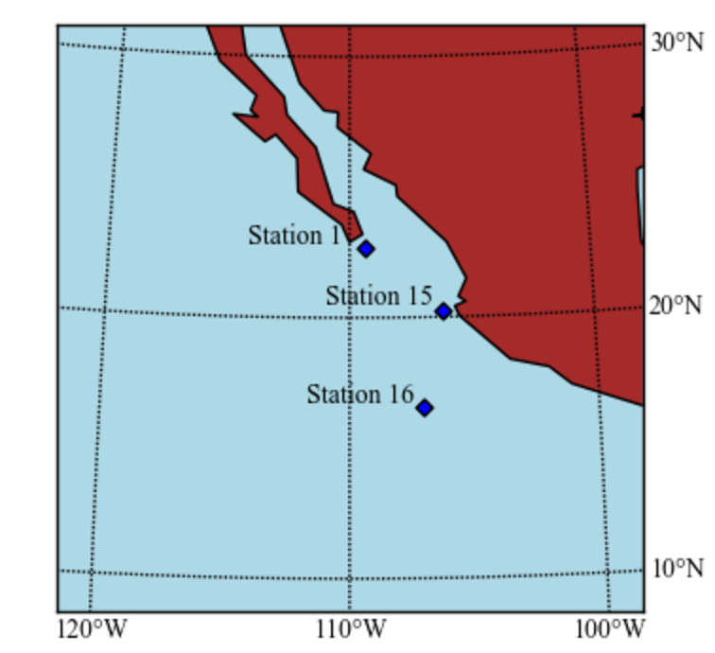
Figure 1: Map of station locations in the Eastern Tropical North Pacific oxygen deficient zone surveyed in December 2016-January 2017.

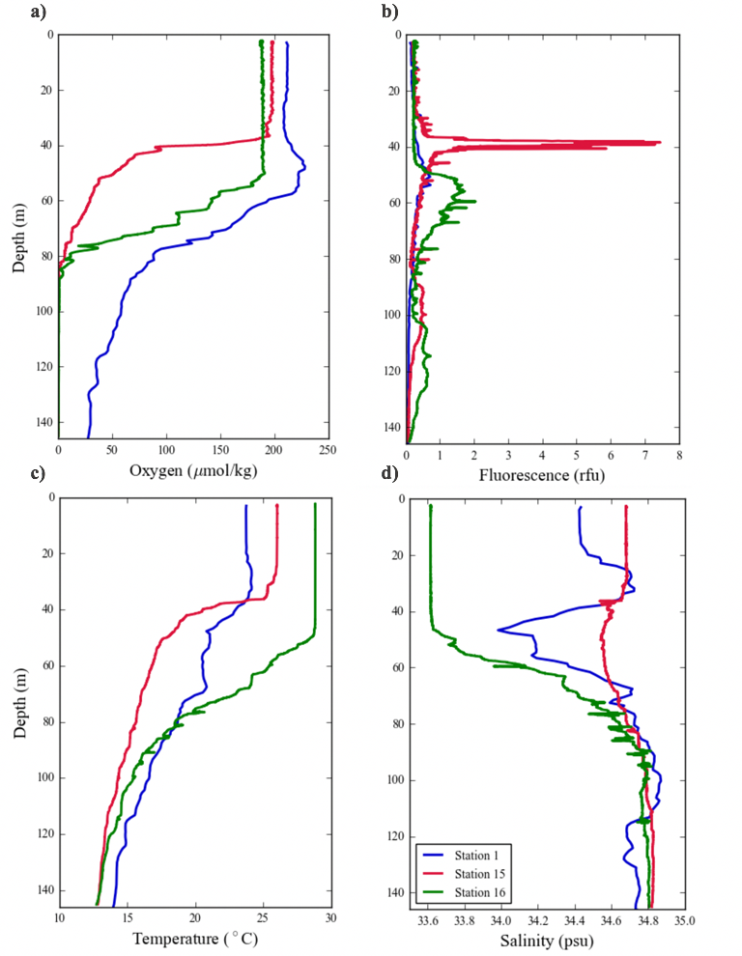

Figure 2: Depth profiles of (a) oxygen, (b) fluorescence, (c) temperature, and (d) salinity at Stations 1, 15, and 16 in December 2016-January 2017.

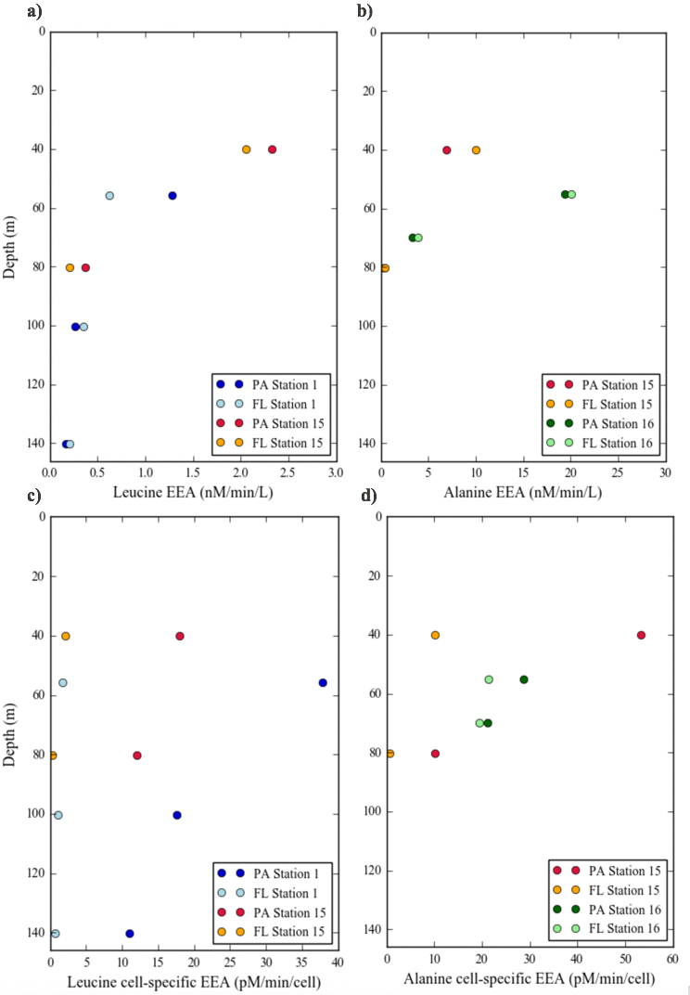
Figure 3: Depth profiles of paricle-associated and free-living bulk and cell-specific extracellular enzyme activity for leucine (a,c) at Stations 1 and 15 and alanine (b,d) at Stations 15 and 16.
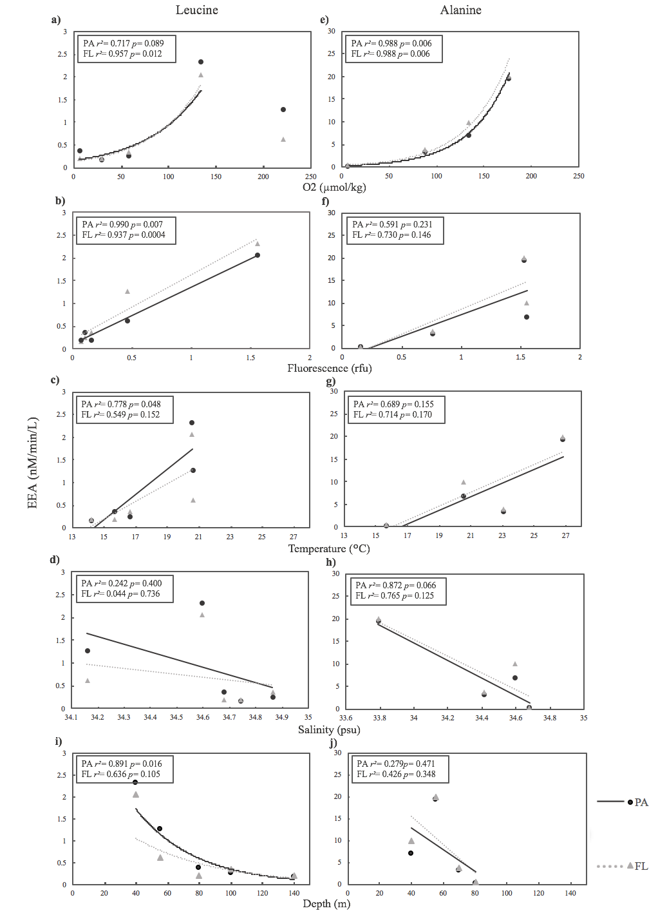
Figure 4: Leucine (a, c, e, g) and alanine (b, d, f, h) extracellular enzyme activity (EEA) regression analyses for oxygen (a, e), fluorescence (b, f), temperature (e, g), salinity (g, h), and depth (i, j) separated into particle-associated (PA) and free-living (FL) fractions. Coefficients of determination (r²) and P-values (p) are shown.
Table 1: Squared correlation matrix of leucine and alanine extracellular enzyme activity (EEA) for particle-associated (PA) and free-living (FL) fractions and environmental variables (oxygen, fluorescence, temperature, salinity, and depth). Coefficients of determination (r²) and P-values (p) are shown. Significant P-values (P < 0.05) are in bold.
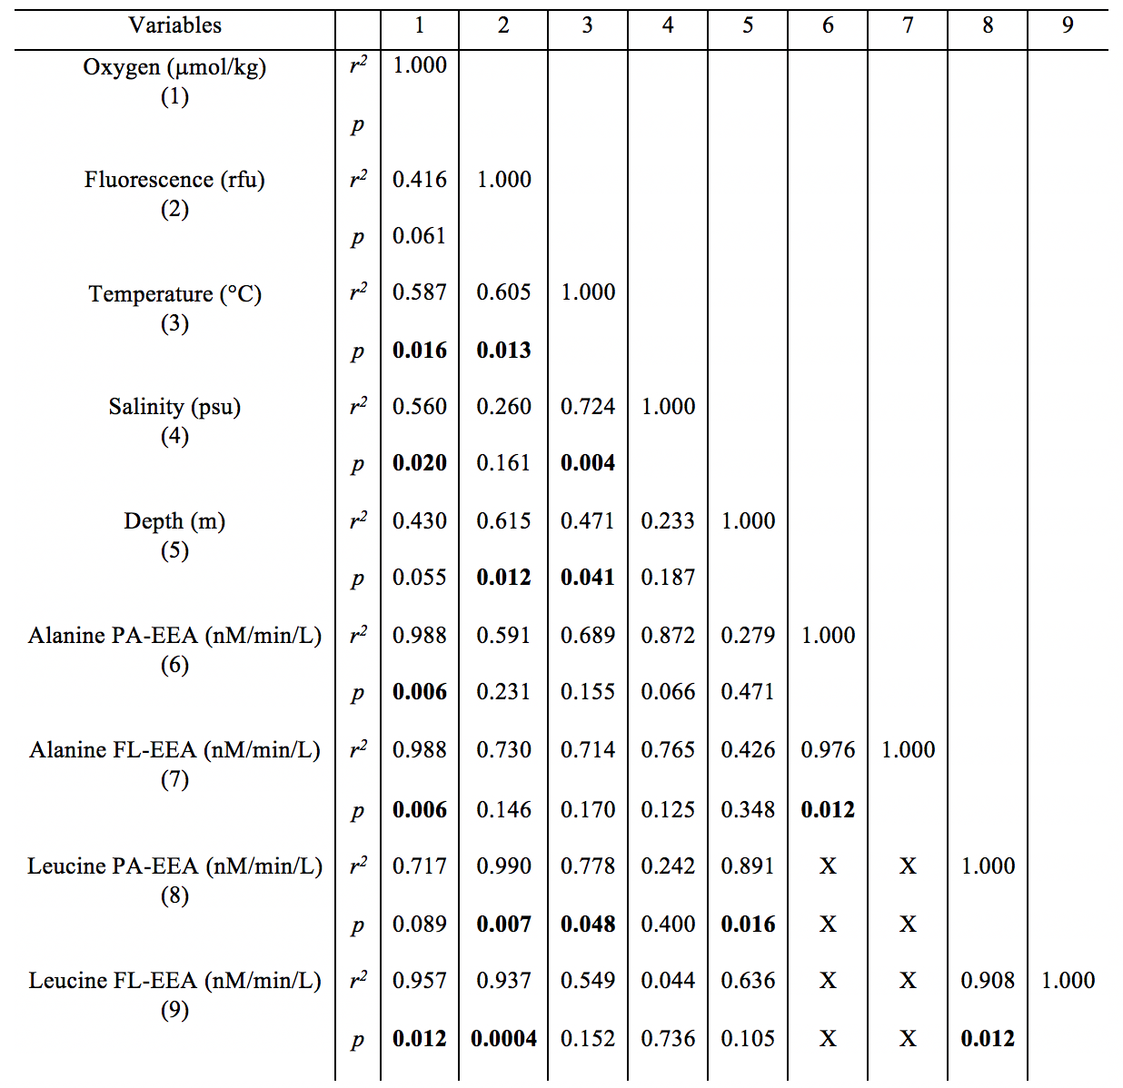

References
Arnosti, C., B. Jørgensen, J. Sagemann, and B. Thamdrup. Temperature dependence of microbial degradation of organic matter in marine sediments: polysaccharide hydrolysis, oxygen consumption, and sulfate reduction. MEPS 165, 59-70 (1998).
Azam F., and F. Malfatti. Microbial structuring of marine ecosystems. Nat. Rev. Microbiol. 5, 782-791 (2007).

Azam, F., G.F. Steward, D.C. Smith, and H.W. Ducklow. Significance of bacteria in carbon fluxes in the Arabian Sea. Proc. Indian Acad. Sci. (Earth Planet Sci.) 103, 341-351 (1994).
Billen, G. Heterotrophic utilization and regeneration of nitrogen. NATO Conference Series 15, 313–355 (1984).
Bueno, E., S. Mesa, E.J. Bedmar, D.J. Richardson, and M.J. Delgado. Bacterial Adaptation of Respiration from Oxic to Microoxic and Anoxic Conditions: Redox Control. Antioxidants & Redox Signaling 8, 819–852 (2012).
Christian, J.R., and D.M. Karl. Bacterial ectoenzymes in marine waters: Activity ratios and temperature responses in three oceanographic provinces. Limnol. Oceanogr. 40, 1042-1049 (1995).
Ganesh, S., D.J. Parris, E.F. DeLong, and F.J. Stewart. Metagenomic analysis of size- 456 fractionated picoplankton in a marine oxygen minimum zone. ISME J. 8, 187–211 (2014).
Ganesh, S., L.A. Bristow, M. Larsen, N. Sarode, B. Thamdrup, and F.J. Stewart. Size-fraction partitioning of community gene transcription and nitrogen 458 metabolism in a marine oxygen minimum zone. ISME J. 9, 2682–2696 (2015).
Glöckner, F.O., R. Amann, A. Alfreider, J. Pernthaler, R. Psenner, K. Trebesius, and K.H. Schleifer. An in situ hybridization protocol for detection and identification of planktonic bacteria. Syst. Appl. Microbiol. 19, 403–406 (1996).
Hartnett, H.E., and A.H. Devol. Role of a strong oxygen-deficient zone in the preservation and degradation of organic matter: A carbon budget for the continental margins of northwest Mexico and Washington State, Geochim. Cosmochim. Ac. 67, 247–264 (2003).
Hoppe, H. Use of fluorogenic model substrates for extracellular enzyme activity (EEA) measurement of bacteria. In: Kemp PF, Sherr BF, Sherr EB, Cole JJ (eds) Handbook of methods in Aquatic microbial ecology, 1st edn. Lewis Publishers, Boca Raton, 423–431 (1993).
Horak, R., W. Ruef, B. Ward, and A. Devol. Expansion of denitrification and anoxia in the eastern tropical North Pacific from 1972 to 2012. Geophys. Res. Lett. 43, 5252–5260 (2016).
Ito, T., A. Nenes, M.S. Johnson, N. Meskhidze, and C. Deutsch. Acceleration of oxygen 427 decline in the tropical Pacific over the past decades by aerosol pollutants. Nat. Geosci. 9, 428 443–448 (2016).
Keil, R.G., J.A. Neibauer, C. Biladeau, K. van der Elst, and A.H. Devol. A multiproxy approach to understanding the "enhanced" flux of organic matter through the oxygen-deficient waters of the Arabian Sea. Biogeosciences 13, 2077-2092 (2016).
Kellogg C.T.E., S.D. Carpenter, A.A. Renfro, A. Sallon, C. Michel, J.K. Cochran, and J.W. Deming. Evidence for microbial attenuation of particle flux in the Amundsen Gulf and Beaufort Sea: elevated hydrolytic enzyme activity on sinking aggregates. Polar Biol. 34, 2007–2023 (2011).
Kellogg C.T.E. and J.W. Deming. Particle-associated extracellular enzyme activity and bacterial community composition across the Canadian Arctic Ocean. FEMS Microbiol. Ecol. 89, 360-375 (2014).
Martin, J.H., G.A. Knauer, D.M. Karl, and W.W. Broenkow.: VERTEX – Carbon cycling in the North East Pacific. Deep-Sea Res. 34, 267–285 (1987).
Misic, C., and M. Fabiano. Ectoenzymatic activity and its relationship to chlorophyll-a and bacteria in the Gulf of Genoa (Ligurian Sea, NW Mediterranean). J. Marine Sys. 60, 193-206 (2006).
Morris, J.J., Z.I. Johnson, M.J. Szul, M. Keller, and E.R. Zinser. Dependence of the Cyanobacterium Prochlorococcus on Hydrogen Peroxide Scavenging Microbes for Growth at the Ocean's Surface. PLoS ONE 6 (2011).
Rogers, H.J. The dissimilation of high molecular weight substances. The Bacteria 2, 121–178 (1961).
Ulloa, O., D.E. Canfield, E.F. DeLong, R.M. Letelier, and F.J. Stewart. Microbial oceanography of anoxic oxygen minimum zones. PNAS 40, 15996-16003 (2012).

Van Mooy, B.A.S., R.G. Keil, and A.H. Devol. Impact of suboxia on sinking particulate organic carbon: Enhanced carbon flux and preferential degradation of amino acids via denitrification. Geochim. Cosmochim. Ac. 66, 457–465 (2002).
Xenopoulos, M.A., and D.F. Bird. Effect of Acute Exposure to Hydrogen Peroxide on the Production of Phytoplankton and Bacterioplankton in a Mesohumic Lake. Photochem. Photobiol. 66, 471-478 (1997).

