Appendix 1. Supplemental field work detail
Pickett Creek
Both Site I and Site II of Buechler et al. (2007) were located. Tuff for radiometric dating and most rock samples for pollen and phytolith extraction were sampled from Site I, although one sample was taken from Site II. We re-measured the stratigraphic section of Site I and identified unit boundaries reported by Buechler et al (2007). In several cases unit thicknesses measured by us differed slightly from those reported in Buechler et al. (2007). For example, we measured to the M to N boundary at -170 cm depth below the grey tuff marker bed, instead of -148 cm reported previously. The upper ash in the image below was radiometrically dated in this study (sample 19P2-0.00).
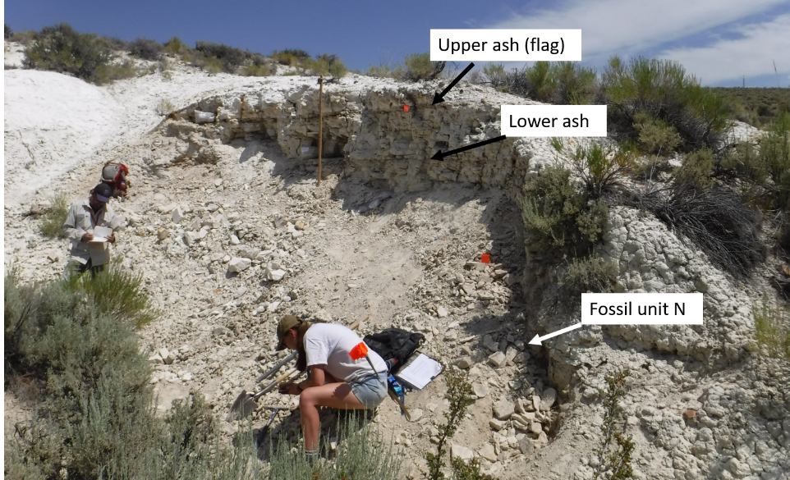
Trapper Creek
Axelrod (1964) reports that fossil plants incorporated in his study come from the upper 30 feet of the Beaverdam Formation, in a number of exposures in a natural amphitheater, where plant-bearing strata crop out part way of the hill slope, or as stated in the pl. 1 fig. 1 caption, in the middle and lower parts of the trenched slope. We refer to this as the ‘Amphitheater’. Axelrod had told Patrick Fields some years ago that fossils were collected from large blocks dislodged when the Amphitheater was terraced without precise knowledge of their original stratigraphic position (P. Fields, personal communication). Mainly poorly bedded siltstones of the Beaverdam Fm. constitute the bottom of the terraced Amphitheater, while the overlying Tuff of Ibex Peak, which is mainly light-colored volcaniclastic sandstones make up the rest of the hill above. That is to say, the stratigraphic location of those blocks are constrained by the extent of Beaverdam Formation exposed in the Amphitheater, which was not measured by us but could be in the future. Instead, ~150 meters northwest of the northwest end of the Amphitheater, there is a thicker well-exposed outcrop of Beaverdam Formation, termed by us the “Western Exposure”. This is where our stratigraphic section was measured and described. After careful attempts were made over several days to locate productive macrofossil horizons through all the exposed Beaverdam Formation in the West exposure and Amphitheater, we found that relatively better preserved fossils (although still fairly poorly preserved) were concentrated within 5 meters below the Tuff of Ibex Peak contact. Our main collecting quarry spanned ~2 meters of stratigraphy directly underlying this contact in the West Exposure, but fossils were not preserved well enough, or in high enough abundance, to permit a full census collection.
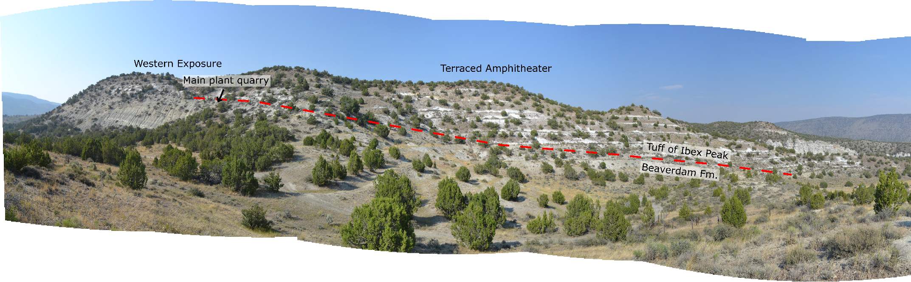
Trout Creek
Both MacGinitie (1933) and Graham (1965) studied specimens collected by Percy Train, the former housed at UCMP and the latter at UMMP. Graham (1965) reports the main collecting sub locality for the Trout Creek flora was the West Quarry. Although “West Quarry” is not explicitly stated by MacGinitie (1933), the location and stratigraphic descriptions he presents, and the figured photograph of the site in Fig. 2, it seems very likely his material was also sourced from the West Quarry. Graham (1965) reports additional sub localities labelled A, B, and C, all apparently within a few hundred feet of one another, but no other details are provided. The West Quarry is where our stratigraphic section was measured and described. However, we also sampled fossil plants from a small exposure ~500 m NE from the W quarry, termed by us the NE Quarry, and tuff from a pumice rich debris below that occurs between these two sub localities, termed by us the Intermediate Exposures. The NE Quarry and Intermediate Exposures may overlap with the A, B, and C sub localities of Graham (1965), but without more detailed information, it is not possible to be certain.
Graham (1965) reports that fossil plants occur fairly regularly throughout stratigraphy at the West Quarry, while MacGinitie (1933) state the diatomite in the lower half of the “formation”, though likely referring to the measured section, below a 15 thick tuffaceous sandstone, contain most of the fossil plant remains. A thick sandstone also occurs in the middle of our measured section and can actually be discerned in the satellite imagery below, although we measure it as 30 m thick accounting for dip. The few fossil plants we collected from the West Quarry also come from these lower diatomites, below the thick sandstone. We note some discrepancies in the stratigraphic column reported by Graham (1965) in Text-Figure 2, and gather some mistakes were made while either describing, correlating, or transcribing measured sections. For example, the “basalt cap” is really a dark pumice rich debris flow, and no basalt is mapped in the nearby region. Graham also refers to a 5 cm “key sand”. We found a likely candidate within the diatomite at the NE quarry, but there is no “basalt cap” here.
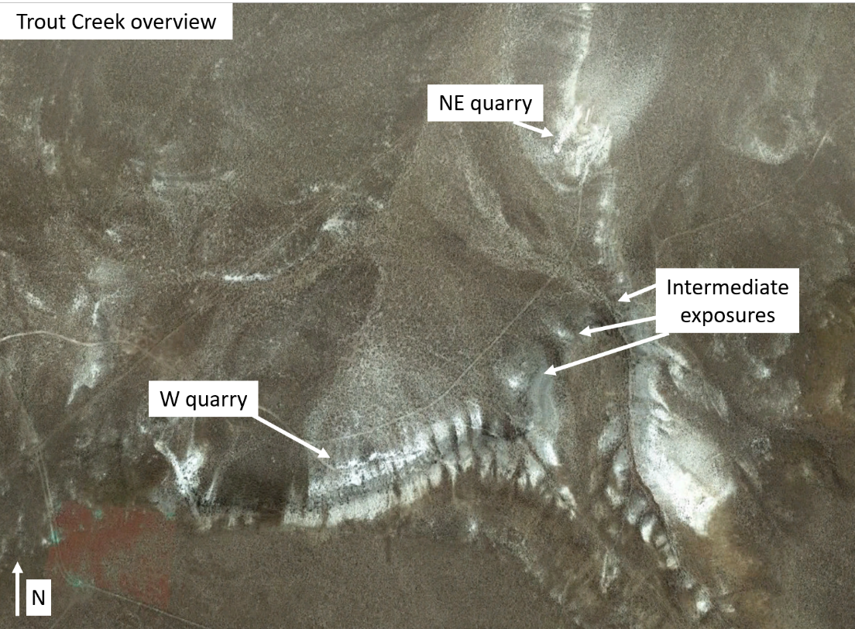
Succor Creek
The Succor Creek flora consists of several sub-localities and we visited the majority of them on a trip led by Patrick Fields. We determined that the Watersnake sub locality in the South Bend area of Fields (1996) offered the most productive and diverse horizons of plant macrofossils within darker shales with potential for palynomorph recovery closely associated with volcanic tuffs.
Plant macrofossils collected both by Patrick Fields and housed at the Orma J. Smith Museum at the College of Idaho, and those collected in a census approach in this study come from WS Zone 1 of Schiller et al. (2024). The complete stratigraphic thickness of this zone is 4.5 m, and while our census horizon (2.8 m in thickness) very likely overlapped with prior collections made by Patrick Fields, some of his collections may have come from above or below our census horizon.
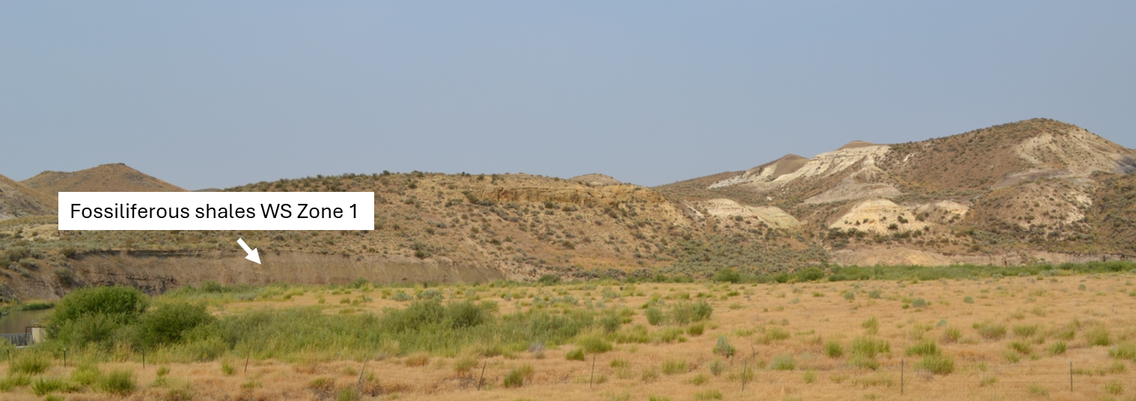
Moose Mountain
This site represents USGS paleobotany locality 9350 as reported in Peck et al. (1964), representing a road cut exposure in the Cascade Mountains, but little details are provided regarding the horizon sampled. A small collection of fossil plants made by us corresponds to the same horizons sampled by Robert Rosé, some of which are housed at University of Florida, some at the Burke Museum, and many others in the private collections of Robert Rosé. A census collection was not pursued because the fossiliferous horizon has extensive vertical fracturing causing most blocks pulled from the outcrop to be broken into smaller pieces.
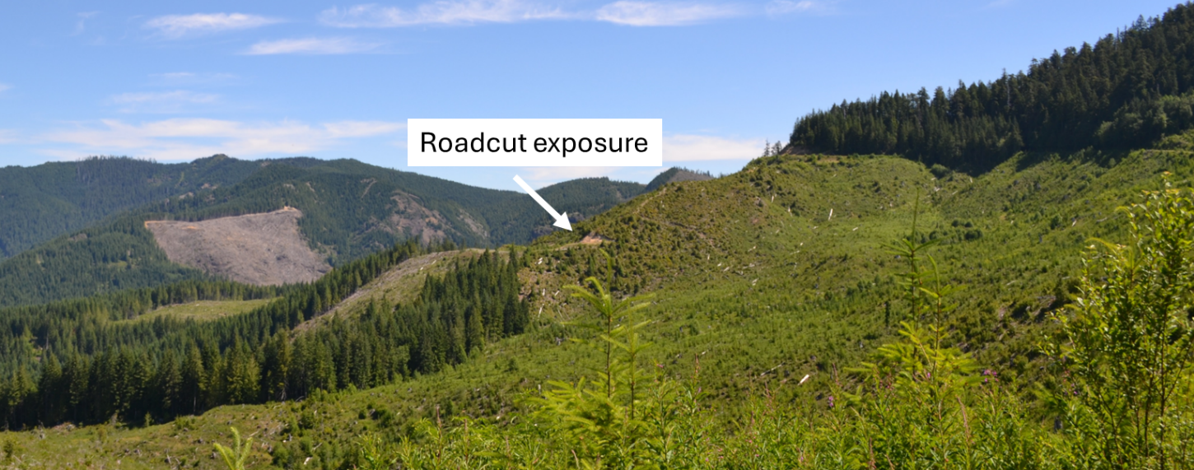
Clarkia
Both the Racetrack/Fossil Bowl (P33) and Emerald Creek (P37) sub localities provide most of the material comprising the Clarkia flora (Smiley and Rember 1985) and included as taxonomic collections in this study. A macrofossil census collection was made at Emerald Creek because one has not yet been published from this sub locality and for ease of logistics. Well preserved fossil plants occur fairly regularly throughout the exposed stratigraphy at Emerald Creek. Our census layer was located 115 cm below the P37-8 tuff of Ladderud et al. (2015) and Geraghty (2017). This horizon was chosen given its easy access and abundance of well-preserved fossil plants.
Mascall
We visited the ‘Bowl’ sub locality of Bestland et al. (2008), near the Mascall Fm. type section, and the Riverbank/Van Horn’s Ranch and White Hills sub localities of Chaney and Axelrod (1959) ~25 km to the east. At the Bowl, we located the exposed contact between the underlying Picture Gorge Basalts and sedimentary rocks of the Mascall Fm., not reported previously. Plant macrofossils were found at the Bowl, including several remains of aquatic plants, but we found no horizons productive enough for a census collection. At Riverbank/Van Horn’s Ranch, fossils in many horizons were well preserved, and potentially abundant, but were located within a well-cemented matrix in a cliff exposure, making a safe census collection logistically challenging. The White Hills hosted several productive and well preserved horizons along a sloping hillside, the best of which we chose for census collections.
Axelrod and Chaney (1959) describe their White Hills collections coming from near the top of the more westerly of the two white hills. We also sampled leaves from the western hill, but we may have been stratigraphically below their stated location, potentially up to 10 m but the true distance is difficult to know precisely. At the base of our stratigraphic section occurs a volcanic unit we interpret as a pyroclastic flow, given angular and poorly sorted clasts within a fine grained matrix (matrix supported). This possibility should be further explored, as Bestland et al. (2008) claim that volcanic sources in the Mascall were distal and no primary pyroclastic deposits occur.
Riverbank/Van Horn’s Ranch:
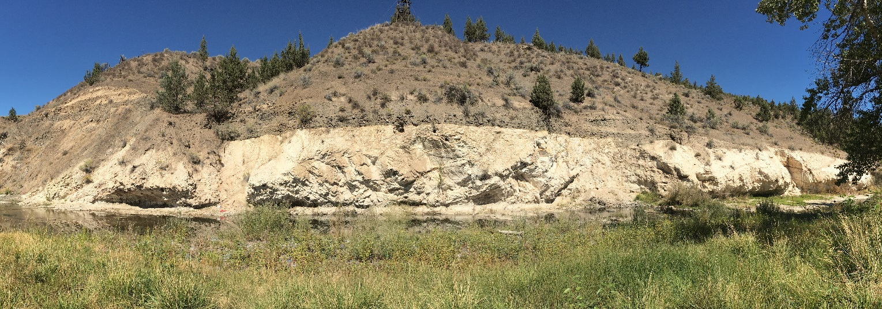

White Hills (Unit07):
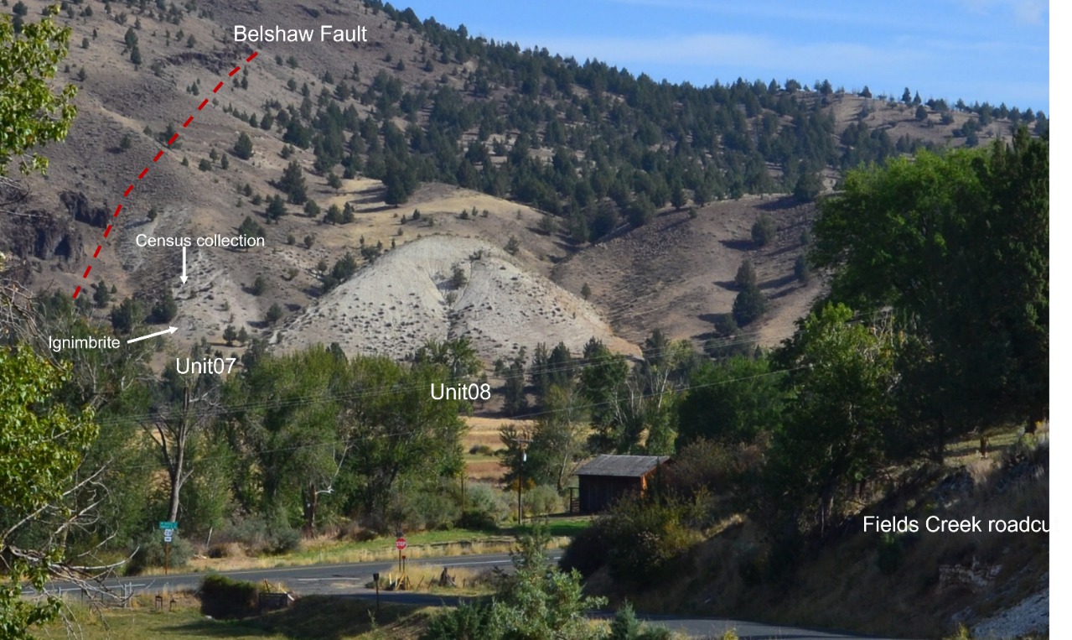
Spokane
Several Spokane sub localities are no longer accessible. Knowlton (1926) describes the Deep Creek sub locality as contributing the larger part of the Spokane collections he analyzed. We located a sedimentary outcrop in the same location he describes (shown below). The lower part of our described section agrees with that reported in Knowlton (1926), although in the interval they report as fossil-rich we found only very fragmented and poorly preserved plant macrofossils. There are some discrepancies in the top of their section to ours. For example, they describe a thick section of sandstone which extends upwards to the overlying basalt. Instead, we observed the sandstone to be overlain by 7-8 m of massive siltstone with conspicuous fossil wood, with the long axis often perpendicular to the bedding plane. Given the lack of productive fossil plant beds, we are unsure if the exposed section that occurs today is the same that was exposed and described in Knowlton (1926).
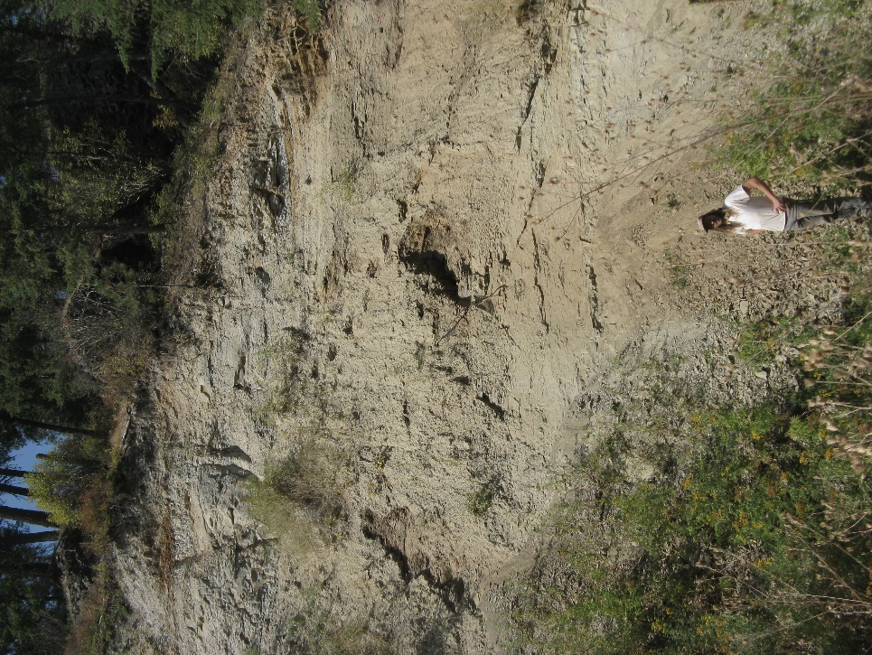
Juliaetta
The bulk of the collections included in this study from Juliaetta are housed at the University of Idaho (UI) and represent census collections we made which are housed at the Burke Museum. Our census collection horizon is shown in the image below. We are unsure the exact stratigraphic location that UI fossils were sampled from, but fine-grained rocks occur only in the lower half of the exposure. Two basalt lobes occur in outcrops, as shown below, and appear to be associated with soft sediment deformation structures, including water escape structures.
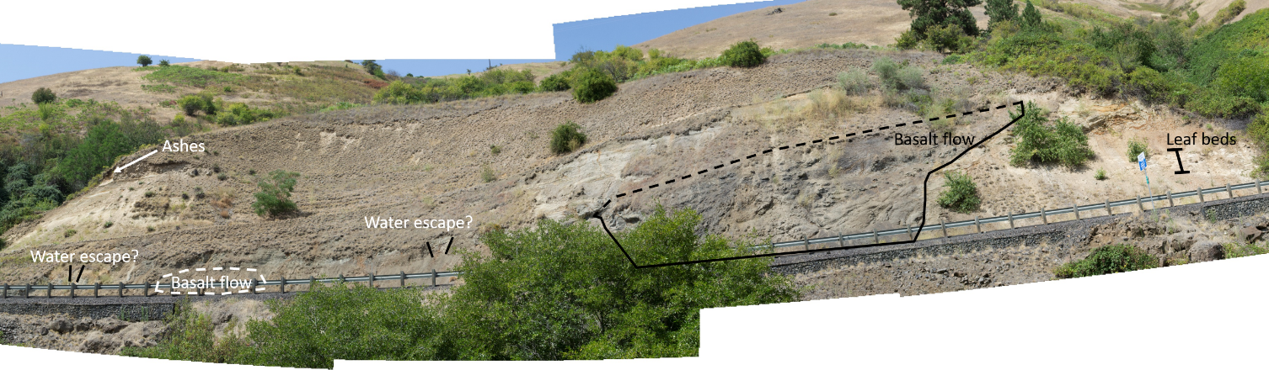
Alvord Creek
Tuff, rock samples for pollen and phytolith extraction, and macrofossil census collections were made at both sub localities 601 and 601N of Axelrod (1944), termed the South Fork and Scarp sites, respectively, by us. At 601, our macrofossil census horizon occurs 20-30 m stratigraphically below a basalt dike. Axelrod (1944) describes fossil collections of his study as coming from ~15 m below the basalt dike, higher in section than our sampled horizon. After careful searching, we did not find a productive layer above the one we sampled. At 601N, Axelrod (1944) and Fuller (1931) describes 200 ft. of shales underlying a basic andesite where fossil plants were sampled. Our census collection was within this extended horizon, though as they do not report their sampling horizons precisely, it is not possible to align our horizon with theirs precisely.
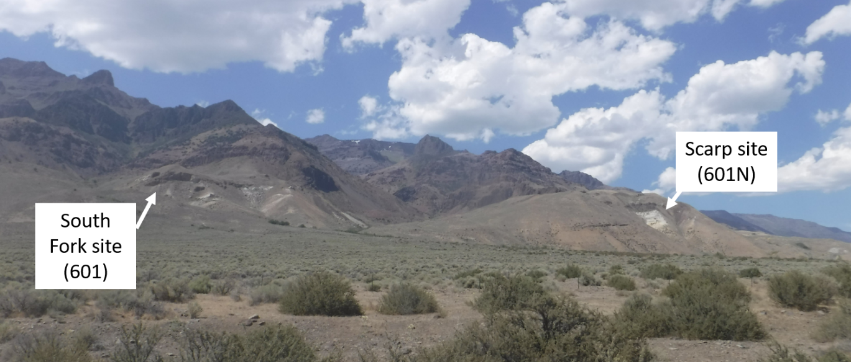
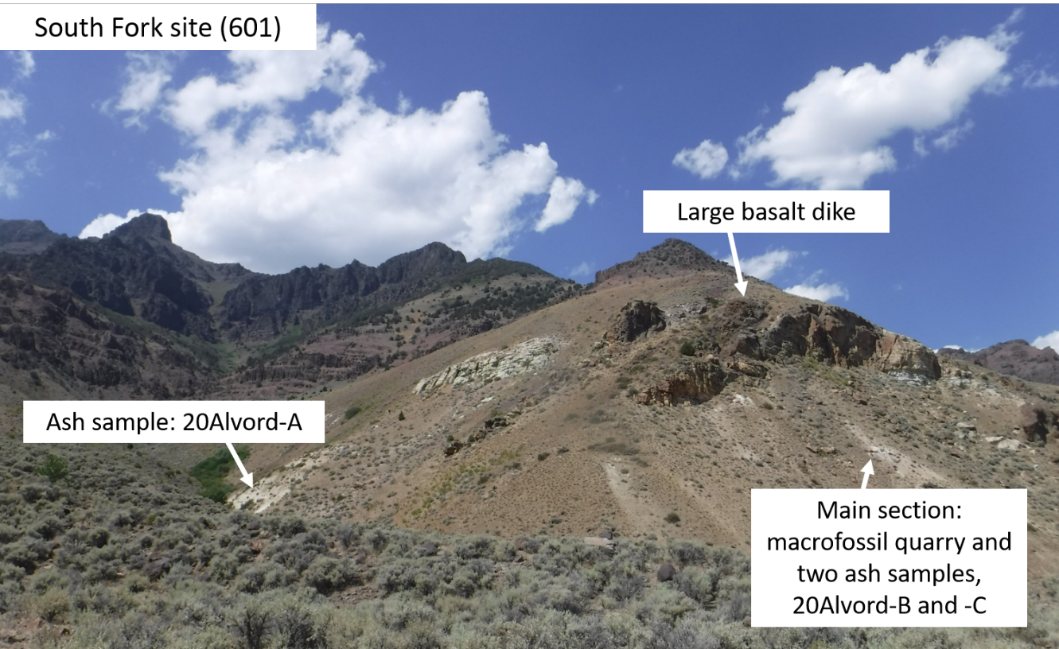
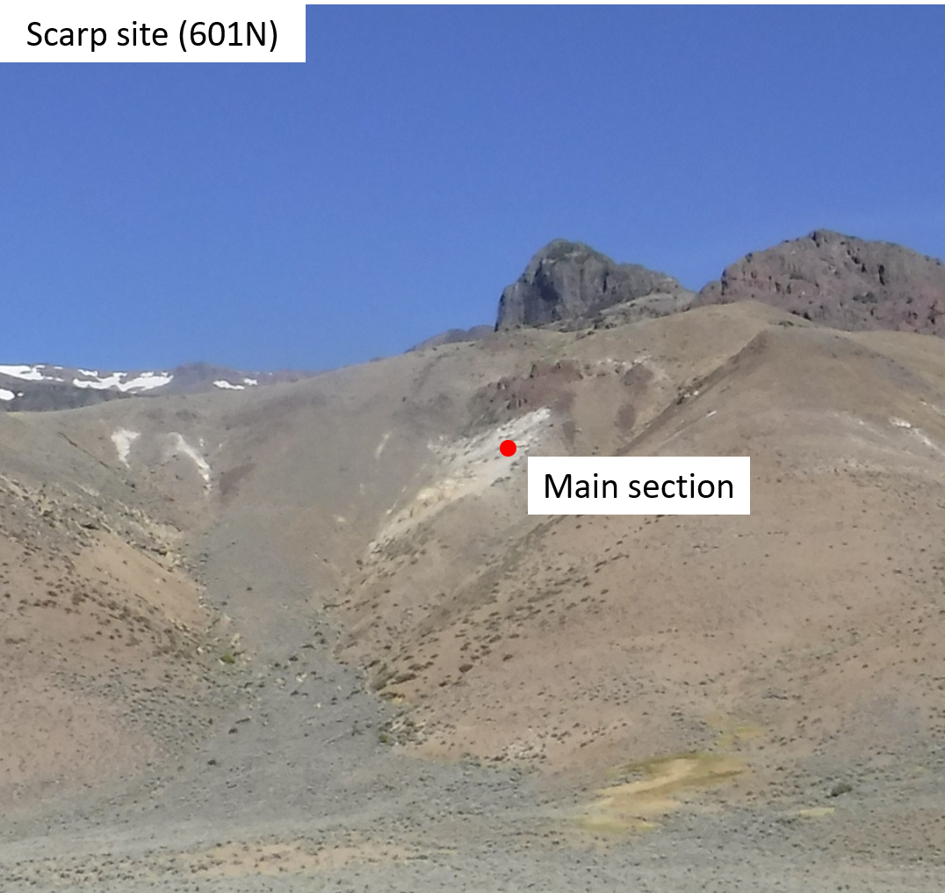
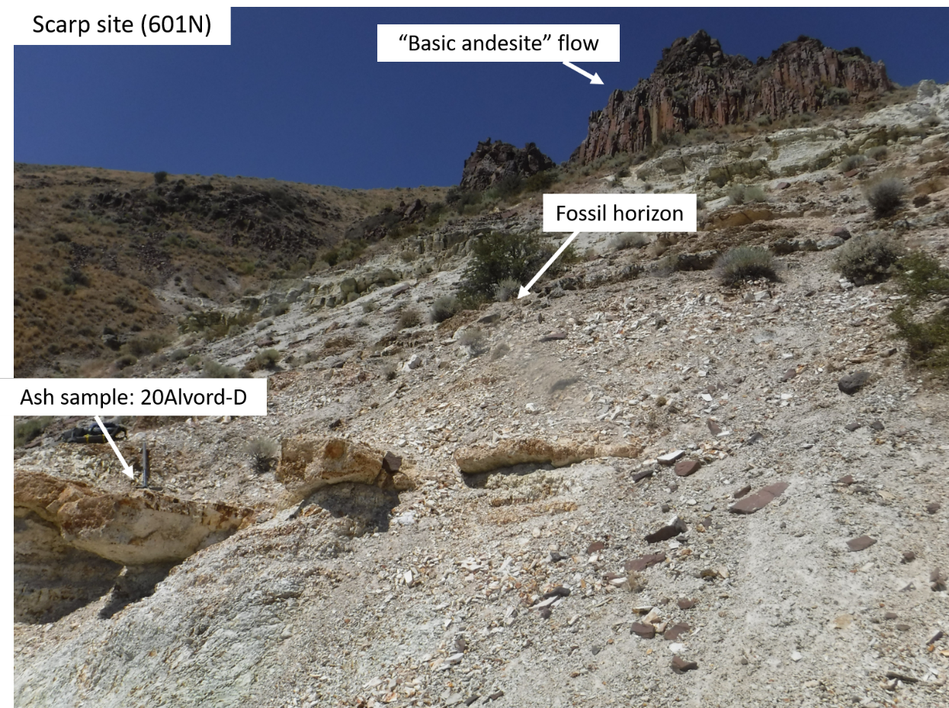

Appendix 2. Confidence scoring
Fossil macrofossils and palynomorphs were ascribed a score of confidence regarding their assignment of taxonomic affinity following the workflow below (Fig. A2.1). This system is used to better acknowledge uncertainty in taxonomic assignments, especially for fossil foliage. Organs are first assigned in isolation (considering a single organ at a single site). Criteria used in these assignments are detailed below. Fossil taxon are most often assigned a score of 3, rather than simply not providing taxonomic affinity (“Unassigned”), to preserve discussion on historical nomenclature and/or to encourage future work. If present, we then allow the occurrence of more diagnostic organs (either pollen or reproductive macrofossils) at the same site to influence the confidence of fossil foliage. Taxonomic Lastly, we consider synonymy drawn between site-level morphotypes (i.e., those included in study-level morphotypes), such that if a morphotype in synonymy is assigned a lower confidence (higher score) at one site, due to poorer preservation or lack of more diagnostic organs co-occurring at the site, than a morphotype under the same synonymy at a separate site, the highest confidence (lowest score) is assumed. Justifications were recorded for each initial confidence score, but for sake of space, are not included in this dissertation; rather they will be incorporated into a publicly available database in the near future.
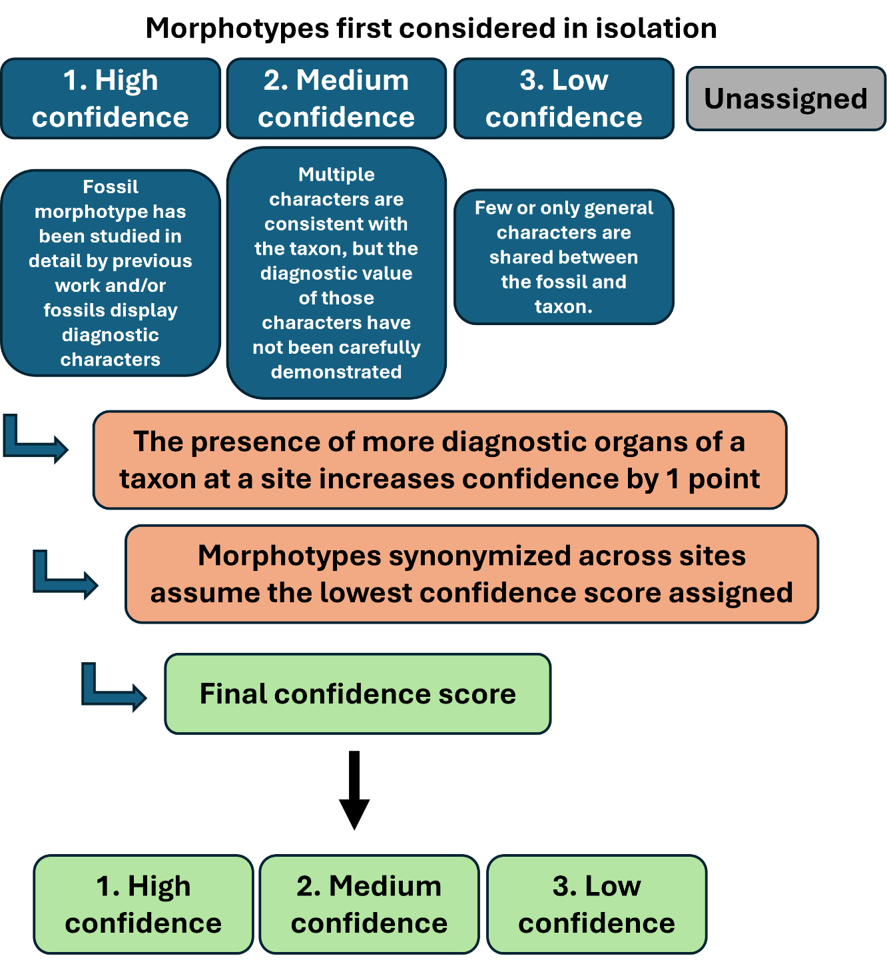
Figure A2.1. Flow diagram illustrating the workflow for assigning confidence scores in assignments of taxonomic affinity

Appendix 5. Impact of confidence on Bioclimatic Analysis
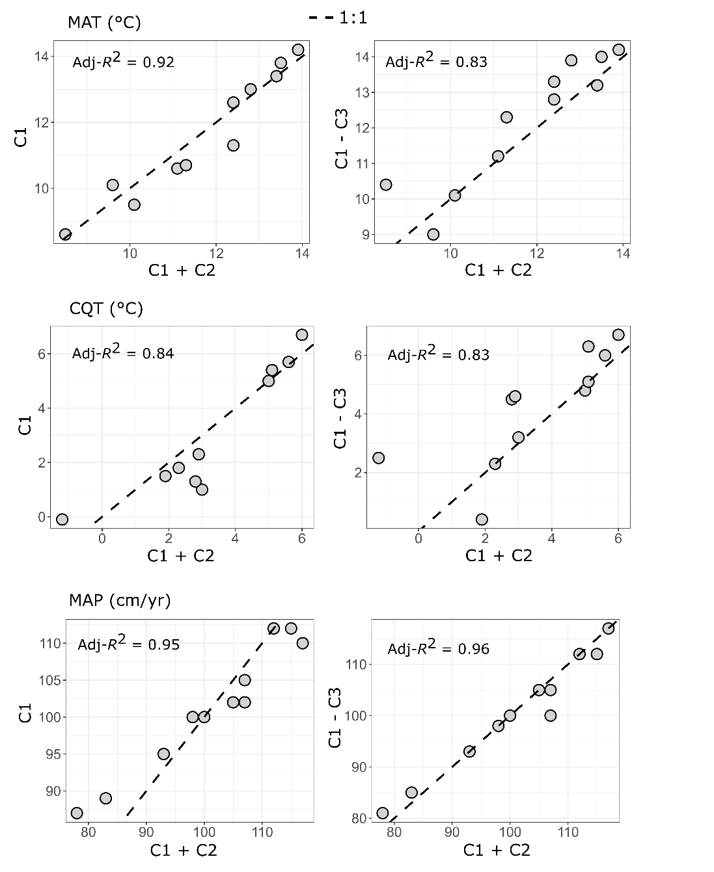
Figure A5.1. The impact of filtering levels, regarding confidence scores of taxonomic affinity, on paleoclimate estimates derived from the Bioclimatic Analysis. In general, there is strong correlation between different filtering levels, suggesting moderately low sensitivity to taxonomic confidence in this particular case. MAT = mean annual temperature, CQT = cold quarter temperature, MAP = mean annual precipitation, C1 = high confidence, C2 = medium confidence, C3 = low confidence.

Appendix 6. Quantification of modern Pacific Northwest climate
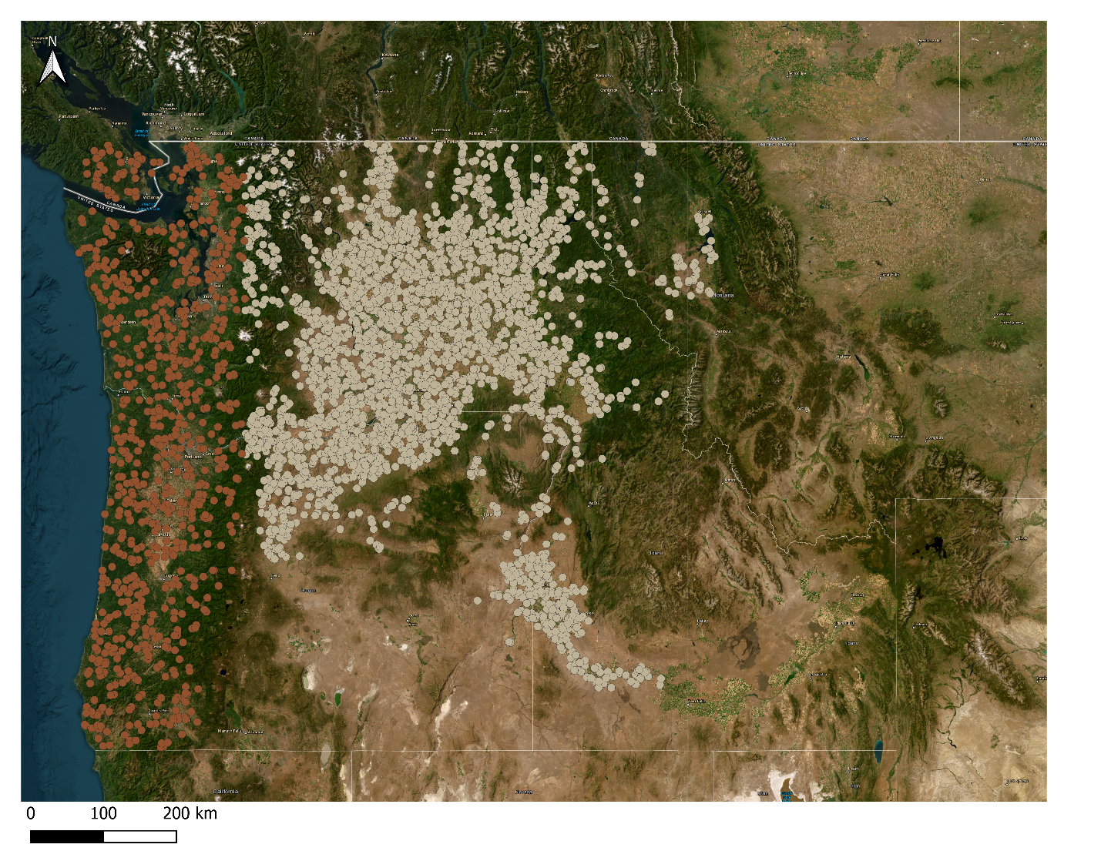
Figure A6.1. Randomly selected coordinates in the Pacific Northwest where modern climate was extracted using WorldCLIM bioclimatic variables. We first generated 1000 random points roughly west of the Cascades and 10,000 points roughly east of the Cascades, along a longitudinal division of -121.75°. Elevation was then ascribed for each coordinate from WorldCLIM and the coordinates were filtered to only include lowland elevations (< 900 m.a.s.l). This resulted in the coordinates figured in the map for those west (brown; n = 788) and east (tan; n = 2809) of the Cascade Mountain Range.

Appendix 9. NMDS excluding Quercus simulata

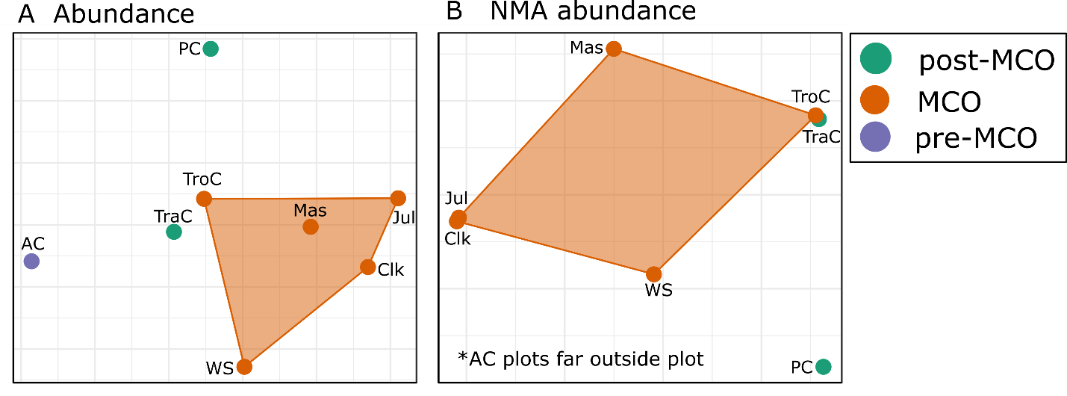
Figure A9.1. Non-metric multidimensional scaling excluding Quercus simulata for (A) foliar morphotype relative abundance and (B) only non-monocot angiosperm (NMA) relative abundance. These figures demonstrate a close similarity of composition between Trout Creek (TroC) and Trapper Creek (TraC) even when Quercus simulata is removed from analyses, whereas similarity of Watersnake (WS) to these two sites is much less when Quercus simulata is removed.

Appendix 10. Rarefaction
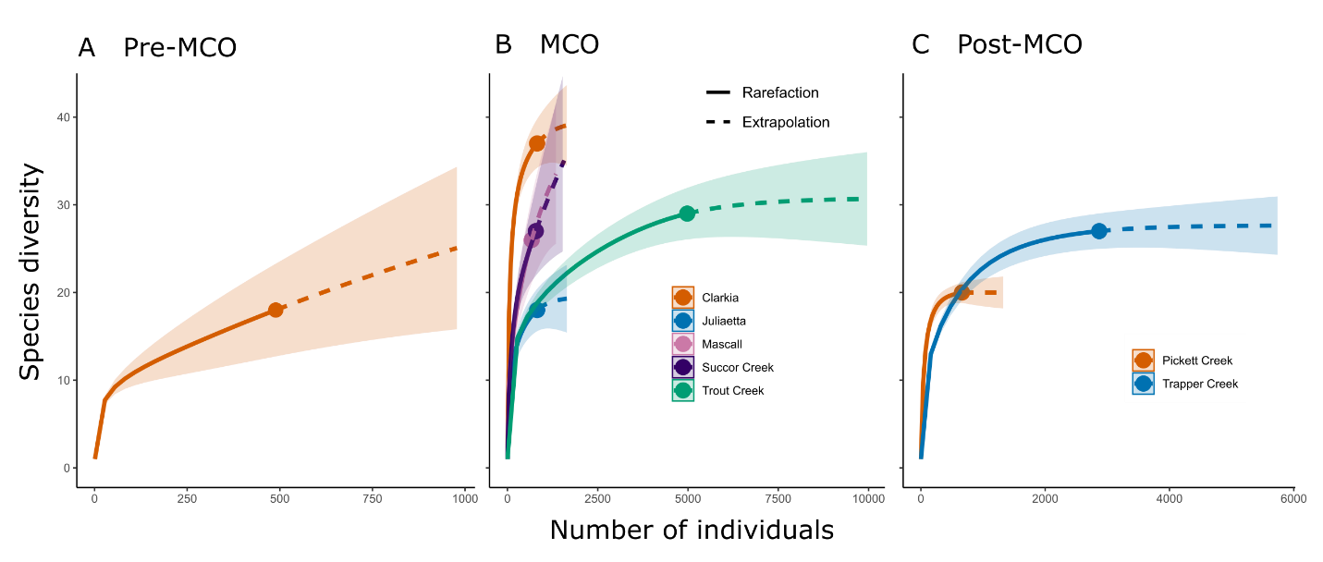
Figure A10.1. Rarefaction curves for floras representing (A) before the MCO, i.e., the Alvord Creek flora, (B) during the MCO, and (C) after the MCO. Collections made at Alvord Creek, Mascall, and Succor Creek, are not plateaued and have high uncertainty surrounding their extrapolated richness, indicating low completeness of the sample.

Appendix 11. Climate and M_{A} sample size tables
Table A11.1. The number of woody non-monocot angiosperm morphotypes included in leaf physiognomy based paleoclimate proxies. Non-entire includes both toothed and mixed-margin morphotypes. Leaf area represents those included in calculation of both site mean leaf area and Feret diameter ratio. Tooth measurements represent those included in calculations of tooth count : internal perimeter.
Site | Total | Non-entire | Leaf area | Tooth measurements
Alvord Creek | 18 | 15 | 15 | 13
Clarkia | 56 | 38 | 51 | 36
Juliaetta | 23 | 12 | 17 | 12
Mascall | 38 | 26 | 36 | 26
Moose Mountain | 26 | 22 | 17 | 22
Pickett Creek | 28 | 23 | 26 | 22
Spokane | 54 | 36 | 51 | 35
Succor Creek | 24 | 17 | 15 | 16
Trapper Creek | 25 | 20 | 16 | 17
Trout Creek | 36 | 25 | 33 | 18
Vasa Park | 17 | 14 | 16 | 13

Table A11.2. The number of taxa included in Bioclimatic Analyses, and at what taxonomic rank they were included. Sample sizes are reported separately at different filtering levels of confidence in taxonomic affinity.
Site | C1 |  |  | C1 + C2 |  |  | C1 – C3
 | Genera | Subfamily | Family | Genera | Subfamily | Family |  | Genera | Subfamily | Family
Alvord Creek | 9 |  | 1 | 17 |  | 1 |  | 19 |  | 1
Clarkia | 41 | 1 | 2 | 47 | 2 | 3 |  | 53 | 2 | 3
Juliaetta | 13 |  | 1 | 18 |  | 2 |  | 20 |  | 3
Mascall | 23 | 1 | 3 | 34 | 1 | 4 |  | 34 | 1 | 5
Moose Mountain | 10 |  | 1 | 15 |  | 2 |  | 16 |  | 2
Pickett Creek | 12 |  | 1 | 15 |  | 1 |  | 16 |  | 1
Spokane | 27 |  |  | 36 |  | 1 |  | 42 |  | 3
Succor Creek | 18 |  | 1 | 26 | 1 | 3 |  | 28 | 1 | 3
Trapper Creek | 14 |  |  | 20 |  |  |  | 22 |  | 1
Trout Creek | 12 | 1 | 3 | 27 | 1 | 4 |  | 34 | 1 | 5
Vasa Park | 7 |  | 1 | 12 |  | 2 |  | 14 |  | 3

Table A11.3. The number of woody non-monocot angiosperm morphotypes included in LMA reconstructions compared to the total number at each site
Site | Total | N | Percent
Alvord Creek | 18 | 12 | 67
Clarkia | 56 | 41 | 73
Juliaetta | 23 | 12 | 52
Mascall | 38 | 28 | 74
Moose Mountain | 26 | 12 | 46
Pickett Creek | 28 | 20 | 71
Spokane | 54 | 34 | 63
Succor Creek | 24 | 11 | 46
Trapper Creek | 25 | 11 | 44
Trout Creek | 36 | 25 | 69
Vasa Park | 17 | 8 | 47

Appendix 12. DiLP calibration check.
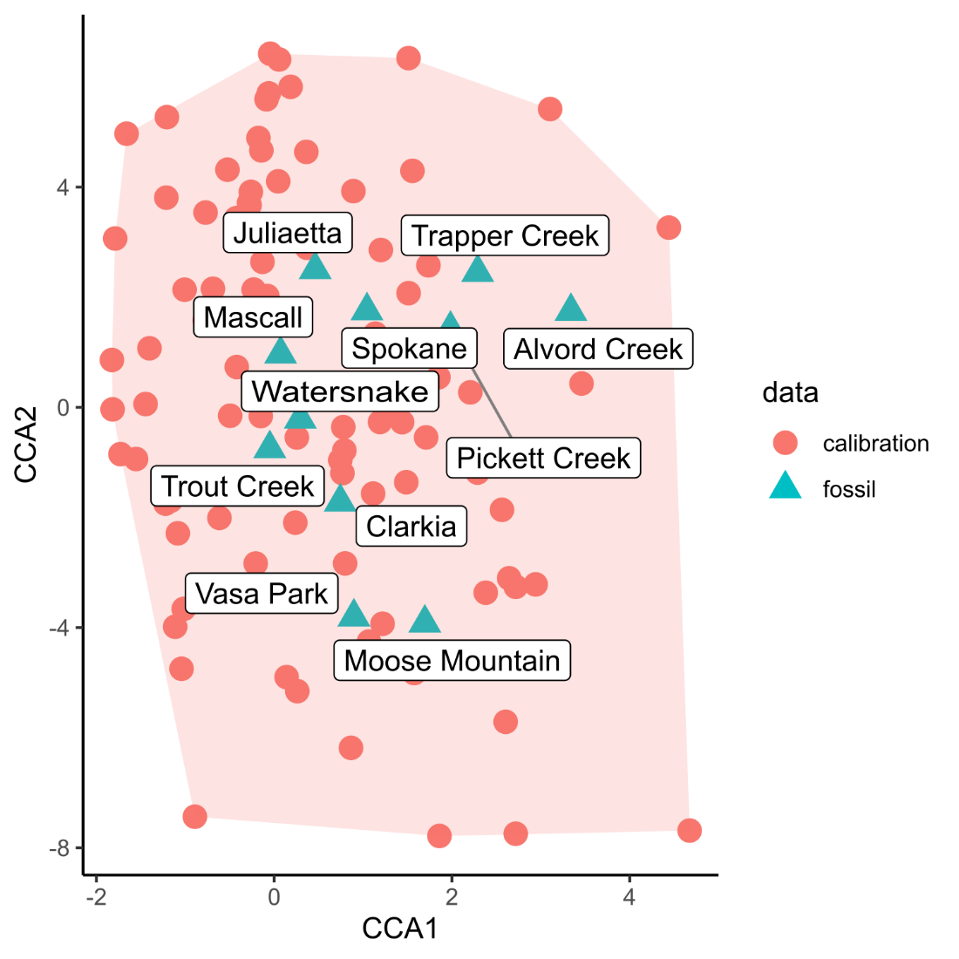
Figure A12.1. A Canonical Correspondence Analysis confirms fossil floras of this study fall within the modern calibration space for the Digital Leaf Physiognomy (DiLP) proxy.

Appendix 13. Paleoclimate method comparisons
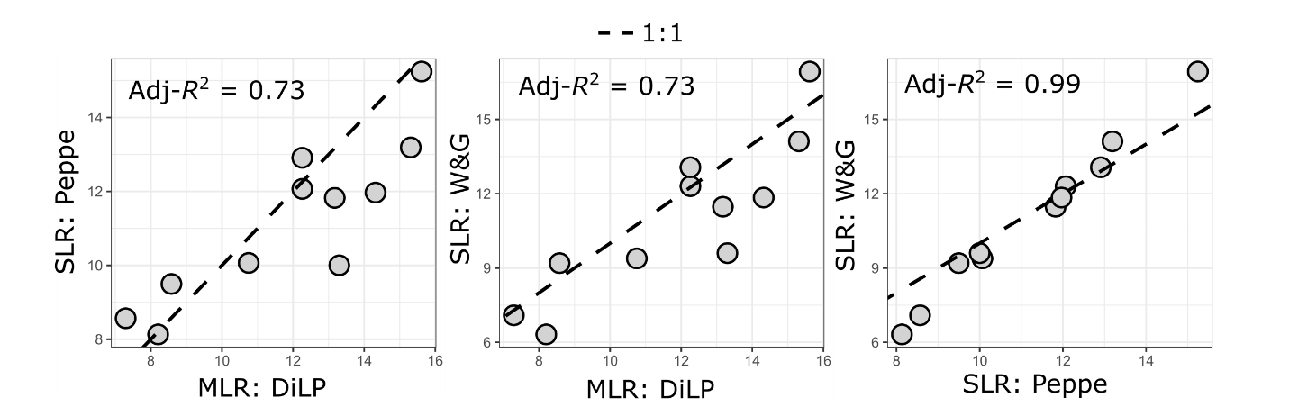
Figure A13.1. Correlations between mean annual temperature reconstructions made from various proxy methods. Proxies include single linear regression (SLR) equations published in Peppe et al. (2011) and Wing and Greenwood (1993), and multiple linear regression equations (MLR), known as the digital leaf physiognomy (DiLP) method, published in Peppe et al. (2011).

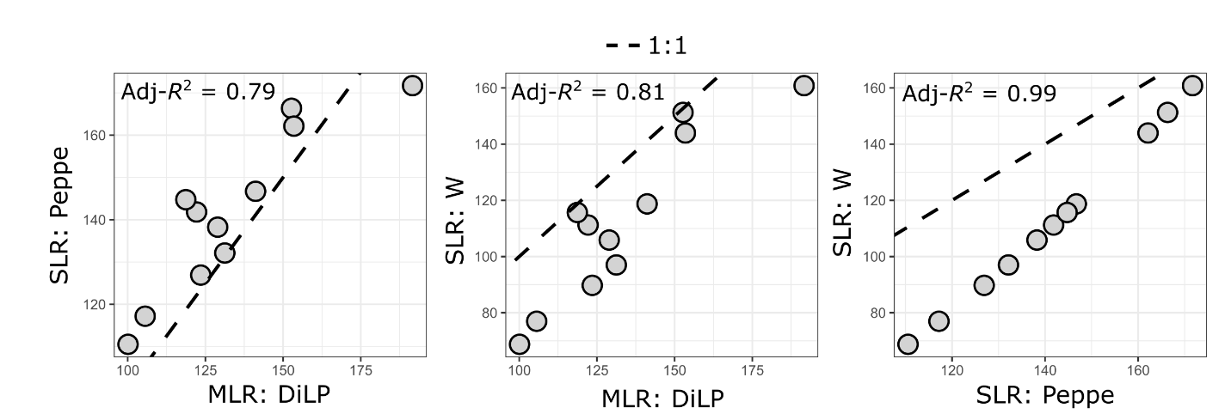
Figure A13.2. Correlations between mean annual precipitation reconstructions made from various proxy methods. Proxies include single linear regression (SLR) equations published in Peppe et al. (2011) and Wilf et al. (1998), and multiple linear regression equations (MLR), known as the digital leaf physiognomy (DiLP) method, published in Peppe et al. (2011).

