Annual Carbon Export at the North Pacific Axial Seamount

Leroy Miller

University of Washington, Seattle, WA
School of Oceanography

Email: leroi.miller@gmail.com

5/17/19

ABSTRACT
As anthropogenic CO₂ levels rise, it becomes increasingly important to quantify the flux from the surface ocean down into the deep, where it may be sequestered for thousands of years. The goal of this project is to estimate carbon export at the Axial Seamount in the N. Pacific (46 N, 131 W). The surface ocean is represented as a simple two-layer box model for oxygen and nitrate and known metabolic ratios are used to convert between nitrate, oxygen, and carbon. Data from the Ocean Observatories Initiative (OOI) Cabled Array is combined with University Corporation for Atmospheric Research (UCAR) current data and World Ocean Data (WOD) surface ocean concentrations for estimates. Annual carbon export at the Axial Seamount was found to be 0.9±0.4 mol/m^2/yr for 2015, ~3 times lower than estimates at the Hawaii Ocean Time‐series (HOT), Ocean Station Papa (OSP), and the Bermuda Atlantic Time‐series Study (BATS), but agreeing with estimates from closer to our study site. Additional uncertainty that is more difficult to quantify stems from failure to include bubble flux and eddy diffusion, however the comparable estimate of annual carbon export to past estimates suggests the efficacy of techniques used.
INTRODUCTION
The increase in anthropogenic CO₂ since the industrial revolution has had a variety of climactic effects, from a global average temperature increase to the acidification of the ocean. Climate models yield varying predictions of global warming and ocean acidification and yet a large gap exists in our fundamental understanding of how the increase in anthropogenic CO₂ is affecting the global ecosystem.
While the behavior of the carbon cycle in the atmosphere is well documented and understood (Falkowski, et al. 2000), once this carbon enters the ocean the difficulty of sampling the ocean and predicting the behavior of a complicated, often dynamic system results in large uncertainty (Bushinsky and Emerson, 2015). Despite the deficit of details, the flux of carbon into the ocean is substantial (Moore, et all. 2011). But how much is sequestered below the surface ocean and how much is rereleased through biological processes such as respiration has long been a topic of debate.
Systematic study of the marine carbon cycle goes back decades, but limitations in modeling and the often cost-prohibitive nature of using traditional ship-based research to take time series of data have largely restricted accurate estimates of export to specific areas of the ocean where long-term research stations have been established, such as the Hawaiian Ocean Time-series (HOT) at Station ALOHA, Ocean Station Papa, and the Bermuda Atlantic Time-Series (BATS). However, with the advent of the Oceanographic Observatory Initiative’s (OOI) Cabled Array, high resolution data with multi-year long temporal coverage is available at the Axial Seamount. While still in the open ocean, the node is nearer the coast than other time-series stations mentioned and provides an opportunity to study a higher energy environment as compared to the subtropical gyres. The study site remains limited by its spatially fixed nature and is not able to capture changes in composition within a water parcel, nor does is it capable of measuring wind speed, both integral to determining fluxes into and out of the surface layer.
This can be circumvented by using environmental data (such as temperature and oxygen concentrations) compiled from many different sources, collected through services such as World Ocean Data (WOD), as well as increasingly accurate charting of ocean currents due to satellite coverage of increased resolution, available through the Physical Oceanography Division (PhOD), both part of the National Oceanic and Atmospheric Administration (NOAA) to calculate atmospheric flux and advection at the study site.
The purpose of this study is to combine traditional carbon cycle estimating methods, which have a history of use going back decades at such long-term sampling sites as Ocean Station Papa and Station ALOHA, with WOD estimates of surface oxygen, nitrate, and current trajectories to determine the advective term at the axial seamount in the Pacific Ocean. By combining the two methods, we will be able to provide a more comprehensive estimate of carbon export and production than either will allow when used alone.
The primary goal of the study is to estimate the annual export of carbon out of the mixed layer above the North Pacific Axial Seamount (46 N 131 W, Fig 1.) near the Juan de Fuca Ridge. As carbon export is in part a function of photosynthesis, there are likely to be higher rates of carbon export during the warmer winter months when compared to the colder. This has proven to be the case in the Sub-arctic Pacific (Bushinsky and Emerson, 2015), and while the two sites have latitudinal differences, they are both in an open ocean environment and we expect summer and winter variations to be analogous. We expect an annual carbon export within or slightly above values reported at Station ALOHA, (4.1±1.9molm^{-2,} via Emerson, et al. 2008) and up to one order of magnitude greater than those found in the subarctic Pacific (0.4±0.4molm⁻², via Bushinsky and Emerson, 2015) because of the Axial Seamount’s location on the Juan de Fuca ridge.
A final aim of this project is to examine the efficacy of OOI Cabled Array data, which, despite its wide availability to both the public and professional realms, has been so far underutilized. By determining reasonable, reliable estimates of carbon export at the Axial Seamount using OOI Cabled Array data, paired with publicly available World Ocean Data (WOD), we hope to increase confidence, as well as interest, in these highly accessible datasets, and make scientific inquiry available to persons with historically low access to oceanographic data or data collection methods.
METHODS
The North Pacific Axial Seamount area was represented as a simple box model, with measured or calculated inputs and outputs. Inputs were atmospheric flux, biological production; outputs were export and advection. Two of these terms, atmospheric flux and advection, were calculated from available data for nitrate and oxygen from the OOI Cabled Array’s Axial Seamount Shallow Profiler and the NOAA Ocean Atlas World Ocean Data (WOD), by converting between any two of the three equations via the Redfield ratio (106C:16N:1P:-138O₂) which was solved for the two remaining unknowns, production and export.
Partially expanded box model and calculation of terms
The generic box model used for nitrate and oxygen runs as follows,
$\frac{d\int_{0}^{h}{[C]}}{dt}=F_{atm}+J_{C}-E_{x}-Adv$ (1)
where $\frac{d\int_{0}^{h}{[C]}}{dt}$ is the change in concentration of a variable (in this case, oxygen or nitrate) integrated over the depth (h) of the mixed layer over time (t), $F_{atm}$ is the inducement of gases into the ocean from the atmosphere, $J_{C}$ is the biological production, $E_{x}$ is the export down from the surface ocean into the deep, and $Adv$ is the change in concentration due to advection.
The change in the concentration of oxygen and nitrate integrated over the depth of the mixed layer over time ($\frac{d\int_{0}^{h}{[C]}}{dt})$ was calculated using data provided by the OOI Cabled Array’s shallow profiler at the Axial Seamount, located near the mid-ocean ridge in the N. Pacific. Data from the year 2015 was used. The mixed layer depth (MLD), which was estimated as the depth at which the temperature at the surface decreased by 0.5 °C, following the methodology outlined by Levitus (1982). For the annual estimate of this change, the average concentration of oxygen or nitrate in the mixed layer for the beginning and end of the year (January and December, 2015) was multiplied by the MLD for the corresponding time frame, and the difference between these two terms was the annual rate of change of oxygen or nitrate in the mixed layer:
${[O_{2},{NO}_{3}^{-}]}_{avg, December}*{MLD}_{December}-{[O_{2},{NO}_{3}^{-}]}_{avg, January}*{MLD}_{January}$ (2)

Average concentrations and MLD were calculated via python (See Appendix 1 for code).
F_{atm} was determined from the equation
$F_{atm}=G_{600}*\left({\left[O_{2}\right]}^{sat}-{\left[O_{2}\right]}^{surf}\right)$ (3)
where G₆₀₀ is the gas transfer coefficient, ${\left[O_{2}\right]}^{surf}$ is the in situ oxygen at the surface ${\left[O_{2}\right]}^{sat}$ is the theoretical oxygen saturation at equilibrium with the atmosphere. $F_{atm}$ rates were determined for each month for means of ${\left[O_{2}\right]}^{sat}$ and ${\left[O_{2}\right]}^{surf}$. ${\left[O_{2}\right]}^{sat}$ was provided by Unisense (Seawater and Gases Table, see appendix 1) and ${\left[O_{2}\right]}^{surf}$ was calculated from Axial Shallow Profiler data.
G₆₀₀ was calculated using the best-fit equation (Emerson and Hedges, 2008)
$G_{600}=(0.22U^{2}+0.33U){(\frac{S_{c}}{600})}^{-1/2}$ (4)
where U is the wind speed ten meters above the surface, and S_{c} is the Schmidt number corresponding to measured salinity (PSU) and temperature (℃). S_{c} values were provided by Unisense (See appendix 1). Salinity, temperature, S_{c}, and U. Temperature and salinity data were provided by the Axial Shallow Profiler on the OOI Cabled Array, and wind data was taken from Station 46005 (46.134 N 131.079 W), a NOAH-owned buoy off the coast of Washington. All data was used to calculate monthly means.

$Adv$ was calculated from a combination of surface concentration gradients ($\frac{d[C]}{dx})$ visualized using ODV with WOD and East to West surface currents ($u)$,
$Adv=u*\frac{d[C]}{dx}$ (6)
where $\frac{d[C]}{dx}$ is the change in concentration at the surface from one location to another over the total horizontal distance between the two points and $u$ is the East-to-West monthly mean of surface current velocity from the Physical Sciences Division of NOAA’s Earth System Research Laboratory (ESRL) It was assumed that the water parcels moved along lines of constant density and the magnitude of change was consistent throughout the euphotic zone. Surface concentration gradients where derived from NOAA Ocean Atlas’s World Ocean Data using all available oxygen and nitrate data through 2018 and visualized via Ocean Data View software.
Measured variables, descriptions of their box models, and calculation of carbon export
The box model for nitrate, a nutrient produced primarily through respiration, contains the fewest terms due to the absence of atmospheric flux. Thus, the model for nitrate can be reduced to
$\frac{d\int_{0}^{h}{[NO3]}}{dt}=J_{NO3}-E_{x,NO3}-{Adv}_{NO3}$ (7)
The box model for oxygen includes the $F_{atm}$ term:
$\frac{d\int_{0}^{h}{[O2]}}{dt}=F_{atm}+J_{O2}-E_{xO2}-{Adv}_{O2}$ (8)
After estimating $\frac{d\int_{0}^{h}{[O2, NO3]}}{dt}$, $Adv$_{O2,NO3} and$F_{atm}$ using the methods described above, equation 7 was solved for $J_{NO3}$, which was converted to $J_{O2}$ by multiplying by the Redfield metabolic ratio (-138 O₂/16 N), and the resultant expression was substituted into equation 8, which was then solved for $E_{x}$. $E_{x}$ was converted by the Redfield ratio of Carbon to Oxygen (-116/138) to determine the flux of carbon out of the mixed layer.
Statistical Analysis
Monthly calculations of atmospheric flux (F_{atm}) and annual calculation of the change in the concentration of oxygen or nitrate integrated over the MLD ($\frac{d\int_{0}^{h}{[C]}}{dt})$ were run with ± one standard deviation from the mean for S_{c,} $U$, ${\left[O_{2}\right]}^{surf}$, and ${\left[O_{2}\right]}^{sat}$ to generate margins of error for annual carbon export.
RESULTS
Carbon export and annual next community production (ANCP) at the axial seamount (46N, 130W) was found to be 0.9±0.4 mol/m^2/yr.
Mixed Layer Depth
The mixed layer reached a maximum depth of 86 m in March (figure 2), before shoaling to a minimum depth of 32 in July. Shoaling occurred most rapidly from May to July, when the mixed layer went from 70 m to the minimum of 32 m, with deepening occurring at a slower rate beyond this point, ending the year at a depth of 82 m. The average depth was 63 meters, with a range of 54 meters.
Average values of oxygen and temperature in the upper ocean (<30 m)
The average monthly oxygen and concentration reached a max value of 256 μmol/kg in February before dropping to a minimum of 133 in June. The overall annual average was 236 μmol/kg.
The average monthly temperature rose from a minimum of 11°C in February to a maximum of 18 °Celsius from July through September, before dropping down to 12 °C by the end of the year.
Sum of average oxygen and nitrate in the representative surface layer (z=86m)

The sum of average oxygen values in the surface layer peaked in July at 23.0 mol/m^2 and fell to a minimum of 21.5 mol/m^2 in November. Nitrate values were offset from this pattern by about
three months, with a maximum of 4.3 mol/m^2 in April, with a sharp decline to 0.32 mol/m^2 in August. The annual difference in the sum of average oxygen and nitrate values in the representative surface layer was 0.32 and 0.14 mol/m^2/yr respectively
Determination of wind speed and atmospheric flux of oxygen
Wind speed, U10 (m/s), was higher during the winter months, reaching a maximum monthly average of 10.2 m/s in December, with weaker winds during the summer months, with a minimum of 5.1 m/s in June (Figure 2). The annual average was 7.1 m/s, and the average standard deviation was 0.1 m/s.
Atmospheric flux of oxygen was highest in the winter months due to the higher wind speed and greater degree of supersaturation caused by colder temperatures, with a maximum of -5.8*10^-7 mol/m^2/s in December, and a minimum of -0.21*10^-7 mol/m^2/s in July, with an annual average of -3.33*10^-7 mol/m^2/s
Annual estimates of current and advection for oxygen and nitrate
Annual current velocity was 0.05 m/s to the east (figure 3), and advection for oxygen and nitrate was 1.18 and 0.234 mol/m^2/yr respectively (figure 4). Table 1 Summarizes these values.

DISCUSSION
As carbon export is equal to annual net carbon production (ANCP) (Emerson, 2014) it is appropriate to compare our estimated carbon export to previous measurements of ANCP. Our estimate of 0.9±0.4 mol C/m^2/yr at the N. Pacific Axial Seamount is ~3 times lower than that estimated at the Hawaiian Ocean Time-series (HOT), Bermuda-Atlantic Time-series Station (BATS), and Ocean Station Papa (OPS), all of which are estimated at 3±1 mol C/m^2/yr. This may be due to coastal upwelling in spring and summer, especially considering the location of the axial seamount in the N. Pacific, where the upwelling water has spent the most time at depth (t~1000 years) due to thermohaline circulation, which may remix exported carbon from this region back into the surface layer, depending on the balance between remineralization and export rates vs. upwelling rates. For example, if export and remineralization rates were slower than upwelling rates, measured net export rates may appear negative, or, as in our case, comparatively small. However, this is belied by the notion that ANCP equals export, because ANCP is higher nearer the coasts, especially in the Pacific, due to the nutrient-rich waters that are upwelled when compared to the time series stations (HOT, BATS, and OSP).
Our estimate agrees more with carbon flux measurements from sediment traps, which estimate approximately 1 mol C/m^2/yr (Emerson, 2014), although these are generally regarded as underestimates due to the traps missing some forms of organic carbon, especially in its dissolved form. Our estimate is also about 3 times lower than those derived from satellite measurements for latitudes studied (45-60 N vs. 46 N) (Laws, et al. 2011). However, a 2015 study by Bushinsky and Emerson that used in situ oxygen measurements from a profiling float with a gas model, similar to the methods used here, derived an annual estimate of 0.7±0.5 mol C/m^2/yr, indicating that the comparatively low estimate in both cases, and agreement between the two, may be due to the methodology used, as well as both studies taking place in the N. Pacific at similar latitudes (50 – 49N vs. 46N). Table 2 summarizes these carbon export and ANCP comparisons.
Inaccuracy in measurements due to sensor configuration
The mixed layer depth (MLD) for many of the summer months, including July, August and September, was between 32-34 meters, which is roughly the shallowest depth at which the sensors on the OOI Cabled Array shallow profiler records measurements. Thus, the estimated surface values of oxygen, nitrate, temperature, and salinity are likely inaccurate during these months. As oxygen production is generally limited to the MLD, the oxygen surface values during these months are likely an underestimate. However, our measured surface temperatures reach a maximum during these same months (July, August, and September), suggesting trends are accurate despite the depth of the shallowest measurement being below or at the MLD in some cases (figure 6). To account for these unknown values, one carbon export calculation was done assuming that the shallowest concentration remained constant to the surface as well as one in which oxygen or nitrate concentration changed linearly from the first and second most shallow depths to the surface. No significant difference in carbon export was found between the two methods.
Oxygen sensors used also have a tendency to drift. Average May oxygen values from 50-60 meters for the years 2015 and 2016 were compared to quantify sensor drift between deployment 1 (October 2014 – July 2015) and deployment 2 (July 2015 – July 2016), and a negative change of 1.2 umol/kg was found at this depth, which did not have a significant impact on carbon export calculations (figure 7).
Inaccuracy in measurements due to estimation of Fatm
Our failure to explicitly incorporate bubble flux, Fbub, into our estimation of annual carbon export introduces an error difficult to quantize due to the intricacies and difficulties of parameterizing bubble flux, and failure to include it may make carbon export appear artificially high. Indeed, all estimates that we have compared our own to thus far did not explicitly incorporate bubble flux. Bushinsky and Emerson (2015), in the same study which demonstrates carbon export rates in this area similar to our findings, measure an ANCP 20 times lower when explicitly incorporating bubble flux (2.1 vs. 0.1 mol C/m^2/yr) in the subarctic Pacific Ocean during the summer months. This suggests that our measured export is an overestimate of a similar or greater magnitude, as bubble flux can be expected to increase during the winter months when waves are generally larger due to greater wind speeds and inject more bubbles into the surface ocean, and carbon export rates are more sensitive to latitudinal than longitudinal differences (Emerson, Table 1, 2014), and our study sites were near the same latitude (50-49N vs. 46N).
Error due to diapycnal eddy diffusion
Eddy diffusion, or the diffusion of a variable out of or into the surface layer due to concentration gradients, is highest in the Winter and early Spring, and possibly results in a slight overestimation of annual carbon export, although the magnitude is likely small (Emerson and Hedges, 2008), and remixing during the Winter months may correct the net effect of this loss, as the critical depth for determining ANCP is the maximum depth of the mixed layer, as demonstrated by Quay, at al (2012) and Kortzinger, et al (2008) using oxygen/argon isotopes and seasonal pCO2 measurements respectively, and by mass balances (Emerson and Stump, 2010).
Conclusion
An estimated annual carbon export at the Axial Seamount of 0.9±0.4 mol/m^2/yr, has demonstrated that using a combination of OOI Cabled Array, World Ocean Data, and NOAA data, all readily available and easily accessible to many can yield results of a similar scale to methods that require comparatively large resources, and further refinement of the techniques used here, specifically inclusion of bubble flux and eddy diffusion will likely yield more accurate results. The largest issue associated with this study has been the absence of true surface measurements of salinity, temperature, oxygen and nitrate, with the OOI Cabled Array shallow profiler situated at the Axial Seamount taking high resolution data from 30 to ~150 meters but neglecting shallower depths. Further research would greatly benefit from increasing this range to include depths above 30 meters, allowing increased accuracy in estimating surface values, integral for calculating accurate surface layer budgets and determining carbon export and ANCP.

Figures

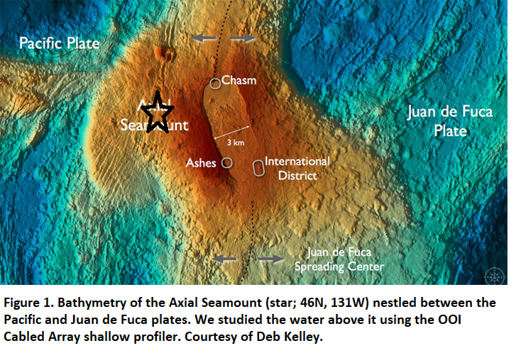
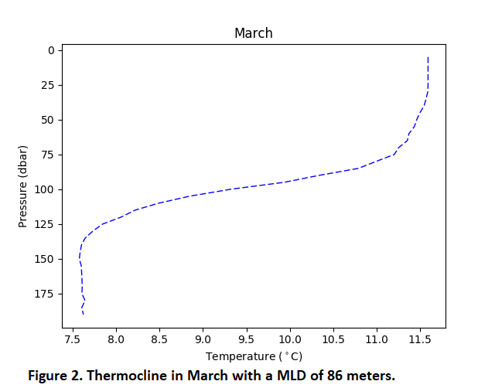
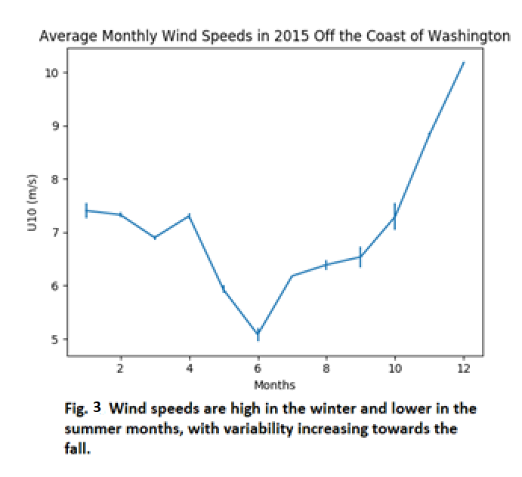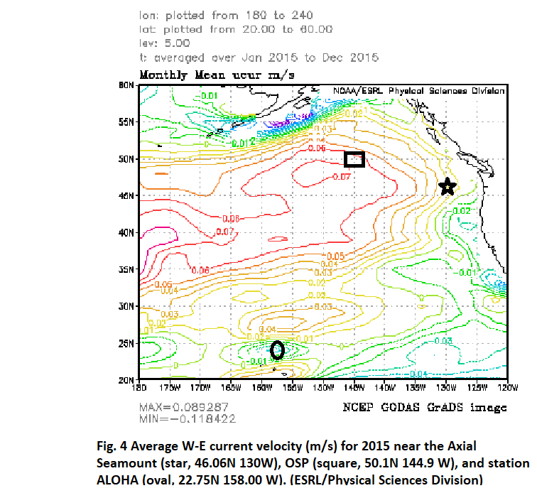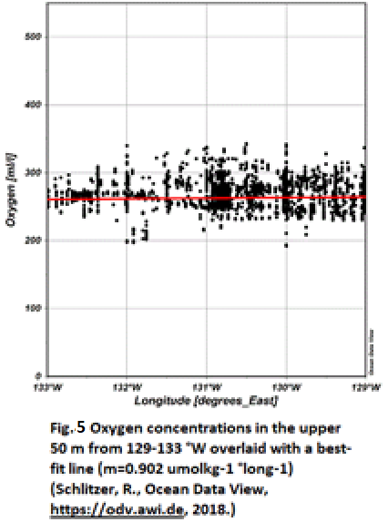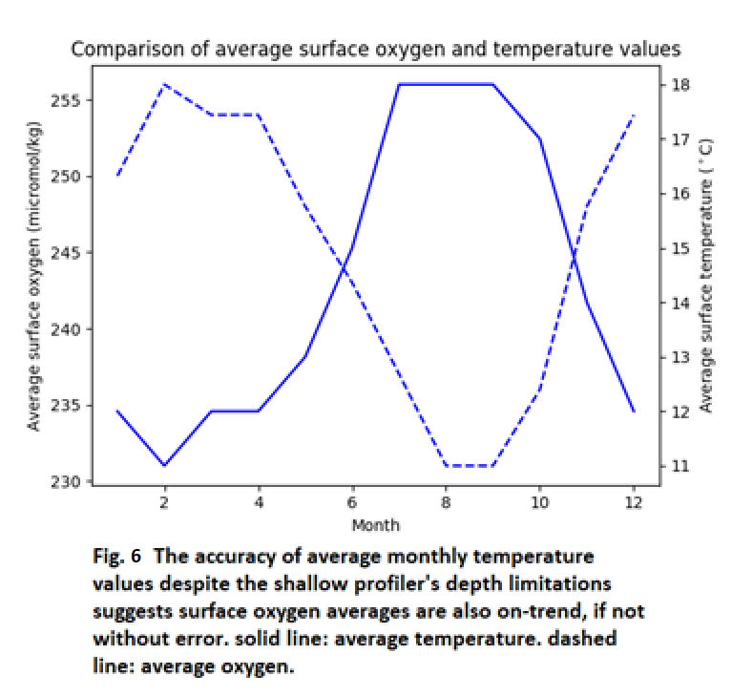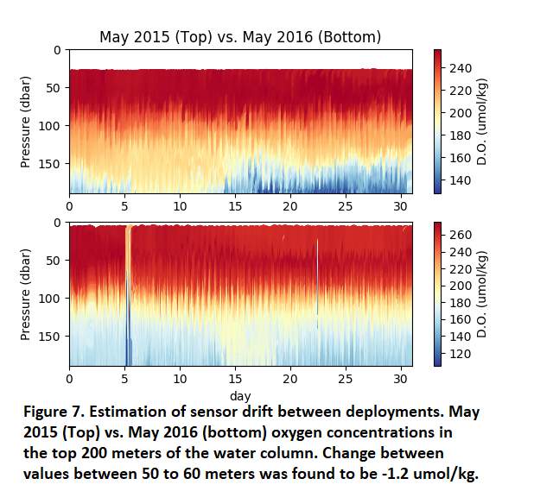

Tables

Table 1: Summary of monthly and annual averages
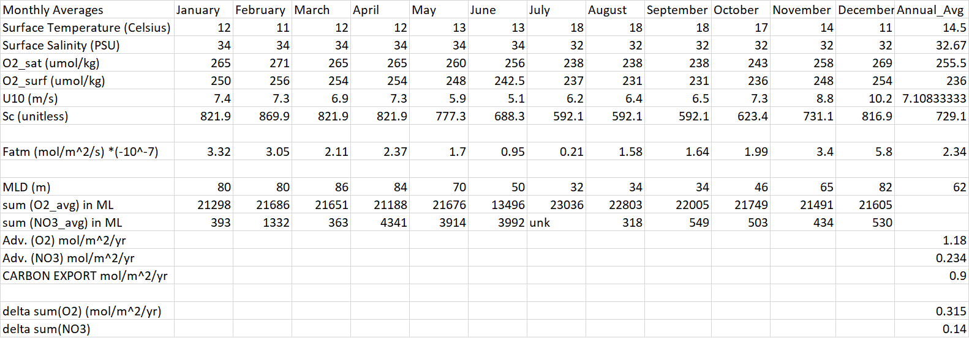

Table 2: Summary of carbon export comparisons
Method | Estimate (Mol/m^2/yr)
Time- Series Stations (HOT, ALOHA, BATS) | 3±1
Sediment Traps | Around 1
Satellite Estimates | Between 2 and 3 for this latitude (45-60 deg. N)
Profiling Float (N. Pacific (49-50 deg. N) | 0.7±0.5

References
Bushinsky, S. M., and S. Emerson (2015), Marine biological production from in situ oxygen measurements on a proﬁling ﬂoat in the subarctic Paciﬁc Ocean, Global Biogeochem. Cycles, 29, 2050–2060, doi:10.1002/ 2015GB005251.

Emerson, S. (2014), Annual net community production and the biological carbon flux in the ocean, GlobalBiogeochem. Cycles, 28, 14–28, doi:10.1002/2013GB004680

Emerson, S., and Hedges, J. (2011) Chemical Oceanography and the Marine Carbon Cycle, doi:10.1017/cbo9780511793202.013.

Emerson, S., P. D. Quay, C. Stump, D. Wilbur, R. Schudlich (1995) “Chemical Tracers of Productivity and Respiration in the Subtropical Pacific Ocean.” Journal of Geophysical Research, vol. 100, no. C8, 1995, p. 15873-15887., doi:10.1029/95jc01333.

Emerson, S., and Stump, C. ( 2010), Net biological oxygen production in the ocean II: Remote in situ measurements of O₂ and N₂ in the subarctic Pacific surface waters, Deep Sea Res., Part I, 57,1255– 1265, doi:10.1016/j.dsr.2010.06.001.

Emerson, S., C. Stump, and D. Nicholson (2008), Net biological oxygen production in the ocean: Remote in situ measurements of O₂ and N₂ in surface waters, Global Biogeochem. Cycles, 22, GB3023, doi:10.1029/2007GB003095.

Falkowski, P.; Scholes, R. J.; Boyle, E.; Canadell, J.; Canfield, D.; Elser, J.; Gruber, N.; Hibbard, K.; Högberg, P.; Linder, S.; MacKenzie, F. T.; Moore b, 3.; Pedersen, T.; Rosenthal, Y.; Seitzinger, S.; Smetacek, V.; Steffen, W. (2000). "The Global Carbon Cycle: A Test of Our Knowledge of Earth as a System". Science. 290 (5490):pp 291–296.

Kortzinger, A., Send, U., Lampitt, R. S., Hartman, S., Wallace, D. W. R., Karstensen, J., Villagarcia, M. G., Llinas, O., and DeGrandpre, M. D. ( 2008), The seasonal pCO₂ cycle at 49°N/16.5°W in the northeast Atlantic Ocean and what it tells us about biological productivity, J. Geophys. Res., 113, C04020, doi:10.1029/2007JC004347.

Laws, E. A., D'Sa, E., and Naik, B. ( 2011), Simple equations to estimate ratios of new or export production to total production from satellite‐derived estimates of sea surface temperature and primary production, Limnol. Oceanogr. Methods, 9, 593– 601.

Levitus, Sydney (1982), Climatological Atlas of the World Ocean, NOAA Professional Paper 13, U.S. Department of Commerce

Liang, J.‐H., C. Deutsch, J. C. McWilliams, B. Baschek, P. P. Sullivan, and D. Chiba (2013), Parameterizing bubble‐mediated air‐sea gas exchange and its effect on ocean ventilation, Global Biogeochem. Cycles, 27, 894–905, doi: 10.1002/gbc.20080.

Moore, T. S., M. D. DeGrandpre, C. L. Sabine, R. C. Hamme, C. J. Zappa, W. R. McGillis, R. A. Feely, and W. M. Drennan (2011), Sea surface pCO₂ and O₂ in the Southern Ocean during the austral fall, 2008, J. Geophys. Res., 116, C00F11, doi: 10.1029/2010JC006560.

Quay, P., Stutsman, J., and Steinhoff, T. ( 2012), Primary production and organic carbon export rates across the subpolar N. Atlantic Ocean basin based on triple oxygen isotope and dissolved O₂and Ar gas measurements, Global Biogeochem. Cycles, 26, GB2003, doi:10.1029/2010GB004003

Acknowledgements and special thanks

To Professors Eric D’Asaro for advising my project, Randy Bundy, who was an advisor on an earlier version of this project, Deb Kelley, who provided guidance and inspiration during early stages of development, Julian Sachs, who also advised in early stages, and Arthur R. Nowell, my long-suffering editor (sometimes a carrot – sometimes a stick).

To the captain and crew of the R/S Revelle and everyone who works or has worked on the OOI Cabled Array

To Jenna Barret, for providing thoughtful edits to an early draft of the manuscript, Wendi Ruef and Katie Bigham for help with data analysis.

Finally, to Mom and Dad, who provided (fairly) unconditional love and support,

Thank You

