The value of drifters for modeling fine scale circulation around manmade structures of the shoreline

Rebecca Zieber

June 13, 2018
University of Washington
School of Oceanography
zieber@uw.edu

Abstract
For this project, a data integration plan for the development of a simple mathematical model to show fine scale circulation around manmade structures was designed utilizing Davis-Star drifters. A simple field test determined which environmental factors to consider for such a model, which was then designed around the appropriate governing equations, and applied to a case study. The case study illustrated how to incorporate a variety of elements into the data frame, and how to represent the data mathematically to illustrate the circulation of water around the University of Washington’s dock in Portage Bay, WA. This study showed that by using a simple model and data that is publically available, a high-resolution picture of the fine scale circulation around manmade structures can be generated.
Introduction
Human engineering of coastal environments has significant impacts on the natural processes of the surrounding ecology. The most commonly engineered structures of the coastal zone of marine environments are piers or docks, seawalls, and jetties located along the shoreline. Roughly 5,500 piers/docks have already been built in marine waters within the state of Washington (Ecology, 2017).
Construction of manmade structures often leads to the permanent destruction of habitats, feeding grounds, and spawning locations for many organisms, as well as increased erosion due to higher wave activity resulting from these designs. Often the human activities associated with the use of these structures for both commercial and recreational purposes tend to pollute the surrounding water. Overwater structures in general shade the underlying habitat where alterations in light can disrupt the productivity and behavior of a variety of organisms. Changes to the substrate resulting from pile driving during construction disturbs the sediment and bathymetric structure which in turn affects benthic organisms and their habitat. Circulation of water along the coast line is disrupted by these structures, which is known to have a negative impact on littoral drift (Nightingale and Simenstad, 2001). Vegetation is also lost during construction, and later due to the introduction of shade by the structures. This decreases species diversity (J. Brennan et al, 2009). Similarly, longshore transport is also affected by jetties which create an uneven deposition and accretion of sediment along the updrift side, and erosion along the downdrift side. Passive and active erosion are increased by designs that have an impact on wave refraction, such as seawalls. Wave refraction intensifies as it meets the structure, and long-term net erosion causes the shoreline to migrate landward beyond the seawall (Thieler, 2000). These factors are significant and cannot be ignored if coastlines are to be preserved for the good of the environment, and future generations.
One of the most useful tools to gain a better understanding of how manmade structures shape the shoreline and, in particular, how they alter circulation, is the use of a mathematical model. Several box models describing the circulation of water already exist. A box model is useful for illustrating the flow of water driven by density differences. That multiple stable states can exist within a given physical environment was developed by Stommel in 1961 (Stommel, 1995). Welander in 1982 developed a box model to describe the flow of water driven by the thermocline, and it’s capable of modeling intrinsic oscillatory behavior (Welander, 1982). Both prove useful as starting points where the similarities found from these approaches define the necessary criteria for creating more complex models or models designed for specific questions. Components that are always present in a box model include a set of governing equations, and the assumption that the system is at steady state. From that beginning it is then possible to tailor a box model to a specific purpose. For example, Babson et al. in 2006 illustrates the process of modeling circulation and transport of water between the various basins within Puget Sound, and serves as an excellent reference for employing the overlying principles of a box model to answer a scientific question.
Simple box models require initializing data which are then transformed through governing equations into information on the movement of water over time. The data regarding wind, tides, river discharge, and other forcing variables (which will be elaborated on later) must all be ingested within the modeling framework. The objective of this research is to create a data integration plan for the development of simple mathematical models that can be used in describing the fine scale circulation around urban waterfront structures, and to test that data framework in a case study application. The focus of the data integration plan is on data that has already been recorded by various outside sources, including by the National Oceanic and Atmospheric Administration, Weather Underground, and the United States Geological Survey, which provide tide charts, wind data, and river gauge readings, respectively. In addition to the integration of existing data, this research investigates the role of observational data to determine the time rate of change at which water circulates within the environment with the use of surface drifters.
Methods
This project proceeds through three distinct stages. The focus begins with procedures for identifying and acquiring the necessary data for model development before describing the governing equation and construction of the model itself. A simple model is then tested as a case study in the use of simple models for fine scale shoreline circulation.

Data integration
Spatial models require both spatial and temporal data. Therefore, the first step in the process of data integration is to identify which data is necessary to collect. The major aspect of data integration is the acquisition of data regarding inputs and outputs, forcings, and movement. Inputs/outputs include tides and rivers, while significant forcings are determined experimentally during a field test. Examples of forcings to the system include wind, currents, shear stress, density-driven differences, and Coriolis. Movement describes how direction and speed of water mass movement can be measured and observed directly by the use of surface drifters in the environment. These will make up the categories used to classify the data, which is then collected.
The data used to describe inputs and outputs to a system and the forcing upon the system are summarized in the table (Figure 1) for models of Puget Sound Washington. Similar data sites are available for most coastal environments. These data sets are available for download and may require transform into standard or uniform units for use within a modeling framework.

Data Type | Data Source
Wind Data for Field Test (28/1/2018)  Weather Underground | https://www.wunderground.com/history/airport/KPAE/2018/1/28/DailyHistory.html?req_city=&req_state=&req_statename=&reqdb.zip=&reqdb.magic=&reqdb.wmo=
Wind Data for Case Study (18/5/2018)  Weather Underground | https://www.wunderground.com/history/airport/KBFI/2018/5/18/DailyHistory.html?req_city=Seattle&req_state=WA&req_statename=Washington&reqdb.zip=98101&reqdb.magic=1&reqdb.wmo=99999
Tidal Chart for Field Test (28/1/2018)  NOAA | https://tidesandcurrents.noaa.gov/noaatidepredictions.html?id=9447659&units=metric&bdate=20180128&edate=20180128&timezone=LST/LDT&clock=24hour&datum=MLLW&interval=hilo&action=dailychart
River Discharge for Field Test (28/1/2018)  USGS | https://nwis.waterdata.usgs.gov/usa/nwis/uv/?cb_00060=on&cb_00065=on&format=gif_default&site_no=12150800&period=&begin_date=2018-01-28&end_date=2018-01-28
Figure 1: Table of hyperlinks to the outside data sources used within this study.
Data regarding the movement of water at fine time scales can be acquired by direct observation using a surface drifter. A version of the Davis-Star drifter was employed and first tested on January 28, 2018 by the Snohomish river mouth. Conditions were generally poor; there was lots of wind, rough seas, and some rainfall (See Figure 2). The drifter was deployed in half hour increments off the R/V Welander, and its position was recorded using a Garmin GPS, which allowed the Welander to monitor the drifter’s position at all times (See Figure 3). After the field test, it was clear that winds and currents were the two most important forcings to consider for the model. Once the drifters’ track lines are collected by the GPS, time steps can be assigned depending on how rapidly the drifter’s positions were changing; i.e. if the drifters were moving quickly, then large time scales would be inappropriate since the model would no longer be fine scale.

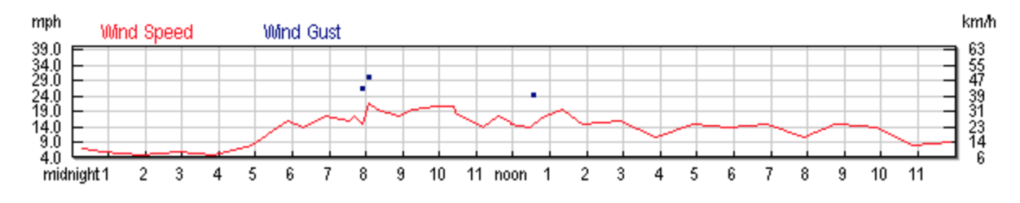
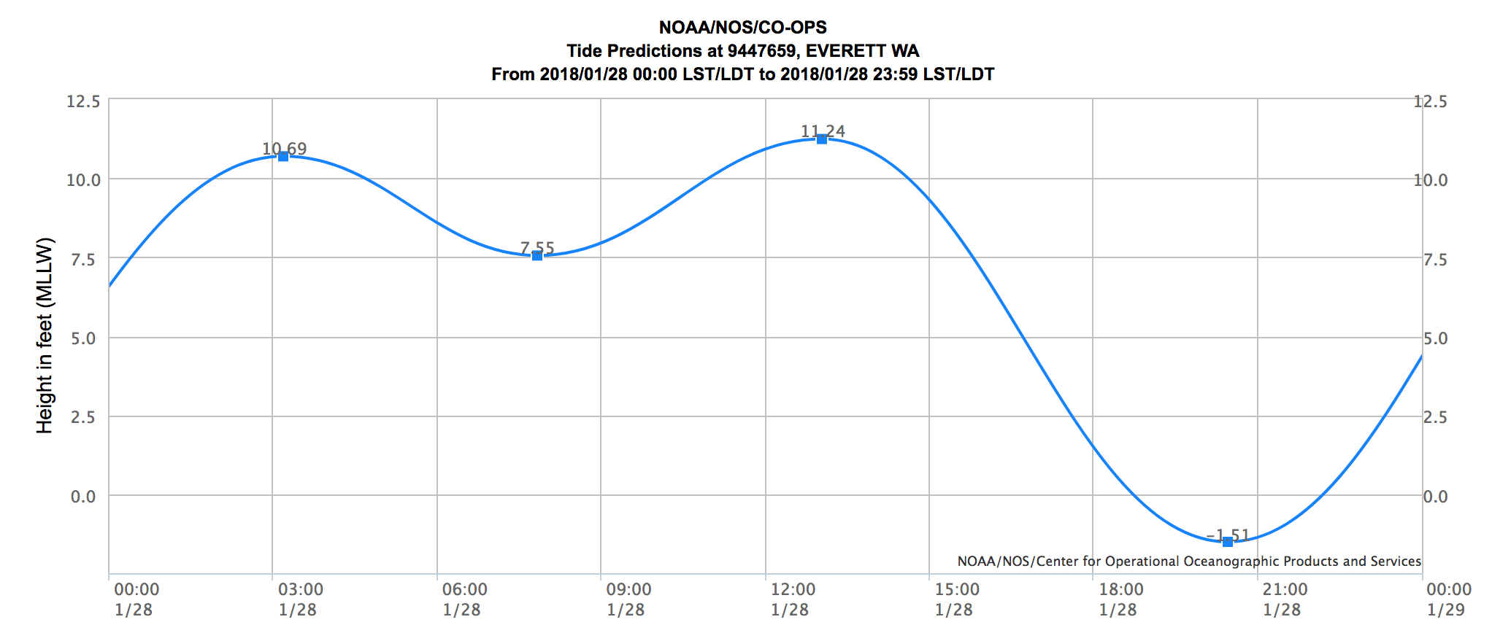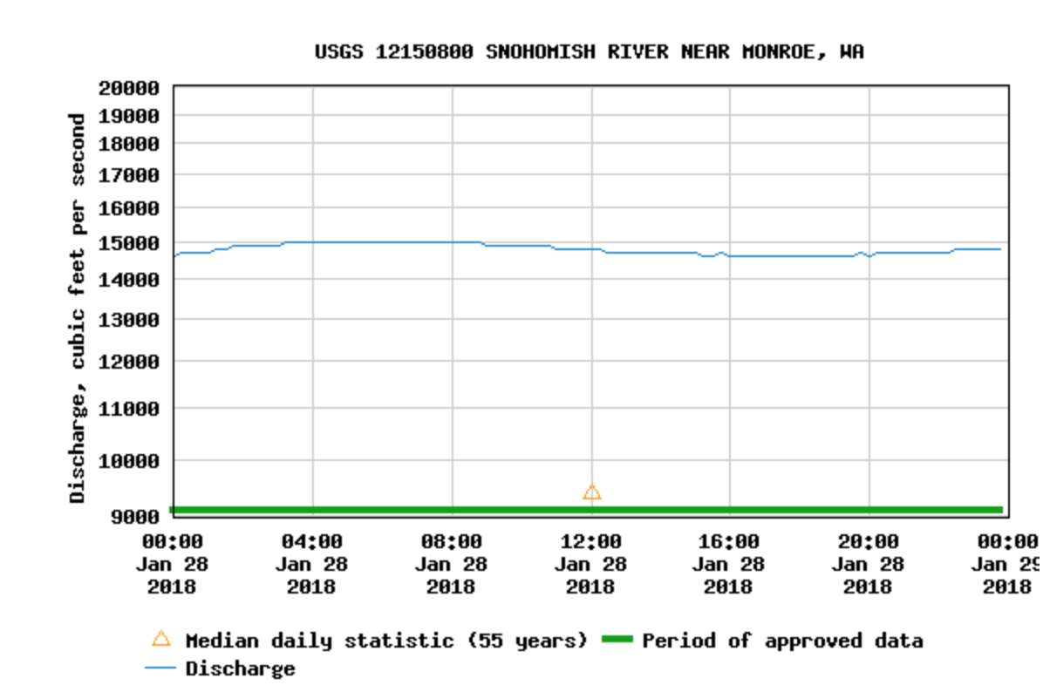

Figure 2: Data for the field test on January 28, 2018. From top to bottom, left to right, the data reads as follows: Wind data was taken at Paine Field from Weather Underground; tide chart was provided by NOAA; Snohomish River discharge rate given by USGS.

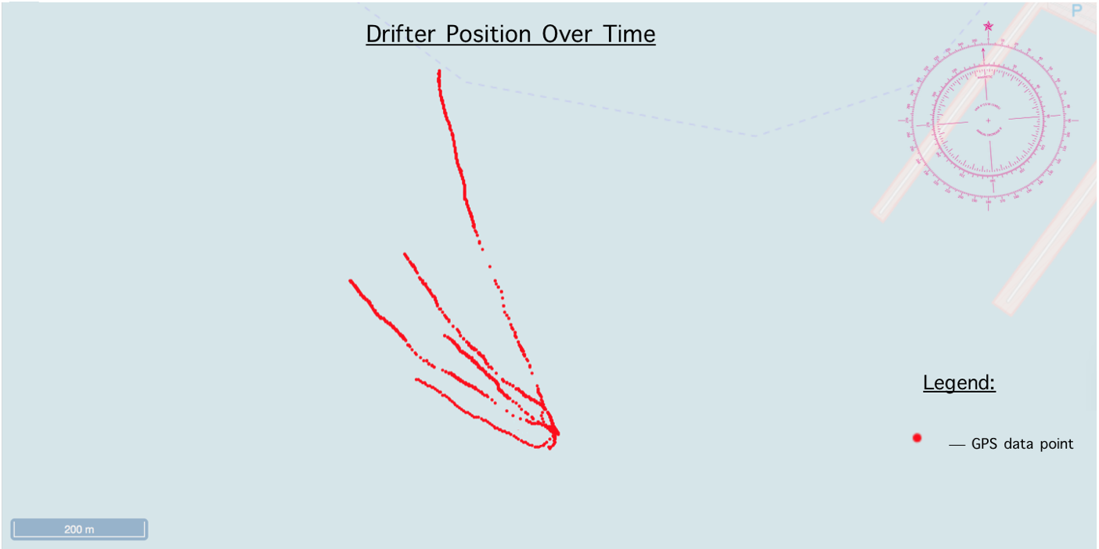
Figure 3: Drifter track lines for the field test on January 28, 2018 off the marina in Everett, WA.

Following the acquisition of all required data the final step in data integration is to determine the common unit of space and time (e.g. meters per second) which are need for the model application. With the data transformed into common modeling units and the data frame established it is then possible to parameterize the model.
Modeling
The first step in creating a mathematical model is to establish its governing equations. For simple box models of the shoreline it is possible to limit governing equation to just the conservation of volume, a variation of which is defined in Babson et al (2006) to be:
$-Γ_{seaward}∓ Γ_{interface}∓ Γ_{landward}+ Γ_{forcing}=0$ (eq.1)
In this case, “seaward” and “landward” can be grouped into the same variable, as they are simply opposites of each other and direction is assigned by the sign of the variable and may be referred to as “motion”. In these shallow water settings, the “interface” term may be equivalent to “height” or “depth”. Therefore, the equation for the conservation of volume then only includes three variables, and can be rewritten as:
$Γ_{forcing}∓ Γ_{height} {∓ Γ}_{motion}=0$ (eq. 2)
These simple models can be implemented with a spreadsheet such as Microsoft Excel where a data grid is constructed dividing data into its three distinct categories, which were determined to be inputs/outputs, forcings, and movement. The data frame can be populated by incorporating these data from the data frame. Finally, the model is run by iterating through suitable time steps, all based on the governing equations.
Case study
The case study is simply a way to verify the validity of the previous two steps. Values for tides, river flow, and wind speed/direction are all available through NOAA, USGS, and Weather Underground, respectively. Current speed/direction is taken from the drifter speed/direction, which was measured from a Davis-Star drifter.

Results
The case study was conducted in Portage Bay, Seattle off the University of Washington dock on May 18, 2018, between the hours of 9:30am and 10:30am. Two drifters outfitted with thumb drive GPS units were deployed in half hour increments. They were initially positioned farther away from the dock, closer towards the Montlake Cut; one drifter closer to shore, and the other parallel with the Rachel Carsen. After half an hour, they were moved up shore, towards the dock, while leaving their horizontal position constant (See Figure 4). Wind speed was about 88 meters per minute from the southwest at both the beginning and the end of the testing period. At 10:00am, wind speed dropped to 0 meters per minute (See Figure 5). Since the case study is in Lake Washington, tides are not a factor. The current data is collected by the drifter’s position. The drifters moved initially at 0.5 meters/minute for the first fifteen minutes, with an average heading towards the southwest, then sped up to 1.5 meters/minute, headed west. A model processing time steps of five minutes was found to be appropriate, as it maintained the model’s fine scale requirements while considering the fact that the drifters were moving fairly slowly. Wind and current data can then be entered into the model (See Figure 6).
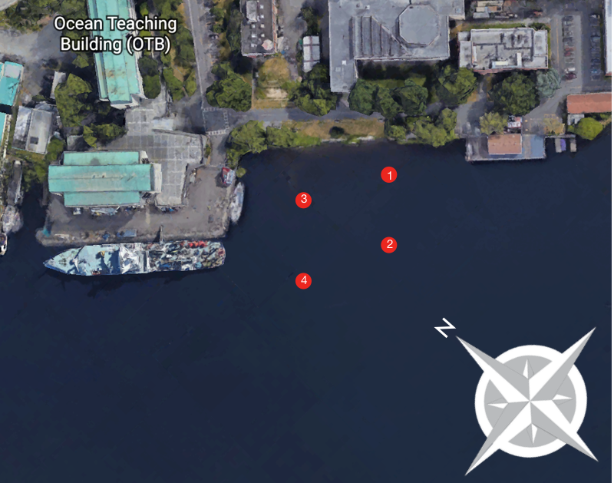
Figure 4: Map of the Portage Bay field case. Each red dot represents where the drifters were deployed. The numbers represent the order in which the drifters were released from the row boat.

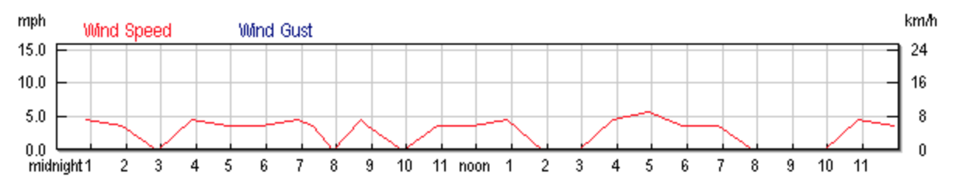Figure 5: Wind speed data for the case study in Portage Bay, Seattle WA on May 18, 2018. Data provided by Weather Underground.

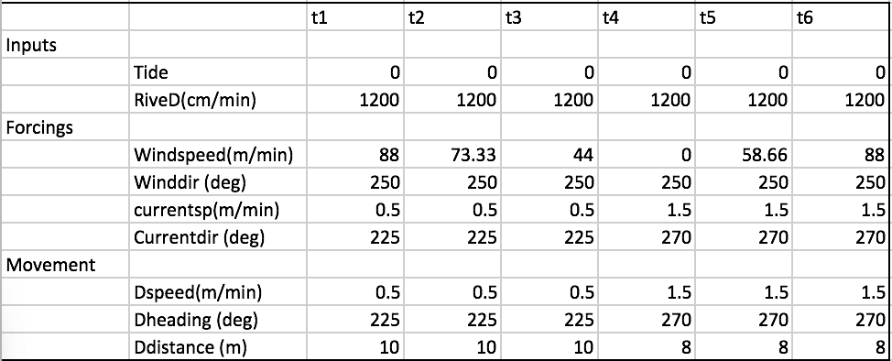
Figure 6: Table used in Excel to populate the data frame. Data is broken down into the three categories, and recorded values for each category are entered.

For the purpose of this case study a target model cell (box) within the model domain was selected, and using the governing equation for the conservation of volume, the model was run through all six time step iterations. The vectors governing where the drifter traveled were defined by:
Current Heading – Wind Heading = Direction Vector
Headings are given in degrees, where I defined the degree according to the compass rose (See Figure 7) and then plugged them into the equation above to get the resulting direction vector. The direction vector dictates how water from the surrounding grids flows into the target cell (See Figure 8). A percentage is assigned to each cell neighboring the target cell, where the percentages depend on the overall direction vector. Winds remained at a constant heading during the case study, at ~170˚ (See Figure 9). Current data is extrapolated from the drifter position, which is averaged over the four deployments. Observations show that the drifters, on average, moved westward, and out towards the middle of the bay. Therefore, drifter movement demonstrated a drifter heading of 225˚ for the first fifteen minutes, and 270˚ for the other fifteen minutes. The direction vector can now be determined for each time step iteration.

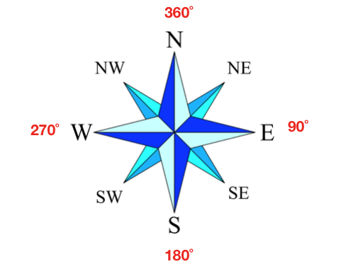
Figure 7: Headings (e.g. SW or due N) are defined in degrees by this compass rose.
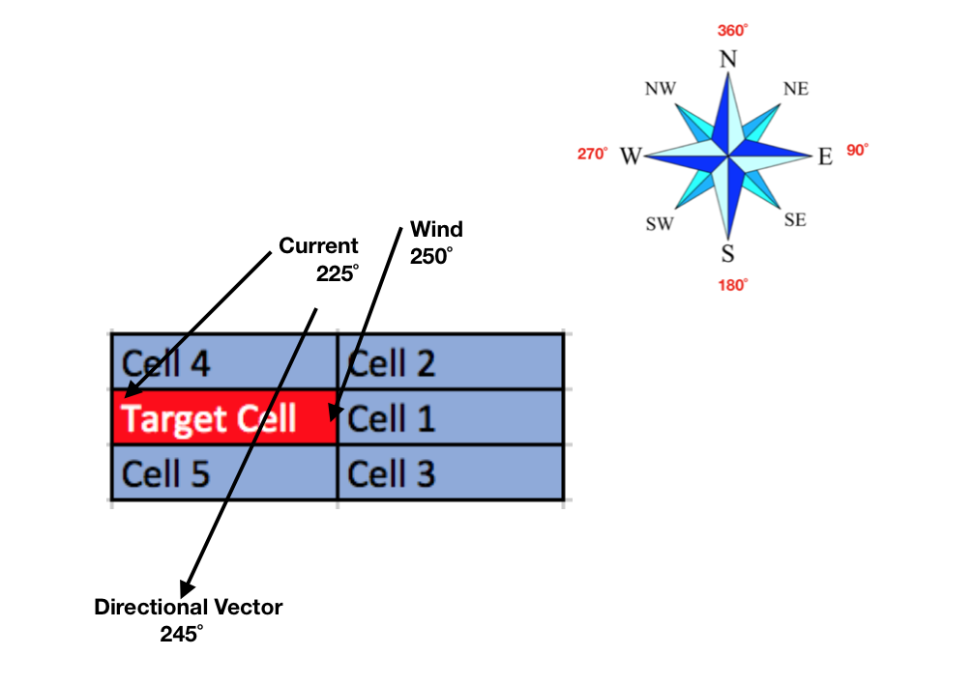
Figure 8: Example target cell, using data from time step 1. In this case, Cell 4 provides 60% of the volume flowing into the target cell, Cell 2 provides 30%, and Cell 1 provides 10% while Cells 3 and 5 provide 0%.

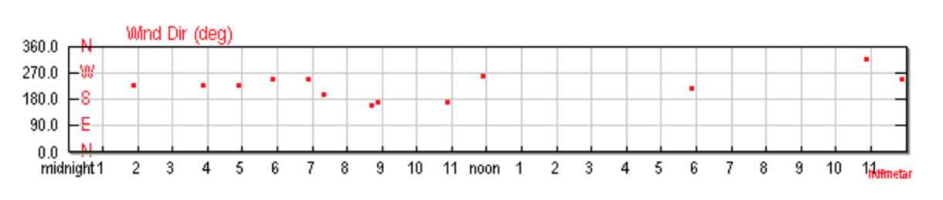
Figure 9: Wind direction for the case study in Portage Bay, Seattle WA on May 18, 2018. Data provided by Weather Underground.

It is important to note that which vector plays a more important role in determining what percentages to assign to the surrounding cells depends on speed. For example, if wind speed decreased from time step 1 to 2, then it should become less important when thinking about how the surface water was affected. With this in mind, at each time step a new representation of the model can be generated (See Figure 10).
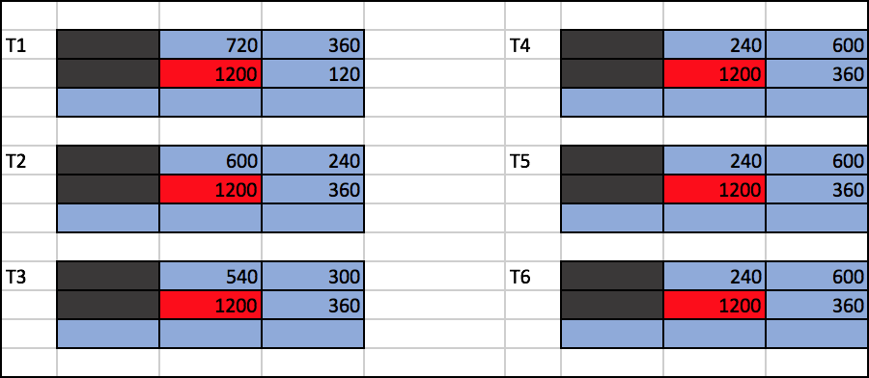
Figure 10: How each surrounding cell contributes volume to the target cell, taking wind speed & direction, and current speed & direction into account.

This is the full iteration through the model, governed by the conservation of volume.

Discussion and Conclusion
Simple box models of circulation are not difficult to conduct in that they can primarily utilizes data that is readily available. Wind speed, tide charts, and river output are all published to the public and easy to obtain online. Current data can be collected by simple surface drifters which boasts a simple and cost-effective design. The mathematical model is simple as well, since its governing equation is not hard to implement. Through the application of the model using drifter data, it is clear that changes in wind and tide can have an effect on the target cell, by changing the direction vector by which the surface water is represented. It is also clear that time scales influence our understanding of fine scale circulation, since time intervals directly affect the resolution. The sensitivity of position data collected by the Davis-Star drifter is therefore very important to this study’s ability to produce a high-resolution model of this fine scale circulation. For a follow-up study, I would suggest the implementation of 4 drifters at once. By increasing the number of drifters, more accurate directional vectors can be produced in the model, which allows the resolution of the model to increase as well. This would produce a more realistic spatial representation of the currents surrounding manmade structures. The case study presented here illustrates that such simple models, when supplied with readily available data and supplemented with observational data of movement from surface drifters can provide useful insight into fine scale circulations.
References

A. L. Babson, M. Kawase & P. MacCready (2010) Seasonal and Interannual Variability in the Circulation of Puget Sound, Washington: A Box Model Study, Atmosphere-Ocean, 44:1, 29-45, DOI: 10.3137/ao.440103

Brennan, J., Culverwell H., Gregg, R. and Pete Granger, Washington Sea Grant. 2009. Protection of Marine Riparian Functions in Puget Sound, Washington, for Washington State Department of Fish and Wildlife, June 2009.

Ecology, 2017, Shoreline Master Program Planning Process, publication number 11-06-010, Department of Ecology, Olympia WA

E. Robert Thieler, et al. “The Use of Mathematical Models to Predict Beach Behavior for U.S. Coastal Engineering: A Critical Review.” Journal of Coastal Research, vol. 16, no. 1, 2000, pp. 48–70. JSTOR, JSTOR, www.jstor.org/stable/4300011.

Nightingale, B. and C. Simenstad, University of Washington, 2001. Overwater Structures: Marine Issues for Washington Departments of Fish and Wildlife, Ecology and Transportation.

Stommel, H., Hogg, Nelson G, Huang, Rui Xin, & Woods Hole Oceanographic Institution. (1995). Collected works of Henry M. Stommel. Boston, MA: American Meteorological Society.

Welander, Pierre, “A simple heat-salt oscillator” Dynamics of Atmospheres and Oceans, July 1982, Elsevier B. V.

