Analysis of Nitrite Concentrations Over Time in the Eastern Tropical North Pacific
Juliette Birkner
University of Washington, School of Oceanography
May 28, 2017
Abstract:
The Oxygen Minimum Zone in the Eastern Tropical North Pacific is the largest and most intense in the world. The lack of oxygen causes bacteria to respire anaerobically and therefore changes the nitrogen cycle. Nitrite has previously been measured in this zone 4 times from 1972 to 2012. I collected and compared data from 2016/17 to previous data and conclusions. In particular, data was collected from a profile at a time series station for direct comparison to the 2012 data. In 2012 the maximum nitrite concentration in the area was 8.51 μmol/L and the maximum at the time series station was 5.86 μmol/L whereas in 2016/17 the maximum concentration in the area was 4.13 μmol/L and the maximum at the time series station was 1.51 μmol/L. The data from 2012 showed nitrite concentration that were much higher than previous years. However, the data from 2016/17 does not show the same high concentrations implying that 2012 may have been an anomaly. The data from the time series station was then used as representative of the study area for an analysis of how the area of high nitrite changes in spatial area and intensity given the changes in maximum nitrite concentration. Using GLODAP data in ODV nitrite concentrations were raised by a constant proportion for 2012 and 2016/17 forcing the maximum nitrite concentration in the ETNP to match the concentration measured at the time series station for each year respectively. Based on this simple analysis it is shown that while more data is needed it is likely that when the maximum nitrite concentration increases, the zone of high nitrite concentration both expands and intensifies.
Introduction:
Dissolved oxygen is unevenly distributed throughout the world’s oceans. While there are varying levels of dissolved oxygen in different parts of the ocean, some areas have less dissolved oxygen than average. These areas, referred to as oxygen minimum zones (OMZs), result predominantly from poor ocean ventilation and ocean transport (Karstensen et al. 2008). OMZs impact the ocean environment in a variety of ways. Low oxygen water can completely restructure ecosystems (Bertrand et al. 2011), possibly making it impossible for anything but bacteria to survive (Cline and Richards 1972), and change nutrient cycling (Lam et al. 2011). There is both current and paleoclimatological evidence that as the planet warms OMZs will expand (Lam et al. 2011, Praetorius et al. 2015, Horak et al. 2016).
There is debate in the scientific community about what qualifies as an OMZ. Though the threshold oxygen concentration is not well defined, Karstensen et al (2008) considers three possible thresholds, with 90 µmol/kg dissolved oxygen as the highest oxygen concentration possible within an OMZ. Given the range of oxygen concentrations possible an OMZ with a lower maximum concentration is of higher intensity than an OMZ with a higher maximum concentration. The OMZ in the eastern North Pacific Ocean is the most intense OMZ in the world, as well as being the thickest and shallowest (Karstensen et al. 2008). This OMZ has been the topic of a fair amount of study, including four cruises along the same transect in the Eastern Tropical North Pacific (ETNP) (Horak et al. 2016). Based on this data the volume of oxygen deficient water has increased and low oxygen water has risen to shallower depths between 1972 and 2012 (Horak et al. 2016).
Oxygen concentration can have a profound impact on the nitrogen cycle in the ocean. When less than 20 µmol/L oxygen is present, some organisms, mostly bacteria, begin to breathe without oxygen. Respiration (breathing) uses oxygen as an electron acceptor and produces energy. Other compounds are not as good electron acceptors because they do not produce as much energy, but nitrate is the next best acceptor available in the water column after oxygen (Froelich et al. 1979, Lam et al. 2011). Nitrate (NO₃⁻) and nitrite (NO₂⁻) are both nitrogen containing compounds found in seawater. When nitrate is used as an electron acceptor nitrogen is lost from the water column and ultimately transformed to nitrogen gas in a process called denitrification (Cline and Richards 1972, Codispoti and Christensen 1985). Nitrite is an intermediate product formed in the first step of this process and builds up in the water at places where denitrification occurs. Denitrification appears to be inhibited by oxygen in the water and nitrite concentrations appear to have some dependence on oxygen concentrations (Cline and Richards 1972).
Since the production of nitrite only happens under certain circumstances, high nitrite concentrations associated with low oxygen concentration can be used to infer the process occurring. If nitrite appears in high concentration within an OMZ we can assume that denitrification is occurring. There is a primary nitrite maximum at the location in the water column where phytoplankton die and get remineralized as this is an oxygen consuming process (Lam et al. 2011). In an OMZ, as oxygen concentrations decrease denitrification will increase and the nitrite concentrations will increase, meaning that nitrite concentration can be used as a proxy for OMZ intensity. As the intensity of the OMZ increases the oxygen concentration approaches zero and becomes harder to measure accurately. In fact, Lam (2011) claims that there is only one kind of sensor that can accurately measure oxygen levels lower than 5 µmol/L and that the process of nitrate reduction to nitrite becomes obligate for bacteria at oxygen levels between 2 and 4 µmol/L. Since the nitrite concentration increases at these low oxygen levels, called the secondary nitrite maximum, it is a better indicator of when the OMZ reaches the lowest levels of oxygen concentration.
This study aims to use the relationship between nitrite and oxygen to better understand change in the OMZ in the ETNP. Nitrite data from 2016 will be used to look at the change in the OMZ from 2012. This study will compare the maximum nitrite concentration in the OMZ and the full nitrite profile at a single time series station to infer whether the OMZ has continued to intensify between 2012 and 2016. Using this information about the variation in the nitrite concentration in the OMZ over time and assuming constant rate of change, a hypothetical area for the OMZ will be calculated as a prediction of future OMZ change.

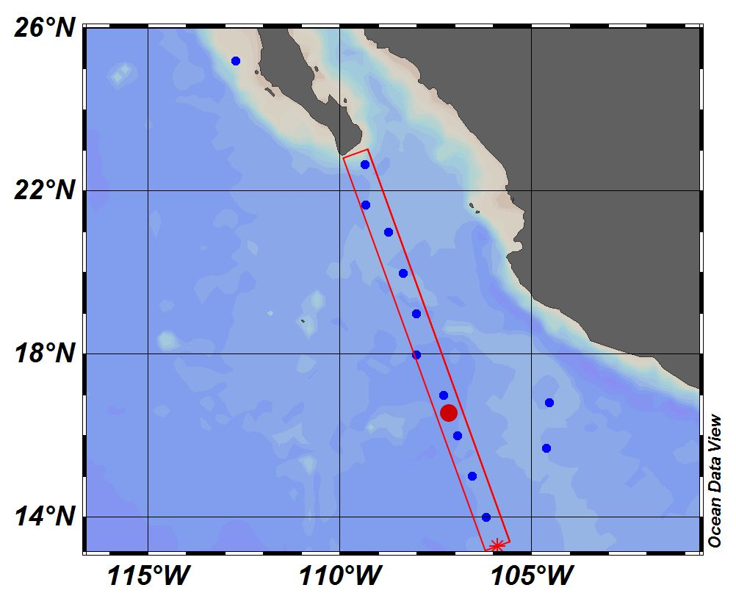
Methods:
Figure 1: location of stations. The blue dots represent sample locations, the red dot represents station 8, a time series station that occurs at the same location as a station in the Horak et al. (2016) data set. The red box encloses the stations that were used to create the section profile in figure 2
Sample collection: Between 7 and 24 samples were taken at each of 13 stations along the cruise track for a total of 261 samples (See Figure 1). Samples were taken from CTD Nisken bottles and filtered, all but stations 1 and 2 were filtered directly from the Nisken. Samples from station 11 and 12 were frozen at -20ºC and analyzed in the lab in Seattle. All other samples were stored in the fridge until being analyzed on the ship. For every sample collected for my own analysis at least one sample was collected and frozen at -20 ºC for Kathy Krogsland to analyze at the UW Marine Routine Chemistry Lab.
Chemical Analysis: The methods for the detection of nitrite were adapted from the Bermuda Atlantic Time Series (BATS) method for detecting nitrite in seawater (Howse 1997). 10mL samples were mixed with 200uL of a sulfanilamide solution and 200uL of a NED solution. The NED solution consisted of 1g of N-(1-Naphthyl)-ethylenediamine dihydrochloride (NED) and 100mL or Milli-Q water. The sulfanilamide solution consisted of 10g of sulfanilamide in 100 mL of hydrochloric acid and 600 mL Milli-Q water. On the ship 10% HCl was used and in the lab in Seattle concentrated HCl was used. Though using concentrated HCl is the standard procedure, reagents made with 10% were made and taken on the ship in error. Mixed samples and reagents were put into cuvettes and read on a spectrophotometer. The absorbance of the sample was measured at 543nm.
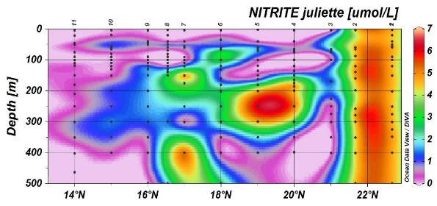
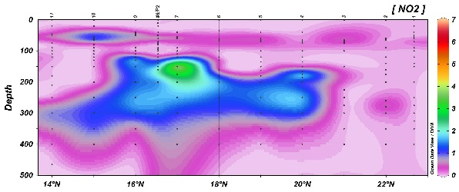
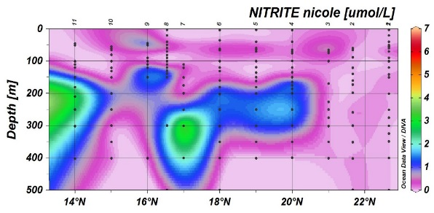
An 8 or 9 point standard curve was made each day on the ship to correct for any changes or degradation of the reagents. Standard curves were made using progressive dilutions from 16 µmol to .0625 µmol or .125 µmol. The concentrations and the absorbance of each standard was used to create a regression to obtain an equation for the samples. Once samples were read in spectrophotometer, nitrite concentrations were calculated from the regression of the standards.
Figure 2: 2016 nitrite data along the cruise transect analyzed (from top to bottom) by Juliette, Nicole Travis (travis dataset), and Kathy Krogsland (auto analyzer). Station 1 appears on the right, station 11 on the left. The colors represent nitrite concentration in umol/L.
Data Analysis: Nitrite data was combined with the CTD sensor data (including oxygen concentration). Data was imported to Ocean Data View (ODV version 4) and all subsequent calculations were done in ODV. ODV was used to produce all figures.

Results:
The nitrite data ranged from a maximum of 6.78 µmols/L to a minimum calculated value of -0.75 µmols/L. However, all negative values are understood to be zero concentration. The maximum nitrite concentration occurred at station 4 (19.99467 N, 108.363 W) at a depth of 186 meters. The average depth of maximum nitrite concentration across all stations was 218.1 meters.
Krogsland
The range of concentrations for the time series station (station 8) was -0.75 µmols/L (considered 0) to 2.38 µmols/L. The maximum occurred at 150m.
A run of my standards was also analyzed using the auto-analyzer at University of Washington’s Marine lab. The results of this analysis are shown in Table 1. The standard values represent the values used to calculate the nitrite concentration of ocean water samples. These values are based on my preparation of standards with a stock solution. The calculated values are taken to be the true concentration of the nitrite standards based on the accuracy of the auto analyzer.
Standard Values [μM] | Calculated Values [μM] | Difference  [μM] | Percent Difference
0.125 | 0.21 | -.085 | 51.29
0.5 | 0.60 | -.10 | 17.62
2 | 2.21 | -.21 | 9.90
16 | 17.32 | -1.32 | 7.93
Table 1: Standard values are the values that I made based on my standard and calculation. Calculated values were obtained by Kathy Krogsland in the marine lab with an auto-analyzer. The difference represents the Standard Value minus the Calculated Value. The percent difference represent how accurate my standards were for one run at the lab in Seattle.
There was a graduate student from Stanford University, Nicolle Travis, collecting samples and running the same nitrite analysis as me on board the ship. I used her data as an independent check for the accuracy of my data. The average difference between my data and hers was 1.26 µmols/L meaning that my values tended to be higher. The range of difference between concentrations of samples from the same station and same depth was -4.75 µmol/L to 6.03 µmol/L. Where the difference value is positive I calculated a higher concentration, where the difference value is negative Travis calculated a higher concentration.
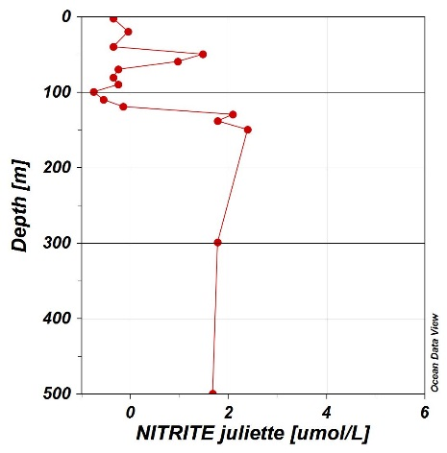
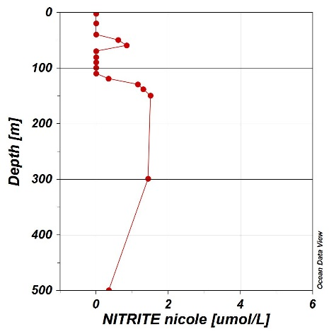
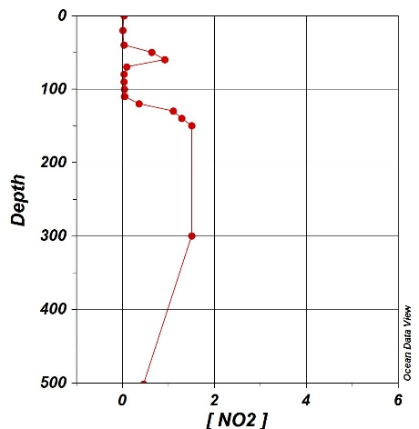
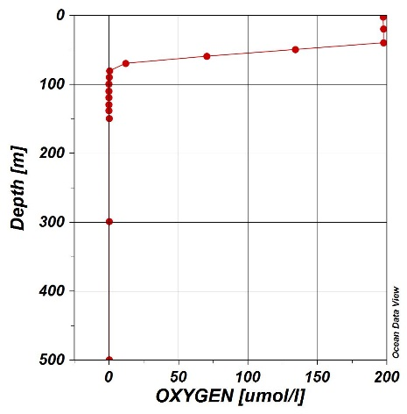
Within the time series station the difference values between the two data sets is low (-0.7 to 1.3 µmol/L).
Figure 3: Nitrite data at station 8 collected and analyzed by Juliette, nitrite data at station 8 collected and analyzed by Nicole Travis (Travis dataset), and nitrite data collected on the ship at station and analyzed by Kathy Krogsland with an auto analyzer. The oxygen data from station 8 collected by CTD is included for reference.
NITRITE Krogsland [umol/L]
The samples sent to the marine lab were analyzed by Kathy Krogsland from both my stations and stations on the second leg of the cruise. Within this data set the highest nitrite concentration was 4.13 µmol /L at station 7 (16.999 N, 107.298 W) at 150 meters depth. The time series station has a maximum concentration of 1.51 µmols/L at 300 meters and the next highest concentration 1.49 µmol/L at 150 meter depth. This data set more closely matches the Travis dataset than mine. Within the time series station the Travis dataset and data from Kathy Krogsland have an average difference of .086 µmols/L where the largest difference is 1.15 µmol/L.

Discussion:
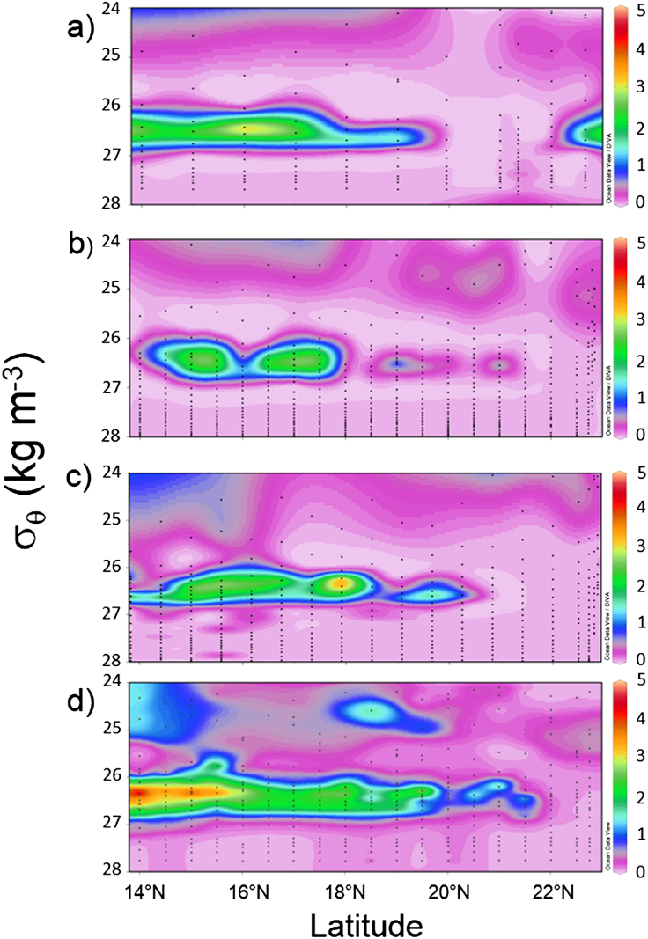
My chemical analyses and the Travis data set are not in agreement. Particularly in stations 1 and 2 the concentrations in my data set are much higher than those in the Travis data set. Three reasonable explanations for the difference between data sets present themselves. The first is the level of experience in the chemical analysis. The second is that the standards which I used to calculate the nitrite concentrations may not have been reliable. This is shown in Table 1 where one set of my standards were analyzed in the auto analyzer and came back as very different concentrations than those I targeted. While I could use the corrected standard concentrations to back calculate correct sample calculations, I would not be confident in my new results since the standards were made daily and only one batch were run in the auto analyzer. The third is that since my reagents were made differently from the standard procedure for the ship there may have been differences due to reagents.
Figure 4: This is Figure 1 in (Horak et al. 2016) and shows the nitrite measurements from four cruise in the OMZ of the ETNP. “NO₂⁻ (μmol kg⁻¹) concentrations for (a) TGT66, 1972; (b) WOCE, 1994; (c) CLIVAR, 2007; and (d) TN278, 2012, along the 110°W section. The color bar represents NO₂⁻ (μmol kg⁻¹)”
The nitrite concentrations from the auto analyzer are more precise than those from chemical analysis by hand. In addition, the marine lab data set using the auto analyzer and the Travis data set are closely in agreement with each other, giving extra confidence to those results. For these reasons I will be focusing on the Marine Lab data for comparison to previous data in the OMZ in the ETNP. In addition station 8, the time series station, has reasonable agreement across all three data sets, further increasing the confidence in this comparison.
The maximum nitrite concentrations across all data from the 2016/17 cruise was 4.38 µmol/kg lower than the maximum nitrite concentration from the 2012 data set (Horak et al. 2016). In general the maximum nitrite concentration at all stations was higher in 2012 than in 2016/17. While Horak et al. (2016) argued that the OMZ is getting more intense over time on the grounds that the nitrite levels rose during successive samplings, the 2016/17 data does not follow that trend. This suggests that 2012 may have been an anomalously high nitrite concentration year. The 2016/17 data is similar to the 2007 data, increasing the confidence that 2012 represents an anomaly. This implies that even as nitrite may be increasing over time, 2012 was in fact the anomaly.
I have not investigated causes of the 2012 anomaly, but the high nitrite concentrations observed that year do not appear to represent a sustained state in the OMZ of the ETNP. In fact, the nitrite concentrations decreasing between 2012 and 2016 would suggest that the intensity of the oxygen deficiency has decreased. Though the lack of nitrite could be a product of oxygen deficiency so intense that all of the nitrite has been used up in the denitrification process, this would most likely be expressed in the core of the high nitrite zone. Since we continue to see the highest nitrite concentrations within the core of the high nitrite zone, we can assume that the highest rate of denitrification (occurring within the core) is lower than in 2012, implying an improvement in the oxygen deficiency. This inference is important because the nitrite measurements are more sensitive than oxygen data, which is measured as a zero concentration in both 2012 and 2016 at depths below 100m. However, the difference in nitrite concentrations shows that there must be some difference between years and since nitrite is produced in the water via anaerobic processes (Cline and Richards 1972, Froelich et al. 1979, Codispoti and Christensen 1985) it is reasonable to assume that this difference is trace differences in oxygen concentration. While the oxygen concentration from both years is measured at zero, oxygen concentrations below 5 μmol/L are extremely difficult to measure with accuracy (Lam et al. 2011).
Another student on the 2016/17 cruise, Anna Baker worked also looked at nitrite data and found that there might be a correlation between OMZ thickness and El Nino/La Nina. She finds that more data would be needed but it is possible that La Nina year have thicker OMZs, which in turn would be reflected in the nitrite profile. While I did not analyze the area of high nitrite thickness, this could be another indicator or change in the OMZ that could not be accurately measured from oxygen data alone. However, Baker also found that there is daily variation in nitrite concentrations, meaning that more data from each station in each year is needed to be confident in results. This highlights the possibility that the data from 2012 could be an anomaly, but lowers the confidence in the analysis given here. To increase confidence the same station would need to be measured several days in a row and an average profile would need to be constructed for comparison from year to year. An average profile would also be useful for determining improvement in the oxygen deficiency.
Given that there is evidence that the concentration of nitrite in the OMZ of the ETNP is variable it should be considered how the changes in nitrite concentration impact the area of high nitrite. There are three possible ways that the area of nitrite could change as the maximum nitrite concentration increases. Here we will define intensification as a situation in which the area of high concentration remains constant while the maximum concentration increases, increasing the gradient as the boundary changes steeply from zero to the maximum. Expansion is the situation in which the boundaries do not steepen as the maximum concentration increases and as a result the area of the high concentration increases. These options are not mutually exclusive and a combination situation is also possible.
Intensification
Expansion
Figure 5: This figure shows a schematic for the two independent ways that the nitrite zone area can change over time. Each oval is representative of a contour line. Contour lines that are closer together represent steep change.

The expansion effect makes more physical sense in many ways. While the nutrients are concentrated in the ocean by physical processes, the physical zone where the OMZ is ‘stuck’ is very large. Within this zone it makes sense that as a nutrient is produced it would diffuse, and expand the area of the zone. To visualize potential expansion of the nitrite zone in the ETNP I have created a simple model based on the nitrite concentrations at the times series station from 2012 and 2016.
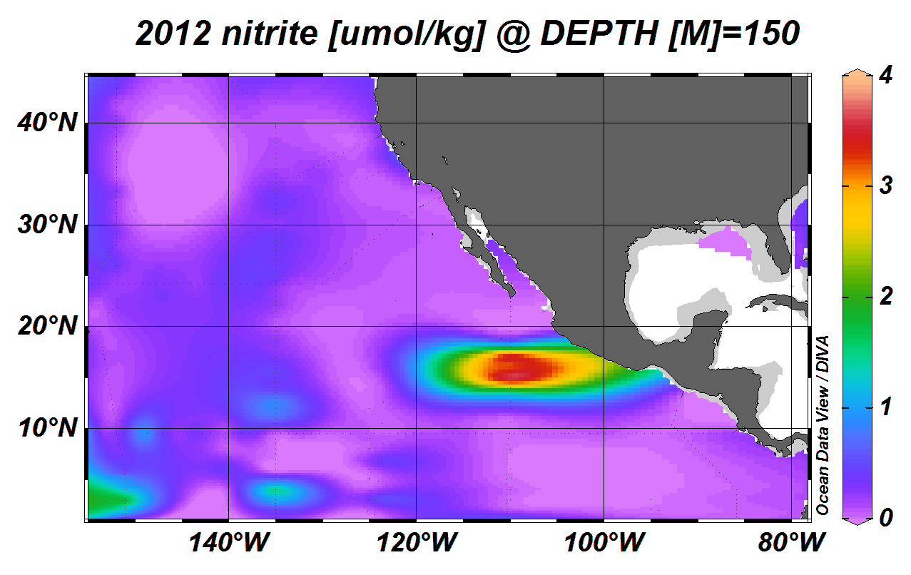
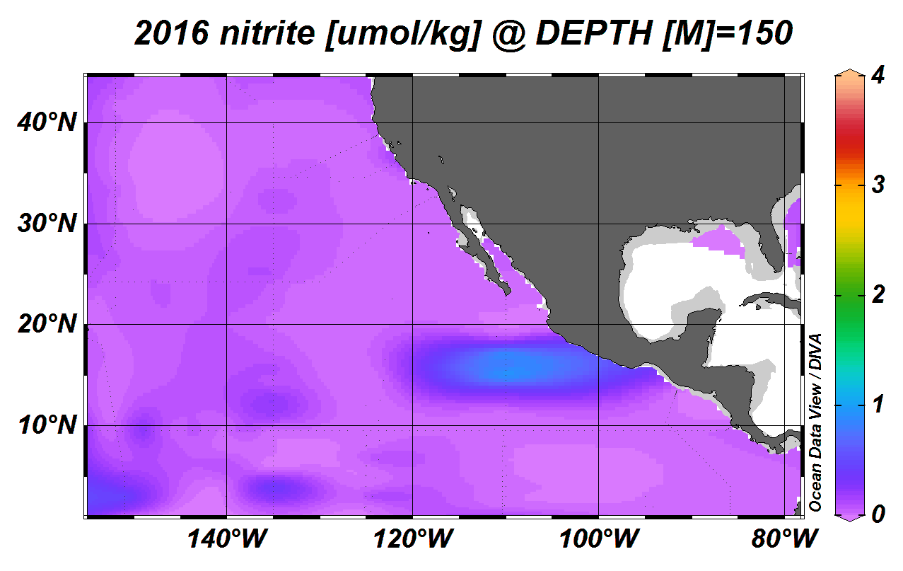
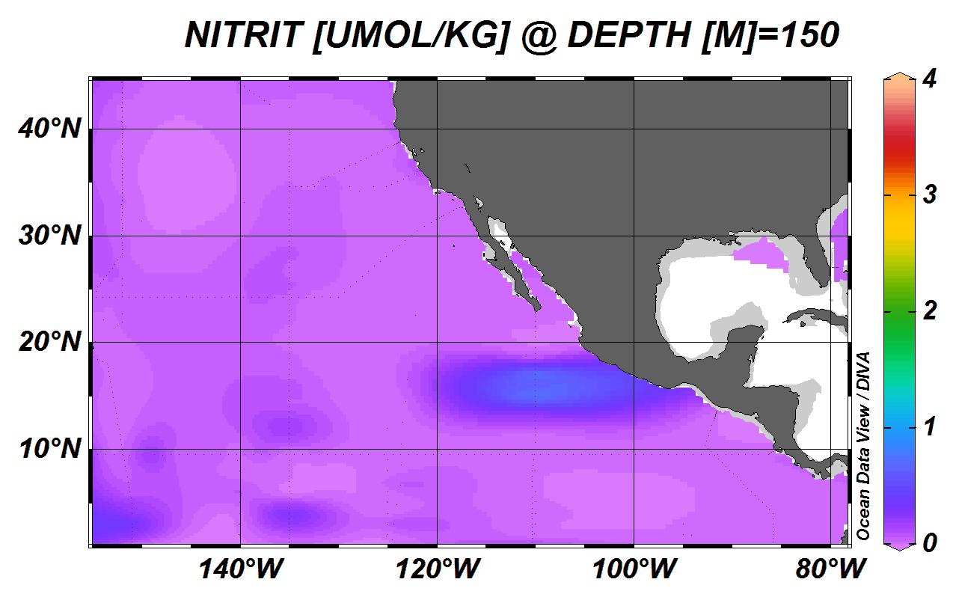
Based on both the data from 2016/17 and the data from 2012 from (Horak et al. 2016) there is consistently high nitrite between 100 and 300 meters. In the Horak et al. (2016) data the highest concentration at the time series station reached its maximum at 150 meters, while in 2016/17 it occurred at 300 meters. Nevertheless, it was very close to the concentration at 150 meters. As seen in Figure 4 the potential density of the high nitrite zone is fairly constant across time at about 26.5 kg/m³, which in the ETNP approximately correlates to 150 meters. Based on this information 150 meters was selected as the depth of the nitrite maximum, and the assumption for the purposes of this analysis was that it remained constant over time. It was further assumed that the time series station is representative of the ETNP region of study. In order to have a nitrite surface to work with in the ENTP at 150 meters the GLODAP gridded dataset of nutrients was used (Key et al. 2004).
Figure 6: Model for nitrite zone expansion in the ETNP. On the left is the original GLODAP nitrite data gridded in ODV. In the middle is the hypothetical data for 2012 where the GLODAP nitrite data values were increased ~500% so that the maximum nitrite value is 5.86 umol/kg. On the right is the hypothetical data for 2016 where the GLODAP nitrite data values were increased ~130% so that the maximum nirtie value is 1.49 umol/kg.
To model the expansion of the high nitrite zone in the ETNP I used the GLODAP data as a baseline and then changed nitrite concentration values to match the data from 2012 and then 2016. For each year the GLODAP data point were multiplied by a proportion to artificially raise the maximum value from the data set to the value that was observed in 2012 and 2016 respectively. This was meant to simulate a proportional change in microbial nitrite production at each data point since nitrite is a product of anaerobic respiration (Cline and Richards 1972, Lam et al. 2011). Then the data were gridded in ODV so that the area of high nitrite could be visualized. The resulting area of high nitrite is larger because ODV is interpolating between the values that remain zero (since any percent more productivity of zero is still zero) and the values that are higher in concentration.
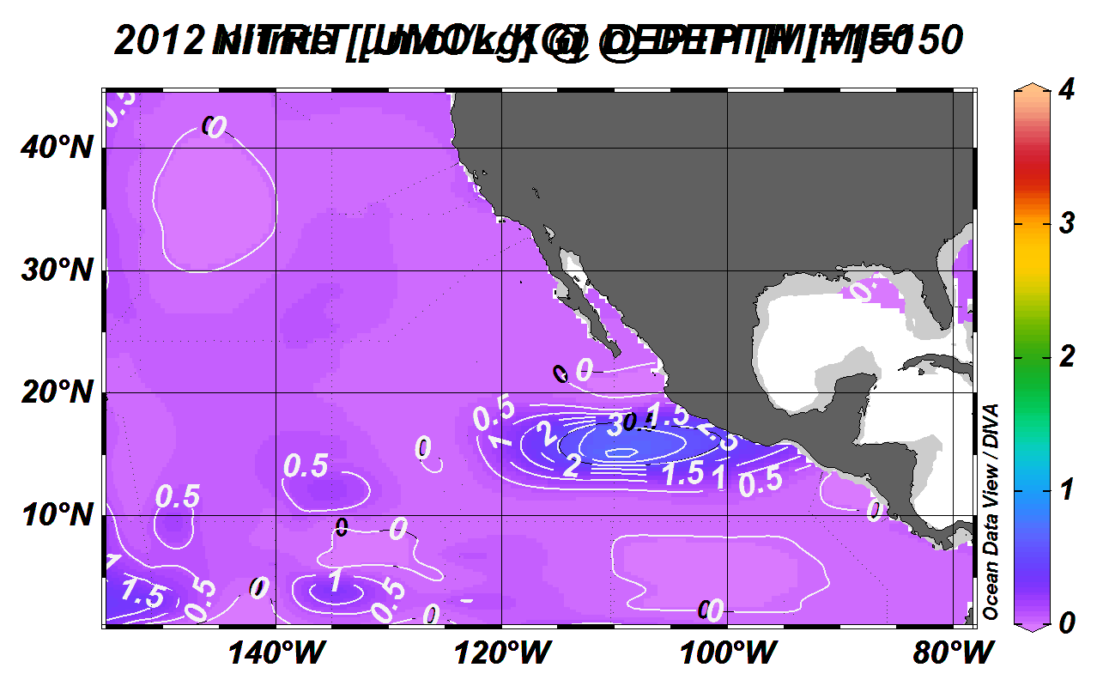
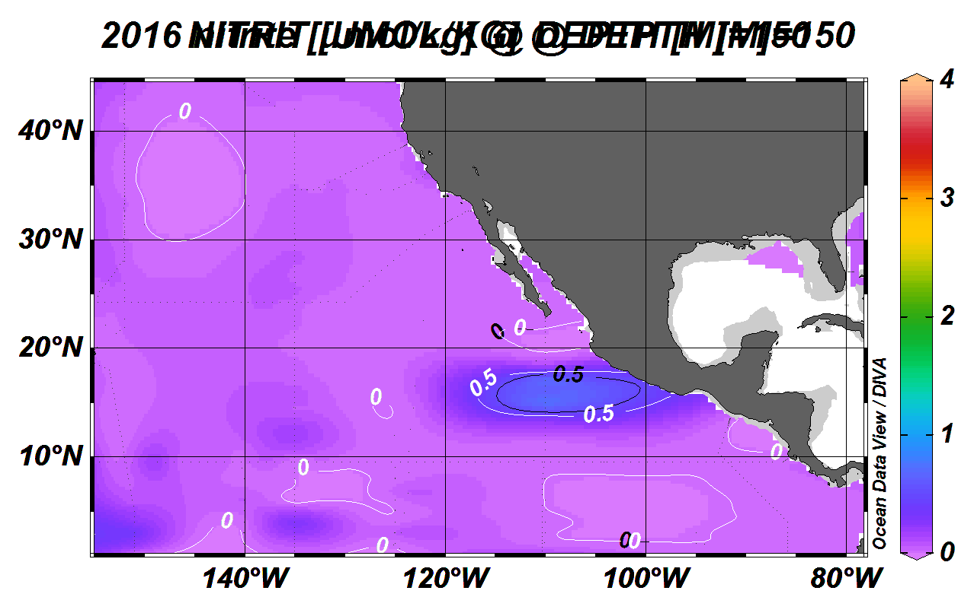
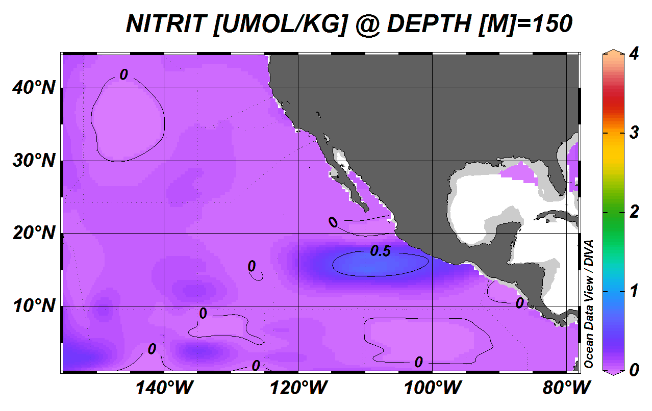
Though there is some expansion effect that is shown in these models it is not clear if or by how much the area of nitrite has expanded between the original data and the hypothetical data for each year. Overlaying contour lines helps illustrate the expansion (see Figure 7) and shows that 2012 represents more expansion that 2016, but that both show expansion from the original dataset.
2012 overlay
2016 overlay
Figure 7: Model for expansion including contour lines. Each map has the original GLODAP nitrite data mapped and the contour lines in black always represent the original GLODAP nitrite data. In the middle the figure is then overlaid with the hypothetical 2012 nitrite data in white contour lines, showing where the nitrite concentration above zero is outside the area defined in the original data. One the right the figure is overlaid with the hypothetical 2016 nitrite data in white contour lines, again showing where the nitrite concentration falls outside the area defined in the original data.
It is also clear from the 2012 model that there is a combined effect of expansion and intensification. The contour lines are much closer together from the hypothetical 2012 nitrite data than either the original or the hypothetical 2016 data sets even as it has the largest area of nitrite. This shows us that the nitrite zone has the potential to expand in area over time, even with only a small increase in nitrite production. It also shows that as the increase in nitrite production increases the area is likely to both expand and intensify. There is not enough spatial data over time to confirm these predictions, but this analysis serves to show that the nitrite zone in the ETNP is not stagnant. It would be valuable to have more evenly spaced nitrite data as well as better coverage through time to further investigate the change in the nitrite zone. If the nitrite zone does behave as this simple model predicts, we can assume that the OMZ also expands and contracts in area over time since it is unlikely that the nitrite zone would expand into areas that did not have an oxygen deficiency.

Conclusion:
Nitrite was measured in the same area of the ocean 5 times between 1972 and 2016/17 and at the same location in 2012 and 2016/17. While the nitrite concentration has been shown to increase over time, the high nitrite levels in 2012 were not maintained in 2016/17 and are likely an anomaly. Using the nitrite concentrations from 2012 and 2016/17 it is estimated that the spatial area of high nitrite concentration was expanded and intensified in 2012 compared to 2016/17. This in turn means that the oxygen minimum zone is likely smaller and less intense in 2016/17 than it was in 2012. More data with greater spatial coverage is needed to confirm these spatial changes, and continued monitoring of the zone is important to better understand the causes of changing concentrations. In light of climate change and speculation that OMZs will expand on a warming planet (Praetorius et al. 2015) continued study of this area is key to predicting and protecting the future of our oceans.
Acknowledgments: This work would not have been possible without the help and support of Al Devol, Wendi Ruef, and Rick Keil. Data was made available to me from Nicole Travis and Kathy Krogsland as for which I am very grateful. Thank you also to Anna Baker for allowing me to see and reference her results.
References
Bertrand, A., A. Chaigneau, S. Peraltilla, J. Ledesma, M. Graco, F. Monetti, and F. Chavez. 2011. Oxygen: A Fundamental Property Regulating Pelagic Ecosystem Structure in the Coastal Southeastern Tropical Pacific. Plos One 6.
Cline, J., and F. Richards. 1972. Oxygen Deficient Conditions And Nitrate Reduction In Eastern Tropical North-Pacific Ocean. Limnology and Oceanography 17:885-900.
Codispoti, L., and J. Christensen. 1985. Nitrification, Denitrification and Nitrous-Oxide Cycling in the Eastern Tropical South-Pacific Ocean. Marine Chemistry 16:277-300.
Froelich, P. N., G. P. Klinkhammer, M. L. Bender, N. A. Luedtke, G. R. Heath, D. Cullen, P. Dauphin, D. Hammond, B. Hartman, and V. Maynard. 1979. Early Oxidation of Organic-Matter in Pelagic Sediments of the Eastern Equatorial Atlantic- Suboxic Diagenesis. Geochimica Et Cosmochimica Acta 43:1075-1090.
Horak, R., W. Ruef, B. Ward, and A. Devol. 2016. Expansion of denitrification and anoxia in the eastern tropical North Pacific from 1972 to 2012. Geophysical Research Letters 43:5252-5260.
Howse, F. 1997. Chapter 10. The Determination of Nitrite in Sea Water. Pages 67-70. Bermuda Biological Station For Research, Inc., Bermuda Atlantic Time-series Study Methods.
Karstensen, J., L. Stramma, and M. Visbeck. 2008. Oxygen minimum zones in the eastern tropical Atlantic and Pacific oceans. Progress in Oceanography 77:331-350.
Key, R. M., A. Kozyr, C. L. Sabine, K. Lee, R. Wanninkhof, J. L. Bullister, R. A. Feely, F. J. Millero, C. Mordy, and T.-H. Peng. 2004. A Global Ocean Carbon Climatology: Results from GLODAP. Global Biogeochemical Cycles.
Lam, P., M. Kuypers, C. Carlson, and S. Giovannoni. 2011. Microbial Nitrogen Cycling Processes in Oxygen Minimum Zones. Annual Review of Marine Science, Vol 3 3:317-345.
Praetorius, S., A. Mix, M. Walczak, M. Wolhowe, J. Addison, and F. Prahl. 2015. North Pacific deglacial hypoxic events linked to abrupt ocean warming. Nature 527:362-379.

