Title: Effects of habitat structure on the size distribution and abundance of Hemigrapsus oregonensis in False Bay, Washington

Milly Marriott-Green
Biodiversity & Monitoring of Estuarine Ecosystems
Fall 2021

Keywords
- Shore crab
- Rock
- Substrate
- Ulva

Abstract
Climate change is transforming the biodiversity of intertidal communities with increasing speed through rising temperatures and anoxic conditions. One shallow water dwelling invertebrate that has very low tolerance to these conditions is Hemigrapsus oregonensis, normally found in estuary settings along the west coast of the United States. This study was focused on their presence in False Bay, located in the San Juan Islands in Washington State. There, two locations were sampled, one adjacent to False Bay Creek and another at Forest Creek. Each zone was sampled six times looking at the number of rocks, rock area, crab abundance, crab carapace width, and percent coverages of algal species. This data found relationships between habitat structure, crab abundance, and crab size distribution. In total 194 Hemigrapsus crabs were located with crabs preferring rocks that had a larger area for habitat. Two species of Hemigrapsus crabs were seen, H. oregonenesis and H. nudus. All crabs were located at Forest Creek, which had more algal species for shelter and food, as well as less opportunity for human disturbance. Algal species coverage, weather conditions, and human disturbance are all possible explanations for absence of crabs at False Bay Creek. This research can be applied to Hemigrapsus, and other shore crab species research, to further identify the relationship between habitat structure, crab abundance, and crab size distribution.

Introduction
Benthic invertebrates with little tolerance to hypoxic conditions, or conditions with low oxygen levels, are experiencing adverse effects on the development of their larval stages as global temperatures rise due to anthropogenic climate change (Eerkes-Medrano, 2013). Large changes in temperature increase stress on invertebrates, increasing metabolic rates and demand of oxygen, which ultimately depletes oxygen in the area (McBryan et al., 2013). As hypoxia increases in coastal waters with global temperature rises, as seen in the nearshore waters of the California Current Large Marine Ecosystem (Grantham, 2004), severe hypoxic and anoxic conditions will continue to generate mass loss of fish and benthic invertebrates (Chan et al., 2008).
One species that has been affected by changing environmental conditions is Hemigrapsus oregonensis, a shore crab species which primarily feed on algae, Ulva spp., and diatoms, but also feed on bivalves, marine worms, oysters and other small crabs (de Rivera, 2011; Dethier et al.,2019 ). This scavenging behavior changes the abundance and biodiversity of other species, one example being intertidal clam communities (Dethier et al., 2019), which are predated on by H.oregonensis and prefer to inhabit locations on the tide flat where the crabs are not located. Lehto et al, 1997, conducted research on protists/detritus as food for larval H. oregonensis that shows the impact of this wide variety of prey consumed by H. oregonensis. Their research found a link between abundance of carbon sources in the microbial loop and crab larvae diet to show how as food sources increase, the abundance of crabs also increases to use those resources. Spatial distribution of H. oregonensis can also be affected by predation by larger crabs, such as Cancer magister, and marine birds which changes food web relationships (McDermott, 2011). One of these changes to the food web is the introduction of parasites, such as metacercariae, to marine birds who feed on the shore crabs, which then spread the parasites across estuaries for other organisms to become host to (McDermott, 2011).
Research into the function of intertidal shore crabs on the west coast of the United States has found that species similar to H. oregonensis, mainly H. sanguineus (Asian shore crab), have strong preferences to shelter as adults but struggle to compete with other Hemigrapsus crabs for shelter as juveniles (Steinberg & Epifanio, 2011). This may have a direct effect on the size distribution of H. oregonensis in rocky intertidal areas as the spatial distribution of rocks can be variable, which limits shore crab habitat capacity and growth of species. Observations such as this one are especially important as research has shown that H. oregonensis is predisposed to certain water depths in larval stages, which affects “cross-shelf distribution” and substrate choice for settlement of adult intertidal invertebrates (Miller & Morgan, 2013 ). This means that dispersion of larvae greatly impacts what substrate type is chosen for adult invertebrates, which relates to similar research that shows how crab species use rock habitats as a way to avoid predation and desiccation (Steinberg & Epifanio, 2011). H.oregonensis have a preference for rock habitat as it provides a hiding place from other organisms and a wet environment that allows for increased water retention (Steinberg & Epifanio, 2011). Removal of rock habitats negatively affects different brachyuran species regardless of tidal height and is often seen as a dictator of intertidal zonation (Lohrer et al., 2000).
When looking at habitat preferences for H.oregonensis, substratum and tidal height are very important factors. H.oregonensis choose habitats that are less exposed lower banks of shore where they are able to burrow and hide in the silty clay (Sliger, 1982). Hemigrapsus crabs are also more likely to stay in burrows under coverage where there are more rocks present for them to stay under (McGaw, 2001). This was seen in research of the purple shore crab, H. nudus, where crabs tolerated lower salinity for longer periods of time when more shelter was present (McGaw, 2001). Study has also found that as habitat complexity increases, the abundance of shore crabs increases (McGaw, 2001; Steinberg & Epifanio, 2011).
Dispersion of species as a result of tidal height in the rocky intertidal can be examined on the west coast in places such as False Bay, San Juan Island, Washington. False Bay (48°49’0’’ N, 123° 6’60’’ W) is a 1600 meter-long estuarine tide flat and biological preserve owned by the University of Washington. This tide flat completely empties at certain low tides and has sediment types that range from fine clay to coarse cobbles and boulders providing habitat to many intertidal organisms including H. oregonensis. The bay receives input from the nutrient-rich waters of the Strait of Juan de Fuca and possible agricultural runoff from False Bay Creek. Additional nutritional input has been observed with possible uptake of Ulvoids within the bay (Berg, 2012).
Within False Bay, there are two main creek outflow streams, Forest Creek and False Bay Creek. False Bay Creek, is located near the bluff of the bay where there is a road, homes, and other possible sources of human disturbance. Forest Creek, is about 625 meters away from the major road and False Bay Creek. Studies indicate that crab species decrease in abundance as levels of human disturbance increase. Lucrezi et al, 2009, support this in their research of two beach areas in urban Australia, one with high human disturbance levels, one with low level human disturbance, finding ghost crabs decreased in density at the sight with low level human disturbance and burrow counts varied between locations. This was important to consider in the study of Hemigrapsus crabs in False Bay as the two environments available provide very different ecological niches, similar to this study of ghost crabs.
The primary objective of this study was to determine the relationship between rock coverage, substrate type, abundance and size distribution of H. oregonensis in False Bay. Two hypotheses were formed that addressed these relationships: Firstly, larger size classes of H. oregonensis would be found in areas with more coarse grain sizes and larger rocks as there is greater opportunity for habitat. Secondly, H. oregonensis would be less abundant along the sampling area closest to False Bay Creek, due to an increased chance of human disturbance and desiccation from low tides.
The study of H. oregonensis is important to evaluate the role of habitat conditions and structure in variability of the abundance and size distribution of crabs found on the shores of rocky intertidal zones.
Methods
To address the main objective of this study, the locations in False Bay where H.oregonensis are found and what habitat characteristics define these locations was determined. Determinations of whether substrate type and size affects the size distributions of these crabs was also made. Locating H.oregonensis was dependent on the ability to sample a variety of surface sediment sizes, ranging from very coarse pebbles to cobbles. A range of rocks between 6 and 45 centimeters long were chosen as representative habitat for sampling of H.oregonensis as preliminary findings found these to be ideal habitats in False Bay. The environmental conditions of the habitat were also important factors when determining how best to locate this species, as substrate could not be too dry or too anoxic for survival. This was measured qualitatively through looking at the color of the substrate and feeling for moisture in sediment when sampling.
There were two sampling locations for this project, False Bay Creek and Forest Creek. Each location was chosen based on availability of shore crab habitat and suitable substrate conditions (Fig. 1). Availability of habitat was determined by walking the length of each creek and marking where rock formations started and ended. Suitable substrate conditions were determined based on sediment hydration, which when too low decreases fitness of H. oregonensis. The perimeter of each zone was taken using a GPS device, then area was calculated. The area of the sampling zone at Forest Creek was 720 m² and 1408 m² at False Bay Creek. Each zone was repeatedly sampled with a 1 m² quadrat eight times on six separate occasions. In total, 96 spots were sampled between the two zones.
Studies have shown that H. oregonensis do not require consistent prey availability or adequate light conditions to catch their prey to continue their development (Sulkin, 1998). This means that locating this species is dependent on flipping over and inspecting large rock habitats rather than prey availability. The feeding habits of H. oregonensis are not dependent on the time of day, so it was not taken into account when considering sampling time. Preliminary observations taken at the estuary in False Bay, Washington, between September and October of 2021 suggest that ideal rock habitats are between 6 and 20 cm wide ranging from cobbles to boulders on the Wentworth Grain Size Scale. As smaller crabs, H. oregonensis are quite mobile; researchers have attempted to capture and study them using pitfall traps; however, visually counting H. oregonensis is more accurate (Kent &McGuiness, 2006).
Rock coverage is patchy within False Bay and to ensure varied rock habitats were sampled, sampling zones contained a range of rock sizes. Random sampling within each quadrat was done by automatically selecting the first small rock ( > 6cm wide) and the largest rock for inspection. The first rock measured between those two sizes was labeled the medium rock and then inspected. In total, 288 rocks were inspected for H. oregonensis. Rocks were eligible for inspection based on their composition and habitability for H. oregonensis. Eligible rocks were mostly composed of granite, basalt, and other igneous amalgamations. Rocks that were not suitable for crab habitats (buried too deeply, too large to flip over) were not included in rock counts.
Rock inspection was performed by using a ruler to measure the length and width of the rock, then the rock was flipped and specimens were placed into a tupperware container for counting. Specimens were identified as H. oregonensis through their distinctive square carapace, wide-set eyes, and three marginal teeth located on the left and right frontal portion of their carapace (Waldrop, 2015; Heibert et al., 2015). Small handheld nets and latex gloves were used to gather specimens until they could be transferred to tupperware for sizing. Calipers were then used to measure the carapace of each crab, which historically have an average width of 35mm (Waldrop, 2015). All specimens were then released upon completion of measurements.
Quadrat location was determined by randomly generating a number of paces to walk along the edge of each sampling zone at a designated spot. Paces averaged a speed of 1.59 m/s. This method is primarily used in ecology to visually identify plant species in the field and works by having a square device with cross sections that allow for calculations of percent coverages (Schmida, 1984). Within each 1m² quadrat, the number of rocks were quantified and three rocks were chosen to inspect for crabs. After quadrat sampling was complete, a smaller quadrat (0.0625 m²) was placed adjacent to the top right corner of the large quadrat to do secondary visual identifications of substrate type. Substrate was classified as primarily sand, mud, clay, boulder, cobbles, or pebbles.
Statistical analysis was conducted using R to compare the mean carapace width(mm) of H. oregonensis between the Forest Creek replicates by calculating mean, standard deviation, and conducting linear modeling to establish relationships and significance of findings (R Core Team, 2020). To test habitat preference for small, medium, or large rock areas, linear models with the response of mean crab width (mm) against rock class were conducted for each rock class. Linear modeling was also used to compare coverage of seaweed and algal species at each sampling location with linear models that had a response of mean coverage against location.
Results
Throughout the six replicates of study, Forest Creek yielded a total of 194 shore crabs. 190 shore crabs were H. oregonensis and 4 shore crabs were H. nudus. False Bay Creek yielded a total of 0 shore crabs. Mean crab carapace width calculations found that Forest Creek replicate 1 yielded the highest mean at 12.78 mm (5.16 SD) and replicate 2 yielded the lowest at 4.93 mm (4.25 SD) (Figure 2). Forest Creek replicate 3 had a mean carapace width of 6.67 mm (4.53 SD), replicate 4 had a mean of 6.5 mm (4.14 SD), 5 had a mean of 10.50 mm (0.71 SD), and 6 had a mean of 11.2 mm (4.45 SD). The average carapace width of H. oregonensis overall was 8.4 mm. The mean carapace width of H. oregonensis found under small rocks was 5 mm, 8 mm under medium rocks, and 9 mm under large rocks. Across the six Forest Creek replicates, H.nudus was seen on three separate occasions. The average carapace width of H. nudus observed was 11.25 mm. Statistical analysis found that carapace width had a positive relationship to rock class size (p=0.05). The mean carapace width of H. oregonensis found under small rocks was 5 mm, 8 mm under medium rocks, and 9 mm under large rocks. The average area of large rocks was 0.0258 m², medium rock average area was 0.0142 m², and small rock average area was 0.0063 m².

The most common sizes of shore crab observed were crabs with a carapace width of 2mm and those with a 10mm width (Figure 3). 45 crabs had a carapace width of 10mm and 45 shore crabs had a carapace width of 2mm. All other ranges of carapace width between those had a count below 20. The largest H. oregonensis observed had a carapace width of 24mm and the smallest had a carapace width of 2mm.
Results also showed that as rock class size increased, abundance of crabs under them also increased with mean abundance having significant, positive relationship to rock area for each class size (p<0.001) (Figure 4). When looking at mean carapace width versus rock class, H. oregonensis had a mean carapace width of 15 mm under large rocks, 20 under medium rocks, and 12 under small rocks. The amount of crabs seen was highest under the large rock class with a value of 116 crabs. 55 crabs were under the medium rock class and 19 crabs under the small rock class (Figure 5).
Analysis of the mean area of each rock class versus mean crab abundance per class shows that there is a higher abundance of shore crabs found under rocks with a larger area. This is apparent as small rocks had an average abundance between 0 and 0.5 crabs, medium rocks between 0 and 2 crabs, and large rocks between 0 and 5.5 crabs.
Other environmental variables, such as availability of shelter under Ulva spp., kelp and red algae were analyzed to determine their significance to crab abundance (Figure 6). At the Forest Creek sampling zone, I found that average Ulva coverage was 37.6%, average kelp coverage was 8%, and average red algae coverage 0.63%. At the False Bay Creek sampling zone average Ulva coverage was 3%, average kelp coverage was 1.19%, and average red algae coverage was 0.35%. Red algae coverage was considerably lower in both locations (Table 1). Statistical analysis found a strong significant, positive relationship between Ulva coverage and location (p<0.001).
Discussion
This study aimed to understand the relationship between habitat, abundance, and size distribution of H. oregonensis in False Bay. It was hypothesized that larger sizes would be found among more coarse grains and larger rock size classes. Results show that this hypothesis was supported as there was a higher crab abundance under large rock class sizes. Statistical analysis also showed that habitat structure has a positive relationship to size of carapace width. It was also hypothesized that there would be a lower abundance of H. oregonensis at False Bay Creek. Results show that this hypothesis was also supported as there were no crabs found in False Bay Creek and there were 194 found at Forest Creek.
The results of this study have identified that H.oregonensis is more abundant under larger rock classes and although the species H. nudus was also observed, the amount observed was not enough for statistical analysis or comparison. Unlike originally anticipated, crab size was variable under each rock class. Although the average carapace length per rock class suggests that smaller shore crabs prefer smaller rocks and larger shore crabs prefer large rocks.
There were no species of share crab observed in any replicates conducted in False Bay Creek. Weather conditions could be contributors to the absence of species in this location as research has shown some shore crab species prefer higher temperatures and salinities. Todd & Dehnel, 1960, conducted research on heat and salinity tolerance for H. oregonensis and H. nudus which found that both species of crab prefer high heat and high salinity. As sampling was conducted in the fall, temperatures were lower and freshwater input was increased due to increased precipitation. Colder temperatures and lower salinities observed post storm may be why there was a lower abundance of crabs in later replicates of this study, as it was interrupted by atmospheric change.
Average carapace widths of crabs observed in False Bay were different than expected as they were about half the average width of an adult shore crab. Preliminary observations of crabs in False Bay suggested that Hemigrapsus crabs would be of similar sizes under each rock inspected, however, results in the Forest Creek sampling zone found that very small crabs and larger crabs were discovered under the same rock habitats. This is a possible implication of recruitment of crabs within that section of the bay. As new individuals are added to a population, different sizes of individuals are observed as was found in this study. Groups of smaller sized crabs (2 mm in width) and larger crabs (10 mm in width) seen together mean that one group came later, or was recruited, into the area. This is a possible explanation for why shore crabs did not reach the average carapace width of an adult Hemigrapsus crab during sampling as growth was still occurring.
Environmental differences between the sampling zones may be a factor in the abundance of crabs observed. More Ulva was present at False Bay Creek than Forest Creek, meaning there was less suitable habitat cover and food sources for crabs. In this study, more organisms, algae and Ulva were available as food and shelter at Forest Creek when compared to False Bay Creek. This makes Forest Creek more preferable for shore crab species to inhabit as increased shelter and food means increased fitness. This observation relates to Lehto et al., 1997, who found that Hemigrapsus crabs utilize a variety of prey. This means that as food sources increase, carbon sources increase and shore crab species increase to use those carbon sources.
Less human disturbance at Forest Creek than False Bay Creek could be another contributing factor in why differences in abundances between sampling zones was seen. As studies have shown that human disturbance impacts the presence and habitat usage of crab species (Lucrezi et al., 2009), the location of False Bay Creek near the main road provides far more opportunity for interference and absence of crabs.
Other environmental conditions that differed between the sampling zones were sediment hydration and range of rock size. Forest Creek had more variable rock sizes and large boulders than False Bay Creek. False Bay Creek also had less hydrated sediment than Forest Creek as it was at a higher tidal zone, meaning there was more opportunity for drying. These were noted as personal observations seen throughout this study. Weather conditions may have also been an important factor in differences seen through sampling due to salinity differences brought on by increased freshwater input from major storms occurring in the area between replicate 3 and 6 of sampling.
In order to get a more accurate crab abundance for the False Bay Creek sampling zone, post storm, pitfall traps were laid at False Bay Creek to determine crab abundance. On two separate occasions, a set of five pitfall traps were placed with GPS locations marked. The first set of traps were left for two hours, the second set of traps were left for 24 hours. Pitfall traps failed to accurately show crab abundance in False Bay Creek as none were found in either set.
These findings are important to fill knowledge gaps in the understanding of shore crab species in False Bay, Washington. They are also important to the understanding of habitat structure complexity in estuaries throughout the world as movement of shore crabs throughout the intertidal give way to variability in biodiversity and topography of ecosystems that help to understand presence and absence of intertidal organisms.
Future Directions
In conclusion, habitat structure has a clear effect on the size distribution and abundance of shore crab species in False Bay, Washington. The results of this study can be applied to shore crab research in estuaries across the globe and replicated to further establish the relationship between habitat structure, abundance, and size distribution of shore crabs. Further research should aim to compare zones in estuaries where rocks are patchy versus dense to look at habitat utilization and the relationship to abundance further.
The next question coming out of these results is; how do environmental conditions change the way shore crab species utilize rock habitat? This question is important as both sampling zones provided such unique living conditions in False Bay and had such varied results between them.
If this study was conducted again, elevation and oxygen measurements should be included. More data on the abundance of shore crabs throughout False Bay, not just near the two creek mouths, would be necessary to learn more about the primary habitats of shore crab species in False Bay. Research should also include determining life stages of shore crabs in estuaries to determine the locations of adult Hemigrapsus in the future within False Bay. This would allow a deeper understanding of exactly how shore crabs utilize rock structures for breeding, shelter, and feeding purposes.

Acknowledgements
I would like to thank Mariah Josten, Monica Groth, Erika Merto, and Brooke Sullivan for assistance in the field when conducting research. I would like to thank Wesley Hull, Alan Trimble, and Megan Dethier for assistance in the methods and interpretation of results for this project. I would like to thank Wendel Raymond and Rob Hoekendorf for assisting me in conducting statistical analysis and data modeling for this project. I would like to thank Jack Rosen for assistance in the proof-reading and editing of this paper. I would also like to thank Friday Harbor Labs for lending lab spaces and equipment to conduct this research.

Citations
Berg, E. 2012. Nutrient Pollution and Effects on the Water, Sediment, and Ulvoid species creating Green Tides in False Bay, San Juan Island, WA. Department of Environmental Science 1:1-12.
Chan,F., Barth, J.A., Lubchenco, J., Kirincich, A., Weeks, H., Peterson, W.T., & Menge, B.A. 2008. Emergence of anoxia in the California Current Large Marine Ecosystem. Science 319: 920
Dethier, M.N., et al. 2019. Vulnerability of juvenile clams to predation by shore crabs. Aquaculture 506: 350-354.
de Rivera, C. E., Grosholz, E. D., & Ruiz, G. M. 2011. Multiple and long-term effects of an introduced predatory crab. Marine Ecology Progress Series 429: 1-11.
Eerkes-Medrano, D., Menge, B. A., Sislak, C., & Langdon, C. J. 2013. Contrasting effects of hypoxic conditions on survivorship of planktonic larvae of rocky intertidal invertebrates. Marine Ecology Progress Series 478:139-151.
Hiebert, T.C., Butler ,B.A., & Shanks, A.L. 2015. Oregon Estuarine Invertebrates: Rudys' Illustrated Guide to Common Species. Oregon Estuarine Invertebrates: Rudys' Illustrated Guide to Common Species 3rd edition.
Grantham, B.A., Chan, F., Nielsen, K.J., Fox, D.S., et al. 2004. Upwelling-driven nearshore hypoxia signals ecosystem and oceanographic changes in the Northeast Pacific. Nature 429: 749−754.
Kent, C.S. , and McGuinness, K.A. 2006. A comparison of methods for estimating relative abundance of grapsid crabs. Wetlands Ecology and Management 14.1: 1-9.
Lehto, J.A. 1997. The use of protists and detritus as a diet for the first zoeal stage of the brachyuran crabs Cancer magister and Hemigrapsus oregonensis .MS thesis.
Lohrer, A.M., Fukui, Y., Wada, K., & Whitlatch, R.B. 2000. Structural Complexity and Vertical Zonation of Intertidal Crabs, with Focus on Habitat Requirements of the Invasive Asian Shore Crab, Hemigrapsus Sanguineus (de Haan). Journal of Experimental Marine Biology and Ecology 244(2): 203–17.
Lucrezi, S., Schlacher, T.A. & Walker, S. 2009. Monitoring human impacts on sandy shore ecosystems: a test of ghost crabs (Ocypode spp.) as biological indicators on an urban beach. Environ Monit Assess 152: 413–424
McBryan, T.L., Anttila, K., Healy, T.M., & Schulte, P.M. 2013. Responses to Temperature and Hypoxia as Interacting Stressors in Fish: Implications for Adaptation to Environmental Change. Integrative and Comparative Biology 53(4):648–659.
McDermott, J. J. 2011. Parasites of shore crabs in the genus Hemigrapsus (Decapoda: Brachyura: Varunidae) and their status in crabs geographically displaced: a review. Journal of Natural History 45: 2419-2441.
McGaw, I. J. 2001. Impacts of Habitat Complexity on Physiology: Purple Shore Crabs Tolerate Osmotic Stress for Shelter. Estuarine, Coastal and Shelf Science 53(6): 865–76.
Miller, S. H., and Morgan, S. G. (2013). Interspecific differences in depth preference: Regulation of larval transport in an upwelling system. Marine Ecology Progress Series 476: 1-6.
R Core Team (2020). R: A language and environment for statistical computing. R Foundation for Statistical Computing, Vienna, Austria. URL https://www.R-project.org/.
Shmida, Avi. 1984. Whittaker's plant diversity sampling method. Israel Journal of Botany 33.1: 41-46.
Sliger, M.C. 1982. Distribution and microhabitat selection of Hemigrapsus oregonensis(Dana) and Pachygrapsus crassipes Randall in Elkhorn Slough, Monterey County, California. MS thesis. Calif. State University, Hayward.
Steinberg, M.K., and Epifanio, C.E. 2011. Three's a crowd: Space competition among three species of intertidal shore crabs in the genus Hemigrapsus. Journal of experimental marine biology and ecology 404: 57-62.
Sulkin, S., Blanco, A., Chan, J. et al. 1998. Effects of limiting access to prey on development of the first zoeal stage of the brachyuran crabs Cancer magister and Hemigrapsus oregonensis . Marine Biology 131: 515–521.
Todd, M.E., & Dehnel, P. 1960. Effect of temperature and salinity on heat tolerance in two grapsoid crabs, Hemigrapsus nudus and Hemigrapsus oregonensis. The Biological Bulletin 118:150-172.
Waldrop, L., Hann, M., Henry, A., Kim, A., Punjabi, A., and Koehl, M. 2015. Ontogenetic changes in the olfactory antennules of the shore crab, Hemigrapsus oregonensis , maintain sniffing function during growth. Journal of the Royal Society 102: 1-11.
Wentworth, C. 1922. A scale of grade and class terms for clastic sediments. The journal of geology 30.5: 377-392.
Tables:

Table 1: Mean percent coverage and standard deviation of algal and seaweed species
Cover Type | Location | Mean Percent Coverage (%) | SD Percent Coverage
Ulva | False Bay Creek | 3.06 | 8.64
 | Forest Creek | 37.56 | 39.19
Kelp | False Bay Creek | 1.19 | 4.02
 | Forest Creek | 8.96 | 16.26
Red Algae | False Bay Creek | 0.35 | 1.16
 | Forest Creek | 0.63 | 2.65

Figures
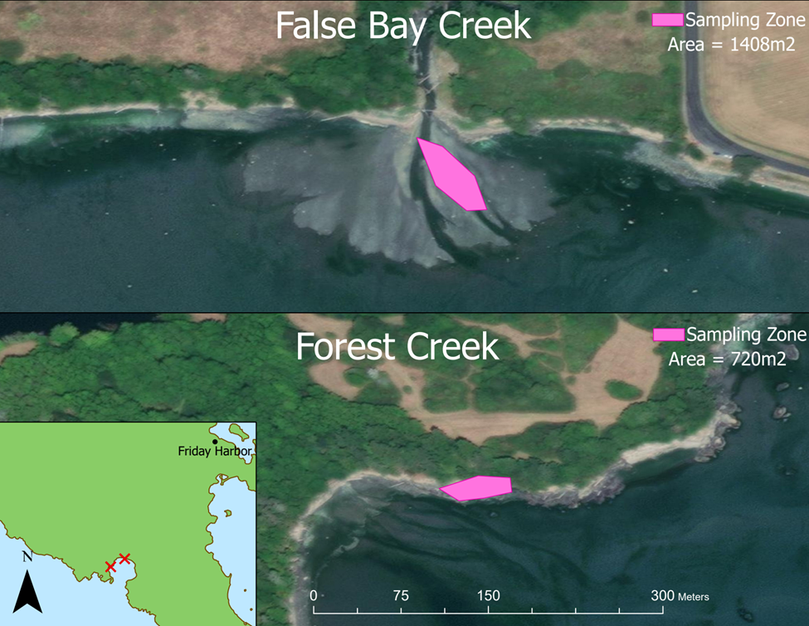
Figure 1: Map of sampling locations in False Bay. Top image is False Bay Creek located at 48°29'25.48"N, 123° 4'5.93"W. Bottom image is Forest Creek located at 48°29'14.83"N, 123° 4'33.84"W. False Bay Creek sampling zone area 1408 m². Forest Creek sampling zone area 720m².

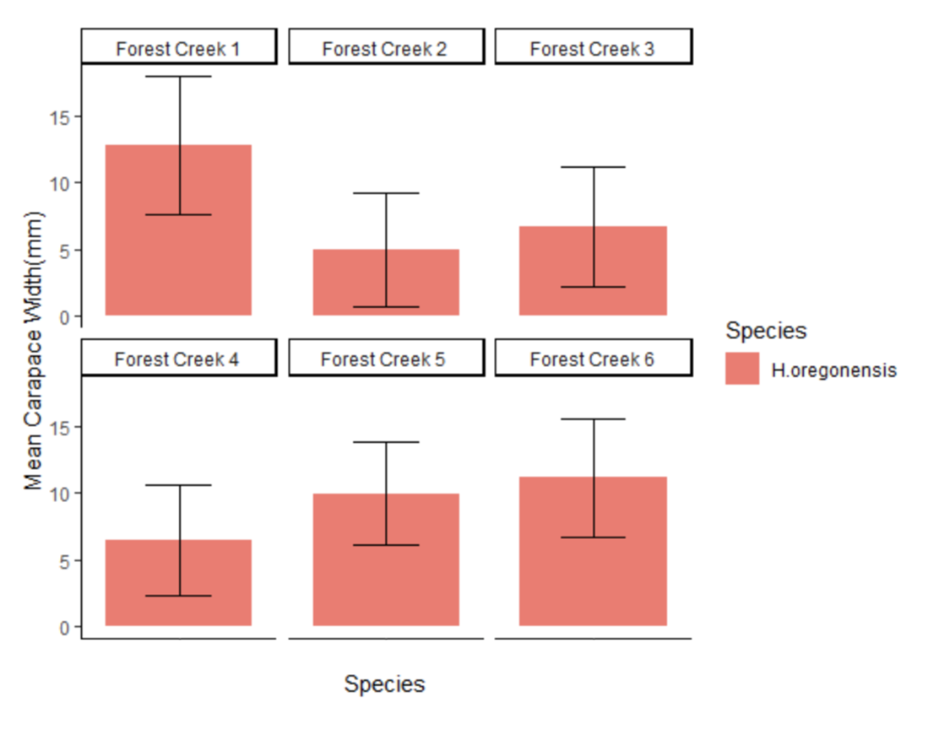
Figure 2: Mean carapace width of H. oregonensis (mm) by replicate in Forest Creek. Error bars indicate the standard deviation of these averages.

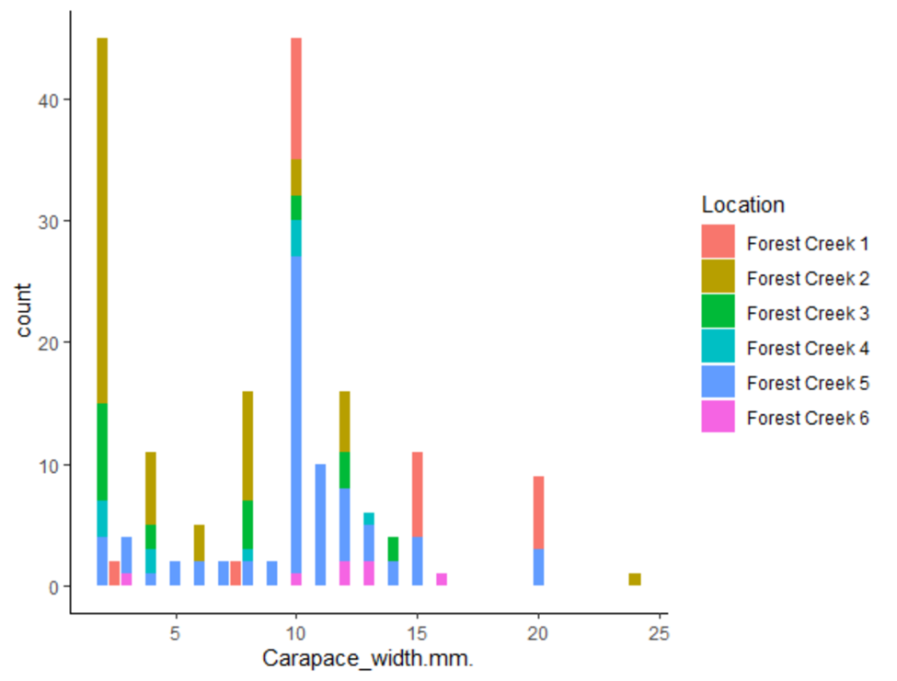
Figure 3: Carapace width of H. oregonensis (mm) by count.

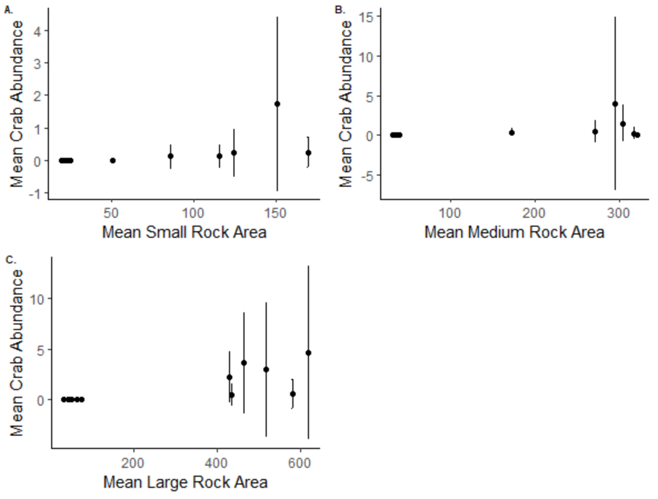

Figure 4: Mean crab abundance by mean rock area of each rock class size. Each dot represents a temporal replicate of sampling. Mean abundance had a significant, positive relationship to rock area for each class size (p<0.001).

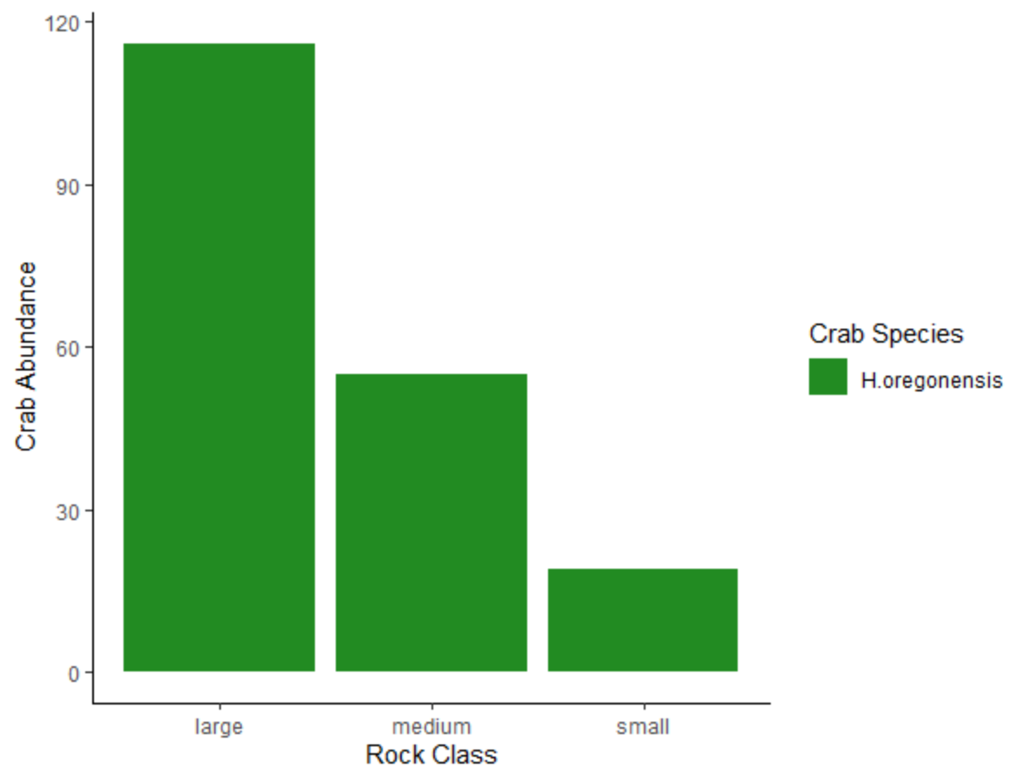
Figure 5: Crab abundance by rock class.

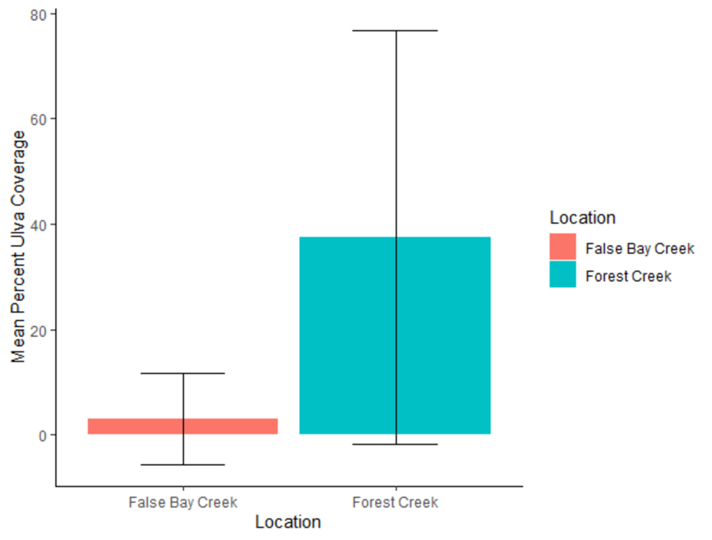
Figure 6: Mean percent Ulva spp. coverage for each location.

