Impact of the Implementation of the Croup Clinical Standard Work Pathway in the Urgent Care and Emergency Department Settings in an Academic Pediatric Center

Jeanne Mouiche Anyouzoa

A thesis
submitted in partial fulfilment of the
Requirements for the degree of

Master of Public Health

University of Washington
2018

Committee:
Mark Oberle
Usha Sankrithi
Julianne Bishop

Program Authorized to Offer Degree:
School of Public Health

©Copyright 2018
Jeanne Mouiche Anyouzoa

University of Washington

Abstract

Impact of the Implementation of the Croup CSW Pathway in the Inpatient Length-of-Stay and Readmission Rates Realized at an Academic Pediatric Center

Jeanne Mouiche Anyouzoa

Chair of the Supervisory Committee:
Mark Oberle
Department of Health Services

Objective: To determine the impact of the implementation of the Croup Clinical Standard Work (CSW) pathway in an academic pediatric center (Seattle Children’s Hospital), with the overarching goal of standardizing delivery of care for croup.
Aims: Analyze variations in the use of resources (e.g., dexamethasone, racemic epinephrine, and chest and neck radiographs) in the management of croup in Urgent Care and Emergency Department before and after implementing the Croup CSW Pathway; describe the relationship between resource utilization and patient outcomes including admission rates, length of stay (LOS), return to the emergency department for croup within 7, 14, 21, and 30 days, and readmission rates.

Study design: Our study is a retrospective analysis of patients diagnosed with croup in ED and UC between January 1, 2010 and December 31, 2017. The study population consisted of patients aged 6 months to 6 years. We obtained demographic data on gender, age, and race. We compared resource utilization and patient outcomes in Pre-CSW period vs. Post-CSW period.

Results: There were 2,101 croup patients in the Pre-CSW pathway (353 in UC and 1,748 in ED) and 5,917 croup patients in the Post-CSW pathway (2,552 in UC and 3,365). Analysis shows noticeable changes in the management of croup in UC vs. ED. Dexamethasone administration shows a 3.83 percentage point increase in UC and a 1.97 percentage point decrease in ED (with a p-value of 0.0242 and 0.0355 respectively). Racemic epinephrine use decreased 6.95 percentage points in the UC (with a p-value of 0.0001). Statistically significant differences in inpatient length of stay between Urgent Care Pre-CSW vs. Emergency Department Pre-CSW, and Urgent Care Post-CSW and Emergency Department Post-CSW suggest significant variations in patient outcomes in both settings.

Conclusions: Noticeable changes in the management of croup in the UC and ED at Seattle Children’s occurred after the implementation of the CSW pathway. The Emergency Department decreased the administration of racemic epinephrine and dexamethasone. But Urgent Care increased dexamethasone administration.

Introduction
Croup (laryngotracheobronchitis) is a common cause of upper airway obstruction in children aged 6-36 months, with a peak incidence at 12-24 months of age, and with a male predominance of 3:2.^{1,3} Hoarseness characterizes croup as well as, barking cough, inspiratory stridor and variable respiratory distress due to upper airway inflammation and swelling of the subglottic mucous membrane.⁶ Symptoms are usually worse at night and usually resolve within 48 hours. ⁴ Non-specific symptoms such as cough, rhinorrhea, and fever often precede croup symptoms.^{2,3}
There is increasing evidence of the existence of an immunological component for the acute laryngotracheobronchitis. Some studies report that children with croup caused by parainfluenza viruses had higher titers of both parainfluenza virus-specific IGE, and histamine in their nasal secretion, in comparison with children who had only an upper respiratory tract infection caused by parainfluenza virus.³ Viral invasion of the subglottic mucosa causes inflammation and edema, leading to narrowing of the upper airway. This narrowing increases the pressure gradient necessary to move air through the upper airway leading to increased breathing effort. This may result in fatigue of the respiratory muscles and subsequently lead to respiratory failure, requiring emergency intubation. However, croup is mostly mild and transient and resolves with supportive care. Systemic, oral, or nebulized corticosteroids are the currently accepted treatment for moderate to severe cases, supplemented in more severe cases by nebulized epinephrine and oxygen.⁶ To provide some perspective on this problem, over half of children with a history of croup develop increased airway hyperactivity and have abnormal pulmonary function after the acute episode.³
Today’s standard management of croup includes racemic epinephrine, which provides only temporary relief, and steroids. The use of steroids for the treatment of viral croup has been controversial until recent studies have shown that there is a reduction in the length and severity of illness.⁵ Past recommendations against the routine use of steroids in patients with croup have stressed the potential for infrequent but serious gastrointestinal hemorrhage, and other adverse effects after dexamethasone therapy. This concern still exists despite evidence of a decline in hospital admission rates, fewer intensive care unit admissions, and shorter lengths of stay with the use of steroids.^{3,5}
Though the use of steroids is now well accepted, there exists a great deal of practice variability in the dose and route of administration. Some studies show that intramuscular dexamethasone and inhaled budesonide are effective in relieving the symptoms of croup as early as six hours after treatment, with outcomes like oral dexamethasone. However, comparing intramuscular dexamethasone with nebulized budesonide, intramuscular dexamethasone results in more rapid improvement.⁵ At a dosage of 0.6 mg/kg for a maximum dosage of 16 mg a day, there is no difference between oral and intramuscular dexamethasone. In a large study⁴, a clinical comparison with prednisolone also concluded that dexamethasone and prednisolone are equally effective at 6 and 12 hours, but with readmission more likely with prednisolone.
While most children with croup have mild presentation of the disease, a small minority have severe symptoms characterized by marked chest wall retraction, agitation and lethargy. Treatment with corticosteroids and nebulized epinephrine (adrenaline) are usually administered concurrently to reduce respiratory distress, with the knowledge that corticosteroids improve symptoms, but it takes time for its beneficial effects to be fully achieved. Nebulized epinephrine is associated with clinically and statistically significant transient reduction of symptoms at 30 minutes post-treatment. It works by causing mucosal vasoconstriction and reduction of subglottic edema,⁴ but may result in dose-related adverse effects including tachycardia, arrhythmias and hypertension, and its benefit may be short-lived.⁶

Background

Definition
Laryngotracheobronchitis (commonly known as ‘‘croup’’) is a common pediatric respiratory illness affecting approximately 3 out of 100 children with an annual incidence ranging from 1.5% to 6%. It represents a common reason for presentation to primary care physicians and emergency departments (ED).^{7,8} Croup mainly affects children aged between 6 months and 3 years. However, it can occur in babies as young as 3 months of age and in adolescents, with the highest rate of occurrence happening during the second year of life. As many as 6% of children with croup require hospitalization in the United States annually.^{7,9,10}
Croup is more common in boys than in girls, with males 1.43 times more likely to be diagnosed with the disease.^{9,10} Furthermore, males and infants have a higher risk of hospitalization compared to females and older children. Among young children (2 years old and under) presenting to the emergency department with croup symptoms, approximately 8% are hospitalized and fewer than 1% are admitted to the pediatric intensive care unit.¹¹ The incidence of the infection exhibits a seasonal and biennial trend, peaking in autumn and winter but can occur at any time. Larger peaks have been reported in alternating years and in the fall and winter months; summer months have the fewest cases.⁷ Overall, croup affects more than 1.4 million children annually for an estimated cost of $56 million annually in the United States.¹²

Brief History of Croup
The word croup derives from the Anglo-Saxon ‘kropan’ meaning to cry aloud.¹³ In I765, Dr. Francis Home of Edinburgh added “Croup” to the lexicon of scientific medicine with his Inquiry into the Nature, Cause, and Cure of Croup. Until then, it was only a popular term in Scotland and Sweden for stridulent breathing, crowing or croupy respiration.¹⁴ It seems to have started getting wider acceptance and use in the nineteenth century, specifically in 1873, when the New York Foundling Asylum opened its hospital near Lexington Avenue, New York, with Joseph O’Dwyer as one of the newly appointed physicians. It was there that O’Dwyer encountered the ravages of diphtheria in young children and its lethal accompaniment–diphtheritic croup. The management of croup, and more specifically the maintenance of an airway in the more extreme cases, was to become an obsessional focus of O’Dwyer’s work.
Before the advent of treatment with corticosteroids and racemic epinephrine for severe croup, intubation and tracheotomy were typical treatments and death was common. Treatment has evolved from barbaric methods including bleeding and application of leeches, through mist kettles (pots of boiling water), mist rooms, and mist tents, to the current evidence-based practice of corticosteroids and epinephrine delivered via nebulizer.¹⁵ Oxygen, analgesics, antipyretics, antibiotics, antitussives, decongestants, and short-acting β2 agonists were also used for the management of croup, with the widespread consensus that these treatments are beneficial in these circumstances, even though there was no published evidence of their efficacy in managing signs of respiratory distress. Oxygen administered via a plastic hose with the opening held within a few centimeters of the nose and mouth (also referred to as “blow-by oxygen”) will not agitate a child. The use of analgesics or antipyretics can reduce fever or discomfort in children with croup. Since croup has a viral cause, the use of antibiotics is unreasonable unless superinfections (e.g., bacterial tracheitis and pneumonia) arise. Furthermore, the lack of physiologically rational basis for the use of antitussives or decongestants argues against their administration. Lastly, in view of the pathophysiology of croup as an upper-airway disease, we found no valid reasons for the continued use of short-acting β2 agonists for treatment of croup.¹⁵
Other historical treatment approaches included exposure to cold atmospheric air at home, and humidified air in hospitalized children even though there is no scientific evidence to support that exposing children with croup to chilly air reduces the intensity of symptoms, nor that the use of humidified air to treat hospitalized patients has shown any improvement in the case of mild-to-moderate croup.¹¹

Etiology
Viral infection is the most common cause of croup. The most common causes of laryngotracheitis croup are parainfluenza viruses (types 1, 2, 3 and 4), accounting for up to 80% of cases—with Parainfluenza I serving as the leading pathogen.^{9,11} Other causative viruses are respiratory syncytial virus (RSV), influenza A and B viruses, human metapneumovirus, adenovirus, enterovirus, influenza virus, Mycoplasma pneumoniae (M. pneumoniae) and human bocavirus. Co-infections by more than one viral agents such as rhinovirus and respiratory syncytial virus are not uncommon.^{6,9,11} There is a growing body of research that found that a family history of croup among siblings and parents was the most important risk factor for croup and its recurrence. Additionally, there are two forms of croup that occur during the first 3 years of life.¹⁶ Two thirds of children with croup have wheezing during croup episodes, or during episodes of some other lower respiratory infections, while one-third show no wheezing at all during respiratory infections. Reportedly, infants in whom croup occurs with wheezing have significantly lower mean measures of small airways shortly after birth, than those who later developed croup without wheezing or some other lower respiratory infection. These children have increased inspiratory resistance as well, and there may be some inherited structural factors that are conducive to croup.¹⁶

Pathophysiology
Viral invasion of the subglottic mucosa causes inflammation and edema, leading to narrowing of the upper airway.⁶ Inflammation of the airway of the larynx, trachea and larger bronchi is a powerful stimulus for coughing. The rapidly adapting pulmonary stretch receptors (RAR) in the airway epithelium of the larynx and the tracheobronchial tree are the primary sensory pathways for cough. Pulmonary and bronchial C-fiber receptors mediate neurogenic inflammation and release tachykinins, which can activate RARs. RARs and C-fiber receptors correlate with vagal afferent fibers - the central connections of the C-fiber receptors – which are known to inhibit coughing.¹⁶
In the inflammation process, tumor necrosis factor-alpha (TNF-α), interleukin-1 (IL-1), interleukin-6 (IL-6), interleukin-8 (IL-8), and platelet activating factor (PAF) show proinflammatory activity. Added to that, Eosinophil granule proteins cause damage in the epithelial cells, contraction in the airway smooth muscle. The mediators released by the effect of immunoglobulin E (Ig E) cause bronchoconstriction.¹⁷ Symptoms result from swelling in the windpipe (trachea) just below the voice box (larynx). Laryngotracheal airway inflammation can induce symptoms in children, typically. Laryngotracheal airway inflammation is due to a small decrease in diameter, secondary to mucosal edema and inflammation, which exponentially increases airway resistance and the work of breathing. During inspiration, the walls of the subglottic space draw together, thereby producing the stridor characteristic of croup.⁹ The relationship between the onset of symptoms and the cortisol circadian rhythm is not yet clearly known. Symptoms are typically seen at night hours, which may be related to the circadian rhythm of cortisol, concentrations of which peak at about 0800 h and reach a trough between 2300 h and 0400 h.^{15,17} Depending on the degree of inflammation and subglottic narrowing, each child will develop varying degrees of respiratory distress.⁹ As noted above, this narrowing increases the pressure gradient necessary to move air through the upper airway leading to an increased breathing effort. This may result in fatigue of the respiratory muscles and subsequently lead to respiratory failure, requiring emergency intubation.⁶

Signs and Symptoms
Croup’s symptoms are typically abrupt and usually occur at night. A child with croup presents a harsh cough, described as ‘seal-like barking’ or ‘brassy’, inspiratory stridor, hoarseness, low grade fever and respiratory distress that may slowly or quickly develop. The variably pitched noise of breathing associated with a partially obstructed upper airway defines stridor. Inspiratory stridor occurs primarily with obstruction of the glottis but also with subglottic edema.⁹ The characteristic symptoms of croup fluctuate in severity depending on whether the patient is agitated or calm. One to two days of upper respiratory tract symptoms that may or may not include fever usually precede croup.^{7,15} These generally short-lived symptoms resolve the barky cough within 48 h in about 60% of children.^{7,9} Assessing the severity of croup can be based on clinical features such as increased respiratory rate; increased heart rate; altered mental state – anxiety, agitation, confusion; work of breathing with the use of accessory muscles; and stridor. Hypoxia is a late sign in croup as this reflects gas exchange at the alveolar level, while the disease in croup involves the upper airway. Thus, measuring oxygen saturations is of no clinical benefit absent issues such as concurrent pneumonia.¹⁸

Diagnosis
Croup is a clinical diagnosis. In the child with classic signs and symptoms, the diagnosis of croup is straightforward often based on history and physical examination alone. However, laryngoscopic examination may observe erythema and swelling of the lateral walls of the trachea.^{7,17} immunofluorescence and culture of a nasopharyngeal aspirate (NPA) can confirm the specific cause of croup. However, this does not alter croup management in any way and is likely to cause unnecessary distress to the child.¹⁸
Both direct and indirect measures can determine the clinical severity in children. Direct measures include clinical scores, transcutaneous carbon dioxide concentrations, pulsus paradoxus, impedance plethysmography, and radiographic measurement of tracheal diameter.² Indirect measures on the other hand include the rate and duration of intubation, the rate and duration of hospitalization, the rate of return to seek medical care for ongoing croup symptoms, and other subjective measures such as sleep lost by parents, and parental stress. Routine laboratory tests do not help in establishing the diagnosis, and ancillary testing is for rare atypical presentations. Radiographic studies are rarely indicated and should be considered in a child in whom the diagnosis is unclear or who does not respond as expected to treatment.⁹ Moreover, manipulations of the child’s neck to acquire appropriate radiologic views of the airway may pose a risk to airway patency in a patient with moderate-to-severe upper airway obstruction.¹⁵ So, radiographs should be considered only after airway stabilization. Anteroposterior radiographs of the neck can show the diagnostic subglottic narrowing of croup known as the ‘steeple sign’. The most important assessment being the initial evaluation of croup severity, which is based on assessment of respiratory status and rate, chest wall retractions, stridor, heart rate, use of accessory muscles and mental status. The Westley croup score (WCS) is the most widely used system by which to evaluate the severity of this disorder.⁹

Differential Diagnosis
There are often clues in the history of croup management or clinical features of that illness that suggest the possibility of alternative diagnoses. Physicians must be aware of conditions that may manifest like croup, namely, ailments with symptoms of stridor and respiratory distress. Generally, it helps to distinguish between infectious (bacterial tracheitis, epiglottitis, and parapharyngeal abscess) and noninfectious causes of stridor (foreign body aspiration, allergic reaction, laryngomalacia, subglottic stenosis, hemangioma, vascular ring, and vocal cord paralysis).⁹ Bacterial tracheitis is a serious, life-threatening bacterial infection that can arise after an acute, viral respiratory-tract infection. Patients usually have a mild-to-moderate illness for 2–7 days but then become acutely worse. If they are febrile, have a toxic appearance (i.e., look unwell and have reduced interaction with their environment), and do not respond favorably to treatment with nebulized epinephrine, bacterial tracheitis should be considered.¹⁵
A second potentially life-threatening alternate diagnosis is epiglottitis. It is particularly important to differentiate a presentation of croup from acute epiglottitis, which is a medical emergency due to the risk of sudden airway obstruction, from other stridor related issues such as foreign-body aspiration.^{9,15} A child may appear more toxic and obviously unwell. Epiglottitis is now seen rarely due to widespread immunization against H. influenzae B. The sudden onset of high fever, drooling, dysphagia, anxiety, and a preference to sit upright and in the so-called sniffing position (i.e., sitting forward with head extended) to open the airway should prompt consideration of epiglottitis, as should a cough that does not have the characteristic barking sound of croup.¹⁵ Other very rare causes of stridor that should be considered in children presenting with atypical croup symptoms include foreign-body aspiration in the upper airway or esophagus, peritonsillar or retropharyngeal abscess, angioedema, and laryngeal diphtheria. In the case of foreign-body aspiration, onset is usually sudden with no prodrome or fever (unless secondary infection occurs). Hoarseness and barking cough are usually absent.¹⁵
Foreign body aspiration (FBA) can be a fatal problem in all age groups. In the specific case of the pediatric age group, diagnosis can be delayed because of various challenges.¹⁹ A foreign body causing incomplete laryngeal obstruction may present with less severe symptoms, which are hard to differentiate from infectious causes. Symptoms of FBA change with the level of obstruction. Symptoms such as hoarse cry, stridor, neck pain, or acute respiratory distress suggest impaction of a foreign body in the larynx. Foreign bodies tend to settle in the larynx because they are too large or have an irregular shape and sharp edges. Any combination of prolonged wheezing, cough, hoarseness, stridor, and dyspnea should always raise an index of suspicion for FBA, particularly in children.¹⁹
Peritonsillar or retropharyngeal abscess are also in the differential diagnosis of croup. They could present with dysphagia, drooling, stridor, dyspnea, tachypnea, neck stiffness, and unilateral cervical adenopathy, and a lateral neck radiograph can show posterior pharyngeal edema and retroflexed cervical vertebrae. Acute angioneurotic edema or allergic reaction can present at any age and with rapid onset of dysphagia and stridor and possible cutaneous allergic signs such as urticarial rash. Always check if the patient has a history of allergy or previous attack.¹⁵

Management and Treatment of Croup

General Measures
Croup management is a condition in which controversies in management lend themselves to further research. In search of the right therapy over decades, antibiotics were common, since they would prevent more difficult bacterial infections of the laryngotracheal area, and because epiglottitis could not be ruled out.¹⁰ Major changes were subsequently made in the symptomatic treatment of croup, producing a significant decrease in admission rates to both hospital and intensive care unit.²⁰
Treatment of croup varies according to the severity of the clinical presentation. Most patients with croup are cared for in outpatient settings in the pediatricians’ office, where diagnosis and treatment are usually based on a history of nighttime croup symptoms rather than office presentation.¹⁰ The consensus is that children with croup should be made as comfortable as possible by ensuring a relaxed and reassuring atmosphere to minimize oxygen demand and respiratory muscle fatigue. Clinicians should therefore take particular care during assessment and treatment in order not to frighten or upset patients because agitation causes substantial worsening of symptoms. Sitting the child comfortably on parents’ or caregivers’ laps is usually the best way to lessen agitation.¹⁵ Reserve oxygen therapy, in conjunction with corticosteroids and adrenaline, for children with hypoxia and significant respiratory distress. Never force oxygen therapy on a child, especially if it results in significant agitation. ‘Blow-by’ administration of oxygen through a plastic hose with the end opening held within a few centimeters of the child’s nose and mouth is often the most beneficial means of administration.²¹

Pharmacologic Treatments

Glucocorticoids
Glucocorticoids have been shown to be an effective adjunct in the outpatient management of croup, improving the rate of symptom relief, decreasing hospital admission rate, and decreasing return visits to the emergency department for additional care during the 7–10 days after the initial visit.^{15,22} The use of steroids in the treatment of all children with croup presenting to ED is now widely recommended.⁸ Glucocorticoid therapy has been shown to benefit patients with croup by decreasing edema in the laryngeal mucosa and plays a part in the management of croup regardless of severity. In this class of medications, dexamethasone and prednisolone are the most commonly used glucocorticoids and are the most effective for mild-to-moderate croup.⁹ There is general agreement that oral dexamethasone is the preferred drug of choice based on its efficacy, cost, and ease of administration,⁸ with numerous studies assessing indication, route of administration, dosage, safety, and efficacy of glucocorticoids in the management of croup.
It is now widely accepted that a single dose of systemically administered dexamethasone is sufficient, and is indicated in all children with viral croup, irrespective of severity (mild, moderate, or severe). One dose of oral dexamethasone 0.15–0.6 mg/kg should be given even to children with mild croup, i.e., with no increased work of breathing, because it reduces the risk of returning to the emergency department for additional care during the 7–10 days after the initial visit. The oral route is more convenient than the parenteral route for both the child and the staff.¹¹ However, orally and intramuscularly administered dexamethasone have comparable efficacy, as well as the use of systemic versus nebulized dexamethasone. A single oral dose of prednisolone at 1 mg/kg has also been used, and its efficacy in mild-to moderate croup does not differ from 0.15 mg/kg or 0.6 mg/kg of dexamethasone. However, comparing a single oral dose of prednisolone 1 mg/kg to oral dexamethasone 0.15 mg/kg, one study found that subjects with mild-to-moderate croup who received prednisolone, return more frequently to the emergency department for additional medical care.¹¹ In addition, recent studies found no differences in the efficacy of dexamethasone at doses of 0.6, 0.3 and 0.15 mg/kg. The peak onset of action is 1 to 2 hours after oral administration, with a half-life of 4.3 hours.^{10,11} The beneficial effects of systemic corticosteroids in croup include but are not limited to the reduction in the intensity of symptoms related to upper airway obstruction (at 6, 12, and 24 hr. after treatment); the decreased use of nebulized epinephrine; the reduced length of stay in the emergency department; fewer hospital admissions or return visits to the emergency department; and decrease in the need for intubation. The onset of action of dexamethasone clinically apparent is as soon as 30 minutes after its administration. Thus, corticosteroids improve croup symptoms, but it takes time to achieve their full effect. Therefore, finding a safe and effective treatment to bridge the gap between the administration and effectiveness of the corticosteroids is important in clinical practice.^{6,11}

Epinephrine
Historically, nebulized epinephrine has seen wide adoption after the first report of its effectiveness in a 1971 study.² Just as with the use of corticosteroids, several studies have also assessed indication, route of administration, dosage, safety, and efficacy of epinephrine in the management of croup. Epinephrine most likely causes vasoconstriction in the mucosa of the subglottic area and reduces airway edema, providing symptomatic relief for the duration of its action (<2 hr.). L-epinephrine and racemic epinephrine (RE) were shown to be effective in short-term treatments for croup complicated by stridor. Racemic epinephrine (2.25%) is not available in all countries, but a standard L-epinephrine preparation (1:1,000) is equally effective, less expensive and widely available. Various doses have been reported in the literature. For racemic epinephrine dosage has ranged between 0.25 and 0.75 ml or 0.05 ml/kg and for the standard 1:1000 preparation of L-epinephrine from 3 to 5 ml.¹¹ A single study has demonstrated that nebulized L-epinephrine for post-extubation stridor at doses of 0.5, 2.5, and 5 ml demonstrated a lack of dose response in effect and modest increases in heart rate and blood pressure at higher doses. Thus, the proposed action was to use the lowest dose of 3 ml of L-epinephrine 1:1,000 solutions for children with moderate croup which is less likely to cause tachycardia and blood pressure elevation. In such cases, the treatment can be repeated every 2 hours if intercostal retractions are present or even more frequently in cases of severe upper airway obstruction.¹¹
Extensive studies indicate racemic epinephrine in patients with moderate to severe croup show documented improvement in croup symptoms up to 120 minutes after administration, with a peak impact at 30 minutes. This timing suggests that RE provides up to 120 minutes of effect.¹⁰ Since nebulized epinephrine decreases upper airway resistance temporarily, its role in croup is like that of bronchodilators in asthma exacerbation, allowing time for slower anti-inflammatory action of systemic corticosteroids.¹¹ It is also believed that epinephrine-induced vasoconstriction decreases upper airway edema. The clinical effect of is obvious at 30 min after nebulization, with the caveat that there is no difference with untreated children at 2 hr. post-treatment. Observation for 3–4 hr. is therefore recommended after the administration of nebulized epinephrine prior to discharge from the emergency department because croup symptoms may recur due to the limited duration of action of the medication.¹¹ Although often known as effective and safe, epinephrine can also have undesired effects such as increased heart rate and anxiety, so that its use for the treatment of croup at home should be contraindicated due to the possible recurrence of symptoms. However, the only relative contraindication for nebulized epinephrine is ventricular outflow tract obstruction, such as Tetralogy of Fallot.^{6,11}

Heliox
Another recent modality is heliox (blended helium and oxygen) which shows short-term benefits when administered together with oral or intramuscular dexamethasone in children with moderate to severe croup.¹⁰ Heliox is a mixture of helium and oxygen (at 70:30 or 80:20 ratio) with lower density than oxygen or air. The initial proposal to use heliox was based on the concept that a less dense gas mixture could overcome physiologic airway resistance, thus easing ventilation.²³ It improves airflow in cases of airway obstruction when airflow is turbulent. Although the evidence for the use of heliox in various clinical scenarios is mixed, most agree with its use as a rescue therapy in children with upper airway obstruction.^{11,23} An important limitation for the use of heliox in cases of laryngotracheitis accompanied by hypoxia is the low fractional concentration of inspired oxygen in the gas mixture.¹¹
Croup treatment has come a long way from humidified air. Today’s “standard management of croup” can safely discharge home croup patients after three hours of observation with a treatment of racemic epinephrine and dexamethasone.

Objectives, Aims, and Hypothesis
The use of glucocorticoids for the treatment of viral croup has been controversial until recent studies have concluded that there is a reduction in the length and severity of illness resulting from their use. There is indeed unambiguous evidence of a decline in hospital admission rates, fewer intensive care unit admissions, and shorter length of stay with the use of glucocorticoids.
Readmission rates are proposed as a marker of the quality of hospital care. State and federal agencies have imposed financial penalties on institutions with high rates of readmission. Those penalties stem from the fact that readmissions account for a substantial proportion of health care expenditures. Readmissions have become a standard measure of the quality of the US health care system. Reducing croup readmission rates requires improved clinical decision making through guidelines based on “systematically developed evidence-based statements”. Understanding the impact of those guidelines on physician behavior can be an important determining factor for directing resources toward better croup management.
The purpose of the current study is to determine the impact of the implementation of the Croup Clinical Standard Work (CSW) pathway in a pediatric hospital, with the overarching goal of standardizing delivery of care for croup. This study analyzes the variations in the use of resources such dexamethasone, racemic epinephrine, and chest and neck radiographs in the management of croup in Urgent Care (UC) and Emergency Department (ED) before and after the implementation of the Croup CSW Pathway. Our secondary aim was to describe the relationship between resource utilization and patient outcomes including the following: admission rates, inpatient length of stay (LOS), hospital readmission rates for croup within 7, 14, 21, and 30 days, and return to the emergency department within 7 days. We hypothesize that, given the implementation of the Croup CSW Pathway and practice guidelines, there would be significant variation in the evaluation and management of patients with croup. We further hypothesize that patient outcomes would not vary significantly between the Urgent Care and the Emergency Department, nor by the amount of resources used.

Data Analysis

Methods
This study is a retrospective analysis of inpatients diagnosed with croup in Emergency Department (ED) and Urgent Care (UC) settings. The study population consists of patients aged 6 months to 6 years diagnosed with croup and admitted at Seattle Children’s Hospital (Seattle, WA), a tertiary care pediatric hospital between January 1, 2010 and December 31, 2017. Seattle Children’s Hospital had an annual census of 205,748 patient visits recorded in 2017, with 45,462 received in the ED, and 36,773 visits in UC. Seattle Children’s Hospital and the University of Washington Institutional Review Boards (IRB) approved the protocol for this study with a waiver of informed consent because it did not involve human subjects.
We obtained demographic data on gender, age, and race (cf. “Table 1: Patients Demographic Characteristics”). We evaluated patients with respect to age, sex, and resources used (racemic epinephrine, dexamethasone, radiology). Length of stay (LOS), return to the ED within 7, 14, 21, 30 days, and readmission rates can evaluate patients’ outcomes (cf. “Table 3: Patients' Outcomes” and “Table 6: Summary of outcomes statistics”). We compare the Pre-CSW period to the Post-CSW period based on resources use (Cf. “Table 2: Resource Use”) and patients’ outcomes.
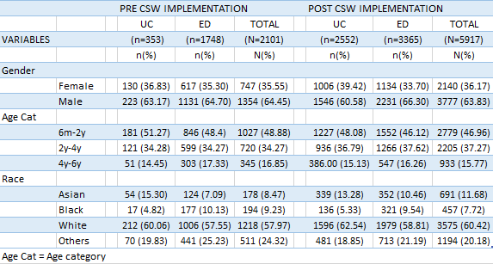
Table 1: Patients Demographic Characteristics

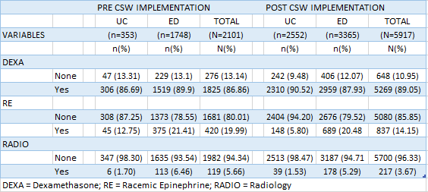
Table 2: Resource Use

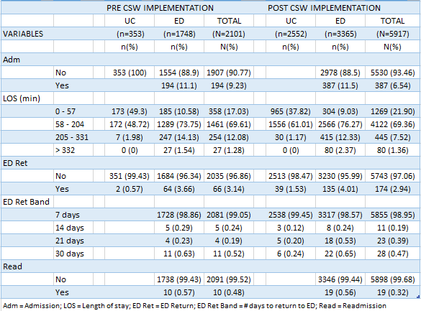
Table 3: Patients' Outcomes
Study variables were defined a priori, and complete data were available for our use. Patient-level characteristics include the following: demographic characteristics (sex, age in years, and race). Hospital level variables include admission rate for croup from the ED and UC calculated as the number of patients admitted through the ED and UC with croup, over the total number of patients seen with croup in the ED and UC. Additional hospital-level variables include use of resources (dexamethasone, racemic epinephrine, radiography) and LOS.
Standard statistics are used, including the Welch's t-test to compare the means of the study quantitative variables Pre-CSW [LOS (cf. “Table 4: Welch's test for LOS in UC”, “Table 5: Welch's test for LOS in ED”), mean number of days of return to the ED, mean LOS after readmission, and age of patients] with their Post-CSW values. The chi-square test was used to compare Pre-CSW and Post-CSW proportions for the study qualitative variables which include: gender, age category, race, units in which the patients were seen, ED transfers, admissions, dexamethasone use, racemic epinephrine use, radiography use, ED return within 7, 14, 21, and 30 days, and readmissions (cf. “Table 6: Summary of outcomes statistics”). We ran all those statistical tests at 5% confidence level (p < 0.05).
We performed statistical analysis using STATA (Intercooled Stata 15.1 for Windows; StataCorp LP, College Station, TX), MedCalc Software, Socscistatistics.com, and GraphPad Software.

Table 4: Welch's test for Length of Stay in UC

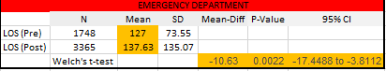
Table 5: Welch's test for Length of Stay in ED

Results
The croup Pre-CSW pathway implementation contributed data from January 1, 2010 to November 30, 2012, while the croup Post-CSW pathway contributed data from December 1, 2012 to December 31, 2017. There were 2,101 and 5,917 patients with croup in the Pre-CSW pathway and Post-CSW pathway groups, respectively.
At first glance, a shift in the racial mix of the ED patient population occurred. This change was significant with Chi-squared test with a p-value of 0.000039. Asians and White contributions in the croup ED population have move up 3.37 percentage points and 1.26 percentage points respectively, while Blacks and other races contributions have gone down 0.59 and Others 4.04 percentage points respectively (“Table 9: Race descriptive statistics” and “Table 10: Welch's t-test applied to Race”) confirmed by a Chi-squared test with a p-value of 0.000039.

Variation in the use of resources

Dexamethasone
A chi-square test between Pre-CSW and Post-CSW data usage in Urgent Care (UC) and the Emergency Department (ED) of the Seattle Children’s Hospital was performed to determine whether there was a significant difference between Pre-CSW and Post-CSW behaviors in the use of dexamethasone. Dexamethasone administration shows a 3.83 percentage point increase in UC and a 1.97 percentage point decrease in ED (with a p-value of 0.0242 and 0.0355 respectively). This indicates noticeable changes in the management of croup in the UC and ED at Seattle Children’s (cf. “Table 11: Dexamethasone descriptive statistics” and “Table 12: Welch's t-test applied to Dexamethasone use”).

Racemic Epinephrine
A chi-square test between Pre-CSW and Post-CSW data usage in Urgent Care and the Emergency Department of the Seattle Children’s Hospital was performed to determine whether there was a significant difference between Pre-CSW and Post-CSW behaviors in the use of Racemic Epinephrine. The only statistically significant change was seen in UC with a 6.95 percentage point decrease in the use of Racemic Epinephrine, with a p-value of 0.0001.

Chest and Neck Radiographs
A chi-square test between Pre and Post-CSW data usage in Urgent Care and the Emergency Department of the Seattle Children’s Hospital was performed to determine whether there was a significant difference between Pre-CSW and Post-CSW behaviors in the use of chest and neck radiographs in the management of croup in Urgent Care and Emergency Department before and after the implementation of the Croup CSW Pathway. Analysis shows that there was no statistically significant change in either UC no ED.

Other Noticeable Changes in the Post-CSW environment at Seattle Children’s Hospital

Length of Stay
Statistical analysis using the Welch's t-test has shown that there is a significant change in the LOS in ED with an increase of 10.63 minutes in average with a p-value of 0.0022. This is correlated by an increase of 628.41 unit points in kurtosis, and a 18.71 unit points increase in skewness in the LOS distribution which points to the appearance of significant outliers in ED admittance Post-CSW (cf. Figure 1, “Table 4: Welch's test for LOS in UC”, “Table 5: Welch's test for LOS in ED” and “Table 7: Length of Stay descriptive statistics”).
Comparing inpatient length of stay between UC Pre-CSW vs. ED Pre-CSW and UC Post-CSW and ED Post-CSW, we noticed a statistically significant difference, suggesting that there is a significant variation in patient outcomes in both settings (cf. “Table 7: Length of Stay descriptive statistics”)
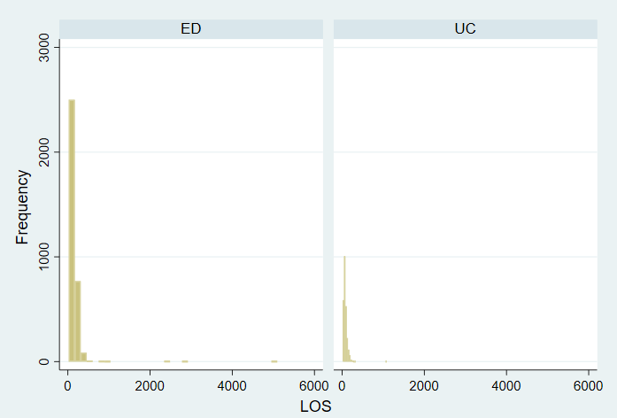
Figure 1: Length of Stay distribution in ED vs UC Post-CSW (min)


Table 6: Summary of outcomes statistics


Table 7: Length of Stay descriptive statistics


Table 8: Variations in patients Length of Stay outcomes

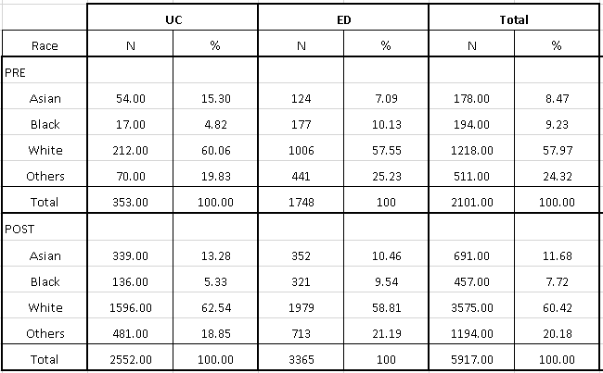
Table 9: Race descriptive statistics

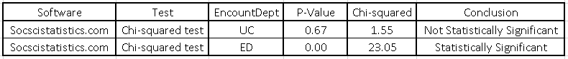
Table 10: Welch's t-test applied to Race
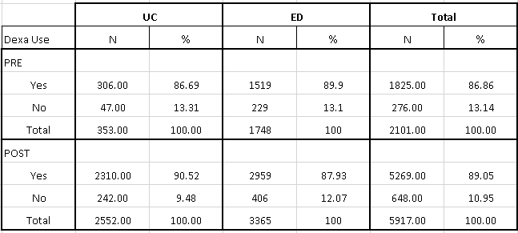
Table 11: Dexamethasone descriptive statistics

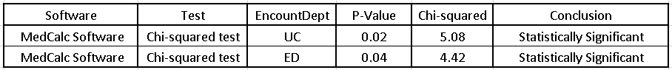
Table 12: Welch's t-test applied to Dexamethasone use

ED Transfer
UC has seen a statistically significant decrease in ED transfer with a of 6.53 percentage points confirmed by a Chi-squared test with a p-value of 0.0001.

Hospital Units
A shift in the specific clinical service handling croup took place at SCH. Emergency and Observation have lost 0.46 and 1.13 percentage points respectively while the Inpatient service increased by 1.59 percentage points (Chi-squared test with a p-value of 0.002265, Table 6). This suggests that more patients are being admitted for a better follow of the Croup CSW Pathway protocol.

Regression Analysis on admission rates, inpatients length-of stay (LOS), return to the emergency department, and readmission rates
For finding relationships between outcomes [admission rates, length of stay (LOS), return to the ED, and readmission rate] and dependent variables [gender, race, having a PCP, ED transfer, use of dexamethasone, use of RE, use of radiology], we made use of REGO, a Stata module that decomposes R² (share of explained variance) of an Ordinary Least Square (OLS) model into contributions of regressor variables with the help of Shapley or Owen values. We assessed goodness of fit of the regression model using “R-squared (R²).” Running REGO on the Pre-CSW and Post-CSW data for each of the outcomes mentioned above, we obtained the following results:

Admission Rates
“Table 13: Ordinary Least Squares applied to Admission Rate (Pre-CSW)” and “Table 14: OLS applied to Admission Rate (Post-CSW)” summarize Ordinary Least Square (OLS), while “Table 6: Summary of outcomes statistics” provides descriptive statistics on its Pre-CSW and Post-CSW values. With an R² value of 32% Pre-CSW and Post-CSW, we cannot say that the regressed model is a good fit for this problem, but the contributions of regressor variables on R² gives an indication of the importance of those variables in predicting the variations and evolution of the admission rates. “Table 13: Ordinary Least Squares applied to Admission Rate (Pre-CSW)” and “Table 13: Ordinary Least Squares applied to Admission Rate (Pre-CSW)” show clearly that racemic epinephrine is the most influential variable in predicting hospital admission with 78.9% contribution Pre-CSW, and 66.9% contribution Post-CSW, with a p-value of 0.0001. One should note that racemic epinephrine is seeing a predictive power drop of 12 percentage points Post-CSW, while dexamethasone’s contribution, although modest compared to that of racemic epinephrine, has seen an increase of 6 percentage points in prediction power.
 |  | Dexamethasone | Racemic Epinephrine
Coef. | Pre | -0.072 | 0.38
Coef. | Post | -0.135 | 0.341
 | Change | -0.063 | -0.039
 | Percentage Change | 88% | -10%
Shapley | Pre | 2.06 | 78.91
Shapley | Post | 8.22 | 66.99
 | Change | 6.16 | -11.92
 | Percentage Change | 299% | -15%
Table 13: Comparative changes in predictors
The coefficient of dexamethasone in Pre-CSW and Post-CSW changed from -0.072 to -0.13 which indicates that for each 1% increase in dexamethasone usage, the admission rate reduction declines from 0.072% to 0.13% holding all other variables constant. This an 88% change in correlation.
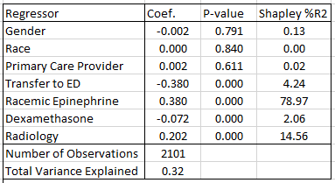
Table 14: Ordinary Least Squares applied to Admission Rate (Pre-CSW)
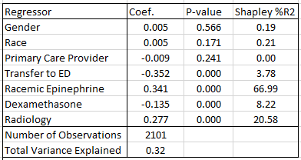
Table 15: Ordinary Least Squares applied to Admission Rate (Post-CSW)

Inpatients Length-of Stay (LOS)
Ordinary Least Square (OLS) for Inpatients Length of Stay in these datasets has a larger shares of explained variance than in the Admission Rate analysis, but the predicting power of dexamethasone is dwarfed by that of racemic epinephrine (cf. “Table 15: OLS on Length of Stay Pre-CSW” and “Table 16: OLS on Length of Stay Post-CSW” [Racemic epinephrine (83.25%), Dexamethasone (0.13%)]. However, with Pre-CSW and Post-CSW p-value > 0.05, we cannot put forward conclusive statements regarding the impact of dexamethasone in this study. Further analysis is required.
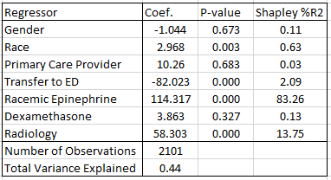
Table 16: Ordinary Least Squares on Length of Stay Pre-CSW

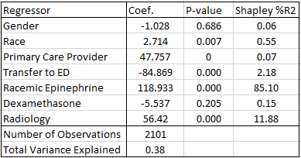
Table 17: Ordinary Least Squares on Length of Stay Post-CSW

Return to the Emergency Department
With an explained variance of 0.02%, “Ordinary Least Squares” is clearly not a good fit to model the relationship between “Return to the Emergency Department” and the dependent (cf. “Table 17: OLS on Return to the Emergency Department Pre-CSW” and “Table 18: OLS on Return to the Emergency Department Post-CSW”). This calls for further analysis with more elaborate techniques.
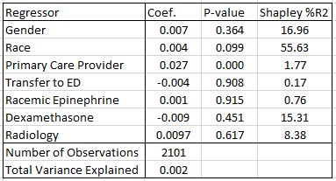
Table 18: Ordinary Least Squares on Return to the Emergency Department Pre-CSW
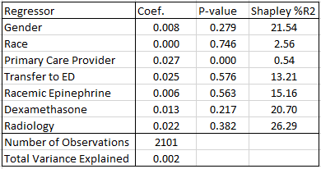
Table 19: Ordinary Least Squares on Return to the Emergency Department Post-CSW

Readmission Rates
We were interested in the odds of a patient to be readmitted after having been discharged. For this purpose, logistic regression was used. “Table 19: OLS on Readmissions Pre-CSW” and “Table 20: OLS on Readmissions Post-CSW” summarizes our findings.
The likelihood ratio chi-square of 33.04 with a p-value of 0.0001 suggests that our model as a whole fits significantly. From these results, with a p-value < 0.005 in Pre-CSW and Post-CSW, we can say that racemic epinephrine did not better or worsen the chance of a patient being readmitted during the study. On the other hand, radiology seems to be an important predictor in patients’ readmission. For each one-unit increase in using radiology, the increase in the odds of a patient being readmitted (versus not being readmitted) related to radiology use increased from a factor of 6.91 to a factor of 15.8.
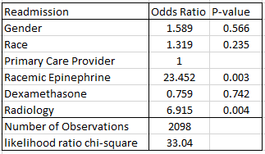
Table 20: Logistic Regression on Readmissions Pre-CSW

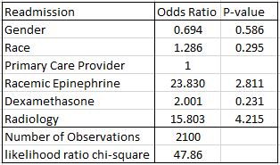
Table 21: Logistic Regression on Readmissions Post-CSW

Discussion
Effective pharmacological treatment of croup is well established, but implementation of recommended treatment is a more complex phenomenon. One strategy is to develop clinical care guidelines to optimize resource utilization and patient outcomes when dealing with croup as at Seattle Children’s Hospital. Hence, SCH initiated the implementation of the Croup CSW pathway. The purpose of this pathway is to provide continuity of care all the way from the UC, the ED to the inpatient unit. This is done no matter if the care was initiated in the UC or the ED to provide a seamless care experience for the families and a standard of care for the providers.
With the implementation of the croup CSW pathway, UC decreased racemic epinephrine administration by 6.95 percentage points and increased dexamethasone administration by 3.83 percentage points. The ED decreased dexamethasone by 1.97 percentage points. This can be explained by the fact that, once the CSW pathway was rolled out at SCH, it became a standard to initiate dexamethasone in the UC as soon as patients were seen prior to sending them to the ED. Ordinary least square regression on Pre-CSW and Post-CSW data shows that racemic epinephrine use is a strong predictor of admission rates compared to dexamethasone. However, Post-CSW, the influence of racemic epinephrine waned, while that of dexamethasone has gone up, with racemic epinephrine losing 12 percentages points of explained variance in admission rate, while dexamethasone gained 6 percentage points. It is also noteworthy to mention that, in the time period following the beginning of the implementation of the croup CSW pathway, there was an 88% increase in percentage points of the contribution of dexamethasone in the admission rate reduction. The fact that nurses started doing the respiratory scores more consistently and received training in doing these scores in UC further explains the decrease in the use of racemic epinephrine in the UC. Moreover, the pathway gave providers a standard treatment protocol as well as an impetus for initiation of early transfers, contributing to the speculation that, all these efforts contributed to a decrease in use of racemic epi in UC areas.
A 6.53 percentage points decrease in ED transfers were observed post CSW. This suggests that the protocol is working. From ED onward, a shift in the specific clinical service handling croup took place in the same time period (cf. Figure 2: Seattle Children's Hospital Patients Route). For example, in the percent distribution of place of treatment, Emergency and Observation declined by 0.46 and 1.13 percentage points respectively while the Inpatient service increased by 1.59 percentage points. This finding suggests that costs, while difficult to assess might increase since inpatient costs are usually higher.
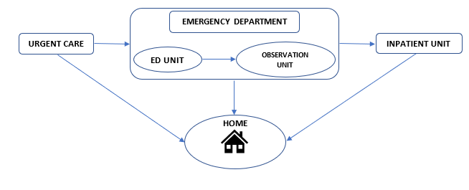
Figure 2: Seattle Children’s Hospital Patients Flow
Early in the croup CSW pathway, there was no reliable way to capture patients who were seen in the ED, but received their dexamethasone elsewhere (PCP, UC). The shift in clinical units handling croup patients may have obscured the length of stay, admission, and readmission effects of the protocol. Over the past 2-3 years, medication intake data in the ED has become much more reliable and SCH was able to better track patients and patients related numbers. Further studies may examine the data year by year from for a better understanding of resource use, and its impact on patient outcomes.
Our study has several limitations. Being a retrospective study, we relied on information from clinical and administrative data at Seattle Children’s Hospital over a 7-year time period, only focusing on patient data. Therefore, related results might not generalize to other institutions. Furthermore, providers at children’s hospitals may have more experience with croup management and/or may have institutional clinical care guidelines to guide management and treatment decisions. In which case our findings may underestimate utilization and would need to be reviewed based on these guidelines and knowledge.
Ordinary least square applied to inpatient length of stay was not conclusive enough to assess the weight of dexamethasone on how long patients stay at the hospital for croup related illness. However, analyzing Pre-CSW and Post-CSW data with the Welch’s test, we noticed an increase of 10.63 minutes in average. It is worth noting that, 10.6 minutes may be statistically significant but not clinically relevant since the shift of patients between UC and ED may wind up accounting for this difference for administrative rather than clinical management reasons; or the patient severity mix might have changed.

Conclusion
With the implementation of the croup CSW pathway, SCH experienced a decrease in the administration of racemic epinephrine in UC and dexamethasone in ED; and an increase of dexamethasone administration in UC, validating the hypothesis that there will be changes in management of croup patients as a consequence of implementing the CSW pathway, while rejecting the hypothesis that no significant variation in the use of resources will be detected. Racemic epinephrine use was found to be a strong predictor in inpatient admission rates compared to dexamethasone whose contribution in admission rate reduction has seen an 88% increase in percentage points during the croup CSW implementation. Comparing inpatient length of stay between Pre-CSW and Post-CSW data was statistically significant, but probably not clinically relevant since the shift of patients between UC and ED may wind up accounting for this difference for administrative rather than clinical management reasons; or the patient severity mix might have changed. However, comparing inpatient length of stay between UC Pre-CSW vs. ED Pre-CSW and UC Post-CSW and ED Post-CSW yields statistically significant differences, suggesting that there is a significant variation in patient outcomes in both settings, rejecting the hypothesis that there will be no variation in patient outcomes between UC and ED.
A shift in clinical service handling croup took place during the timeframe covered by this study with Emergency and Observation treating fewer patients while a higher proportion of patients were admitted to the inpatient service, suggesting that costs, while difficult to assess will probably go up since inpatient costs are usually higher. We recommend further studies to better understand the relationships between patient outcomes and this study’s predictors.

Table of Tables
Table 1: Patients Demographic Characteristics 14
Table 2: Resource Use 14
Table 3: Patients' Outcomes 15
Table 4: Welch's test for Length of Stay in UC 16
Table 5: Welch's test for Length of Stay in ED 16
Table 6: Summary of outcomes statistics 18
Table 7: Length of Stay descriptive statistics 19
Table 8: Variations in patients Length of Stay outcomes 19
Table 9: Race descriptive statistics 19
Table 10: Welch's t-test applied to Race 19
Table 11: Dexamethasone descriptive statistics 20
Table 12: Welch's t-test applied to Dexamethasone use 20
Table 13: Comparative changes in predictors 21
Table 14: Ordinary Least Squares applied to Admission Rate (Pre-CSW) 22
Table 15: Ordinary Least Squares applied to Admission Rate (Post-CSW) 22
Table 16: Ordinary Least Squares on Length of Stay Pre-CSW 23
Table 17: Ordinary Least Squares on Length of Stay Post-CSW 23
Table 18: Ordinary Least Squares on Return to the Emergency Department Pre-CSW 24
Table 19: Ordinary Least Squares on Return to the Emergency Department Post-CSW 24
Table 20: Logistic Regression on Readmissions Pre-CSW 25
Table 21: Logistic Regression on Readmissions Post-CSW 25

Acknowledgements
Usha Sankrithi MB, BS, MPH, FAAP, for offering me the opportunity to work on such an interesting subject, and for guidance on clinical interpretation; Julianna Bishop, MD, Clinical Associate Professor for her time and support; Ian Painter PhD, MSc for his guidance; James Johnson, Data Analyst for his time and support; and Mark Oberle, MD, MPH, Professor Emeritus at the University of Washington School of Public Health for his invaluable guidance.

References
1. Alshehri M, Almegamsi T, & Hammdi A. Efficacy of a small dose of oral dexamethasone in croup. Biomed Res (Aligarh). 2005; 16:65-72.
2. Bjornson C, Russell K, Vandermeer B, Klassen TP, Johnson DW. Nebulized epinephrine for croup in children. Cochrane Database of Systematic Reviews. 2013; 10: CD006619

3. Bhatt J. Croup (Laryngotracheobronchitis). Nottingham University Hospitals. 2015
4. Croup v.1.1: ED Management, Inpatient Management. Seattle Children's Hospital. 2015
5. Donaldson D, Poleski D, Knipple E, Filips K, Reetz L, Pascual R, G, & Jackson, R. E. Intramuscular versus Oral Dexamethasone for the Treatment of Moderate-to-severe Croup: A Randomized, Double-blind Trial. Academic emergency medicine, 2003; 10(1); 16-21.
6. Moraa I, Sturman N, McGuire T, & Van Driel M, L. (2013). Heliox for croup in children. The Cochrane Library.
7. Rosychuk R J, Klassen TP, Voaklander DC, Senthilselvan A, Rowe BH. Seasonality patterns in croup presentations to emergency departments in Alberta, Canada: a time series analysis. Pediatr Emerg Care. 2011 Apr; 27: (4):256-60. doi: 10.1097/PEC.0b013e31821314b0. PMID: 21490537
8. Dobrovoljac M, Geelhoed GC. 27 years of croup: an update highlighting the effectiveness of 0.15 mg/kg of dexamethasone. Emerg Med Australas. 2009 Aug; 21: (4):309-14. doi: 10.1111/j.1742-6723.2009.01202. x. PMID: 19682017
9. Cutrera R, Baraldi E, Indinnimeo L, Miraglia Del Giudice M, Piacentini G, Scaglione F, Ullmann N, Moschino L, Galdo F, Duse M. Management of acute respiratory diseases in the pediatric population: the role of oral corticosteroids. Ital J Pediatr. 2017 Mar; 23: 43(1):31. doi: 10.1186/s13052-017-0348-x. Review. PMID: 28335827
10. Penezić A, Ivkić M, Ivkić B, Baudoin T. Subglottic laryngitis--Changes in therapy approach over the past 20 years. Auris Nasus Larynx. 2015 Oct; 42(5):390-5. doi: 10.1016/j.anl.2015.03.004. Epub 2015 Apr; 24; PMID: 25921270
11. Petrocheilou A, Tanou K, Kalampouka E, Malakasioti G, Giannios C, Kaditis AG. Viral croup: diagnosis and a treatment algorithm. Pediatr Pulmonol. 2014 May; 49(5):421-9. doi: 10.1002/ppul.22993. Epub 2014 Mar; 5: Review. PMID: 24596395
12. Tyler A, McLeod L, Beaty B, Juarez-Colunga E, Birkholz M, Hyman D, Kempe A, Todd J, Dempsey AF. Variation in Inpatient Croup Management and Outcomes. Pediatrics. 2017 Apr; 139(4). pii: e20163582. doi: 10.1542/peds.2016-3582. Epub 2017 Mar; 14: PMID: 28292873
13. Baskett TF. Resuscitation great. Joseph O'Dwyer and laryngeal intubation for croup. Resuscitation. 2007 Aug; 74(2):211-4. Epub 2007 Mar; 26; No abstract available. PMID: 17382453
14. Cormack JR. History and Meaning of the Terms Diphtheria and Croup. Br Med J. 1875 Apr; 24: 1(747):544. No abstract available. PMID: 20747841
15. Bjornson CL, Johnson DW. Croup. Lancet. 2008 Jan 26; 371(9609):329-39. doi: 10.1016/S0140-6736(08)60170-1. Review. PMID: 18295000
16. Pruikkonen H, Dunder T, Renko M, Pokka T, Uhari M. Risk factors for croup in children with recurrent respiratory infections: a case-control study. Paediatr Perinat Epidemiol. 2009 Mar; 23(2):153-9. doi: 10.1111/j.1365-3016.2008.00986. x. PMID: 19159401
17. Üzüm Ö, Çağlar A, Küme T, Sayıner A, Er A, Akgül F, Ulusoy E, Yılmaz D, Duman M. Are cytokines and cortisol important predictors for the severity of pediatric croup: A case control study. Turk J Pediatr. 2017; 59(3):281-287. doi: 10.24953/turkjped.2017.03.008.
18. Rajapaksa S, Starr M. Croup - assessment and management. Aust Fam Physician. 2010 May; 39(5):280-2. Review. PMID: 20485713
19. Ibrahimov M, Yollu U, Akil F, Aydin F, Yener M. Laryngeal foreign body mimicking croup. J Craniofac Surg. 2013 Jan; 24(1): e7-8. doi: 10.1097/SCS.0b013e31826465e5. PMID: 23348345
20. Louise Borland, Franz E. Babl, Nisa Sheriff, Amanda Doreen. Croup Management in Australia and New Zealand A PREDICT Study of Physician Practice and Clinical Practice Guidelines. Lippincott Williams & Wilkins 2008; by ISSN: 0749-5161/08/2407-0452
21. Bjornson CL, Johnson DW. Croup in the paediatric emergency department. Paediatr Child Health. 2007 Jul; 12(6):473-477. PMID: 19030411
22. Lisa Amir, Henry Huberman, Ayelet Halevi, Meirav Mor, Marc Mimouni, Yehezkel Waisman. Oral Betamethasone Versus Intramuscular Dexamethasone for the Treatment of Mild to Moderate Viral Croup: A Prospective, Randomized Trial. Pediatr Emerg Care. 2006 Aug; 22(8):541-4. PMID: 16912619
23. Sarah Kline-Krammes, Christina Reed, John S. Giuliano, Jr, Hamilton P. Schwartz, Michael Forbes, John Pope, James Besunder, Michael D. Gothard, Kerry Russell, Michael T. Bigham. Heliox in Children with Croup: A Strategy to Hasten Improvement. Air Medical Journal Associates 2012; doi: 10.1016/j.amj.2011.08.004

