Sensor Development for Monitoring Biofilm Production and Accumulation using Underwater
Imaging in Nearshore Waters

Cassandra Chamberlain
University of Washington
School of Oceanography
1503 NE Boat St
Seattle, WA 98105

chamberc@uw.edu

Abstract

The presence of eelgrass in the nearshore environment can be used as a proxy for the amount of ecosystem health due to its quick response to the ever changing properties of water quality, benthic condition, and physical forcing. A key ecological service provided by eelgrass is the accumulation of biofilm as a food source for marine organisms. Biofilm is a functional community of microbes embedded in an organic polymer matrix, adhering to a surface. Biofilm has three basic components which include microbes, glycocalyx and a substrate. Biofilm growth is limited by the availability of nutrients in the immediate environment, the perfusion of those nutrients to the cells within the biofilm and the removal of waste. Not only is identifying the amount of growth and accumulation of biofilm on eelgrass ecologically important, understanding biofilm accumulation can also assist in improving the functionality and performance of underwater sensors. The development of an in-situ sensor to assess biofilm production and accumulation on a variety of surface materials that may act as proxies of eelgrass structure for the purpose of quantifying ‘slime’ accumulation is presented. The aim of this research and development project is to asses a non-destructive method for the selection of construction materials used to simulate in-situ slime accumulation on eelgrass in the nearshore. While this work is conducted in the low energy nearshore environment of existing eelgrass beds in Puget Sound, Washington, the proposed method provides an approach which returns optimum material selections for other nearshore settings. In addition to monitoring the accumulation of biofilm, the in-situ sensor also monitors changes in environmental conditions which influence the production of ‘slime’. This work provides nearshore scientists and managers a cost-efficient alternative to the design and implementation of monitoring tools for the growth of biofilm accumulation in nearshore environments with potential application as a key component to those interested in monitoring programs during shoreline restoration projects.

Introduction
Aquatic environments, like estuaries such as Puget Sound, significantly contribute to the total bacterial activity. Seagrasses such as eelgrass and other associated algal communities dominate the primary production in many shallow coastal environments. These seagrasses provide a large surface area for algal and bacterial colonialization and growth (Søndergaard and Tӧrnblom 1999). However, it’s not just bacteria and algae that colonize and grow on these seagrasses; many other organisms contribute to the biofilm that develops on these surfaces.
Biofilm is a functional community of microbes embedded in an organic polymer matrix, adhering to a surface. Biofilm has three basic components: microbes, glycocalyx and a surface; if one is not present then biofilm cannot be produced. Glycocalyx is a glue-like substance that holds the biofilm to the colonized surface and is a complex of exopolysaccharides of bacterial origin and trapped exogenous substances found in the local environment. The growth potential of any biofilm is limited by availability of nutrients in the immediate environment, the perfusion of those nutrients to the cells within the biofilm and the removal of waste. Other factors that control biofilm maturation are internal pH, oxygen perfusion, carbon source and osmolality (Dunne 2002). Dissolved organic carbon however is continuously being excreted or leeched from growing aquatic plants and the carbon used in bacterial biomass production can be a large portion of eelgrass production (Søndergaard and Tӧrnblom 1999).
Eelgrass is very important in Washington State because it provides a substrate for several small organisms that are a food source for larger species. Eelgrass provides a great source of carbon into the nearshore habitats and also stabilizes the surrounding sediments. Unfortunately, eelgrass and other seagrasses have been declining around the world, especially in areas of increased human development. Anthropogenic stresses can attribute to the decline in eelgrass populations. There are certain anthropogenic activities that disturb the seagrass beds both directly and indirectly. These include but aren’t limited to dredging, anchor scars or even over-water structures that reduce the light able to penetrate into the water column. River runoff also increases turbidity and reduces the clarity of the water column as well as the ability for the light to penetrate into the water. Nutrient addition is an issue that eelgrass and other seagrasses face; this can come from facilitating algal blooms as well as many other sources. However, the deeper edges within the seagrass beds are the most vulnerable to stressors (Sewell et al. 2001).
The need for state-wide data on eelgrass status and trends has been known for a long time and is imperative for developing effective management for this resource (Sewell et al. 2001). Though eelgrass is monitored in many places around Puget Sound, many places still have data that has yet to be collected. Monitoring the eelgrass is needed because it serves as an indicator for nearshore habitat quality and primary production.
Identifying the amount of growth and accumulation of biofilm is important to not only measure the amount of productivity within the ecosystem but also to measure the functionality and performance of equipment and sensors. Within minutes of submerging a clean surface (equipment, sensors, etc.) into the water, it absorbs a molecular ‘conditioning’ film which consists of dissolved organic material. Bacteria can colonize within hours and these early small colonizers form biofilm. This is an assemblage of attached cells which are sometimes referred to as ‘microfouling’ or ‘slime’. A number of ‘cues’ are involved in attracting spores to a particular surface, on which to settle and attach to that surface. Negative phototaxis guides zoospores and zygotes to areas of low light, although diffusible chemical cues released from surface-associated organisms such as bacteria may also guide the swimming spores toward suitable surfaces (Callow and Callow 2002).
To identify an optimum method for an in-situ measure of biofilm production, accumulation and utilization on eelgrass beds in Puget Sound, the development of an in-situ sensor was used to assess ‘slime’ build up on a variety of surface materials which acted as proxies for the structural surface of the eelgrass blade on which slime accumulation occurs. In addition, the in-situ sensor monitors changes in environmental conditions which influence slime production. With the combined goals of assessing surface materials which best simulate eelgrass structure for the accumulation of slime and measuring that accumulation over time in a non-destructive way, an in-situ sensor made of PVC and use of an underwater imaging camera, tested which material, (PVC, acrylic, aluminum, or wood), most closely simulated biofilms at the same rate as eelgrass. Due to the decline in eelgrass and other seagrasses, the need for artificial seagrasses may help in restoring the natural habitat quality. For this purpose, each material can be assessed and in the future the material that biofilms at the same rate as the eelgrass can help in the production of artificial eelgrass for monitoring and restoration purposes.
Design and Implementation
Design parameters are the guiding principles that control and constrain the elements of a design. They help determine cost, the design itself, and risk tradeoffs from the items used in the development; they help evaluate the success of the design. While the design parameters for this project guided the design process eight different iterations designs, only one was selected for prototype construction. The primary design parameter was to facilitate the testing of everyday materials for slime accumulation and to monitor that accumulation in a non-destructive way. The first seven designs had some sort of platform incorporated into it with a camera and light system attached overhead, however, the last and final design (Fig. 1, Fig. 2 A and B) required less material making the entire design more efficient.. The final design was also chosen for its simplicity compared to the others which made both construction and implementation much easier. It was critical to make a unique design because other designs only included using artificial eelgrass made of a general plastic and green plastic ribbon. Other studies have only used plastic to look at the bioaccumulation rates, whereas this study uses different everyday materials as well as using a camera system (Fig 3 A&B). An advantage of this design is that it can easily be constructed and adapted for use with a live video stream for use in public outreach and education programs.
Underwater imaging, specifically a weatherproof TTL serial JPEG camera with NTSC video and IR LEDs, was used as a photogrammetry tool to ensure minimal disturbance to the in-situ environment. The in-situ sensor has the ability to be deployed into eelgrass beds and left for several days in order to collect data; however, it also can be connected to a live stream video feed for continuous monitoring and education outreach purposes. The design parameters of the prototype sensor required low cost solutions for a sensor package that may be deployed for up to twenty four hours and recovered by two people during small boat operations. A variety of surface materials which include PVC, glass, wood, and aluminum are used as potential surfaces in simulating biofilm accumulation on eelgrass structure. Two different replicates of each surface material are tested at two depths, later referred to as tiers, which can be set by the user prior to deployment. An Arduino UNO microcontroller is used in conjunction with the weatherproof camera provides user controlled timed intervals between photographic samples. Growth rates of biofilm accumulation are assessed by changes in the intensity of the color spectrum of sample surface material imagery. Considering that eelgrass grows within a depth range between 1-10 meters in Puget Sound, field trials of this sensor package focused on data collection in the lower depth range for eelgrass. The package is anchored to the desired depth and depth intervals between replicates are set to allow for experimental trials at various sites. The results of this work presents sensor design guidance, material selection, deployment, data recording and analysis methods.
Testing Methods
There were four phases to testing the sensor. The first phase included building the camera and light system and testing the power and communication system. Simple circuit conductivity and voltage insured system integrity.
Phase two in the testing plan was successful completion of a bench test. A bench test includes testing not only the circuits and wiring but also ensuring a working code for microcontrollers and data storage. The Arduino UNO microcontroller was selected for this project. Code was written to loop the acquisition of an image at predetermined time intervals until power limitations were reached or data storage requirements were exceeded. Additionally the Arduino code to turn on and off the LED lights before and after the camera was to take a picture.
The third test phase was a wet test. This test was to ensure that the equipment, sensors, and sensor packages were waterproof. This wet test or performance test took place in Portage Bay on Saturday April 15th, 2017 next to the University of Washington’s dock; the sensor was deployed into Portage Bay with an anchor attached to the bottom of it and tied to the dock for four hours (all electronics were left on the dock to ensure they wouldn’t get wet – for actual deployment electronics will be in a splash-proof case that is attached to a buoy above water). Leaving the sensor there for this long was to ensure that the sensor wouldn’t be exposed to leakages or other issues that needed to be addressed before continuing on. The procedures that were followed during the test included the camera taking pictures every fifteen minutes resulting in four pictures every hour, as well as the light array turning on and off before and after the camera took the picture, then waiting until it was time to take the next picture.
For both the bench and wet test performance goals were established in order to evaluate the success of the design. The bench test performance goals included the camera taking pictures, wires completing a circuit via using a voltage meter, lights being able to turn on and off, and making sure that the code is working properly. The wet test objectives included all of the bench test objectives and also included ensuring that the light tube (Fig 4.) was water tight and waterproof, as well as the camera to ensure no leakages would occur.
As a result of the wet test, it was found that the light tube as well as the camera had leaked. The camera wasn’t flooded to the point where it couldn’t be salvaged but the light tube was at the point where the electronics were damaged. Though these leakages happened, the camera was still capable to take continuous pictures every 15 minutes and the light tube produced light for the first few images before it was completely turned off.
The fourth phase of testing was conducted as an actual field test without a camera or light system. The sensor was deployed and hung off the dock within the Shilshole Bay Marina within the Port of Seattle in Seattle, WA on April 26th, 2017- May 3rd 2017 (Fig 5.). The sensor was originally set at 1.83 meters (6 feet). Unfortunately during the field test the deployment line slipped and the sensor package rested at 3.05 meters (10 feet).
After seven days the sensor was recovered from the field test site within the Shilshole Marina. The bioaccumulation on all the materials varied within this region as well as to which tier they were on (tier 1 or tier 2). Analysis of photographs that were taken (Fig 6) was processed using the open source ImageJ software. This software provides a histogram of pixel counts for each scaled value of color intensity in the primary colors of visible light: red, green, and blue (RGB) (Table 1). Images included in this analysis were those that were taken as a control, those dry without algae present and those when wet without algae present. Following the 7 days of deployment, pictures were taken of the materials wet with algae present and dry with algae present.
The histogram of each image scales the intensity of each color between a range from 0-255 (Fig 7). At this point it is critical to not have any pixels within the image to have intensities at 0 or 255. These values represent individual pixels that are either under or over exposed. Zero is also the point where there is no brightness and 255 is the point where there is full brightness, the rest of the range represents linear scaled values of all other possible brightness values. The count of pixels in the histogram tells how many pixels are assigned to each intensity value in the image. The minimum and maximum intensity value and the count of pixels assigned to the minimum and maximum intensity quantify the range a portion of the image with extreme values while the peak of the histogram reflects the mode or the color that is most present in. The mean and standard deviation of intensity values is informative of the overall distribution of color and is used to quantify shifts in the color combination of surface materials before and after slime accumulation
Testing Results
This study found that when looking at specifically the color red, acrylic had the overall highest values. Depending on the standard deviation, this gives indication as to how intensity affects each material; a higher standard deviation indicates a higher intensity while a lower standard deviation indicated a lower intensity. Specifically comparing the wet without algae and dry without algae or the control, on both tiers the color red had the lowest change or shift was from the acrylic. Specifically however tier one had the highest change or most shift for the mean and mode but the most shift for standard deviation, or largest intensity, was from the PVC (Fig. 8). On tier two, the most shift was from the aluminum. Comparing the wet with algae and dry with algae, tier one had the lowest shift in acrylic for both mean and mode but the lowest shift in PVC for the standard deviation. Tier two however had the lowest shift for acrylic regarding the mode and standard deviation but aluminum had the lowest shift for the mean (Fig. 9 , Fig. 10).
When comparing the color green for the wet without algae and the dry with algae both tiers had the lowest shift in the acrylic but in tier two the acrylic had the lowest shift for the mean and mode but wood had the lowest shift for standard deviation. The most shift for both tiers was from the wood however, for tier one the most shift in standard deviation was from the PVC (Fig 8). Comparing the wet with algae to the dry with algae the color green had much different results. Tier one had the lowest shift for aluminum regarding the mean and standard deviation but the lowest shift in mode was from the acrylic. Tier two had the lowest shift in acrylic regarding standard deviation and the mode; the aluminum however also had the lowest shift for the mode and median values (Fig 9.). The most shift in both tier one and tier two for the mean and mode came from the wood but the most shift in standard deviation for both tiers came from the PVC (Fig. 10).
Comparing the color blue for the wet without algae to the dry without algae both tier one and tier two had the lowest shift in acrylic while only in tier two wood also had the lowest shift for the standard deviation. Both tiers also had the most shift from the wood but tier two had the most shift from the aluminum for the standard deviation (Fig. 8, Fig. 9). When comparing the wet with algae to the dry with algae materials, both tier one and two had the lowest shift in aluminum for the standard deviation and mean but the lowest shift in mode for PVC. Also, both tiers had the most shift in wood but in addition had the most shift in standard deviation for PVC (Fig. 10).

Discussion
Interpretation
A higher standard deviation indicates which of the colors, red, green, or blue had the greatest intensity. The change in standard deviation or color intensity between dry conditions and following the seven day deployment was greatest on the aluminum test material regardless of the depth (tier). From this observation, aluminum would have the best chance to bio accumulate faster compared to the other materials.
Tom et al (2008) found that high growth rates of eelgrass were recorded during periods of low irradiance; this suggests that these plants are utilizing stored carbohydrates. From their observations, they saw that winter plants were physically adapted for lower quantities of light. Tom et al. (2008) found that because of the light conditions being so low, eelgrass, specifically in the Pacific North West, grows during the late winter and these plants are adapted to take full advantage of the short irradiance bursts. Anderson (1995) found that seasonal differences indicate that the microscopic assemblages of biofilm production can vary in many complex ways within a relatively short time-scale. Though this study was conducted in April, the beginning of spring and also the beginning of the fouling season, materials that were tested showed that they were capable to endure the low levels of irradiance no matter which tier they were placed on. This was evident when looking at the intensities or standard deviations of the colors, which helped determine which material had the most growth based on its intensity of red, green or blue within the color spectrum.
Heupel et al (2008) found in their study that biofouling accumulated heavily on their non-treated equipment. Like the present study, none of the materials used were treated. However, aluminum, the material that had the highest color intensity shown by each colors standard deviation, also was most reflective. With this in mind, the aluminum material was likely to attract the biofouling community that was present. Reflective surfaces, such as that of the aluminum can provide light, heat and energy to the fouling community.
In an OOI (Ocean Observatories Initiative) report it was noted with several other deployments, a series of panels were deployed in Shilshole Bay Marina in the month of April, the same place where this study took place. The panels were then pulled up in early May and it was found that fouling was obvious on the panels while in the water. In the both report and this study, care was taken not to disturb the amount of fouling; this was achieved by slowing retrieving the sensor package. The OOI’s study ran for over a year while this study only ran for one week.
Big Picture, Impacts and Solutions
Humans can benefit from marine and coastal ecosystems both directly and indirectly. Puget Sound is home to about 3.8 million people who inhabit temperate-latitude lands and rivers from the Cascade and Olympic mountains through the fjord-type estuary to the Pacific Ocean (Plummer et al. 2013). Climate change affects the structure and function of many coastal ecosystems (Ehlers et al 2008). These ecosystems are vulnerable because seagrasses such as eelgrass form a structurally complex habitat with very high primary and secondary production in the shallow water environments. Many commercial and recreational species utilize the seagrass beds for nurseries or foraging grounds (Sirota and Hovel 2006, Thayer and Phillips 1977). However, artificial seagrass have been used in past lab experiments to overcome problems such as leaf height, leaf density, area, depth and location in order to know how the formation of a seagrass beds occur and how the surrounding environment helps influence the fauna associated (Bell et al. 1985). Bell et al. (1985) studied the usefulness of artificial seagrass for the purposes of field experiments. Bell constructed artificial seagrass units or ASUs by attaching galvanized steel mesh (artificial leaves) to a grid size of 100mm. Each ASU contained bundles of leaves that included plastic strips. Bell found that because of the limited time that the ASUs were submerged into the water, they resulted in having a lower number of species surrounding the ASUs. Though they were submerged for a short time, the ASUs attracted fauna that resembled that from eelgrass. Bell et. Al (1985) only used a variation of plastic and steel mesh to construct artificial seagrasses. This study goes beyond the known material and indicates there are other materials and ways to monitor the intensity of color produced on materials in addition to properly construct simulated replications of seagrasses.
Søndergaard and Tӧrnblom (1999) found there is a strong coupling between attached bacterial communities and plant primary production. In the present study, aluminum, PVC, wood and acrylic materials were submerged for a very short time period. Though the specific fauna wasn’t tested, it can be assumed that the fauna present resembled that of eelgrass. This is because bacteria and diatoms (Onuf 2006) are a part of the fouling community and they are initiated when a material is submerged into the water.

Further Research
Added research is needed to assess the biofilm production on materials that were tested in this study to ensure that in fact, aluminum would be the best material to make artificial eelgrass and to help monitor populations around the Puget Sound based on the red, green, and blue color intensities or standard deviations that were found. In addition to this, leaving the materials submerged for a much longer period of time would also be advised have more accurate results. Having both a longer term photo series along with sample collection of fauna that are present would be beneficial to accurately compare eelgrass to the everyday materials in order to see which in fact is the best suited to make artificial eelgrass for monitoring purposes. It would also be useful to test not just the four materials like in this study, but to test a much larger array of materials.

References
Anderson, M.J. 1995. Variations in biofilms colonizing artificial surfaces: seasonal effects and effects of grazers. Mar. Biol. Ass. U.K 75:705-714.

Bell, J.D. Steffe, A.S., Westoby, M. 1985. Artifical seagrasses: how useful is it for field experiments on fish and macroinvertebrates?. Exp. Mar. Biol. Ecol. 90:171-177

Callow, J. A., Callow, M.E. 2002. Marine biofouling: A sticky problem. Bio. 49: 1-5.

Dunne, M.W.J. 2002. Bacterial adhesion: Seen any good biofilms lately? Clin. Micro. Rev. 15:155-166.

Ehlers, A., Worm, B., Resuch, T.B.H. 2008. Importance of genetic diversity in eelgrass Zostera marina for its resilience to global warming. Mar. Ecol. Prog. Ser. 355:1-7.

Heupel, M.R., Reiss, K.L., Yeiser, B.G., Simpfendorfer, C.A. 2008. Effects of biofouling on performance of moored data logging acoustic recievers. Liminol. Oceanogr:.Methods 6:327-335

Onuf, C. P. 2006. Biofouling and the continuous monitoring of underwater light from a seagrass perspective. Est. and Coa. 29: 511-518.

O. O. I. Regional Scale Nodes Report on Fouling Degradation Experiments, 2010-2011. rep.

Plummer, M.L., Harvey, C.J., Anderson, L.E., Guerry, A.D, Ruchelshaus, M.H. 2013. The role of eelgrass in marine community interactions and ecosystem services: results from ecosystem-scale food web models. Ecos.. 16:237-251.

Sirota, L., Hovel, K.A. Simulated eelgrass Zostera marina structural complexity: effects of shoot length, shoot density, and surface area on the epifaunal community of San Diego Bay, California, USA. Mar. Eco. Prog. Ser. 326:115-131.

Sewell, A.T., Norris, J.G., Wyllie-Echeverria, S., Skalski, J. 2001. Eelgrass monitoring in puget sound: overview of the submerged vegetation monitoring project. Pug. Soun. Resea. 1-13

Søndergaard, M., Tӧrnblom, E. 1999. Seasonal dynamics of bacterial biomass and production on eelgrass Zostera marina leaves. Mar. Ecol. Prog. Ser. 179: 231-240.

Thayer, G.W., Phillips, R.C. 1977. Importance of eelgrass beds in puget sound. Mar. Fish. Rev. 1271:18-22.

Thom, R.M, Southard, S.L, Borde, A.B., Stoltz, P. 2008. Light requirements for growth and survival of eelgrass (Zostera marina L.) in pacific northwest (USA) estuaries. Est. and Coas. 31:969-980.

Acknowledgements
I would like to thank the UW Oceanography department for the opportunity to work and learn from researchers, teachers and mentors. I would like to specifically thank Miles Logsdon as my mentor and for the guidance, advice and encouragement as I struggled with the design, build and implementation of this project. I would also like to thank Skip Denny for allowing me to place my sensor off his slip in Shilshole Bay Marina, his advice and sharing the report he did for OOI. Also I would like to thank all of the seniors involved in the course for encouragement, discussions and collaboration over the course of the year.

Figures

Fig. 1 Picture of final design with materials and electronics attached. From top to bottom: mounted camera, LED light tube along with 3D printed LED light holders (Fig. 2), everyday materials (from left to right: aluminum, acrylic, PVC, wood), these are all held on to the PVC frame by being screwed into a 3D printed material holder (Fig. 3) that’s glued into a PVC mount.

Fig. 2A TinkerCAD 3D print diagram of LED light holders
Fig. 2B TinkerCAD 3D print diagram of material holder for PVC mount

Fig. 3A. Fritzing diagram of camera system attached to Arduino microcontroller and a USB cord which is to be connected to power supply.
Fig. 3B Fritzing diagram of camera system attached to Arduino microcontroller, a monitor for live feed, and a USB cord which is to be connected to a power supply.
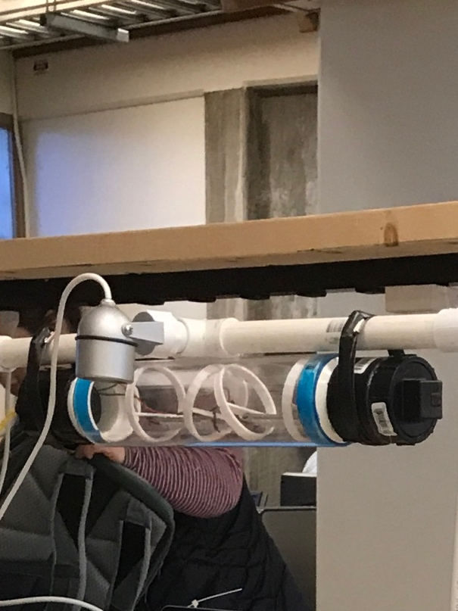
Fig. 4 LED light tube with 3D printed LED light holders inside and camera mounted on PVC sensor.

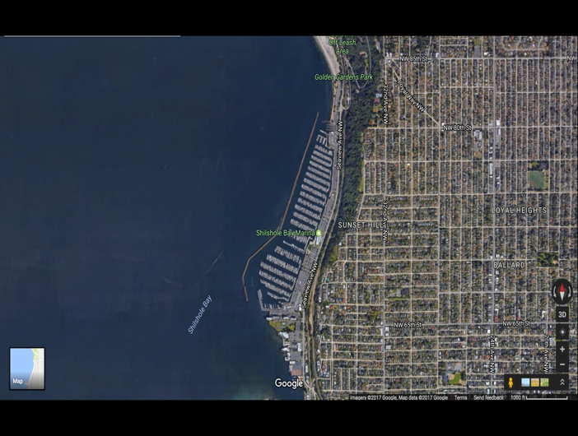
Fig. 5 Shilshole Bay Marina, Port of Seattle, Seattle, WA

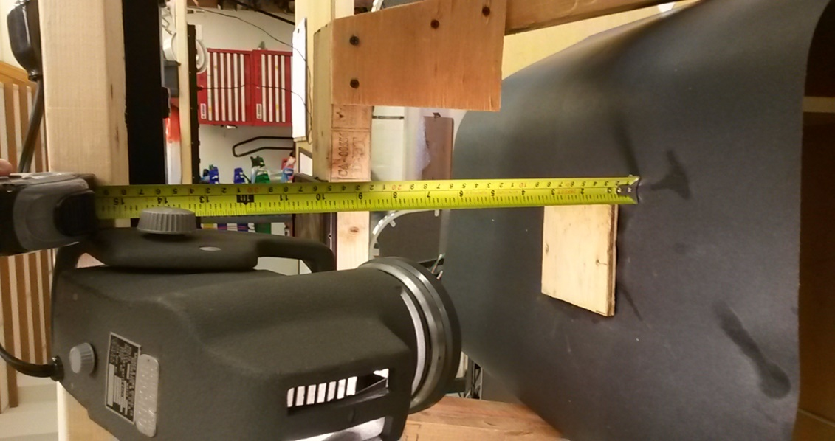
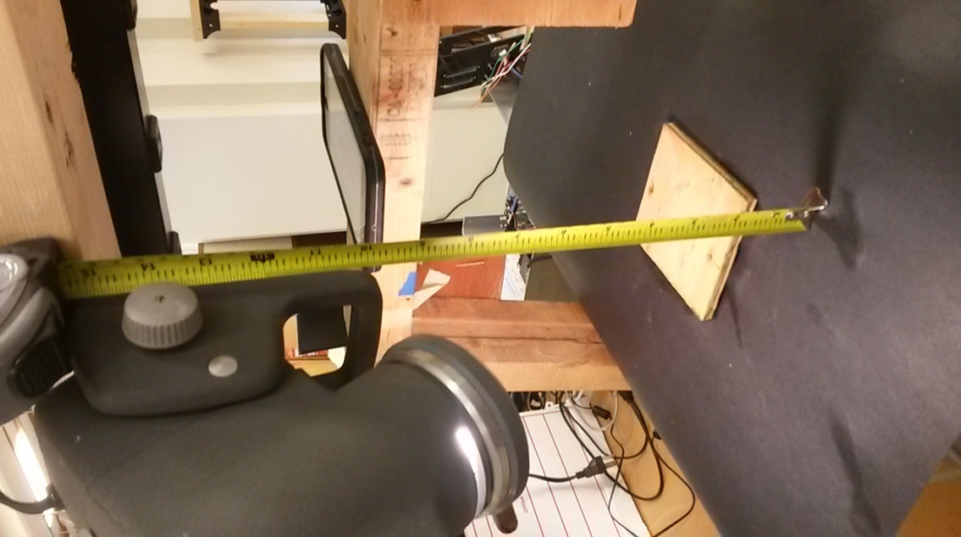
Fig. 6 Set up light source shining on the materials while taking pictures (pre-processing) via an iPhone 7 Plus.

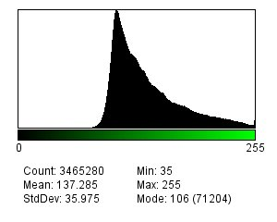
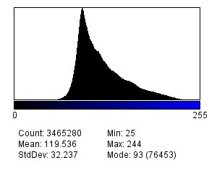
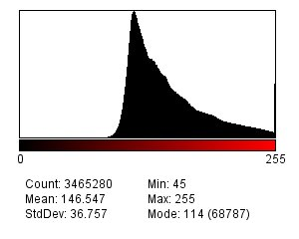
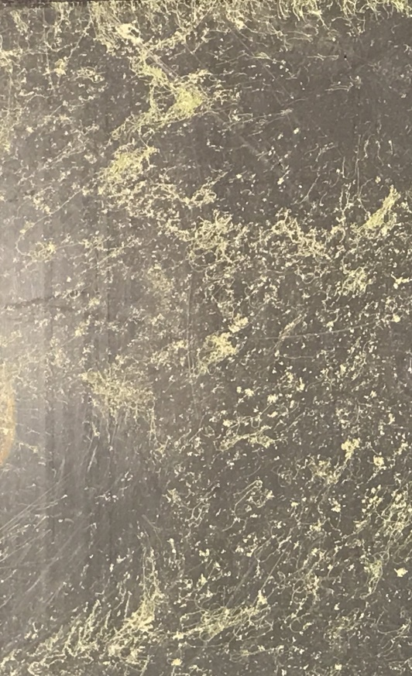
Fig 7 PVC material dry with algae present on tier one showing red, green and blue histograms for specific material

Table 1 Quantitative view of all materials, wet and dry, with and without the presence of algae demonstrating values for the mean, mode and standard deviations. All values were taken off of the histograms for each color.
Dry w/out Algae |  |  | Acrylic | Aluminum | PVC | Wood | Wet w/out Algae |  |  | Acrylic | Aluminum | PVC | Wood
Tier 1 | R | Mean | 233.98 | 129.94 | 181.1 | 226.52 | Tier 1 | R | Mean | 232.8 | 133.42 | 178.35 | 220.29
 |  | Mode | 232 | 124 | 167 | 225 |  |  | Mode | 231 | 128 | 172 | 218
 |  | Stdev | 4.94 | 18.07 | 13.91 | 16.01 |  |  | Stdev | 4.88 | 17.35 | 9.12 | 14.81
 | G | Mean | 218.68 | 117.25 | 171.14 | 169.77 |  | G | Mean | 218.62 | 122.28 | 168.12 | 143.37
 |  | Mode | 216 | 110 | 159 | 169 |  |  | Mode | 217 | 115 | 164 | 143
 |  | Stdev | 4.95 | 18.69 | 12.75 | 16.8 |  |  | Stdev | 4.88 | 17.96 | 8.12 | 13.71
 | B | Mean | 191.53 | 100.99 | 154.13 | 114 |  | B | Mean | 192.08 | 106.45 | 150.77 | 76.1
 |  | Mode | 189 | 91 | 142 | 119 |  |  | Mode | 190 | 97 | 148 | 74
 |  | Stdev | 4.94 | 19.14 | 12.69 | 17.07 |  |  | Stdev | 4.83 | 18.74 | 7.76 | 11.99
Tier 2 | R | Mean | 236.63 | 163.86 | 172.78 | 224.88 | Tier 2 | R | Mean | 233.55 | 179.47 | 163.22 | 215.02
 |  | Mode | 233 | 161 | 165 | 232 |  |  | Mode | 233 | 167 | 164 | 228
 |  | Stdev | 4.93 | 18.24 | 13.68 | 18.73 |  |  | Stdev | 3.41 | 22.71 | 11.98 | 22.89
 | G | Mean | 224.96 | 151.57 | 166.6 | 172.35 |  | G | Mean | 221.15 | 167.28 | 156.93 | 139.49
 |  | Mode | 221 | 147 | 159 | 193 |  |  | Mode | 221 | 157 | 156 | 167
 |  | Stdev | 4.93 | 18.42 | 12.78 | 20.33 |  |  | Stdev | 3.53 | 21.65 | 11.13 | 25.21
 | B | Mean | 199.44 | 134.87 | 154.9 | 110.61 |  | B | Mean | 197.12 | 149.17 | 144.46 | 69.02
 |  | Mode | 196 | 134 | 147 | 92 |  |  | Mode | 197 | 140 | 144 | 56
 |  | Stdev | 4.93 | 19 | 12.71 | 18.18 |  |  | Stdev | 3.12 | 21.13 | 11.09 | 17.83
Dry w Algae |  |  | Acrylic | Aluminum | PVC | Wood | Wet w Algae |  |  | Acrylic | Aluminum | PVC | Wood
Tier 1 | R | Mean | 231.35 | 149.4 | 146.55 | 227.06 | Tier 1 | R | Mean | 230.13 | 153.72 | 130.54 | 224.3
 |  | Mode | 232 | 175 | 114 | 229 |  |  | Mode | 232 | 167 | 129 | 224
 |  | Stdev | 6.26 | 35 | 36.76 | 15.285 |  |  | Stdev | 7.35 | 34.55 | 9.72 | 17.38
 | G | Mean | 222.7 | 146.11 | 137.29 | 175.73 |  | G | Mean | 212.91 | 145.25 | 122.67 | 145.03
 |  | Mode | 223 | 170 | 106 | 179 |  |  | Mode | 214 | 160 | 122 | 144
 |  | Stdev | 6.23 | 34.24 | 35.98 | 15.01 |  |  | Stdev | 7.3 | 33.47 | 9.28 | 17.2
 | B | Mean | 198.76 | 126.01 | 119.54 | 125.17 |  | B | Mean | 177.7 | 123.2 | 108 | 70.89
 |  | Mode | 200 | 147 | 93 | 126 |  |  | Mode | 182 | 132 | 107 | 71
 |  | Stdev | 6.46 | 31.25 | 32.24 | 14.31 |  |  | Stdev | 8.94 | 31.43 | 9.28 | 15.54
Tier 2 | R | Mean | 233.2 | 176.74 | 139.73 | 224.3 | Tier 2 | R | Mean | 225.08 | 170.16 | 127.87 | 201.09
 |  | Mode | 229 | 189 | 117 | 234 |  |  | Mode | 225 | 173 | 128 | 217
 |  | Stdev | 6.58 | 26.16 | 30.9 | 16.15 |  |  | Stdev | 8.04 | 23.92 | 13.54 | 25
 | G | Mean | 224.9 | 172.39 | 135.35 | 174.3 |  | G | Mean | 212 | 164.49 | 123.04 | 131.38
 |  | Mode | 221 | 181 | 112 | 186 |  |  | Mode | 211 | 171 | 124 | 157
 |  | Stdev | 6.78 | 25.5 | 30.54 | 18.18 |  |  | Stdev | 8.15 | 23.3 | 12.77 | 25.78
 | B | Mean | 202.33 | 158.72 | 123.54 | 119.84 |  | B | Mean | 183.19 | 151.71 | 109.02 | 63.133
 |  | Mode | 198 | 168 | 103 | 129 |  |  | Mode | 183 | 151 | 110 | 80
 |  | Stdev | 7.22 | 24.56 | 28.33 | 17.66 |  |  | Stdev | 8.34 | 23.46 | 12.06 | 19.21

Fig. 8 A: Mean, mode, and standard deviation of all four dry materials without the presence of algae on tier one. B: Mean, mode, and standard deviation of all four dry materials without the presence of algae on tier two. C: Mean, mode, and standard deviation of all four dry materials with the presence of algae on tier one. D: Mean, mode, and standard deviation of all four dry materials with the presence of algae on tier two.
A
C
D
B

Fig. 9 A: Mean, mode, and standard deviation of all four wet materials without the presence of algae on tier one. B: Mean, mode, and standard deviation of all four wet materials without the presence of algae on tier two. C: Mean, mode, and standard deviation of all four wet materials with the presence of algae on tier one. D: Mean, mode, and standard deviation of all four wet materials with the presence of algae on tier two.

B
D
C
A

Fig.10 A: Standard deviation of all four dry materials without the presence of algae on tier one for each color, red, green, and blue. B: Standard deviation of all four dry materials without the presence of algae on tier two for each color, red, green, and blue. C: Standard deviation of all four wet materials without the presence of algae on tier one for each color, red, green, and blue. D: Standard deviation of all four wet materials without the presence of algae on tier two for each color, red, green, and blue.
A
C
B
D

Fig. 11 A: Standard deviation of all four dry materials with the presence of algae on tier one for each color, red, green, and blue. B: Standard deviation of all four dry materials with the presence of algae on tier two for each color, red, green, and blue. C: Standard deviation of all four wet materials with the presence of algae on tier one for each color, red, green, and blue. D: Standard deviation of all four wet materials with the presence of algae on tier two for each color, red, green, and blue.
A
B
D
C

