Heavy metal contamination in the greater Puget Sound from various anthropogenic point sources; concentrations in the sediment in comparison to marine biota

Karrin Leazer
University of Washington, Seattle, WA
School of Oceanography, Box 357940
email: knleazer@uw.edu

5/27/2018

Abstract
Heavy metals are naturally occurring elements that have a high atomic weight and are usually found in trace levels within the environment, but can become toxic to marine organisms at elevated concentrations. They can enter the marine environment from a variety of anthropogenic point sources, including from anti-fouling paint from fish farms as well as from mining activities. In this study, heavy metals in the surface sediments and within the marine biota were analyzed at four different stations within the greater Puget Sound area: at one fish farm site and at three mining sites. There was elevated heavy metal contamination present in the surface sediments at all four of the stations, and when these heavy metals were detectable within the surface sediments, they were found within both benthic and pelagic organisms at enrichments approximately one order of magnitude higher than in the sediments. It is now known that heavy metals are present within the local region at highly enriched concentrations and have made their way into the biota; more work is needed to begin to understand the implications of this enrichment for the greater Puget Sound ecosystem.

Introduction
Heavy metals are defined as naturally occurring elements that have a high atomic weight and a density at least 5 times greater than that of water (Fergusson 1990, Tchounwou et al. 2012.) They are also considered “trace” elements due to their presence in low concentrations within the environment, ranging from concentrations in parts per billion to concentrations less than 10ppm (Kabata-Pendia 2001, Tchounwou et al. 2012.) Although heavy metals are naturally occurring, they can become toxic if they are present at increased concentrations within the environment (Tchounwou et al. 2012.) Heavy metals can enter the marine environment from a variety of sources, including from weathering, volcanic eruptions, metal corrosion, atmospheric deposition, leaching of heavy metals from soil, and sediment re-suspension (Nriagu 1989, Tchounwou et al. 2012.) Anthropogenic point sources can be significant contributors of heavy metal contamination to the marine environment, and can include anti-fouling paint from fish farms and mining activities (Haggarty et al. 2003.)
Fish farms could be potential sources of heavy metal contamination to the environment via anti-fouling paint. Many sessile organisms, such as mussels, barnacles, ascidians, bryozoans, polychaetes, and anemones, attach to fish farm nets (Haggarty et al. 2003.) In order to prevent such fouling, fish farms can either remove the nets from the water and scrape them off, or they can apply anti-fouling chemicals that will altogether prevent the growth of organisms on net pens. Tributyltin (TBT) was a common antifouling paint that was banned in British Columbia fish farms in 1988 due to the discovery of its harmful environmental effects (Haggarty et al. 2003.) Once TBT was banned, many BC fish farms started to use antifouling chemicals with copper compounds instead (Gardner and Peterson 2003.) Anti-foulants may provide a significant source of copper, and possibly zinc, to the marine environment (Brooks and Mahnken 2003; Dean et al. 2007.)
In a study conducted in the Bay of Arcachon in France, where oysters were previously observed to be very negatively affected by TBT, researchers found an increase in copper concentrations within the oysters after 1982-when TBT was banned in France and copper-based anti-fouling paints were used instead (Claisse and Alzieu 1993.) Additionally, Katranitsas et al. (2003) found that copper-based anti-fouling paint was not only very harmful to the target sessile organisms on the fish farm nets, but was very toxic to a “non-target” species of brine shrimp, effectively decreasing the shrimp’s enzymatic activity. These results signify that copper from anti-fouling net treatments is entering the environment and bioaccumulating within non-target organisms.
Mining activities could be another potential source of heavy metal contamination to the environment. In 2016, Shon Purdy-a senior oceanography student at the University of Washington-found a spatial difference in heavy metal contamination within the surface sediments of Nootka Sound, located in northwest Vancouver Island, with more elevated metal concentrations near river mouths that ran from old mining sites (Purdy et al. 2016) (Fig. 1.) There are many possible environmental impacts that the disposal of mine tailings could have, including loss of natural benthic habitat, increased concentrations of metals in the water column and the sediments, toxic effects on plants/animals, loss of diversity, bioaccumulation, and change in benthic community structure, and in some cases the disappearance of life (Kay et al. 1989, Haggarty et al. 2003.) According to a study conducted in the Atacama region of northern Chile, there was a significant measurable decrease in the density and diversity of species assemblages at sites that were exposed to copper mine tailings (Lee and Correa 2005.)
There have been many studies on the presence of heavy metals in marine organisms. The major point of entry of metals into the food web is through uptake by primary producers, which happens when metal ions bind to receptors on membrane proteins and are then subsequently transported into the cell (Sunda and Huntsman 1998.) From the primary producers, heavy metals can bioaccumulate up the food chain through trophic interactions. Wang (2002) investigated the biological accumulation of heavy metals in both pelagic and benthic marine food chains, and found that the concentrations of metals within predatory benthic organisms were much higher than they were within pelagic predators. This supports Bryan and Langston’s (1992) finding that concentrations of heavy metals in marine sediments are between three to five orders of magnitude greater than the concentrations in the overlying water column. In this study, the sediments and marine benthic invertebrates were sampled given the fact that the concentrations of heavy metals are so much higher in the sediments than in the water column.
Despite the fact that the heavy metal contamination signal is strongest within the sediments and within benthic organisms, the contamination signal within pelagic organisms cannot be ignored (Wang 2002.) In 2016, Ashley Maloney-a PhD student in oceanography at the University of Washington-analyzed zooplankton from Nootka Sound to determine whether heavy metals were present. She found a positive correlation between the sediment contamination and the zooplankton contamination (Ashley Maloney, personal communication, October 13, 2017.) Additionally, a study conducted in the Barents Sea found heavy metals present within zooplankton, although the concentrations of each specific kind of metal varied among species of zooplankton (Zauke and Schmalenbach 2006.)
Toxicity of heavy metals is hard to measure, both in the environment and in the biota (Haggarty et al. 2003.) In aquatic environments, toxicity of copper is related to the concentration of highly reactive cupric (Cu2+) ions (Brooks and Mahnken, 2003; EPA 1984.) According to Haggarty et al. (2003), the cupric ion can be toxic to marine organisms at relatively low concentrations. Sometimes however, the cupric ions can react to make chemical species of copper that are not bioavailable for uptake, and are therefore non-toxic (Haggarty et al. 2003.) The many different chemical species of copper are maintained in an equilibrium that depends on salinity, temperature, pH, alkalinity, dissolved oxygen, sediment physicochemical characteristics, and the presence of other inorganic and organic molecules (Brooks and Mahnken, 2003; Haggarty et al., 2003.) Additionally, organisms can react differently and have different tolerances to elevated copper concentrations. For example, in a study that compared the copper tolerances of two different marine diatoms, one diatom exhibited a decreased growth rate with increased copper concentrations while the other diatom grew faster with exposure to elevated copper concentrations (Metaxas and Lewis 1991.) Even if copper and other heavy metal contaminants are present within the environment, it is very hard to determine the effects these contaminants will have on the environment or on the organisms that live within the environment, due to the complexity of ecosystem interactions. The goal of this study is not to determine the effects of heavy metals, but to take the first step in determining if the metals are present at all, either within the environment or within the organisms that live there.
It is hypothesized that:
1). There will be elevated heavy metal contamination present in the surface sediments at all of the experimental stations within the greater Puget Sound area. There will likely be elevated concentrations of copper and possibly zinc at the fish farm site due to runoff from anti-fouling paint (Brooks and Mahnken 2003; Dean et al. 2007) and of copper and arsenic at the historic metal mining sites from mining activities.
2). When these contaminants are detectable within the sediment, they will also be detectable within the benthic invertebrates and within the pelagic zooplankton.

Methods
Sampling locations
Three stations were sampled which were likely deposits from historic metal mines (Fig. 2.) CB01 is located near a tributary that runs into Cowichan Bay, near the town of Duncan. The tributary runs past three historic polymetallic mines, one of which was copper (Ministry of Energy, Mines, and Petroleum Resources et al. 2003) (Fig. 2.) SC01 is located between the towns of Chemainus to the north and Crofton to the south, and is near two tributaries that empty into the inlet (Fig. 2.) Each of these tributaries runs from four historic copper mines on Mt. Sicker, all four of which were affiliated with the Lenora, Tyee, and Richard III mines which were in operation between approximately 1898-1910, and then were amalgamated and operated again between 1942-1952 (Ministry of Energy, Mines, and Petroleum Resources et al. 2003.) Copper would be extracted from them on Mt. Sicker, and then would be sent to the Crofton smelter for processing (MINFILE Record Summary No 092B001, Ministry of Energy and Mines.) PS01 is located at the mouth of the Snohomish River. The Snohomish River watershed runs through the Cascades, and past many historic metal mining sites including the Kromona mine, the Zeta mine, and the Copper Belle mine (<http://www.ghosttownsofwashington.com/>; accessed April 10, 2018.)
One station was sampled which was near three fish farms owned by Cooke Aquaculture Pacific. RP01 is located off the southern end of Bainbridge Island, and is adjacent to one of the fish net pens owned by Cooke Aquaculture Pacific (Fig. 2.) Two other net pens owned by the same company are in near proximity to the sampling site.
Field-sampling methods
A surface sediment sample at each location was collected using a Shipek Grab. Once the collected sediment was on board the ship, ~5cm of the intact surface sediment was scooped up and stored in a Ziploc bag at 4°C onboard the ship. The rest of the surface sediment sample was filtered through a 1mm mesh sieve (Aylagas et al. 2016), and any invertebrates that were living in the sediment were rinsed off with deionized (DI) water and placed within an acid clean/trace-metal free bottle labeled with the sample station. In the lab onboard, all invertebrates within this bottle were separated out by phylum, re-rinsed with DI water, and stored in clean petri dishes which were then frozen at -20°C onboard the ship, following the protocol of Kathy Newell (personal communication, November 29, 2017.)
Additionally, at each location, a zooplankton vertical net tow was taken right above the sediments. Once the net tow was taken, the contents of the cod-end were filtered through a >0.7μm filter in order to separate the zooplankton from the seawater. The zooplankton were then back-rinsed off of the filter with DI water into an acid clean/trace-metal free bottle labeled with the sample station, and were then frozen at -20°C onboard the ship (Ashley Maloney, personal communication, November 17, 2017.)
Laboratory-sampling methods
A subset of the collected sediment sample from each station, as well as the invertebrate tissue samples, were freeze-dried at -40°C in Julian Sach’s laboratory. Dry weights of the different phyla of invertebrates were taken, and percent weights by phylum were calculated. All phyla of invertebrate tissue were then ground up with a mortar and pestle and placed into a single 15mL conical centrifuge tube. The frozen zooplankton samples were thawed into a mortar, and then dried out in a 80°C drying oven overnight (Ashley Maloney, personal communication, November 17, 2017.) Once dry, the zooplankton samples were ground up with a mortar and pestle and placed into a 15mL conical centrifuge tube. The freeze-dried sediment, the freeze-dried/ground-up invertebrate tissue samples, and the dried/ground-up zooplankton samples from each station were submitted to the School of Environmental and Forest Sciences (SEFS) Soil Lab for heavy metal analyses. The samples were digested in acid in accordance with the EPA 3050B method (1996.) The resulting digest solution was analyzed for 21 different metals (Al, As, B, Ba, Ca, Cd, Cr, Cu, Fe, K, Mg, Mn, Mo, Na, Ni, P, Pb, S, Se, Zn, Si, Ag) via inductively coupled plasma-atomic emission spectrometry (ICP-AES) in accordance with the EPA 200.7 method (2001.) The measured concentrations of each metal were reported in μg/g when these concentrations were above the respective “quantitative limit” (Table I.) If the measured concentration of a metal fell below its respective “detection limit” (Table I), its concentration was reported as ND, or “none detected” (Table II.) If the measured concentration fell between the detection limit and the quantitative limit, its concentration was reported as TR, or “trace” (Table II.) In addition to metal analyses, the SEFS Soil Lab measured total organic carbon within the biological samples (invertebrate tissue and zooplankton tissue) via CHN analysis in accordance with Method 29‐2.2 (Page et al., 1982.)
A different subset of the collected sediment sample from each station was used for grain-size analysis. The Sediment Dynamics Group’s LS 13 320 Laser Diffraction Particle-Size Analyzer, or Coulter Counter, was used to measure grain-size. Approximately 2g of sediment were filtered through a 2mm mesh sieve to remove larger sediment particles that could potentially clog the machine. The filtered sample was then run in the machine, which reported the sizes of all the grains in the sample by percent volume. From these percent volumes, percent fractions for all the different sizes of sediment present in each sample were calculated. Additionally, the instrument automatically calculated the median grain diameter (D50.)

Results
Enrichment of Metals
Concentrations of 22 different elements (Al, As, B, Ba, Ca, Cd, Cr, Cu, Fe, K, Mg, Mn, Mo, Na, Ni, P, Pb, S, Se, Zn, Si, Ag) within both the surface sediments and in biological samples were reported by the School of Environmental and Forest Sciences (SEFS) Lab (Table II.) Concentrations of each of these elements were then ratioed to the measured aluminum (Al) concentration, as Al is not affected by biological or diagenetic processes (Brumsack et al. 2006.) These element/Al ratios were then compared to reference values in average shale in order to calculate any deviation from average shale composition (Brumsack et al. 2006; Pastorinho et al. 2012.) Enrichment factors (EFs) were calculated from this ratio comparison using the following equation:
𝐸𝐹 = ([𝑀𝑒𝑡𝑎𝑙]/𝐴𝑙)𝑠𝑎𝑚𝑝𝑙𝑒/([𝑀𝑒𝑡𝑎𝑙]/𝐴𝑙)𝑠h𝑎𝑙𝑒
The reference concentrations for average shale were taken from Turekian and Wedepohl (1961) and Brumsack et al. (2006.) EFs were reported for both surface sediment samples and for biological samples (including zooplankton and invertebrates) (Table III, Fig. 3., Fig. 4.)
In the surface sediments, all elements were enriched compared to reference values-with an EF above 1- except for Ba (depleted) and Cd, Pb, and Ag (all either ND or TR raw concentrations.) (Table II, Table III.) For the subset of nine heavy metals investigated in Table II, seven of these metals, excepting Pb and Ag, showed enrichment factors within the surface sediments at stations CB01 and SC01, with higher values for Se, Mo, and As (Fig. 3.) At station PS01, only Ni and Se were enriched, while at station RP01, only Se was enriched (Fig. 3.) Se showed a much higher enrichment within the surface sediments than all of the other metals investigated (Table III, Fig. 3.)
In the biota, all elements investigated in Table III showed enrichment at stations CB01 and SCO1 (Fig. 4) about one order of magnitude higher than the enrichment within the surface sediments, with Se, Ag, As, and Mo showing the highest enrichment (Table III.) At stations PS01 and RP01, the nine heavy metals listed in Table III were either not detected within the biota (ND), or were only detected in trace amounts (TR), so no enrichment factors could be calculated for the metals at these two stations (Table II, Table III.) Although no Ag was detected within the surface sediments at any station (Table II, Table III), it was highly enriched within the benthic invertebrates at stations CB01 and SC01 (Fig. 4), and was present in trace amounts within the benthic invertebrates at station PS01 (Table II, Table III.)
Only the zooplankton sample from station CB01 (CB01-Z) was submitted for metal analysis, as the zooplankton samples from the other stations did not have a large enough volume to analyze. Eight of the nine heavy metals listed in Table III were found within the zooplankton, excluding Ag (Fig. 4.) These metals were more enriched in the pelagic zooplankton than they were in the benthic invertebrates (Fig. 4.)
Concentration of metals within the biota were standardized to the amount of organic carbon within the respective biotic samples (Fig. 5.) With this standardization, relative trends between the nine heavy metals changed (Fig. 4, Fig. 5.) Se, As, and Zn have some of the highest concentrations per gram of organic carbon as compared with the other six metals, although Se dropped more in the line with the rest of the elements after standardization (Fig. 4, Fig. 5.) Ag and Mo have the lowest concentrations per gram of organic carbon as compared with the other seven metals (Fig. 5.) In addition, Zn and Cu concentrations per gram of organic carbon are higher than all the rest of the standardizations, and are higher than all the other metals within zooplankton (Fig. 5.)
Grain-size analyses
Overall, CB01 had the smallest grain sizes as compared with the other stations, while RP01 had the largest grain sizes (Fig. 6.) At station CB01, the sediment was 12% clay, 74% silt, and 14% sand with a D50 value of 17.88 μm. At station SC01, the sediment was 1% clay, 9% silt, and 90% sand with a D50 value of 159.61 μm. At station PS01, the sediment was 8% clay, 41% silt, and 51% sand with a D50 value of 65.71 μm. At station RP01, the sediment was 1% clay, 2% silt, and 97% sand with a D50 value of 502.44 μm.
Principal Component Analyses (PCAs)
Two PCAs were run using R-script, including one sediment PCA considering the D50 values from the grain-size analysis, as well as the EFs of the elements found within the surface sediments (Fig. 7), and one biota PCA considering the %Organic carbon (OC) within the biota as well as the EFs of elements found within the biological tissues, including zooplankton tissue and invertebrate tissue (Fig. 8.) Any elements with ND as a concentration were assigned an EF value of 0.001, below all detection limits listed in Table I. Any elements with TR as a concentration were assigned an EF value that was the midpoint between the detection and quantitative limits for that respective element (Table I.)
The sediment PCA revealed a covariance between Ba, Cr, Mo, As, Zn, B, K, Cu, and Cd on the negative end of Axis 1 (Fig. 7.) A covariance was also revealed between S, Na, Al, P, Mg, Ni, and Fe on the negative end of Axis 2 (Fig. 7.) Axis 1 explained 51% of the variance within the dataset, and Axis 2 explained 36% of the variance.
The biota PCA revealed a covariance between Mo, Ni, Zn, Cu, Na, and Cd, on the positive end of Axis 1 and negative side of Axis 2 (Fig. 8.) Another covariance was displayed between P, Ag, Al, Se, and As on the positive end of Axis 2 and the negative side of Axis 1 (Fig. 8.) In addition, the %OC stood alone but pulled very strongly towards the negative end of Axis 2 (Fig. 8.) Axis 1 explained 49% of the variance within the dataset, and Axis 2 explained 34% of the variance.

Discussion
Sediment Enrichment Factors (EFs)
The initial hypothesis that there would be elevated heavy metal contamination present in the surface sediments at all of the experimental stations within the greater Puget Sound area was supported (Fig. 3,) although the specific predictions of which heavy metals would be most enriched were not entirely supported. It was hypothesized that there would be elevated concentrations of Cu and As at the historic metal mining sites (CB01, SC01, PS01) from mining activities. At stations CB01 and SC01, two of the three historic mining sites, there were indeed elevated concentrations of Cu and As, as well as elevated concentrations of Cr, Mo, Ni, Zn, and Se (Fig. 3.) However, there were not any As or Cu enrichments at station PS01- there were only elevated concentrations of Ni and Se (Fig 3.) The comparatively higher concentration of Ni at station PS01 relative to stations CB01 and SC01 could be due to the wastewater treatment plant located in Everett, WA, close to the mouth of the Snohomish River (station PS01.) According to the Nickel Institute, (<https://www.nickelinstitute.org/Sustainability/EnvironmentalQuality>; accessed May 1, 2018), Ni can be added to the surface waters directly via industrial discharge associated with wastewater treatment, and marine sediments can act as a sink for this anthropogenic Ni discharge. With station PS01 being 8% clay and 41% silt (Fig. 6), the sediments would have ample surface area for the adsorption of Ni.
It was also hypothesized that there would be elevated concentrations of Cu and possibly Zn at the fish farm site (RP01) due to leaching from anti-fouling paint (Brooks and Mahnken 2003; Dean et al. 2007.) However, at station RP01, there were not elevated concentrations of Cu or Zn; the only heavy metal that showed enrichment within the surface sediments at this station was Se (Fig. 3.)
At all four of the stations (CB01, SC01, PS01, and RP01), Se showed enrichment about two orders of magnitude higher than all the other heavy metals (Fig. 3.) According to the Agency for Toxic Substances & Disease Registry’s Toxicological Profile for Se, although Se is a naturally occurring compound, it can become toxic at elevated concentrations (USDHHS, Toxicology, Se.) It can have many anthropogenic sources to the marine environment, including emissions from coal and oil combustion, Se refining factories, base metal smelting/refining factories, mining operations, end-product manufacturers, sewage effluent, agricultural runoff, and industrial wastewater (USDHHS, Toxicology, Se.) The high enrichment of Se at the three mining stations (CB01, SC01, and PS01) could be explained by Se sources from mining operations, and the PS01 Se enrichment might also be explained by agricultural runoff from the Snohomish River watershed as well as wastewater from the Everett treatment plant. For instance, Se is an ingredient that is used within anti-dandruff shampoos in high concentrations (USDHHS, Toxicology, Se), and so could potentially contribute to Se enrichment within wastewater. Even though these may be sources that contribute to the observed Se enrichment, since Se is even more highly enriched at station RP01 (fish farm site) than at the other three stations, these are likely not the only sources (Fig. 3.) Se has been recommended as a supplement for fish feed in aquaculture (Pacitti et al. 2016), so this could potentially be a source of Se to station RP01. The behavior of Se within the environment can also be influenced by its oxidation state and the differences in behavior of its different chemical compounds (USDHHS, Toxicology, Se.)
In a recent study, EFs were calculated for the surface sediments of two fjords on Vancouver Island: Zeballos Inlet and Tahsis Inlet (Fig. 1) (Purdy et al. 2016.) Purdy et al. (2016) concluded that As, Cd, and Se were the biggest problems for the local environment, given their high EFs compared to average shale (Fig. 1.) The EFs of As and Se calculated for the surface sediments in the present study (Fig. 3) were much higher than the EFs calculated in Purdy et al.’s (2016) study, by approximately one order of magnitude. One possible explanation for these differences in As and Se EFs could be due to the fact that the mines that were located north of the rivers in Zeballos Inlet and Tahsis Inlet were not in operation as long as the Lenora, Tyee, and Richard III mines near stations CB01 and SC01 north of Saanich Inlet. The Zeballos mines were operated between 1924-1929 and again from 1934-1948, with intermittent mining activities within those time periods (Stevenson, 1950.) The Lenora, Tyee, and Richard III mines were in operation between approximately 1898-1910, and then were amalgamated and operated again between 1942-1952 as the “Twin J” mine
(MINFILE Record Summary No 092B001, Ministry of Energy and Mines.) In addition to the mines near Saanich Inlet being run for a longer total period of time and more recently than the mines in Zeballos Inlet, there were more consistent/less intermittent mining activities conducted during the years of operation. This likely allowed more time for greater accumulation of heavy metals within the sediments at stations CB01 and SC01 than at Purdy et al.’s (2016) Zeballos Inlet and Tahsis Inlet stations, contributing to higher As and Se EFs at these sites. However, it is important to note that the EF for Cu in Purdy et al.’s (2016) study was higher than the EF for Cu in the present study (Fig. 3, Fig. 1,) even though the mines in both studies were copper mines. The amount of Cu extracted from the “Twin J” mine (comprised of three separate sites) was 16.72 lbs/ton (MINFILE Record Summary No 092B001, Ministry of Energy and Mines,) while the amount of Cu extracted from the suite of fifteen Zeballos mines was approximately 35.6 lbs/ton (Stevenson, 1950.) Even though the mines north of Saanich were in operation more consistently and for a longer total period of time, allowing for a greater accumulation of heavy metals such as As and Se, the total amount of Cu extracted from the Saanich mines was not as much as was extracted from the Zeballos mines because there were fewer mining sites. The greater total amount of Cu extracted from Zeballos likely contributed to the higher Cu EF in Purdy et al.’s (2016) study. Since these two studies were conducted in separate fjords, it is possible that differences in sediment accumulation rates, along with differences in the amount of metal that could be potentially still leaching from inland mine tailings, could have contributed to the differences between the calculated EFs. The higher the sediment accumulation rate and the lower the amount of metal that could be potentially still leaching from mine tailings, the lower the EF in the surface sediments would be. Likewise, the lower the sediment accumulation rate and the higher the amount of metal that could be potentially still leaching from mine tailings, the higher the EF in the surface sediments would be. More research would need to be done to further investigate this potential process in order to get a broader understanding of what contributes to elevated metal concentrations between different locations.

Biota Enrichment Factors (EFs)
The second hypothesis, that when these heavy metal contaminants were detectable within the sediments they would also be detectable within the benthic invertebrates and pelagic zooplankton, was also only partially supported. All the heavy metals that showed elevated concentrations within the surface sediments also showed elevated concentrations within the invertebrates and zooplankton (Fig. 3, Fig. 4), which supports the hypothesis. It is possible that some metals are still leaching from inland mine tailings, which is why they are enriched within the surface sediments and within the biota (Table III,) however, more research is needed in order to investigate this mechanism. The EFs calculated for the biota were approximately one order of magnitude higher than the EFs calculated for the surface sediments, providing evidence of bioaccumulation of heavy metals into the food web (Fig. 3, Fig. 4.) Two of the heavy metals were enriched in the biota but were not detected within the sediments. Pb was present at elevated concentrations within the zooplankton at station CB01 and within the invertebrates at station SC01, and Ag was present at highly elevated concentrations within the invertebrates at both stations CB01 and SC01 (Fig. 4), even when these two metals were not detected within the surface sediments at either station (Table II.) The Lenora, Tyee, and Richard III mines produced mainly copper, silver, and gold. But when these three mines were amalgamated and run from 1942-1952, they produced Au, Ag, Cu, Pb, Zn, and Cd (MINFILE Record Summary No 092B001, Ministry of Energy and Mines.) Since it has been 66 years since the mines were in operation, there are likely no leftover traces of Pb and Ag to the surface sediments, and these metals are likely located lower within the sediment column and therefore do not show up in the surface sediments. Since benthic invertebrates can move within the sediments, they likely moved farther down within the sediment column, accumulating the Ag and Pb that had been deposited earlier, before coming back up to the surface sediments. In order to validate this theory, further studies would need to be conducted on the sediments at stations CB01 and SC01 in order to determine the distribution of heavy metal contaminants within the sediment column.
The concentrations of the nine heavy metals within each sample, along with the % organic carbon (OC) within the same respective sample, were used to calculate an amount of metal per gram of OC in order to provide a standardization that will overcome spatial and temporal constraints and will allow comparison to other similar datasets (Fig. 5.) Out of the nine heavy metals present at enriched concentrations within the invertebrate tissue (Fig. 4), As, Se, and Zn showed the highest amounts per gram of OC (Fig. 5.) All three of these metals are found naturally within the environment, but when these concentrations become enriched (Fig. 4), they can become toxic to marine life, and sometimes can affect humans. For instance, one study estimated the target cancer risks (TR) based on a 95% occurrence probability from ingesting inorganic As by consuming oysters with concentrations of As up to 33.37 μg/g at a rate of 18.6-56 g/day (Liu et al. 2006.) The probabilities of TR from consuming these oysters fell within the range that suggested a potential cancer risk (Liu et al. 2006.) The invertebrates in this study had As concentrations much higher than the As concentrations in these oysters; the zooplankton at station CB01 had an As concentration of 81 μg/g, the invertebrates at station CB01 had an As concentration of 155 μg/g, and the invertebrates at station SC01 had an As concentration of 310 μg/g (Table II.) This level of As enrichment has the potential to cause harm to organisms farther up the food chain, if the concentrations of As within their tissue range from 47.63 μg/g to 276.63 μg/g higher than what would be considered a cancer risk.
Different organisms can accumulate different metals in different concentrations, and enrichment of these metals can be species-specific. In a study measuring the bioaccumulation of heavy metals within two species of gastropod and three species of bivalve, it was found that one of the species of gastropod accumulated Cd more than the other species, one species of bivalve accumulated Cu and Zn in higher amounts than the other species, and one species of bivalve accumulated Ni in higher amounts than the other species (Liang et al. 2004.) In the present study, not only were there various species of bivalve and gastropod, but there were also annelids, crustaceans, echinoderms, and cnidarians mixed together along with the mollusks and were submitted collectively for metal analyses. Given this fact, and Liang et al.’s (2004) findings, it is very difficult to determine from the results of the present study which phyla of benthic invertebrates contributed to the calculated EFs within the invertebrate samples. In future studies, it would be beneficial to separate the invertebrates by phylum, or even by species, and submit each phylum/species for metal analysis separately in order to see if there is an obvious distribution of accumulation of various metals across the different phyla/species.
It is important to note that the mollusks within the mixed invertebrate samples were submitted for metal analysis with their shells still attached. Although the proportional weight of the mollusk shells within the mixed samples was accounted for and removed by utilizing measured Ca concentrations, the reported metal concentrations (Table II) and resulting EFs (Table III) for the biotic samples do not account for any metals that were within the shells themselves. Therefore, the reported EFs are maximum values, and include all the metals within the soft bodies and within the shells of the invertebrates. According to Jitar et al. (2015), metal uptake by organisms with shells can be different from uptake by organisms without shells. For example, organisms with shells have higher Pb uptake than those without shells, because Pb follows similar biochemical models as Ca (Jitar et al. 2015.) Given this, the reported concentrations and EFs for the biological samples could have been different if the shells had been removed prior to analysis. In order to try to correct for this, values from Demina et al.’s (2016) study on the relative percentages of soft tissue vs shell for two mollusk species were utilized (Fig. 9.) A wide range of EFs are possible, and this was only after considering two mollusk species. It is important to note that these two mollusks from Demina et al. (2016) are both species of bivalve mussels, but in the present study, a combination of bivalves and gastropods were considered in metal analysis and in the calculation of EFs. So even this correction (Fig. 9) is not perfect and is definitely not all-encompassing. In future studies, the shells should be removed from all mollusks in order to get a more representative and accurate EF calculation.
The EFs of heavy metals were higher in the zooplankton than they were in the benthic invertebrates, even with the EFs for the invertebrates being maximum values (Fig. 4.) This was an unexpected result, given that benthic invertebrates generally feed at a higher trophic level than zooplankton and should therefore show signs of increased bioaccumulation. Wang (2002) found that the concentrations of metals within predatory benthic organisms were much higher than they were within pelagic predatory organisms. This study’s findings go against Wang’s (2002) findings. Given that there was a lack of replication in sampling in this study, and given that only one zooplankton sample could be submitted for metal analysis, it is almost impossible to determine whether these results are a noteworthy anomaly, or whether they represent a sampling error. Further research needs to be done, ensuring replication, so that the significance of these results can be determined.
Principal Component Analyses
The sediment PCA revealed a covariance between Ba, Cr, Mo, As, Zn, B, K, Cu, and Cd on the negative end of Axis 1 (Fig. 7.) Because three out of the four stations sampled in this study were located at mining sites that were known to mine Cu, and because As, Cd, Mo, and Zn are known to enter the environment from mines (Haggarty et al. 2003; USDHHS, Toxicology, Zn,) it is possible that Axis 1 could represent the sources of metals to the environment, with the negative side of Axis 1 representing mining sources. Se is on the positive end of Axis 1, so is anti-correlated with the cluster of metals mentioned above. Using the suggested representation of Axis 1 as sources of metals, this would imply that Se has a source other than mining. This is supported by the fact that Se was more highly enriched at station RP01 (the fish farm site) than two of the three mining sites (Fig. 3.) More research is needed in order to further investigate this potential “other” source of Se to the Puget Sound region.
A covariance was also revealed between S, Na, Al, P, Mg, Ni, and Fe on the negative end of Axis 2, while Ca was anticorrelated with this cluster (Fig. 7.) Because Al is very common in the earth’s crust (Turekian&Wedepohl 1961, Brumsack 2006) and because Fe is also associated with terrigenous sources, it is possible that the negative end of Axis 2 could represent lithogenic elements. The fact that Ca is anti-correlated with the “terrigenous-sourced” metals is supported by the fact that Ca is abundant in seawater and in both organic and inorganic biotic materials.
In addition, D50 showed a close association with Ca (Fig. 7.) Larger D50 values correspond with larger sediment grains, and Ca is a large component of shells. Given this, the larger D50 values are likely associating with larger pieces of shell within the sediment samples.
The biota PCA revealed a covariance between Mo, Ni, Zn, Cu, Na, and Cd, on the positive end of Axis1, with Ca, Mn, and Si being anti-correlated (Fig. 8.) Because Ca is a major component in the formation of mollusk shells, because Mn can sometimes replace Ca during shell formation (Soldati et al. 2016), and because Si is a primary constituent of opal or silica (SiO2) shells, it is likely that the negative end of Axis 1 represents shell-derived elements, while the positive end of Axis 1 most likely represents elements in the soft tissue. Komjarova (2009) found that the addition of Na to an aqueous medium had an affect on the uptake of Cd and Ni by aquatic organisms. This could explain why Na is clustered near those two metals (Fig. 8.)
Another covariance was displayed between P, Ag, Al, Se, and As on the positive end of Axis 2 and the negative side of Axis 1 (Fig. 8.) It has been found that As and P have similar chemical characteristics, and therefore As can be substituted for P in certain metabolic pathways (National Research Council, As,) which would explain why those two elements are clustered together. It is possible that other metals within this same cluster could affect organisms through altering P concentrations within the body, but little is known about this and more research is needed.

Conclusions
In this study, both initial hypotheses were partially accepted: first, it was found that there was elevated heavy metal contamination present in the surface sediments at all four of the experimental stations within the greater Puget Sound area, although the specific predictions of which heavy metals would be most abundant were not entirely supported. In addition to the predicted Cu and As that were present at most of the mining sites, there was also enrichments of Cr, Mo, Ni, Zn, and Se, with Se showing the highest enrichment. Cu and Zn were predicted to be enriched at station RP01 due to runoff from anti-fouling paint, but neither were enriched; the only element enriched at station RP01 was Se.
Second, when these heavy metal contaminants were present within the surface sediments, they were present within the biota, but Pb and Ag were present within the biota without being detected within the surface sediments. As, Se, and Zn showed the highest concentrations per gram of OC within the biota, and As enrichment within the biota was higher than concentrations known to be a cancer risk. This could have serious implications for the health of the ecosystem, and these elevated As concentrations, along with Se and Zn, could bioaccumulate up the food chain.
Further studies need to be conducted on the surface sediments and within the biota at all stations, but continuing to build on the data set at stations CB01 and SC01 would be ideal. It is still unknown where in the sediment column the heavy metal contaminants are distributed; box cores would need to be taken and the sediments dated at those locations in order to determine this. In addition, separating out the invertebrates by phylum and making sure to remove the mollusk shells before submitting the samples for metal analysis will produce a more representative and accurate view of the distribution of accumulation of metals across the different phyla, as well as more accurate EF values. Repetition within the zooplankton samples will allow significance of results to be determined.
There is still much work to be done in understanding the nature of heavy metal processes within the local environment and within the organisms that live there. However, future work can build upon the results of this study; it is now known that heavy metals are present within the local region at highly enriched concentrations, and more work is needed to begin to understand the implications of this enrichment for the greater Puget Sound ecosystem.

Acknowledgements
I would like to thank the Captain and crew of the R/V Thomas G. Thompson and R/V Clifford A. Barnes for contributing to two successful data collection cruises. I would like to thank the School of Oceanography for the funding that made this project possible. I would like to offer special thanks to the following people: Arthur Nowell and Julian Sachs for their help with project planning, advising meetings, and support through the entire project; Kathy Newell and Miles Logsdon for all of their help in cruise preparation and for ensuring I had all the equipment I needed; and Susanna Michael and Angie Boysen for their invaluable technical support and assistance with data analysis. Thank you all for making this project a success.

References
Aylagas E., Mendibil I., Borja Á, and Rodríguez-Ezpeleta N. 2016. “Marine Sediment Sample Pre-processing for Macroinvertebrates Metabarcoding; Mechanical Enrichment and Homogenization.” Front. Mar. Sci. 3:203
Brooks K.M. and Mahnken C.V.W. 2003. “Interactions of Atlantic salmon in the Pacific Northwest environment III. Accumulation of zinc and copper.” Fisheries Research. 62:295-305.
Brumsack H.J., 2006. “The trace metal content of recent organic carbon-rich sediments:
Implications for Cretaceous black shale formation.” Palaeogeogr., Palaeoclimatol., Palaeoecol. 232: 344-361
Bryan G. W. and Langston W.J., 1992. “Bioavailability, accumulation and effects of heavy metals in sediments with special reference to United Kingdom estuaries: a review.” Environ. Pollut. 76:89-131
Claisse D. and Alzieu C.I. 1993. “Copper Contamination as a Result of Antifouling Paint Regulations?” Mar. Pollut. Bull. 26(7):395-397.
Dean R.J., Shimmield T.M., and Black K.D. 2007. “Copper, zinc and cadmium in marine cage fish farm sediments: An extensive survey.” Environ. Pollut. 145:84-95.
Demina L.L., Oskina N.S., and Galkin S.V. 2016. “Trace metal accumulation in carbonate biominerals of the Atlantic Ocean.” Oceonology 56(1):131-136
“Environmental Quality.” Nickel Institute. https://www.nickelinstitute.org/Sustainability/EnvironmentalQuality, accessed May 1, 2018.
EPA, 1984. “Ambient Water Quality Criteria for Copper.” United States Environmental Protection Agency.
EPA, 1996. “Method 3050B: Acid Digestion of Sediments, Sludges, and Soils,” Revision 2. United States Environmental Protection Agency.
EPA, 2001. “Trace Elements in Water, Solids, and Biosoilds by Inductively Coupled Plasma-Atomic Emission Spectrometry.” Revision 5. United States Environmental Protection Agency.
Fergusson, J.E. 1990. “The Heavy Elements: Chemistry, Environmental Impact and Health Effects.” Oxford: Pergamon Press.
Gardner J. and Peterson D.L. 2003. “Making Sense of the Salmon Aquaculture Debate; Analysis of issues related to netcage salmon farming and wild salmon in British Columbia.” Pacific Fisheries Resource Conservation Council.
Ghost Town Listings Washington State. Ghost Towns of Washington. http://www.ghosttownsofwashington.com/, accessed April 10, 2018.
Haggarty, D.R., B. McCorquodale, D. I. Johannessen, C.D. Levings, and P.S. Ross, 2003. “Marine environmental quality in the central coast of British Columbia, Canada: A review of contaminant sources, types and risks.” Can Tech. Rep. Fish. Aquatic Sci. 2507: x+153 p.
Jitar O., Teodosiu C., Oros A., Plavan G., and Nicoara M. 2015. “Bioaccumulation of heavy metals in marine organisms from the Romanian sector of the Black Sea.” N. Biotechnol. 32(3)
Kabata-Pendia A. 2001. “Trace Elements in Soils and Plants.” Boca Raton, FL: CRC Press
Katranitsas A., Castritsi-Catharios J., and Persoone G. 2003. “The effects of a copper-based antifouling paint on mortality and enzymatic activity of a non-target marine organism.” Mar. Pollut. Bull. 46:1491-1494.
Kay B.H. 1989. Pollutants in British Columbia’s marine environment: a Status report. A state of the environment report. SOE report, 89-1. Canada. Environmental Protection.
Komjarova I. 2009. “Uptake of Trace Metals in Aquatic Organisms: a Stable Isotopes Experiment.” Doctorate Dissertation, Department of Biology, University of Antwerp.

Lee M.R. and Correa J.A. 2005. “Effects of copper mine tailings disposal on littoral meiofaunal assemblages in the Atacama region of northern Chile.” Mar. Environ. Res. 59:1-18.

Liang L.N., He B., Jiang G.B., Chen D.Y., and Yao Z.W. 2004. “Evaluation of mollusks as biomonitors to investigate heavy metal contaminations along the Chinese Bohai Sea.” Sci. Total Environ. 324:105-113
Liu C.W., Liang C.P., Huang F.M., Hsueh Y.M. 2006. “Assessing the human health risks from exposure of inorganic arsenic through oyster (Crassostrea gigas) consumption in Taiwan.” Sci. Total Environ. 361:57-66
Metaxas A. and Lewis A.G. 1991. “Copper tolerance of Skeletonema costatum and Nitzschia thermalis.” Aquat. Toxicol. 19:265-280.
MINFILE Record Summary No 092B001, Ministry of Energy and Mines. http://minfile.gov.bc.ca/Summary.aspx?minfilno=092B++001
Ministry of Energy, Mines, and Petroleum Resources, British Columbia, 2003. The MapPlace-Historic Mines Atlas. http://www.empr.gov.bc.ca/Mining/Geoscience/MapPlace/thematicmaps/Pages/HistoricMines.aspx.
National Research Council (US) Committee on Medical and Biological Effects of Environmental Pollutants. Arsenic: Medical and Biologic Effects of Environmental Pollutants. Washington (DC): National Academies Press (US); 1977. 5, Biologic Effects of Arsenic on Plants and Animals. Available from: https://www.ncbi.nlm.nih.gov/books/NBK231025/, accessed May 11, 2018.

Nriagu J.O. 1989. “A global assessment of natural sources of atmospheric trace metals.” Nature. 338:47–49
Pacitti D., Lawan M.M., Feldmann J., Sweetman J., Wang T., Martin S.A.M., and Secombed C.J. 2016. “Impact of selenium supplementation on antiviral responses: a whole transcriptomic analysis in rainbow trout (Oncorhynchus mykiss) fed supranutritional levels of Sel-Plex.” BMC Genomics. 17:116
Page A.L., Miller R.H., and Keeney D.R. 1982. “Methods of Soil Analysis, Part 2 ‐ Chemical and Microbiological Properties.” American Society of Agronomy (ASA), Soil Science Society of America (SSSA), 2nd edition.
Pastorinho M.R., Telfer T.C., Nogueira A.J.A., Soares A.M.V.M., and Ranville J.F., 2012. “An evaluation of trace metal distribution, enrichment factors and risk in sediments of a coastal lagoon (Ria de Aveiro, Portugal.)” Environ. Earth Sci. 67:2043-2052.
Purdy S., Belleman C., and Sachs J., 2016. “Sources and transport of surface sediment and metals in B.C. fjord, Tahsis and Zeballos Inlets.”
Soldati A.L., Jacob D.E., Glatzel P., Swarbrick J.C., and Geck J. 2016. “Element substitution by living organisms: the case of manganese in mollusc shell aragonite.” Sci. Rep. 6:22514

Stevenson J.S. “Geology and Mineral Deposits of the Zeballos Mining Camp, 6.C. Ministry of.” Energy, Res., Miscellaneous Report. Mines&Pet. Res., Bull27 (1950.)
Sunda W.G. and Huntsman S.A. 1998. “Processes regulating cellular metal accumulation and physiological effects: Phytoplankton as model systems.” Sci. Total Environ. 219:165-181.
Tchounwou P.B., Yedjou C.G., Patlolla A.K., and Sutton D.J. 2012. “Heavy Metals Toxicity and the Environment.” EXS. 101:133-164
Turekian K.K. and Wedepohl K.H., 1961. “Distribution of elements in some major units of the earth’s crust.” Geol. Soc. Am. Bull. 72: 175–192
USDHHS Public Health Service, Toxicology. “Toxicological Profile for Selenium.” Agency for Toxic Substances and Disease Registry (ATSDR)
USDHHS Public Health Service, Toxicology. “Toxicological Profile for Zinc.” Agency for Toxic Substances and Disease Registry (ATSDR)
Wang W., 2002. “Interactions of trace metals and different marine food chains.” Mar. Ecol. Prog. Ser. 243:295-309
Zauke G.P. and Schmalenbach I., 2006. “Heavy metals in zooplankton and decapod crustaceans from the Barents Sea.” Sci. Total Environ. 359: 283-294

Table I. Detection and quantitative limits for each metal that was analyzed by the SEFS lab. The PCA TR value represents the midpoint between the detection limit and the quantitative limit for each respective element, and was subsequently used to replace the TR values in Principal Component Analyses.

 | Detection Limit | Quantitative Limit | PCA TR value
Al | 0.039 | 0.130 | 0.084
As | 0.083 | 0.277 | 0.180
B | 0.009 | 0.030 | 0.019
Ba | 0.006 | 0.020 | 0.013
Ca | 0.056 | 0.187 | 0.121
Cd | 0.046 | 0.153 | 0.100
Cr | 0.042 | 0.140 | 0.091
Cu | 0.019 | 0.063 | 0.041
Fe | 0.019 | 0.063 | 0.041
K | 0.395 | 1.317 | 0.856
Mg | 0.109 | 0.363 | 0.236
Mn | 0.003 | 0.010 | 0.006
Mo | 0.018 | 0.060 | 0.039
Na | 0.10 | 0.34 | 0.219
Ni | 0.008 | 0.027 | 0.017
P | 0.085 | 0.283 | 0.184
Pb | 0.070 | 0.233 | 0.152
S | 0.075 | 0.250 | 0.162
Se | 0.147 | 0.490 | 0.318
Zn | 0.029 | 0.097 | 0.063
Si | 0.092 | 0.307 | 0.199
Ag | 0.005 | 0.017 | 0.011

Table II. Concentrations (in μg/g) of metals found in the surface sediments (S) as well as in the biota (Z-zooplankton, I- invertebrate) at each station. The concentrations for invertebrate samples are reported as μg of metal per g of soft body, as the weight of the invertebrate shells were accounted for and removed. Note that Ca values are still quite high for the invertebrate samples, given that these Ca concentrations were used to normalize the values for shell weight. ND stands for “none detected,” which means the measured value fell below the detection limit reported in Table I. TR stands for “trace,” which means that the measured value fell between the detection limit and the quantitative limit reported in Table I.
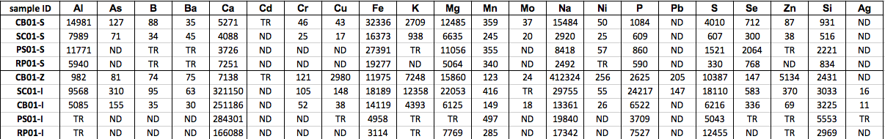

Table III. Enrichment factors (EF) of a subset of metals in the surface sediments (S) as well as the biota (Z-zooplankton, I- invertebrate) at each station. EFs were calculated using the average values in shale (Turekian and Wedepohl 1961; Brumsack et al. 2006.) ND means that no EF could be calculated due to the measured concentration being under the detection limit; TR means that no EF could be calculated due to the measured concentration being between the detection limit and the quantitative limit.
sample ID | As | Cr | Cu | Mo | Ni | Pb | Se | Zn | Ag
CB01-S | 76.80 | 3.04 | 5.66 | 165.99 | 4.32 | ND | 6337.07 | 5.28 | ND
SC01-S | 81.14 | 3.07 | 4.18 | 164.71 | 4.13 | ND | 5002.87 | 4.30 | ND
PS01-S | ND | ND | ND | ND | 6.25 | ND | 23377.12 | TR | ND
RP01-S | ND | ND | ND | ND | TR | ND | 17244.02 | ND | ND
CB01-Z | 749.82 | 121.13 | 5948.59 | 1623.54 | 338.18 | 835.74 | 19893.76 | 4751.32 | ND
CB01-I | 276.63 | 10.01 | 14.59 | 237.03 | 6.53 | ND | 8796.63 | 12.25 | 2610.93
SC01-I | 294.99 | 10.81 | 30.41 | TR | 7.52 | 61.36 | 8131.29 | 35.13 | 2025.39
PS01-I | ND | ND | TR | ND | ND | ND | TR | TR | TR
RP01-I | ND | ND | ND | ND | ND | ND | ND | TR | ND

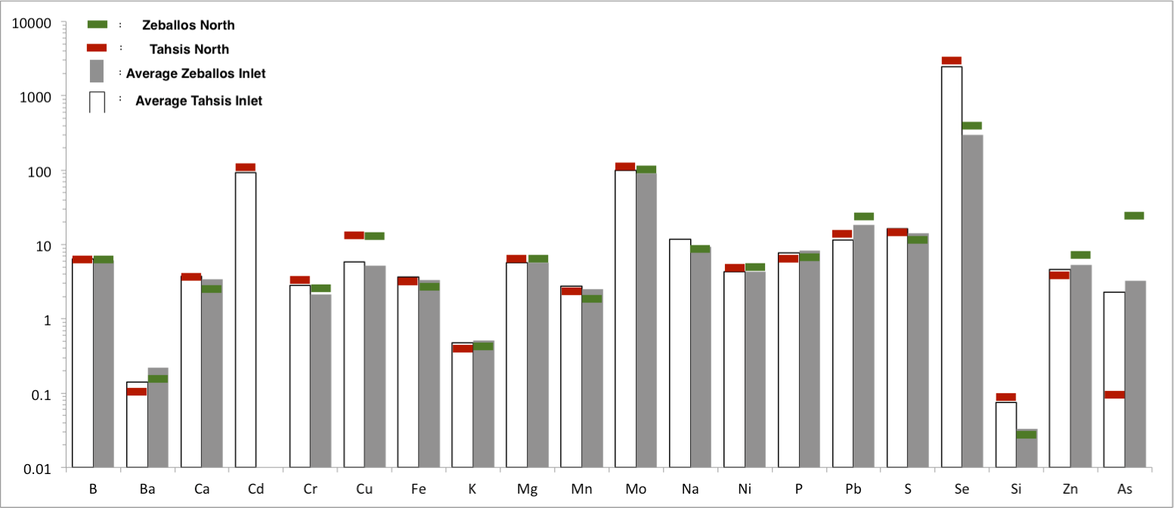

Figure 1: Figure taken from Purdy et al. (2016): “The average enrichment factors of each metal in Tahsis and Zeballos Inlets, using the average values in shale (Turekian and Wedepohl, 1961). The y-axis is on a log scale. The data includes 2014 and 2015 combined dataset of enrichment factors. The red colored bars indicate the northernmost stations in Tahsis Inlet (T-1-T4) in the, while the green bars show the northernmost stations in Zeballos Inlet (Z-3). The clear bars show the average concentration throughout Tahsis Inlet, while the grey bars show average concentration throughout Zeballos Inlet.” The northernmost stations within both Tahsis and Zeballos Inlets are closest to historic mining activity.

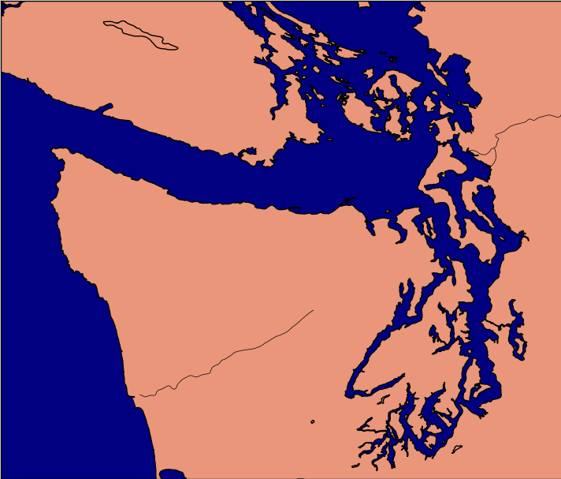
RP01
PS01
CB01
SC01

Fig. 2. Map of sampling locations off of Vancouver Island (CB01 and SC01) and in Puget Sound (PS01 and RP01.) CB01 is a metal mine station located at 48° 44.964’ N/ 123° 37.026’ W and is 49m deep. SC01 is a metal mine station located at 48° 55.542’ N/123° 41.028’ W and is 24m deep. PS01 is a metal mine station located at 48° 01.7820' N/122° 16.6592' W and is 20m deep. RP01 is a fish farm station located at 47° 35.0223' N/122° 31.9416' W and is 22m deep.

Figure 3: Enrichment factors of metals in the surface sediments at each station, calculated using the average values in shale (Turekian and Wedepohl 1961; Brumsack et al. 2006.) The y-axis is on a logarithmic scale. Only those elements that occurred above the quantitative detection limit at two or more locations are shown. The following elements occurred at ND levels: Ag and Pb.
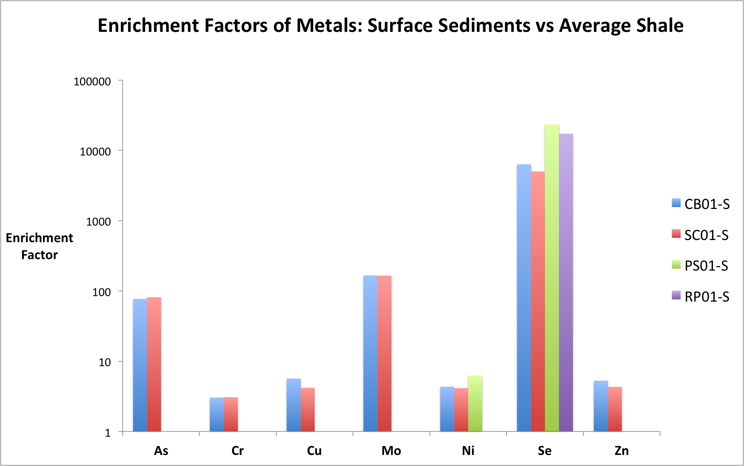

Figure 4: Enrichment factors of metals within the biota at the two northernmost stations (CB01 and SC01), calculated using the average values in shale (Turekian and Wedepohl 1961; Brumsack et al. 2006.) Biota samples include both zooplankton samples (Z) and invertebrate samples (I.) The y-axis is on a logarithmic scale. Only those elements that occurred above the quantitative detection limit at two or more locations are shown.
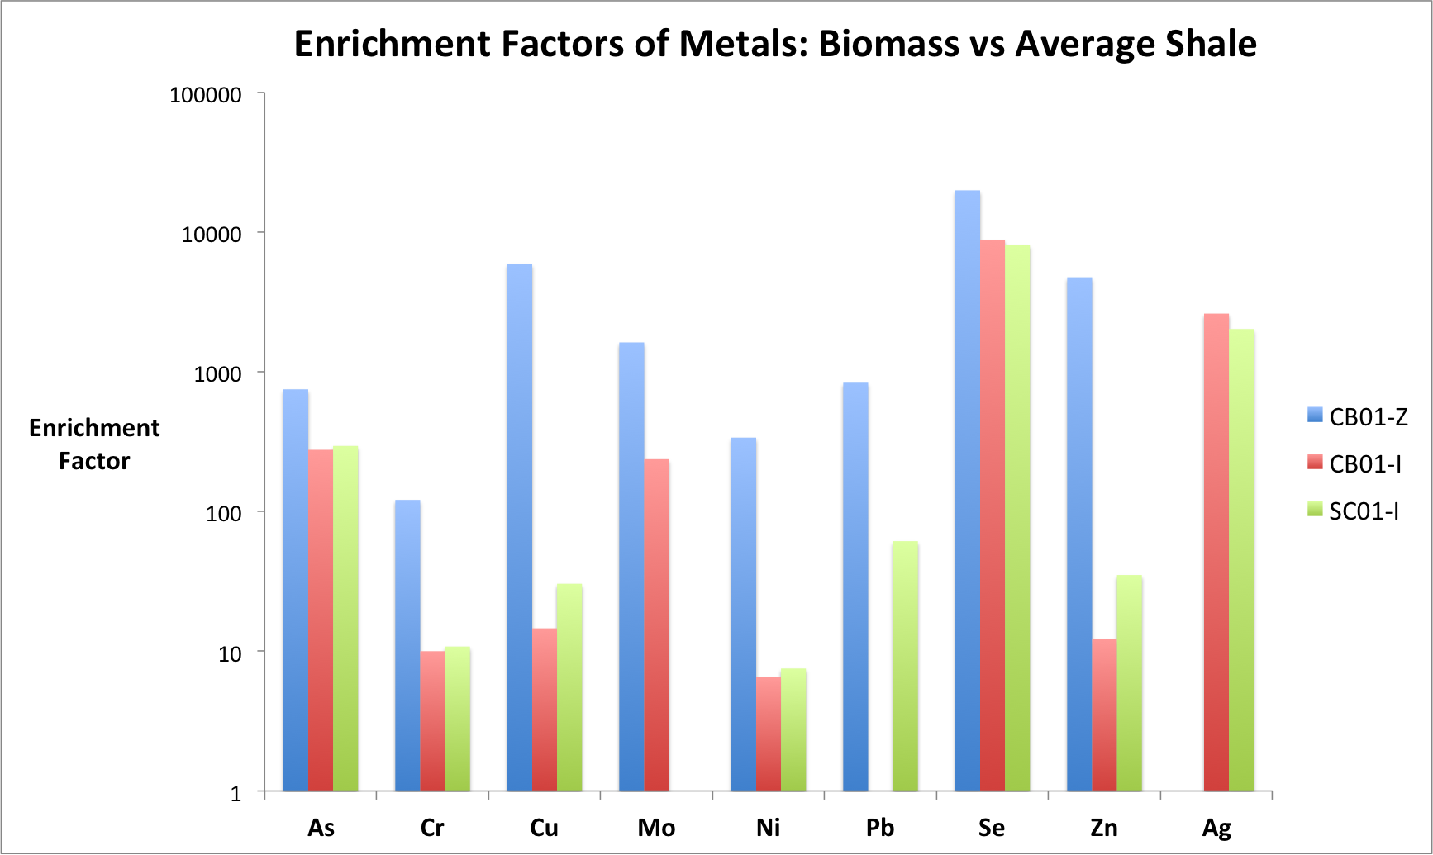

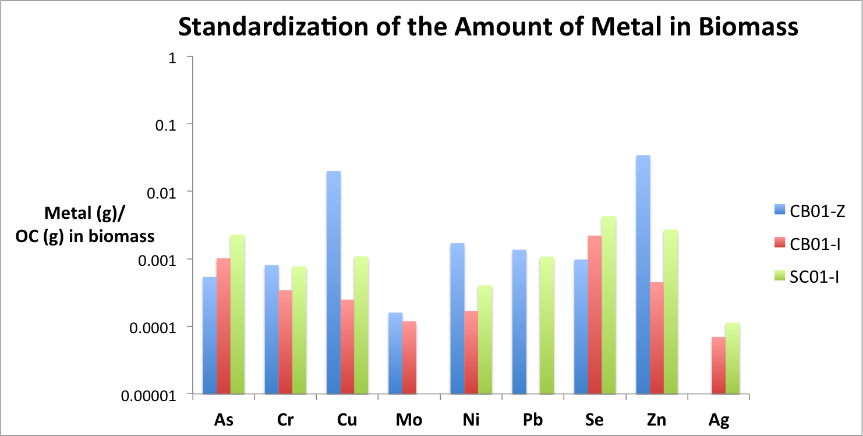
Figure 5: Amount of metal measured in the biological samples standardized to the amount of organic carbon measured within the same respective sample. The y-axis is on a logarithmic scale.

Figure 6: Percentages of various grain-sizes within the surface sediment samples at all four stations.

Figure 7: The graphical result of the sediment Principal Component Analysis (PCA) plotted on Axis 1 and Axis 2. This PCA considered the D50 values from the grain-size analysis, as well as the EFs of elements found within the surface sediments, excluding Pb and Ag. Any elements with ND as a concentration were assigned an EF value of 0.001, below all detection limits listed in Table III. Any elements with TR as a concentration were assigned an EF value that was the midpoint between the detection and quantitative limits for that respective element, as shown in Table III. The concentrations assigned to Pb and Ag had no variation between sites, and could therefore not be run in the PCA.

Figure 8: The graphical result of the biota PCA plotted on Axis 1 and Axis 2. This PCA considered the %Organic carbon (OC) within the biota as well as the EFs of elements found within the biological tissues, including zooplankton tissue and invertebrate tissue. Any elements with ND as a concentration were assigned an EF value of 0.001, below all detection limits listed in Table III. Any elements with TR as a concentration were assigned an EF value that was the midpoint between the detection and quantitative limits for that respective element, as shown in Table III.

Figure 9: Calculated EFs at stations SC01 (panels A and B) and CB01 (panels C and D) corrected with the relative concentrations of various metals within the shell and within the soft tissue of two species of bivalve mussels, Mytilus galloprovincialis and Bathymodiolus azoricus (taken from Demina et al. 2016). Demina et al. (2016) did not calculate levels of Mo within shell vs. soft body, so no correction could be utilized for Mo (note the question mark in panel C.) Also note that Ag and Se are on a separate scale at both stations (panels B and D,) due to their comparatively higher enrichment than the other metals (panels A and C.)
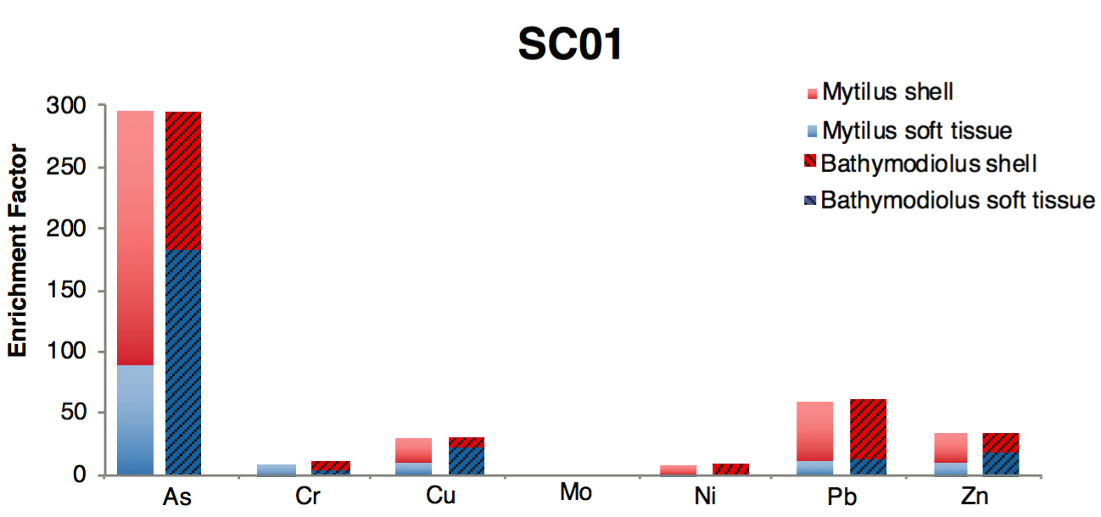
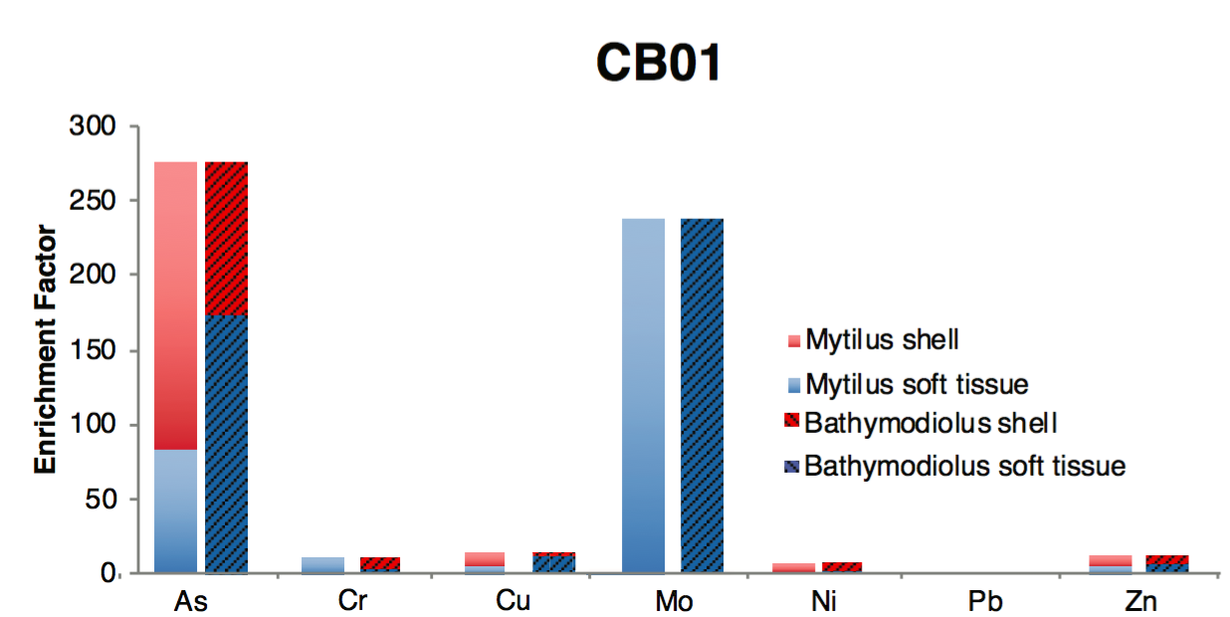
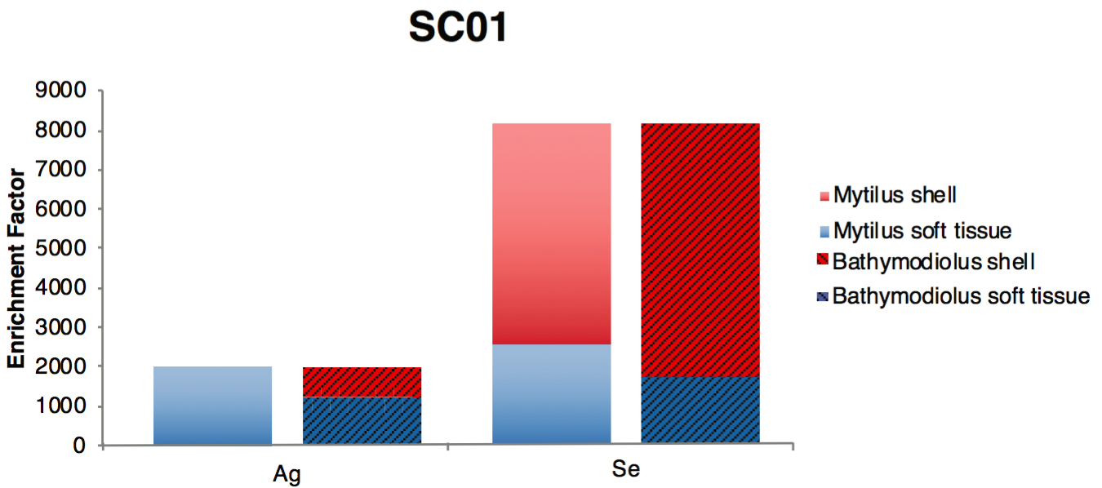
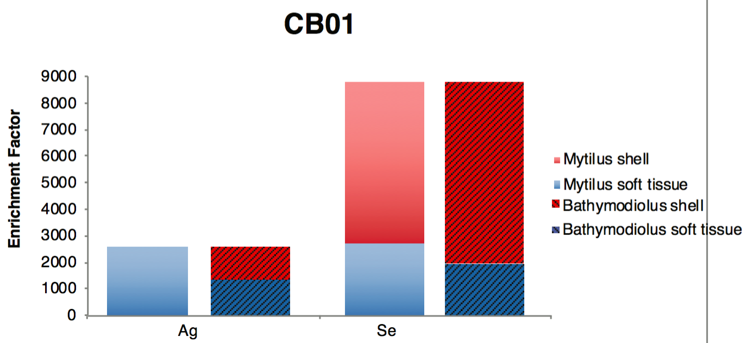
A
B
C
D
?

