Survey of Algal Drift Composition and Distribution at Cattle Point: A Comparison of Two Sampling Methods

Yssy Wallace-Wells

Research partners: Nicole Seiger & Joelle Worthley
Friday Harbor Laboratories, University of Washington
FHL 470: Research in Marine Biology
Dr. Terrie Klinger
May 24, 2022

Abstract
Algal wrack is an integral ecological engineer and food source for many terrestrial and marine organisms. We surveyed the wrack line on a sand and gravel substrate at Cattle Point on San Juan Island Washington. We addressed four questions: (1) What is the algal composition of the wrack? (2) Is there spatial separation between algal groups? (3) What is the effect of the sampling methods? (4) Is there a spatially associated size difference? We employed two different sampling methods, cookie cutter and point contact method. We hypothesized that there would be a difference in both algal composition and size across the beach. We also hypothesized that the two different survey methods would yield different results. We analyzed the samples in the lab, sorting them into algal groups labeled kelp, other non-kelp brown algae, red blades, filamentous/branched reds, seagrass, and green algae. We also took size measurements of the point contact samples. We found that overall algal composition was consistent between both sampling methods with kelp being the most abundant and in descending order other non-kelp browns, filamentous/branched reds, red blades, seagrass, and greens being the least numerous. Although we did not find that there were any detectable patterns in algal composition or size when looking at the individual sections. There was also no consistency comparing the sampling methods within the individual sections. This suggests that there may not be any difference in algal group distribution along the wrack line or any spatial relation to size differences.
Introduction
Beaches provide an interesting intermediary point between marine and terrestrial environments. One of the main connecting components is wrack. Wrack is composed of seaweed and other organic and non-organic detritus that is cast ashore in masses that accumulate in the high tide zone (Rodil et al., 2008). This wrack is mainly made up of macroalgae and seagrasses imported from surrounding marine ecosystems. It is commonly unevenly distributed along a beach depending on the physical environment and landscape of the beach and is a diverse resource for beach inhabitants (Gómez et al., 2013).
Beach environments have little primary production, therefore many species of invertebrates, birds, and other coastal organisms rely on algal wrack for food source and habitat (Nguyen, 2015). It is estimated that 40% of beach dwelling invertebrate species rely on wrack (“Wrack Community,” n.d.). The presence of invertebrates makes wrack a suitable location for seabird feeding. It is also a potential spawning location for beach-spawning fish.
On a biomechanical level beach wrack is an ecological engineer and is very important for stabilizing beach and dune habitats. Beach wrack can help neutralize wave action and acts as a barrier for storm surge. Wrack also helps hold dunes together by holding sand at the top of the beach, mitigating erosion (McGuirk et al., 2022). This in turn helps with terrestrial plant recruitment.
We investigated the composition of wrack as well as spatial and size associations within multiple macroalgal groups. We sampled wrack on a sandy gravel beach following a high wind event. We also compared two different study methods to measure their scope of application. Our objectives were to address the questions (1) What is the algal composition of the wrack? (2) Is there spatial separation between algal groups? (3) What is the effect of the sampling methods? (4) Is there a spatially associated size difference? We predicted that there would be spatial separation between algal groups in composition and size groups, and that the results of the sampling methods would differ because the sample is larger in the cookie cutter method.
Materials and Methods
Surveys were conducted at Cattle Point on San Juan Island between 11-12:10 and 14:45-15:30 on the 19th of May 2022. In the first sampling effort a point contact method was used. We laid out a 100 meter transect tape to 60 meters through the center of the algal drift on the high tide line. We arranged the tape to put as much of it as possible through the middle of the seaweed patches. Our survey regions were broken up into 15 meters sections with the forth one being accidentally 15.5 meters. The first quadrant ran from zero meters to 14.5 meters. Within each quadrant we took samples every half of a meter starting at zero and ending with 14.5. We poked a pencil down into the top layer of algae on the seaward side of the transect tape. We then removed the first dried layer of algae and again poked into the same spot. We then collected the second layer or piece of algae. Bare sections were skipped. We repeated the same collection method for section two from 15 meters to 29.5 meters and again for section three from 30 meters to 44.5 meters and finally quadrant four from 45 meters to 60 meters. Samples were put into separate labeled five-gallon buckets and refrigerated at 10°C covered with sea water soaked paper towels to minimize degradation.
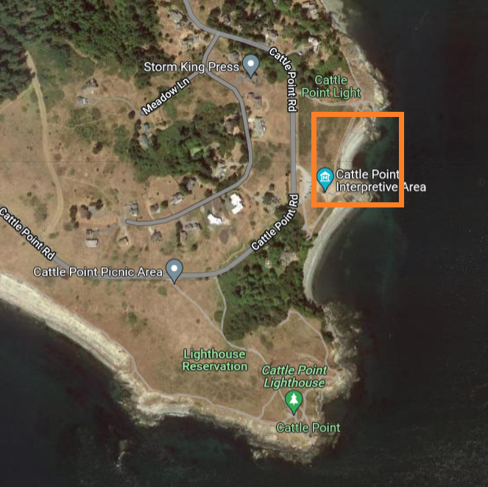
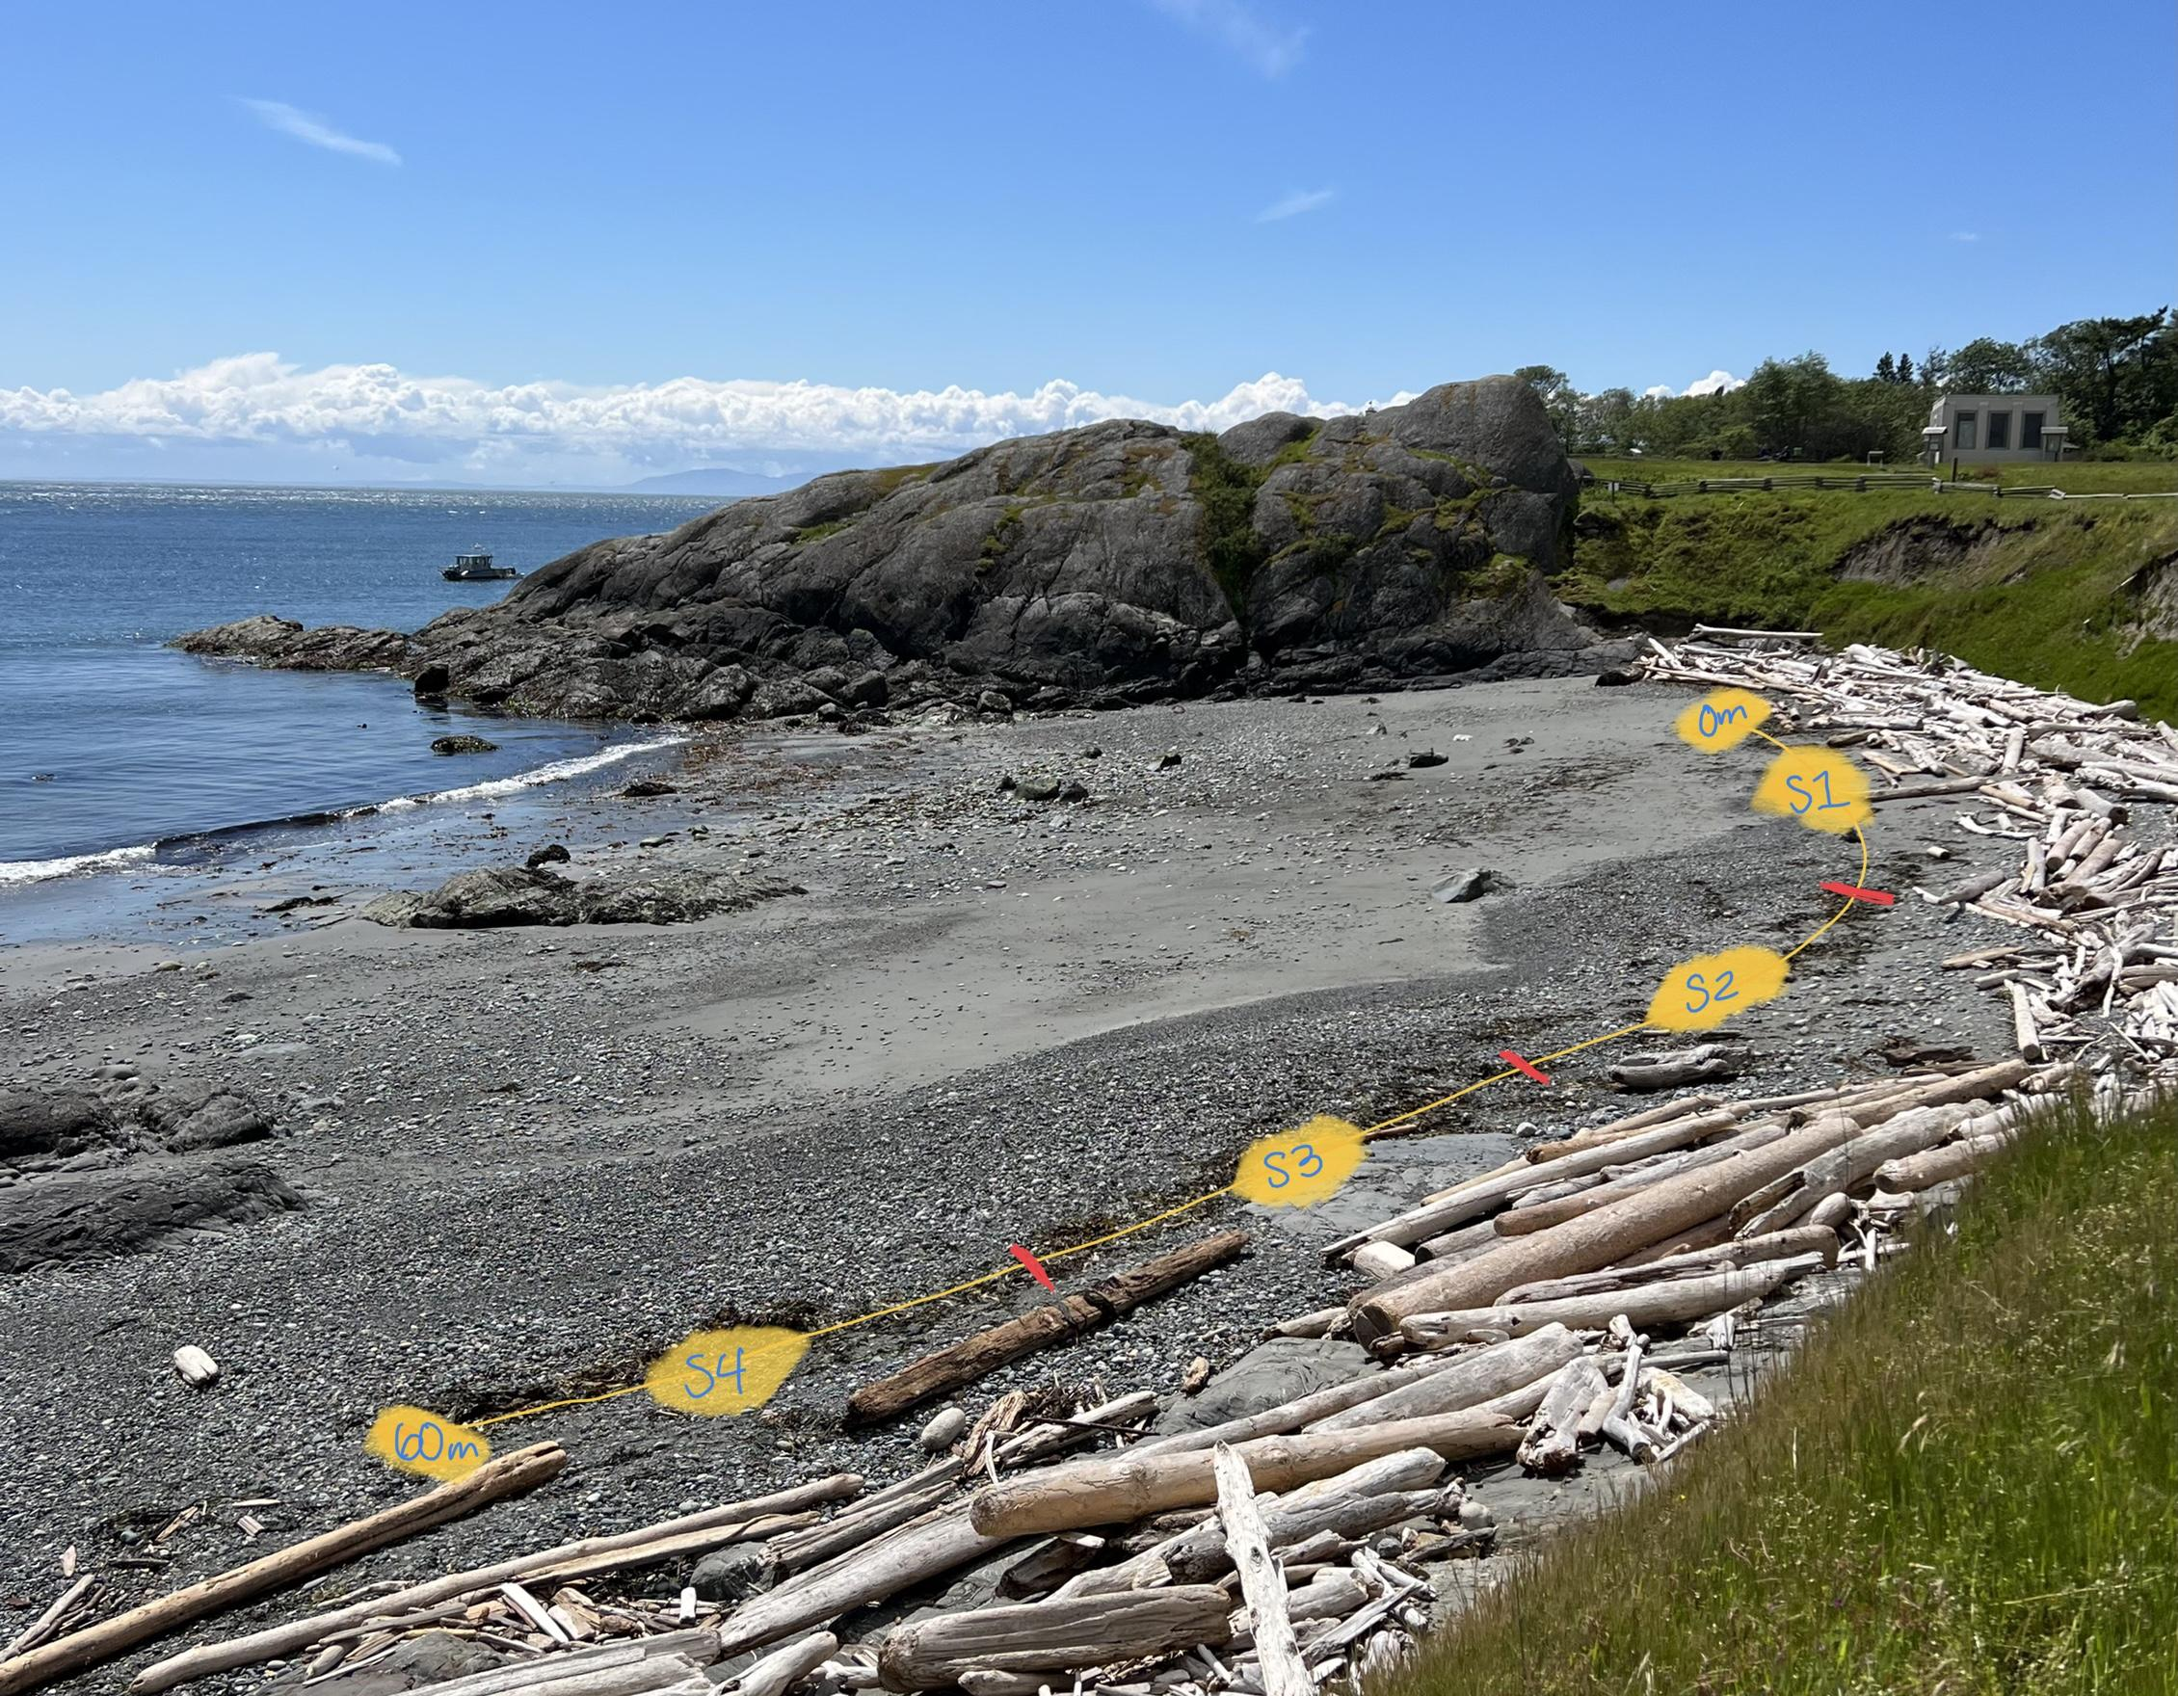
Fig. 1 Map showing survey site at cattle point, outlined in orange | Fig. 2 Map showing survey site closer view with sections identified across algal wrack

In the second sampling effort in the afternoon of May 19th we used the “cookie cutter method”. First we started by laying out the transect tape identically to above. A 10cm diameter clam gun was placed on top of the algal drift piles at intervals of five meters starting at zero meters. We then used a kitchen knife to cut out around the clam gun making a seaweed disc. The whole seaweed disc was then added to our section separated, labeled buckets. We repeated this procedure in each section as identified in sampling method one with the goal of collecting three samples per section (section 1 at zero meters, five meters, and ten meters, section 2 at: 15 meters, 20 meters, and 25 meters, section three at: 30 meters, 35 meters, and 40 meters, and section four at: 45 meters, 50 meters, and fifty-five meters.). In section two the 25-meter sample was moved to 26 meters and in section three the 30 meter sample was moved to 31 meters to avoid bare spots. These buckets were also placed in the refrigerator.
Processing of the point contact samples was done the same day as sampling. The bucket from each section was individually dumped out and sorted into six categories: kelp, other browns, red blades, filamentous/branched reds, seagrass, and greens. We recorded how many samples were in each category and then took a measurement of the longest portion of each sample. Processing of the cookie cutter samples was done the following day using similar methods. Size measurements were excluded for the cookie cutter method.
The data were then compiled into two google sheets. We created bar graphs in R as well as a box plot for the size data. We then ran a PERMANOVA analysis to test for differences.
Results
The cookie cutter sampling method yielded more algal pieces then the point contact method. In both methods kelp was most frequent. This was followed in descending order by the presence of other non-kelp brown algae, then filamentous reds, red blades, and seagrasses. This order was consistent across both sampling methods. Green algae were only found in the point contact sampling method and was the least numerous groups. Between the two sampling methods the data collected shows similar patterns.
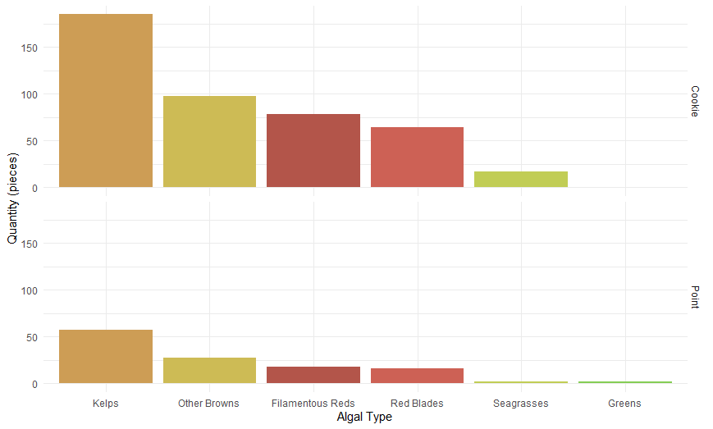
Fig. 3 Faceted bar chart depicting the abundance of the different algal groups in cookie cutter method (top) and point contact method (bottom).

The distribution of algal groups varied across sections and sampling methods. It is again shown that the cookie cutter method had more samples overall and, in each section, individually. Kelp was the prevailing group found in all the sections in both methods. Greens were only found in the point contact method in section three. Sea grass was found in three of the four sections in the cookie cutter method (all but section 2) while it was only found in section four of the point contact method. There is little consistency between the algal groups and their spatial location on the beach (P value: 0.184). There is also little consistency in comparing the sections in both sampling methods (P value: 0.492).
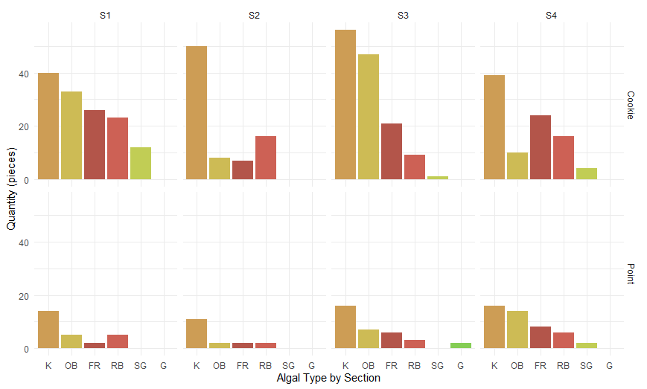
Fig. 4 Faceted multi-section bar chart depicting the sections and their algal distribution in cookie cutter method (top) and point contact method (bottom).

Across all sections in the point contact method there is no significant size difference as it relates to space. The median line is roughly equal across all sections. As well the mean (shown with a diamond) is roughly equal. Section one had a smaller range of size then the rest of the sections. Most algal samples collected were less than 50 centimeters and over 15 centimeters.
Permutation test for adonis under reduced model
Terms added sequentially (first to last)
Permutation: free
Number of permutations: 999
Adonis2(formula = algae_prop[, 3:8] ~ Method + Section, data = algae, method = “bray”)
 | Df | SumOfSqs | R2 | F | Pr (>F)
Method | 1 | 0.013773 | 0.07272 | 0.7589 | 0.492
Section | 3 | 0.121184 | 0.63983 | 2.2259 | 0.184
Residual | 3 | 0.054442 | 0.28745
Total | 7 | 0.189399 | 1.00000

Table 1 Results of PERMANOVA test performed in Rstudio.

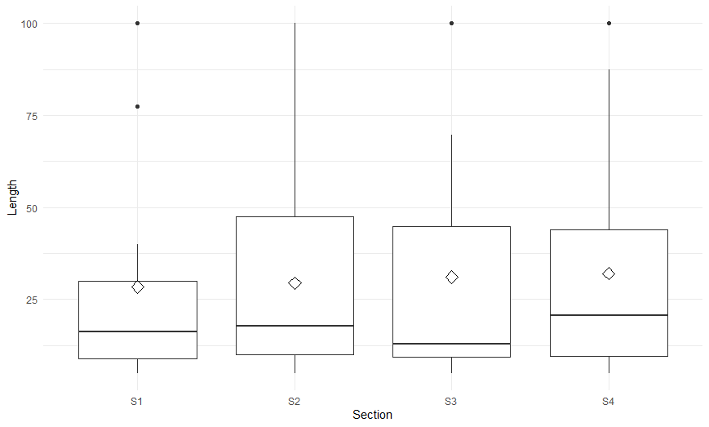
Fig. 5 Length (cm) of algal samples across the four sections in the point contact sampling method. The median (bold line) of each section is about equal across sections.

Discussion
We found that regardless of where the algae were collected the wrack composition was made up mainly of kelp. This is like previous studies reporting that gravel beaches retain more kelp due to wave action and kelp buoyancy (Orr, 2005) (Paloares, 2020) (Liebowitz et al., 2016). Other significant constituents of the wrack composition in total (figure 3) were other non-kelp brown algae followed in descending order by filamentous reds, red blades, sea grasses, and greens making up the smallest portion. This is also consistent with previous investigations that Ulva sp. has a quick decomposition rate (Mews et al., 2006) and its usual habitat is less wave exposed areas with rocky substrates (Proudfoot & Fretwell, n.d.)
We found that the frequency of algal groups was not consistent when looking at individual sections. Looking at sections individually kelp was still the most frequent in all datasets but the presence of other algal types was variable and showed no consistent pattern. Additionally, size showed no spatial association across the beach which is contrary to our hypothesis that there would be spatial separation between size and algal type.
Finally, the cookie cutter and point contact methods gave consistent results when looking at the whole study region even though more samples were picked up in the cookie cutter method. Although this consistency was lost when we looked at sections individually(P value: 0.492). . It would also be beneficial to create a graph based on the proportion of algal group to total algae in each quadrant to compensate for he inconsistent number of samples. The point contact method missed most of seagrass samples which were identified in the cookie cutter method, while the cookie cutter method missed a sample of green algae. In this way it seems like using both in tandem allowed us to study the region more closely, although we think that using the cookie cutter method would be the most efficient method.
These results have the potential to contribute to sparse data on San Juan Island wrack zones. They also address the angle of looking at a gravel beach while most previous studies have looked at wrack on fine sand beaches. All our data was collected over the course of one morning and one afternoon which means we are lacking a full picture of how the wrack changes over time. I would be curious to follow up with this as has been done previously to gain information about how the wrack composition changes overtime (Liebowitz et al., 2016).
Reference List
Gómez, M., Barreiro, F., López, J., Lastra, M., & de la Huz, R. (2013). Deposition patterns of algal wrack species on estuarine beaches. Aquatic Botany, 105, 25–33. https://doi.org/10.1016/j.aquabot.2012.12.001
Liebowitz, D. M., Nielsen, K. J., Dugan, J. E., Morgan, S. G., Malone, D. P., Largier, J. L., Hubbard, D. M., & Carr, M. H. (2016). Ecosystem connectivity and trophic subsidies of sandy beaches. Ecosphere, 7(10). https://doi.org/10.1002/ecs2.1503
McGuirk, M. T., Kennedy, D. M., & Konlechner, T. (2022). The role of vegetation in incipient dune and Foredune Development and morphology: A Review. Journal of Coastal Research, 38(2). https://doi.org/10.2112/jcoastres-d-21-00021.1
Mews, M., Zimmer, M., & Jelinski, D. E. (2006). Species-specific decomposition rates of beach-cast wrack in Barkley sound, British Columbia, Canada. Marine Ecology Progress Series, 328, 155–160. https://doi.org/10.3354/meps328155
Nguyen, B. (2015). Effects of wrack composition, age, and cover on the ... - explorations. Explorations: The UC Davis Undergraduate Research Journal . Retrieved May 23, 2022, from https://explorations.ucdavis.edu/docs/2015/nguyen.pdf
Orr, M., Zimmer, M., Jelinski, D. E., & Mews, M. (2005). Wrack deposition on different beach types: Spatial and temporal variation in the pattern of subsidy. Ecology, 86(6), 1496–1507. https://doi.org/10.1890/04-1486
Paloares, M. (2020). Algal Wrack community composition and Succession on a sandy beach in San Diego, CA. Digital USD. https://doi.org/10.22371/02.2020.015
Proudfoot, B., & Fretwell, K. (n.d.). Sea lettuce • ulva lactuca. Biodiversity of the Central Coast. Retrieved May 24, 2022, from https://www.centralcoastbiodiversity.org/sea-lettuce-bull-ulva-lactuca.html
Rodil, I. F., Olabarria, C., Lastra, M., & López, J. (2008). Differential effects of native and invasive algal wrack on macrofaunal assemblages inhabiting exposed Sandy Beaches. Journal of Experimental Marine Biology and Ecology, 358(1), 1–13. https://doi.org/10.1016/j.jembe.2007.12.030
UCSB. (n.d.). Wrack Community. Explore beaches. Retrieved May 23, 2022, from https://explorebeaches.msi.ucsb.edu/sandy-beach-life/wrack-community
Weinberger, F., Sundt, S., Staerck, N., Merk, C., Karez, R., & Rehdanz, K. (2021). Shifting Beach Wrack composition in the SW Baltic Sea and its effect on beach use. Ecology and Society, 26(4). https://doi.org/10.5751/es-12759-260443

