Assessing euphausiid homogeneity in Puget Sound scattering layers

Joshua Lai
School of Oceanography, University of Washington, Seattle, WA 98225
laij99@uw.edu

Abstract
Euphausiids are ecologically important zooplankton in Puget Sound that vertically migrate and can form scattering layers. The depth of euphausiids across sex, species, and length affects what predator-prey interactions occur and the rate of biogeochemical cycling. Multinet tows collected euphausiids from various depths within different layers in northern Puget Sound. No significant variation in euphausiid sex or length with depth was found. Euphausiid size significantly increased with depth in the layer, with the median euphausiid length increasing from 8.3 mm to 15.3 mm over 20 m at Hazel Point. The strength of this trend varied, possibly due to the proximity of fish. Environmental modeling could be improved by better accounting for euphausiid size increase with depth even in small scales.

Introduction
Euphausiids, commonly known as krill, are zooplankton that are important in Puget Sound’s ecosystem. Euphausiids are widespread and numerous, and play a large role in energy cycling and food chain dynamics (Sun et al. 2010; Park et al. 2011). As consumers, euphausiids feed on phytoplankton and occasionally other zooplankton such as copepods (Park et al. 2011). As prey, euphausiids are eaten by fish such as hake, herring, and salmon, as well as birds, whales, and other marine organisms (Robinson 2000; Tanasichuk 2002; Harvey et al. 2012). Given their importance in the ecosystem, understanding euphausiids reveals information about organisms reliant on euphausiids for food as well as the creatures euphausiids feed on. Understanding their role as prey shapes the management of fisheries that rely on euphausiids as a food source. We can better assess harm to fisheries that cascade from harm to euphausiids, such as through ocean acidification.
The most common euphausiid in Puget Sound is Euphausia pacifica, the subject of numerous articles, often regarding their diel vertical migration and reproduction (e.g., Ross et al. 1982; Bollens et al. 1992; Sun et al. 2011). E. pacifica forms a layer during the day between 50 m and 125 m. This is thought to be driven by avoidance of visual predators such as fish who are at the surface. At night, euphausiids migrate to the surface to feed.
Acoustic systems can detect these layers of euphausiids by sending out sound waves. The backscatter of the signal appears to be proportional to the concentration of biomass in these layers (Iida et al. 1996). These layers are richly populated and migrate vertically which can contribute to the biological carbon pump. The rate of carbon sequestration is influenced by zooplankton length and biomass (Archibald et al. 2019). However, characteristics of individual animals such as length are not generally available from acoustic data. In the open ocean, there can be multiple layers with lantern fish and euphausiids dominating these layers (Dietz 1962). Meanwhile, acoustic scattering layers in Puget Sound include copepods, euphausiids, amphipods, chaetognaths and others. These layers are largely composed of euphausiids, second only to copepods (Cooney 1971).
Vertical layering of species is not uncommon, and patterns can persist between years. This persistence suggests a significance to the layering (Cheriton et al. 2007; Benoit-Bird et al. 2010). Scattering layers can have thicknesses in the tens of meters (Cooney 1971), at least three orders of magnitude larger than most zooplankton. It is likely that the top and bottom of a layer will have different predators and prey present. Species cannot thrive with too many predators or without enough food. Cooney (1971) found that the predatory chaetognaths were more typically seen above the layer than below or within. Meanwhile, copepods, prey to euphausiids, were most commonly found within the layer. The depth of these species may drive euphausiids to different parts of the layer, segregating them by length, sex, or species. Understanding where categories of euphausiids tend to be may improve models of ecosystems or provide justification for simplifying the layer to being considered homogeneous.
Similar research has been conducted on the structure of euphausiid layers beyond Puget Sound. While different species may exhibit different characteristics, their general patterns may be analogous to those in Puget Sound. Near Antarctica, layers were suggested to act like multiple smaller swarms that were each relatively homogeneous in terms of sex and development (Watkins and Murray 1998). Swarms often had very different sex ratios, and it was not uncommon to have swarms of over 80% males or females (Nicol 1984; Higginbottom and Hosie 1989). Different species of euphausiids occurred together and larvae abundances were positively correlated, suggesting similar environmental factors and a lack of competition between species (Shulenberger et al. 1984). However, adult abundances were not spatially correlated. Also, the larvae were seen to be vertically distinct from the adults and sharply divided, but with no clear pattern.
In Puget Sound, euphausiids were previously seen in scattering layers throughout the year at Kayak Point, Mabana, and Green Point (Cooney 1971). Cooney found that euphausiid size tended to increase with depth but did not segregate euphausiids by sex. Additionally, previously identified trends in distribution may have changed with ocean acidification affecting the development of larvae (McLaskey et al. 2016) which could hinder ability to vertically migrate or avoid threats.
My research has a narrow scope of testing the null hypothesis that euphausiids in the scattering layer are vertically homogeneous. Euphausiid homogeneity was assessed across length, sex, and species where the distribution by sex had not been previously assessed. My research included locations that had not been previously identified as having scattering layers of euphausiids. This research updated findings and built onto prior research. My research briefly explored if different sites experience similar variation and what factors may account for differences.

Methods
Sampling methods
Samples were collected from the R/V Rachel Carson on January 18 – 21, 2019. Samples were collected during the day, between 11:00 am and 3:00 pm. Kayak Point and Mabana were chosen due to previous observations of year-round scattering layers as well as proximity to other sampling locations (Cooney 1971) (Fig. 1). Additionally, in transit between stations, a ship-mounted Simrad acoustic system with 38 kHz and 200 kHz frequencies was used to detect the scattering layers at Hazel Point and Gedney Island.
Once detected, each station was sampled with nets at four depth intervals in and around the layer. We collected samples using a Hydrobios Multinet System towed at ~ 2 knots. It included five black-dyed 0.25 m² nets with 335-µm mesh and a flow meter to measure the volume filtered. Acoustics were used to detect the approximate bottom and top of the layer. We chose to sample evenly-spaced 5-m intervals with the lowest net capturing the bottom of the layer and just below, and the highest net capturing the top and just above (Fig. 2). The net was held beneath the layer before sampling, then rising to the layer and opening and closing at selected depths. Samples were preserved in a 5% formalin and seawater solution until brought to a laboratory for analysis.
One station, Mabana Point, was arbitrarily chosen to be sampled twice as a replicate and to provide an estimate of natural variability between tows. Net tows where nets failed to open, such as at Hazel Point, were also repeated, resulting in similar but non-exact replicates from the same location.
Laboratory methods
Samples were either counted in entirety or quantitatively split with a Folsom splitter to obtain a representative subsample of 50 – 100 euphausiids. Each euphausiid was identified by sex and species. Euphausiids less than 10 mm long were considered juveniles and were not sexed. Male were identified by the presence of a petasma on the first pleopod. Euphausiids missing the first pleopod were marked as having unknown sex. Species was determined by the length of the rostrum and the presence of dorsal spines or bilobed eyes. Euphausiid length was measured through a microscope at 10x magnification from the base of the rostrum to the end of the telson. Euphausiids missing either of these features were not included in analysis.
Analytical methods
The presence of trends in characteristics with depth was assessed by comparing relative depths at one location. I used a binomial test to assess if sex or species proportions between subsamples were significantly ($α$ = 0.01) different from their overall proportions. Only E. pacifica lengths were considered as they dominated the taxa and other species have different size distributions. For variation in length, I used a Kruskal-Wallis test to significantly ($α$ = 0.01) compare median lengths among depths.
The variation in trends among different stations was assessed by comparing patterns qualitatively. Explanations for variations in trends were explored in acoustic indications of fish and euphausiid concentrations.

Results:
Species variation:
Over 99% (n = 1308) of euphausiids counted were Euphausia pacifica. Only E. pacifica was found in Mabana Point samples (Fig. 5). Other stations were also overwhelmingly comprised of E. pacifica but some had one or two other species (Fig. 3, 4, 6). One Thysanoessa raschii was recorded from the shallowest depth at Hazel Point and the second shallowest depth at Gedney Island. Two T. raschii were found at the shallowest depth at Kayak Point. Thysanoessa spinifera was only seen in Kayak Point, with seven at the shallowest depth.
Sex variation
The sex ratio of adults varied among locations from 54.9% female at Hazel Point to 68.9% female at Kayak Point (Figures 3 - 6). However, no station had a sex ratio that differed significantly from the overall average of 60.4%. Furthermore, at all stations, the sex ratio at each depth did not significantly differ from the station average.
Length variation
Median euphausiid length varied from 7.3 mm to 15.3 mm, excluding the 18.0 mm median from Kayak Point with only 9 euphausiids counted (Table 1). The smallest range of median euphausiid lengths was a 4.3 mm range at Gedney Island, and the largest range of 7.0 mm at Hazel Point. Deeper depths tended to have longer euphausiids with the largest median length found in the deeper half of the layer and the shortest median length in the shallower half of the layer. A significant increase in median euphausiid length was present between the shallowest depth and deepest depth at all stations except Kayak Point (Table 1). There were no significant decreases in median length with increasing depth.
Different stations varied in their trend of increasing euphausiid length with increasing depth. The trend was most apparent at Hazel Point where median size increased from ~8.3 mm to ~15.2 mm in both net tows (Table 1). At Hazel Point and the second tow from Mabana Point, there were multiple significant increases in median euphausiid length with increasing depth. At Gedney Island and the first net tow from Mabana Point, only the deepest depth had a significantly larger median euphausiid length. The deepest depths from those tows had median euphausiid lengths over 2 mm longer than any of the shallower median lengths. The three shallower depths had similar median lengths. At Kayak Point, no depth significantly differed in median euphausiid length from others, but low sample densities ( < 0.5 individuals / m³) and very few euphausiids (n = 40) were sampled there overall.

Discussion
Overall, euphausiid layers were not found to be significantly different than homogeneous with regards to sex or species. However, a significant increase in mean euphausiid length was found at all stations where over 50 euphausiids were counted, although the strength of this relationship varied among stations.
Species variation
I failed to reject the null hypothesis that euphausiid speciation in layers is homogeneous. Although species other than E. pacifica were only found in the upper half of layers, the small sample sizes prevent conclusions about their distribution patterns. Proportions of E. pacifica than may be skewed to be higher due to the presumption that euphausiids were E. pacifica with regards to immature euphausiids and imperfect speciating. My finding that E. pacifica makes up an overwhelming majority of euphausiids in northern Puget Sound is consistent with previous studies such as Cooney (1971) who similarly found few T. raschii and T. spinifera present in samples.
However, whereas Cooney found Thysanoessa longipes as the second most abundant euphausiid in samples in northern Puget Sound, no T. longipes were identified my samples. This could suggest a decrease in T. longipes since the 1970s or, given my small sample size, could be due to natural variation over decadal time scales or patchiness in sampling.
Kayak Point was different from other stations, with the fewest krill, lowest proportion of E. pacifica and the presence of T. spinifera. The few krill found contrasts with previous observations (Cooney 1971) of year-round layers of euphausiids at that location possibly suggesting a shift in habitat. The presence of T. spinifera at only one depth of one sample might indicate that T. spinifera is not homogeneous and could suggest clustering or a preference of location. Further research with a larger sample size would be required to determine if T. spinifera do prefer Kayak Point. Furthermore, despite similar acoustic backscatters, Kayak Point had a much lower euphausiid concentration than other stations that could be explained by other organisms such as copepods, amphipods, and shrimp. This reinforces the hypothesis that layers within northern Puget Sound can be variable in composition and cannot be assumed to be primarily euphausiids.
Sex variation
I failed to reject the null hypothesis that euphausiid sex in layers is homogeneous. For each station, differences in sex ratios among depths could be explained from natural variation of a homogeneously mixed layer. This homogeneity indicates that modeling euphausiid populations with a homogeneous sex ratio may be a reasonable assumption. However, studies on other euphausiids have found very different sex ratios with equal or often more males than females depending on the time of year (Tarling 2003). Variation in the timing of vertical migrations due to sex was also found. The contrast between findings indicates that the pattern of sex homogeneity within euphausiids found within my research is not universally applicable. Other patterns may occur with other species of euphausiids, at different times of the year or at different locations than northern Puget Sound. Additionally, patterns at smaller spatial scales could be missed by averaging over larger volumes.
Length variation
I rejected the null hypothesis that euphausiid length in layers is homogeneous. This relationship supports findings from Cooney (1971) that deeper depths within a layer tended to have larger euphausiids and is consistent with previous studies that found larger, more visible zooplankton stayed deeper to avoid visual predators at the surface (De Robertis 2002). The deepest depth had a larger median length than the shallowest depth at every station except at Kayak Point which did not have any significant differences in length and had the lowest abundance of euphausiids. Modeling of the biological carbon pump from zooplankton diel vertical migration could be improved by including this relationship as larger euphausiids with more carbon mass are at deeper depths where their carbon is more likely to be exported (Archibald et al. 2019).
The relationship between depth and size was clearest at Hazel Point. This location would be a prime site for future research into layers of euphausiids due to the high numbers of euphausiids and the strong association found. The strength of this relationship could be conjectured to be because Hazel Point had the highest concentration of euphausiids (Table 2). Alternatively, Hazel Point has acoustic indications of fish that are closer to the scattering layer than any other station, which could possibly be perceived by euphausiids, prompting a greater segregation by length (Fig 2).
The distribution of lengths at different depths was sometimes bimodal at Hazel Point and Mabana Point (Fig. 5, 6). This pattern was not seen from Cooney (1971) who consistently found unimodal length distributions in mid-winter. Cooney did find a bimodal distribution from spring to autumn at some stations, likely from the annual recruitment of younger individuals into the population. If not variation from sampling, the presence of two generations could explain the second peak.

Conclusion
Euphausiids in scattering layers could be considered homogeneous across sex and species, but not length. Larger euphausiids are seen deeper in the layer further from where chaetognaths and other organisms are found. Models of ecology or biogeochemical cycling would be improved by this study and current values of euphausiid distribution. The presence of other organisms such as copepods or chaetognaths was not assessed in detail within this study but could provide insight into specific ecological interactions. Additionally, the use of underwater cameras or other imaging methods over the course of a diel vertical migration cycle could provide insight on how these euphausiids segregate by length within the layer.

References:
Archibald, K. M., D. A. Siegel, and S. C. Doney. 2019. Modeling the Impact of Zooplankton Diel Vertical Migration on the Carbon Export Flux of the Biological Pump. Global Biogeochemical Cycles 33: 181–199. doi:10.1029/2018GB005983
Benoit-Bird, K. J., M. A. Moline, C. M. Waluk, and I. C. Robbins. 2010. Integrated measurements of acoustical and optical thin layers I: Vertical scales of association. Continental Shelf Research 30: 17–28. doi:10.1016/j.csr.2009.08.001
Bollens, S. M., B. W. Frost, and T. S. Lin. 1992. Recruitment, growth, and diel vertical migration of Euphausia pacifica in a temperate fjord. Marine Biology 114: 219–228. doi:10.1007/BF00349522
Cheriton, O. M., M. A. McManus, D. V. Holliday, C. F. Greenlaw, P. L. Donaghay, and T. J. Cowles. 2007. Effects of mesoscale physical processes on thin zooplankton layers at four sites along the west coast of the U.S. Estuaries and Coasts 30: 575–590. doi:10.1007/BF02841955
Cooney, R. T. 1971. Zooplankton and micronekton associated with a diffuse sound-scattering layer in Puget Sound, Washington., Thesis (Ph. D.)--University of Washington.
De Robertis, A. 2002. Size-Dependent Visual Predation Risk and the Timing of Vertical Migration: An Optimization Model. Limnology and Oceanography 47: 925–933.
Dietz, R. S. 1962. The Sea’s Deep Scattering Layers. Scientific American 207: 44–51.
Harvey, C. J., G. D. Williams, and P. S. Levin. 2012. Food Web Structure and Trophic Control in Central Puget Sound. Estuaries and Coasts 35: 821–838. doi:10.1007/s12237-012-9483-1
Higginbottom, I. R., and G. W. Hosie. 1989. Biomass and population structure of a large aggregation of krill near Prydz Bay, Antarctica. Marine Ecology Progress Series 58: 197–203.
Iida, K., T. Mukai, and D. Hwang. 1996. Relationship between acoustic backscattering strength and density of zooplankton in the sound-scattering layer. ICES Journal of Marine Science 53: 507–512. doi:10.1006/jmsc.1996.0073
McLaskey AK, McElhany P, Olson MB, Busch DS, Maher M, and Winans AK. 2016. Development of Euphausia pacifica (krill) larvae is impaired under pCO2 levels currently observed in the Northeast Pacific. Mar Ecol Prog Ser 555: 65–78.
Nicol, S. 1984. Population structure of daytime surface swarms of the euphausiid Meganyctiphanes norvegica in the Bay of Fundy. Marine ecology progress series. Oldendorf 18: 241–251.
Park, J.-I., C.-K. Kang, and H.-L. Suh. 2011. Ontogenetic diet shift in the euphausiid Euphausia pacifica quantified using stable isotope analysis. Marine Ecology Progress Series 429: 103–109.
Robinson, C. L. K. 2000. The consumption of euphausiids by the pelagic fish community off southwestern Vancouver Island, British Columbia. Journal of Plankton Research 22: 1649–1662. doi:10.1093/plankt/22.9.1649
Ross, R. M., K. L. Daly, and T. S. English. 1982. Reproductive cycle and fecundity of Euphausia pacifica in Puget Sound, Washington1. Limnology and Oceanography 27: 304–314. doi:10.4319/lo.1982.27.2.0304
Shulenberger, E., J. H. Wormuth, and V. J. Loeb. 1984. A large swarm of Euphausia Superba: overview of patch structure and composition. Journal of Crustacean Biology 4: 75–95.
Sun, S., Y. Huo, and B. Yang. 2010. Zooplankton functional groups on the continental shelf of the yellow sea. Deep Sea Research Part II: Topical Studies in Oceanography 57: 1006–1016. doi:10.1016/j.dsr2.2010.02.002
Sun, S., Z. Tao, C. Li, and H. Liu. 2011. Spatial distribution and population structure of Euphausia pacifica in the Yellow Sea (2006–2007). Journal of Plankton Research 33: 873–889. doi:10.1093/plankt/fbq160
Tanasichuk, R. W. 2002. Implications of interannual variability in euphausiid population biology for fish production along the south-west coast of Vancouver Island: a synthesis. Fisheries Oceanography 11: 18–30. doi:10.1046/j.1365-2419.2002.00185.x
Tarling, G. A. 2003. Sex-dependent diel vertical migration in northern krill Meganyctiphanes norvegica and its consequences for population dynamics. Marine Ecology Progress Series 260: 173–188.
Watkins, J. L., and A. W. A. Murray. 1998. Layers of Antarctic krill, Euphausia superba : are they just long krill swarms? Marine Biology 131: 237–247. doi:10.1007/s002270050316

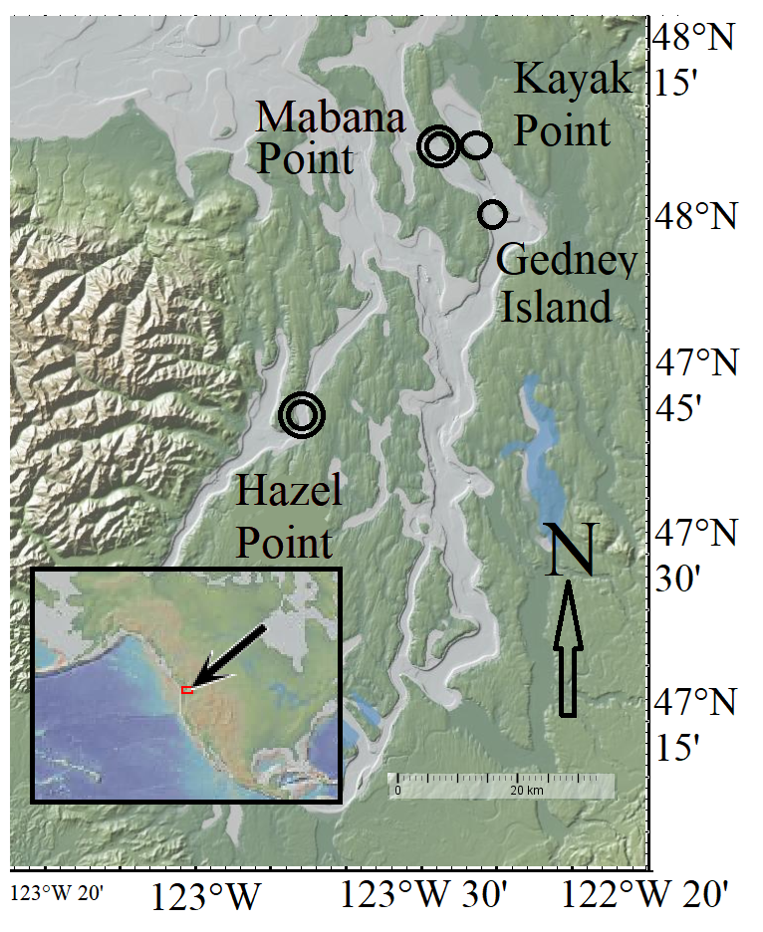Figure 1: Map of locations from which euphausiids were sampled from. Stations with two circles had two net tows.
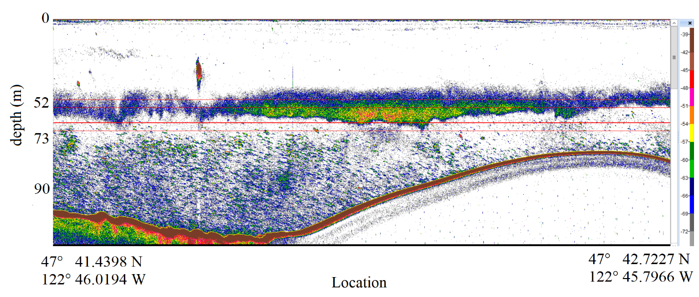Figure 2: An example of acoustic backscatter found along a ~2 km transect of Hazel Point. White areas indicate little to no backscatter. Blue and green regions have some backscatter, and yellow and red regions have the strongest backscatter. Horizontal red lines indicate depths that nets were opened and closed. The very top and very bottom of the layer are sampled by these nets.

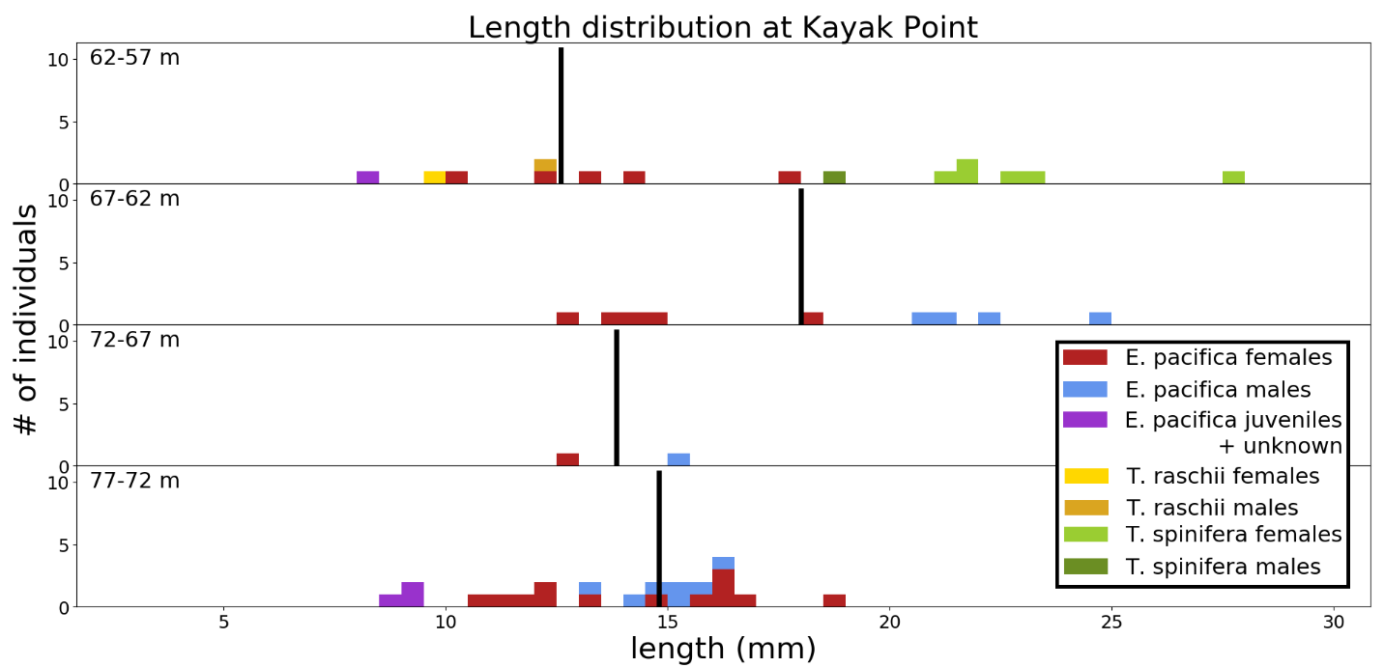Figure 3: Distribution of euphausiids by length from Kayak Point. Vertical lines indicate the median size of E. pacifica. T. spinifera and T. raschii are present. No significant trends with size are seen in the smaller (n = 40) sample size.

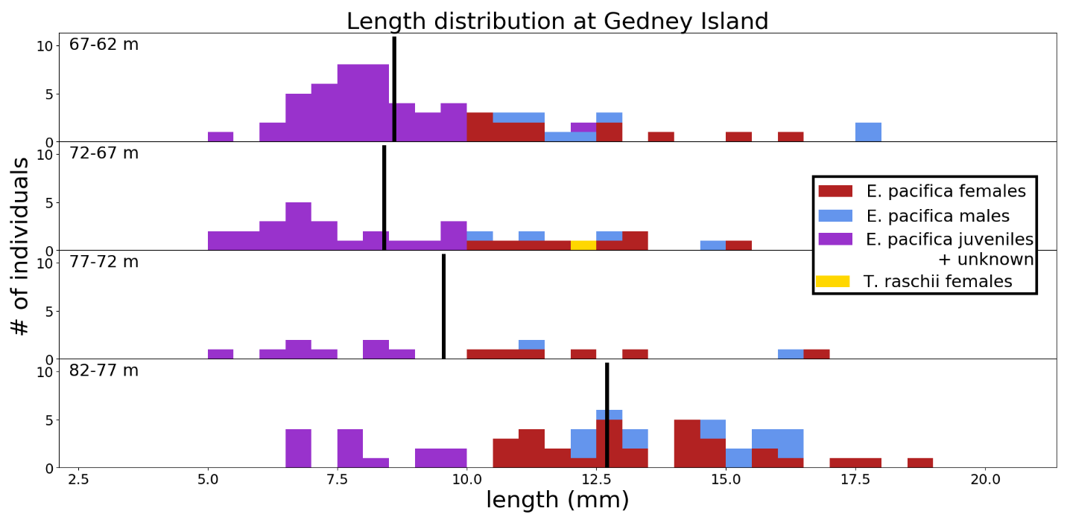Figure 4: Length distribution of euphausiids from Gedney Island colored by species, stage and sex. Vertical lines indicate the median size of E. pacifica. The deepest depth has the largest median length.
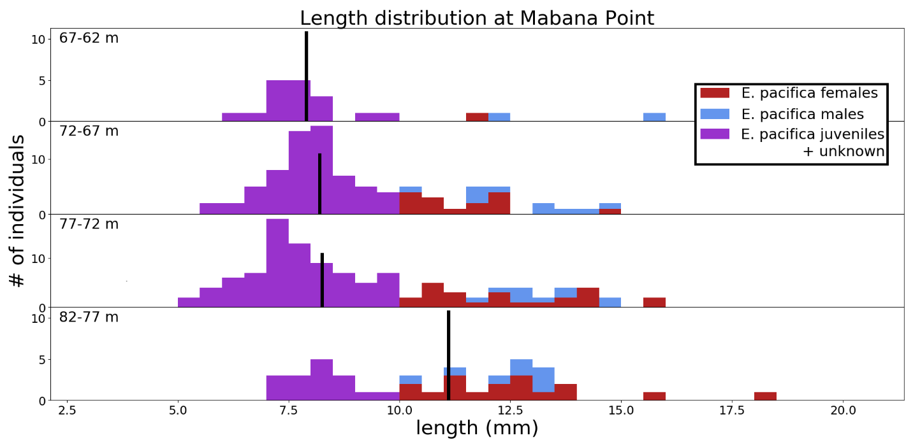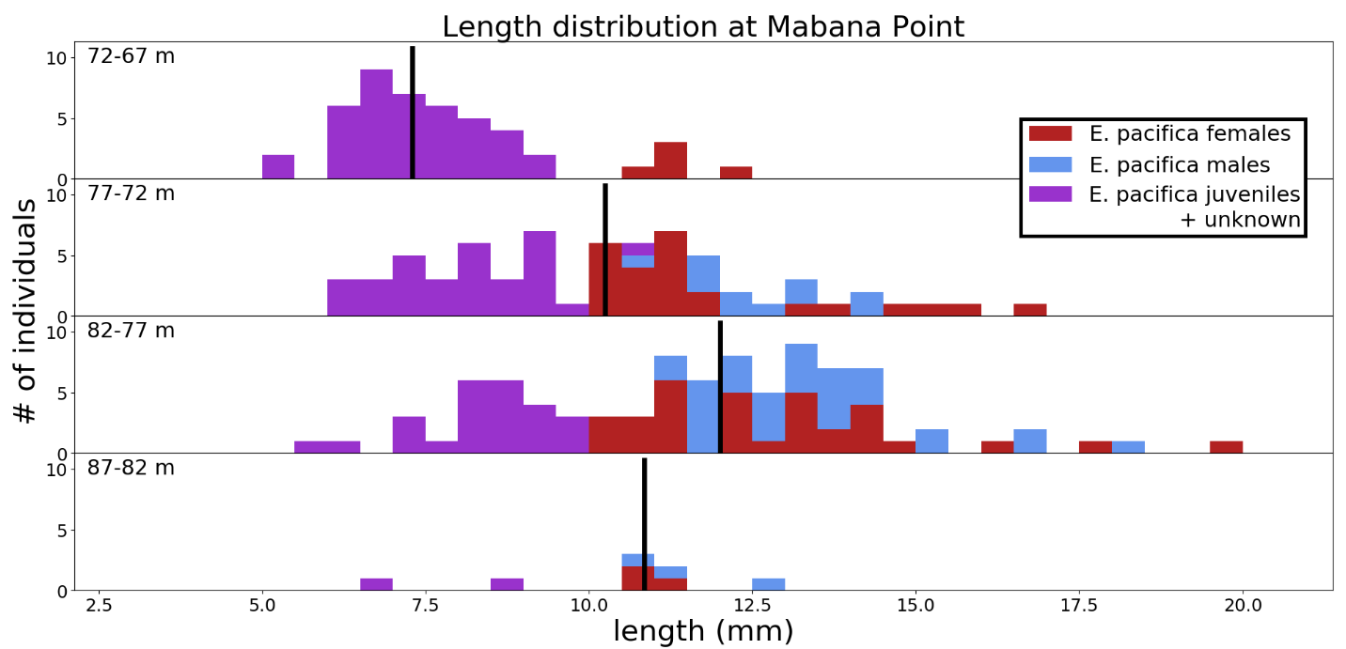Figure 5: Length distribution of euphausiids from two tows at Mabana Point. Vertical lines indicate the median size of E. pacifica. The deepest depth of the first net tow has the largest median length. For the second net tow, size increases with depth for all but the deepest depth which only had 8 euphausiids counted.

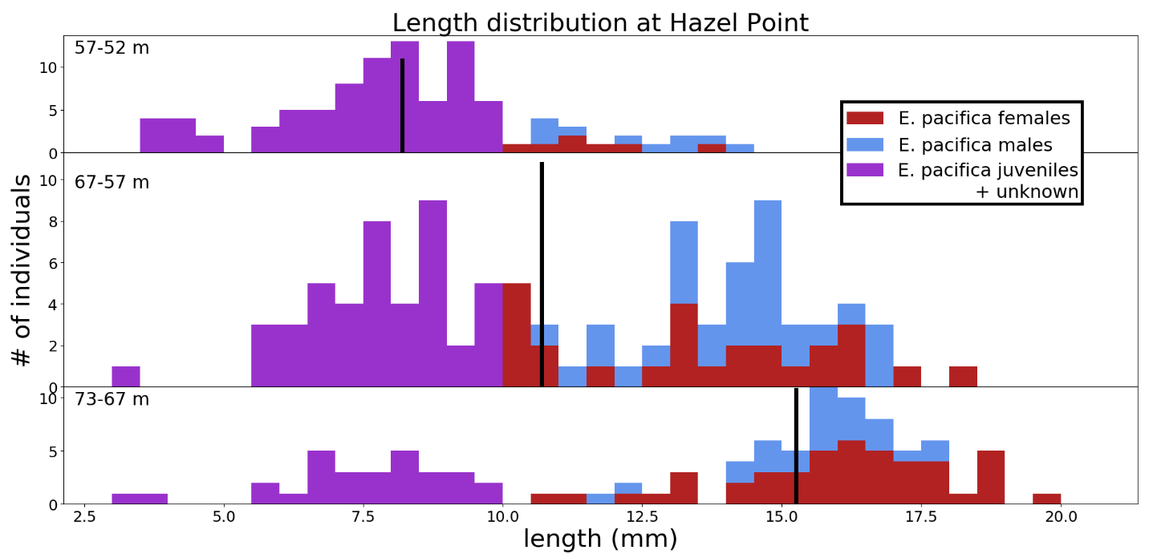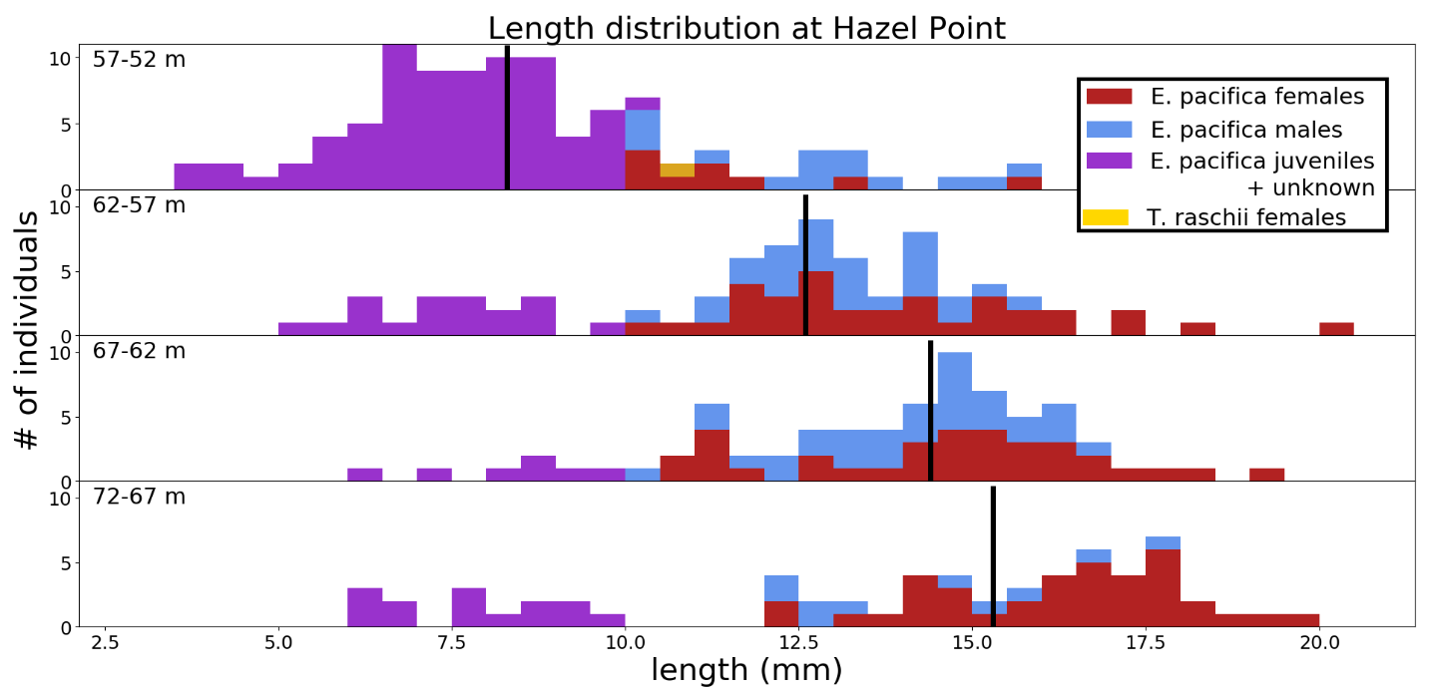
Figure 6: Length distribution of euphausiids from two tows at Hazel Point. One net failed to open for the first tow. Vertical lines indicate the median size of E. pacifica. Size very apparently increases with depth in both net tows.

Table 1: Median size and standard deviation in mm of E. pacifica counted by station and depth. Letters indicate significantly (p = 0.01) different medians within each net tow.
 | Kayak Point | Gedney Island | Mabana Point 1 | Mabana Point 2 | Hazel  Point 1 | Hazel  Point 2
Shallowest | 12.6±1.37a | 8.6±0.35  a | 7.9±0.50  a | 7.3±0.23  a | 8.2±0.24  a | 8.3±0.26  a
Second Shallowest | 18.0±1.45a | 8.4±0.48  a | 8.2±0.22  a | 10.2±0.30  b | 10.7±0.35  b | 12.6±0.35  b
Second Deepest | 13.8±1.35a | 9.6±0.88  a | 8.2±0.25  a | 12.0±0.29  c | 10.7±0.35  b | 14.4±0.30  c
Deepest | 14.8±0.56a | 12.7±0.40  b | 11.1±0.40  b | 10.9±0.65  bc | 15.2±0.42  c | 15.3±0.49  c

Table 2: The concentration of E. pacifica from net tows (individuals / m³) with sample size given in parenthesis. Kayak point had much lower concentrations of euphausiids and Hazel Point had much higher concentrations.
 | Kayak Point | Gedney Island | Mabana Point 1 | Mabana Point 2 | Hazel  Point 1 | Hazel  Point 2
Shallowest | 0.12 (6) | 1.49 (61) | 0.83 (20) | 0.53 (46) | 50.89 (97) | 19.8 (99)
Second Shallowest | 0.09 (9) | 0.81 (35) | 5.16 (89) | 8.77 (68) | 36.36 (100) | 28.73 (79)
Second Deepest | 0.06 (2) | 0.76 (16) | 3.86 (112) | 12.41 (90) | 36.36 (100) | 33.86 (73)
Deepest | 0.18 (23) | 0.53 (59) | 1.95 (41) | 0.04 (8) | 18.82 (100) | 33.60 (63)

Appendix:
Acoustic backscatter from other locations:
Kayak Point: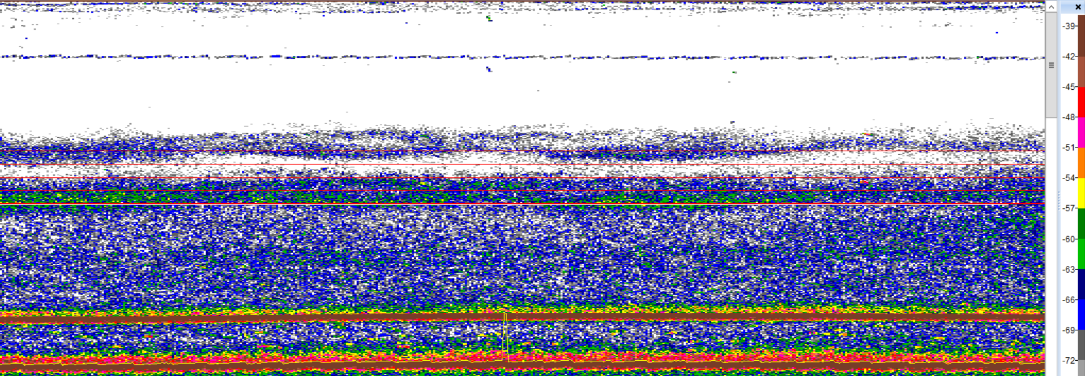
Gedney: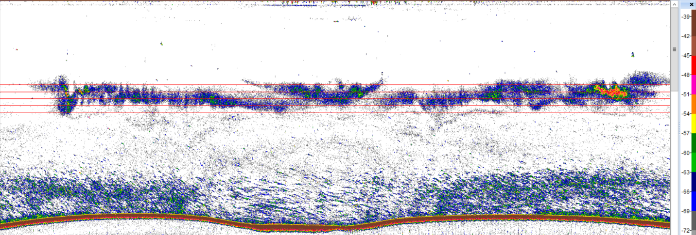
Hazel Point 2: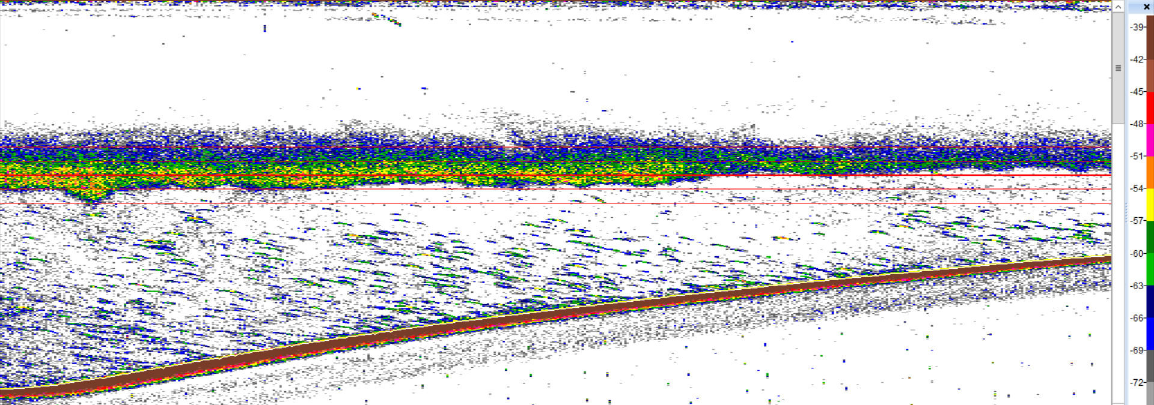
Mabana Point 1: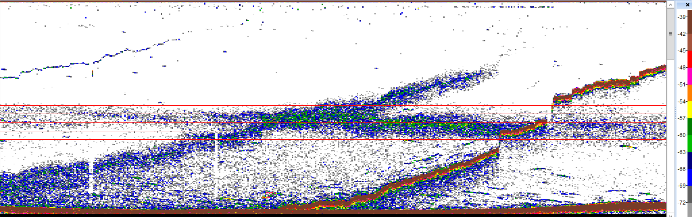
Mabana Point 2: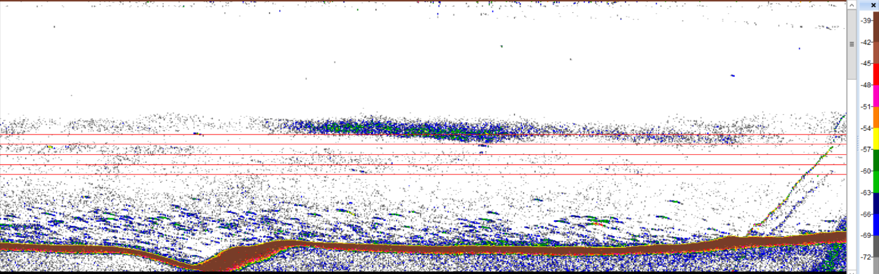
Additionally, the code for my analysis can be found in the repository at: https://github.com/joshua-lai/uw-ocean-senior-thesis-2019

