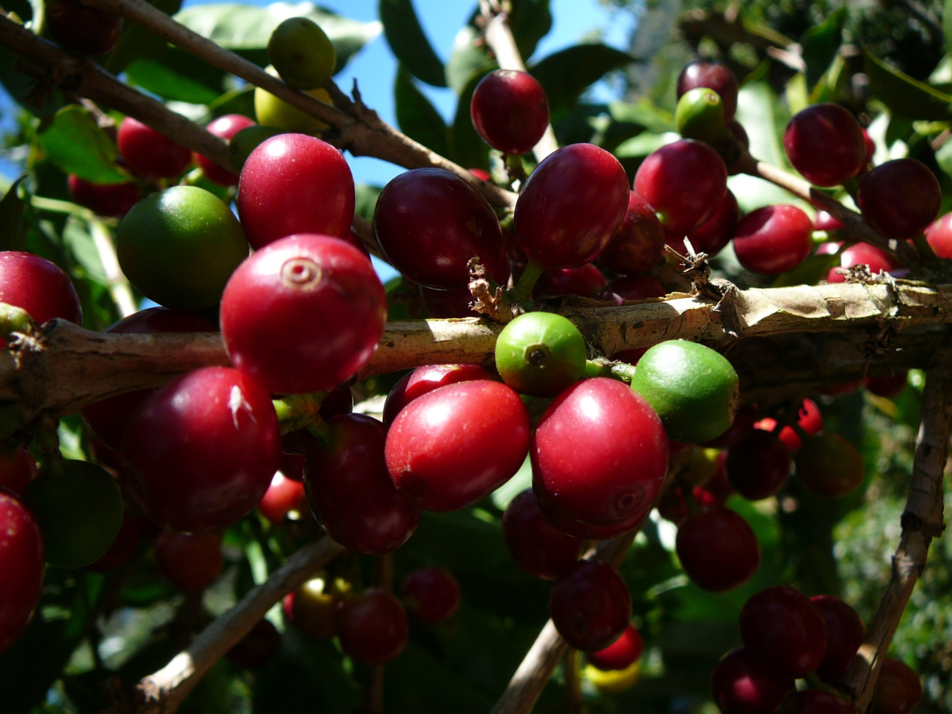
Katri Rahkonen
University of Washington Tacoma GIS Certificate Project 2009
Tarrazu Valley, Costa Rica: Study in Coffee Farming

Purpose

After spending two weeks in the Southwestern mountainous Tarrazu region of Costa Rica, I was moved and motivated by the landscape surrounding me. The mountainous region my sustainable coffee farming research was located in took my breath away (Fig. 1). The unending emerald green valleys were covered with coffee farms and dotted with forest patches and small towns. For the first time, in this rich physical environment, I began to understand visually what spatial data was and how it connected charts and tables with physical form. With this vista before me, I began to contemplate the indigenous knowledge behind the placement of coffee farms.
I was intrigued by the geography of the region and how it related to coffee production rates. The hillsides were steep, farm terraces seemed to face every direction, and the sun was intense. I wanted to see how this physical and visual experience could translate into the world of GIS. This translation became an evaluation of the relationship between coffee farm productivity in the southwestern mountainous region of the Tarrazu Valley of Costa Rica as it relates to the valley’s ground cover, slope, aspect, and solar radiation levels. The tropical effects of cloud cover, topography and difficulty in differentiation of woody plant types in aerial and orthophotos are recognized stumbling blocks in tropical land cover mapping (Cordero-Sancho, 2007). I anticipated finding the highest coffee production rates in areas of least slope with a southwesterly aspect as well as in areas of moderate solar radiation levels. The momentum created in this inspiring environment carried me through every twist and turn of this project with the desire to delve deeper with every step.

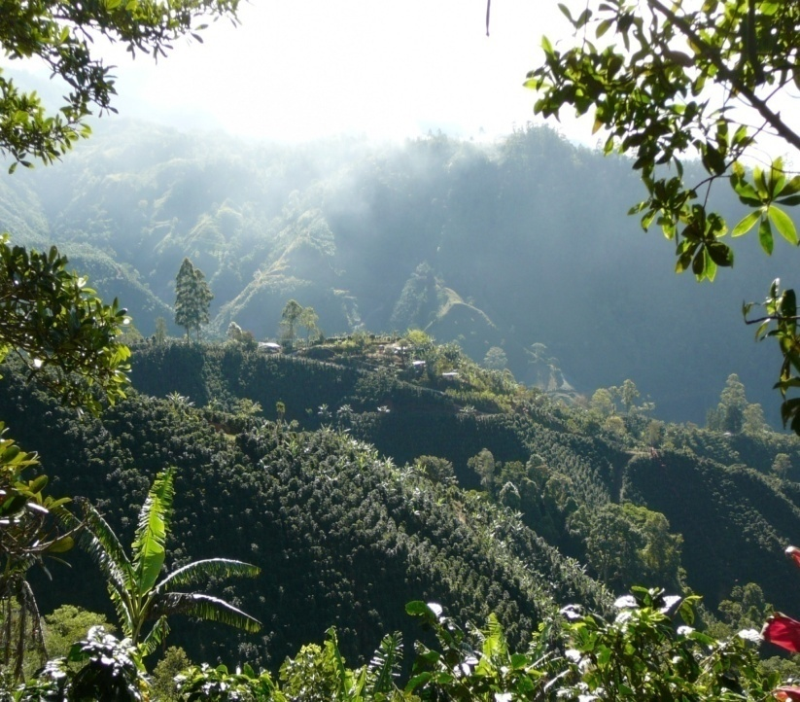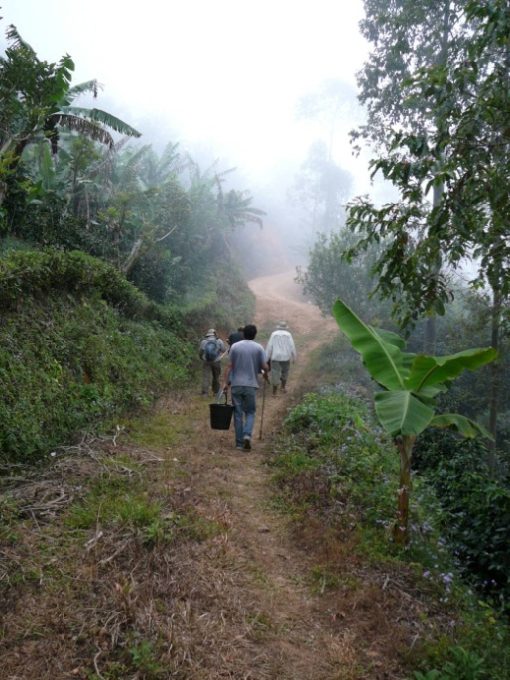
Figure 1: Image 1, Coffee farm terraces in the Tarrazu Valley, Costa Rica 2009. Image 2, Road into sustainable coffee research farm in the Tarrazu Valley, Costa Rica 2009.
Coffee Background

Our morning cups of coffee, and the many pots to follow, come to us from a variety of regions around the world. An agricultural product of about 60 countries (Fig. 2), the coffee industry employs over 25 million people annually (Starbucks, 2008). The two predominant species of coffee, Robusta 35% and Arabica 65% (Cordero-Sancho, 2007), are the second most traded commodity next to oil, on a transactional basis (Geromel et al., 2008) and are traded on the London “LIFE” market as well as the New York “C” market (Starbucks, 2008).
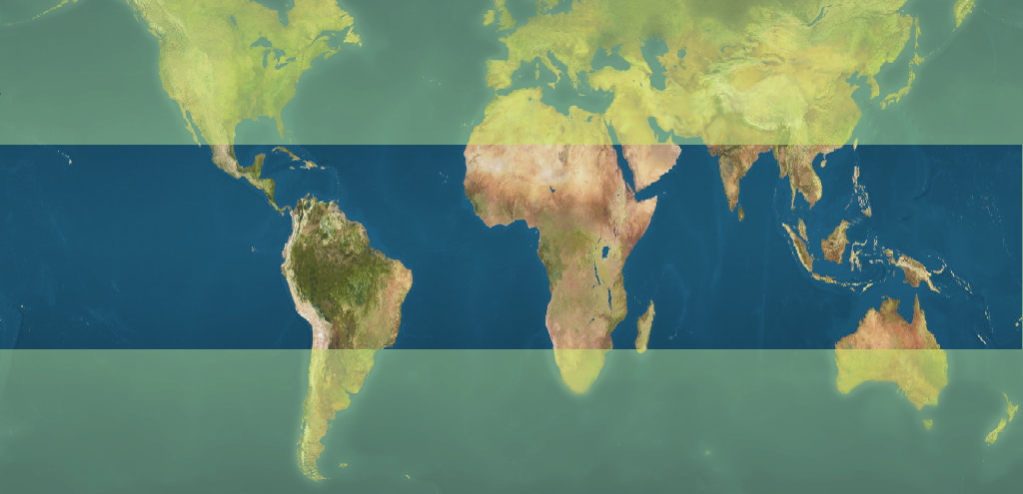
TROPIC OF CAPRICORN
TROPIC OF CANCER
Hawaii
Philippines
Mexico
India
Brazil
Costa Rica
Sumatra
Jamaica
Cameroon
Vietnam
Guatemala
Papua New Guinea
Yemen
Dominican
Republic
Zimbabwe
Venezuela
Honduras
Kenya
Cuba
Ivory Coast
El Salvador
Tanzania
Bolivia
Puerto Rico
Peru
Burundi
Colombia
Panama
Uganda
Ethiopia
Nicaragua
Ecuador
Timor
Rwanda
Zambia
Congo
Paraguay
Guinea
Sierra-Leone
Ghana
Nigeria
Sri Lanka
China
Thailand
Sulawesi
Java
Borneo
Madagascar
Angola
Zaire
Indonesia
Cuba
Haiti
Figure 2: Coffee producing countries. Top ten producers are in red.
Much of the world production of coffee is from smallholder farms of 2 to 3 hectares (Bosselmann et al., 2009). Smallholder farms each produce about 100 to 200 pounds annually (Bosselmann et al., 2009). With only a few large traders worldwide, co-ops, such as those formed in many parts of Costa Rica, help smallholder farmers obtain top price for their product (Starbucks, 2008).
Costa Rica is recognized internationally as a high quality shade coffee producer. This nation is a middle-income, developing country with a strong democratic tradition. It has had a stable democracy since 1949. Over the past 20 years, poverty has been reduced from 40 percent of the population to below 20 percent. Its per capita income was $4,670 in 2004, compared with $33,090 in the United States. Major crops include bananas, pineapples, and coffee (Valdes, 2008).
Costa Rican coffee growers have benefited from Starbucks' emergence as a global company. Gourmet coffee has been made fashionable and the Starbuck’s name is recognized among other companies, such as McDonald's and Dunkin Donuts, worldwide. The Seattle company buys about 15 percent of the roughly 235.2 million pounds of coffee produced in Costa Rica. Starbucks pushes producers to concentrate on quality instead of volume and prefers to buy coffee from farms certified under its environmental and social-standards program introduced in 2003. Those standards are known as Café Practices, which stands for Coffee and Farmer Equity Practices (Valdes, 2008). Café Practices produce healthier and more productive coffee farms.
The Tarrazu Valley, in the southwestern mountainous region of Costa Rica, is known for its breathtaking landscaped and high quality shade grown coffee. Tarrazu is a canton in the province of San Jose in the mountains of Los Santos (Fig. 3). San Marcos de Tarrazu, the capital of the canton, is located on the bank of the Pirris River. The town is located at 1350 meters above sea level on a foundation of volcanic soil. This geography is ideal for coffee production.
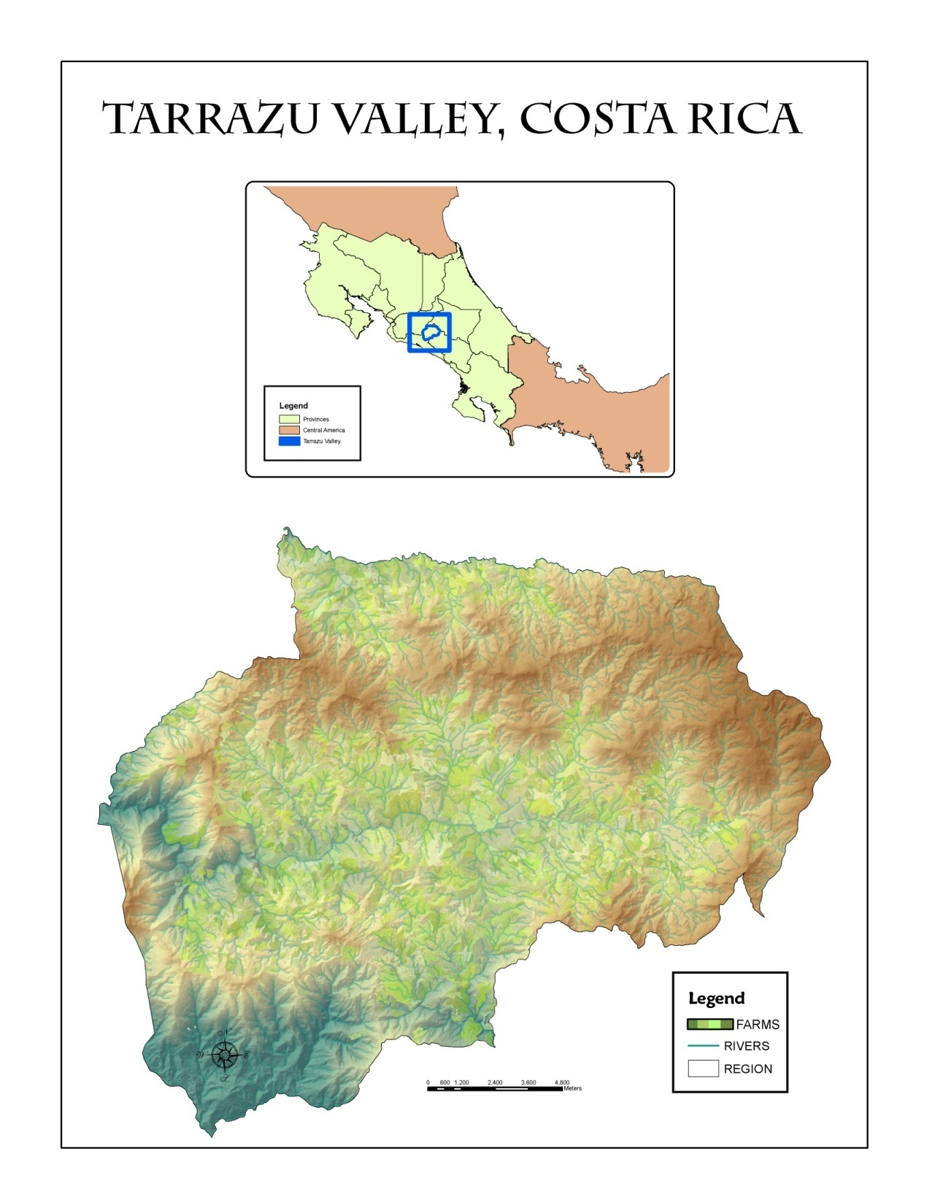
Figure 3: The Tarrazu canton in the province of San Jose, Costa Rica.
Coffee grows well in humid, cloudy conditions with rich volcanic soil. This dark green person sized plant (Fig. 4) originates from shaded habitats and has limited ability to grow in the full sun (Ramalho et al., 1997). With strongly sloped hillsides and intense sun, this need for shade had led to the development of “shade grown” coffee farms in Costa Rica, as well as worldwide. Shade is provided at varied levels, by growing banana, porro, or other varied quality shade trees.
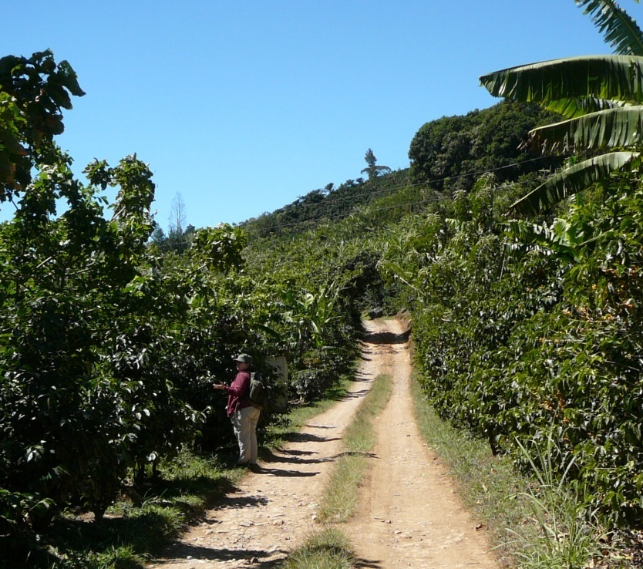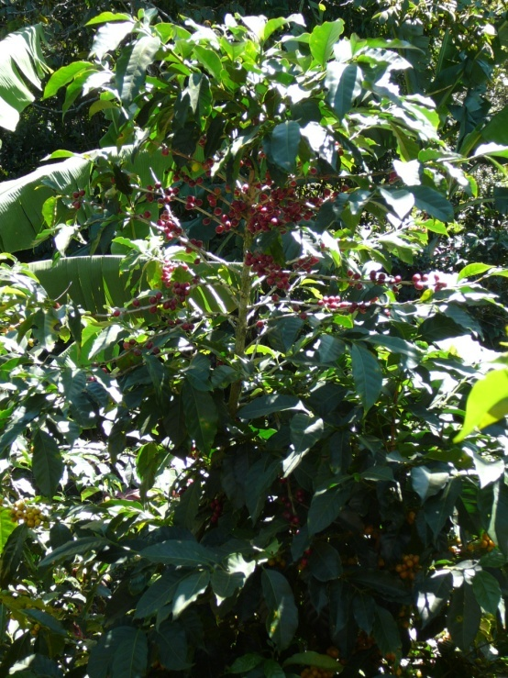
Figure 4: Rebecca Singer on road through coffee farm with “shade trees” producing red and yellow berried coffee plants.

Methods

My methods began with the preview of countless files in ArcCatalog, Spanish to English translation tool at my side. After sorting through piles of data and naming them in English in my file geodatabase, and finally obtaining farm polygons from a charming though frequently inaccessible Costa Rican contact, I set on the task of connecting the physicality of the Tarrazu Valley with the production rates of the coffee farms there in. As this was a study in trial and error, I have not listed all of the steps along the way, but rather the steps that contributed to the spatial data visuals and analysis which follow. Extraction by mask and finding different ways to represent the data were the two most useful tools. Through trying different visual representations of variables, I feel I was able to create a product that both represented the data as well as my personal style. The following flowchart represents best the steps taken once the geodatabase was created (Fig. 5). Analysis was then conducted on the correlation of the various variables and coffee production on selected farms in the Tarrazu Valley of Costa Rica.
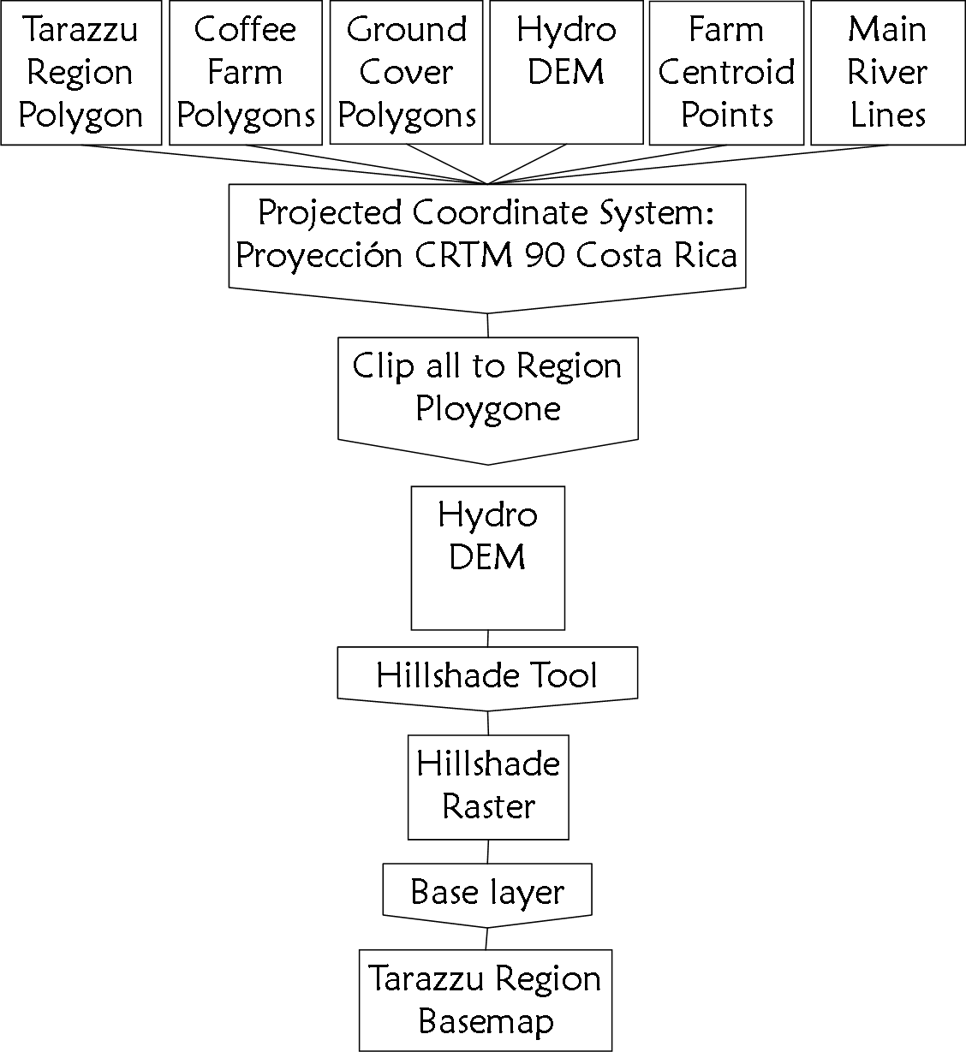

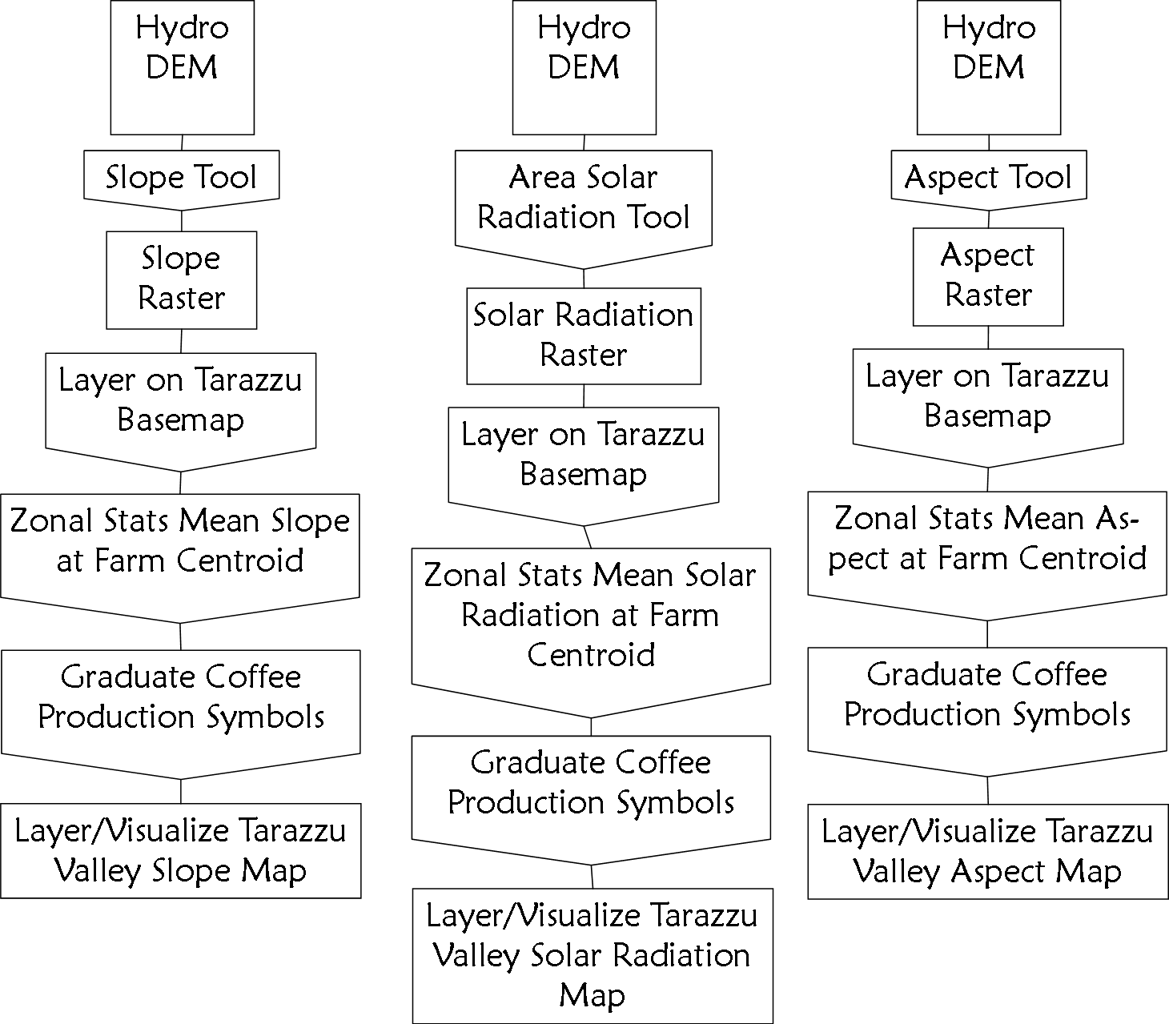

Figure 5: Flowchart of steps taken in the creation of the visualization of the Tarrazu Valley.
Hydro DEM
Tarrazu
Region
Polygon
Coffee Farm Polygons
Ground Cover Polygons
Hydro DEM
Projected Coordinate System:
Proyección CRTM 90 Costa Rica
Farm Centroid Points
Main River Lines
Clip all to Region Polygon
Hillshade Tool
Hillshade Raster
Base layer
Hydro DEM
Tarrazu
Region
Polygon
Coffee Farm Polygons
Ground Cover Polygons
Hydro DEM
Projected Coordinate System:
Proyección CRTM 90 Costa Rica
Farm Centroid Points
Main River Lines
Clip all to Region Polygon
Hillshade Tool
Hillshade Raster
Base layer
Results

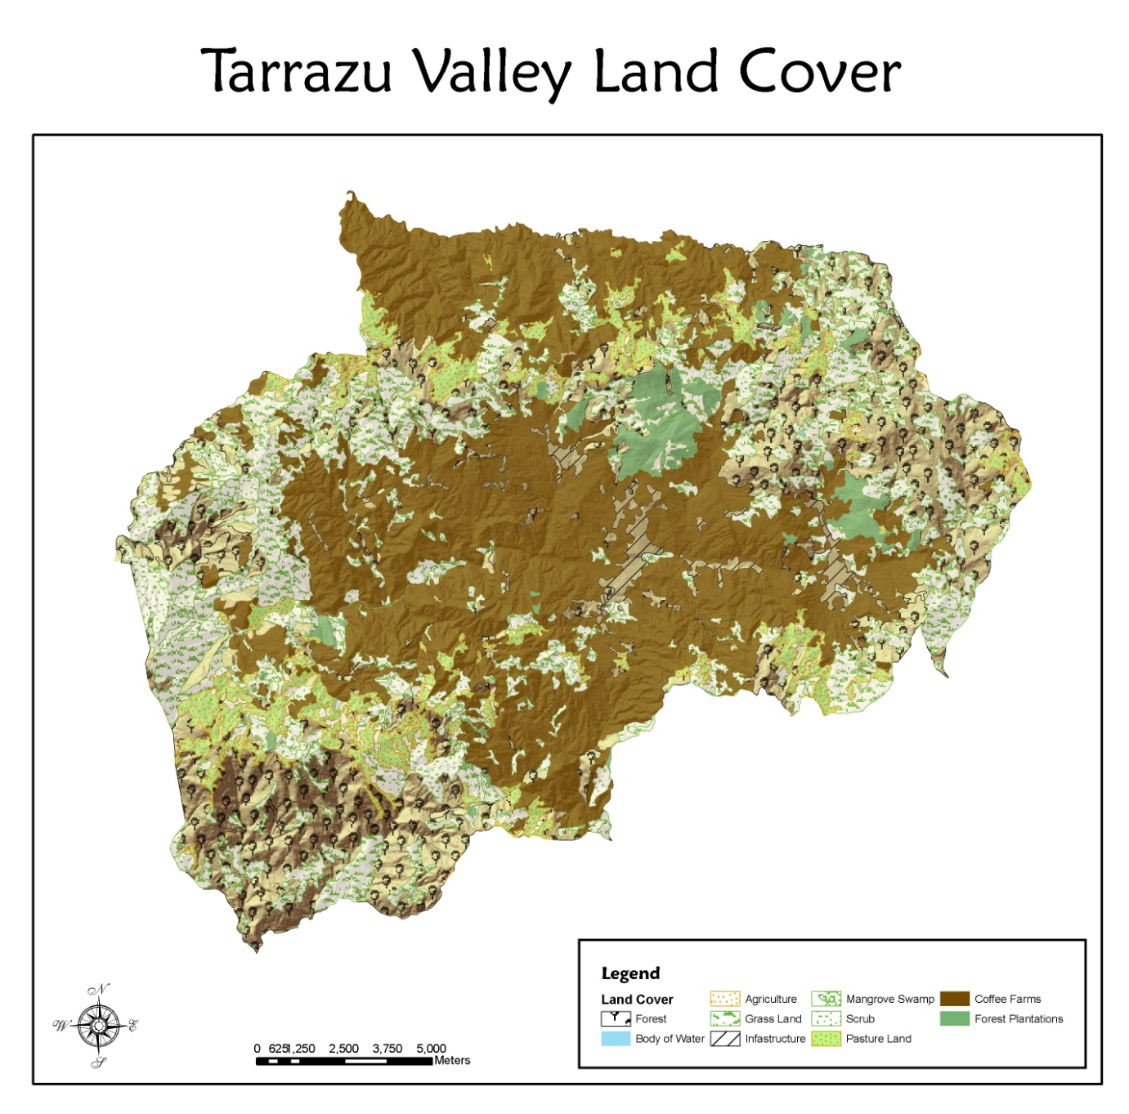
Figure 6: Ten land cover types dominate the Tarrazu Valley.

Driving across the Tarrazu Valley’s 689,577 square kilometers of diverse landscape, coffee farms blend into the green landscape. Coffee farming covers 20% of the valley at 137,534 square kilometers. These farms sprawl across the landscape, creating pockets of forest, scrub, and pasture land. This region’s main source of income is deeply seated in a culture of coffee farming.
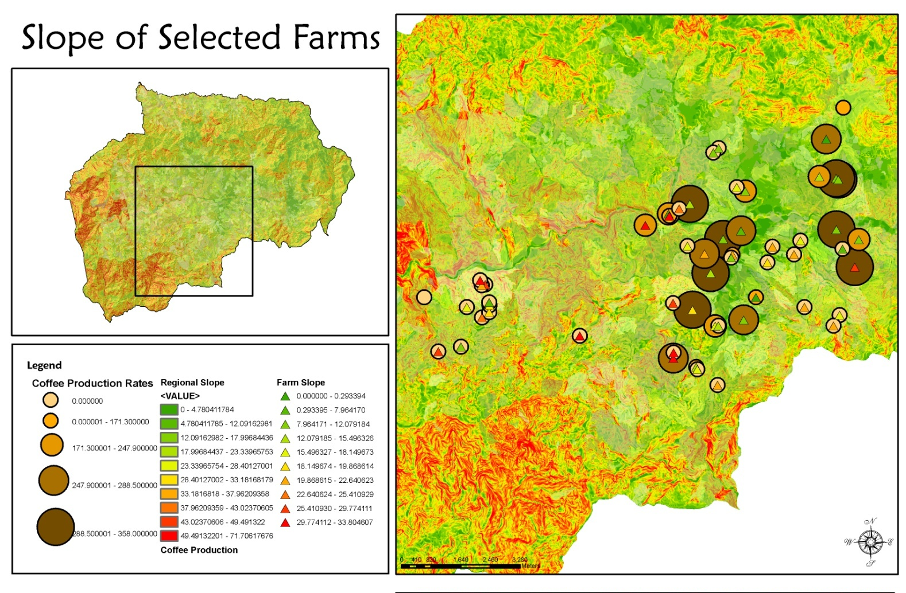
Figure 7: Selected farms, 54, were selected for individual farms slope analysis.

Slope is defined as the steepness, incline, or grade of a surface. In the case of topography, it is the degree to which the land surface inclines. The mean slope of the Tarrazu Valley is 18.008 degrees. Higher coffee production was found, at a slightly but not significantly higher rate, on farms having 7 to 15 degree slopes. Easier slopes in terms of land management and harvesting could attribute to the higher production numbers. Farms with higher production rates were also grouped together. Possible soil types and other resources could also have had an effect on the coffee production rates. Selected coffee farms with lower production rates had no clear correlation.
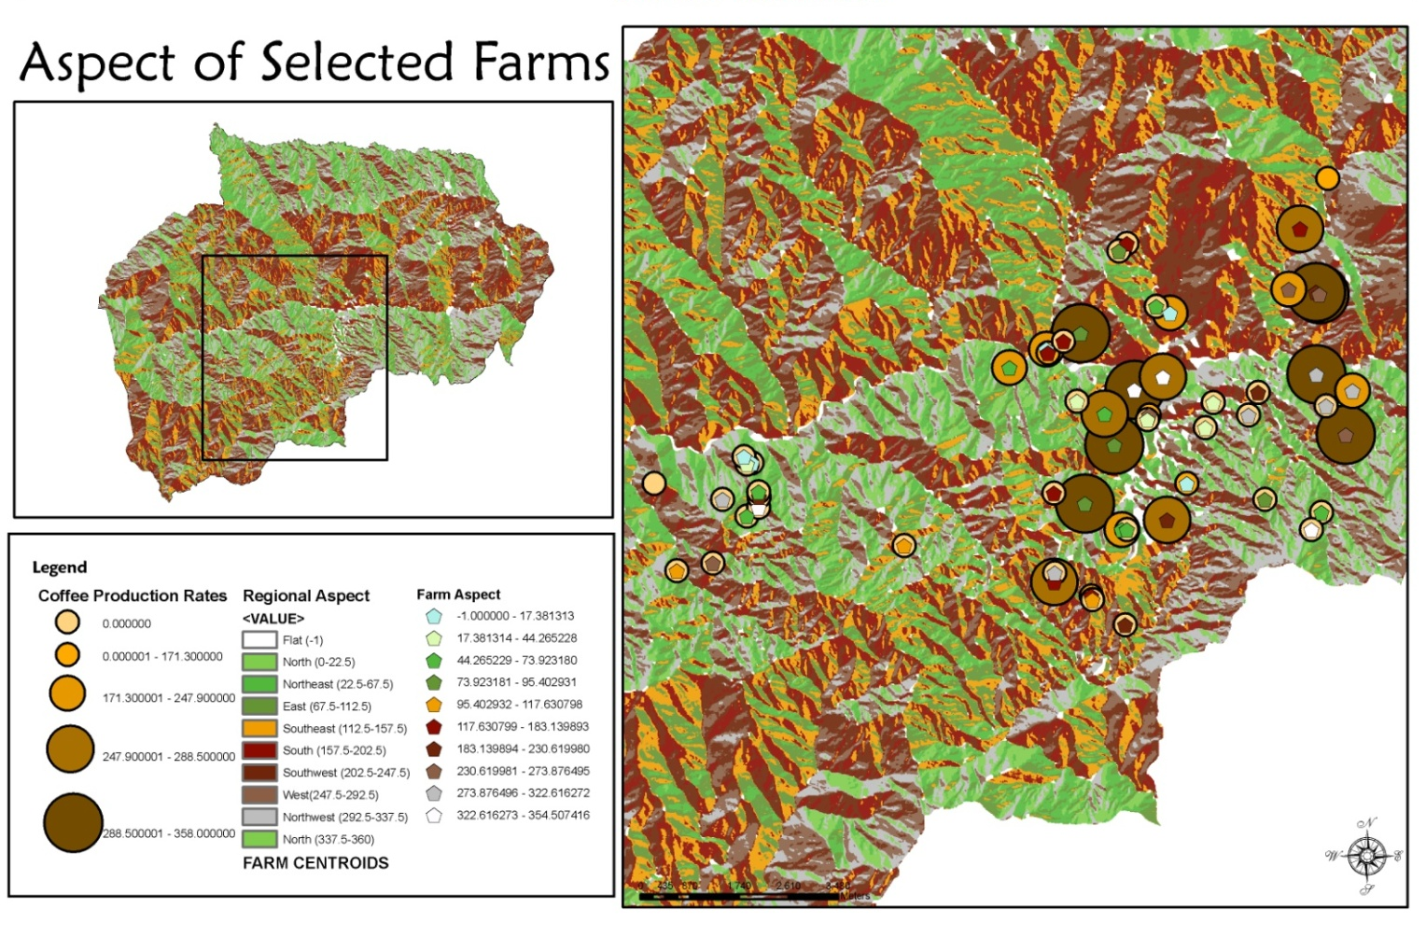
Figure 8: Aspect analysis for the Tarrazu Valley, Costa Rica

Aspect is defined as the direction of slope. In terms of the Tarrazu Valley, aspect is the compass direction the land surface’s slope is directed. The mean valley’s aspect was in a southwesterly direction at 155.27955. The higher coffee producing farms, at a slightly higher but not significantly rate, had a north-northeasterly aspect. With coffee plants producing better under moderate sun, the north-northeasterly aspect suggests that the coffee plants thrive in morning sun with protection from the intense afternoon sun. Low production rate farms did not have a significant correlation.
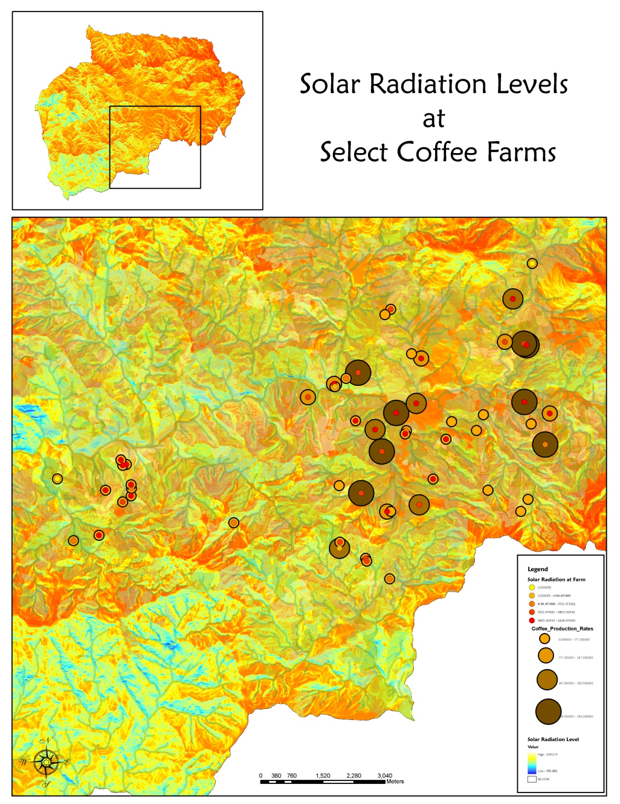
Figure 9: Solar Radiation levels range dramatically with the landscape.
Solar radiation levels were calculated. Moderately high solar radiation levels dominated the valley. Moderately high levels were also associated with all levels of coffee production. Calculation and analysis did not include percent shade cover per farm based on land cover.
Future Research

This project is the result of my initial questioning. Regarding the current data, solar radiation analysis for the valley would benefit from the inclusion of land cover to provide a more accurate view of coffee production as it relates to the sun. . It is my hope to follow this investigation by answering questions regarding farm productivity as it relates to proximity to infrastructure as well as developing a more extensive farm data set within the Tarrazu Valley of Costa Rica.

Works Cited
Bosselmann, A. S., K. Dons, T. Oberthur, C. Olsen, A. Ræbild, H. Usma. 2009. The influence of shade trees on coffee quality in small holder coffee agroforestry systems in Southern Colombia. Agriculture, Ecosystems & Environment. 129:253-260.
Cordero-Sancho, S. and S. A. Sader. 2007. Spectral analysis and classification accuracy of coffee crops using Landsat and a topographic-environmental model. International Journal of Remote Sensing 28:1577-1593.
Geromel, C., L. P. Ferreira, F. Davrieux, B. Guyot, F. Ribeyre, M. dos Santos Scholz, L. Protasio Pereira, P. Vaast, D. Pot, T. Leroy, A. A. Filho, V. Esteves Vieira, L. Gonzaga, P. Mazzafera, P. Marraccini. 2008. Effects of shade on the development and sugar metabolism of coffee (Coffea arabica L.) fruits. Plant Physiology & Biochemistry. 46:569-579.
Ramalho, J. C., T. L. Pons, L. Thijs, H. W. Groeneveld, M. Nunes. 1997. Photosynthetic responses of <em>Coffea arabica</em> leaves to a short-term high light exposure in relation to N availability. Physiologia Plantarum 101:229-239.
Starbucks. 2008. Annual Report
Valdes, M. 2008. Starbucks changing the way Costa Rican farmers grow coffee- and live. Seattle Times. 3.30.2008

