School Mental Health Services for People with Disabilities – Survey Report

Back in Fall 2025, 25 participants consented to participation in a research study for Katherine Dolphin’s MSW Capstone Project, overseen by Dr. Anindita Bhattacharya. This report contains the outcome of the survey, and proposed intervention as a result of the data collection. Some of the data was condensed, summarized, or excludes personal identifying information so the report could be shared with UW Research Works, making it available to anyone with an internet connection, and has been modified for accessibility using UW’s Document Conversion Service; formats are available via this word document, braile, and as an MP3 with English: https://access.sensus.dk/sb4/sb4amrsp/rba11-28-03-2026-101744.mp3 and Spanish: https://access.sensus.dk/sb4/sb4amrsp/rba14-28-03-2026-102140.mp3
In summary, this report takes a closer look at the unique barriers people with disabilities navigate in school settings, particularly when trying to obtain access to mental health and wellness resources. A historical overview of existing laws, policies, current interventions, and levels of discrimination that still persists in schools and into adulthood was reviewed. The final report from the “School Mental Health Survey” captures current attitudes, prevalence of stigma, and ideas for interventions, as elicited by current school staff in the 2025-26 academic year, majority of participants from WA State Schools. This data informs the MSW Candidate’s proposal for an intervention to make mental health more accessible, inclusive, holistic, and specific to the intersectional needs of each individual, with a primary focus on supporting adult educators with disabilities.
- What is your staff role within a school environment? 24% were Teachers, Professors, or Instructors. 4% were Student Teachers or Interns. 8% were Substitutes. 24% were paraeducators. 12% were Behavior Technicians. 8% were Occupational or Physical Therapists. 16% were School Social Workers. 8% were School Counselors. 20% fell into other categories, including Trainers, BCBAs, and Volunteers.

2. What types of school environments do you work at? Participants could choose more than one answer if they assumed multiple roles.

16% worked in Preschool or future ready kindergarten.
40% worked in Elementary.
56% worked in Middle School/Junior High.
52% worked in High Schools
8% worked in Colleges or Universities.
12% worked in Alternative or Virtual Schools.
4% worked in private or religious schools.
8% worked in home-based schools or private tutoring.

- How would you describe the population you work with? 64% General Education, 20% SPED High Supported Learning, 5% SPED Hi Social Emotional Learning, 0% Specialists such as Art, Music or PE, 5% Adult Learners, 8% Combination of more than 1 or all.
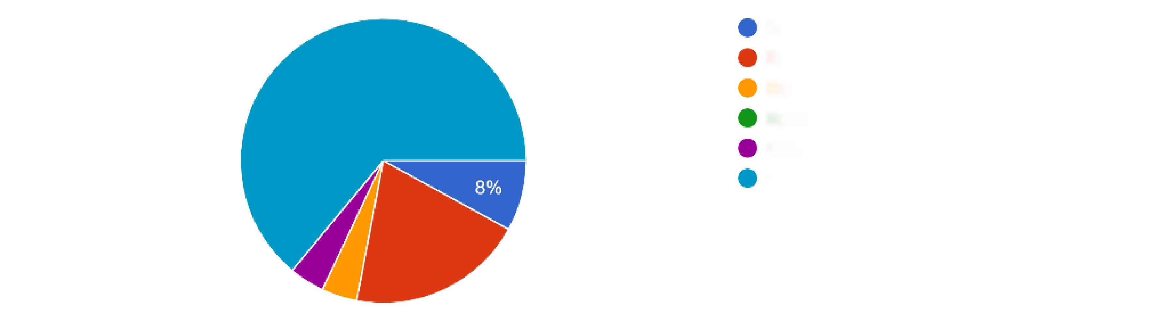
General Education, 64%
SPED Highly Supported Learning, 20%
SPED Social Emotional Learning, 5%
Specialization such as Music, Art, PE, 0%
Adult Learners, 5%
Combination of more than one, or all, 8%
20%
64%
- What is your highest level of education achieved? 5% Doctorate, 44% Masters, 36% Bachelors, 5% Associates, 8% Specialized Certification, 0% for GED and High School Diploma
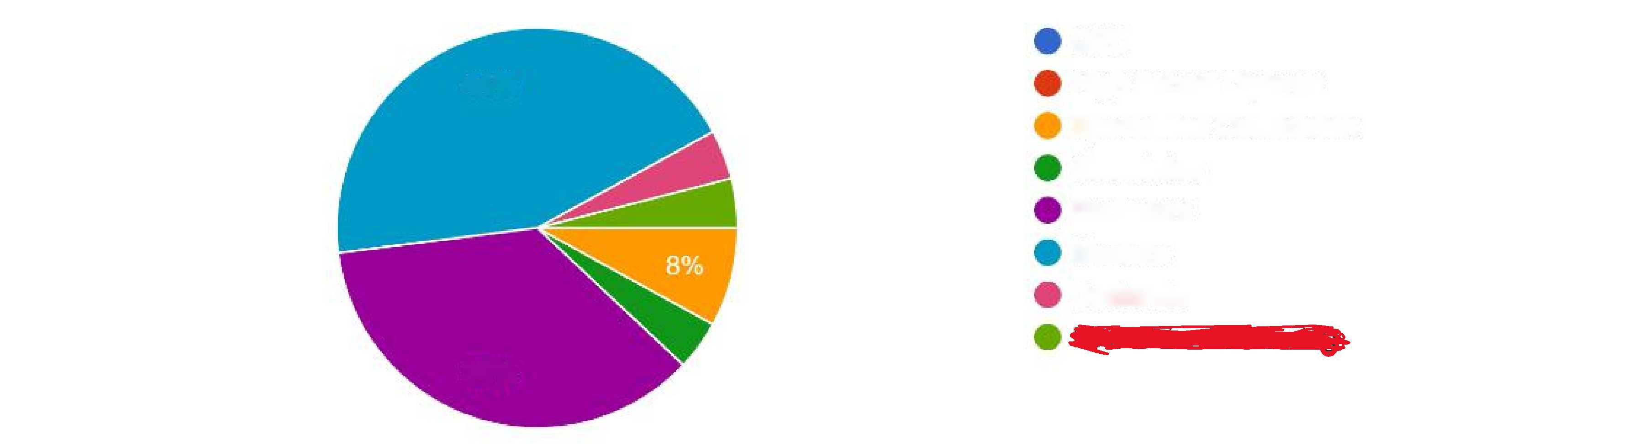
GED, 0%
High School Diploma, 0% Specialized Certification, 8% Associates, 5%
Bachelors, 36%
Masters 44%
Doctorate, 5% (additional answer redacted)
44%
36%
- What State do you currently work in? (50 states were listed; 4% were from California, 96% were from WA)
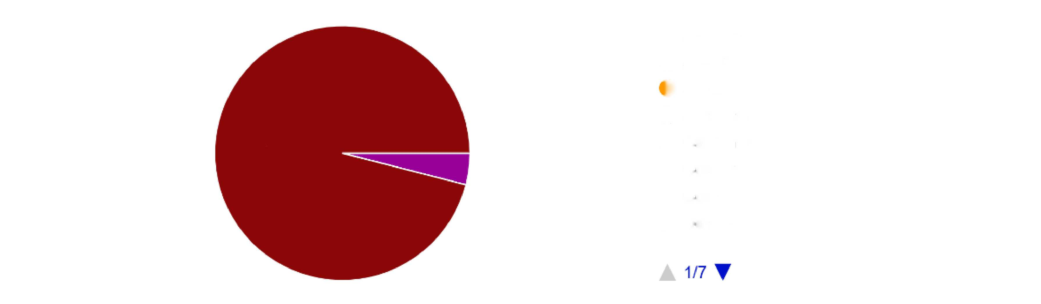
96%

6. How would you describe your racial identity? 80% White, 12% Multiracial, 4% Hispanic or Latino, 4% Black or African American, 0% Asian, 0% Pacific Islander, 0% Native or Indigenous

- How would you describe your gender identity? 12% Cis-Male, 68% Cis-Female, 0% Trans-Male, 0% Trans-Female, 12% Non-binary or Genderqueer, 4% Other/unsure, 4% redacted answer
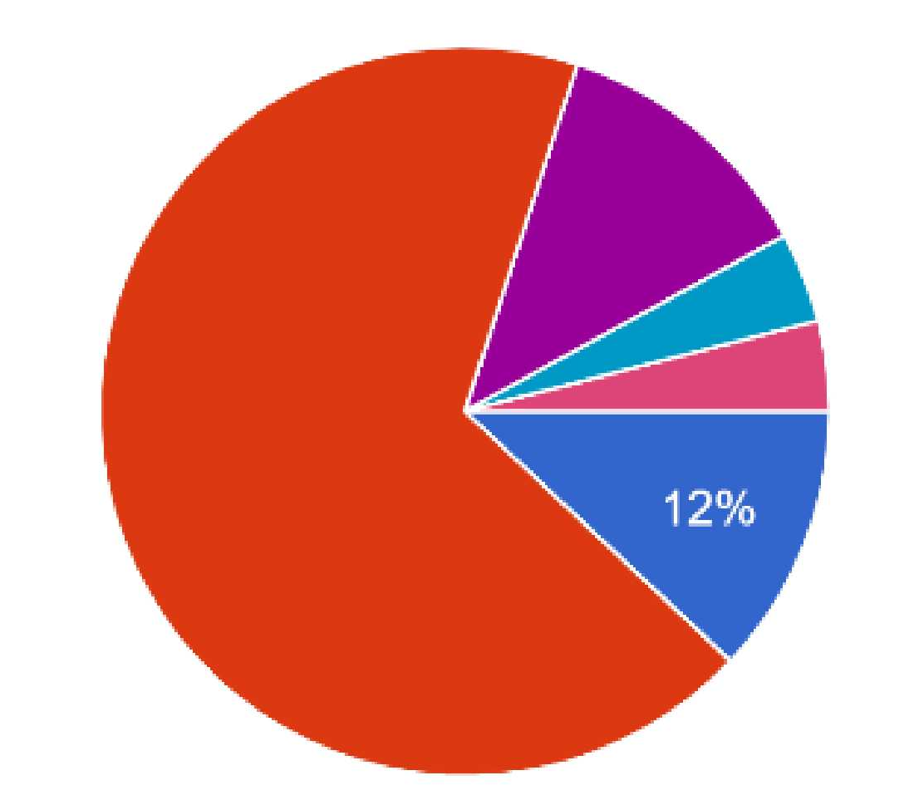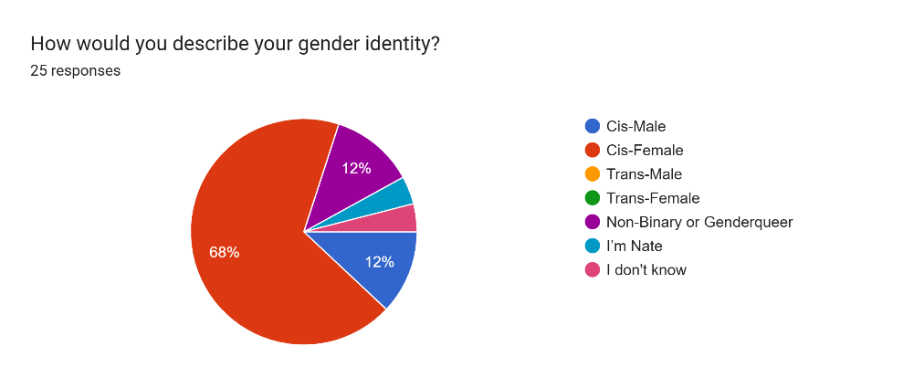
Cis-Male12%
Cis-Female 68%
Trans-Male 0%
Trans-Female 0%
Non-Binary or Genderqueer 12%
(Answer redacted)
Other/Unsure 4%
12%
68%
- How would you describe your sexual orientation? 68% Heterosexual or straight, 4% Gay or Lesbian, 12% Bisexual, 12% Pansexual, 4% Demisexual, 0% Queer, 0% Asexual, 0% Unsure/Questioning
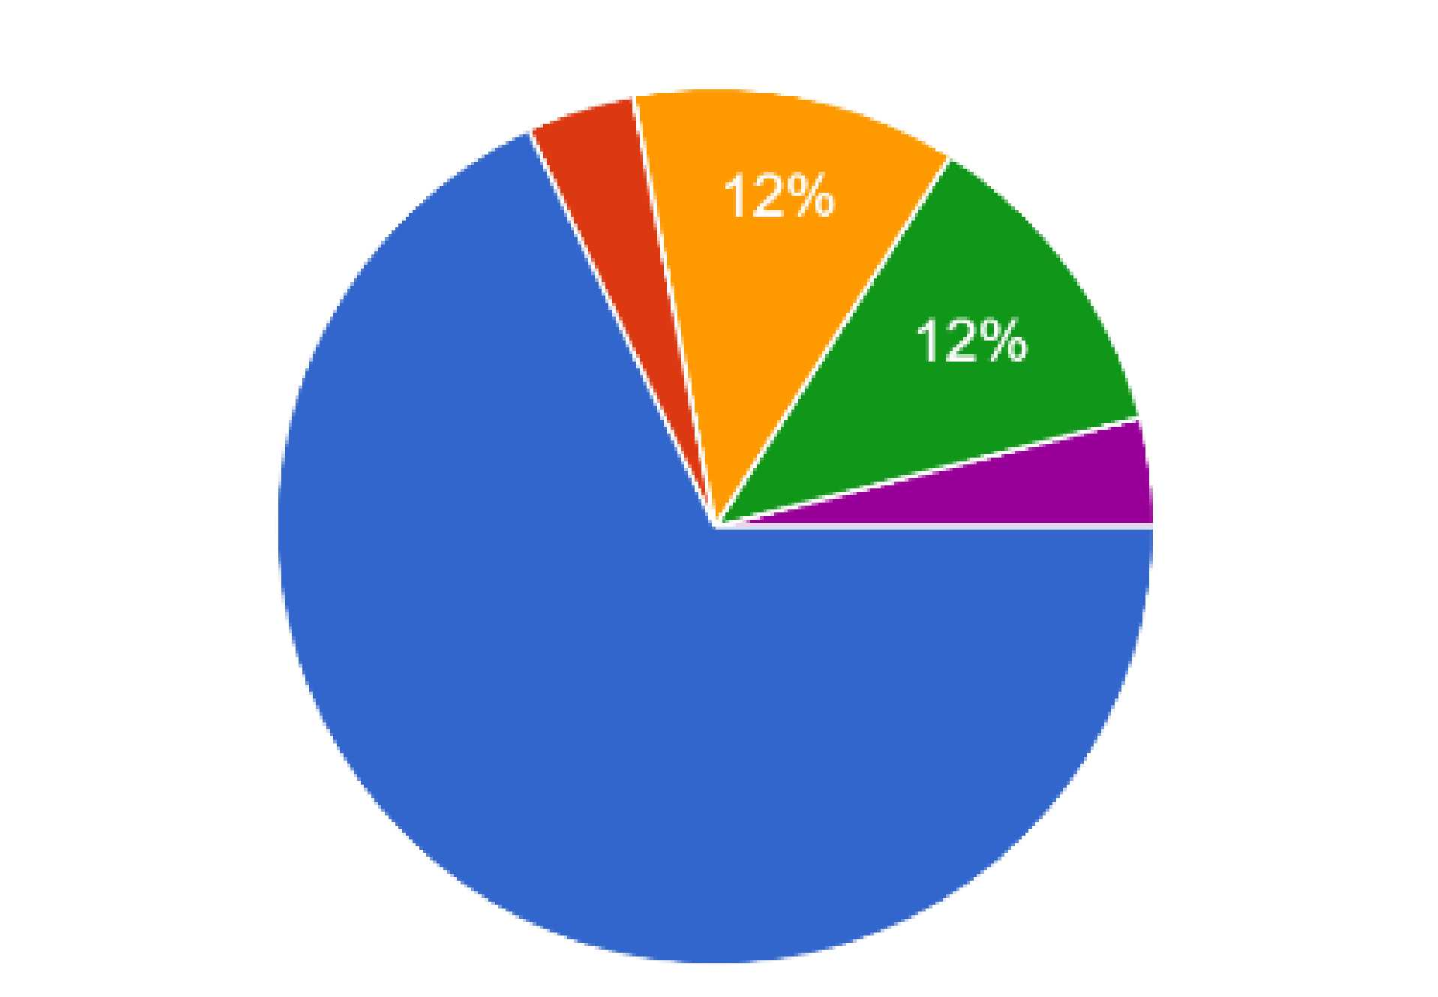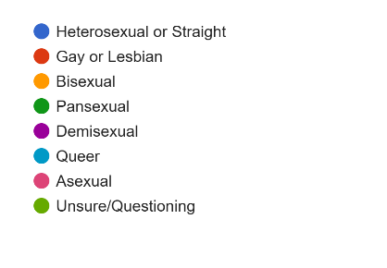
Heterosexual or Straight 68%
Gay or Lesbian 4%
Bisexual 12%
Pansexual 12%
Demisexual 4%
Queer 0%
Asexual 0%
Unsure/Questioning 0%

68%
- Are you a veteran or military member? 92% said No, 8% Yes
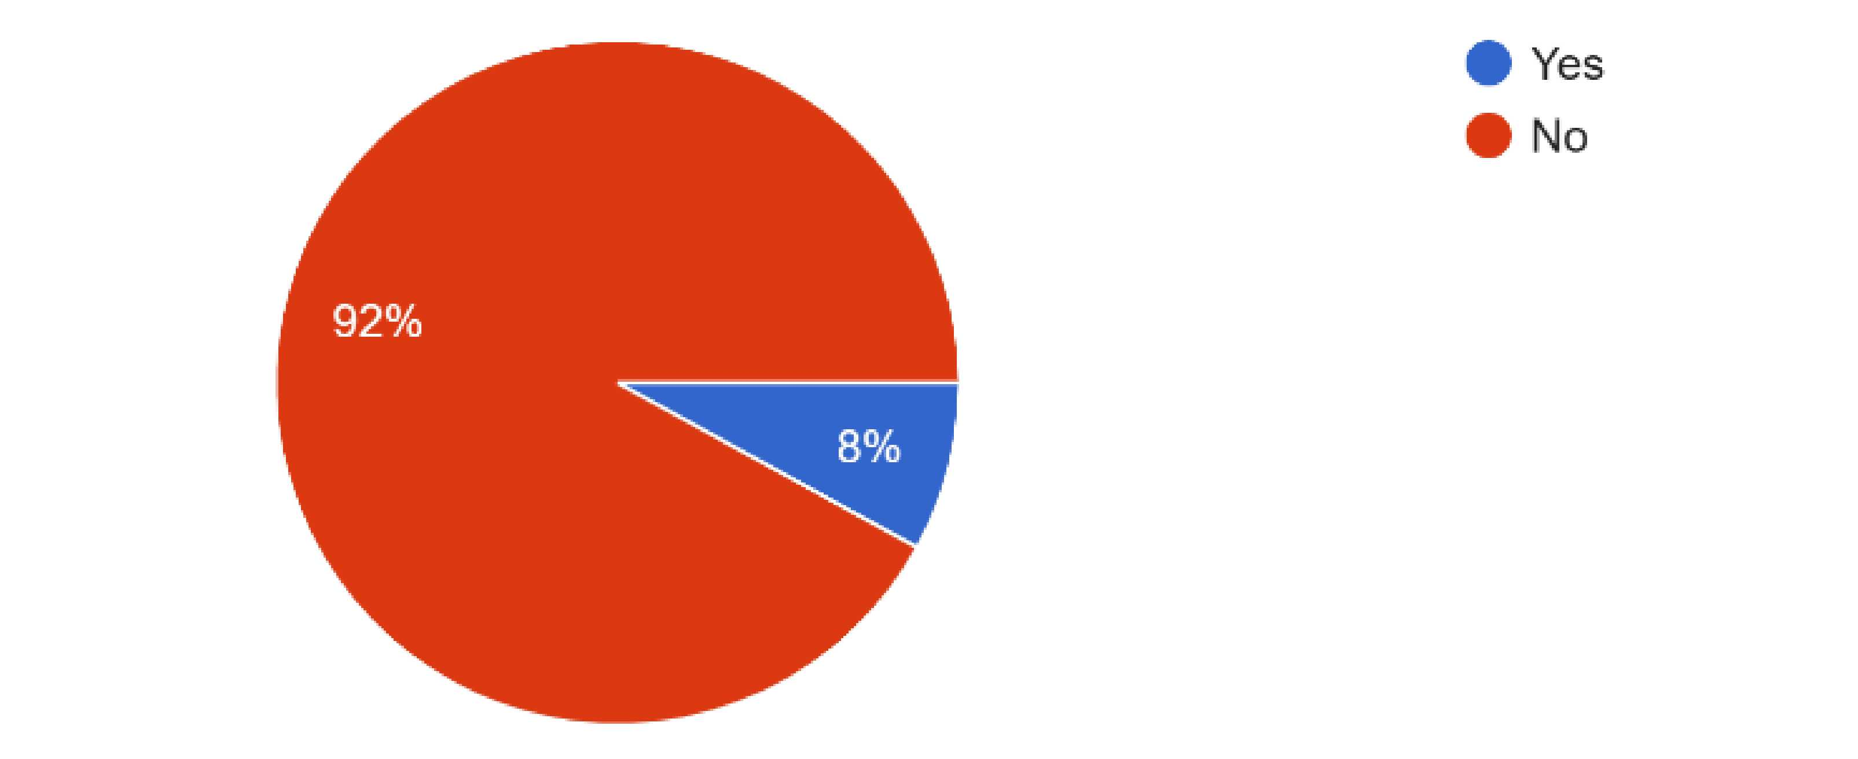
- Thinking back to your days in school, do you recall having any role models, teachers or mentors
at school that had a disability? 60% said No, 40% said Yes
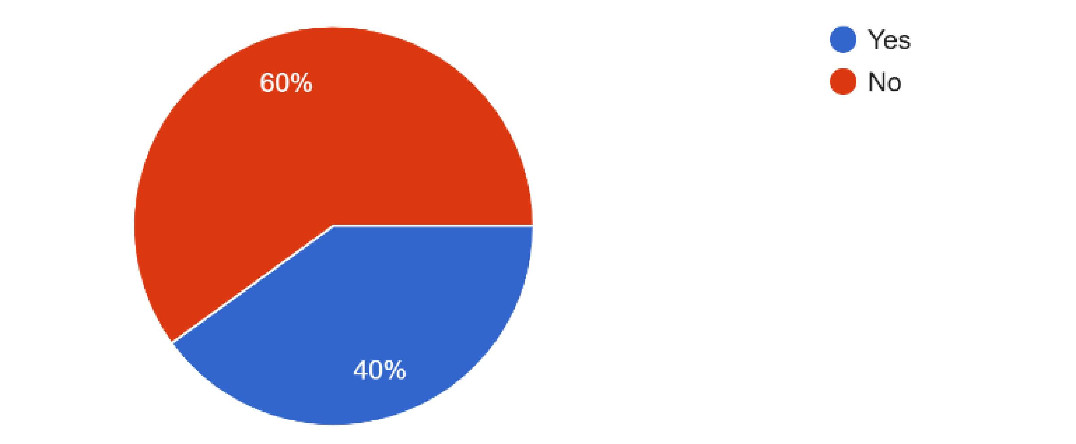
- 11. Do you identify as someone who currently lives with, or has formerly been diagnosed,
with a disability? 56% said Yes currently, 8% said Yes formerly, 36% said No
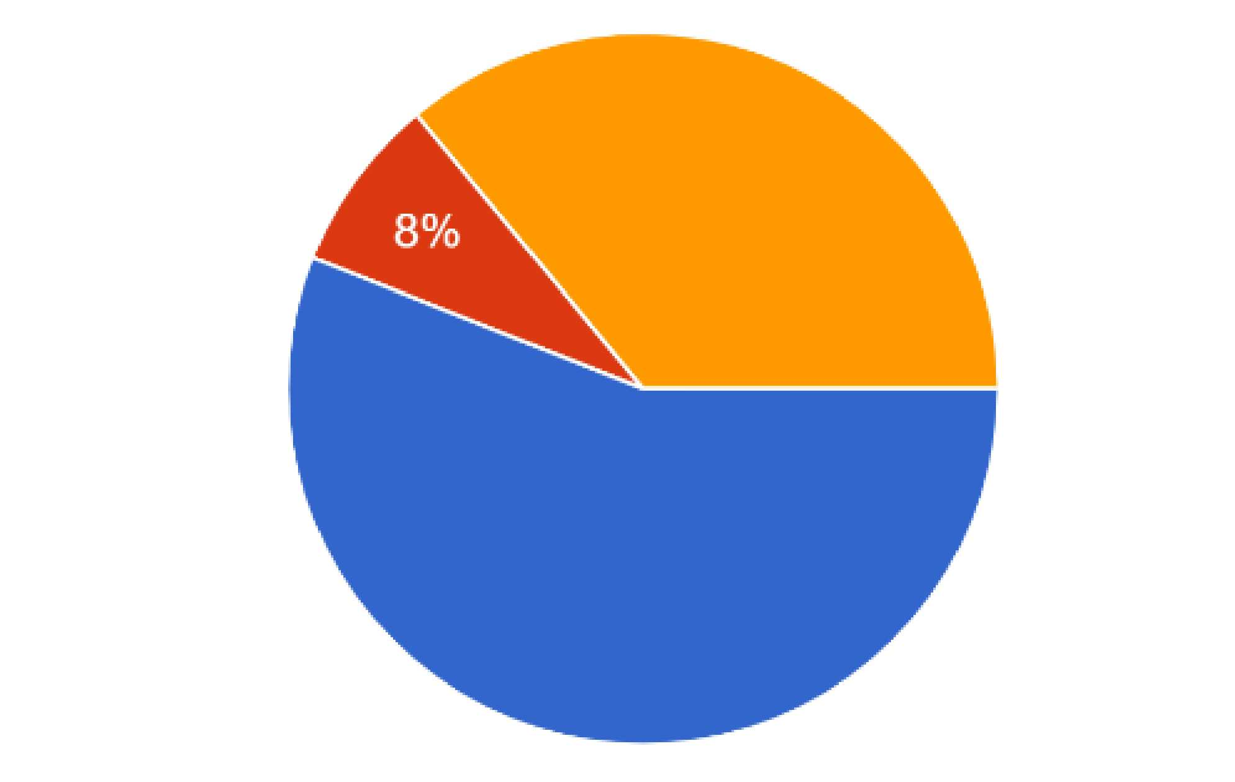
36%
56%
- 12. How would you describe your disability? 18.5% Physical, 25% Mental, 25% Invisible, 31.3% Multiple Comorbidities
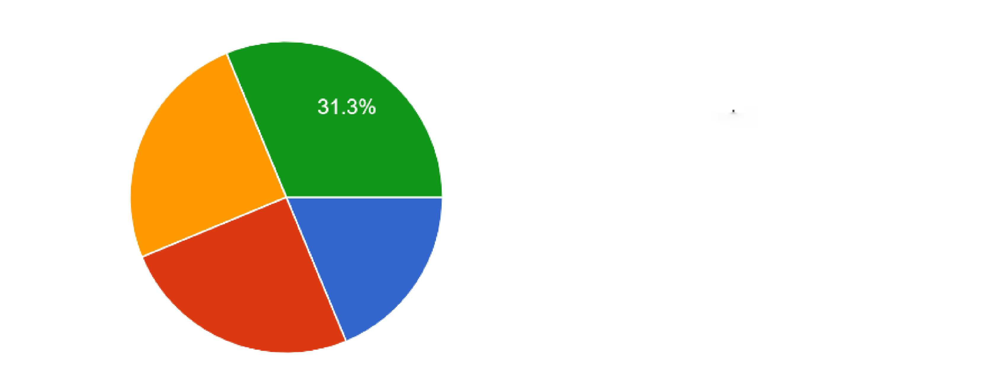
18.5% Physical
25% Mental
25% Invisible
31.3% Multiple comorbidities
25%
18.8%
25%
- 13. What is the status of your disability(s)? 70.6% Chronic, 0% Temporary, 17.6% Treatable, 0% Rehabilitated, 11.8% Nonexistent/no longer applies
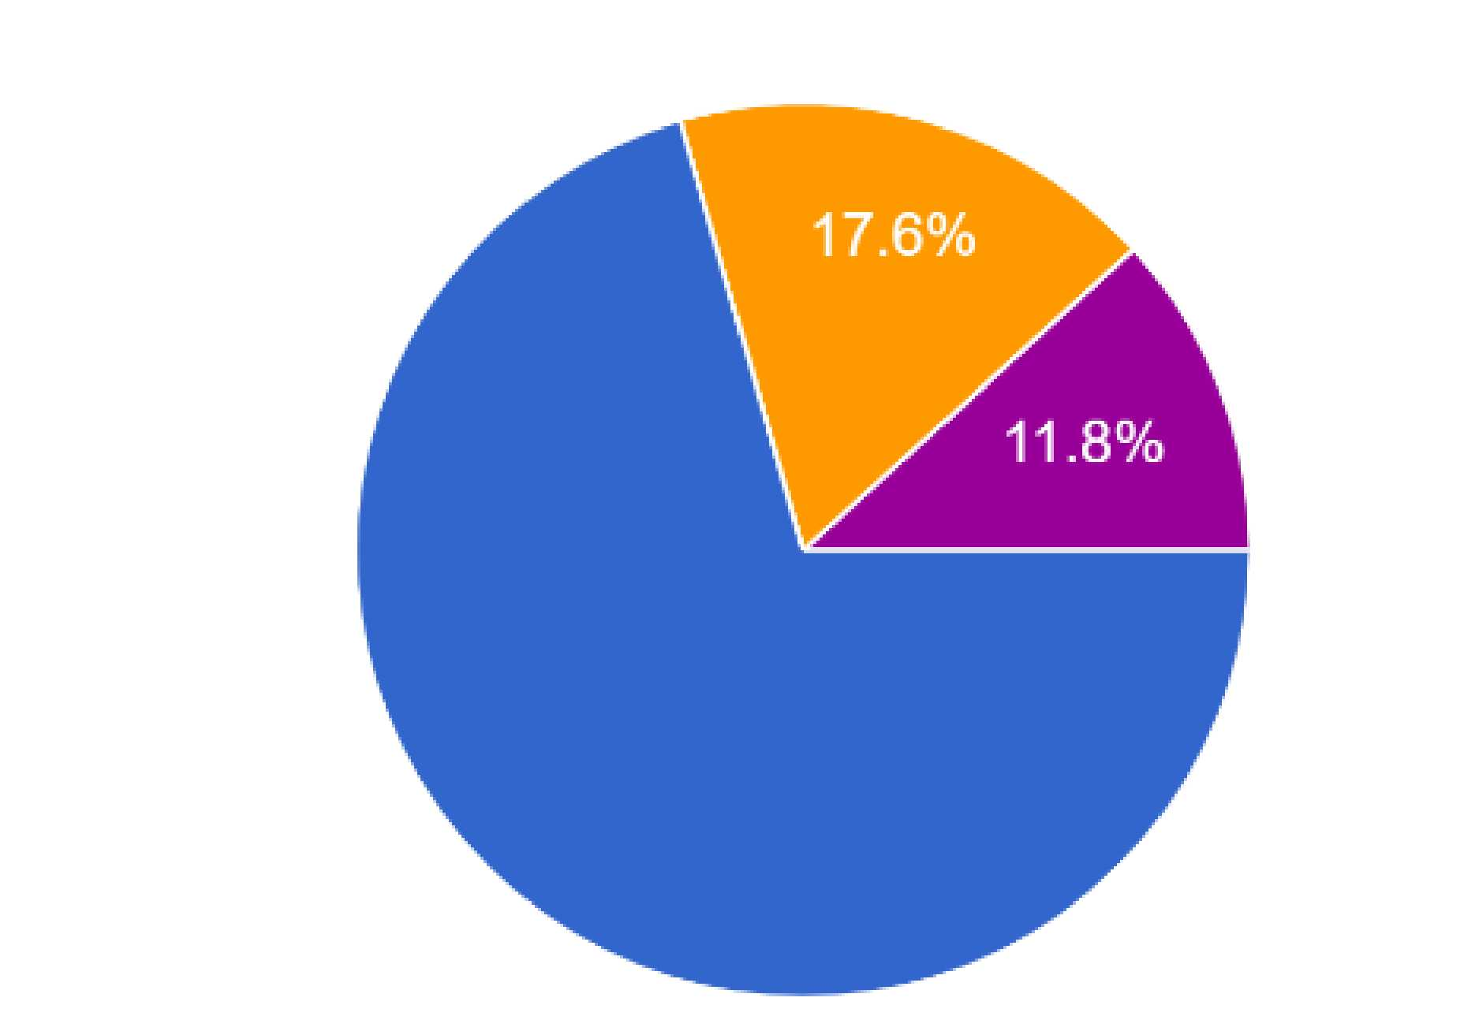
70.6% Chronic
0% Temporary
17.6%Treatable
0% Rehabilitated
11.8% Nonexistent/no longer applies
70.6%

14. Please list your specific disability(s) here if you wish, and for long you’ve been diagnosed. (Example: Anxiety - 3hrs, Broken Arm - 3 months) In this section, people listed a variety of diagnosis and date ranges spanned months to years or life long, to include; ADHD or ADD, Deaf or Hard of Hearing, CPTSD or PTSD, Bipolar Disorder, Depression, Anxiety, Sensory Processing Disorder, Epilepsy, Autism, Chronic Pain, Ehlers Danlos Syndrome, Gastroparesis, Dyslexia, Gestational Diabetes, liver disorder during pregnancy, auditory processing, Multiple Sclerosis, Degenerative disc disease, and Arthritis.


- If you feel comfortable, please elaborate on what your experience is like being a school staff member with a current or former disability at your school?” (If you cannot speak to this experience, please note any observations you have about your school’s attitude towards staff or students with disabilities? Afterwards, please skip to Section 4 of the survey.)

Some folks shared about their disability being impacted by working in settings where they deal with a lot of direct violence.
Others had challenges with reaching above their head, standing too long, sitting for too long, uncontrollable shaking, struggling to read, struggling to communicate, struggling with concentration and focus, struggles with memory impairment, struggles to maintain blood sugar levels, and frequent absenteeism due to medical appointments.
Several reported that their experiences with having a disability in the past or present caused them to feel incompetent, ashamed, or embarrassed for not being able to do their job at the expected level, and felt like they needed to keep it hidden because of fear that others will not understand, or that they would experience more discrimination.
A few who mentioned that they did disclose their disability status shared that some people were understanding and “never would have known” or were accused of “using it as an excuse.” One person mentioned that it helped a disabled student feel like they were not alone.
Those who shared about observations of treatment towards disabled students noted higher rates of exclusion, bullying, othering, often treated as an after thought, and overheard negative comments from teachers or staff who were unwilling to provide appropriate accommodations, and were not held accountable. Alternatively, the needs of the disabled student(s) were assumed and inappropriate.
- 16 . How much does (or did) your disability impact your ability to do your job? (0- not at all, 11.1%. 1 - mildly, once per month, 27.8%. 2 - moderately, weekly, 50%. 3 - severely, daily, 11.1%)
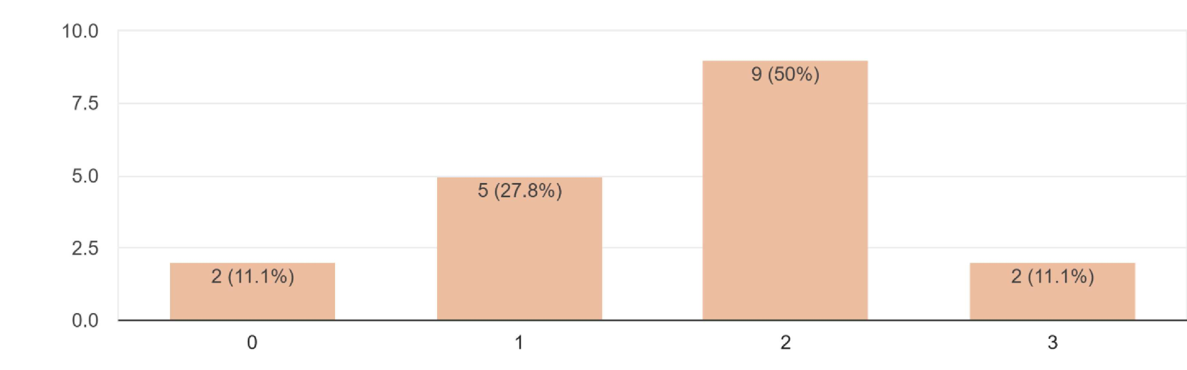

- 17. What aspects of your job are most impacted by your disability(s)? Some of the themes in responses include impact to general or precise movement, ability to lift, sitting or standing, general physical safety, sleep hygiene, mood swings, energy levels, blood sugar levels, communication or not having interpreters, immune system misfiring, remembering to complete tasks, concentration, and organization.

- 18. How much does (or did) your disability impact your mental health and well-being? (0- not at all, 11.1%. 1 - mildly, once per month, 38.9%. 2 - moderately, weekly, 38.9%. 3 - severely, daily, 11.1%)
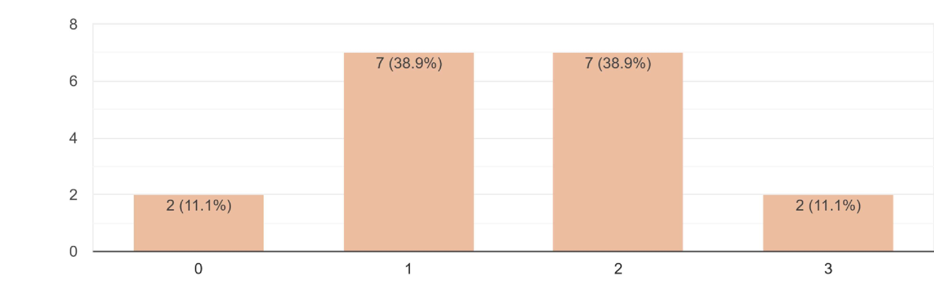
- 19. How comfortable do you feel reaching out to your school’s leadership for support to receive accommodations or resources for mental health/wellness support? (0- not comfortable at all, 52.6%. 1- mildly, 21.1%. 2- moderately, 15.8%. 3- very comfortable, 10.5%.)
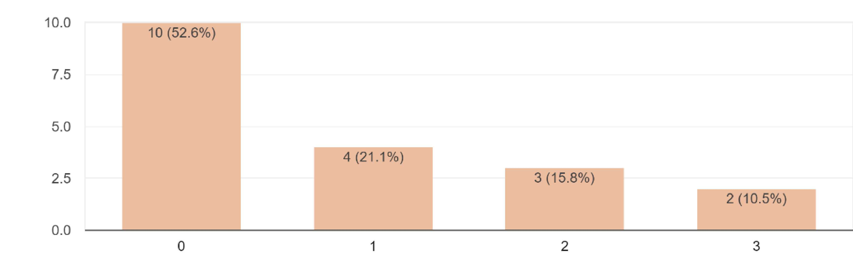
- If you rated a 0 or 1 on the previous question, what are some of the reasons that impact your comfort level with reaching out for mental health/wellness support? You may select more than one, or add your own… I only included the top 3 reasons listed, there were several “other” answers.

- 53.3% said they don’t feel seen or understood.
- 33.3% said their school/place of work doesn’t offer appropriate services or accommodations to meet their needs.
- 13.3% said they don’t have a good relationship with the school’s leadership.

- What current resources are available at your school to support staff or students with the disability(s) you currently/formerly have? (Only the top 5 are listed, there were several “other” answers.)
60% Paid Sick or Medical Leave
35% ADA friendly environment
35% Specialized counseling or training
25% Social Awareness through support groups
20% Specific referrals

- What resources are missing and/or impact your school’s ability to provide better support and awareness when it comes to being inclusive of people with disabilities? (multiple answers could be chosen: (40% said Stigma, 55% said lack of voice or representation, 45% finances/resources, 20% cultural differences, 5 % laws/policies, 35% exposure, 15% political climate, 30% environmental design, 20% social media, 10% specialized counseling, 5% specific referrals, 10% trained practitioners, 30% social awareness, support clubs/committees, 5% listed other answers.)

23. Do you feel judged, discriminated against, or treated differently at your school due to your
disability status? 26.3% said yes, 21.1% said sometimes in the past, 52.6% said no.
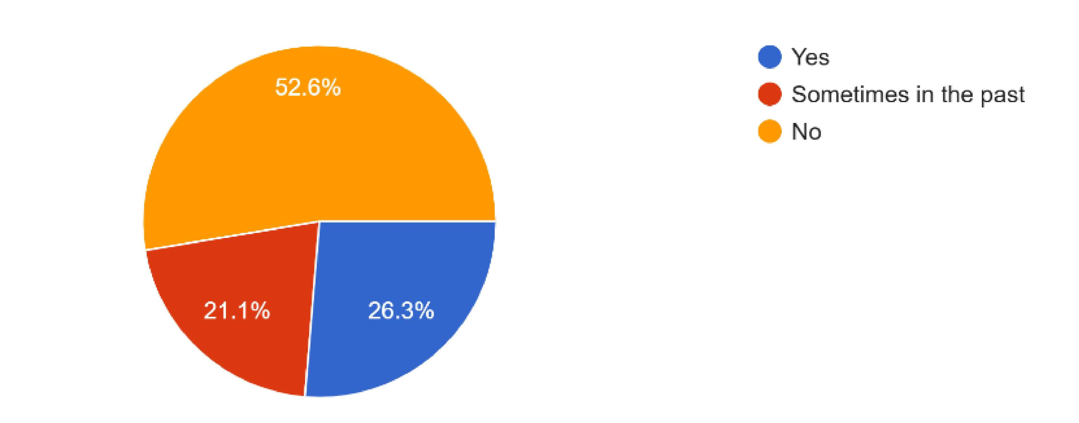
24. “What ideas do you have that could make your school climate more inclusive to staff/students with disabilities?”
Some of the themes of the ideas shared were having more exposure through guest speakers, team meetings, modifications and adaptions incorporation into building design, community understanding and at- home teaching (parents to children) to instill foundational values, peer mentor programs, more trainings and workshops, ASL classes, structured social interactions or lunch groups, more classes that combine gen-ed with SPED, changing language and expectations for students.
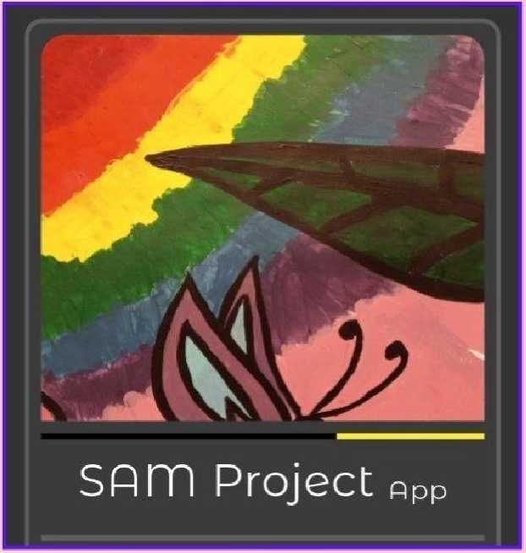
School Alliance for Mental Health Project:
Making Mental Health & Wellness Inclusive for All
A Capstone Project by Katherine Dolphin, MSW Candidate
UW Tacoma, kcoxl987@uw.edu

Needs statement:
School staff with disabilities need more centralized,
accessible, inclusive mental health support that increases awareness, visibility, and proactively reduces stigma, to promote a more welcoming school culture and wider range
of role models for students.

Background:
- The vast majority of people with disabilities don’t have access to appropriate, adaptive mental health or wellness resources in schools today, despite comprising 29% (about 1 in 4) of the population.
- 32.9% of adults with disabilities experienced 14 or more mentally unhealthy days within a 30-day period in 2018.
- Only 56% of US schools claim to be able to effectively serve all students in need of mental health services; lack of access to adaptive mental health treatment to disabled learners-especially those with additional intersectionalities— experience higher rates of expulsion in schools.
- There is limited research on challenges that educators with disabilities face, which decreases visibility of role models for students, limiting exposure to employment possibilities postgraduation.
- People with disabilities (ages of 16-64) average around 37.4% of the employment population ratio compared to 74.9% of non-disabled people. Of 16-19-year-olds with disabilities, the unemployment rate is 23.9% compared to 12.3% of non-disabled peers, and of 20-24- year-olds with disabilities 13.3% compared to 7.1% of non-disabled.
- People with disabilities make significantly less money, are more likely to live in poverty, have reduced quality of life in comparison to nondisabled adults; in 2022 people with disabilities were estimated to make an average of $46k per year with 25.9% living in poverty compared to $55K per year of non-disabled people with 11.5% living in poverty.

Proposed intervention:
The SAM (School Alliance for Mental Health) Project is a one-
stop-shop platform for inclusive mental health and wellness
resources in WA State schools, created for people with
disabilities. Through the use of the accessibly designed App,
staff will be able to use the custom search tool that
incorporates an intersectional lens, and customizes mental
health/wellness resources that address the unique needs of
each person holistically. It will also include a section that will
feature evidence-based training programs, literature, inclusive
lesson plans, and tips for making school wellness rooms or
“calm corners” for a more accessible classroom.
- Validates how intersectionality and comorbidities impact one’s experience of access to mental health resources.
- Provides needed services to adults with disabilities in a demanding field; optimizing job performance, maintaining employment, financial stability, sense of pride, and connection to society.
- Uses trauma-informed, person first language that is user-friendly and accessible in a variety of languages and formats.
- Reduce the amount of time trying to locate appropriate resources.
- Reduces stigma by creating more visibility and voice for people with disabilities, normalizing mental health treatment for all.
- Aligns with the Framework for the 21st Century School Social Work
Practice to make schools healthier for staff, students, families and communities.

Outcome 1: Schools will have increased
accessibility of inclusive mental health supports
and resources. Indicator A: Staff will self-report in
monthly surveys about their mental health status,
if they have appropriate accommodations and
resources via the SAM Project, and overall job
satisfaction. Indicator Β: Schools will monitor and
report monthly on staff engagement in resources,
job performance, attendance rates, and
employment rates. If a staff member decides to
resign, they will be offered an exit interview.

Outcome 2: Schools will be more proactive about addressing stigma surrounding mental health and disabilities. Indicator A: Schools will provide ongoing monthly anti-stigma training and literacy to address topics such as the social model of disability, highlighting intersectionality, and integrated mental health education. Indicator Β: Schools will promote more inclusive visibility, ensuring 1-3 images of people with disabilities are featured in all school-based images and promotional materials. Indicator C: Schools will do bi-annual evaluation, reporting, and modifying of physical/digital accessibility.

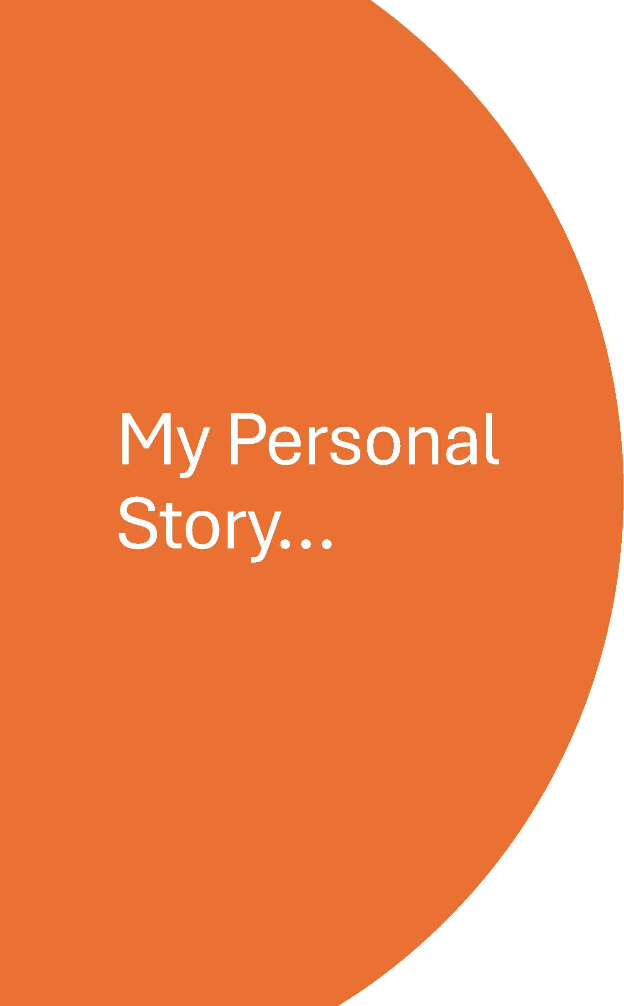

I have lived experience as a young student with a disability who grew up to be an adult with a disability, who didn’t have visible role models, and didn’t always receive appropriate accommodations, or people who understood. I was 12 years old when I was hospitalized and began my mental health treatment journey at a very young age; my presenting symptoms have received a variety of different diagnoses and medications over the years, and after 20+ years of treatment my condition is now considered chronic. I grew up in a time (1990s-early 2000s) before the awareness of the ACEs studies were more prevalent, before “trauma-informed” care or trainings were available, and was then navigating the education profession pre, during, and post-COVID; I feel I have an intimate understanding of how the pandemic has changed our level of awareness, and how the era of “pick yourself up by your bootstraps” mentality has impacted the prevalence of stigma, as well as how school staff respond to the mental health crisis our young people face today…how can we support children if we have not done our own work? As stated by Dr. Bruce Perry “A dysregulated adult cannot regulate a child.” I have been able to observe the social problem from many angles - as a former student, para, teacher, substitute, and now a social worker. I believe that unless we start providing better training, support, and neurodiversity visibility among our school staff who support students with disabilities, this population is projected to continue experiencing higher rates of exclusion, trauma, abuse, and bullying throughout their lifetime, which will have a larger impact on reduced opportunities for participation in educational activities, and in the workforce as they phase into adulthood. We must provide a wider range of role models for young students, with and without disabilities; it sends them powerful messages about who they can aspire to be as adults, what kinds of employment opportunities they can have, and levels of education they can achieve.
Additionally, as a MSW Candidate with an invisible disability who received accommodations to be able to complete this project; I believe I can attest the level of possibilities one has when given the support they need to achieve their goals. We all deserve to feel seen, heard, and know that our contributions matter.

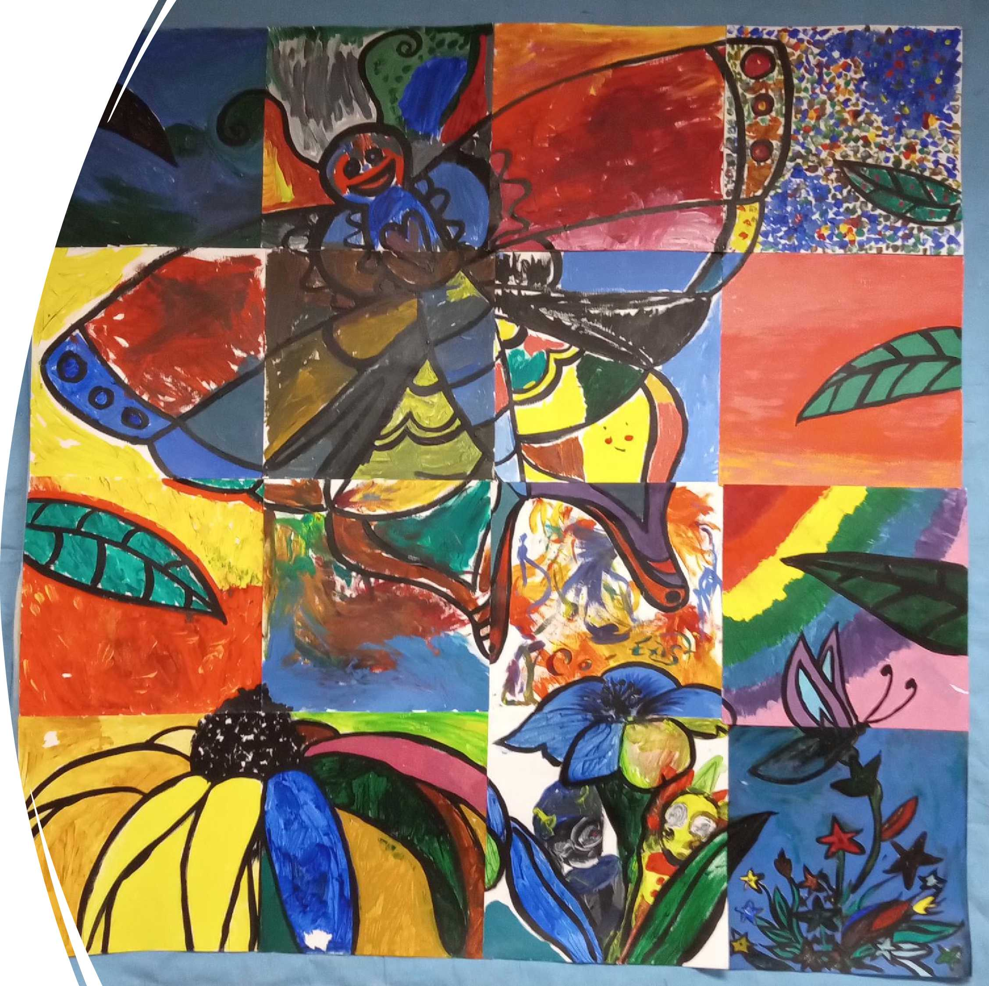
Dedication

The acronym “SAM” represents the name of a former beloved student who I cared deeply for, who sadly didn’t survive her mental health condition, passing away in November 2023. She was a great kid, who frequently spent time helping students with disabilities in our classroom. She also participated in our collaborative mural project (known as Butterfly 2, currently hanging at Nisqually Middle School in Lacey, WA) and painted the square that represents the logo for The SAM Project. I dedicate my capstone project to her memory and what she stood for; how essential it is to care for our mental health, and what the world could be if we were a little kinder and more accepting of each other.

References
Alderson, C. (2024, January 31). Mental health barriers and solutions for AAC users. •
Smarbox. https://thinksmartbox.com/news/mental-health-barriers-and-solutions-for-aac- • users
Autism Science Foundation (2025, February 10) Supporting and Sharing Autism •
Research to Improve the Real Lives of Real People.
https://autismsciencefoundation.org/participate_research/coaching-educators-to-use- positive-behavioral-supports-for-autistic-children/
Bitonte RA, De Santo M. Art Therapy: An Underutilized, yet Effective Tool. Ment Illn. 2014 Jul 3;6(1):5354. doi: 10.4081/mi.2014.5354. PMID: 25478139; PMCID: PMC4253394. •
Bureau of Labor Statistics (2017) Persons with a Disability: Labor Force Characteristics Summary. https://www.bls.gov/news.release/disabl.nr0.htm
CDC. (2024, December 10). Disability Impacts All of Us Infographic. Disability and Health;
CDC. https://www.cdc.gov/disability-and-health/articles-documents/disability-impacts-all- • of-us infographic.html
Childhood Trauma in Mental Disorders: A Comprehensive Approach, 367-383. Hoover, D. • W., Fleming, T. C., & Khan, M. (in review). Treating traumatized children with intellectual disabilities: Tailoring Trauma-Focused Cognitive Behavior Therapy for a vulnerable population. •
D’amico, P., Vogel, J. M., Mannarino, A. P., Hoffman, D. L., Briggs, E. C., Tunno, A. M., Smith, C. C., Hoover, D., & Schwartz, R. M. (2021). Tailoring Trauma-Focused Cognitive Behavioral Therapy (TF-CBT) for youth with intellectual and developmental disabilities: A survey of nationally certified TF- CBT therapists. Evidence-Based Practice in Child & • Adolescent Mental Health, 1-13. https://doi.org/10.1080/23794925.2021.1955639
Digest of Education Statistic (2012) National Center for Education Statistics, US Dept. of • Education. https://nces.ed.gov/programs/digest/d12/tables/dt12_098.asp
Digest of Education Statistics (2015) National Center for Educational Statistics. US Dept. of Education. https://nces.ed.gov/pubs2016/2016014.pdf •
Disability & Rehabilitation Volume: 39 Issue 13. ISSN: 0963-8288 Online ISSN: 1464
5165 Sokal, L., Woloshyn, D., Wilson, A., and (2017) Pre-service Teachers with
Disabilities: Challenges and Opportunities for Directors of Student Teaching. Vol 8. Issue • 3. Article 7
Disability in the Workplace 2024 Insights Report sponsored by the National Organization • for Disability (n.d.) https://nod.org/wp-content/uploads/NOD-Disability-in-the-Workplace- 2024-Insight-Reports_FINAL.pdf US Department of Education. (2024) Section 504. U.S. • Department of Education.
Gragoudas, S. (2012) Preparing Students with Disabilities to Transition from School to Work through Self Determination Training. Institute for Community Inclusion, University of • Massachusetts, 100 Morrissey Boulevard, Boston, MA. Work 407–411 DOI
10.3233/WOR-131782 IOS Press •
Graves G.Group art therapy for patients with traumatic brain injuries: a pilot study. Degree Diss.; Virginia Commonwealth University, Richmond, Virginia;2006.
Hoover D.W & Romero E.M.G (2019). The Interactive Trauma Scale: A web-based measure for children with autism. Journal of Autism and Developmental Disorders, 49, 1686-1692. Doi.org/10.1007/s10803- 018-03864-3. •
Hoover, D. W. (2020). Trauma in children with neurodevelopmental disorders: Autism, • intellectual disability, and attention-deficit/hyperactivity disorder.
Hoover, D. W., & Kaufman, J. (2018). Adverse childhood experiences in children with • autism spectrum disorder. Current opinion in psychiatry, 31(2), 128.
Houtenville, A., & Bach, S. (2024). Annual Report on People with Disabilities in America: • 2024. Durham, NH: University of New Hampshire, Institute on Disability.
How telemedicine has transformed one autism and I/DD provider network. (2025).
Healthcare IT News. https://www.healthcareitnews.com/news/how-telemedicine-has- • transformed-one-autism-and-idd provider-network?lid=0e3qj7iwva6z
https://askjan.org/media/educators.html
https://ies.ed.gov/schoolsurvey/spp/SPP_April_Infographic_Mental_Health_and_Well_Bei • ng.pdf •
https://iris.who.int/server/api/core/bitstreams/40e5a13a-fe50-4efa-b56d-
6e8cf00d5bfa/content Chisholm, D., Sweeny, K., Sheehan, P., Rasmussen, B., Smit, F., Cuijpers, P., & Saxena, S. (2016). Scaling-up of treatment of depression and anxiety –
Authors’ reply. The Lancet Psychiatry, 3(7), 603–604. https://doi.org/10.1016/s2215-0366 • (16)30131-6
https://reportcard.ospi.k12.wa.us/ReportCard/ViewSchoolOrDistrict/103300
https://sites.ed.gov/idea/about-idea
https://www.basicsnw.com/post/neurodiversity-affirming-training-series
https://www.dshs.wa.gov/sites/default/files/rda/reports/DCYFcovid.pdf •
https://www.ed.gov/laws-and-policy/individuals-disabilities/section-504 •
Kuo M. (2015). How might contact with nature promote human health? Promising
mechanisms and a possible central pathway. Frontiers in Psychology, 6, 1093. •
Lucenko, B. Child Welfare data displayed through August 2025. SOURCES: DSHS Integrated Client Databases (RDA), ProviderOne Operational Data (HCA), and FamLink • Data Warehouse (DCYF). (CPS) Screened-In Intakes Monitoring Child Protective
Services Intakes and Medical Visits during the COVID-19 Pandemic CHILD WELFARE • SERVICES -MONTHLY TREND. Retrieved October 20, 2025, from
Luft, P. (2015) Transition Services for DHH Adolescents and Young Adults: Challenges • and Theoretical Frameworks. American Annals of the Deaf, Vol. 160 Num. 4 Fall 2015, pp. 395-414 (article) Published by Gallaudet University Press. DOI
10.1353/aad.2015.0028 • Mental Health and Well-Being of Students and Staff during the Pandemic Results from the April 2022 School Pulse Panel. (n.d.).
MES Wellness Center: Supporting Students & Staff. (2025). Wednet.edu. •
https://osd.wednet.edu/news/district_news_archive__2024-
25_/m_e_s_wellness_center__supporting_students___staff
Morris, Lyndsay. 2024. “Generation Wellness Research.”
Https://Www.generationwellness.com/,
file:///C:/Users/Cyndi%20Lou/Documents/KT/a8e0ce0-4aa-effb-6add- c00d52ccad7_GW_Research_Doc_2024_1_.pdf. Accessed 22 Nov. 2025.
Morrow R.The use of art therapy in a patient with chronic schizophrenia. Jefferson Journal of Psychiatry. 1985.
National Alliance on Mental Illness. (2023, April). Mental health by the numbers. National Alliance on Mental Illness; National Alliance on Mental Illness.
https://www.nami.org/about-mental-illness/mental-health-by the-numbers/
One Out of Five: Disability History and Pride Project, WA State Governor’s Office of Education Ombuds. (n.d.)www.oeo.wa.govhttps://www.oeo.wa.gov/en/education- issues/one-out-five-disability-history-and pride-project
Paedu.org. (2025). Pinnacle Private Elementary STEM School. Paedu.org.
https://paedu.org/blog/breaking-barriers-inclusive-education-for-a-better-tomorrow
Pifalo T.Art therapy with sexually abused children and adolescents: extended research study. Art Therapy 2006;23:181-5.
Plotner, Anthony. (2017) Centers for independent living and secondary transition collaboration: characteristics for enhanced service delivery for adolescents in the United States
Praslova, L. (2023). Disability inclusion in the workplace: Special issue introduction. Consulting Psychology Journal, 75(3), 197–201. https://doi.org/10.1037/cpb0000264 Removing Barriers for Students with Learning Disabilities Neurodivergent students, from Kindergarten through college, continue to face barriers due to the lack of proper funding, accommodations, and resources to support their academic success. Young adults from the National Center for Learning. (n.d.). https://ncld.org/wp- content/uploads/2024/06/Download-this-Report.pdf
Report Card - Washington State Report Card. (2024). K12.Wa.us.
Rivera RA.Art therapy for individuals with severe mental illness. Masters Diss.; University of Southern California, Los Angeles, USA; 2008.
Survey Results. (n.d.). Disabled Teachers Network DTN.
https://disabledteachersnetwork.weebly.com/survey results.html
Tailoring Trauma-Focused Cognitive Behavioral Therapy for Youth with Developmental Disabilities (TF-CBT IDD) and their Caregivers. (n.d.). https://tfcbt.org/wp- content/uploads/2023/10/TF-CBT-IDD-Implementation-Guide.pdf
Tan, K. & SSWAA. (2024) National School Social Work Practice Model 2.0: A Framework for 21st Century School Social Work Practice. School Social Work Association of America.
Retrieved from https://sswaa.org/ssw-model
Tcordray. (2025, May). Neurodiversity-Affirming Training Series. BASICS NW.
Thomas, T., Aggar, C., Baker, J., Massey, D., Thomas, M., D’Appio, D., & Brymer, E. (2022). Social prescribing of nature therapy for adults with mental illness living in the community: A scoping review of peer-reviewed international evidence. Frontiers in Psychology, 13. https://doi.org/10.3389/fpsyg.2022.1041675
Thomson LJ, Morse N, Elsden E, Chatterjee HJ. Art, nature and mental health: assessing the biopsychosocial effects of a 'creative green prescription' museum programme involving horticulture, artmaking and collections. Perspect Public Health. 2020 Sep;140(5):277-285. doi: 10.1177/1757913920910443. Epub 2020 May 24. PMID: 32449492; PMCID: PMC7498904.
U.S. Department of Education (2024) About IDEA. IDEA; U.S. Department of Education.
U.S. Department of Labor. (2024). Disability Employment Statistics | U.S. Department of Labor. https://www.dol.gov/agencies/odep/research-evaluation/statistics
Ulrich R. S. (1984). View through a window may influence recovery from surgery. Science, 224, 420–421.
Villegas, A.M., Irvine, J.J. 2010. Diversifying the Teaching Force. Urban Review 42:175– 192 DOI 10.1007/s11256- 010-0150-1
WA, T. (2025). Grant-Funded TOT WA Flyer 2025.pdf. Google Docs.
https://drive.google.com/file/d/1FdQVjeE_7X7bB_fMlQkm4KfMhvLUInh4/view
Wetzel, M., Goddard, T.M., Mathess, L. - 2016. Occupation and Industry Series: Accommodating Educators with Disabilities. Job Accommodation Network. Retrieved 1/29/2018 from
Wolf, K. L. 2003. Youth and Mental Health: Work Projects in Urban Green Space. In C.
Kollin (ed.), Engineering Green: Proceedings of the 11th National Urban Forest Conference. Washington D.C.: American Forests.
Wolf, K.L., and EarthCorps. 2007. Trees and Youth in the City: Research on Urban Forest
Stewardship & Positive Youth Development. In: Sustaining America’s Forests: Proceedings of the Society of American Foresters 2007 National Convention. Bethesda MD: Society of American Foresters (Portland, OR)

Ill Thank you! ©
