Travel Behavior Modeling and Emerging Mobility Technologies

Annual Report from the University of Washington
To Argonne National Laboratory

By

Yuanjie (Tukey) Tu
Parastoo Jabbari
Moein Khaloei
Don MacKenzie (Principal Investigator)

Department of Civil & Environmental Engineering
University of Washington

September 9, 2021

Table of Contents
Overview 4
1. Autonomous vehicle ownership and mode choices 4
Data 4
Modeling AV ownership 5
Methods 5
Results 9
ELASTICITY ANALYSIS 11
Reference [AV OWNERSHIP MODELING] 15
Tour-based mode choice modeling 16
Approach one 18
Approach two 18
REFERENCE [TOUR BASED MODE CHOICE MODELING] 20
2. Solo/pooled ridehailing behavior 20
Study overview 20
Background 20
Survey implementation 23
COVID-19 psychometric questions 26
Quality check questions 26
Survey administration 27
Comparison between MTurk and Facebook 27
Modeling 28
Factor analysis 28
Preliminary model specifications and results 32
Integrated choice and latent variable model specification and results 32
Sensitivity Analysis 37
Conclusions 40
REFERENCE [SOLO/POOLED MODELING] 40
3. Data collection on ridehailing driver behaviors 43
Study overview 43
Research design 43
Literature search 43
Working time choice and relocation choice 44
Response to request 45
Survey technical design 46
Survey structure 46
Experimental design 47
Working time and relocation choice 47
Response to a request 48
Survey Implementation 49
Survey administration 49
Challenges and solutions 49
Low response rate 49
Administering the survey via multiple channels 50
Gaining trust 51
Increasing the incentives 51
Uncertain data quality 51
Verify the ridehailing drivers 52
Comprehension checks 52
Attention check 52
Logic checks 52
Representativeness 53
Data collection approach comparison 53
REFERENCE [DRIVER DATA COLLECTION] 54
4. COVID data collection 55
Study overview 55
COVID – transit work 55
Summary 55
Clustering transit rider groups 55
Who are they? 57
What is their attitude towards taking transit? 58
Where would they go after the pandemic? 59
Switching to other modes. 59
The use of information communication technology (ICT). 61
REFERENCE [COVID AND TRANSIT] 62
5. Personality traits and transportation attitudes. 63
APPENDIX 64
Questionnaire: Ridehailing driver behavior survey 64
Ride-hailing driver behavior interview protocol 68
Tutorial: hosting an online survey using AWS 70
COVID travel behavior survey wave 1~3 72
Personality traits and attitudes questionnaire 72

Overview
This report presents work completed at the University of Washington in 2020-21 under contracts with Argonne National Laboratory. Specifically, it includes work completed in the fourth year of the UW’s efforts on the US-China Clean Energy Research Center - Clean Vehicles Consortium (CERC-CVC), and work under the Systems and Modeling for Accelerated Research in Transportation (SMART) consortium. The work completed includes survey design, data collection, and modeling. Specifically, we report on:
- Modeling and analysis of autonomous vehicle mode choices and car ownership decisions that leverage data collected in prior years with CERC-CVC support.
- Collection of data on travelers’ preferences for solo and pooled ridehailing services, taking advantage of a survey that was designed with prior CERC-CVC support but delayed by the onset of the COVID-19 pandemic. We also report on modeling efforts employing these data.
- Design and administration of a stated choice survey of ridehailing drivers, aimed at collecting data to support modeling of drivers’ working time, location, and trip request acceptance decisions. We also include a summary of some practical lessons learned about surveying this hard-to-reach group.
- Analysis of changes in transit usage before and during the COVID-19 pandemic, exploring differences between those who plan to return to transit and those who do not.
- The design of a survey intended to link personality traits with preferences for autonomous vehicles and for sharing rides in ridehailing services.

Autonomous vehicle ownership and mode choices
We conducted behavioral modeling work in two areas related to autonomous vehicles (AVs) and travel. Both modeling exercises take advantage of data collected under Year 2 of our work with the US-China Clean Energy Research Center, Clean Vehicles Consortium (CERC-CVC). We first mode AV ownership choices, considering both trip-level and individual-level characteristics.
Additionally, we model mode choice decisions in the context of tour structure.

Data
We rely on survey data collected in year 2 of our work under CERC-CVC. This survey investigated respondents’ stated preferences for vehicle ownership when AVs become available in the US. It included four sections: trip diary, choice experiments, psychometric measures, and socio-demographics. Full details on the data collection can be found in Jabbari, Ranjbari & MacKenzie (2020), and are summarized briefly here.
Trip diary: Respondents were asked to provide information including the origin, destination, and trip purpose of each trip they made on their most recent working day.
Choice experiments: A total of 4 choice scenarios were presented to the respondents in which they were asked to make travel-related choices including (1) buying or selling a conventional car or AV, and (2) mode choices for each trip in the tour they had reported in their travel diary, given the vehicle ownership decisions made in (1). If a respondent has elected not to own a conventional car or AV, they cannot choose the corresponding mode(s) in the associated mode choice exercise.
Psychometric measures: We also measured respondents’ attitudes towards private cars, AVs, and ridehailing. The psychometric measures include AV safety perceptions, car pride, ride-sharing perceptions, car dependency, attitude on sharing rides, cyber security of AVs, and environmental concerns.
Socio-demographics: Information including age, gender, individual income, education level, job status were collected.

Modeling AV ownership
We incorporated trip-level characteristics in autonomous vehicle ownership modeling using an integrated choice and latent variable model and investigated elasticities of vehicle ownership market shares. The results are: (1) At the trip level, parking cost, travel cost, and travel time are important predictors of vehicle ownership; (2) At the individual level, monthly payment, car dependency, and AV safety perceptions are significant predictors; (3) The elasticities of vehicle ownership market shares are all less than 1, suggesting that vehicle ownership decisions are relatively inelastic to the change of either individual- or trip-level characteristics; (4) While individual-level characteristics have the most prominent effect on vehicle ownership decisions, trip-level characteristics have a small but measurable effect; (5) Among trip-level characteristics, parking cost has the largest impact on vehicle ownership decisions, followed by travel cost of ridehailing (both conventional and autonomous), and transit travel time. Transit travel cost has almost no effect on vehicle ownership decisions.

Methods
We adopted an integrated choice and latent variable (ICLV) modeling framework (Ben-Akiva et al., 1997; Vij and Walker, 2016). The model consists of a discrete choice model and a latent variable model (Figure 1.1), which allows for attitudinal factors to predict the utility of vehicle ownership choices. In the discrete choice model, we split the utility of vehicle ownership into two parts (1) non-travel related utility at the vehicle ownership level and (2) travel-related utility at the trip level (Le Vine and Lee-Gosselin, 2013). This allows us to investigate the net utility resulting from the (dis)utility of owning, paying for, and maintaining vehicles, and the utility of the travel options enabled by the chosen vehicle ownership level (Figure 1.2). The discrete choice model is estimated by a sequential procedure, since the use of a simultaneous estimation for such a multidimensional choice context is “technically more complex and subject to numerical analysis problems” (Koppelman and Pas, 1986). That is to say, the mode choice model is estimated first, and then the vehicle ownership model is estimated conditional on the coefficient values estimated in the mode choice model. The full model is specified in Eq. (1.1) ~ Eq. (1.7). Variable descriptions and summary statistics are shown in Table 1. The model estimation and prediction are conducted in Biogeme (Bierlaire, 2020).
The dependent variable is ownership of both conventional cars and AVs, including four levels: (1) zero conventional cars, zero AVs; (2) one or more conventional car(s), zero AVs; (3) zero conventional cars, one AV; (4) one or more conventional car(s), one AV. (The survey did not support scenarios in which respondents could own more than one AV.)
​​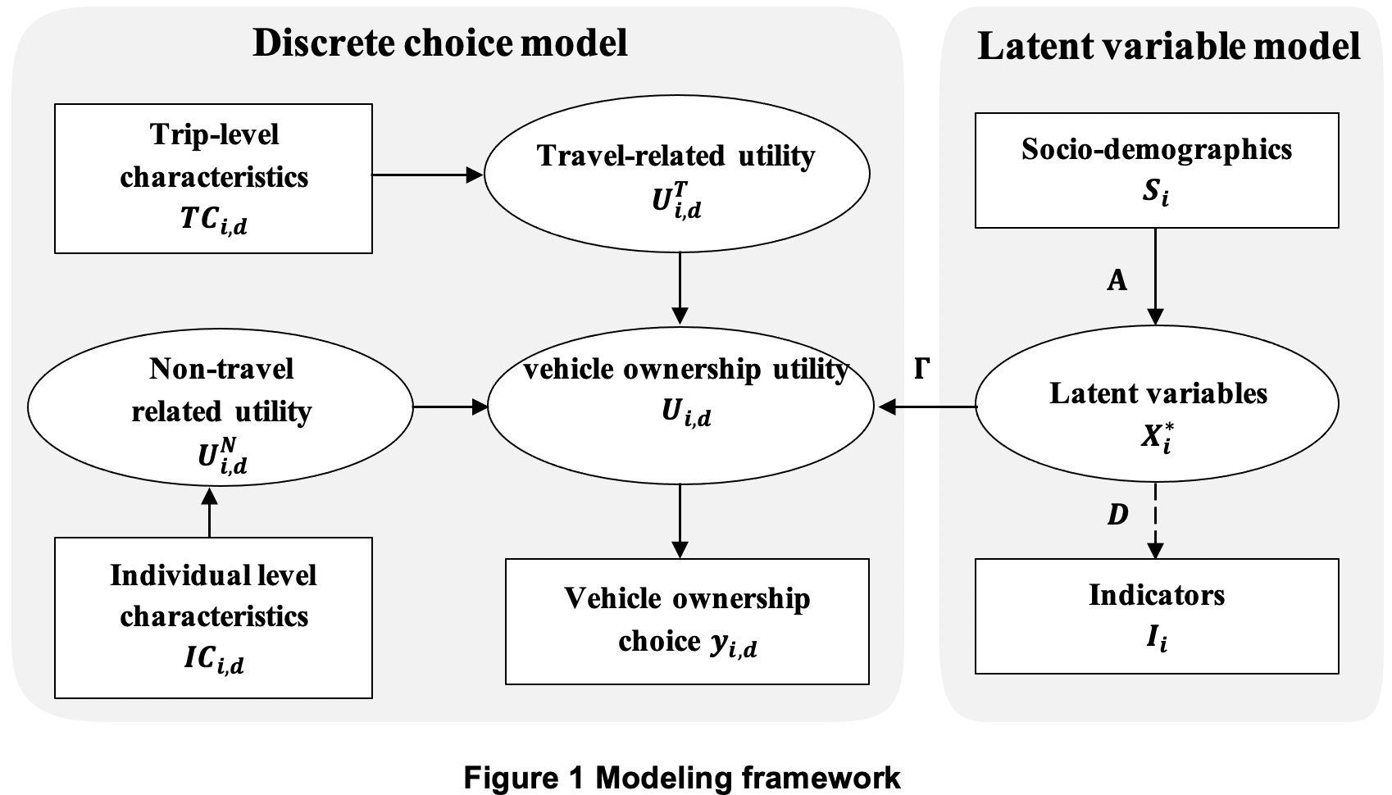
Figure 1.1 Modeling structure

The utility of individual i choosing vehicle ownership bundle d is
$U_{i,d}=V_{i,d}^{N}+V_{i,d}^{T}+ΓX_{i}^{*}+ε_{i,d}$ Eq. (1.1)
Where $V_{i,d}^{N}$ is the systematic non-travel related utility, which means (dis)utility of acquiring and maintaining the selected vehicle ownership bundle; $V_{i,d}^{T}$ is the systematic travel-related utility, meaning (dis)utility of using the travel modes enabled by the selected vehicle ownership bundle. $X_{i}^{*}$ is a vector of individual-level latent explanatory variables affecting vehicle ownership choices, including car dependency and AV safety perceptions. $Γ$ is a matrix of coefficients describing sensitivities to the latent variables.$ε_{i,d}$ is the random component of the utility of a car ownership bundle.
The non-travel related utility, $V_{i,d}^{N}$ is specified as
$V_{i,d}^{N}=β_{d}\sum_{c=0,∀c∈Z_{d}}^{Z_{d}}{V_{i,c}^{N}}$ Eq. (1.2)
Where $\sum_{c=0,∀c∈Z_{d}}^{Z_{d}}{V_{i,c}^{N}}$ is the cost of acquiring vehicle ownership bundle d (e.g., monthly car payment) (Table 1.1). c means the index for vehicles and Z_{d} represents the set of vehicles included in vehicle ownership bundle d.$β_{d}$ is the coefficient of $\sum_{c=0,∀c∈Z_{d}}^{Z_{d}}{V_{i,c}^{N}}$.
We use a mixed logit model at the mode choice level since it can deal with unobserved correlations between alternatives in a flexible way (Train, 2002). $U_{ijd}^{T}$, the utility of individual i choosing mode j conditional on the vehicle ownership bundle d can be expressed as
$U_{ijd}^{T}=V_{ijd}^{T}+μ_{jd}ϕ_{ijd}+ε_{ijd}^{T}$ Eq. (1.3)
Where $V_{ijd}^{T}$ is the systematic utility of individual i choosing mode j conditional on the vehicle ownership bundle d, and is determined by parking cost, travel cost, travel time and waiting time. The specific variable descriptions are shown in Table 1.1. $ϕ_{ijd}$ are the random effects used to account for unobserved correlations, including a vector of independent, standard normal distributed random variables (private vehicles, ridehailing, and autonomous vehicles). $μ_{jd}$ are the standard deviations of the error components. $ε_{ijd}^{T}$ is the random error term.
Thus, the travel-related utility, $V_{i,d}^{T}$, is the expected (dis)utility of all modes in the trip, can be written as
$V_{i,d}^{T}=λ^{d}ln\sum_{n∈m(i,d)}^{N}{e^{{(V}_{ijd}^{T}+μ'ϕ_{ijd})*\frac{1}{λ^{d}}}}$ Eq. (1.4)
Where $m(i,d)$ is a set of feasible choices for the given trip including conventional car, AV, walk, bike, driverless ride hailing, conventional ridehailing, and transit. $λ^{d}$ is the scale parameter for vehicle ownership d and it captures the unobserved similarities between alternatives. It ranges from 0 to 1; closer to 0 means higher unobserved correlations between the alternatives and closer to 1 means less correlations in the unobserved component of utility.
$X_{i}^{*}$, the latent variables can be written as
$X_{i}^{*}=AS_{i}+υ_{i}$ Eq. (1.5)
$X_{i}^{*}$ includes AV safety perceptions and car dependency, which have previously been found to be significant predictors of AV mode choice (Jabbari et al., 2020). $S_{i}$ is a vector of socio-demographics including age, gender, income, education levels, whether the individual holds a driver’s license, and whether they hold a transit pass (Table 1.1). $A$ refers to a matrix of coefficients describing the structural relationship between latent variables and socio-demographics.
Finally, $I_{i}$, a vector of indicators that are used to measure the latent variables, can be specified as
$I_{i}=DX_{i}^{*}+η_{i}$ Eq. (1.6)
$D$ is a matrix of coefficients denoting the sensitivities of measurement indicators to the latent variables. $η_{i}$ is an independently and identically distributed error term.
$y_{i,d}=\left\{\begin{aligned}1 if U_{i,d}≥ U_{i,d^{'}} for d^{'}∈\{1,2,…,4\} \\ 0 otherwise\end{aligned}\right.$ Eq. (1.7)
$y_{i,d}$ is the choice indicator, and it equals to 1 if individual i chooses alternative d, 0 otherwise.

0 conv. cars,
0 AVs
1+ conv. cars,
0 AVs
0 conv. cars,
1 AV
1+ conv. cars,
1 AV
Vehicle ownership choice
- Walking
- Biking
- Transit
- Conv. ridehailing
- Auto. ridehailing
- Walking
- Biking
- Transit
- Conv. ridehailing
- Auto. ridehailing
- Conv. car
- Walking
- Biking
- Transit
- Conv. ridehailing
- Auto. ridehailing
- AV
- Walking
- Biking
- Transit
- Conv. ridehailing
- Auto. ridehailing
- Conv. car
- AV
Mode choice

Figure 1.2 Choice structure

Table 1.1 Variable description
Variable | Description | Mean | Std.
Trip level
Travel time (conv. car) | Conventional car travel time of a trip, in minutes | 16.332 | 14.700
Travel time (AV) | AV travel time of a trip, in minutes | 16.161 | 14.809
Travel time (transit) | Transit travel time of a trip, in minutes | 48.357 | 98.990
Travel time (walking) | Walking travel time of a trip, in minutes | 147.186 | 180.052
Travel time (biking) | Biking travel time of a trip, in minutes | 61.477 | 79.277
Travel time (conv. ridehailing) | Conv. ridehailing travel time of a trip, in minutes | 16.409 | 15.212
Travel time (autonomous ridehailing) | Auto. ridehailing travel time of a trip, in minutes | 16.452 | 14.824
Waiting time (transit) | Transit waiting time of a trip, in minutes | 9.952 | 3.282
Waiting time (conv. ridehailing) | Conv. ridehailing waiting time of a trip, in minutes | 5.421 | 5.036
Waiting time (autonomous ridehailing) | Auto. ridehailing waiting time of a trip, in minutes | 5.342 | 4.900
Travel cost ratio (transit) | The ratio of transit travel cost to daily income | 0.012 | 0.016
Travel cost ratio (conv. ridehailing) | The ratio of conv. ridehailing travel cost to daily income | 0.130 | 0.204
Travel cost ratio (autonomous. ridehailing) | The ratio of auto. ridehailing travel cost to daily income | 0.126 | 0.217
Parking cost ratio (conv. car) | The ratio of conv. car parking cost to daily income | 0.012 | 0.015
Parking cost ratio (AV) | The ratio of AV parking cost to daily income | 0.011 | 0.014
Individual level
Monthly payment ratio (owning 1+ conv. cars and 0 AVs) | The ratio of monthly payment to monthly income for those who own 1+ conv. cars and 0 AVs | 0.127 | 0.147
Monthly payment ratio (owning 0 conv. cars and 1 AVs) | The ratio of monthly payment to monthly income for those who own 0 conv. cars and 1 AVs | 0.134 | 0.129
Monthly payment ratio (owning 1+ conv. cars and 1 AVs) | The ratio of monthly payment to monthly income for those who own 1+ conv. cars and 1 AVs | 0.204 | 0.224
Car dependency | Latent variable describing the dependence on private vehicles | - | -
AV safety perceptions | Latent variable describing the perception of autonomous vehicle safety | - | -
Younger adults | If respondent is younger than 40 years old, 1; otherwise, 0 | 0.684 | -
Older adults | If respondent is equal to or older than 65 years old, 1; otherwise, 0 | 0.023 | -
Male | If respondent is male, 1; otherwise, 0 | 0.529 | -
Higher education | If respondent has an education higher than high school, 1; otherwise, 0 | 0.883 | -
Higher income | If respondent has an income equal to or higher than $70k, 1; otherwise, 0 | 0.485 | -
Driver’s license | If respondent has a driver’s license, 1; otherwise, 0 | 0.989 | -
Transit pass | If respondent has a transit pass, 1; otherwise, 0 | 0.205 | -

Results
The mode choice model (Table 1.2) shows that longer travel time and higher parking cost are negatively associated with using conventional cars and AVs. One interesting finding is that travel time is more negatively associated with the utility of AVs than conventional cars. Longer travel time and higher travel cost are negatively correlated with ridehailing use (both conventional and autonomous) and transit. However, the effect of waiting time is statistically insignificant for both ridehailing (conventional and autonomous) and transit. Longer travel time is likely to reduce the utility of walking and biking as well. Three error components including private vehicles, autonomous vehicles and ridehailing were included in the model to account for the unobserved correlations between similar modes. 500 random draws were taken from a normal distribution to simulate the random effects. The error component “private vehicle” is the only significant one, meaning that there are significant unobserved correlations in the utility of private conventional cars and private AVs.
The vehicle ownership model results (Table 1.2) show that respondents with lower car dependency are more likely to own 0 conventional cars and 0 AVs, while higher safety perceptions are positively correlated with owning AVs (0 conventional cars and 1 AV, and 1+ conventional car(s) and 1 AV). Monthly payment ratio is negatively associated with owning any type of vehicles (1+ conventional car(s) and 0 AVs, 0 conventional cars and 1 AV, and owning 1+ conventional car(s) and 1 AV).
Table 1.2 Discrete choice model results
Model | Coefficients | p-value
Mode choice level
Conventional car
Travel time | -0.030 | 0.056*
Parking cost ratio | -20.971 | 0.053*
Error component: private vehicle | 4.216 | 1.159e-06***
AV
ASC | 3.203 | 1.287e-10***
Travel time | -0.034 | 0.067*
Parking cost ratio | -20.971 | 0.053*
Error component: private vehicle | 4.216 | 1.159e-06***
Error component: autonomous vehicle | 0.028 | 0.928
Conventional ridehailing
ASC | -3.970 | 7.409e-06***
Travel time | -0.045 | 1.379e-04***
Waiting time | -0.016 | 0.554
Travel cost ratio | -5.181 | 1.662e-03***
Error component: ridehailing | 1.814 | 0.122
Autonomous ridehailing
ASC | -3.877 | 8.185e-06***
Travel time | -0.053 | 2.349e-05***
Waiting time | 0.006 | 0.813
Travel cost ratio | -5.181 | 1.662e-03***
Error component: autonomous vehicle | 0.028 | 0.928
Error component: ridehailing | 1.814 | 0.122
Transit
ASC | -5.284 | 9.230e-10***
Travel time | -0.012 | 0.015**
Waiting time | 0.072 | 0.099*
Travel cost ratio | -5.181 | 1.662e-03***
Walking
ASC | -3.178 | 2.634e-06***
Travel time | -0.055 | 2.861e-11***
Biking
ASC | -2.498 | 5.517e-05***
Travel time | -0.065 | 0.000***
Car ownership level
0 conventional cars, 0 AVs
Car dependency | -1.186 | 2.492e-10***
$λ_{0,0}$ | 0.819 | -
1+ conventional car(s), 0 AVs
ASC | -1.180 | 0.025**
Monthly payment ratio | -5.973 | 0.000***
$λ_{1,0}$ | 0.751 | -
0 conventional cars, 1 AV
ASC | -5.356 | 0.000***
AV safety perception | 0.472 | 2.192e-10***
Monthly payment ratio | -5.973 | 0.000***
$λ_{0,1}$ | 0.407 | -
1+ conventional car(s), 1 AV
ASC | -5.485 | 0.000***
AV safety perception | 0.957 | -
Monthly payment ratio | -5.973 | 0.000***
$λ_{1,1}$ | 0.865 | -
Model performance
Initial log likelihood (mode choice) | -3322
Final log likelihood (mode choice) | -1660
AIC (mode choice) | 3363
BIC (mode choice) | 3480
Initial log likelihood (vehicle ownership) | -40657
Final log likelihood (vehicle ownership) | -26666
AIC (vehicle ownership) | 53412
BIC (vehicle ownership) | 53635

The latent variable model (Table 1.3) illustrates the relationship between socio-demographics and the chosen latent variables (car dependency and AV safety perception). Our model results suggest that males, younger adults, and those who have a transit pass are less car dependent. People of higher education and those who have a driver’s license are more car dependent. As for AV safety perceptions, males and younger adults are more likely to perceive AVs as safe, while those who have a driver’s license have lower AV safety perceptions.
Table 1.3 Latent variable model results
Variables | Coefficients | p-value | Coefficients | p-value
 | Car dependency |  | AV safety perception
Male | -0.170 | 7.103e-08*** | 0.806 | 0.000***
Younger adults | -0.158 | 9.455e-05*** | 0.748 | 7.704e-14***
Older adults | 0.089 | 0.444 | 0.163 | 0.506
Higher income | 0.008 | 0.813 | -0.075 | 0.374
Higher education | 0.123 | 0.029** | -0.227 | 0.078*
Driver’s license | 0.989 | 2.785e-08*** | -0.791 | 0.024**
Transit pass | -0.239 | 1.040e-07*** | 0.163 | 0.119
Intercept | 0.330 | 0.082* | 0.533 | 0.161
Standard deviation of the error term | -0.718 | 0.000*** | -1.771 | 0.000***
Note: * significant at 0.1 level, ** significant at 0.05 level, *** significant at 0.01 level

ELASTICITY ANALYSIS
This section explores the elasticity of vehicle ownership market shares via Monte Carlo simulation in Biogeme (Figure 1.3~1.6). We also explained the mechanism on how trip-level characteristics impact vehicle ownership decisions.
Monthly Car Payments
Figure 1.3 shows the monthly payment elasticity. Increasing monthly payment ratio of AV is positively associated with owning 0 conventional cars and 0 AVs, and 1+ conventional cars and 0 AVs, while negatively associated with owning 0 conventional cars and 1 AV, and both conventional cars and AVs, and vice versa. Similar patterns are observed when conventional car monthly payment ratio changes. However, one difference between changing AV and conventional car monthly payment ratios is that owning 0 conventional cars and 1 AV is more elastic to the change of AV monthly payment ratio than owning 1+ conventional cars and 0 AVs is to the change of conventional car monthly payment ratio.
The findings indicate that: (1) the elasticities are all less than 1, suggesting vehicle ownership decisions are relatively inelastic to vehicle price change; (2) conventional cars and AVs are substitute goods; respondents would switch between them when one of their monthly payment ratio changes; (3) Increasing monthly payment of conventional cars/AVs would decrease the corresponding market share of conventional cars/AVs, but owning 1+ conventional cars and 0 AVs is less elastic to the monthly payment change than owning 0 conventional cars and 1 AV; (4) Owning 0 conventional cars and 0 AVs is less elastic than most of the other alternatives when changing either AV or conventional car monthly payment ratio. This finding means that changing monthly payment ratio of only one type of vehicles may encourage people to buy an additional AV, conventional car, or switch between each other, but it does not influence people to get rid of a car as much; (5) Changing monthly payment ratio of either conventional cars or AVs would decrease the market share of owning 1+ conventional car(s) and 1 AV.
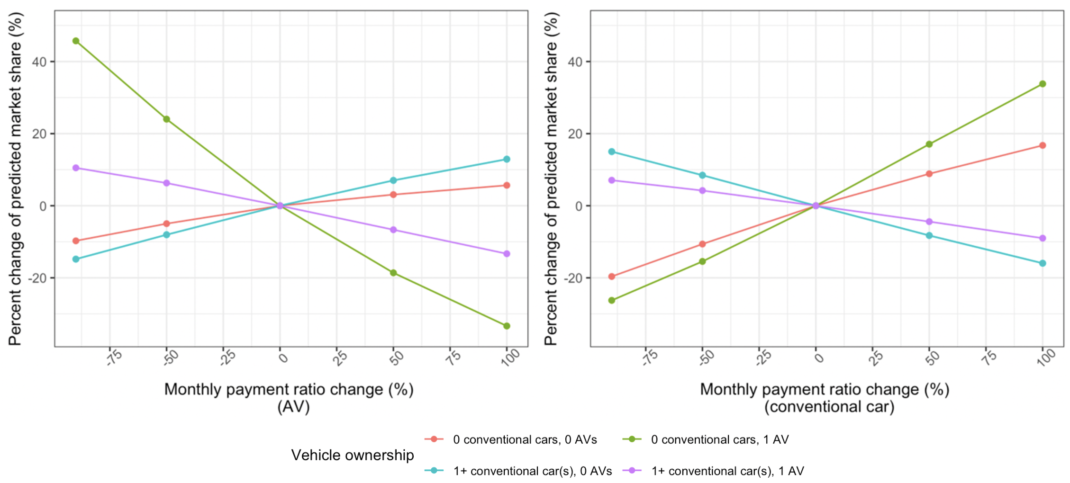
Figure 1.3 Monthly payment elasticity
Trip-level characteristics
To affect vehicle ownership decisions, trip-level features first affect the utility of modes in a trip. For example, decreasing ridehailing travel time increases the utility of choosing ridehailing when making mode choices for a trip. In turn, trip-level characteristics affect the expected utility of the mode choice sets enabled by different vehicle ownership levels. Everything else being equal, decreasing ridehailing travel times makes owning zero private cars more appealing, because it increases the utility of the set of non-private-car mode options. Figures 1.4~1.6 show the elasticity curves of vehicle ownership.
Parking cost. Increasing parking cost ratio of AVs is likely to increase the market shares of owning 0 conventional cars and 0 AVs, and 1+ conventional cars and 0 AVs, while decreasing the market share of owning 0 conventional cars and 1 AV, and both conventional cars and AVs (Figure 1.4). Similar patterns can be seen when adjusting parking cost of conventional cars. The reason why owning 1+ conventional cars and 1 AV would increase as the parking cost of conventional cars increases might be that those who planned to buy an additional conventional car when they already own (more than) 1 conventional car would buy an additional AV instead.
The results show that (1) the elasticities are less than those of individual-level characteristics, showing that vehicle ownership decisions are less elastic with respect to parking cost change than to monthly payment change; (2) Since AV and conventional cars are substitute goods, increasing parking cost of one of them would encourage respondents to switch between them; (3) Owning 0 conventional cars and 0 AVs is less elastic than other alternatives when changing either AV or conventional car parking cost ratio; (4) The elasticity with respect to parking cost ratio is similar for both AVs or conventional cars.
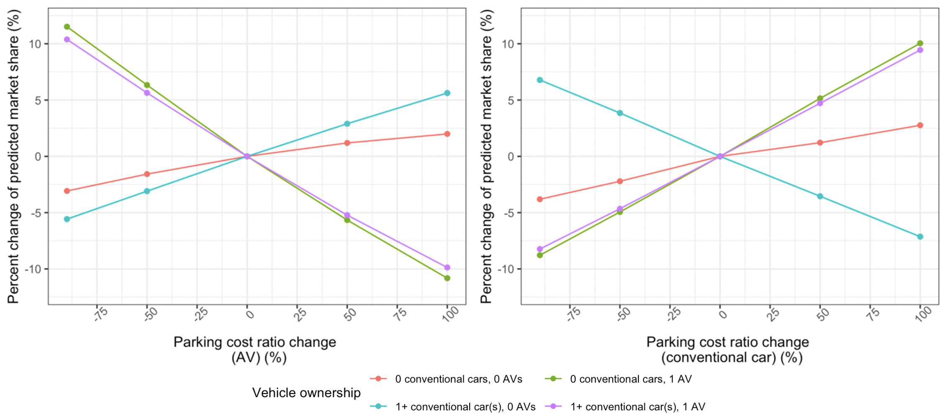
Figure 1.4 Parking cost elasticity
Transit travel time and cost. Decreasing transit travel cost and travel time both have a positive effect on owning 0 conventional cars and 0 AVs, a negative impact on owning 0 conventional cars and 1 AV, and 1+ conventional cars and 1 AV, and 1+ conventional cars and 0 AVs, and vice versa (Figure 1.5). Percentage change in market shares in Figure 1.5 fluctuates mildly because they are calculated via Monte Carlo simulation.

The major findings are (1) the elasticities are very small, meaning that adjusting transit service quality (including decreasing travel time and cost) has a mild impact on vehicle ownership decisions. It has the largest impact on owning 0 conventional cars and AVs, followed by choosing 0 conventional cars and 1 AV, both conventional cars and AVs, while has the smallest impact on owning 1+ conventional cars and 0 AVs. The implication is that improving transit service quality alone is not likely to substantially deter car ownership. This echoes the literature that improving existing transit rather than introducing transit to transit-unavailable areas only has a marginal effect on car ownership decisions (Ben-Akiva and Lerman, 1975; Deka, 2002). (2) Vehicle ownership decisions are more elastic to the change of transit travel time than travel cost ratio. One possible explanation is that transit travel cost is already low, thus changing it does not have much effect on vehicle ownership decisions. On the contrary, transit travel time is relatively longer compared to other modes; it has larger space for improvement; (3) The magnitude of elasticity increases when decreasing the transit travel time or travel cost ratio, and vice versa.
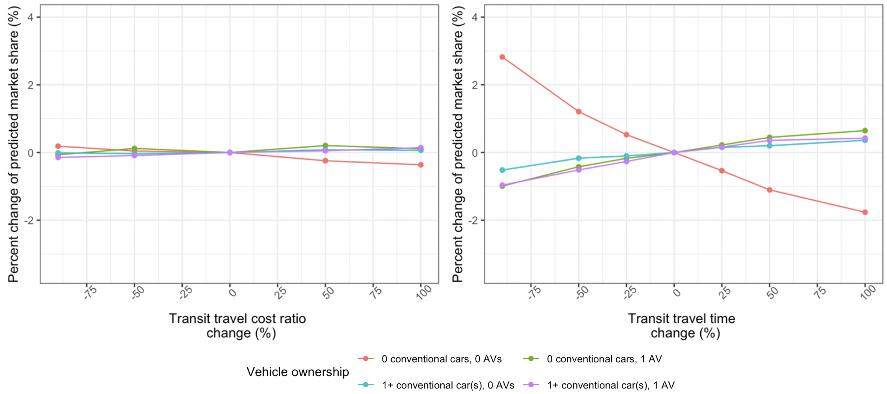
Figure 1.5 Transit travel time and cost elasticity
Ridehailing travel cost. Decreasing the travel cost ratio of autonomous ridehailing is likely to increase the probability of owning 0 conventional cars and 0 AVs, while decreasing the probability of owning other bundle of vehicles. Similar patterns can be observed when changing travel cost of conventional ridehailing (Figure 1.6).
The results show that (1) respondents perceive conventional and autonomous ridehailing as substitute goods. They share similar attributes and have similar effects on vehicle ownership decisions; (2) Compared to transit, decreasing ridehailing travel cost is more effective in influencing vehicle ownership decisions.
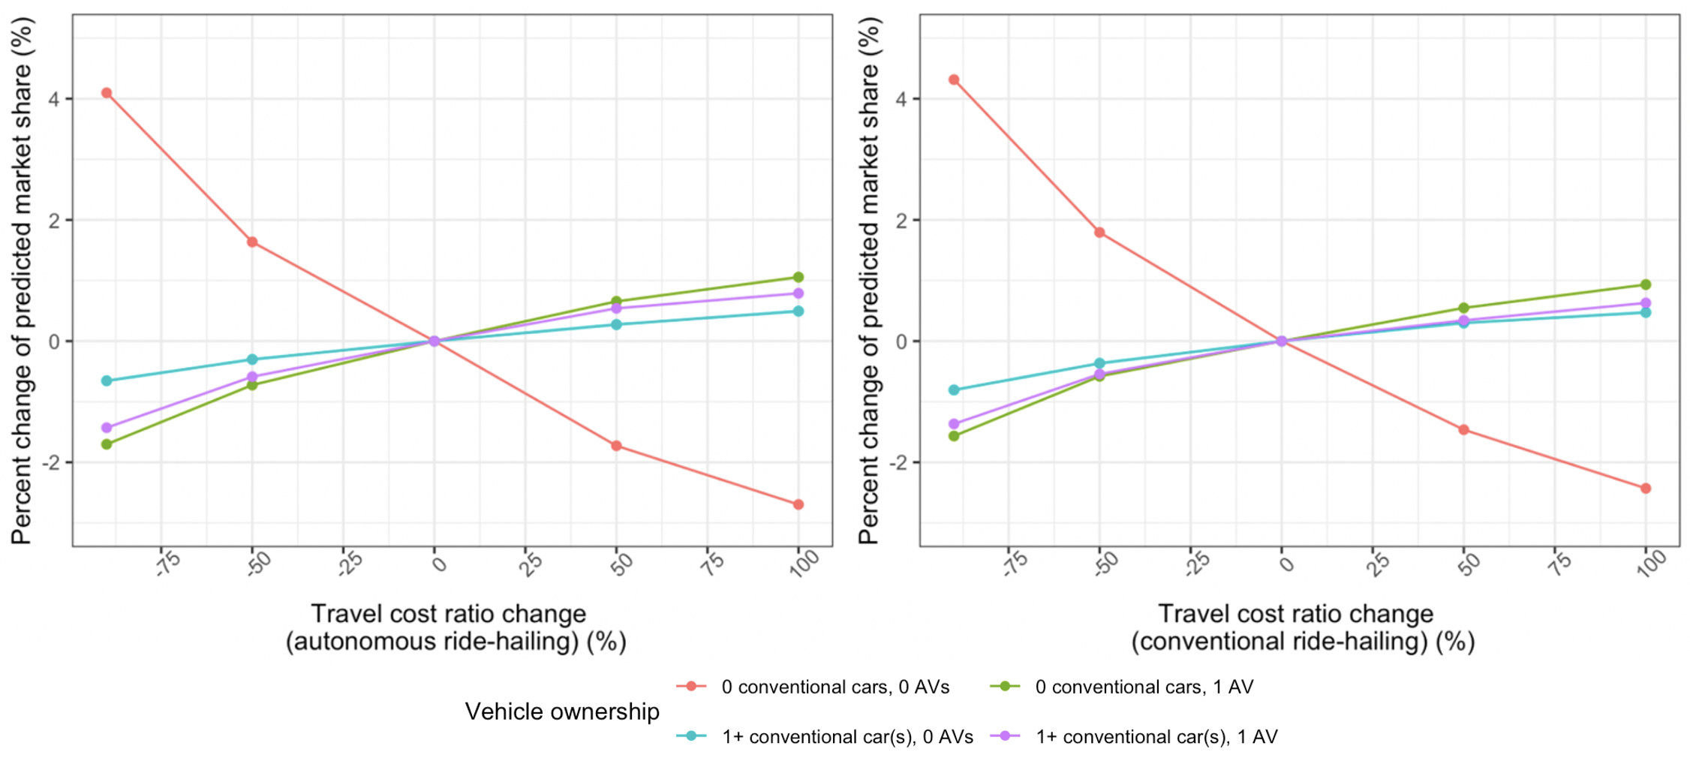
Figure 1.6 Ridehailing travel cost elasticity
In summary, (1) the elasticities of vehicle ownership are all less than 1, suggesting that vehicle ownership decisions are relatively inelastic to changes in either individual- or trip-level characteristics; (2) while individual-level characteristics have the most prominent effect on vehicle ownership decisions, trip-level characteristics also have a measurable effect; (3) Among trip-level characteristics, parking cost ratio has the largest impact on vehicle ownership decisions, followed by travel cost of ridehailing (both conventional and autonomous), and transit travel time. Transit travel cost has almost no effect on vehicle ownership decisions; we speculate that this may reflect the fact that transit prices are already very low.

Reference [AV OWNERSHIP MODELING]
Ben-Akiva, M., Lerman, S., 1975. Disaggregate behavioural model of automobile ownership. Transp. Res. Rec. 569, 34–51.
Ben-Akiva, M., Walker, J., Bernardino, A.T., Gopinath, D.A., Morikawa, T., Polydoropoulou, A., 1997. Integration of Choice and Latent Variable Models 40.
Bierlaire, M., 2020. A short introduction to Pandas Biogeme 22.
Deka, D., 2002. Transit Availability and Automobile Ownership: Some Policy Implications. J. Plan. Educ. Res. 21, 285–300. https://doi.org/10.1177/0739456X0202100306
Jabbari, P., Ranjbari, A., MacKenzie, D., 2020. How do safety perceptions and car dependency affect autonomous vehicle adoption. Presented at the 100th Transport Research Board Annual Meeting, Washington, D.C.
Koppelman, F., Pas, E., 1986. Multidimensional choice model transferability. Transp. Res. Part B Methodol. https://doi.org/10.1016/0191-2615(86)90046-9
Le Vine, S., Lee-Gosselin, M., 2013. A new concept of accessibility to personal activities: development of theory and application to an empirical study of mobility resource holdings. J. Transp. Geogr. 10.
Train, K., 2002. Discrete Choice Methods with Simulation. Cambridge University Press.
Vij, A., Walker, J.L., 2016. How, when and why integrated choice and latent variable models are latently useful. Transp. Res. Part B Methodol. 90, 192–217. https://doi.org/10.1016/j.trb.2016.04.021

Tour-based mode choice modeling
In this work, we are developing a tour-based mode choice model to explore how AVs may change travel patterns and mode choices while taking into account psychometric constructs and the interdependence of choices. We aim to improve on prior work by more realistically representing choices involving automated vehicles and future mobility services, which are not currently in the market and with which users therefore have limited familiarity. The work completed this year and reported here primarily involves theoretical model development. Model estimation and interpretation of results is planned for the next performance year.
In the survey conducted under year two of the UW’s CERC-CVC work, a choice experiment asked respondents to choose modes for each trip of their most recent (or typical) workday. The purpose of designing the experiment as described was to make the choice situations as realistic as possible. Although trip-based mode choice models may be appropriate in some cases, they are nowadays seen as lacking “behavioral realism,” as one’s mode choices for different trips in a tour are usually not independent (Ben-Akiva et al., 1998). Ben-Akiva et al. (1998) explored the complexity of work tours in Boston. They found that travel patterns vary dramatically across the population. They highlighted the heterogeneity of people and the variety of patterns in which travel occurs could not be captured by simplistic models. They discussed policies that aim to achieve their objective by influencing individuals’ behavior and capturing the complex ways that travelers adjust their behavior. Tour-based modeling matches the process of making travel decisions more closely compared to trip-based approaches. Frank et al. (2008) used a tour-based modeling framework to explore how travel time, cost, and land-use patterns affect mode choice and trip chaining behavior. They found that travel time was the strongest predictor of mode choice while urban form was the strongest predictor for the number of stops within a tour. Roorda et al. (2009) also used a tour-based model to incorporate minor modes (e.g., bicycling, drive/transit access commuter rail, drive access subway) of transportation into a simulation-based mode choice model as realistically as possible.
We created choice experiments based on users’ typical workdays and asked them to choose a mode for each trip within the tour, helping them imagine their day-to-day life with these new modes. However, it is not clear how respondents approached the experiment. They may have considered each trip independently and tried to maximize their utility for each trip, or they may have considered previous options when choosing the next mode. Therefore, we propose two approaches for modeling tour-based mode choices: (1) Treating trips as independent; and (2) a “dynamic-like” approach that considers interdependence. Below, we will discuss the model structures we propose for this task, then provide more detail in the following sections.
To estimate these models, we will use a random utility approach, which defines the utility of person i choosing mode j for trip t, $U_{ijt}$:
$U_{ijt}$=$V_{ijt}$+ $ε_{ijt}$ (1.8)
Where:
$V_{ijt}$= systematic utility component of mode j for trip t for person i.
$ε_{ijt}$= random utility component of mode j for trip t for person i,
This is a general formulation for $U_{ijt}$. We will discuss how we modify this formulation to capture the tour-based nature of the data in the upcoming sections. Based on the assumption of random utility maximization, individual i chooses mode J* when:
$U(i,J^{*})≥(i,J) ∀ J,J^{*}∈ C, J^{*}≠J$ (1.9)
C: choice set of all available modes
$V_{ijt}$ is formulated as below:
$V_{ijt}$=${βx}_{ijt}$+ $Γx_{i}^{*}+ε_{i}$ (1.10)
$x_{ijt}$ is the vector of alternative-specific observable explanatory variables (e.g., travel time, cost adjusted by income, parking fee, wait time), and $x_{i}^{*}$is the vector of latent variables, β and Γ are matrices of unknown model parameters corresponding to observable and latent variables, respectively. Depending on the approach, $V_{ijt}$
To estimate latent variables, we need a structural equation that describes the latent variables in terms of observable exogenous variables, and a measurement equation that links latent variables to indicators:
The structural equation is:
$x_{i}^{*}$=$Ax_{i}+ ν_{i}$ (1.11)
And the measurement equation is:
$I_{i}=Dx_{i}^{*}+ ζ_{i}$ (1.12)
$A$ is the matrix of parameters that indicate the structural relationship between the latent and observable variables.$ν_{i}$is the vector of the stochastic component of that relationship. $I_{i}$ corresponds to a vector of indicators used to measure the latent variables for the decision-maker i. $D$ is the matrix of unknown parameters that indicate the relationship between indicators and latent variables and$ζ_{i}$ is a vector of measurement equations error terms.
To estimate these models, we will use a mixed logit model with random effects on travel time to reflect the notion that individuals might have different perceptions of the disutility of travel time, and to represent repeated observations of the same individual respondents. The random draw is individual-specific and does not vary across alternatives for the same individual. The above model estimations include calculating integrals that do not have a closed form. Therefore, we will employ a Monte Carlo approximation with Halton draws from a normal distribution (Bierlaire, 2018). We plan to implement these approaches using Biogeme software (Bierlaire, 2020).

Approach one
For the first approach, we assume that the utility of choosing a combination of modes that are selected for trips of a tour can be captured by summing up their utility. The choice experiment included seven modes, five of which could be chosen on any trip as long as the first trip was anything other than a personal car or self-driving car. “Other” modes include biking, walking, ridehailing, driverless ridehailing, and transit. For “other” modes (any mode except the personal vehicle), we decided to use expected utility for each trip (which is logsum of utilities of available alternatives for that trip) and then use the sum of expected utilities as the total utility of each tour. Below, we discuss the proposed formulation for modeling tour-based mode choices.
The utility functions for choosing a regular car, self-driving car, and other modes are as below:
$V_{car}=\sum_{t=1}^{4}{V_{car,t}}$ (1.13)
$V_{self-driving car}=\sum_{t=1}^{4}{V_{self-driving car,t}}$ (1.14)
$V_{other}=\sum_{t=1}^{4}{V_{other,t}}$ (1.15)
We defined utility of choosing “other” modes as expected utility for each trip:
$V_{other, t}=log \sum_{j}^{J}{e^{V_{j,t}}}$ $j∈J=\{biking, walking, ridehailing, driverless ridehailing, transit\}$ (1.16)
The probability of choosing any of car, self-driving car and other options (from the set of {car, self-driving car, other}) is:
$P_{j'}=\frac{e^{V_{j'}}}{\sum_{j'}{e^{V_{j'}}}}$ $j^{'}∈\{car, self-driving car, other\}$ (1.17)

For “other” we have:
$P_{other}= \frac{\prod_{t}{e^{log\sum_{j}^{J}{e^{V_{j,t}}}}}}{\prod_{t}{e^{log\sum_{j}^{J}{e^{V_{j,t}}}}}+e^{V_{car}}+ e^{V_{self-driving car}}}$ (1.18)

Then, the probability of choosing mode j from among the set of “other” modes J is the probability of choosing “other” multiplied by conditional probability of choosing mode j from all the available alternatives in the “other” category:

$P_{j}=P\left(j | other\right)P\left(other\right)$ $= \prod_{t}{\frac{e^{Vj,t}}{\sum_{j}^{J}{e^{V_{j,t}}}}×P_{other}}$ (1.19)

Approach two
For the second method, I decided to use a “dynamic-like” approach which is a modification to the dynamic discrete choice model (DDCM). In DDCMs, decision makers’ goal is to maximize their expected intertemporal utilities (Aguirregabiria & Mira, 2010). DDCM is more appropriate when the decision makers’ choices depend on choices previously made, and those earlier choices were made knowing that there would be uncertain future payoffs (Ge, 2019). In other words, DDCM assumes rational agent is forward looking and consider choices interdependencies when making a decision (Hu, 2021). In a typical DDCM, the utility at each period is dependent on state variables that are known to the researcher and the component of the state variables that the researcher does not observe, but it is known to the decision maker (Ge, 2019).
In our experiment, participants could see the whole travel day and mode options and attributes all at once. There was no uncertainty about future modes and their attributes. One possible respondents’ thought process could be maximizing the utility of each trip (which I captured through approach one in the last section) by choosing solely based on the available options for that trip. Another thought process could be thinking about the whole travel day and considering some unobservable state variable, such as comfort, physical activity, etc., or following a habit. For example, respondents may think that since they have previously selected transit or ridehailing, walking would be a more appropriate mode to gain some physical activity. In another example, they may choose transit and stick with it for the next trips because that is the familiar combination of modes.
The underlying hypothesis is that respondents may consider their earlier mode when choosing a mode for the current trip. I called this approach “dynamic-like” because it is not a DDCM since I am not including an observable state variable into the model and there are no uncertainties about future options, but there might be interdependencies between choices. My approach captures respondents’ forward looking behavior, if there are any, in the experiment setting. Model formulation I propose is as follow:
$U_{ijt}= V_{ijt}+\sum_{c∈C}{ρ_{jc}y_{ijc(t-1)}+ ε_{ijt}}$ (1.20)
$U_{ijt}$ is the utility of mode j for individual i on trip t. $V_{ijt}$ is the deterministic part of the utility. We assumed the current level of utility of mode j is partly dependent on the previously chosen mode. The weight $ρ_{jc}$ measures the effect of choosing mode c for trip t-1 on choosing mode j for trip t and it is the same for each individual. $y_{ijc(t-1)}$ is a dummy variable with value one if mode c is chosen on trip t-1. The error term$ε_{ijt}$ captures unobserved factors. Lagged variable $y_{ijc(t-1)}$ and$ε_{ijt}$ are correlated since both depend on a time-invariant factor. We need to address this endogeneity to avoid bias in parameter estimation. The assumption of independence of error terms $ε_{ij(t-1)}$and $ε_{ijt}$can be relaxed by replacing error term $ε_{ijt}$by sum of two error terms as proposed by Danalet et al. (2016) as follow:

$ε_{ijt}$ = $α_{ij}$+ ${ε'}_{ijt}$ (1.21)

$α_{ij}$is time-invariant agent effect which represents the long-term preferences or habits of individual i over time for mode j. We propose to model the distribution of $α_{ij}$ dependent on exogenous explanatory variables:

$α_{ij}= a + b\underline{x} + ξ_{ij}$ (1.22)

Work the estimation process for these two approaches is ongoing, and results are expected in the next performance year.

REFERENCE [TOUR BASED MODE CHOICE MODELING]
Aguirregabiria, V., & Mira, P. (2010). Dynamic discrete choice structural models: A survey. Journal of Econometrics, 156(1), 38–67. https://doi.org/10.1016/j.jeconom.2009.09.007
Ben-akiva, M., Bowman, J., Ramming, S., & Walker, J. (1998). Behavioral realism in urban transportation planning models. In: Transportation Models in the Policy-Making Process: A Symposium in Memory of Greig Havey.
Bierlaire, M. (2018). Estimating choice models with latent variables with PandasBiogeme. 70.
Bierlaire, M. (2020). A short introduction to PandasBiogeme (Technical Report TRANSP-OR 200605). Transport and Mobility Laboratory, ENAC, EPFL.
Danalet, A., Tinguely, L., Lapparent, M. de, & Bierlaire, M. (2016). Location choice with longitudinal WiFi data. Journal of Choice Modelling, 18, 1–17. https://doi.org/10.1016/j.jocm.2016.04.003
Frank, L., Bradley, M., Kavage, S., Chapman, J., & Lawton, T. K. (2008). Urban form, travel time, and cost relationships with tour complexity and mode choice. Transportation, 35(1), 37–54. https://doi.org/10.1007/s11116-007-9136-6
Ge, Y. (2019). Discrete Choice Modeling of Plug-in Electric Vehicle Use and Charging Behavior Using Stated Preference Data. University of Washington.
Hu, Y. (2021). Dynamic Discrete Choice. http://www.econ2.jhu.edu/people/hu/teaching/Lecture-Dynamic-Discrete-Choice.pdf
Roorda Matthew J., Passmore Dylan, & Miller Eric J. (2009). Including Minor Modes of Transport in a Tour-Based Mode Choice Model with Household Interactions. Journal of Transportation Engineering, 135(12), 935–945. https://doi.org/10.1061/(ASCE)TE.1943-5436.0000072

Solo/pooled ridehailing behavior

Study overview
We conducted an online stated choice experiment to elicit respondents’ preferences for making a trip via solo (private) versus pooled (shared) ridehailing services. We used an integrated choice and latent variable model to characterize how this choice depends on factors like travel time and cost, as well as on the respondent’s attitudes and perceptions of factors like social norms when traveling in a shared ridehailing vehicle.

Background
Reducing car ownership and vehicle miles traveled (VMT) are supposed benefits of ridehailing services, as the introduction of ridehailing motivates a shift from the current car ownership paradigm into a service paradigm (ITF, 2017). However, to reduce VMT, ridehailing must be delivered as pooled services, or serve a limited number of trips for users whose travel is otherwise largely car-free (Wu and MacKenzie, 2021; Ward et al., 2019).
Most evidence suggests that to date, ridehailing services are increasing VMT overall due to empty vehicle miles, induced trips, and modal shifts from public transport, cycling and walking (Erhardt et al., 2019; Henao and Marshall, 2018). Also, the estimated effects on car ownership are small, heterogeneous, and sensitive to how they are measured (Schaller, 2021; Wen et al., 2021). This increase in VMT has also been acknowledged by the ridehailing providers themselves (Hawkins, 2019).
A reason for the increase in VMT could be the fact that to date, the large majority of ridehailing trips are single-passenger (solo) rides. Currently, pooled rides are not always and everywhere offered by ridehailing platforms, and only around 20% of on-demand users request pooled services even in places where they are offered (Gehrke et al., 2018; Gonzalez et al., 2020; Chen et al., 2018; Uber, 2018).
Therefore, replacing solo ridehailing and single occupancy private car trips with pooled ridehailing appears to be the most promising way for ridehailing to contribute to reducing VMT, congestion, and GHG emissions. According to Fagnant and Kockelman (2018), a market share of pooled services of 20–50% is required to provide tangible mobility gains; however, Rodier et al. (2016) found that even a larger percentage is likely to be required.
Current pooled ridehailing's unpopularity may lead to larger implications if autonomous vehicles can travel empty to self-park and to pick up passengers, with already low occupancy rates suffering further declines and VMT further increasing. Developing pooled services in autonomous ridehailing fleets could be the key to reducing the VMT. However, there are key gaps in our understanding of people’s choices to use pooled ridehailing.
Levin et al. (2017) observed that among autonomous ridehailing services during peak periods, only the pooled service was able to effectively control empty vehicle travel and avoid increases in congestion. Other simulation studies have also evidenced the need for autonomous pooled ridehailing if the move to AVs is not to be accompanied by increased congestion and overall VMT (Liu et al., 2018; Wang et al., 2018). However, consumers may elect not to use pooled autonomous ridehailing services. Krueger et al. (2016) used a stated choice experiment to investigate people’s willingness to adopt (solo) shared autonomous vehicles (SAVs) and pooled shared autonomous vehicles (PSAVs). Surprisingly, they found that PSAVs are associated with a higher value of travel time saving (VTTS) compared to SAVs. In summary, research focusing on understanding user choices between using SAVs and PSAVs is still developing and needs more investigation in this area as these modes do not exist currently (Lavieri and Bhat, 2019).
Nevertheless, considering the commonalities between future PSAVs and current pooled ridehailing services, as well as the anticipated motivations and barriers to their adoption, it is reasonable to assume that the overall incentives and deterrents to using these two modes will be similar, yet with certain influencing factors will amplified, and others alleviated. For instance, PSAV users still need to accept the potentially longer (and less reliable) travel times of a pooled ride due to pick-up/drop-off of additional passengers, which may still hinder the attractiveness of this mode compared to SAVs. However, the absence of drivers can decrease the operational costs of ride services (Bösch et al., 2018), reducing the weight of monetary considerations. On the other hand, users may become more apprehensive about the safety of AV technology and the risk of sharing the vehicle with strangers in the absence of an operator (Merat et al., 2017). It is also frequently stated that, because people will not have to drive or pay attention to traffic, they will be able to make better use of their trip time and lessen the perceived disutility of traveling (Cyganski et al., 2015; Malokin et al., 2017; Merat et al., 2017; Sarriera et al., 2017).
In this regard, psychosocial aspects are among major determinants of an individual's engagement in pooling behavior (Amirkiaee and Evangelopoulos, 2018). Zhang et al. (2020) suggested that people prioritized cost and time in both automated and non-automated ridehailing, but they raised the concern of understanding the importance of having a driver, the new norms of social interaction, and safety issues that involve in ridehailing preference under the AV context. An important obstacle to pooled ridehailing adoption is the user’s willingness-to-share rides (WTS) with strangers which may compromise on privacy, space, and security (Tahmasseby et al., 2016; Sarriera et al., 2017; Amirkiaee and Evangelopoulos, 2018). A survey of Transportation Network Company (TNC) users showed that social interactions were relevant to mode choice and specifically “having a negative social interaction was more of a deterrent to use of pooled ridehailing than the potential of having a positive social interaction was an incentive” (Sarriera et al., 2017). Therefore, a successful implementation of SAVs would also depend on people’s willingness to use the autonomous technology and to share the vehicle with unfamiliar others (Seuwou et al., 2017; Zhang et al., 2019; Cunningham and Regan, 2020).
Other factors that have been identified as relevant to ridehailing traval choices are socio-demographic characteristics (especially income, but also ethnicity and gender, which reflect cultural aspects and social roles respectively; see Delhomme and Gheorghiu, 2016 and Shaheen, 2018). Based on a behavioral modeling framework, Lavieri et al. (2017) found that young, urban residents with a high level of education are more likely to adopt AVs and to have a greater proclivity toward the use of SAVs and PSAVs.
Altogether, few studies have delved into the future adoption of autonomous pooled and solo ridehailing, This study contributes to the literature through (1) Separating the effects of having a human driver involved in the social interactions during a ride, from the effects of having a human versus a computer controlling the car and exploring its effect on the future share of pooled ridehailing service; and (2) Providing a deeper understanding of the unobservable (latent) attitudes associated with a traveler’s acceptance of pooling rides with others along with the observable factors such as socioeconomic characteristics of travelers. Therefore, this study explicitly accounts for five unobservable (latent) subjective attitudes related to sharing rides, AV technology safety concern, along with attitudes related to COVID-19 measured to account for pandemic effects.
In this study, we explore how future autonomous ridehailing share is influenced by having a human versus a computer controlling the car. Therefore, we include a vehicle type of human driven car, and distinguish AV ridehailing types by autonomous car accompanied by staff and autonomous car without staff. We collected data in a national survey comprising four parts: socio-economic questions, actual mode choice questions (revealed preference or RP data), hypothetical mode choice questions (stated preference or SP data), and psychometric questions related to sharing attitudes and COVID-19 attitudes. In the third part, various choice scenarios were developed in which respondents chose between solo ridehailing and pooled ridehailing. The effects of vehicle automation and the staffed/unstaffed status of the ridehailing were elicited by including these as attributes of ridehailing service in the experimental design. To model the behavior of riders an integrated choice and latent variable mixed logit model was employed using joint SP data, considering solo ridehailing as the reference mode.

Survey implementation
We designed a questionnaire comprising four sections: (1) socio-demographic questions; (2) questions about details of a recent trip made by respondents; (3) choice experiment that collects respondents’ binary choices between a solo ridehailing service and a pooled ridehailing service; (4) psychometric questions that provide indicators of latent constructs for hybrid choice modeling.
In section 1 we asked about respondents’ socio-economic information including age, gender, racial group, education, disability status, occupation. They were also asked about their individual and household’s income, size, numbers of full-time and part-time workers, and number of members younger than 18.
In section 2 we asked respondents about the most recent trip they had made for a specific purpose, which was selected at random. The purpose of this approach was to create more realistic choice scenarios, to obtain responses that are more likely to reflect their true preferences and behavior (Rose et al., 2008). We asked respondents to provide the approximate time, people they traveled with, trip mode, and duration of their most recent trip (defined as traveling for more than 1 mile and stopping at a new location) for the specified trip purpose.
The trip purpose (destination) was randomly selected from six categories: work/school, shopping, meal, social/recreation, errands, and home. Based on the answers to the socio-economic questions in the previous section, people who do not go to work or school outside their home were not shown the work/school category. For the home category, they were also asked about the place from which they were returning. Figure 2.1 provides examples of the questions for the most recent trip for work and home purposes.

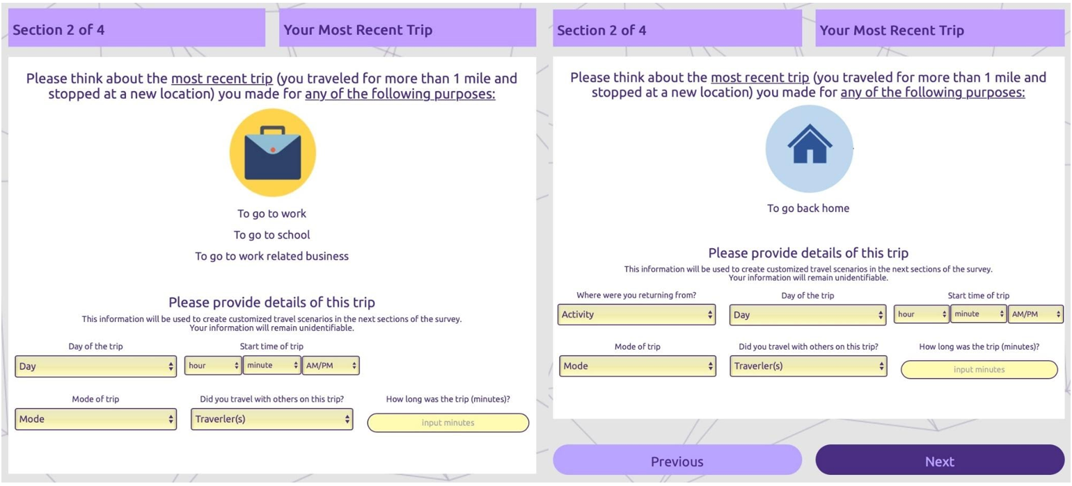
Figure 2.1. Examples of the section asking about the respondent’s most recent trip
In the choice experiment, we asked respondents to choose between a solo ridehailing service and a pooled ridehailing service for a trip similar to their previously reported most recent trip. For each alternative, the attributes of interest were orthogonally designed. Respondents made a binary choice based on these attributes, assuming solo and pooled ridehailing were the only two options for the trip. Levels of the attributes are displayed in Table 2.1. Both solo ridehailing and pooled ridehailing options drew from the same set of potential attributes and levels.
Table 2.1. Attributes and levels of the attributes in experimental design
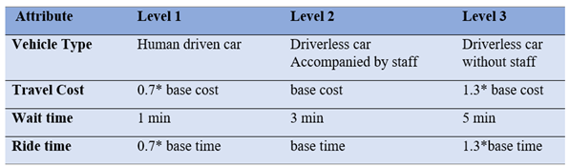
To investigate how preferences may change when ridehailing is provided by AVs, we use a vehicle type attribute with three levels of technology and service settings. To disentangle the effects of having a human driver involved in the social interactions during a ride, from the effects of having a human versus a computer controlling the car, we include vehicle types of (1) human driven car, (2) driverless car accompanied by staff, and (3) driverless car without staff.
Since respondents might have different levels of understanding and experience about ridehailing, a brief explanation of the ridehailing services was given to the respondents as follows, prior to starting the choice experiment. The general concepts of ridehailing and driverless ridehailing were explained to respondents as follows:
Ride-hailing: services are services such as Uber and Lyft, that connect passengers to local drivers to give them a ride.
Solo ride-hailing: services provide a ride-hailing service under your request only. Other users cannot make requests to share the ride with you.
Pooled ride-hailing: services match you with riders heading in the same direction, so you can share the ride and cost.
Driverless car: a self-driving car with no human backup driver.
Driverless Ride-hailing services: services that connect passengers to driverless vehicles to give them a ride. It cannot be driven by the passenger.
Driverless car accompanied by staff: A ride-hailing company's employee sits in a passenger seat for the whole trip, but cannot drive or control the driverless vehicle
Driverless car without staff: No ride-hailing service company's employee sits in the driverless vehicle. The only people in the car are you and any other travelers with whom you are matched.
Base values for travel cost are calculated based on travel mode and travel duration reported by respondents about their most recent trip. We assumed a speed of 25 mph for automobile-based modes, 17 mph for bus, 30 mph for rail, 9.6 mph for cycling, and 3.1 for walking. Multiplying the speed and reported travel duration, we obtain an approximate distance of the reported trip. Adapting the price scheme published by Uber, we calculate the base travel cost using the formula below:
Base cost = $2.20 (booking fee) + $1.60 (additional cost per mile) * distance
Base value for ride time is calculated by dividing the distance by the assumed speed of 25 mph for automobile-based modes. Both the travel cost and the ride time shown to respondents in the choice set pivot around the base values with 30% variation. Figure 2.2 presents an example of the choice scenario.
Each respondent completed six scenarios/choice tasks, all of which were associated with the same trip purpose.
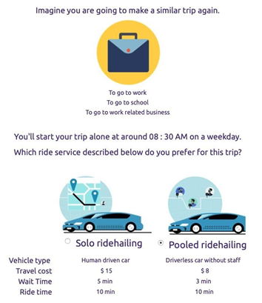
Figure 2.2. An example of a choice scenario displayed to a respondent

COVID-19 psychometric questions
In the last section of the questionnaire, we presented respondents with a series of psychometric questions aimed at measuring latent variables identified by Ge et al. (2018) and other relevant literature (Hamari et al., 2016; Amirkiaee and Evangelopoulos, 2018). We prepared a set of latent constructs and indicator questions that were most relevant to ridehailing and autonomous vehicles, and were intended to measure norms, perception, and attitudes towards social interaction and AV technology and their intention of using shared AVs. The total of 41 psychometric questions included a combination of Likert scaled and semantic differential scaled responses. The selected categories of questions are displayed in Table 2.2.
Table 2.2 Selected categories of questions
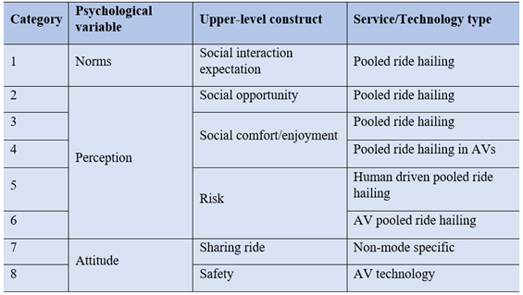

Quality check questions
In order to control data quality, we applied established quality-control techniques to identify and filter out data of low quality. In our experiment, low-quality data may result from several concerns. A particular concern with respondents being paid to complete a survey is that some may respond without giving adequate consideration to questions, or even clicking mindlessly. To address these concerns, quality metrics in three categories were applied: Concept checks, logic checks, and response time checks.
During the survey, concept questions followed the section in which the concepts of ridehailing and driverless ridehailing were defined for the respondents. Respondents were only allowed to proceed if they had answered every concept check question correctly.
After the survey, responses that failed any of the two logic checks were removed. First, a respondent’s individual income must be equal/less than his/her household income. Second, in the respondent’s household information, the number of children must be fewer than the total number of people in the household including the respondent. Also, a response time check was applied to flag the respondents with very long or very short survey completion times relative to the 16 minutes average completion time. The allotted time to take the survey was 60 minutes and the minimum threshold to pass the check was about 4 minutes specified by timekeeping of just reading the questions and randomly answering/checking the answer and going forward. Finally, after dropping respondents with failed quality questions, 10,236 observations from 1,706 respondents were retained.

Survey administration
The survey was released in January 2021 on a nation-wide scale via Amazon Mechanical Turk (MTurk) and Facebook ads. MTurk respondents were paid $2.50 for their responses via MTurk’s payment platform. We obtained 1,234 responses via MTurk, distributed proportional to the population of each of the 50 U.S. states via quota sampling. Including respondent compensation and Amazon’s administrative fee for the MTurk service, the cost per response was $3.50 on MTurk. Facebook ads were placed on all available Facebook services, and respondents who completed the survey were compensated with a $5 digital gift card. We obtained 880 responses via Facebook, at an average cost of $7 per response including both advertising costs and respondent compensation. In all, we collected a total of 12,684 stated choice observations.

Comparison between MTurk and Facebook
Table 2.3 presents a summary of demographic statistics for the retained respondents in the final sample.
Table 2.3. Summary of the Demographics by the platform used
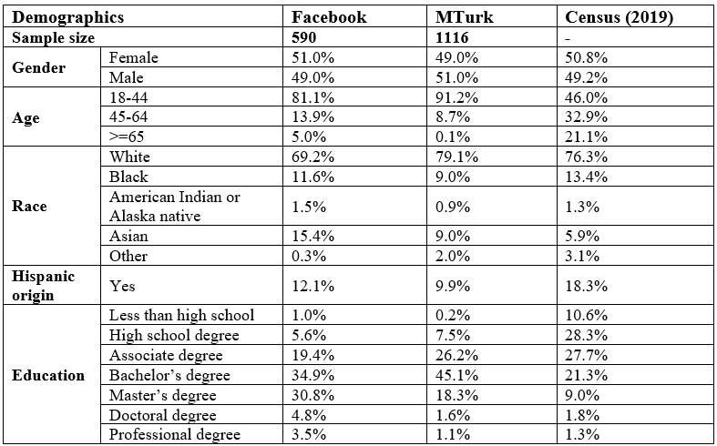
As can be seen in Table 2.3, Both MTurk and Facebook sample overrepresent young people (age 18-44), Asians, and highly educated people. They both underrepresent elderly people, Black and Hispanic Americans, and people of lower education levels.

Modeling

Factor analysis
We began our analysis with an exploratory factor analysis (EFA) to check the constructs’ validity and reliability. The goal in this step was to understand whether and to what extent indicators data may reflect underlying hypothetical constructs, known as factors. This will be important during the construction of structural equations for latent variables and the identification of latent classes, at the choice modeling stage. Based on scree plots (Figure 2.3 and 2.4) we concluded that there were 3 COVID-related constructs and 5-6 constructs related to ridehailing attitudes and perceptions.
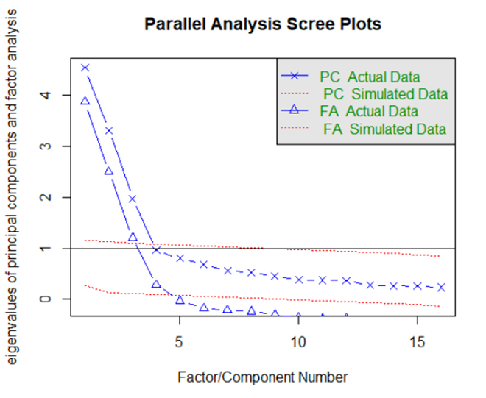
Figure 2.3. Eigenvalues of COVID-related indicators
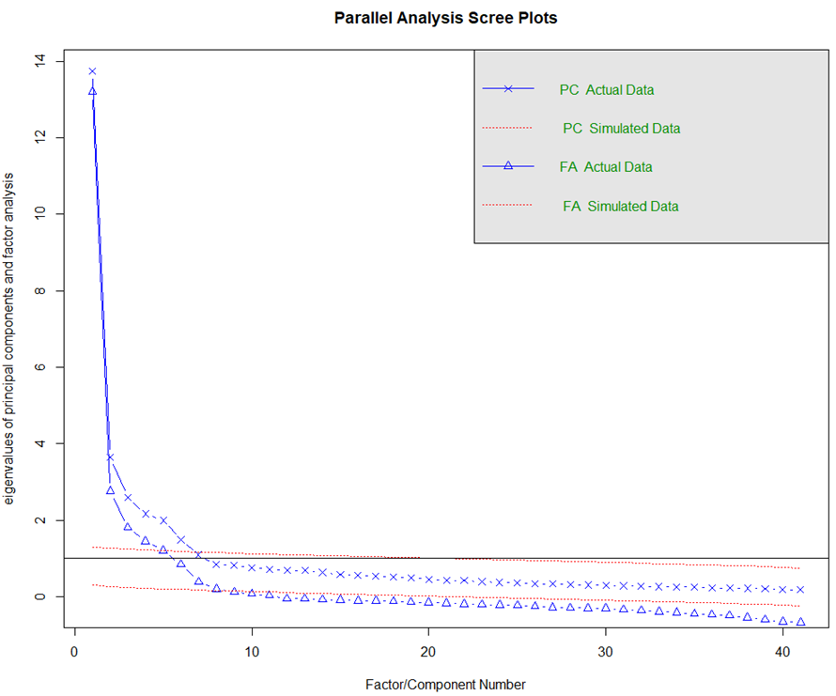
Figure 2.4. Eigenvalues of ridehailing-related indicators
Accordingly, the factor loadings of indicators were estimated separately for COVID-related and ridehailing-related indicators as indicated in Table 2.4 and Table 2.5 respectively.

Table 2.4. COVID-related indicators and factor loadings
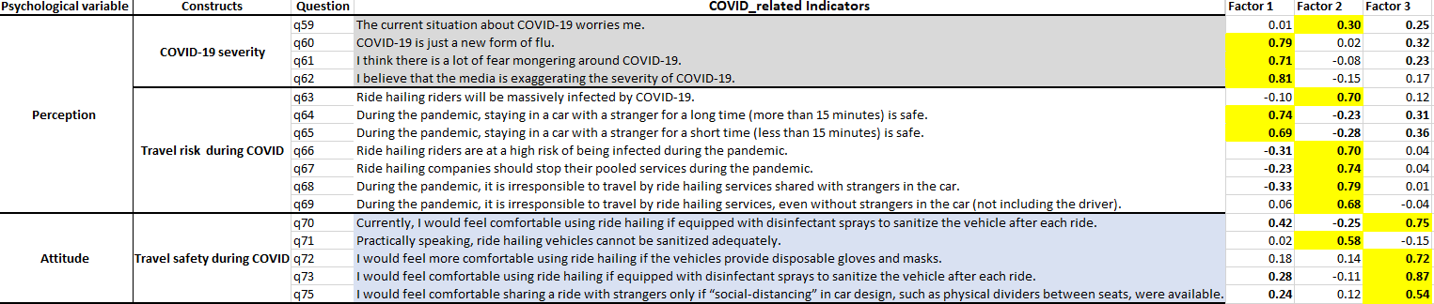



Table 2.5. Ridehailing-related and AV tech. safety indicators and factor loadings
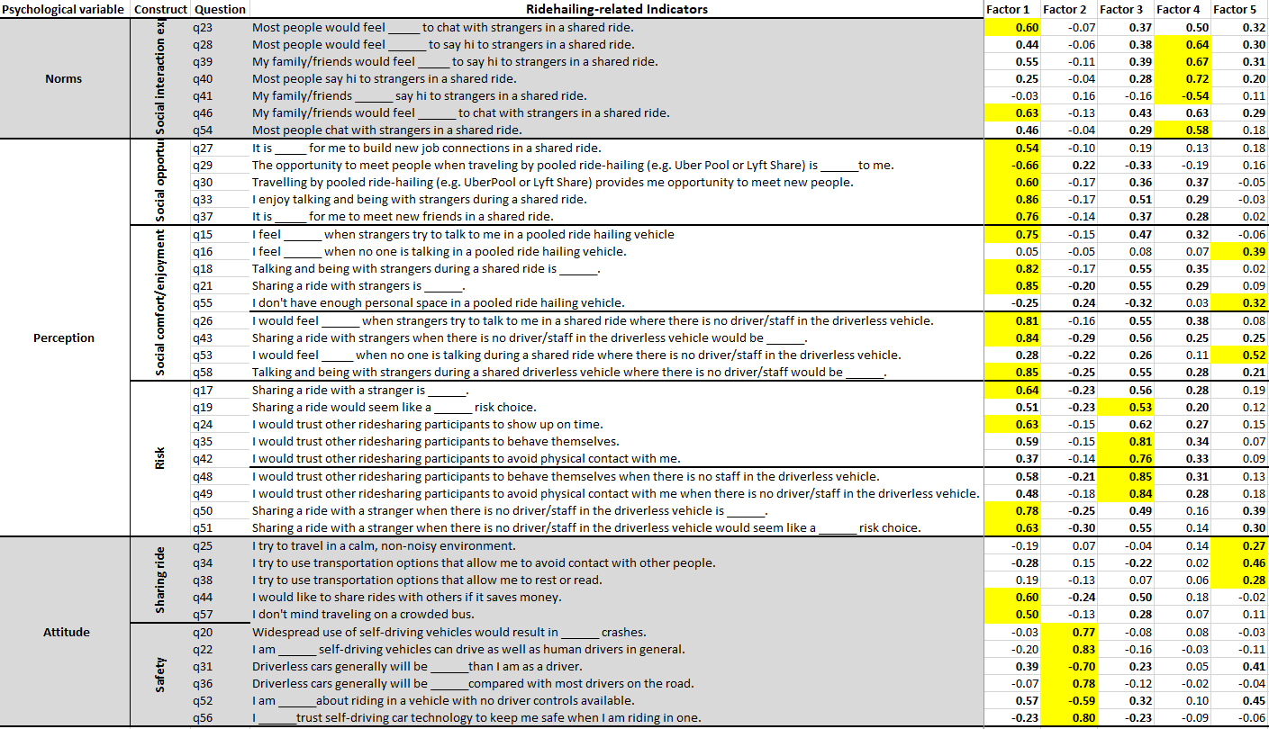
Based on the type of indicators that load on each factor we labeled the associated factors as the following latent variables:
COVID-related factors:
Factor 1: Low perceived COVID severity
Factor 2: Ridehailing infection risk
Factor 3: Responsiveness to Personal Protective Equipment (PPE)
Sharing ride-related factors:
Factor 1: Social interactions
Factor 2: Appropriate sharing behavior
Factor 3: Social norms / expectations
Factor 4: Desire for privacy/personal space
Autonomous vehicle related factors:
Factor 1: AV technology safety concern

Preliminary model specifications and results
Before moving on to more complicated models, a multinomial logit model (MNL) was developed. The results are shown in Table 2.6. This provides a useful check on the reasonableness of the model specification and the quality of the data.

Integrated choice and latent variable model specification and results
The structural equations to estimate the latent variables include socio-economic variables including age, education, race, and number of children younger than 18 in the household. We assumed a linear structural regression equation for the chosen latent variables. The results are shown in Table 2.8.
We estimated a mixed logit (ML) model to explain the choice behavior between solo and pooled ridehailing, with the latent variables incorporated directly in the utility function of the ML model.
The results of the final ML model estimated in BIOGEME 3.2.6 are presented in Table 2.7. The effect of travel cost on the choice between solo and pooled ridehailing has been estimated with a generic random parameter with lognormal distribution. In addition, the effect of household income as a potential source of heterogeneity around the mean travel cost has been considered using a common fixed effect of travel cost divided by the midpoint of the household income category reported by the respondent.
While the ride time effect has been separated for solo and pooled ridehailing by two different fixed parameters, the coefficients on waiting time were assumed to be fixed and the same for solo and pooled ridehailing. All travel time parameters were found significant with negative signs for coefficients, which is consistent with intuition.
Automation has been incorporated as an attribute for solo and pooled ridehailing modes. The effect of a ridehailing vehicle being human-driven or driverless/autonomous on the choice between solo and pooled ridehailing has been estimated for both modes using a common random coefficient with a normal distribution. As presented in Table 2.7 the mean effect of automation on both solo and pooled ridehailing is negative, reflecting an aversion to riding in autonomous ridehailing vehicles that has been previously reported (Choi and Yong, 2015; Khaloei et al., 2020; Khaloei et al., 2021).
Also, the effect of a driver or staff/attendant on the choice behavior of ridehailing riders has been evaluated. The associated attribute is explained by alternative-specific fixed coefficients for solo and pooled ridehailing. The results show that an unstaffed service has a negative and significant impact on choosing solo ridehailing and a negative but insignificant impact on choosing pooled services.
In this regard, the statistically significant and negative parameter for the interaction term of the unstaffed service, and the covariate, gender of a traveler, suggests that female travelers are generally less willing to ride in unstaffed ridehailing vehicles and this unwillingness is larger for pooled ridehailing in accordance with the larger coefficient relative to solo ridehailing. In addition to the interaction term, the main effect of the covariate, gender of a traveler, indicates that female riders are less likely to choose pooled services. This may reflect a level of discomfort these respondents would have in riding in a car with a stranger and no company staff present.
Furthermore, the impact of trip purpose on ridehailing choice behavior implies that riders show more willingness to use pooled ridehailing service when they commute.
Among the latent variables related to COVID-19, perceptions of a high infection risk from ridehailing use have the largest impact on deterring individuals from pooled ridehailing. Also, individuals with higher levels of responsiveness to personal protective equipment (PPE) use in ridehailing are more likely to choose pooled ridehailing. In terms of the COVID-19 severity, the less individuals perceive COVID-19 as severe, the more likely they are to choose pooled ridehailing.
Among the latent variables related to sharing rides, the desire for privacy/personal space is indicated as the most influential in the utility of pooled ridehailing. That is, pooled ridehailing has a high disutility among individuals with pro-privacy attitudes who believe the contact with others is not avoidable in pooled ridehailing. On the other hand, as indicated in Table 2.7, individuals enjoying more social interaction are more likely to choose pooled ridehailing.
Social norms and expectations play an important role in the utility of pooled ridehailing. Those individuals who endorse pooling-friendly social norms are more likely to use pooled ridehailing. Also, the more concerned individuals are about the misbehavior of other shared ride passengers, the less likely they are to choose pooled ridehailing.

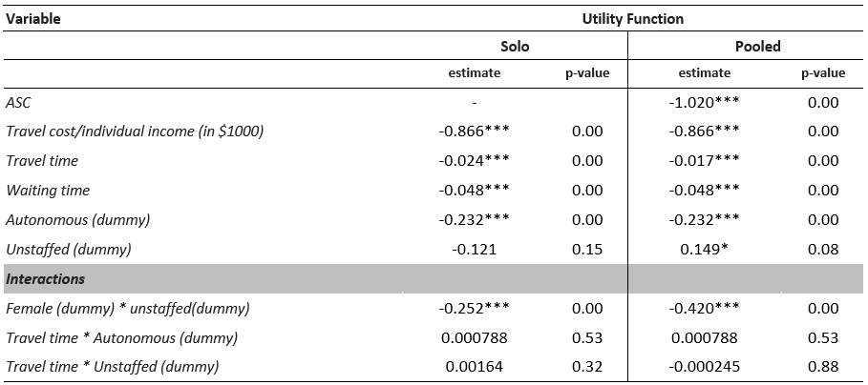
Table 2.6. Multinomial Logit model

Table 2.7. Mixed logit model with latent variables
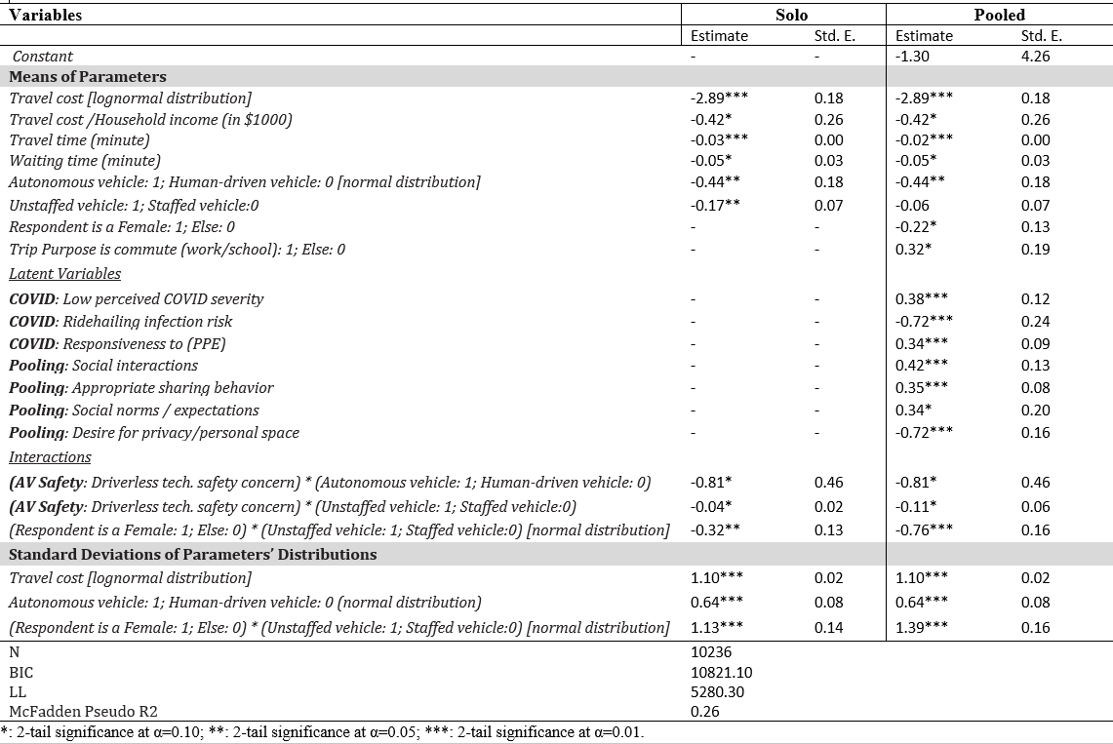

Table 2.8. Structural Equation of latent variables (Linear Regression)
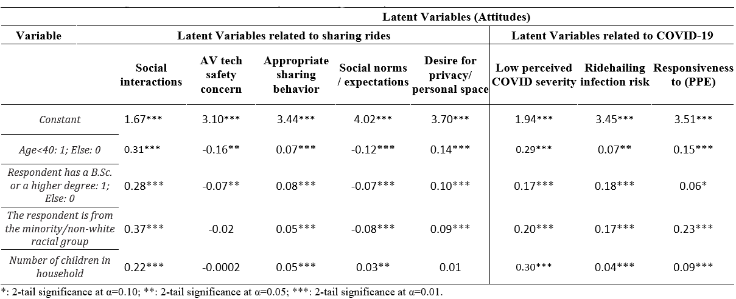

Sensitivity Analysis
After building the choice model, a sensitivity analysis was conducted to examine how the market share of pooled service changes compared to solo services when key variables are changed. In order to disentangle the effects of having a human driver involved in the social interactions during a ride, from the effects of having a human versus a computer controlling the car, we include a vehicle type of human driven car, and distinguish AV ridehailing types by autonomous car accompanied by staff in scenario 1 and autonomous car without staff in scenario 2. The scenario 1 and scenario 2 are presented in Table 2.9.
Table 2.9. The status of automation and unstaffed service in different scenarios
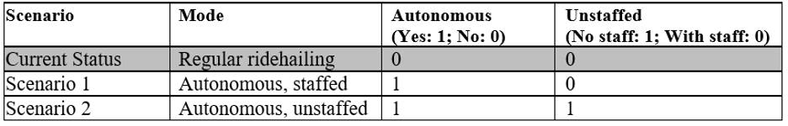
It should be noted that whenever in the scenarios the predictors of automation and unstaffed status are varied, other predictors both in discrete choice model and latent variable model are held constant at the values indicated in Table 2.10. While other predictors remain constant, the gender of rider varies to compare the impact of unstaffed status on females with the impact on males.
TABEL 2.10. Reference Values of Variables in the Sensitivity Analysis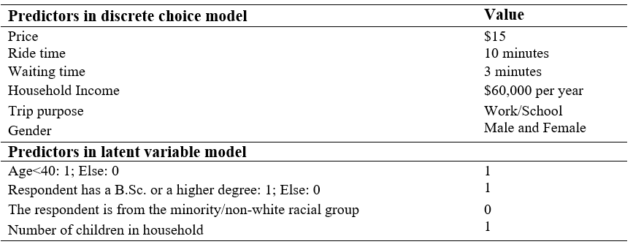
The mean probabilities/market shares were estimated using all the variables in Table 2.10 separately for scenario 1 for scenario 2. The share of pooled ridehailing rides from the total ridehailing rides (i.e., solo, and pooled ridehailing) in each scenario is displayed in Figure 2.5 for male and female travelers.
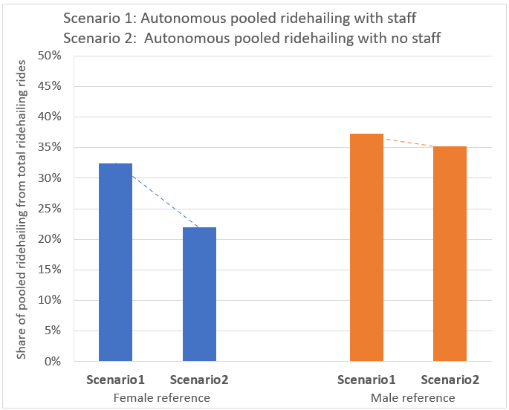
Figure 2.5. The share of pooled ridehailing rides from the total ridehailing rides in scenarios 1-2
According to Figure 2.5, an estimated 37% of males and 32% of males choose the pooled option in scenario 1, in which there is a human staff person present in the vehicle. Eliminating the staff in scenario 2 reduces the share of males choosing the pooled option to 35%, but reduces the share of females choosing the pooled option to 22%. That is, eliminating the service provider’s staff from the autonomous pooled ridehailing would be expected to lead to a much higher drop in the share of females choosing the pooled ride than in the share of males. This is in addition to any effects due to automation of the vehicle controls per se.
Comparing scenario 1 with scenario 2, we can conclude that if ridehailing services are provided by autonomous vehicles, particularly vehicles with no company staff in the vehicle, the share of travelers choosing pooled ridehailing declines, especially among female riders. This may reflect concerns with sharing a ride in an autonomous car with strangers when no driver/staff is present.
Policy Implications
Eliminating staff/drivers from ridehailing may lead to a shift of riders from pooled ridehailing to solo ridehailing. If mitigating VMT growth is a desired outcome, then it is helpful to assess policies that can encourage more riders to use autonomous pooled ridehailing with no staff in the vehicle. To help target appropriate policies, the impacts of a unit changes in the latent variables/attitudes on the share of autonomous pooled ridehailing without staff were simulated in scenarios 1 and 2. The reference values used for this simulation include the reference values in Table 2.10 and the means of the latent variables across the sample, i.e. 2.48, 2.87, 3.64, 3.86, 3.95, 2.7, 3.74, and 3.81 for social interactions, AV tech safety concern, appropriate sharing behavior, social norms/expectations, desire for privacy/personal space, low perceived COVID severity, ridehailing infection risk, and responsiveness to PPE, respectively. In Figure 2.6. The results are displayed only for the five latent variables related to sharing rides.
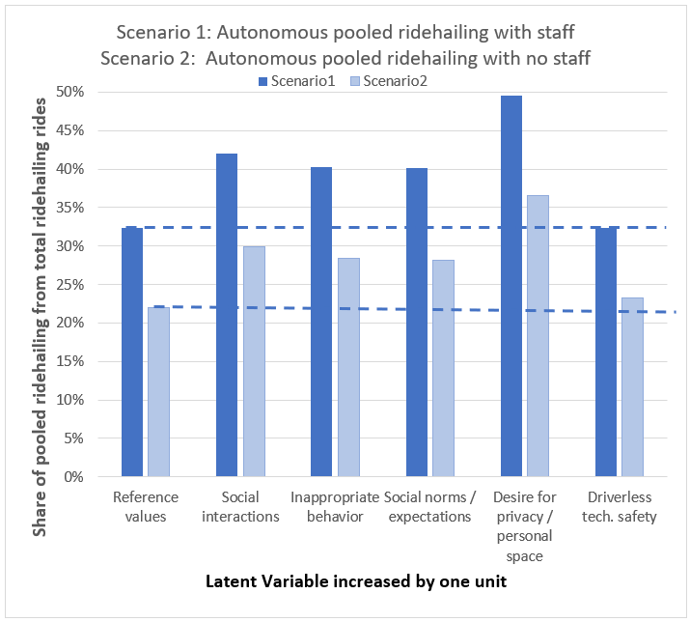
Figure 2.6. Probabilities/Shares of pooled ridehailing as a result of a unit change in attitudes
According to the probabilities in Figure 2.6, a unit change in the attitude of desire for privacy/personal space has the largest impact on increasing the share of pooled ridehailing both in scenario 1 and 2 relative to pooled ridehailing shares in reference value. A unit change in this attitude has increased the share of autonomous pooled ridehailing with staff from 32% in scenario 1 for reference values to about 50% in scenario 1 for a unit change in the attitude desire for privacy/personal space.
The simulation results show that shifting attitudes might help to offset the decline in pooling that would result from eliminating in-vehicle staff. For the most influential attitude in our model – desire for privacy/personal space – a 0.75 unit decline in the desire for privacy and personal space could compensate the decline in pooled ridehailing resulting from eliminating staff. However, to the extent it reflects intrinsic preferences, changing the desire for personal space may be difficult to effect through policy. A more promising opportunity may lie in shifting expectations around social norms and interactions, and in preventing inappropriate behavior. There is also a risk here, though: if the removal of staff in fact exacerbated instances of bad behavior, it could lead to even fewer travelers being willing to use pooling.

Conclusions
The results of this work indicate that with the advent of fully autonomous ridehailing services, if the staff/driver is totally eliminated from the ride, more travelers are likely to select solo rides rather than pooled rides. This is due not just to changes in prices or the automation of the vehicle per se, but specifically to eliminating a staff person from the car, even if they weren’t driving. The shift from pooled to solo rides appears to be disproportionately concentrated among female travelers, who are generally less willing to ride in autonomous ridehailing vehicles with no staff in the car. This result deserves further investigation, but we speculate that it may reflect concerns females have about sharing a ride with a stranger when no staff/driver is in the car.
Mitigating and reversing a shift from pooled to solo ridehailing will likely be necessary if cities are to avoid increased VMT and congestion. One approach to doing so may lie in shifting some of the perceptions and attitudes that affect travelers’ willingness to use pooled rides. Beyond issues of price and travel time, this work has shown that the choice between solo and pooled rides depends on the latent attitudes and perceptions of travelers. Among these, the desire for privacy/personal space is particularly influential, though social norms and interactions, and concerns over inappropriate behavior by other travelers, are also significant. Careful management of these factors by policymakers and especially TNCs will be key to encouraging pooling behavior by a wider range of travelers.
This work has left several avenues unexplored. Future researchers may wish to consider factors such as travel party size to understand how the number of passengers affects the willingness of riders to pool. In addition, this study considered only the choice between solo and pooled ridehailing; in the future this choice could be embedded in the broader context of choices between ridehailing and other modes, particularly transit and private automobiles. Finally, an important limitation is that the data for this study were collected during the COVID-19 pandemic. Though we measured and controlled for latent constructs related to COVID-19 risks, the effect of the pandemic on pooling behavior – both in our models and in the real world – remain a key source of uncertainty.

REFERENCE [SOLO/POOLED MODELING]
Alonso-Gonzalez, M.J., O. Cats, N. van Oort, S. Hoogendoorn-Lanser, S. Hoogendoorn. What are the determinants of the willingness to share rides in pooled on demand services? Transportation, 2020.
Amirkiaee, S.Y. and N. Evangelopoulos. Why do people rideshare? An experimental study. Transportation Research Part F, 2018. 55, 9-24.
Bösch, P.M., F. Becker, H. Becker and K.W. Axhausen. Cost-based analysis of autonomous mobility services. Transport Policy, 2018. 64, 76-91.
Chen, X., H. Zheng, Z. Wang, X. Chen. Exploring impacts of on-demand ridesplitting on mobility via real-world ridesourcing data and questionnaires. Transportation (Amst), 2018.
Choi, J.K. & G. J. Yong. Investigating the Importance of Trust on Adopting an Autonomous Vehicle. International Journal of Human–Computer Interaction, 2015. 31:10, 692-702
Cunningham, M. L. and M. A. Regan. 5 Public Opinion About Automated and Self-Driving Vehicles. Handbook of Human Factors for Automated, Connected, and Intelligent Vehicles, 2020.
Cyganski, R., E. Fraedrich and B. Lenz. Travel-time valuation for automated driving: A use-case-driven study. Presented at the 94th Annual Meeting of the Transportation Research Board, Washington, D.C., January, 2015. Paper No. 15-4259.
Delhomme, P. and A. Gheorghiu. Comparing French carpoolers and non-carpoolers: Which factors contribute the most to carpooling? Transportation Research Part D, 2016. 42, 1-15.
Erhardt, G.D., S. Roy, D. Cooper, B. Sana, M. Chen, J. Castiglione. Do transportation network companies decrease or increase congestion? Sci. Adv., 2019.
Fagnant, D.J., K.M. Kockelman. Dynamic ride-sharing and fleet sizing for a system of shared autonomous vehicles in Austin. Texas. Transportation (Amst), 2018.
Ge, Y., D. MacKenzie, D. R. Keith, Gas anxiety and the charging choices of plug-in hybrid electric vehicle drivers. Transportation Research Part D: Transport and Environment, 2018. Volume 64, Pages 111-121.
Gehrke, S.R., A. Felix, T. Reardon. Fare choices. A survey of ride-hailing passengers in metro Boston, 2018.
Hamari, J., M. Sjöklint, & A. Ukkonen. The sharing economy: Why people participate in collaborative consumption. Journal of the association for information science and technology, 2016. 67(9), 2047-2059.
Hawkins, A.J.: Uber and Lyft finally admit they’re making traffic congestion worse in cities, https:// www.theverge.com/2019/8/6/20756945/uber-lyft-tnc-vmt-traffic-congestion-study-fehr-peers
Henao, A., W.E. Marshall. The impact of ride-hailing on vehicle miles traveled. Transportation (Amst), 2018.
ITF, 2017. Shared Mobility Simulations for Helsinki. Int. Transport Forum Policy Papers, No. 39, OECD Publishing, Paris. https://doi.org/10.1787/3d340a2a-en [accessed 07/19/2020].
Khaloei, M., A. Ranjbari, and D. MacKenzie. Analyzing the Shift in Travel Modes’ Market Shares with the Deployment of Autonomous Vehicle Technology. 99th Annual Meeting of the Transportation Research Board, Washington, D.C, 2020.
Khaloei, M., A. Ranjbari, K. Laberteaux, & D. MacKenzie. Analyzing the Effect of Autonomous Ridehailing on Transit Ridership: Competitor or Desirable First-/Last-Mile Connection?. Transportation Research Record, 2021 [Available online].
Krueger, R., T.H. Rashidi and J.M. Rose. Preferences for shared autonomous vehicles. Transportation Research Part C, 2016. 69, 343-355.
Lavieri, P.S., V.M. Garikapati, C.R. Bhat, R.M. Pendyala, S. Astroza, F.F. Dias. Modeling individual preferences for ownership and sharing of autonomous vehicle technologies. Transport. Res. Rec.: J. Transport. Res. Board, 2017. 2665, 1–10.
Lavieri, P. S., & C. R. Bhat. Modeling individuals’ willingness to share trips with strangers in an autonomous vehicle future. Transportation Research Part A: Policy and Practice, 2019. 124, 242-261.
Levin, M.W., K.M. Kockelman, S.D. Boyles and T. Li. A general framework for modeling shared autonomous vehicles with dynamic network-loading and dynamic ride-sharing application. Computers, Environment and Urban Systems, 2017. 64, 373-383.
Liu, Z., T. Miwa, W. Zeng and T. Morikawa. An agent-based simulation model for shared autonomous taxi system. Asian Transport Studies, 2018. 5(1), 1-13.
Malokin, A., G. Circella and P.L. Mokhtarian. Do multitasking millennials value travel time differently? A revealed preference study of northern California commuters. Presented at the 96th Annual Meeting of the Transportation Research Board, Washington, D.C., January, 2017. Paper No. 17-00891.
Merat, N., R. Madigan and S. Nordhoff. Human factors, user requirements, and user acceptance of ride-sharing in automated vehicles. International Transport Forum, 2017. Discussion Paper No. 2017-10.
Rodier, C., F. Alemi, D. Smith. Dynamic ridesharing–exploration of potential for reduction in vehicle miles traveled. Transp. Res. Rec. J. Transp. Res. Board, 2016.
Rose, J. M., M. Bliemer, D. A. Hensher, and A. T. Collins. Designing Efficient Stated Choice Experiments in the Presence of Reference Alternatives. Transportation Research Part B: Methodological, 2008. Vol. 42, No. 4, pp. 395–406
Sarriera, J. M., G. Escovar Álvarez, K. Blynn, A. Alesbury, T. Scully, and J. Zhao. To share or not to share: Investigating the social aspects of dynamic ridesharing. Transportation Research Record: Journal of the Transportation Research Board, 2017. 2605, 109-117.
Schaller, B. Can sharing a ride make for less traffic? Evidence from Uber and Lyft and implications for cities, Transport Policy, 2021. Volume 102, Pages 1-10
Seuwou, P., , E. Banissi, G. Ubakanma, M. S. Sharif and A. Healey. Actor-network theory as a framework to analyse technology acceptance model’s external variables: the case of autonomous vehicles. In International Conference on Global Security, Safety, and Sustainability, 2017. 305-320. Springer, Cham.
Shaheen, S. and A. Cohen. Shared ride services in North America: definitions, impacts, and the future of pooling. Transport Reviews, 2018.
Tahmasseby, S., L. Kattan and B. Barbour. Propensity to participate in a peer-to-peer social-network-based carpooling system. Journal of Advanced Transportation, 2016. 50(2), 240- 254.
Uber: uber–facts & figures as of December 2018, https://www.uber.com/en-GB/newsroom/companyinfouberpoolau/
Wang, Y., B. Zheng and E.P. Lim. Understanding the effects of taxi ride-sharing—A case study of Singapore. Computers, Environment and Urban Systems, 2018. 69, 124-132.
Ward, J. W., J. J. Michalek, C. Samaras, I. L. Azevedo, A. Henao, C. Rames, & T. Wenzel. The impact of Uber and Lyft on vehicle ownership, fuel economy, and transit across U.S. cities. IScience, 2021. 24 (1), 101933.
Wu, X., & D. MacKenzie. Assessing the VMT effect of ridesourcing services in the US. Transportation Research Part D: Transport and Environment, 2021. 94, 102816.
Xiao Wen, A. Ranjbari, F. Qi, R. R. Clewlow, D. MacKenzie. Challenges in credibly estimating the travel demand effects of mobility services. Transport Policy, 2021. Volume 103, Pages 224-235.
Zhang, W., S. Guhathakurta, E.B. Khalil. The impact of private autonomous vehicles on vehicle ownership and unoccupied VMT generation. Transp. Res. Part C: Emerg. Technol., 2018. 90, 156–165.
Zhang, T., , D. Tao, X. Qu, X. Zhang, R. Lin, W. Zhang. The roles of initial trust and perceived risk in public’s acceptance of automated vehicles. Transportation Research Part C: Emerging Technologies, 2019. Vol. 98, 207-220.

Data collection on ridehailing driver behaviors

Study overview
This task collects data on three key behaviors of ridehailing drivers:
- Working time choice (when a driver chooses to stop working within a day)
- Relocation choice (where a driver would go after completing a trip request)
- Response to a request (whether a driver will accept or reject a trip request)
The purpose of collecting such data is to build a micro-level behavior model on ridehailing driver behaviors, and the parameterizations will be incorporated into Polaris, an agent-based simulation tool developed by Argonne National Lab. Our primary data source is 230 questionnaires completed by Seattle area ridehailing drivers.
The remainder of this section is organized as follows. (1) Research design shows the overall modeling plan, which is the foundation of the survey design. (2) Survey technical design describes the overall survey structure and experiment design. (3) Survey implementation includes survey administration approaches; we also summarized challenges we met and how we solved them.

Research design

Literature search
We did a literature search before completing the research design, to ensure a basic understanding of which questions have been studied already and key factors to include in the design.
There exist some empirical studies on the response to a request of both taxi drivers and TNC drivers. Existing studies discuss whether the trip is shared or solo (Morris et al., 2020), discrimination against race and class (Brown, 2019; Ge et al., 2020), and demand/supply intensity (Xu et al., 2018).
Regarding time to stop working, the vast majority of literature focuses on labor supply (working hours) of taxi drivers rather than TNC drivers (Agarwal et al., 2013; Crawford and Meng, 2011; Farber, 2005). A few modeled the labor supply of TNC drivers (Angrist et al., 2017; Brodeur and Nield, 2016; Sun et al., 2019; Xu et al., 2020). Useful variables are accumulated working hours, earnings, hour of the day, day of the week, and location factors.
Not much literature focuses on understanding relocation choices. Most existing studies try to find a relocation strategy that maximizes driver earnings. One study simulated driver behaviors on working time and relocation and optimized the strategy for highest earnings (Chaudhari et al., 2018). Another study built a regression model between spatial distribution of TNC trips and a variety of variables, but the focus is on “location” rather than “relocation” (Brown, 2019). One study uses ethnographic methods to investigate the earnings of ride hailing drivers and their relocation strategies (Henao and Marshall, 2019).

Working time choice and relocation choice
We plan to model working time choice and relocation choice jointly using a nested logit model. After completing a trip, a driver will first make the working time choice where he/she can choose to stop or continue working. If the driver chooses to continue working, he/she goes to the relocation choice, where he/she can choose to stay in the same place or relocate to nearby neighborhoods. Independent variables fall into three categories: socio-demographics, driver travel characteristics and neighborhood characteristics. Figure 3.1 shows the structure of the nested logit model.
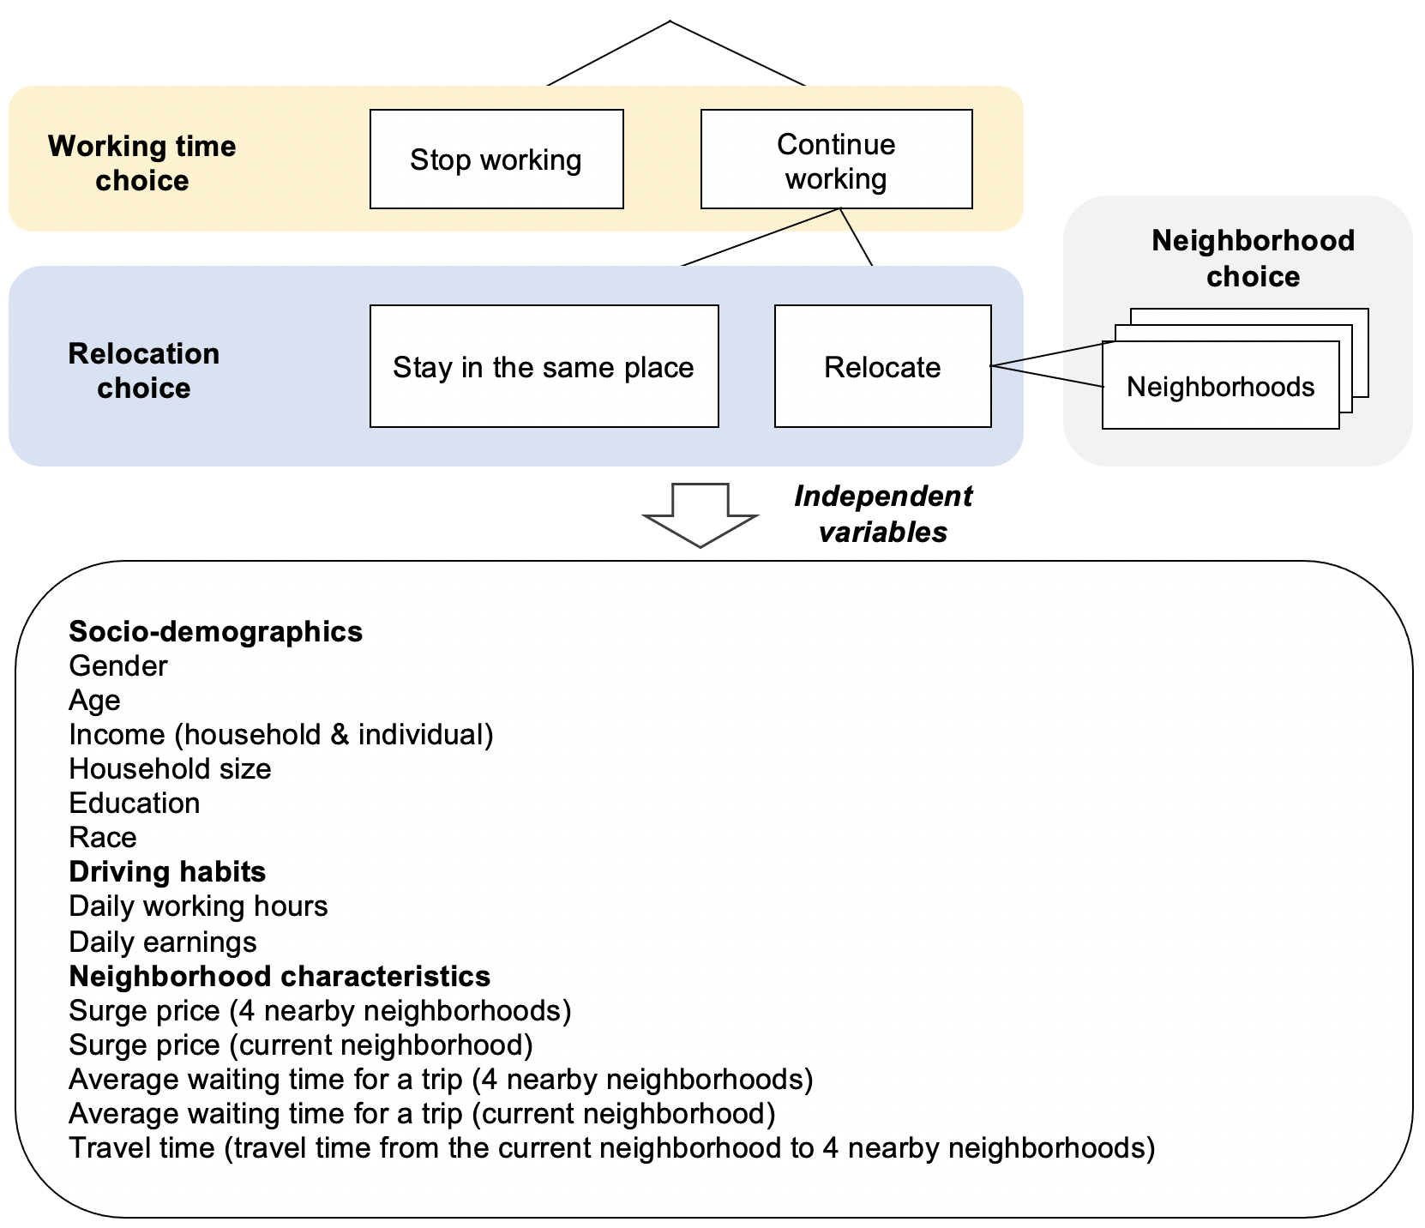
Figure 3.1. Structure of nested logit model

Response to request
We plan to apply a binary logit model to understand response to a request, that is, to accept or reject the request when the driver is assigned a trip. Independent variables include trip features, driving habits, and socio-demographics. Figure 3.2 shows the structure of the binary logit model.
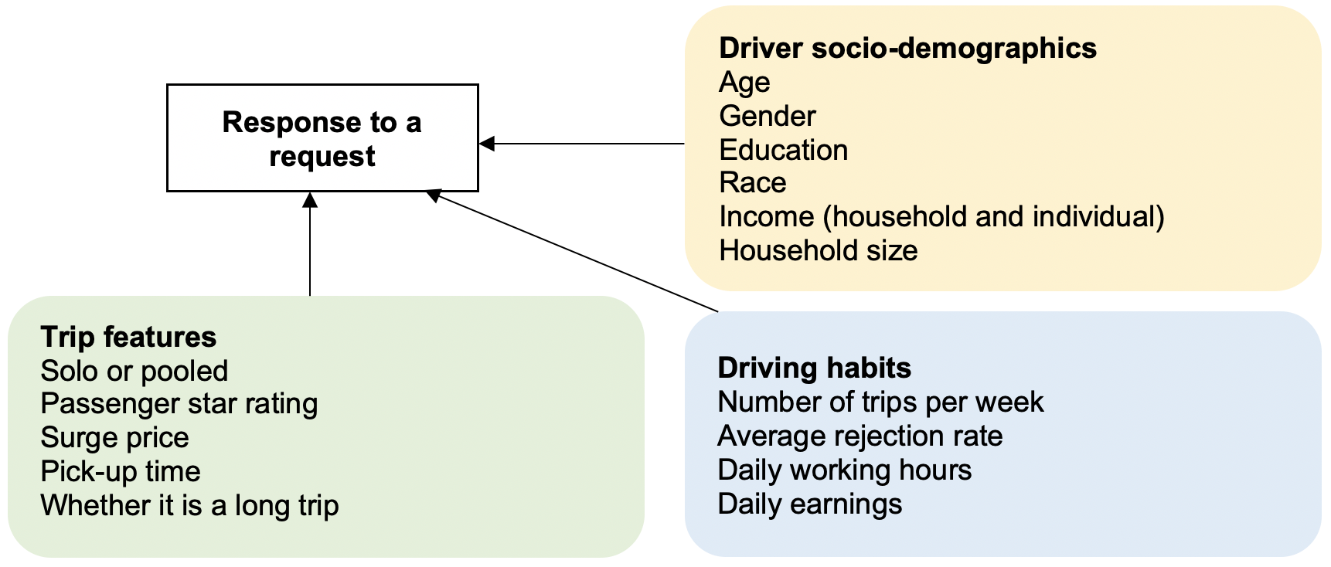
Figure 3.2. Structure of the binary logit model

Survey technical design

Survey structure
The survey consists of 3 sections (Figure 3.3). Section 1 asks the basic driving information of the TNC drivers, and the answers will be used as parameters in Section 2. Section 2 is the choice experiment section where respondents face multiple choice scenarios on both (1) working time and relocation choice and (2) response to a request choice. The purpose of the experiment is to test the causal relationship between driver choices and variables of interest. The detailed choice scenarios are presented in the next session “Experimental design”. Section 3 includes individual and household socio-demographic questions. The questionnaire is shown in the Appendix.
Several points related to survey design deserve clarification: (1) though this survey was implemented during COVID-19, we do not consider the impacts of COVID-19 on ridehailing driver behaviors. The major reason is that though ridehailing driver behaviors are different than in the normal times during the COVID-19 pandemic, many of the changes are caused by demand change during the pandemic. The effects of COVID-19 will also be discussed in Interview design and implementation. (2) We used the term “ridesharing” instead of “ridehailing” in the questionnaire because drivers are more familiar with it. (3) We also conducted a pilot interview section with multiple ridehailing drivers before we designed the survey, to ensure we had captured the most important variables, terminology, etc. The interview protocol is shown in the Appendix.
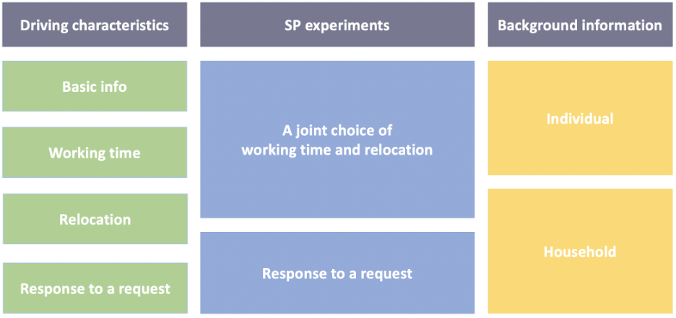
Figure 3.3. Survey structure

Experimental design
The experimental design is divided into two parts: (1) working time and relocation choice and (2) response to a request. For each respondent, we generate 6 choice situations for each choice type.

Working time and relocation choice
As shown in Figure 3.1, we have two levels of choices. At the top level (working time choice), a driver can decide whether to stop or continue working. We have three experimental variables including (1) daily earnings, (2) daily working hours, and (3) ridehailing demand in the current neighborhood.
At the bottom level (relocation choice), we suppose a driver can choose between staying in the current neighborhood or relocating to one of four nearby neighborhoods. We treat these neighborhoods as unlabeled alternatives, meaning they are assumed to be identical except for the experimental variables. We do not include real-world neighborhood characteristics (e.g., neighborhood name) therefore the same survey can be used to collect data in other cities. Each neighborhood has two experimental variables (ridehailing demand and relocation time), and there are a total of 8 variables at the bottom level. Table 3.1 shows the variable descriptions and Table 3.2 shows the variable levels.
Table 3.1. Descriptions of experimental variables
Level | ID | Attributes | Descriptions
Working time choice | 1 | Daily earnings | Target earnings on a typical day. Base earning is acquired from Survey Section 1. If the respondent have not fixed daily earnings, we assume the base earning to be $100.
Working time choice | 2 | Daily working hours | Expected number of working hours on a typical day. Base time is acquired from Survey Section 1. If the respondent does not have a fixed number of working hours, we assume the base time to be 8 hours.
Working time choice | 3 | Ridehailing demand (current neighborhood) | Represents the demand for ridehailing services in the current neighborhood. Measured jointly by surge price (in dollars) and average waiting time for a trip request (in minutes). Higher demand areas have lower waiting times and higher surge price and vice versa.
Relocation choice | 4-7 | Ridehailing demand (nearby neighborhoods) | Represents the demand for ridehailing services in nearby neighborhoods. Measured jointly by surge price (in dollars) and average waiting time for a trip request (in minutes). Higher demand areas have lower waiting times and higher surge price and vice versa.
Relocation choice | 8-11 | Relocation time | Describes the travel time from the current neighborhood to the destination neighborhood, in minutes.

Table 3.2. Experimental attribute levels
ID | Attributes |  | Levels
1 | Daily earnings ($) |  | 0.4*  base earning |  | 0.7*  base earning |  |  | 1*  base earning |  |  | 1.3*  base earning |  |  | 1.6*  base earning
2 | Daily working hours (h) |  | 0.4*  base time |  | 0.7*  base time |  |  | 1*  base time |  |  | 1.3*  base time |  |  | 1.6*  base time
3-7 | Ridehailing demand | Surge price ($) | 16 | 12 |  | 8 | 4 |  | 0 | 0 |  | 0 | 0 |  | 0
3-7 | Ridehailing demand | Average waiting time (min) | 0 | 0 |  | 0 | 0 |  | 0 | 8 |  | 16 | 24 |  | 30
8-11 | Relocation time (min) |  | 4 |  | 8 |  |  | 12 |  |  | 16 |  |  | 20

Response to a request
A total of 5 experimental variables are included for “response to a request”, including ridehailing demand, relocation time, passenger ratings, mode (solo or shared), and whether it is a long trip. The variable descriptions are shown in Table 3.3 and levels in Table 3.4.
The experimental design is conducted as follows. First, we generate the full matrix of combinations of the attributes and levels. Next, we created blocks of 6 combinations for each respondent.
Table 3.3. Descriptions of experimental variables
Attributes | Definition
Ridehailing demand | Represents the demand for ridehailing services. Measured jointly by surge price (in dollars) and average waiting time for a trip request (in minutes). Higher demand areas have lower waiting times and higher surge price and vice versa.
Passenger pick-up time | Describes the time to pick up the passenger, in minutes.
Passenger ratings | Average rating the passenger received from drivers, ranging from 0 to 5.
Mode | Whether the trip is a solo or shared trip.
Long trip | If the trip is over 45 minutes, 1; otherwise, 0

Table 3.4. Experimental attribute levels
ID | Attributes |  | Levels
1 | Ridehailig demand | Surge price ($) | 16 | 12 |  | 8 | 4 |  | 0 |  | 0 |  | 0 | 0 |  | 0
1 | Ridehailig demand | Average waiting time (min) | 0 | 0 |  | 0 | 0 |  | 0 |  | 8 |  | 16 | 24 |  | 30
2 | Relocation time (min) |  | 4 |  | 8 |  |  | 12 |  |  |  | 16 |  |  | 20
3 | Passenger ratings |  | 4.1 |  | 4.3 |  |  | 4.5 |  |  |  | 4.7 |  |  | 4.9
4 | Mode |  | Shared |  |  |  |  |  |  | Solo
5 | Long trip |  | Yes |  |  |  |  |  |  | No

Survey Implementation
The survey was administered to ridehailing drivers in the Seattle WA region in August-September 2021. Our team encountered significant challenges in recruiting drivers to participate in the survey before finding a successful approach. In the end, we obtained responses from approximately 230 drivers.

Survey administration
In this section, we discuss some of the practical challenges and lessons learned about recruiting ridehailing drivers for survey research. Specifically, we address the following three questions:
- What are the challenges encountered in recruiting ridehailing drivers for survey completion?
- How do we resolve these challenges?
- What are the differences in effectiveness between data collection approaches?

Challenges and solutions

Low response rate
Low response rate was the most challenging issue we encountered in recruiting ridehailing drivers. After interviewing multiple ridehailing drivers, three main reasons are identified for the low response rate: (1) Ridehailing drivers do not trust surveys and interviews. The most frequently asked questions when administering the survey are “what is the purpose of the study” and “do you work for Lyft or Uber”. Their major concern is that the responses will be used by TNC companies and therefore their rights will be harmed. Another concern is that drivers worry that their phone will be hacked by exposing their personal information. (2) Ridehailing drivers receive a lot of spams every day. This is especially true when we tried to access drivers via online channels (e.g., Facebook Ads, text messages) – it’s possible the survey invitations were treated as spams. (3) Ridehailing drivers do not use social media when they are driving, thus the chance is smaller to recruit them via posting the survey invitation on social medias like Facebook or online forums, compared to the general population. To improve the response rate, we adopted several strategies:

Administering the survey via multiple channels
We administered the survey via three channels: online, in-person, and personal connections. The detailed descriptions are shown in Table 3.5. The online channel included paid ads on Facebook and other Facebook-owned sites, online forums, and sending out survey invitations via text messages. The in-person channel included recruiting drivers at the airport ridehailing waiting area and via hailing rides. Personal connections included involving the Seattle Rideshare Drivers Association, asking drivers to share the survey with their driver friends, and inviting the drivers from the pilot interviews to complete the survey.
Table 3.5. Survey administration approaches
Administration approach | Description
Online channel
Facebook Ad | A Facebook Ad was launched from Aug 11 to 20 (10 days). The people who click the Ad were directed to the project website (MacKenzie, 2021). There, they were asked to complete an eligibility form (~2 minutes). If they are eligible, a survey link will be sent to their Email. The eligibility issue will be discussed in Section 3.2, uncertain data quality.
Online forums | A brief project introduction and survey invitation was published in Uber Driver’s Forum and RideShare Forum. They are asked to complete an eligibility form (~2 minutes). If they are eligible, a survey link will be sent to their Email.
Text messages | Phone numbers of potential ridehailing drivers were collected from Seattle business licensing website by searching key words “TNC”, “Uber”, “Lyft”, and also two categories “all other ground transportation” and “taxi services”. The project website is attached in the end of the text message (MacKenzie, 2021). People who click the website link were asked to complete an eligibility form (~2 minutes). If they are eligible, a survey link will be sent to their Email.
In-person channel
Airport: with and without computer assistance | Research assistants were asked to invite ridehailing drivers waiting at the Sea-Tac airport staging areas to complete the survey. If drivers complete the survey on site, RAs were able to help when necessary. If drivers expressed interest but have no time to complete the survey, research assistants would give them a flyer with the project introduction, survey link and QR code. Drivers can complete it in their free time without assistance.
Hail rides: with and without computer assistance | Research assistants were asked to hail rides in two high-demand areas of Seattle (U district and downtown) and asking drivers to complete the survey during and after the ride. If drivers complete the survey on site, RAs were able to help when necessary. If drivers expressed interest but have no time to complete the survey, research assistants will give them a flyer with the project introduction, survey link and QR code. Drivers can complete it in their free time without assistance.
Personal connections
Seattle Rideshare Driver’s Association | Seattle Rideshare Drivers Association (aka ridehailing drivers’ union), an organization aiming at fighting for ridehailing drivers’ rights, also helped to send out surveys to their members via email.
Drivers’ Friends | Respondents were asked to share the survey information with their ridehailing driver friends after completing the survey.
Previous interview respondents | We also sent emails to the respondents from previous Pilot interviews and ask them to complete the survey.

Gaining trust
One critical reason ridehailing drivers are reluctant to participate is that they do not trust the survey recruiters. To solve this issue, we created a webpage using the domain of University of Washington (UW) describing the research project (MacKenzie, 2021), leveraging the UW’s position as a trusted institution in Washington State. When we recruited drivers online, potential respondents were directed to the project webpage and checked for more information. We also explicitly explained the purpose of this study when recruiting drivers online and in person.
Another important aspect is to ensure respondents’ anonymity. It’s effective to explicitly explain that all information they provide will be anonymous and will not be used for any other purposes than this research project. When recruiting ridehailing drivers in person, physical gift cards might work better than digital ones since they do not need to provide contact information.

Increasing the incentives
Amazon and Walmart gift cards were used as survey incentives. The survey incentive initially was set to be $15 per response, and was varied between $10 and $20. However, increasing the incentive amount was not effective in attracting more respondents. The response rate (both via online and in person recruitment) was roughly the same when we change the incentive from $10 to $15 and $20. Other evidence that most ridehailing drivers are insensitive in incentives is (1) some drivers completed the survey voluntarily, saying that they have no need for $10~20, and (2) only around 70 out of 230 retrieved their digital gift cards after completing the survey.

Uncertain data quality
One drawback of the survey is that the data quality can be uncertain. In this section, five major data quality issues and corresponding solutions are introduced.

Verify the ridehailing drivers
One challenge was verifying whether respondents are actually ridehailing drivers. It might be possible that: (1) some non-ridehailing drivers are interested in the survey incentives; and (2) ridehailing drivers may share the survey link with their non-ridehailing driver friends. To verify ridehailing drivers, we asked them to provide their King County for-hire driver’s permit number in the survey and verify them on the King County government website. (Permit numbers were not retained or linked to individual responses.) This strategy could be applied in other cities with similar permitting provisions such as Chicago and Los Angeles.

Comprehension checks
To make sure respondents understand the choice scenarios, we included two comprehension check questions in the survey. For each comprehension question, we asked the respondent to choose the correct meaning of a highlighted number in a choice scenario. Every respondent can answer each of the comprehension questions twice. They could only proceed if they answered them correctly, otherwise the survey was terminated.

Attention check
There is one attention check in the survey. In the choice scenario section, the respondent was asked to choose the option that fulfills the description in the question in a given choice scenario (Figure 3.4).
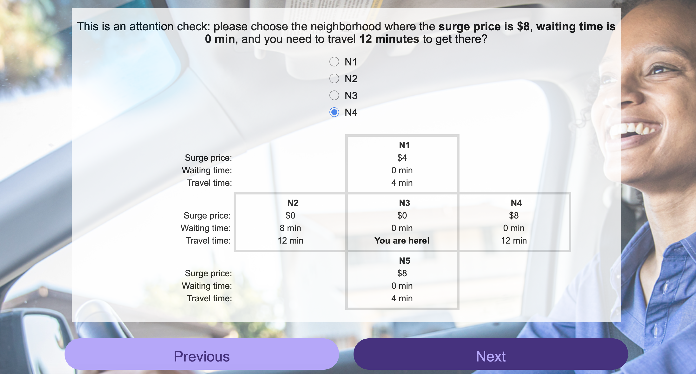
Figure 3.4. Attention check

Logic checks
We applied three logic checks in the survey. In the Background information section, we asked respondents the number of people and children in their household, their annual income (both household and individual), and the number of trips (both rejected and accepted) last week. The three logic checks are (1) number of people in a household should be equal or larger than number of children under 18; (2) annual household income should be equal or larger than individual income; and (3) weekly number of trips rejected must be smaller than total number of trips they completed. Responses failing both the attention and logic checks were removed.

Representativeness
Representativeness means the extent to which the sample can represent the ridehailing driver population. A biased sample can lead to biased and therefore unreliable findings. For example, if we only recruit drivers from one source, say Sea-Tac airport, the sample would bias towards those who live in South Seattle and those who prefer long trips. This is likely to remain as a significant limitation of our data set.

Data collection approach comparison
The data collection process spanned from August 11 to September 9 and 230 responses were collected. In this section, we compare the effectiveness of multiple data collection approaches in the following dimensions: average monetary cost and time cost, and response rate for verified drivers. Table 3.6 shows the comparison results.
Online administration was the most ineffective approach in recruiting ridehailing drivers, due to its very low response rate. We spent $253 in Facebook advertisements over 10 days, but only two verified ridehailing drivers responded and completed the survey. No verified drivers responded from online driver forums. Only one verified driver responded to the text message and completed the survey. Along with the low response rate, another downside of using online administration is that they attract more unverified drivers than verified real ones.
In-person recruitment was the most effective one among three approaches. Recruiting at the airport with computer assistance had the highest response rate. The monetary and time costs were the lowest – only $15 survey incentives and 15-minute computer assistance time. Hailing rides with computer assistance has the second highest response rate but the monetary and time costs were higher – around $25 and 25 minutes higher – because we need to take and pay for the rides. Airport and hailing rides without computer assistance have low response rates. No drivers from the airport completed the survey later, while only 2 out of 15 drivers recruited via hailing rides completed the survey later on.
Recruitment via personal connections did not work well in general. Only 3 respondents from previous interview pilot responded and completed the survey.
Table 3.6. Comparison of different survey administration approaches
Administration approach | Average monetary cost/response (in dollars) | Average time cost/response (in mins) | Response rate (verified drivers)
Online channel
Facebook | $126.50 | 0 | 4
Online forums | 0 | 0 | 0
Text messages | 0 | 0 | 16/1000
In person channel
Airport: with computer assistance | $15 | 15 | 200
Airport: without computer assistance | $15 | 0 | 0
Hail rides: with computer assistance | $32.50 | 32.5 | 4/7
Hail rides: without computer assistance | $90 | 75 | 2/15
Personal connection channel
Seattle Rideshare Driver’s Association | $15 | 0 | 0
Drivers’ Friends | $15 | 0 | 0
Email to previous interview respondents | $15 | 0 | 3

REFERENCE [DRIVER DATA COLLECTION]
Agarwal, S., Diao, M., Pan, J., Sing, T.F., 2013. Labor Supply Decisions of Singaporean Cab Drivers. SSRN Electron. J. https://doi.org/10.2139/ssrn.2338476
Angrist, J., Caldwell, S., Hall, J., 2017. Uber vs. Taxi: A Driver’s Eye View (No. w23891). National Bureau of Economic Research, Cambridge, MA. https://doi.org/10.3386/w23891
Brodeur, A., Nield, K., 2016. Has Uber made it Easier to get a Ride in the Rain? 30.
Brown, A.E., 2019. Prevalence and Mechanisms of Discrimination: Evidence from the Ride-Hail and Taxi Industries. J. Plan. Educ. Res. 0739456X1987168. https://doi.org/10.1177/0739456X19871687
Chaudhari, H.A., Byers, J.W., Terzi, E., 2018. Putting Data in the Driver’s Seat: Optimizing Earnings for On-Demand Ride-Hailing, in: Proceedings of the Eleventh ACM International Conference on Web Search and Data Mining. Presented at the WSDM 2018: The Eleventh ACM International Conference on Web Search and Data Mining, ACM, Marina Del Rey CA USA, pp. 90–98. https://doi.org/10.1145/3159652.3159721
Crawford, V.P., Meng, J., 2011. New York City Cab Drivers’ Labor Supply Revisited: Reference-Dependent Preferences with Rational-Expectations Targets for Hours and Income. Am. Econ. Rev. 101, 1912–1932. https://doi.org/10.1257/aer.101.5.1912
Farber, H.S., 2005. Is Tomorrow Another Day? The Labor Supply of New York City Cabdrivers. J. Polit. Econ. 113, 46–82. https://doi.org/10.1086/426040
Ge, Y., Knittel, C.R., MacKenzie, D., Zoepf, S., 2020. Racial discrimination in transportation network companies. J. Public Econ. 190, 104205. https://doi.org/10.1016/j.jpubeco.2020.104205
Henao, A., Marshall, W.E., 2019. An analysis of the individual economics of ride-hailing drivers. Transp. Res. Part Policy Pract. 130, 440–451. https://doi.org/10.1016/j.tra.2019.09.056
MacKenzie, D., 2021. Ridesharing Driver Survey [WWW Document]. Sustain. Transp. Lab. URL https://sites.uw.edu/stlab/ridesharing-driver-survey/ (accessed 8.23.21).
Morris, E.A., Zhou, Y., Brown, A.E., Khan, S.M., Derochers, J.L., Campbell, H., Pratt, A.N., Chowdhury, M., 2020. Are drivers cool with pool? Driver attitudes towards the shared TNC services UberPool and Lyft Shared. Transp. Policy 94, 123–138. https://doi.org/10.1016/j.tranpol.2020.04.019
Sun, H., Wang, H., Wan, Z., 2019. Model and analysis of labor supply for ride-sharing platforms in the presence of sample self-selection and endogeneity. Transp. Res. Part B Methodol. 125, 76–93. https://doi.org/10.1016/j.trb.2019.04.004
Xu, K., Sun, L., Liu, J., Wang, H., 2018. An empirical investigation of taxi driver response behavior to ride-hailing requests: A spatio-temporal perspective. PLOS ONE 13, e0198605. https://doi.org/10.1371/journal.pone.0198605
Xu, Z., A.M.C. Vignon, D., Yin, Y., Ye, J., 2020. An empirical study of the labor supply of ride-sourcing drivers. Transp. Lett. 1–4. https://doi.org/10.1080/19427867.2020.1788761

COVID data collection

Study overview
Our team has now conducted two waves of a survey of Puget Sound Area residents about the impacts of the COVID-19 pandemic on their travel patterns. We have asked about recollections of pre-pandemic travel, current travel, and expectations for post-pandemic travel. The first wave of the survey was conducted in June-July 2020, the second wave in February-March 2021, and a third wave is planned for September 2021. This remainder of this section focuses primarily on an analysis of changes in transit ridership reported in wave 1 of the survey and a comparison of the characteristics of those who plan to return to transit post-pandemic versus those who do not.

COVID – transit work

Summary
We identified six groups of respondents characterized by their transit use frequency before, during, and after the pandemic. We focus primarily on the group lost riders: those who used transit frequently pre-pandemic but expect to ride less post-pandemic. We try to answer the following three questions: Who are they? What is their attitude towards taking transit? Where would they go after the pandemic, if they do not expect to return to transit? We found that they account for 28% of transit riders in our sample. Compared with rebounding frequent riders, who expect to return to heavy transit use post-pandemic, lost transit riders are older and wealthier; no significant attitudinal differences towards taking transit are found between two groups. Though they would not return to transit post-pandemic, lost riders would not switch to other travel modes either. Instead, they expect to reduce travel frequency by 3.4 days per week, mainly due to increasing working from home (WFH) frequency by 1.6 days per week, on average.

Clustering transit rider groups
To group respondents based on their transit usage, we adopted a bottom-up clustering approach in two steps. In each step, eight clustering methods (K-means, K-medians, complete linkage, single linkage, centroid linkage, average linkage, Ward and Ward2) are applied to detect different transit rider groups based on three variables: days of transit use per week (1) before the pandemic, (2) during the pandemic, and (3) expected frequency of transit use after the pandemic. For ease of interpretation, we converted the ordinal travel frequencies into numerical values (we do so throughout the remainder of the paper). For each clustering method, the number of clusters, K, changes from 2 to 10. In total, there were 72 combinations of clustering methods and K. To determine the best combination, 26 clustering quality indices were adapted from Helmus et al. (2020) which are provided in the Appendix. Based on its own criterion, every index votes for the optimal clustering method and number of clusters, K. The combination with the largest number of votes is selected as the optimal option. More details about implementing clustering and quality check can be found in the R package NbCluster (Charrad et al., 2014).
In the first step, using the entire dataset, our clustering approach resulted in the optimal clustering algorithm being K-means and the number of clusters equal to two: non-transit riders (N = 1,106) and transit riders (N = 204). In the second step, the same clustering approach was performed on the 204 transit riders. This time, the single linkage method with K = 5 was selected as the optimal combination. This resulted in a total of six clusters listed below. The days of transit use of each cluster before, during, and after the pandemic are also shown in Figure 4.1.
Non-transit users. Most respondents (84.4%) are identified as non-transit users. They almost never used transit, and never would.
Lost transit riders. This group includes transit riders who are reluctant to ride transit after the pandemic and accounts for 28% of total transit riders in our sample (i.e., excluding the non-transit riders). They rode transit daily before the pandemic and expect to ride it only 2 days per week after the pandemic, on average.
Rebounding frequent riders. Rebounding transit riders are people whose transit use would rebound to the previous level. Rebounding frequent riders are heavy transit riders who reported daily transit use before the pandemic. They depressed their transit use to zero during the pandemic but expect to rebound to daily use. They account for 36% of transit riders.
Rebounding moderate riders. Rebounding moderate riders are transit riders whose transit use frequency were moderate before the pandemic. They used transit 3.5 days per week on average before and expect to do the same after the pandemic, though they were not riding during the pandemic. Rebounding moderate riders accounted for 24% of transit riders.
Rebounding higher riders. Rebounding higher riders depressed their transit use during the pandemic, but they expect an increased transit riding frequency when it ends. They account for 10% of the transit users.
Loyal transit riders. Loyal transit riders have high transit riding frequency, even during the pandemic, and expect to keep it at that level after it ends. However, only 3 respondents, or less than 2% of our sample, fell into this category.
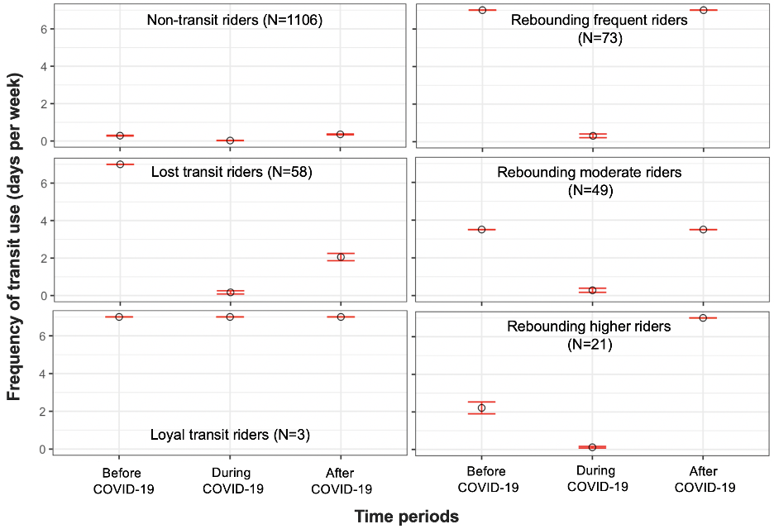
FIGURE 4.1 Transit rider groups derived by the clustering approach and their corresponding transit riding frequency
Note: Black circles are average values, and red lines are error bars representing 95% confidence intervals (CI) for the means

Who are they?
Lost riders and rebounding frequent riders were both heavy transit riders that reduced their transit use to near zero but expect to part ways after the pandemic. Why would lost riders not return to transit as rebounding frequent riders do? To unravel this puzzle, we present the socio-demographics of both groups. We used the Fisher’s exact test to assess the distribution differences between the two groups. The Fisher’s exact test is especially useful for data with small sample sizes (an expected frequency less than 5).
The age and income differences between the two groups are found significant. Both groups are relatively young, with 60% of lost riders and 80% of rebounding frequent riders between the age of 18 to 39. Although both groups skew younger than our sample as a whole, the lost riders have a lower percentage of respondents between 18 to 39 and a higher percentage of respondents above 65 compared with the rebounding frequent riders. The lost riders also have higher income than rebounding frequent riders, which is reflected in the higher percentage of high-income respondents (annual income >= $100,000). No significant differences are detected between these two groups considering race and whether they were an essential worker.
TABLE 4.1 Socio-demographics of Lost Transit Riders and Rebounding Frequent Riders
Attributes |  | Lost riders (N=58) | Rebounding frequent riders (N=73)
Age** | 18-39 | 60% | 80%
Age** | 40-64 | 33% | 20%
Age** | >=65 | 7% | 0%
Income* | < $50,000 | 14% | 25%
Income* | $50,000-$99,999 | 21% | 29%
Income* | >= $100,000 | 65% | 47%
Race | White | 62% | 67%
Race | Asian | 17% | 25%
Race | African American | 3% | 3%
Race | Other | 17% | 6%
Essential worker | Yes | 7% | 8%
Essential worker | No | 93% | 92%
Note: * difference between 2 groups is significant at 10% level, ** significant at 5% level, Fisher’s exact test.

What is their attitude towards taking transit?
In this section we compare attitudes towards taking transit in lost riders and rebounding frequent riders. Table 4.2 compares those attitudes between the two groups using a Wilcoxon rank-sum test, which is commonly used for comparing two distributions of ordinal variables or two independent samples that are not normally distributed. The results show that both groups are unwilling to take transit during the pandemic. However, no significant attitudinal differences towards taking transit are discovered between the two groups. The results indicate that lost transit riders do not perceive riding transit as riskier than rebounding frequent riders do; both groups would not travel on a crowded bus, even when physical distancing measures are taken; and they both try to use transportation options that allow them to avoid contact with others. The attitudes towards taking transit partly explain respondents’ transit use change during the pandemic and might not be the reason why lost riders would not return to transit after the pandemic.
TABLE 4.2 Attitudes Towards Taking Transit for Lost Transit Riders and Rebounding Frequent Riders
Attitudes towards taking transit |  | Lost transit riders  (N = 58) | Rebounding frequent riders (N=73)
Q1: Traveling by bus or light rail poses a risk to my health | Strongly disagree | 0% | 3%
Q1: Traveling by bus or light rail poses a risk to my health | Disagree | 9% | 4%
Q1: Traveling by bus or light rail poses a risk to my health | Somewhat disagree | 3% | 3%
Q1: Traveling by bus or light rail poses a risk to my health | Somewhat agree | 19% | 26%
Q1: Traveling by bus or light rail poses a risk to my health | Agree | 28% | 27%
Q1: Traveling by bus or light rail poses a risk to my health | Strongly agree | 41% | 37%
Q2: I don’t mind traveling on a crowded bus | Strongly disagree | 69% | 62%
Q2: I don’t mind traveling on a crowded bus | Disagree | 19% | 19%
Q2: I don’t mind traveling on a crowded bus | Somewhat disagree | 9% | 11%
Q2: I don’t mind traveling on a crowded bus | Somewhat agree | 2% | 6%
Q2: I don’t mind traveling on a crowded bus | Agree | 2% | 1%
Q2: I don’t mind traveling on a crowded bus | Strongly agree | 0% | 1%
Q3: I try to use transportation options that allow me to avoid contact with other people | Strongly disagree | 2% | 0%
 | Disagree | 4% | 1%
 | Somewhat disagree | 2% | 6%
 | Somewhat agree | 10% | 6%
 | Agree | 21% | 29%
 | Strongly agree | 62% | 59%
Q4: I would travel by bus or light rail if physical distancing measures are enforced | Strongly disagree | 12% | 11%
 | Disagree | 16% | 12%
 | Somewhat disagree | 9% | 10%
 | Somewhat agree | 26% | 30%
 | Agree | 17% | 22%
 | Strongly agree | 21% | 15%

Where would they go after the pandemic?
Finally, we discuss where lost riders would go, if they do not expect to return to transit after the pandemic.
Switching to private cars.
If people would not use transit as much as before, could it be because they expect to turn to private cars as some researchers suspect (Gillingham et al., 2020; Wang et al., 2021)? The results show that expected driving frequency remains moderate, shifting from 2.1 days per week pre-pandemic to 2.4 days per week post-pandemic. A Wilcoxon rank sum test shows the difference is insignificant (Figure 4.2). This modest shift toward private cars does not explain the large reduction in expected transit use frequency post-pandemic.
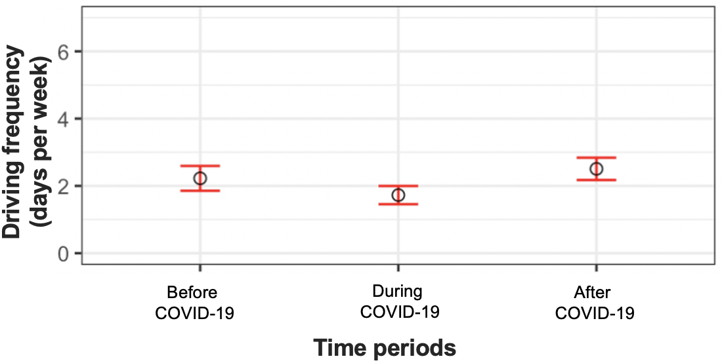
FIGURE 4.2 Driving alone frequency of lost transit riders
Note: **difference between before and after COVID-19 is significant in 5% level, Wilcoxon rank sum test; black circles are average values; red lines are error bars representing 95% CI for the means

Switching to other modes.
People may switch from transit to other transportation modes like carpooling and biking. Figure 4.3 shows the travel frequency of other modes for lost transit riders in pre-, during-, and post-pandemic times. No modes saw a significant change in travel frequency between before and after the pandemic, ruling out the possibility that lost transit riders mainly would expect to switch to other travel modes. But if they would not switch to other travel modes, where would they go?
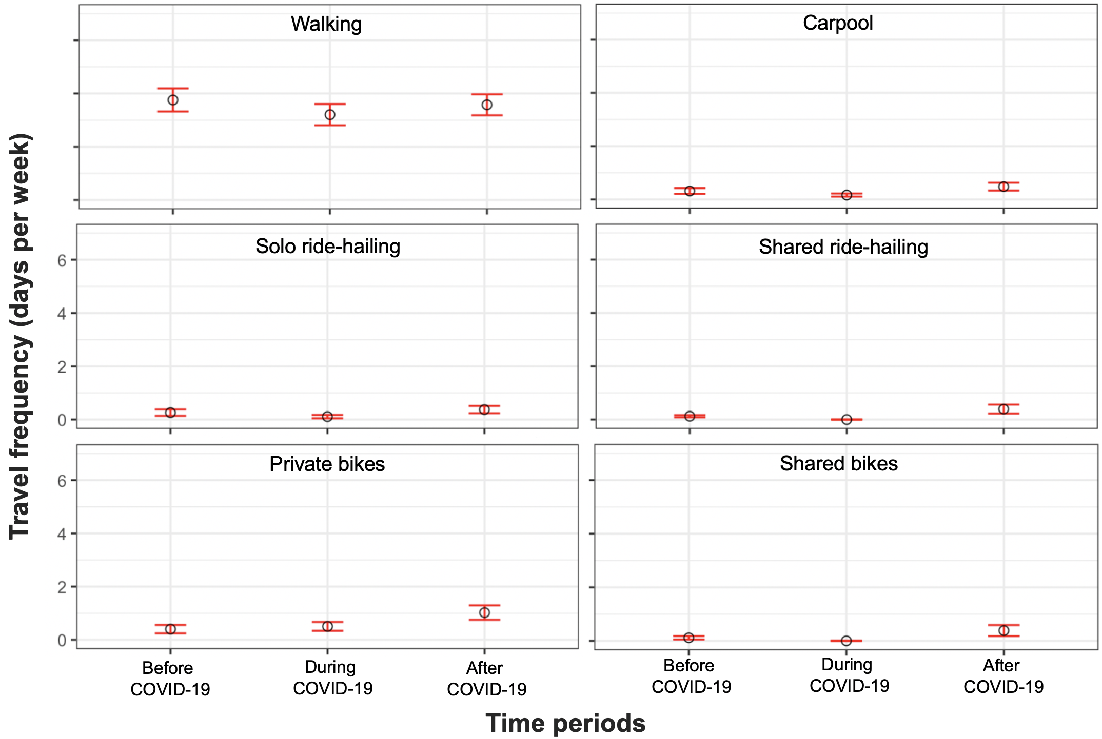
FIGURE 4.3 Travel frequency of alternative modes of lost transit riders
Note: ** difference between before and after COVID-19 is significant in 5% level, Wilcoxon rank sum test; black circles are average values; red lines are error bars representing 95% CI for the means
Reducing travel.
Another possibility is that people expect to reduce their amount of travel post-pandemic (Figure 4.4). We calculated overall frequency of travel as the sum of travel frequencies made by each mode, and therefore some values unintuitively are larger than 7 days a week. A drop in overall travel frequency is most visible from before pandemic to during the pandemic, when the lost riders reported a reduction of 8.3 days per week in overall travel frequency. After the pandemic, the expected overall travel frequency would rebound to 10.8 days per week, with a significant decrease of 3.4 days per week than the pre-pandemic. It is possible that lost transit riders reduce some of their activities entirely, yet a big part of the travel frequency reduction is likely to be caused by the availability of information communication technologies (ICT) as discussed in the next section.
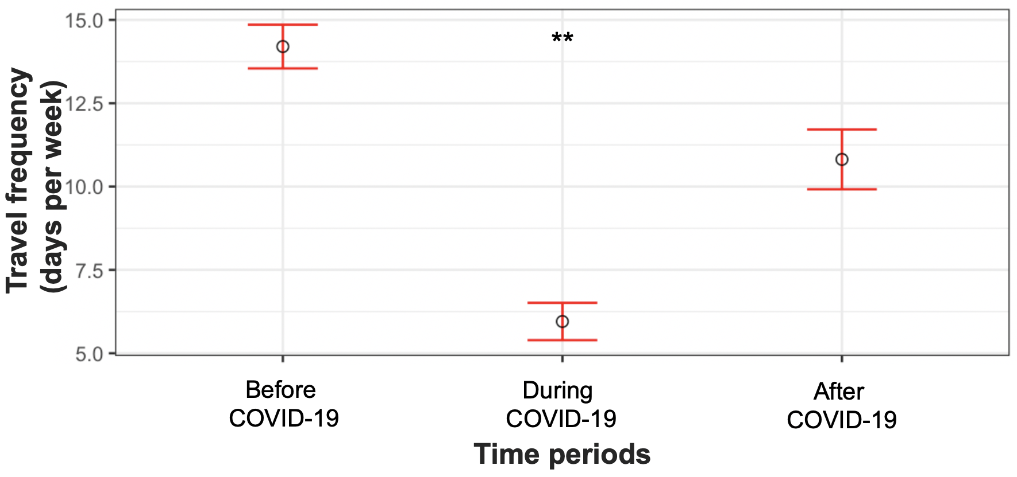
FIGURE 4.4 Overall frequency of travel across all modes for lost transit riders
Note: ** difference between before and after COVID-19 is significant in 5% level, Wilcoxon rank sum test; black circles are average values; red lines are error bars representing 95% CI for the means

The use of information communication technology (ICT).
As COVID-19 brings sharp reduction in physical travel, the availability of ICT enables online activities that could replace in-person trips to some degree. In this section, we mainly include working from home and engagement in e-commerce (online shopping and online food delivery) as activities replacing in-person trips.
Working from home (WFH), or telecommuting, has been long discussed as a future possibility after the telephone was invented to enable long-distance communications in the 19th century (Mokhtarian, 2009). With 288 million internet users in the US (Kemp, 2020), a recent report finds that 37% of the jobs in the US can be completely replaced by working from home (Dingel and Neiman, 2020). And Washington State’s Stay home, stay healthy order during the pandemic makes WFH a reality (Herz and Vandor, 2020).
This is also reflected in our results (Figure 4.5). In general, WFH frequency pre-pandemic averaged 0.7 days per week, which increased to 3.1 days per week during the pandemic. For lost transit riders, the frequency of WFH was 0.6 days before the pandemic, showing that lost transit riders barely worked from home in normal times. During the pandemic, they work from home 4 days per week on average. Their expected WFH frequency decreases after the pandemic to 2.1 days per week, still much higher than that in pre-pandemic times. The difference of WFH frequency between before and after pandemic times is found significant by using a Wilcoxon rank sum test.
Other ICT use such as online grocery shopping, other-purpose online shopping and online food delivery indicate little changes between before and after pandemic times. Lost riders have slightly higher frequency in these online activities during the pandemic, but they expect to return to their previous levels of use when the pandemic is over. One thing worth noting is that the data were collected in June/July 2020, early in the stage of staying at home. The expected frequency of various ICT use after the pandemic could be higher as people become accustomed to the quarantine life and are dependent on using communication technologies – or could be lower due to fatigue with virtual interactions.
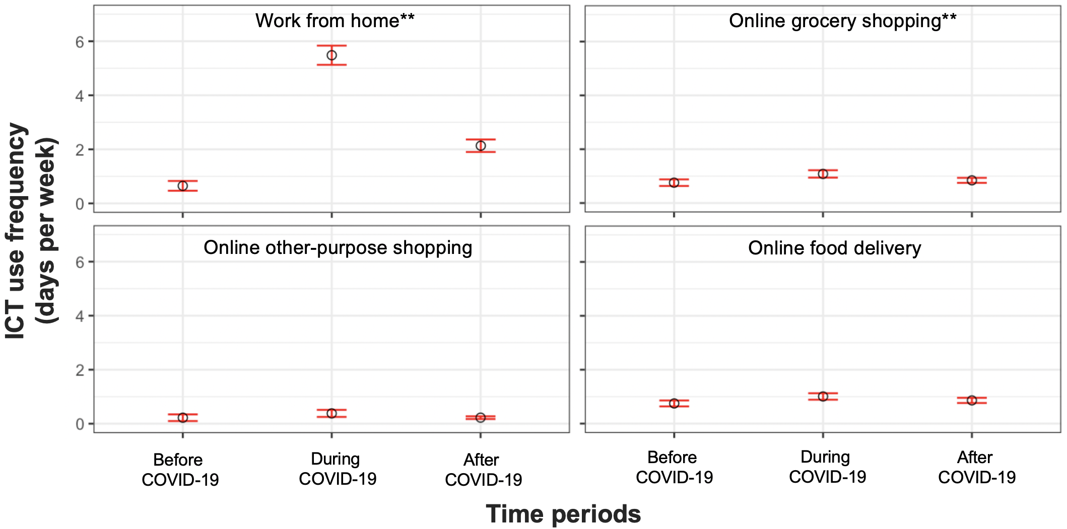
FIGURE 4.5 The ICT use frequency for lost transit riders
Note: ** difference between before and after COVID-19 is significant in 5% level, Wilcoxon rank sum test; black circles are average values; red lines are error bars representing 95% CI for the means

REFERENCE [COVID AND TRANSIT]
Charrad, M., Ghazzali, N., Boiteau, V., Niknafs, A., 2014. NbClust: An R Package for Determining the Relevant Number of Clusters in a Data Set. J. Stat. Softw. 61. https://doi.org/10.18637/jss.v061.i06
Dingel, J.I., Neiman, B., 2020. How Many Jobs Can be Done at Home? (No. w26948). National Bureau of Economic Research. https://doi.org/10.3386/w26948
Gillingham, K.T., Knittel, C.R., Li, J., Ovaere, M., Reguant, M., 2020. The Short-run and Long-run Effects of Covid-19 on Energy and the Environment. Joule 4, 1337–1341. https://doi.org/10.1016/j.joule.2020.06.010
Helmus, J.R., Lees, M.H., van den Hoed, R., 2020. A data driven typology of electric vehicle user types and charging sessions. Transp. Res. Part C Emerg. Technol. 115, 102637. https://doi.org/10.1016/j.trc.2020.102637
Herz, K., Vandor, J., 2020. Washington State Issues “Stay Home — Stay Healthy” Order | Davis Wright Tremaine [WWW Document]. URL https://www.dwt.com/blogs/employment-labor-and-benefits/2020/03/washington-state-stay-at-home-order (accessed 2.22.21).
Kemp, S., 2020. Digital 2020: The United States of America [WWW Document]. DataReportal – Glob. Digit. Insights. URL https://datareportal.com/reports/digital-2020-united-states-of-america (accessed 2.22.21).
Mokhtarian, P., 2009. If telecommunication is such a good substitute for travel, why does congestion continue to get worse? Transp. Lett. 1, 1–17. https://doi.org/10.3328/TL.2009.01.01.1-17
Wang, D., He, B.Y., Gao, J., Chow, J.Y.J., Ozbay, K., Iyer, S., 2021. Impact of COVID-19 behavioral inertia on reopening strategies for New York City transit. Int. J. Transp. Sci. Technol. 10, 197–211. https://doi.org/10.1016/j.ijtst.2021.01.003

Personality traits and transportation attitudes.
The goal of this study is to understand the connections between personality traits and acceptance of new transportation technologies and ridehailing preferences, as well as how aspects of survey design influence responses.
We are using the Big Five Inventory (BFI), which is designed to measure the five key personality traits (extraversion, agreeableness, conscientiousness, neuroticism, and openness). Then we will explore how each of these personality traits contributes to the acceptance of autonomous vehicle technology and individuals’ attitudes toward sharing rides.
Additionally, this study will test whether forcing online survey respondents to slow down, by deliberately introducing delays before they can select their answer to each question, results in higher quality responses. We will launch the survey in two batches for a control and treatment group. The control group can move from one question to the next when they are ready, whereas those in the treatment group survey will have to wait 5 seconds before they can select their answer and move on.
To test whether throttling responses in this manner improves the quality of the collected data we will use Cronbach’s alpha, a widely used indicator of reliability that characterizes the consistency between items (Green, 2003; John & Soto, 2007). In addition to the Cronbach’s alpha, we will evaluate data quality by comparing the frequency of participants failing attention, comprehension, and logical consistency checks. The questionnaire for this survey can be found in the Appendix.

We intend to field this survey in September, 2021.

APPENDIX

Questionnaire: Ridehailing driver behavior survey
Section 1: Your driving information (10 questions)
1 | Which ride-sharing companies are you driving for? Check all that apply.  - Uber  - Lyft  - Wingz  - Another (please specify) ___________
2 | How long have you been an active ride-sharing driver? “Active” means the time between two rides should not be longer than a month.  - 2 years or more  - 1.5 years ~ less than 2 years  - 1 year ~ less than 1.5 years  - 6 months ~ less than 1 year  - Less than 6 months
3 | Do you drive during COVID-19?  - No, I stop driving during the pandemic  - Yes, I am still driving
4 | Do you have another job besides ride-sharing driver?  - Yes, employed, full-time (35+ hours/week)  - Yes, employed, part-time (fewer than 35 hours/week)  - Yes, I am a homemaker  - No, and I do not plan to find another job  - No, but I want to find another job  - Another (please specify) _______
5 | Do you start driving at around the same time every day?  - No  - Yes (please specify), I start working at ________ AM/PM
6 | Do you stop driving at around the same time every day?  - No  - Yes (please specify), I stop working at ________ AM/PM
7 | Do you usually try to work a certain number of hours per day?  - No  - Yes (please specify) ________hours
8 | Do you usually try to earn a certain amount of money per day?  - No  - Yes (please specify) $________
9 | How many trips did you get last week?  _________
10 | Out of those, how many trips did you reject?  _________
Section 2: Choice experiments (18 questions)
2.1 Stopping time and relocation choice (12 questions)
Scenario 1~6: | Suppose today you worked as a ride-sharing driver for X hours and earned $X so far. The map below shows the information in your current location and surrounding neighborhoods. Will you continue working now (see the mock-up)?  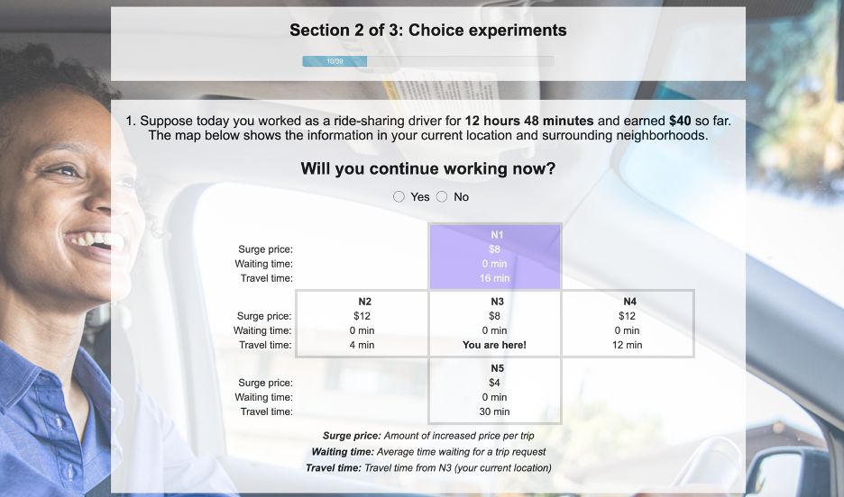
 | Yes | When would you start your next shift? (0~24 hours later)  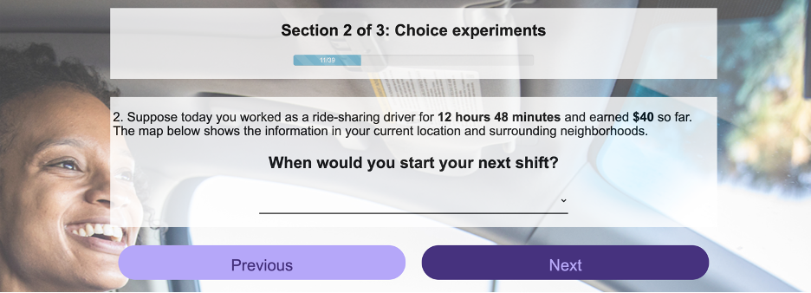
 | No | Where would you like to go? (Neighborhoods N1~N5)  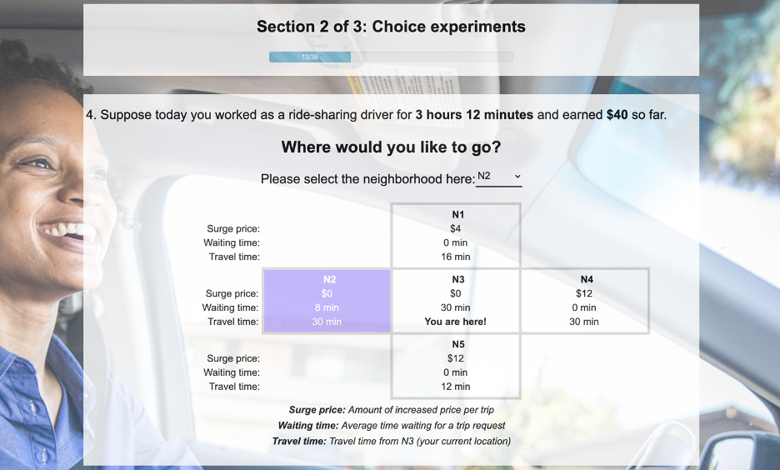
2.2 Response to a request (6 questions)
Scenario 1~6: | Suppose you just receive a trip request. The trip information is shown below (see the mock-up). Will you accept or reject the trip?  - Accept  - Reject  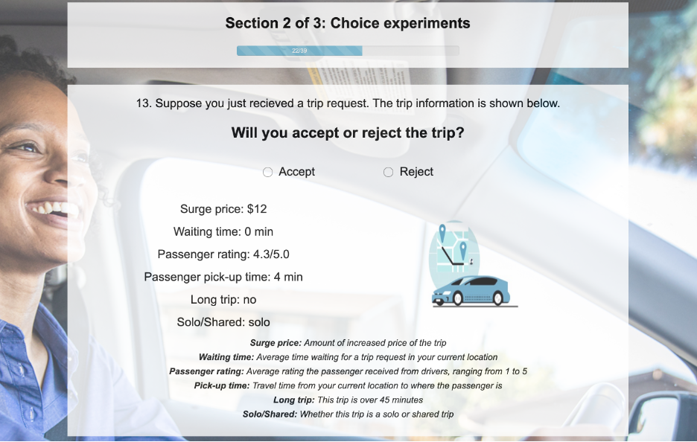
Section 3: Background information (socio-demographics) (12 questions)
1 | What is your age? ______________
2 | What is your gender identity?  - Female  - Male  - Another  - Prefer not to answer
3 | Are you of Hispanic, Latino, or Spanish origin?  - Yes  - No  - Prefer not to answer
4 | What is your race?  - White  - Black or African American  - Asian or Pacific Islander  - Hispanic or Latinx  - Native American or American Indian  - Decline to state  - Another (please specify) ____________
5 | Were you born in the United States?  - Yes  - No  - Prefer not to answer
6 | Are you currently a student?  - No, not a student  - Part-time student (fewer than 35 hours/week)  - Full-time student (35+ hours/week)
7 | What is the highest degree or level of school you have completed?  - Less than high school  - High school graduate or GED  - Some college/technical school training  - 2-year college degree (Associates)  - 4-year college degree (BA, BS)  - Master’s degree  - Doctor’s degree  - Professional degree (MD, JD)
8 | What is the zip code where you currently live? _____________
9 | How many people live in your household (including yourself)? Your household includes yourself, people living with you and sharing income with you (e.g., spouse, partner, or dependents). _____________  Of these, how many are children under age of 18? _____________
10 | What category best describes your household income before taxes from the last calendar year including yourself? Your household includes yourself, people living with you and sharing income with you (e.g., spouse, partner, or dependents).  - Under $10,000  - $10,000 ~ $14,999  - $15,000 ~ $19,999  - $20,000 ~ $24,999  - $25,000 ~ $34,999  - $35,000 ~ $49,999  - $50,000 ~ $74,999  - $75,000 ~ $99,999  - $100,000 ~ $149,999  - $150,000 ~ $199,999  - $200,000 ~ $249,999  - $250,000 or more
11 | What category best describes your individual income before taxes from the last calendar year? Your household includes yourself, people living with you and sharing income with you (e.g., spouse, partner, or dependents).  - Under $10,000  - $10,000 ~ $14,999  - $15,000 ~ $19,999  - $20,000 ~ $24,999  - $25,000 ~ $34,999  - $35,000 ~ $49,999  - $50,000 ~ $74,999  - $75,000 ~ $99,999  - $100,000 ~ $149,999  - $150,000 ~ $199,999  - $200,000 ~ $249,999  - $250,000 or more
12 | What is your health status?  - Very good  - Good  - Fair  - Poor  - Very poor  - I don’t know  - Prefer not to answer

Ride-hailing driver behavior interview protocol
Date/time: ___________________________
Interviewee: __________________________
Interviewer: __________________________
Survey sections used:
______ A: Working time choice
______ B: Relocation choice
______ C: Response to a request
______ D: Other strategies
______ E: COVID impacts
Other topics discussed: ____________________________________________________________________________________________________________________________________________________________________________________
Post interview comments or leads:
____________________________________________________________________________________________________________________________________________________________________________________
[Note: the interviewer will use phrases such as “tell me more”, “why”, “how do you decide”, “could you give me an example”, “could you explain that?” as prompts to solicit more detailed information when needed.]

UNDERSTANDING RIDE HAILING DRIVER BEHAVIORS
Introduction (2 min)
Hi ______, so glad to have you here! How are you?
We are from the Sustainable Transportation Lab at University of Washington. I am Tukey, a graduate student, and this is my advisor Professor Don MacKenzie. Thank you for participating in our driver behavior interview. We are very happy to chat about some of your working choices including working time, relocation, and response to a request as a ride hailing driver.
- Working time choice (5~8 min)
- Do you have a fixed working time schedule, like when to start and stop working?
- Do you work straight through? Or do you drive for some time, do something else, and then drive more later in the day?
- When you want to stop working, what factors do you consider?
- [solicit open ended responses first] Possible factors: expected daily income/hours, accumulated income/hours, time of day, surging price (high/low price, distance far/close), weather, current neighborhood

- Relocation choice (5~8 min)
- What areas do you usually go to when starting your day of driving? When you complete a trip, what do you do or where do you go?
- Do you pull over and wait, cruise around, or go to another neighborhood? How do you decide?
- What things do you consider when deciding what to do
- [only after open ended responses] Possible factors: relocation time, surging price (high/low price, distance far/close)
- Do you have some hard geographic constraints?
- Response to a request (5~8 min)
- When you receive a request, what makes you decide whether to accept it? How often do you reject a trip request?
- [only after open ended responses] Possible factors: solo/pooled, surging price, relocation time, passenger star ratings, time of day, neighborhood
- What information
- COVID impacts [optional] (3 min)
- Does COVID-19 make your work more difficult? In which ways? Fewer drivers. Personal connections.
- Other strategies [optional] (3 min)
- Do you do these decisions all by yourself, or do you also use an App that recommends places to go, or do you also follow your friends’ decisions?
- When you make these decisions, what other factors do you consider other than maximizing the earnings? For example, avoid danger or troubles? How do you do that?
- Do you also have personal connections?
Closing lines (2 min)
Great! These are all of our questions. Do you have any questions for us? Or any additional comments.
Can we contact you again for completing our pilot survey?
Thanks again for participating in our interview. Feel free to contact us if you have any questions or suggestions later. The Amazon gift card will be sent to your email account this week. Hope you have a great day.

Tutorial: hosting an online survey using AWS
Step 1 Install Xampp in your local drive
Windows: https://wpmudev.com/blog/setting-up-xampp/
Mac: https://www.youtube.com/watch?v=EK_AUTzV7OI
Step 2 Prepare your survey website files and test it locally
First, code the survey and database in php and html.
Second, put the survey code folder in the folder “htdocs”. For example, the survey folder name in our study is named “​​CERC-Ridehailingdriver” (Figure A.1)
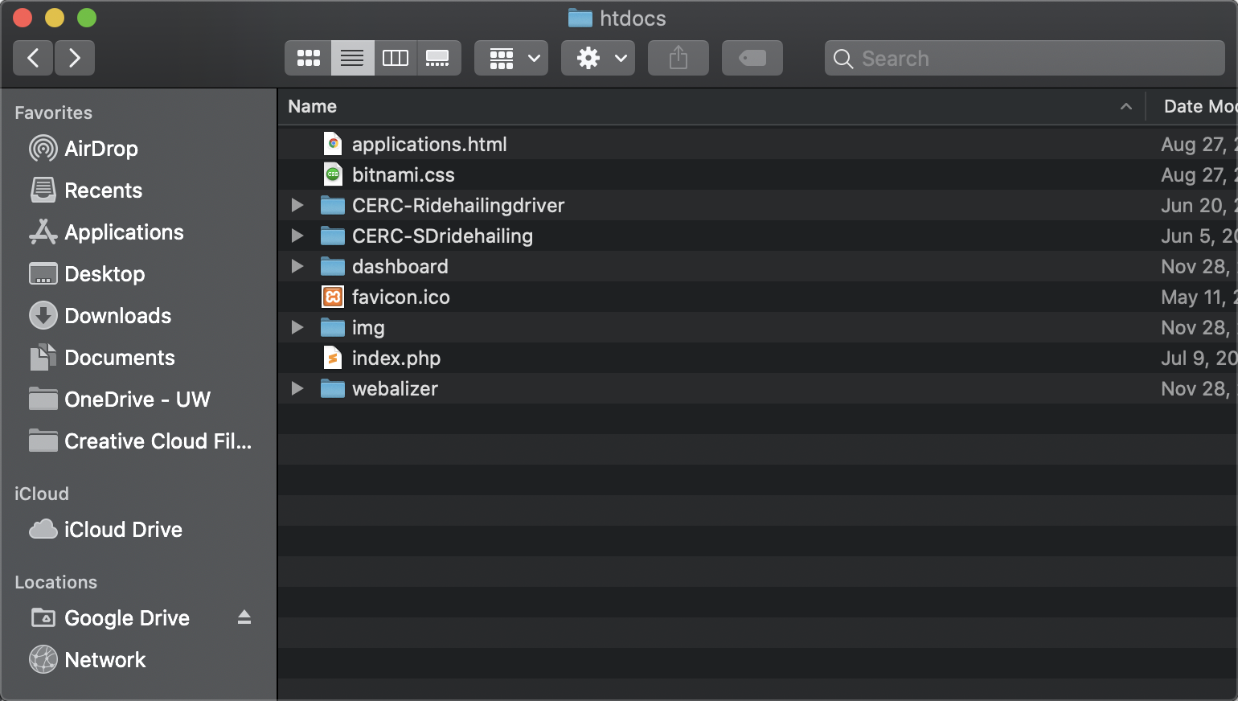
Figure A.1 Survey code files
Third, test the survey and database locally (Figure A.2 and A.3)
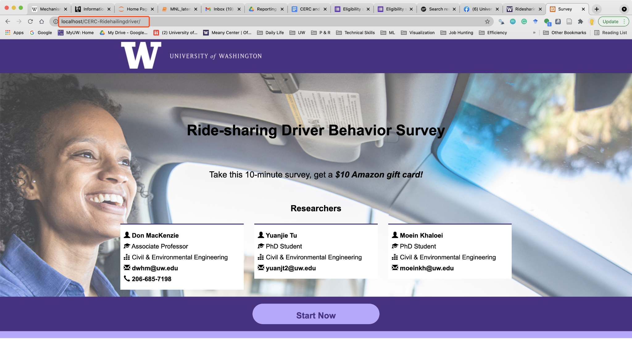
Figure A.2 Local survey website
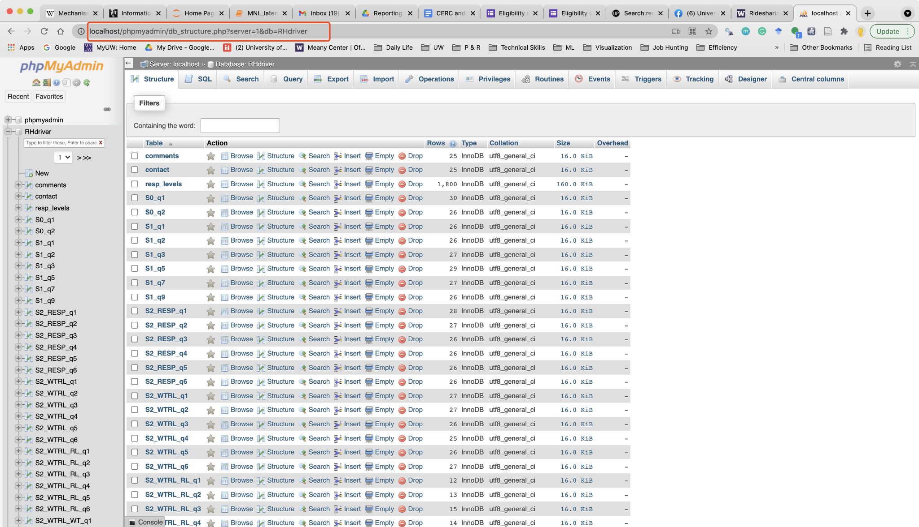
Figure A.3 Local survey database website
Step 3 Create AWS EC2 and install linux Xampp
https://www.youtube.com/watch?v=h04jIAIcBhg
https://techviewleo.com/how-to-install-xampp-on-ubuntu/
https://codepen.io/x-dream/post/remove-xampp-from-linux-ubuntu
Step 4 Create a domain in AWS Route 53
https://www.youtube.com/watch?v=aHuQExY360I
Step 5 Move the local files to AWS EC2 by Filezilla
https://angus.readthedocs.io/en/2014/amazon/transfer-files-between-instance.html
Step 6 Associate the IP address with the domain address
Replace the IP name in Route 53 (Figure A.4)
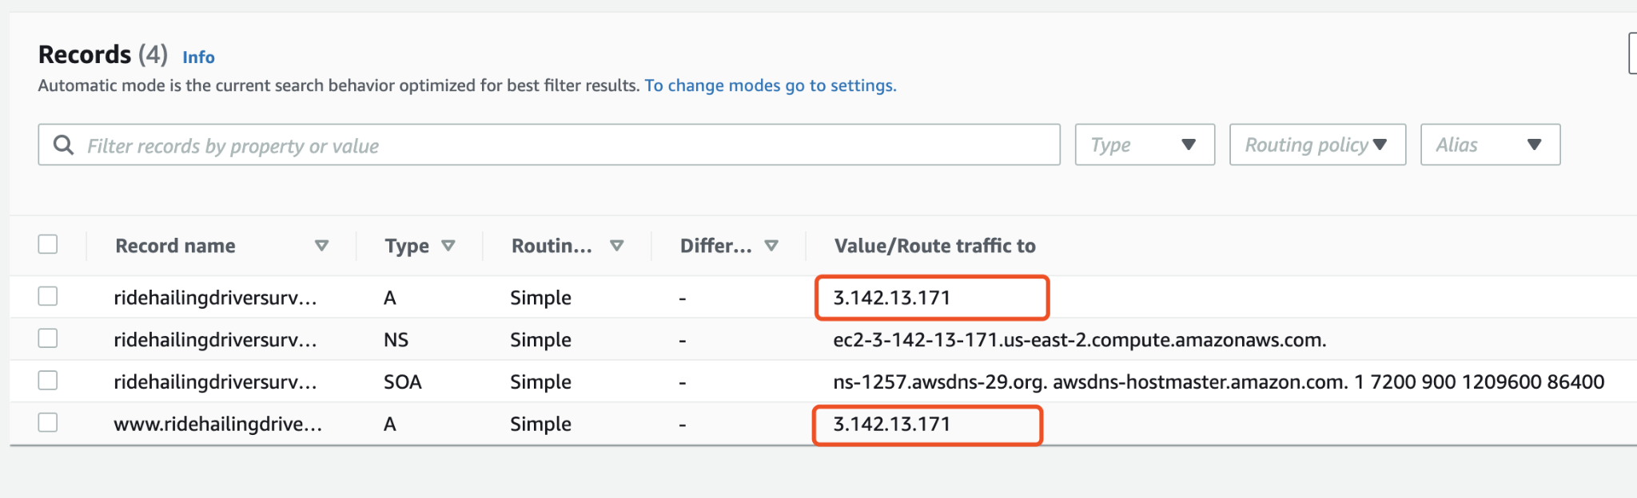
Figure A.4 Local survey database website
Now see if you can access it!
Possible errors and solutions
- netstat: command not found: sudo apt install net-tools
- Database access:
https://www.youtube.com/watch?v=h04jIAIcBhg
- solve security block to the database: https://stackoverflow.com/questions/11999371/access-to-the-requested-object-is-only-available-from-the-local-network-phpmyadm

COVID travel behavior survey wave 1~3
Please find PDF files attached.

Personality traits and attitudes questionnaire
1- Socioeconomic questions
1- What is your age?
2- What is your gender?
a. Male
b. Female
c. Another: __
3- Which category best describes your *household income before taxes from the last calendar year?
*Your household includes people living with you and sharing income with you (e.g. spouse, partner, or dependents).
a. Under $10,000
b. $10,000 ––$14,999
c. $15,000 ––$19,999
d. $20,000 ––$24,999
e. $25,000 ––$34,999
f. $35,000 ––$49,999
g. $50,000 ––$74,999
h. $75,000 ––$99,999
i. $100,000 ––$149,999
j. $150,000 ––$199,999
k. $200,000 ––$249,999
l. $250,000 or more
m. Prefer not to answer

4- Are you of Hispanic, Latino, or Spanish origin?
a. Yes, of Hispanic, Latino or Spanish Origin
b. No, Not of Hispanic, Latino or Spanish Origin

5- What is the highest degree or level of school you have completed?
a. Less than High School
b. High School Graduate or GED
c. Some College/Technical school training
d. 2-Year College Degree (Associates)
e. 4-Year College Degree (B.A., BS)
f. Master’s Degree
g. Doctoral Degree
h. Professional Degree (M.D., J.D.)

6- What is your race?
a. White
b. Black or African American
c. American Indian or Alaska Native
d. Asian
e. Native Hawaiian or Other Pacific Islander
f. Another: __

7- Are you currently a student?
a. No, not a student
b. Part-time student
c. Full-time student

8- Which of the following best describes your current employment status?
a. Employed, Full-time (35+ hours/week)
b. Employed, Part-time (Fewer than 35 hours/week)
c. Homemaker
d. Looking for work
e. Unable to work due to a disability
f. Retired
g. Unemployed
h. Another: ___

9- Were you born in the United States?
a. Yes
b. No
c. Prefer not to answer

10- What is the zip code where you currently live?_
11- What is the city where you currently live?_
12- What is your birth year?
13- How many people live in your household? Of these, how many are children under the age of 18?_.
*Your household includes people living with you and sharing income with you (e.g. spouse, partner, or dependents).
2- The Big Five Inventory
Here are a number of characteristics that may or may not apply to you. For example, do you agree that you are someone who likes to spend time with others? Please write a number next to each statement to indicate the extent to which you agree or disagree with that statement.
Options: 1=disagree, 2=slightly disagree, 3=neutral, 4=slightly agree and 5=agree,
I see myself as someone who...
1. Is talkative.
2. Tends to find fault with others.
3. Does a thorough job.
4. Is depressed, blue.
5. Is original, comes up with new ideas.
6. Is reserved.
7. Is helpful and unselfish with others.
8. Can be somewhat careless.
9. Is relaxed, handles stress well.
10. Is curious about many different things.
11. Is full of energy.
12. Starts quarrels with others.
13. Is a reliable worker
14. Can be tense.
15. Is ingenious, a deep thinker.
16. Generates a lot of enthusiasm.
17. Has a forgiving nature.
18. Tends to be disorganized.
19. Worries a lot.
20. Has an active imagination.
21. Tends to be quiet.
22. Is generally trusting.
23. Tends to be lazy.
24. Is emotionally stable, not easily upset.
25. Is inventive.
26. Has an assertive personality.
27. Can be cold and aloof.
28. Perseveres until the task is finished.
29. Can be moody.
30. Values artistic, aesthetic experiences.
31. Is sometimes shy, inhibited.
32. Is considerate and kind to almost everyone.
33. Does things efficiently.
34. Remains calm in tense situations.
35. Prefers work that is routine.
36. Is outgoing, sociable.
37. Is sometimes rude to others.
38. Makes plans and follows through with them.
39. Gets nervous easily.
40. Likes to reflect, play with ideas.
41. Has few artistic interests.
42. Likes to cooperate with others.
43. Is easily distracted.
44. Is sophisticated in art, music, or literature.
3- Transportation Questions

Q1 | I enjoy talking and being with strangers during a shared ride. | Strongly disagree; Disagree; Slightly disagree; Slightly agree; Agree; Strongly agree
Q2 | It is _____ for me to meet new friends in a shared ride. | Very unlikely; Unlikely; Slightly unlikely; Slightly likely; Likely; Very likely
Q3 | I feel ______ when strangers try to talk to me in a pooled ride hailing vehicle | Very uncomfortable; Uncomfortable; Slightly uncomfortable; Slightly comfortable; Comfortable; Very comfortable
Q4 | Talking and being with strangers during a shared ride is ______. | Very uncomfortable; Uncomfortable; Slightly uncomfortable; Slightly comfortable; Comfortable; Very comfortable
Q5 | Sharing a ride with strangers is ______. | Veryuncomfortable; Uncomfortable; Slightly uncomfortable; Slightly comfortable; Comfortable; Very comfortable
Q6 | Talking and being with strangers during a shared driverless vehicle where there is no driver/staff would be ______. | Very uncomfortable; Uncomfortable; Slightly uncomfortable; Slightly comfortable; Comfortable; Very comfortable
Q7 | Widespread use of self-driving vehicles would result in ______ crashes. | A lot fewer; Fewer; Slightly fewer; Slightly more; More; A lot more
Q8x | I am___ self-driving vehicles can drive as well as human drivers in general. | Extremely confident; Confident; Sort of confident; A little doubtful; Doubtful; Extremely doubtful
Q9x | Driverless cars generally will be ______than I am as a driver. | Much more dangerous; More dangerous; A little more dangerous; A little safer; Safer; Much safer
Q10x | Driverless cars generally will be ______compared with most drivers on the road. | Much safer; Safer; A little safer; Somewhat more dangerous; More dangerous; Much more dangerous
Q11x | I am ______about riding in a vehicle with no driver controls available. | Very worried; Worried; Slightly worried; Slightly excited; Excited; Very excited
Q12x | I ______trust self-driving car technology to keep me safe when I am riding in one. | Definitely would; Probably would; Maybe would; Maybe would not; Probably would not; Definitely would not

4- Quality check questions
I feel ______ when strangers try to talk to me in a pooled ride hailing vehicle | Very uncomfortable; Uncomfortable; Slightly uncomfortable; Slightly comfortable; Comfortable; Very comfortable
Driverless cars generally will be ______than I am as a driver. | Much more dangerous; More dangerous; A little more dangerous; A little safer; Safer; Much safer
I see myself as someone who tends to be quiet. | 1=disagree, 2=slightly disagree, 3=neutral, 4=slightly agree and 5=agree,
I see myself as someone who starts quarrels with others. | 1=disagree, 2=slightly disagree, 3=neutral, 4=slightly agree and 5=agree,

Q1- The last US president before Donald Trump was…
Barack Obama / John F Kennedy / Abraham Lincoln / George Washington
Q2- True/False questions
“One plus one is three.
There are 5 hours in a day.
Strawberries are red.”
Q3- Do you have any final comments/questions?______

https://www.uberpeople.net/forums/seattle.48/
https://www.ridesharingforum.com/
https://www.seattle.gov/license-and-tax-administration/find-a-licensed-business
https://kingcounty.gov/depts/records-licensing/licensing/taxi-for-hire-transportation-networks/driver.aspx
Everyday: 7, 3-4 days a week: 3.5, 1-2 days a week: 1.5, A few times a month: 0.625, Once a month or less: 0.125, Never: 0
People who work in delivery or postal service, transportation, grocery, utilities (water, electricity, etc.), medical, and building maintenance and repair
In the context of work-related questions, “every day” is interpreted as 5 days a week (every working day), while it is interpreted as 7 days a week for other transportation questions.

