Changes in water stratification due to methane plumes on the Washington Margin

Michelle Lee
University of Washington
School of Oceanography
Box 357940, Seattle, WA 98195
Email: mklee3@uw.edu
May 27, 2018

Acknowledgements:
I would like to acknowledge professor Paul Johnson and Susan Hautala for providing guidance and feedback for this study and mentoring me throughout this research. I would also like to acknowledge Arthur Nowell for providing comments and edits on the writing process of this study. Additionally, I would like to thank the Ronald E. McNair Scholars program for providing support on my research. Finally thank you to all my Oceanography peers, especially the peers within my small group discussions (Drew V., Maryka A., Caiti G., Claire G.) that had supported and reviewed my research.

Abstract:
The changing climate is causing more methane releases from the seafloor making it important to understand how methane plumes can impact the ocean. Methane plumes can have impacts on stratification and circulation which can influence primary productivity and possibly atmospheric greenhouse gas levels if the methane from the plume gets exchanged with the atmosphere. Along the Washington margin there has been over 1772 individual bubble plumes located and identified in depths ranging from 40m to 1988m. Using a compilation of CTD (Conductivity, Temperature, Depth) casts off the Washington Margin from various cruises, temperature, salinity, density, buoyancy frequency and flux of sites with and without methane were compared. When comparing the sites with and without the presence of methane plumes, there were no significant differences among the temperature, salinity, density, or calculated buoyancy flux and frequency. Additional data and further analysis on the methane plume sites on the Washington Margin are needed to fully understand the potential impact of the methane plume on the stratification of the water column.

Introduction:
Methane Bubble Plumes
Gas hydrates are one of the largest reservoirs of organic carbon on Earth (Boswell and Collette, 2011). With the increase in temperature of ocean seawater, methane that is buried in the sediment, usually found on continental shelves and margins, is being released into the water column. Methane gas hydrates are metastable (Kvenvolden, 1993), meaning that changes of pressure and temperature can impact the stability. As water temperature increases in the atmosphere due to climate change, the ocean also warms. This change in ocean temperature can cause hydrates to become unstable, releasing methane that was previously trapped in the seafloor to the water column as methane bubble plumes. While there are natural releases of methane from the sea floor, due to temperature increase of the water, the quantity of active plumes releasing methane on the seafloor have increased. Methane plumes have been the focus of prior studies since methane is a potent greenhouse gas and there could be a potential that the methane released in these bubble plumes can reach the atmosphere and contribute to the atmospheric greenhouse gases (McGinnis et al, 2006; Solomon et al, 2009, Leifer et al, 2015; Yamamoto et al, 2009).
There are two mechanisms in which methane can transport up the water column. Methane can either transport up the water column directly in the bubbles or indirectly in the plume fluids or upwelled fluids that is methane enriched through dissolution (Leifer et al, 2015). The methane transported through these mechanisms can enter the atmosphere through directly transfer the from the plumes or indirectly through air-sea gas exchange (Nauw et al, 2015).
The fluid coming out of the seafloor in these methane plumes have different physical properties of the surrounding water, including temperature and salinity. As bubble plumes rise, they can cause an upwelling of deeper, cooler, more saline and nutrient-rich water. The bubbles can provide a sufficient amount of momentum to cause an upwelling flow of the surrounding fluid to the sea surface (Leifer et al, 2009). The plumes contain the energy to lift the denser water against the density gradient. Once the energy dissipates, it can cause detrainment of the upwelled water. The detrainment creates horizontal intrusions of denser water in the water column. The detrainment can impact methane dissolution and result in less methane reaching the atmosphere (Leifer et al, 2009). The detrainment of the fluid can also cause a disruption in the stratification of the ocean.
Methane Plumes and Stratification
The upwelling flow associated with methane plumes has the potential to reduce the stratification of the water column. Stratification of the water column can impact primary productivity (Lozier et al, 2011). An increase in stratification, meaning a smaller mixed layer can cause inhibition of primary productivity since the productivity will be limited to the shallower mixed layer. On the other hand, a decrease in stratification will result in a deeper mixed layer. The deeper mixed layer will allow for more primary productivity. Bubble plumes have been associated with an early breakdown of a seasonal thermocline. Nauw et al (2015) found that at the 110m deep plume site in the North Sea, the thermocline broke down between mid-October and early November which is several weeks earlier than other comparable areas. Since a decrease in stratification can allow for an increase in productivity, methane plumes can indirectly cause an increase in productivity. Prior studies have found elevated chlorophyll concentration in areas of hydrocarbon seeps (D’Souza et al, 2016). Bubble plumes upwell nutrient-rich water which enhances phytoplankton growth since nutrients can be a limiting factor in primary productivity.
Methane plumes can cause intrusions of nutrient-rich saline water and can potentially reduce stratification, which both can cause an increase in productivity in depths where productivity might not have occurred. Methane plumes breaking stratification can potentially cause methane plumes to reach closer to the surface of the ocean. The thermocline acts as a trap for the methane plumes as many dissipate once reaching the thermocline (Nauw et al, 2015; Colomer et al, 2003). However, if the methane plumes are able to disrupt the thermocline, methane can possibly reach shallower depths leading to exchanges with the atmosphere for the plume fluids that are detrained.
Area of Study: Washington Margin
The focus area of study for this research is the 250km long Washington margin. Along the Washington margin there has been over 1772 individual bubble plumes located and identified in depths ranging from 40m to 1988m. The 1772 plumes can be clustered into 486 emission sites using an established clustering method (Figure 1; Johnson et al, 2015). The Washington margin is also an important study area since due to climate change, the Washington margin has a potential to release 45-80 Tg of methane by 2100 (Hautala et al, 2014). Prior studies have focused on certain methane sites or individual plumes on the Washington margin (Torres et al, 2002). Studies that have looked at the margin as a whole (Johnson et al, 2015; Heeschen et al, 2003) did not focus on the water column impacts caused by the plumes. There have not been studies on the impact the plumes have on stratification of the water column along the entire margin.
Many prior studies on methane plumes have focused on how methane plumes can impact the atmosphere and climate (Solomon et al, 2009) or on the upwelling flow caused by the plume (Leifer et al, 2009; Sato and Sato, 2001). There have been prior studies associating hydrothermal vents and stratification (Carazzo et al, 2008), but not many have focused on methane plumes and their impact on the stratification, especially not for an area with as many identified plume locations as the Washington margin. By understanding methane plume impacts on stratification, we can understand how methane plumes can influence productivity and also how it can impact the structure of the water column.
Methods:
Water Column Temperature and Salinity Data
A selection of temperature and salinity profiles used for this study were from a compiled high-resolution conductivity-temperature-depth (CTD) dataset used in Hautala et al (2014). The CTD temperature and salinity profiles were extracted from the World Ocean Database (National Oceanographic Data Center (NODC)) for the Washington Margin region (124.5°W to 127.5°W and 46.5°N to 48.5°N). The extracted dataset used, from Hautala et al (2014), also included CTD casts from a field program in August 2013 that were in vicinity to methane plumes. The CTD casts used for this study were collected during cruises from 2005 until 2013 at various times of the year.
In order to look at the impacts of methane plumes on the temperature and salinity profiles, the CTD stations were selected and separated into sites in the vicinity of a methane plume and not near a methane plume (Figure 1). For this study, any CTD cast within a 300-meter radius to an identified methane was considered a site with a methane plume. The 300-meter radius was chosen based off the 300-meter radii methane site clustering method in Johnson et al (2015). Methane plumes within a 300-meter radius were clustered together into one methane emission site. Following that method, we assumed that a CTD cast within a 300-meter radius of a methane plume can be considered to reflect a water column profile at a methane site. Any CTD site not within a 300-meter radius to a methane plume was considered a site without a methane plume and therefore used as a representation of the Washington margin water column without the influence of a methane plume.
To further compare specific temperature profiles of sites with and without a methane plume, some sites were also paired based off proximity to one another. A CTD cast identified as without a plume was paired with one with a plume in a relative location based on latitude and seafloor depth with the assumption that the other factors that influence stratification would be the same for both locations.
Calculating Density and Buoyancy
Density profiles were estimated using the TEOS-10 Gibbs Seawater Oceanographic Toolbox (McDougall and Barker, 2011) and the measured temperature, salinity, and pressure from the CTD casts. Density (ρ) is calculated using
$ρ=ρ_{0}+[-α\left(T-T_{0}\right)+β\left(S-S_{0}\right)+κP$ [1]
where
T= temperature
S=Salinity
P=pressure
α=thermal expansion coefficient
β=salinity contraction coefficient
κ=pressure compressibility coefficient
Using the estimated densities, the buoyancy frequency (N) was also calculated.
$N=\left[-\frac{g}{ρ}\right][\frac{dρ\left(z\right)}{dz}]$ [2]
Buoyancy frequency was calculated using gravitational acceleration (g), density, and depth (z). The buoyancy frequency is used to determine the effect of stratification on methane plumes (Leifer et al, 2009).
Buoyancy flux (B) was also calculated (Speer and Rona, 1989) using area (A), temperature, salinity, and vertical velocity(W).
$B=-g\left[-α\left(T-T_{0}\right)+β\left(S-S_{0}\right)\right]AW$ [3]
Results:
Along the Washington Margin there are over 1772 identified methane plumes in water depths ranging from 40 meters below sea level (mbsl) to 1988mbsl. The depth distribution of methane plumes on the margin is not even. When ordering the methane plumes by their depth distribution (Figure 2), we find that majority of the plumes are located between 150 and 200mbsl with 907 of the 1772 plumes located in that depth range.
In order to observe and compare the variations between the 27 paired stations with and without methane plumes, the temperature, salinity, and densities of the two groups of stations at 175mbsl were compared (Figure 3). The properties at 175mbsl was chosen because majority of the methane plumes were located between 150 and 200mbsl. Since most paired stations were not located at the same depths, looking at the properties at 175mbsl for all the stations kept the depth and pressure consistent when looking at the properties. The temperature at 175mbsl for stations in the presence of methane plumes ranged from 6 to 7.4 degrees Celsius, with an average of 6.52±0.26 degrees Celsius. The temperature for stations without the presence of methane plumes ranged from 6 to 7 degrees Celsius, with an average of 6.44±0.22 degrees Celsius. The salinity at 175mbls for both groups of stations ranged between 33.9 and 34 PSU, with the average for sites with plumes at 33.96±0.022 PSU and without plumes at 33.96±0.0322 PSU. The density at 175mbsl for stations with plumes ranged between 1025.4 and 1026.4 kg/m³. For stations without plumes, the density ranged between 1025.4 and 1026.2 kg/m³. The average density for the stations with methane plumes was 1025.725±0.189 kg/m³ and without methane plumes was 1025.669±0.15 kg/m³.
In addition to comparing the temperature, salinity, and density at 175mbsl, depth profiles for temperature and salinity were also compared. The temperature, salinity, and density depth profiles were compared for 3 paired stations with the stations with a methane plume all located at around -125.26W and 46.78N and stations without plumes located around -125.22W and 46.83N (Figure 4). The temperature, salinity, and density depth profiles were also compared for another paired station with the station with a plume at -126.06W and 48.11N and the station without a plume at -125.98W and 47.96N (Figure 5).
The buoyancy frequency (N) and buoyancy flux (B) were also calculated using the CTD data for stations in vicinity and not in vicinity of methane plumes. The buoyancy frequency for the stations with methane plumes ranged from 1.5x10⁻⁵ s⁻¹ to 5x10⁻⁵ s⁻¹. N for stations without methane plumes ranged from 1.5x10⁻⁵ s⁻¹ to 5x10⁻⁵ s⁻¹. The mean N for stations with methane plumes was 2.8774x10⁻⁵ ± 7.492x10⁻⁶ s⁻¹ and for stations without plumes was 2.657x10⁻⁵ ±5.96x10⁻⁶ s⁻¹. The buoyancy flux for the methane stations ranged from 0.0306 to 0.0345 m⁴/s² and for non-methane stations ranged from 0.0302 to 0.0333 m⁴/s². For both groups, the average buoyancy flux was the same at 0.0318± 0.0008 m⁴/s².
Discussion:
Comparing the results from methane-present sites and methane-absent sites, there was no significant difference between the two sets. The temperature, salinity, and density values for both sets of sites had averages that were statistically the same with the values falling within the error margin of each sets of sites. Similar to the temperature, salinity, and density values, the calculated values for buoyancy frequency and flux were also statistically the same. Since there were no significant differences between methane sites and no methane sites, the methane plumes on the Washington margin seem to have no effect on the stratification of the water column.
The temperature profile at one of the coupled sites showed a difference where the location with a methane plume had colder temperatures by about a degree Celsius at 75mbsl to 100mbsl (Figure 4). However, this pattern did not appear in subsequent coupled locations (Figure 5). The decrease in temperature in the shallower depths at a methane plume site is consistent with Leifer et al (2009) where bubble plumes entrain colder water to the shallower depths of the water column. Since this did not appear in other profiles, we are not able to conclude whether or not the methane plumes on the Washington margin also entrains colder water to the shallower depths enough to show a significant change within the temperature profiles. While the temperature profile at this coupled site showed a colder temperature at about 75mbsl to 100mbsl, this difference wasn’t present in other profiles of salinity and density at the same site as well (Figure 4).
One aspect of the study that was implied that might influence the accuracy of the analysis of the results is the activity of the methane plume sites. For this study, we had assumed that all the CTD casts done near a methane site was collected during a time where there were active methane emissions at the site. Methane emissions at plume sites are intermittent, meaning that they aren’t always active. Methane emissions can be active for different time periods at a plume site. Some sites are active for long periods of time, while other could be active for only a couple minutes at once. Because the CTD casts used for this study were not conducted for the purpose of looking at methane plumes, the methane emission status was not determined and recorded for all the CTD casts. Without knowing whether or not the plume sites were active and not having any way to determine whether or not the CTD casts were done at a time of active methane emissions, we assumed that the CTD casts we used for the study at methane plumes sites to be collected during the time of active methane emissions. This assumption could have impacted the results analyzed for the methane plumes sites.
The results from this pilot study show that since there was no significant difference between the sites with methane plumes present and without methane plume present, methane plumes do not have an impact on the water column. However, due to the assumptions and limited CTD cast availability during the time of this pilot study, we are not able to conclusively determine the impacts on stratification by methane plumes on the Washington margin. In order to accurately determine the impacts, further studies will need to be conducted.
Conclusion:
Through this pilot study, we found null results where there were no significant differences between the sites with methane plumes and without methane plumes. Due to the limited CTD availability at methane sites to compare in this pilot study, we were not able to conclusively say that methane has no impact on stratification. In order to conclusively determine whether or not the methane plumes on the Washington margin impacts the stratification of the water column, additional studies will need to be conducted.
Moving forward with this study beyond the pilot trial, additional CTD casts will be collected from archive data sets that are amongst the depth ranges of the methane plumes on the Washington Margin. Using the additional CTD casts, we will be able to do further analysis on sites with methane plumes to compare to sites without the presence of methane plumes. Amongst the additional CTD casts that will be analyzed are CTD casts at methane sites where the activity of the methane plumes is known. Some of the CTD casts were collected at methane sites during a known period of time where the methane plumes present were known to be active. By knowing that some of the CTD casts were collected at times and locations of active methane plumes, we will be able to more accurately compare the impacts of methane plumes on stratification.
While there were no significant conclusions found during this pilot study, we could determine the additional analysis needed in order to further the study to determine whether or not the methane plumes on the Washington margin impacts the stratification of the water column. With further studies, we would be able to determine the impacts methane plumes on the Washington Margin have on stratification of the water column.

References:
Boswell, R., & Collett, T. (2011). Current perspectives on gas hydrate resources. Energy & Environmental Science, 4(4), 1206-1215.
Carazzo, G., Kaminski, E., & Tait, S. (2008). On the rise of turbulent plumes: Quantitative effects of variable entrainment for submarine hydrothermal vents, terrestrial and extra terrestrial explosive volcanism. Journal of Geophysical Research: Solid Earth, 113(B9).
Colomer, J., Serra, T., Soler, M., & Casamitjana, X. (2003). Hydrothermal plumes trapped by thermal stratification. Geophysical Research Letters, 30(21).
D’souza, N.A., Subramaniam, A., Juhl, A.R., Hafez, M., Chekalyuk, A., Phan, S., . . . J. P. Montoya, J.P. (2016). Elevated surface chlorophyll associated with natural oil seeps in the Gulf of Mexico. Nature Geoscience, 9(3), 215-218.
Hautala, S., Solomon, E., Johnson, H., Harris, R., & Miller, U. (2014). Dissociation of Cascadia margin gas hydrates in response to contemporary ocean warming. Geophysical Research Letters, 41(23), 8486-8494.
Heeschen, K., Tréhu, A., Collier, R., Suess, E., & Rehder, G. (2003). Distribution and height of methane bubble plumes on the Cascadia Margin characterized by acoustic imaging. Geophysical Research Letters, 30(12).
Johnson, H., Miller, U., Salmi, M., & Solomon, E. (2015). Analysis of bubble plume distributions to evaluate methane hydrate decomposition on the continental slope. Geochemistry, Geophysics, Geosystems,16(11), 3825-3839.
Kennett, J., Cannariato, K., Hendy, I., & Behl, R. (2003). Methane hydrates in Quaternary climate change; the clathrate gun hypothesis. Washington, DC: American Geophysical Union.
Kvenvolden, K. (1993). Gas hydrates-geological perspective and global change. Reviews of Geophysics, 31(2), 173-187.
Leifer, I., & Patro, R. (2002). The bubble mechanism for methane transport from the shallow sea bed to the surface: A review and sensitivity study. Continental Shelf Research, 22(16), 2409-2428.
Leifer, I., Jeuthe, H., Gjoesund, S., & Johansen, V. (2009). Engineered and Natural Marine Seep, Bubble-Driven Buoyancy Flows. Journal of Physical Oceanography, 39(12), 3071-3090.
Leifer, I., Solomon, E., Schneider Von Deimling, J., Rehder, G., Coffin, R., & Linke, P. (2015). The fate of bubbles in a large, intense bubble megaplume for stratified and unstratified water: Numerical simulations of 22/4b expedition field data. Marine and Petroleum Geology, 68, 806-823.
Lozier, M., Dave, A., Palter, J., Gerber, L., & Barber, R. (2011). On the relationship between stratification and primary productivity in the North Atlantic. Geophysical Research Letters, 38(18).
Mcdougall, T. (1978). Bubble plumes in stratified environments. Journal of Fluid Mechanics, 85(4), 655-672.
McDougall T. and Barker P. (2011). Getting started with TEOS-10 and the Gibbs Seawater (GSW) Oceanographic Toolbox, SCOR/IAPSO WG127, 28.
McGinnis, D., Greinert, J., Artemov, Y., Beaubien, S., & Wüest, A. (2006). Fate of rising methane bubbles in stratified waters: How much methane reaches the atmosphere? Journal of Geophysical Research: Oceans, 111(C9).
Nauw J., Linke, P., & Leifer, I. (2015). Bubble momentum plume as a possible mechanism for an early breakdown of the seasonal stratification in the northern North Sea. Marine and Petroleum Geology, 68, 789-805.
Rona, P., Bemis, K., Silver, D., & Jones, C. (2002). Acoustic imaging, visualization, and quantification of buoyant hydrothermal plumes in the Ocean. Marine Geophysical Researches, 23(2), 147-168.
Sato, K., & Sato, T. (2001). A study on bubble plume behavior in stratified water. Journal of Marine Science and Technology, 6(2), 59-69.
Speer, K. and Rona, P. (1989). A model of and Atlantic and Pacific hydrothermal plume. Journal of Geophysical Research, 94, 6213-6220.
Torres, M., Mcmanus, J., Hammond, D., De Angelis A., Heeschen, K., Colbert S., . . . Suess, E. (2002). Fluid and chemical fluxes in and out of sediments hosting methane hydrate deposits on Hydrate Ridge, OR, I: Hydrological provinces. Earth and Planetary Science Letters, 201(3), 525-540.
Yamamoto, Yamanaka, & Tajika. (2009). Modeling of methane bubbles released from large sea-floor area: Condition required for methane emission to the atmosphere. Earth and Planetary Science Letters, 284(3), 590-598.

Figure Captions:
Figure 1: Map of methane plume locations on the Washington Margin relative to the depth of the seafloor in meters relative to sea level with negative values as below sea level and positive above sea level. Map also includes location of CTD station sites used for temperature, salinity, and density profiles
Figure 2: Depth distribution of the 1772 methane plumes on the Washington Margin.
Figure 3: Histogram distribution of temperature (A), salinity (B), and density (C) for stations with methane plumes in the vicinity (yellow) and station without methane plumes in the vicinity (grey) at 175 meters below sea level.
Figure 4: Temperature (A), Salinity (B), and Density (C) profiles for paired stations with one at a methane plume site (-125.2637W 46.7825N) (green) and one not at a methane plume site (-125.2183W 46.8287N) (black).
Figure 5: Temperature (A), Salinity (B), and Density (C) profiles for paired stations with one at a methane plume site (-126.06W 48.11N) (green) and one not at a methane plume site (-125.98W 47.96N) (black).

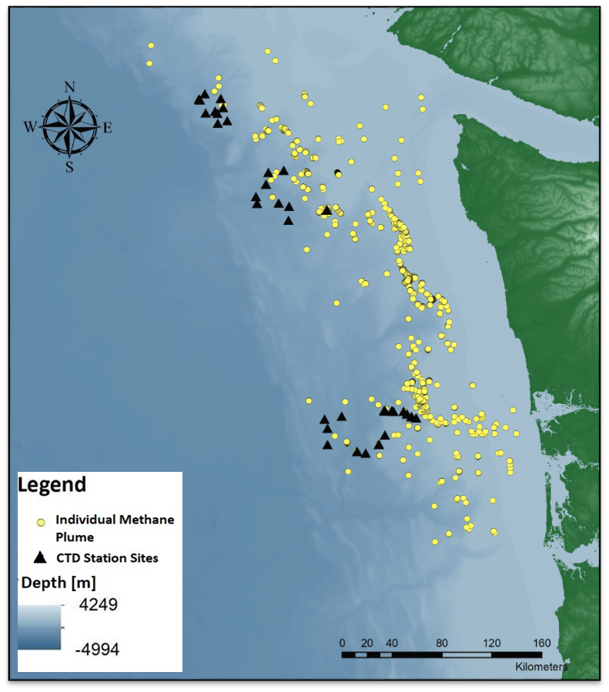
Figure 1:

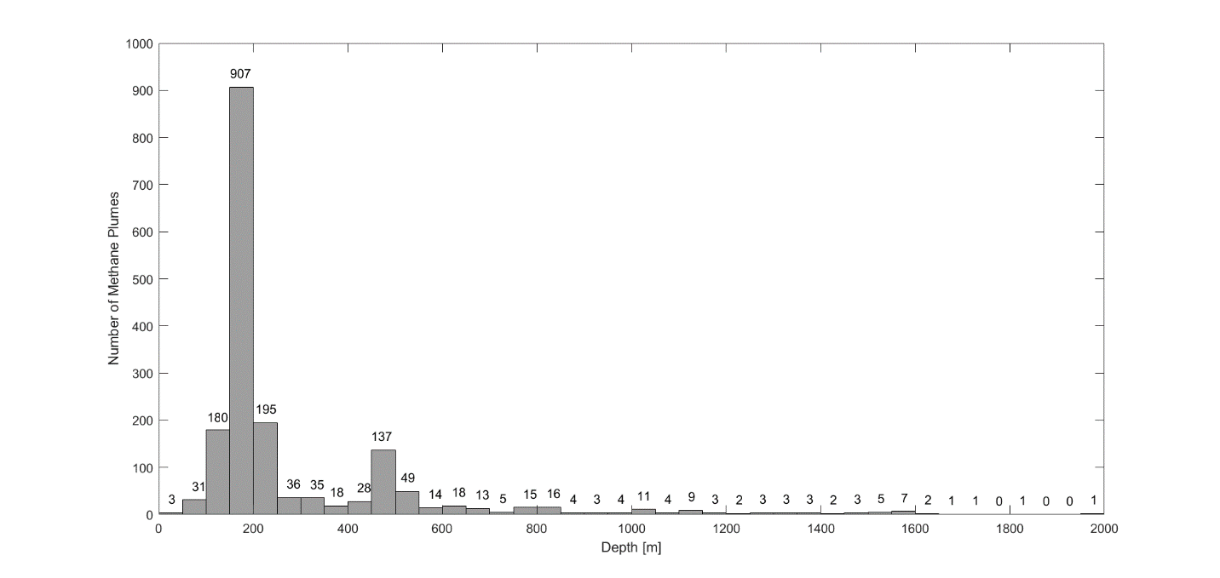
Figure 2:

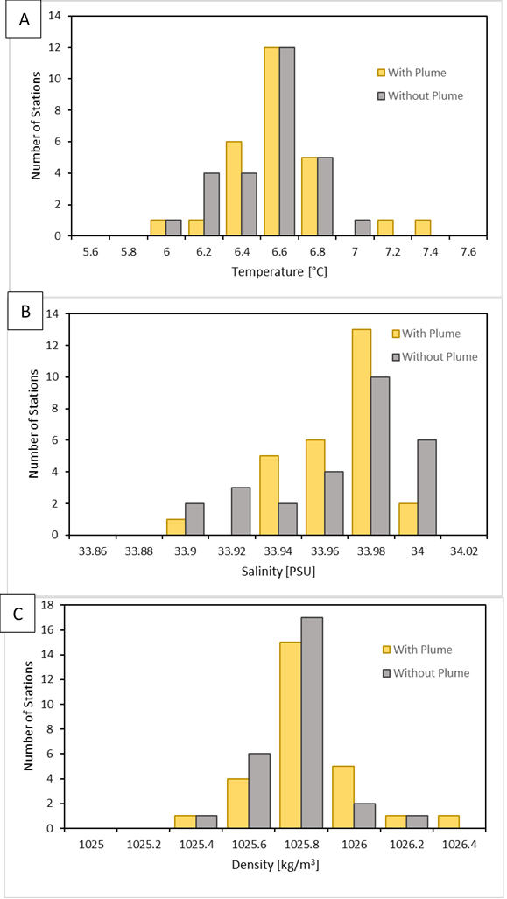
Figure 3:

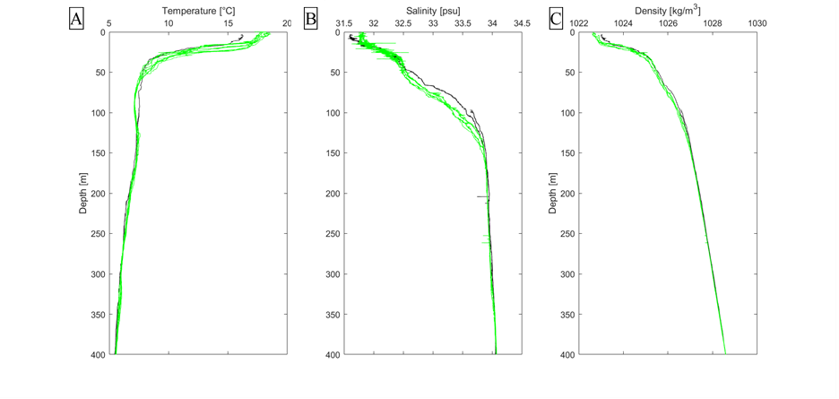
Figure 4:

Figure 5:
