Determination of respiratory processes in the Oxygen Deficient Zone of the Eastern Tropical North Pacific using targeted proteomics

Senior Thesis in Oceanography, University of Washington

Jamee Adams¹
jameeca@uw.edu
05/28/2017

¹University of Washington, School of Oceanography, Box 357940, Seattle, Washington, 98195-7940

Abstract

The majority of the ocean contains sufficient oxygen to support aerobic respiration. However, when oxygen concentrations fall to levels of 10 umol/kg or less, microorganisms utilize alternative electron acceptors such as nitrogen and sulfur during respiration. Regions of the ocean where this occurs are called Oxygen Deficient Zones (ODZ). Bacteria play a pivotal role in cycling nutrients through such anaerobic pathways as denitrification, and the sulfur cycle, as well as through the chemoautotrophic process, anammox, which is an important component of the energy web in ODZs. Suspended particulate organic matter, containing these bacteria, was collected in the Eastern Tropical North Pacific (ETNP). Six samples were analyzed, using targeted proteomics, to establish the presence and relative magnitudes of each of these processes. Denitrification, anammox, and sulfur cycling occur simultaneously at all six depths sampled between 50-1200m, as opposed to occurring in single process dominated zones. Despite this overlap in zonation, the relative proportions of one process over another does change with depth. This research also provides insight into the expanding concept of anoxic microzones within particles suspended in low oxygen regions of the ocean.

Introduction
When considering life in the ocean, it is easy to focus on the visible intricacies that make up aquariums and tide pools. However, there is an entire consortium of life that most people never see and rarely think to consider as huge providers to the ecosystem. The bacterial community plays an important role in the cycling of nutrients throughout the water column under a variety of conditions. One environmental condition under which bacteria exhibit these cycling abilities is in oxygen deficient zones (ODZs).

ODZs occur within sub-oxic waters that tend to be between 100-1,000m, and are generally characterized as having a low degree of ventilation and a high supply of organic matter, which results in increased oxygen consumption during degradation (Wyrtki, 1962). These combined traits result in a decrease in available oxygen for organisms, and create an environment inhospitable to life that depends solely on oxic-respiration for survival.

As oceans warm due to climate change, their ability to take up gases decreases, and in the case of ODZs this means a predicted expansion, both vertically and horizontally, in oxygen-depleted regions of the ocean (Horak et al., 2016; Stramma et al., 2010). These decreases in oxygen can have severe consequences for ecosystems, including fish kills due to low oxygen, and subsequently large inputs of nutrients, which can exacerbate the problem further by increasing the amount of respiration required for full decomposition to occur (Stramma et al., 2012). Consequently, life dependent on oxic-respiration for survival may be eliminated from ODZs. This is a large group of organisms, integral to the food web, which may be at risk in response to changing water chemistry. However, these regions are not purely dead zones as one might expect if there was only one energetic pathway, oxic respiration. As life at many trophic levels exists in the ODZ it is important to understand which life forms occupy the ODZ, and how these organisms manage to survive (Levin et al., 2002).
Despite very limited oxygen, there are a variety of processes that support life in oxygen deficient zones. Because oxygen is the most energetically beneficial electron acceptor, it is preferentially utilized in the ocean environment (Froelich et al., 1979). However, denitrification and anammox both rely on the presence of dissolved nitrogen species, and sulfur cycling relies on the reduction and oxidation of sulfate by nitrate, both of which can supply energy for life in the absence of oxygen (Froelich et al., 1979).What is lost in efficiency by utilizing nitrogen or sulfur, as opposed to oxygen, is made up for by allowing life to persist in seemingly uninhabitable ODZ regions at a variety of depths.
Denitrification is a heterotrophic respiratory process that has been found to occur in low-oxygen environments, and uses nitrate (NO₃⁻ ) as the primary terminal electron acceptor. The denitrification reaction (Table 1) follows the reduction pathway: NO₃⁻ NO₂⁻ NO N₂O N₂, ending with the conversion of nitrous oxide (N₂O), a potent greenhouse gas, to nitrogen gas (N₂) (Babbin et al., 2014).The expansion of ODZs in conjunction with a warmer climate has implications for the denitrification reaction, particularly in regards to this potent intermediate. Nitrous oxide is an ozone-depleting agent, and should denitrification increase under future climates, increased release of N₂O could have consequences for both the ocean and the atmosphere (Babbin et al., 2014).
An additional process involved in the reduction of oceanic nitrogen is anammox (Table 1). Anammox is the anaerobic oxidation of ammonium by nitrite to yield nitrogen gas (N₂) and water (Galan et al., 2009). This process is an alternative method of retrieving energy in ODZs for autotrophic organisms, most commonly with free-living bacteria as opposed to particle-associated bacteria in the water column (Fuchsman et al., 2012). Anammox relies on the presence of bioavailable nitrogen for microbial energy, and contributes substantially to nitrogen removal in ODZs, which makes it an important pathway for further exploration, especially as nitrogen is considered a limiting nutrient in the ocean (Devol, 2003; Lam and Kuypers, 2011).
A third, and less extensively studied aspect of ODZ biochemistry, involves the sulfur cycle and how it may interact with the nitrogen cycle in ODZ regions. Very little is known about sulfur cycling in ODZs, primarily because the cycle itself is cryptic (Canfield et al., 2010). During the sulfur cycle, sulfate (SO4²⁻) is reduced to sulfide (H₂S), which is immediately re-oxidized by available nitrate to sulfate. This process is nearly imperceptible through analysis of water chemistry in the ocean, and as a result vertical distribution of this process has been virtually unstudied in most ODZs (Stewart, 2011). This cycle relies on the availability of nitrate as an oxidizer, which has implications for coupling between the nitrogen and sulfur cycles and makes it an important topic for further investigation (Galan et al., 2014).
This research examines the relative vertical distribution of denitrification, anammox, and sulfur cycling in the oxygen deficient zone of the Eastern Tropical North Pacific. The study compares the relative magnitude of processes, specifically in the regions above, within, and below the ODZ, and what implications this may have for coupling between nitrogen and sulfur cycles including whether or not these processes occur simultaneously or in process dominated zones at different depths. This research identifies how this vertical variability may be affected by such factors as sedimentation rates, chlorophyll concentration, and temperature, as many of these factors are expected to adjust as a result of climate change.

Methods
Study Location and Sample Collection
Samples were collected using McLane in situ pumps while onboard the R/V Sikuliaq approximately 200 nautical miles off the coast of Manzanillo, Colima, Mexico at 32˚32.377’N/107˚3.868’W, between January 8th 2017 and January 13th 2017 (Fig. 1). Ocean water was filtered in situ onto two McLane pump filter stacks, each equipped with two filters per stack. The first filter in the stack was a GFD 2.7-micron filter, which was used to capture phytoplankton. The second filter, GF-75 0.3-micron filter, was situated below the 2.7-micron filter. This finer filter was used to capture bacteria suspended within the water column. All samples utilized for this research were taken from bacteria captured on the GF-75 0.3-micron filters, and were stored at -80˚C until further analysis. Six samples, each from a different depth down the same water column profile, and two control samples using clean GF-75 0.3-micron filters, were chosen out of all cruise samples for analysis during this research project (Table 2).

Sample Protein and Peptide Analysis
Sample protein analysis was conducted according to the Keil Lab 2016 standard method for protein extraction (Keil et al., 2016). Peptides were extracted from GF-75 filter surfaces while suspended in a 50mM Ammonium Bicarbonate / 5mM EDTA lysis buffer, and alternation between sonicated bead beating, and quick freezing to promote cell lysis. These two methods combined have been shown to increase both the frequency with which protein is released from the filter surface, and the magnitude of cell lysis that occurs before digestion. Following protein extraction, a Lowry assay for total protein per sample was performed by creating a standard curve on the UV-Visible spectrometer and observing where these standard concentrations showed a peak in absorbance. In this case, peak absorbance occurred at 750nm. Samples were compared to this standard curve by inserting 100uL of each sample and creating sample curves indicative of total protein concentrations per sample. The Lowry assay gave total protein values for all samples, including the two controls, which could then be converted to Lowry total protein concentrations per sample.

Following the Lowry assay, protein was enzymatically digested using trypsin to cut available proteins at predictable fragmentation points into known peptides. All samples were then desalted, using a MacroSpin C₁₈ column (NestGroup) to decrease interference during mass spectrometer analysis, and were re-suspended in 5% Acetonitrile (ACN) / 0.1% Formic Acid prior to being run on a triple-quadrupole mass spectrometer. All eight samples, nine weak wash blanks to reduce peptide carryover between samples, and three Keil Lab ODZ standards containing all 38 targeted peptides at concentrations of 50fmol, 100fmol, and 150fmol were run on a Waters Xevo TQ-S triple-quadrupole mass spectrometer targeting for 38 standard ODZ peptides (Table 3) known to be associated with denitrification, anammox, and sulfur cycling.

Data Reduction
Spectra from the triple-quadrupole mass spectrometer were loaded into the Skyline software system (Version 5) for proteomics analysis (https://proteome.gs.washington.edu/software.html). This software allowed for comparison between the Keil Lab ODZ standard peaks and the peptide peaks in all samples in order to conduct a presence/absence report for all targeted peptides. Once determination of presence or absence was complete, peak area for each targeted peptide was calculated using Skyline software. Average peak areas from the nine weak wash blanks were subtracted from each sample to reduce carryover bias and obtain a more accurate peak area per peptide for each sample. The two control samples did appear to show low presences of eight of the 38 targeted peptides; however, following blank subtractions the peak area values associated with both control samples went to either negative values or were so low that their persistent presence was due most likely to the fact that the blank subtraction was an average of all weak wash peak areas. Any values found within control samples following blank subtraction was attributed to human error and was not considered in further analyses.

Results

The oxygen and fluorescence levels from CTD cast data, evaluated on days when filter samples were collected using McLane pumps, indicated that the vertical extent of the oxygen deficient zone in the ETNP remained fairly constant at 100m down to 850m, during sample collection. CTD data also indicated that primary and secondary chlorophyll maxima were present in all cases at ~50m and ~125m respectively. These chlorophyll maxima were used as proxies for particle abundance, indicating where high inputs of organic matter were occurring (Fig. 2). CTD water samples were analyzed post-cruise to determine nitrate, nitrite, and ammonium concentrations. These concentrations of nitrogen species are shown in order to indicate how nitrogen is reduced with depth, and how this may be used as a road map for how nitrogen reduction may be influenced by microbial activity at depth (Fig. 3).

Analysis of filter samples, using a targeted proteomics approach, resulted in a vertical depth profile comparing the distribution of denitrification, anammox, and sulfur cycling peptides with their relative abundance to one another at all sample depths (Fig. 4). Denitrification, anammox, and sulfur cycling all occur simultaneously at all six depths sampled throughout the water column, and not in specific process dominated zones as one hypothesis suggested. When samples are compared as concentrations of total peptides associated with each process per liter of seawater (Fig. 4a-c), denitrification shows dominance over anammox and sulfur cycling above the ODZ within the primary chlorophyll maximum, as well as below the ODZ at 1200m. Anammox shows dominance from ~150m-250m. Sulfur, while never dominant, does appear to have its own internal fluctuations that may be tied to changes in denitrification and changing particle abundance with depth.

When total peptide abundance attributable to each respiratory process was normalized against total protein per sample at all sample depths (Fig. 4d-f), as opposed to volume of seawater per sample depth, the resulting graphs reveal the relative importance of peptides associated with each of the respiratory processes in question within the total protein calculated at each depth. These graphs indicate that in the surface samples (50m-100m), where oxygen has not yet been functionally depleted and particle abundance is relatively high, there is a clear dominance by denitrification peptides. However, as oxygen decreases with depth, denitrification and anammox peptide abundance appear correlated, implying a tighter degree of coupling between the two processes at depths within the ODZ where particle abundance has decreased (Fig. 4d-f). Sulfur cycling peptides do not dominate the water column in abundance of all three processes, however these peptides appear to fluctuate in response to the denitrification curve, implying a biological relationship between the two, reminiscent of Figures 4a-c.

After total peptides per process were compared to each process as both a concentration per liter seawater, and a proportion of process peptides per total protein at every sample depth, the magnitudes of the processes were compared to one another as both concentrations in seawater and peptides per total protein to look for indications of potential dependence between one process and another in the water column (Appendix I, Appendix II). Insignificant correlations between denitrification and anammox, and anammox and sulfur cycling from both a concentration perspective (fg/L) (Appendix I) and a peptide per total protein proportion (fg/ug) (Appendix II) were identified through this analysis. Denitrification and sulfur cycling compared as total peptide per process to total protein proportions also failed to show any significant relationship (Appendix II). However, denitrification and sulfur peptides compared as total peptide abundance per liter seawater at all sample depths showed a strong correlation to one another (R² value of 0.8865, and significant p-value of 0.005) (Fig. 5). As denitrification peptide abundance increased, sulfur cycling peptides also increased, suggesting that particularly in the first ~50m of the water column, where particle abundance is high (Fig. 2), there appears to be a strong correlation between an increase in denitrification and a subsequent increase in sulfur cycling.

Discussion
The oxygen deficient zone (ODZ) located within the Eastern Tropical North Pacific (ETNP) is the largest of these low oxygen oceanic features. Taken together, ODZs constitute 30-50% of all oceanic nitrogen loss (DeVries et al., 2012). ODZs are growing in size due to climate change, and understanding how they operate is important for predicting how the ocean may change in the future. As climate change alters the temperature of the ocean, the volume of ODZs will likely increase, because warmer waters can hold less oxygen gas. By decreasing the amount of available oxygen in the ocean, the degree with which nitrogen is expected to be reduced in these areas is liable to increase as organisms turn to nitrogen cycling as an alternative energy pathway (Froelich et al., 1979). An increase in nitrogen loss, in a system that is already considered to be nitrogen limited, has the potential for severe consequences to the ecosystem function of those regions located not just within, but also outside of ODZ regions (Keil et al., 2016). A continued increase in the removal of nitrogen over long time scales has the potential to shift the overall oceanic environment from one of a diverse and productive marine system, to that of a region reduced of its productivity.

These consequences make the study of the nitrogen cycle in ODZs important, in examining the relationships among alternative energy transfer pathways within the nitrogen cycle (denitrification, anammox), as well as coupling between alternative systems on broader scales, such as the sulfur and nitrogen cycles. By studying these various interrelated mechanisms, factors that contribute most to the function of these cycles, and whether altering one system may have drastic consequences for the function of another, can be determined.

Depth profile analysis of denitrification, anammox, and sulfur cycling
Throughout the ETNP ODZ, the dominance of one energy process over another changes, depending on depth. The depth profiles of denitrification, anammox, and sulfur cycling peptides per liter seawater and as a proportion of peptide abundance to total protein (Fig. 4) reveal the magnitude of these changes. Denitrification maintains dominance through the semi-oxic portion of the ODZ samples, where particle abundance is high (50m-100m) (Fig. 2, Fig. 4).

Denitrification has been shown to occur most often in the presence of particle-associated bacteria as opposed to free-living bacteria (Fuchsman et al., 2012). This association provides a possible explanation for the increased abundance of denitrification over anammox in the first ~50m-100m of the ODZ water column. While this correlation holds at the 100m sample depth, the dominance over anammox is much less extreme. This observation correlates with the decrease in particulate organic matter, as a high rate of remineralization is likely to have occurred at the chlorophyll maximum, reducing the abundance of particles that propagate deeper through the water column. While the presence of denitrification in a region with a high degree of particulate organic matter seems plausible, the fact that it is occurring in an oxygenated region of the ocean is unusual, and calls for further investigation.

The presence of both denitrification and sulfur cycling peptides at 50m depth, within the particle rich, oxygenated zone above the ODZ has strong implications for the presence of oxygen-depleted microzones existing within particles associated with this region of high particulate organic matter (Brandes and Devol, 1995). Microzones participating in denitrification, despite being immersed in oxic-conditions, have been observed previously in the Arabian Sea (Wyman et al., 2013). Our data from the ETNP ODZ suggest that within these microzones, oxygen is quickly depleted on the outside of a particle and that bacteria switch to nitrogen as their terminal electron acceptor through denitrification as bacteria move inwards (Fig. 6). However, not all of the available nitrogen has a chance to diffuse throughout the particles at this depth, which have a high respiratory potential because they are large, fresh, and relatively shallow. Because nitrogen may not remain fully available throughout the whole particle, bacteria deeper within the particle must adapt to the oxygen- and nitrogen-depleted conditions by respiring sulfur (Paerl and Pinckney, 1996) (Fig. 6). The presence of microzones provides an argument as to why denitrification and sulfur cycling may occur in unexpected and unpredicted proportions, including why an increase in denitrification peptides correlates with an increase in sulfur cycling peptides (Fig. 5).

Anammox has been shown previously to associate most often with free-living bacteria as opposed to particle-associated bacteria (Fuchsman et al., 2012); such as we suggest occurs in microzone reactions. This theory has implications for the stark contrast in the proportion of denitrification and anammox occurring at the same depth where particle abundance is high, and the eventual shift in dominance at 130m where particle abundance decreases, anammox dominates, and the potential for more free-living bacteria increases.

Assessing the remaining data points below 100m indicates that within the ODZ, anammox becomes the dominant nitrogen reducing process over denitrification and sulfur cycling until ~300m. Below this level denitrification dominates again, but at a lower proportion than in the surface samples, indicating that this dominance may not come about due to the same microzone mechanism as higher in the water column. A decrease in both particle abundance and available oxygen delivers a more typical depth profile where processes associated with the nitrogen cycle are highly correlated to one another, and sulfur remains correlated with increases and decreases in particle-associated denitrification (Fig. 4). The relationship between sulfur and denitrification-associated particles is not as tightly coupled as denitrification and anammox as these processes are directly associated with the nitrogen cycle, while sulfur cycling is more indirectly associated, as it is a component of an alternate cycle.

Coupling between denitrification and anammox is an expected, observable trend within ODZs due to nitrite (NO₂⁻) production, a component that is both a crucial intermediate step in denitrification and a key component of the anammox reaction (Table 1) (Hulth et al., 2005). This trend follows as denitrification increases in the ODZ region of the ETNP and releases NO₂⁻, anammox also shows an increase due to utilization of this reservoir. While at a particle level this trend between denitrification and anammox was not observed (Fig. 4a-c), from a total peptide per total protein in the water column perspective (Fig. 4d-f), it becomes clear how strongly correlated these two processes are in the ETNP ODZ.

Conclusion
Peptides individually associated with denitrification, anammox, and sulfur cycling were used to create a depth profile indicative of the vertical distribution associated with these processes in the ETNP ODZ. The vertical profile shows that these processes are not necessarily constrained to specific niches within the water column, but instead are correlated with one another and change accordingly with depth. This linkage among the three processes results in a vertical depth profile that shows all three processes occurring simultaneously, but with different respective dominance at different depths. Denitrification and anammox peptide abundances show strong correlations, with anammox being more dominant in the core of the ODZ, and denitrification being more dominant at the top and the base of the ODZ. There is also evidence for the presence of microzones throughout the water column, most notably at the ~50m mark. The sample from the 50m depth used in this study was the only sample used that was both above the ODZ and showed evidence for the presence of microzones. More research into how microzones form in a suspended particle, and further analysis of samples from depths above the ODZ would help to strengthen understanding of microzones and would help to corroborate the data shown within this study.
Acknowledgments
I would like to thank everyone who sailed as part of the research crew on the R/V Sikuliaq and offered their data and insight as part of this research cruise. Particularly Rick Keil, Jaqui Neibauer, and Megan Duffy for their incredible patience, support, and humor throughout this project. I would also like to acknowledge Arthur Nowell and Julian Sachs for their thoughts and guidance on this research. Finally, thank you to Anna Bakker and Marisa Borreggine for arguing tirelessly with me about the ocean and loving every minute of it.

Figures and Tables
Table 1. Denitrification, anammox, and cryptic sulfur cycle chemical reactions.
Denitrification | 5CH₂O + 4NO₃⁻ + 4H⁺ 2N₂ + 5CO₂ +7H₂O
Anammox | NH₄⁺ + NO₂⁻ N₂ + 2H₂O
Sulfate reduction | SO₄²⁻ + 8e⁻ +10H⁺ H₂S +4H₂O

Sample Number | Depth (m)
1 | 50m
2 | 100m
3 | 130m
4 | 265m
5 | 300m
6 | 1200m
7 | Control 1
8 | Control 2
Table 2. Sample depths utilized during this research project. Samples collected approximately 200 nautical miles off the coast of Manzanillo, Colima, Mexico at 16˚32.377’N/107˚3.868’W between January 8th 2017 and January 13th 2017. Two control samples from clean, unfiltered, GF-75 filters, snipped and processed through the same protocol as all six samples.

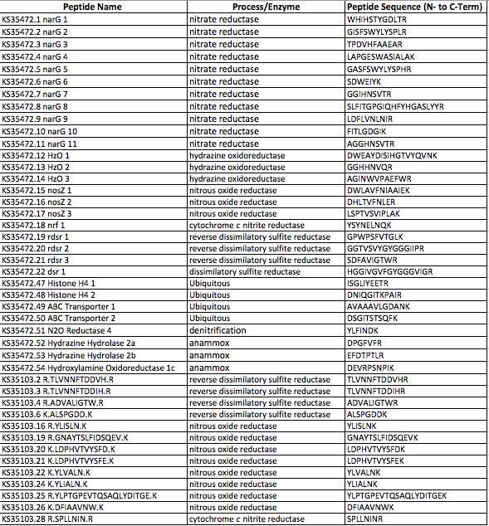
Table 3. Complete list of targeted peptides for denitrification, anammox, and sulfur cycling, including peptide name, associated process or enzyme, and peptide sequence used for this project.
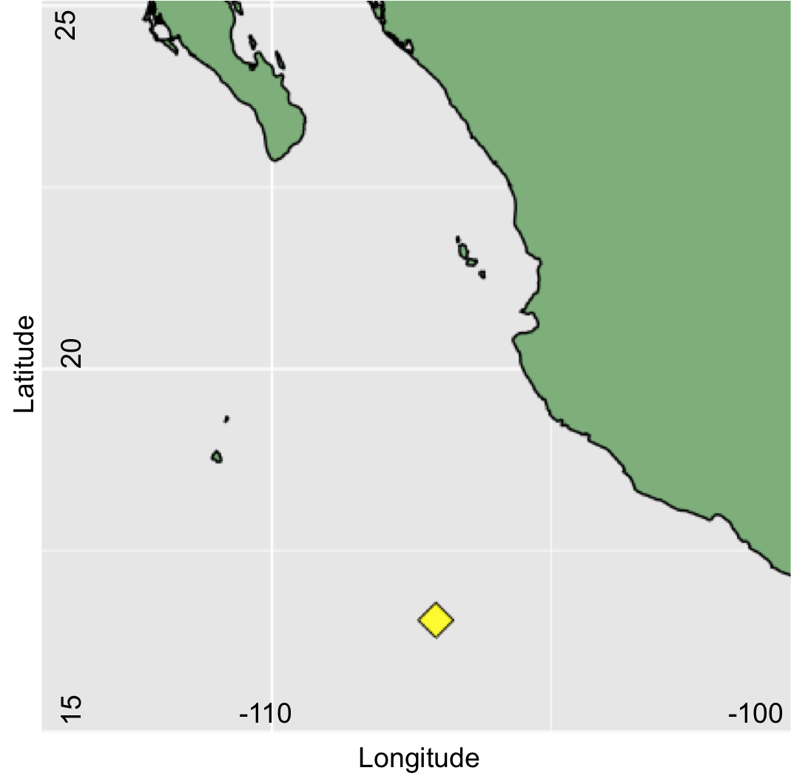
Figure 1. Offshore station (yellow diamond) from which all filter samples were collected. Located approximately 200 miles off the coast of Manzanillo, Colima, Mexico at 16˚32.377’N/107˚3.868’W between January 8th 2017 and January 13th 2017.

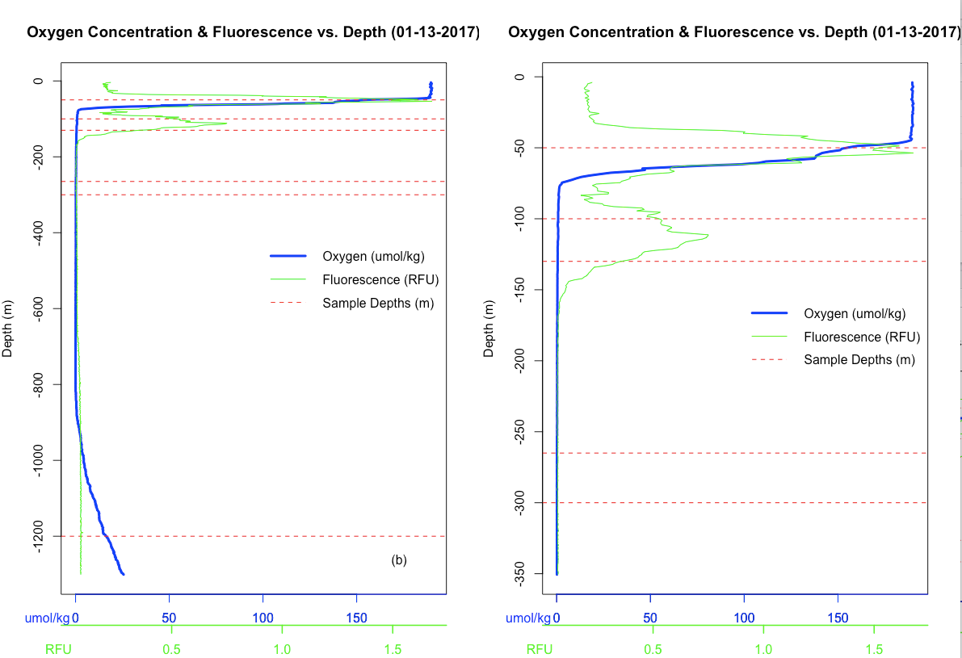
Figure 2. CTD cast data from the ETNP ODZ showing oxygen concentration and fluorescence. Dashed lines indicate depths from which filter samples were taken. Graph (a) shows a full depth profile with all six sample depths included, while graph (b) shows only the first five samples to give a close up view of the primary and secondary chlorophyll maxima.
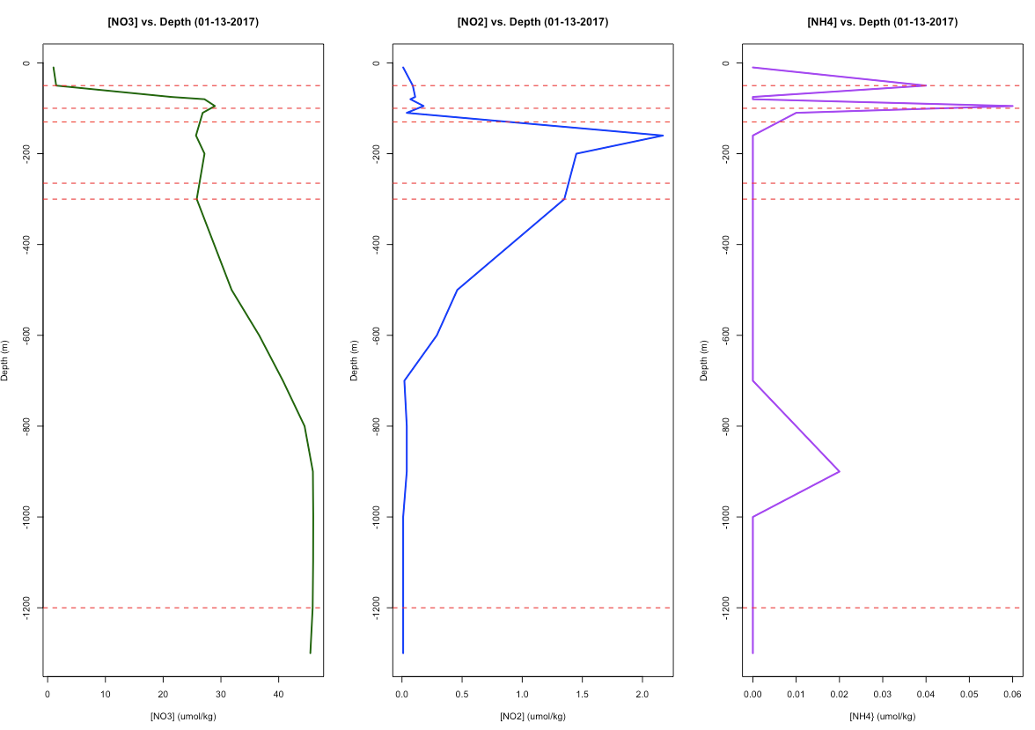
Figure 3. Nutrient depth profiles for nitrate, nitrite, and ammonia from the ETNP ODZ. Water samples collected on 01/13/2017. Dashed lines indicate depths from which samples were taken.

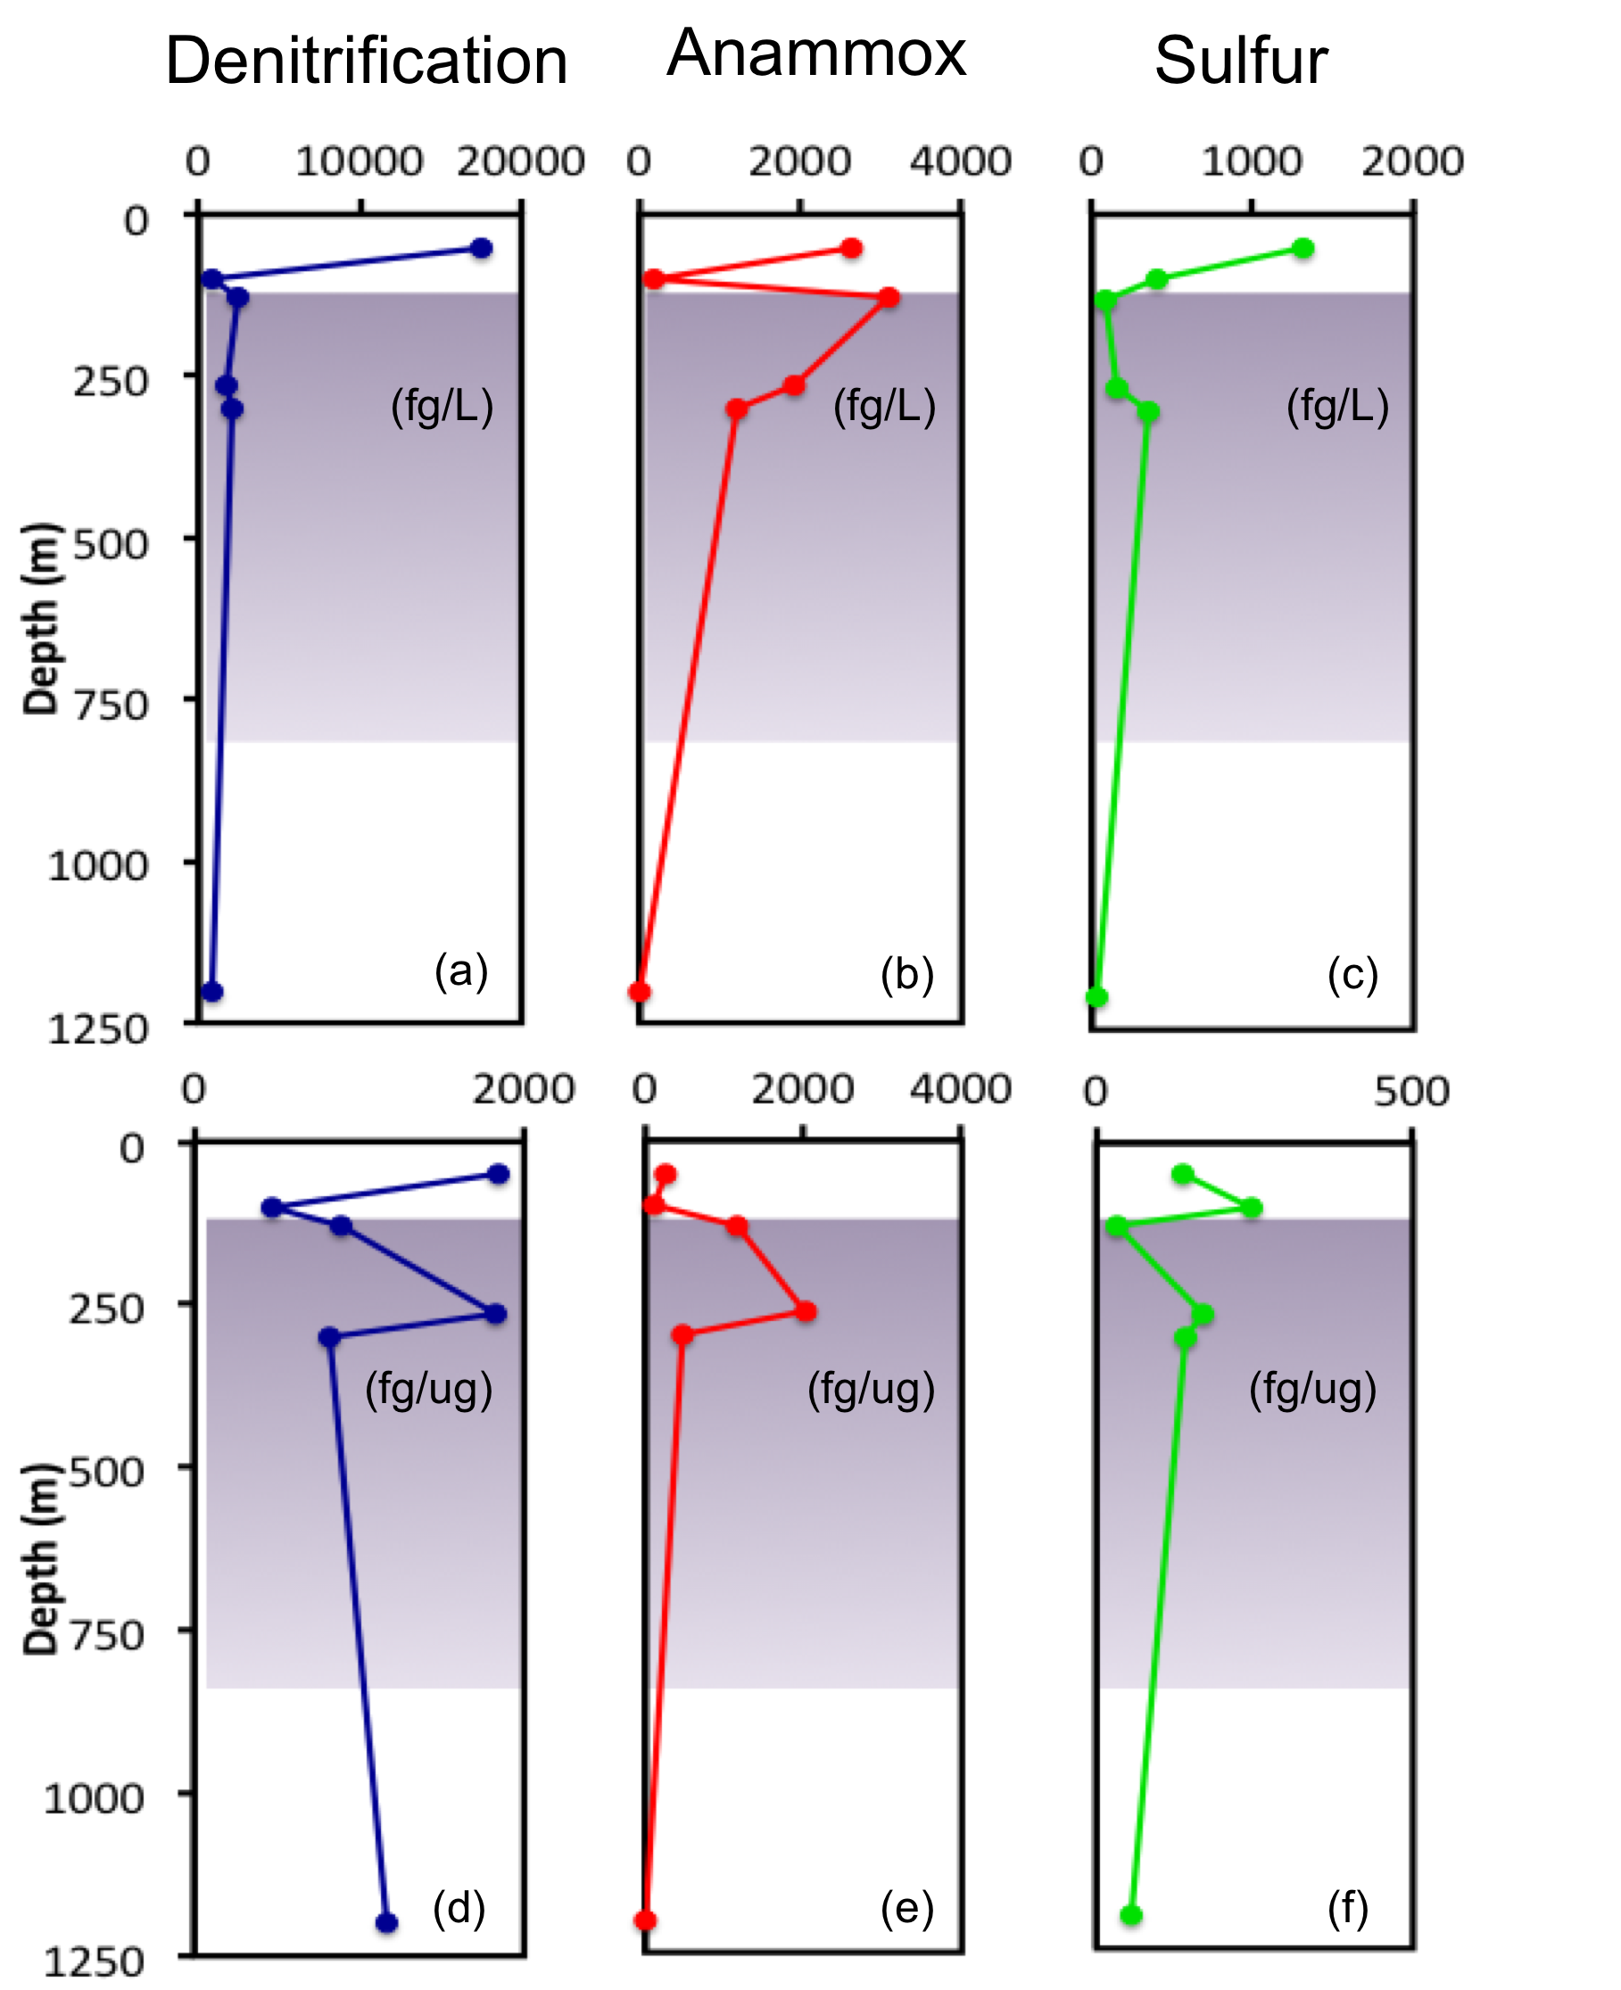
Figure 4. Average peptide abundance associated with each individual respiratory process (denitrification, anammox, sulfur cycling) plotted against each sample depth as a concentration per liter seawater (a-c). Average peptide abundance associated with each individual respiratory process plotted against each sample depth as a ratio of total peptide abundance per process (fg) to total protein abundance (ug) at depth (d-f). Peptide abundance normalized against the number of targeted peptides per process in order to decrease sampling bias. Purple boxes in all graphs represent the oxygen deficient zone.

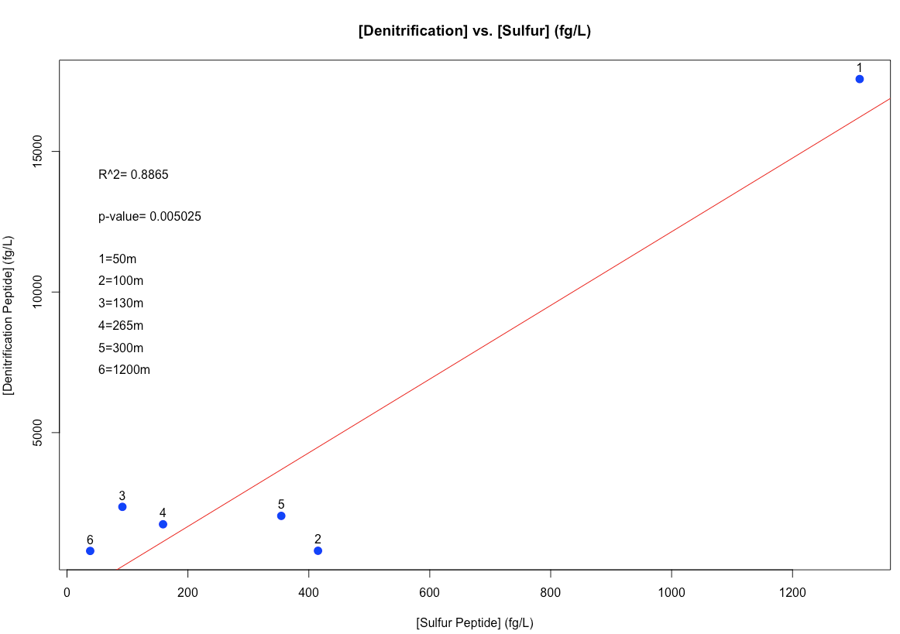
Figure 5. Total denitrification peptides plotted against total sulfur peptides per liter seawater for all six samples. R^2 value of 0.8865 indicates a strong correlation, and a p-value of 0.005025 indicates a significant relationship.

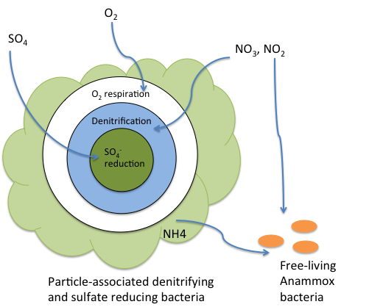

Figure 6. Microzone schematic showing oxic respiration, denitrification, and sulfate reduction all occurring simultaneously within a sinking particle. Anammox represented in the system, separate from the microzone.

References

Babbin, A. R., R. G. Keil, A. H. Devol, and B. B. Ward, 2014, Organic Matter Stoichiometry, Flux, and Oxygen Control Nitrogen Loss in the Ocean: Science, v. 344, p. 406-408.
Brandes, J. A., and A. H. Devol, 1995, SIMULTANEOUS NITRATE AND OXYGEN RESPIRATION IN COASTAL SEDIMENTS - EVIDENCE FOR DISCRETE DIAGENESIS: Journal of Marine Research, v. 53, p. 771-797.
Canfield, D. E., F. J. Stewart, B. Thamdrup, L. De Brabandere, T. Dalsgaard, E. F. Delong, N. P. Revsbech, and O. Ulloa, 2010, A Cryptic Sulfur Cycle in Oxygen-Minimum-Zone Waters off the Chilean Coast: Science, v. 330, p. 1375-1378.
Devol, A. H., 2003, Nitrogen cycle - Solution to a marine mystery: Nature, v. 422, p. 575-576.
DeVries, T., C. Deutsch, F. Primeau, B. Chang, and A. Devol, 2012, Global rates of water-column denitrification derived from nitrogen gas measurements: Nature Geoscience, v. 5, p. 547-550.
Froelich, P. N., G. P. Klinkhammer, M. L. Bender, N. A. Luedtke, G. R. Heath, D. Cullen, P. Dauphin, D. Hammond, B. Hartman, and V. Maynard, 1979, EARLY OXIDATION OF ORGANIC-MATTER IN PELAGIC SEDIMENTS OF THE EASTERN EQUATORIAL ATLANTIC - SUBOXIC DIAGENESIS: Geochimica Et Cosmochimica Acta, v. 43, p. 1075-1090.
Fuchsman, C. A., J. T. Staley, B. B. Oakley, J. B. Kirkpatrick, and J. W. Murray, 2012, Free-living and aggregate-associated Planctomycetes in the Black Sea: Fems Microbiology Ecology, v. 80, p. 402-416.
Galan, A., J. Faundez, B. Thamdrup, J. F. Santibanez, and L. Farias, 2014, Temporal dynamics of nitrogen loss in the coastal upwelling ecosystem off central Chile: Evidence of autotrophic denitrification through sulfide oxidation: Limnology and Oceanography, v. 59, p. 1865-1878.
Galan, A., V. Molina, B. Thamdrup, D. Woebken, G. Lavik, M. M. M. Kuypers, and O. Ulloa, 2009, Anammox bacteria and the anaerobic oxidation of ammonium in the oxygen minimum zone off northern Chile: Deep-Sea Research Part Ii-Topical Studies in Oceanography, v. 56, p. 1125-1135.
Horak, R. E. A., W. Ruef, B. B. Ward, and A. H. Devol, 2016, Expansion of denitrification and anoxia in the eastern tropical North Pacific from 1972 to 2012: Geophysical Research Letters, v. 43, p. 5252-5260.
Hulth, S., R. C. Aller, D. E. Canfield, T. Dalsgaard, P. Engstrom, F. Gilbert, K. Sundback, and B. Thamdrup, 2005, Nitrogen removal in marine environments: recent findings and future research challenges: Marine Chemistry, v. 94, p. 125-145.
Keil, R. G., J. A. Neibauer, C. Biladeau, K. van der Elst, and A. H. Devol, 2016, A multiproxy approach to understanding the "enhanced" flux of organic matter through the oxygen-deficient waters of the Arabian Sea: Biogeosciences, v. 13, p. 2077-2092.
Lam, P., and M. M. M. Kuypers, 2011, Microbial Nitrogen Cycling Processes in Oxygen Minimum Zones, in C. A. Carlson, and S. J. Giovannoni, eds., Annual Review of Marine Science, Vol 3: Annual Review of Marine Science, v. 3: Palo Alto, Annual Reviews, p. 317-345.
Levin, L., D. Gutierrez, A. Rathburn, C. Neira, J. Sellanes, P. Munoz, V. Gallardo, and M. Salamanca, 2002, Benthic processes on the Peru margin: a transect across the oxygen minimum zone during the 1997-98 El Nino: Progress in Oceanography, v. 53, p. 1-27.
Paerl, H. W., and J. L. Pinckney, 1996, A mini-review of microbial consortia: Their roles in aquatic production and biogeochemical cycling: Microbial Ecology, v. 31, p. 225-247.
Stewart, F. J., 2011, Dissimilatory sulfur cycling in oxygen minimum zones: an emerging metagenomics perspective: Biochemical Society Transactions, v. 39, p. 1859-1863.
Stramma, L., E. D. Prince, S. Schmidtko, J. G. Luo, J. P. Hoolihan, M. Visbeck, D. W. R. Wallace, P. Brandt, and A. Kortzinger, 2012, Expansion of oxygen minimum zones may reduce available habitat for tropical pelagic fishes: Nature Climate Change, v. 2, p. 33-37.
Stramma, L., S. Schmidtko, L. A. Levin, and G. C. Johnson, 2010, Ocean oxygen minima expansions and their biological impacts: Deep-Sea Research Part I-Oceanographic Research Papers, v. 57, p. 587-595.
Wyman, M., S. Hodgson, and C. Bird, 2013, Denitrifying Alphaproteobacteria from the Arabian Sea That Express nosZ, the Gene Encoding Nitrous Oxide Reductase, in Oxic and Suboxic Waters: Applied and Environmental Microbiology, v. 79, p. 2670-2681.
Wyrtki, K., 1962, THE OXYGEN MINIMA IN RELATION TO OCEAN CIRCULATION: Deep-Sea Research, v. 9, p. 11-23.

Appendices

Appendix I.

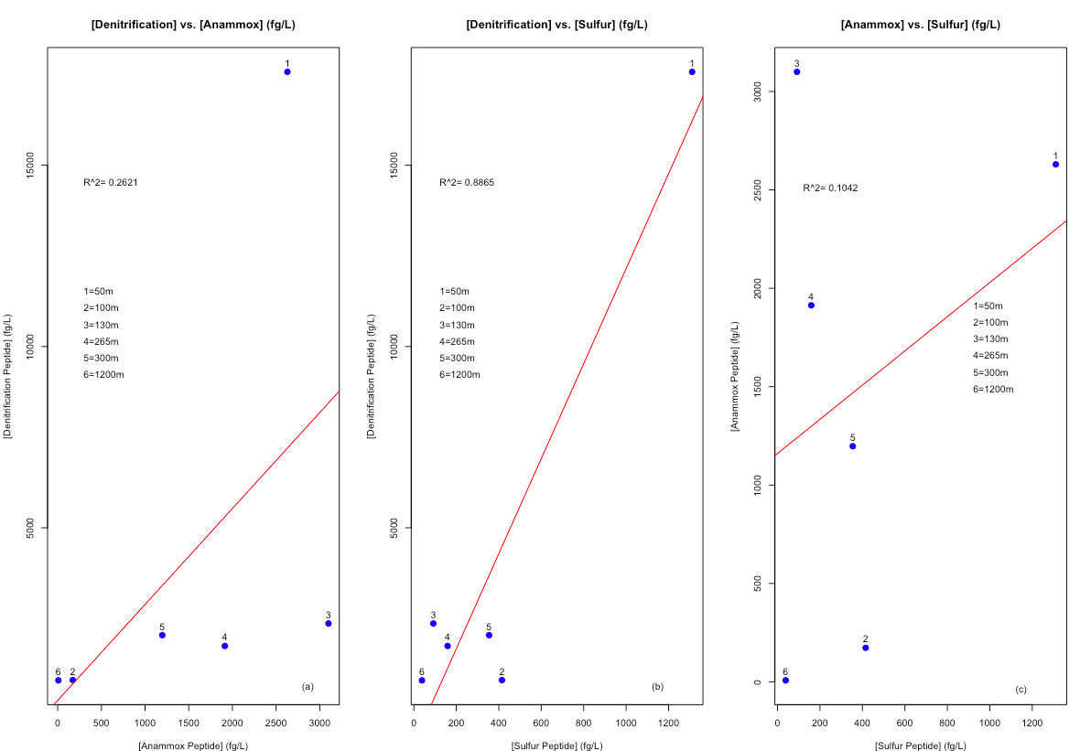
Appendix I. Average concentration of denitrification peptides compared with concentration of anammox peptides (a), denitrification peptides compared with sulfur cycling peptides (b), and anammox peptides compared with sulfur cycling peptides (c) per liter seawater at all six sample depths. R² values provided to indicate degree of significance between each correlation. Appears that only (b) has a significant correlation. All peptide data normalized as in Figures 2 and 3.

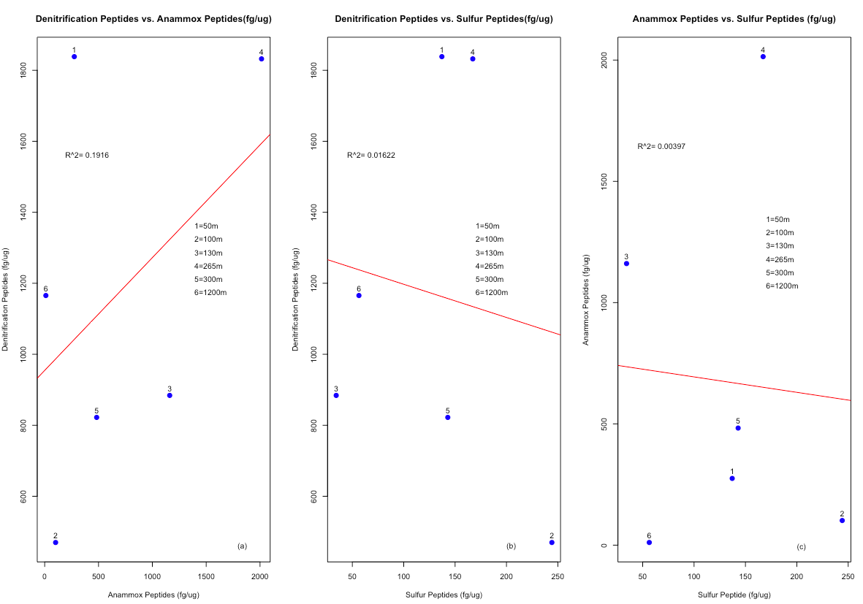
Appendix II.
Appendix II. Average ratio of denitrification peptides compared with anammox peptides (a), denitrification peptides compared with sulfur cycling peptides (b), and anammox peptides compared with sulfur cycling peptides (c) per microgram of total protein at all six sample depths. R² values provided to indicate degree of significance between each correlation. No significant correlations found in these data.

