Sub Surface Expression of the Antarctic Polar Front at Regions of Large and Small Latitudinal Variability

Juliana Chen
University of Washington
jpez@uw.edu
May 30th, 2017
Abstract
The Polar Front is an important meridional heat transport boundary. So, its location and strength are important to understanding the heat budget. Previous studies have been conducted on the position of the Polar Front using surface properties, but none have focused on the sub surface expression of the gradient. This study will focus on the subsurface expression of the Polar Front, qualifying the vertical shear, at locations where the surface position of the Polar Front shows high and low variability. By sampling six different locations along the Polar Front, it is found that there is no distinct pattern of the gradients as compared by locations of high and low variability of position. It is found, however, that the Polar Front has a distinct pattern in all locations seasonally.

Introduction

The Antarctic Circumpolar Current (ACC) connects the Southern Atlantic, Indian, and Pacific basins while simultaneously acting as a barrier against meridional heat transport, allowing the unique and isolated climate of Antarctica (Rintoul, Hughes, & Olbers, 2001). Creating these barriers within the ACC are multiple hydrographic fronts characterized by strong gradients in oceanographic properties (Pollard, Lucas, & Read, 2002). The ACC is built of three hydrographic fronts (from North to South): the Subantarctic Front, the Polar Front, and the Southern ACC Front (Orsi, Whitworth III, & Nowlin Jr., 1995). This study will focus on the Antarctic Polar Front. The Polar Front is a barrier that marks the transition between the fresh, cold Antarctic waters and saltier, warmer sub-Antarctic waters (Pollard et al., 2002). As the front acts as a barrier, the position of the Polar Front can change the physical and biogeochemical state of the Southern Ocean (Pollard et al., 2002).
Studies have been done previously on the position of the Polar Front from surface properties (Freeman, Lovenduski, & Gent, 2016). These studies examine interannual variability in the Polar Front’s position. It was found that there was relatively no interannual variability in the latitudinal position of the Polar Front, but the temperatures show a prominent seasonal cycle (Freeman et al., 2016). Previous studies have only looked at the surface expression of the Polar Front, so this study focuses on the sub surface expression of the Polar Front. We compare regions where the climatological seasonal position of the Polar Front is highly variable with regions that are mostly consistent and analyze the seasonal strength of the vertical gradient. This is important in understanding how the Polar Front seasonally acts as a meridional heat transport barrier.

Methods

This study uses two existing data sets for our analysis. The main data sets are from the Freeman et al. (2016) and Monthly Isopycnal and Mixed-layer Ocean Climatology (MIMOC) data. Freeman et al. (2016) calculated the Polar Font position was using satellite sea surface temperature (SST) that was measured using wave-penetrating microwave radiometers (Freeman et al., 2016). The Polar Font data is a weekly position with a resolution of half a degree longitude with data between 2002-2014. The MIMOC data was calculated through averaging Argo CTD profiles with a supplement of shipboard and Ice-Tethered Profiler CTD data (Schmidtko, Johnson, & Lyman, 2013). The MIMOC data was originally created by Schmidtko, Johnson, and Lyman (2013) and is a pressure-gridded global monthly climatology data set with a resolution of half a degree by half a degree.
For our analysis we used the Freeman et al. (2016) Polar Front position and made a climatology data set. The standard deviation was then calculated, showing variability in all regions of the Southern Ocean. Six regions (three high and three low regions of variability) were then chosen according to the following criteria: they had to be positions of either high or low variability and the MIMOC data must have the Polar Front and the standard deviation within its data set. According to this criteria longitude 0ºE, 80ºE, and 115ºE were chosen as the regions to represent the small variability in the Polar Front position. Longitude 100ºE, 130ºE, and 40ºW were chosen as the regions to represent large variability in the Polar Front position. As the variability in the Polar Front gradient was most prominent in the summer and winter periods, the MIMOC data was then averaged for each of the seasons: summer (January-March) and winter (July-September). Using the seawater equation of state, the density of the MIMOC data was calculated using the surface as the reference (Equation 1).
Equation 1: σ_{t} = ρ(T, S, 0) – 1000
These regions were then visually analyzed for differences in the Polar Front gradient.

Results
Six positions where chosen (three regions of large and three regions of variability): longitude 0ºE, 80ºE, and 115ºE were chosen as the regions to represent the small variability in the Polar Front position; longitude 100ºE, 130ºE, and 40ºW were chosen as the regions to represent large variability in the Polar Front position (Figure 1). Figure 2 shows the potential density at the regions of small variability of the position of the Polar Front. The noticeable feature of these figures is that there is a much more prominent gradient in the winter than the summer. Also, there is a lowering of the main shear in the Polar Front during the winter. Figure 3 shows the potential density of the regions of large variability of the position of the Polar Front. Again, there is a more prominent gradient in the winter than summer, and the main shear in the Polar Front is found lower in the water column in the winter. There is also no distinct difference in the shear between regions with small and large variability in the position of the Polar Front.

Discussion
The study shows that the subsurface expression of the Polar Front is more dependent on the season rather than the variability of the position of the Polar Front. This data is similar to what studies have found previously, the Polar Front does not have much interannual variability, but can vary significantly between seasons (Freeman et al., 2016). The difference that has been previously found for the variability of the Polar Front point to the bathymetry of the Southern Ocean (Freeman et al., 2016). The regions of high variability are usually located on abyssal planes while regions of low variability are surrounded by large bathymetric features (Freeman et al., 2016). While this may affect the position of the Polar Front, it does not seem to have a major impact on the gradient of the Polar Front. Both the regions of small and large variability do not have any significant differences in the gradient. On the other hand, the seasonal variability is obvious. More research must be done on why this may be, but the results are consistent with previous studies on the surface expression of the Polar Front.

Acknowledgements
I would like to thank LuAnne Thompson for all of her guidance and knowledge that she very kindly shared with me throughout the process of creating this piece and keeping me on track. I also would like to thank Arthur Nowell for his guidance, and the rest of my ocean physics group for their continued support.

Figures
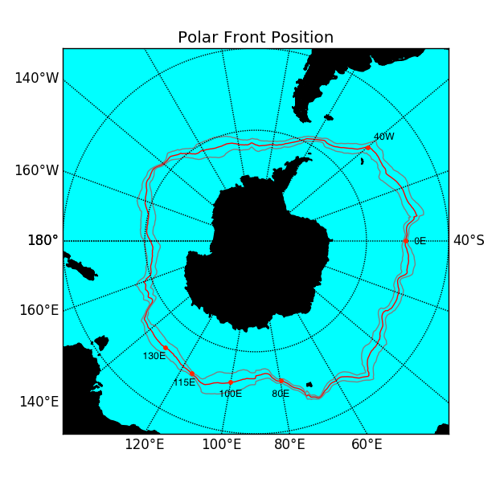
Figure 1 Temporal mean (red) and standard deviation (black) in the monthly Polar Front position (June 2002 to February 2014).

0ºE Longitude
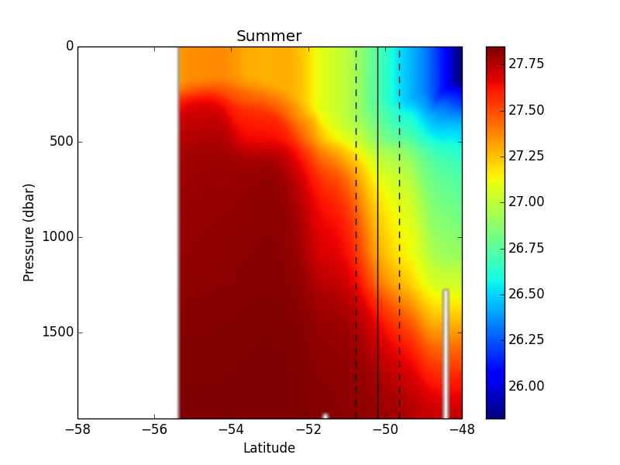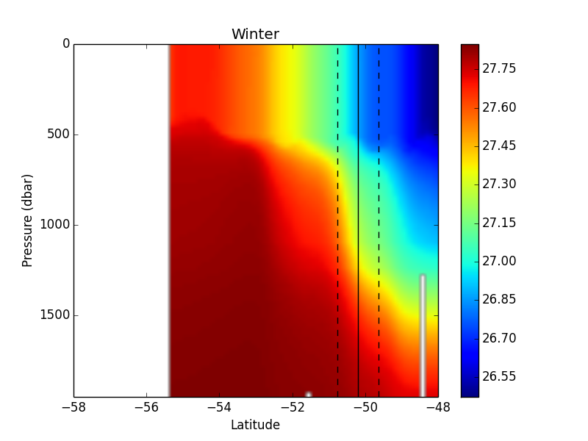
80ºE Longitude
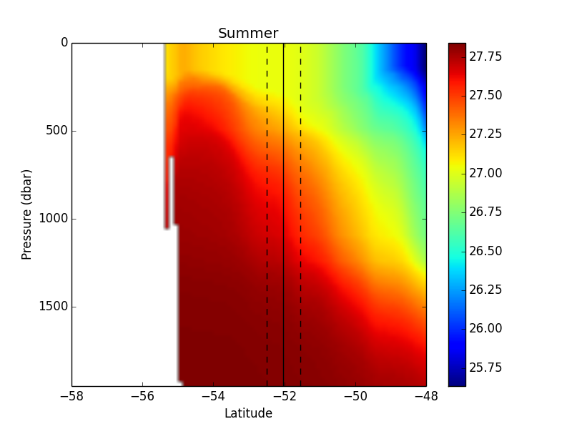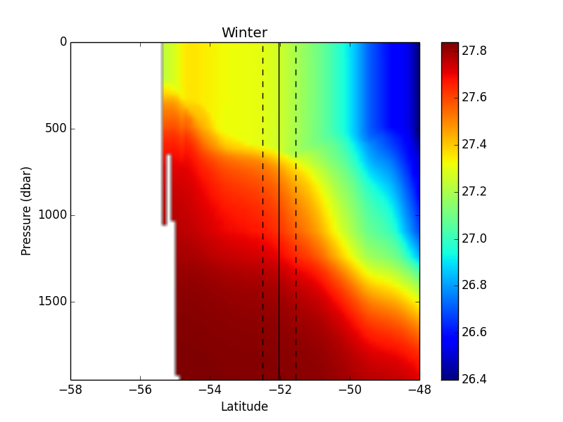
115ºE Longitude
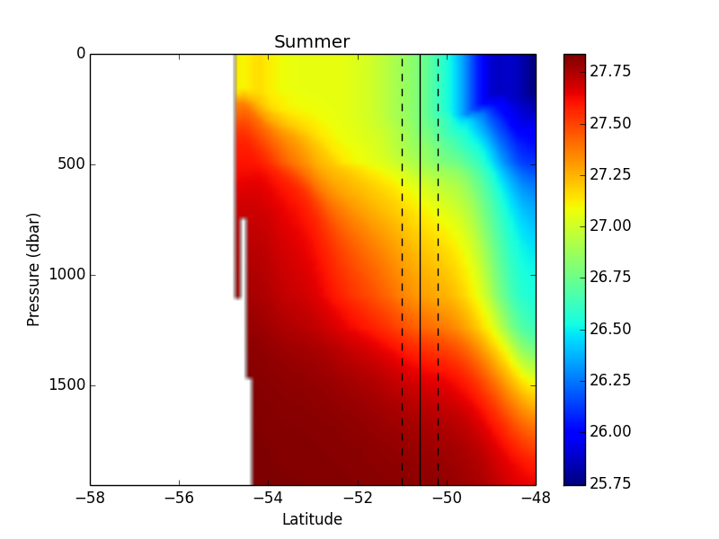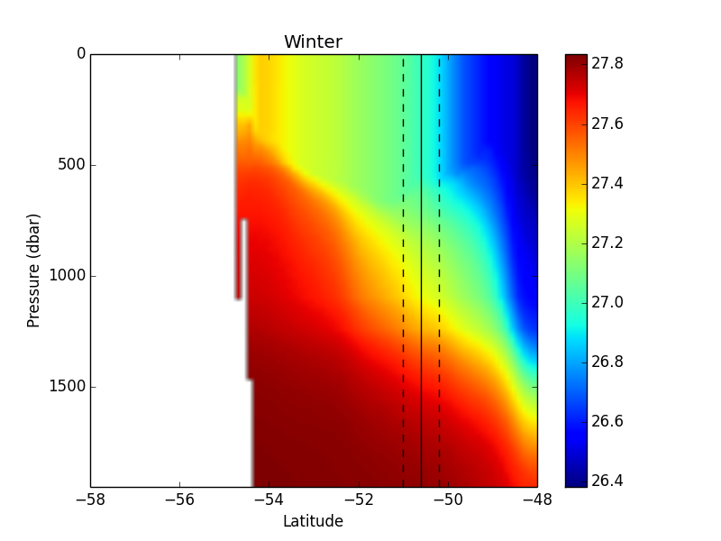

Figure 2 Climatological potential densities of regions of small latitudinal variability in summer and winter calculated from MIMOC data. Note that the shear is more prominent in winter than in summer.
100ºE Longitude
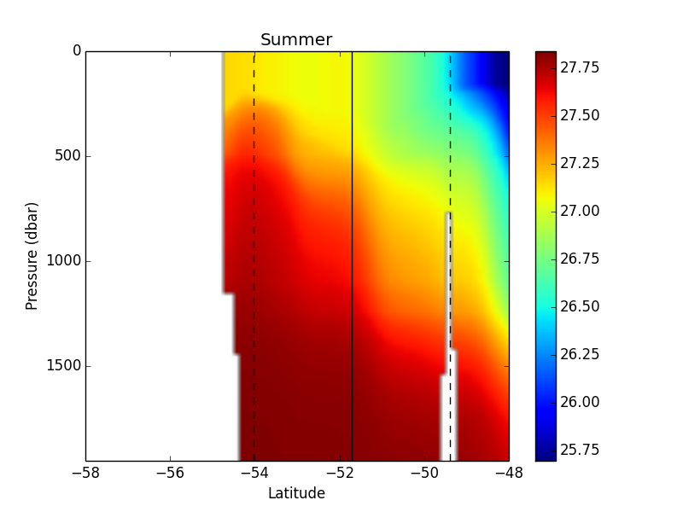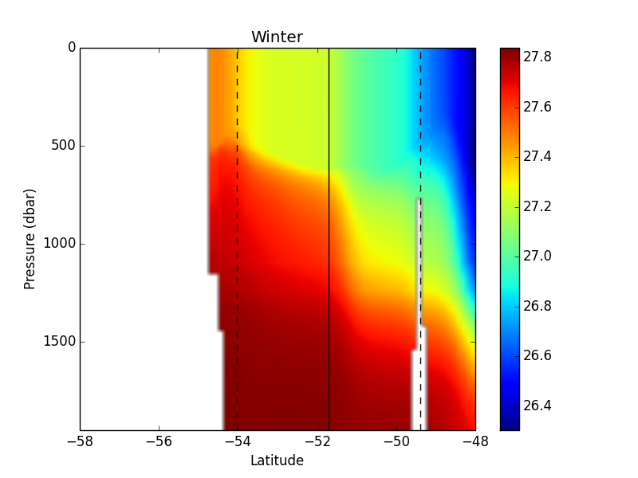
130ºE Longitude
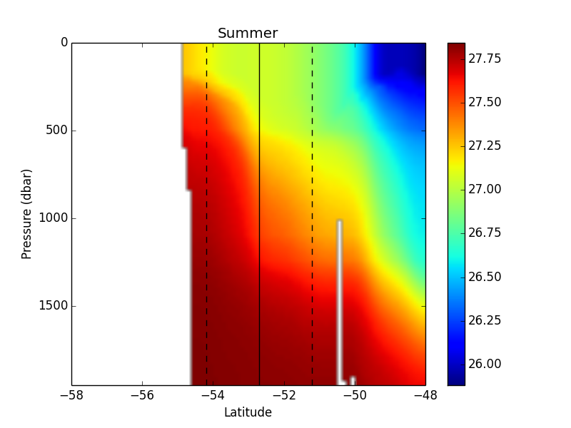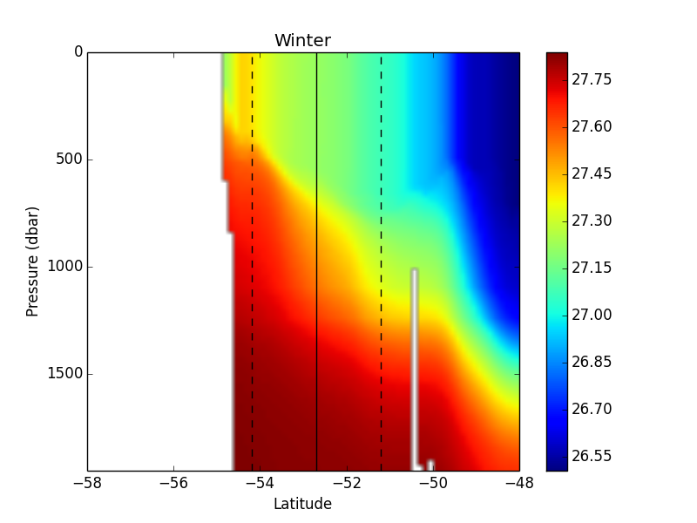
40ºW Longitude
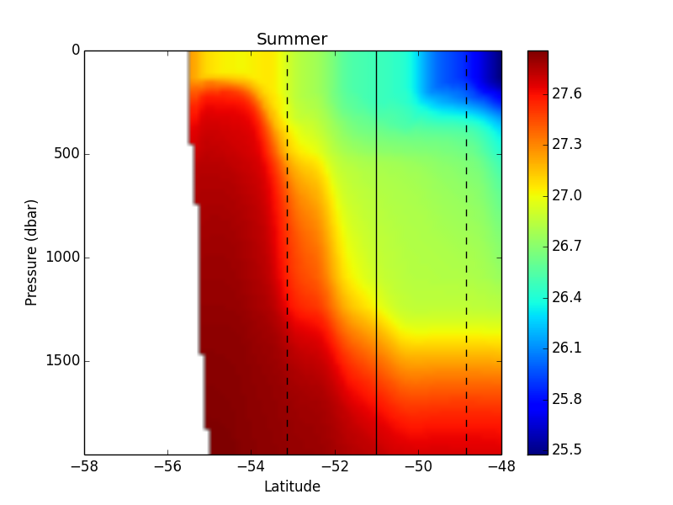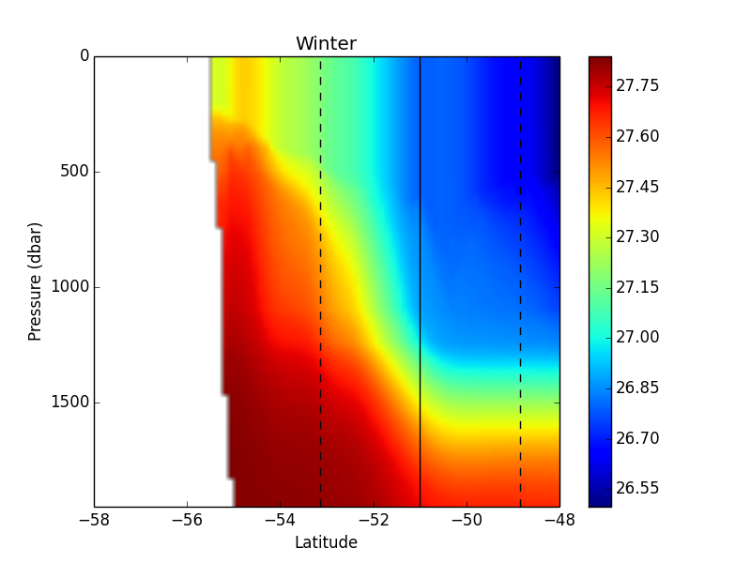
Figure 3 Climatological potential densities of regions of large latitudinal variability in the winter and summer calculated from MIMOC data. Note that the shear is more prominent in the winter than the summer.

References
Freeman, N. M., Lovenduski, N. S., & Gent, P. R. (2016). Temporal variability in the Antarctic Polar Front (2002-2014). Journal of Geophysical Research: Oceans, 121(10), 7263-7276. doi:10.1002/2016jc012145
Orsi, A. H., Whitworth III, T., & Nowlin Jr., W. D. (1995). On the meridional extent and fronts of the Antarctic Circumpolar Current. Deep Sea Res., Part I, 42, 32.
Pollard, R. T., Lucas, M. I., & Read, J. F. (2002). Physical controls on biogeochemical zonation in the Southern Ocean. Deep Sea Res., Part II, 49, 16. doi:10.1016/S0967-0645(02)00084-X
Rintoul, S. R., Hughes, C., & Olbers, D. (2001). The Antarctic Circumpolar Current system, in Ocean Circulation and Climate. International Geophysics, 77, 31.
Schmidtko, S., Johnson, G. C., & Lyman, J. M. (2013). MIMOC: A Global Monthly Isopycnal Upper-Ocean Climatology with Mixed Layers. Journal of Geophysical Research: Oceans, 118. doi:10.1002/jgrc.20122

