Supplemental Table 1. Data Memo
Data Element | Decision | Date
Centre | Include Centre in Table 1, 2, and 3. Combine Homa Bay and St. Paul due to proximity of location  - Include because there may be sociodemographic differences  - Do not adjust for centre because it is not clear what this adjustment will be accounting for (possible malaria differences?) | 11/19/2019
Age (months) | In table 1, categorize as following  - 1 to < 6mo  - 6 to < 12mo  - >= 12 to < 24mo  - >= 24 mo | 11/19/2019
HIV Infected | Keep in table 1, but take out of table 2 and 3  - because HIV is likely to have a very large impact on many of the exposures of interest, so excluding them completely is the cleanest approach  - this will magnify the signal-to-noise ratio of other exposures  - adjusting for HEU status takes care of a lot of residual confounding not just for HIV exposure but for probably additional related/sociodemographic factors as well | 11/19/2019
Household income | Use caregiver income as household income until further notice | 11/19/2019
Age and HIV-Exposure | Adjust these 2 together in 1 model because ______________  - adjust age as continuous variable sc_age  - adjust HIV-Exposure as the new variable for exposed/unexposed (hivex_yesno) | 11/19/2019
SAM | Instead of SAM/No SAM, create a categorical variable:  - gen wastingbywhz2= .  - replace wastingbywhz2=2 if en_whz < -3  - replace wastingbywhz2=1 if en_whz >=-3 & en_whz<-2 & en_whz != .  - replace wastingbywhz2=0 if en_whz >=-2 & en_whz != .  - ta wastingbywhz2  - label define l_wastingwhz2 0 "No wasting" 1 "MAM" 2"SAM"  - label values wastingbywhz2 l_wastingwhz2  - ta wastingbywhz2 | 11/19/2019
Figure 2. CMV Viral Load by HIV Status | We want to depict the boxplot for the following 3 categories (this is with the full 1024 population):  - HIV Unexposed  - HIV Exposed, Uninfected  - HIV Infected | 11/19/2019
Currently Nursing | Assess for only those under 24 months | 11/25/2019

Figure 1. Number enrolled and included study participants
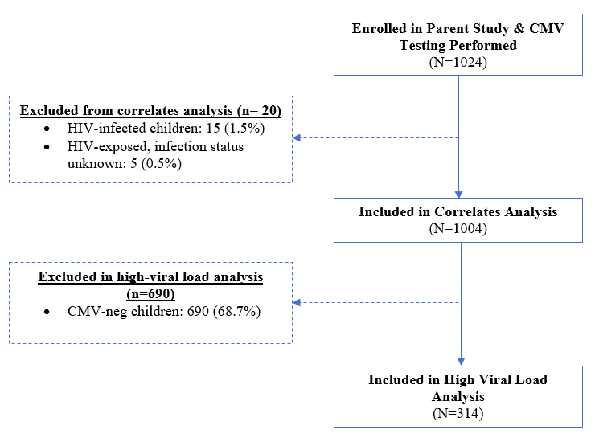
Figure 1. Exclusion criteria for analysis, resulting in N=1004

Figure 2. CMV DNA viral loads in HIV Unexposed, HIV Exposed Uninfected, and HIV- Infected children with CMV viremia
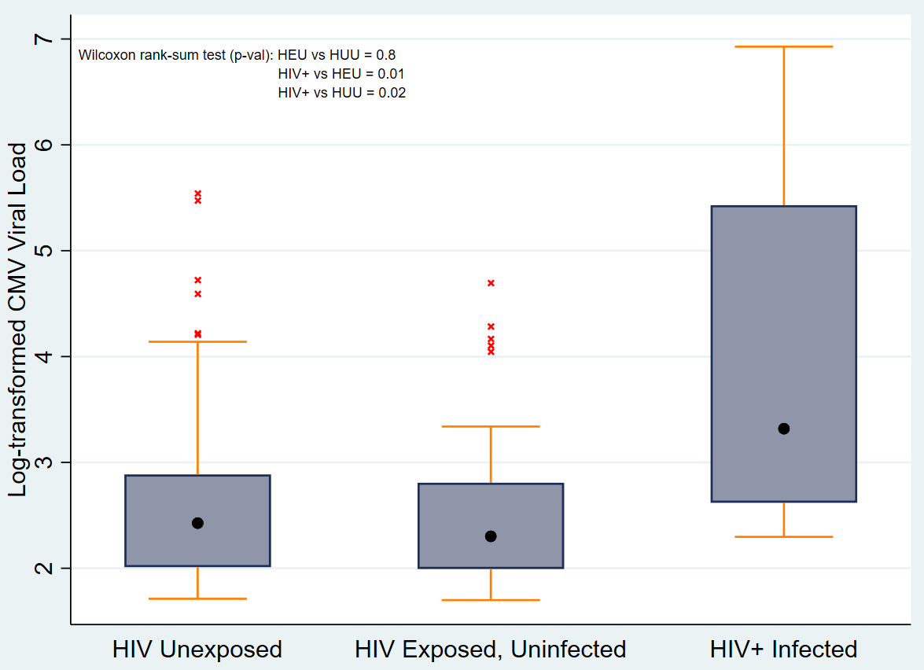
Figure 2. CMV viral load (log-transformed) in children, by HIV Unexposed, HIV Exposed Uninfected, and HIV+ Infected status (from left to right). Median values are shown by a black dot, IQR is shown within the blue box, outlier whiskers are shown by orange lines, and outlier values are indicated as red x-marks.

Table 1. Characteristics of enrolled children (N=1,024)
 | n | (%)
Characteristic | Median | (IQR)
Site
Kisii | 628 | (61.3)
Homa Bay/ St. Paul | 396 | (38.7)
Household
Crowding | 462 | (45.1)
Household Income
None | 307 | (30.0)
< 10,000 ksh | 490 | (47.8)
≥ 10,000 ksh | 168 | (16.5)
Caregiver Characteristics
Biological Mother | 927 | (90.5)
Biological Father | 32 | (3.1)
Other | 65 | (6.4)
Child Characteristics
Male | 621 | (60.8)
Female | 401 | (39.2)
Age (months)
1 to > 6 mo | 137 | (13.4)
6 to < 12 mo | 199 | (19.4)
≥ 12 to 24 mo | 328 | (32.0)
≥ 24 mo | 360 | (35.2)
Nutritional Status
Median WAZ | -0.5 | (-1.3 to 0.3)
Underweight (WAZ < -2) | 127 | (12.4)
Median WHZ | 0.0 | (-0.8 to 0.9)
Wasted (WHZ < -2) | 57 | (5.6)
Severe Acute Malnutrition (WHZ < -3) | 17 | (1.7)
Median HAZ | -0.9 | (-0.9 to 0.0)
Stunted (HAZ < -2) | 248 | (24.3)
MUAC (cm) | 14.3 | (13.2 to 15.2)
< 12.5 | 127 | (12.4)
≥ 12.5 | 897 | (87.6)
Length of Hospitalization (days)
< 7 | 841 | (85.1)
≥ 7 | 183 | (17.9)
HIV Status
HIV Unexposed | 871 | (85.1)
HIV Exposed, Uninfected | 96 | (9.4)
HIV Infected | 15 | (1.5)
Uninfected, Exposure Status Unknown | 37 | (3.6)
HIV Exposed, Infection Status Unknown | 5 | (0.5)
Breastfeeding Status
Never Breastfed | 18 | (1.8)
Exclusively Breastfed | 467 | (45.9)
Currently Nursing | 483 | (75.6)
Final Diagnosis
Anemia | 133 | (13.0)
Lower Respiratory Tract Infection | 350 | (34.2)
Gastroenteritis/ diarrhea | 187 | (18.3)
Malaria | 276 | (27.0)
Malnutrition | 58 | (5.7)
Meningitis | 53 | (5.2)
Sepsis | 30 | (2.9)
Sickle Cell | 70 | (6.8)
Tuberculosis | 15 | (1.5)
Other | 257 | 25.1

Table 2. Socio-demographic and clinical characteristics of CMV DNA-negative and DNA-positive children (1,004)
 | CMV Negative |  | CMV Positive |  | Prev Ratio |  |  | P > |z| | Age & HIV- Adjusted PR |  | P > |z|
Characteristic | n | % | n | % |  | PR | (95% CI) |  | PR | (95%CI)
Site
Kisii | 474 | (76.6) | 145 | (23.4) |  | [REF]
Homa Bay/ St. Paul | 216 | (56.1) | 166 | (43.1) |  | 1.8 | (1.5 to 2.3) | <0.001 | 1.9 | (1.5 to 2.4) | <0.001
Child Characteristics
Male | 428 | (70.0) | 183 | (30.0) |  | [REF]
Female | 261 | (66.8) | 130 | (33.2) |  | 1.1 | (0.9 to 1.4) | 0.4 | 1.1 | (0.9 to 1.4) | 0.4
Age (months)
< 24 mo | 399 | (63.3) | 231 | (36.7) |  | [REF]
≥ 24 mo | 291 | (77.8) | 83 | (22.2) |  | 0.6 | (0.5 to 0.8) | <0.001 | 0.6 | (0.5 to 0.8) | <0.001
Nutritional Status
Not Underweight | 606 | (68.7) | 276 | (31.3) |  | [REF]
Underweight (WAZ < -2) | 84 | (68.9) | 38 | (31.1) |  | 1.0 | (0.7 to 1.4) | 1.0 | 0.9 | (0.6 to 1.2) | 0.4
Not Wasted | 647 | (68.5) | 298 | (31.5) |  | [REF]
Moderate Acute Malnutrition (WHZ ≥ -3) | 28 | (75.7) | 9 | (24.3) |  | 0.7 | (0.4 to 1.5) | 0.4 | 0.7 | (0.4 to 1.4) | 0.4
Severe Acute Malnutrition (WHZ < -3) | 10 | (58.8) | 7 | (41.1) |  | 1.3 | (0.6 to 2.8) | 0.5 | 0.9 | (0.4 to 2.0) | 0.8
Not Stunted | 519 | (68.0) | 244 | (32.0) |  | [REF]
Stunted (HAZ < -2) | 169 | (70.7) | 70 | (29.3) |  | 0.9 | (0.7 to 1.2) | 0.5 | 0.9 | (0.7 to 1.2) | 0.4
MUAC
> 12.5 cm | 615 | (69.4) | 271 | (30.6) |  | [REF]
< 12.5 cm | 75 | (63.6) | 43 | (36.4) |  | 1.2 | (0.9 to 1.6) | 0.3 | 0.9 | (0.6 to 1.2) | 0.5
Length of Hospitalization (days)
< 7 | 571 | (68.7) | 260 | (31.3) |  | [REF]
> 7 | 119 | (68.8) | 54 | (31.2) |  | 1.0 | (0.7 to 1.4) | 1.0 | 0.9 | (0.7 to 1.2) | 0.5
HIV Status
HIV Unexposed | 614 | (70.5) | 257 | (29.5) |  | [REF]
HIV Exposed, Uninfected | 58 | (60.4) | 38 | (39.5) |  | 1.3 | (1.0 to 1.9) | 0.1 | 1.4 | (1.0 to 2.0) | 0.04
Not Currently Nursing | 376 | (74.3) | 130 | (35.7) |  | [REF]
Currently | 312 | (62.9) | 184 | (37.1) |  | 1.4 | (1.2 to 1.8) | <0.001 | 1.1 | (0.8 to 1.5) | 0.5
Never Breastfed | 13 | (72.2) | 5 | (27.8) |  | [REF]
Exclusively | 300 | (65.4) | 159 | (34.6) |  | 1.2 | (0.5 to 3.0) | 0.6 | 1.4 | (0.6 to 2.4) | 0.5
Final Diagnosis
Anemia | 78 | (60.9) | 50 | (39.1) |  | 1.3 | (1.0 to 1.8) | 0.1 | 1.4 | (1.0 to 1.8) | 0.05
Pneumonia | 204 | (65.8) | 106 | (34.2) |  | 1.1 | (0.9 to 1.4) | 0.3 | 1.0 | (0.8 to 1.3) | 1.0
Gastroenteritis/diarrhea | 126 | (68.9) | 57 | (31.1) |  | 1.0 | (0.7 to 1.3) | 1.0 | 0.9 | (0.7 to 1.2) | 0.5
Lower Respiratory Tract Infection | 22 | (59.5) | 15 | (40.5) |  | 1.3 | (0.8 to 2.2) | 0.3 | 1.2 | (0.7 to 2.0) | 0.6
Malaria | 182 | (67.4) | 88 | (32.6) |  | 1.1 | (0.8 to 1.4) | 0.7 | 1.2 | (1.0 to 1.6) | 0.1
Malnutrition | 32 | (58.1) | 23 | (41.8) |  | 1.4 | (0.9 to 2.1) | 0.2 | 1.1 | (0.7 to 1.7) | 0.7
Meningitis | 42 | (79.2) | 11 | (20.8) |  | 0.7 | (0.4 to 1.2) | 0.2 | 0.7 | (0.4 to 1.3) | 0.3
Sepsis | 18 | (60.0) | 12 | (40.0) |  | 1.3 | (0.7 to 2.3) | 0.4 | 1.3 | (0.7 to 2.3) | 0.4
Sickle Cell | 53 | (75.7) | 17 | (24.3) |  | 0.8 | (0.5 to 1.2) | 0.3 | 0.9 | (0.6 to 1.5) | 0.7
Tuberculosis | 13 | (92.9) | 1 | (7.1) |  | 0.2 | (0.0 to 1.6) | 0.1 | 0.2 | (0.0 to 1.3) | 0.1

 |  |  | Table 3. Socio-demographic and clinical characteristics of CMV High Viral Load Among CMV+ children (N=314)
 |  | Viral Load Copies  (log-transformed) |  |  |  |  | ≤ 1000 copies/ml |  |  | > 1000 copies/ml |  |  | Prev Ratio |  | P > |z| | Age & HIV- Adjusted PR |  | P > |z|
Characteristic |  |  |  | Median |  | (IQR) |  | n | % |  | n | % | PR | (95% CI) |  | PR | (95%CI)
All |  |  |  |  | 2.4 | (2.0 to 2.9) |  | 248 | (79.0) |  | 66 | (21.0)
Site
Kisii |  |  |  |  | 2.3 | (2.0 to 2.7) |  | 123 | (84.8) |  | 22 | (15.2) | [REF]
Homa Bay/ St. Paul |  |  |  |  | 2.5 | (2.0 to 3.0) |  | 125 | (74.0) |  | 44 | (29.0) | 1.7 | (1.0 to 2.9) | 0.04 | 2.2 | (1.3 to 3.7) | 0.003
Child Characteristics
Male |  |  |  |  | 2.4 | (2.0 to 2.8) |  | 146 | (79.8) |  | 37 | (20.2) | [REF]
Female |  |  |  |  | 2.4 | (2.0 to 2.9) |  | 101 | (77.7) |  | 29 | (22.3) | 1.1 | (0.7 to 1.8) | 0.7 | 1.0 | (0.6 to 1.7) | 0.9
Age (months)
< 24 mo |  |  |  |  | 2.5 | (2.1 to 3.0) |  | 169 | (73.2) |  | 62 | (26.8) | [REF]
≥ 24 mo |  |  |  |  | 2.1 | (1.9 to 2.5) |  | 79 | (95.2) |  | 4 | (2.8) | 0.2 | (0.1 to 0.5) | 0.001 | 0.2 | (0.1 to 0.5) | 0.001
Nutritional Status
Not Underweight |  |  |  |  | 2.4 | (2.0 to 2.8) |  | 220 | (79.7) |  | 56 | (20.3) | [REF]
Underweight (WAZ < -2) |  |  |  |  | 2.6 | (2.2 to 3.3) |  | 28 | (73.7) |  | 10 | (26.3) | 1.3 | (0.7 to 2.5) | 0.5 | 1.1 | (0.5 to 2.1) | 1.9
Not Wasted |  |  |  |  | 2.4 | (2.0 to 2.9) |  | 237 | (79.5) |  | 61 | (20.5) | [REF]
Moderate Acute  Malnutrition (WHZ ≥ -3) |  |  |  |  | 2.3 | (2.2 to 2.5) |  | 8 | (89.0) |  | 1 | (11.1) | 0.5 | (0.1 to 4.0) | 0.5 | 0.4 | (0.1 to 3.1) | 0.4
Severe Acute  Malnutrition (WHZ < -3) |  |  |  |  | 3.6 | (2.0 to 3.6) |  | 3 | (42.9) |  | 4 | (57.1) | 2.7 | (1.0 to 7.7) | 0.05 | 2.4 | (0.8 to 7.0) | 0.1
Not Stunted |  |  |  |  | 2.4 | (2.0 to 2.9) |  | 189 | (77.5) |  | 55 | (22.5) | [REF]
Stunted (HAZ < -2) |  |  |  |  | 2.4 | (2.0 to 2.8) |  | 59 | (84.3) |  | 11 | (15.7) | 0.7 | (0.4 to 1.3) | 0.3 | 0.7 | (0.4 to 1.4) | 0.4
MUAC
≥ 12.5 cm |  |  |  |  | 2.4 | (2.0 to 2.8) |  | 219 | (80.8) |  | 52 | (19.2) | [REF]
< 12.5 cm |  |  |  |  | 2.7 | (2.2 to 3.3) |  | 29 | (67.4) |  | 14 | (32.6) | 1.7 | (0.9 to 3.1) | 0.08 | 1.0 | (0.6 to 1.9) | 0.9
Length of Hospitalization (days)
< 7 |  |  |  |  | 2.4 | (2.0 to 2.8) |  | 208 | (80.0) |  | 52 | (20.0) | [REF]
> 7 |  |  |  |  | 2.6 | (2.0 to 3.0) |  | 40 | (74.1) |  | 14 | (25.9) | 1.3 | (0.7 to 2.3) | 0.4 | 1.0 | (0.5 to 1.8) | 1.0
HIV Status
HIV Unexposed |  |  |  |  | 2.4 | (2.0 to 2.9) |  | 202 | (78.6) |  | 55 | (21.4) | [REF]
HIV Exposed, Uninfected |  |  |  |  | 2.3 | (2.0 to 2.8) |  | 31 | (81.6) |  | 7 | (18.4) | 0.9 | (0.4 to 1.9) | 0.7 | 1.0 | (0.5 to 2.2) | 1.0
Not Currently Nursing |  |  |  |  | 2,2 | (1.9 to 2.7) |  | 115 | (88.5) |  | 15 | (11.5) | [REF]
Currently |  |  |  |  | 2.1 | (2.1 to 3.0) |  | 133 | (72.3) |  | 51 | (27.7) | 2.4 | (1.4 to 4.3) | 0.003 | 1.0 | (0.5 to 2.1) | 1.0
Never Breastfed |  |  |  |  | 2.1 | (2.0 to 2.1) |  | 4 | (80.0) |  | 1 | (20.0) | [REF]
Exclusively Breastfed |  |  |  |  | 2.4 | (2.0 to 2.9) |  | 124 | (78.0) |  | 35 | (22.0) | 1.1 | (0.2 to 8.0) | 1.0 | 1.0 | (0.1 to 7.5) | 1.0
Final Diagnosis
Anemia |  |  |  |  | 2.5 | (2.0 to 2.7) |  | 43 | (86.0) |  | 7 | (14.0) | 0.6 | (0.3 to 1.4) | 0.2 | 0.9 | (0.4 to 2.0) | 0.8
Pneumonia |  |  |  |  | 2.5 | (2.0 to 2.9) |  | 82 | (77.4) |  | 24 | (22.6) | 1.1 | (0.7 to 1.9) | 0.7 | 0.7 | (0.4 to 1.2) | 0.2
Gastroenteritis/diarrhea |  |  |  |  | 2.3 | (2.0 to 3.0) |  | 42 | (73.7) |  | 15 | (26.3) | 1.3 | (0.7 to 2.4) | 0.3 | 1.1 | (0.6 to 2.0) | 0.7
Lower Respiratory Tract  Infection |  |  |  |  | 2.5 | (2.1 to 3.2) |  | 9 | (60.0) |  | 6 | (40.0) | 2.0 | (0.9 to 4.6) | 0.1 | 1.3 | (0.6 to 3.1) | 0.5
Malaria |  |  |  |  | 2.3 | (2.0 to 2.7) |  | 76 | (86.4) |  | 12 | (13.6) | 0.6 | (0.3 to 1.1) | 0.1 | 0.9 | (0.5 to 1.8) | 0.9
Malnutrition |  |  |  |  | 2.3 | (2.0 to 3.3) |  | 16 | (69.6) |  | 7 | (30.4) | 1.5 | (0.7 to 3.3) | 0.3 | 1.3 | (0.6 to 3.0) | 0.5
Meningitis |  |  |  |  | 2.7 | (2.1 to 3.1) |  | 8 | (72.7) |  | 3 | (27.3) | 1.3 | (0.4 to 4.2) | 0.7 | 1.2 | (0.4 to 3.7) | 0.8
Sepsis |  |  |  |  | 2.6 | (2.0 to 3.0) |  | 8 | (66.7) |  | 4 | (33.3) | 1.6 | (0.6 to 5.5) | 0.3 | 1.7 | (0.6 to 4.5) | 0.3
Sickle Cell |  |  |  |  | 2.0 | (1.8 to 2.3) |  | 16 | (94.1) |  | 1 | (5.9) | 0.3 | (0.0 to 1.9) | 0.2 | 0.4 | (0.1 to 3.1) | 0.4
Tuberculosis |  |  |  |  | 1.8 | (1.8 to 1.8) |  | 1 | (100) |  | 0 | (0) | 0.0 | (0.0 to 0.0) | 1.0 | 0.0 | (0.0 to 0.0) | 1.0

Due to proximity and sociodemographic similarity, Homa Bay and St. Paul have been combined
The 1/3 of respondents who responded “none” to income are most likely subsistence farmers who have other sources of income in the form of bartering and trade
There are 2 observations in the data with missing sex data
MUAC of between 11.0cm and 12.5cm indicates Moderate Acute Malnutrition. MUAC of less than 11.0cm indicates Severe Acute Malnutrition, and the child should seek care immediately.
Exclusive breastfeeding is defined by an infant receiving only breast milk in its first 6 months or up until the child’s current age at recent hospitalization. Currently nursing is defined as a child who is breastfeeding at the time of recent hospitalization, and not mutually exclusive of those in the exclusively breastfed groups. Children’s whose breastfeeding status was unknown or who only partially breastfed are not displayed
Among those less than 24 months old
The age and HIV-adjusted prevalence ratio treats age as a continuous variable and includes only HIV-unexposed and HIV-exposed groups
Includes children with known HIV exposure status

