Supplement Material
Figure 1: Principle Component Analysis results
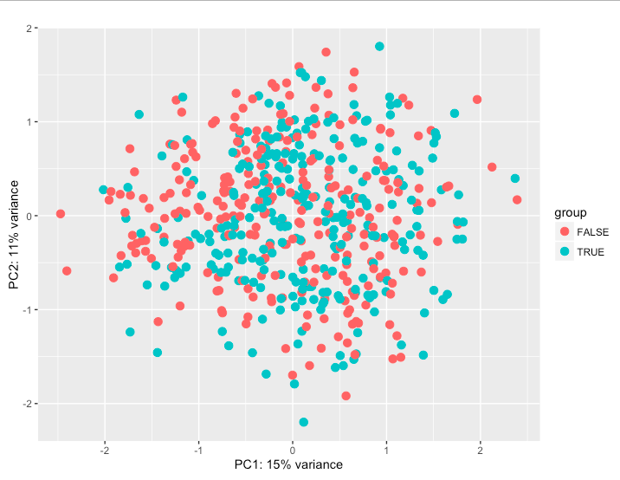

Figure 2: Random Forest model feature importance
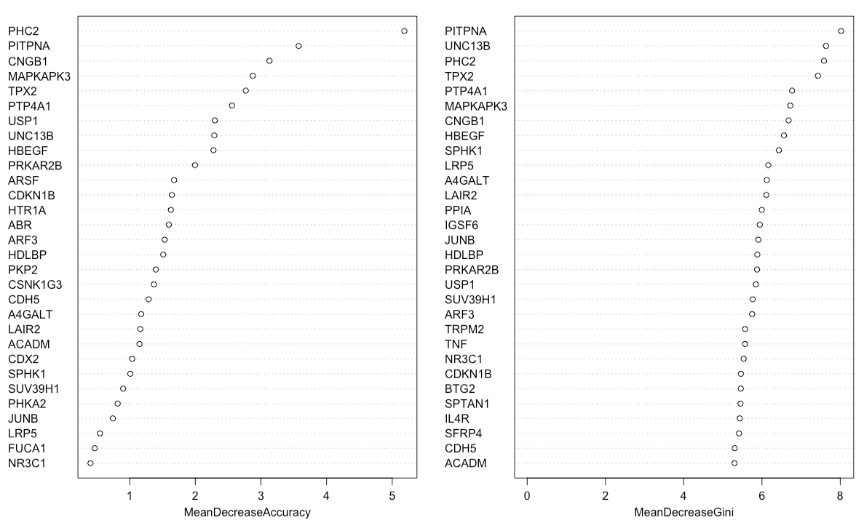

The datasets without any additional predictors are compared on the proportion of positive nodal metastasis status in each level, shown in supplement Table 1. The probabilities in each column do not sum up to be 1 as they are independent of each other.
Table 1 Datasets Comparison – Positive Nodal Metastasis in Each Level
Nodal Metastasis Level | TCGA  n = 349 | UW Tumor Board  n = 383 | Combination  n = 595
No Met | 0.51 | 0.33 | 0.46
Level I | 0.19 | 0.09 | 0.15
Level II | 0.30 | 0.34 | 0.31
Level III | 0.17 | 0.20 | 0.18
Level IV | 0.08 | 0.06 | 0.08
Level V | 0.03 | 0.03 | 0.03

