Design Alternatives for Sea Level Monitoring in Developing Anthropogenic Settings of South Asia
An Ocean Technology Design and Build Project

Submitted by:
Surbhi H. Ghadia
School of Oceanography, University of Washington
surbhig@uw.edu
27 May 2018

Submitted to:
Miles Logsdon
Ocean Technology Center, University of Washington
1503 NE Boat St
Seattle, Washington 98105
mlog@uw.edu

Executive Summary
Melting land ice and the thermal expansion of water, both results of Earth’s warming climate, are currently contributing to global sea level rise. Because its implications are not directly apparent from day to day, the immediacy of sea level rise can be overlooked. While the intensity of South Asian summer monsoonal rise events is likely increasing with increasing global sea level, little has been said about the exact nature of this correlation. This project entailed the design, construction, and pre-monsoonal testing of a cost-effective instrument that, with additional time, can help us estimate the extent to which sea level rise influences monsoonal rise fluctuations. It also assessed the willingness of ordinary South Asian citizens to monitor the waters of developing coastlines using oceanographic technologies, which are often alien to them.
Two instrumental prototypes were built and tested during the span of this project. Both used an HC-SR04 ultrasonic ranging sensor to detect water level fluctuations, and both recorded changes in water color, allowing researchers to differentiate between the effects of sea level rise and evolving precipitation patterns on annual timescales. Prototype #1 was tested in Dwarka, India in December 2017. It acquired two hours of functional data during the test, indicative of tidal ebbing (i.e. water level variations) and increasing sunlight (i.e. changes in sea surface reflectivity, water color) in the late morning. The test presented issues with data storage and sunlight measurements, which were addressed in Prototype #2. A group of Indian citizens assisted with the deployment of Prototype #1, and they showed interest in the technology.
Prototype #2 was tested at the UW Oceanography Dock in April 2018. Though it acquired only ten minutes of functional data due to problems with its solar panel power source, it successfully stored this data and collected sunlight measurements. The data was indicative of wake on otherwise steady waters. UW Staff Miles Logsdon and Kathy Newell assisted with the deployment of Prototype #2.
The final product of the design process was titled S.H.R.I., or Sea Height Remote Investigator. It was largely inspired by the components of Prototype #2, but used a different, shorter-term power source (i.e. a battery pack). Aside from the HC-SR04 sensor, S.H.R.I. incorporated a SparkFun ISL29125 RGB light sensor to detect sea surface reflectivity, a PhotoResistor to measure sunlight – and highlight ocean color changes when compared to sea surface reflectivity, a SparkFun microSD shield to store data in situ, and PVC pipes of varying widths to protect the technology – for floatation and mounting. S.H.R.I. was made in under $100, with functioning parts that could collect oceanographic data, and an easy-to-replicate design.
The involvement of people from differing backgrounds in the prototype deployments enabled me to see that the average South Asian citizen may suffer more from a lack of opportunity, when it comes to environmental projects, than a case of cultural carelessness. The volunteers who helped me in the deployment of Prototype #1 knew little about Oceanography, but this made them more curious to learn about the instrument and the process being studied (i.e. sea level rise). They asked questions similar to those I received at the UW, regarding this project.
I. Introduction
Earth’s climate, which has oscillated throughout geologic time, is now changing at a speed unsupported by natural variability alone. Because of the combined effects of natural and anthropogenic forcings, the polar regions of the planet are warming rapidly, melting land ice (i.e. glaciers and ice sheets) at rates unprecedented in recent history (Orlowski, 2013). Basic physics ordains that, while the melting of sea ice cannot increase the volume of the planet’s oceans, the melting of land ice can – and has begun to. As a result of that, and of the thermal expansion of sea water as our climate warms, global sea level is projected to rise by up to 1 meter (3 feet) by 2100 (Jones, 2013), generating devastating consequences for coastal communities worldwide.
Continual wave and tide motions can make it difficult to see and to measure the gradual changes in global sea level that happen on daily timescales. People often determine this as a reason to disregard the immediacy of sea level rise, which poses danger in coastal settings. The projected sea level rise has the potential to displace millions who live in low-lying regions of the world, and to impact many more millions via increased flooding during storm events (Orlowski, 2013). However, the assessment of variations in storm surge intensity, frequency, and in tidal cycles of a region can be used to make changes in sea level more apparent to the average citizen.
The scope of this science and technology project was to design and develop an instrument that easily quantifies the influences of global sea level rise on monsoonal rise events in South Asia, in particular. The time constraints of the project allowed for only the design, build, and testing of two instrumental prototypes prior to the onset of the monsoon, to evaluate design functions so that a final product for prospective, long-term deployments could be presented. Long-term deployments of an instrument that collects data illustrating the fluctuation patterns of marine water levels over annual timescales can make it feasible to predict the severity of the impacts of sea level rise on future episodic events. This can benefit the developing communities affected yearly by monsoonal flooding, and spread awareness within South Asian communities of the urgency of action. The instrument was designed to be cost-effective with easy assembly, to promote involvement, a notion of accessibility, and a means to observe unmonitored regions.
This project aimed to answer three researchable questions. (1) How effective can low-cost, electronic remote sensing technologies be in documenting ocean water level and water property changes? (2) What is the observed variation in baseline water level and apparent water properties, where measured? (3) What role does culture play in a citizen’s willingness to interact with ocean technology and monitor local marine waters? The instrumental product of the project should – with long-term deployments – increase understanding of (i) how episodic events in marine waters vary in severity, (ii) how these events compare to those controlled exclusively by monsoonal rainfall and not sea level rise, (iii) the role sea level rise plays in the severity of the marine variances, and (iv) how comfortable ordinary citizens are with oceanographic concepts and technologies. If implemented on a large scale, the product should help us recognize the spatial and temporal effects of climate change on water levels of currently unmonitored waters.
II. Background
Of South Asian countries, India has recently become considerably active in the Argo Program, which uses internationally-owned profiling floats to monitor ocean water properties, such as temperature and salinity (Fig. 1). While this is encouraging, as a representation of governmental awakening, more work needs to be done to track sea level rise in the region, specifically, especially near Bangladesh – a nation lying dangerously close to sea level (Harris, 2014). In association with the Argo Program is the Deep Argo array, which samples from ocean bottom to surface to provide information on how steric factors (i.e. thermal expansion) relate to sea level. The majority of Deep Argo floats, however, are in the Mid-Atlantic and Southern Oceans (Jayne et. al, 2017), and do not detail even thermosteric sea level rise in South Asia.
At present, tide stations are a key method of sea level rise detection in South Asia. Though these stations cover most major coastlines, they are still widely dispersed (Fig. 2). Because of this, it can be assumed that the average South Asian citizen does not have knowledge this sea level rise data exists, let alone of its significance. Satellite data is also commonly used to track changes in sea level (Sekhar, 2018), but it is, too, likely confined within scientific circles. When observations do not encompass or reach the developing communities that need the most time to prepare for floods, the biggest victims of sea level rise are left alone and unprepared.
Nonetheless, sea level rise is not the sole result of climate change. A meta-analysis of literature on projected weather events claims that South Asian summer rainfall could increase by 3.6% per degree Celsius of worldwide warming (Moore et. al, 2015). Moreover, an analysis of a multimodel ensemble predicts a decrease in South Asian monsoon circulation and an increase in summer monsoon precipitation over the rest of the twenty-first century (Fan et. al, 2012).
A majority of the recent studies on the South Asian monsoon focuses on precipitation, making it necessary to research the relationship between sea level rise and episodic monsoonal events. In addition, deaths and property damage related to the SASM have increased recently, with increases in inundation and infections (Siddique, 2017). Data with which future coastal events can be predicted will be useful to the South Asian people and to the scientific community.
III. Methods
a. Design Constraints
This project entailed the design, construction and testing of two instrumental prototypes that could be used to track global sea level rise on the local scale. Each prototype was cost-effective (i.e. cost less than $100 to assemble and to deploy), and was designed for simple reproduction (to make citizen assembly and deployments more possible in the future). Each prototype was capable of remaining stationary during deployment, so that the sensors did not move with the water level during data acquisition. The overall instrumental design took into consideration the possibility for episodic fluctuation in water level, and provided height and a flotation device to protect the sensors from underwater submersion. The power supply for each prototype was able to run for half a day at a time (at minimum). The instrumental design included a component to identify if the severity of a monsoonal rise event is more dependent on precipitation or on sea level rise (i.e. observing salinity/density changes). Finally, each prototype included a method of saving data not reliant on WIFI, which is often unavailable in open areas.
b.i. Prototype #1 Design Elements
The design for Prototype #1 incorporated a metal pipe (½ inch thick, at least 2 meters tall) as a mount, to be screwed onto a stationary dock at the test site and allow the instrument to remain static during deployment. The most important component of this design was the HC-SR04 ultrasonic ranging sensor. Facing downwards, it read the distance between itself and the water’s surface (from 0 to 5 meters), thus detecting changes in water level. The power source for Prototype #1 was a 5000 mAh, cylindrical battery pack. To determine if a monsoonal rise event would be accredited to precipitation more than to sea level rise, two SparkFun ISL29125 RGB light sensors were integrated into this prototype. The first RGB light sensor faced upwards, towards the Sun, to measure the amount of sunlight shining down, which was to be compared to the water’s reflectivity, measured by the second, downward-facing RGB light sensor. Changes in the reflectivity of the water would correspond to those in water properties over annual timescales (Green and Sosik, 2004), or when the water’s behavior was highly contingent on precipitation patterns. An SD card in a SparkFun microSD shield was used for data collection, to account for WIFI issues at the test site. An H₂OhNo! sensor was added to the casing of Prototype #1 to perform leak detection, especially in vision of long-term deployments. All of these elements were placed in a cylindrical PVC pipe case, positioned parallel to a longer, PVC-made float.
b.ii. Prototype #1 Test Deployment
Prototype #1 was originally to be deployed for testing in Jamnagar, a coastal city in northwestern India. However, because Jamnagar was recently made into an Indian naval base, I was forced instead to deploy in the city of Dwarka. The chosen site was clean and unpopulated, ideal for avoiding external obstacles. The deployment occurred from the evening of 27 December 2017 through the morning of 28 December 2017, under clear (though slightly windy) conditions. The HC-SR04 worked well, but other issues arose. Only the downward-facing RGB light sensor was functional from the same Arduino board. In addition, the microSD shield was damaged during shipment, and data was recorded directly to a laptop through parts of the night and into the morning. I was, therefore, unable to test the battery pack’s endurance. The case and mount protected well – although the mount was installed on a rocky cliff, not a stationary dock.
c.i. Prototype #2 Design Elements
Prototype #2 was constructed of several of the same elements as Prototype #1. The same HC-SR04 ultrasonic ranging sensor was used for water level measurements, a downward-facing SparkFun ISL29125 RGB light sensor was used to detect variations in water properties, and a SparkFun microSD shield was used for data collection. Another H₂OhNo! sensor was implemented for leak detection, and the same case and floatation device were maintained. The mount was redesigned, made from two ½ inch PVC pipes and an elbow piece for deployment off of a cushioned stationary dock (not a cliff). A SparkFun Sunny Buddy and solar panel served as substitutions for the cylindrical battery pack, to offer a more continuous and long-term power source. The upward-facing RGB light sensor was replaced with a PhotoResistor, which did not measure light values in RGB, but did provide a method to track sunlight, for comparison’s sake. A second microSD shield was installed, all codes were recompiled, and the SD card was tested several times beforehand to ensure success in data acquisition during the second test deployment.
c.ii. Prototype #2 Test Deployment
Prototype #2 was deployed off of the UW Oceanography Dock – a relatively tranquil area – from 11:30 AM on 19 April 2018 to noon on 20 April 2018, under mostly sunny conditions. Deployment was untroubled, with the mount screwed into the dock for easy access and removal of the instrument. Upon checking the SD card for data, I discovered the Sunny Buddy did not work as I had hoped. Data was acquired due to the backup battery – which was not powerful enough to support all three sensors for long – not the solar panel. Consequently, I attained usable data for the HC-SR04 from only 11:30 to 11:40 AM on 19 April 2018. This was not a complete disappointment, because the microSD shield still worked successfully, as did each of the sensors.
IV. Deliverables
a. Final Product
The instrument that resulted from the design process was named S.H.R.I., or Sea Height Remote Investigator. (Note: This name alludes to the Hindu goddess of fortune, who emerged from a cosmic ocean.) As shown in Fig. 3, S.H.R.I. imitated the design elements of Prototype #2, replacing only the SparkFun Sunny Buddy with the power source of Prototype #1 – a 5000 mAh, cylindrical battery pack. The Sunny Buddy could not support the sensor load for this instrument.
b. Prototype #1 Test Data
The data acquired in Dwarka, India was not continuous. It was processed and plotted using Microsoft Excel, and a moving average trendline was added to each plot to highlight important trends and outlying points. Less than two hours of data is displayed in Figs. 4 and 5, of the eight hours of testing. Fig. 4 demonstrates a late morning decrease in water level – from about 2.75 m to 1.75 m - while Fig. 5 does a late morning increase in sea surface reflectivity, in the red, green and blue spectrums. Outlying data is common in Figs. 4 and 5 from 8:20 to 9:30 AM, with the most frequent outliers from 8:40 to 8:55 AM and from 9:07 to 9:20 AM in Fig. 5.

c. Prototype #2 Test Data
Due to power issues during the deployment of Prototype #2, only ten minutes of the twenty-four hours of testing done could be plotted in Fig. 6 – and only these same ten minutes were plotted in Fig. 7. Data was, again, processed and plotted using Microsoft Excel, and a moving average trendline was added to each plot for trend emphasis. Fig. 6 indicates a nearly steady water level – where the distance of the water level from the HC-SR04 sensor is 0.95 m – from 11:34 to 11:38 AM. A water level lower than this average was recorded at 11:31 AM – where the distance of the water level from the sensor is highest on the plot – and a water level higher than it was recorded from 11:32 to 11:34 AM – where the distance of the water level from the sensor is lowest. A fluctuation in water level is also apparent around 11:39 AM. Fig. 7 demonstrates relatively constant PhotoResistor values from 11:32 to 11:39 AM – of about 1000 lx – and lower, more irregular initial values. Fig. 7 indicates, too, steady water surface reflectivity from 11:34 to 11:38 AM, in the red, green and blue spectrums. Lower reflectivity values were recorded from 11:31 to 11:32 AM, and higher values from 11:33 to 11:34 AM. A decrease in reflectivity values is noticeable at 11:39 AM, after a spike just seconds earlier.
V. Discussion and Conclusions
a. Findings
S.H.R.I. was assembled for under $100 with fairly accessible remote sensing technologies and materials (Appendix A). Though there were problems with its power source during deployment, Prototype #2 – S.H.R.I.’s predecessor – performed well. It collected and stored water level and water color data that was later available for analysis and visualization. S.H.R.I. was straightforward in assembly and should be easy to deploy off of a dock. The codes for the individual parts are comprehendible, even when compiled and even for a novice like me (Appendix B). This instrument is simple and capable of recording information on changing water levels and water properties. It is quite suitable for sea level monitoring on developing coastlines.
Water level decreases in Fig. 4 from 8:20 to 10:00 AM, from 2.75 m off the seafloor to 1.75 m, because the waters in Dwarka were marine – with tides! It can be concluded the tide was ebbing in the late morning at this location. In addition, it can be surmised that the intensity of the ebbing decreased as 10:00 AM approached – few outliers can be noticed on Figs. 4 and 5 after 9:30 AM. These outliers were likely the result of the sensors detecting crashing waves, which would skew water level and water reflectivity data relative to the data of more steady waters. The general increase in sea surface reflectivity observed in Fig. 5 can be attributed to an increase in sunlight over the monitored waters as the morning progressed.
In contrast, water level is steady through most of Fig. 6 – as is water surface reflectivity through most of Fig. 7 – presumably because the UW Oceanography Dock rests over Portage Bay – little tidal influence. The water level outliers recorded immediately before and after the steady period – which was 11:34 to 11:39 AM – may have resulted from wake generated by passing vessels (longer period of wake, could explain 11:32 to 11:34 AM data) or seabirds (shorter period of wake, could explain 11:39 AM data). Wake may have also triggered outliers in the water reflectivity data, because i) they occurred inversely to the water level outliers – higher RGB values correspond to less distance between the HC-SR04 and water level on the plots, and ii) only RGB values show dramatic outliers in Fig. 7 from 11:32 to 11:34 AM and at 11:39 AM, not PhotoResistor values – which are steady after 11:32 AM. Initial outliers – at 11:31 AM – in Figs. 6 and 7, and the subsequent gap in data could be accredited to setup/deployment activities.
A central aim of this project was to create an instrument that could be used by individuals in developing communities, engaging them in the environmental matters that impact their livelihoods. It seems an ordinary citizen of India would have a more difficult time interacting with ocean technology than a student at the UW School of Oceanography – a consequence of cultural and educational differences – but the test deployment of Prototype #1 demonstrated otherwise. Before I could elaborate on the intent of my project to volunteers, several offered their full involvement in the project, for the sake of the technology itself or for an excuse to interact with the coastline. Four uncles, five aunts, five cousins and my parents aided me in mounting the instrument and joined me late into the night and in the early morning as I collected data on my laptop. I know they were involved partially because they willed for my success, but their questions on how the equipment worked, how acquired data could be used, and how effectively the project could be expanded to communities all around South Asia also reassured me of their genuine interest in my work – especially the engineering behind it. My Indian relatives, none of whom had heard of Oceanography before I began studying it, asked me questions on par with the ones my peers did at the UW. This helped me realize that culture may not play as much of a part in a citizen’s willingness to participate in ocean science as opportunity, exposure and age do.
b. Future Work
This project has great room for expansion. More of these instruments can be assembled and deployed around various parts of South Asia, on annual timescales – in other words, actual monsoonal rise data can be collected. This data can be used for educational purposes at the local level, and citizens can learn to assemble and deploy their own instruments. For this to happen, I first need to find a long-term power source fit to power all elements of the instrument for days to weeks at a time, demanding little human interaction on the daily basis. Eventually, I would like to construct and distribute kits containing the parts of the instrument to a number of coastal areas in South Asia, thereby encouraging citizen participation by making the project more accessible.
References
Fan, Fangxing, M.E. Mann, S. Lee, and J.L. Evans. 2011. Future Changes in the South Asian Summer Monsoon: An Analysis of the CMIP3 Multimodel Projections. American Meteorological Society, 25: 3909-3928.

Green, R.E. and H.M. Sosik. 2004. Analysis of apparent optical properties and ocean color models using measurements of seawater constituents in New England continental shelf surface waters. J. Geophys. Res., 109: C03026.

Harris, Gardiner. (2014, March 28). Borrowed Time on Disappearing Land. Retrieved from https://www.nytimes.com/.

Jayne, S.R., D. Roemmich, N. Zilberman, S.C. Riser, K.S. Johnson, G.C. Johnson, and S.R. Piotrowicz. 2017. The Argo Program: Present and Future. Oceanography, 30(2): 18–28.

Jones, Nicola. (2013, October 21). How Fast and How Far Will Sea Levels Rise? Retrieved from https://e360.yale.edu/.

Moore, T.R., H.D. Matthews, C. Simmons and M. Leduc. 2015. Quantifying Changes in Extreme Weather Events in Response to Warmer Global Temperature. Atmosphere-Ocean, 53(4): 412-425.

Orlowski, J. (Director, Producer), J. Aronson, P. Pesmen (Producers), D. Cornfield, L. Cornfield (Executive Producers), and M. Monroe (Writer). 2013. Chasing Ice [Motion Picture]. United States: New Video Group.

Sekhar, Aswin. (2018, January 29). Oh Buoy! It’s Drowning. Retrieved from https://www.telegraphindia.com/.

Siddique, Haroon. (2017, August 30). South Asia Floods Kill 1,200 and Shut 1.8 Million Children out of School. Retrieved from https://www.theguardian.com/.

Figures
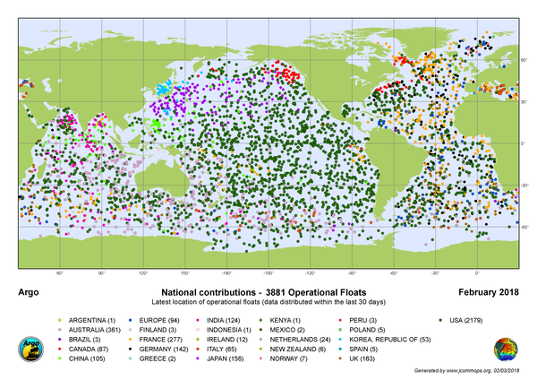

Figure 1: The active floats of the Argo Program, coded by country. These floats collect information on ocean water temperature, salinity, currents, etc. Updated in February 2018. https://en.wikipedia.org/wiki/Argo_(oceanography).

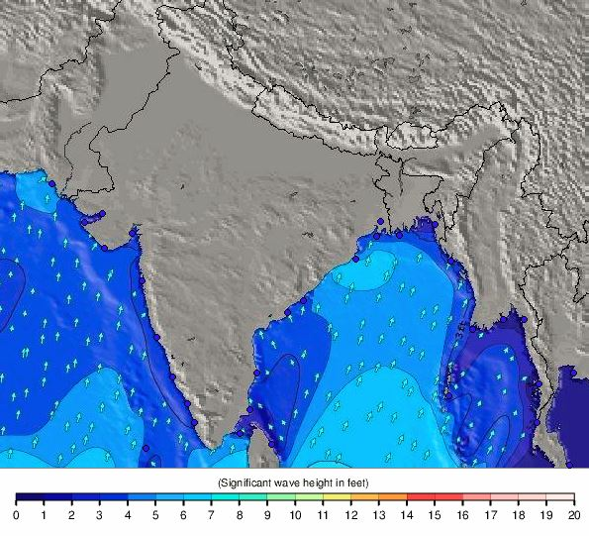

Figure 2: Tide stations – indicated by blue dots – in South Asia. Sea level changes are recorded at these locations. Data from 13 May 2018. https://www.tide-forecast.com/weather_maps/India.

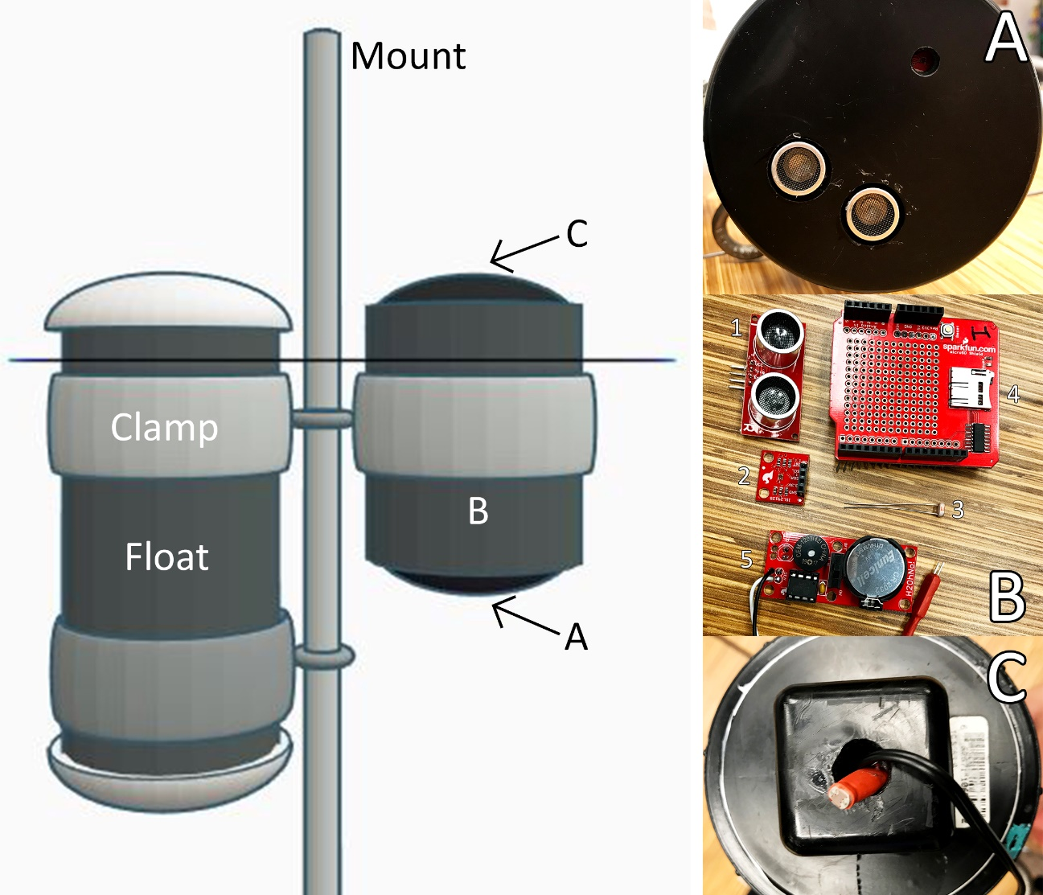

Figure 3: (Main) External elements of the Sea Height Remote Investigator, the end product of this project. (A) A bottom view of the technology case, set up for deployment with slots for a downward HC-SR04 ultrasonic ranging sensor and SparkFun ISL29125 RGB light sensor. (B) An open view of the individual components of the instrument – excluding a power source – with 1) a HC-SR04 ultrasonic ranging sensor, 2) a SparkFun ISL29125 RGB light sensor, 3) a PhotoResistor, 4) a SparkFun microSD shield, and 5) a H₂OhNo! sensor displayed. (C) A top view of the technology case (lid) set up for deployment with a slot for an upward PhotoResistor.

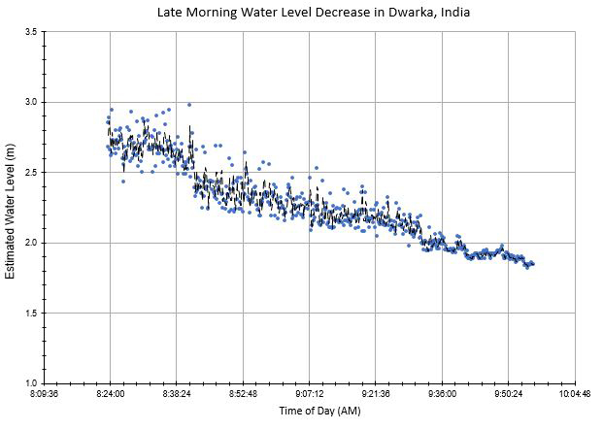

Figure 4: Water level (tidal) fluctuations from 8:20 to 10:00 AM (12-27-17) at a site in Dwarka, India, calculated using ultrasonic HC-SR04 readings – 10 s intervals – from the deployment of Prototype #1. Each reading measured the distance from instrument mount to water level, from 0 to 5 m, and was subtracted from 5 m to attain bottom-up water level estimates for analysis.

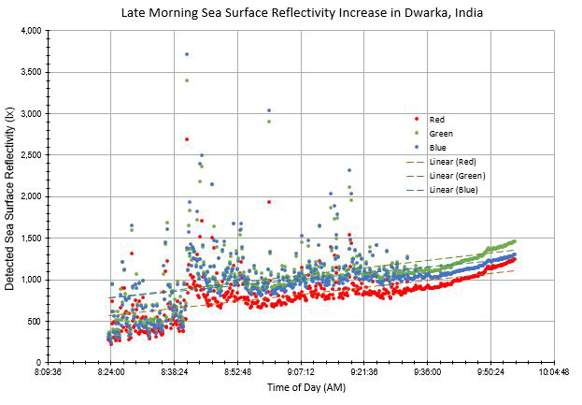

Figure 5: Variations in sea surface reflectivity from 8:20 to 10:00 AM (12-27-17) at a site in Dwarka, India, given by a downward ISL29125 RGB light sensor – 10 s intervals – during the first deployment of Prototype #1. Prototype #1 failed to measure sunlight, due to a missing upward RGB light sensor. Two light sensors were needed to highlight changes in water properties that can indicate the importance of sea level rise for major events.

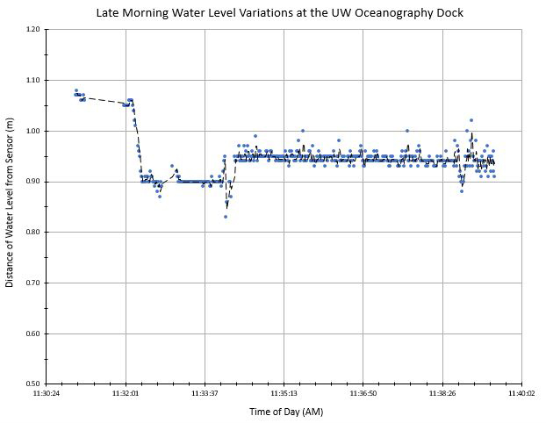

Figure 6: Water level fluctuations from 11:30 to 11:40 AM (04-19-18) at the University of Washington’s Oceanography Dock, given by ultrasonic HC-SR04 readings – 1 s intervals – from the deployment of Prototype #2. Each reading measured the distance from the instrument mount to water level, from 0 to 5 m.

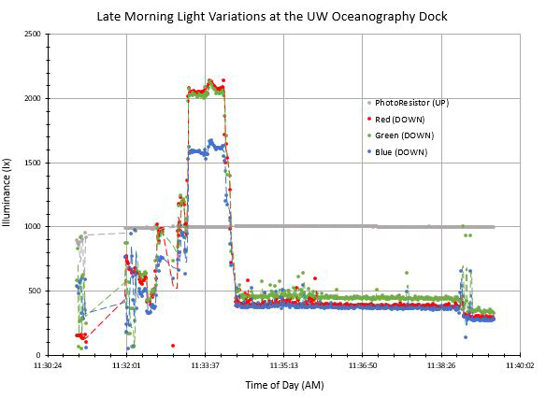

Figure 7: Fluctuations in sun illuminance and water surface reflectivity from 11:30 to 11:40 AM (04-19-18) at the University of Washington’s Oceanography Dock, given by an upward PhotoResistor and a downward ISL29125 RGB light sensor – 1 s intervals – during the deployment of Prototype #2.

Appendix A – Parts
Part | Quantity | Cost | URL
Arduino Uno R3 Board | 1 | $22.00 | https://store.arduino.cc/usa/arduino-uno-rev3
HC-SR04 Ultrasonic Ranging Sensor | 1 | $3.95 | https://www.sparkfun.com/products/13959
SparkFun ISL29125 RGB Light Sensor | 1 | $7.95 | https://www.sparkfun.com/products/12829
PhotoResistor (+ 10k Resistor) | 1 ea. | $1.00 | https://www.adafruit.com/product/161
SparkFun MicroSD Shield | 1 | $14.95 | https://www.sparkfun.com/products/12761
H2OhNo! Sensor | 1 | part retired | https://www.sparkfun.com/products/retired/12069
5000 mAh Cylindrical Battery Pack | 1 | $12.95 | https://www.amazon.com/gp/product/B01CU1EC6Y/  ref=oh_aui_detailpage_o03_s00?ie=UTF8&psc=1
6'' PVC Pipe (Case, Float) - lengths vary | 2 | undefined | -
1/2'' PVC Pipe (Mount) - lengths vary | 1+ | undefined | -
6'' PVC Cap (Case, Float) | 4 | undefined | -
Metal Clamp (+ Loop) | 2 ea. | $4.00 | https://www.mcmaster.com/#3033t18/=1cp2gj7
Electronic Solderless Breadboard | 1 | $4.95 | https://www.sparkfun.com/products/12002
Misc. (Connectors, Washers, etc.) | varies | undefined | -
 | Known Cost | $71.75
 | Max. Total | $100.00

Appendix B – Code

#include <SPI.h>
#include <SD.h>
#include <SparkFunISL29125.h>
#define trigPin 4
#define echoPin 7
int lightPin = 0;
const int chipSelect = 8;

// Declare ISL29125
SFE_ISL29125 RGB_sensor;

void setup() {
Serial.begin (9600);

// Initialize HC-SR04
pinMode(trigPin, OUTPUT);
pinMode(echoPin, INPUT);

// Initialize SD Card
pinMode(lightPin, OUTPUT);
Serial.print("Initializing SD card...");
if (!SD.begin(chipSelect)) {
Serial.println("Card failed, or not present");
return;
}
Serial.println("card initialized.");
}

void loop() {

// HC-SR04 values
long duration, distance;
digitalWrite(trigPin, LOW);
delayMicroseconds(2);
digitalWrite(trigPin, HIGH);
delayMicroseconds(10);
digitalWrite(trigPin, LOW);
duration = pulseIn(echoPin, HIGH);
distance = (duration/2) / 29.1;
if (distance >= 500 || distance <= 0){
Serial.println("Out of range");
}
else {
Serial.print("Distance: ");
Serial.print(distance);
Serial.println(" cm");
}

// ISL29125 values
unsigned int red = RGB_sensor.readRed();
unsigned int green = RGB_sensor.readGreen();
unsigned int blue = RGB_sensor.readBlue();
Serial.print("Red: "); Serial.println(red,DEC);
Serial.print("Green: "); Serial.println(green,DEC);
Serial.print("Blue: "); Serial.println(blue,DEC);
Serial.println();

// PhotoResistor values
Serial.print("PhotoResist: ");
Serial.println(analogRead(lightPin));
int sensor = analogRead(lightPin);

delay(1000);

// Write values to SD Card
File dataFile = SD.open("datalog.txt", FILE_WRITE);
if (dataFile) {
dataFile.print(sensor);
dataFile.print(",");
dataFile.print(distance);
dataFile.print(",");
dataFile.print(red);
dataFile.print(",");
dataFile.print(green);
dataFile.print(",");
dataFile.println(blue);
dataFile.close();
}
else {
Serial.println("error opening datalog.txt");
}
}

