Supplementary Figure 1: QQ plot of Hispanic/Latino QRS duration GWAS meta-analysis
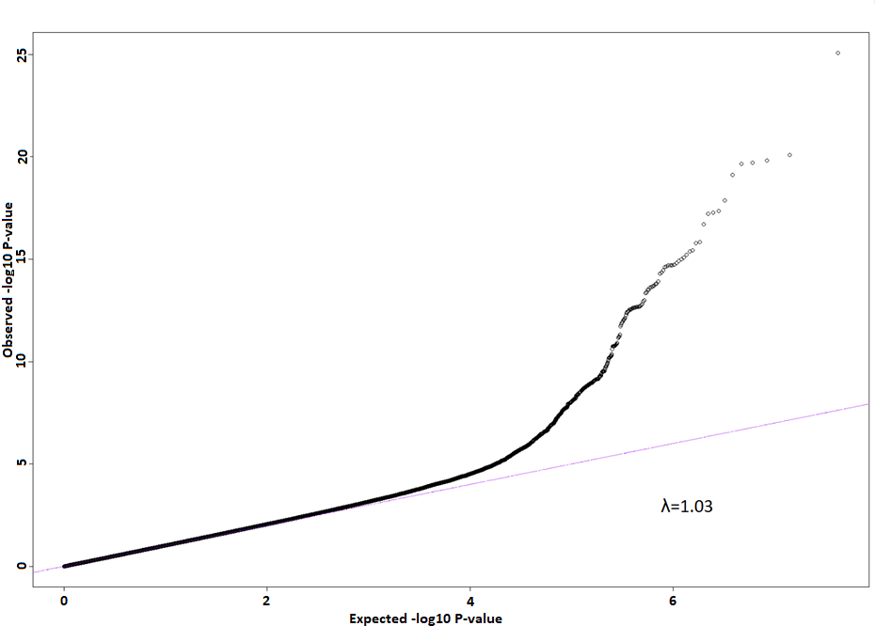
Supplementary Figure 2: Individual Study QQ plots A) MESA B) HCHS/SOL C) WHI and D) Starr County
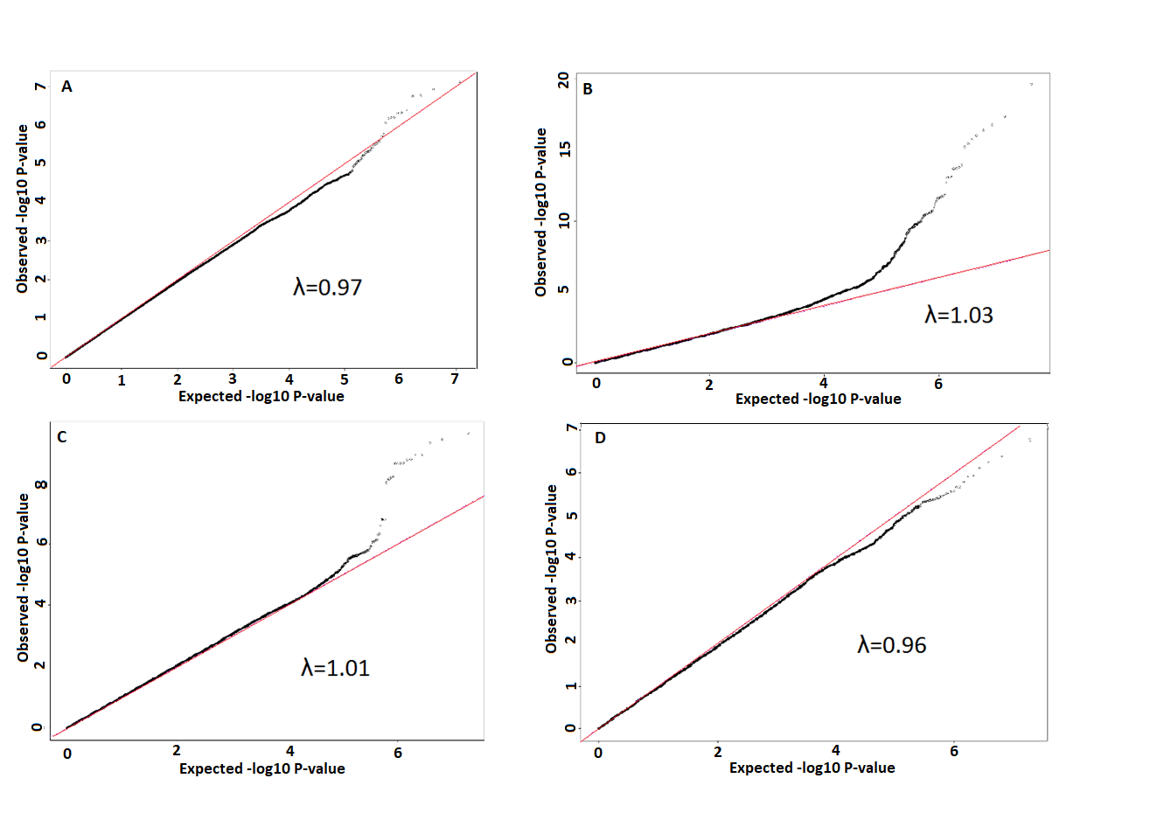
Supplementary Figure 3 - Forest plots showing 95% confidence intervals of the effect size of each Hispanic/Latino index SNP on QRS duration in milliseconds across each contributing study and the combined meta-analysis.
Supplementary Figure 3A
Index SNP: rs62241190
Effect Allele: G/A
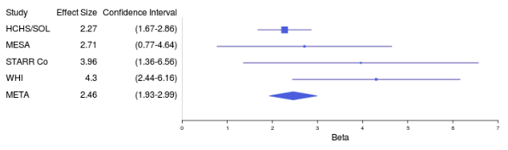

Supplementary Figure 3B
Index SNP: rs3922844
Effect Allele: C/T
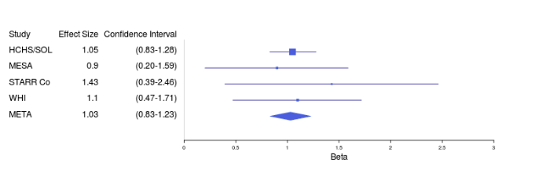

Supplementary Figure 3C
Index SNP: rs9856387
Effect Allele: C/T
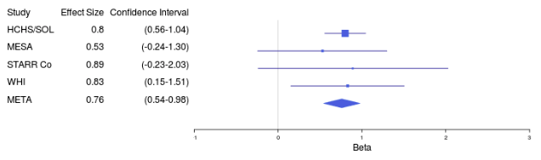

Supplementary Figure 3D
Index SNP: rs10428132
Effect Allele: T/G
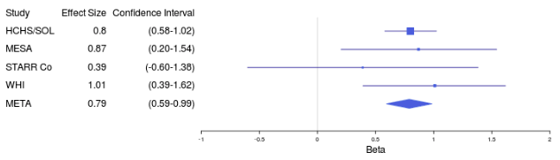

Supplementary Figure 3E
Index SNP: rs13165478
Effect Allele: G/A
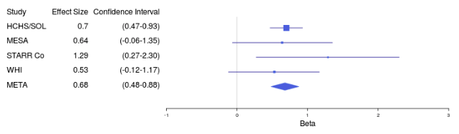

Supplementary Figure 3F
Index SNP: rs3176326
Effect Allele: A/G
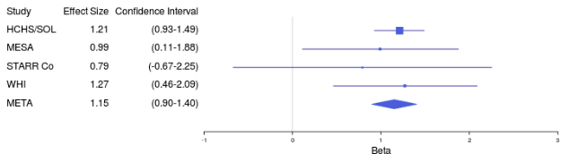

Supplementary Figure 3G
Index SNP: rs2395642
Effect Allele: T/C
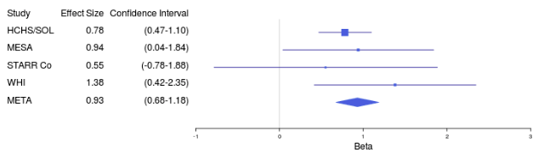

Supplementary Figure 3H
Index SNP: rs7906312
Effect Allele: A/C
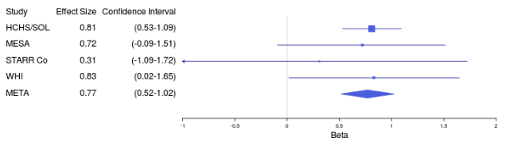

Supplementary Figure 3I
Index SNP: rs4842438
Effect Allele: C/A
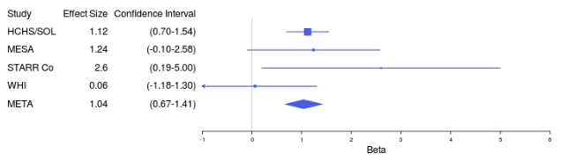

Supplementary Figure 3J
Index SNP: rs16946539
Effect Allele: T/C
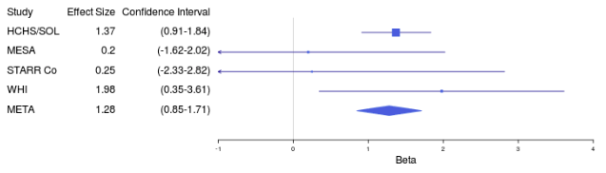

Supplementary Figure 4: Regional association plots showing all results in the European, Hispanic/Latino, and African American QRS duration GWAS surrounding each of the Hispanic/Latino significant loci. Plots created with LocusZoom software.[21] The index SNP in each figure is labeled and colored purple. All other SNPs in the region are plotted at their significance levels. The color of each SNP corresponds to the linkage disequilibrium (r²) between the plotted SNP and the index SNP.
Supplementary Figure 4A – Regional association plots of SCN5A-SCN10A. i. (top-left) – Hispanic/Latino GWAS. ii. (top right) – European GWAS. iii. (bottom left) – African American GWAS
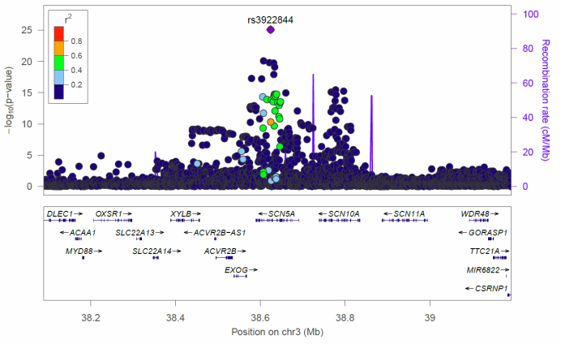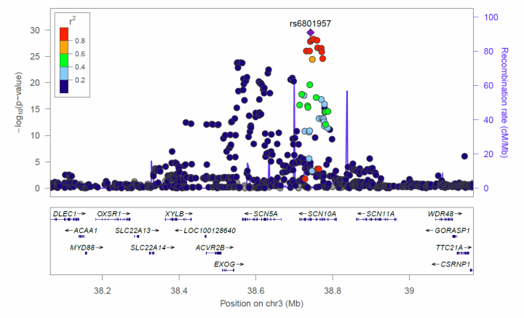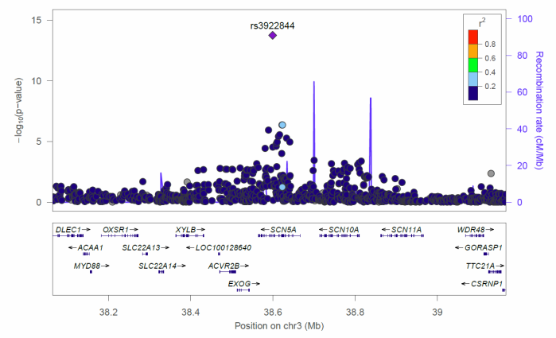

Supplementary Figure 4B – Regional association plots of HAND1. i. (top-left) – Hispanic/Latino GWAS. ii. (top right) – European GWAS. iii. (bottom left) – African American GWAS
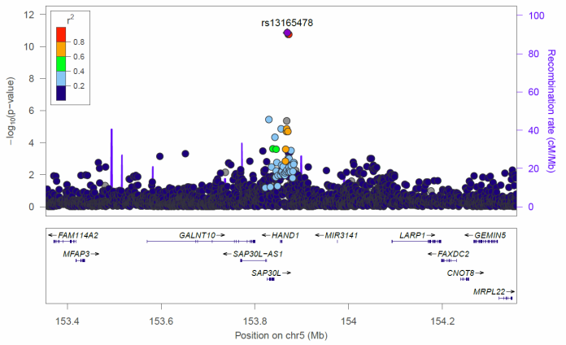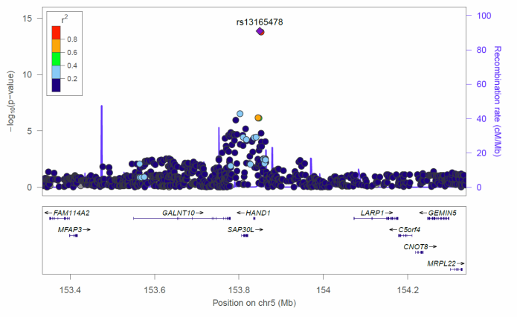
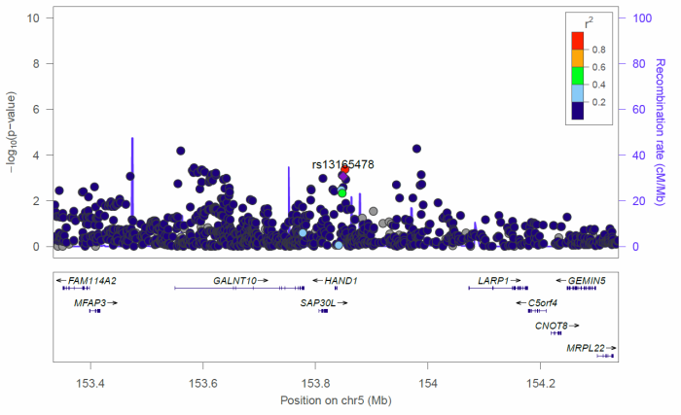

Supplementary Figure 4C – Regional association plots of CDKN1A. i. (top-left) – Hispanic/Latino GWAS. ii. (top right) – European GWAS. iii. (bottom left) – African American GWAS. iv. (bottom right) – Hispanic/Latino GWAS showing an expanded view including SNPs near genome-wide significance.
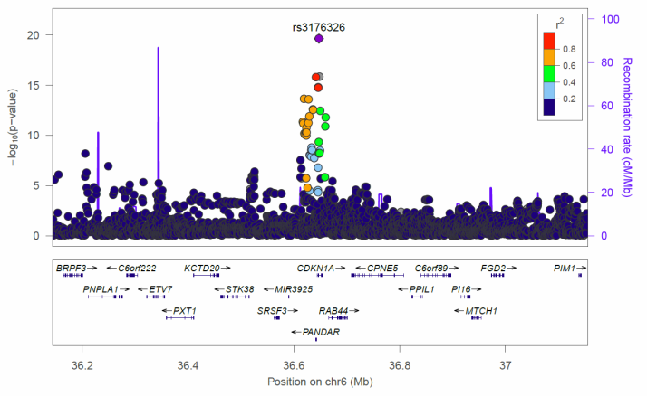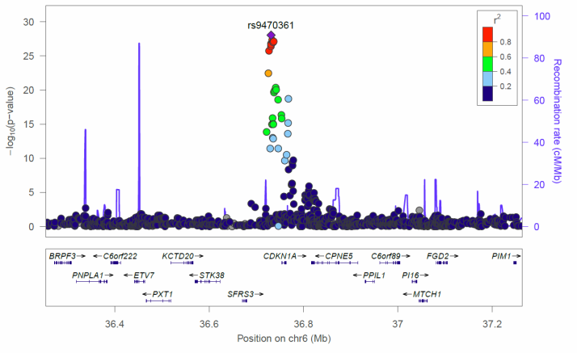
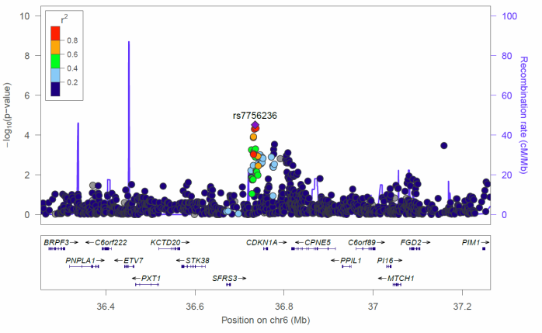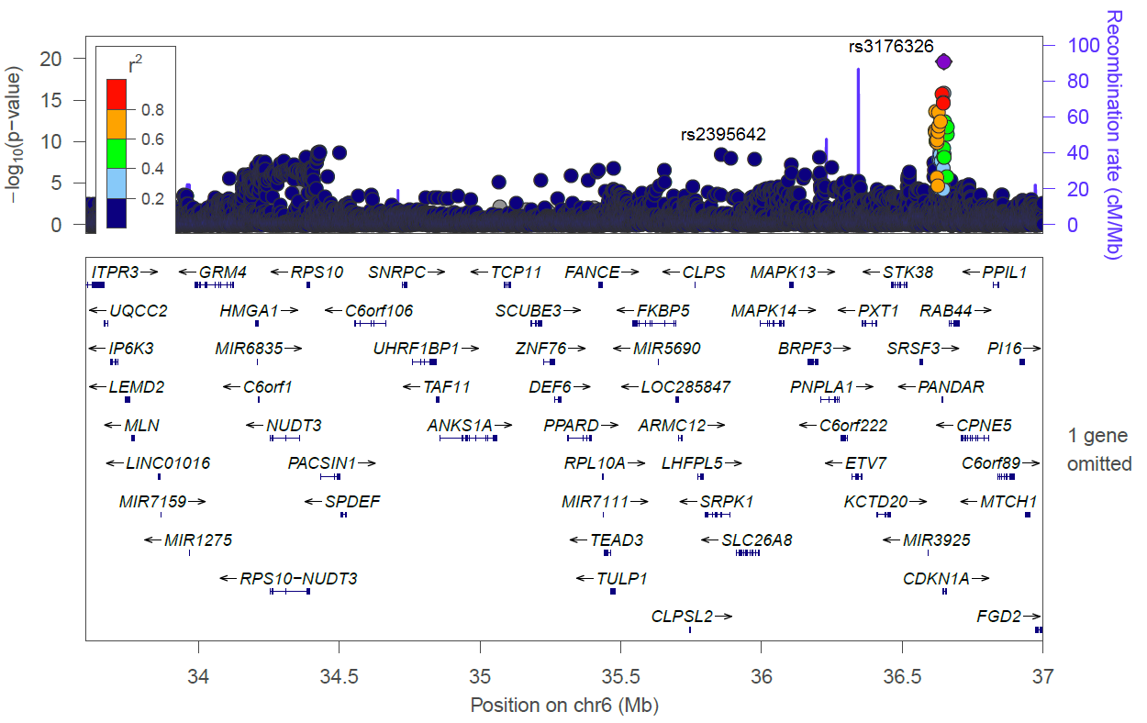

Supplementary Figure 4D – Regional association plots of VTI1A. i. (top-left) – Hispanic/Latino GWAS. ii. (top right) – European GWAS. iii. (bottom left) – African American GWAS
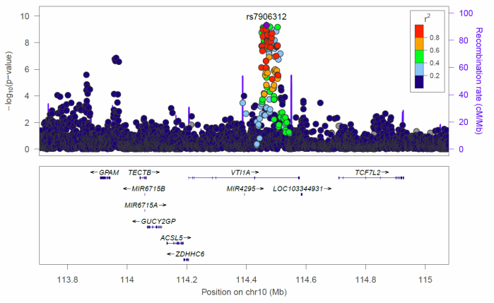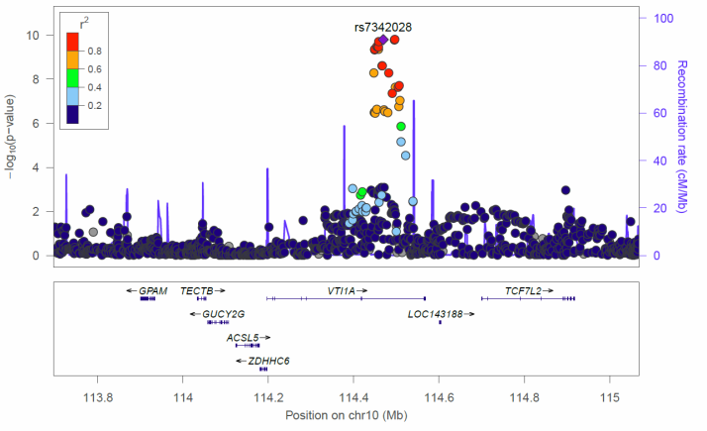
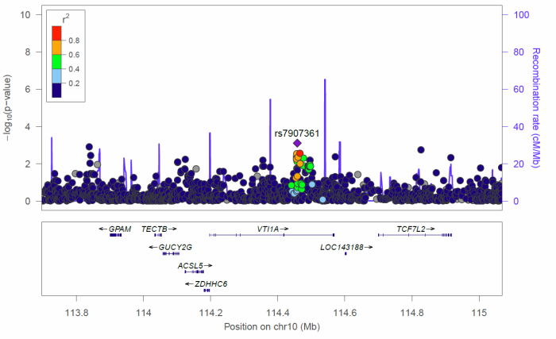

Supplementary Figure 4E – Regional association plots of SYT1. i. (top-left) – Hispanic/Latino GWAS. ii. (top right) – European GWAS. iii. (bottom left) – African American GWAS
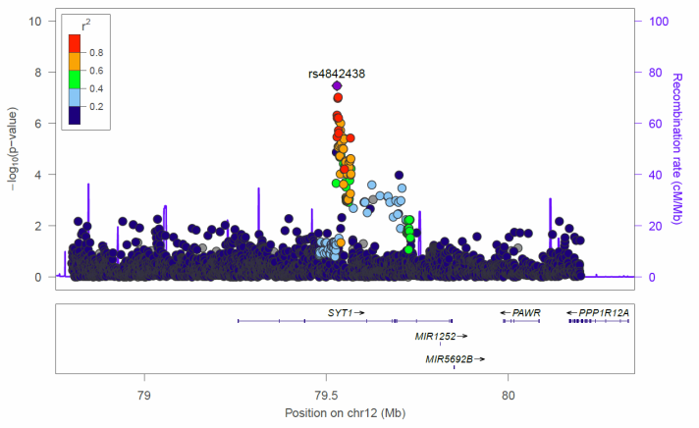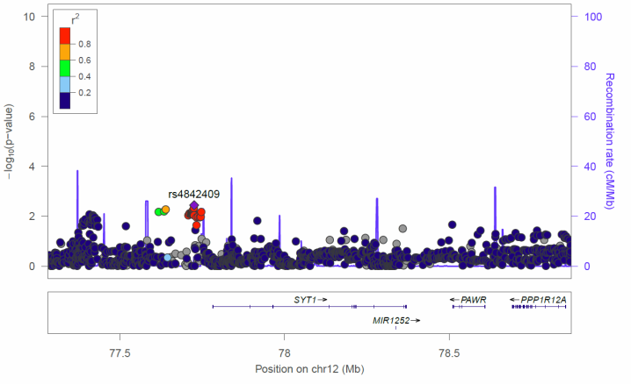
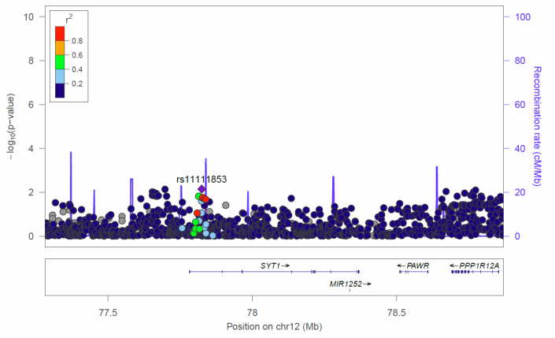

Supplementary Figure 4F – Regional association plots of MYOCD. i. (top-left) – Hispanic/Latino GWAS. ii. (top right) – European GWAS. iii. (bottom left) – African American GWAS
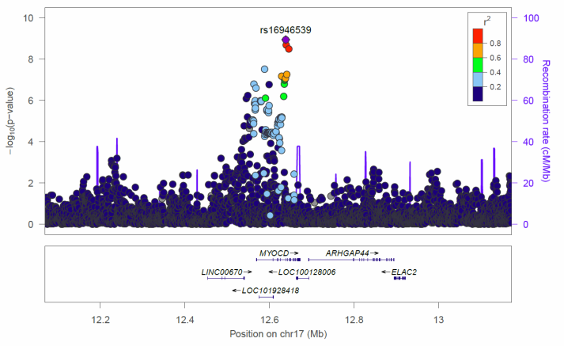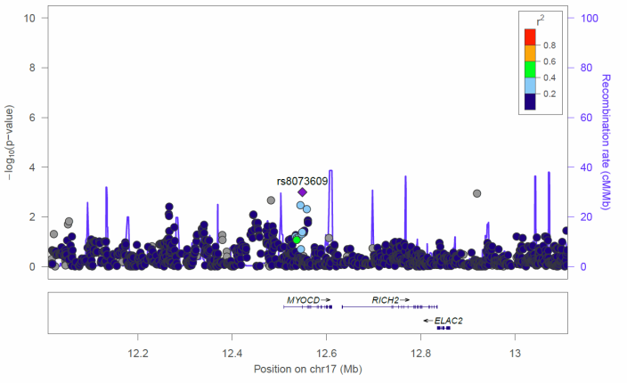
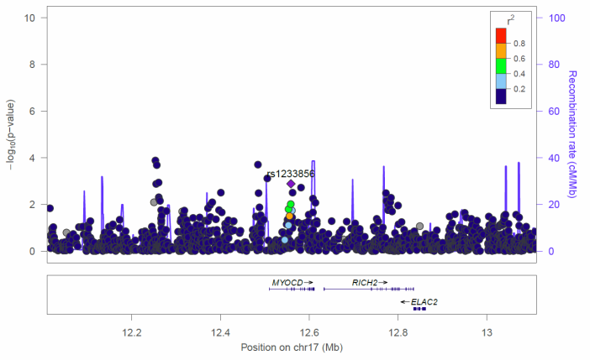

Supplementary Figure 5: Regional association plots for the HCHS/SOL cohort for each of the index SNPs which was imputed rather than being directly genotyped in the cohort. Plots created with LocusZoom software.[21] Each plot shows all GWAS results surrounding the index SNP. The index SNP in each figure is labeled and colored purple. All other SNPs in the region are plotted at their significance levels. The color of each SNP corresponds to the linkage disequilibrium (r²) between the plotted SNP and the index SNP. SNPs plotted as circles were directly genotyped, and SNPs plotted as X’s were imputed.
Supplementary Figure 5A
Index SNP: rs2395642

Supplementary Figure 5B
Index SNP: rs3176326

Supplementary Figure 5C
Index SNP: rs4842438

Supplementary Figure 5D
Index SNP: rs16946539

Supplementary Figure 5E
Index SNP: rs62241190

