Analyzing algal bloom within False Bay through cultivation of Ulva spp. in experimental settings

Kevin Ryu

Biodiversity and Monitoring of Estuarine Ecosystems

Autumn 2021

Abstract
False Bay, San Juan Island experiences a bloom of the green algae Ulva spp. During the summer. The large abundance of Ulva spp. That subsequently washes up on the upper shore deigns to decay and subsequently produces a pungent smell. This smell is noticeable from multiple kilometers away, leading to numerous complaints from local inhabitants. However, in Friday Harbor, despite being on same island, there seems to be less algae accumulated near its shore. To analyze what could have caused False Bay’s algal accumulation near its shore, I conducted an experiment to explore unique condition in False Bay that causes the phenomenon. In this research, water condition, including factors outside of chemicals, was tested. Ulva spp. samples gathered in False Bay was cut to even size and were cultivated in water from False Bay, Friday Harbor, and artificially made seawater in experimental settings. During the first trial, I found that there is no significant difference in amount of growth in Ulva spp. samples cultured in False Bay and Friday Harbor’s seawater. However, both had significantly larger growth rate compared to artificial seawater,. During the second trial of the experiment, many Ulva spp. lost pigemtation, which caused weakening of structure and stunted growth among the samples. Trial 2 showed no significant difference in growth rate based on source of seawater. It is concluded that while nutrient within False Bay aids in the growth of Ulva spp., it may be not the driving factor of algal blooms during summer seasons. More research is needed to find the possible cause of algal accumulation in False Bay’s shore and understand its nature, because while heavy accumulation Ulva spp. can reduce the abundance of sediment species, its decomposition provides detritus for various animals in False Bay such as clams.

Key Words
Ulva lactuca, Algae bloom, False Bay
Background
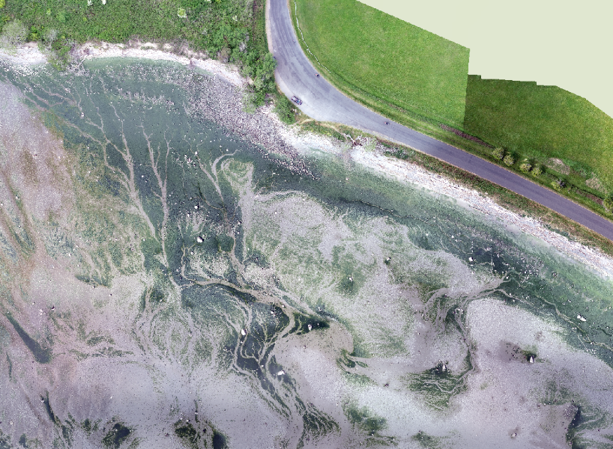
Figure 1: Drone photograph showing algae bloom in False Bay during summer season. Picture by Wendel Raymond.

Green tides are a common environmental problem experienced worldwide. Due to the excessive accumulation, dying, and decomposition of algae, dead zones can be created through intense absorption of oxygen (Misra et al., 2020). Control of algal bloom remains as one of the tasks in coastal waters worldwide. In Northeast Asia, many countries, including China, Japan, and Korea, conduct many surveys in Yellow Sea to track movement and cause of green tide in hopes to prepare and resolve the phenomenon. A study by Zhang, Jianheng found that Ulva prolifera attached to rafts plays important role in rapid development of blooms, after using satellite images to identify origin of macroalgal blooms (Zhang, 2014). False Bay, located in San Juan Island in Washington, U.S., suffers a similar problem. The bloom of Ulva spp. in False Bay creates an accumulation of biomass near shore that produces pungent smell as it rots, causing numerous complaints from nearby inhabitants. However, the rotting smell is not the only issue that is created by over-accumulation of macroalgae on the shore. Heavy seasonal algal cover can reduce the abundance of Phoronopsis, horseshoe worms, and Macoma, species of clams. It is also known that Macoma transplanted to area with heavy algal cover showed lower growth rate, indicating that area with heavy algal cover is not an ideal environment for sediment dwelling organisms (Everett, 1991). In the sediment survey conducted in various points within False Bay by Friday Harbor lab’s Biodiversity and Monitoring of Estuarine Ecosystem class, sediment dweller’s abundance rapidly decreased in the area where heavy accumulation of algae is common. Though the report of accumulation is mentioned for periods of time, if the phenomenon is occurring at higher frequency and greater magnitude, the biome within False Bay mudflat can drastically change from continued decline of pre-existing sediment dwellers and their predators. Thus, the accumulation of algae is not only problem for the local residents near False Bay but also to the environment in False Bay, which requires greater attention to the factors that led to the phenomenon as well as its future trend.
To resolve this environmental issue, one must understand the characteristics of the algal accumulation. Plant biomass requires balance of carbon, nitrogen, and phosphorus to grow, which is commonly referred to as Redfield Ratio. When one or more of the elements is not sufficient to match the ratio, growth halts as it needs to match the ratio for further growth. Therefore, in areas where insufficient nutrients limited algae’s growth, can later experience algal blooms after being supplied with excess nutrients. This can come in the form of nutrient loadting form external inputs. For instance, However, Hernandez et al. found that an increase in nutrient loading in river was least likely to be the leading factor that triggered a massive algal bloom in Palmones River, Spain, considering that the river was always exceeding maximum nitrogen and phosphorus limit. Therefore, considering factors outside of nutrient within the bay is crucial for learning the nature of the bloom. Other than the growth of algae itself, abundance of grazers could also influence the algae’s growth. False Bay has fewer rocky substrate, which grazers such as sea snails favor, than Friday Harbor. Therefore, it is possible that little amount of grazers caused the overgrowth in False Bay.
Ulva spp. can also be imported biomass from area outside of the bay could be another suspect for recent algal blooms. Winds waves from adjacent Haro straight may bring the algae into the bay contributing the accumulation of Ulva spp. biomass. However, considering that in shallow estuaries, nutrient conditions within the area leads macroalgal accumulation more than tidal imports (Shaw 2018), the chance of import causing massive accumulation is low.
To identify the main cause of the algal blooms identifying major factor for algal accumulation could guide toward solving the over-accumulation of Ulva lactuca in False Bay. I investigated the effect of unique water conditions in bodies of water in Ulva spp. growth. Despite being located near False Bay, Friday Harbor seems to have less accumulation of Ulva spp. compared to False Bay, suggesting that there may be a critical difference between the two locations. As mentioned earlier, the likelihood of foreign introduction of macroalgae is unlikely considering the geography of area near False Bay. However, even if Ulva spp. is imported, conditions within False Bay are still critical factors that could contribute to macroalgal blooms. One of the differences between False Bay and Friday Harbor is the difference in amount of development: while False Bay is more rural, Friday Harbor contains port and large settlement nearby. The different characteristics of development in these areas may have different level of influence on water through the amount of sewage or water use, possibly differentiating one water composition to another. I hypothesize that the water condition within the bay, including nutrient and chemical composition, is the cause of observed difference in algal accumulation between False Bay and Friday Harbor. To validate this hypothesis, observing algae growth between two regions will help determine whether the unique water composition within False Bay contributes to the recent algal bloom surrounding the area or not.

Methods
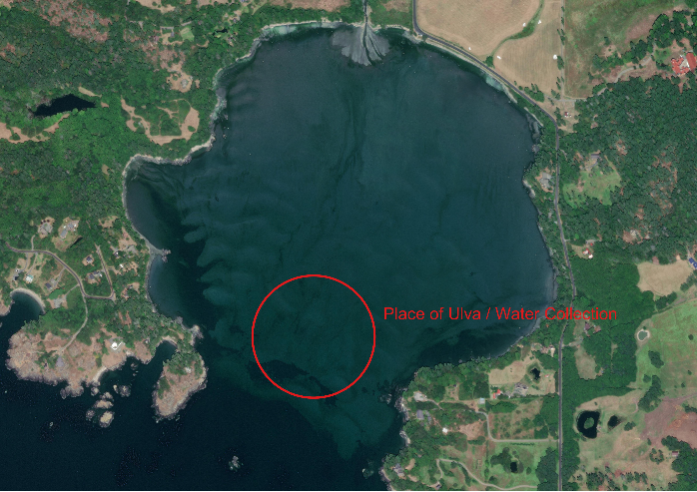 | 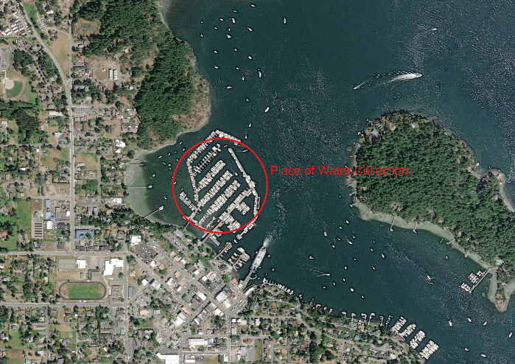
Figure 2: Map revealing the collection sites for Ulva spp. and water needed for the experiment.

To conduct my experiment, I first collected the seawater from False Bay using 18 L water bottle. The collection site was randomly chosen to eliminate selection bias as much as possible (Fig 2). Using 25 μm sock filter, the water was filtered before being collected in the container to eliminate presence of microorganism within the water such as diatoms, zooplanktons, and amphipods. Using nitrate measuring kit and phosphate measuring kit, nutrient composition within collected water samples was tested. Nitrate test kit measures concentration in 0 to 10 rating, which the increase in one level represents addition of 4.4ppm of nitrates in concentration. Phosphate measures phosphate concentration in scale of 0.1 ppm. Salinity was also tested for the seawater using YSI probe. I collected water from Friday Harbor following the same method.
I created control group using stock seawater kit. To make sterile seawater, InstantOcean was used for the experiment. Using the salinity data from two water samples from False Bay and Friday Harbor, the seawater’s salinity was set to the average of two sample locations. In trial 1, salinity of False Bay and Friday Harbor were 30.2 ppt and 28.8 ppt each, and 29.8 ppt and 29.1 ppt for trial 2. Using the measurements, salinity was adjusted to 29.6 for trial 1 and 29.4 ppt for trial 2. This control treatment water was devoid of nutrients.
For test subjects, I collected free-floating Ulva spp. in False Bay To prevent variation caused by species difference and minimize genotypic difference, Ulva spp. fragments with similar characteristics and within same species were collected. To prevent possible influence from grazers such as amphipods and sea snails, each collected Ulva pieces were cleansed with water. The samples were then placed inside a tank with running seawater to eliminate any influence of False Bay seawater within algae samples and reveal any possible hidden organisms that were not removed by first process. Using 5cm diameter petri dish as a guide, samples were cut into identical pieces using razorblade. To prevent disease or damage influencing growth rate, area with least amount of infection and damage were chosen. Total of 45 pieces were extracted from the samples.

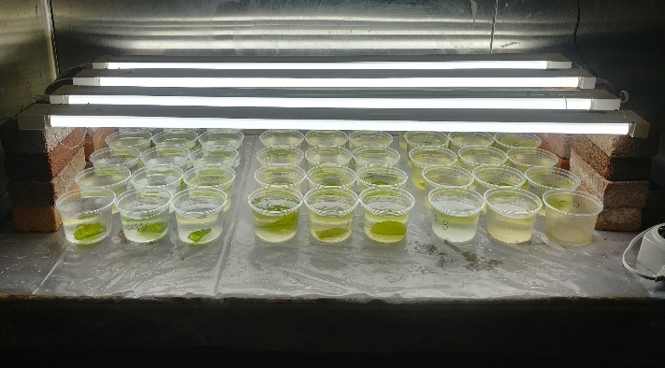 | 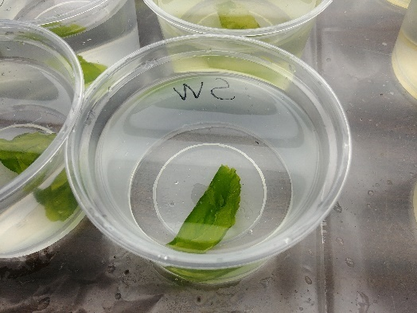
Figure 3: Experimental setup (left) and a close-up photo of individual culture (right)

In each water condition treatments, I cultured 15 individuals. First, samples were placed in cold-room, where temperature was maintained at 9◦ Celsius to prevent growth rate change caused by temperature difference. The optimal temperature for Ulva lactuca growth is between 17 to 23 Celsius (Zertuche‐González 2021), but due to the limitation in available equipment within the Friday Harbor Lab facility, forementioned temperature was chosen. Each Ulva samples were placed randomly within 45 identical 300ml plastic cups. Dividing the cups to three, I filled with three seawater conditions: sample from False Bay, Friday Harbor, and artificial seawater created using InstantOcean. Lamps illuminated for a 12:12 light:dark period of time on Ulva samples to encourage growth. (Hiraoka 2020, Fort 2019). To avoid uneven light distribution influencing individual growth rate, light sources outside of lamps were eliminated and lamps were placed evenly across the cups, elevated 20 cm using bricks. Water within each cup was changed every two days to avoid nutrient depletion. The replacement water for each condition was collected using the same method from initial collection process. Ulva discs were given 10 days to observe growth. After 10 days, each Ulva discs were collected. Amount of growth was measured by measuring the diameter of the disc after the treatment. To minimize experimental bias, two trials are conducted to stabilize the data output.
Using RStudio, I organized data into each category, and I measured the growth for each Ulva spp. discs from the difference in approximate surface area calculated using the diameter before and after the experiment. The average growth for each water conditions were then calculated. With the data set, I analyzed differences in growth rate within different water sources.

Results
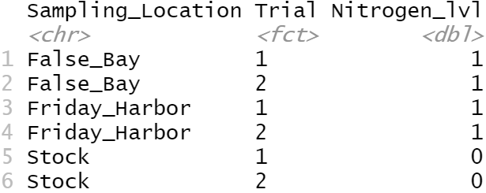 | 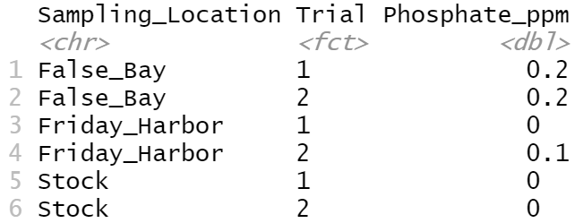
Table 1: concentration of nutrients within water sample.

Upon initial testing, nutrient concentration for two locations did not differ much. Both samples displayed level 1 in nitrate concentration test, which roughly translates to 4.4 ppm.
Phosphate concentration test revealed that there is little variation in concentration of phosphate within the water samples.
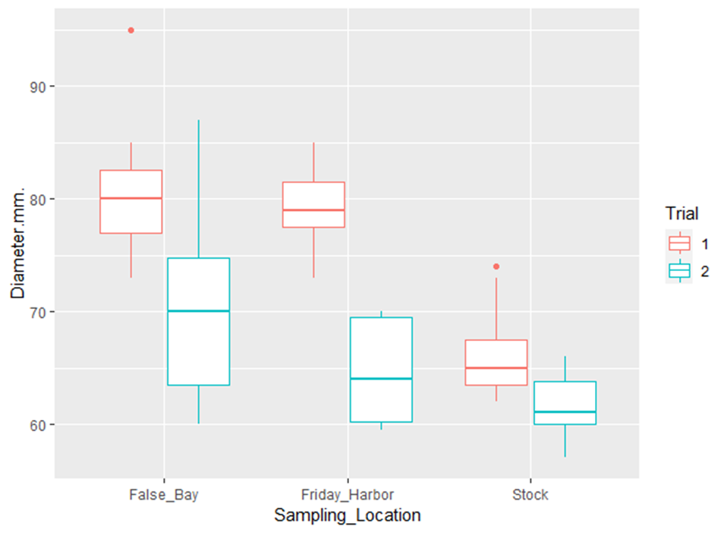
Figure 4: Diameter of Ulva Spp. disks after the experiment. Trial 1 shows a difference in growth rate compared to stock condition, while trial 2 shows no significant difference among sampling locations.
The growth rate of Ulva spp. for the first trial has shown distinct difference between the False Bay, Friday Harbor, and the stock water, but the difference in False Bay and Friday Harbor water’s growth rates is uncertain. The mean diameter of False Bay samples after 10 days of culture was 80.3 mm in trial 1 (5.28 SD), which is similar to the mean diameter of 79.0 mm (3.12 SD) in Friday Harbor samples. Despite the similarity of two treatments’ outcome, both sample groups showed that the amount of growth surpasses the mean diameter of control treatment, which was 66.1 mm (3.54 SD).
Trial 2 showed less growth among Ulva samples. The mean diameter of False Bay samples was 70.1 mm(8.30 SD). Friday Harbor samples had the mean diameter of 64.5 (4.34 SD), similar to stock sample’s 61.6 mm(2.40 SD). Although there is a considerable difference in mean diameter size between the False Bay and Friday Harbor samples, the box and whisker plots reveal that there are overlapping ranges of values for every experimental groups. Trial 2 showed lower growth rate of Ulva spp. than trial 1 and had no significant difference that distinguishes each growing conditions.
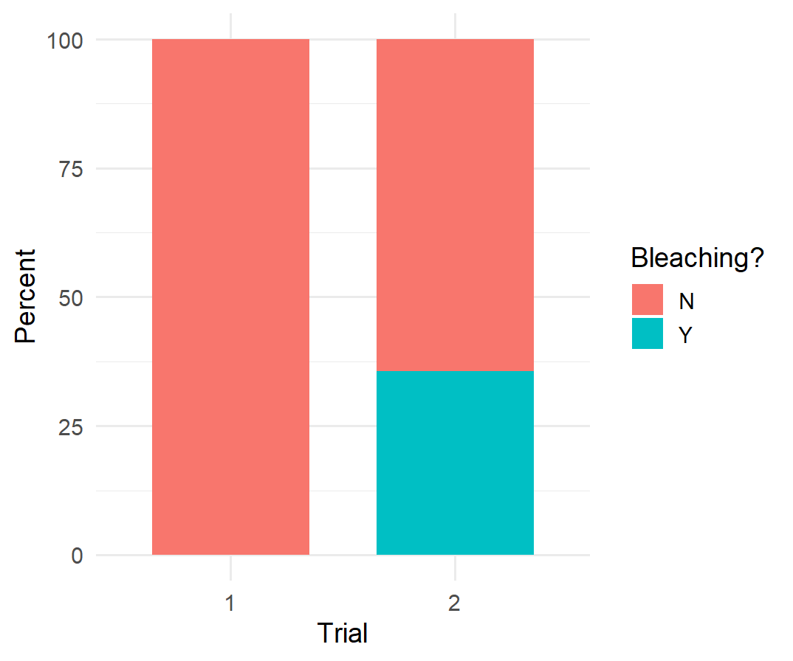 | 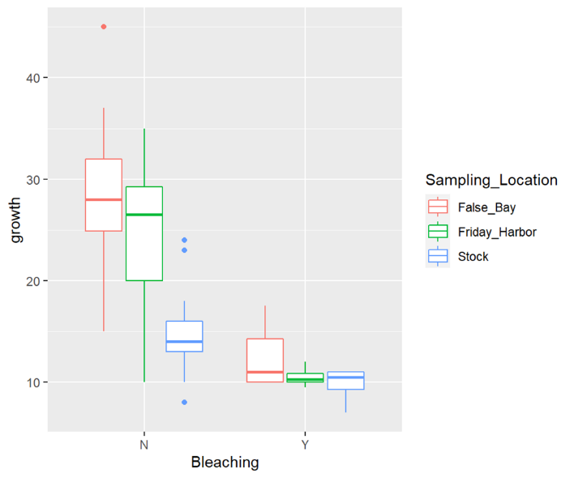
Figure 5: Percentage of Ulva spp. samples experiencing bleaching event in each trial (left)
and comparison of amount of growth based on occurrence of bleaching event in each water conditions. (right)

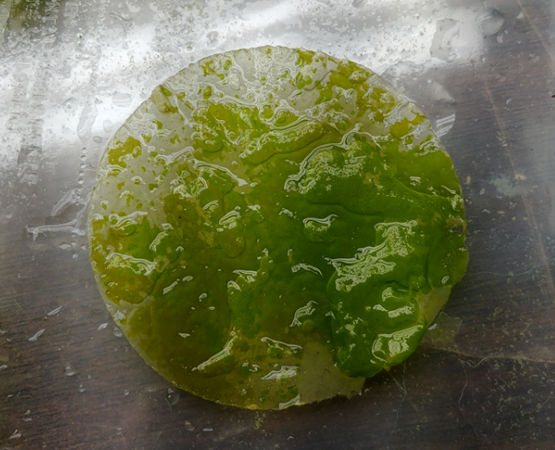
Figure 6: Example of Ulva spp. experiencing bleaching.

There was a widespread “bleaching” event in the second trial where Ulva spp. samples lost their pigmentation and turned transparent (figure 6). Samples that were affected by the event showed stunted growth rate and more brittle structure. As represented in the graph, there seems to be a significant difference in growth rate when compared based on sampling locations(figure 5). However, when compared trial 1’s stock seawater’s amount of growth with trial 2’s amount of growth among False Bay samples, there was not enough significant difference to distinguish one condition to another.

Discussion
The experiment revealed no evidence of a difference between growth rate of Ulva spp. and water conditions between False Bay and Friday Harbor. Nutrient tests conducted with Lamott test kit showed that there is no distinct difference in nutrient gradient of waters from False Bay and Friday Harbor. However, notable differences were found in two Ulva spp. culture conditions when compared with stock seawater condition, if not affected by the bleaching event. It is evident that presence nutrient plays key role in growth rate, but may not be a driving factor for difference in algal accumulation between False Bay and Friday Harbor. Although it cannot be said for certain that unique water condition within False Bay causes algal bloom, it is certain that presence of nutrients within the environment causes difference in growth rate compared to sterile conditions.
The bleaching event in trial 2 seems to significantly affect the growth rate of individuals. Although in-depth analysis of bleached samples was not possible due to the time constraints, the event seems to be correlated with stunted growth in bleached individuals compared to the unaffected samples. While unaffected samples displayed results that resemble trial 1, most of the bleached Ulva samples showed similar amount of growth. This could mean that bleaching event could possibly be a natural event where Ulva spp. cease to grow, viral or life cycle wise.
The cause for the loss of pigmentation has multiple causes, including its lifecycle. In various Ulva species, transformation of vegetative cells into haploid gametes is one of reproductive strategies of Ulva, which the loss of pigmentation in trial 2 can be explained by reproduction of Ulva lactuca(Balar, 2020). A second possibility is the difference in lighting conditions. A lack of sufficient light exposure can cause photosynthetic organism to wither. Other than the possibility of lack of photosynthesis, it is suggested that light intensity of 45-70 μmol photons m² s⁻¹ can trigger reproductive cycle in Ulva l.(Balar, 2020). However, considering that the light condition was equal for both trials—which Ulva l. samples received 12:12 hour light and dark cycle with same intensity, this assumption is unlikely. However, it is possible that prior to collection, trial 2 samples could have already entered reproductive phase due to change in daylight exposure during autumn season.

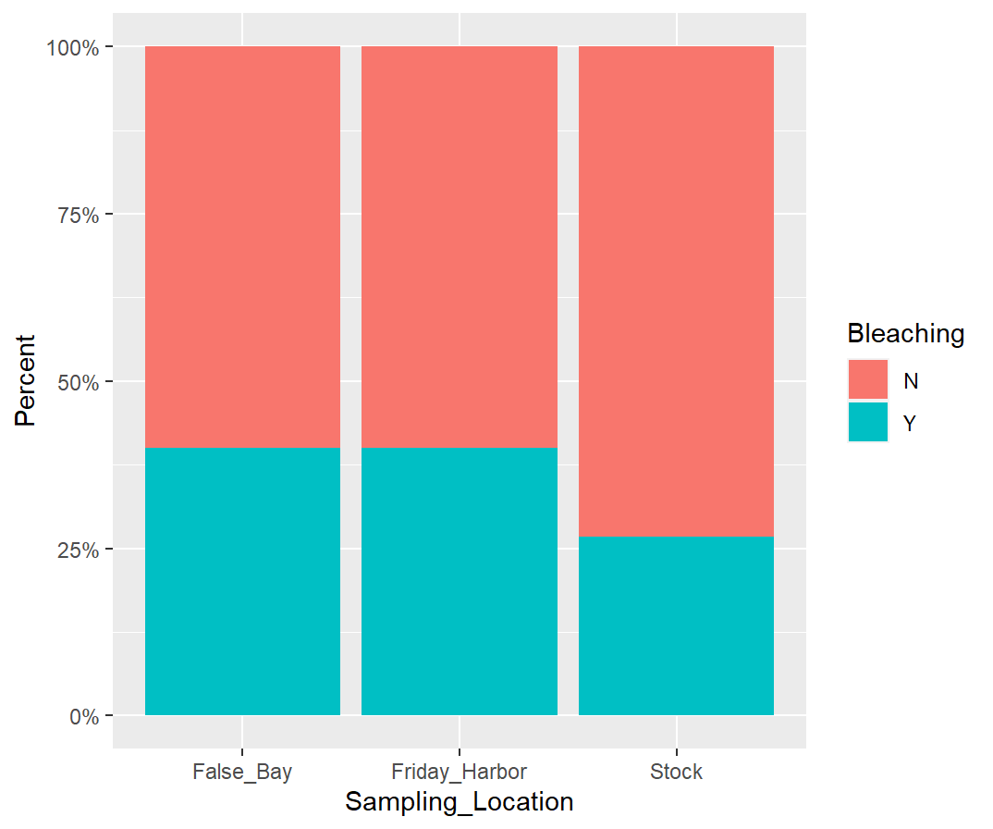
Figure 6: Percentage of samples that experienced bleaching event in trial 2 of the experiment, sorted by water source.

A third possibility is the loss of moisture during preparation. While preparing the culture medium for stock seawater condition, Ulva disks were exposed to atmosphere for within an hour. Being an aquatic organism, prolonged exposure to dryness can cause death. The lack of moisture and inability to exchange of oxygen in aquatic environment could have induced trial 2 samples’ bleaching. Moreover, while anoxia can decrease Ulva’s vitality, such exposure to the environment does not affect survivability within two-month period (Vermaat, 1987), suggesting that Ulva l. is resistant to anoxic conditions. Thus, this possibility is unlikely. During the preparation Ulva disks that were exposed to the dryness the most were within stock seawater group—a group that had the least number of samples with bleaching event. While False Bay and Friday Harbor samples were situated in their respective growing cup after cutting into disks, samples in stock seawater condition were exposed longer to the atmosphere due to the time needed to prepare their growth medium. Other possibilities, such as possibility of viral infection was suspected, reason being that samples cultured within artificially prepared seawater had less bleaching event observed than the other growth conditions that sources from “wild environment.” However, due to the time constraints, detailed analysis of bleached segment was not possible. More investigation is needed to examine the bleaching event in depth.
Though I conducted the experiment with many considerations in mind, few flaws in the design could be identified. Algal bloom in False Bay occurs during summer. The detailed conditions, such as temperature, nutrient influx, and light exposure, varies from autumn season. To better analyze the algal bloom within False Bay, conducting the experiment during the blooming season could better represent the characteristics of the event. More precise measurement was needed for the analysis of nutritional conditions within False Bay and Friday Harbor. The LaMott test kit provided rough estimates of concentrations of nitrate and phosphate, which made impossible to analyze False Bay and Friday Harbor’s nutritional characteristics in detail. With more precise measurements, differences in nutritional composition within two bodies of water can be better analyzed and applied on the research. Lastly, there is limitation in which lab experiment can simulate the wild environment. In nature, multiple factors influence the algae bloom, including change in nutrient influx over time and presence of grazers. With limited number of variables lab experiments can control, it is impossible to fully analyze multiple facets of the phenomenon by single experiment alone. Therefore, regular survey of algae bloom in False Bay around blooming season is needed to supplement the experimental data.
The research holds much potential for analyzing False Bay, opening possibilities for future studies that can reveal more about the unknown facets of the region or even guiding future government policies. For example, the accumulation of Ulva l. plays crucial role in shaping False Bay ecosystem. Upon degradation of Ulva l., nutrients gathered from eutrophic water is transferred to sediments (Lyons, 2012). This supplies many organisms, such as clams and polychaete worms, with organic material to consume: the study of algal bloom provides the key to knowing the dynamics of carbon/nutrient cycle within False Bay. From distribution of organisms based on food availability to calculating nutrient thresholds of the environment, more references for management of resources can be identified by learning the dynamics. Moreover, studying the frequency of heavy algae cover in the area can provide pattern in infaunal distribution in intertidal sedimentary habitats, (Everett, 1991) a good tool to analyze the species distribution within False Bay ecosystem. Using the heavy algal cover as a guide, researchers can find best place to plan their future survey for sedimentary organisms. In terms of human welfare, comparing the amount of algae accumulation with the past can provide a clue in whether the rotting stench is a recent or prolonged issue among residents near False Bay. Through this, authorities can determine the pattern and trend of algal bloom, giving more insight for the control of algae bloom. The study of algal bloom is not only crucial for the sake of science, but also the well-being of the local residents and the protection of nature as well.

Acknowledgements:
I would like to thank Dr. Megan Dethier, Dr. Alan Trimble, Dr. Brooke K. Sullivan, an Dr. Wendel Raymond for guiding my research.
I would like to thank Dr. Wendel Raymond for letting me reference the drone footage of False Bay, and the rest of Biodiversity and Monitoring of Estuarine Ecosystem crews for being trusty companions of my academic exploration.

References
Balar, N. B., & Mantri, V. A.. (2020). Insights into life cycle patterns, spore formation, induction of reproduction, biochemical and molecular aspects of sporulation in green algal genus Ulva: implications for commercial cultivation. Journal of Applied Phycology, 32(1), 473–484. https://doi.org/10.1007/s10811-019-01959-7
Everett, R..(1991). Intertidal distribution of infauna in a central California lagoon: the role of seasonal blooms of macroalgae. Journal of Experimental Marine Biology and Ecology, 150(2), 223-247. https://doi-org.offcampus.lib.washington.edu/10.1016/0022-0981(91)90069-9
Fort, A., Lebrault, M., Allaire, M., Esteves-Ferreira, A. A., Mchale, M., Lopez, F., Fariñas-Franco, J. M., Alseekh, S., Fernie, A. R., & Sulpice, R.. (2019). Extensive Variations in Diurnal Growth Patterns and Metabolism Among Ulva spp. Strains. Plant Physiology, 180(1), 109–123. https://doi.org/10.1104/pp.18.01513
Hernandez, I., Peralta, G., Perez-Llorens, J. L., Vergara, J. J., & Niell, F. X.. (1997). Biomass and dynamics of growth of Ulva species in Palmones River Estuary. Journal of Phycology, 33(5), 764–772. https://doi.org/10.1111/j.0022-3646.1997.00764.x
Hiraoka, M., Kinoshita, Y., Higa, M., Tsubaki, S., Monotilla, A. P., Onda, A., & Dan, A.. (2020). Fourfold daily growth rate in multicellular marine alga Ulva meridionalis. Scientific Reports, 10(1). https://doi.org/10.1038/s41598-020-69536-4
Lyons, D. A., Mant, R. C., Bulleri, F., Kotta, J., Rilov, G., & Crowe, T. P.. (2012). What are the effects of macroalgal blooms on the structure and functioning of marine ecosystems? A systematic review protocol. Environmental Evidence, 1(1), 7. https://doi.org/10.1186/2047-2382-1-7
Misra, A. K., Singh, R. K., Tiwari, P. K., Khajanchi, S., & Kang, Y.. (2020). Dynamics of algae blooming: effects of budget allocation and time delay. Nonlinear Dynamics, 100(2), 1779–1807. https://doi.org/10.1007/s11071-020-05551-4
Shaw, KC., Howes, BL., Schlezinger, D. (2017). Macroalgal composition and accumulation in New England estuaries. Journal of Environmental Management. https://doi.org/10.1016/j.jenvman.2017.10.021
Trimble, A. (2021, Oct. 20) Personal Interview. [in-person interview]
Vermaat, J. E., & Sand-Jensen, K.. (1987). Survival, metabolism and growth of Ulva lactuca under winter conditions: a laboratory study of bottlenecks in the life cycle. Marine Biology, 95(1), 55–61. https://doi.org/10.1007/bf00447485
Zertuche‐González, J. A., Sandoval‐Gil, J. M., Rangel‐Mendoza, L. K., Gálvez‐Palazuelos, A. I., Guzmán‐Calderón, J. M., & Yarish, C.. (2021). Seasonal and interannual production of sea lettuce ( Ulva sp.) in outdoor cultures based on commercial size ponds. Journal of the World Aquaculture Society. https://doi.org/10.1111/jwas.12773
Zhang, JH., Huo, Y., Wu, H., Yu, K., Kim, Jk., Yarish, C., Qin, Y., Liu, C., Xu, R., & He, P..(2014). The origin of the Ulva macroalgal blooms in the Yellow Sea in 2013. Marine Pollution Bulletin, 89(1-2), 276-283. https://doi-org.offcampus.lib.washington.edu/10.1016/j.marpolbul.2014.09.049

