The Performance of Drifters for Oil Spill Tracking

Conner Laursen
University of Washington
OCEAN 445

Abstract:
Oil spills can be devastating to marine ecosystems so knowing how to track where the spills should go is a concern that could decide the fate of communities near spills. After contemplation on which design of drifter would be best suited for rapid response, a design of drifter created by Charlie Brennan and refurbished by Conner Laursen is set to be the most practical and cost-effective way to track said disaster. Two field tests were conducted to determine the performance of the drifter in different conditions; the first on a harsh windy day in Puget Sound and the second in the calmer waters off the docks of the old Oceanography building. The drifters showed that the design was not perfect, as it followed the wind in Puget Sound but showed more promise than tennis balls due to the above water surface ratio, allowing the drifters to more accurately follow the currents of the water. The drifters show excellent potential in reliably and accurately predicting where oil will float to, depending on how harsh the conditions in the area are.

Introduction:
Scientific question: How does the drifter design perform in real world oceanographic hazard response?
A potentially catastrophic event that happens all too often in oceanographic environments are oil spills. Hazard response to oil spills and other disasters matters so much for the health of our ocean and everything in it. The more we can refine and perfect our disaster tracking methods, the better off we are in spreading education and emergency response. I believe using drifters to collect data would be the most efficient and practical way to accomplish what needs to be done and my intention is test the performance of a refurbished drifter design in its ability to track oil spill fronts in different weather conditions. Current methods in oil spill tracking include the use of satellites that are not only incredibly expensive to deploy, but if the satellite is not over the affected area it takes too much time to wait for it to be in the right area or is downright unusable (Migliaccio, 2013). Oil or diesel spills move through the water in a pattern that is trackable and knowing where the contamination is headed can lead to prevention in damage to sensitive areas such as biologically thriving ecosystems. One type of drifter that shows great promise in this application is the Davis star drifter first built by Davis et all. Another type that has a more cost efficient and practical design at the cost of depth of effect and durability was built in house at the University of Washington by a student named Charlie Brennan in years past. Both drifters have pros and cons to dealing with the problem at hand and both will yield different results depending on the conditions and environment they are deployed in. The type of the drifter chosen to tackle the problem at hand is incredibly important because the performance should simulate an oil spill front as accurate as possible and not vary by conditions that do not strongly affect the oil in the water in order to have the most accurate simulation as possible during testing and the most accurate results during real world application. Oil and diesel blend with the water in the surface mixed layer and are ultimately affected by Ekman transport, which furthers the movement of the oil away from the original site (Price, 2003). The ideal drifter to tackle oil spill response has the most negligible effect on wind as possible but is practical for transport to oil spills and rapid deployment. The drifters as assembled pieces are shown below with the large purple sailed drifter being the Davis Star drifter and the small red sailed drifter being the newly improved, Charlie made drifter.
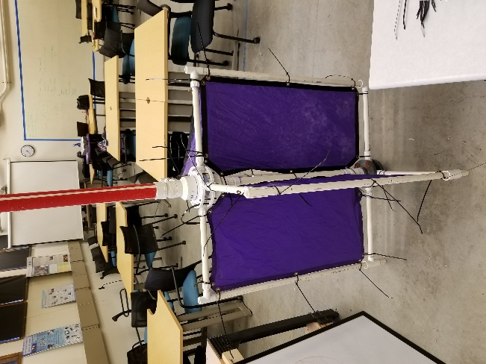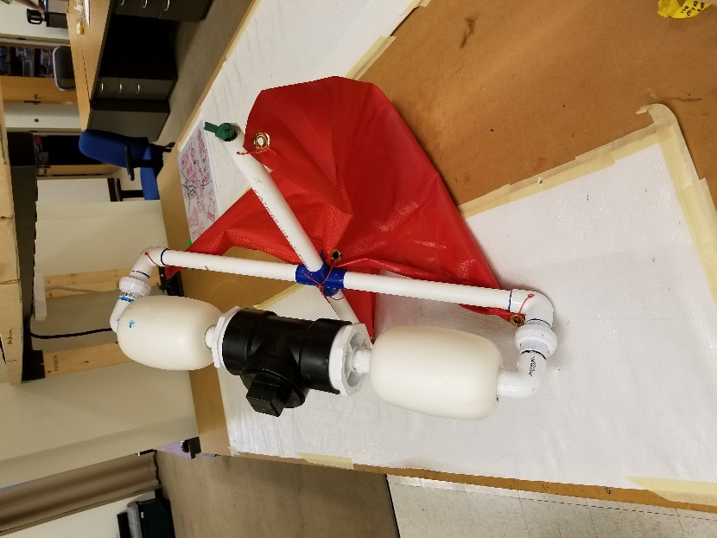

Both drifters are made from pvc plastic piping and the Davis Star drifter features rectangular sails that extend one meter down below the surface water in four different perpendicular directions. The red pvc housing that extends vertically from the top of the drifter is a watertight chamber that encases the GPS battery equipment being used. The four triangular sails that sit on top of the drifter near the buoys provide the drifter with the stability it needs to remain upright in the water. Inexpensive LED strobe lights are mounted to both drifter to aid in the recovery retrieval time of the drifter. The ideal surface to below surface ratio that makes the Davis Star drifter so effective is 1:40. This means that any wind around the drifter has a negligible effect on how it moves. Although the Charlie made drifter does not have the ideal surface to below surface ratio that the Davis Star does, it excels in its ability to be assembled and deployed incredibly quickly. The Davis Star drifter takes two people around 30 minutes to assemble while the Charlie designed drifter takes a single person less than 1 minute. Both of the drifters are promising, but one will be chosen for reasons that make it the most practical and useful overall for real world hazard response.

Materials and Methods:
The most important decision I made for the sake of this project was determining which type of drifter I would test and why. I have determined that both the Davis Star drifter and the drifter created at the University of Washington by Charlie can accurately and efficiently measure the needed parameters. Both drifters are made of PVC plastic piping and water-resistant cloth masts done held together with glue and zip ties with attached buoys on top to create an overall buoyant instrument that penetrates one meter down below the surface of water with the Charlie designed drifters penetrating half of a meter below the surface. A watertight case is also included to house any electronical equipment needed. In this case, the GPS devices and external battery packs will be housed inside. The GPS can be programmed to record a coordinate at any time interval we choose, with all data being stored on board the memory of the GPS.
The drifters as assembled pieces are shown below with the large purple sailed drifter being the Davis Star drifter and the small red sailed drifter being the newly improved, Charlie made drifter.
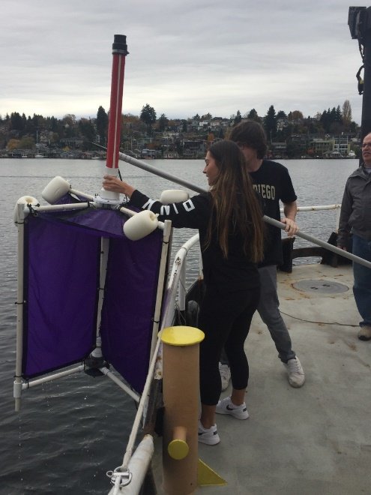

The Davis Star drifter is already stellar in design, so nothing was altered to the design and build; it can be assembled with the provided parts in the exact way it was intended to take measurements. The drifter was tested and documented beforehand to prove that it is easily deployable and retrievable by two people maximum, shown in one of the pictures. Both drifters are made from pvc plastic piping and the Davis Star drifter features rectangular sails that extend one meter down below the surface water in four different perpendicular directions. The red pvc housing that extends vertically from the top of the drifter is a watertight chamber that encases the GPS battery equipment being used. The four triangular sails that sit on top of the drifter near the buoys provide the drifter with the stability it needs to remain upright in the water. The ideal surface to below surface ratio that makes the Davis Star drifter so effective is 1:40. This means that any wind around the drifter has a negligible effect on how it moves. Inexpensive LED strobe lights are mounted to both drifter to aid in the recovery retrieval time of the drifter. The Charlie made drifter needed multiple design improvements to improve the quality, durability and rapid response capability of the drifter. Some of the drifter’s sails were ravaged and had holes in critical mounting points on the pvc piping. I repaired these in house and outlined the holes in metal to prevent tearing and aided in the overall quality of the sails and drifter. The drifter was originally designed with twist ties holding everything together. I replaced these with much more durable zip ties by drilling bigger mounting holes in the drifter and reattaching them all in the same places as the zip ties. This improves the durability of the drifter and will prevent anything from falling apart. The original drifter had latex surgical tubing elastically clenching some of the arms together so when it is taken apart, it folds nicely together and does not separate the arms from the spine. Some arms did not have this tubing at all. To make the drifter a much more able to be rapidly deployed, I replaced the tubing with more durable and quality bungee cord and added bungee cord to the arms that did not have tubing to begin with, making the drifters able to be full assembled in seconds. The watertight housing and buoys and mounted on top of these drifters as well. Although the Charlie made drifter does not have the ideal surface to below surface ratio that the Davis Star does, it excels in its ability to be assembled and deployed incredibly quickly. The Davis Star drifter takes two people around 30 minutes to assemble.
After careful consideration of how each drifter would perform, the quality and practicality of the design and how well each type would be for helping with the intended hazard response utilization I have in mind for it, I decided to ultimately go with the Charlie designed drifter. The material costs due to smaller size, ease of transport and short time to put together and deploy outweigh the accuracy of results durability of the Davis Star drifter. The first of two experiments planned to be carried out tested the drifter’s viability in windy conditions in the Puget sound. The intent is to compare how much the drifter was affected by wind to see if it can still be used when weather conditions are not ideal.

Results:
The first design test of the drifter was carried out in front of the Mukilteo beach. The GPS recording devices were set to take measurements 5 minutes apart. The drifters were taken out on the Wielander boat provided by the University of Washington. The wind speed was moderate-strong. At 10:42am on January 28th, the drifter was deployed and was retrieved again at 11:33am. The drifter was then taken back to approximately the same deployment location as the first go and set again at 11:38am. It was retrieved again at 12:23pm. This process was repeated one more time at 12:28pm and retrieved one last time at 1:07pm.
The second design test was conducted of the old Oceanography dock to test the design against tennis balls to see which would be better in a controlled test to track oil spills. 9 tennis balls were thrown into a perimeter of 3 of the Charlie designed drifters and were meant to simulate an oil spill that can be retrieved because putting any type of liquid or oil into the water would be polluting. The drifters had the GPS tracking devices inside to record coordinates every 5 seconds and a drone flown by licensed drone pilot Hannah Rotta took pictures every 5 minutes while the drifters and tennis balls drifted. The drifters and tennis balls were deployed at 12:23pm on April 19th and pictures were taken at 12:23, 12:28, 12:34, 12:38, 12:43 and 12:48 before the tennis balls began to drift under the dock. The drifters were retrieved at 1:05pm. The current of the water tested was towards the canal, a South-Eastern direction from the deployment site compared to the North-Western wind. Wind speeds were taken one meter above the surface of the water and the 10 wind recordings taken averaged out to be 1.99 MPH NW and the overall weather during the day was sunny, nearly the opposite of the previous field test.
Below is a figure depicting the path the drifters took during all 3 data sets. The map was generated using the program CanWay, which is the program used to import data from the GPS devices to import the data is has and export it to any other application. The red lines show the path the drifter took, and the blue lines show the route not recorded back to the original location for the drifter to be relaunched.
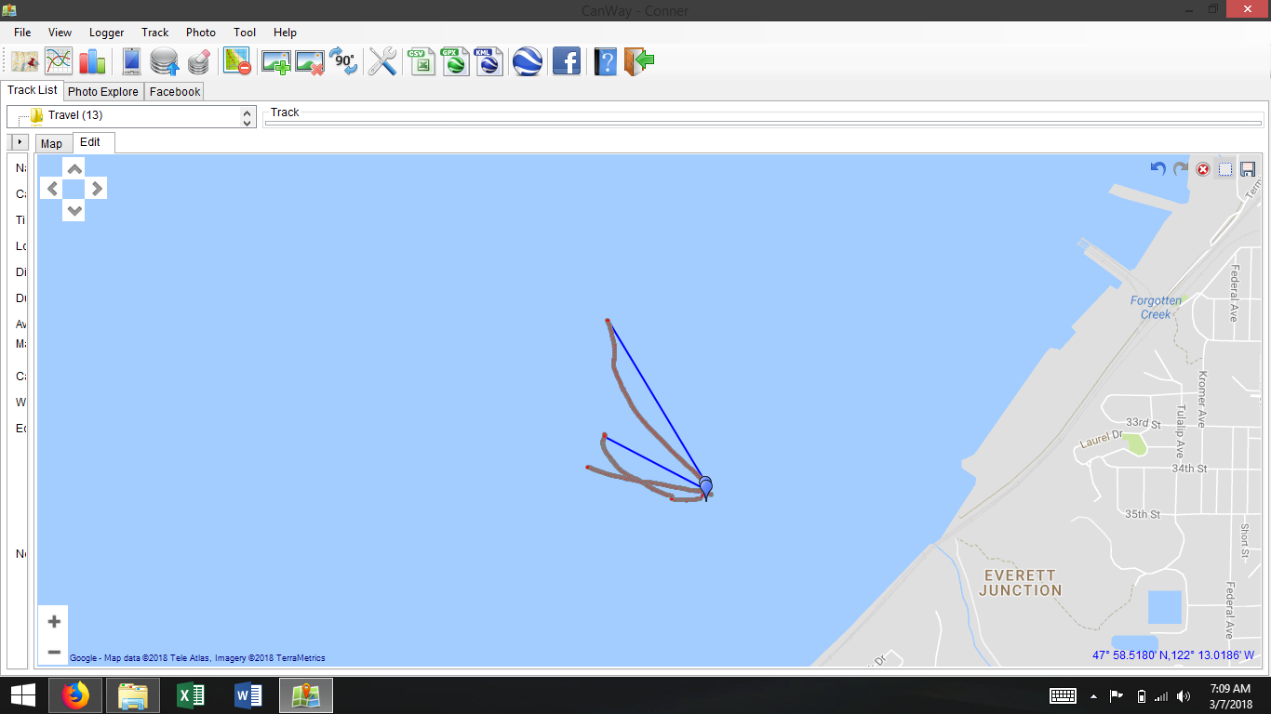
The three figures below show the latitude and longitude coordinates over time during the tennis ball field test for each of the 3 drifters. The graphs were generated in excel using the latitude and longitude coordinates that the GPS devices recorded.

The figure below shows the path the drifters took during the experiment. The graph was generated in the program CanWay. The blue line is the followed path.
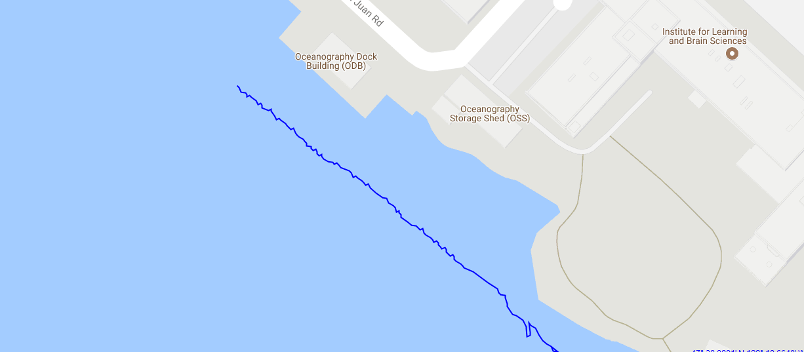
The images below show the path that the drifters and tennis balls took compared to each other every 5 minutes. The pictures were taken in the orientation so that North is towards the bottom of the picture, and the wind direction, 1.99 MPH NW is towards the bottom right of the pictures.
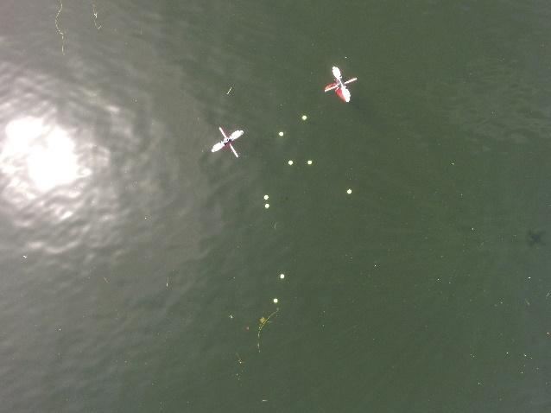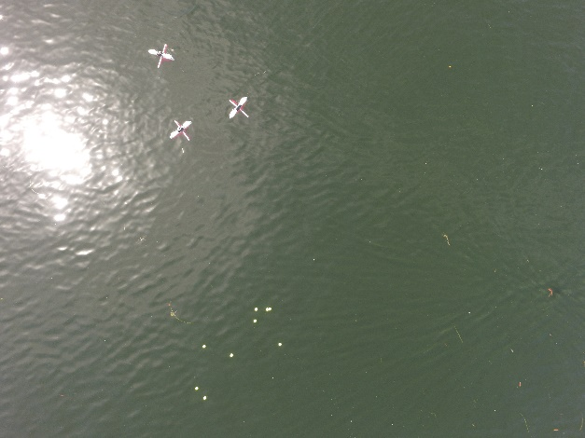

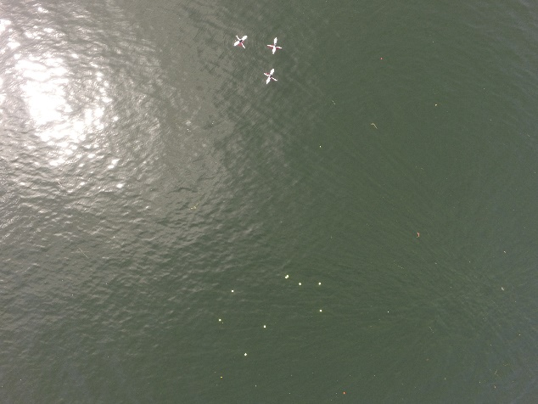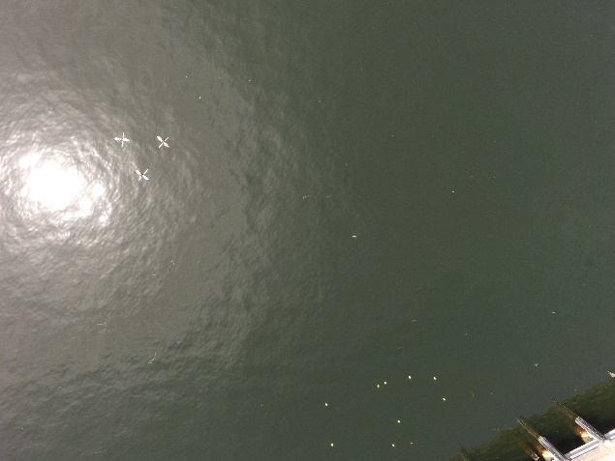

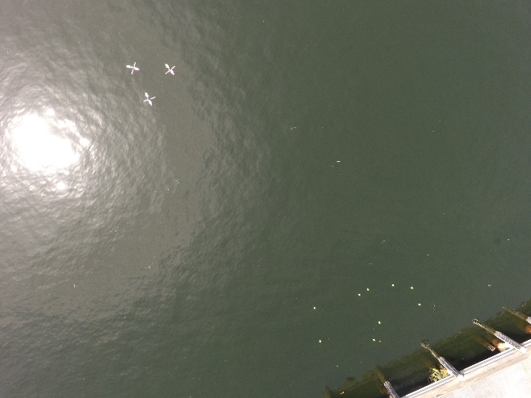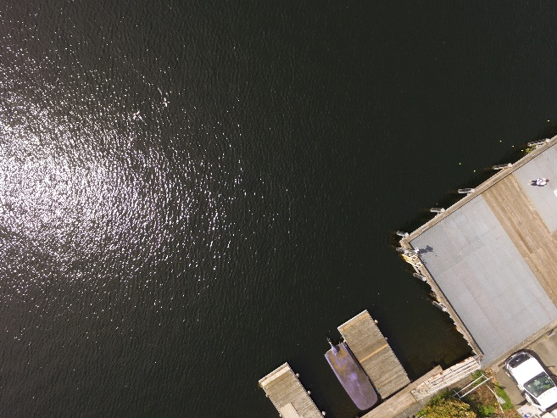

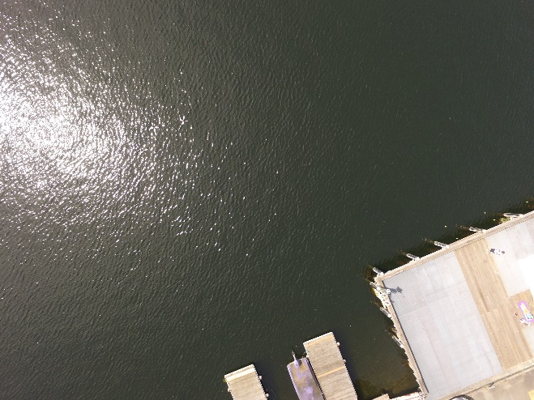
Discussion:
After careful analysis of the drifter locational data, both observational and through the coordinates recorded on the GPS devices, the performance of the drifter is more situational and is much better suited in addressing the problem of oil spill tracking when conditions are ideal. During the first field test, the winds were dominating, and the drifters showed a tendency to follow the general direction of the wind combined with little direction from the currents below. The map created in CanWay shows the path the drifter took, and it is believed to change the way it has over the three tests because the wind was switching directions and each test following the previous was impacted from a different direction of wind.
The field test during the day with ideal conditions showed much more promise for the drifter becoming a viable option to deploy in real world scenarios. The above surface ratio for the tennis balls is different than that of the drifters. The tennis balls are more buoyant, so the majority of the ball is above water compared to the total surface area, as opposed to the drifter which more of the surface area is below water compared to the total. The results show themselves in the pictures taken from the drone. The current of the water tested was towards the canal, a South-Eastern direction from the deployment site compared to the North-Western wind. The drifters seemed to follow the path of the current nearly exactly, heading straight towards the entrance of the canal. The tennis balls followed a different path; what appeared to be a path created from a mix of the current forcing and the wind forcing. The current caused the tennis balls to move east at about the same speed as the drifters, the pictures show both moving parallel to the dock at nearly the same speed in the east direction. The tennis balls, with the forcing from the wind, took a more North-Eastern path causing them to dip under the dock they were deployed near. This means that the drifters were less impacted from the wind as opposed to the tennis balls because they followed the path of the current more accurately.
The field tests show that the drifters are moderately affected by winds, but under ideal conditions can be an accurate tool for predicting the current of the water and the projected path the oil spill will float. This, on top of the drifter being the most practical, easily transportable, cost effective and rapidly deployable option makes it an excellent choice for any type of marine hazard prevention, with oil spill prediction being the most opportunistic choice for the design.

References:

“American Meteorological Society.” A Simple Model of Fjord and Coastal Circulation
Interaction: Journal of Physical Oceanography: Vol 11, No 12, journals.ametsoc.org/doi/abs/10.1175/15200485%281981%29011%3C1612%3AASMOFA%3E2.0.CO%3B2.
Caruso, M.J., M. Migliaccio, J.T. Hargrove, O. Garcia Pineda, and H.C. Graber. 2013. “Oil spills
and slicks imaged by synthetic aperture radar”. Oceanography 26(2):112–123, http://dx.doi. org/10.5670/oceanog.2013.34.
J.M. Price et al., "Evaluation of an oil spill trajectory model using satellite tracked, oil spill
simulating drifters,"OCEANS 2003. Proceedings, San Diego, CA, USA, 2003, pp. 1303-311 Vol.3.doi: 10.1109/OCEANS.2003.178046
US Department of Commerce, National Oceanic and Atmospheric Administration.
“Tides and Water Levels.” NOAA National Ocean Service Education, 19 Dec. 2004,
oceanservice.noaa.gov/education/kits/tides/tides07_cycles.html.
Wang, B. “Kelvin Waves.” Elsevier Science Ltd., 2002,
http://www.soest.hawaii.edu/MET/Faculty/bwang/bw/paper/wang_103.pdf
Caruso, M.J., M. Migliaccio, J.T. Hargrove, O. Garcia Pineda, and H.C. Graber. 2013. “Oil spills
and slicks imaged by synthetic aperture radar”. Oceanography 26(2):112–123, http://dx.doi. org/10.5670/oceanog.2013.34.

