“Where’s Waldo?”: Unraveling the puzzle of Idotea wosnesenskii abundance across San Juan Island

Abigail Huber ¹

¹ School of Aquatic and Fishery Sciences
Box 355020
University of Washington
Seattle 98195, USA

ahuber3@uw.edu

ABSTRACT
Idotea wosnesenskii are intertidal isopods typically found on kelp, mussel beds, and intertidal rocks. With a relatively large geographical range, I. wosnesenskii can be found from Alaska to northern Mexico while also appearing along the coastlines of Siberia. This study examined the influence of rock width, substrate preference, shore crab presence, and intertidal height on the abundance and distribution of I. wosnesenskii across San Juan Island. We found that aggregations of I. wosnesenskii are likely to be found under rocks with width larger than 25.6 cm (R² = 0.36, p = 0.028). In comparison, singular individuals of I. wosnesenskii are more likely to be found under rocks with width smaller than 25.6 cm. Idotea wosnesenskii also had a substrate preference of seaweed, cobble, and bedrock (F = 10.9, p = 0.01). Shore crab presence and intertidal height had no significant effect on the abundance of I. wosnesenskii (p > 0.05). These findings may support observations from past studies that Idotea are primarily mesograzers who can also be omnivorous depending on food availability. However, further research is required to determine the full impact of shore crab presence, and intertidal height on the distribution of I. wosnesenskii.

INTRODUCTION
In 1798, Fabricus described a new genus within the order Isopoda: Idotea. Idotea are small littoral and sublittoral marine crustaceans with flattened, segmented bodies (Salemaa, 1979). Mainly found across the northern hemisphere and in temperate waters, Idotea are ecologically important herbivores that graze on algae and seagrass (Jaschinski & Sommer, 2008; Roth et al., 2010; Starko et al., 2016). Within the genus Idotea, species are polymorphic - with pigmentation ranging between black, yellow, tan, and pink (Merilaita, 2001). Over the years, polymorphism has been shown to play a crucial role in assisting with mate selection and reducing the likelihood of predation (Merilaita, 2001). Much research has focused on examining these color-inducing mechanisms and how they influence Idotea ecology, distribution, and sexual selection (Lee & Gilchrist, 1972; Jormalainen, 1995; Merilaita, 2001).
In comparison to their polymorphic traits however, the distribution of individual species within the genus Idotea remains vastly understudied and primarily focused on species concentrated along the European coast (Gutow, 2003; Panova et al., 2016). Furthermore, the distribution of Idotea native to the Pacific is almost nonexistent, with studies mainly focusing on genetic analyses or the influence of water currents on Idotea behavior (Gurjanova, 1968; Rafi & Laubitz, 1990).
Within the Pacific Northwest, Idotea are known to range between Prince William Sound, Alaska, to Juan de Fuca Strait, Washington (Rafi & Laubitz, 1990). Two of the most extensively studied species indigenous to the Pacific Northwest are I. resecata and I. wosnesenskii, with many reports examining temporal patterns, attachment strength, and swimming capabilities (Alexander, 1988; Thom et al., 1995; Starko et al., 2016). However, no study currently has analyzed small scale distribution or abundance for either species.
This study aims to survey the distribution and abundance of I. wosnesenskii across several sites on San Juan Island, Washington, USA. We hypothesized that I. wosnesenskii abundance would be higher under rocks of width over 25.6 cm, and that I. wosnesenskii would prefer boulders to other substrates such as seaweed, rocks, and sand. We also hypothesized that I. wosnesenskii abundance would be inversely proportional to crab abundance, as well as proportional to intertidal height. We then analyze the findings using a general linearized model, one-way ANOVA, and Tukey tests, and relate our findings and implications to past studies.
METHODS
Study Location
Four sites were surveyed across San Juan Island, Washington: Eagle Cove, Third Lagoon, Cattle Point, and Beaverton Cove. All surveys were conducted during the lowest tide of the day (Table 1).
Data Collection
Three transects were laid parallel to the waterline and spaced five meters apart at each site. Transects were categorized as a low, medium, or high depending on the distance away from the waterline (Fig. 1). Ten 0.5 m2 quadrats were randomly placed along each transect on both sides of the transect tape. Substrates and sediment grain size were recorded for each quadrat and organized into the following: seaweed, pebbles (0.2-6.5cm), cobbles (6.5-25.6cm), boulders (25.6-409.6cm), and bedrock (>409.6cm). The sediment grain size was determined using the Wentworth scale, published by Chester K. Wentworth in 1992 and measured using a caliper, tape, or meter stick. Rock width was calculated by measuring the width of the rock.
Total counts of I. wosnesenskii were recorded for each quadrat. Rock width was also measured for all isopods found under rocks. Only the substrate was recorded if the isopod was not located under a rock. The presence or absence of crabs within the quadrat was also noted.
Data Analysis
A generalized linear regression was then performed to analyze the influence of the rock width on the distribution of I. wosnesenskii. In addition, a one-way ANOVA was performed to examine the impact of shore crab presence, substrate preference, and tidal height on the abundance of I. wosnesenskii.
RESULTS
The influence of rock width on the abundance of I. wosnesenskii was statistically significant (R² = 0.36, p = 0.028) (Fig. 1). Aggregations (more than two individuals) of I. wosnesenskii were more likely to be found under rocks over 25.6cm width. In contrast, single individuals of I. wosnesenskii were more likely to be found under rocks less than 25.6cm in width. The data also show that there is a strong likelihood that I. wosnesenskii prefer substrates such as seaweed, cobbles, and bedrock (F = 10.9, p = 0.01) (Fig. 2).
Furthermore, the presence of shore crabs had no significant effect on the abundance of I. wosnesenskii across all sites sampled (F = 2.84, p = 0.09) (Fig. 3). Finally, we detected no significant influence of tidal height on the distribution of I. wosnesenskii (Fig. 4).
DISCUSSION
This study is the first to examine the influence of rock width, substrate preference, crab presence, and intertidal height on the abundance of I. wosnesenskii. Furthermore, this study is also the first to examine the influence of intertidal rock width on any species of Idotea.
Our finding is that aggregating I. wosnesenskii (> 2 individuals) are more likely to inhabit boulders, while solitary I. wosnesenskii (< 2 individuals) are more likely to inhabit areas with cobbles and pebbles. This aggregating behavior is not yet well understood, but it may be a form of social aggregation seen in other genera of isopods (Shuster & Wade, 1991; Shuster, 1990). Social aggregation amongst isopods has been found to reduce risks such as predation or desiccation and increase the odds of finding a mate (Salma & Thomson, 2016; Salma & Thomson, 2017). The aggregating behavior observed in I. wosnesenskii may also be explained by the findings of Salma & Thomson, 2016, and Salma & Thomson, 2017, but requires further examination to validate this conclusion.
Idotea are also herbivorous crustaceans feeding on filamentous macroalga (Orav-Kotta & Kotta, 2004, Naylor, 1995a). However, depending upon food availability, Idotea may be omnivorous (Naylor, 1995b). Our finding that I. wosnesenskii preferred seaweed, cobbles, and boulders, supports the likelihood of omnivorous feeding within I. wosnesenskii. However, our finding that I. wosnesenskii are likely to be found on other substrates besides seaweed directly contradicts a study performed by Starko et al., 2016. Due to morphological constraints, those researchers determined that most I. wosnesenskii are limited to habitats with thicker seaweed and higher wave intensity. However, our study found very similar numbers of I. wosnesenskii amongst seaweed, cobbles, and bedrock. We believe this may be because researchers did not survey equal amounts of each substrate at all locations.
While macroalgae were present at all locations, only two of the four sites had significant amounts of algae, specifically Fucus, or were prone to high wave action. Whether I. wosnesenskii directly feeds on Fucus rather than inhabiting it is still unknown, but several studies along the European coast suggest that it may be a possibility (Roth et al., 2010; Engkvist & Tobiasson, 2000; Salemaa, 2012). Therefore, to quantify the true impact of macroalgae on the abundance of I. wosnesenskii, we recommend that future research direct attention towards limiting transects to areas strictly covered by macroalgae and areas strictly without macroalgae instead of sampling areas with a combination of both.
This study found no statistically significant influence of shore crab presence on the abundance of I. wosnesenskii despite observations of a higher abundance of I. wosnesenskii in areas with no crabs present. While common shore crabs and alien crabs can negatively affect other intertidal species via predation or competition, this study, at first glance, suggests that there does not seem to be competition for space or resources with I. wosnesenskii. However, this finding requires further research. Therefore, we recommend that future research investigate the behaviors between I. wosnesenskii and shore crabs before concluding that there is no impact of shore crabs on the distribution or abundance of I. wosnesenskii.
Finally, we found that intertidal height does not influence I. wosnesenskii abundance. This finding directly supports observations that the genus Idotea are spatially distributed throughout the intertidal shore (Ranta & Salemaa, 1991; Salemaa, 1986; Salemaa, 1997). Furthermore, in a study by Leifsson, 1998, the vertical distribution of Idotea were found to be subject to change depending on the season or food availability. These observations may explain why the current study found no significant preference between tidal height and I. wosnesenskii abundance. To quantify the influence of seasonality on I. wosnesenskii distribution, we recommend that future research repeat this experiment during the summer, fall, and winter.
As an intertidal crustacean, the genus Idotea are well adapted to life in the intertidal (Hultgren & Mittelstaedt, 2015; Starko et al., 2019; Wethey & Woodin, 2008). With adaptations such as lipid storage and plastic physiology, these herbivores may be well-equipped to face some of the challenges posed by climate change. However, ocean acidification still poses a threat - reducing survival rates, genetic diversity, and overall immunocompetence (Rugiu et al., 2021; Wood et al., 2014; Roth et al., 2010).
Furthermore, Idotea are ecologically important mesograzers that influence the structure of intertidal communities (Jaschinski & Sommer, 2008). A sudden plummet in the abundance of Idotea due to increasing effects of climate change may then result in the restructuring of current intertidal communities (Engkvist et al., 2000; Gonzalez & Biddanda, 1990; Boström & Mattila, 1999). Because of the ecological importance of Idotea, we must better understand what influences their abundance and distribution not just across San Juan Island but also globally to predict future implications of climate change on the structuring of intertidal communities (Hultgren & Mittelstaedt, 2015).

ACKNOWLEDGEMENTS
Firstly, I would like to thank Hanna Zulmuthi for making this project enjoyable with her support and humor during data collection and analyses. Throughout this project, thank you to Terrie Klinger for her invaluable advice, assistance, and patience. Thank you, Joe Dupree, for your aid in analyses and coding. Thank you to Megan Dethier for helping us develop the project question.

TABLES AND FIGURES
Table 1. The time researchers began surveying each transect and the tidal height associated with the transect.
Date | Location | Transect | Time | Tidal Height ('MLLW)
16-May-22 | Third Lagoon | Low | 9:28 AM | -2
16-May-22 | Third Lagoon | Medium | 10:16 AM | -2.5
16-May-22 | Third Lagoon | High | 10:51 AM | -2.5
17-May-22 | Cattle Point | Low | 10:35 AM | -2.9
17-May-22 | Cattle Point | Medium | 11:18 AM | -3.2
17-May-22 | Cattle Point | High | 11:50 AM | -3.1
18-May-22 | Beaverton's Cove | Low | 12:39 PM | -2.9
18-May-22 | Beaverton's Cove | Medium | 1:20 PM | -2.8
18-May-22 | Beaverton's Cove | High | 2:10 PM | -2.5
19-May-22 | Eagle Cove | Low | 12:15 PM | -2.8
19-May-22 | Eagle Cove | Medium | 12:53 PM | -3.1
19-May-22 | Eagle Cove | High | 1:30 PM | -3

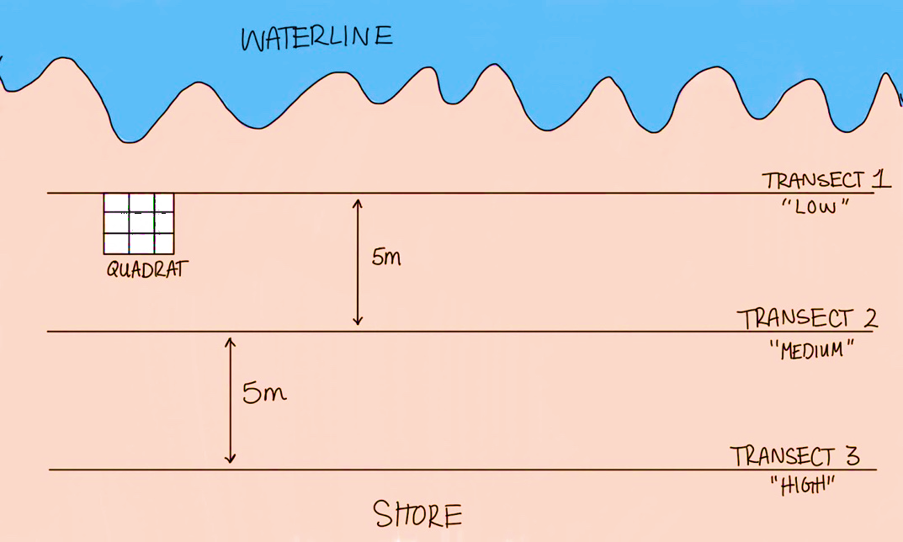
Figure 1. Experimental setup for surveying each location.

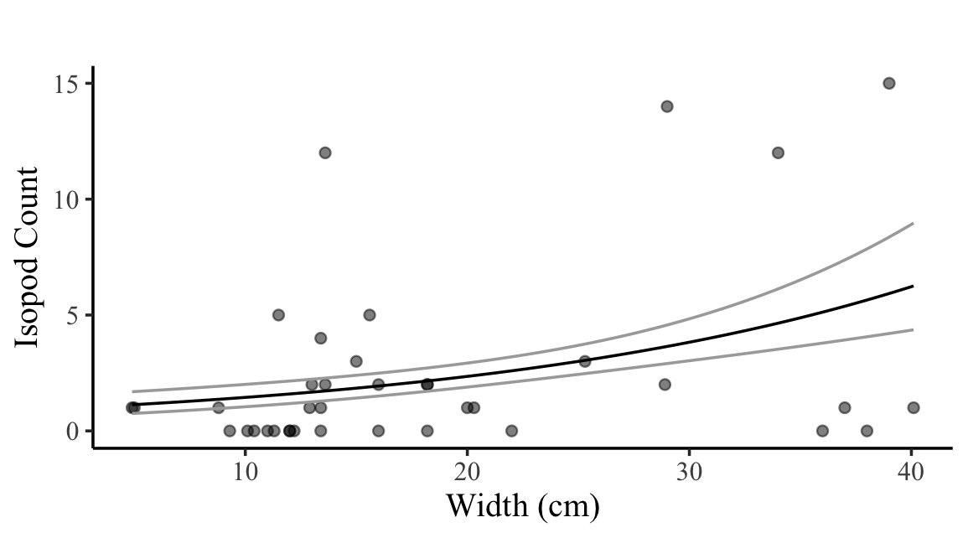

Figure 2. Number of I. wosnesenskii versus width of rock (p < 0.01).
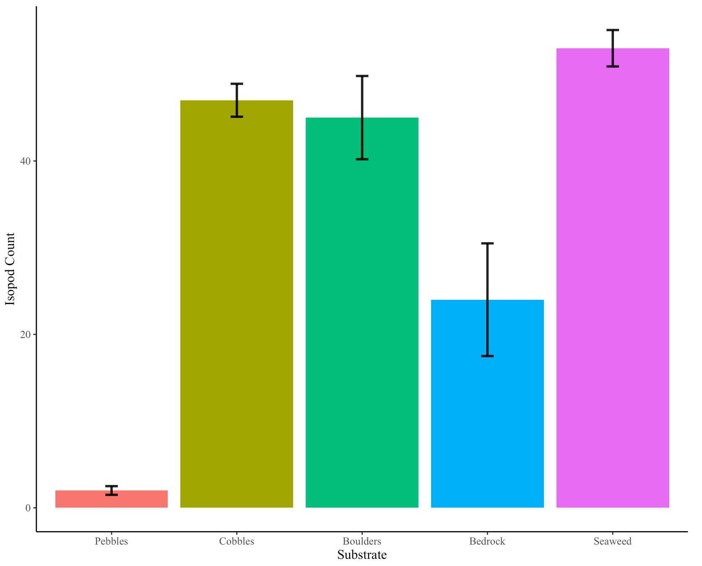

Figure 3. Count of I. wosnesenskii present on each substrate. Rock substrates were categorized into the following sizes: seaweed, pebbles (0.2-6.5cm), cobbles (6.5-25.6cm), boulders (25.6-409.6cm), and bedrock (>409.6cm).
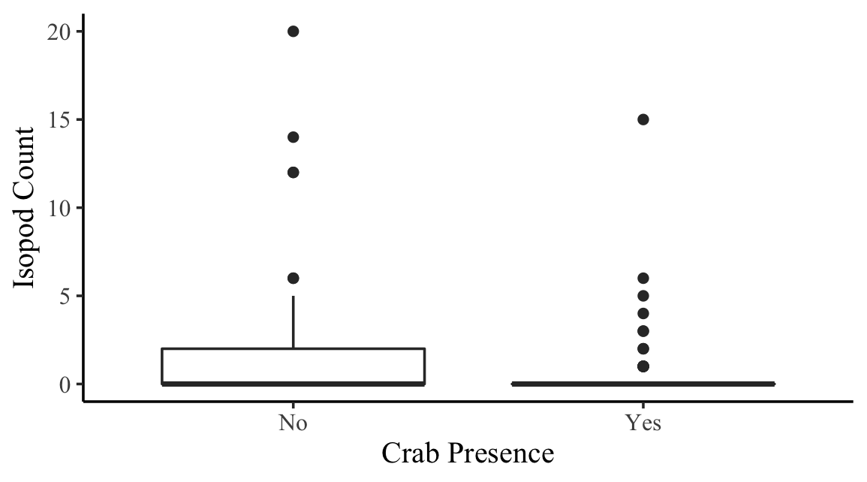
Figure 4. The count of I. wosnesenskii present in areas with crabs and areas without crabs present.
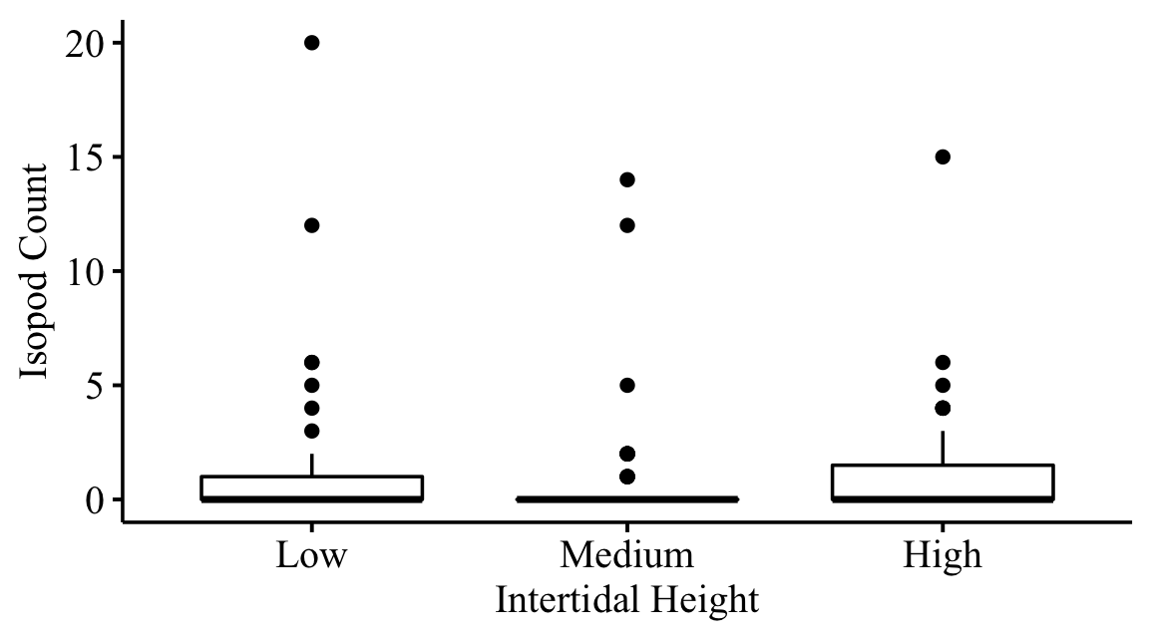

Figure 5. Idotea wosnesenskii count for each transect height. Low transects were located 5m away from the waterline.

LITERATURE CITED
Alexander, D. E. (1988). Kinematics of swimming in two species of idotea (Isopoda: Valvifera). Journal of Experimental Biology, 138(1), 37–49. https://doi.org/10.1242/jeb.138.1.37
Boström, C., & Mattila, J. (1999). The relative importance of food and shelter for seagrass-associated invertebrates: A latitudinal comparison of habitat choice by isopod grazers. Oecologia, 120(1), 162–170. https://doi.org/10.1007/s004420050845
Engkvist, R., Malm, T., & Tobiasson, S. (2000). Density dependent grazing effects of the isopod Idotea baltica Pallas on Fucus vesiculosus L in the Baltic Sea. Aquatic Ecology, 34(3), 253–260. https://doi.org/10.1023/a:1009919526259
Epifanio, C. E. (2013). Invasion biology of the Asian Shore crab hemigrapsus sanguineus: A Review. Journal of Experimental Marine Biology and Ecology, 441, 33–49. https://doi.org/10.1016/j.jembe.2013.01.010
Gonzalez, H., & Biddanda, B. (1990). Microbial transformation of metazoan (Idotea granulosa) faeces. Marine Biology, 106(2), 285–295. https://doi.org/10.1007/bf01314812
Gurjanova, E. F. (1968). The influence of water movements upon the species composition and distribution of the marine fauna and flora throughout the Arctic and North Pacific Intertidal zones. Sarsia, 34(1), 83–94. https://doi.org/10.1080/00364827.1968.10413373
Gutow, L. (2003). Local population persistence as a pre-condition for large-scale dispersal of Idotea Metallica (crustacea, Isopoda) on drifting habitat patches. Hydrobiologia, 503(1-3), 45–48. https://doi.org/10.1023/b:hydr.0000008482.33369.ec
Hultgren, K. M., & Mittelstaedt, H. (2015). Color change in a marine isopod is adaptive in reducing predation. Current Zoology, 61(4), 739–748. https://doi.org/10.1093/czoolo/61.4.739
Jaschinski, S., & Sommer, U. (2008). Functional diversity of Mesograzers in an eelgrass–epiphyte system. Marine Biology, 154(3), 475–482. https://doi.org/10.1007/s00227-008-0942-y
Jormalainen, V. (1995). Differential predation on sexes affects colour polymorphism of the isopod Idotea Baltica (pallas). Biological Journal of the Linnean Society, 55(1), 45–68. https://doi.org/10.1016/0024-4066(95)90028-4
Kotta, J., Paalme, T., Martin, G., & Mäkinen, A. (2000). Major changes in macroalgae community composition affectthe food and Habitat Preference Ofidotea Baltica. International Review of Hydrobiology, 85(5-6), 697–705. https://doi.org/10.1002/1522-2632(200011)85:5/6<697::aid-iroh697>3.0.co;2-0
Lee, W. L., & Gilchrist, B. M. (1972). Pigmentation, color change and the ecology of the marine isopod Idotea Resecata (Stimpson). Journal of Experimental Marine Biology and Ecology, 10(1), 1–27. https://doi.org/10.1016/0022-0981(72)90089-5
Leifsson, B. R. (1998). Life cycles, breeding periods and vertical distribution of idotea granulosa (crustacea, Isopoda) on Icelandic Shores. Sarsia, 83(1), 1–13. https://doi.org/10.1080/00364827.1998.10413664
Merilaita, S. (2001). Habitat heterogeneity, predation and gene flow: Colour polymorphism in the isopod, Idotea Baltica. Evolutionary Ecology, 15(2), 103–116. https://doi.org/10.1023/a:1013814623311
Naylor, E. (1955a). The diet and feeding mechanism of idotea. Journal of the Marine Biological Association of the United Kingdom, 34(2), 347–355. https://doi.org/10.1017/s0025315400027703
Naylor, E. (1955b). The ecological distribution of British species of Idotea (Isopoda). The Journal of Animal Ecology, 24(2), 255. https://doi.org/10.2307/1713
Orav-Kotta, H., & Kotta, J. (2004). Food and habitat choice of the isopod Idotea Baltica in the northeastern Baltic Sea. Hydrobiologia, 514(1-3), 79–85. https://doi.org/10.1023/b:hydr.0000018208.72394.09
Panova, M., Nygren, A., Jonsson, P. R., & Leidenberger, S. (2016). A molecular phylogeny of the north-east Atlantic species of the genus with focus on the Baltic Sea. Zoologica Scripta, 46(2), 188–199. https://doi.org/10.1111/zsc.12200
Rafi, F., & Laubitz, D. R. (1990). The idoteidae (crustacea: Isopoda: Valvifera) of the shallow waters of the northeastern North Pacific Ocean. Canadian Journal of Zoology, 68(12), 2649–2687. https://doi.org/10.1139/z90-370
Ranta, E., & Salemaa, H. (1991). Phenotypic variability of the intertidal isopod idotea granulosa Rathke in the Irish Sea. Crustaceana, 61(2), 155–174. https://doi.org/10.1163/156854091x00650
Roth, O., Kurtz, J., & Reusch, T. B. (2010). A summer heat wave decreases the immunocompetence of the MESOGRAZER, Idotea Baltica. Marine Biology, 157(7), 1605–1611. https://doi.org/10.1007/s00227-010-1433-5
Rugiu, L., de Wit, P., Kostian, I., & Jormalainen, V. (2021). Climate change driven hyposalinity as a selective agent in the littoral mesoherbivore idotea balthica. Marine Environmental Research, 163, 105216. https://doi.org/10.1016/j.marenvres.2020.105216
Salemaa, H. (1979). Ecology of Idotea spp. (Isopoda) in the northern Baltic. Ophelia, 18(1), 133–150. https://doi.org/10.1080/00785326.1979.10425495
Salemaa, H. (1986). Breeding Biology and microhabitat utilization of the intertidal isopod idotea granulosa Rathke, in the Irish Sea. Estuarine, Coastal and Shelf Science, 22(3), 335–355. https://doi.org/10.1016/0272-7714(86)90047-8
Salemaa, H. (2009). Geographical variability in the colour polymorphism of Idotea Baltica (Isopoda) in the northern baltic. Hereditas, 88(2), 165–182. https://doi.org/10.1111/j.1601-5223.1978.tb01619.x
Salma, U., & Thomson, M. (2016). Gregarious aggregative behavior in the marine isopod Icirolana harfordi. Invertebrate Biology, 135(3), 225–234. https://doi.org/10.1111/ivb.12134
Salma, U., & Thomson, M. (2017). Social aggregation of the marine isopod Icirolana harfordii does not rely on the availability of light-reducing shelters. Physiological Entomology, 43(1), 60–68. https://doi.org/10.1111/phen.12229
Shuster, S. M. (1990). Courtship and female mate selection in a Marine Isopod Crustacean Paracerceis sculpta. Animal Behaviour, 40(2), 390–399. https://doi.org/10.1016/s0003-3472(05)80935-2
Shuster, S. M., & Wade, M. J. (1991). Female copying and sexual selection in a marine isopod crustacean, Paracerceis sculpta. Animal Behaviour, 41(6), 1071–1078. https://doi.org/10.1016/s0003-3472(05)80645-1
Starko, S., Smyth, C., & Kucera, H. (2016). Attachment strength of the herbivorous rockweed isopod, Idotea wosnesenskii (Isopoda, Crustaceae, Arthropoda), depends on properties of its seaweed host. Journal of Experimental Marine Biology and Ecology, 477, 1–6. https://doi.org/10.1016/j.jembe.2016.01.006
Thom, R., Miller, B., & Kennedy, M. (1995). Temporal patterns of grazers and vegetation in a temperate seagrass system. Aquatic Botany, 50(2), 201–205. https://doi.org/10.1016/0304-3770(95)00449-a
Wethey, D. S., & Woodin, S. A. (2008). Ecological hindcasting of biogeographic responses to climate change in the European Intertidal Zone. Challenges to Marine Ecosystems, 139–151. https://doi.org/10.1007/978-1-4020-8808-7_13
Wood, H. L., Sköld, H. N., & Eriksson, S. P. (2014). Health and population-dependent effects of ocean acidification on the marine isopod Idotea Balthica. Marine Biology, 161(10), 2423–2431. https://doi.org/10.1007/s00227-014-2518-3

