Temperature and salinity effects on the growth of Alaria marginata
Shawn Nigel Canonizado
FHL 470 Spring 2022: Research in Marine Biology
Keywords: Climate change, Ochrophyta, kelp, meristem growth, thermal tolerance

Abstract
With current projections of worsening climate conditions, it is important to determine how nearshore kelps (Order Laminariales) will be affected. It has been documented that increased ocean temperature leads to kelp deforestation, thus leading to rapid and widespread changes at the ecosystem level. This study aims to understand the effects of climate change on kelp growth. Specifically, it investigates how temperature and salinity affect meristem growth.
I used an experimental approach to analyze the impacts of temperature and salinity on Alaria marginata, a species of kelp, over a duration of 5 days. A. marginata thalli were acclimated to outdoor seawater tanks, then transported to 4 testing tanks, each with a unique combination of high salinity (33 ppt) & ambient salinity (32 ppt), and high temperature (15.8° C) & ambient temperature (13.4° C). Growth was measured via meristem growth and percentage change of the blade’s length. I hypothesized that increased salinity and increased temperature would result in less growth and that an interaction effect would occur between the two independent factors. Data were analyzed using a two-way ANOVA test. There was a significant effect of temperature on meristem growth and blade growth, but no significant effect of salinity on growth, though there was a significant interaction effect between salinity and temperature.
These results suggest that temperature is the key factor that results in kelp growth and practices that alter water temperatures should serve as the basis for kelp remediation. Other abiotic factors such as salinity are less of a focus as they do not significantly alter kelp growth.

Introduction
The northwest Pacific coast hosts a crucial group of algae in the phylum Ochrophyta known commonly as kelp (Order Laminariales). Kelps are important primary producers that have the ability to sequester carbon and introduce it into food webs. Eighty-two percent of annual kelp productivity is used in detrital production through blade erosion and mucilage, which settles within kelp beds and drifts to surrounding habitats (Krumhansl and Scheibling 2012). The detritus is an important food source for filter feeders and detritivores. Kelps also have a crucial secondary role as ecosystem engineers as they provide a three-dimensional habitat structure for many marine plants and animals, some of which are economically important (Teagle et al 2017). Kelp itself also harbors economic value- kelps produce alginate and this chemical compound can be extracted for use in biomedical and bioengineering products (Peteiro 2018). The pacific northwest hosts a variety of algae in the order Laminariales, including Alaria marginata.
A. marginata is a species of kelp that is found bordering the low intertidal and shallow subtidal where it grows in wave-exposed waters (Garza 2012). Also known as “wakame”, seaweeds in the family Alariaceae are used in a variety of Asian and western cuisines (Prabhasankar 2009). Alaria is a genus that is adapted to cold temperate waters, and current projections in climate change may shift its distribution in the northern hemisphere due to climate change scenarios (Sudo et al 2020).
Current projections in climate change predict a 2° C change in average global water temperatures (Jevrejeva et al 2016). Alaria distribution is limited by salinity, substrate, and wave action, but most importantly temperature (Kraan 2020). Alaria growth and recruitment are directly affected by temperature which is a direct impact of climate change. Effects of temperature include decreased recruitment of zoospores (Fredersdorf et al 2009) and a decrease in abundance (Starko et al 2019). By extension, the effects of climate change have the ability to affect kelp ecosystems and negatively affect economic output through direct means and indirect means. Kelp productivity and abundance have been decimated on the Pacific coast due to extreme marine heatwaves (Cavanaugh et al 2019). Additional studies have shown that kelp habitats are susceptible to climate change as kelp forests affected by heatwaves have lower genetic diversity and resilience (Wernberg et al 2018).
As we discover the long-term effects of climate change on kelp, it is also important to conduct further studies about the short-term effects of climate change on kelp. This study investigates how A. marginata growth is affected by increased temperature and salinity. The growth is measured by measuring the meristem growth, as well as the blade’s change in length. The meristematic region is located near the base of the blade (Krumhansl et al 2015) and was measured by punching holes along the length of the blade and measuring the change in distance between 2 holes. The blade length measurements will be used in conjunction with meristem growth to determine the effects of salinity. We will explore aspects of kelp growth when under the influence of climate change stressors: (1) Is there a relationship between growth and temperature? (2) Is there a relationship between salinity and growth? (3) How do salinity and temperature interact with each other? We predict that (1) kelp growth will decrease with the higher temperatures, (2) and decrease in high salinity, and (3) interaction effects between temperature and salinity will be present.
Methods
Thirty-two A. marginata thalli were collected from the Friday Harbor Laboratories docks (48.5452, -123.0120) and divided into four 56-gallon outdoor seawater tanks, each with their own combination of salinity and temperature treatments at either ambient conditions or high conditions. Salinity was adjusted by placing a container of rock salt (grains >1 cm in diameter) near the influx of the tank. Salt was replaced daily and measured via a hemocytometer. The temperature was maintained with the use of three 300-watt aquarium heaters placed near the influx of the tanks. Saltwater was introduced to each tank at a steady flow rate in order to maintain salinity and temperature. Observations of temperature and salinity were made daily in order to account for weather patterns during the experimental period.
In each tank, the thalli were fastened at the base of the stipe to a nylon line, and the line was fastened to the tank such that the blades pointed in the same direction of the water flow. Measurements included thallus length, blade length, and intercalary growth which was measured by punching two holes 5 cm and 10 cm above the stipe on the blade and measuring the distance between holes (Figure 1). Measurements were recorded daily over the course of 5 days.
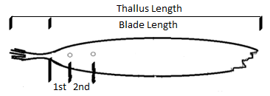
Figure 1 Diagram of an Alaria thallus showing which measurements will be taken, as well as the location of the two holes.
A two-way ANOVA was used to analyze the effect of salinity and temperature treatments on A. marginata meristem growth and blade growth and identify possible interaction effects. Post hoc analysis included Tukey’s test to determine which groups performed statistically differently. To standardize the measurements of the blade length growth, the analysis was conducted over the percent change of the blade from day 1 to day 5.

Results
The two independent variables in this study are temperature and salinity. High temperatures averaged 2.4 ° C (sd = 1.34) higher than ambient temperatures at 13.4° C. High salinity averaged 1.4ppt (sd = 0.54) above ambient salinity averaging at 32 ppt.
During the length of the experiment, in the ambient temperature and high salinity tank, all 8 of the thalli showed signs of vegetative cell death, with 2 of the thalli eroding away such that only the midrib remained. For this reason, findings for this group included their growth up until the 4th day which is when the blades started to die. Because of this, measurements for this group featured a large standard deviation (Figure 2 & Figure 3).
Meristem growth
The two-way ANOVA revealed that there was a statistically significant interaction between the effects of salinity and temperature in the meristem growth of the A. marginata thalli (f(1) = 3.768, p = 0.062). Simple main effects analysis showed that temperature did have a significant effect on growth (f(1) = 9.171, p <0.005 ), but not salinity treatment (f(1) = 0.295, p = 0.591).
A Tukey’s post-hoc test revealed significant pairwise differences between the high temperature- high salinity treatment and ambient temperature-ambient salinity treatment (p < 0.078), and high temperature-high salinity and ambient temperature – ambient salinity treatment (p < 0.008) (Figure 2 & Table 1).

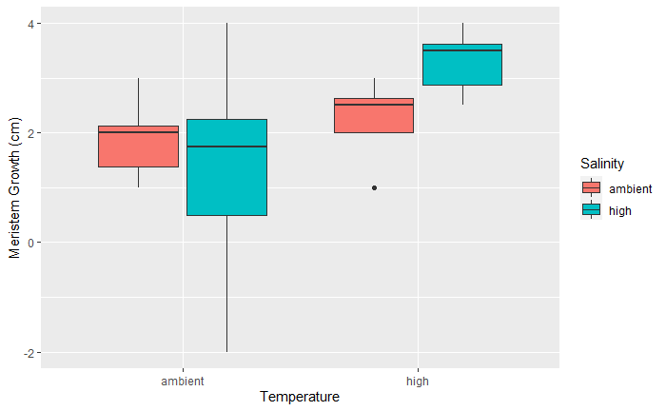
Figure 2 A bar plot showing the quartile ranges of the meristem growth data. Starting from left-right, the average meristem growth per day (SD) was 1.88 (0.69), 2.31 (0.65), 1.31 (1.98), and 3.31 (0.59).
Table 1 A table of Tukey multiple comparisons of means with adjusted p values for the meristem growth data.
Group 1 (Temperature : Salinity) | Group 2 (Temperature : Salinity) | p value
High : Ambient | Ambient : Ambient | 0.867
Ambient : High | Ambient : Ambient | 0.757
High : High | Ambient : Ambient | 0.078
Ambient : High | High : Ambient | 0.315
High : High | High : Ambient | 0.315
High : High | Ambient : High | 0.008

Blade Growth
There was a statistically significant interaction between the effects of salinity and temperature for blade growth (f(1) = 14.675, p < 0.001). Simple main effects analysis showed that temperature did have a significant effect on growth (f(1) = 20.247, p < 0.000), but salinity did not (f(1) = 0.031, p < 0.861).
A Tukey’s post-hoc test revealed significantly significant pairings between all groups except the high temperature- ambient salinity and ambient temperature – ambient salinity group (Figure 3 & Table 2).
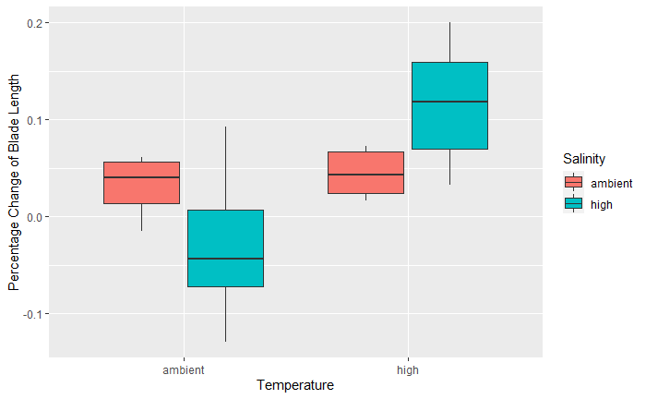
Figure 3 A bar plot showing quartile ranges of the blade length data. From left to right, average blade length percent change (SD) was 0.032 (0.028), 0.044 (0.024), -0.032 (0.071), and 0.115 (0.060).
Table 2 A table of Tukey multiple comparisons of means with adjusted p values for blade length data
Group 1 (Temperature : Salinity) | Group 2 (Temperature : Salinity) | p value
High : Ambient | Ambient : Ambient | 0.964
Ambient : High | Ambient : Ambient | 0.069
High : High | Ambient : Ambient | 0.013
Ambient : High | High : Ambient | 0.024
High : High | High : Ambient | 0.040
High : High | Ambient : High | < 0.000

Discussion
A. marginata responded to increased temperature with a significant increase in growth. A conclusion that can be drawn from this is that increased thermal stress is not harmful if within the thermal tolerance of the algae. With our treatment groups, a 2° C increase from 12°C falls within the thermal tolerance of A. marginata, but the fact that growth showed a statistically significant increase suggests how even small increments of temperature can affect kelp growth. In kelp aquaculture, this could mean slightly elevated water temperatures would be the most optimal for maximum yield. For kelp forests, this would mean increased kelp growth and larger kelp forests, but only if the kelp is not outcompeted by other marine algae.
We found no significant effect of salinity on the growth of A. marginata, suggesting that salinity does not play a large factor in growth. However, looking at the average salinity of the ocean at 35 ppt, we see that a 2 ppt difference in salinity falls within the average fluctuations of ocean salinity from 32 to 37 ppt. Low variability in salinity is not enough to affect the growth of kelp as it falls within the osmolarity capabilities of kelp. The interaction effect between salinity and temperature suggests that salinity only has an effect on growth if the temperature is also altered in some way.
For a more robust conclusion on how temperature and salinity affect Alaria growth, a longer study duration is suggested. 5 days is a short duration for a time series experiment and can thus only reveal a short-term response. More information can be gathered from a long-term study which would be useful when assessing kelp forest health and kelp forest recovery from anthropogenic factors. However, based on this study, a focus should be placed on temperature control as other abiotic factors such as salinity do not significantly alter kelp growth.
Observing how kelp grows when under the effects of altered water conditions is important due to the role of kelp in the environment. Kelp sequesters carbon and provides food and habitats for other species, but anthropogenic factors that increase temperature have resulted in kelp deforestation. A reduction in kelp diminishes the sequestering of carbon dioxide from the atmosphere, as well as limits the size of the kelp ecosystem and marine food webs since kelp provides habitat and food for many other organisms. Protecting kelp should become a top priority as kelp has value in multiple sectors. With evidence found in the literature, understanding how temperature and salinity affect kelp might help future ecologists assess the damage and employ strategies that either limit kelp loss, or expedite kelp growth. My work suggests continuous research is needed to monitor the effects of temperature and salinity of other kelp species such that we can continue to enjoy the services that kelp provides.
Literature cited
Cavanaugh, K. C., Reed, D. C., Bell, T. W., Castorani, M. C., & Beas-Luna, R. (2019). Spatial variability in the resistance and resilience of giant kelp in southern and Baja California to a multiyear heatwave. Frontiers in Marine Science, 6, 413.
Fredersdorf, J., Müller, R., Becker, S., Wiencke, C., & Bischof, K. (2009). Interactive effects of radiation, temperature and salinity on different life history stages of the Arctic kelp Alaria esculenta (Phaeophyceae). Oecologia, 160(3), 483-492.
Garza, D. 2012. “Common Edible Seaweeds in the Gulf of Alaska” Alaska Sea Grant Program, Alaska. P. 8-10
Jevrejeva, S., Jackson, L. P., Riva, R. E., Grinsted, A., & Moore, J. C. (2016). Coastal sea level rise with warming above 2 C. Proceedings of the National Academy of Sciences, 113(47), 13342-13347.
Kraan, S. (2020). Concise review of the genus Alaria Greville, 1830. Journal of Applied Phycology, 32(6), 3543-3560.
Krumhansl, K. A., Demes, K. W., Carrington, E., & Harley, C. D. (2015). Divergent growth strategies between red algae and kelps influence biomechanical properties. American journal of botany, 102(11), 1938-1944.
Krumhansl, Kira & Scheibling, Robert. (2012). Production and fate of kelp detritus. Marine Ecology Progress Series. 467. 281-302. 10.3354/meps09940.
Peteiro, C. (2018). Alginate production from marine macroalgae, with emphasis on kelp farming. In Alginates and their biomedical applications (pp. 27-66). Springer, Singapore.
Prabhasankar, P., et al. "Edible Japanese seaweed, wakame (Undaria pinnatifida) as an ingredient in pasta: Chemical, functional and structural evaluation." Food Chemistry 115.2 (2009): 501-508.
Starko, S., Bailey, L. A., Creviston, E., James, K. A., Warren, A., Brophy, M. K., ... & Neufeld, C. J. (2019). Environmental heterogeneity mediates scale-dependent declines in kelp diversity on intertidal rocky shores. PLoS One, 14(3), e0213191.
Sudo, K., Watanabe, K., Yotsukura, N., & Nakaoka, M. (2020). Predictions of kelp distribution shifts along the northern coast of Japan. Ecological Research, 35(1), 47-60.
Teagle, H., Hawkins, S. J., Moore, P. J., & Smale, D. A. (2017). The role of kelp species as biogenic habitat formers in coastal marine ecosystems. Journal of Experimental Marine Biology and Ecology, 492, 81-98.
Wernberg, T., Coleman, M. A., Bennett, S., Thomsen, M. S., Tuya, F., & Kelaher, B. P. (2018). Genetic diversity and kelp forest vulnerability to climatic stress. Scientific Reports, 8(1), 1-8.

