In-Situ Towed Sampling Device for Integrated Calibration and Monitoring of Surface Water Microplastics

Caitlin Guerin
Miles Logsdon, Science Advisor
Ocean Technology Center, University of Washington
caitig@uw.edu
27 May, 2018

Abstract
Current advancements in the emerging technology of embed sensors for ocean research now offers opportunities to apply low-cost solutions for real-time investigation of the spatial distribution of microplastics and particles. Microplastics absorb and transfer chemicals that cause organisms to be intoxicated or starved. This project is focused on the design and development of a prototype sensor for in-situ measurements of microplastic concentrations. This device makes use of data from optical interruptions of particles in a flow through water stream onboard a towed platform relayed to a ship board computer via USB. The prototype device consists of 5 components (1) architecture of the water sample flow-through system; (2) the selection of photo interrupter sensors for particle detection; (3) inclusion of a filter net and codend collection for calibration; (4) the layout of these components on a towed platform; and (5) the power and data communication requirements. Results show the spatial variability of microplastic and particle concentrations. An overall rough positive correlation between particle and microplastic concentrations is observed at Shilshole Bay Marina. Tests confirm the stability and ability of the device to take particle and microplastic measurements.

Introduction
Microplastics are a global growing concern and there exist only a few methods which provide information on their density and distribution in our world’s oceans. The world’s production and improper disposal of plastics has led to accumulations in the ocean where they breakdown into microplastics (defined as plastics between 1-5mm by a recent review of microplastics in sediment) and occupy even the most extreme and remote parts of the marine environment (Van Cauwenberghe et.al. 2015). Microplastics are detrimental to the health of marine ecosystems which in turn affects the worlds fishing and shellfish industry and alters the natural balance of all marine species within their environment.
Microplastics absorb persistent organic pollutants (POP’s) and can transfer these harmful chemicals to other areas of the ocean, they can enter organisms of similar size by endocytosis and cause them to be poisoned by the chemicals, or cause them to starve from lack of nutrition (Andrady et.al. 2011). Impacts felt by the lower trophic levels will work their way up to higher trophic levels, including humans (Wright et.al. 2017). Microplastics can also be ingested by filter feeders and fish, and can cause inflammation, developmental affects, and lethargy which can lead to less feeding (Van Cauwenberghe 2015). As these health issues in marine organisms increase, the fishing and shellfish industry will lose large amounts of money and the ability to provide food to the public. According to reports from NOAA and the Washington Sea Grant (WSG), between the Washington Shellfish Industry and the fishing industry in the U.S. alone, there are 1,603,200 jobs at stake and $208.27 billion lost due to the potential effects of microplastics.
There currently exist only a few methods for obtaining reliable and trusted quantitative measurements of microplastic concentrations. Most of these methods require unique training and specialized equipment in arriving at an estimate of microplastics from a spatial sample. One method includes measuring microplastic concentrations in waste water, where much of the organic material is present. To get rid of organic material, first H2O2 is added. Then focal plane array based reflectance micro-Fourier-transform imaging (FPA-FT-IR) is used which is able to identify the many types of microplastics such as polyethylene and polypropylene. This method has a successful identification rate of 98.33%, however this process takes about 9 hours for a 47mm diameter sample (Tagg et.al. 2015). Shimizu et. al. 2017 analyzed the amount of oxygen carried by an individual particle and analyzes spikes in data relative to the amount of oxygen and size. It also provides information on the particle-electrode reaction. This is possible, because on the outside, the particles have a negative charge. This method is also able to single out spherical plastics. This experiment however took place in the lab and took 15 minutes to obtain results for one sample, which still required sorting (Shimizu et.al. 2017). Dumichen et.al 2017’s method involves using thermal degradation. The specific degradation product of the microplastic (polymer) is absorbed on a solid-phase absorber and then analyzed by thermal desorption gas chromatography mass spectrometry. The chromatography works by identifying nonpolar species, like microplastics, versus polar species like environmental particles. This method is successful in distinguishing between microplastics and naturally occurring particles. This method measures microplastic concentrations at 100mg per 2-3 hours in the field (Dumichen et.al. 2017).
A review of all methods in measuring microplastics can demonstrate that as of 2011, infrared (IR) spectroscopy is the most reliable method. Collection by net and counting by hand is discussed as time consuming and unreliable, however it is still widely used today because it is cheap (Hidalgo-Ruz et.al. 2012). IR analysis remains the most reliable, however it is still expensive and time consuming. Sampling methods are very different in sediment in which the mixture of microplastics and sediment are placed in a solution of typically NaCl and microplastics are separated out by floating or sinking based on densities (Van Cauwenberghe et.al. 2015). From previously conducted studies, there has yet to be a method that gives cheap, real time data while in the field.
With advances in small imbedded microelectronics supporting the development of low-cost sensors, today’s field of ocean technology is experiencing the development of sensors which can provide reliable, real-time data of a variety of variables in the marine environment. Making use of a suite of these new sensor technologies, a prototype in-situ towed sampling device for integrated calibration and monitoring of surface water microplastics was designed to estimate the concentration and spatial distribution of microplastics in comparison to particles. The prototype provides a comparison of three different particle enumeration sensors with a raw count of microplastics collected by a more traditional net tow. The device addresses 1) concentration, by correlating digital sensors counting of particles per volume of water with a manual enumeration of microplastics when observed through a microscope. 2) Comparison of intersecting optical sensors to other sensors and the traditional net tow method. 3) Spatial variation in particle and microplastic concentrations, by utilizing a sampling approach of geo-registered transects.
Methods
- Design Phase
This project addresses the design challenge for an in-situ sampling device which can simultaneously provide direct enumeration of microplastics while estimating particle density over a spatial transect of coastal and inland waters. The design process used three different phases before arriving at a final prototype.
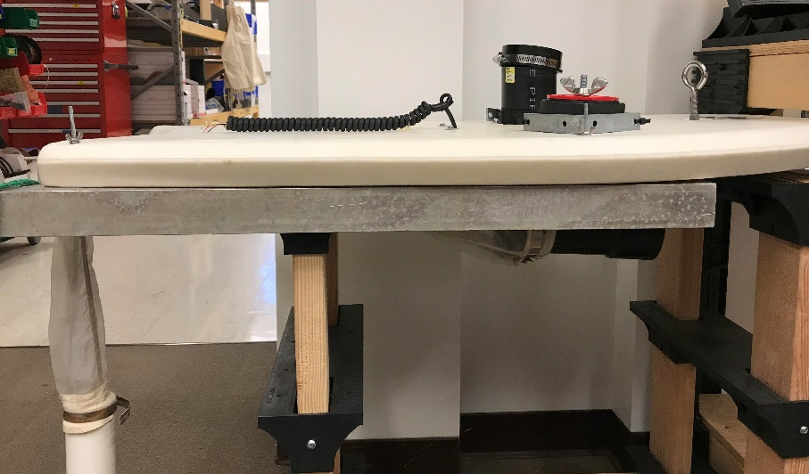
- Phase 1
Figure 1: Side view of Prototype 1 including net codend, and housing for photo interrupters.
The first phase described the scope and application constraints for the device and the selection of components. The main components of the prototype from phase one were: (1) architecture of the water sample flow-through system; (2) the selection of photo interrupter sensors for particle detection; (3) inclusion of a filter net and codend collection for calibration; (4) the layout of these components on a towed platform (figure 1); and (5) the power and data communication requirements. The early decision to focus on the use of photo interrupters was guided by our investigation into the use of multiple beam angles to interpret particle shape and size (appendix 1). The platform selection and layout in the early stages of the design and build process evolved as requirements for platform stability and waterproofing of electronics became paramount. We decided to utilize a tethered power and data communication solution for the towed device and placed a low-power Arduino-UNO microcontroller on the platform within close proximity to the photo interrupters, all housed in a surface mounted waterproof container. The data stream is therefore delivered via a 12 foot USB cable for visualization and storage on an onboard computer. Phase one concluded with a saltwater tank test where the functionality and stability of each design component was tested at a variety of towing speeds. The results of the phase one test indicated that the towing platform was acceptable for slow speed deployment yet towing speeds did affect the reliability of the photo interrupters for consistent detection and some leakage occurred upon submergence of the device (figure 2). As expected the device would require attention to waterproofing and cable strain solution in later phases.
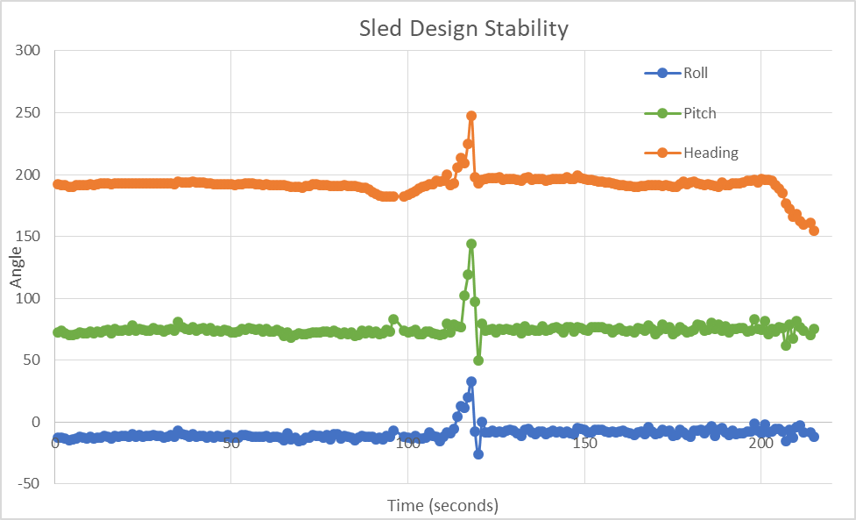
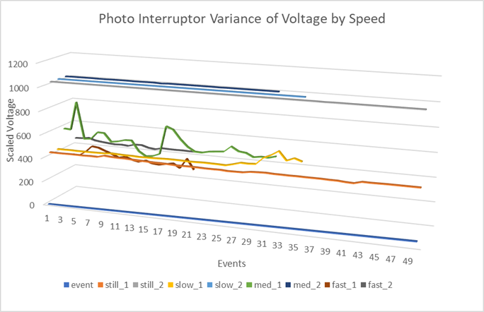
- Phase Two
Figure 3: Reliability of intersecting photo interrupters in sea water with events in half second intervals on the x-axis and scaled voltage of the photo interrupters on the y-axis.
Figure 2: Stability of the design with time in seconds on the x-axis and the angle of roll, pitch, and heave on the y-axis and each tow as an “event”.
The effect of the towing platform’s motion on the photo interrupter sensors was the main objective of Phase Two. A field experiment was conducted using a 9-axis degree of freedom accelerometer to serve as an internal motion unit (IMU) recording roll, pitch and heave of the device in field conditions (figure 3) . Results confirmed that the design was stable up to a 2kts speed and the platform remained level with all water flow-through inlets below water level.
- Phase Three
The final design phase before field trails focused on a redesign of the water sampling flow-through system to include a digital peristaltic pump and flow meter. At this point a simple turbidity sensor was added to the sensor suite. The turbidity sensor (sensor Turb) along with a pair of angled photo interrupters (sensors A (top) and B (bottom)) and a lone photo interrupter (sensor C) will all be counting particles at the same time on the device. More optical sensors were added to increase the accuracy in particle measurements and to compare the various methods of obtaining a particle concentration.
- Field Testing and Analysis
- Field Test
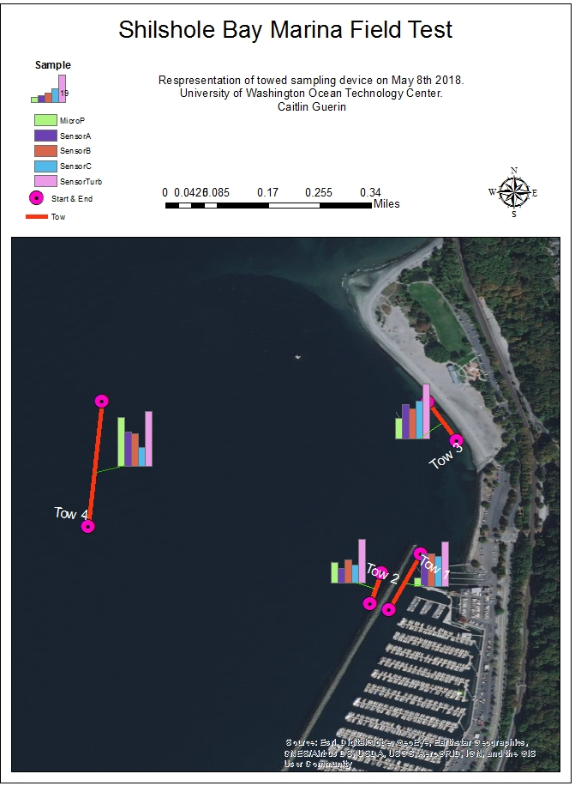
The final field test was conducted at Shilshole Marina and the surrounding water on May 8th 2018. The device was towed along four transects around the marina, referenced as tows 1-4. During each transect, the data from each sensor was directly recorded by “CoolTerm” and the net and 330micrometer codend were simultaneously collecting microplastics. At the end of each transect, the data was saved to a file and the microplastic sample was rinsed into a bottle for sampling. The deployment consisted of two individuals lifting the device into the water, one handling the cable and the device and the other handling the codend and the device. Once in the water, the device is towed for about 30 seconds to work out air bubbles before recording begins. Each transect lasted between 1 and 2 minutes, and the recording was then stopped. Once each transect was finished, the device was recovered the same way it was placed in, by two individuals. The microplastic samples were rinsed from the codend into a jar for sampling and the net and codend were then rinsed at the next transect before towing began. The codend was reattached to the net and the device was ready for the next transect. Data of the counts from the four sensors and the counts of microplastic from the four transects are geographically displayed by a map produced in ArcGIS (figure 4).
- Sensor Analysis
To process the sensor data, we retrieved saved files from “Cool Term” that documented each sensor’s voltage reading every 0.5 seconds and converted the data to an .XLSX format. Calculations were performed in Excel. To decide what an interruption is, the average voltage reading of each sensor was calculated. The corresponding average of each sensor was then subtracted from each reading. The standard deviation was then calculated per sensor. If the value after subtraction of the average was outside of the standard deviation in the negative direction, then that reading is considered an interruption. The excel equation for “Stdev.s” was used to calculate standard deviation.
Figure 4: Coordinates from start and end points were plotted with a transect line connecting the points. A bar graph of the raw counts of particles and microplastics are placed next to each transect to show the variation in counts between geographical locations.
- Microplastic Analysis
To process the microplastics, samples were filtered through a 330 micrometer sieve. Each sample (100mL each) was then added to a beaker with 20mL hydrogen peroxide, to fix any biology in the sample. The samples were heated to a boil, cooled, and then heated at a boil for 30 minutes. About 30 grams of salt was added to each sample to increase the density and heated to help dissolve the salt. The samples were then placed in a suspended funnel with attached tubing to allow the particles to separate by density, because microplastics float. The bottom of the sample was drained as to only analyze the floating microplastics. The sample was then sieved again and placed under a dissecting scope. Samples were analyzed at 3x objective magnification, and a count of microplastics per sample was produced. Protocol was followed from The MERI- Guide to Microplastic Identification.
- Calculations
To determine the concentration of the particles by sensors A, B, and C through the pump system, a calibration of the pump was conducted to yield a flow rate of 0.00045L/s. This flow rate was then multiplied by the amount of time in seconds each transect took. Finally the particle counts were divided by this value to give a concentration in particles/L.
To determine the concentration of particles by sensor Turb, the height and length of the sensor flow-through area were multiplied by the distance of the transect to give a volume of m^3 which were then converted to L. Finally the particle counts were divided by this value to give a concentration in particles/L.
To determine the concentration of microplastics, the volume of a cylinder was calculated with the height of the cylinder being the distance of the transect and the radius being the radius of the tube that water flowed through. This gives a volume in m^3 which is then converted to L. Finally the particle counts were divided by this value to give a concentration in microplastics/L.
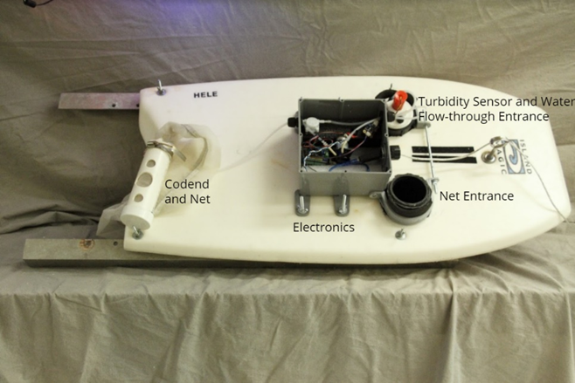
Results
- Final Design Results
The final prototype design has multiple abilities. It can successfully give a real time count and concentration of particles that can be correlated to microplastics. It will be deployable by two people from any size vessel as it is light weight and easy to use (appendix 10). It includes code used for all aspects of the design (data measurement by 4 sensors, pump system, and flowmeter) and testing (appendix 24). Includes a materials cost list (appendix 25) and schematics and layout of embedded electronics (appendix 3-5). The final design, mounted on a platform, includes: a codend and net, electronics within housing, an entrance system for the net, an entrance system for the turbidity sensor suspended in water with flow-through entrance for sensors A-C, and a 12 foot long USB cable for power and data relay (figure 5, layout of final prototype; appendix 2, side view of prototype).
Figure 5: Birds-eye view of prototype with labeled components.
- Field Results
From the results of each tow, three major analyses can be made. 1) Comparisons between the concentration of particles measured by sensors and the concentration of microplastics measured by a traditional net tow. 2) Agreement of counting a particle at the same time between sensors A and B and their comparison to microplastic counts. 3) The spatial distribution of counts of particles and microplastics by transect. The flowmeter did not receive a steady stream of water, and did not give any readings, however a calibration was conducted by the pump by timing the pump system to fill a graduated cylinder to 10mL. A flow rate of 0.00045L/s was calculated.
1) The concentrations of particles between sensors A-C were fairly similar, while concentrations of microplastics by net tow and concentrations of particles by the turbidity sensor were all vastly different (see figures 6-8 for tables and see appendix 12-23 for graphical representation of interruptions per tow). Sensors A and B gave the most similar concentrations of particles in comparison of the concentration of microplastic calculated from a traditional net tow. Sensor C was closest in comparison to sensors A and B. Sensor Turb measured particle concentrations in counts/L in the millions while Sensors A-C were in the hundreds, and microplastic concentrations in the thousands. In tow 1, sensors A and B correlated the closest to the microplastic concentration. In tow 2, sensor B correlated the closest to the microplastic concentration. In tow 3, sensor C correlated the closest to the microplastic concentration. In tow 4, sensor A correlated the closest to the microplastic concentration. In tow 1, sensors A and B have the closest concentration to microplastic concentration than any other sensor from any other tow. The turbidity sensor has the lowest correlation in all tows to microplastic concentration. There is a negative correlation between sensor A and microplastics, meaning that as particles increase, microplastics decrease. There is a positive correlation between sensor B and microplastics, except in tow 4. There is a positive correlation between sensor C and microplastics except in tow 2. There is a positive correlation between sensor Turb and microplastics except in tow 1 and 2.
Figure 7: This table shows the concentration of microplastics in pieces/L for each transect.
Figure 6: This table shows the concentration measured by each sensor along each transect in particles/L.
2) The comparison of agreement between sensors A and B is highest at tow 2, and lowest at tow 3 (see figure 8). The count generated by sensors A and B were the lowest concentrations among all other sensor types. The count does not correlate as well to the microplastic count as sensors A-C without intersection. There is a positive correlation between sensor A and B agreement percentage and microplastic concentration.
Figure 8: This table shows the agreement of sensors A and B. It was determined by a count of when the two sensors agreed on an interruption at the same half-second. This value was then divided in to the total interruptions by the sensor with the least interruptions to give a percent on agreement. This yields results that show what percent of the time sensors A and B were counting a particle at the same time as well as a concentration in corresponding particles/L.
3) There is variation in all sensors and all microplastic concentrations with geographical location (see figure 4). Microplastic concentrations outside of the marina and in front of the beach have the highest concentrations. Turbidity concentration is highest geographically outside of the marina (tow 2). Particles measured by sensors A-C is highest by sensor B outside of the marina (tow 2). There is no correlation between distance from shore and microplastic and particle concentration. Most particle and microplastic concentrations are highest outside of the marina (tow 2).
Discussion
- Final Design
From the initial development of a prototype of a cheap, in-situ microplastic counter, we adjusted the initial design based on leakage of the device from field tests, to compare more than one type of particle sensor, and to control an influx of water. We finished the final prototype with the hope that there can be data looking at a correlation between particles in the water to microplastics. This prototype can make novel, in-situ measurements by spatial distribution, while remaining stable during tows, easily deployable from a small craft by two people, utilizing simple code, and costing about $100 to produce (appendix 25).
- Field Data
There are current studies that show comparisons of sediment concentrations to the energy of the beach they are located, such as high energy beaches, and low energy mudflats. A recent study conducted by Hoi-Shing (2018) at these two locations show that low wave energy locations receive much more microplastic pollution because the waves are unable to move the microplastic away from the location. Microplastic accumulation at these sites are detrimental to the health of the organisms that live here (Van Cauwenberghe 2015).
Based on this study, we can see how the results in areas in Puget Sound compare by 1) particle to microplastic concentrations 2) count agreement between sensors A and B and microplastics and 3) spatial distribution of particles and microplastics. Although we did not take sediment samples from the top of the seafloor, we should still expect to see greater microplastic accumulation where sediment or particle concentration is greater based on aggregation properties of microplastics and sediments discussed in this paper.
1) In the comparison of the concentration recorded by sensors A-C and sensor Turb to the concentration of microplastics calculated from a traditional net tow, it can be concluded that there is a rough overall positive correlation between microplastics and particles measured by these particular sensors. Tow 2 did produce the highest concentrations of particles and microplastics. There is an overall positive correlation between particles and microplastics if measurements by sensor A are ignored. For the purposes of sensor comparisons, sensor Turb is not useful for the purpose of microplastic correlation, due to a vast difference in the concentration measurements. This particular sensor is a more sensitive device than sensors A-C (photo interrupters) because it is meant to measure turbidity by giving a deviation from a base reading which is influenced by the light it receives. The cheaper photo interrupters are meant to give an “interruption” of light when they encounter objects. Although they are similar in optical design, their functions differ and therefore give different readings. Photo interrupters differ by only 1 order of magnitude from the microplastic concentrations, and are better sensors for comparing particles to microplastics. We do not know what caused the interruptions made by the photo interrupters. Potential answers could be biology, sediment, microplastics, bubbles, or any object in the water that deflects light.
2) The idea of intersecting photo interrupter sensors to get a more accurate comparison to microplastics is not supported by this data (figure 8). The photo interrupters picking up on a count of particles at the same time may have just been coincidence, a large irregular shaped particle, multiple particles occupying the same space at the same time, a spherical particle (which is what we were initially looking for from this design), or many other objects deflecting light. We did not collect the water directly behind the sensors, although the water collection by net directly next to the sensors was intended to give us an idea of what the sensors were counting. Since all biology was disposed of before counting for microplastics from the net, no other particle types were analyzed. Overall, we cannot support that the intersection of photo interrupters give an accurate concentration of microplastics or spherical particles.
3) Although there is no spatial correlation between the distance of tows from shore and particle or microplastic concentrations, there are only 4 transects being compared which makes it difficult to establish a trend. Tow 2, outside of the marina, has the highest number of particle concentrations by sensor B and Turb, and the highest concentration of microplastics. This is the only transect that received high concentrations by the three different measurement methods (turbidity, photo interrupters, and microplastics). Tow 3, outside of the beach, has the next highest counts by all three measurement methods. Tow 1, inside of the marina, had the lowest concentrations by all three measurement methods, which is interesting because of how close in proximity it is to tow 2, yet we see much different concentrations. Overall, no spatial pattern can be established between the transects, although within such a small geographical location, there is a notable difference in all measurements of particle and microplastic concentrations. Some explanations of the distributions of particles and microplastics could be from the barriers between locations and the mixing by tides that occurs twice a day in Puget Sound. Others could be from boat traffic, fishing, and urban development along the shore. These are some suggestions, although no one answer can be confirmed by these results.
The results obtained from the final field test in Shilshole Bay Marina agree with previous predictions from the Hoi-Shing paper. There is a rough positive correlation between wave energy (amount of particles) and microplastic concentration.
III. Microplastic Characteristics
Most microplastics found were fibers. Fibers are especially hard to count and have an accurate measure on due to the way they are oriented. Fibers can fall through sieves and not appear under the microscope if they are oriented vertically. Fibers can also be shed from clothing during field and lab sampling and contribute to the sample. For this reason, it is difficult to get an accurate reading of microplastic data, especially fibers. The majority of the fibers found in this analysis were clear (appendix 7) or blue in color (appendix 6). The color of the fibers did not match the color of clothing worn by individuals sampling or analyzing, so a contribution of fibers from worn clothing can be discredited in this case. Although there is no direct known source of these colored fibers, conclusions can be suggested that the blue fibers came from sail covers in the marina and clear wires came from broken down fishing line as these items were commonly observed in and near the water at the marina (appendix 11). Fibers tend to aggregate together and aggregate to biological matter as shown in appendix 6. This causes concern for harm to marine organisms, especially when ingested and tangled around vital organs (Van Cauwenberghe 2015). It is also hard to make a direct comparison between microplastics found, mostly fibers in this analysis, and particles measured by sensors because the orientation of fibers would not allow the sensors to be interrupted and make a count.
Conclusion
Overall, the design results reveal that a stable, in situ, cheap, functioning particle and microplastic counting device was produced through three design phases with testing in tanks and in the field. The combination of a traditional net tow with optical sensor measurements provides an increased confirmation in the sensor samples based off of some correlations between concentrations in the data. This device shows promise to eventually correlate particles to microplastics spatially by optical sensors. Adjustments will need to be made in sensor design to be more appropriate for analyzing particles similar in characteristics to microplastics. A successful novel design idea produced real time measurements for data collection that has since been able to be measured in real time.
The field results demonstrate that 1) the turbidity sensor is more sensitive than the photo interrupters and that there is a rough overall positive correlation between particles and microplastics in Shilshole Bay Marina. 2) Intersecting photo interrupters producing a more comparable count of particles to microplastics is not supported by this data, as the isolated photo interrupter (sensor C) gave a more accurate count. 3) Although there is no overall spatial pattern of particle and microplastic concentration, there is a variance in concentrations within a small geographical location.
It must be taken into account that there is room for error in all measurements. The sample size and amount of transects were small and makes it more difficult to see real correlations between data versus a coincidence. There were also too many variables in the field that may have contributed to correlations and affect the results. Things such as only testing on one day, the effects of the boat wake on the device, and many other environmental factors. There may have been errors in calculations and producing tables and graphical representations. Although none of these factors most likely drastically affected the results, they should still be taken into consideration when looking at the accuracy of the device.
In the future, many adjustments could be made to the design to receive more accurate results. A considerable addition to the device could be a camera fixed on the underside of the device to receive a live stream and recording of particles entering the device. The recording could later be analyzed for particle differentiation. Another considerable design idea could have focused on the static properties of plastics to come up with an in-situ sampling device using electric current to identify pieces of different materials. The ability to use statics on microplastics in an in-situ sensor is currently unavailable, although much of this technology is still evolving.

References
Andrady, A. L. 2011. Microplastics in the Marine Environment. Marine Pollution Bulletin 62.1596-1605 (2011). Web. 29 May 2014. DOI: 10.1016/j,marpolbul.2011.05.030
Fisheries, N. (2017, May 09). NOAA Fisheries Releases Fisheries Economics of the U.S. and Status of Stocks Reports. November 21, 2017, http://www.nmfs.noaa.gov/stories/2017/04/05_feus_sos_reports.html
Hidalgo-Ruz, V., Gutow, L., Thompson, R., & Thiel, M. (n.d.). Microplastics in the marine environment: A review of the methods used for identification and quantification. Environmental Science & Technology, 46(6), 3060-3075.
Hoi-Shing Lo, Xiaoyu Xu, Chun-Yuen Wong, Siu-Gin Cheung (2018).
Comparisons of microplastic pollution between mudflats and sandy beaches in Hong Kong. Environmental Pollution, 236, 208-217 https://doi.org/10.1016/j.envpol.2018.01.031.
Tagg, A., Sapp, A., Harrison, M., & Ojeda, J. (n.d.). Identification and Quantification of Microplastics in Wastewater Using Focal Plane Array-Based Reflectance Micro-FT-IR Imaging. Analytical Chemistry., 87(12), 6032-6040.
Van Cauwenberghe, L., Devriese, L., Galgani, F., Robbens, J., & Janssen, C. (2015). Microplastics in sediments: A review of techniques, occurrence and effects. Marine Environmental Research, 111, 5-17.
Washington Sea Grant (2015) Shellfish aquaculture in Washington State. Final report to the Washington State Legislature, 84 p.
Wright, S., & Kelly, S. (n.d.). Plastic and Human Health: A Micro Issue? Environmental Science & Technology, 51(12), 6634-6647.
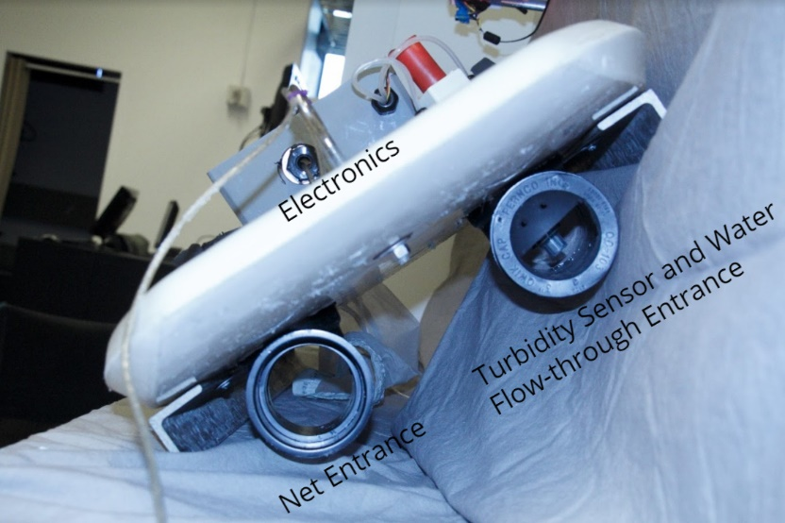
Appendix
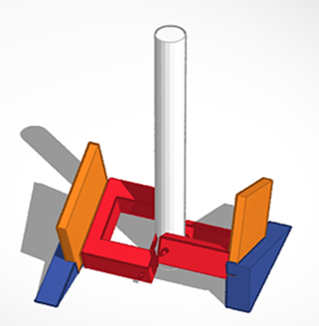
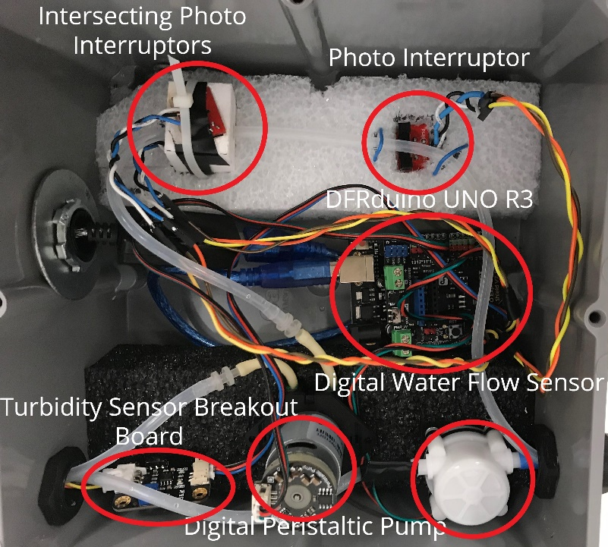
Appendix 3: Labeled diagram of the electronic sensor system inside housing. Turbidity sensor breakout board connects to the turbidity sensor housed underwater.
Appendix 2: Front view of final prototype with labeled compenents.
Appendix 1: A model of photo interrupters with breakout boards intersecting at angles of 22.5 degrees with wedge mounts and plastic tubing running through.

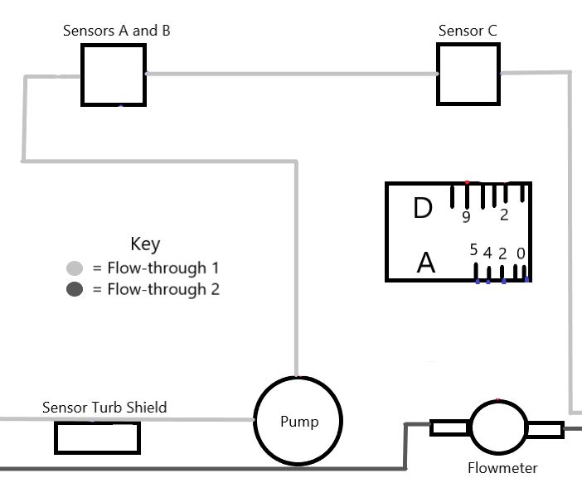
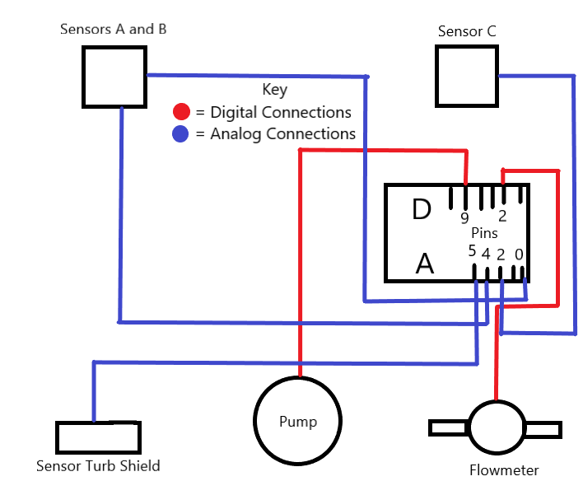
Appendix 5: Schematic of flow-through channels for final prototype.
Appendix 4: Schematic of electronic system analog and digital connections for final prototype.
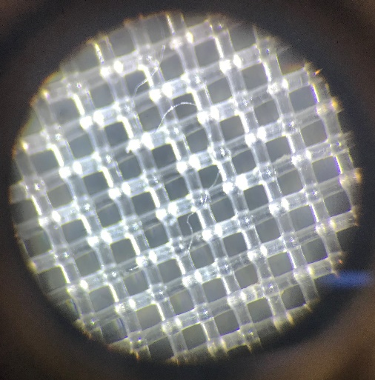
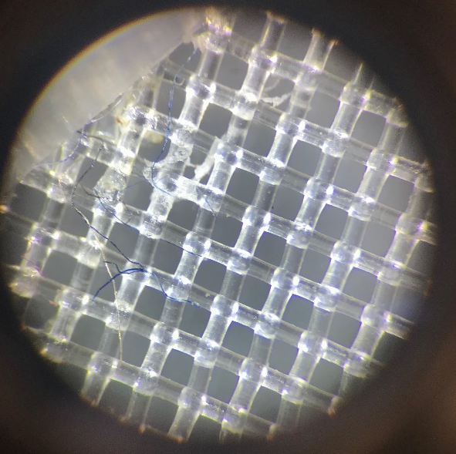

Appendix 7: Image of clear fiber on dissecting scope at 3x objective magnification.

Appendix 6: Image of blue fibers on dissecting scope at 3x objective magnification aggregating together.

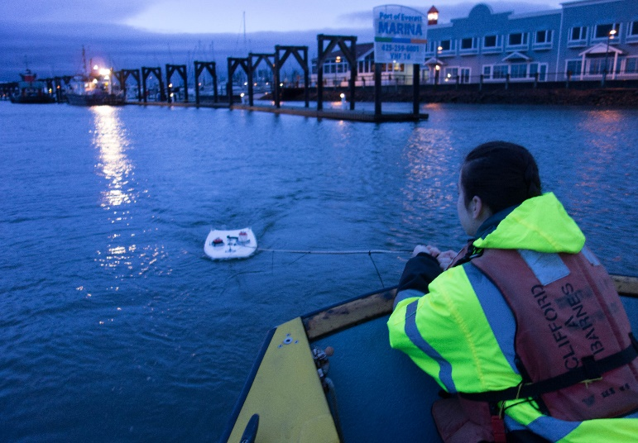
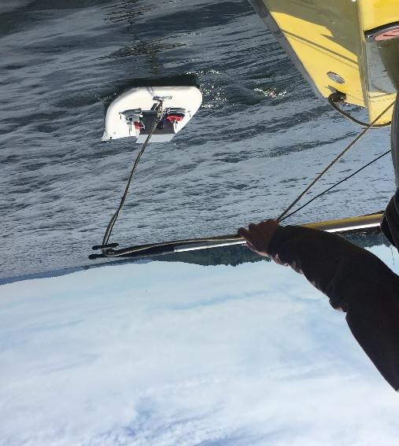

Appendix 9: Initial field deployment outside of Everett Marina, testing movement of the device.
Appendix 8: Final field deployment outside of Shilshole Bay Marina.

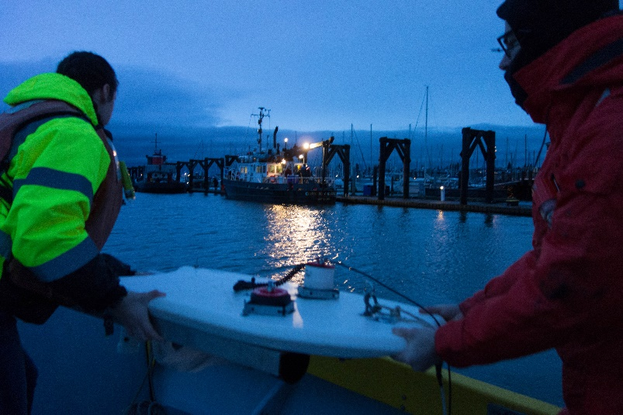

Appendix 10: Initial field deployment outside of Everett Marina demonstrating a deployment by two people in a small craft.

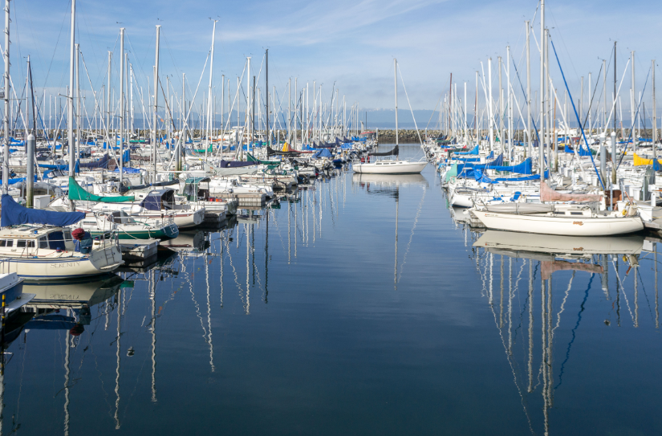
Appendix 11: Image of Shilshole Bay Marina with blue sail covers to demonstrate microplastic fiber sources. From https://commons.wikimedia.org/wiki/File:Shilshole_Bay_Marina-4.jpg

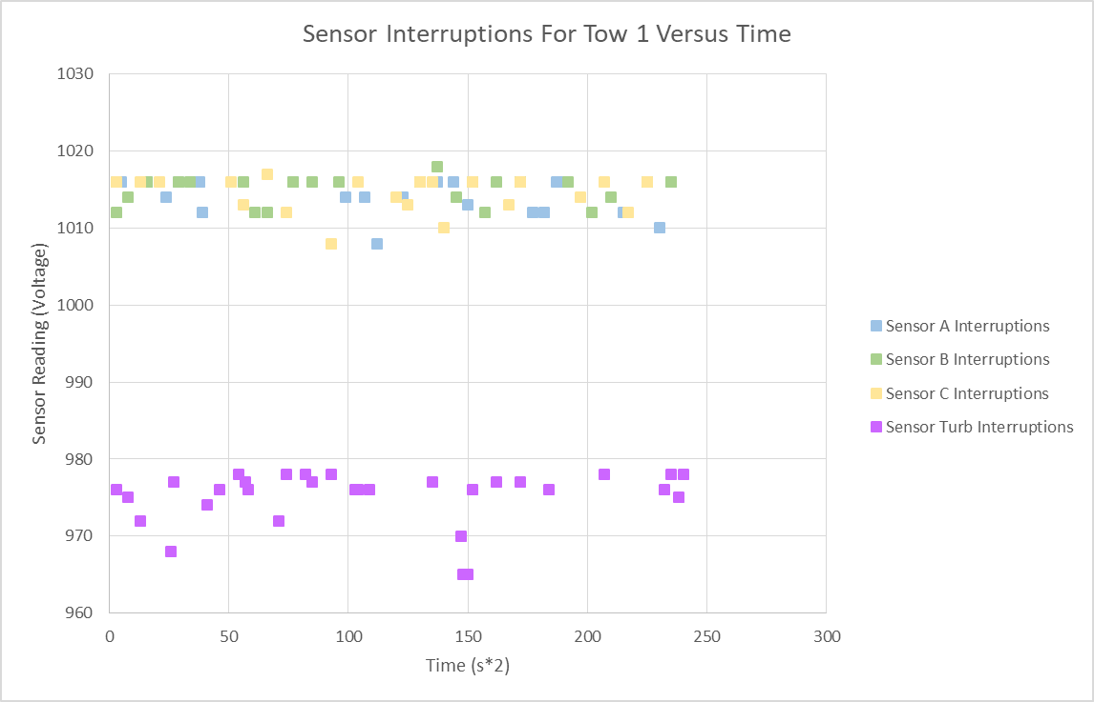
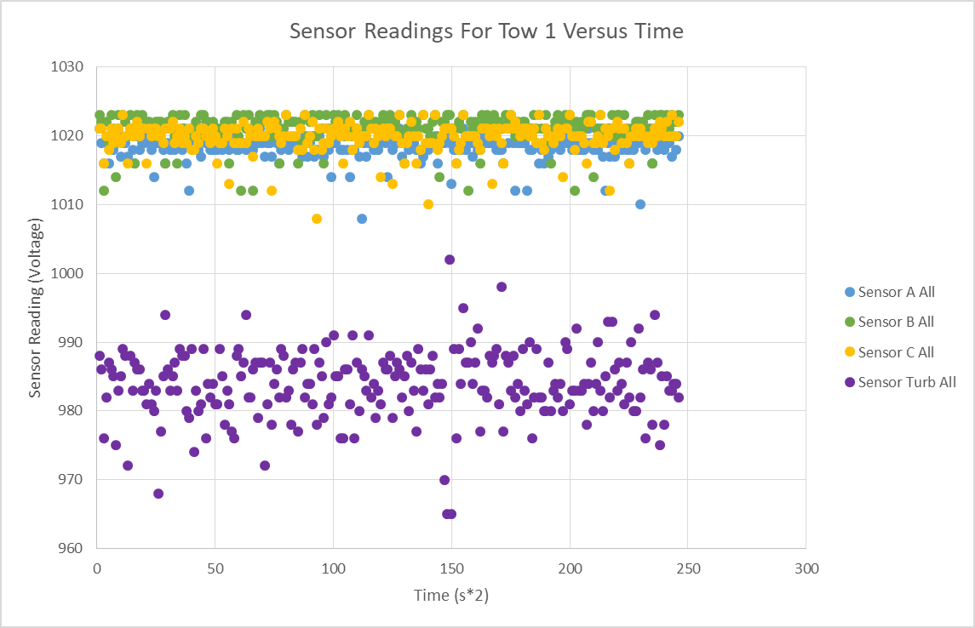
Tow 1:
Appendix 13: On the x-axis is time in half-seconds. On the y-axis is the sensor readings in units of voltage. Each point represents an interruption recorded by each sensor. This plot shows all interruptions measured by all four sensors in tow 1.
Appendix 12: On the x-axis is time in half-seconds. On the y-axis is the sensor readings in units of voltage. Each point represents a reading by each sensor. This plot shows all points collected by all four sensors in tow 1.
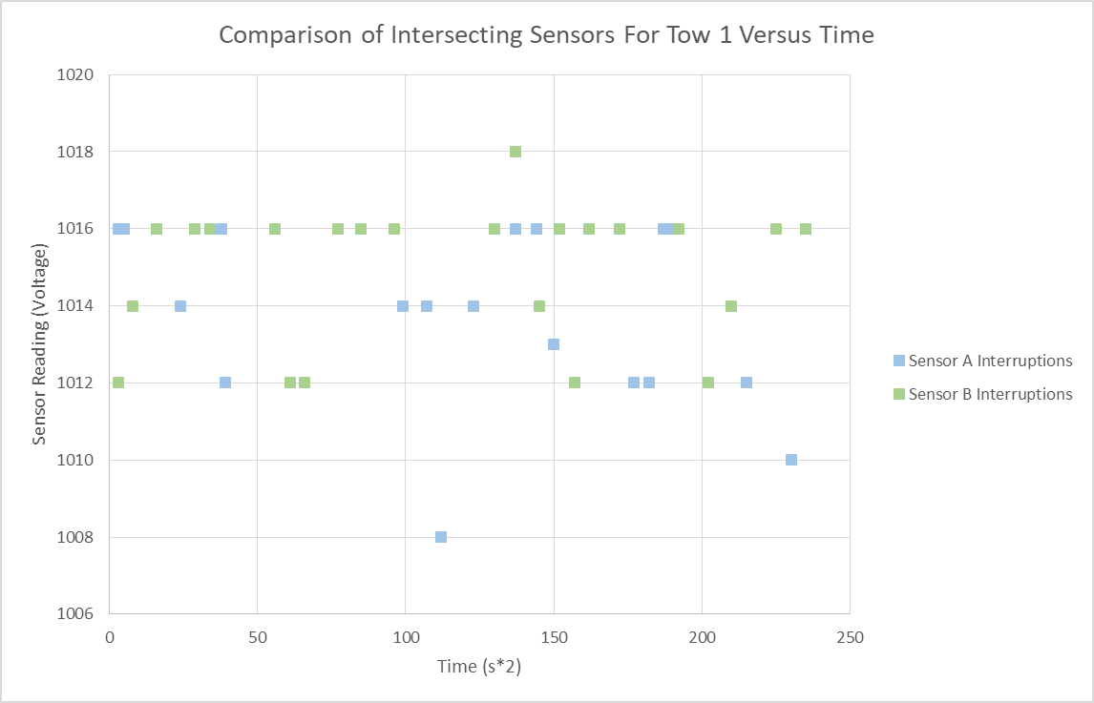
Appendix 14: On the x-axis is time in half-seconds. On the y-axis is the sensor readings in units of voltage. Each point represents an interruption measured by sensors A and B respectively. This plot shows the relationship between the measured interruptions by the intersection of sensors A and B in tow 1.

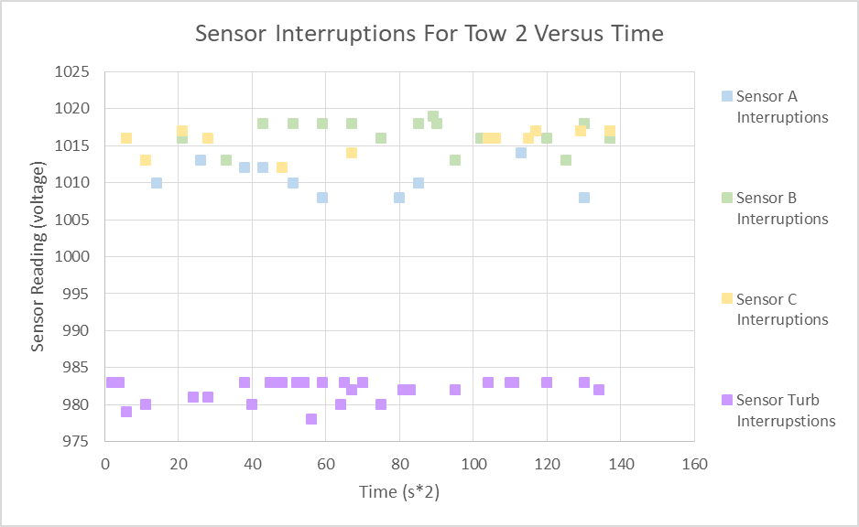
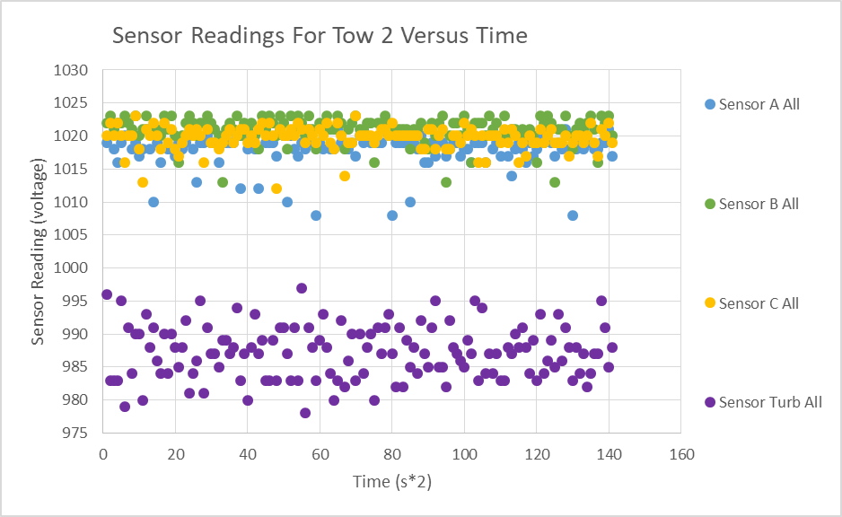
Tow 2:
Appendix 16: On the x-axis is time in half-seconds. On the y-axis is the sensor readings in units of voltage. Each point represents an interruption recorded by each sensor. This plot shows all interruptions measured by all four sensors in tow 2.
Appendix 15: On the x-axis is time in half-seconds. On the y-axis is the sensor readings in units of voltage. Each point represents a reading by each sensor. This plot shows all points collected by all four sensors in tow 2.
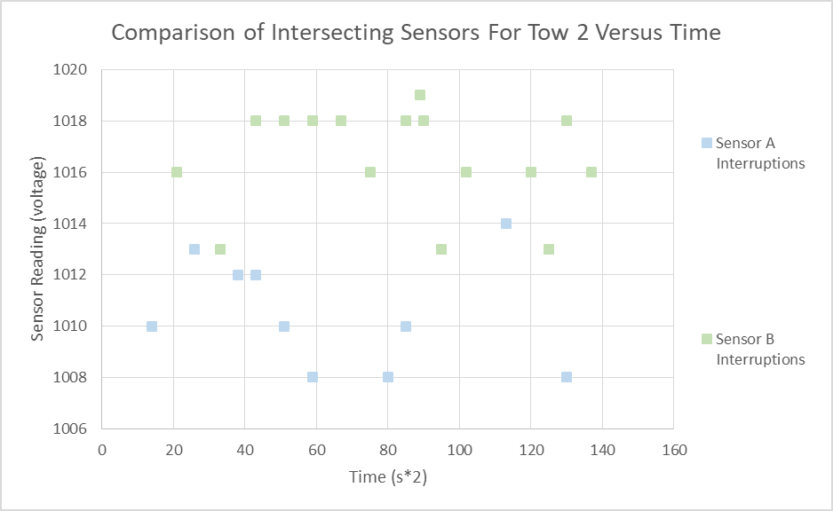
Appendix 17: On the x-axis is time in half-seconds. On the y-axis is the sensor readings in units of voltage. Each point represents an interruption measured by sensors A and B respectively. This plot shows the relationship between the measured interruptions by the intersection of sensors A and B in tow 2.

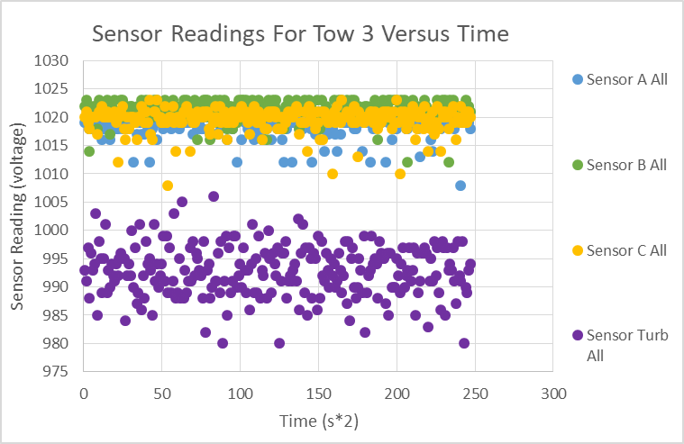
Tow 3:

Appendix 18: On the x-axis is time in half-seconds. On the y-axis is the sensor readings in units of voltage. Each point represents a reading by each sensor. This plot shows all points collected by all four sensors in tow 3.
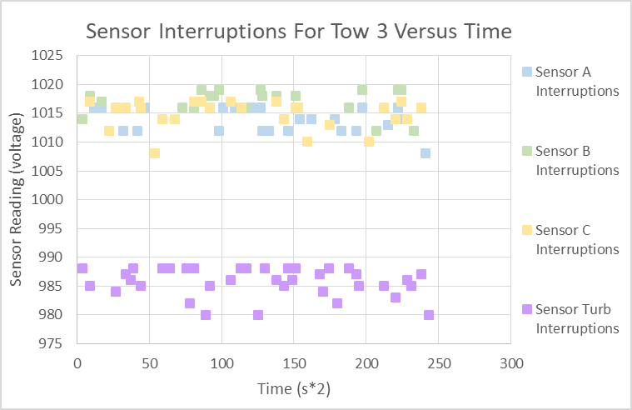

Appendix 19: On the x-axis is time in half-seconds. On the y-axis is the sensor readings in units of voltage. Each point represents an interruption recorded by each sensor. This plot shows all interruptions measured by all four sensors in tow 3.

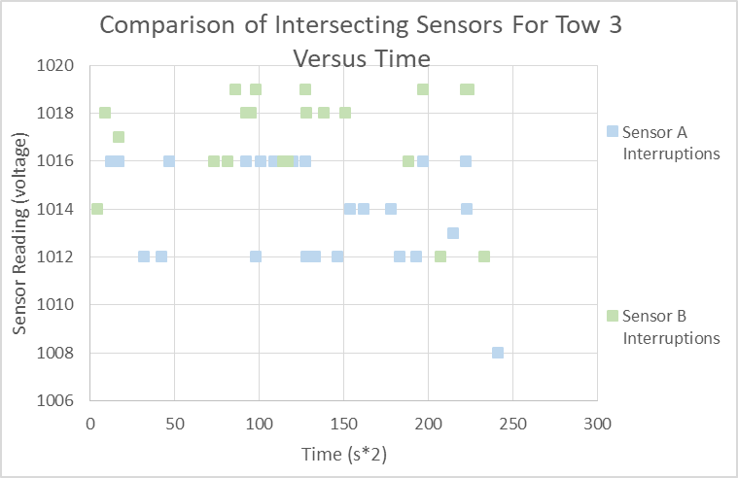
Appendix 20: On the x-axis is time in half-seconds. On the y-axis is the sensor readings in units of voltage. Each point represents an interruption measured by sensors A and B respectively. This plot shows the relationship between the measured interruptions by the intersection of sensors A and B in tow 3.

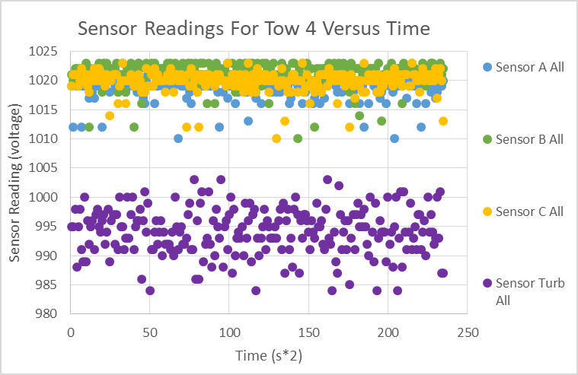
Tow 4:

Appendix 21: On the x-axis is time in half-seconds. On the y-axis is the sensor readings in units of voltage. Each point represents a reading by each sensor. This plot shows all points collected by all four sensors in tow 4.
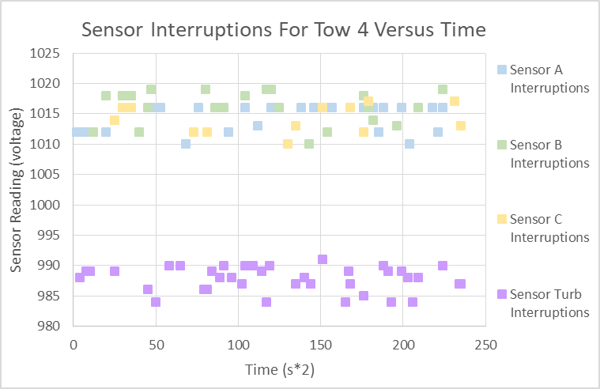
Appendix 22: On the x-axis is time in half-seconds. On the y-axis is the sensor readings in units of voltage. Each point represents a reading by each sensor. This plot shows all points collected by all four sensors in tow 4.

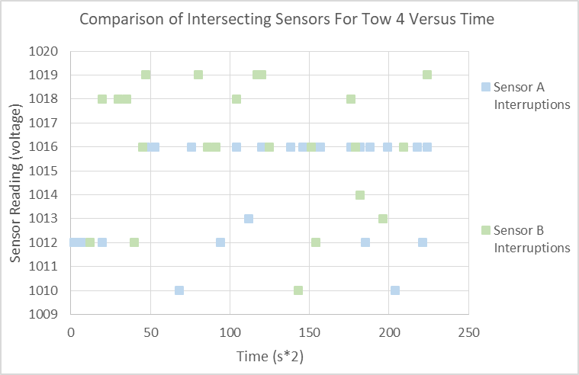
Appendix 23: On the x-axis is time in half-seconds. On the y-axis is the sensor readings in units of voltage. Each point represents an interruption measured by sensors A and B respectively. This plot shows the relationship between the measured interruptions by the intersection of sensors A and B in tow 4.

Appendix 24: Code for all sensors and pump system:
int PhotoA;
int PhotoB;
int PhotoC;
int Turb;
#include <Servo.h>
Servo myservo;
volatile double waterFlow;
#define PUMPPIN 9
void setup()
{
Serial.begin(9600);
myservo.attach(PUMPPIN);
myservo.write(0); //Clockwise maximum speed rotation
waterFlow = 0;
attachInterrupt(0, pulse, RISING);
}
void loop()
{
PhotoA = analogRead(A4);
PhotoB= analogRead(A0);
PhotoC= analogRead(A2);
Turb= analogRead(A3);
Serial.print(PhotoA);
Serial.print(",");
Serial.print(PhotoB);
Serial.print(",");
Serial.print(PhotoC);
Serial.print(",");
Serial.print(Turb);
Serial.print(",");
Serial.println(waterFlow);
delay(500);
}
void pulse()
{
waterFlow += 1.0 / 5880.0;
}

Appendix 25: Cost and Materials:
Photo Interrupters (x3): $5.85 https://www.sparkfun.com/products/9299
Photo Interrupter Breakout Boards (x3): $4.50 https://www.sparkfun.com/products/9322
Mounts (3D printed) $0.5
Housing, net and codend: Repurposed
Analog Turbidity Sensor For Arduino: $9.90 https://www.dfrobot.com/product-1394.html
Digital Water Flow Sensor For Arduino - 1/8"Pump: $8.90 https://www.dfrobot.com/product-1531.html
DFRduino UNO R3 - Arduino Compatible: $19.90 https://www.dfrobot.com/product-838.html
Digital Peristaltic Pump: $59.50 https://www.dfrobot.com/product-1698.html
Total: $109.05

