Marine Debris: Modeling the Spatial Distribution of Sinking Plastics
into the Deep Ocean

Heather Corral

University of Washington
1503 NE Boat St., Seattle, WA 98105

hcorral@uw.edu
29 May 2017

Abstract

Four to twelve million metric tons of plastic enter the ocean each year. Although there is such a large influx of plastic entering the ocean, much of it does not remain floating at the surface. I implemented a wind-driven surface ocean circulation model (Van Sebille et al., 2012) for the top 23 sources of plastic (as identified by Jambeck et al., 2015). I initiated the model at the 23 locations simultaneously and applied a first-order degradation/sinking rate in order to evaluate both sinking and floating debris. Overall, 37% of the plastic sinks in the first year close to shore, 24% sinks on the pathway to ocean gyres, and 39% of the plastic sinks once it is in a gyre. Selected sources were further evaluated including New York, and the four sources that feed into the Mediterranean Sea: Algeria, Turkey, Egypt, and Tunisia. Plastic pollutants sourced from New York traveled across the North Atlantic Ocean with some traveling up into the Arctic ocean and some circulating back into the Caribbean. With an average of 0.075 MMT leaving New York, approximately 0.028 million metric tons (MMT) sunk at the coast of the United States prior to crossing the Atlantic, 0.018 MMT sunk on the path between the coast of New York and the journey to the Arctic Ocean, and 0.029 MMT sunk from the surface once it reached its destination. A similar situation occurred in the Mediterranean Sea. 0.61 MMT of plastic is released to the Mediterranean each year. With my locations being on the southern shore of the Mediterranean Sea, the plastic traveled North over time. 37%, which calculates to 0.23 MMT, sank close to the initial location. 0.15 MMT of plastic sunk before traveling Northeast or Northwest (depending on site), and 0.24 MMT sunk from the surface once reaching the Northern shores of the Mediterranean Sea. Finally, it is interesting to note that none of the 23 largest sources of plastic source into the Southern Pacific Ocean directly.

Introduction

Since the introduction of plastic materials in the 1950s, production has steadily increased due to the materials inexpensive, lightweight, and durable properties (Barnes 2009). According to research done by Jambeck (2015), there has been a 620% increase in the amount of plastic produced since 1975. The accumulation of plastic in the ocean can be attributed to both land sources as well as sources from the sea (Ryan 2009). Moore (2008) further said this by noting that the production of plastic has increased “25-fold, while recovery of the material remained below 5%”. Unfortunately, with the lack of awareness concerning the impacts that plastic would have on our environment, much of the plastic produced has now ended up in our world’s oceans. In 2015, John Schwartz estimated that approximately 8 million metric tons (MMT) of plastic waste was reaching the ocean. Consistent with this, it was estimated that 60-80% of the US municipal waste stream is now plastic (Moore 2008). The longevity of this plastic debris is unknown, but it has been hypothesized that depending on its density, shape, and size it could stay in the ocean anywhere from 100 to 1000 years (Barnes 2009). Ryan stated that size and buoyancy are the main factors to be considered when determining not only how long plastic will stay in the ocean, but even more, how long it will stay at the surface before sinking to a greater depth (2015).
When studying plastics, it is crucial to define the characteristics of the plastics that are consistently entering the ocean. Although large plastics do enter the ocean every day, they eventually breakdown, and fragmentation leads to a large accumulation of microplastics in the ocean. The US National Oceanic and Atmospheric Administration defined microplastics as anything smaller at 5mm. With this, Long et al. (2015) defined two different subcategories of microplastics within this larger classification according to their origin. The first, primary microplastics (MP), stem from “cosmetics, paints, textiles in household wastewaters or as pellets”. In comparison, as previously discussed, secondary plastics is a category that is derived from the breakdown of plastics. Secondary microplastics arise from the fragmentation of macroplastics usually by means of UV radiation or physical factors like waves and currents. Chubarenko et al. (2016) explained that the fate of these different plastics in the sea is dependent on their physical properties including shape, size, and density. Nonetheless, the variance in residence time has been predicted to be as much as thousands of years, leading to detrimental effects in the ocean.
Due to this long residence time, there are many harmful effects that plastic have on the environment and its inhabitants including absorption of persistent bioaccumulative and toxic compounds (PBT) which include persistent organic pollutants (POP) which are then ingested by organisms affecting them directly as well as the organisms all the way up the food chain to humans (Hidalgo-Ruz 2012). More specifically, James Moore (2008) gave specific direct effects that marine plastic is having on the biota in the ocean. This included, ingestion of plastic by sea turtles and seabird species as they mistake common plastics in the ocean for food. To summarize all of this, Moore concluded that, “267 species of marine organisms worldwide are known to have been affected by plastic debris.” With that said, knowing just how much plastic we are dealing with, and the areas in which it is likely to accumulate are each important factors when considering a solution to the current “Plastic Age” that we are in.
Current research primarily focuses on the abundance of plastic in the sediment, water surface, and beaches, which can be much more easily and directly experimented on and collected. Unfortunately, the fate of the large portion of plastic entering the ocean and accumulating is currently unknown. Van Sebille currently has a model that shows the fate of plastic floating at the surface of the ocean. This model has the assumption that plastic never sinks and uses wind as the means to drive it. In 2010, Jenna R. Jambeck did an extensive study focused on quantifying the amount of plastic entering the ocean from 192 coastal countries. The cumulative amount of marine debris entering the ocean was then calculated from these values (Table 1). Her research, along with research defining the sinking rates of plastic in the ocean will lead me to the development of a box model to determine the fate of plastic in the ocean. Research done by Valeria Hidalgo-Ruz et al. (2012) will also play a role in my box model as this research team attempted to quantify the abundances of plastics in the ocean at different levels (surface, water column, sediments). Ruiz et al. (2012) estimated that the sediment has the greatest abundance of plastic with 0.21-77,000 items/m^2. Second to this was the sea surface which had a large range of 8*10^-5 to 5 items/m^2. More specifically to my research is the abundance of microplastics (<5mm). Sediments were also estimated to have the greatest abundance ranging from 185 to 80,000 items m^3. This research, along with the relative sinking rates of plastics will all be crucial components of my final box model attempting to predict the fate of microplastics in the ocean.
Although there are no specific studies researching the sinking rates of microplastics in the ocean, there are several studies currently published that attempt to put a value on this rate. There are multiple characteristics of plastics that inherently affect the rates at which they sink. Most influential are the density and size. Valeria Hidalgo-Ruz et al. (2012) addressed density differences and identified that positively buoyant microplastics with a characteristically low specific density are more likely to stay at the surface of the ocean and travel long distances. Concurrently, microplastics with a high-specific density are more likely to sink at a greater rate and therefore end up somewhere within the water column, or sink as deep as the sediment. With that said, there is a certain amount of fluidity in association with the density of plastics. Erosion can lead to a decrease in specific density, and therefore increase the items buoyancy, or the density of the plastic can increase if microorganisms attach to the plastics (Hidalgo-Ruz et al. 2012). The other major characterization affecting the sinking rate is the size of the plastic. This is also variable because the size of microplastics can greatly fluctuate because it is defined as anything less than 5 mm. As with the density, there is a certain amount of changeability associated with this due to the journey that each plastic particle will undertake once it enters the ocean. Jenna R. Jambeck (2015) identified these conditions as: exposure to saltwater, UV radiation, and the potential shredding of plastics into smaller pieces by waves. These factors will influence the sinking rates of microplastics in the ocean.
To determine the fate of the “missing” plastic in the ocean, Fazey and Ryan ran an experiment in 2014 to evaluate the rates at which polyethylene sank, which is a well-known type of plastic littering our ocean. They submerged multiple sizes of plastic for 12 weeks off the coast of Africa to be the first to quantify the sinking rate of plastics. The results of this studied varied, but found that most samples (out of 986) were negatively buoyant after 12 weeks of submergence. In conclusion, they stated that biofouling was accountable for a large portion of plastic sinking from the surface of the ocean, but that this is hard to define for the entire ocean. This is because biofouling is affected by many things including season, geographic location, water temperature, and nutrient levels (Fazey and Ryan, 2014). Although this research only looked at one type of plastic, it is one of the very first experiments that attempted to quantify the sinking rate plastics in the ocean.
The multiple studies considering sinking rates of plastic will help inform the degradation rate I apply to my final model of plastic in the global ocean. Although not specifically addressing marine microplastics by themselves, Marc Long et al. (2015) did quantify the rate of sinking plastic when in conjunction with marine aggregates. Marine aggregates have been identified as a possible sink for microplastics in the ocean, which likely provide the vertical pathway that plastics travel through the water column. Examples of this research can be found in Fig. 3 of their paper which range from 122 m day⁻¹ all the way to 165 m day⁻¹. Even more relevant, Fazey and Ryan quantified the sinking rate of high-density polyethylene and low-density polyethylene in a 12-week study done in South Bay Africa. Further research needs to be to better determine the average sinking rate of microplastics in the ocean, but Fazey and Ryan’s research (2014) gave the first insight into the sinking rates of all marine microplastic from the surface of the ocean.
The goal of my research is to determine where marine debris is sinking in the ocean, and where it is most likely to accumulate. Up till now, current research has solely focused on the accumulation of plastic at the surface, while ignoring the large amount of “missing” plastic that sinking to deeper depths. I will prepare a box model that estimates the volume of plastics accumulating in different areas of the deep ocean to further understand the impacts that plastic have on the marine environment, and truly understand the fate of plastic that cannot be easily sampled at the surface or scattered on land. This knowledge is currently unknown and will be important in understanding the ramifications that marine debris has on the environment and its inhabitants

Materials and Methods

Marine Plastic Debris
To determine the amount of plastic marine debris being input into the ocean, data from Jambeck et al. study looking at mismanaged plastic waste was used. From the files, I extrapolated the 23 countries with the highest input of plastic waste into the waterways (Table 1). These values were based off the World Bank’s widespread assessments of waste generation, involving plastic waste, for 145 countries. Of the 145 countries selected, the data set was then compacted into a list of the top 20 countries’ mismanaged waste values. From this, the plastic marine debris totals were estimated based off 15%-40% of the mismanaged waste entering the ocean. These values will be used as the initial concentration of plastic entering the ocean at each chosen location.

Adrift Model
The adrift model that was created by Van Sebille (2012) simulates the progression of free floating particles at the surface of the global ocean. The model uses the observational data that was developed by the NOAA Global Drifter Program. This is based on data provided from surface drifter buoys which then provided langrangian data. Essentially, the information from the buoys is merged together to display all the possible scenarios that the buoys may travel. This data is demonstrative of anything in the upper 15 meters of the global ocean as the drifters are constrained to the top 15 meters of the ocean which are influenced by wind. Drifter routes are translated into transition matrices representative of the global ocean. The designated time is set to two months because it considers seasonality as well as endorses an adequate number of diagonal crossings. The limitations to this model is that it assumes that the probability of the plastic being at the surface of the ocean is always 1. The model does not reflect that particles could be sinking or washing up on shore. A color scale is used by Van Sebille that is representative of the percentage of the total number of particles in each 1x1 degree grid, with a maximum value of 1%. I used this model as the base starting point for each of my chosen 23 locations.

Modeling Plastic Loss
Initially, I was hoping to model plastic loss in the ocean by using two sources: a term to age and fragment the plastic into smaller pieces and a second term to allow the plastic to sink from the surface. However, I ended up combining these into a single first order lost term because I struggled to find literature with experimental rates already determined. I had difficulty finding a fragmentation rate as well as the distribution of primary plastics versus secondary. While Halle et al. (2016) explicitly set out to describe fragmentation of plastic in the ocean, it failed to provide an actual rate of fragmentation. The article only stated that fragmentation was in fact happening. I could not find consistent literature that would allow me to fragment the plastics with the information I had. I would have needed to add water temperature and amount of UV sunlight hitting the plastic to model the fragmentation, which I was unable to quantify specifically to each individual location. Additionally, plastics are known to be eaten by several marine organisms including fish, birds, and sharks. Bellas et al. (2016) conducted a study examining the ingestion of plastics by demersal fish in the Mediterranean and found that 45% of fish caught off Spain are found to have plastic within their guts (2016). There is just no good way yet to quantify the biotic influence that consumption has on the concentration of plastic.
I selected not to incorporate actual sinking rates into my model because the literature for sinking rates of plastic varied by 2-3 orders of magnitude and was not consistent. For example, the paper written by Chubarenko et al. (2016) suggested sinking rates including 4 mm s¹ and 18 cm s¹. This is suggesting hundreds of meters per day which seems unrealistically fast. With a sinking rate of 18 cm s¹, it would take plastic approximately a half hour to reach a depth of 250 m. A second paper suggested sinking rates varying between 6 and 91*10⁻³m s¹ depending on the type of plastic you are investigating. Kowalski (2016) suggested three different sinking rates for polysterene: 17, 13, and 8 *10⁻³m s¹ at three different salinities: 0,15, and 36 (2016). This further exemplifies the vast range of possible sinking rates all of which are dependent on location, temperature, salinity, type of plastic etc. Additionally, some plastics might become neutrally buoyant in the water and there is no literature that states how much or how fast this occurs. Kowalski et al. (2016) stated that plastic particles should slow down with increasing depth as the temperature and therefore density of the water increases. Once the water density and particle density are equal, the particle will remain neutrally buoyant at that depth.
Therefore, I decided to apply an inverse modeling approach. It is well-known that 99% of plastic delivered to the ocean does not accumulate in the gyres. Halle et al. (2016) stated that microplastics afloat in the ocean is merely 1% of the plastic that goes into the ocean yearly from around the world. There was also an expedition that took place between 2010 and 2011 in which four ships set out to sample garbage from the five major ocean gyres: Indian, North Atlantic, North Pacific, South Pacific, South Atlantic. The scientists were surprised with how much plastic they did not find. They also estimated that approximately 99% of the ocean was missing, or could not be found (Chen 2014). Because multiple sources cited only 1% of the plastic being accounted for I decided to apply a degradation rate that would remove 99% of the plastic over the ten-year data set that I recovered from the Van Sebille model.
Figure 1 shows different first order rate constants. Starting with the smallest degradation constant of 0.1(dark blue), all the way to 0.6 (green), I found the best degradation constant that would cause 99% percent of the plastic to be missing from the model after 10 years had passed. In other words, I calculated the first order degradation rate where ~1% of the initial plastic would be remaining after 10 years time. The closest value I could calculate was 0.46 (purple). This left with me with 1.005% of the plastic remaining floating at the end of the Van Sebille Model. Therefore, I modeled the loss of plastics using the following first-order formula:

$${[CONC]}_{F}{{=[CONC]}_{i}}^{(-0.46×t)}$$

Results

Locations
The 23 locations selected include Algeria, Turkey, Egypt, and Tunisia that put plastic into the Mediterranean, Vietnam, Indonesia, Philippines, India, Thailand, Sri Lanka, Iran, Pakistan, Malaysia, Bangladesh, and Burma that put plastic into the Indian Ocean, North Korea and China that put plastic into the Western Pacific, and Senegal, United States, Nigeria, and Morocco that put plastic into the North Atlantic (Figure 2). In addition, there was two sources to the South Atlantic: Brazil and South Africa. These source locations are identified in Figure 2B. You can also see a list of the 23 countries chosen in Table 1, along with their coastal populations, plastic waste in 2010, and marine debris in 2010.
After 10 years, 44.35% of the ocean’s surface was influenced by plastic. This can be seen visually in Figure 2B, or quantitatively in Table 2. The percentages ranged from as low as 0.07% for Turkey up to as much as 2.71% for Nigeria. The locations where plastic is still floating after 10 years is identified in Figure 2C. It is important to note that there are no places in the ocean that have one one-hundredth of plastic because the plastic is so dispersed and in low abundance. Given my degradation rate constant of 0.46, Figure 2D denotes where plastic has sunk after the first year.

Discussion
Plastic enters the ocean and most of it is not found floating at the surface. Cozar et al. (2014) estimated that 99% of the plastic that enters the ocean is missing from the surface. This is even more alarming than previously as there is a major increase in plastic production worldwide due to plastic’s lightweight, inexpensive, and durable characteristics. Plastic ends up in the ocean from both land sources as well as sea sources and the effects are detrimental to the oceanic environment. Organisms in the ocean are subject to ingestion of toxic chemicals that plastics are composed of which have a direct negative effect on them as well as the trophic levels above them. Along with absorption of POPs, entanglement in large plastics has become another alarming and persistent issue with organisms including sea turtles. With all the harmful effects associated with plastic in the marine environment it is important to identify and quantify where the “missing plastic” is ending up and how we can prevent this from happening.
My research is the first that I am aware of to attempt to find where this missing plastic is ending up in our global oceans using a modeling approach. I quantified a percentage of plastic ending up and proceeding to sink in three different zones: close to the shoreline, pathway to the gyre, and at the gyre for 23 different locations. I implemented Van Sebille’s model for the top 23 locations that I determine based off a compiled list of Jambeck et al. table of top twenty countries with plastic waste entering the ocean for the year 2010 and 2025. I improved the model by applying a 0.46 sinking rate to all the plastic that entered the ocean, while taking it one step further in starting every chosen location concurrently. This was a great improvement from Van Sebille’s original model which assumed that all plastic remained in the upper 15 meters of the ocean, and that no plastic faced any sort of mortality including sinking, consumption by marine organisms, or washing ashore.

New York, United States
I chose two sources to explicitly focus on: New York and the four sources that add plastic to the Mediterranean Sea. Plastic pollutants tracked from New York traveled across the North Atlantic with a portion of it circulating into the Arctic, and another percentage coming back down to the Caribbean. Figure 3 visually shows plastic debris floating at different time intervals sourced from New York. Figure 3A is at time 0 before, just initially after the Van Sebille model has begun. Figure 3B is after 2 months. Most of the floating plastic is still confined to the coastal water, near the initial location. Continuing chronologically 3D is floating debris after 0.5 years, 3E after 8 months, and 3F after one year. Take note of the scale of each graph as time goes on, the concentration of plastic decreases. Figure 3G shows floating plastics after 2 years. At this point we begin to see the debris traveling across the North Atlantic Ocean up into the Arctic. This trend continues into year 5 (Fig. 3H) and year 10 (Fig. 3I) with circulation back through the Caribbean and North returning to the East Coast. Again, while the marine debris is diluting out further from the initial location, the concentration has vastly decreased in comparison to 2 months (Fig 3B). Quantitatively, the percent of ocean coverage by marine plastic sourced from New York increases over time. After one year, 2.08% of the ocean is covered, after 2 years this increases to 2.10%, and at the 5 year mark the percentage has increased to 2.4%. At the conclusion of the model, 2.58% of the global ocean is covered by plastic sourced from the United States (Table 2). This does not indicate that the total concentration of plastic is increasing over time, only that it is diffusing out due to currents and winds to cover a larger area. The total amount of plastic is still decreasing as can be seen in Figure 4.

Mediterranean Sea
The second initial location I concentrated on included the four places that had plastic that sourced into the Mediterranean Sea: Algeria, Turkey, Egypt, and Tunisia. I repeated the same process with my focus being the Mediterranean Sea (Figure 4). Visual 4A depicts floating plastic at time=0. Coastal locations for Algeria, Turkey, Egypt, and Tunisia are represented with green dots. Figure 4B shows plastic at the surface after 2 months. Again, the concentration of plastic is isolated close to the coastlines. Figure 4D, 4E, and 4F identify concentration of plastic after half a year, two years, and ten years. It is vital to pay close attention to the scales, and while it appears visually that there is more plastic at the surface, the actual concentration is much more thinned. In comparison, I graphed the sunken concentration of plastics in the Mediterranean at half a year (Fig. 4G), 2 years (Fig. 4H), and 10 years (Fig. 4I). The concentration of plastic that is identified as “sunk” increases over time. As completed with New York, I also calculated the percentage of global ocean coverage by the sources into the Mediterranean. I determined the individual percentages at the time intervals of 0.5 years, 1 year, 2 years, and 10 years then summed them together. After half a year, 0.60% of the global ocean was floating plastic from Algeria, Tunisia, Turkey, and Egypt. 0.93% of the ocean was covered after 1 year, 1.31% after 2 years, and 1.62% after 10 years. Algeria had the greatest contribution to this with 0.62% coverage at the end of 10 years. This is interesting considering the total amount of debris entering the ocean, as shown by Jambeck et al. had Egypt with an input of 0.27 MMT, and Algeria with only 0.145 (Table 1). Even though Egypt started with a higher concentration, the percent coverage as contributed by Egypt at the end of 10 years was 0.38%. Tunisia, which started out with the least amount of marine plastic (0.65 MMT), also unexpectedly did not have the lowest percentage of surface ocean coverage. Turkey was responsible for this with only 0.067% coverage after 10 years. This shows that even the countries with the greatest quantity of plastic at the start, may not cause the most damage, depending on the currents and winds surrounding the country.

Future Research
Although my research took strides in further understanding the fate of plastic entering the ocean, there still is a lot that needs to be done in the future. A large component that was left out was secondary plastics. My model focused on primary plastics which are plastics that start out as microscopic size (Cole et al. 2011). Secondary plastics are those that start out as large and are fragmented into smaller pieces (Ryan et al. 2009). This process can happen in several ways including chemical, biological weathering and photodegradation by sunlight. My model also was under the assumption that all plastic was equal and sunk at the same rate. This is clearly not true as there are several different plastics with different shapes, sizes and densities that all affect the rate at which they will sink in the ocean. For example, just when looking at microplastics, their size can vastly range up to 5 mm. In the study done by Chubarenko et al. (2016), microplastics ranged from 0.5-5 mm, which can lead to very different sinking rates. This study also examined the different types of polymers and the densities associated with them. There is a large variance in the specific densities of plastics based on the type of polymer they are and how they are made. Chubarenko et al. explained that the “density values for plastic range from <0.05 g cm-3 for polystyrene foam to 2.1-2.3 g cm-3 for Teflon”. There is also a large variance in the type of plastic present in the global ocean dependent on the location and therefore the sources that feed into that location. These factors (density, location, size) can and will affect the sinking rates. Future models should attempt to implement different plastic sizes and densities when attempting to quantify plastic sinking from the surface.

Marine Snow
Marine snow is defined by Alldredge as “large amorphous aggregates of detritus algae, bacteria, fecal matter and debris that form in the upper ocean and sediment to the seafloor” (2017). Marine snow is a large source of particle flux and energy from the surface mixed layer down to the deep ocean. It provides a vital source of food and carbon to the oceanic environment. As to be expected with plastic, there is also a large range in the sinking rate of marine snow due to the variability in “size, shape, composition, porosity, and rigidity” (Alldredge & Gotschalk 1988). Unfortunately, my model did not take marine snow into account at all. My model solely focused on plastic sinking by itself from the surface of the ocean down to the deep ocean. Future research should consider the role of marine snow and its effect on sinking plastic in the ocean.

Other Sources
Another source into marine debris that my model did not consider was the amount of plastic in the ocean via ocean transport. I only studied debris resulting from land, but ocean transport is another large source of marine debris that could end up in the gyres. It has been identified that land and ocean are the two sources of plastic entering the ocean so it is important to remember my results are conservative because they lack ocean-based sources. Li et al. (2016) estimated that 20% of marine plastic debris is sourced from the ocean. A common example of this is commercial fishing. This represents 10% of marine debris alone due to the amount of fishing gear discarded into the oceans. Examples include: nylon netting and monofilament lines. In making this model more realistic secondary plastics would be a very important source to include.

Plastic in the South Pacific
As you may note, there is no plastic marine debris present in the South Pacific Ocean in my model (Figure 2). One reason for this is because there were no sources (out of my chosen 23) that feed into the South Pacific. With this list provided by Jambeck et al. (2015), there were no countries in the top 20 lists for 2010, and predictive list of 2025 that feed into the South Pacific Ocean. This does not however, indicate that there is no plastic present there and that it should not be paid attention to. Eriksen et al. conducted a study in 2013 to confirm whether microplastics were present in the South Pacific Subtropical Gyre (SPSG). The study found and documented the existence of plastic, including microplastic in the SPSG, but in a smaller concentration compared to studies that looked at the North Pacific Subtropical Gyre (NPSG). The researchers attributed this to “lower input from shipping and shore activities in the South Pacific compared to the North Pacific”. There was a more recent study conducted by the University of Tasmania that looked at the pollution on Henderson Island, which resides in the South Pacific (Hunt 2017). They determined this location to have the highest concentration of anthropogenic debris in the world with nearly 18 tonnes of plastic present (macro and micro). 38 million pieces of plastic were projected to be on Henderson Island with approximately 13,000 new items washing ashore daily. This might make you question why there is no plastic in the South Pacific in my model, but this is because after examination of the debris on the Island, it shows it is mainly from fishing boats. If you look at a map of marine traffic, you can see that there is heavy traffic through the South Pacific. There is no plastic in the South Pacific in my model because it only reflects land-based sources. By adding marine based sources my model could be greatly improved.

Concluding Remarks
One of the greatest mysteries of plastics today is the fate of plastic that is not found floating at the surface. My model shows that it can end up sinking at multiple sites including close to the shore, on the pathway to the gyre, and at the gyre. It is very likely that these plastics are very different in composition, size, and specific density, all of which will affect the rate at which they sink, as well as how far they sink in the water column. Future research specifically identifying percentage of secondary versus primary plastics entering the ocean and identifying how long it takes for large particles to fragment into smaller particles will help improve upon my model predictions and increase our understanding of the fate of plastic marine debris. A better understanding of the different types of plastic will also better inform future models. It is likely that the plastics entering the ocean through land source and marine source are very different, which will inherently affect the composition and therefore density of the particles. This will influence the rate at which the particles sink and where they end up in the water column. By determining a sinking rate of the particles experimentally or in situ will make strides for better perception of where the 99% of plastic is ending up. While the ocean will ultimately deliver the plastic marine debris to the seafloor or the beaches and shorelines, therefore removing it from the major ocean gyres, the ultimate solution to the problem is to prevent the plastic waste from entering the ocean at all. This must be the end goal: prevention of plastic waste.

Acknowledgements

First I would like to thank my family for all their unwavering emotional and moral support during my five years at the University of Washington, as well as during my life. I would also like to thank my boyfriend, Nik Little, for continuous encouragement and always lifting my spirit when I felt overwhelmed or stressed out. This accomplishment would not be possible without my loved ones in my corner throughout this process. All my classmates were fantastic because they helped me to strive for excellence in the classroom as well as life in general. I want to thank every one of them that directly or indirectly helped me in this venture. Dr. Van Sebille graciously shares his wind-driven model, without which my thesis would not have been possible. Arthur Nowell always made me feel like competing at the highest level academically and athletically was possible. Without his tremendous affability and constant reassurance this thesis would not be possible and not nearly as enjoyable to complete. And to my incredibly remarkable top-shelf adviser Rick Keil, I cannot say thank you enough. No matter how complicated our schedules became he always went above and beyond to find times to guide me through my research and final thesis. While consistently allowing this to be my own work, he guided me and taught me the things I needed to know, while making this year one of the most enjoyable of my college career through our work together. I cannot put into words the gratitude I will always have for you through your overwhelming support this past year. Thank you all.

Tables/Figures

Country | Coast Population  (millions) | Plastic Waste (2010) | Marine Debris (2010) | Average Marine Debris (MMT)
China | 262.9 | 8.82 | 1.32-3.53 | 2.425
Indonesia | 187.2 | 3.22 | 0.48-1.29 | 0.885
Philippines | 83.4 | 1.88 | 0.28-0.75 | 0.515
Vietnam | 55.9 | 1.83 | 0.28-0.73 | 0.505
Sri Lanka | 14.6 | 1.59 | 0.24-0.64 | 0.44
Thailand | 26 | 1.03 | 0.15-0.41 | 0.28
Egypt | 21.8 | 0.97 | 0.15-0.39 | 0.27
Malaysia | 22.9 | 0.94 | 0.14-0.37 | 0.255
Nigeria | 27.5 | 0.85 | 0.13-0.34 | 0.235
Bangladesh | 70.9 | 0.79 | 0.12-0.31 | 0.215
South Africa | 12.9 | 0.63 | 0.09-0.25 | 0.17
India | 187.5 | 0.6 | 0.09-0.24 | 0.165
Algeria | 16.6 | 0.52 | 0.08-0.21 | 0.145
Turkey | 34 | 0.49 | 0.07-0.19 | 0.13
Pakistan | 14.6 | 0.48 | 0.07-0.19 | 0.13
Brazil | 74.7 | 0.47 | 0.07-0.19 | 0.13
Burma | 19 | 0.46 | 0.07-0.18 | 0.125
Morocco | 17.3 | 0.31 | 0.05-0.12 | 0.085
North Korea | 17.3 | 0.3 | 0.05-0.12 | 0.085
United States | 112.9 | 0.28 | 0.04-0.11 | 0.075
Iran | 9.1 |  | 0.04-0.10 | 0.07
Senegal | 8.13 |  | 0.04-0.10 | 0.07
Tunisia | 7.27 |  | 0.04-0.09 | 0.065
 |  |  | TOTAL: | 7.47
Table 1. 23 locations globally chosen based off Jambeck et al. Values based off year 2010 dataset.

Country | Percent Covering Ocean After 10 Years
Algeria | 0.615110416
Bangladesh | 2.506085898
Brazil | 2.506085898
Burma | 2.506085898
China | 1.919231438
Egypt | 0.380368632
India | 2.573465484
Indonesia | 2.32568249
Iran | 1.741001565
Malaysia | 2.58868023
Morocco | 2.545209529
Nigeria | 2.712571727
North Korea | 1.782298731
Pakistan | 2.523474178
Philippines | 1.806207616
Senegal | 2.519127108
South Africa | 1.547556947
Sri Lanka | 2.477829943
Thailand | 1.790992871
Tunisia | 0.55642497
Turkey | 0.067379586
United States | 2.582159624
Vietnam | 1.775778126
Total: | 44.3488089
Table 2. Percent plastic covering surface of the ocean after 10 years have passed.

Location | Average Plastic (MMT) | Coastal Abundance (MMT) | Path to Gyre (MMT) | Gyre (MMT)
United States | 0.075 | 0.02775 | 0.018 | 0.02925
Algeria | 0.145 | 0.05365 | 0.0348 | 0.05655
Turkey | 0.13 | 0.0481 | 0.0312 | 0.0507
Egypt | 0.27 | 0.0999 | 0.0648 | 0.1053
Tunisia | 0.065 | 0.02405 | 0.0156 | 0.02535
Mediterranean | 0.61 | 0.2257 | 0.1464 | 0.2379
23 locations | 7.47 | 2.7639 | 1.7928 | 2.9133
Table 3. New York City and locations feeding into the Mediterranean: Algeria, Turkey, Egypt, Tunisia and all 23 locations added together. Average plastic marine debris based off Jambeck 2010 data. Coastal abundance calculated (37%) total debris, the path to the gyre (24%), and marine debris at the gyre (39%).

Figure 1. Model of degradation over 10 years for different rate constants. Blue (0.1), Red (0.2), Green (0.4), Purple (0.46), Light Blue (0.5), Orange (0.6). Degradation constant chosen for my model: 0.46

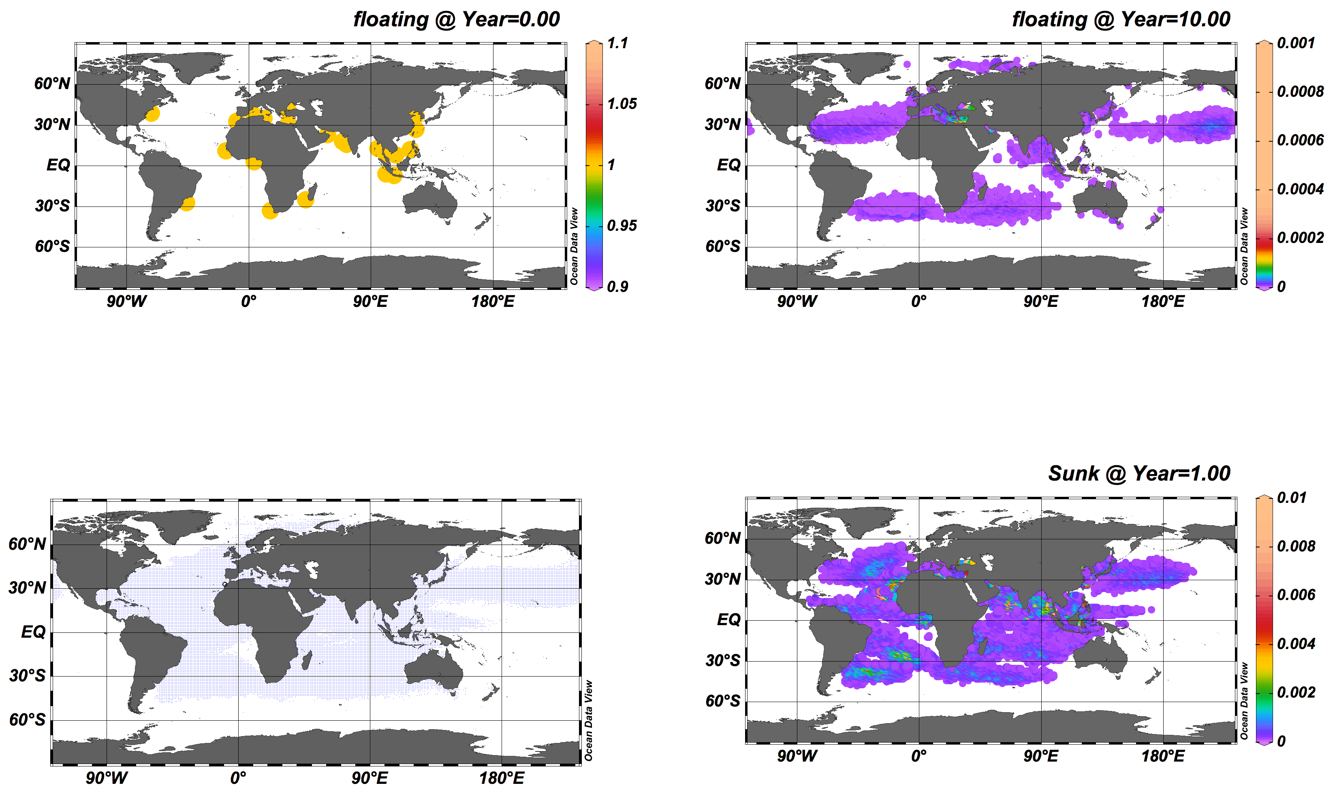
Figure 2. Panel A: 23 initial locations in yellow; Panel B: All of the data points on the gridded ocean that plastic went over 10 years; Panel C: Floating plastic after 10 years; Panel D: Plastic Sunk after 1 year

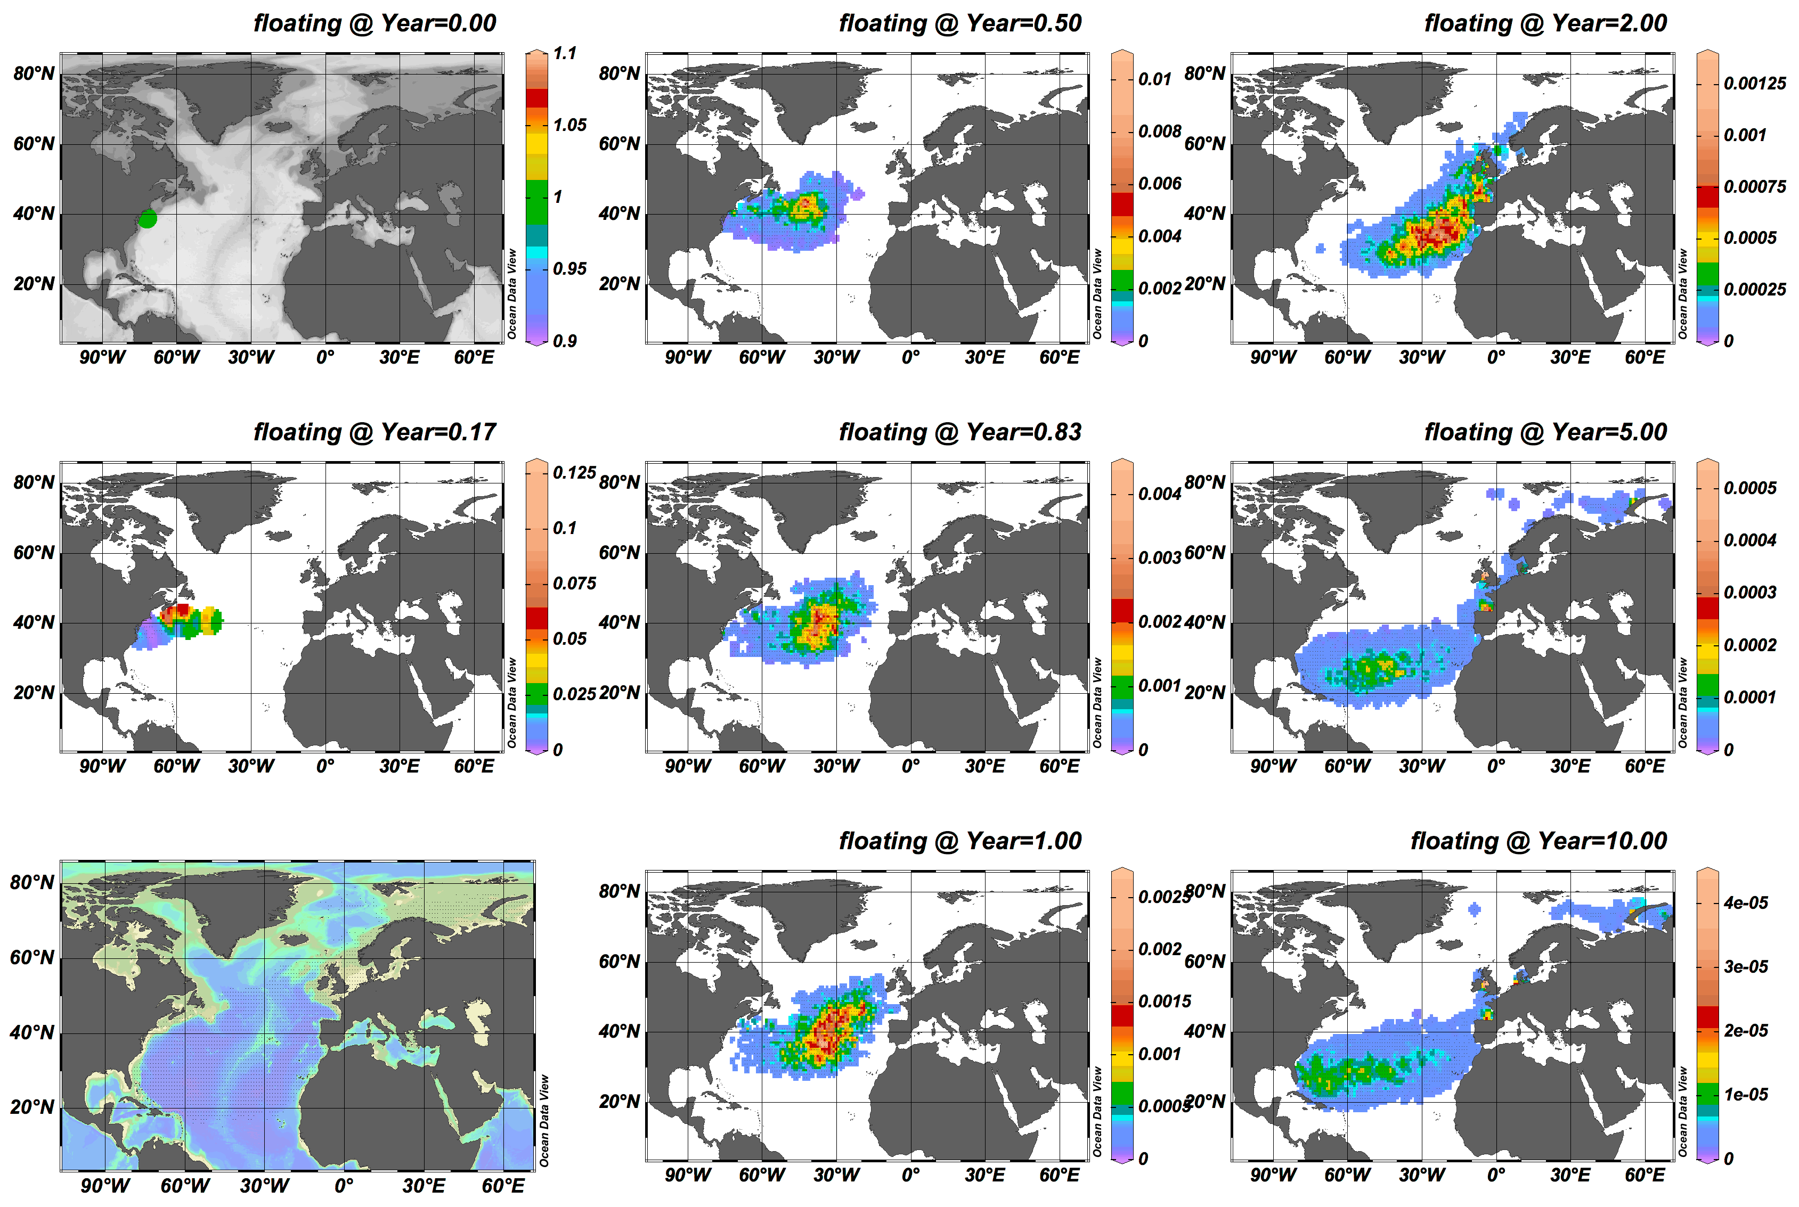
Figure 3: New York Location. Multiple panel view of plastic floating over 10 year period: at starting time (A), after 2 months (B), 6 months (D), 10 months (E), 1 year (F), 2 years (G), 5 years (H), and 10 years (I).

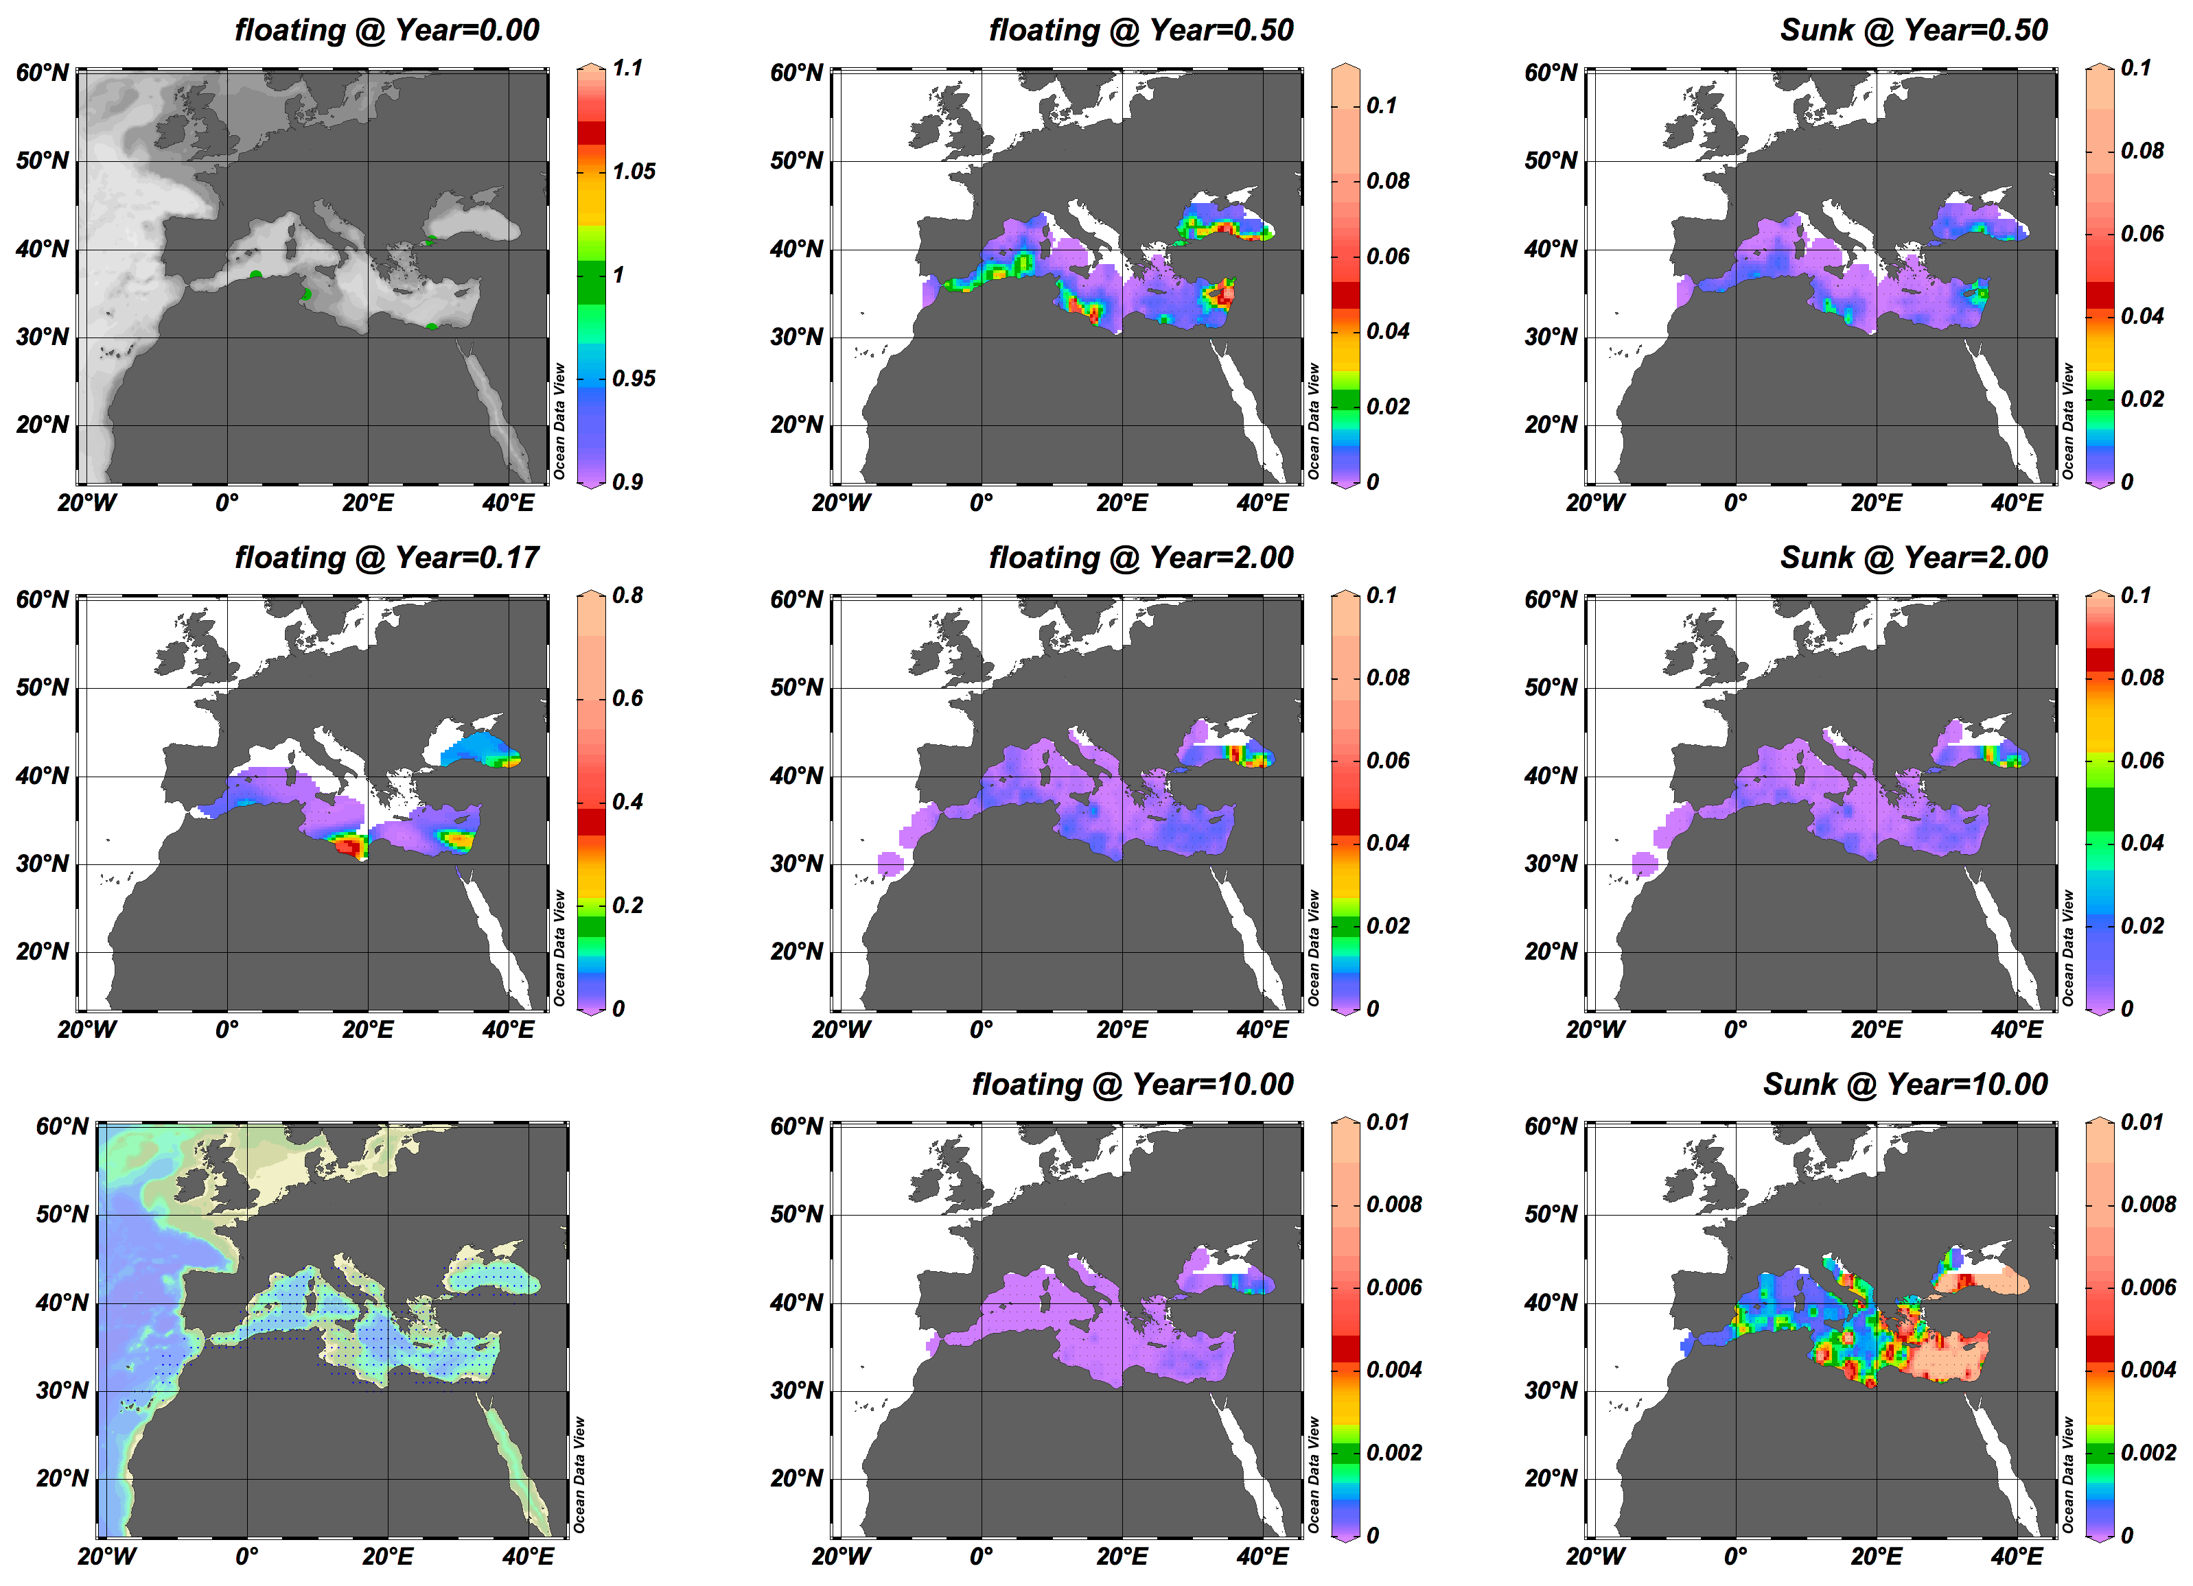
Figure 4: Four locations feeding into Mediterranean Sea (A): Algeria, Turkey, Egypt, Tunisia. Floating plastic after 2 months (B), 6 months (D), 2 years (E), 10 years (F). Plastic that has sunk in the Mediterranean after 6 months (G), 2 years (H), and 10 years (I).

References
1. Alldredge A (2017) Ecology, Evolution, and Marine Biology | UC Santa Barbara. In: Ecology, Evolution, and Marine Biology | UC Santa Barbara. https://www.eemb.ucsb.edu/people/faculty/alldredge. Accessed 21 May 2017
2.Alldredge AL, Gotschalk C (1988) In situ settling behavior of marine snow1. Limnology and Oceanography 33:339–351. doi: 10.4319/lo.1988.33.3.0339
3.Barnes DKA, Galgani F, Thompson RC, Barlaz M (2009) Accumulation and fragmentation of plastic debris in global environments. In: Philosophical Transactions of the Royal Society of London B: Biological Sciences. http://rstb.royalsocietypublishing.org/content/364/1526/1985. doi: 10.1098/rstb.2008.0205
4.Bellas J, Martínez-Armental J, Martínez-Cámara A, et al (2016) Ingestion of microplastics by demersal fish from the Spanish Atlantic and Mediterranean coasts. Marine Pollution Bulletin 109:55–60. doi: 10.1016/j.marpolbul.2016.06.026
5.Chen A (2014) Ninety-nine percent of the ocean's plastic is missing. In: Science | AAAS. http://www.sciencemag.org/news/2014/06/ninety-nine-percent-oceans-plastic-missing.
6.Chen A (2015) Here’s how much plastic enters the ocean each year. Science. doi: 10.1126/science.aaa7848
7.Chubarenko I, Bagaev A, Zobkov M, Esiukova E (2016) On some physical and dynamical properties of microplastic particles in marine environment. Marine Pollution Bulletin 108:105–112. doi: 10.1016/j.marpolbul.2016.04.048
8.Cole M, Lindeque P, Halsband C, Galloway TS (2011) Microplastics as contaminants in the marine environment: A review. Marine Pollution Bulletin 62:2588–2597. doi: 10.1016/j.marpolbul.2011.09.025
9.Cozar A, Echevarria F, Gonzalez-Gordillo JI, et al (2014) Plastic debris in the open ocean. Proceedings of the National Academy of Sciences 111:10239–10244. doi: 10.1073/pnas.1314705111
10. Eriksen M, Maximenko N, Thiel M, et al (2013) Plastic pollution in the South Pacific subtropical gyre. Marine Pollution Bulletin 68:71–76. doi: 10.1016/j.marpolbul.2012.12.021
11.Fazey FM, Ryan PG (2016) Biofouling on buoyant marine plastics: An experimental study into the effect of size on surface longevity. Environmental Pollution 210:354–360. doi: 10.1016/j.envpol.2016.01.026
12.Halle AT, Ladirat L, Gendre X, et al (2016) Understanding the Fragmentation Pattern of Marine Plastic Debris. Environmental Science & Technology 50:5668–5675. doi: 10.1021/acs.est.6b00594
13.Hidalgo-Ruz V, Gutow L, Thompson RC, Theil M (2012) Microplastics in the Marine Environment: A Review of the Methods Used for Identification and Quantification. Environmental Science and Technology 46:3060–3075. doi: 10.1021/es2031505
14.Hunt E (2017) 38 million pieces of plastic waste found on uninhabited ... In: The Guardian. https://www.theguardian.com/environment/2017/may/15/38-million-pieces-of-plastic-waste-found-on-uninhabited-south-pacific-island.
15.Jambeck JR, Geyer R, Wilcox C, et al (2015) Supplementary Materials For: Plastic waste inputs from land into the ocean. Science 347:768–771. doi: 10.1126/science.1260352
16.Jambeck JR, Geyer R, Wilcox C, et al (2015) Plastic waste inputs from land into the ocean. Science 347:768–771. doi: 10.1126/science.1260352
17.Kowalski N, Reichardt AM, Waniek JJ (2016) Sinking rates of microplastics and potential implications of their alteration by physical, biological, and chemical factors. Marine Pollution Bulletin 109:310–319. doi: 10.1016/j.marpolbul.2016.05.064
18.Li WC, Tse HF, Fok L (2016) Plastic waste in the marine environment: A review of sources, occurrence and effects. Science of the Total Environment 566-567:333–349. doi: https://doi.org/10.1016/j.scitotenv.2016.05.084
19.Long M, Moriceau B, Gallinari M, et al (2015) Interactions between microplastics and phytoplankton aggregates: Impact on their respective fates. Marine Chemistry 175:39–46. doi: 10.1016/j.marchem.2015.04.003
20.Moore CJ (2008) Synthetic polymers in the marine environment: A rapidly increasing, long-term threat. Environmental Research 108:131–139. doi: 10.1016/j.envres.2008.07.025
21.Ryan PG, Moore CJ, Franeker JAV, Moloney CL (2009) Monitoring the abundance of plastic debris in the marine environment. Philosophical Transactions of the Royal Society B: Biological Sciences 364:1999–2012. doi: 10.1098/rstb.2008.0207
22.Schwartz J (2015) Study Finds Rising Levels of Plastics in Oceans. In: The New York Times. https://www.nytimes.com/2015/02/13/science/earth/plastic-ocean-waste-levels-going-up-study-says.html. Accessed 14 May 2017
23.Sebille EV, England MH, Froyland G (2012) Origin, dynamics and evolution of ocean garbage patches from observed surface drifters. Environmental Research Letters 7:044040. doi: 10.1088/1748-9326/7/4/044040
24. Willis K, Hardesty BD, Kriwoken L, Wilcox C (2017) Differentiating Littering, Urban Runoff and Marine Transport as Sources of Marine Debris in Coastal and Estuarine Environments. Scientific Reports 7:1–9. doi: doi:10.1038/srep44479

