Impact of Databases on Oceanographic Citizen Science

Hithaishi Paraselli
Advisors: Miles Logsden and Arthur Nowell
The University of Washington, Seattle, WA
School of Oceanography
email: paraseli@uw.edu
06/10/2019

Abstract

Due to recent advances in low-cost and easily programmable micro-electronic sensors, citizen scientist interested in learning more about their personal connection to the ocean and those aspects of marine waters that they interact with are now able to gather and organize data. They can then visualize that data and draw some basic conclusions about the dynamics of their local marine environment. A key component of this pathway towards citizen science engagement is the implementation of an effective and easy to use database architecture. A database application and user interface was designed, built, and tested to investigate the effectiveness of the application in drawing conclusions regarding marine water dynamics. The application was tested by a small group of undergraduate students who reported strong agreement with positive evaluation statements about the helpfulness of the application. This prototype database development also provides for opportunities to collaboratively investigate with other citizen scientists and archive solutions for long-term data analysis research. The database application is meant for a wide level of expertise as it can be manipulated without novel data but also previous data collected by other scientists.

Introduction

This project is based on the expectation that receiving an appreciation of oceanographic data will motivate further independent study by citizen scientists. This will require citizen scientists to have the ability to curate and analyze their own samples which will increase their confidence in oceanography data to inform the general population about the marine environments around them. Roughly 40% of the world’s population live within 100 kilometers of a coast and even more have access to local bodies of water, yet if they were curious about its characteristics, they would not have the means to perform any analysis (Columbia University).
One obstacle they may encounter is just not having the proper equipment. Young scientists may have the misconception that they need heavy duty equipment, such as a CTD Rosette, or lab equipment to analyze water samples once they have been collected. It may not be evident that a simple sensor which can be lowered to various depths, can also take measurements that can answer a wide variety of question such as temperature, light, and depth. Another obstacle is the analysis of received data. Young scientists may not know how to turn the raw data that they receive from their sensor into information they can interpret.
Oceanographic citizen science requires turning field data collected in the water column into meaningful information that can be understood intuitively. As professional oceanographers, scientists spend months learning programming languages that they use to manipulate data, creating visualizations that tell a story. The ability to visualize data allows scientists to compare bodies of water around the world as well as throughout history. New, inexperienced scientists may not have these same foundations that allow them to turn raw data, in the form of numbers on a spreadsheet, into a graph that illustrates what is occurring at different depths throughout the water column. Many instructors believe that visualizations greatly improve a student’s ability to learn (Naps et al., 2003). This implies that not being able to produce easily interpreted visual representation could prevent people from drawing accurate conclusions from data.
Databases and how it allows for everyday citizens to be more involved and take an active role in furthering their own understanding (Prat et al., 2006). While this article focused the importance of databases in Public Health, there are many connections that can be made between the two disciplines.
In health, it is important to have databases to track changes in a person’s health. This allows for the visualization of long term trends that may not have been caught otherwise. More importantly, it also gives patients the ability to advocate for their health and recognize trends for on their own. Since conclusions made are based on their own health data, patients are more likely to have confidence in the diagnosis and understand the development since they participated in the data analysis. Lastly, users are empowered through personally tracking their own data allowing them to advocate for their own health.
Similarly, when looking at the ocean, databases can help show trends in the water column. If someone were to test water samples on a very small timescale, they would still be able to see differences for which they could hypothesize reasons and draw conclusions. Furthermore, as the database grows, citizen scientists can utilize the data to examine the accuracy of their hypothesis. Much as Public Health, an Oceanographic database would empower citizen scientists to learn from the data that they collected and build confidence in the conclusions that are ultimately drawn.
Citizen science is an integral part to data collection because, through citizen science, we can recruit “the public in collecting large quantities of data across an array of habitats and locations over long spans of time (Bonney et al, 2009).”
The intent of this work is to allow for the furthering of citizen science and to allow more people to explore the ocean gaining a deeper understanding of its process with data they can trust since they collected it themselves. Giving people the ability to collect their own data is important because they will be able to see exactly where the samples are coming from, how they are being analyzed, and what specific procedures are being done to get these samples. By having all this information, users have complete faith that the results they are receiving are very accurate and will have been obtained exactly how they wanted it to be. The overall purpose of this research is to identify whether people will be more informed about bodies of water surrounding them if they are able to view and manipulate the data themselves. One platform that has already created an interactive database for weather monitoring is called Wunderground. Wunderground allows users to set up their own weather stations and then broadcast the information (Fig. 1) being received by the sensors to the website. The website also includes an interactive map where users can look at other weather stations around them that other users have created. By doing this they can get a sense of weather trends across the map. It is also a method to check with nearby weather station data to ensure that each sensor is working properly and is giving data that makes sense.
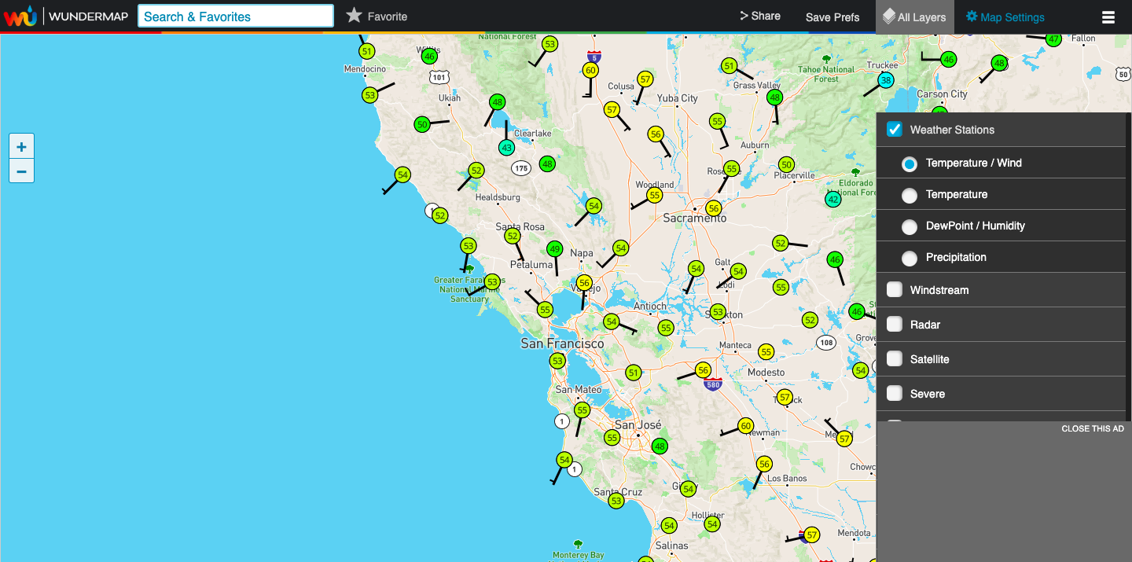
Figure 1: Wunderground's interface where many other weather stations can be seen along with the data they are collecting.
This technology should make it easy for users to run tests on their local water sources and understand what the measurement means. The user interface must also serve to educate people to start seeing trends and understand what water conditions may be harmful. This software has the capacity to create a large database that will hold a great deal of marine data, and that anyone can access in order to make their own independent conclusions.
Another example of a platform that visualized oceanographic data is NVS NANOOS, Northwest Association of Networked Ocean Observing Systems. NVS provides easy access to observation, forecasts, data, live webcams, water quality and visualization. The maps can also be customized to show the user exactly what they are looking for by going to the layers panel and clicking on different overlays to be added to the map.
The importance of this tech can be illustrated through the Flint Water Crisis in Michigan. NRDC (2018) reports that in late April of 2014, Flint residents started complaining that their water smelled, tasted, and looked funny. A little over a month later, the first case of Legionnaires’ case was reported and it was determined the cause was from local water sources; however, the public was not made aware of this for another year. In instances like this, where the public might suspect their water is not safe, it is empowering to be able to test water for themselves and could potentially prevent harm and improve safety.
This work results in the creation of a sensor, database, and interface that will enable citizen scientists to better understand changes that may be occurring in the water near the user. The sensor is able to test for depth, temperature, light, and includes a real-time clock. In order to test if the application is actually helping user understanding of the data, we conducted a two-part experiment. The first part tested to see how usable the interface is. Usability inspection outlines a set of effective methods to of evaluating user interfaces to find problems with the usability. One inspection method is called a cognitive walkthrough. In a cognitive walkthrough, we “simulate a user’s problem solving process at each step through the dialogue, checking if the simulated user’s goals and memory content can be assumed to lead to the next correct action.” (Neilsen, 1994). The second part tests if the interface facilitates learning; therefore, teaching about local changes in the water column and how they came to be. The measurement of gained knowledge is a difficult one, but many reviews indicate that assessment has the potential to accurately measure learning (William, 2011). This method of usability inspection and this measurement of learning to make a conclusion on the effectiveness of the technology built here. If the application proves to be useful to citizen scientists, then we should see an increase in understanding and accuracy when students were given the application to visualize the data through.

Methods

Before design of a database and user interface application, a basic set of environmental sensors were selected: light sensor, temperature sensor, and included a real-time clock. These environmental variables were selected for their simplicity, yet ability to convey much about the water column sample conditions. Following populating the database with data from these sensors, a testing process for the usability and effectiveness was conducted by getting users to test the new technology and give feedback as to its effectiveness.
The database was built using SQL, a language to collect, control, and retrieve data from a database. Before coding and building the database, an entity relationship diagram (ERD) was sketched. A well-constructed database should be built for the environment that it is being used in and should deeply understand how each data variable related to each other. Through this sketch (Fig. 2), it was possible to find a meaningful way to organize the data. Through organizing the data into a database, the data then became searchable and filterable meaning the data was now ready to be manipulated to answer user questions. Queries were written in SQL that could link together different variables that the user wanted to compare, such as temperature versus depth or light versus time. By systematizing the data, it was possible to write queries that could virtually link any two categories together and output the relevant data necessary for analysis.
Once the database was completed, the next step was to create visualizations. The database queries can return the relevant data, but at this point the data is in the form of filtered numbers. Using Tableau, a coding language, visualizations were created that turned the raw data into graphs. These graphs are far more interpretable than numbers, so theoretically, citizen scientists should be able to draw conclusions from the visualizations faster than they should from the raw data.
To ensure that the database is truly helpful, there had to be some user testing. Through using students who are unfamiliar with oceanography, it was clear to see how well the sensor, database, and application together could accurately benefit someone without a background in oceanography. Students were first given the raw data before it was put into the database and were asked to look at it in the form of numbers on an excel spreadsheet for 60 seconds to. They were asked to describe any trends they saw such as the decrease of light and temperature with depth. After those 60 seconds, those students were asked to come up with a theory on what they believe the data is conveyed.
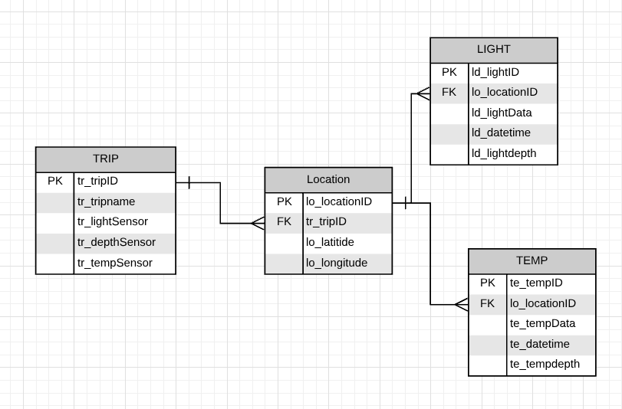
Figure 2: Entity Relationship Diagram (ERD) of how the database is structured on the backend.

The second part of the user testing involved use of the technology created, the visualizations that were made from the database. Students were given 60 seconds with the application and again asked to give a hypothesis as to what the data conveys.
Students were then given a survey afterwards to get further information on how useful they found the database to be. This survey asked them three question for which they gave an answer from one to five (one being strongly disagree and five being strongly agree).
1. The application helped me understand the data better.
2. I feel more confident in my thesis after I viewed the data on the application.
3. It would be helpful to see more data visualized through graphs. If no, explain what’s the best format to view data.

Results

Results are interpreted in two parts: the initial data collection and then the data analysis. The first part includes asking the initial question, posing a hypothesis, and then collecting data. This data collection portion can include the user building their own sensor or simply just the use of a basic sensor to gather data. The second part, the data analysis portion, includes sending the collected data to the database, turning the information in the database into visualizations, and finally resulting in increased conceptual understanding for the user. This last part also includes giving the user the liberty to completely explore their data expand on their initial questions than what they originally came in with. By clicking through the dropdown menus in the front end, the citizen scientist can locate new trends that they find in their samples which could ultimately bring them to a different conclusion.
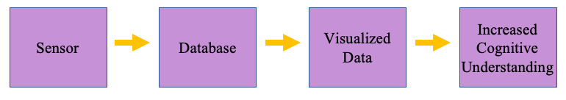
Figure 3: General flow of how the user would use the interface to gain knowledge.
The database has an easy to understand layout that can be built off from for future needs. The main table holds the various types of sensors that the user used to take their measurements and information about the station. This station description could include the date, the type of station, weather conditions on that day, or any other information that might seem useful to the user. From that first table, there are three other tables attached to store each reading that comes in about the depth, temperature, and light data at that specific location.
Now that all the measurements are in the database, basic queries can be used to answer questions. Through stored procedures, we can dynamically change which parameters are being sought after, this returning the specific data that is required by the user. These parameters are chosen by the user on the front end. Depending on what drop down options they select from the app view, those options can be sent to the database query which will return the result back to the front end (Fig. 4).
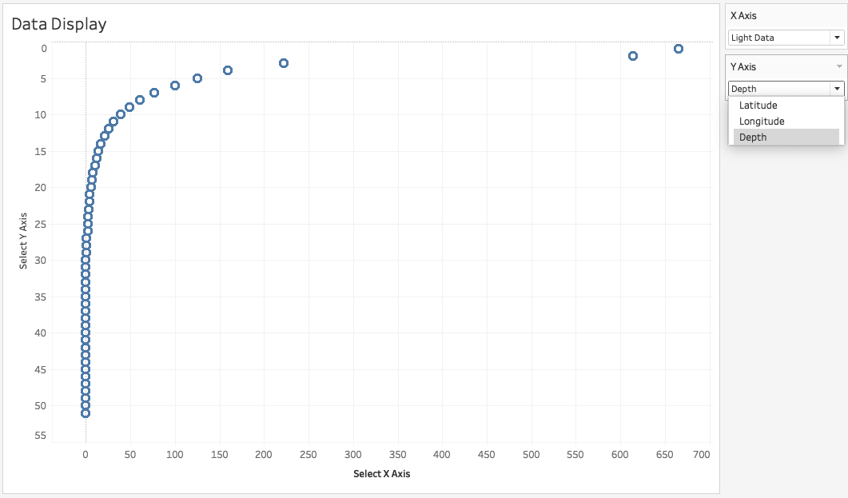
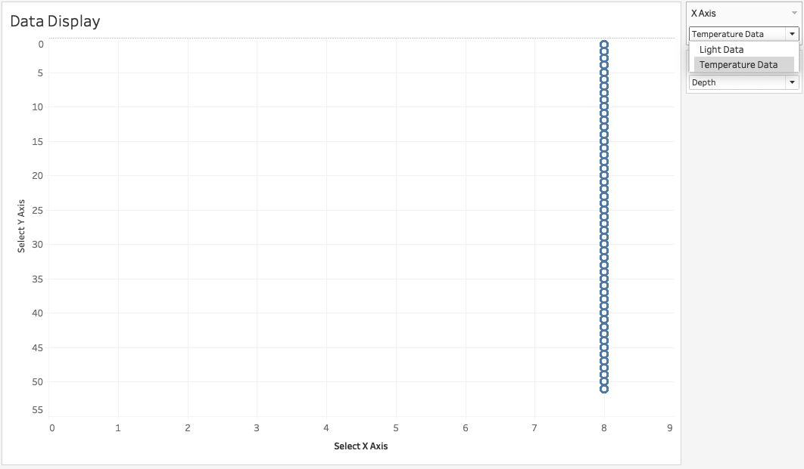
Figure 4: Simple visualizations made from the database depicting drop down menu choices.

In order to get a realistic understanding or if the total project proved to help citizen science understanding, user research was done. In total, five different students were surveyed. These students were all undergraduate students attending the University of Washington. The majors of the students were different and none of them were Oceanographic majors to ensure that a user with absolutely no oceanographic background could interpret visualizations that were created from the database. These five students included two communications majors, one informatics major, one business administration major, and one computer science and engineering major.
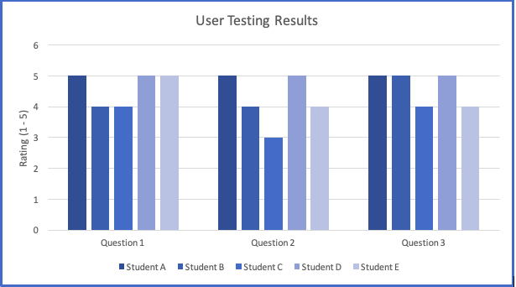
Figure 5: Results from user testing.
When asking the test group if they thought the application was beneficial during the user testing, the entire group rated it very highly. The following are the average response that the students responded with for each question on the survey, with 5 being strongly agree (Fig. 5):
1. The application helped me understand the data better. – 4.6
2. I feel more confident in my thesis after I viewed the data on the application. – 4.2
3. It would be helpful to see more data visualized through graphs. If no, explain what’s the best format to view data. – 4.6
Their answers for the three questions mentioned previously ranged 4.6 (5, 4, 4, 5, 5), 4.2 (5, 4, 3, 5, 4), and 4.6 (5, 5, 4, 5, 4) respectively.
Discussion

There are many ways in which creating a shared interactive oceanographic database will be beneficial to the larger community. Not only does it help a user understand what their data means, but it also improves the interactions between citizen scientists. Through having a regulated database, the amount of time a user has to spend analyzing their data decreases, the quality and consistency of the data increases, and data can be analyzed in a variety of ways which will turn seemingly disparate data into knowledge.
One of the big benefits of having a collaborative database is that citizen scientists can access one another’s data. Overtime as more data is added to the database, newer scientist can go through the data previous users collected and utilize that to answer their own unique questions. However, one of the main reasons this database platform was created was to allow for complete confidence that the data was collected properly and how the citizen scientist imagined it to be gathered.
A designated database for input data allows for improved quality and consistency of information. A guideline can be created to dictate how data should be retrieved, but also what format it should be input in. When adding new data from a cruise or excursion, the database can ask for what kind of instrument was used and a brief description of how the data was collected. If one user decides to measure their depth measurements in feet rather than meters, a database can understand that difference and convert the data accordingly when producing a visualization. This improves the accuracy of the data and eliminates chances of human error.
Another benefit of this database platform is that it can turn seemingly random information into a valuable source. It is common to gather data, analyze it, draw conclusions from it, and then lose track of that data. This data could still be very relevant and important to someone else’s work, especially if their question has to do with time and trends in a specific region. Therefore, this database platform allows citizen scientist to have one location where they can see and obtain the various data that has already been collected.
On a larger scale, since this is a collaborative database, it will provide as a centralized store of past citizen scientist’s data. Once one user is done using the data, it can still be useful for another user. Ultimately, it all comes down to the questions that one scientist has over another. If the data that one scientist needs is already in the database, they can use that and eliminate the need to self-access various sources. The degree of citizen’s knowledge and experience with ocean sensors could vary greatly. One person might be able to create a very complex sensor that can detect more than the baseline sensor. In this case, it is once again useful to someone who may not have the ability to create a complex sensor to simply be able to use that data.
Further work on this, could improve on the types of visualizations and the collaborative quality of the platform. The aspect of creating a network where citizen scientists have a trusted community of others interested in their work would be very helpful when trying to learn new skills and gain general knowledge. The next step would be to not only have other people’s data available, but also the conclusions that were drawn from it available. From there, one scientist can reach out to another to better understand what question they were trying to understand and what meaningful data they gathered from it.

Conclusion

Overall, the application seems to improve user understanding of data. The workflow of the application and database closely follow what the real life workflow is like, so it is very easy to integrate into the scientific process. The first half of the process requires that the user asks a question, comes up with a potential hypotheses, and then goes out and collects data. This data collection process allows for a wide variety of expertise to take part. If a person has a lot of experience, they can build their own sensor and input what type of light, temperature, and depth sensor they used into the database. Inputting the type of sensor that was used strengthens the data because future users of this data collection can keep in mind variations that different sensors may have when they are analyzing their results. If a person does not have much experience building a sensor, they can use the basic sensor that was originally built with the database.
The second part of the process is when the collected data gets put into the database, the database then makes visualizations, and then the user is able to draw an understanding from those graphs that were produced. The unique part about this is that the database can very quickly generate different visualizations. By simply clicking different parameters in the dropdown menu, new visualizations can be created in seconds. The benefit of seeing numerous visualizations is that new trends become evident and can shape the final conclusion that is drawn. The original idea of creating database that could dynamically answer numerous questions also proved to work. Especially with the culmination of data that will occur overtime within the database, the ability for citizen scientists to review historical data is more accessible.

Bibliography

Denchak, M. (2018, November 8). Flint Water Crisis: Everything You Need to Know. Retrieved from https://www.nrdc.org/stories/flint-water-crisis-everything-you-need-know#sec-timeline
Nielsen, Jakob. (1994, April. Usability Inspection Methods. Retrieved from http://www.idemployee.id.tue.nl/g.w.m.rauterberg/lecturenotes/0h420/nielsen[1994].pdf
PERCENTAGE OF TOTAL POPULATION LIVING IN COASTAL AREAS. (n.d.). Retrieved from https://sedac.ciesin.columbia.edu/es/papers/Coastal_Zone_Pop_Method.pdf
Pratt, W., Unruh, K., Civan, A., & Skeels, M. (2006, January). Personal Health Information Management [Integrating personal health information helps people manage their lives and actively participate in their own health care.]. Retrieved from http://faculty.washington.edu/wpratt/Publications/CACMp51-pratt.pdf
Rick Bonney, Caren B. Cooper Janis Dickinson Steve Kelling Tina Phillips Kenneth V. Rosenberg Jennifer Shirk. (2009, December). Citizen Science: A Developing Tool for Expanding Science Knowledge and Scientific Literacy. Retrieved from https://academic.oup.com/bioscience/article/59/11/977/251421
Thomas Naps, Stephen Cooper, Boris Koldehofe, Charles Leska, Guido Rößling, Wanda Dann, Ari Korhonen, Lauri Malmi, Jarmo Rantakokko, Rockford J. Ross, Jay Anderson, Rudolf Fleischer, Marja Kuittinen, Myles McNally. (2003, June). Working group reports from ITiCSE on Innovation and technology in computer science education. Retrieved from https://dl.acm.org/citation.cfm?id=960540

Wiliam, Dylan. (2011, March). What is assessment for learning? Retrieved from https://www.sciencedirect.com/science/article/pii/S0191491X11000149
Wundermap. (n.d.). Retrieved from https://www.wunderground.com/wundermap

