Monitoring Benthic Conditions as an Early Warning System for Alexandrium Blooms in Puget Sound

Alexis Dittoe
University of Washington School of Oceanography
May 2017

Abstract

The production of saxitoxin by the dinoflagellate Alexandrium catenella and the bioaccumulation of neurotoxin in shellfish can result in people contracting paralytic shellfish poisoning (PSP) after consuming contaminated shellfish. The Washington State Department of Health (WDOH) routinely tests commercially farmed shellfish for saxitoxin concentrations, however, recreationally harvested shellfish pose a public health risk because a delay in posting warning signs about contamination or closing beaches increases the risk of exposure to saxitoxin through contaminated shellfish. Many Alexandrium blooms are initiated by cysts, a dormant form of A. catenella that can remain viable in sediments for long periods of time. The purpose of this research is to develop a low cost and easy to build instrument to serve as an early warning system for Alexandrium blooms that monitors benthic conditions as a proxy for the likelihood of a bloom. The in-situ instrument will have multiple nodes of temperature and light sensors along a submerged cable terminating at an above-water data logger. Temperature and light are monitored because benthic temperatures above 12° C and adequate light reaching the cysts can trigger cyst germination making them good predictors of Alexandrium bloom likelihood. Because of the simple design of the instrument, citizen scientists can become engaged in the coastal and public health issue of harmful algal blooms along their local beaches. With citizen involvement in monitoring where and when blooms are likely to occur it allows citizens become more aware of PSP and increase public safety surrounding the issue as well as increase scientific awareness of Alexandrium bloom progression in Puget Sound as a result of increased monitoring.

Introduction
The production of saxitoxin by the dinoflagellate Alexandrium catenella and the bioaccumulation of the neurotoxin in shellfish during blooms can result in people contracting paralytic shellfish poisoning (PSP) after consuming contaminated shellfish (Horner et al., 1997). The saxitoxin levels within A. catenella cells during a bloom are higher than in the surrounding water because the toxin is produced and accumulated within the cell (Lefebvre et al., 2008). As a result of the high concentration, the toxin can be easily accumulated in the tissues of filter feeding organisms such as shellfish. The Washington State Department of Health (WDOH) monitors commercially sold shellfish for saxitoxin levels but the WDOH is unable to monitor the toxin levels in recreationally harvested shellfish due to lack of resources to effectively sample and monitor shellfish throughout Puget Sound. As a result, people who recreationally harvest and consume shellfish are at a higher risk of contracting PSP. Warning signs or beach closures are the methods utilized to alert people that the shellfish harvested from that area are contaminated (Nishitani et al., 2004). In order for warning signs to be posted, toxin concentrations in the water or shellfish must be sampled and tested which results in a delay between the toxin accumulation in shellfish and when warning signs can be posted. Even though there are many biotoxins produced by algae, the saxitoxin produced by A. catenella is of concern because the biotoxin causes paralysis and can be severe enough to cause respiratory paralysis and asphyxiation (Hurley et al., 2014).
If Alexandrium cells are present in the water column and the conditions become unfavorable for growth the cells can form cysts, which are vegetative Alexandrium cells that settle in sediment and remain viable for roughly 50-80 years (Tobin and Horner, 2011). Alexandrium cysts are often formed as remnants of previous blooms and can spread throughout Puget Sound depending on current flow. Cyst beds are formed when high concentrations of cysts settle in a specific location. Currently, the main cyst beds in Puget Sound are located in Quartermaster Harbor, Sequim Bay, and Bellingham Bay and as a result these areas most likely to be the initiation locations for blooms as a result of cyst germination under the correct conditions (Cox et al., 2008). While there are both endogenous and exogenous factors determining excystment, the main factors determining the excystment of A. catenella in Puget Sound are temperature and light; A. catenella had higher excystment success rates with higher temperatures and more light (Moore et al., 2015). Once the blooms are initiated in these areas the cells and or cysts can be transported to other parts of Puget Sound by currents (Cox et al., 2008).
Currently, in-situ methods for monitoring when conditions favor an A. catenella bloom rely on a very small number of spatially distributed Oceanic Remote Chemical-optical Analyzer (ORCA) buoys. The area of Puget Sound monitored by the ORCA buoy network is limited and therefore to be more effective the network of buoys would have to be expanded for increased data collection in areas that have a high bloom risk (Moore et. al, 2008). In addition to the in-situ monitoring done by ORCA buoys, monthly sampling of water properties and the plankton community is done by the Washington State Department of Ecology (DOE) throughout Puget Sound. Therefore, monitoring is especially important in shallow waters because DOE monitoring programs do not capture the water column conditions in shallow bays such as Quartermaster Harbor (Moore et al., 2015). Monthly water quality sampling is also done by the Washington State Department of Health. However, the most comprehensive sampling is done by program called Sound Toxins. Volunteers take water samples every two weeks in order to monitor toxins and water properties in Puget Sound. The National Oceanic and Atmospheric Administration (NOAA), Washington Sea Grant, and the Washington State Department of Health jointly manage the Sound Toxins program. Despite the sampling done through these organizations, increased in-situ sampling through additional citizen science engagement would increase monitoring frequency at times when conditions for an A. catenella blooms are favorable in a specific area.
In order to increase monitoring of Alexandrium blooms in Puget Sound, the University of Washington Ocean Technology Center (UW OTC) has developed an in-situ instrument of temperature and light sensing nodes that can be deployed along the surface sediments in cyst seedbeds allowing for fine scale spatial monitoring of the primary exogenous factors determining excystment. This benthic conditions monitoring system can be utilized to increase the warning time prior to a bloom allowing the public to be notified sooner if a bloom is likely to occur in their location. The objective of this research and development is to design, build, and test a low cost instrument that can monitor fine scale changes in the benthic environment and can be implemented by citizen scientists as an early warning system for Alexandrium blooms in Puget Sound.
Design and Implementation Methods

The parameters that guided the design process of the in-situ benthic monitoring system consisted of a low cost to build and maintain instrument containing spatially discrete sensor nodes that are easily deployable by two people (non-experts) from shore or a small boat, may remain operational for up to a month without being removed, and provides the ability to store data internally for the entire length of deployment. The design elements of each sensor node include light and temperature sensors where multiple nodes can be constructed in order to compose the string of temperature and light sensing nodes along an expandable cable network. In order to keep the overall cost as low as possible while still addressing the goal of operation by non-experts, an Arduino microcontroller with an Secure Digital Card (SD) memory shield was used to give the instrument the ability to save data to a removable SD memory card while in the water. The majority of the components were sourced from a hardware store or online. The casings were designed using low cost materials found at any hardware store, while the temperature and light sensors are commonly found for under ten dollars a piece from SparkFun (Table 1). The cost for one sensor node and data logger was roughly $100 with an additional $30 increase for each sensor node added to the instrument (Table 1). In order to be easily deployable by two people, the final design of each node included a ½ inch polyvinyl chloride (PVC) tee in a 3-D printed brace attached to a 5x7 inch metal anchor plate with a handle so that if a node is dropped in the water it will sink to the bottom and rest on top of the sediment without sinking into the mud (Fig. 1). The battery powering the microcontroller, SD memory card, and circuitry of the temperature and light sensors nodes is in an on-shore control box allowing battery and SD card replacement without complete system redeployment (Fig. 1).
In the initial design phase, the sensors were contained in Plexiglas tubes. However, the clear tubes while allowing for water tight housing of the light sensors did not allow enough space for the network wiring to be contained within the node housing. Therefore, PVC tees with clear epoxy encasing were used allowing both space for the wiring and the ability for the light sensor to be orientated at the top of the tee, ensuring it would remain facing the surface and downwelling light. In the initial design batteries were contained within each node, but transitioning to an on-shore control box in later designs provided improved access to the microcontroller, battery, and SD memory card for maintenance while allowing the nodes to remain deployed.
Each sensor node is wired to the on-shore control box along the five-wire cable. Sensor nodes house a DS18B20 One Wire temperature sensor and a TEMT6000 light sensor (Fig. 1, 2). The power and ground wires were shared by all sensors. All DS18B20 One-Wire temperature sensors required only the use of a single signal wire, while the digital light sensors required an individual wire form each sensor node for data to the control box. The instrument code was written in the Arduino platform and is pictured in figures 3 and 4. The control box containing the Arduino microcontroller board, battery, and SD memory card was designed to be mounted on a pole or dock near the cable deployment. A single shared cable allowed the instrument to be deployed along the sediment surface from shallow to deep water recording fine scale variation in the temperature and light variables which are known factors influencing bloom initiation.
Testing Methods

Instrument testing was conducted in three phases; circuitry test, bench test, and field test. Circuitry testing was done periodically throughout the building process to ensure the components were functional prior to the assembly of the instrument. This type of testing was done with a voltmeter and confirmed with the production of a serial monitor live data stream from the connected temperature and light sensors through the microcontroller. Calibration of temperature and light sensors also took place during circuitry testing. After all nodes were connected and assembled, the second phase was bench testing the instrument. Objectives for the bench test included the instrument functioning on battery power, continuous data collection from both nodes, and data stored on the SD card. Once these parameters were met, the sensor could be moved to the next phase, the field test. The goal of this phase was to test the functionality of the instrument in the field. This test focused on instrument waterproofing, the ability to collect and store continuous data, and ensuring deployment methods were effective and met the design parameters. The field test was conducted on the East side of Portage Bay, Seattle, WA on April 15, 2017. Data was collected by each sensor five times per second throughout the deployment of the instrument between 2:30 pm – 4:30 pm. The control box remained on shore and the cable was deployed perpendicular to the shoreline (Fig. 5). In alignment with the design parameters, one person from a small boat deployed the cable while a second person gave placement directions from shore. The anticipated outcome of data collected from the field test was a demonstrated relationship between depth of sensor nodes and variation of temperature and light values. The light and temperature values were anticipated to be higher at the shallower sensor node (node 1) than at the deeper sensor node (node 2). As a result of the difference in depth, cloud cover, and other short-term environmental changes the field test data was anticipated to illustrate spatial and temporal variation in the observed values of both environmental variables at the sensor nodes.
Analytical Methods
Analysis of the field test data began with the division of the time series data into smaller data sets each containing data collected over consecutive 5-minute periods. For testing purposes, these five-minute divisions of the temporally continuous data record are used to simulate analysis options that may select characteristics of the potential duration for similar light and temperature regimes that favor bloom conditions. Trends in the overall data record were characterized by the difference between the mean temperature of any 5-minute period from the immediately previous 5-minute time period. The differences between these average temperatures were then plotted to represent the changes in temperature and light recorded by each node during the deployment. A warming trend would be signified by an positive increase in difference from the previous average while maintaining a trend would be signified by a continuous difference of zero represented by data points consistently along y = 0. Using this method for data representation effectively communicates the assessment of changing conditions of risk of an Alexandrium bloom occurring in the monitored location because it is clear if a warming trend were occurring and if the warmer temperature was being maintained. Additionally, the average temperature over daylight hours may also be used as a cumulative threshold for an Alexandrium bloom risk. Both of these types of analysis of data provide a simple assessment tool for use by the public and allow for closer monitoring of a beach in order to mitigate the public health risk of a bloom in a timely manner.
Test Results

The test deployment found that the design parameters which sought to achieve instrument deployment utilizing only two people (one was able to row in a small boat while a second person gave direction on placement from on shore) were met effectively. The anchor plates were also effective in achieving and maintaining the correct positioning of each node throughout the deployment. The instrument was watertight throughout the field test so data was recorded by all temperature and light sensors within the instrument continuously between 2:30 pm and 4:30 pm at a frequency of roughly 1 data point per second. Despite data being collected more frequently, figures 6 and 7 illustrate temperature and light values recorded at 2.5-minute intervals from each node in order to simplify the graphs produced. In order to filter out noise and make the temperature and light trends clear, the averages were calculated over 5-minute intervals and plotted (Fig. 8, Fig. 9). On average, the temperature at node 2 was 0.64 °C colder than node 1 which was expected since node 2 rested at a depth of about 1 m while node 1 was at a depth of about 0.3 m with a distance of 2 meters between the nodes. While the general patterns in temperature values between the two nodes are similar, there is greater variation in the patterns recorded by the sensors than is seen in the light data (Fig. 6, Fig. 7). The light values from each node follow extremely similar patterns but the light value at node 1 is, on average, 1.2 lux higher than at node 2, which was expected due to the greater depth. The light values recorded at nodes 1 and 2 decreased equally with the cloud cover that occurred briefly after 30 minutes of data collection, despite the difference in depth. Throughout the deployment, greater variation is seen in the light values over time than was observed in the temperature data without significant variation seen in the response to environmental disturbance by the same parameter at the depths tested (Fig. 8, Fig. 9). The light sensors reacted almost instantaneously to environmental change where as temperature sensors responded slowly if at all to short term changes in the surrounding environment (Fig. 10, Fig. 11).
Discussion
Alexandrium blooms are most likely to be initiated via excystment within the ideal temperature being above 12 °C with an increase in excystment success with increasing temperature (Moore et. al, 2015). While the probability of successful excystment significantly increased above 12 °C, with temperatures above 15 °C the probability nearly doubled what had been previously observed. Overall, the excystment success rate significantly improves with increasing temperature between 12 °C and 20 °C (Moore et. at, 2015). Light is also a factor in excystment success however the studies done on factors regulating the life cycle of Alexandrium cysts the presence of light with increasing intensity has allowed for higher survival rates of germinating Alexandrium cysts (Moore et. al, 2015). Higher temperatures and increased light most often occur within the shallow waters of cyst beds in Puget Sound. Since the Washington State Department of Ecology or the ORCA buoy monitoring does not effectively monitor the shallow water conditions throughout Puget Sound (Moore et, al, 2015), this leaves a monitoring gap where the data is crucial to predicting Alexandrium bloom occurrence in Puget Sound.
After the initial deployment of the benthic conditions monitoring system as well as the data analysis, it is clear that the background noise and short-term variation in the data can be filtered out by calculating the differences between the average temperatures for a time period in order to highlight the sustained trends in benthic temperature and light (Fig. 7, 8, 9, 10). During the deployment, the light sensors reacted almost instantaneously to environmental changes or disturbances, producing a record of short-term changes such as cloud cover and other sources of light exposure alterations. Due to the increased reactivity of the light sensors, light is a better proxy for short-term environmental disturbances while temperature data a more reliable data source for highlighting sustained environmental change.
The instrument developed through this research could be easily utilized to monitor the shallow water conditions in cyst beds in order to better anticipate Alexandrium blooms, monitor their progression, and track their movement. Closely monitoring bloom progression can not only allow the public to be more quickly informed when a bloom occurs but the ability to track bloom timelines and movement will allow for better bloom prediction in the future. Being able to track Alexandrium blooms early could also allow for modeling and monitoring to track where in Puget Sound a blooms is moving. Over time, Alexandrium blooms are being seen further south as well as further into the Main Basin than previously recorded, introducing a new risk to the area. By tracking bloom movement through Puget Sound from the start of the bloom, potential cyst bed formation can also be tracked and new monitoring stations can be set up to decrease the risk for people in that area to be exposed to saxitoxin. Harmful algal bloom prevalence is expected to increase with climate change impacts so having a monitoring system in place for Alexandrium could significantly aid future efforts to mitigate the impacts of Alexandrium blooms.
Due to the low cost and simple assembly of the instrument, the sensor packages could easily be assembled and distributed to communities where citizen scientists are able to monitor benthic conditions first hand, providing the real time conditions report to the people who the information is able to impact the most. Involving citizen scientists in harmful algal bloom research also allows for increased data collection and a significantly larger data set than would previously been possible.
Future development considerations for the instrument include using PVC tees with a larger diameter to better accommodate space required for wiring, wiring instrument with clips rather than soldering for increased modularity within the instrument, as well as using watertight detachable connections to connect nodes for increased flexibility regarding the number of temperature and light sensing nodes in an instrument. Ethernet capability would also need to be developed to allow for long-term instrument deployments to achieve remote access to the data recorded by the instrument. Currently, the instrument utilizes an Ethernet shield for data logging and as a result the Ethernet capability could be developed with no additional cost and greatly enhance the convenience of the benthic monitoring system.
Conclusions
The results of the design, build, and deployment process illustrate that low cost sensors combined with a small investment in coding can produce long term data records capable of increasing oceanographic knowledge and decreasing public health risks surrounding Alexandrium blooms. Utilizing the developed instrument to monitor the shallow waters in cyst beds would apply the known exogenous excystment parameters to significantly reduce the time gap between water sampling and public notification of an Alexandrium bloom. As a result of the developed early warning system, exposure to saxitoxin through recreationally harvested shellfish can be significantly reduced due to the increased capability to track bloom progression and promptly warn the public when a harmful algal bloom occurs.

Acknowledgements
I would like to thank Miles Logsdon for his continuous support and mentorship as well as the University of Washington School of Oceanography and the Ocean Technology Center, and the ocean technology senior thesis group for their assistance throughout the design and build process.

References

Cox, A.M., Shull, D.H., Horner, R.A. 2008. Profiles of Alexandrium catenella Cysts in Puget
Sound Sediment and the Relationship to Paralytic Shellfish Poisoning Events. Harmful Algae 367, 1-10.
Greengrove, C.L., Masura, J.E., Moore, S.K., Bill, B.D., Hay, L.R., Eldred, K.C., Banas, N.S.,
Salathe, E.P., Mantua, N.J., Johnstone, J.A., Anderson, D.M., Trainer, V.L., Stein, J.E. 2014. Alexandrium Cyst Distribution and Germination in Puget Sound, WA, USA. Marine and Freshwater Harmful Algae. 16th International Conference on Harmful Algae.
Horner, R. A., Garrison, D. L., Plumley, F. G., 1997. Harmful Algal Blooms and Red Tide
Problems on the U.S. West Coast. Limnol. Oceanogr. 42, 1076 – 1088.
Horner, R.A., Greengrove, C.L., Davies-Vollum, K.S., Gawel, J.E., Postel, J.R., Cox, A.M.,
2011. Spatial Distribution of Benthic Cysts of Alexandrium catenella in Surface Sediments of Puget Sound, Washington, USA. Harmful Algae 11, 96-105.
Hurley, W., Wolterstorff, C., MacDonald, R., Schultz, D. 2014. Paralytic Shellfish Poisoning: A
Case Series. West J Emerg Med, 15: 378 – 381.
Lefebvre, K. A., Bill, B. D., Erikson, A., Baugh, K. A., O’Rourke, L., Costa, P. R., Nance, S.,
Trainer, V. L. 2008. Characterization of Intracellular and Extracellular Saxitoxin Levels in Both Field and Cultured Alexandrium spp. Samples from Sequim Bay, Washington. Mar. Drugs 6, 103-116.
Moore, S.K., Bill, B.D., Hay, L.R., Emenegger, J., Eldred, K.C., Greengrove, C.L., Masura, J.E.,
Anderson, D.M. 2015. Factors Regulating Excystment of Alexandrium in Puget Sound, WA, USA. Harmful Algae 43, 103-110.
Moore, S.K., Trainer, V.L., Mantua, N.J., Parker, M.S., Laws, E.A., Backer, L.C., Fleming, L.E.
2008. Impacts of Climate Variability and Future Climate Change on Harmful Algal Blooms and Human Health. Environ. Health 7, 1-12.
Nishitani, L., Chew, K. K., King, T. L. 2004. Gathering Safe Shellfish in Washington.
Washington Sea Grant, 1-8.
Tobin, E., Horner, R. 2011. Germination Characteristics of Alexandrium catenella Cysts from
Surface Sediments in Quartermaster Harbor, Puget Sound, Washington, USA. Harmful Algae 10, 216-223.

Appendix
Material | Cost
Arduino Uno Microcontroller | $23.95
Ethernet Shield | $15.99
MicroSD Card | $5.98
DS18B20 Temperature Sensor* | $9.95
TEMT600 Ambient Light Sensor* | $4.95
½ in PVC Tee* | $0.40
½ in PVC Caps*(2) | $0.80
Cable ($1.10 per ft) | $12.00
Anchor Plate* | $11.95
Control Box Case | $11.00
Total Cost | $96.97

Table 1. Itemized list of instrument component costs. Materials labeled with (*) are the components necessary for construction of additional nodes; total cost of each additional node is $28.05. Total cost listed on table is for instrument with one node.

Figure 1. Instrument pictured with node 1 (A), node 2 (B), control box (C) containing the battery pack (D), and the arduino board with Ethernet shield and SD card (E). Each node (A and B) contains one temperature sensor and one light sensor in PVC casing attached to a 5x7 inch anchor plate.
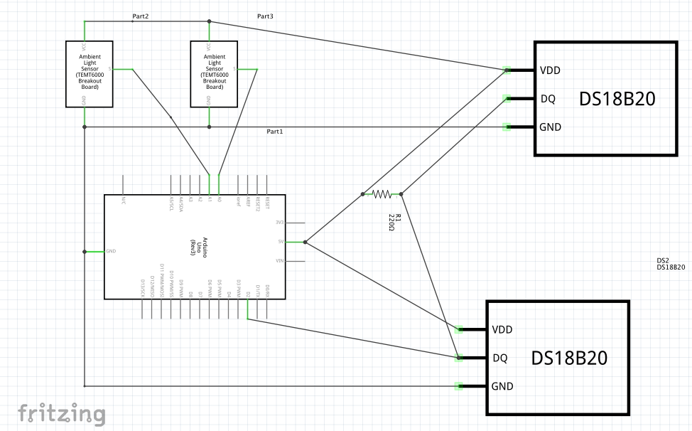
Figure 2. Wiring diagram for two node cabled deployment containing TEMT6000 ambient light sensors and DS18B20 One Wire temperature sensors with Arduino Uno microcontroller.

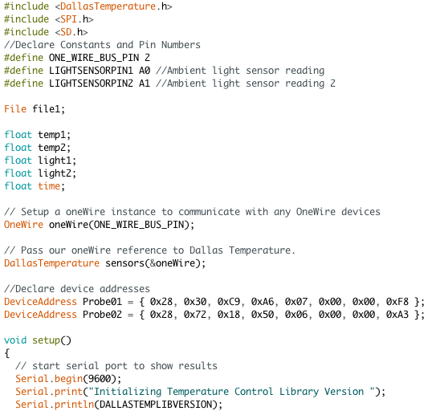
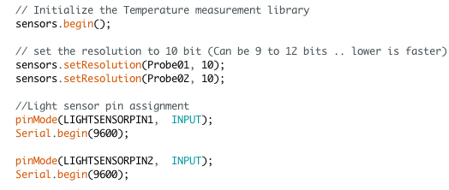
Figure 3. Instrument code dictating the setup for light and temperature sensors in all nodes.

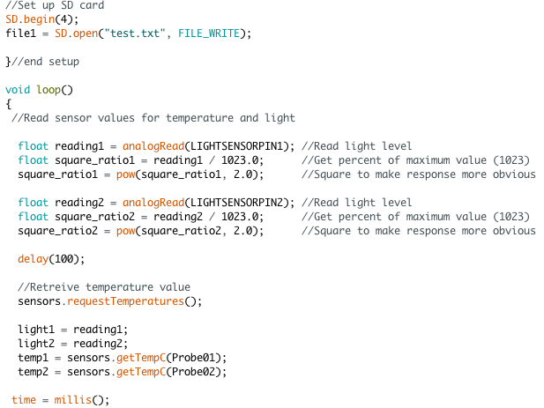
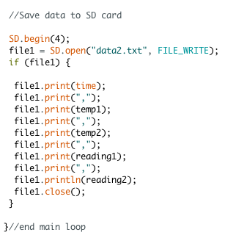
Figure 4. Instrument code to retrieve temperature and light readings from instrument and log data to the SD card.

Figure 5. Instrument deployed perpendicular to shoreline on the East side of Portage Bay. Control box (A), node 1 (B), and node 2 (C) are pictured. Photo credit: Malea Saul.

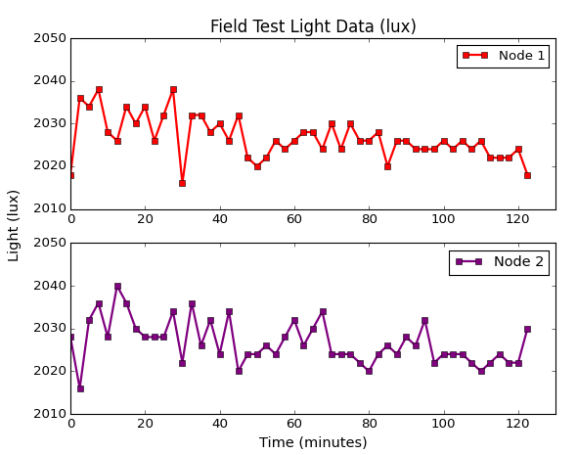

Figure 6. Light data (in lux) taken every 2.5 minutes from nodes 1 and 2 over a 124-minute deployment period.

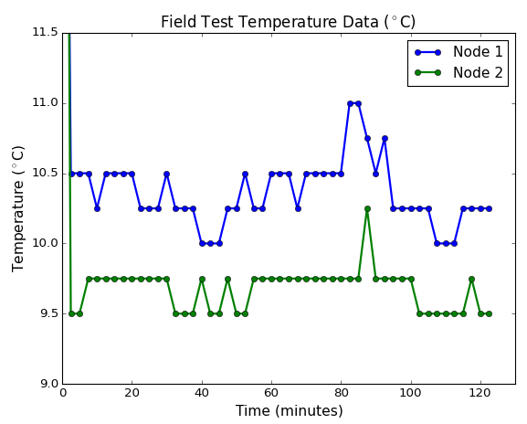

Figure 7. Temperature data (°C) taken every 2.5 minutes from nodes 1 and 2 over a 124-minute deployment period.

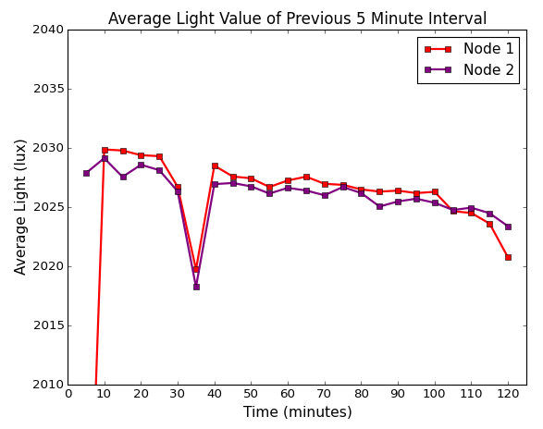

Figure 8. Temperature (°C) averages from both nodes over 5-minute time intervals of 120-minute instrument deployment.

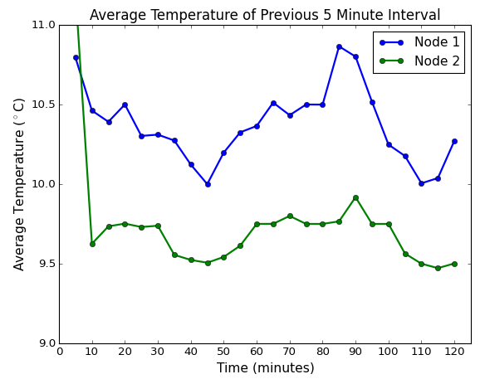

Figure 9. Light averages (lux) from both nodes over 5-minute time intervals of 120-minute instrument deployment.

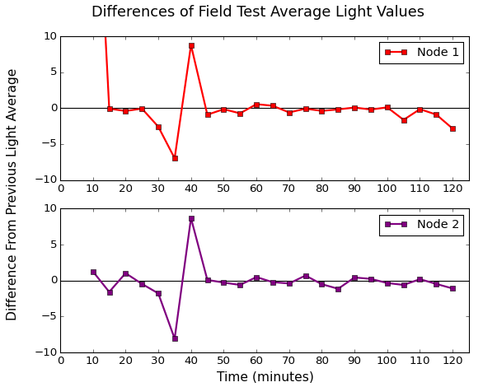

Figure 10. Difference from previous light average plotted. Differences taken between average light readings of consecutive 5-minute time intervals.
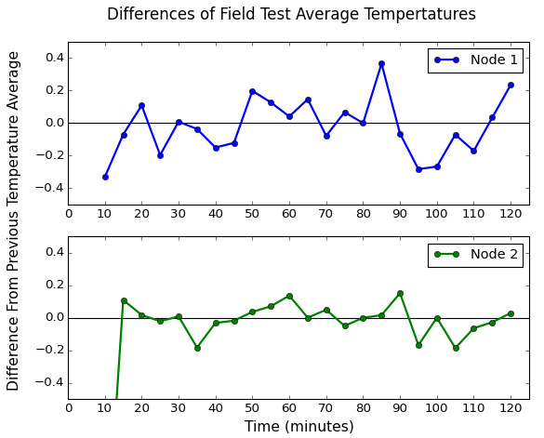
Figure 11. Difference from previous temperature average plotted. Differences taken between average temperature readings of consecutive 5-minute time intervals.

