Oncology Clinic Staff Training
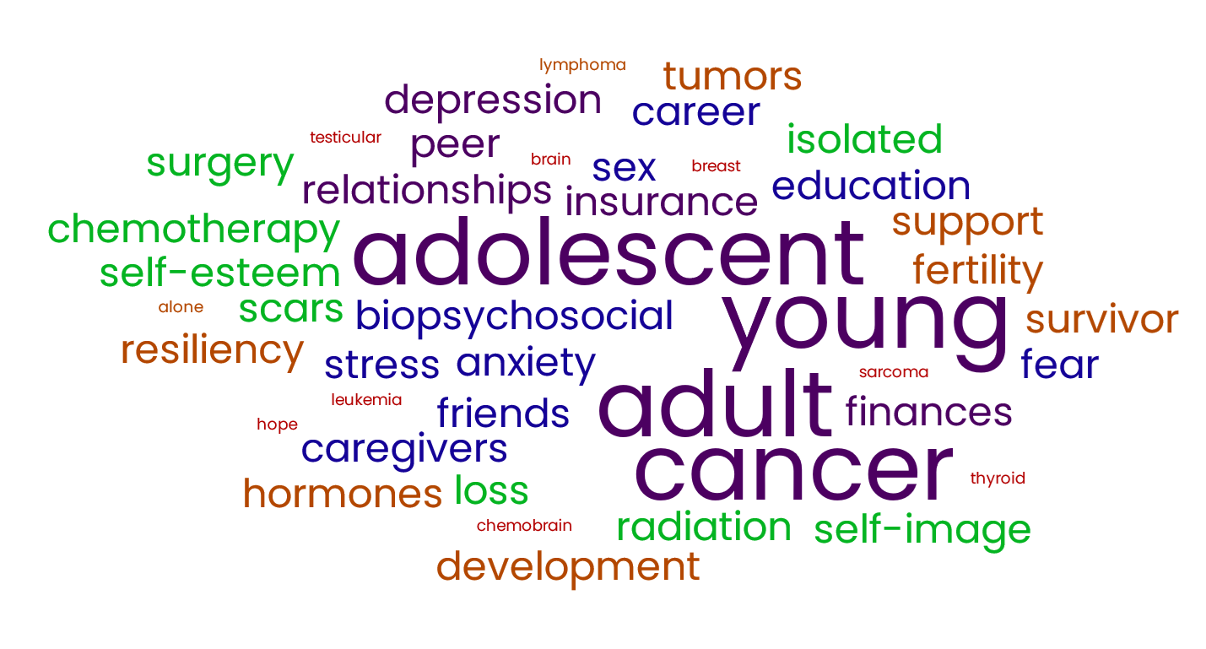
Lunch and Learn: Addressing Needs and Resources of Adolescent and Young Adult Cancer Patients
Come enjoy a complimentary lunch while learning about the needs of your adolescent and young adult cancer patients and available resources you can take with you!!!

[Insert 1st Training Date, Time (start and end), and Location]

[Insert 2nd Training Date, Time (start and end), and Location]

[Insert 3rd Training Date, Time (start and end), and Location]

Sign Up Now!!!
[Insert Sign Up Link Here]

Contact [Insert Name]: at [Insert email] with Questions

