SUPPORTING INFORMATION:
Table S1: Provided as separate file. Sample data for all 923 modern diaspores used in this study. Columns are tip – phylogenetic tip of taxon, individual – internal number for individual sampled herbarium specimens, prefixes refer to institutions as follows: KS17 – field collected in Kansas 2017, MO- Missouri Botanical Garden, NYBG – New York Botanical Garden herbarium, NYBG_18 – New York Botanical herbarium collected in 2018, Pip – US National Herbarium, Shef – growth chamber grown specimens at the University of Sheffield, US – US National Herbarium, WTU- University of Washington herbarium, WB – field collected, USDA – USDA GRIN-Global germplasm, specimen – diaspore sample from a given individual, herbarium.code – identifier for specimens taken from herbaria, area – diaspore area, perim – diaspore perimeter, circ- diaspore circularity, AR – diaspore aspect ratio, round – diaspore roundness, solid – diaspore solidity, rough – diaspore roughness, velocity.md – median diaspore falling velocity (cm/s) from falling trials, velocity.sd – standard deviation of falling velocity, avg.mass – mean diaspore mass (mg) from all weight trials, se.mass – standard error of diaspore mass, species – taxonomic information taken from herbarium sheets, grw.habit – growth habit of taxon, exposure – inferred diaspore exposure (see Will et al., 2007), unit – structural unit comprising the diaspore, lemma – degree of induration of the lemma or other enclosing bract (e.g., when floret is not the diaspore), callus – shape of callus, awn.max – maximum typical awn length (mm), awn.persitence – whether awn is persistent on the diaspore, AtP – attachment potential estimated from sheep based regression model from Will et al. (2007), gbif – taxonomic information matched to GBIF records.

METHODS S1:
Phytolith extraction and analysis
A total of seven productive phytolith assemblages were analyzed to characterize phytolith assemblages. These were obtained from five fossil sites preserving silicified anthoecia, listed below:
JRT-9 – Ellis, KS (late Miocene)
JRT-50 – Lewellen, NE (late Miocene)
JRT-65 – Mitchell, NE (early Miocene)
JRT-69 – Mitchell, NE (early Miocene)
JRT-74 – Broadwater, NE (late Oligocene – early Miocene)

Site names follow those originally established by Thomasson when initially investigated for fossil anthoecia (see e.g., Thomasson, 1985). Three of these sites (JRT-65, 69, and 74) were extensively sampled by us, and are consequently described in more detail below in Figs. S1-S3. The remaining two sites (JRT-9 and 50) were only briefly visited, or could not be visited at all, but have been thoroughly described in the literature (Thomasson, 1979; Thomasson, 2005). JRT-9 and JRT-50 appear to be of approximately similar age (early Hemphillian) (Thomasson, 1979; Thomasson, 1985; Thomasson, 2005). At JRT-9 phytolith samples (FHSU17-038) were taken from Thomasson’s “unit 2” (see Appendix in Thomasson, 1979). At JRT-50, phytolith samples were taken from base of Thomasson’s “bed 7” (see Fig. 2 in Thomasson, 2005). The abundance of silicified root casts, burrows, and complexes interpreted as ant nests (the “daemonelix” of previous authors; Smith et al., 2011) in units from all five sites which fossil anthoecia and phytolith samples were recovered, suggests that fossil bearing units represent sequences of paleosols (Thomasson, 1979; Thomasson, 2005; Figs. S1-3). Although this similarity of facies is encouraging, the presence of fluvial deposits (e.g., channel lags) in close proximity to these units at some sites (e.g., JRT-69, Fig. S2), and lacustrian deposits (e.g., marls) near others (e.g., JRT-65, Fig. S3) suggests the broader depositional context may be variable across sites. Together these sites do not represent all anthoecia included in the publication, however all those sites which were not directly sampled for phytoliths (e.g., JRT-64, JRT-56; Table S2) are geographically, depositionally, and temporally similar to one of the sampled sites (Thomasson, 1979; Thomasson, 1985; Thomasson, 2005). Furthermore, these phytolith data fit within a well-established history of phytolith assemblages from the North American Great Plains throughout the Miocene (e.g., Strömberg, 2005; Strömberg, 2011).
We extracted phytoliths from paleosols and sediment (1 gram per sample) following standard extraction procedures described in Strömberg et al. (2007), which involves carbonate removal using hydrochloric acid (sediment only); removal of large particles using a 250 µm sieve; removal of organic material using Schulze’s solution; sediment deflocculation with a 53 µm sieve; and biosilica separation through centrifugation with zinc-bromide-based heavy liquid. The extracted silica was dried in an oven and mounted on slides using a fixed mounting medium (Cargille MeltMount®) for microscope observation and imaging.
For most samples, at least 200 diagnostic phytoliths were counted for each productive sample to ensure robust environmental reconstructions (Strömberg 2009). Diagnostic phytoliths consisted of three main Phytolith Plant Functional Type (Phytolith PFT) categories, broadly following the scheme developed for deep time studies by Strömberg and colleagues (discussion in Strömberg et al., 2018; Crifò and Strömberg, 2020): (1) PALM (palm, family Arecaceae) phytoliths, (2) Other FI, which are non-palm forest indicator (FI) phytoliths, primarily including morphotypes typical of woody and herbaceous dicotyledonous angiosperms and monocotyledonous plants often associated with closed habitats (e.g., Zingiberales), and (3) GSSCP, or grass silica short cell phytoliths, which are exclusive to the grass family (Poaceae) and further subdivided into GSSCP PFT (see below). Remaining phytolith morphotypes were considered non-diagnostic and were classified into three main categories: (4) AQ, which encompass phytoliths typical of plants often living near water, such as sedges (Cyperaceae) and horsetail (Equisetum); (5) NDG (Non-Diagnostic Grass), which includes non-GSSCP grass phytoliths, morphotypes produced in abundance by grasses but also by other monocotyledonous plants, and/or conifers (including silicified bulliform cells, trichomes, and spiny elongates); and (6) NDO (Non-Diagnostic Other), which are non-diagnostic phytoliths produced by a wide range of plants and thus of unclear origin. As the silicification of bulliform cells, trichomes, and elongates by herbaceous plants greatly varies according to abiotic factors like water supply and evapotranspiration rate (e.g., Bremond et al., 2005, Madella et al., 2009), phytoliths from the NDG and NDO Phytolith PFT were not used in the estimate of the arboreal cover. AQ was also not used as it should reflect microhabitats near water rather than overall local vegetation type (Strömberg et al., 2018).
The GSSCP category was further divided into six Phytolith PFT linked to taxonomy and/or ecology (Strömberg et al., 2018): (a) APPBO (closed-habitat grasses) GSSCP, which are diagnostic of grasses in the different clades of early diverging grasses (Anomochlooideae, Pharoideae, Puelioideae), Bambusoideae, and Oryzoideae, all of which tend to live in closed and/or wet habitats; (b) POOID-D (Pooid Diagnostic) GSSCP, which are morphotypes typically produced by grasses in the Pooideae; (c) POOID-ND (Pooid Non-Diagnostic) GSSCP, forms often produced in abundance by pooids, but also by a wide range of other Poaceae taxa; (d) CHLOR GSSCP, a range of morphotypes diagnostic of the Chloridoideae in the PACMAD clade , which today contains exclusively C4 grasses; (e) PACMAD General GSSCP, which includes morphotypes typically formed in different PACMAD taxa, which could be either C4 or C3; and (f) OTHG GSSCP, which are morphotypes for which the taxonomic affinity is not known or that are broken or whose shape is otherwise obscured, preventing interpretation.
To assess the relative abundance of grasses relative to other plants, we calculated the FI-t ratio (Strömberg et al., 2018), that is, the percentage of forest indicator phytoliths (PALM + Other FI) out of the sum of diagnostic phytoliths (PALM + Other FI + GSSCP) (Table S9). The FI-t ratio is often used as a proxy for arboreal cover (i.e., vegetation structure) (e.g., Strömberg, 2005), but note that the relative abundance of “forest indicator” taxa is not always correlated with openness of habitat (Dunn et al., 2015). Ninety-five percent confidence intervals for the FI-t metric were assessed by bootstrapping using the R software environment (v. 4.1.3; R Core Team, 2022). The relative abundance of different grass PFTs were used to analyze grass community composition. The presence and abundance (in semi-quantitative terms) of diatoms, sponge spicules, and chrysophyte cysts were used to assess proximity to water (e.g., wet soils, lakes, riparian zone) (Clarke, 2003).

Table S2: Table including all measured fossil phytoliths. Columns are as follows: sample – internal sample number, roughly corresponding to a single taxon obtained from a single sediment sample (i.e., one taxon from a distinct point in time/space, specimen – specific anthoecium from a specific sample, area – diaspore area, AR – diaspore aspect ratio, circ – diaspore circularity, round – diaspore roundness, solid – diaspore solidity, rough – diaspore roughness (following Will et al., 2007), preservation – evaluation of the general quality of diaspore preservation, independent of its completeness, incomplete – indication of how complete each diaspore is (partial refers to part being partially preserved), site – fossil site that anthoecium came from, subsite – specific layer from which fossils were obtained, these are cross-referenced with Thomasson’s original notes, taxon – species name, det – source of determination for species name, lemma – reconstruction of lemma induration, callus – reconstruction of callus morphology, exposure – reconstruction of likely diaspore exposure, fhsu loan# - for loaned specimens the original FHSU loan number, other – additional notes on source of fossil, including for literature sourced fossils the original reference, awn – reconstruction of whether awn was present or not (all coded as absent or deciduous), awn.size – interpretation of functional awn length (0 for all taxa), Vt.fit – estimated falling velocity of fossil (see Results S6), Vt.lwr – lower 95% confidence interval for estimated falling velocity, Vt.upr - upper 95% confidence interval for estimated falling velocity.

Figure S1: Next page. Stratigraphic section of fossil site JRT-74. Broadwater, NE (41° 36’ 9” N, 102° 46’ 52” W). Lower portions (U1, U2) are assigned to either the Monroe Creek or Harrison Formations, which cannot be distinguished at the locality. Assignment is on the basis of sedimentary structure (i.e., “pipy concretions”) typical of these units (Thomasson, 1985; Thomasson pers. comm.). Phytolith assemblages (Ne18-075, Ne19-012) and fossil anthoecia (see Table S2) were taken from U1. Unit descriptions are as follows: U1 – greyish-tan to slightly pink fine to very fine grain sand, poorly consolidated. Locally well cemented, forming large nodules to more or less continuous ledges. The latter up to 0.5 meters thick. “Daemonelix” and other silicified inclusions (e.g., root traces) preserved in abundance. Fossil anthoecia locally abundant. U2 – yellowish-tan, fine to very fine-grained sand poorly to moderately consolidated. Locally cemented, forming large nodules to more continuous ledges, resembling U1. Silicified inclusions (e.g., root traces) locally abundant. U3 – Caliche, locally sandy poorly consolidated to well cemented. U4 – Tan to grey, fine grained sand matrix with frequently larger clasts, which are subrounded to rounded and of various lithology. Moderately to well consolidated. U5 – lower contact obscured by vegetation and washed material. Pink to tan sand, fine to coarse grained, poorly sorted, rounded, poorly to moderately consolidated. Distinct lenses of varying grain size, in lower portions which also preserve some bedding surfaces. U6 – Brown to red-brown sand, fine to coarse grained, unconsolidated to well consolidated or locally cemented (especially in upper levels). Base of unit with prominent lamination and beds of gravel, including also some rip-up-clasts. Beds of grey volcanic ash near top of unit. U7 – White marl.

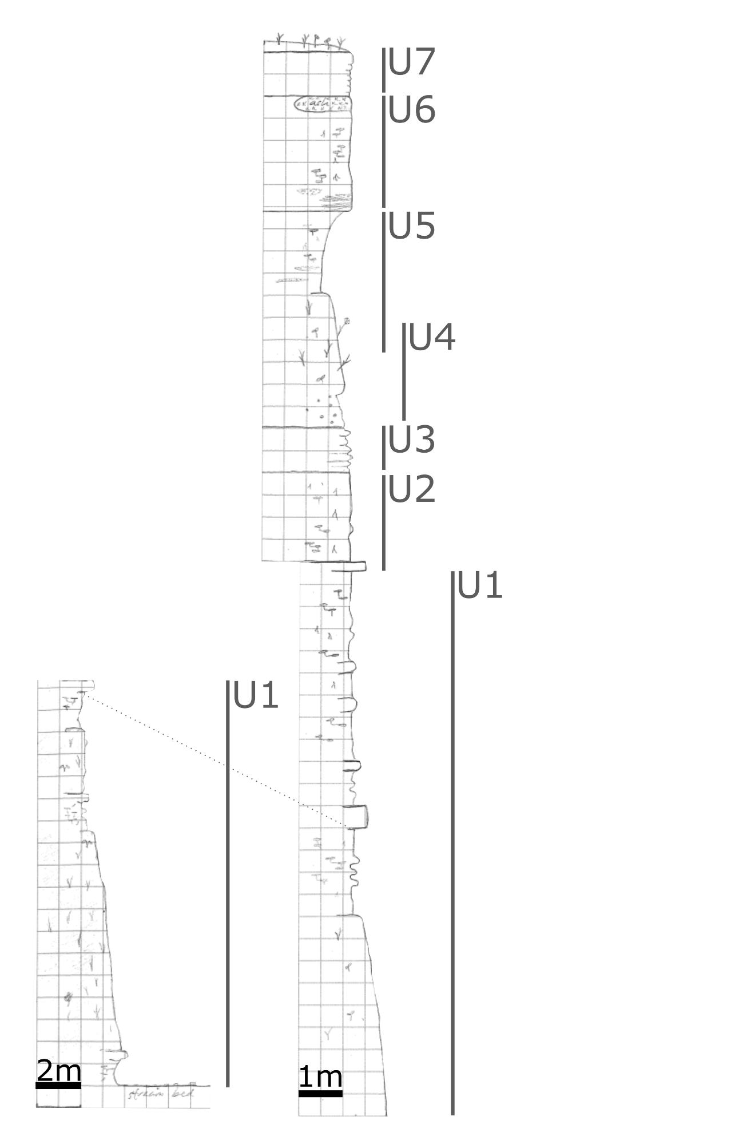
Figure S2: Next page. Stratigraphic section of fossil site JRT-69A and JRT-69B. Mitchell, NE (42° 11’ 18” N, 103° 46’ 13” W). All units are in “Pliohippus draw” and assigned to Sheep Creek Formation following Skinner et al. (1977). Phytolith assemblages were analyzed from U1 (Ne18-042) and U8 (Ne18-068) from JRT 69A and fossil anthoecia were taken from several units (see Table S2). Unit descriptions are as follows at JRT-69A: U1 – poorly consolidated, fine grained to very fine-grained sand, tan, well sorted, with abundant silicified root casts, anthoecia (locally abundant), and other material (e.g., “Daemonelix”). Locally well cemented. U2 – yellowish-tan, fine to very fine-grained sand poorly to moderately consolidated. Locally cemented, forming large nodules to more continuous ledges, resembling U1. Silicified inclusions (e.g., root traces) locally abundant. U3 – poorly consolidated, fine grained, moderately to well sorted, sand. Yellowish-tan. Relatively abundant silicified root traces and anthoecia. Unit capped by more cemented sediments forming a distinct “ledge”. U4 – yellowish-tan, fine grained to very-fine grained sand, well sorted, poorly to moderately consolidated, locally cemented. Preserves lenses of silicified anthoecia and other material (root casts?). Thickness of unit variable. U5 – Grey to tan, fine grained sandstone, well sorted. Weather to blocky appearance at base of unit. Unconformably overlies U4, cutting into portions of the underlying unit. Channel fill. U6 – Grey ash, fine grained, locally overlies either U4 or U5. U7 – contact with U6 not distinct, fine grained to very fine grained yellowish-tan sand poorly consolidated to locally well cemented. Cememnted portions form large lenses or more continuous ledges near the bottom of the unit. Uncemented portions of contain very abundant silicified inclusions (root traces, anthoecia), these forming a more continuous layer at the top of unit. U8 – mostly covered at study site, true thickness thus unclear. Fine to very-fine grained sand and silt, well sorted, tanish-yellow to grey in color, poorly consolidated. Locally well cemented, forming large lenses, to more continuous ledges. Abundant silicified inclusions (e.g., root casts). Unit descriptions at JRT-69B: U1 – U5: same as at JRT-69A. U6 – lower portions largely obscured, precise contact with U4 and/or U5 thus unclear. Fine grained, tan to grey sands, moderately consolidated, to locally cemented. Weathers to rough crumbly appearance. Abundant silicified inclusions (e.g., root traces). U7 – only locally present, fine to very-fine grained sandstone. Well sorted, greyish-tan to yellow color. U8 – Fine to very-fine grained yellowish-tan sands well sorted, poorly consolidated, silicified inclusions less abundant. U9 – greyish-tan fine to very-fine grained sandstone. Moderately to well cemented. Thickness variable, forming prominent ledge. Cemented upper portions of U8? U10 – contact with U9 obscured. Greyish to yellow fine to very-fine grained sandstone, with some small silicified inclusions of unclear origin. Grading into U11. U11 – white marl, lower sections showing sandy interbeds. U12 – dark tan to reddish brown sand, poorly sorted with occasional large clasts, poorly consolidated, changing color to more grey near the top. U13 – moderately consolidated grey ash, sandier near base of unit. U14 – tan, fine grained sand, poorly consolidated. Preserving some silicified inclusions. Capped by resistant ledge of varying thickness. 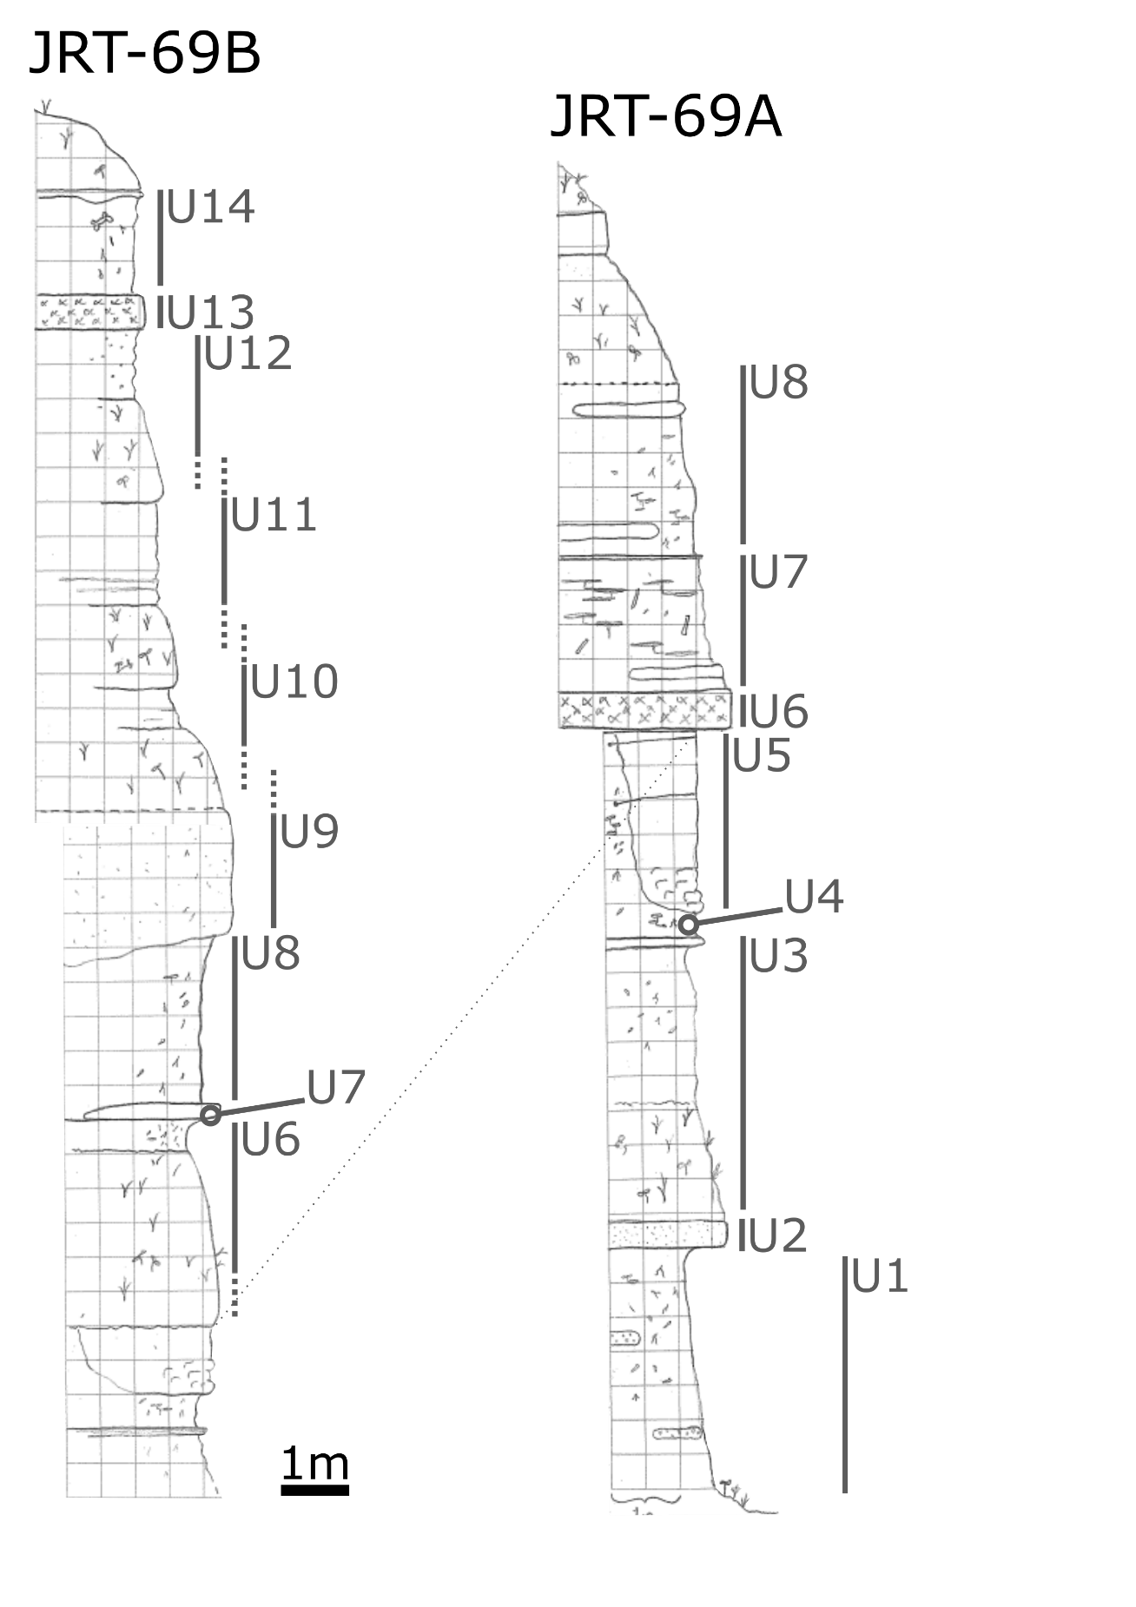
Figure S3: Next page. Stratigraphic section of fossil site JRT-65. Mitchell, NE (42° 11’ 33” N, 103° 46’ 47” W). All units are in “Merychippus draw” and assigned to Sheep Creek Formation following Skinner (1977). Phytolith assemblages were analyzed from U1 (Ne18-002) and fossil anthoecia were taken from several units (see Table S2). Unit descriptions are as follows: U1 – fine to very-fine grained sands and silts, well sorted, poorly consolidated, light tan color. Abundant silicified inclusions including many “daemonelix” and root traces/burrows. Anthoecia locally present. Capped by better cemented “platy ledge”. U2 – similar to U1. Fine to very-fine grained sands and silts, tanish color, well sorted, poorly consolidated. Capped by better cemented “platy ledge”. U3 – similar to U1 and U2. fine to very-fine grained sands and silt, well sorted, tan color, poorly consolidated. Capped by better cemented “play ledge”. U4 – fine grained sand, poorly consolidated, well sorted, tan. Redder in color than underlying units. Some silicified inclusions (e.g., root traces). U5 – grey ash, poorly to locally well consolidated. Thin (~5cm) darker and coarser grained material at base of unit. Above finer grained and lighter in color. Upper portions also including silicified inclusions as found in lower units. Grading into U6. U6 – tan, fine to medium grained sand. Poorly sorted and consolidated. Preserving “daemonelix” and other silicified inclusions”.

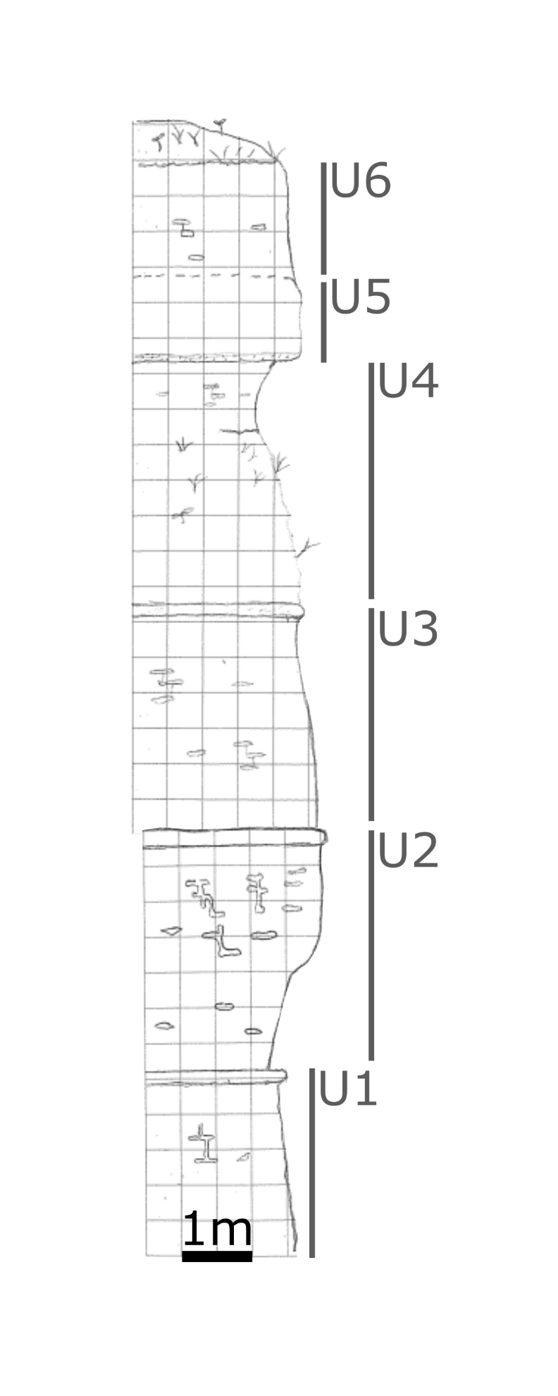
Table S3: Provided as separate file. Accession numbers for sequence data downloaded from gen bank for each marker used in phylogenetic analyses.

Figure S4: Dimensions of the chamber and camera setup used in measuring diaspore falling velocity. Falling velocity was measured from high-speed video (959.04 frames/second) of diaspores descending through an enclosed, plexiglass chamber, and calculated from the number of frames elapsed before diaspores travelled the vertical distance of the frame. Diaspores were placed in a repurposed camera shutter and dropped into the chamber using a manual shutter release to ensure controlled release. The chamber ensured air currents in the surrounding room did not disrupt the trajectory of the falling diaspore.
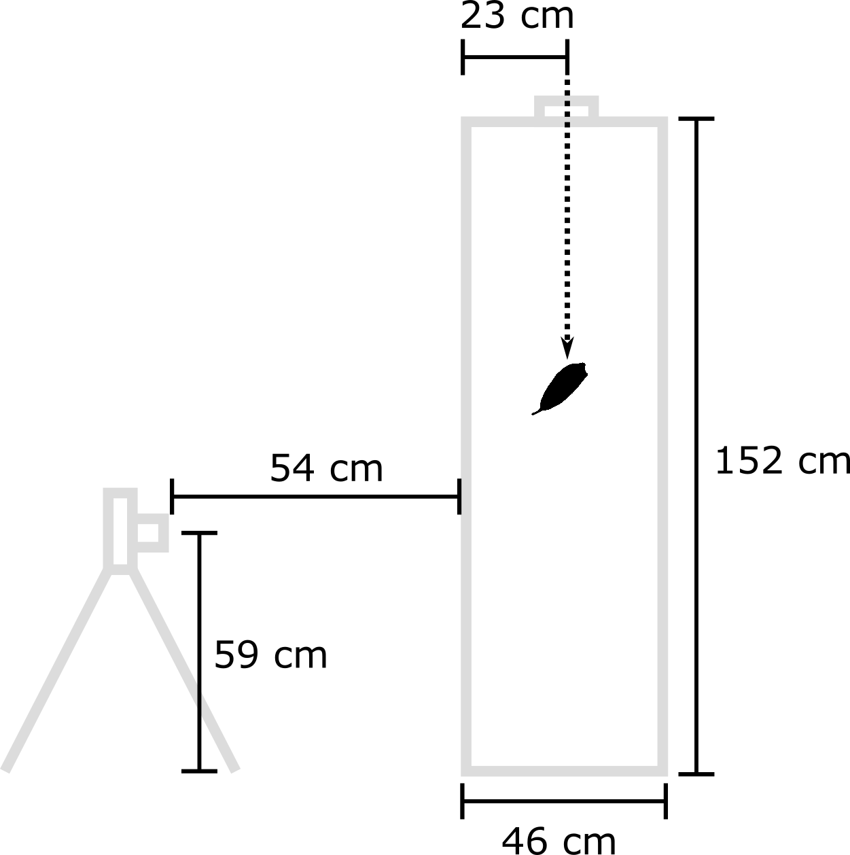

METHODS S2:
Notes on diaspore exposure
To classify taxa as having exposed, partially enclosed, or enclosed diaspores we followed the protocols of Will et al. (2007). Sample for this was on largely non-grass taxa, below are our notes on how this was adapted specifically to grasses.

Enclosed
- Floret is diaspore
- glumes approx. same length as entire spikelet (incl. awn, if persistent)
- if not as above, then foliage enclosing or obscuring diaspores (e.g., Aciachne spp., Pennisetum clandestinum)

Partial
- floret or multiple florets diaspore
- glumes shorter than above (rel. to spikelet), but still covering part (e.g., Stipeae with glumes exceeded by awns), and/or fertile florets many per spikelet and densely packed (e.g., Brachypodium distachyon)
- if glumes hardly covering spikelet or diaspore is spikelet, then panicle contracted (e.g., Glyceria borealis) and/or spikelets appressed to prominent rachis (e.g., Axonopus)

Exposed
- spikelet is diaspore
- if diaspore does not contain glumes, then glumes covering a negligible portion of spikelet (e.g., Lycochloa avenacea)
- panicle not contracted, or if contracted is spikelike with diaspores oriented so they are facing outward, sometimes obscuring main axis of inflorescence (e.g., Melica altissima, Melica ciliata)

Table S4: Provided as separate file. Raw geospatial data with extracted grassland region and MODIS data provided for all 470,910 occurrence records which met our sampling criteria (Methods S3). Includes species, longitude, latitude, grassland type (i.e., “formation” following Dixon et al., 2014), raw tree cover, tree cover from only high-quality data points, and number of high-quality data points.

METHODS S3:
GBIF vetting procedures
Ecological data for the project were obtained using a Geographic Information System (GIS) approach. Georeferenced occurrence records were downloaded from the Global Biodiversity Information Facility (GBIF) separately for Poaceae (6,666,615 records; GBIF.org, 2022a) and three outgroup genera (Flagellaria, Joinvillea, Ecdeiocolea) (5,953 records; GBIF.org, 2022b). Once obtained, occurrence records were “cleaned” using GBIF’s internal quality tags, limiting records to just those associated with preserved specimens collected after 1949, and excluding all those which were flagged with any of the following notifications.

CONTINENT_INVALID
COORDINATE_PRECISION_INVALID
COORDINATE_ROUNDED
COUNTRY_DERIVED_FROM_COORDINATES
COUNTRY_INVALID
COUNTRY_MISMATCH
GEODETIC_DATUM_ASSUMED_WGS84
GEODETIC_DATUM_INVALID
IDENTIFIED_DATE_UNLIKELY
OCCURRENCE_STATUS_UNPARSABLE
PRESUMED_NEGATED_LATITUDE
PRESUMED_NEGATED_LONGITUDE
PRESUMED_SWAPPED_COORDINATE
RECORDED_DATE_INVALID
RECORDED_DATE_UNLIKELY
RECORDED_DATE_MISMATCH
TAXON_MATCH_FUZZY
TAXON_MATCH_HIGHERRANK

The remaining records were subjected to further checks using the CoordinateCleaner package (v 2.0-11; Zizka et al., 2019) in the R software environment (v. 4.1.3; R Core Team, 2022). This excluded all records that were assigned the coordinates of the capital or centroid of the country in which they were found (within 1km) or those assigned the coordinates of known institutions housing preserved specimens (e.g., botanical gardens, herbaria). Records were dropped if collection country did not match its coordinate data. Records with the same latitude and longitude or zero values were also excluded. Finally, the dataset was limited to unique records (i.e., limit of one record per locality).

Earth engine code
Java script used to extract tree cover data from MOD44B cover maps in Google Earth Engine is provided as separate file.

Reference taxa
Grassland and non-grassland reference taxa, with citations
- North American Tall Grass Prairie (abv. TGP):
  - Andropogon gerardii (Gibson, 2009)
  - Sorghastrum nutans (Gibson, 2009)
  - Panicum virgatum (Gibson, 2009)
  - Hesperostipa spartea (Gibson, 2009)
  - Sporobolis heterolepis (Gibson, 2009)
  - Schizachyrium scoparium (Gibson, 2009)
  - Poa pratensis- introduced (Gibson, 2009)
  - Spartina pectinata- on wet/inundated sites (Gibson, 2009)

- North American Mixed/Mid Grass Prairie (abv. MGP):
  - Hesperostipa comate (Gibson, 2009)
  - Koeleria macrantha (Gibson, 2009)
  - Sporobolus cryptandrus (Gibson, 2009)
  - Pascopyrum smithii (Gibson, 2009)
  - Bouteloua curtipendula (Gibson, 2009)
  - Bouteloua dactyloides (Gibson, 2009)
  - Bouteloua gracilis (Gibson, 2009)
  - Elymus lanceolatus (Gibson, 2009)
  - Festuca spp. (Gibson, 2009)
    - Festuca saximontana (Stubbendieck et al., 2017)

- North American Short Grass Prairie (abv. SGP):
  - Bouteloua gracilis (Gibson, 2009)
  - Bouteloua dactyloides (Gibson, 2009)
  - Hilaria belangeri (Gibson, 2009)
  - Hilaria mutica (Gibson, 2009)

- Mongolian-Manchurian prairie (abv. MMP):
  - Aneurolepidium chinense (Gibson, 2009)
  - Cleistogenes squarrosa (Gibson, 2009)
  - Fillifolium sibiricuman (Gibson, 2009)
  - Stipa baicalensis (Gibson, 2009)
  - Stipa grandis (Gibson, 2009)
  - Stipa krylovii (Gibson, 2009)
  - Stipa capillata (Gibson, 2009)

- Venezuelan Savannah (abv VS):
  - Trachypogon plumosus- dominant species (Gibson, 2009)- synonym of T. spicatus (see Cerrado species)
  - Trachypogon vestitus- dominant species (Gibson, 2009)
  - Axonopus canescens (Gibson, 2009)
  - Axonopus anceps (Gibson, 2009)
  - Andropogon selloanus (Gibson, 2009)
  - Aristida spp.(Gibson, 2009)
    - A. longifolia (Davidse et al., 2004)
    - A. riparia (Davidse et al., 2004)
    - A. setifolia (Davidse et al., 2004)
  - Leptocoryphium lanatum (Gibson, 2009)
  - Sporobolus indicus (Gibson, 2009)
  - Sprobolus cubensis (Gibson, 2009)
  - Paspalum carinatum (Gibson, 2009)

- Cerrados (abv. CSS):
  - There are many communities with variable physiognomy that fall under the “cerrado” umberella (Oliveira and Margquis, 2002). The taxa listed below are common components of the cerrado sensu stricto, which is a community with a substantial woody component of up to roughly 30% coverage (Oliveira and Margquis, 2002). The taxa chosen were taken from descriptions in Oliveira and Margquis (2002) and from the most common taxa from Silberbauer-Gottsberger (1984), which was a one hectare survey of grasses in a cerrado (sensu stricto) habitat.

  - Aristida megapotamica (Silberbauer-Gottsberger, 1984)
  - Axonopus spp. (Oliveira and Margquis, 2002)
    - A. pellitus (Silberbauer-Gottsberger, 1984)
    - A. suffultus (Silberbauer-Gottsberger, 1984)
  - Diandrostachya chrysothrix (Silberbauer-Gottsberger, 1984)
  - Echinolaena spp. (Gibson, 2009)
    - E. inflexa (Oliveira and Margquis, 2002)
  - Paspalum spp. (Gibson, 2009)
    - P. carinatum (Silberbauer-Gottsberger, 1984)
  - Schizachyrium tenerum (Silberbauer-Gottsberger, 1984)
  - Trachypogon spp. (Gibson, 2009)
    - T. spicatus (Silberbauer-Gottsberger, 1984; Oliveira and Margquis, 2002)
  - Tristachya spp. (Gibson, 2009)
    - T. leiostachya (Silberbauer-Gottsberger, 1984; Oliveira and Margquis, 2002)

- Serengeti Ecosystem:
  - Classification based largely upon McNaughton (1983), which through cluster analysis identified a number of discrete grassland communities within the Serengeti Ecosystem. Representatives of five clusters representing short-grass dominated communities and 8 clusters representing mid-grass communities are included. The former are communities common in the Serengeti plains and other more open habitats of the region, and will be considered to represent an open grassland/prairie among the assembled reference communities (i.e., TGP, MGP, SGP, and Mongolian-Manchurian prairie). The latter include those communities typically found in more closed, savannahs or wooded grasslands (sensu Lind and Morrison, 1974) and will be considered to represent savannah among the assembled reference communities (i.e., Venezuelan Savannah and Cerrado censu stricto).
    - Representatives were chosen so that the top two most abundant taxa from each community (see Table 1 in McNaughton, 1983), along with all taxa representing a substantial portion of the recorded individuals in a community (>6%)

  - Short Grass Serengeti
    - Sporobolus kentrophyllus (McNaughton, 1983)- synonymous w/ S. ioclados (Tropicos)
    - Sporobolus ioclados (McNaughton, 1983)
    - Digitaria macroblephara (McNaughton, 1983)
    - Cynodon dactylon (McNaughton, 1983)
    - Pennisetum mezianum (McNaughton, 1983)
    - Andropogon greenwayi (McNaughton, 1983)
    - Chloris pycnothrix (McNaughton, 1983)
    - Chrysochloa orientalis (McNaughton, 1983)
    - Setaria sphacelata (McNaughton, 1983)
    - Themeda triandra (McNaughton, 1983)
  - Mid Grass Serengeti
    - Themeda triandra- dominant tall grass (Lind and Morrison, 1974; McNaughton, 1983; Gibson, 2009)
    - Sporobolus fimbriatus (McNaughton, 1983)
    - Harpachne schimperi (McNaughton, 1983)
    - Digitaria ternata (McNaughton, 1983)
    - Heteropogon contortus (McNaughton, 1983)
    - Eustachys paspaloides (McNaughton, 1983)
    - Loudetia arundinacea (McNaughton, 1983)
    - Panicum coloratum (McNaughton, 1983)
    - Eragrostis tenuifolia (McNaughton, 1983)
    - Sporobolus pyramidalis (McNaughton, 1983)
    - Bothriochloa insculpata (McNaughton, 1983)
    - Pennisetum mezianum (McNaughton, 1983)
    - Eragrostis cilianensis (McNaughton, 1983)
    - Aristida adoensis (McNaughton, 1983)
    - Andropogon schirensis (McNaughton, 1983)
- Closed Forest (& other non-grassland) – in large part these were taken from a list of genera which are restricted to full or partial shade habitats (i.e., never found in full sun) taken from the supplement of Gallaher et al. (2019).
  - Centotheca lappacea (Innes and Clayton, 1977)
  - Streptogyna americana (Gallaher et al., 2019)
  - Chrysochloa orientalis (van der Pijl, 1982)
  - Brylkinia caudata (Flora of China v.22)
  - Flagellaria indica (Flora of China v.22)
  - Streptochaeta spicata (Gallaher et al., 2019)
  - Anomochloa marantoidea (Gallaher et al., 2019)
  - Pharus latifolius (Gallaher et al., 2019)
  - Pharus lappulaceus (Gallaher et al., 2019)
  - Leptaspis zeylanica (Innes and Clayton, 1977; Gallaher et al., 2019)
  - Scrotochloa urceolata (Gallaher et al., 2019)
  - Puelia olyriformis (Gallaher et al., 2019)
  - Sasa kurilensis (Gallaher et al., 2019)
  - Pariana radiciflora (Gallaher et al., 2019)
  - Pariana campestris (Gallaher et al., 2019)
  - Olyra latifolia (Innes and Clayton, 1977; Gallaher et al., 2019)
  - Oplismenus hirtellus (Innes and Clayton, 1977; Gallaher et al., 2019)
  - Microstegium vimineum (Flora of China v.22; Gallaher et al., 2019)
  - Puelia ciliata (Gallaher et al., 2019)
  - Humbertochloa bambusiuscula (Gallaher et al., 2019)
  - Brachyelytrum aristosum (Gallaher et al., 2019)
  - Brachyelytrum erectum (Gallaher et al., 2019)
  - Diarrhena americana (Gallaher et al., 2019)
  - Diarrhena obovata (Gallaher et al., 2019)
  - Melica uniflora (Cope and Gray, 2009)
  - Melica nutans (Cope and Gray, 2009)

Table S5: Output from brms model(s) predicting falling velocity, showing priors used in analyses. Columns show the prior (using brms syntax), the parameter class, the coefficient to which it corresponded and the source of each prior.
prior | class | coef | group | source
normal(0, 0.75) | b |  |  | user
normal(0, 0.75) | b | fmlwld.trop |  | (vectorized)
normal(0, 0.75) | b | fmtemperate |  | (vectorized)
normal(0, 0.75) | b | fmwarm.arid |  | (vectorized)
normal(0, 0.75) | b | perc.gld |  | (vectorized)
normal(0, 0.75) | b | raw.tre |  | (vectorized)
student_t(3, 5, 2) | Intercept |  |  | user
student_t(3, 0, 2.5) | sd |  |  | user
student_t(3, 0, 2.5) | sd |  | tip | (vectorized)
student_t(3, 0, 2.5) | sd | Intercept | tip | (vectorized)
normal(0, 1) | sigma |  |  | user

Table S6: Output from brms model(s) predicting diaspore mass, showing priors used in analyses. Columns show the prior (using brms syntax), the parameter class, the coefficient to which it corresponded and the source of each prior.
prior | class | coef | group | source
normal(0, 0.75) | b |  |  | user
normal(0, 0.75) | b | fmlwld.trop |  | (vectorized)
normal(0, 0.75) | b | fmtemperate |  | (vectorized)
normal(0, 0.75) | b | fmwarm.arid |  | (vectorized)
normal(0, 0.75) | b | perc.gld |  | (vectorized)
normal(0, 0.75) | b | raw.tre |  | (vectorized)
student_t(3, -0.33, 1.5) | Intercept |  |  | user
student_t(3, 0, 2.5) | sd |  |  | user
student_t(3, 0, 2.5) | sd |  | tip | (vectorized)
student_t(3, 0, 2.5) | sd | Intercept | tip | (vectorized)
normal(0, 0.5) | sigma |  |  | user

Table S7: Output from brms model(s) predicting categorical endozoochory variables, showing priors used in analyses. Columns show the prior (using brms syntax), the parameter class, the coefficient to which it corresponded and the source of each prior.
prior | class | coef | group | source
normal(0, 300) | b |  |  | user
normal(0, 300) | b | perc.gld |  | (vectorized)
normal(0, 300) | b | raw.tre |  | (vectorized)
student_t(3, 0, 2.5) | Intercept |  |  | user
normal(0, 300) | sd |  |  | user
normal(0, 300) | sd |  | tip | (vectorized)
normal(0, 300) | sd | Intercept | tip | (vectorized)

Table S8: Output from brms model(s) predicting diaspore roughness and attachment potential, showing priors used in analyses. Columns show the prior (using brms syntax), the parameter class, the coefficient and response to which it corresponded and the source of each prior.
prior | class | coef | group | resp | source
normal(0, 4) | alpha |  |  | rough | default
normal(0, 0.75) | b |  |  | AtP | user
normal(0, 0.75) | b | perc.gld |  | AtP | (vectorized)
normal(0, 0.75) | b | radiationandro |  | AtP | (vectorized)
normal(0, 0.75) | b | radiationarist |  | AtP | (vectorized)
normal(0, 0.75) | b | radiationchlor |  | AtP | (vectorized)
normal(0, 0.75) | b | radiationpaspal |  | AtP | (vectorized)
normal(0, 0.75) | b | radiationstip |  | AtP | (vectorized)
normal(0, 0.75) | b | radiationtrit |  | AtP | (vectorized)
normal(0, 0.75) | b | raw.tre |  | AtP | (vectorized)
normal(0, 0.75) | b |  |  | rough | user
normal(0, 0.75) | b | perc.gld |  | rough | (vectorized)
normal(0, 0.75) | b | radiationandro |  | rough | (vectorized)
normal(0, 0.75) | b | radiationarist |  | rough | (vectorized)
normal(0, 0.75) | b | radiationchlor |  | rough | (vectorized)
normal(0, 0.75) | b | radiationpaspal |  | rough | (vectorized)
normal(0, 0.75) | b | radiationstip |  | rough | (vectorized)
normal(0, 0.75) | b | radiationtrit |  | rough | (vectorized)
normal(0, 0.75) | b | raw.tre |  | rough | (vectorized)
student_t(3, 1.02, 1) | Intercept |  |  | AtP | user
student_t(3, 0.6, 0.2) | Intercept |  |  | rough | user
lkj_corr_cholesky(0.5) | L |  |  |  | user
lkj_corr_cholesky(0.5) | L |  | tip |  | (vectorized)
student_t(3, 0, 2.5) | sd |  |  | AtP | user
student_t(3, 0, 2.5) | sd |  |  | rough | user
student_t(3, 0, 2.5) | sd |  | tip | AtP | (vectorized)
student_t(3, 0, 2.5) | sd | Intercept | tip | AtP | (vectorized)
student_t(3, 0, 2.5) | sd |  | tip | rough | (vectorized)
student_t(3, 0, 2.5) | sd | Intercept | tip | rough | (vectorized)
normal(0, 1) | sigma |  |  | AtP | user
normal(0, 1) | sigma |  |  | rough | user

Figure S5: Next page. Combined geographic information system (GIS) and literature based ancestral state reconstruction of grassland affinity for all grasses with either GIS data or dispersal data. First two panels show range of values from MODIS tree cover and grassland region GIS variables, with literature identified reference taxa identified (green – forest, tan – grassland). Averages for each reference group, with 95% confidence intervals, are shown at the right. The tree shows ancestral state reconstruction of grassland adaptation with external and interior nodes inferred as grassland adapted shown in green, and non-grassland adapted nodes shown in grey. Labels represent major groups (tribe or subfamily). Abbreviations are given for the Anomochlooideae-Puelioideae-Pharoideae grade (APP), Arundinoideae (Aru.), Aristidoideae (Ari.), Bambusoideae (Bm.), Danthonioideae (Dan.), Micrairoideae (Micrair.), Oryzoideae (Oryz.), Paspaleae (Paspal.), and Triticeae (Trit.).
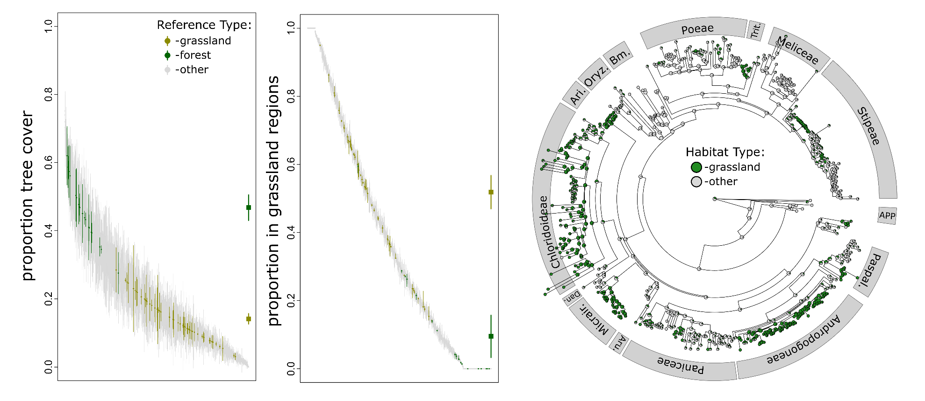
RESULTS S1:
Summary of phytolith results
Phytolith assemblages showed a high proportion of morphotypes diagnostic of open habitat grasses (Table S9), and correspondingly low FI-t ratios at all sites, with the exception of the lower units of JRT-74. These units showed high FI-t ratios and more abundant APPBO phytoliths, indicative of closed forest systems. These are the oldest units sampled in this study and their assignment to the Monroe Creek or Harrison Formation suggests a Late Oligocene or Early Miocene age (Fig. S1; Thomasson, 1985). Open habitat grass morphotypes are dominated by those produced by those of the subfamily Pooideae at remaining sites, except the two Hemphillian sites (Methods S1; FHSU17-028, FHSU17-038), which show a higher proportion of morphotypes indicative of grasses from the PACMAD group (Table S9, Fig. S6). The tribe Stipeae, which dominates the record of fossil anthoecia (particularly at earlier sites, where it is the only taxonomic group recovered) is within the Pooideae subfamily (Soreng et al., 2015).
Patterns recovered among these sites largely match those found in the region more broadly, with assemblages indicative of grass-dominated ecosystems becoming more common through the Miocene and taxonomic turnover toward greater PACMAD component of the flora later in the Miocene (Strömberg, 2011).

Table S9: Next page. Proportions of phytolith morphotype classes recovered from analyzed samples assemblages, along with site and stratigraphic information for each. Detailed descriptions of morphotype classes are provided in Methods S1. Also presented are FI-t ratios and their 95% confidence intervals, along with notable grass silica short cell (GSSC) phytoliths morphotypes and a conservative estimate of grass groups reconstructed as present in each reconstructed community.
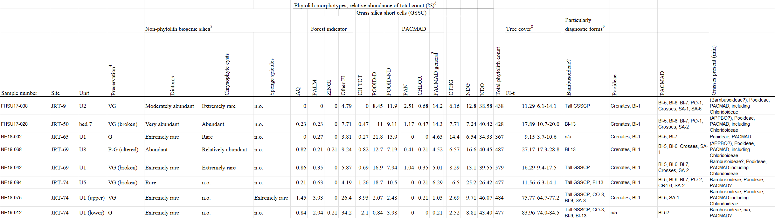
Figure S6: Graphical representation of relative proportions of diagnostic phytolith morphotype classes recovered from all analyzed samples. Forest indicator morphotypes are: PALM – phytoliths diagnostic of the family Arecaceae, ZINGI – phytoliths diagnostic of the family Zingiberaceae, and Other FI – phytoliths produced by other forest occupying plants. Remaining categories are all produced by grass silica short cells (GSSC) and are: CH TOT – phytoliths diagnostic of closed habitat grasses (APP grade taxa, Bambusoideae), POOID-D – phytoliths diagnostic of the subfamily Pooideae, POOID-ND – phytoliths produced by grasses of the subfamily Pooideae, and other non-pooid grasses, PAN – phytoliths diagnostic of the subfamily Panicoideae, CHLOR - phytoliths diagnostic of the subfamily Chloridoideae, PACMAD general – phytoliths produced by a range of grasses within the PACMAD group, OTHG – GSSC phytoliths whose taxonomic affinities could not be determined.
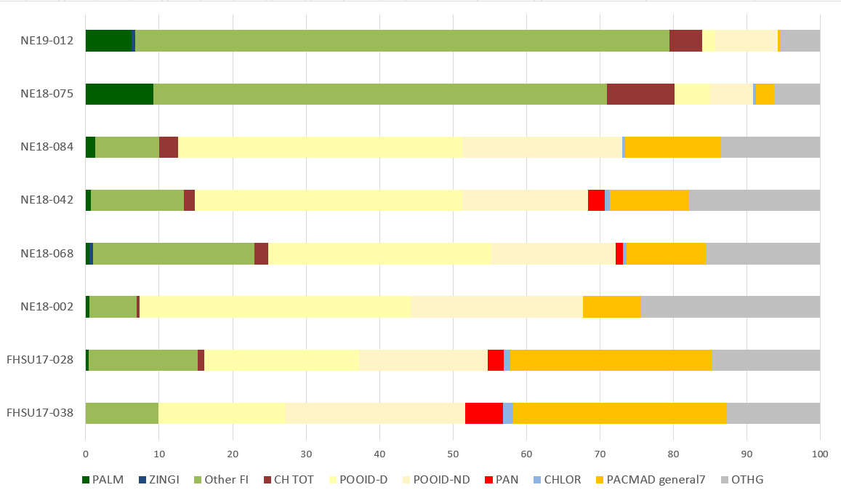

Figure S7: Provided as separate file. Maximum likelihood topology for the full phylogenetic matrix, support values.

Figure S8: Provided as separate file. Maximum likelihood topology for trimmed phylogenetic matrix (i.e., excluding sites with > 90% missing data.

Figure S9: Next page. Ancestral state reconstruction of diaspore roughness obtained using the contMap function in the R package phytools (v 1.0-1, Revell, 2012), with simmap reconstruction of diaspore exposure at exterior and interior nodes obtained using the same package. Note that “rougher” diaspores does not refer to increasing values of roughness, which counterintuitively correspond to “smoother” diaspores.

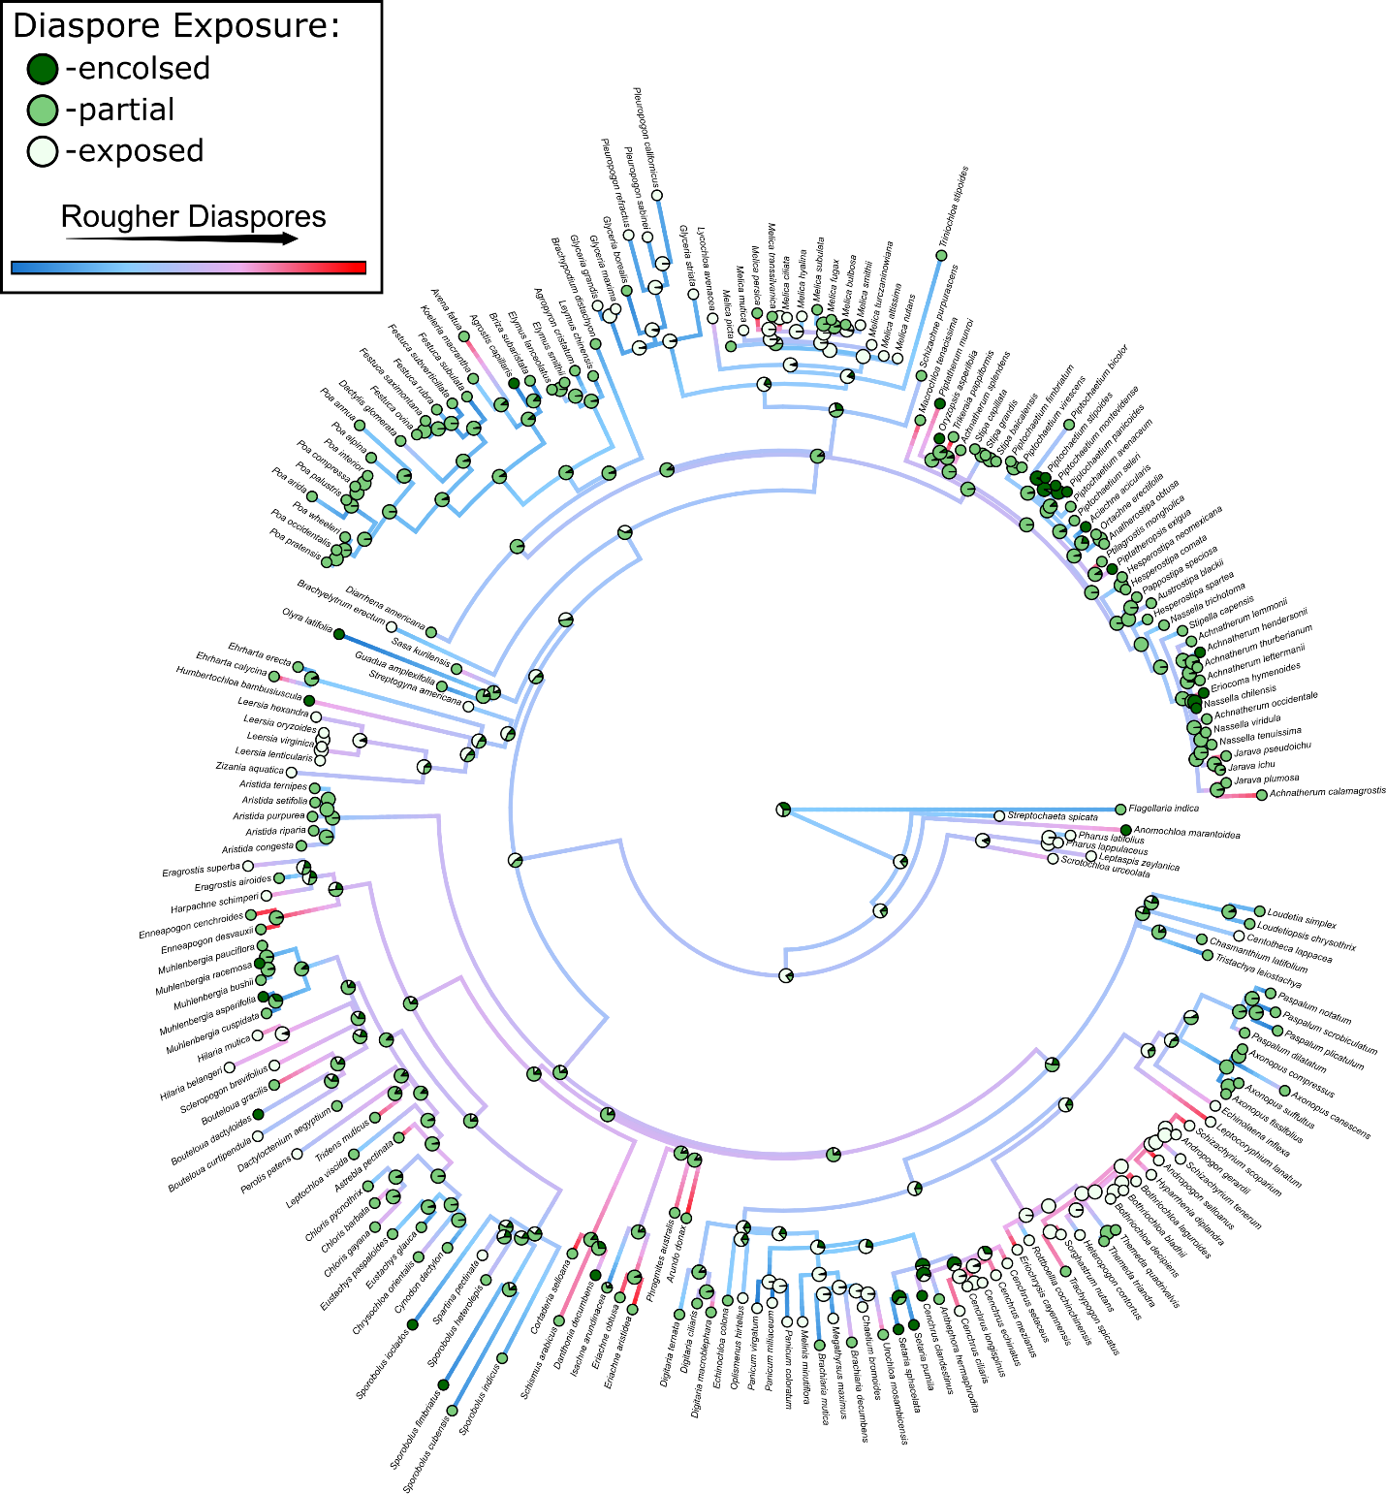

Figure S10: Simmap ancestral state reconstruction of lemma induration. Note that because these data could be easily obtained from the literature, reconstruction is based upon a greater proportion of taxa than from which the full range of diaspore traits were measured. Taxa for which we did not have physical specimens are displayed in bold text.
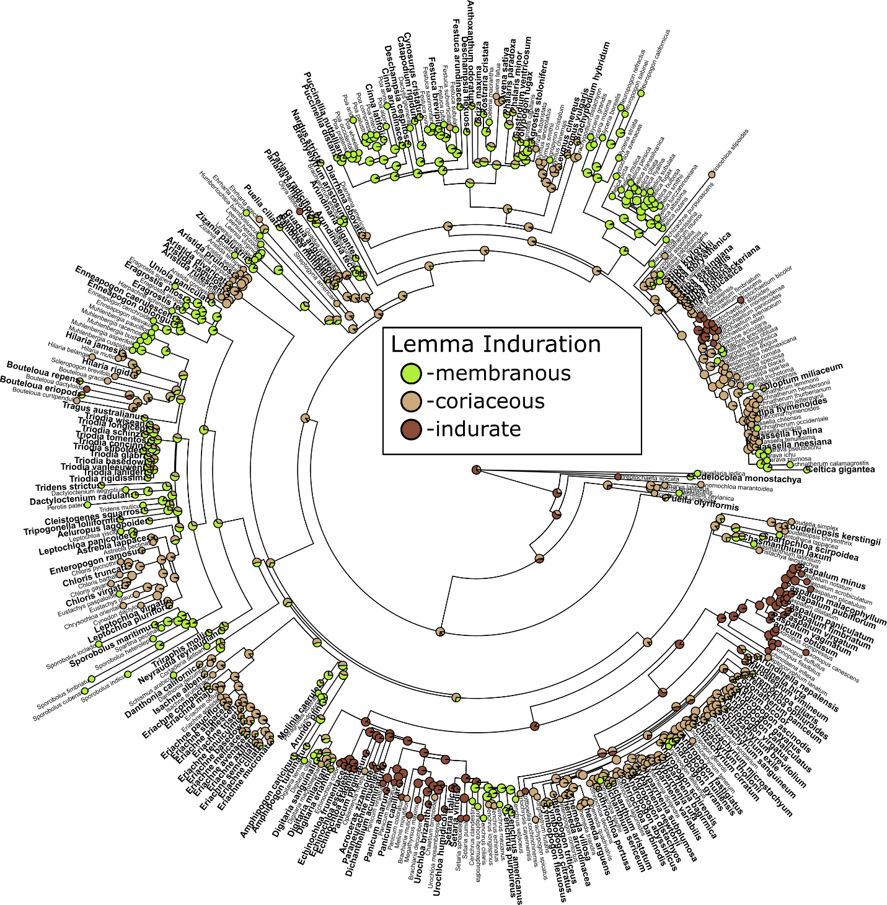

Figure S11: Simmap ancestral state reconstruction of callus morphology. Note that because these data could be easily obtained from the literature, reconstruction is based upon a greater proportion of taxa than from which the full range of diaspore traits were measured. Taxa for which we did not have physical specimens are displayed in bold text.
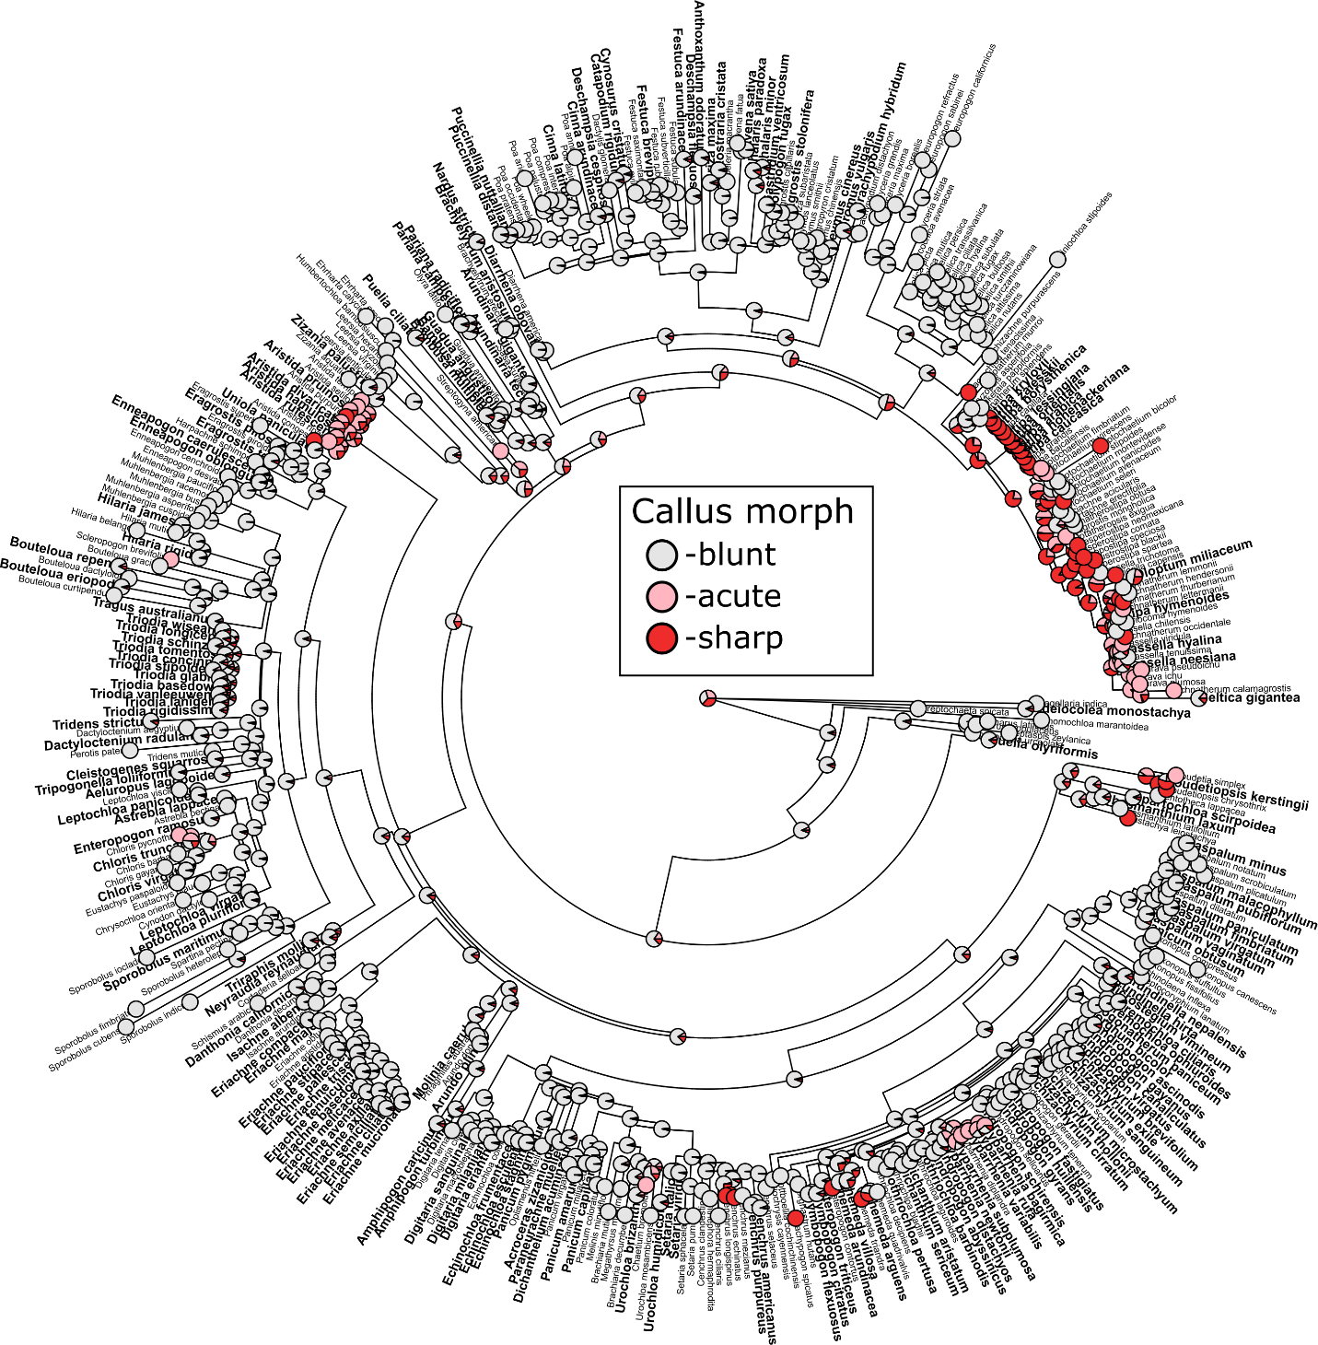

Figure S12: Ancestral state reconstruction of square root of awn length. Note that because these data could be easily obtained from the literature, reconstruction is based upon a greater proportion of taxa than from which the full range of diaspore traits were measured.
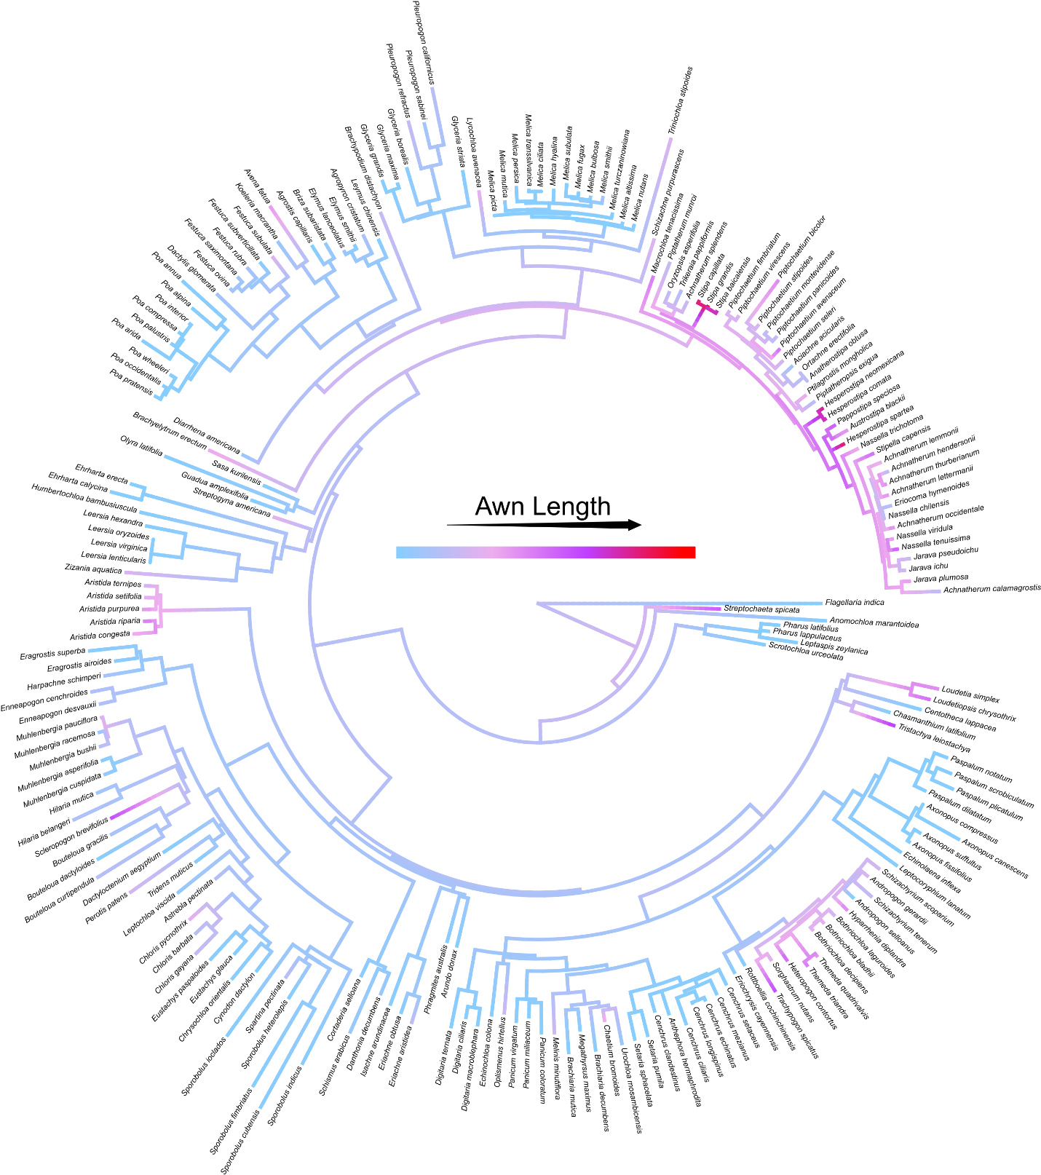
Figure S13: Simmap ancestral state reconstruction of structure comprising the diaspore. Note that because these data could be easily obtained from the literature, reconstruction is based upon a greater proportion of taxa than from which the full range of diaspore traits were measured. Taxa for which we did not have physical specimens are displayed in bold text.
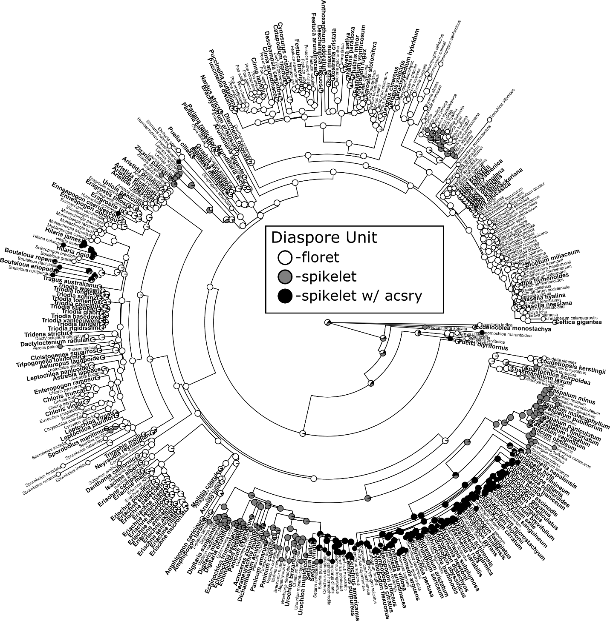

Figure S14: Ancestral state reconstruction of culm length obtained using the contMap function in the R package phytools (v 1.0-1, Revell, 2012), with simmap reconstruction of habit at exterior and interior nodes obtained using the same package.
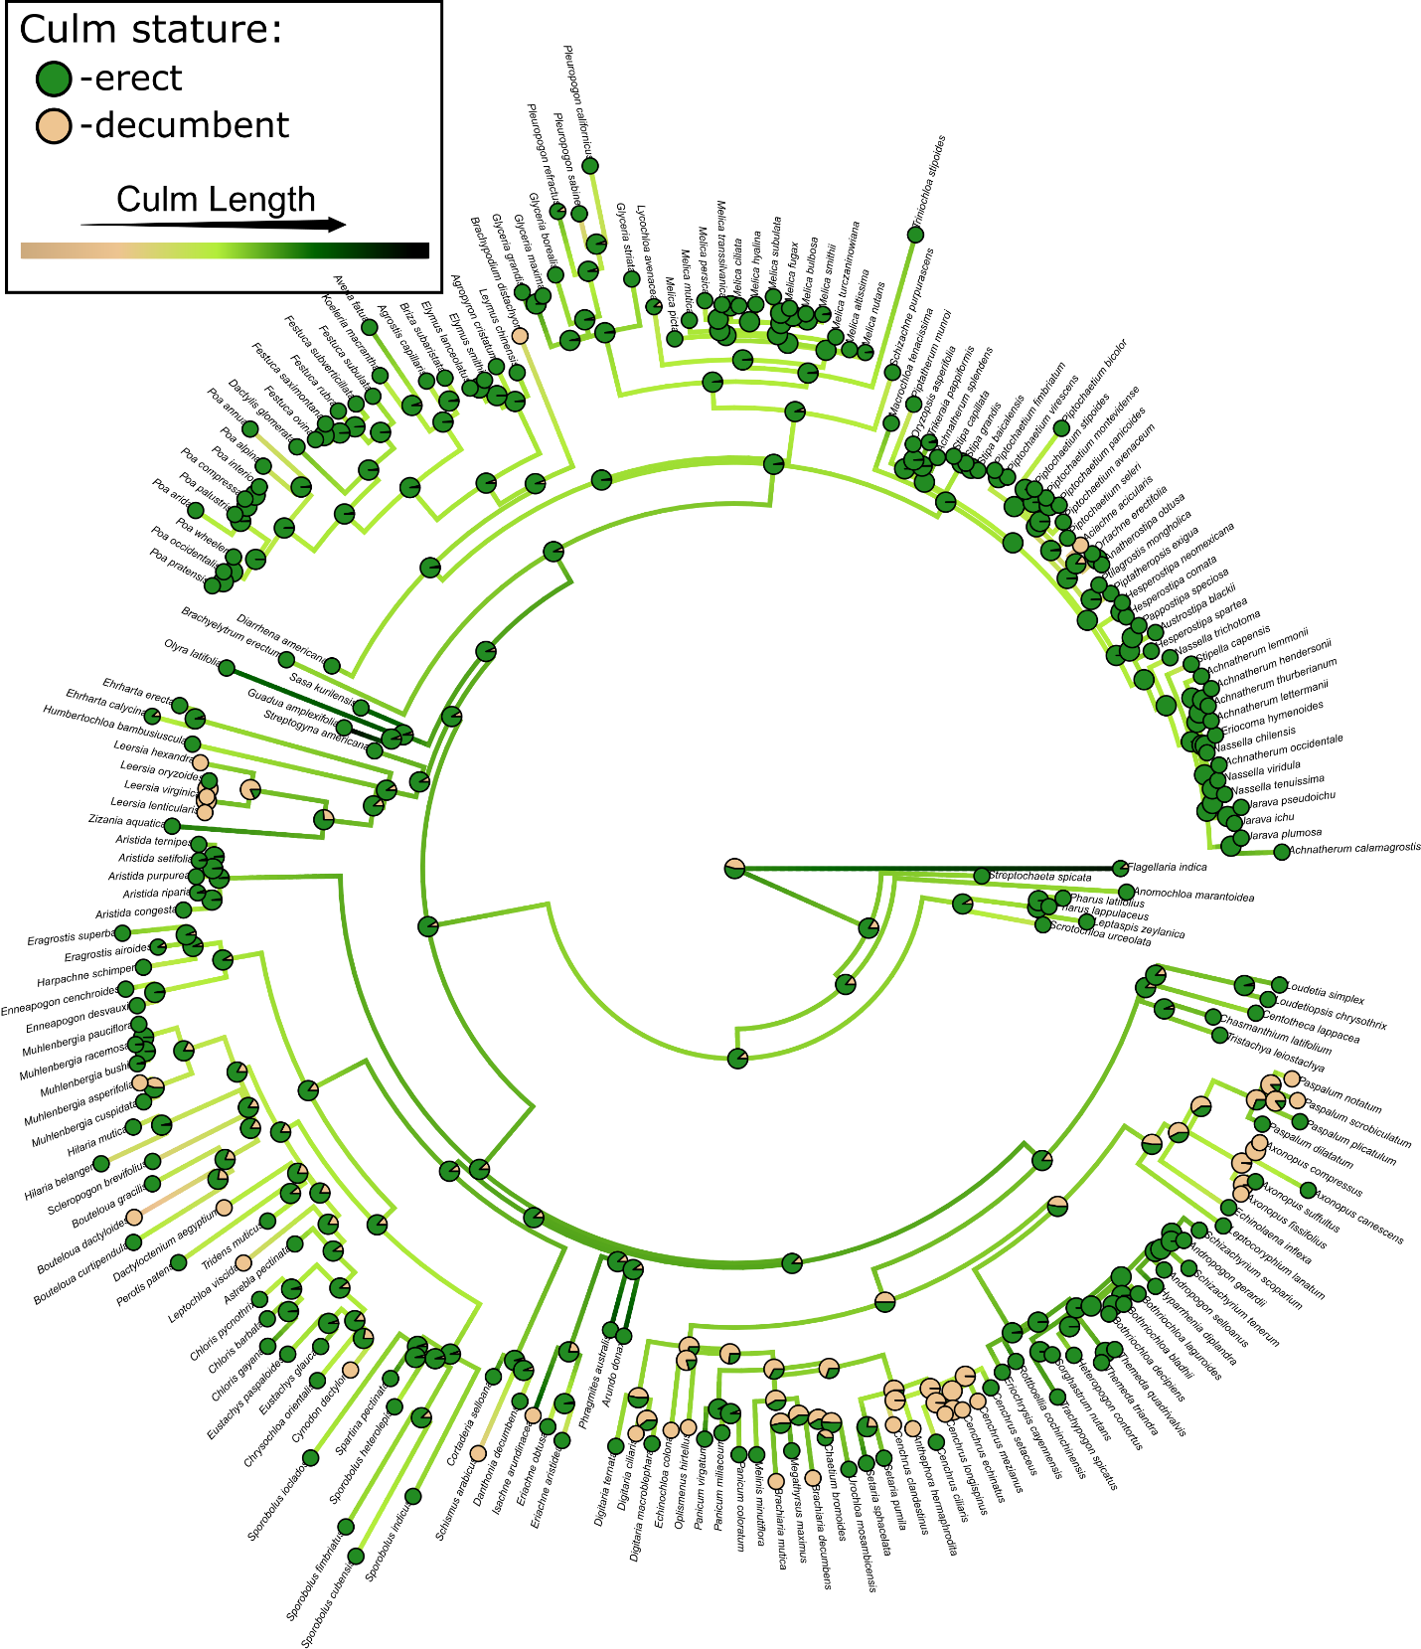

RESULTS S2:
Included below are the full range of model outputs predicting diaspore falling velocity, including results when only high-quality tree cover data and robust phylogenetic relationships are considered in models (see main text Methods). Captions below generally refer to predictors using the following shorthand:
- Tree cover – average percent tree cover across all occurrence records for a given species
- Grassland region – proportion of species occurrences which were found in grassland regions
- Grassland radiation – whether species belonged to a group which we reconstruct as being grassland adapted (see Figs. 1 and S5 and main text Results). Groups were one of core Andropogoneae (andro), Aristidoideae (arist), Chloridoideae (chlor), Paspaleae (paspal), Stipeae (stip), Triticeae (trit), or other.
- Grassland type – for those species reconstructed as being grassland adapted, the grassland formation (following Dixon et al., 2014) in which they were most commonly found (one of warm arid, lowland tropical, temperate, non-grassland/other)
- Growth habit – whether species produced +/- erect or decumbent culms

Table S9: Full brms model summary for model predicting diaspore falling velocity, with tree cover, grassland region, and grassland radiation as predictors. No interactions were modelled between predictors.
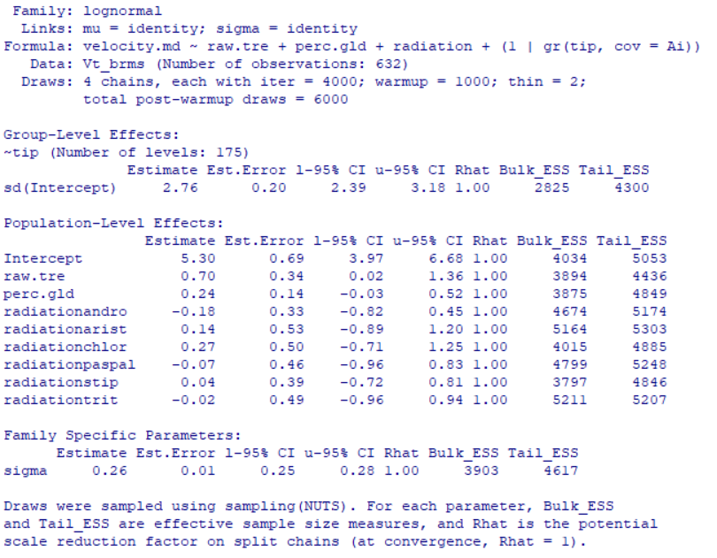

Table S10: Full brms model summary for model predicting diaspore falling velocity, with tree cover, grassland region, and grassland type as predictors. No interactions were modelled between predictors.
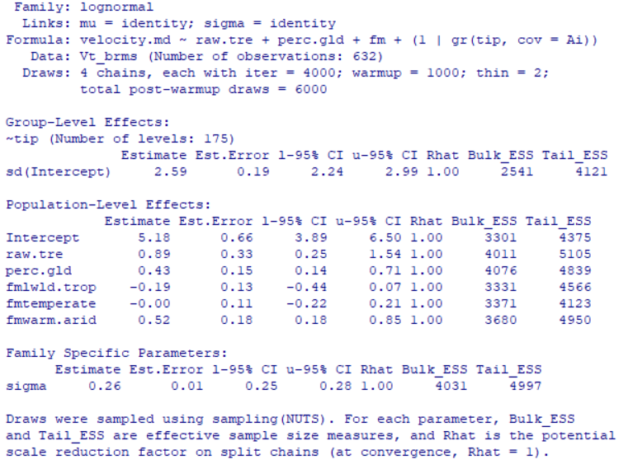

Table S11: Next page. Full brms model summary for model predicting diaspore falling velocity, with tree cover, grassland region, grassland radiation, and growth habit as predictors. All possible interactions were modelled between predictors.

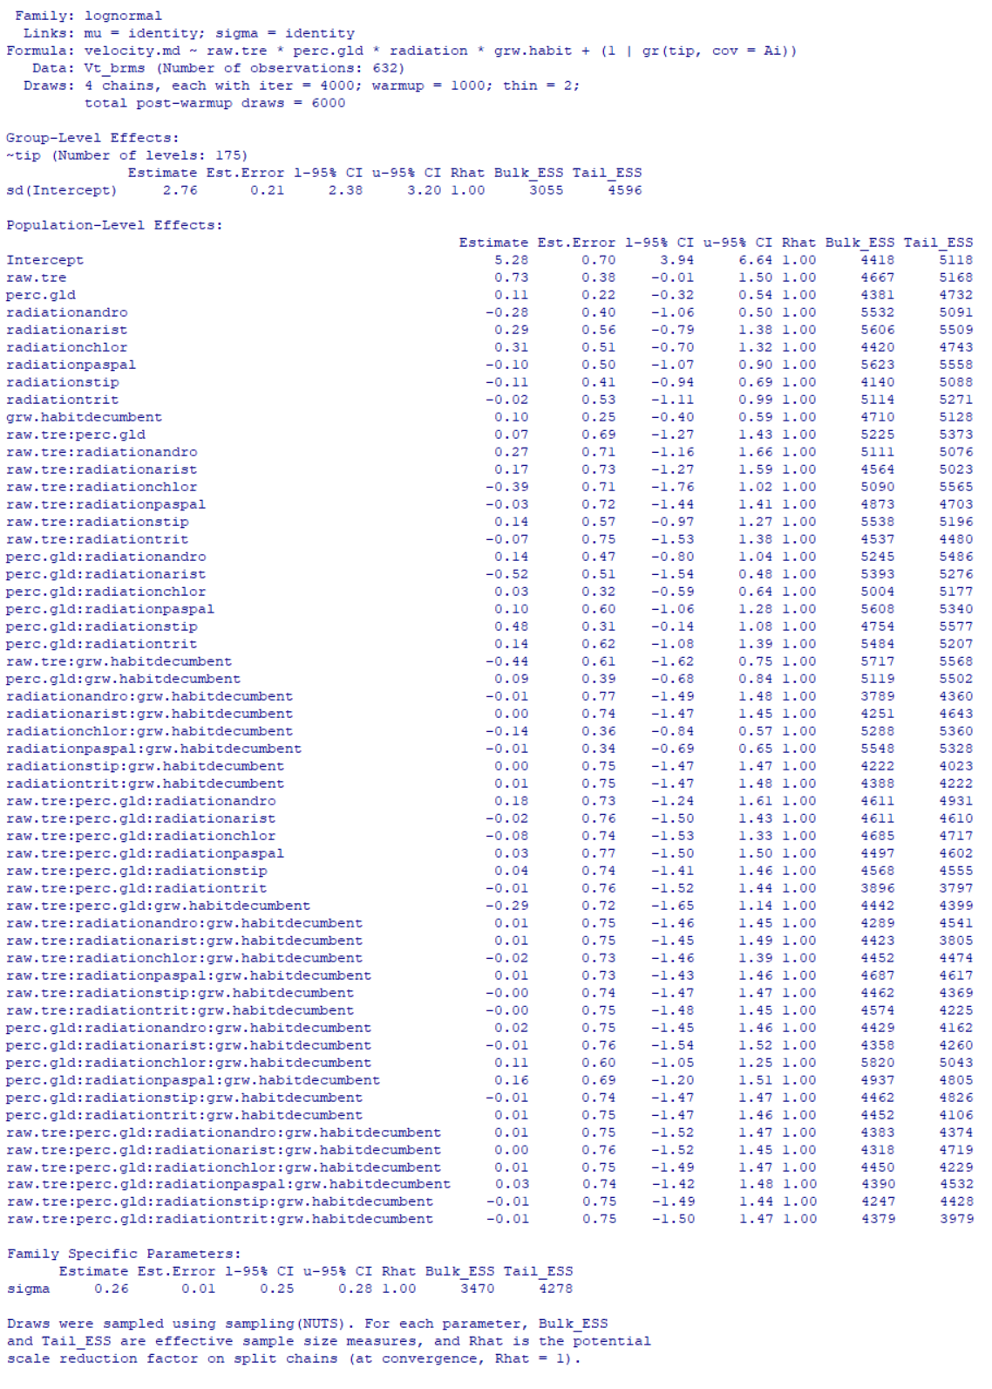
Table S12: Full brms model summary for model predicting diaspore falling velocity, with tree cover, grassland region, grassland type, and growth habit as predictors. All possible interactions were modelled between predictors.
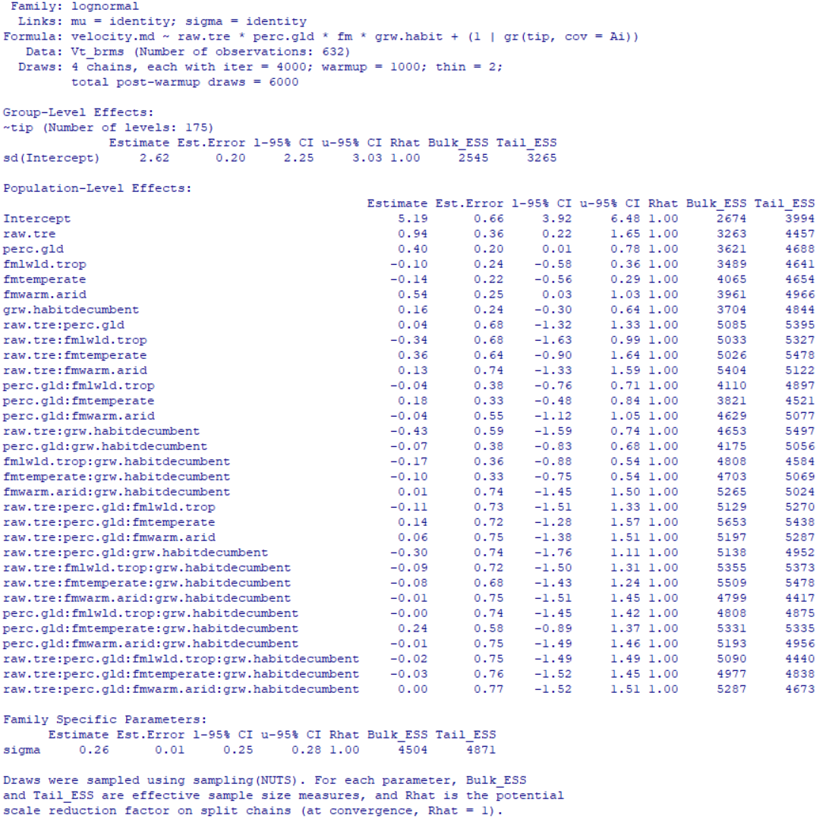

Table S13: Full brms model summary for model predicting diaspore falling velocity, with tree cover, grassland region, grassland type, and growth habit as predictors. All possible interactions were modelled between predictors. Log-transformed diaspore mass is also included in models, but is not included in any modelled interactions between predictors.
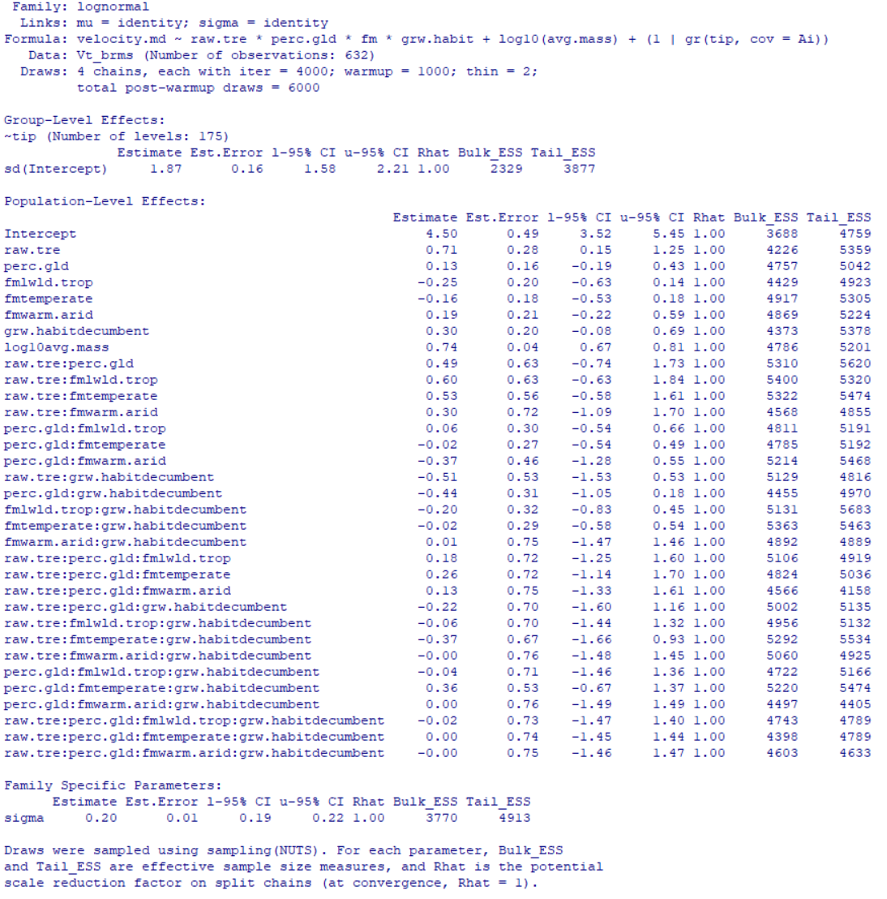

Table S14: Next page. Full brms model summary for model predicting diaspore falling velocity, with tree cover, grassland region, grassland radiation, and growth habit as predictors. All possible interactions were modelled between predictors. Log-transformed diaspore mass is also included in models, but is not included in any modelled interactions between predictors.

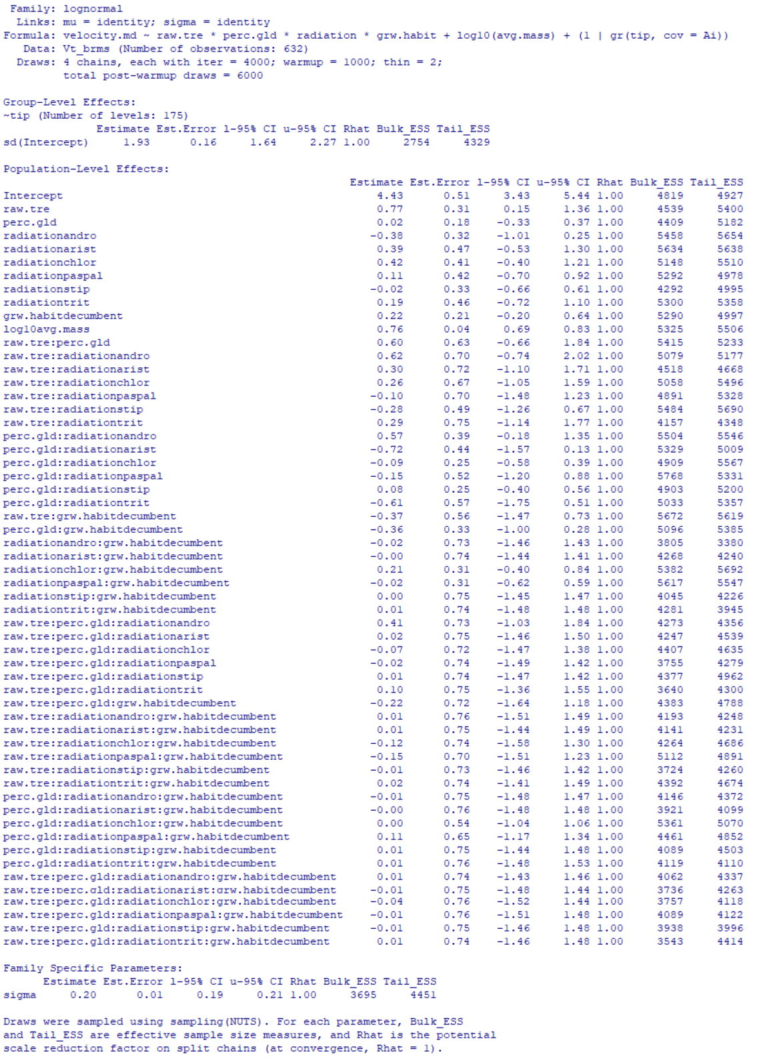
Table S15: Full brms model summary for model predicting diaspore falling velocity, with tree cover, grassland region, grassland type, and log-transformed diaspore mass as predictors. No interactions were modelled between predictors.
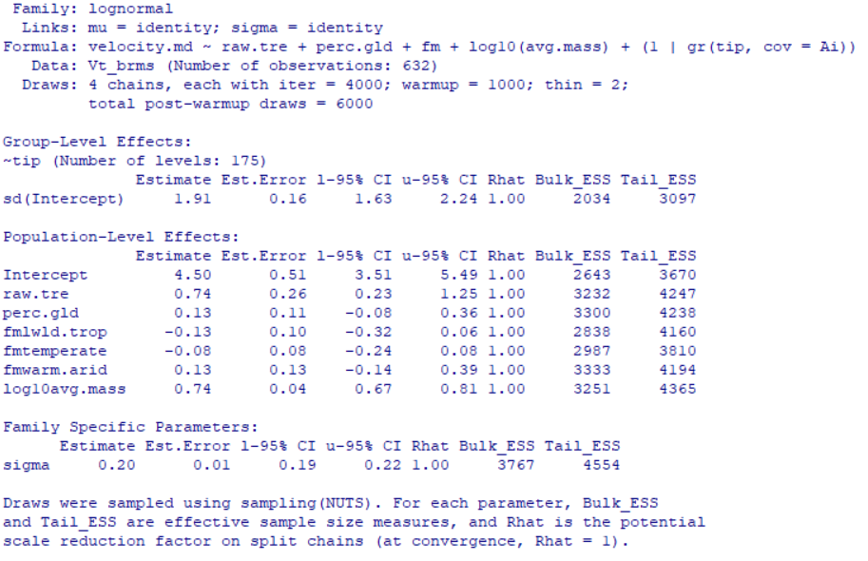

Table S16: Full brms model summary for model predicting diaspore falling velocity, with tree cover, grassland region, grassland radiation, and log-transformed diaspore mass as predictors. No interactions were modelled between predictors.
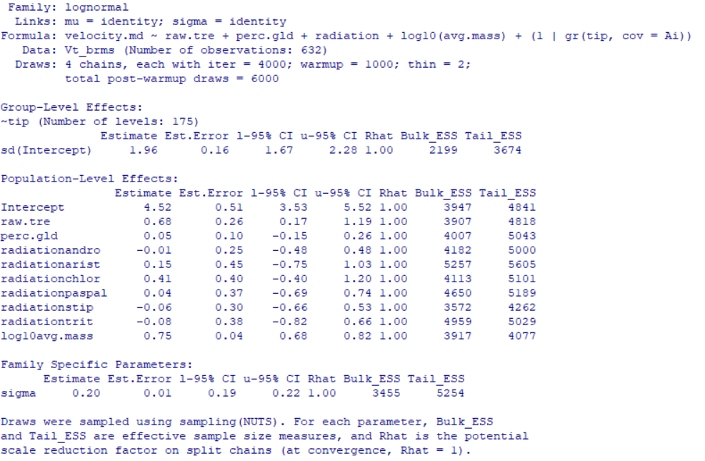

Table S17: Full brms model summary for model predicting diaspore falling velocity, with tree cover, grassland region, and grassland radiation as predictors. No interactions were modelled between predictors. Only “high quality” tree cover measurements were used, and the dataset was trimmed to include only those taxa whose relationships were robust to the inclusion or exclusion of loci with high degrees of missing data (see main text Methods).
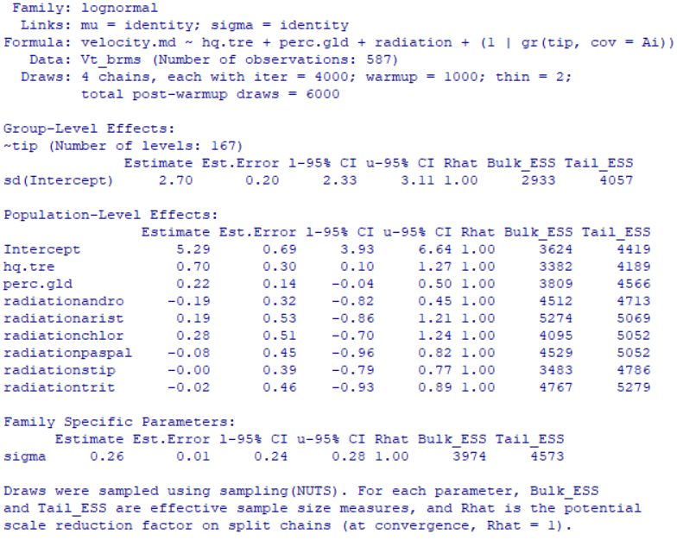

Table S18: Full brms model summary for model predicting diaspore falling velocity, with tree cover, grassland region, and grassland type as predictors. No interactions were modelled between predictors. Only “high quality” tree cover measurements were used, and the dataset was trimmed to include only those taxa whose relationships were robust to the inclusion or exclusion of loci with high degrees of missing data (see main text Methods).
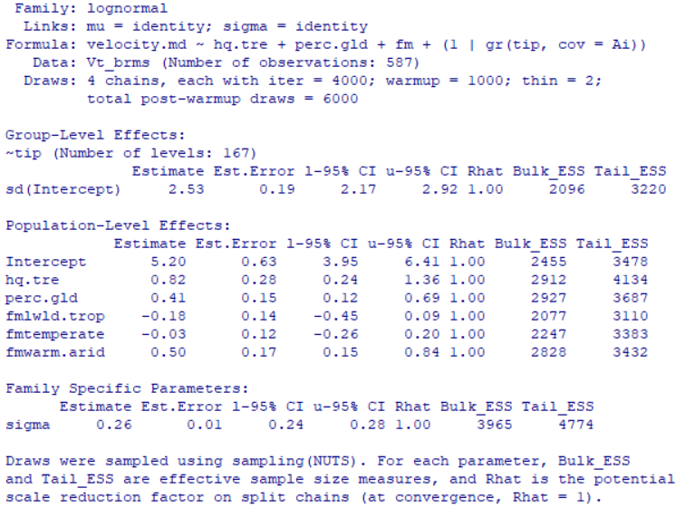

Table S19: Full brms model summary for model predicting diaspore falling velocity, with tree cover, grassland region, grassland radiation, and log-transformed diaspore mass as predictors. No interactions were modelled between predictors. Only “high quality” tree cover measurements were used, and the dataset was trimmed to include only those taxa whose relationships were robust to the inclusion or exclusion of loci with high degrees of missing data (see main text Methods).
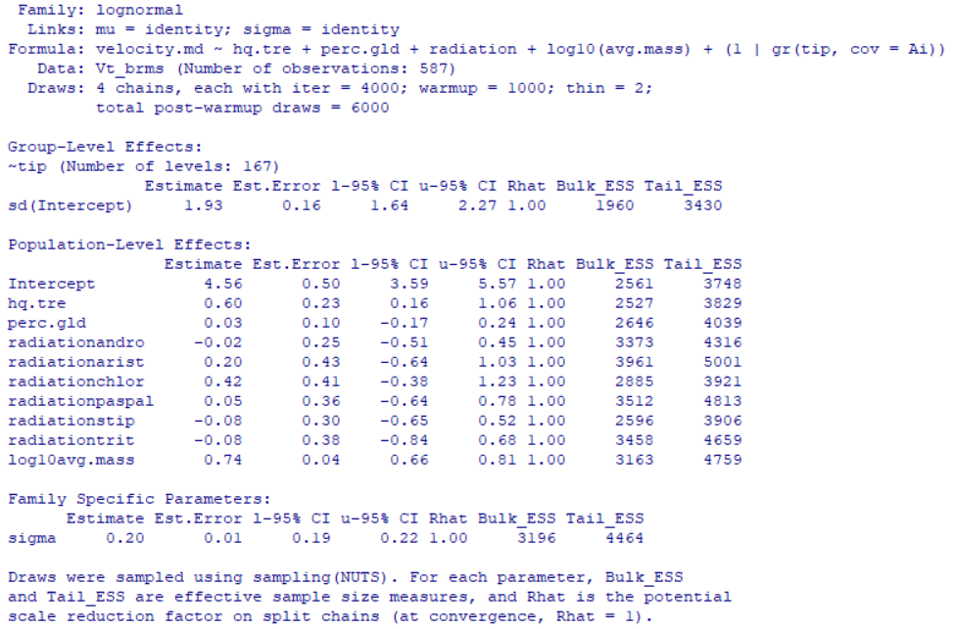
Table S20: Full brms model summary for model predicting diaspore falling velocity, with tree cover, grassland region, grassland type, and log-transformed diaspore mass as predictors. No interactions were modelled between predictors. Only “high quality” tree cover measurements were used, and the dataset was trimmed to include only those taxa whose relationships were robust to the inclusion or exclusion of loci with high degrees of missing data (see main text Methods).
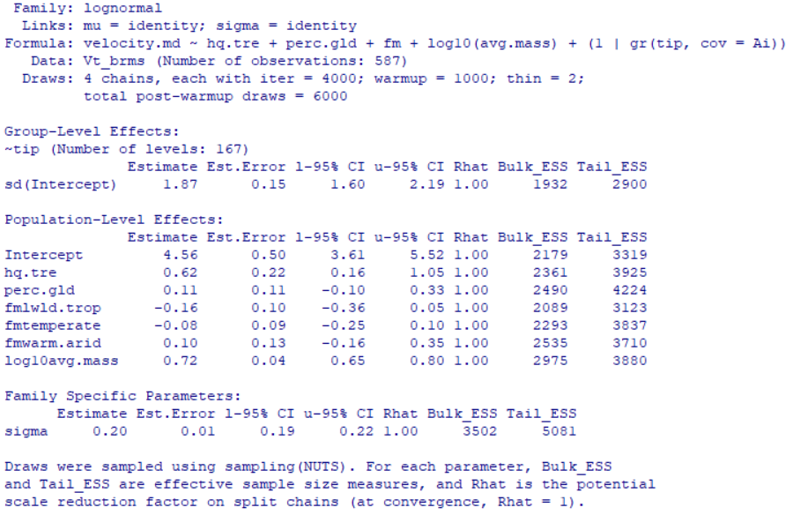

RESULTS S3:
Included below are the full range of model outputs predicting diaspore mass, including results when only high-quality tree cover data and robust phylogenetic relationships are considered in models (see main text Methods). Captions below generally refer to predictors using the following shorthand:
- Tree cover – average percent tree cover across all occurrence records for a given species
- Grassland region – proportion of species occurrences which were found in grassland regions
- Grassland radiation – whether species belonged to a group which we reconstruct as being grassland adapted (see Figs. 1 and S5 and main text Results). Groups were one of core Andropogoneae (andro), Aristidoideae (arist), Chloridoideae (chlor), Paspaleae (paspal), Stipeae (stip), Triticeae (trit), or other.
- Grassland type – for those species reconstructed as being grassland adapted, the grassland formation (following Dixon et al., 2014) in which they were most commonly found (one of warm arid, lowland tropical, temperate, non-grassland/other)
- Growth habit – whether species produced +/- erect or decumbent culms

Table S21: Full brms model summary for model predicting diaspore mass, with tree cover, grassland region, and grassland radiation as predictors. No interactions were modelled between predictors.
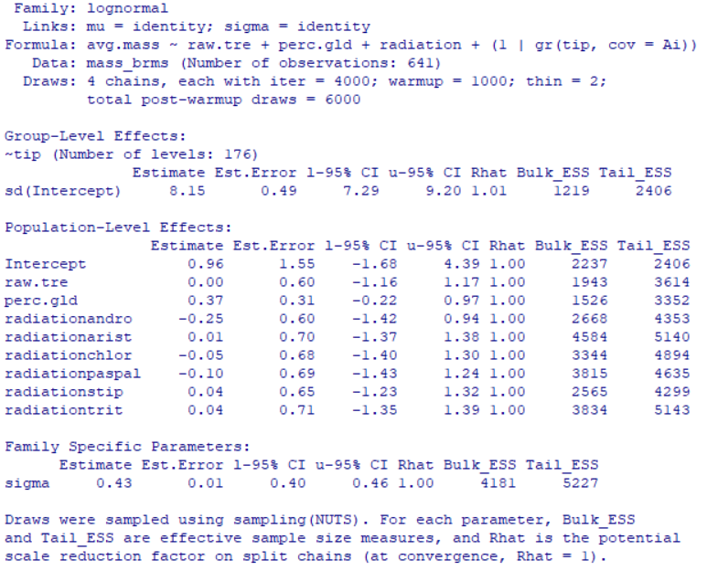

Table S22: Full brms model summary for model predicting diaspore mass, with tree cover, grassland region, and grassland type as predictors. No interactions were modelled between predictors.
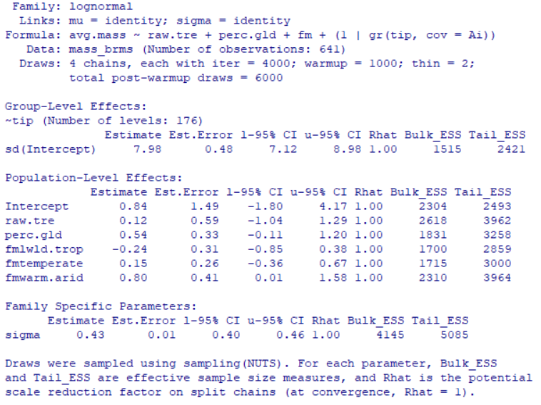

Table S23: Next page. Full brms model summary for model predicting diaspore mass, with tree cover, grassland region, grassland radiation, and growth habit as predictors. All possible interactions were modelled between predictors.
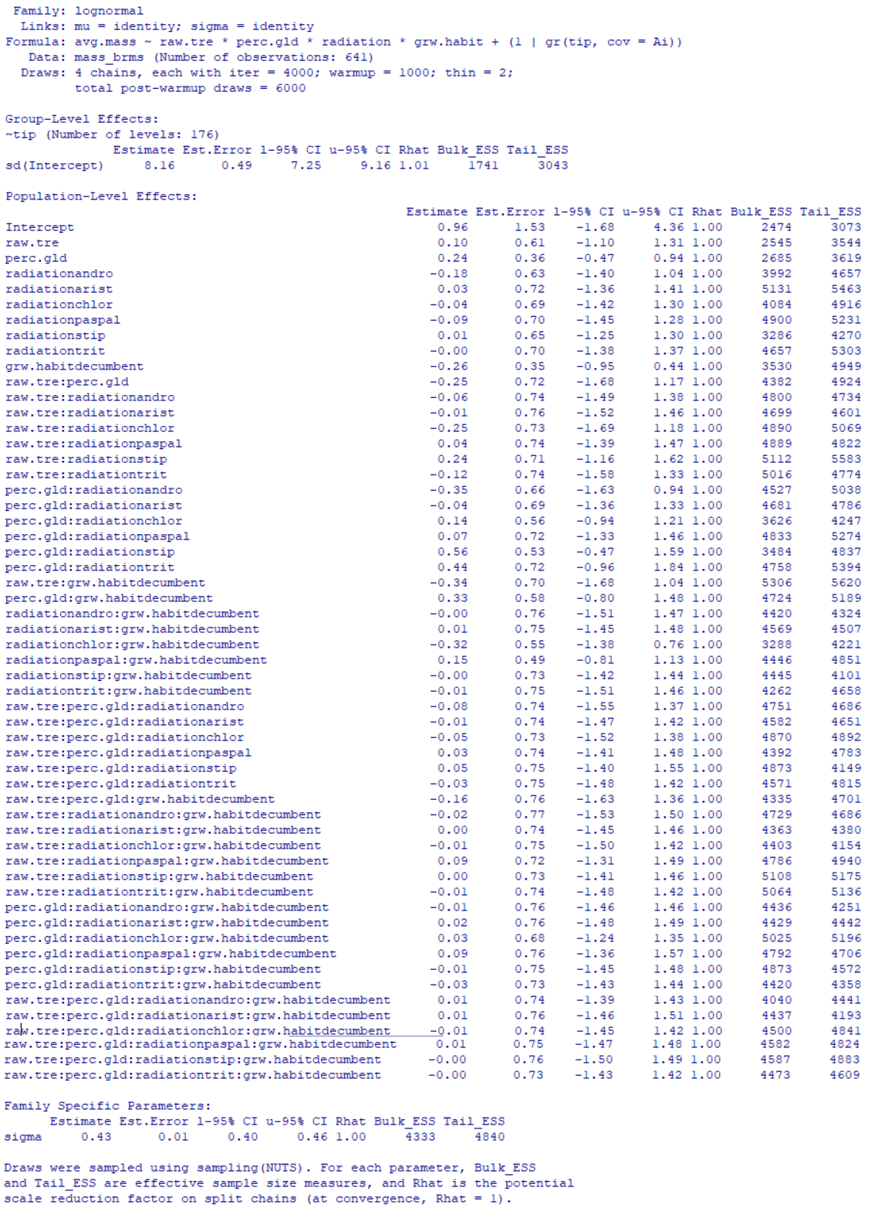
Table S24: Full brms model summary for model predicting diaspore mass, with tree cover, grassland region, grassland type, and growth habit as predictors. All possible interactions were modelled between predictors.
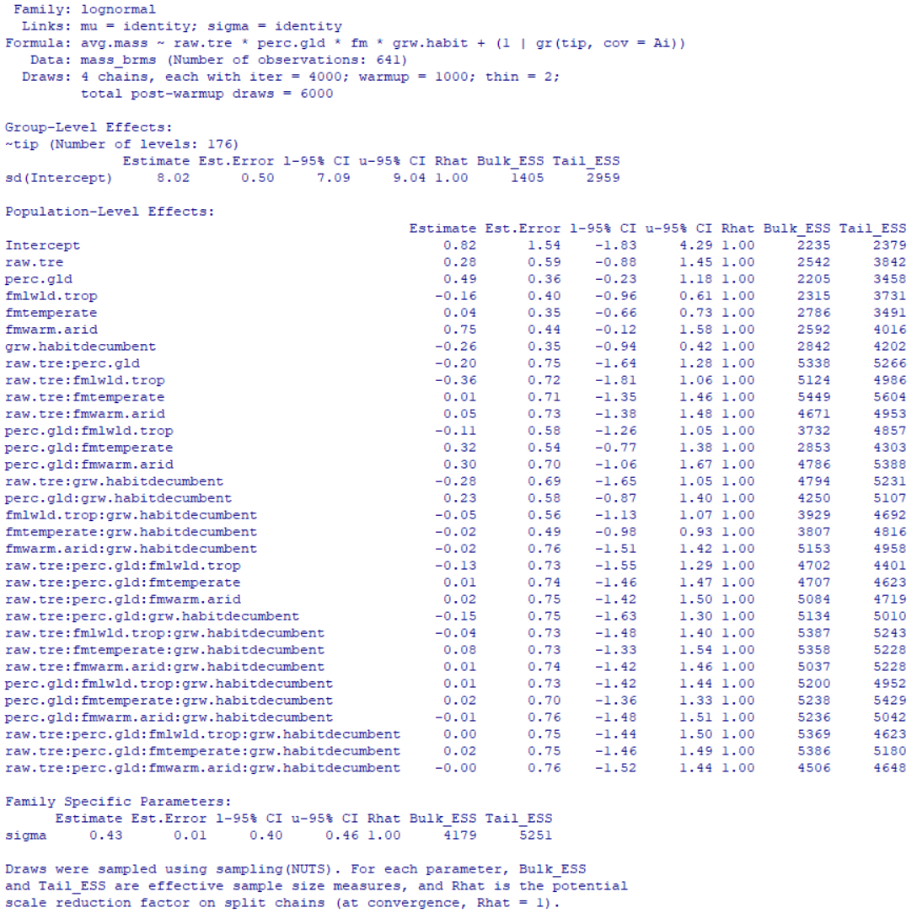

Table S25: Full brms model summary for model predicting diaspore mass, with tree cover, grassland region, and grassland radiation as predictors. No interactions were modelled between predictors. Only “high quality” tree cover measurements were used, and the dataset was trimmed to include only those taxa whose relationships were robust to the inclusion or exclusion of loci with high degrees of missing data (see main text Methods). 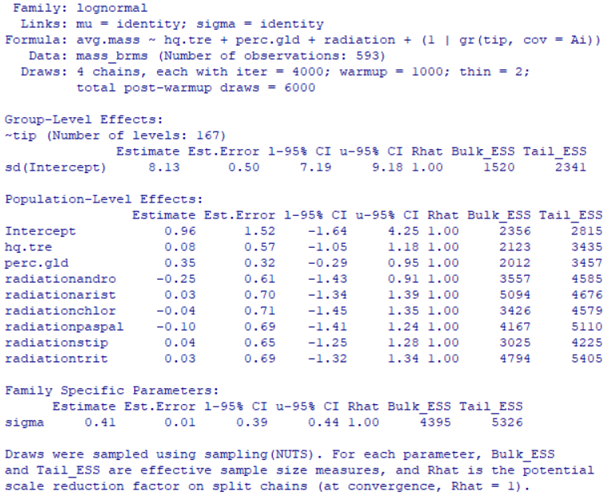

Table S26: Full brms model summary for model predicting diaspore mass, with tree cover, grassland region, and grassland type as predictors. No interactions were modelled between predictors. Only “high quality” tree cover measurements were used, and the dataset was trimmed to include only those taxa whose relationships were robust to the inclusion or exclusion of loci with high degrees of missing data (see main text Methods). 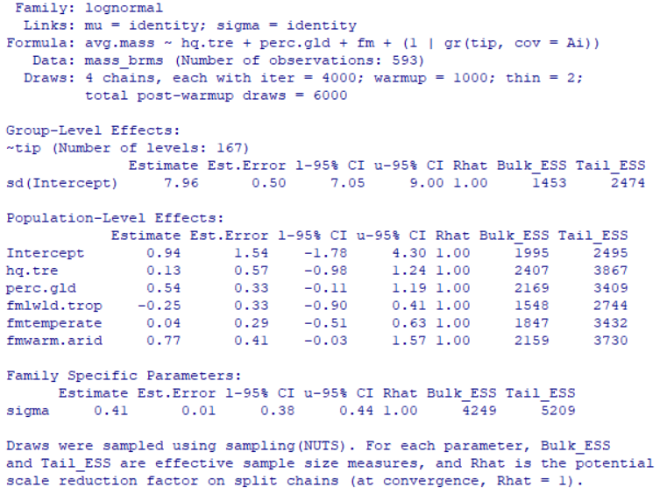

Table S27: Next page. Full brms model summary for model predicting diaspore mass, with tree cover, grassland region, grassland radiation, and growth habit as predictors. All possible interactions were modelled between predictors. Only “high quality” tree cover measurements were used, and the dataset was trimmed to include only those taxa whose relationships were robust to the inclusion or exclusion of loci with high degrees of missing data (see main text Methods).

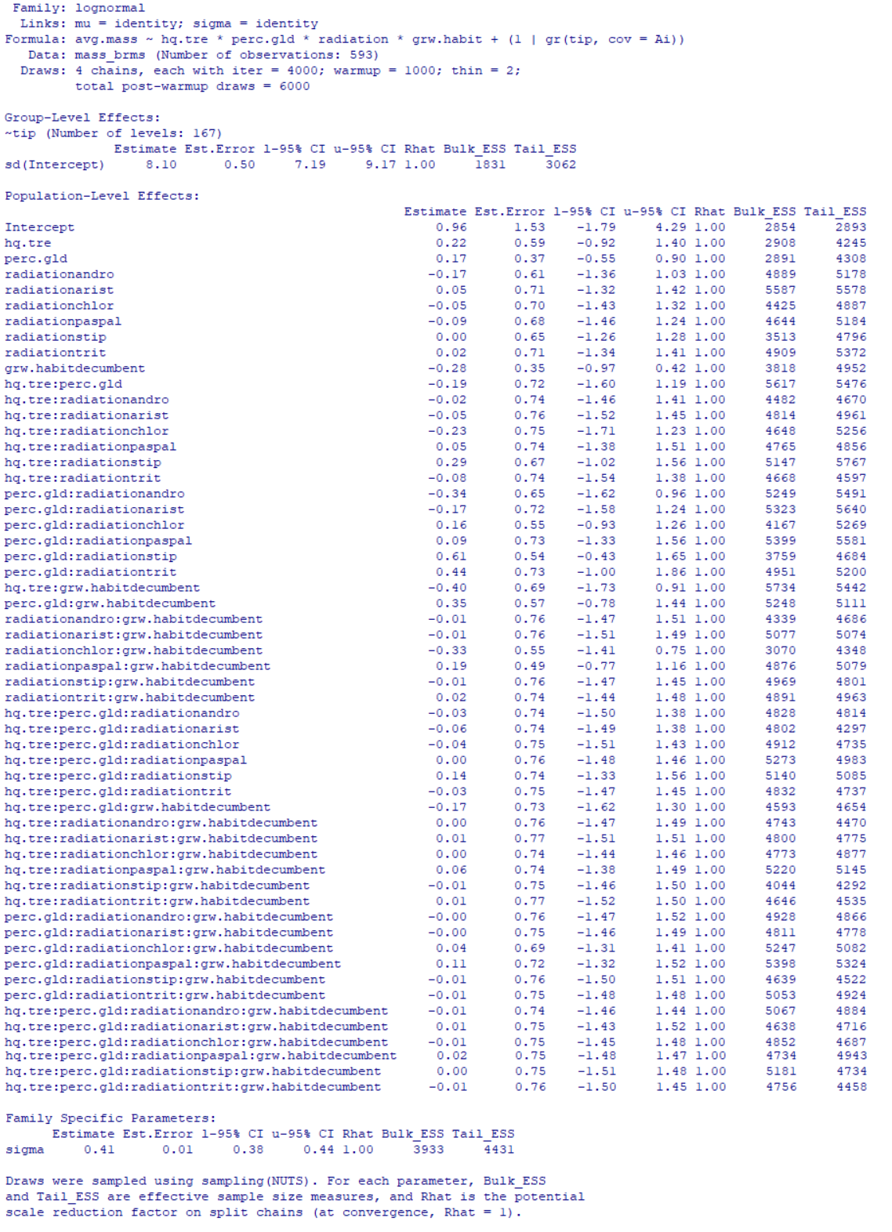
Table S28: Full brms model summary for model predicting diaspore mass, with tree cover, grassland region, grassland type, and growth habit as predictors. All possible interactions were modelled between predictors. Only “high quality” tree cover measurements were used, and the dataset was trimmed to include only those taxa whose relationships were robust to the inclusion or exclusion of loci with high degrees of missing data (see main text Methods).
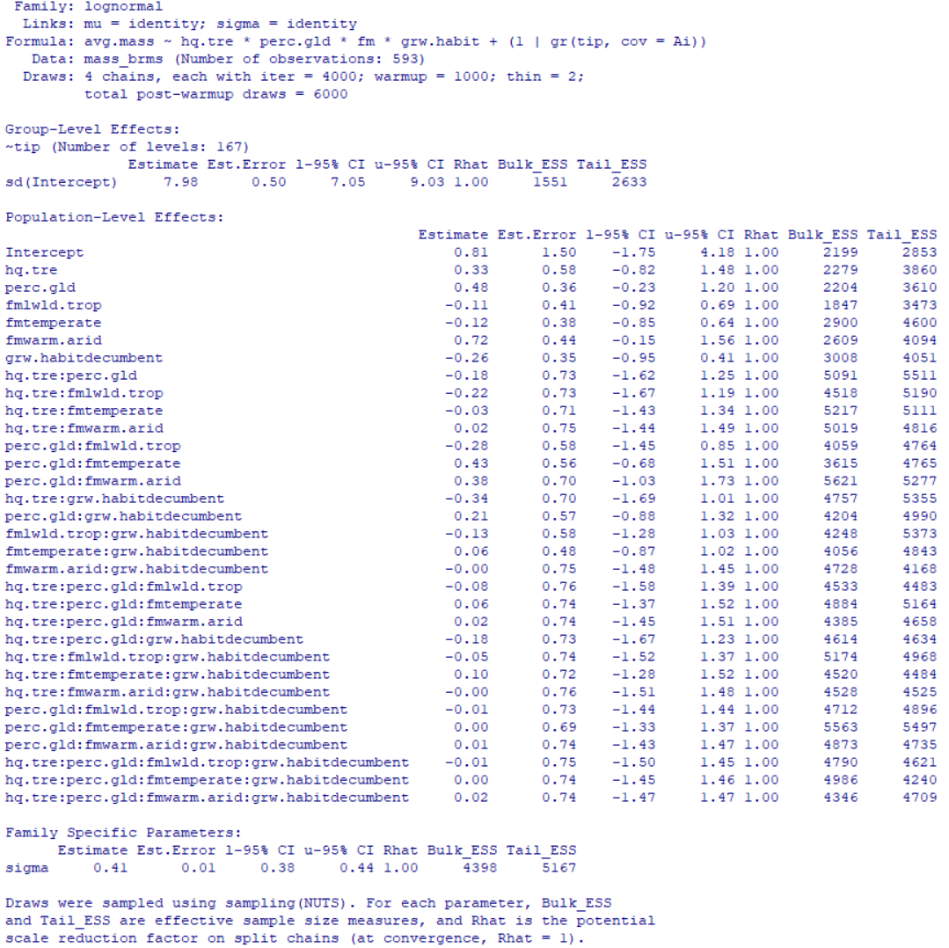

RESULTS S4:
Included below are the full range of model outputs predicting the presence of all three discrete endozoochory related diaspore traits (absence of awn, blunt callus, and indurate or coriaceous outer bract). Results are also presented for “best” models when only high-quality tree cover data and robust phylogenetic relationships are considered in models (see main text Methods). Captions below generally refer to predictors using the following shorthand:
- Tree cover – average percent tree cover across all occurrence records for a given species
- Grassland region – proportion of species occurrences which were found in grassland regions
- Grassland radiation – whether species belonged to a group which we reconstruct as being grassland adapted (see Figs. 1 and S5 and main text Results). Groups were one of core Andropogoneae (andro), Aristidoideae (arist), Chloridoideae (chlor), Paspaleae (paspal), Stipeae (stip), Triticeae (trit), or other.
- Grassland type – for those species reconstructed as being grassland adapted, the grassland formation (following Dixon et al., 2014) in which they were most commonly found (one of warm arid, lowland tropical, temperate, non-grassland/other)
- Growth habit – whether species produced +/- erect or decumbent culms

Table S29: Full brms model summary for model predicting presence of endozoochory traits, with tree cover, grassland region, and grassland radiation as predictors. No interactions were modelled between predictors.
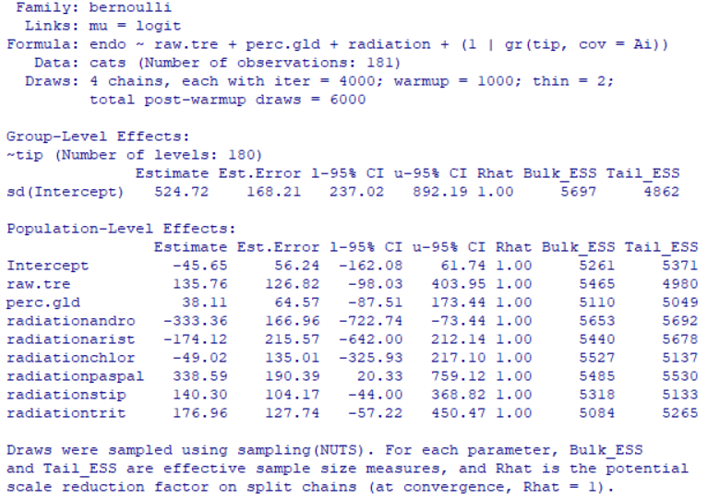

Table S30: Full brms model summary for model predicting presence of endozoochory traits, with tree cover, grassland region, and grassland type as predictors. No interactions were modelled between predictors.
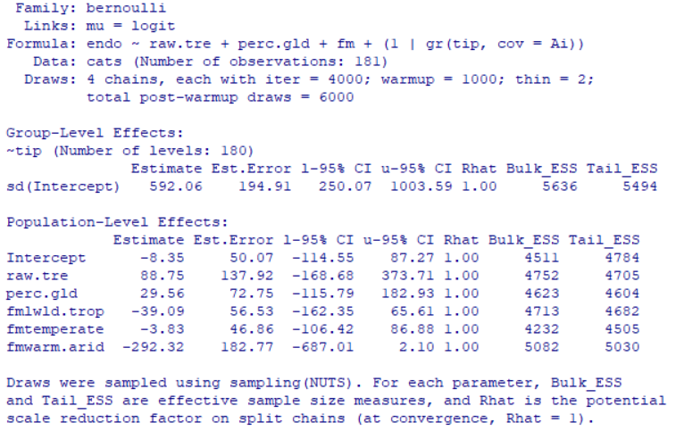

Table S31: Next page. Full brms model summary for model predicting presence of endozoochory traits, with tree cover, grassland region, grassland radiation, and growth habit as predictors. All possible interactions were modelled between predictors.

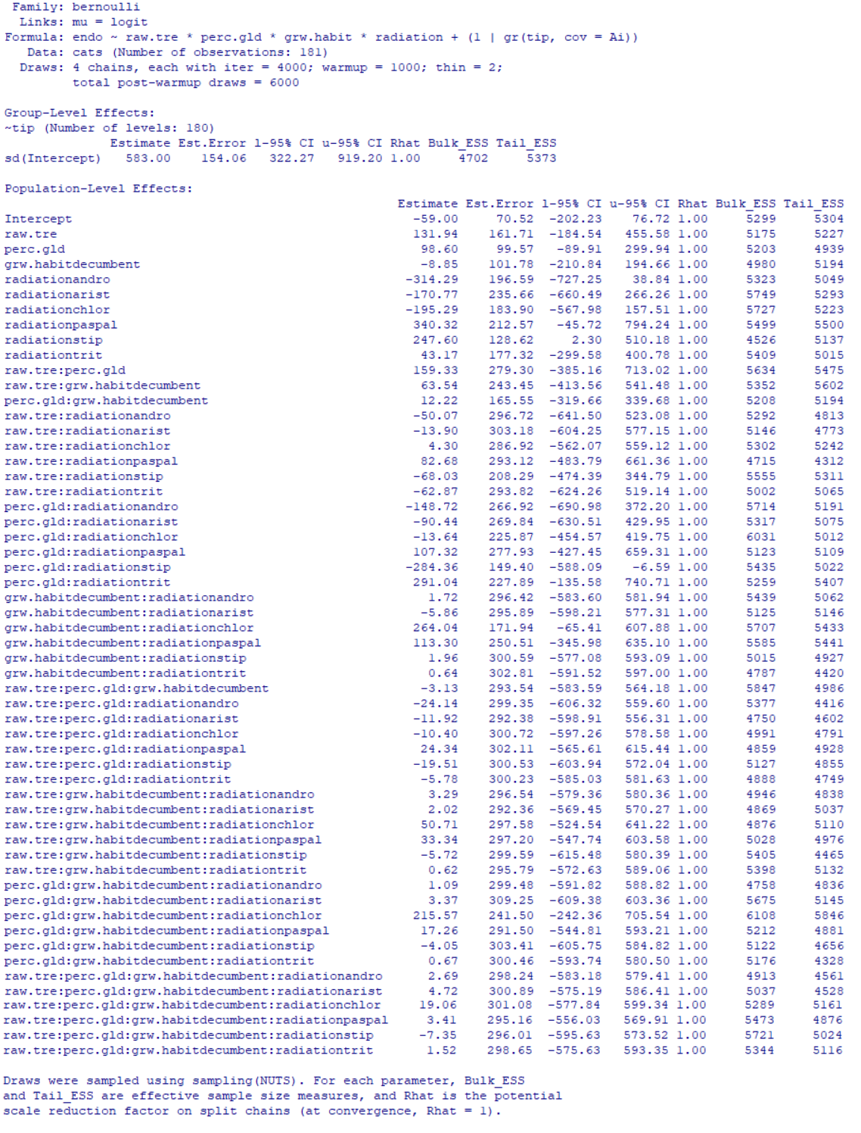

Table S32: Full brms model summary for model predicting presence of endozoochory traits, with tree cover, grassland region, grassland type, and growth habit as predictors. All possible interactions were modelled between predictors.
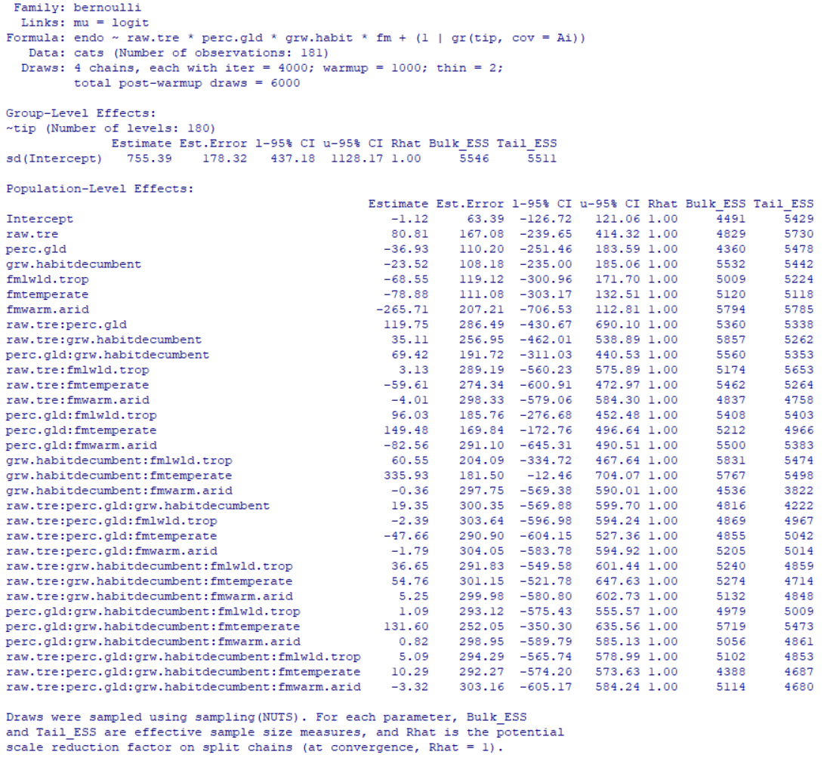

Table S33: Next page. Full brms model summary for model predicting presence of endozoochory traits, with tree cover, grassland region, grassland radiation, and log-transformed diaspore mass as predictors. All possible interactions were modelled between predictors.
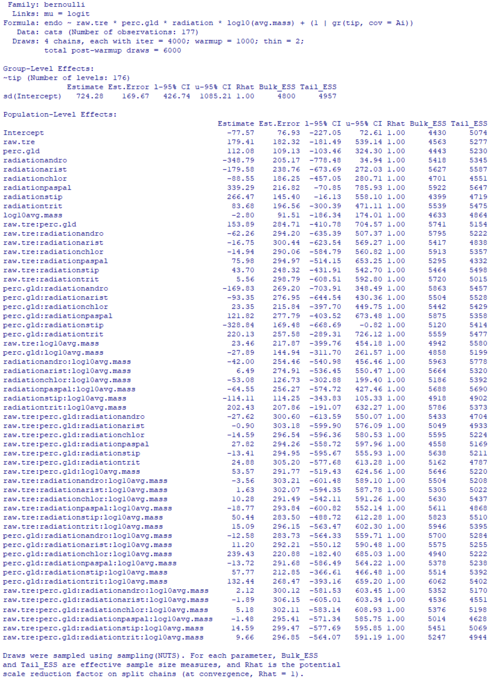
Table S33: Full brms model summary for model predicting presence of endozoochory traits, with tree cover, grassland region, grassland type, and log-transformed diaspore mass as predictors. All possible interactions were modelled between predictors.
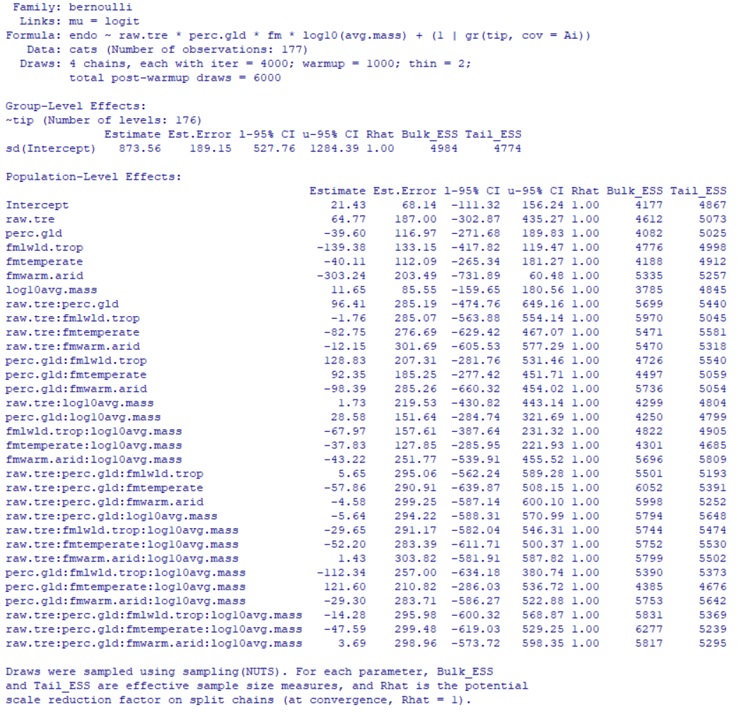

Table S34: Full brms model summary for model predicting presence of endozoochory traits, with tree cover, grassland region, and grassland radiation. Only the interaction between the grassland region and grassland radiation predictors was modelled.
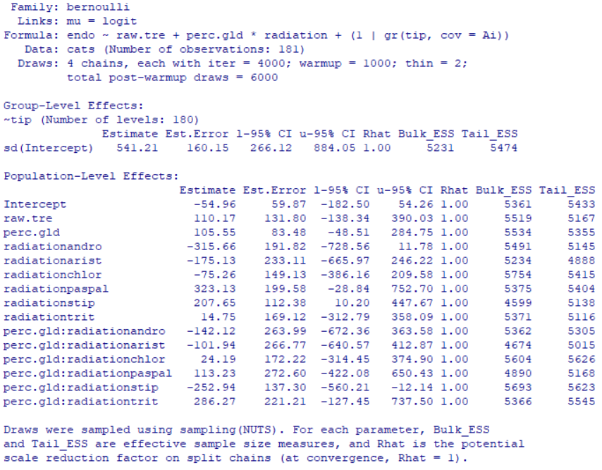

Table S35: Full brms model summary for “best” model predicting presence of endozoochory traits, with tree cover, grassland region, and grassland radiation. Only the interaction between the grassland region and grassland radiation predictors was modelled. Only “high quality” tree cover measurements were used, and the dataset was trimmed to include only those taxa whose relationships were robust to the inclusion or exclusion of loci with high degrees of missing data (see main text Methods).
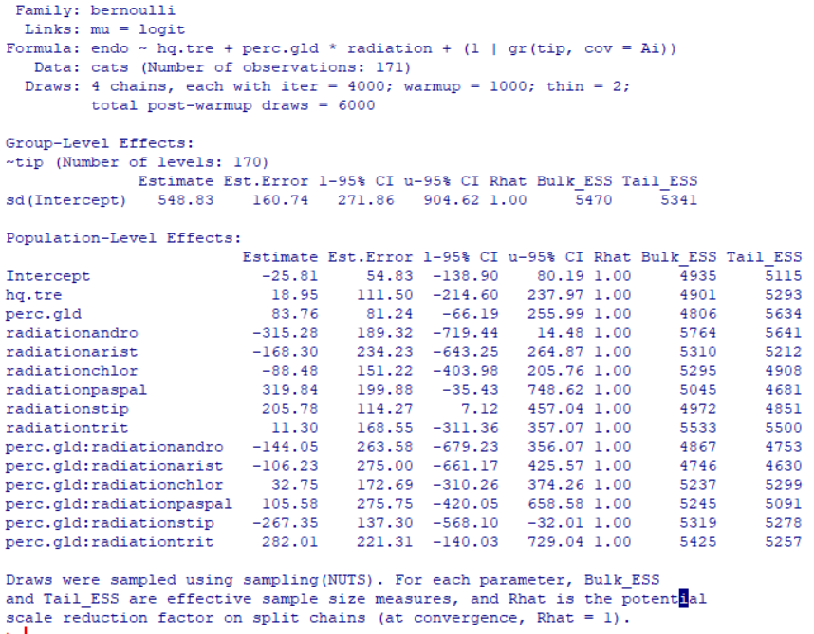

Figure S15: Next page. Figure demonstrating the interaction between the proportion of species occurrences found in grassland regions (horizontal axis) and grassland adapted group (separate panels) on whether species possess, or do not possess, all three discrete endozoochory promoting diaspore traits (vertical axis, 1 – all present, 0 – one or more absent). Note that among groups that are not invariant in the response (i.e., excluding the Paspaleae and Andropogoneae), Stipeae is the only group with its intercept at 1 (i.e., possessing all endozoochory traits).
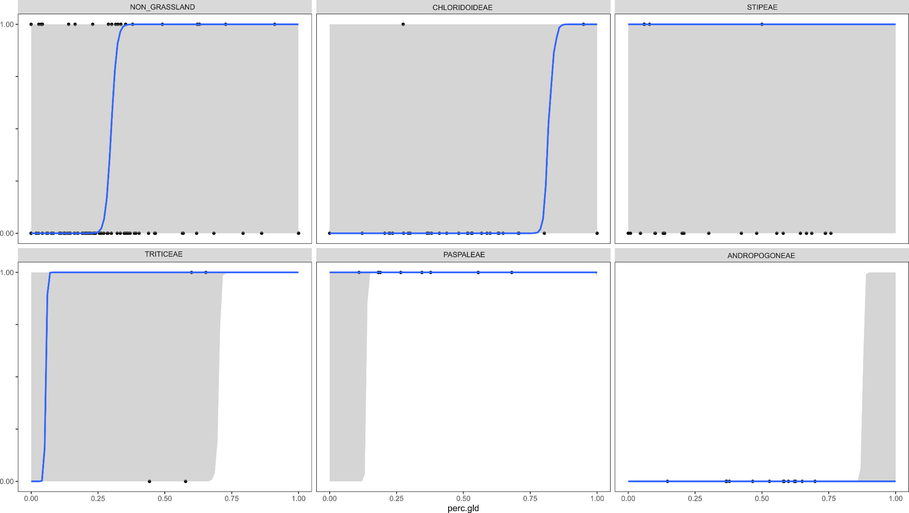
RESULTS S5:
Included below are the full range of model outputs predicting diaspore roughness and attachment potential. Results are also presented for “best” models when only high-quality tree cover data and robust phylogenetic relationships are considered in models (see main text Methods). Captions below generally refer to predictors using the following shorthand:
- Tree cover – average percent tree cover across all occurrence records for a given species
- Grassland region – proportion of species occurrences which were found in grassland regions
- Grassland radiation – whether species belonged to a group which we reconstruct as being grassland adapted (see Figs. 1 and S5 and main text Results). Groups were one of core Andropogoneae (andro), Aristidoideae (arist), Chloridoideae (chlor), Paspaleae (paspal), Stipeae (stip), Triticeae (trit), or other.
- Grassland type – for those species reconstructed as being grassland adapted, the grassland formation (following Dixon et al., 2014) in which they were most commonly found (one of warm arid, lowland tropical, temperate, non-grassland/other)
- Growth habit – whether species produced +/- erect or decumbent culms

Table S36: Next page. Full brms model summary for model predicting diaspore roughness and diaspore attachment potential, with tree cover, grassland region, and grassland radiation as predictors. No interactions were modelled between predictors.

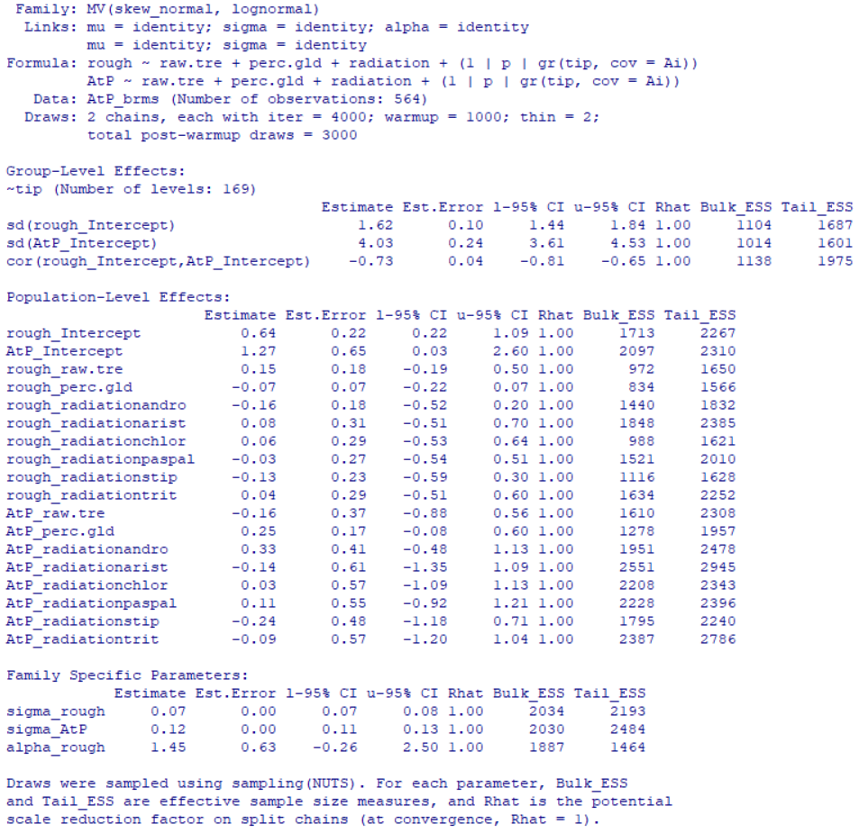

Table S37: Full brms model summary for model predicting diaspore roughness and diaspore attachment potential, with tree cover, grassland region, and grassland type as predictors. No interactions were modelled between predictors.
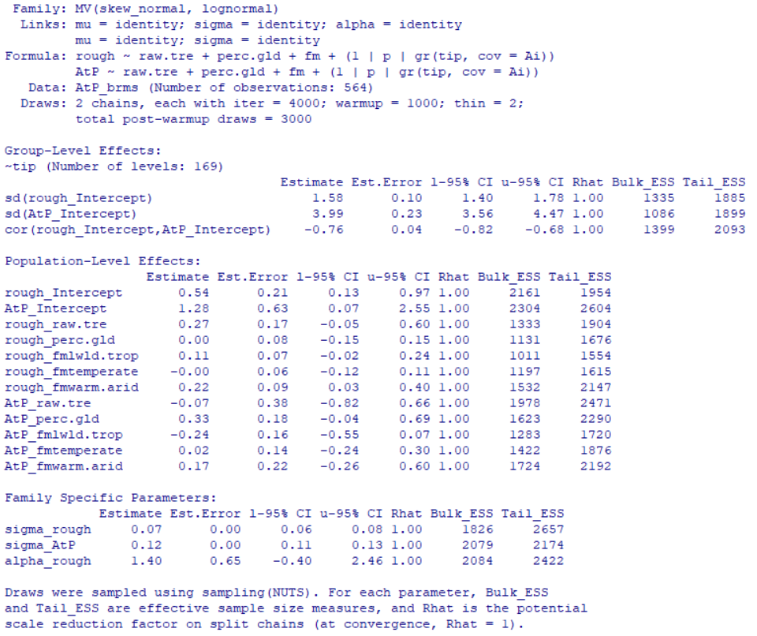

Table S38: Next two pages. Full brms model summary for model predicting diaspore roughness and diaspore attachment potential, with tree cover, grassland region, grassland radiation and growth habit as predictors. All possible interactions were modelled between predictors.
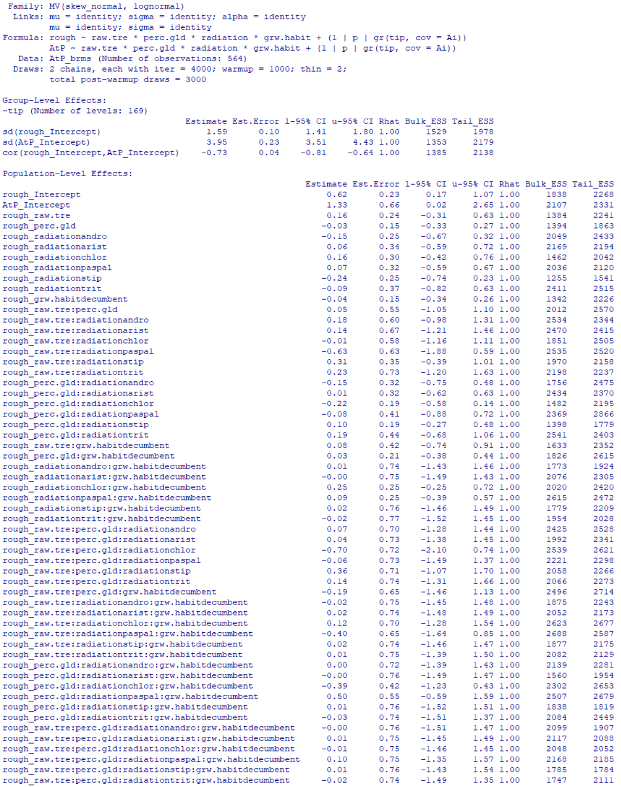
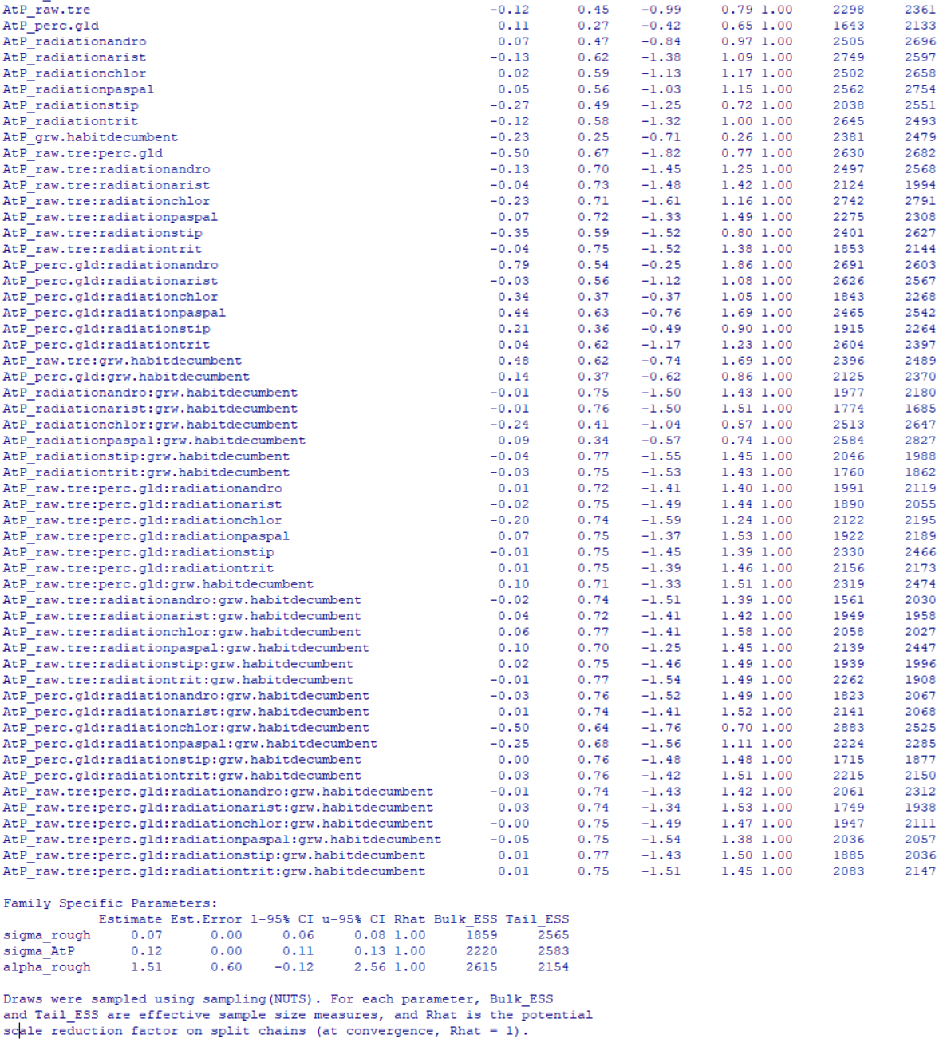

Table S39: This and following page. Full brms model summary for model predicting diaspore roughness and diaspore attachment potential, with tree cover, grassland type, grassland radiation and growth habit as predictors. All possible interactions were modelled between predictors.
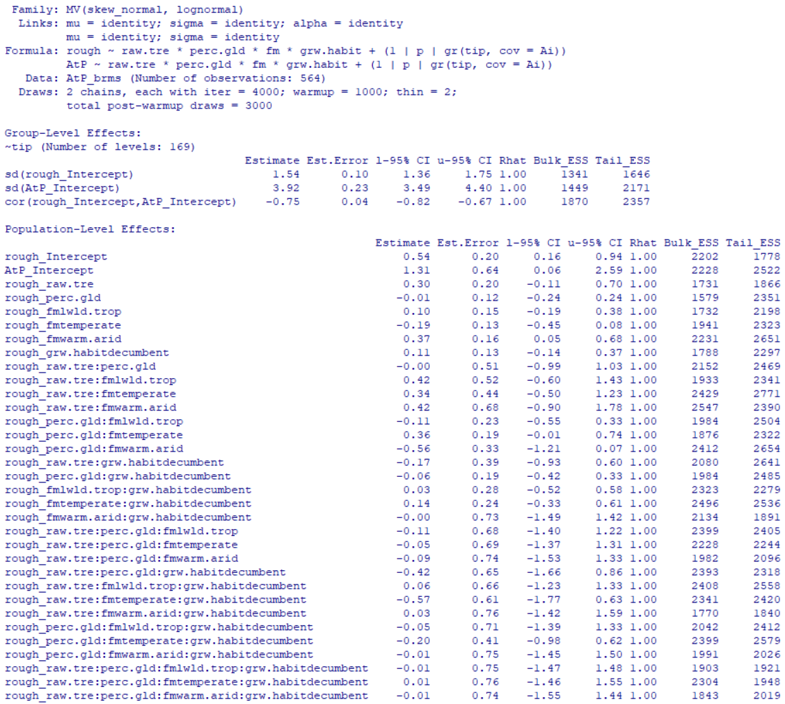
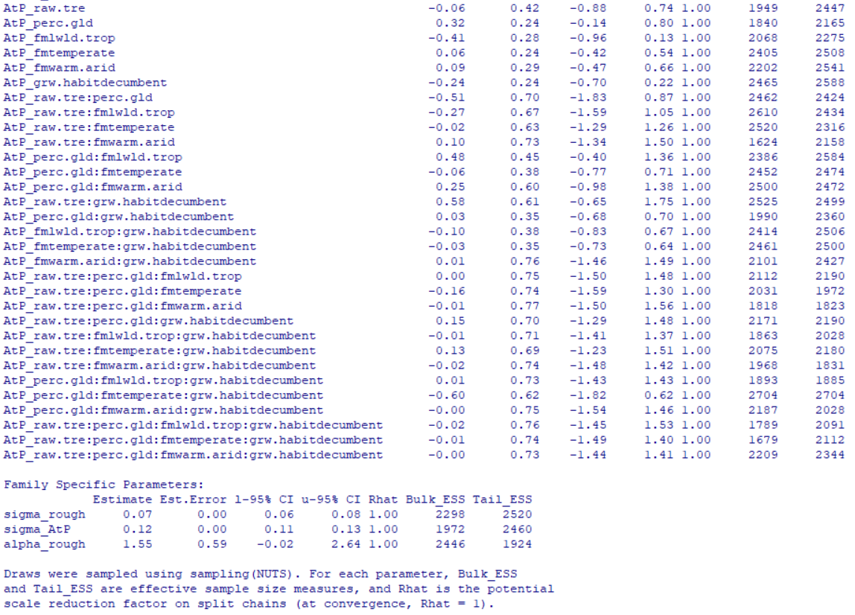
Table S40: Next two pages. Full brms model summary for model predicting diaspore roughness and diaspore attachment potential, with tree cover, grassland region, grassland radiation and log-transformed diaspore mass as predictors. All possible interactions were modelled between predictors.

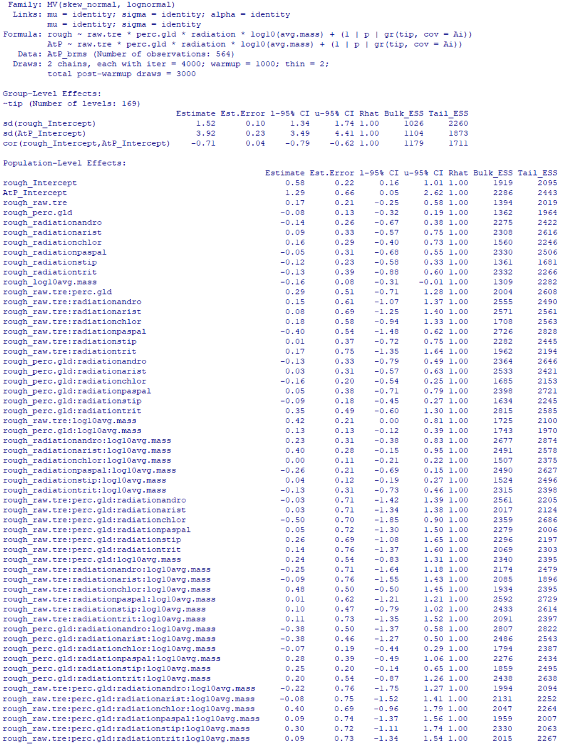

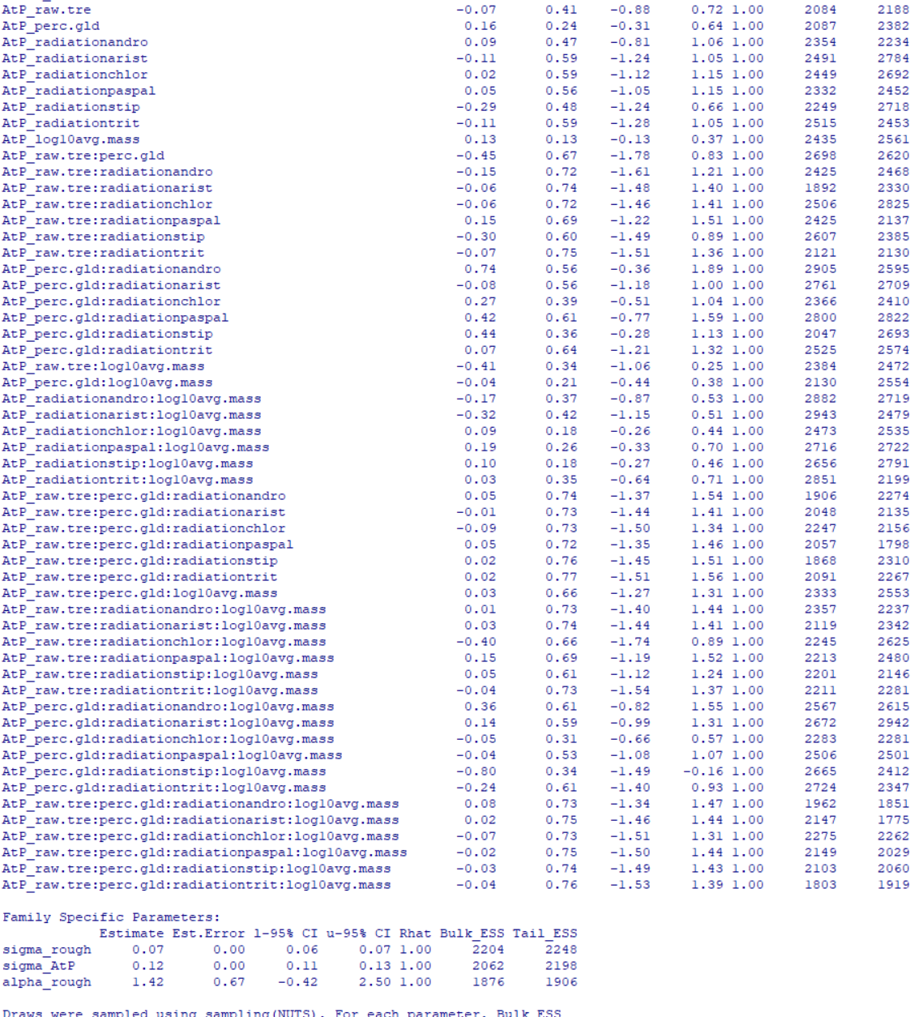

Table S41: This and following page. Full brms model summary for model predicting diaspore roughness and diaspore attachment potential, with tree cover, grassland region, grassland type and log-transformed diaspore mass as predictors. All possible interactions were modelled between predictors.
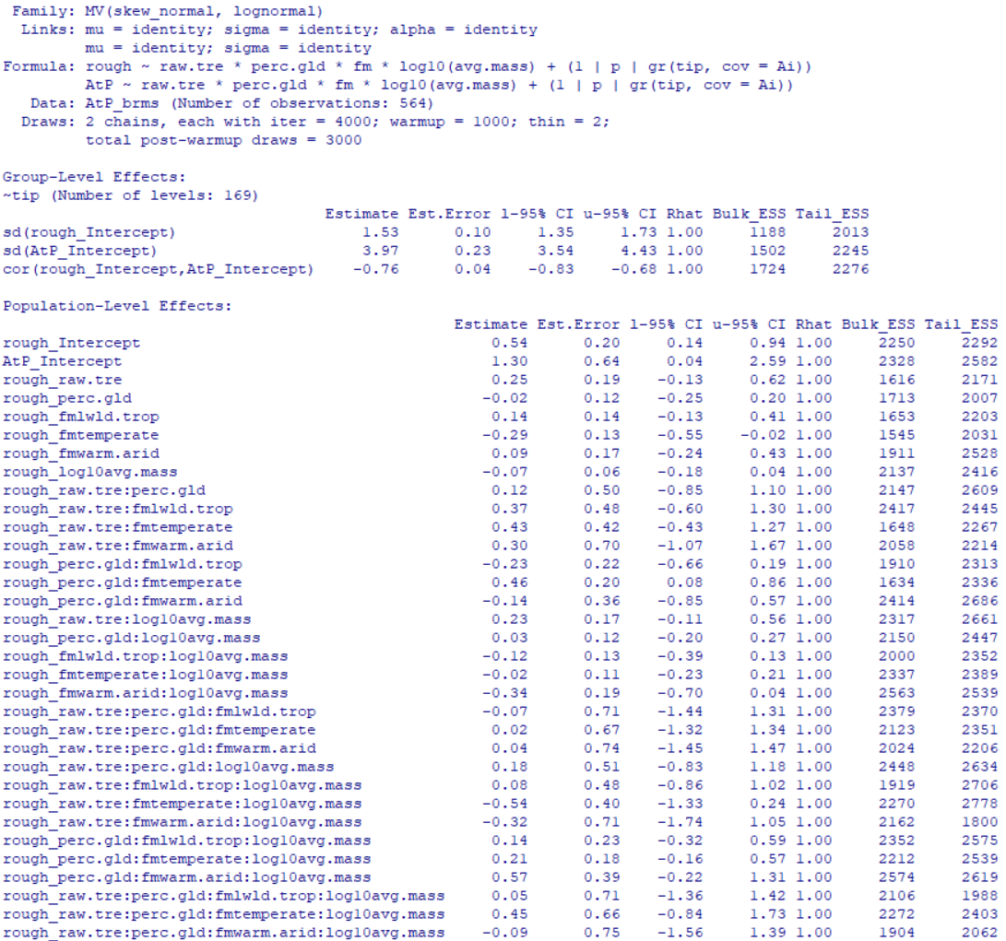

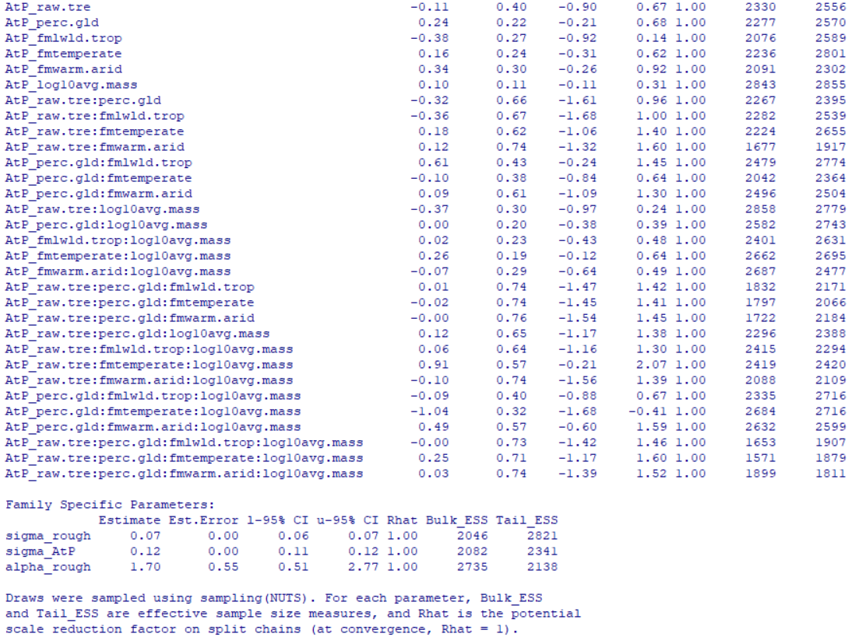
Table S42: Next page. Full brms model summary for model predicting diaspore roughness and diaspore attachment potential, with tree cover, grassland region, grassland type and log-transformed diaspore mass as predictors. Only the three-way interaction between grassland region, grassland type, and diaspore mass was modelled.
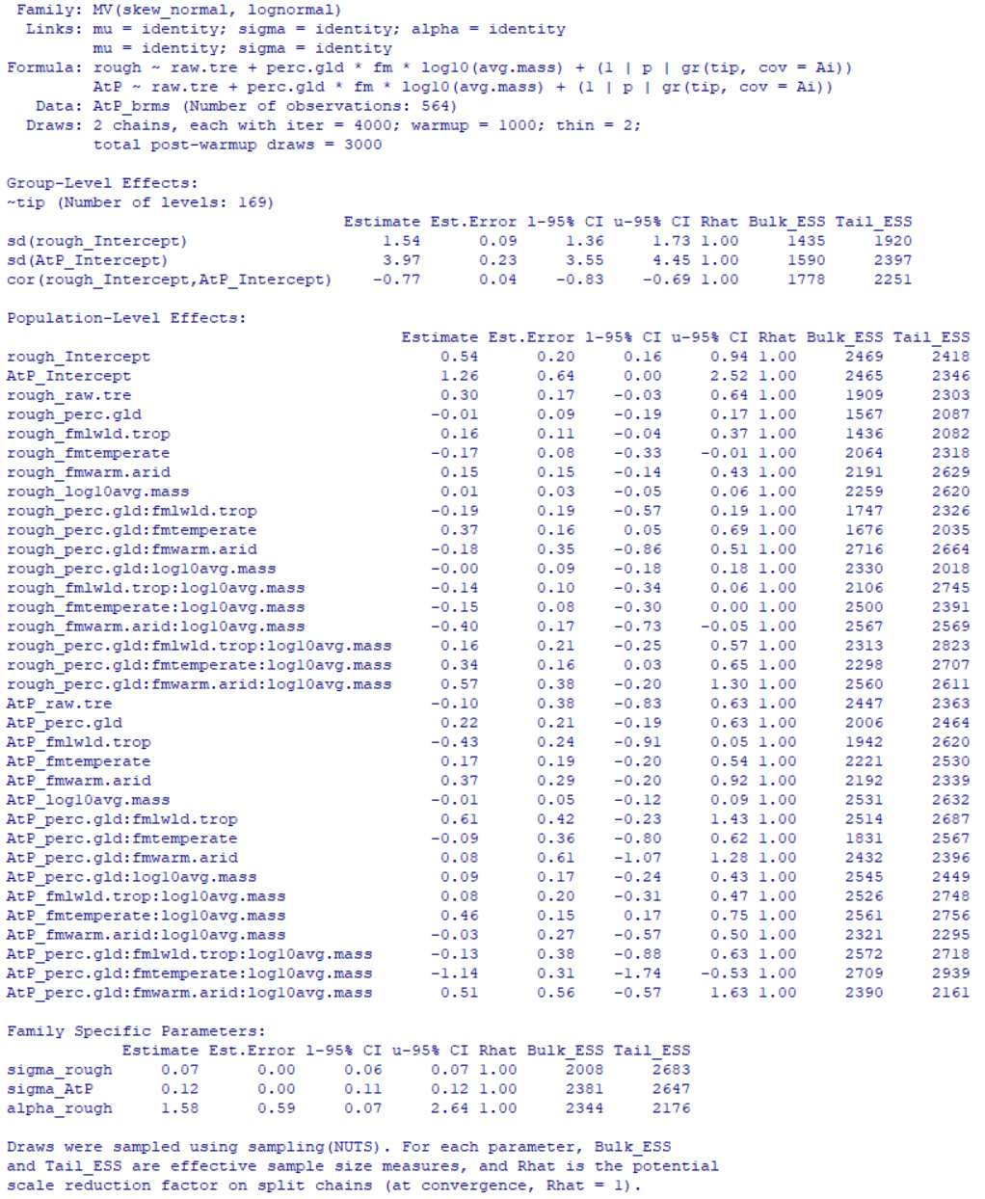

Table S43: Next page. Full brms model summary for model predicting diaspore roughness and diaspore attachment potential, with tree cover, grassland region, grassland radiation and log-transformed diaspore mass as predictors. Only the three-way interaction between grassland region, grassland radiation, and diaspore mass was modelled.
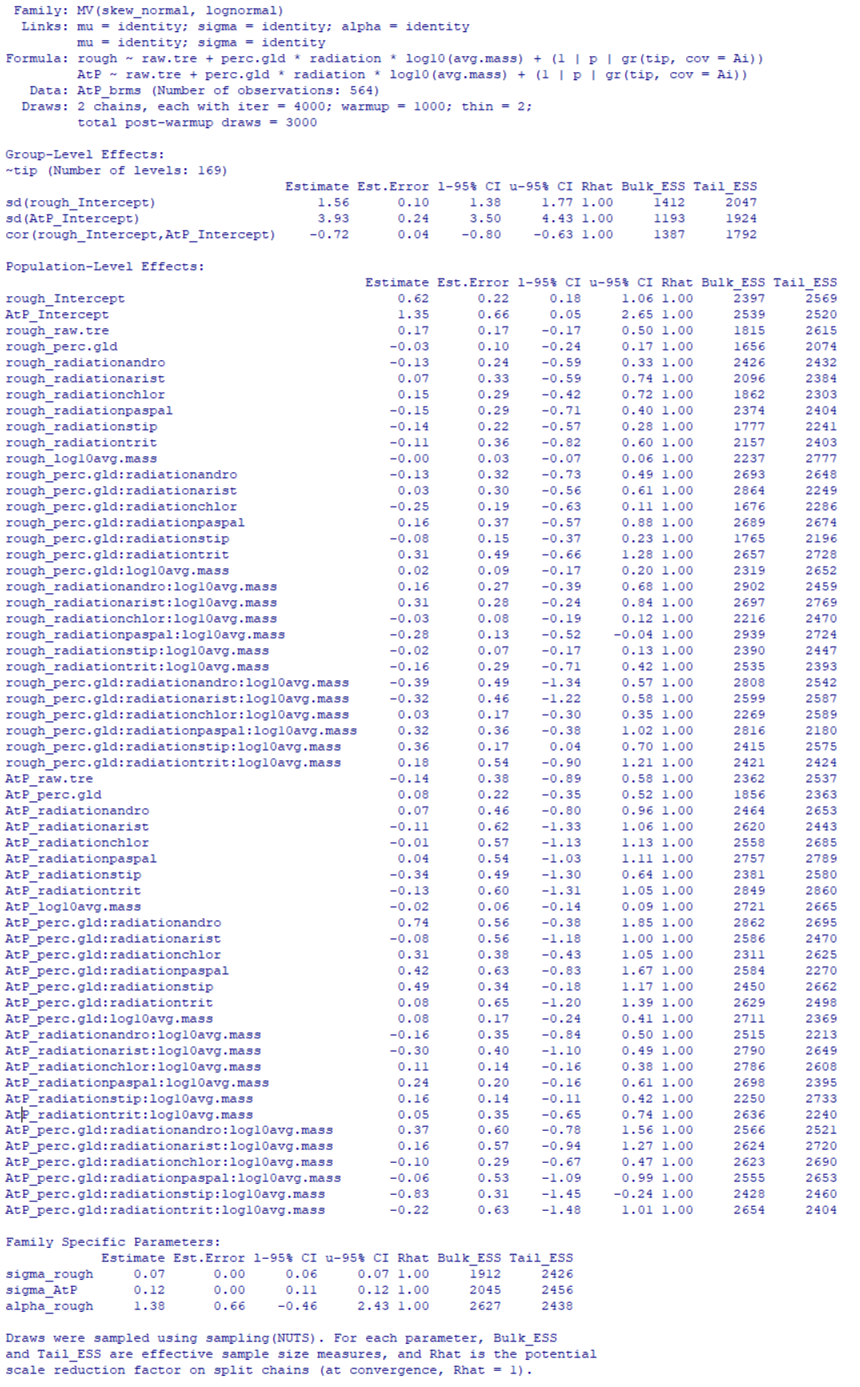
Table S44: Next page. Full brms model summary for model predicting diaspore roughness and diaspore attachment potential, with tree cover, grassland region, grassland type and log-transformed diaspore mass as predictors. Only the three-way interaction between grassland region, grassland type, and diaspore mass was modelled. Only “high quality” tree cover measurements were used, and the dataset was trimmed to include only those taxa whose relationships were robust to the inclusion or exclusion of loci with high degrees of missing data (see main text Methods).
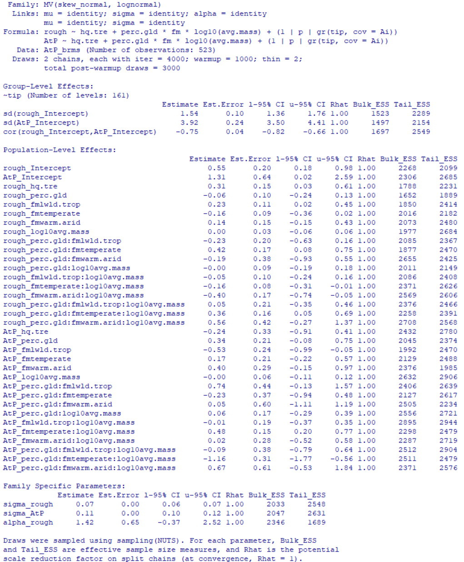
RESULTS S6:
Coding of diaspore traits in fossil Panicum
Extant Panicum primarily, but not exclusively, disperse spikelets (Fig. S11; Clayton et al., 2021). Some taxa (e.g., Panicum coloratum; Burson et al., 1983) even disperse a mix of spikelets and individual fertile florets. Fossils of Panicum elegans preserve the fertile floret, which we are interpreting as the diaspore in this study. We do so for simplicity as all other fossils are interpreted as representing the diaspore, but the preservation of only the fertile floret could reflect poor preservation potential of the sterile floret and glumes (which together with the fertile floret form the spikelet in the genus) since these are less well indurated in extant members (Clayton et al., 2021).
However, if the diaspore were in fact the entire spikelet it is unlikely to have dramatic impact on the reconstructed dispersal ecology. The addition of the sterile floret and glumes would undoubtedly add additional mass and area, but other traits are unlikely to change much. Additional mass would worsen wind dispersal performance, but this is already reconstructed to be poor. Diaspores would also be more highly exposed if the entire spikelet functioned as the diaspore, but the low roughness of most extant Panicum (Table S1) suggests that adhesive dispersal potential is likely to remain poor.

Fossil diaspore falling velocity reconstructions
In total, we tested eight potential linear calibration models (ordinary least squares) for use in predicting fossil diaspore falling velocity, using a sample of 149 stipoid grasses from 50 species. The best-fit model was selected using Akaike Information Criterion (AIC). The full summary output for this best-fit model is provided in Table S45. Compared models differed in the number and identity of the morphological predictors used, as well as whether any interactions between morphological predictors were modelled. In total, we tested the effects of diaspore roughness (see Will et al., 2007), induration of lemma/palea, awn surface area, maximum awn length, diaspore surface area (excluding awn if present), and diaspore solidity (excluding awn if present). All factors returned a significant correlation with diaspore falling velocity, but no interactions were returned as significant. Models are listed below with their corresponding R² values and AIC scores.
- Velocity ~ roughness + solidity [R2 = 0.29, AIC = 1619.3]
- Velocity ~ roughness + solidity + log10(diaspore area) [R2 = 0.38, AIC = 1600.2]
- Velocity ~ roughness + solidity + log10(diaspore area) + awn area [R2 = 0.41, AIC = 1593.7]
- Velocity ~ roughness + solidity + log10(diaspore area) + sqrt(awn area) [R2 = 0.46, AIC = 1581.3]
- Velocity ~ roughness + solidity * log10(diaspore area) + sqrt(awn area) [R2 = 0.47, AIC = 1580.0]
- Velocity ~ roughness + solidity + log10(diaspore area) + sqrt(awn area) + lemma induration [R2 = 0.51, AIC = 1560.9]
- Velocity ~ roughness + solidity + log10(diaspore area) + sqrt(max awn length) + lemma induration [R2 = 0.45, AIC = 1576.7]
- Velocity ~ roughness + solidity + log10(diaspore area) + sqrt(max awn length) * sqrt(awn area) + lemma induration [R2 = 0.50, AIC = 1564.0]

Table S45: Full model summary for best fit model predicting diaspore falling velocity from diaspore traits for use in predicting potential wind dispersal performance in fossil taxa.
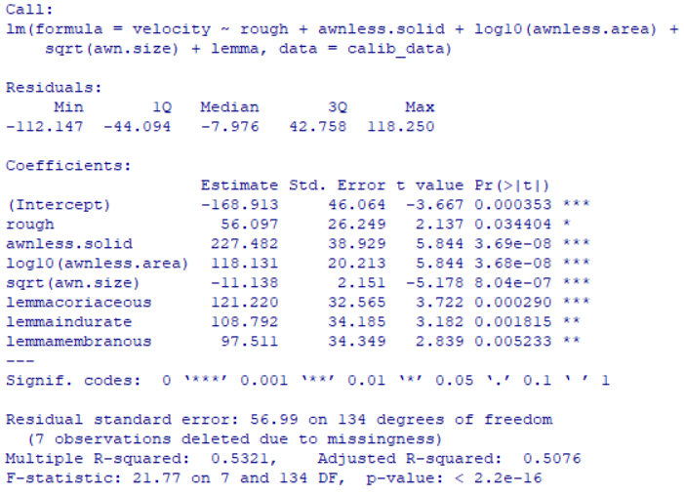
Figure S16: Next page. Panels show first three axes of the reconstructed phylomorphospace of modern taxa with fossil species overlayed. In each, the radiation of stipoid grasses is also indicated with green branches. In both, identifies the approximate range of morphologies found among ecologically dominant members of the extant Cerrados savannas, with the degree of lemma induration (and thus likely preservation potential) identified.
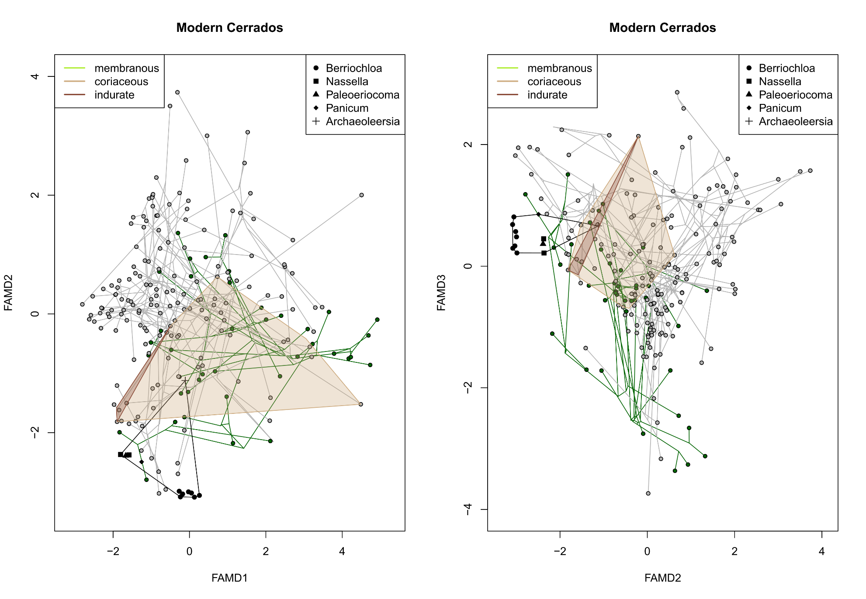
Figure S17: Next page. Panels show first three axes of the reconstructed phylomorphospace of modern taxa with fossil species overlayed. In each, the radiation of stipoid grasses is also indicated with green branches. In both, identifies the approximate range of morphologies found among ecologically dominant members of the extant Venezuelan savannas, with the degree of lemma induration (and thus likely preservation potential) identified.
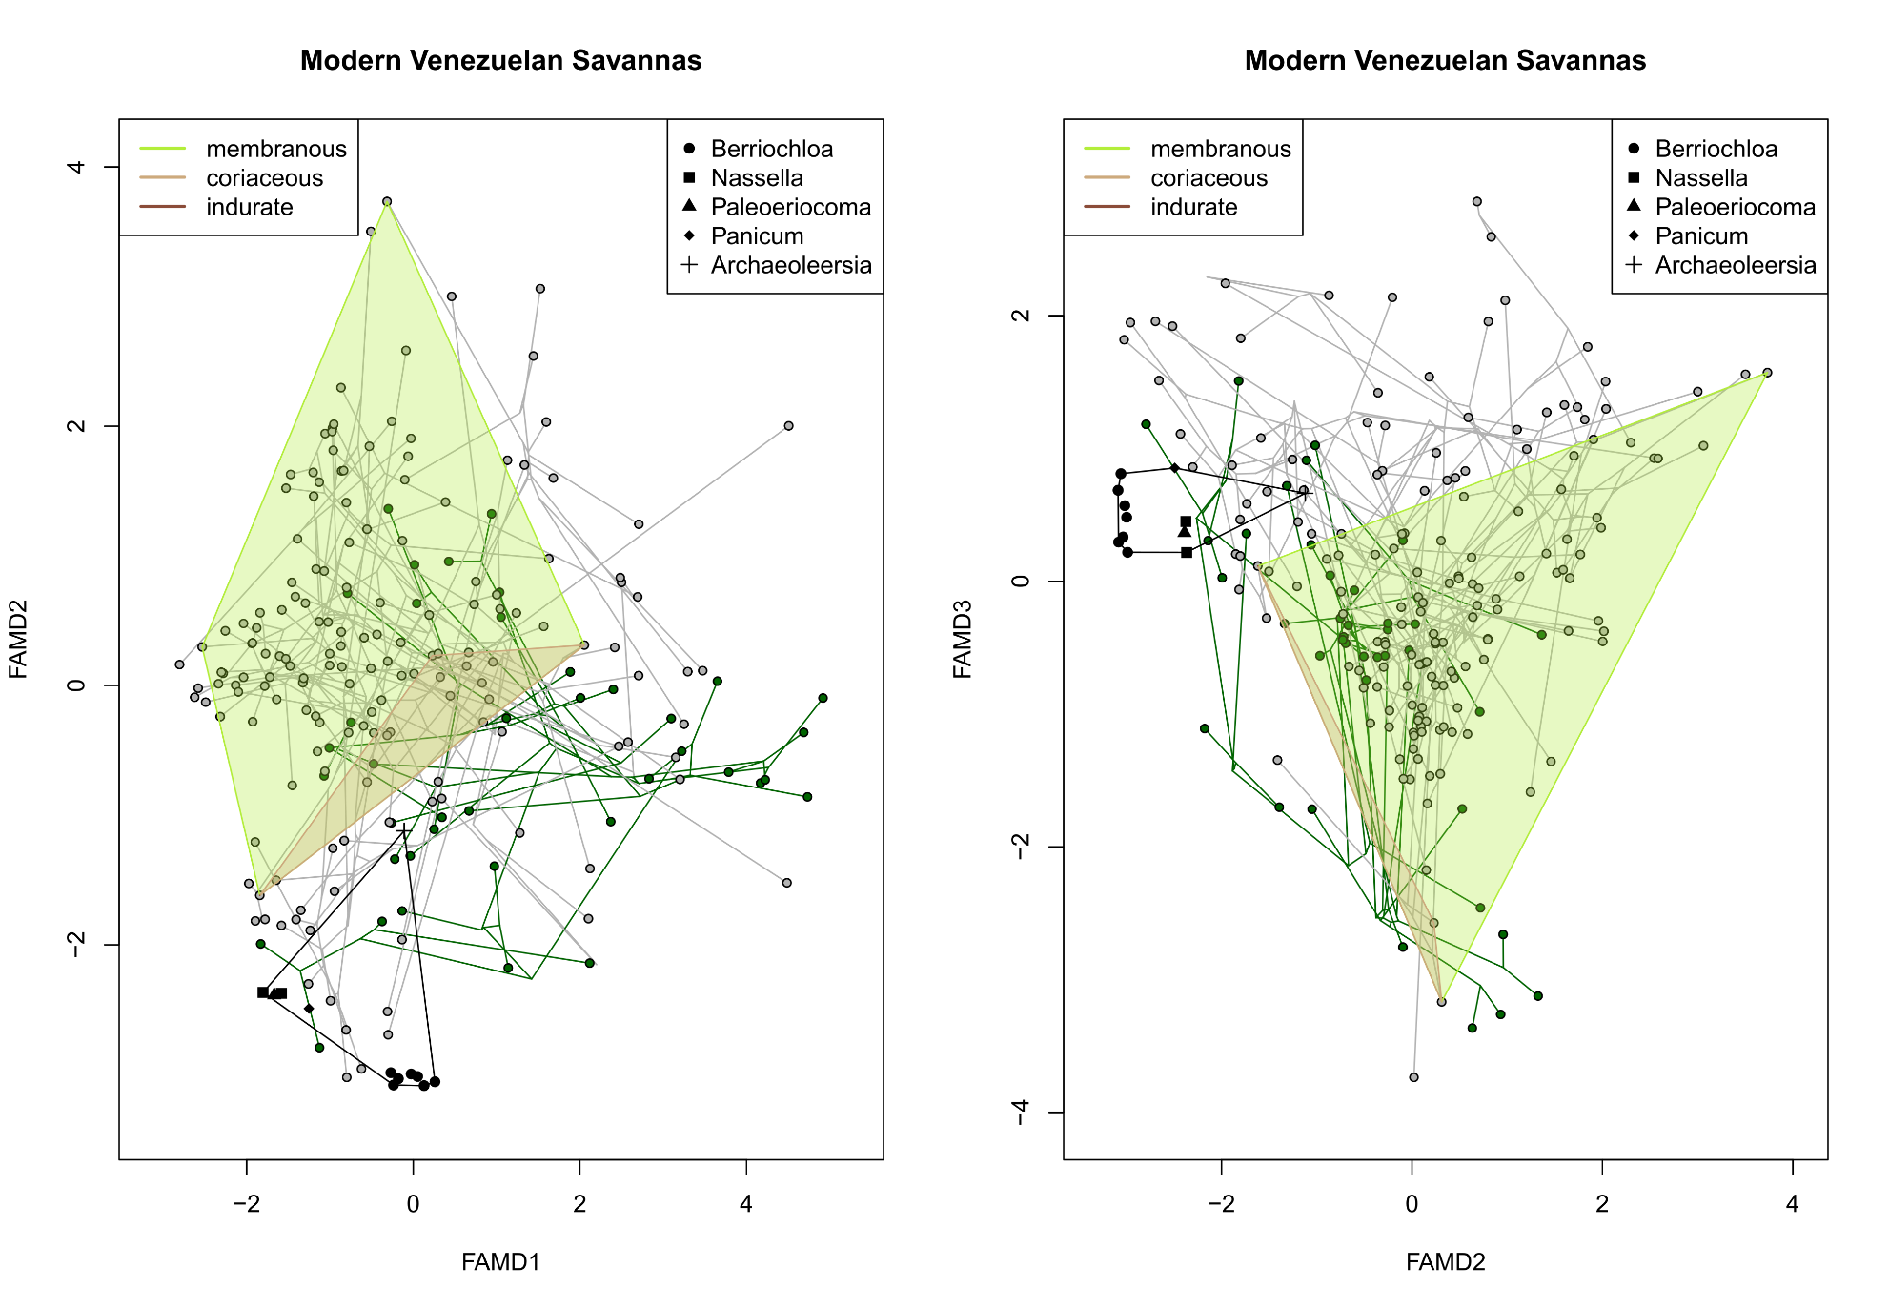
Figure S18: Next page. Panels show first three axes of the reconstructed phylomorphospace of modern taxa with fossil species overlayed. In each, the radiation of stipoid grasses is also indicated with green branches. In both, identifies the approximate range of morphologies found among ecologically dominant members of the extant midgrass (i.e., fire controlled) Serengeti savannas, with the degree of lemma induration (and thus likely preservation potential) identified.
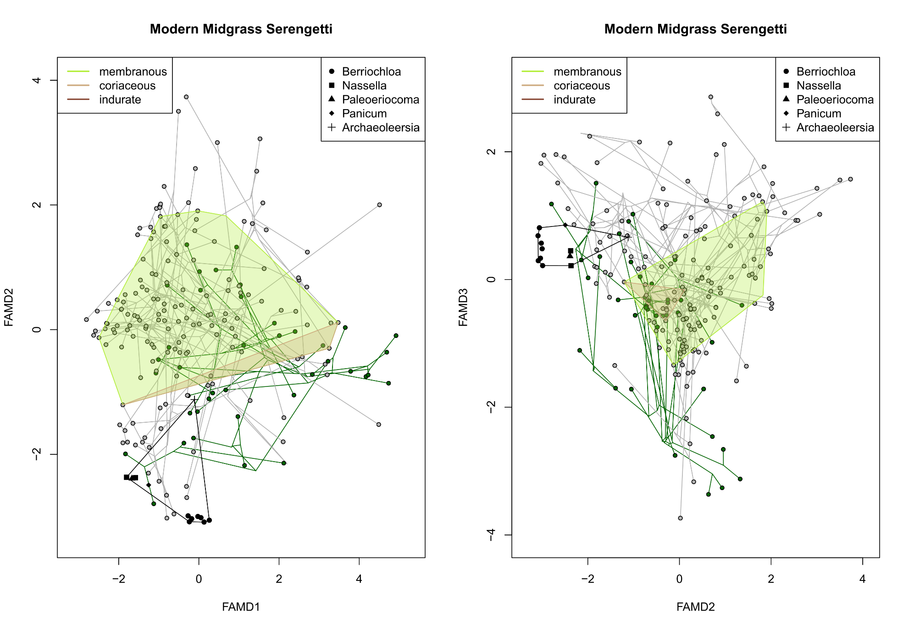
Figure S19: Next page. Panels show first three axes of the reconstructed phylomorphospace of modern taxa with fossil species overlayed. In each, the radiation of stipoid grasses is also indicated with green branches. In both, identifies the approximate range of morphologies found among ecologically dominant members of the extant shortgrass (i.e., grazing controlled) Serengeti savannas, with the degree of lemma induration (and thus likely preservation potential) identified.
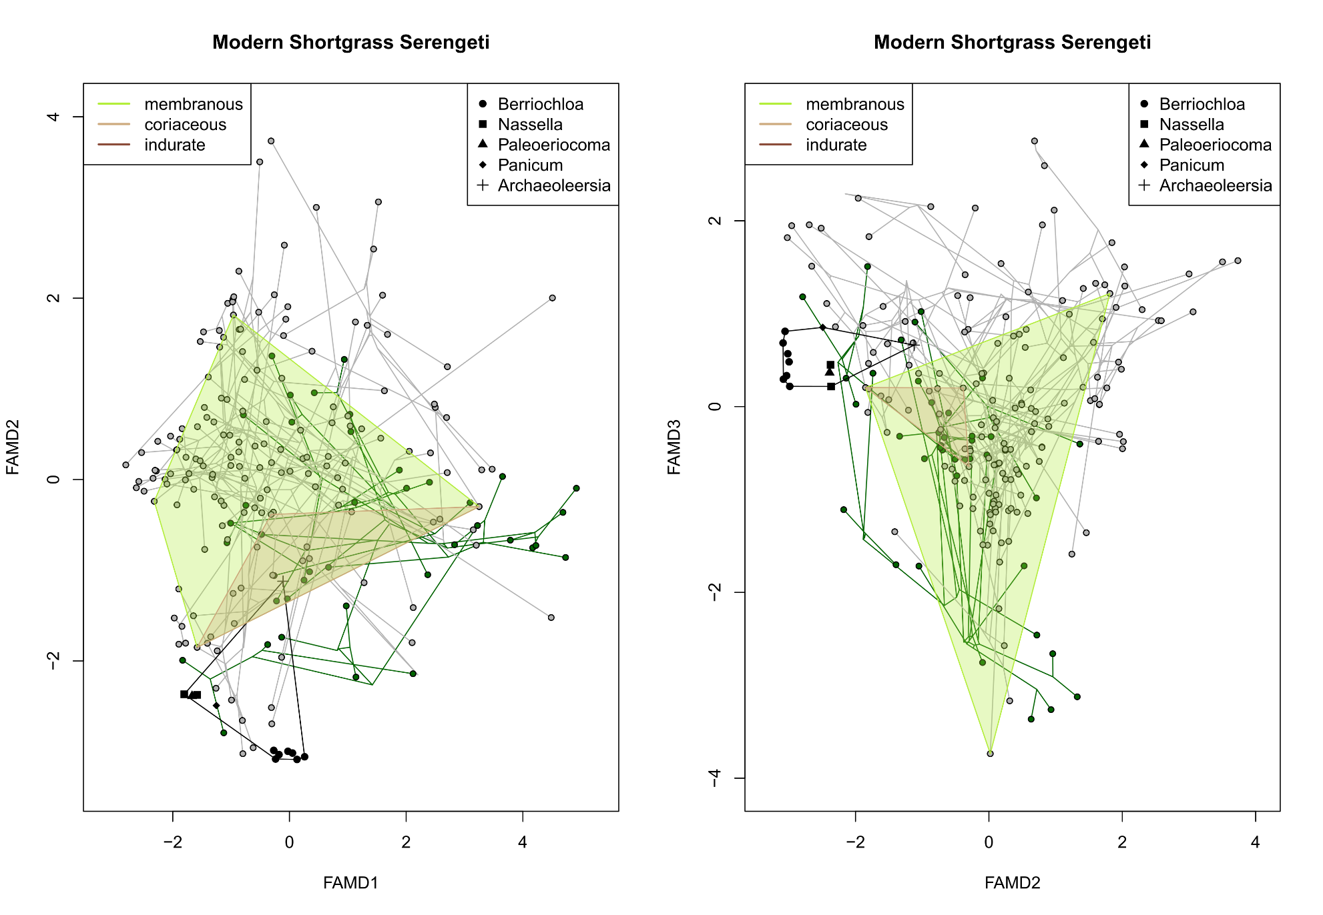
Figure S20: Ancestral state reconstruction of lemma induration and diaspore falling velocity, showing only sampled taxa from the tribe Stipeae (i.e., nearest living relatives of most recovered fossil taxa). Note that higher levels of lemma induration appear to be ancestral within the family, and acquisition of less indurate florets is typically associated with low falling velocities.
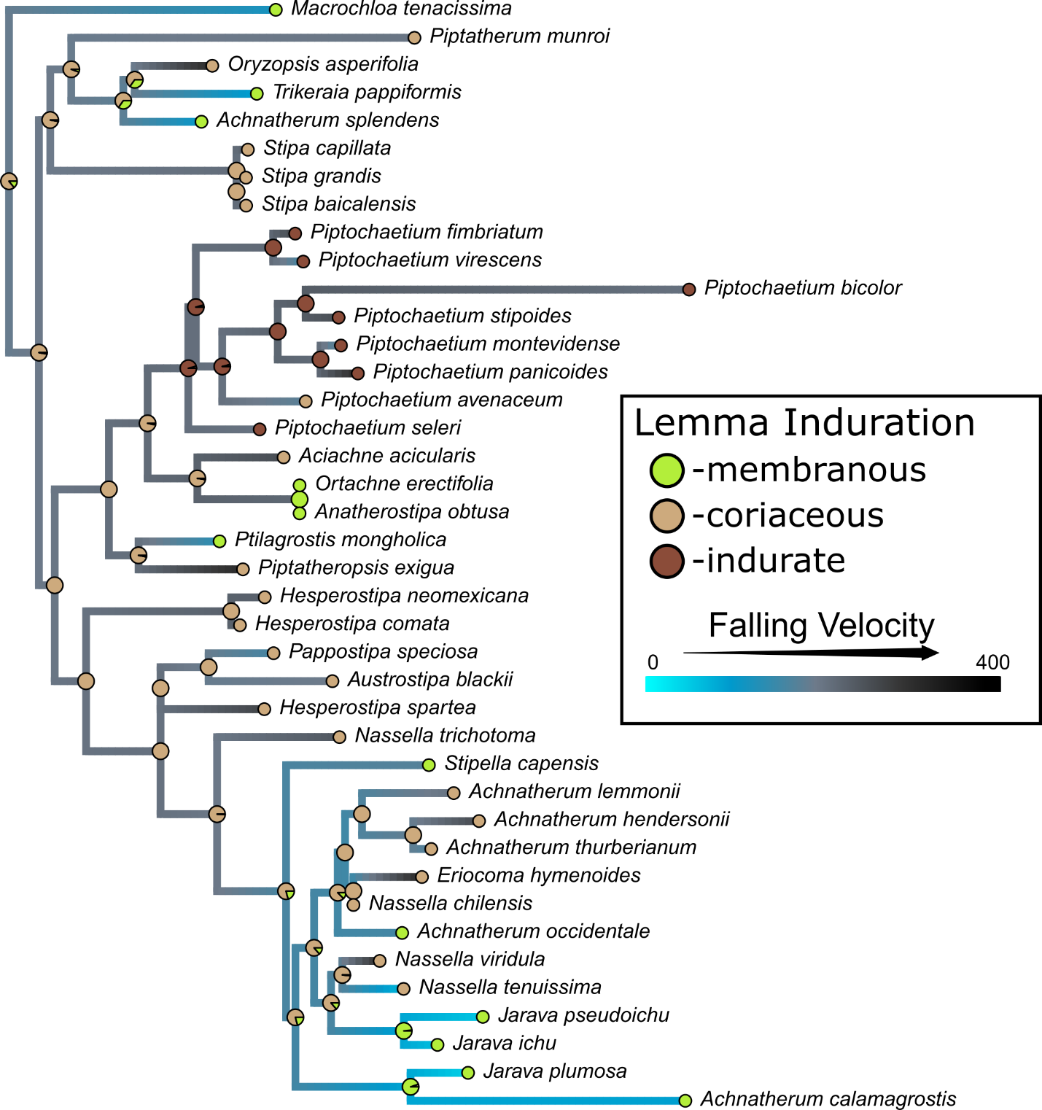

References
Bremond L, Alexandre A, Peyron O, Guiot J. 2005. Grass water stress estimated from phytoliths in West Africa. Journal of Biogeography 32: 311-327.
Clarke J. 2003. The occurrence and significance of biogenic opal in the regolith. Earth-Science Reviews 60:175-194.
Clayton WD, Vorontsova MS, Harman KT, Williamson H. 2021. GrassBase - The Online World Grass Flora. http://www.kew.org/data/grasses-db.html. 12 Dec 2022.
Cope TA, Gray A. 2009. Grasses of the British Isles. BSBI.
Crifo C, Strömberg CAE. 2020. Spatial patterns of soil phytoliths in a wet vs. dry neotropical forest: implications for paleoecology. Palaeogeography, Palaeoclimatology, Palaeoecology 562: 110100.
Davidse, G., Judziewicz, E. J., & Zuloaga, F. O. 2004. Flora of the Venezuelan Guayana vol. 8 Poaceae - Rubiaceae. In P. E. Berry, K. Yatskievych, & B. K. Holst (Eds.), vol. 8 Poaceae - Rubiaceae. Missouri Botanical Garden Press.
Dixon AP, Faber-Langendoen D, Josse C, Morrison J, Loucks CJ. 2014. Distribution mapping of world grassland types. Journal of Biogeography 41: 2003-2019.
Flora of China vol. 22. http://www.efloras.org/volume_page.aspx?volume_id=2022&flora_id=2. 16 Dec. 2022.
Gallaher TJ, Adams DC, Attigala L et al. 2019. Leaf shape and size track habitat transitions across forest–grassland boundaries in the grass family (Poaceae). Evolution 73(5): 927-946.
GBIF.org. 2022a. GBIF Occurrence Download. doi:10.15468/dl.ydtf9b
GBIF.org. 2022b. GBIF Occurrence Download. ; doi: 10.15468/dl.7n8q24
Gibson DJ. 2009. Grasses and Grasslands. Oxford University Press.
Innes RR, Clayton WD. 1977. A manual of Ghana Grasses. Land Resources Division, Ministry of Overseas Development: Surrey.
Lind EM, Morrison MES. 1974. East African vegetation. Longman Group Limited: London.
Madella M, Jones MK, Echlin P, Powers-Jones A, Moore M. 2009. Plant water avaoilability and analytical microscopy of phytoliths: Implications for ancient irrigation in arid zones. Quaternary International 193: 32-40.
McNaughton SJ. 1983. Serengeti grassland ecology: the role of composite environmental factors and contingency in community organization. Ecological Monographs 53(3): 291-320.
Oliveira PS, Marquis RJ. 2002. The Cerrados of Brazil. Colombia University Press: New York.
R Core Team. 2022. R: A language and environment for statistical computing. R Foundation for Statistical Computing.
Revell LJ. 2012. phytools: an R package for phylogenetic comparative biology (and other things). Methods in Ecology and Evolution 3(2): 217-223.
Silberbauer-Gottsberger I. 1984. Fruit dispersal and trypanocarpy in Brazillian cerrado grasses. Plant systematics and evolution 147:1-27.
Skinner MF, Skinner SM, Gooris RJ. 1977. Stratigraphy and biostratigraphy of Late Cenozoic deposits in central Sioux County, western Nebraska. Bulletin of the American Museum of Natural History 158: 5.
Smith JJ, Platt BF, Ludvigson GA, Thomasson JR. 2011. Ant-nest ichnofossils in honeycomb calcretes, Neogene Ogallala Formation, high plains region of western Kansas, USA. Palaeogeography, Palaeoclimatology, Palaeoecology 308: 383-394.
Soreng RJ, Peterson PM, Romaschenko K et al. 2015. A worldwide phylogenetic classification of the Poaceae (Gramineae). Journal of Systematics and Evolution 53(2): 117-137.
Soreng RJ, Peterson PM, Romaschenko K et al. 2017. A worldwide phylogenetic classification of the Poaceae (Gramineae) II: An update and a comparison of two 2015 classifications. Journal of Systematics and Evolution 55(4):259-290.
Strömberg CAE, Dunn RE, Crifo C, Harris EB. 2018. Phytoliths in paleoecology: analytical considerations, current use, and future directions. Methods in Paleoecology doi:10.1007/978-3-319-94265-0_12
Strömberg CAE, Werdelin L, Friis EM, Sarac G. 2007. The spread of grass-dominated habitats in Turkey and surrounding areas during the Cenozoic: phytolith evidence. Palaeogeography, Palaeoclimatology, Palaeoecology 250: 18-49.
Strömberg CAE. 2005. Decoupled taxonomic radiation and ecological expansion of open-habitat grasses in the Cenozoic of North America. Proceedings of the Natural Academy of Sciences 102(34): 11980-11984.
Strömberg CAE. 2009. Methodological concerns for analysis of phytolith assemblages: does count size matter? Quaternary International 193: 124-140.
Strömberg CAE. 2011. Evolution of Grasses and Grassland Ecosystems. Annual Review of Earth and Planetary Sciences 39(1): 517–544. doi: 10.1146/annurev-earth-040809-152402
Stubbendieck J, Hatch SL, Dunn CD. 2017. Grasses of the Great Plains. College Station: Texas A&M University Press.
Thomasson JR. 1979. Late Cenozoic grasses and other angiosperms from Kansas, Nebraska, and Colorado: biostratigraphy and relationships to living taxa. Kansas Geological Survey Bulletin 218.
Thomasson JR. 1985. Miocene fossil grasses: possible adaptation in reproductive bracts (lemma and palea). Annals of the Missouri Botanical Gardens 72: 843-851.
Thomasson JR. 2005. Berriochloa gabeli and Berriochloa huletti (Gramineae: Stipeae), two new grass species from the Late Miocene Ash Hollow Formation of Nebraska and Kansas. Journal of Paleontology 79(1): 185-199.
van der Pijl L. 1982. Principles of dispersal in higher plants. Berlin: Springer-Verlag.
Will H, Maussner S, Tackenberg O. 2007. Experimental studies of diaspore attachment to animal coats: predicting epizoochorous dispersal potential. Oecologia 153: 331-339.
Zizka A, Silvestro D, Andermann T et al. 2019. CoordinateCleaner: Standardized cleaning of occurrence records from biological collection databases. Methods in Ecology and Evolution 10(5): 744-751.

