Influence of Zooplankton Community Composition on Copepod Diel Vertical Migration in Hood Canal

Madison Waugh
University of Washington, Seattle, WA
School of Oceanography, Box 357940
waughm@uw.edu

Abstract

This study observed zooplankton community composition alongside copepod diel vertical migration patterns in order to make conclusions about the relationship between these two factors. Data on zooplankton community, diel vertical migration, and water column properties were collected from two sample locations within the Hood Canal Basin of Puget Sound. By comparing these two stations it was observed that more dramatic DVM patterns are correlated to water columns where more copepod predators are present. This is likely due to the increased need for avoidant behavior by copepods in order to survive in water columns with a higher risk of mortality as a result of predation. In addition, environmental conditions such as depth, water column stability, temperature, salinity, dissolved oxygen, and chlorophyll are hypothesized to aid in habitat selection and are significant factors in influencing the community composition of the zooplankton community as a whole.

Introduction

Zooplankton are a group of widely diverse planktonic organisms which encompass taxa of varying diets, life history strategies, and habitat preferences. Despite the unique characteristics of each taxa, zooplankton as a whole represents a vital part of the marine food web, serving as a key link between photosynthetic producers and higher trophic level organisms (Frederiksen et al, 2006). Because of this, zooplankton are significant in the global carbon cycle by serving as a reservoir during their lifetimes, transferring carbon throughout the pelagic food web, and aiding in export to depth via excretion and other sinking particles (Turner, 2004).
To understand the role of zooplankton in the marine environment, researchers have identified significant behavioral strategies that promote the survivorship of these organisms. One of the most widely recognized behaviors is diel vertical migration, or DVM, in which organisms will adjust their vertical position in the water column depending on a desired outcome. This migration has been hypothesized to occur for a variety of reasons, the most significant being predator avoidance. Multiple types of DVM exist, including nocturnal migration, twilight migration, and multiple twilight migrations, with the type performed depending on the specific life history strategy of a species (Frost, 1988). Typically, organisms that participate in DVM will undergo nocturnal migration in which they move up and down in the water column one time per day. During this cycle, they will generally remain in the depths during the day, and then ascend to the surface water at night in order to feed on the phytoplankton that reside there. This behavior is thought to increase their chances for survival from predators that hunt by sight; by remaining in areas of low light they are much less likely to be detected (Brierley, 2014). A variety of environmental cues may be responsible, including changes in light, temperature, and food availability, though light change tends to be the most widely recognized hypothesis (Ohman, 1990). Due to the advantage created by DVM, it is recognized as a widespread behavior within the marine environment, and includes representatives from most taxa of zooplankton. Though a majority of zooplankton taxa participate in DVM, the extent of their migration is highly variable. An additional behavior that is hypothesized to increase zooplankton survivorship is an overwintering strategy known as diapause. When conditions become unfavorable, organisms will sink to the depths, and lay dormant within the sediments. During this time, they will rely on the lipid supply that they accumulated before the onset of diapause. Those that survive this process will return to the surface in the spring and continue their development (Baumgartner & Tarrant, 2017). Due to the loss of overwintering organisms from the surface waters, this behavior has the potential to alter overall population dynamics within the zooplankton community.
Hood Canal is one of four basins within the estuarine fjord system known as Puget Sound. The basin is characterized by its long residence time, which can range from two to four months (MacCready, 2017). This is a product of its bathymetry, specifically the presence of a sill 40 meters below the surface that limits exchange of water with the rest of the estuary (Babson et al, 2006). Due to this long residence time, Hood Canal frequently experiences hypoxic conditions, which are known to have negative impacts on the survivorship of marine organisms (Grodzins et al, 2016). Puget Sound also experiences estuarine circulation and a strong salinity-driven density gradient due to the opposing inputs of freshwater runoff and saline ocean water; the effects of this are, again, felt especially in Hood Canal due to intense stratification and lack of mixing. Properties such as temperature, salinity, dissolved oxygen, and chlorophyll have the potential to have an impact on the zooplankton community as a whole, affecting the total abundance as well as the species present based upon the specific environmental needs of the organisms.
The objective of this research is to assess zooplankton community composition alongside copepod diel vertical migration patterns at two opposing study sites within the Hood Canal basin in order to ultimately draw conclusions on the relationship between these two variables. Doing so will contribute to a broader understanding of the dynamics between zooplankton of varying trophic levels and the behaviors involved in these interactions. This will provide insight into overall trophic transfer and efficiency in the ocean; a concept that is increasingly important to understand as marine environments are being altered in response to changing climate conditions.

Methods
Sample Locations
Samples were taken from Hood Canal aboard the R/V Thomas G. Thompson on January 13th-15th 2018. Two sample locations were used, which were given the identifiers HC02 and HC09 (Figure 1). These sites were widely spaced within Hood Canal, with HC02 on the northern end of the basin, and HC09 on the southern end near the Great Bend. The depths at each site varied considerably, with HC02 measuring 105 meters deep and HC09 measuring 70 meters deep. This was accounted for during analysis by calculating percent abundance in each sample so as not to create a bias. Due to time constraints, night and day samples could not be acquired from both locations, so in order to generate a complete data set the night samples were taken from HC09 and the day samples were taken at HC02 the following morning.
Field Sampling
A series of three vertical net tows were performed at each station in order to collect zooplankton samples. These tows consisted of a full water column tow, a surface tow (30-0m), and a deep tow (bottom-30m). The 30m splitting point was used due to the location of the oxycline as observed using shipboard instruments. All tows were taken using a 1m diameter 333um mesh closing net. Samples from HC09 were acquired on January 14th at 8:37pm (full water), 8:41pm (deep), and 8:53pm (surface). Samples from HC02 were taken on January 15th at 8:40am (deep), 8:48am (full water), and 9:03am(surface). After each tow, the net was brought onto the deck where the contents of the cod-end were transferred to 750mL collection jars and fixed in a 5% formalin solution for later analysis. CTD casts were also performed at both locations using a Seabird SBE-9 instrument to measure temperature, salinity, dissolved oxygen, and chlorophyll.
Laboratory Analysis
Full water column tows were used to assess the overall community composition at each site, and split water column tows were used to assess copepod DVM. For each sample, organisms were removed from their formalin solutions by filtering onto a sieve, and then transferred into tap water for analysis. Large zooplankton were removed first and counted towards the total abundance. Each sample was then diluted to a fixed volume of water, and 5mL subsets of each were taken using a Stempel pipette. Records of the fixed volumes and counted volumes were kept for later use in calculating the dilution factor and abundances. Each subset was then placed in a counting tray and observed using a dissecting scope. In the full water column tows all zooplankton were identified by taxonomic group, and counted accordingly. In each split water column tow copepods were counted and sorted into two groups based on their size, either large (<2mm) or small (>2mm). After all samples were analyzed the abundances were standardized by multiplying the number of individuals counted in each group by their respective dilution factor and divided by their volume filtered.

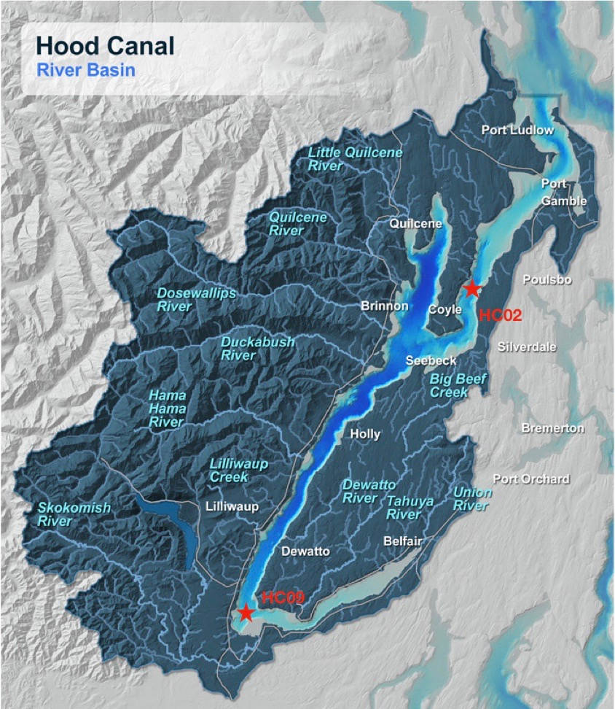
Figure 1.
Map of sample locations HC02 and HC09 within the Hood Canal basin. HC02 is located at 47.735N, -123.75W and HC09 is located at 47.3711N, -123.12W.

Results
Biodiversity and Community Composition
A wide range of different zooplankton taxa were identified across the two stations. At HC09 these taxa included amphipods, euphausiids, chaetognath worms, polychaete worms, larval fish, jellies, larvaceans, copepods (calanoid and cyclopoid), gastropods, and barnacle nauplii. These same taxa, with the addition of ctenophores and zoea, were observed at HC02. This contributed to a total population of 5,439 individuals at HC09, and 14,508 individuals at HC02. Though most of the same taxa were observed at both locations, their abundance and percent makeup of the total community varied significantly (Figure 2).
Copepods were the most abundant taxa at both locations, contributing 65.93% (n=9,565) of the total population at HC02, and 58.83% (n= 3,200) at HC09 (Figure 3). For the purposes of the diel vertical migration portion of this study, calanoid and cyclopoid species were grouped together, though when considering overall diversity these two distinct types varied significantly in their contribution to the total copepod population across the two stations. Calanoid copepods made up a higher proportion of the total copepods at both stations, but cyclopoid copepods contributed more to the total population at HC09. At HC02 the copepod population consisted of 99.5% calanoid (n=9,520) and 0.5% cyclopoid (n=45), which translated to 65.62% and 0.31% of the total zooplankton population respectively. At HC09 this shifted to 75.0% (n=2,400) calanoid and 25.0% cyclopoid within the copepod population, and 44.13% versus 14.7% in the total population.
The remaining taxa had varying significance to the total zooplankton community depending on the station at which the sample was collected (Figure 3). Jellyfish made up the second largest group at both locations with 13.11% (n=1,254) at HC02, and 12.24% (n=666) at HC09. The final taxa with consistent significance between the stations were larvaceans with 3.11% (n=297) at HC02, and 11.03% (n=600) at HC09. Euphausiids contributed 2.31% (n=221) at HC02, and 1.53% (n=83) at HC09. Amphipods contributed 2.81% (n=269) at HC02, and 0.18% (n=10) at HC09. Chaetognath worms contributed 6.48% (n=620) at HC02, and 5.88% (m=320) at HC09. Gastropods contributed 0.54% (n=52) at HC02, and 2.94% (n=160) at HC09. Barnacle nauplii contributed 2.37% (n=23) at HC02, and 5.88% (n=320) at HC09. Larval fish contributed 0.94% (n=90) at HC02, and 0.74% (n=40) at HC09. Polychaete worms contributed 0.82% (n=78) at HC02, and 0.74% (n=40) at HC02. Finally, both zoea and ctenophores were observed at HC02 only, where they contributed 1.24% (n=180) and 0.03% (n=4) respectively.
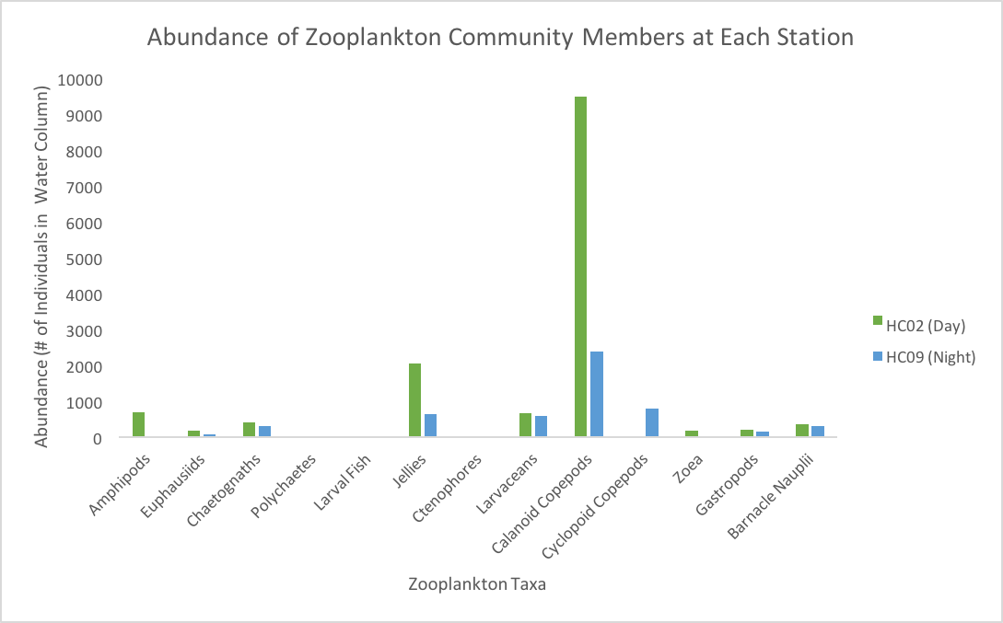

Figure 2.
Representation of zooplankton taxa identified at each station, as well as a comparison of the relative abundances of each shown by the total number that were present throughout the entire water column.

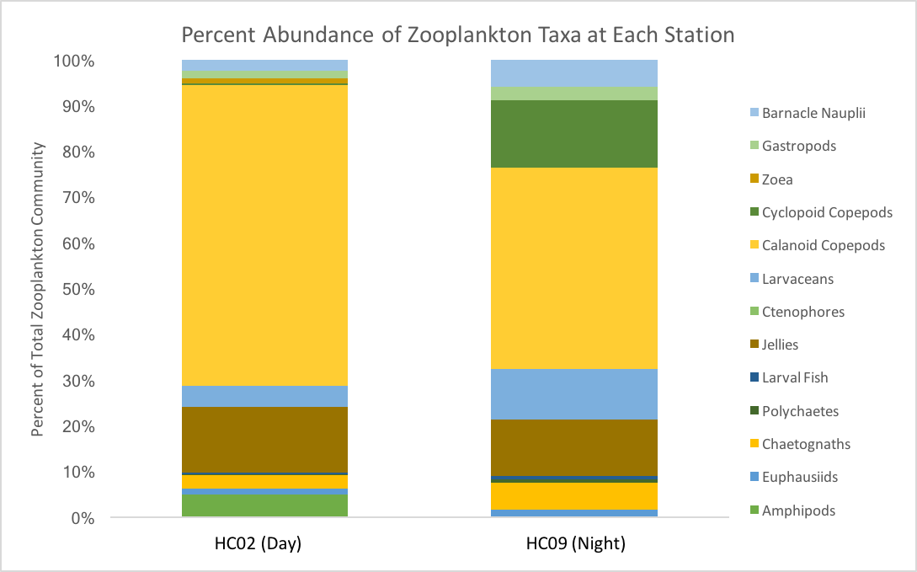

Figure 3.
Contribution of each zooplankton taxa to the overall community as represented by the percent contribution within the total population.

Diel Vertical Migration
Copepod abundances were observed to vary with depth as well as time of day (Figure 4). At night, an abundance of 16.1m⁻³ was observed at the surface, which decreased to 15.8m⁻³ at depth. In contrast, during the day an abundance of 25.9m⁻³ was observed at the surface, and increased to 148.5m⁻³ at depth. At both stations, a vast majority of the total copepod abundance was made up of small individuals whose length was less than 2mm. That said, the proportion of large copepods that were observed to migrate was variable between the two stations (Figure 5). At HC09 (the night sample), 10.7% of copepods at the surface were large, which decreased to 5.4% at the bottom. At HC02 (the day sample), 3.0% at the surface were large, which increased to 23.8% at the bottom.

Figure 4.
Abundance of copepods per cubic meter present at the surface of the water column versus the bottom of the water column at each station. The figures each have different scales, with the top figure increasing at increments of 20m⁻³, and the bottom figure increasing at increments of 0.05m⁻³.

Figure 5.
Distribution of small and large copepods at the surface of the water column versus the bottom at each station as represented by the percent make-up of each size class within the total copepod population.

Environmental Parameters
Using data collected from the CTD casts we were able to consider several water column properties including temperature, salinity, dissolved oxygen, and chlorophyll (Figure 6). These properties varied with depth as well as across the two stations, and are relevant when considering the zooplankton communities.
Temperatures were observed to be consistently higher at HC09 than at HC02. At this warmer site, the temperature within the mixed layer was 10.2°C, which increased slightly with depth until the bottom of the thermocline, where it reached 10.9°C and remained throughout the rest of the water column. In contrast, HC02 did not have a distinct mixed layer or thermocline. At this site, the temperature at the surface was 8.8°C, and decreased with depth until it reached 8.5°C at the bottom of the water column.
Salinity values were consistently higher at HC09 as well, aside from one point at ~20m in which HC02 was higher. At HC09 salinity measured 29.5 PSU throughout the mixed layer, which increased to 30.25 PSU at the bottom of the halocline. After this point, it gradually increased to 30.5 PSU at the bottom of the water column. At HC02 there was no distinct mixed layer, but there was a halocline where salinity increased from 29.1 PSU to 29.9 PSU. At the bottom of this halocline salinity was fairly consistent, though increasing slightly to 30.0 PSU as it neared the seafloor.
The reverse trend was observed with dissolved oxygen, with HC02 having consistently higher values than HC09. Again, a distinct mixed layer or oxycline was not apparent at HC02; the highest value is observed at the surface of 5.9 mL/L dissolved oxygen, which then decreases gradually with depth until the bottom of the water column where it was 4.5 mL/L. At HC09 dissolved oxygen was 3.3 mL/L throughout the mixed layer, then decreased to 2.1 mL/L at the bottom of the thermocline and throughout the rest of the water column.
The trend of chlorophyll throughout the water column is more variable than the previous two properties. Chlorophyll content at HC02 was highest at the surface with 1.13 μg/L, then decreased linearly until ~10m where it dropped to 0.14 μg/L and remained throughout the rest of the water column. At HC09 chlorophyll content started out lower at the surface at 0.99 μg/L, then increased until ~10m where it reached 1.4 μg/L. At this point it decreased with depth until ~30m, where chlorophyll content essentially reached 0 μg/L, and remained throughout the rest of the water column.
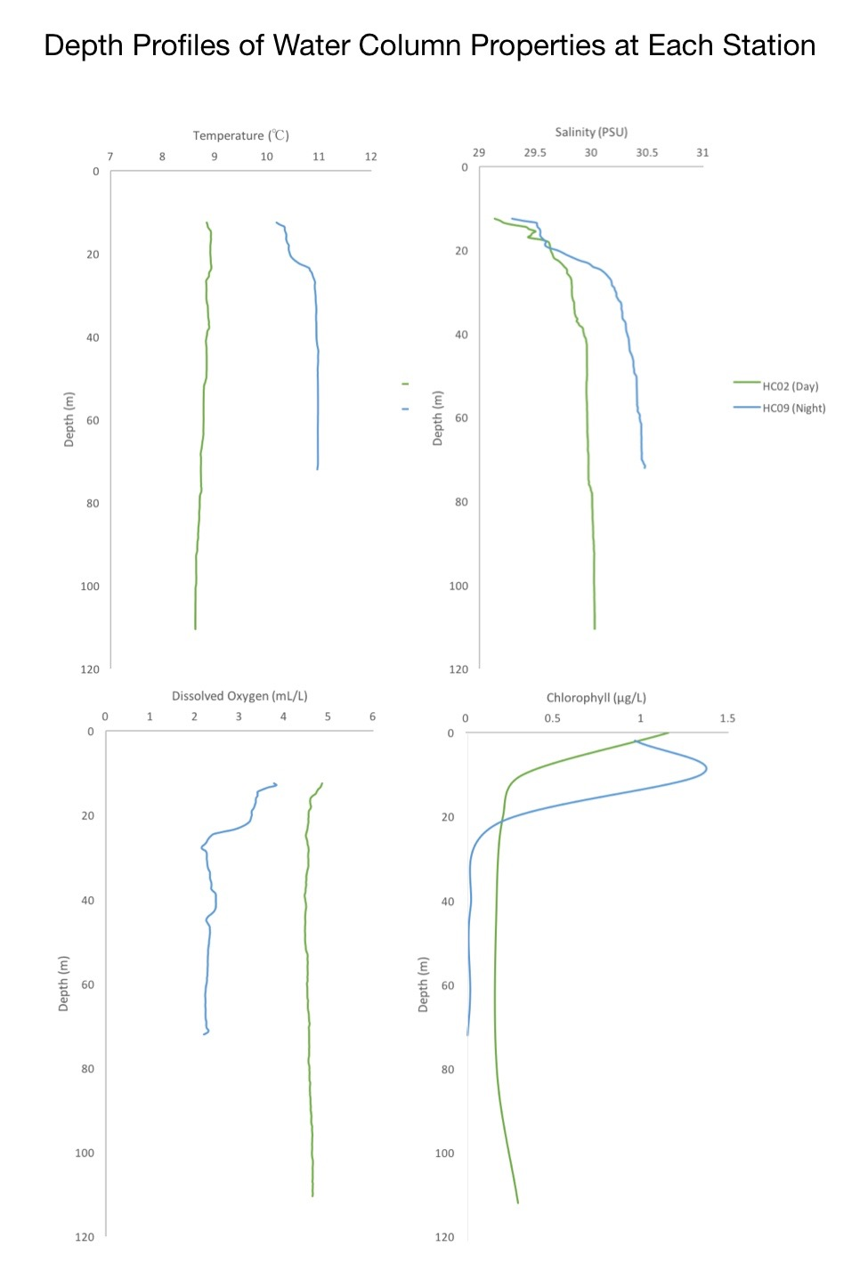

Figure 6.
Depth profiles of environmental parameters including temperature (°C), salinity (PSU), dissolved oxygen (mL/L), and chlorophyll (μg/L) at each station.

Discussion
When considering the relationship between the zooplankton community as a whole, and the diel vertical migration of copepods we need to first identify those taxa that the copepods are avoiding by using this behavior. Across both stations three known copepod predators were identified, which include euphausiids, larval fish, and chaetognath worms (Watson & Davis, 1989; Stuart & Verheye 1991; Bamstedt & Karlson, 1998). Both euphausiids and larval fish rely on vision as their primary sense, making them highly efficient hunters in the presence of light, with reduced efficiency in decreased light conditions. Because of this, diel vertical migration performed by prey would be an effective strategy in order to reduce their likelihood of mortality. Chaetognaths rely on mechanoreception as their primary sense, which has a less significant link to DVM. That said, these organisms still participate in diel vertical migration and follow the same feeding patterns as a result, so it is clear that they are relying on other physical cues to trigger their migration. Chaetognaths may be the most relevant in this study in particular based upon observations that their diet tends to be the most copepod-based, and that they were the most abundant predators at both sites. The sites, however, varied in their respective abundance of predatory individuals, with 9.73% of the population at HC02 as compared to the 8.15% at HC09.
Night and day net tows from within Hood Canal support the hypothesis that copepods are performing diel vertical migration. Though the relative scales of copepod abundances at each site are different, we still observed a larger proportion of their biomass present at the surface during night sampling, and at the bottom during day sampling, which is consistent with typical DVM behavior (Figure 4). At HC02 the difference between the copepod abundance at the surface of the water column as compared to the bottom of the water column was more pronounced than the difference in abundance at HC09. This suggests that a larger proportion of its copepod population is altering its vertical position in response to changes in light intensity, the trigger for diel vertical migration. Additionally, copepod size distribution between the surface and bottom of the water column was variable between stations. At both locations the percentage of large copepods within the population mimicked overall DVM patterns, meaning that they composed more of the population at the surface compared to the bottom at night, and then shifted to compose a larger proportion of the population at the bottom compared to the surface at night. Though this trend occurred at both stations, it was much more pronounced at HC02 where there was a greater difference in their abundance between surface and depth. The combined observations of increased predator abundance alongside more dramatic DVM patterns suggests that there is a cause-effect relationship between these two variables in which a larger predator population leads to an observable increase in copepod DVM behavior. This appeared to be true of large copepods specifically in communities that contain more predatory individuals. This is supported by previous research which states that larger copepods specifically face predation pressure as a result of their increased visibility in the water column, and that mid to large size copepods make up a majority of the migrating copepod population (Ohman & Romagnan, 2016). Since they face greater predation pressure, it is necessary for them to employ such behaviors as diel vertical migration as a means of avoiding predation-based mortality.
Though this relationship was conclusive, there may also be significant underlying environmental influences that contributed to overall differences in abundance and community composition between the stations. These differences may be responsible for causing DVM variability between the stations to appear more pronounced than it would have been otherwise, which may have oversimplified the conclusions that were made. In order to counteract this bias, it would have been beneficial to have complete night and day data sets from both study locations. Since this is not the case, it is useful to explore the factors that affect abundance and community composition, and the influences that they may have had on these study locations. First, since these measurements were taken during January it is likely that a proportion of the zooplankton community, especially copepods, could have been undergoing diapause at this time which would have greatly underestimated their contributions to the total biomass. In addition to this, there are selections of physical characteristics as well as distinct water column properties that have a hand in habitat selection for varying zooplankton taxa that were observed in the water column, especially with respect to size. In this study, physical characteristics include depth and proximity to oceanic input, and water column properties included temperature, salinity, dissolved oxygen, and chlorophyll.
In regard to physical characteristics, a larger overall biomass as well as a larger predator biomass was observed at HC02, which was both vertically deeper and proximally closer to the mouth of the basin than the opposing station. Depth is a significant factor because habitat preferences tend to be size dependent with respect to depth, with larger organisms favoring deeper water columns and smaller organisms favoring shallower water columns. The reason for which is also based on predator avoidance (Reynolds et al. 2002). In deep water, larger organisms have a greater area below the euphotic zone where they are able to avoid predation. This is not required for smaller individuals that are less visible to predators, allowing them to exist in shallower water columns. Large copepods are also able to swim faster than small copepods, allowing them to reach greater depths during their migration that small organisms would not be able to reach. This preference may justify why a greater abundance of predators and large copepods was observed at HC02. In addition, HC02 was located at the mouth of the Hood Canal basin, while HC09 was located further inside the basin. It has been suggested that close proximity to the output of a basin leads to increased mixing and decreased stratification. This allows for more favorable water column conditions to be maintained, resulting in increased abundance for the zooplankton community overall (Laprise & Dodson, 1994). The combination of its depth and location within the basin may have contributed to making HC02 a more favorable basin for a zooplankton community to exist.
Similarly, each water column property has an influence on the composition of the zooplankton community. First, temperature typically dictates growth rate of an organism, with higher temperatures resulting in more rapid rates. The nature of this correlation comes from the role of temperature as a catalyst for metabolic processes within an organism (Ikeda, 1985). Because of this, organisms are able to reach larger sizes in warmer water columns, and so are more likely to be found there as opposed to colder locations. That said, despite having higher overall temperatures, HC09 did not produce greater abundances of large organisms, which may suggest that temperature is not the most significant factor in determining habitat preference (Figure 6). Second, salinity often influences community composition based on the preferences of each taxa (McWhirter, 2016). Large taxa, including the predator species as well as large copepods, are typically associated with high salinity water columns, while small copepods are tolerant of a wide range of salinity conditions. In this study, however, the site with higher salinities was not associated with higher abundances of these large organisms, which may be a result of the salinity differences between the two sites not being significant enough to observe these distinct composition differences. Next, dissolved oxygen is acknowledged to be one of the most important factors in predicting survivorship of zooplankton as well as the entire marine community. Higher dissolved oxygen concentrations are necessary for survival, and are able to support larger populations as opposed to hypoxic conditions (Elliot et al, 2012). In this study, HC02 had higher dissolved oxygen concentrations as well as higher abundances, supporting the link between these two features. Finally, since chlorophyll serves as a representation of the phytoplankton community, high values indicate a larger supply of phytoplankton at the base of the food web. Though chlorophyll was higher in the surface at HC09, it reached nearly 0 μg/L below the euphotic zone, whereas HC02 still had consistent chlorophyll concentrations throughout the remainder of the water column. This suggests that a larger zooplankton population can be supported at this site. Considering the combination of physical characteristics and water column properties, HC02 offered preferable conditions for a diverse, abundant zooplankton community to thrive compared to HC09. Because of this, predatory species such as euphausiids, larval fish, and chaetognaths were able to increase in abundance, ultimately leading to the increased significance of copepod DVM behavior that was observed.
Conclusions
The extent of diel vertical migration of copepods in Hood Canal is influenced by the abundance of predators, with increased predation pressure resulting in more pronounced DVM behavior, especially with respect to larger individuals that are more vulnerable. An underlying cause of these differences in community composition is likely due to the location at which the samples were taken, and their respective physical characteristics and water column properties. More research is required in order to truly understand the coupling between abiotic and biotic features in the ocean, and the implications that this has for biogeochemical processes.

References
Babson, A.L., Kawase, M., MacCready, P. 2010. Seasonal and Interannual Variability in the Circulation of Puget Sound: A Box Model Study. Atmosphere-Ocean, vol.44, 2006, pp.29-45

Båmstedt, U., & Karlson, K. 1998. Euphausiid predation on copepods in coastal waters of the Northeast Atlantic. Marine Ecology Progress Series, 172, 149-168. doi:10.3354/meps172149

Baumgartner, M.F. and Tarrant, A.M. 2017. The Physiology and Ecology of Diapause in Marine Copepods. Annual Review of Marine Science.

Brierley, A. S. 2014. Diel Vertical Migration. Current Biology, vol. 24, no. 22, 2014, doi:10.1016/j.cub.2014.08.054.

Elliot, D.T., Pierson, J.J., Roman, M. R. 2012. Relationship between environmental conditions and zooplankton community structure during summer hypoxia in northern Gulf of Mexico. Journal of Plankton Research. Vol 34, no 4, 602-613

Frederiksen, M., M. Edwards, A. J. Richardson, N. C. Halliday, and S. Wanless. 2006. From plankton to top predators: bottom\up control of a marine food web across four trophic levels. Journal of Animal Ecology 75:1259–1268.
Frost, B. W. 1988. Variability and possible adaptive significance of diel vertical migration in Calanus pacificus, a planktonic marine copepod. Bull. Mar. Sci. 43: 675–694.
Grodzins, M.A., Ruz, P.M., Keister, J.E. 2016. Effects of oxygen depletion of field distributions and laboratory survival of the marine copepod Calanus pacificus. J. Plankton Res. vol.00, pp.1-8
Hays, Graeme C. A. 2003. Review of the Adaptive Significance and Ecosystem Consequences of Zooplankton Diel Vertical Migrations. Hydrobiology, vol. 503, no. 1-3 pp. 163–170., doi:10.1023/b:hydr.0000008476.23617.b0.

Humes, Arthur G. 1994. How Many Copepods? Hydrobiology, vol. 292-293, no. 1, pp. 1–7., doi:10.1007/bf00229916.

Ikeda, T. 1985. Metabolic rates of epipelagic marine zooplankton as a function of body mass and temperature. Marine Biology. Vol. 85, no. 1, pp.1-11.

Laprise, R., and J. J. Dodson. 1994. Environmental variability as a factor controlling spatial patterns in distribution and species diversity of zooplankton in the St. Lawrence Estuary. Marine Ecology\Progress Series 107:67–67.
MacCready, P. 2017. Puget Sound’s physical environment. Encyclopedia of Puget Sound. https://www.eopugetsound.org/articles/puget-sounds-physical-environment
Naganuma, T. 1996. Calanoid Copepods: Linking Lower-Higher Trophic Levels by Linking Lower-Higher Reynolds Numbers. Marine Ecology Progress Series, vol. 136, pp. 311–313., doi:10.3354/meps136311.

Ohman, Mark D., and Jean-Baptiste Romagnan. 2015. Nonlinear Effects of Body Size and Optical Attenuation on Diel Vertical Migration by Zooplankton. Limnology and Oceanography, vol. 61, no. 2, pp. 765–770., doi:10.1002/lno.10251.

Reynolds, C. S., V. Huszar, C. Kruk, L. Naselli-Flores and S. Melo. 2002. Towards a functional classification of the freshwater phytoplankton. Journal of Plankton Research 24: 417-428.
Robertis, A., Saffe, J.F., Ohman, M.D. 2000. Size-Dependent Visual Predation Risk and the Timing of Vertical Migration in Zooplankton. Limnology and Oceanography, vol. 45, no. 8, pp. 1838–1844., doi:10.4319/lo.2000.45.8.1838.

Stuart, V., & H. M. Verheye. 1991. Diel migration and feeding patterns of the chaetognath, Sagitta friderici, off the west coast of South Africa. Journal of Marine Research 49:493–515.

Turner, J. T. 2004. The Importance of Small Planktonic Copepods and Their Roles in Pelagic Marine Food Webs. Zoological Studies 43.
Watson, W, & Davis, R.L. 1989. Larval Fish Diets in Shallow Coastal Waters off San Onofre, Californa. Fishery Bulletin, U.S. 87: 569-591

