The Impact of the Mass Mortality of Ochre Stars (Pisaster ochraceus) and Sunflower Stars (Pycnopodia helianthoides) on Intertidal and Subtidal Communities in Puget Sound
Amanda Rose Smith
University of Washington, School of Oceanography
4014 University Way NE, Seattle, WA 98105
(206) 778-9027 (text only)
amands24@uw.edu
May 29, 2017
Abstract
Severe Sea Star Wasting Disease (SSWD) outbreaks were reported between Alaska and Baja California, including Puget Sound (Eisenlord et al 2016). Eisenlord et al 2016’s results from intertidal surveys in Tacoma and on the San Juan Island are shown in Figure 1a and b. The affected intertidal and subtidal communities were reported in those locales, excluding Puget Sound (Fuess et al 2015). The severe SSWD epidemic has killed very large abundances of sea stars, which are important keystone predators of the marine ecosystem and food web, causing abundances of sea stars’ prey to increase and out-complete other species. This has shifted the communities and ecosystem (Schultz 2016, Montecino-Laterro 2016, Paine & Trimble 2004, Fuess et al 2015). However, the study of the affected communities in Puget Sound was very limited and further studies are necessary. My goals in research are to recognize similar influences in Puget Sound and gain more understanding of the changes in the ecosystem. My two hypotheses are: First, the decline in ochre star populations in Puget Sound due to SSWD causes mussel (Mytilus trossulus) populations to increase and take up space to prevent species from settling down (Menge et al, 2016 and MARINe 2016). Second, the decline in sunflower star populations in Puget Sound due to SSWD outbreaks causes the prey rate in herbivorous invertebrate populations (such as green sea urchins) to increase immediately and consume the kelp forest in Puget Sound (Fuess et al 2015). To achieve my research goals, I was counted and identified species in sea stars’ prey populations through a quadrat method in the intertidal zone (Documenting Plants & Animals in Each Habitat 1999). Sea Stars’ radii were measured in radius with a ruler, counted, and categorized as to the severity of the disease (Eisenlord et al 2014) in transects in the method intertidal zone (J. Engle 2008). The environments the intertidal zone were also identified. I explored MARINe (2016)’s historical data from her intertidal surveys through from between 2009 and 2010 to between 2015 and 2016. Also, I explored ROV (Remote Operated Vehicle) data from Washington Department of Fish and Wildlife (WDFW). I counted Sunflower stars (Pyconpodia helianthoides) and their prey, and identified the environments in subtidal zones.
Introduction
Since 2013, the Sea Star Wasting Disease (SSWD) outbreaks were so severe that 60 to 80 percent of 20 sea star species (Hewson et al., 2015), including Ochre star (Pisaster ochraceus) and Sunflower star (Pycnopodia helianthoides) were wiped out between Alaska and Baja California (Kohl et al., 2016; Eisenlord et al., 2016; Schultz, 2016; Montecino-Laterro, 2016; Paine & Trimble, 2004; Fuess et al., 2015). All of the Ochre stars that were infected with SSWD died in a laboratory experiment by Kohl et al., 2016. The SSWD is a sea star-associated densovirus (SSaDV) that is related to urchin-associated densoviruses in Hawaiian urchins (Hewson et al., 2014). This type of the virus destroys the components of sea stars’ extra-cellular matrix, where the connective tissue remodels when a star gets injured or loses its limb. The tissue melts away when a sea star is infected with SSWD (Fuess et al., 2015).
I am presenting the data from my study of the changes in the intertidal and subtidal communities in Puget Sound where the SSWD outbreaks were reported. To be specific, I will focus on the influence of environmental changes in the intertidal communities from the absence of the Ochre stars and in the subtidal communities from the absence of the sunflower stars. My two hypotheses are: First, the decline in ochre star populations in Puget Sound due to SSWD causes mussel (Mytilus trossulus) populations to increase and take up space to prevent species from settling down (Menge et al., 2016 and MARINe., 2016). Second, the decline in sunflower star populations in Puget Sound due to SSWD outbreaks causes the prey rate in herbivorous invertebrate populations (such as green sea urchins) to increase immediately and consume the kelp forest in Puget Sound (Fuess et al 2015). If my hypotheses are not well supported, then is it possible to find a direct influence on changes in environments related to the lack of the sea stars presence?
The Ochre star is a keystone predator in rocky intertidal communities of the Pacific coast that preys heavily on the dominant space holder (Bay mussels, Mytilus trossulus in Puget Sound and California mussels, Mytilus californianus in the outer coast) (MARINe., 2016) and frees space for a diversity of invertebrates and algae (Shinen et al., 2009). During the sharp decline in the ochre star population due to the SSWD outbreaks, the Bay mussel lost its major predator. The Bay mussel populations were unleashed (over a period of a few months to years) and won the space competition with the other settlement species (Menge et al., 2016). In Paine & Trimble (2004)’s long period of observation on mussel beds and kelp forests (Hedophyllum) where Ochre stars were manually removed, when Ochre stars were not present for a very long period, a mix of small and young California mussels and Bay mussels attached around the kelp. This did not affect the kelp plants. Bay mussels grow to 50mm in 12 to 13 months and California mussels reach 80-86mm in a year of settlement (Shaw et al., 1988). However, when the mussels grew bigger, they outcompeted the kelp plants. The site, which was previously dominated by Hedophyllum kelp became a mussel bed.
San Juan Island, WA. Map. Google Earth, 2 May 2015. Software.
Figure 1a
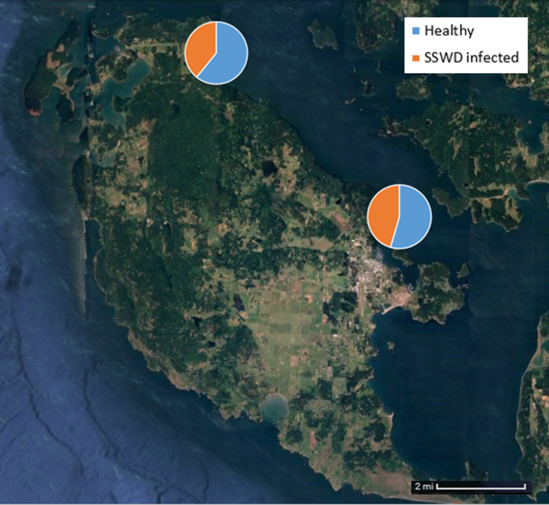
San Juan Island, WA. Map. Google Earth, 2 May 2015. Software.
Figure 1a
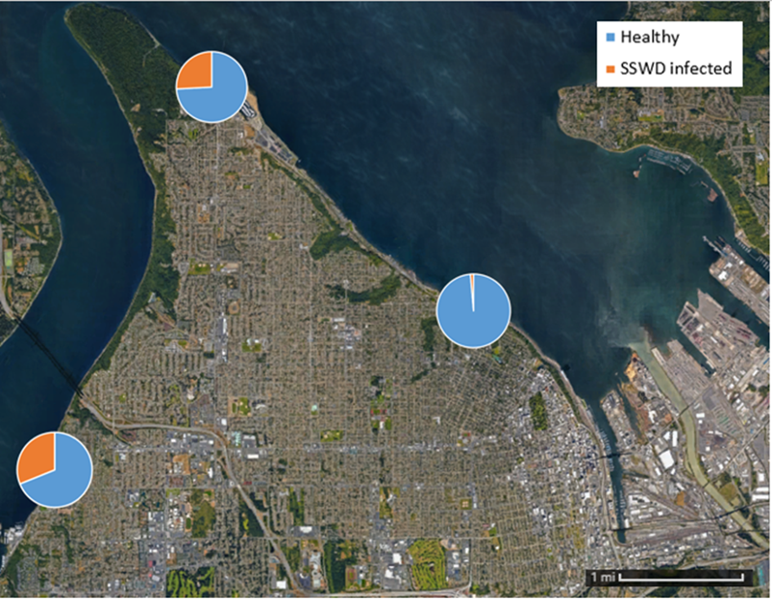
Tacoma, WA. Map. Google Earth, 2 May 2015. Software.
Figure 1b
Figure 1a and b represented Eisenlord et al 2016’s results from the study on the impact of the SSWD outbreaks from 2013 to 2015. This figure represented the maximum hit of the SSWD infection on Ochre stars in Eisenlord et al 2016’s study. The healthy Ochre stars are represented in blue slices and infected with SSWD are in the orange slices.
The Sunflower star (Pycnopodia helianthoides) is another keystone predator in rocky subtidal communities. It preys heavily on the dominant seaweed consumers, green urchins (Strongylocentrotus droebachiensis). It keeps the urchin populations in check and stabilizes the kelp forests that provide shelter, food, and mating habitats for marine animals (Schultz et al., 2016). Since the SSWD outbreaks wiped out so many Sunflower stars, fewer green urchins were preyed on. As a result, the green urchin populations were boosted and the kelp forests overgrazed. The rocky subtidal environments transformed from the highly diverse to the urchin dominant (Schultz et al., 2016).
Methods
I collected modern and historical data on intertidal and subtidal communities to investigate the change in Sunflower stars (Pycnopodia helianthoides) and Ochre stars (Pisaster ochraceus) abundances in areas that were influenced by Sea Star Wasting Disease (SSWD) outbreaks. I also identified the change in intertidal and subtidal communities where those keystone predators are absent. I identified the change in environments in the Puget Sound where the SSWD outbreaks were reported.
The ochre stars, their primary prey (Bay mussels) and secondary prey (gastropods), and intertidal communities were surveyed in seven sites: Three sites in Tacoma and four sites in San Juan Island in December 2016 and in January 2017 at night, from approximately 7 pm to 11pm for each survey. My surveys were located at Titlow Beach, Ruston Way Park, and Jack Hyde Park in Tacoma, and at Reuben Tarte County Park, Colin’s Cove, Friday Harbor Lab (FHL) Shore, and 4th of July Beach on the San Juan Island (Figure 1b, d). I conducted surveys using the quadrat method to count, identify, and measure Ochre stars’ prey as well as to identify the surroundings to gain the current data from the intertidal zones (Eisenlord et al., 2015). Using the quadrat method, is where I surveyed areas of dense and crowding mussels, barnacles, and other small invertebrates, and possibly a sea star if spotted in the sampling plot (SWAT team., 2011) during low tide. I set up two 15-meters baselines perpendicular to the waterline, 5 meters apart. Five transect lines were set up parallel the shore and 3 meters apart along the baselines. The survey was laid from the water’s edge to the upper edge of the shore. The quadrats were 50 cm x 50 cm in area (Documenting Plants & Animals in Each Habitat., 1999 and SWAT Team., 2011). One quadrat was sampled along each transect line across the habitat (Documenting Plants & Animals in Each Habitat., 1999 and SWAT Team., 2011). The populations were counted, species were identified, and the habitat in sampled plots was described and photographed (J. Engle., 2008).
I aggregated subtidal historical and modern data for the subtidal zones in Tacoma from WDFW to identify changes in the subtidal communities where Sunflower star (Pycnopodia helianthoides) populations have declined or are absent. The different abundances of Sunflower stars, prey, and different communities from one area to another were presented in a ROV survey in the Tacoma areas in 2012 and 2016. One site in the Tacoma area was surveyed once in 2012 and three times in 2016. The surveys in the Tacoma area lasted from 30 minutes to an hour. Those surveys were used to explore the direct and indirect influences on the communities and environments due to increases in green urchin (Strongylocentrous droebachiensis) populations where the Sunflower star populations declined or were absent due to SSWD.
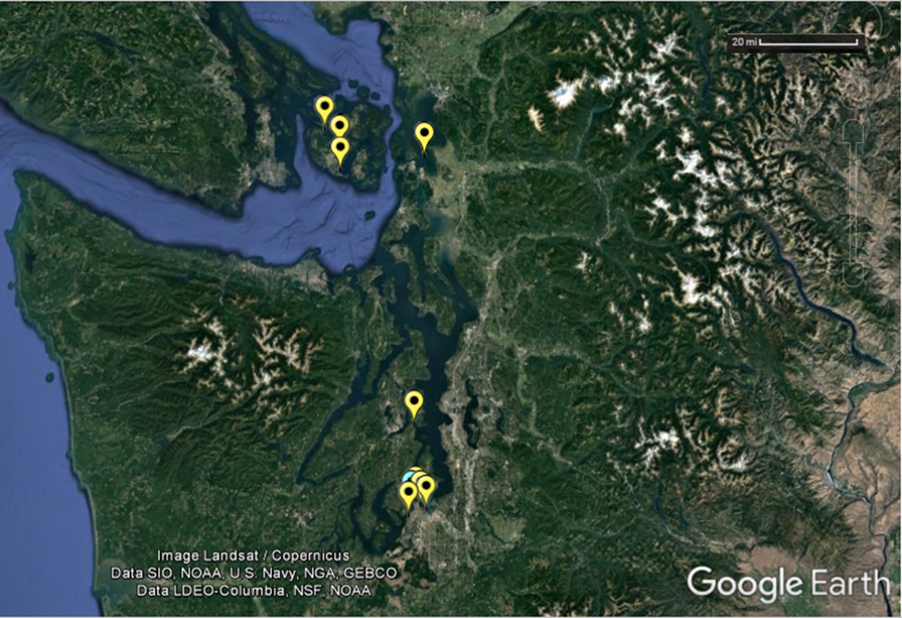
Washington State. Map. Google Earth, 2 May 2015. Software.
Figure 2a—This is a map of Washington State, USA with survey sites marked by yellow and blue pins.
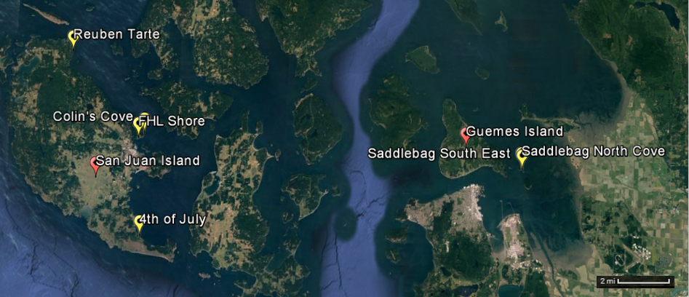
San Juan and Skagit County, WA. Map. Google Earth, 2 May 2015. Software.
Figure 2b
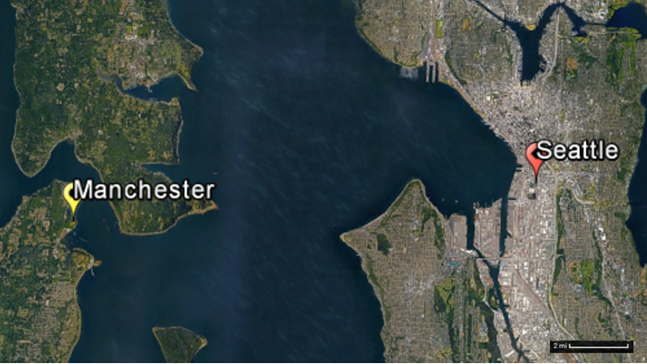
Manchester State Park and Seattle, WA. Map. Google Earth, 2 May 2015. Software.
Figure 2c
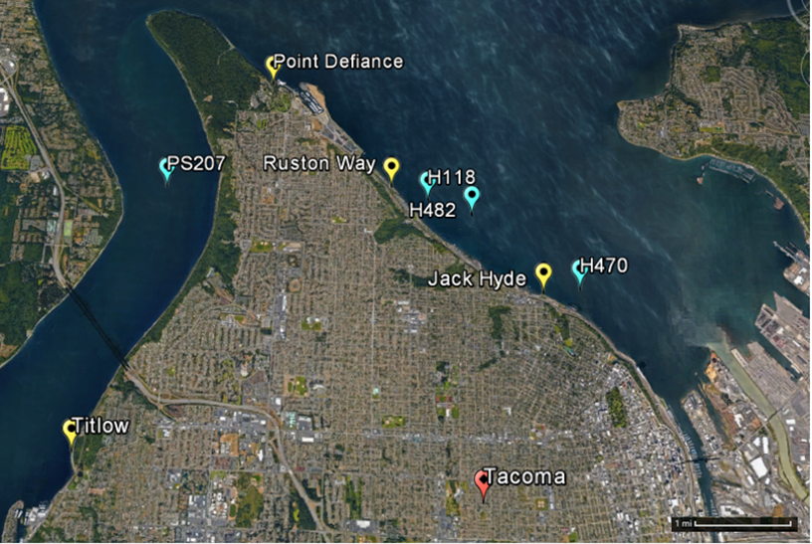
Tacoma, WA. Map. Google Earth, 2 May 2015. Software.
Figure 2d
Figure 2b, c, d—Those marked sites are represented survey locations by MARINe., 2016; Eisenlord et al., 2015; WDFW, and me. The yellow pins represent land-based surveys. The blue pins represent boat-based (ROV) surveys. The red pins represent the name of locations the survey sites were addressed.
Results
Intertidal Surveys
I found only seven sea stars overall at the surveyed sites (Figure 2). Two Ochre stars were found at Titlow Beach in Tacoma and only one young adult Sunflower star with its 11 new limbs was found at 4th of July Beach on San Juan Island. Three Mottled stars (Evasterias troscheli) were found in Tacoma sites and one Pacific blood star (Henricia leviuscula) in one of the San Juan sites.
The Ochre star’s targeted prey, Californian mussels, were not found, but Bay mussels were. However, Bay mussels populations were very few or absent at sites (Titlow Beach and Ralston Way) where Ochre and Mottled sea stars were present. Larger Bay mussel populations were present at other sites (Jack Hyde Park and 4th of July Beach) where those sea stars were absent.
Habitats varied widely from one site to another. Sites in Jack Hyde Park and Ralston Way in Tacoma were barnacle-dominated and covered with a white biotic mat that produced strong rotten-egg odor. The 4th of July Beach on San Juan Island was a sandy ecosystem with a very large rock (approximately 15m in length and 20m in width) covered with a very rich diversity of settlement species. The Friday Harbor Laboratory (FHL) shore was covered with rockweeds, although the area I chose to survey had only 17 percent rockweed cover. The environment in the Colin’s Cove site was covered with bare rocks with poor diversity. The Titlow Beach in Tacoma and Reuben Tarte Beach on San Juan Island had balanced environments, with a such as mixture of barnacles, bare rocks, and seaweeds. However, Reuben Tarte Beach had a very large number of Dog whelks (205 individuals).

Figure 2 – Colored chart bars represent numbers of sea stars found on each site. Orange chart bar represents Ochre star. Grey chart bar represents other sea star species such as mottled star (Evasterias troschelii) and Pacific blood star (Henricia leviuscula). Purple chart bar represents Sunflower star.
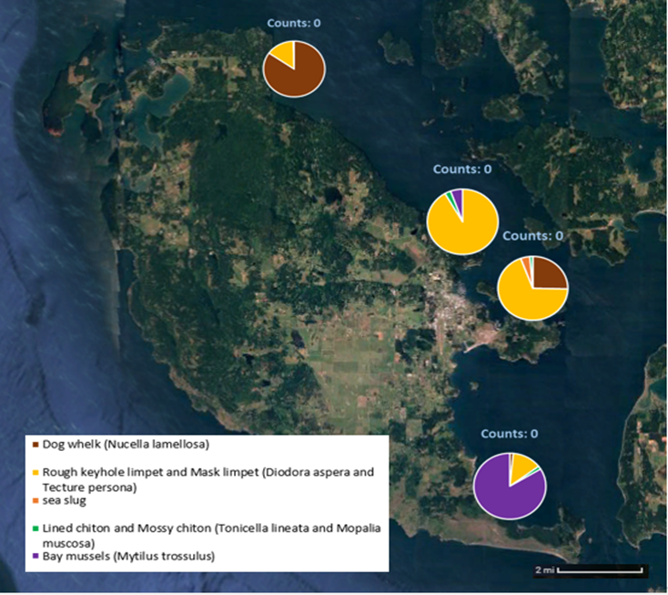
San Juan Island, WA. Map. Google Earth, 2 May 2015. Software.
Figure 3a
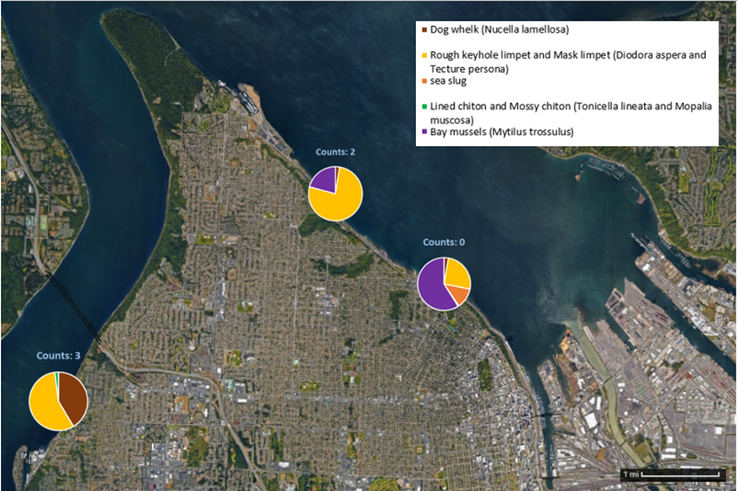
Tacoma, WA. Map. Google Earth, 2 May 2015. Software.
Figure 3b
Figure 3a, b—Pie charts represent number of individual intertidal prey species (Bay mussels and gastropods). Bay mussels are represented by the purple slice and the gastropods are represented by other slice colors: Dog whelk (Nucella lamellose) in brown, Rough keyhole limpet (Diodora aspera) and Mask limpet (Tecture persona) in yellow, sea slug in orange, and Lined chiton (Tonicella lineata) and Mossy chiton (Mopalia muscosa) in green. The blue label above each pie chart shows total number of sea stars (Ochre and Mottled star) were found in my surveys. Mottled stars consume the same primary prey type as Ochre star does (Rogers & Elliott., 2013).
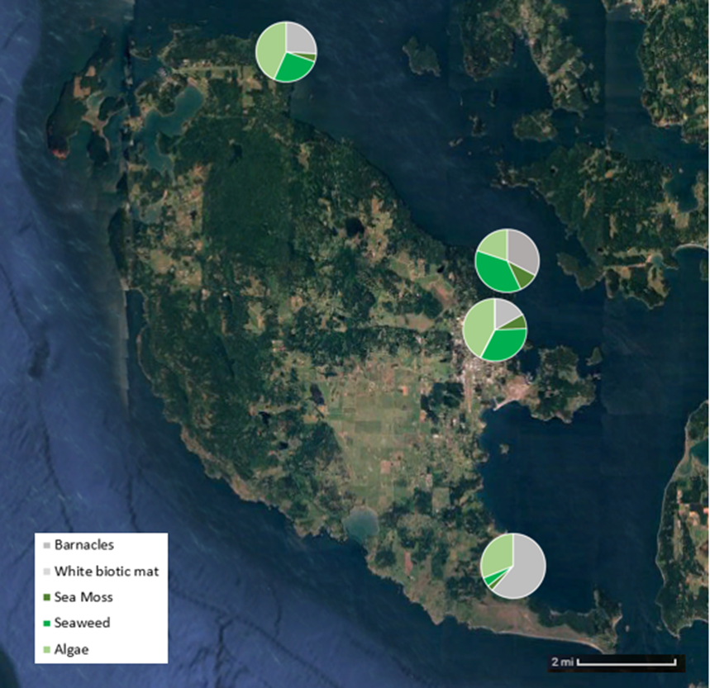
San Juan Island, WA. Map. Google Earth, 2 May 2015. Software.
Figure 4a
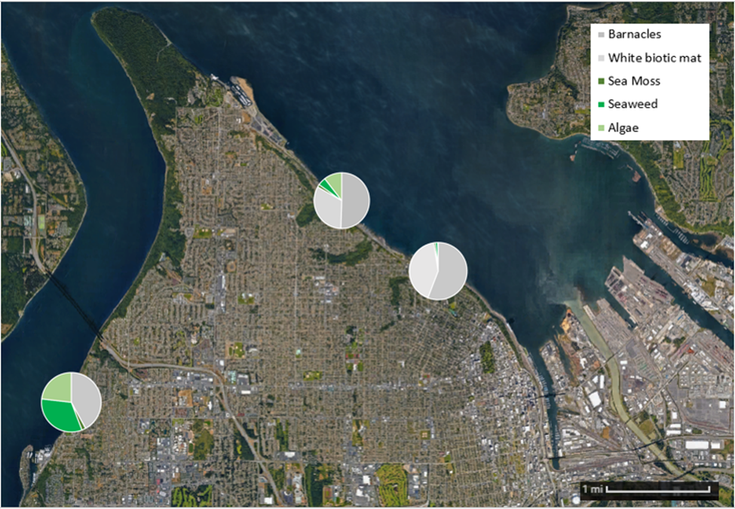
Tacoma, WA. Map. Google Earth, 2 May 2015. Software.
Figure 4b
Figure 4a, b—The surroundings in the intertidal habitats are represented in colored pie charts. White biotic mat in light grey, barnacles in grey, sea moss in dark green, seaweed in medium green, and algae in light green.
Subtidal Surveys
WDFW’s 2012 and 2016 ROV surveys were located in west and east of the Point Defiance Park in Tacoma. Those sites are marked in blue pins with WDFW’s data label (Figure 2d). The site off Salmon Beach in Tacoma in 2012 had an enormous population of Sunflower stars (99 individuals) and other type of sea stars (Ochre and Mottled stars). In the same site, the urchin’s population was small (46 individuals). There was no seaweed in this site. Also, a small group of approximately ten Ochre or Mottled stars were infected with SSWD in the dense population of sea stars. Those infected sea stars had lesions and some visible tissue degradation. This site off the Titlow Beach contained very large number of clam populations (580 individuals) along with Sunflower star and urchin presence, where the habitat was barnacle-dominated. The abundances of the other potentially affected animals were very low (77 sea cucumbers, 59 anemones, 7 fish, and shrimps were absent).
Three more sites off Ruston Way and Jack Hyde Park in Tacoma in 2016 had no sunflower stars and no urchins. The seaweed percent coverage in Ruston Way in 2016 was averaged 30% and 7%, and it was 20% in Jack Hyde Park in 2016 (Figure 5 and 6). Those sites were more diverse (3 and 0 sea cucumbers, 50 and 56 anemones, 159 and 66 fish, 100 and 0 clams, and 126 and 52 shrimps). One site in between had an enormous population of fish (17 anemones, 181 fish, 9 shrimps, clams and sea cucumbers were absent). The habitat in the two southeastern-most sites were covered with sediment deposits.

Figure 5—Bars present number of individual Sunflower star and its prey, urchin, for each site in each year. Purple bar represents Sunflower star and green represents urchin.
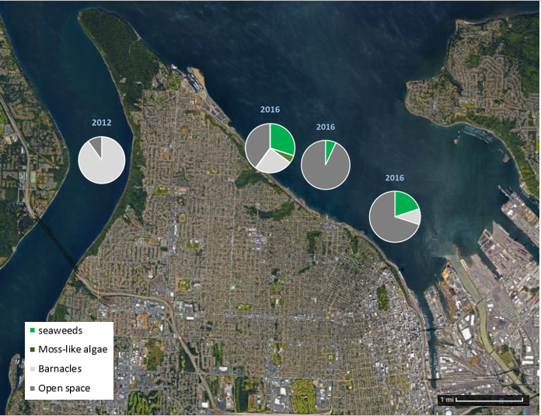
Tacoma, WA. Map. Google Earth, 2 May 2015. Software.
Figure 6—The percent coverage at each habitat in those sites present in pie charts. Blue legal states the year the ROV survey by WDFW occurred. Dark grey slice represents open spaces. Barnacles in light grey, moss-like algae in dark green, and seaweed in medium green. Very high percent of open space in the two sites near the river mouth where the massive sediment deposition occurred.
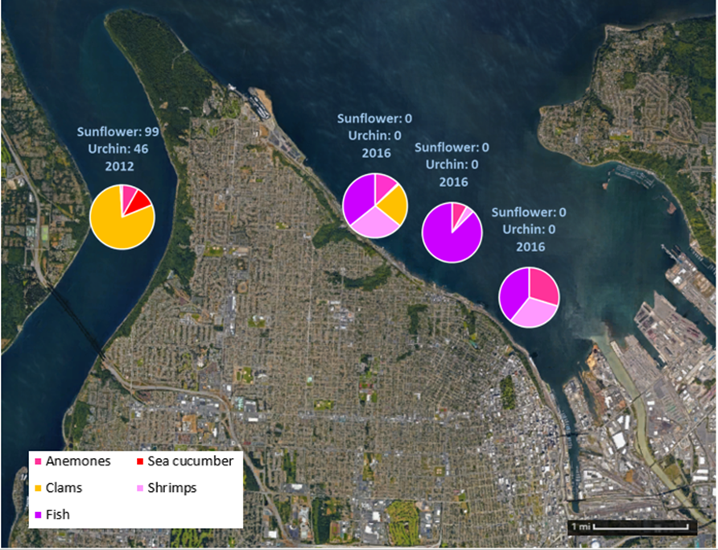
Tacoma, WA. Map. Google Earth, 2 May 2015. Software.
Figure 7—Number of potentially affected animals represented in pie charts for each site. The blue label above each pie chart states the number of subtidal keystone predator (Sunflower star) and prey (urchin) in two different years. Anemones are shown in bright pink, sea cucumbers in red, clams in yellow, shrimps in light pink, and fish in purple.
Discussion
The focus for the intertidal zone and the subtidal zone are discussed separately. The two different types of keystone predator sea stars have different influences on their communities. My focus for the intertidal zone is to recognize the effect on spatially competitive prey where depletion in Ochre star populations from SSWD was reported. My focus for the subtidal zone is to recognize the effect on herbivore grazer prey, urchins, and the subtidal environments from the depletion in Sunflower star populations where the SSWD was reported.
Intertidal
Habitats varied widely from one site to another, as is already described in the results section. This made my studies in intertidal communities more complicated because the variations in habitat from one site to another were caused by outside influences. For example, I found fewer animals on the shore where the white biotic mat with strong sulphuric odor existed, and many animals I found there were unhealthy. The white biotic mat, developed from a hypoxic zone, is a type of bacteria that produced intense methane seepage (Greinert et al., 2010). In another example, 4th of July Beach has a large rock covered with various settlement species attached. This beach is a sandy ecosystem and has extremely limited solid space available for settlement species such as mussels, barnacles, or anemones to attach. Hence, the competition for space was very high.
Since the Ochre star has no preference for species of mussel, it will prey on any type of mussel available. If all of the Ochre star’s primary prey is absent, the Ochre star will feed on its secondary prey such as chitons, limpets, snails, and barnacles (Shinen et al., 2009).
Related to the space competition hypothesis stated in the introduction section, only a few groups of small populations of Bay mussels were found. This was the opposite of what was expected. I expected to find countless Bay mussels attached along the shore. I found small groups of Bay mussels that were small (5mm to 10mm, and a few reaching 20 to 25mm). Hence, I assume those Bay mussels are growing and the population began expanding where the predator Ochre star was absent (Paine & Trimble, 2004., Shaw et al, 1988., Menge et al, 2016). Most sites at the Tacoma shores were barnacle dominated, which affected my observation. Juvenile Bay mussels need to attach on byssal threads of adult mussels or on a bare surface of rock to build their shells and grow (Shaw et al., 1988). However, I found they were also attached to barnacles. A pattern was observed that the Bay mussels were less abundant or absent where a few Ochre and Mottled stars were present in some sites (Figure 3a, b).
Moreover, since the barnacles were spatially competitive with other species that settle and they are currently dominant, the diversity was lower compared to non-barnacle dominated environments. That greatly impacted my observations at most sites in Tacoma. Thus, the hypothesis related to the effect of the Bay mussel as a spatial competitor on the intertidal communities due to lack of the Ochre star presence is partly supported. It was observed that barnacles were the dominated spatial competitors in my study. However, the question about the influence from the changes in intertidal communities is answered from MARINe (2016)’s results.
To gain knowledge of potential changes in Ochre star populations and associated changes in intertidal communities, I explored results from MARINe 2016 study of intertidal communities before and after SSWD outbreaks. I examined their data from three sites: two at Guemes Island, Saddlebag North Cove and Saddlebag South East, and one at Manchester State Park in Central Puget Sound, northwest from Tacoma and cross from Seattle (Figure 2b, c). MARINe (2016)’s results and graphs are discussed in details in Appendix section.
Ochre star’s primary prey, Bay mussels, was excluded in those sites under MARINe (2016)’s study. Only Ochre star’s secondary prey, Limpet and two other gastropods, are shown in MARINe (2016)’s results. The Limpet populations increased in relationship to the declined in Ochre star population from between 2012 and 2013 to late 2015. The percent of seaweed coverage was generally decreased. The percent of coverage by barnacles, the spatial competitor, was either varied or slightly increased. Hence, the intertidal communities were certainly affected by mortality of the keystone predator due to SSWD infection.
Subtidal
Because of my access to survey the subtidal zones was very limited, I aggregated the ROV data from WDFW. Crowded of enormous Sunflower stars and other type of sea stars (Ochre and Mottled stars) were found in the 2012 survey. In the current observations, the populations of herbivore grazer urchins and seaweed present in Tacoma sites were noticeably interrupted by the barnacle-dominated surroundings because barnacles were everywhere (90% coverage in 2012, 25% coverage in 2016) and seaweeds were present either in very small quantity or absent (0% in 2012, 30% in 2016) (Figure 7). Also, the influence of changes in Sunflower star populations and the effects on animals in subtidal communities were noticeably interrupted by the barnacle-dominated surroundings.
In the 2016 ROV surveys, the sites near Jack Hyde Park were covered with sand deposition from the Puyallup River (Mitchell., 2005). The community in this environment was very different from what was expected. There are few settlement species which have adjusted to the sandy environment and many burrowing species, such as burrowing anemones, were found there. For example, similar types of seaweeds were found in this sandy environment and a few sea stars were present there. However, populations of both sunflower star and urchin were absent (Figure 6). There are two possible reasons for the absence of sunflower star and urchin. First, sunflower star populations were wiped out from severe SSWD outbreaks in those sites and had extremely low chances to recruit (Hewson et al., 2015). Second, it is possible that enormous depositions of river sand are not hospitable for Sunflower stars and urchins. Hence, it is not clear whether my hypothesis is supported. My question, stated in introduction section, remains unanswered.
Conclusions
The main idea for this studies is to recognize the influence on the communities and environments in intertidal and subtidal zones due to keystone predator sea stars, Ochre star and Sunflower star, population decreased or absences from SSWD outbreaks in Puget Sound. My hypotheses are not entirely supported, but the influence in environment changes related to lack of sea stars presence, except the river sediment depositing environment, is clear. Further studies is necessary for both intertidal and subtidal communities in Puget Sound. The environments are varied from one site to another due to outside causes. My study on changes in the communities was sort of a snapshot. Thus, a long-term study on the changes in the affected communities related to lack of sea stars presence would be a best option.
References
- Shaw, William N., J.T. Hassler, and D.P. Moran. “Species Profiles: Life Histories and environmental Requirements of Coastal Fishes and Invertebrates (Pacific Southwest)—California sea mussel and Bay mussel.” U.S. Fish Wildl. Serv. Biol. Rep. 82 (1988): 1-16. U.S. Army Corps of Engineers, TR EL-82-4. Print.

- Greinert, J. et al. “Methane seepage along the Hikurangi Margin, New Zealand: Overview of studies in 2006 and 2007 and new evidence from visual, bathymetric and hydroacoustic investigations.” Mar. Geo. (2010): 6-25. Web. 23 May 2017.
DOI: https://doi-org.offcampus.lib.washington.edu/10.1016/j.margeo.2010.01.017

- Fuess, Lauren E., et al. “Up in Arms: Immune and Nervous System Response to Sea Star Wasting Disease.” PLoSOne. (2015): 1-16. Web. 19 Nov. 2016.
DOI: http://dx.doi.org/10.1371/journal.pone.0133053

- Kohl, Warren T. et al. “Decreased Temperature Facilitates Short-Term Sea Star Wasting Disease Survival in the Keystone Intertidal Sea Star Pisiater ochraceus.” PLoSOne. (2016): 1-9. Web. 18 Nov. 2016.
DOI: 10.1371/journal.pone.0153670

- Menge, Bruce A., et al. “Sea Star Wasing Disease in the Keystone Predator Pisaster ochraceus in Oregon: Insights into Differential Population Impacts, Recovery, Predation Rate, and Temperature Effects from Long-Term Research.” PLoS ONE 11.5 (2016) Web. 25 Oct. 2016.
DOI: 10.1371/journal.pone.0157302

- Schultz, Jessica A., Ryan N. Cloutier, and Isabelle M. Cote. “Evidence for trophic cascade on rocky reefs following sea star mass mortality in British Columbia.” PeerJ (2016) Web. 20 Oct. 2016.
DOI: 10.7717/peerj.1980

- Paine, Robert T. and Alan C. Trimble. “Abrupt community change on a rocky shore—biological mechanisms contributing to the potential formation of an alternative state” Ecology Letters. 7.6 (30 Apr 2004): 441-445. Web. Nov. 17 2016.
DOI: 10.1111/j.1461-0248.2004.00601.x

- Montecino-Latorre, Diego, et al. “Devastating Transboundary Impacts of Sea Star Wasting Disease on Subtidal Asteroids.” PLoSOne. (2016): 1-21. Web. Nov. 21 2016.
DOI: 10.1371/journal.pone.0163190

- SWAT Team. “Coastal Biodiversity Survey Protocols.” Santa Cruz, California: University of California. May 2011. 1-6. Print.

- “Documenting Plants & Animals in Each Habitat.” Shorekeeper’s Guide. Apr. 1999. 81-95. Print.

- “Intertidal Sea Star Protocol.” Santa Cruz, California: University of California. 2014. 1-16. Print.

- Hewson, Ian et al. “Densovirus associated with sea-star wasting disease and mass mortality.” PANS. 111.48 (2014): 17278–17283. Web. Nov. 30 2016.
DOI: 10.1073/pnas.1416625111

- Engle, John M. “Unified Monitoring Protocols for the Multi-Agency Rocky Intertidal Network.” MARINE Protocol Handbook. Camarillo, California: Pacific OCS Region. 2008. 1-84. Print.

- Eisenlord, Morgan E. et al. “Ochre star mortality during the 2014 wasting disease epizootic: role of population size structure and temperature.” Phil. Trans. R. Soc. B. 371.20150212 (2015): 1-11. Web. Dec. 6 2016. DOI: 10.1098/rstb.2015.0212

- “Subtidal Sea Star Protocols.” Santa Cruz, California: University of California. 2014. 1-7. Print.

- Shinen, J.S., S.G. Morgan, and A.L. Chan. “Invasion resistance on rocky shores: direct and indirect effects of three native predators on an exotic and a native prey species.” Mar. Ecol. Prog. Ser. 378 (2009): 47-54. Web. May 23 2017. DOI: 10.3354/meps07870

- Mitchell, Neil C. “Channelled erosion through a marine dump site of dredge spoils at the mouth of the Puyallup River, Washington State, USA.” Mar. Geol. 220 (2005): 131-151. Web. May 29 2017. DOI: http://doi.org/10.1016/j.margeo

- Rogers, Tanya L. and Joel K. Elliott. “Differences in relative abundance and size structure of the sea stars Pisaster ochraceus and Evasterias troschelii among habitat types in Puget Sound, Washington, USA.” Mar. Biol. 160 (2013): 853-865. Web. May 26 2017. DOI: 10.1007/s00227-012-2139-7

- MARINe. “Pacific Rocky Intertidal Monitoring: Trends and Synthesis.” Ecol. And Evol. Biol., University of California, Santa Cruz, Dec. 8 2016. URL: http://www.eeb.ucsc.edu/pacificrockyintertidal/sites/sites-region/sites-region-wa.html#wa-salish

Appendix
Ochre star populations (purple line) had noticeably declined in every site. The graph in (Figure A1b, d, f) shows season and year cross the number of individual Ochre stars and their radius size in mm. A small number of individuals is represented by a small dot and a large number of individuals by a larger dot. Figure A1b shows many small stars (approximately 200 individuals sized less than 50 mm in radius in summer 2014, before the populations declined in summer 2016). The graph and data provide a clue that Ochre stars increased their reproduction activity to breed more offspring during the severe SSWD outbreaks before the populations declined again in late 2014.
The populations of the Ochre star’s secondary prey, Limpet, populations in Mean Number/Plot (dark brown line in Figure A2a, b, c) increased in each site when the Ochre star populations declined. The cover percentage of barnacles was noticeably increased in the site in Manchester State Park near Tacoma (Figure A3c), slightly decreased in the Saddlebag North Cove site (Figure A3a.ii), and varied a bit in the Saddlebag South East site (Figure A3b). In general, Seaweed in cover percentage (shown in green lines in Figures A3a.i, b, and c) declined while Limpet populations (number/plot) increase.
Saddlebag North Cove, Guemes Island
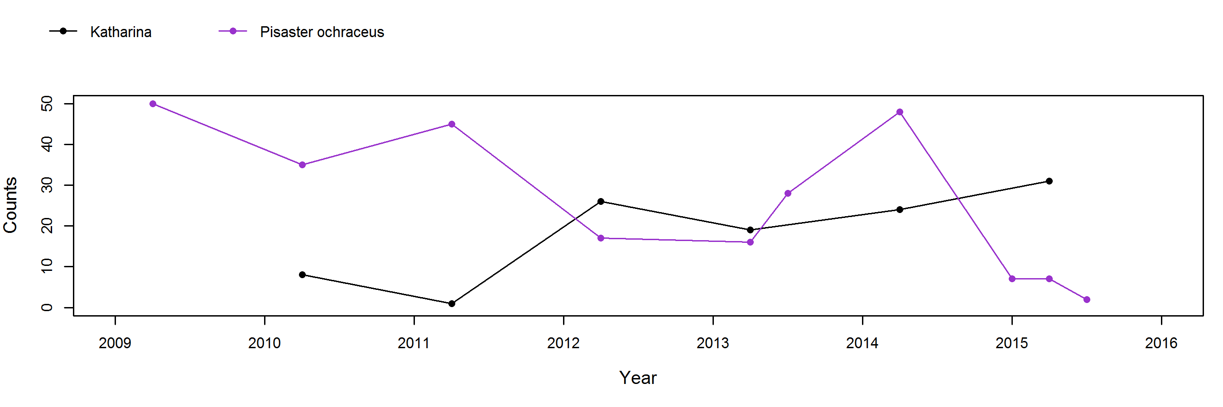
Figure A1a
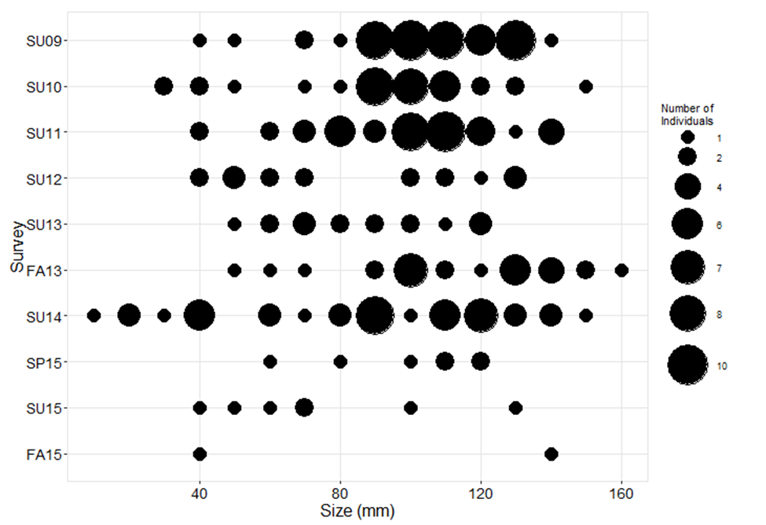
Figure A1b (Saddlebag North Cove, Guemes Island)
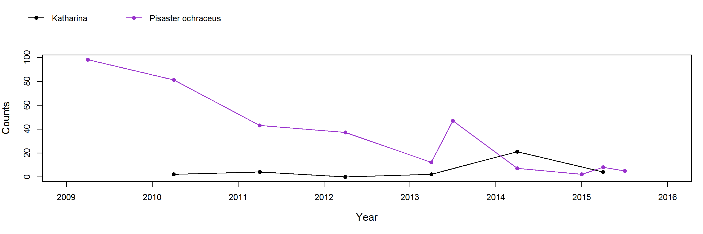
Figure A1c
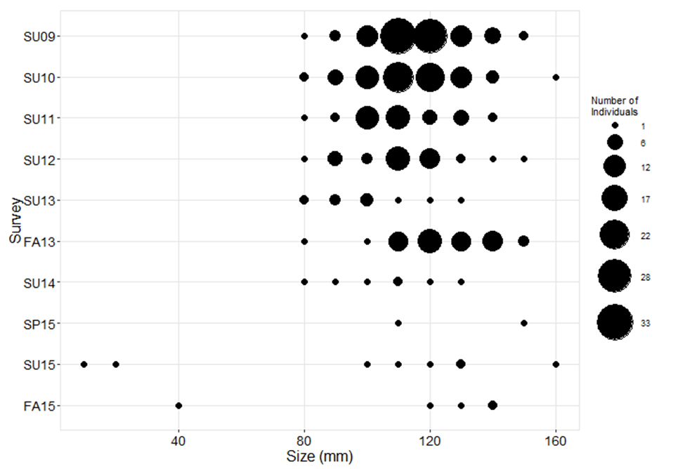
Figure A1d (Saddlebag South East)
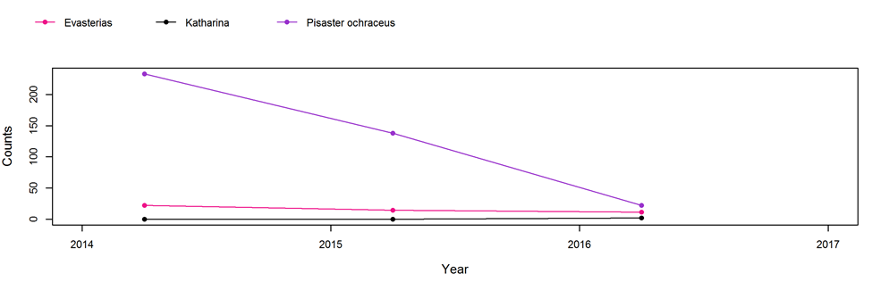
Figure A1e
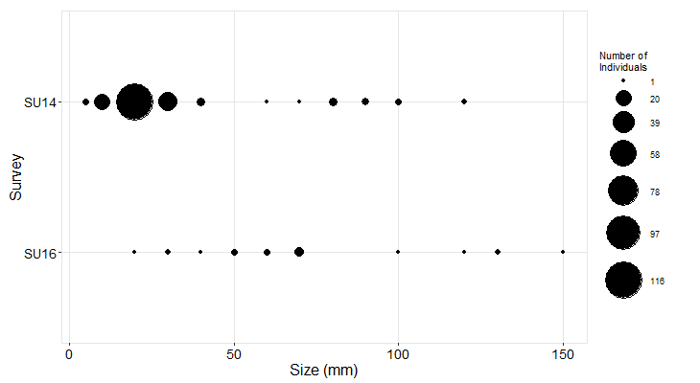
Figure A1f (Manchester State Park)
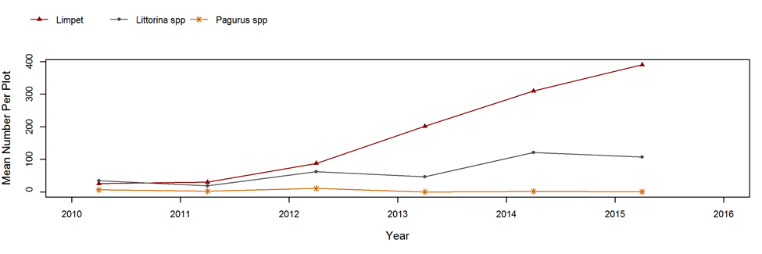
Figure A2a (Saddlebag North Cove)
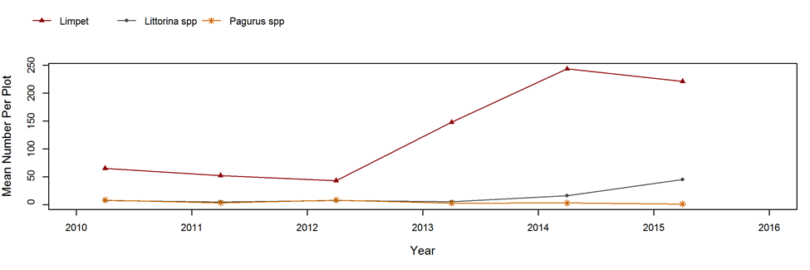
Figure A2b (Saddlebag South East)
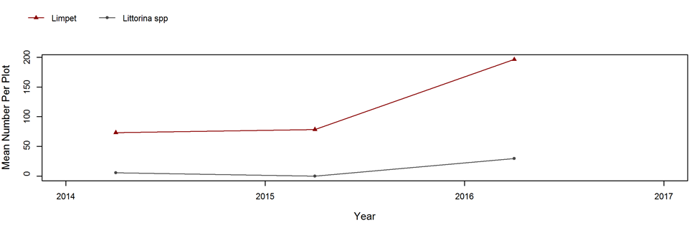
Figure A2c (Manchester State Park)
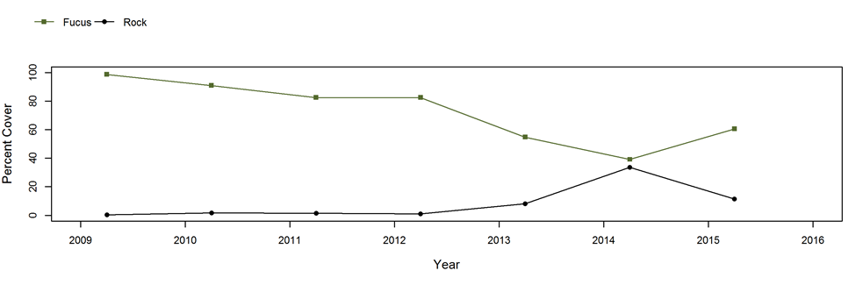
Figure A3a.i (Saddlebag North Cove)
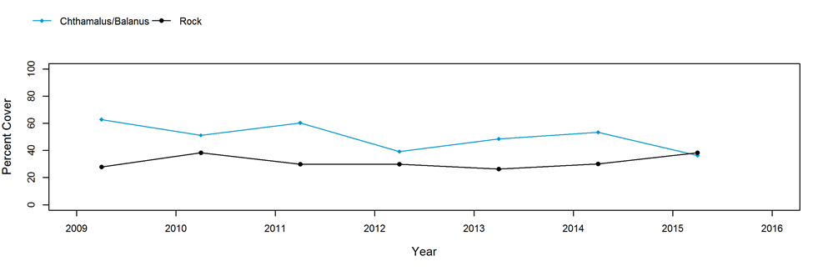
Figure A3a.ii (Saddlebag North Cove)
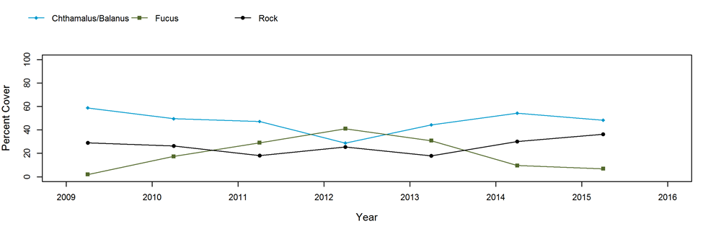
Figure A3b (Saddlebag South East)
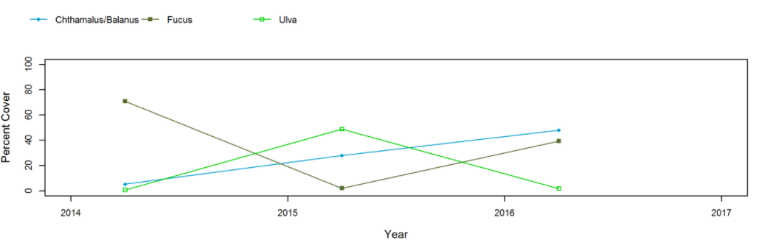
Figure A3c (Manchester State Park)

